ASSESSMENT OF GROUNDWATER POLLUTION LEVEL OF PARTS OF ILORIN AN INSIGHT FROM HEAVY METAL INDICES

BY:
Kehinde Hassan ALASE
ND/23/MPE/FT/0083

BEING A RESEARCH PROJECT SUBMITTED TO THE DEPARTMENT OF MINERAL AND PETROLEUM RESOURCES ENGINEERING, INSTITUTE OF TECHNOLOGY, KWARA STATE POLYTECHNIC, ILORIN

IN PARTIAL FULFILLMENT OF THE REQUIREMENT FOR THE AWARD OF NATIONAL DIPLOMA (ND) IN MINERAL AND PETROLEUM RESOURCES ENGINEERING

AUGUST, 2025.

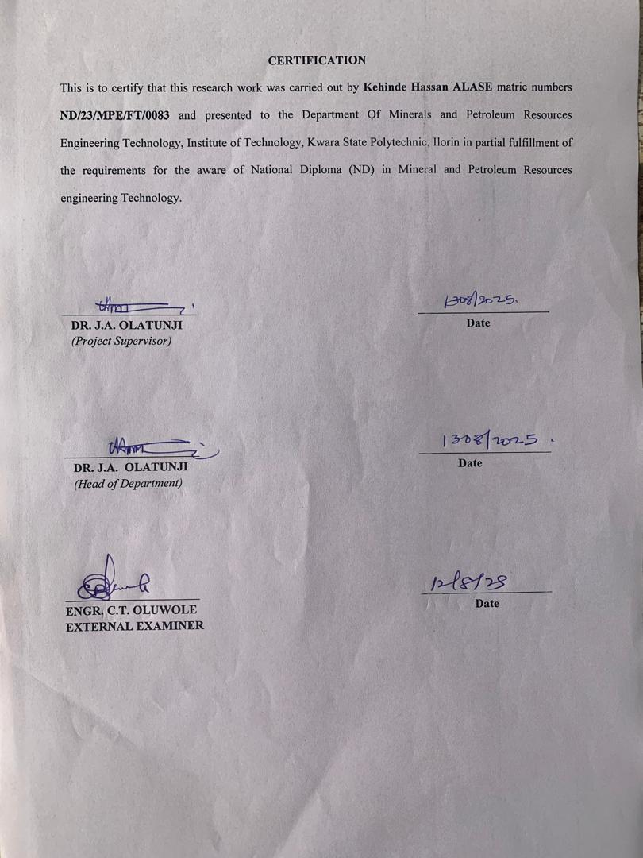
DEDICATION
This research project is dedicated to the Almighty God, the most High that bestows upon us in His infinite mercy, the freedom of life and sustain us throughout the course of my programme at the Kwara State Polytechnic, Ilorin and to our beloved parents and supervisor, who has stood by our side at all times.

ACKNOWLEDGEMENT
First and foremost, I wish to thank and praise the Almighty God for sparing my life and more importantly for His spiritual guidance and heavenly mercies rendered to me since the beginning of my academic pursuit to this stage. I wish to express my profound gratitude to my parents, Mr. and Mrs. ALASE, for their unflinching support, both morally and financially and to siblings for their love and support.
I also wish to express with deep sense of humanity, gratitude and indebtedness to my beloved project supervisor, DR. Olatunji J.A., whose regular and prompt attention, useful suggestions, comments and encouragement at every stage of this work were invaluable. I wish to thank more sincerely for his open handedness and accomplishing nature towards me, praying the good Lord to bless him and his family.
I sincerely appreciate the invaluable help and advice from my departmental H.O.D., DR. Olatunji J.A. and others lecturers in our Department who had impacted something meaningful into my life.
I personally that in moment of sober reflection discover that I am indebted to very many people even for the least achievement. Here I find myself limited in space, I would have gone on and on mentioning them.
Above all, we give endless thanks to Almighty God, the Author and Finisher of my faith, for giving me the grace to embark and successfully complete this programme.

Abstract
This comprehensive study investigates groundwater pollution from heavy metals in Ilorin, Nigeria, with a focus on assessing the levels of iron (Fe), lead (Pb), copper (Cu), chromium (Cr), zinc (Zn), nickel (Ni), cobalt (Co), and cadmium (Cd). Water samples from 30 locations across the city were analyzed for heavy metal concentrations using standard methods and protocols. The results reveal that iron (Fe) and lead (Pb) levels exceeded the World Health Organization (WHO) and Nigerian Standard for Drinking Water Quality (NSDWQ) permissible limits in some sampled locations, indicating potential health risks to consumers. Conversely, copper (Cu), chromium (Cr), zinc (Zn), and cadmium (Cd) levels were within or below permissible limits, suggesting that these metals may not pose significant health risks in the study area. The study highlights potential health risks associated with Fe and Pb contamination, likely due to anthropogenic activities such as industrial influence, poorly managed waste disposal sites, and other human-related activities. The findings of this study underscore the need for regular monitoring and treatment of contaminated water sources to ensure safe drinking water for the inhabitants of Ilorin. Furthermore, the study's results have significant implications for water resource management and public health policy in the region, emphasizing the importance of proper waste management practices, regular water quality assessments, and effective mitigation strategies to reduce the risks associated with heavy metal contamination. The study's findings can inform policy decisions and interventions aimed at protecting public health, ensuring sustainable water resource management, and promoting environmental sustainability in Ilorin and similar urban settings. Ultimately, this study contributes to the growing body of research on heavy metal contamination in groundwater and its implications for human health and environmental sustainability.

Table of Contents
Title Page i
Certification ii
Acknowledgement iii
Dedication iv
Abstract v
Table of Contents vi
List of Figure viii
List of Table ix
Chapter one: Introduction 10
1.1 Background of the Study 10
1.2 Statement of the Problem 11
1.3 Objectives of the Study 12
1.4 Scope and Limitations 12
1.5 Significance of the Study 13
Chapter two: Literature Review 14
2.1 Groundwater Pollution and Quality in Ilorin 14
2.2 Hydrocarbon (HCD) Characteristics of Groundwater in Ilorin 14
2.3 Sources and Types of Groundwater Contaminants 15
2.4 Heavy Metals in Groundwater: Concentrations, Risks, and Indices 16
2.5 Previous Studies 16

Chapter three: Methodology 19
3.1 Desk Study 19
3.2 Field Work 20
3.3 Laboratory Analysis 23
3.4 Data Analysis 25
Chapter four: Results and Discussion 27
4.1 Hadrochemical Laboratory Result 27
4.2 Heavy Metals Concentration Yields Risk 37
Chapter five: Conclusion and Recommendations 38
5.1 Summary of Findings 38
5.2 Conclusion 40
5.3 Recommendations 40
References 41

LIST OF FIGURES
Fig 3.1 | Photo Showing Researchers during Fieldwork Activities, Including Sample Collection | 21
Fig 3.2 | Photos Showing Researchers Collecting Water Samples From Hand-Dug Well Water | 22
Fig 4.1 | Spatial Distribution of Iron (Fe) Concentration within the Study Area | 28
Fig 4.2 | Spatial Distribution of Lead (Pb) Concentration within the Study Area | 29
Fig 4.3 | Spatial Distribution of Copper (Cu) Concentration within the Study Area | 30
Fig 4.4 | Spatial Distribution of Chromium (Cr) Concentration within the Study Area | 31
Fig 4.5 | Spatial Distribution of Manganese (Mn) Concentration within the Study Area | 32
Fig 4.6 | Spatial Distribution of Zinc (Zn) Concentration within the Study Area | 33
Fig 4.7 | Spatial Distribution of Nickel (Ni) Concentration within the Study Area | 34
Fig 4.8 | Spatial Distribution of Cobalt (Co) Concentration within the Study Area | 35
Fig 4.9 | Spatial Distribution of Cadmium (Cd) Concentration within the Study Area | 36

LIST OF TABLES
Table 3.1 | Elements: Sources and Health Concerns in Water | 24
Table 3.2 | Laboratory Analysis Table — Groundwater Pollution Assessment | 24
Table 4.1 | Heavy Metal Concentration of Water Samples | 27

CHAPTER ONE
1.0 INTRODUCTION
1.1 Background of the Study
Groundwater is a vital source of potable water in Nigeria, particularly in urban areas like Ilorin, where rapid population growth and industrial activities have increased reliance on this resource. The importance of groundwater cannot be overstated, as it serves not only as a primary source of drinking water but also supports agricultural and industrial activities. However, the quality of groundwater is often compromised due to anthropogenic activities such as improper waste disposal, agricultural runoff, and industrial effluents. Heavy metals, including iron, lead, cadmium, and arsenic, are among the pollutants that pose significant health risks when present in high concentrations (Olatunji et al., 2015; Odediran et al., 2015).
The assessment of groundwater pollution using heavy metal indices provides valuable insight into the contamination levels and potential impacts on public health and environmental safety. Heavy metal indices are quantitative tools that help evaluate the severity of pollution by aggregating data on various heavy metals present in water samples. These indices are crucial for policymakers and environmental managers as they provide a comprehensive overview of water quality, guiding decisions on mitigation strategies and resource management (Singh et al., 2017).
Previous studies in Ilorin have revealed elevated levels of heavy metals in groundwater sources, exceeding permissible limits set by regulatory bodies like the World Health Organization (WHO) (Olatunji et al., 2015; Odipe & Adewoye, 2022). For instance, lead and cadmium have been detected at levels that pose significant health risks, including neurological damage and kidney dysfunction (WHO, 2011). This study aims to evaluate the pollution levels in parts of Ilorin using heavy metal indices to guide mitigation efforts and policy development.
Moreover, understanding the sources of heavy metal contamination is essential for developing targeted interventions. Agricultural runoff, industrial effluents, and improper waste disposal are common sources of heavy metals in groundwater (Kumar et al., 2023). Identifying these sources will help in implementing effective measures to reduce pollution and protect groundwater resources.
1.2 Statement of the Problem
Groundwater pollution has become a pressing issue in Ilorin due to increasing urbanization and industrialization. Despite its importance as a primary source of drinking water for many residents, limited attention has been given to monitoring and managing its quality. Heavy metals such as lead, cadmium, and iron have been detected in groundwater sources within Ilorin at levels that may pose significant health risks (Olatunji et al., 2015). The lack of comprehensive studies on heavy metal indices further exacerbates the problem, leaving gaps in understanding the extent of contamination and its implications for public health and environmental sustainability.
This study addresses these gaps by assessing groundwater pollution levels using heavy metal indices in parts of Ilorin. It seeks to provide actionable insights for stakeholders to develop effective strategies for pollution control and resource management. The absence of robust data on groundwater quality hinders the formulation of policies aimed at protecting this vital resource. Therefore, this research aims to bridge this knowledge gap by providing detailed information on the current state of groundwater pollution in Ilorin.
Furthermore, the health implications of consuming contaminated water are severe. Exposure to heavy metals can lead to a range of health issues, from mild gastrointestinal symptoms to severe neurological damage and organ failure (WHO, 2011). Thus, understanding the extent of heavy metal contamination is crucial for public health interventions.
1.3 Objectives of the Study
The objectives of this study are:
- To determine the concentration levels of selected heavy metals (e.g., lead, cadmium, iron) in groundwater sources within parts of Ilorin.
- To evaluate the pollution status of groundwater using heavy metal indices.
- To access its suitability for domestic uses
- To recommend mitigation measures for improving groundwater quality.
These objectives are designed to provide a comprehensive understanding of groundwater pollution in Ilorin, focusing on both the extent of contamination and potential solutions.
1.4 Scope and Limitations
This study focuses on assessing groundwater pollution levels in selected parts of Ilorin metropolis using heavy metal indices. It involves sampling of hand-dug wells across different locations within the study area. The analysis includes physicochemical parameters such as pH, total dissolved solids (TDS), nitrate, sulphate, and selected heavy metals like lead, cadmium, and iron.
The scope of this study is limited to the urban areas of Ilorin, where the impact of industrial and agricultural activities on groundwater quality is most pronounced. However, the findings can be extrapolated to similar urban settings in Nigeria.

1.5 Significance of the Study
This study is significant as it provides critical insights into the quality of groundwater resources in Ilorin metropolis with a focus on heavy metal contamination. The findings will help policymakers design effective strategies for pollution control while guiding public health interventions to protect residents from waterborne diseases caused by contaminated water sources.
Moreover, the study contributes to the existing body of research on groundwater pollution, enhancing understanding of the complex interactions between human activities and environmental health. By identifying sources of contamination and recommending mitigation measures, this research supports sustainable development goals related to clean water and sanitation (UN, 2020).
The study's outcomes are expected to inform policy decisions at local and national levels, ensuring that groundwater resources are managed effectively to meet current and future needs without compromising public health or environmental integrity.

Chapter Two

2.0 Literature Review

2.1 Groundwater Pollution and Quality in Ilorin
Groundwater serves as a vital source of potable water in Ilorin metropolis, especially given the inadequacy of surface water supplies and the increasing population pressure exceeding 800,000 inhabitants (Afolabi et al., 2022). The quality of groundwater in this region is influenced by both natural geological factors and anthropogenic activities. Urbanization, poor waste management, and industrialization have significantly contributed to groundwater contamination, posing serious public health risks (Olasunkanmi et al., 2024; Adewuyi et al., 2020). Groundwater pollution in Ilorin is often linked to leachate infiltration from unengineered dumpsites, leakage from petroleum product pipelines, and effluents from industrial and domestic sources (Olasunkanmi et al., 2024; Adewuyi et al., 2020). The Basement Complex geology of the area, characterized by fractured crystalline rocks, controls groundwater occurrence but also influences the transport and fate of pollutants (Afolabi et al., 2022). The vulnerability of shallow aquifers to contamination is exacerbated by permeable soil layers and inadequate containment of waste materials (Olasunkanmi et al., 2024).

2.2 Hydrocardium (HCD) Characteristics of Groundwater in Ilorin
Several studies have characterized the hydrocardium properties of groundwater in Ilorin, revealing a wide variation in physicochemical parameters. Afolabi et al. (2022) analyzed samples from over 30 well water and reported electrical conductivity (EC) values ranging from 44.3 to 1079 µS/cm and total dissolved solids (TDS) between 10.6 and 501 mg/L, indicating variable mineralization. The pH values generally fell within neutral to slightly alkaline ranges (7.0–8.5), suitable for drinking but with localized deviations due to contamination (Afolabi et al., 2022; Olasunkanmi et al., 2024). Major cations such as calcium, magnesium, potassium, and sodium, and anions including chloride, bicarbonate, and sulfate, were detected in concentrations reflecting both natural cardium processes and anthropogenic inputs (Afolabi et al., 2022; Olasunkanmi et al., 2024). Heavy metals including cadmium, chromium, cobalt, nickel, lead, iron, and zinc have been reported in groundwater samples, with some exceeding WHO permissible limits, particularly in areas close to dumpsites and industrial zones (Akinola et al., 2023; Olasunkanmi et al., 2024).
These metals pose significant health risks due to their toxicity and bioaccumulative nature (Olasunkanmi et al., 2024).

2.3 Sources and Types of Groundwater Contaminants
The primary sources of groundwater contamination in Ilorin are linked to anthropogenic activities. Urban dumpsites, especially the Harmony Estate at Zango, Ilorin dumpsite, have been identified as major contributors to groundwater pollution through leachate percolation.
Olasunkanmi et al. (2024) used 2D Electrical Resistivity Tomography (ERT) and soil classification to demonstrate that the shallow topsoil layer at Harmony Estate at Zango, Ilorin has insufficient clay content to effectively prevent leachate infiltration, leading to elevated levels of heavy metals in groundwater and topsoil. The leachate exhibited high pH and electrical conductivity, indicating high total dissolved solids, and heavy metals such as cadmium were found at ecologically risky concentrations (Olasunkanmi et al., 2024). Additionally, filling stations scattered across Ilorin have been shown to contribute petroleum-related pollutants and heavy metals like lead, cadmium, chromium, and nickel to groundwater (Adewuyi et al., 2020). Industrial activities in the central industrial district also release heavy metals and other contaminants into the environment, affecting both sediment and groundwater quality (Akinola et al., 2023). Other sources include sewage leakage, hydrocarbon spills, and waste from auto repair workshops, which introduce hydrocarbons and nutrients into groundwater, further degrading its quality (Adewuyi et al., 2020; Olojoku et al., 2023).

2.4 Heavy Metals in Groundwater: Concentrations, Risks, and Indices
Heavy metals in Ilorin’s groundwater have been extensively studied due to their toxicity and persistence in the environment. Studies report elevated concentrations of cadmium, lead, chromium, nickel, and iron, often exceeding the World Health Organization’s (WHO) permissible limits for drinking water (Olasunkanmi et al., 2024; Akinola et al., 2023).
Cadmium, in particular, has been identified as presenting a high ecological risk in areas surrounding urban dumpsites (Olasunkanmi et al., 2024). The presence of these metals in groundwater poses serious health risks including kidney damage, neurological effects, and carcinogenicity (Akinola et al., 2023). To quantify pollution levels, several indices such as the Heavy Metal Pollution Index (HPI) and Pollution Load Index (PLI) have been applied, providing a composite measure of contamination severity and facilitating risk assessment (Akinola et al., 2023). These indices help in identifying hotspots of contamination and informing remediation priorities. The bioavailability and mobility of these metals are influenced by groundwater pH, redox conditions, and the presence of competing ions (Afolabi et al., 2022).

2.4 Previous Studies
Several key studies have significantly contributed to understanding groundwater pollution and heavy metal contamination in Ilorin metropolis, providing valuable insights and methodologies relevant to this research. One important study by Adewuyi et al. (2020) investigated the effects of filling stations on groundwater quality in Ilorin. This research analyzed water samples from hand-dug wells located near twenty-six filling stations operating for over 15 years, assessing both physicochemical parameters and heavy metal concentrations such as lead, cadmium, chromium, and nickel. The study revealed elevated levels of turbidity, conductivity, total dissolved solids, and heavy metals beyond Nigerian drinking water standards, indicating that activities at filling stations have adversely affected groundwater quality, posing significant health risks to consumers. This work highlights the direct impact of petroleum-related operations on groundwater contamination and underscores the need for regular monitoring and pollution control measures around such facilities (Adewuyi et al., 2020).
Another pivotal study by Olasunkanmi et al. (2024) focused on leachate contamination and groundwater vulnerability in urban dumpsites, specifically the Harmony Estate at Zango, Ilorin area in Ilorin. Employing a combination of 2D Electrical Resistivity Tomography (ERT), soil classification, and physicochemical analyses, the researchers identified a shallow topsoil layer with insufficient clay content to prevent leachate percolation. Their findings showed that leachate from the dumpsite exhibited high pH and electrical conductivity, indicating elevated total dissolved solids, and heavy metals such as cadmium were present at concentrations posing high ecological risks. The study also confirmed that groundwater samples near the dumpsite contained heavy metals exceeding WHO permissible limits. This comprehensive approach combining geophysical and chemical analyses provides a robust framework for assessing groundwater pollution and vulnerability in urban environments, emphasizing the urgent need for sustainable waste management and groundwater protection strategies (Olasunkanmi et al., 2024).
In addition, Raji et al. (2023) conducted an extensive evaluation of groundwater aquifer vulnerability in Ilorin metropolis using geophysical methods, specifically Vertical Electrical Sounding (VES). Their study covered a large area of approximately 322 km² and involved the interpretation of 312 VES data points to delineate geo-electric layers and assess aquifer characteristics. The results identified zones of varying vulnerability to contamination, influenced by overburden thickness and lithology. This work provided critical information for advising on safe borehole siting and highlighted the susceptibility of shallow aquifers to pollution from surface activities such as waste dumping and industrial discharge. The application of geophysical techniques in this study demonstrates an effective non-invasive method for groundwater vulnerability assessment, which is essential for planning and protecting water resources in rapidly urbanizing areas like Ilorin (Raji et al., 2023).
Together, these studies form a strong foundation for understanding the sources, extent, and risks of groundwater pollution in Ilorin, employing diverse but complementary methodologies ranging from chemical analyses of contaminants to geophysical assessments of aquifer vulnerability. They collectively emphasize the importance of integrated approaches in groundwater quality monitoring and management to safeguard public health and the environment.

CHAPTER THREE
3.0 METHODOLOGY

3.1 Desk Study
The desk study phase involved a comprehensive review of existing literature, geological maps, hydrogeological reports, and previous research on groundwater resources within Ilorin Metropolis, Southwestern Nigeria. This review provided essential background on the geological framework, aquifer characteristics, and known contamination issues affecting groundwater quality in the area. Key sources included studies that described the Basement Complex geology underlying Ilorin, such as migmatite-gneiss, quartzite, and granitic intrusions, which form the regolith aquifers exploited by shallow wells and boreholes (Ifabiyi et al., 2016; Sule et al., 2015). The desk study also examined hydrogeophysical surveys and groundwater potential mapping efforts that delineated aquifer thickness, vulnerability, and recharge zones across Ilorin Metropolis (Raji et al., 2019; Ige & Ajiboye, 2016; IJTRD, 2021). Furthermore, the review of hydrochemical data and contamination assessments highlighted the influence of anthropogenic activities—such as agricultural runoff, waste disposal, and urbanization—on groundwater quality (Olasunkanmi et al., 2024; Adeyemi et al., 2023). This foundational information guided the design of field sampling strategies and laboratory analyses, ensuring that the study addressed critical knowledge gaps related to groundwater quality and suitability for domestic and agricultural use in Ilorin.

3.2 field work
Groundwater samples were collected from hand-dug well water across Ilorin Metropolis, within the study area using a systematic sampling technique. This method ensured that samples were representative of the entire study area while capturing variations in pollution levels across different zones.
Sampling Procedure:
- Site Selection: Sampling sites were chosen based on proximity to potential pollution sources such as industrial facilities, agricultural fields, and waste dumps.
- Sample Collection: A total of over 30 groundwater samples were collected using bottle 2.5 Liters’ containers to prevent contamination.
- Preservation: Samples were preserved by adding nitric acid to stabilize heavy metals before laboratory analysis.
- Transportation: Samples were stored in coolers with ice packs to maintain a consistent temperature during transport to the laboratory.
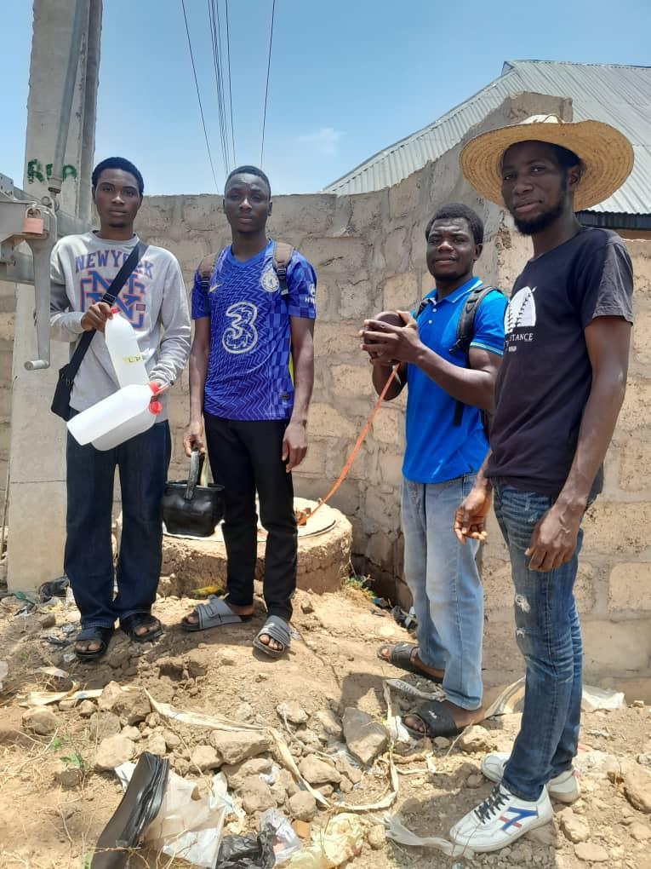
Fig 3.1 Photo Showing Researchers during Fieldwork Activities, Including Sample Collection
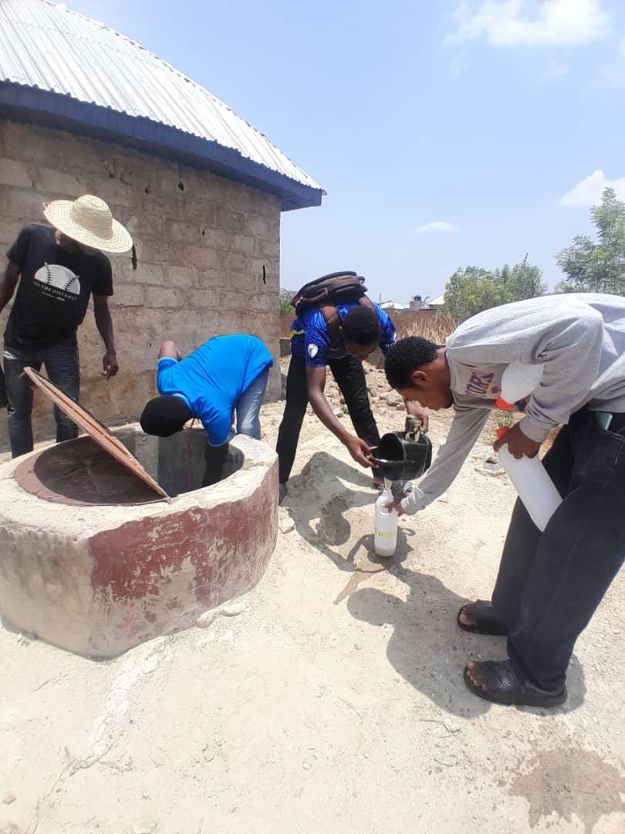
Fig. 3.2: Photos Showing Researchers Collecting Water Samples From Hand-Dug Well Water.

3.3 Laboratory Analysis

Laboratory analysis was conducted on groundwater samples collected from various hand-dug wells and boreholes across Ilorin Metropolis to determine their physico-chemical and hydrochemical properties. Parameters analyzed included pH, electrical conductivity (EC), total dissolved solids (TDS), and concentrations of major cations (Ca²⁺, Mg²⁺, Na⁺, K⁺) and anions (Cl⁻, SO₄²⁻, NO₃⁻, HCO₃⁻). Trace elements such as iron, cadmium, lead, and other heavy metals were also measured to assess contamination levels. Standardized analytical methods were employed, following protocols established by the American Public Health Association (APHA) and other recognized bodies. Instruments such as pH meters, conductivity meters, atomic absorption spectrophotometers (AAS), flame photometers, and titration setups were used to ensure accuracy and precision in measurements (Adeyemi et al., 2023; Ibrahim et al., 2023). Quality control procedures—including the use of blanks, duplicates, and calibration standards—were rigorously applied throughout the analysis process. The data generated provided critical insights into the groundwater quality status across Ilorin Metropolis, enabling comparison with national and international water quality standards and facilitating health risk assessments. These laboratory results formed the empirical basis for evaluating groundwater suitability for domestic consumption and agricultural irrigation, as well as for identifying areas requiring targeted pollution control and management interventions.

Table 3.1: Elements
Element | Symbol | Source in Environment | Concern in Water
Lead | Pb | Batteries, old pipes, industrial runoff | Neurotoxic, especially in children
Arsenic | As | Geologic deposits, pesticides | Carcinogenic
Iron | Fe | Natural soil deposits | Taste, color, staining
Manganese | Mn | Natural and industrial sources | Neurological effects
Cadmium | Cd | Industrial waste, fertilizers | Kidney damage
Chromium | Cr | Dye and tanning industries | Carcinogenic
Copper | Cu | Plumbing systems | Gastrointestinal issues
Source: Jerega, 2025

Table 3.2: Laboratory Analysis Table – Groundwater Pollution Assessment
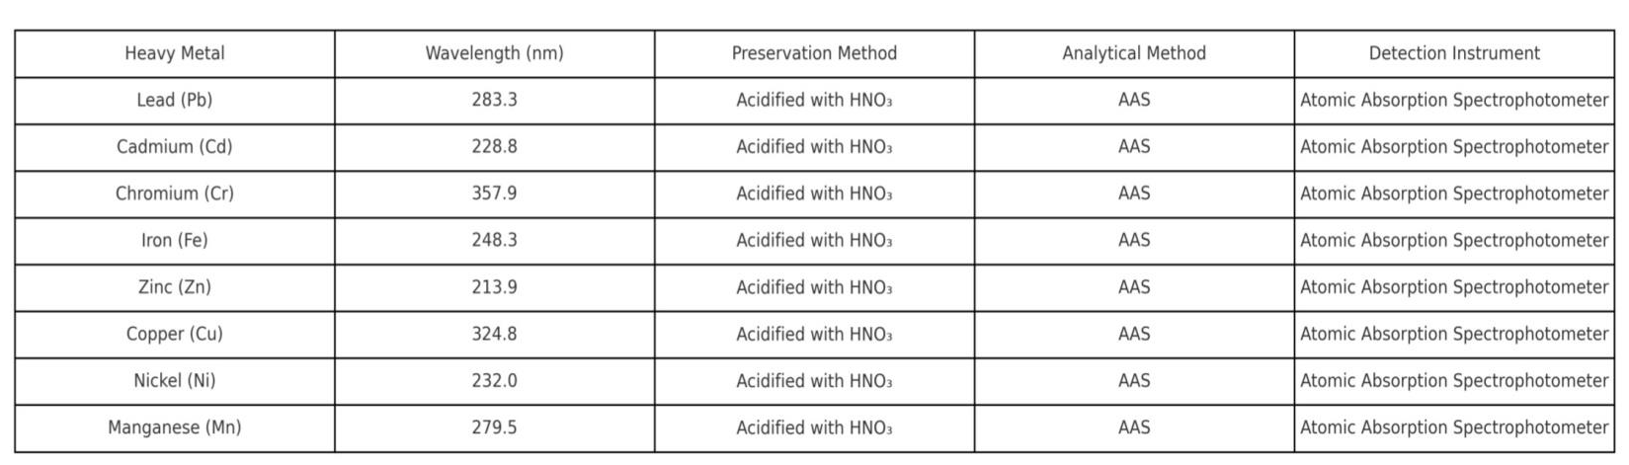

3.4 DATA ANALYSIS
The collected groundwater samples were analyzed for heavy metals such as lead (Pb), cadmium (Cd), iron (Fe), arsenic (As), and nickel (Ni). Analytical methods used include Atomic Absorption Spectrophotometry (AAS) for detecting heavy metal concentrations and physicochemical analysis for parameters such as pH, total dissolved solids (TDS), electrical conductivity (EC), nitrate, and sulphate levels.
Analytical Procedure:
- Sample Preparation: Samples were filtered using Whatman filter paper to remove suspended particles before analysis.
- Physicochemical Analysis method: Parameters like pH, EC, TDS, nitrate, and sulphate were measured using multiparameter probes and titration methods.
- Calculation of Heavy Metal Pollution Index (HPI) method: The HPI method was calculated using a weighted formula that integrates individual metal concentrations with their respective permissible limits set by WHO standards.
- Atomic Absorption Spectroscopy (AAS) method is a sensitive and widely used technique for detecting and quantifying trace levels of heavy metals in water samples. It works by measuring the absorption of light by free metal atoms vaporized in a flame or graphite furnace. Each metal absorbs light at a specific wavelength, allowing for precise determination of its concentration in the sample.
Data analysis involved both statistical methods and geospatial techniques to evaluate pollution levels across the study area comprehensively.

Statistical Analysis:
Descriptive statistics such as mean, standard deviation, minimum, maximum values, and coefficient of variation were calculated for each parameter to summarize groundwater quality data effectively.
Geospatial Analysis:
Spatial distribution maps were generated using ArcGIS software to visualize pollution levels across different locations within the study area. These maps helped identify hotspots of contamination near industrial zones or agricultural fields.
Heavy Metal Pollution Index (HPI):
The HPI values for each sample location were calculated based on concentrations of heavy metals relative to their permissible limits. Locations with HPI values exceeding 100 were classified as highly polluted.

CHAPTER FOUR
4.0 Result and Discussion
4.1 Hadrochemical Laboratory Result
The Hadrochemical Result of the specify area is presented in table 4.1
TABLE OF HEAVY METAL CONCENTRATION OF WATER SAMPLES
SAMPLES HEAVY METALS AND CONCENTRATION LEVELS
LOCATION | FE | Pb | Cu | Cr | Mn | Zn | Ni | Co | Cd
L1 | 0.447 | 0.056 | 0.042 | 0.039 | 0.107 | 0.028 | 0.003 | 0.003 | 0.002
L2 | 0.439 | 0.054 | 0.034 | 0.033 | 0.102 | 0.021 | 0.003 | 0.003 | 0.002
L3 | 0.772 | 0.076 | 0.052 | 0.048 | 0.159 | 0.038 | 0.003 | 0.003 | 0.002
L4 | 0.315 | 0.046 | 0.035 | 0.028 | 0.102 | 0.026 | 0.003 | 0.003 | 0.002
L5 | 0.282 | 0.043 | 0.034 | 0.026 | 0.127 | 0.023 | 0.003 | 0.003 | 0.002
L6 | 0.712 | 0.062 | 0.042 | 0.037 | 0.153 | 0.032 | 0.003 | 0.003 | 0.002
L7 | 0.583 | 0.047 | 0.032 | 0.024 | 0.129 | 0.032 | 0.003 | 0.003 | 0.002
L8 | 0.554 | 0.049 | 0.034 | 0.028 | 0.132 | 0.028 | 0.003 | 0.003 | 0.002
L9 | 2.091 | 0.087 | 0.036 | 0.043 | 0.227 | 0.033 | 0.003 | 0.004 | 0.002
L10 | 0.497 | 0.048 | 0.027 | 0.023 | 0.108 | 0.023 | 0.003 | 0.003 | 0.002
L11 | 0.952 | 0.067 | 0.053 | 0.041 | 0.164 | 0.034 | 0.004 | 0.004 | 0.002
L12 | 0.668 | 0.044 | 0.038 | 0.036 | 0.116 | 0.031 | 0.003 | 0.003 | 0.002
L13 | 2.585 | 0.084 | 0.049 | 0.047 | 0.222 | 0.037 | 0.003 | 0.004 | 0.002
L14 | 2.513 | 0.097 | 0.05 | 0.048 | 0.216 | 0.036 | 0.003 | 0.004 | 0.002
L15 | 0.732 | 0.048 | 0.036 | 0.024 | 0.103 | 0.022 | 0.003 | 0.003 | 0.002
L16 | 3.819 | 0.097 | 0.068 | 0.052 | 0.261 | 0.041 | 0.006 | 0.004 | 0.003
L17 | 3.284 | 0.082 | 0.067 | 0.049 | 0.232 | 0.039 | 0.005 | 0.003 | 0.002
L18 | 3.496 | 0.086 | 0.072 | 0.046 | 0.227 | 0.042 | 0.005 | 0.004 | 0.003
L19 | 0.529 | 0.044 | 0.037 | 0.034 | 0.123 | 0.029 | 0.003 | 0.003 | 0.002
L20 | 0.532 | 0.042 | 0.036 | 0.032 | 0.128 | 0.031 | 0.003 | 0.003 | 0.002
L21 | 1.036 | 0.033 | 0.025 | 0.027 | 0.069 | 0.049 | 0.003 | 0.003 | 0.002
L22 | 0.603 | 0.039 | 0.028 | 0.021 | 0.086 | 0.034 | 0.003 | 0.003 | 0.002
L23 | 0.477 | 0.031 | 0.036 | 0.028 | 0.067 | 0.038 | 0.003 | 0.003 | 0.002
L24 | 0.763 | 0.042 | 0.044 | 0.037 | 0.082 | 0.045 | 0.003 | 0.003 | 0.002
L25 | 0.588 | 0.046 | 0.048 | 0.035 | 0.069 | 0.038 | 0.003 | 0.003 | 0.002
L26 | 4.104 | 0.081 | 0.061 | 0.058 | 0.164 | 0.056 | 0.005 | 0.004 | 0.003
L27 | 1.887 | 0.062 | 0.055 | 0.054 | 0.158 | 0.054 | 0.004 | 0.003 | 0.002
L28 | 2.017 | 0.091 | 0.063 | 0.056 | 0.173 | 0.048 | 0.003 | 0.003 | 0.002
L29 | 1.067 | 0.077 | 0.059 | 0.043 | 0.143 | 0.045 | 0.003 | 0.003 | 0.002
L30 | 0.352 | 0.031 | 0.024 | 0.023 | 0.057 | 0.034 | 0.003 | 0.003 | 0.002
WHO | 0.3 | 0.01 | 1.0 | 0.05 | 0.4 | 3.0 | 0.07 |  | 0.003
NSDWQ | 0.3 | 0.01 | 1.0 | 0.05 | 0.2 | 3.0 | 0.07 |  | 0.003

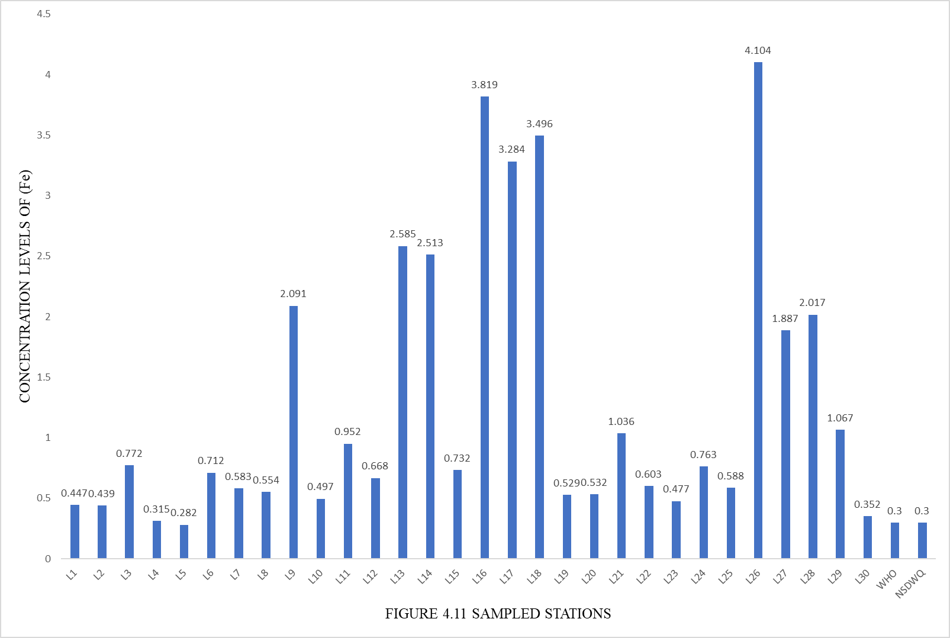
LOCATIONS
Figure 4.1: Special Distribution of Iron (Fe) Concentration within the Study Area
4.1.1 Iron (Fe)
The value of iron recorded in the study ranged from 0.282 to 4.104 mg/L. Sample location 16 and 26 had the highest mean value, which was above the permissible value of 0.3 mg/L. Values obtained in other sampled locations were below the recommended value. Hence, water of this area is safe for drinking. Figure 4.1 showing the sample location values obtained exceeded the WHO standard limit (0.3 mg/L), making the water unsafe for drinking. Concentration of (Fe) greater than 0.3 mg/L can damage fabric, paper, and corrode the inner walls of high pressure boilers. (Hussen 2020).

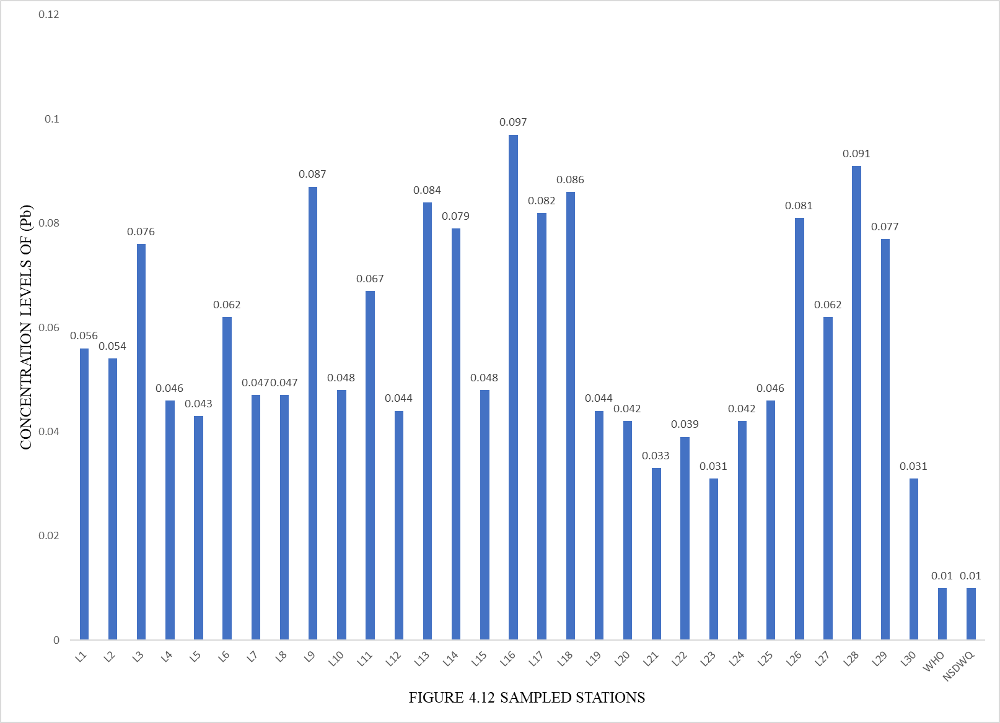
LOCATIONS
Figure 4.2: Special Distribution of Lead (Pb) Concentration within the Study Area

4.1.2 Lead (Pb)
Lead (Pb) was detected in all the sampled locations, with concentrations level above the WHO limit for drinking water (0.01 mg/L). Figure 4.2 shows that the values of Pb exceeded the WHO standard limit, which is 0.01 mg/L. This observation corroborates the findings that (Pb) concentrations were found in groundwater and could be released into the environment from anthropogenic sources related to handling of petroleum products or mechanic workshops (International Journal of Environmental Protection and Policy, 2020).

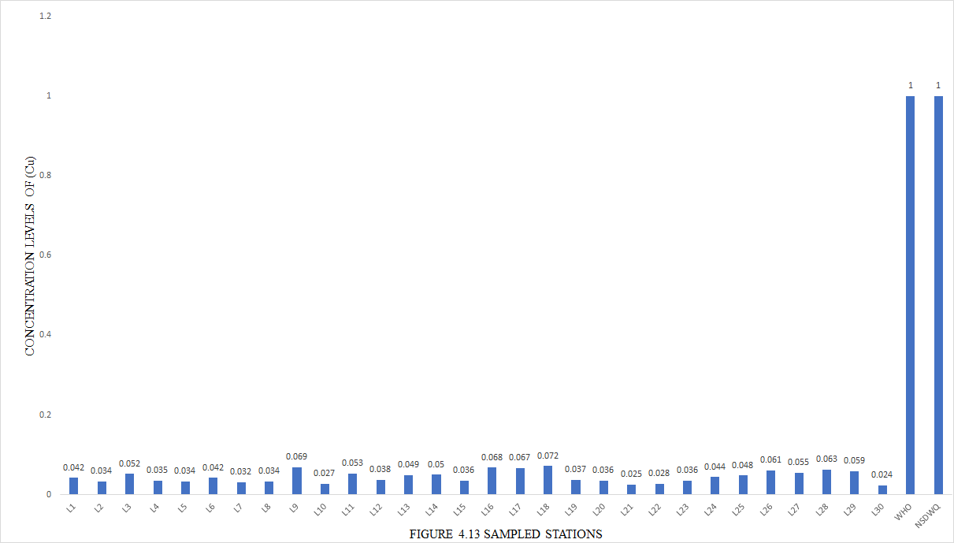

LOCATIONS
Figure 4.3: Special Distribution of Copper (Cu) Concentration within the Study Area

4.1.3 Copper (Cu)
Copper (Cu) concentrations ranged from 0.024 to 0.072 mg/L 4:3. The levels of Cu in every source of water that was sampled are all below the WHO approved permitted limits. The minimum and maximum concentrations that were found where < 0.024 and 0.072 mg/L respectively.

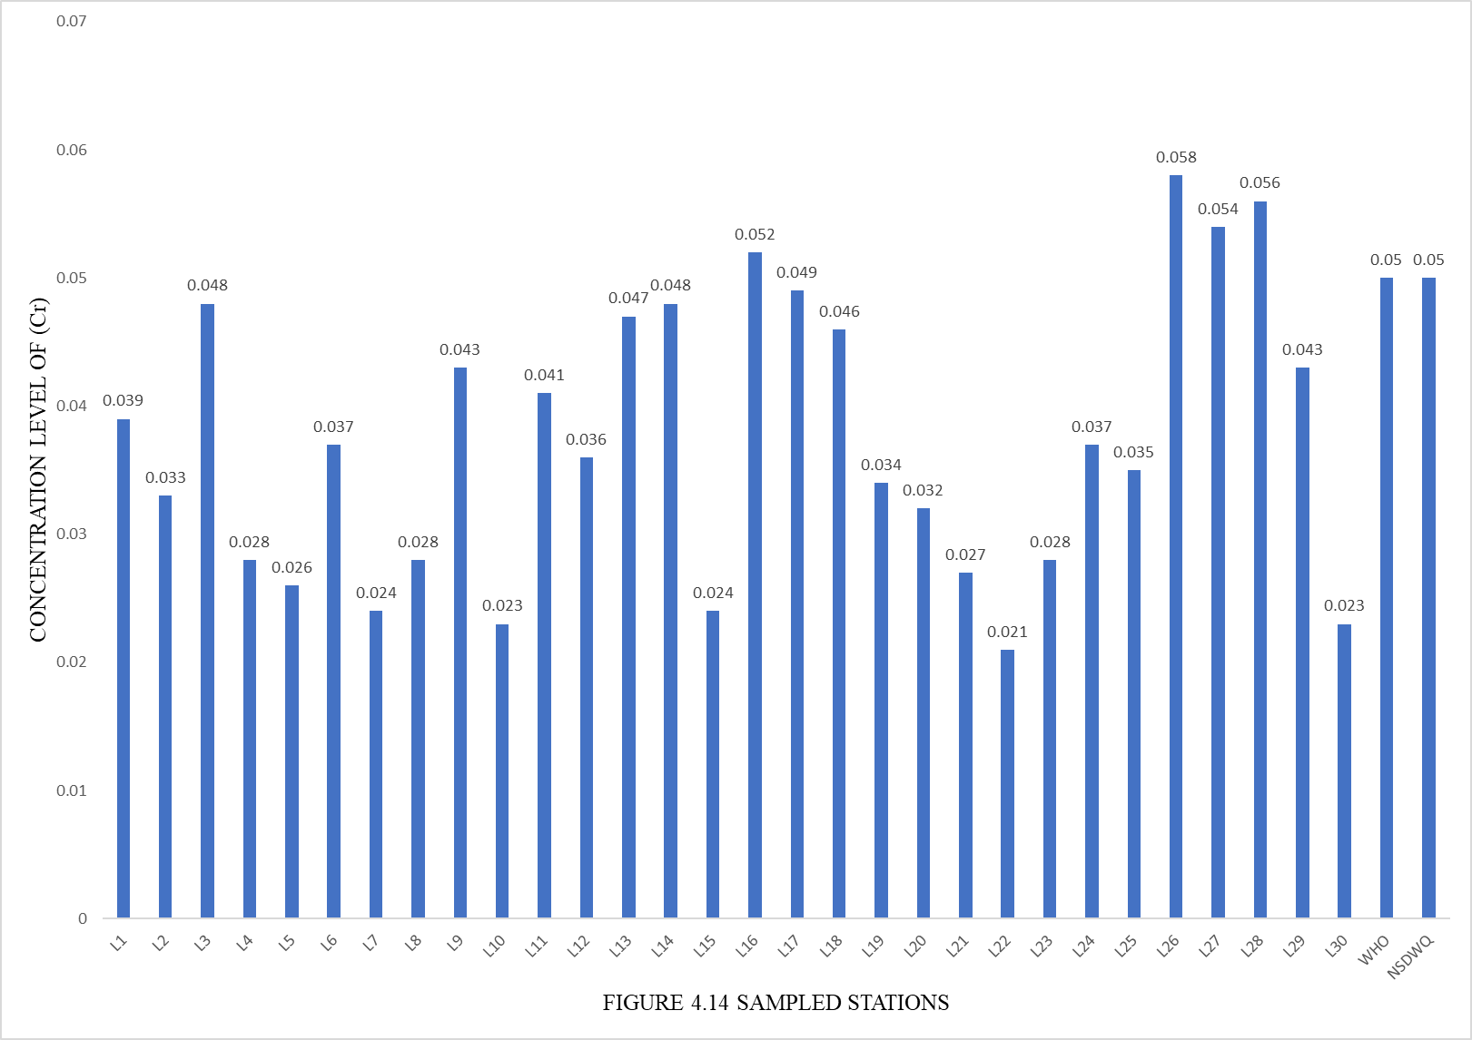
LOCATIONS
Figure 4.4: Special Distribution of Chromium (Cr) Concentration within the Study Area

4.1.4 Chromium (Cr)
With a mean concentration of 0.020–0.05 mg/L, the values for the (Cr) determination ranged from 0.021 to 0.058 mg/L. The WHO maximum permissible level for Cr concentration is met by more than a fourth third (69%) of the analyzed water sources. The minimum and maximum concentrations that were found were 0.021 and 0.058 mg/L respectively, as shown in Figure 4.4.

LOCATIONS
Figure 4.5: Special Distribution of Maganese (Mn) Concentration within the Study Area
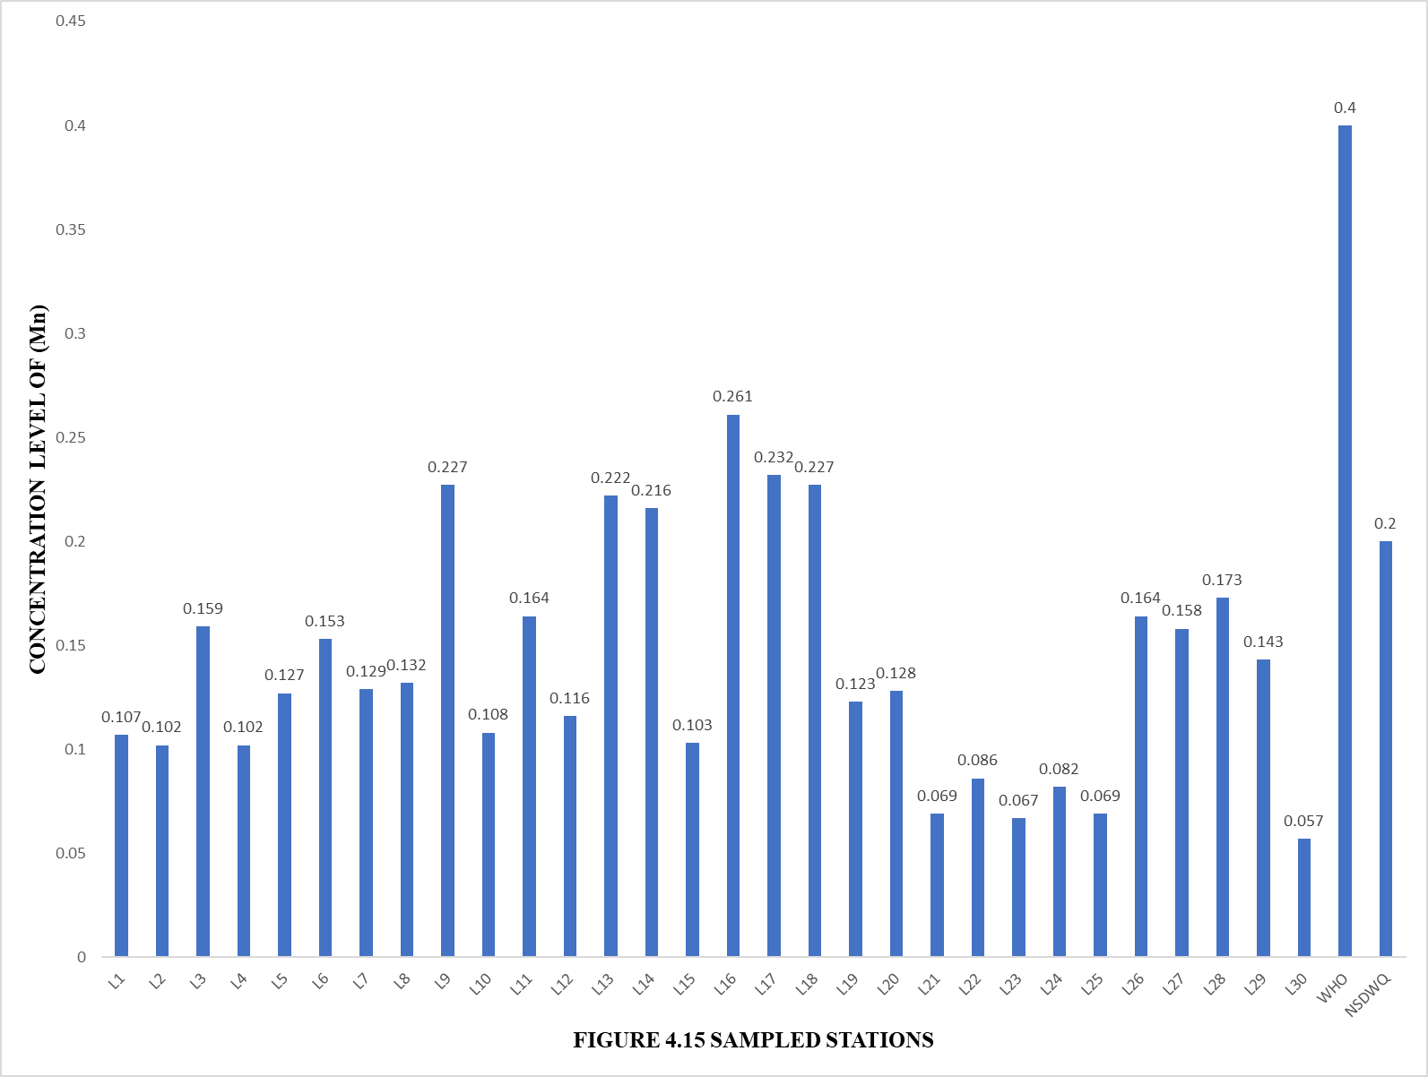
4.1.5 Manganese (Mn)
Level of concentration ranged from 0.261 to 0.057 mg/L, with sample location 16 having the highest mean value and sample location 30 having the lowest mean value. Values obtained were within the acceptable WHO limit, as shown in Figure 4.5

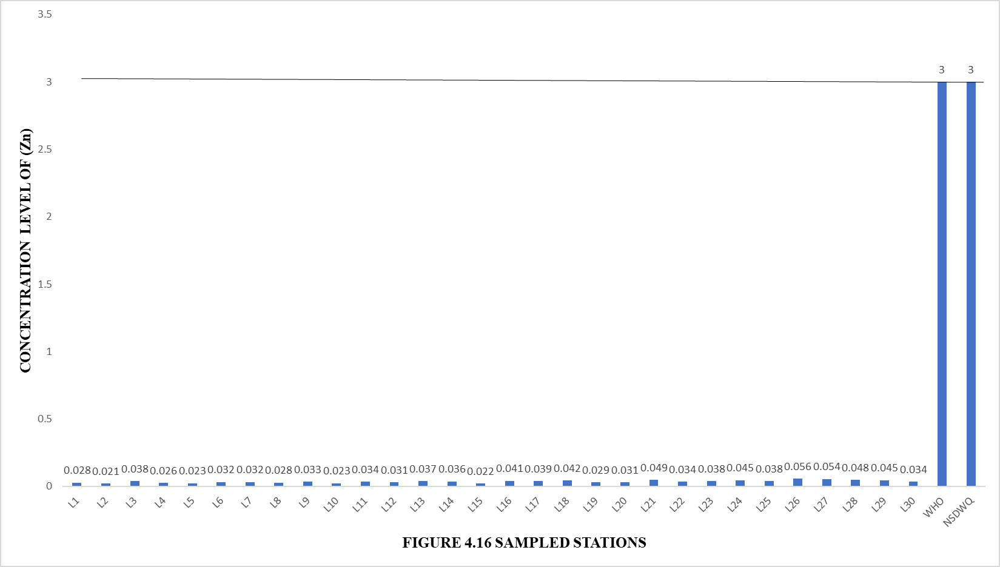
LOCATIONS
Figure 4.5: Special Distribution of Zinc (Zn) Concentration within the Study Area

4.1.6 Zinc (Zn)
The concentration level for Zn ranged from 0.021 to 0.056 mg/L. The concentration (zn) in all sampled locations are below WHO permissible limits. For the sampled location 2 has the lowest concentration level 0.021mg/L, while sampled location 26 has the highest concentration value of 0.056 mg/L.

Figure 4.7: Special Distribution of Nickel (Ni) Concentration within the Study Area

4.1.7 Nickel (Ni)
Level of concentration ranged from < 0.003 to 0.006 mg/L, with about 12 sampled locations having the lowest mean value and location 16 having the highest value. The values obtained were all below the WHO acceptable limit of 0.07 figure 4.7

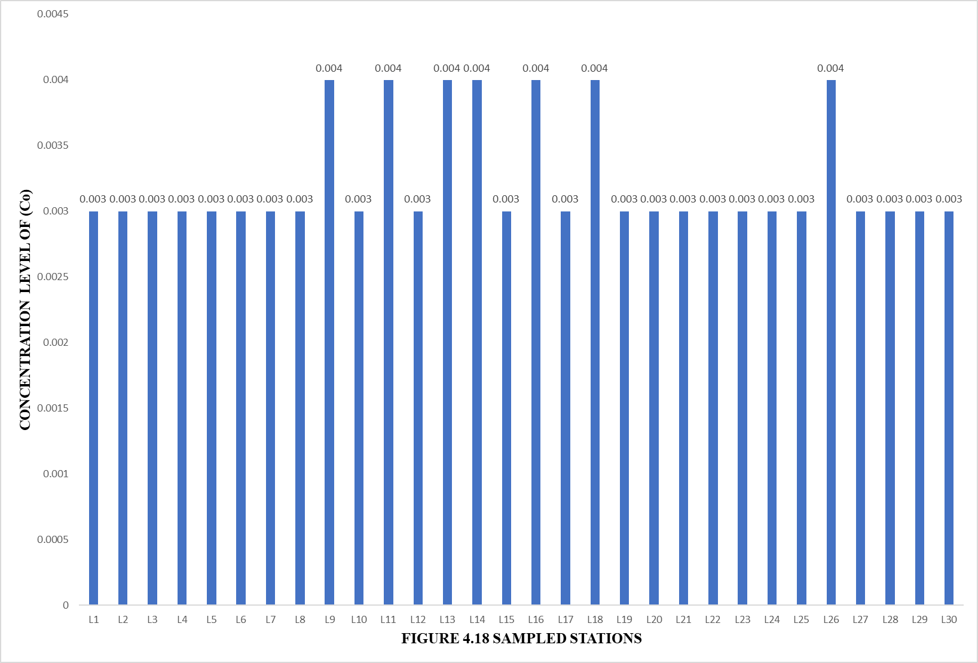
LOCATIONS
Figure 4.5: Special Distribution of Cobalt (Co) Concentration within the Study Area

4.1.8 Cobalt (Co)
Concentration ranged from < 0.003 to 0.004 mg/L respectively. There is no specific limit for Co on WHO permissible level.

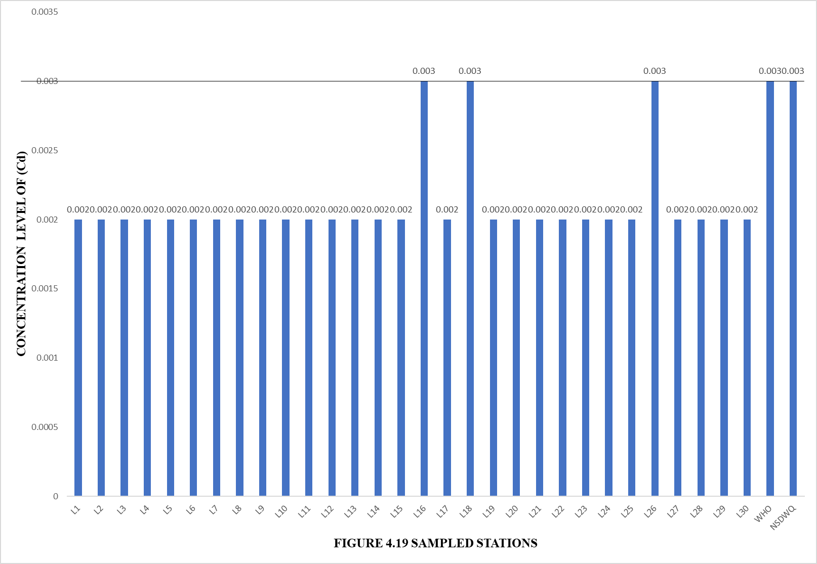
LOCATIONS
Figure 4.5: Special Distribution of Cadmium (Cd)Concentration within the Study Area

4.1.9 Cadmium (Cd)
Content ranges from < 0.002 to 0.003 mg/L. All the sampled locations that were analyzed had Cd concentrations that were below the permissible range outlined by WHO. The minimum and maximum concentrations that were found were < 0.002 and 0.003 mg/L respectively, found in Figure 4:1:9

4.2 Heavy metals concentration yields risk
Groundwater pollution from heavy metals is a significant concern in parts of Ilori, with industrial influence, poorly managed waste disposal sites, and other anthropogenic activities being primary sources. Studies indicate that heavy metals concentration in some areas exceeds acceptable limits for human consumption, posing health risks.
Heavy metals like lead, cadmium, and chromium can cause several health problems, including liver and kidney damage, and contribute to cancer risk. The health risk impacts of heavy metals, even at low concentrations, make it a required assessment for water quality determination.
Hence the exact idea of water quality was determined when concentration of these elements were compared as shown on table 1, the result reveal that Fe an Pb all had high concentration when compared to W.H.O and NSDWQ acceptable limits in the sampled figure (4.1.1, 4.1.2). while Cu, Cr, Zn, and Cd across all sampled had concertation within or below the W.H.O and NSDWQ permissible limit for drinking water standard.

CHAPTER FIVE
5.0 SUMMARY, CONCLUSION AND RECOMMENDATIONS
5.1 SUMMARY OF FINDINGS
Iron (Fe) is an essential element for the human body, playing a crucial role in hemoglobin production, oxygen transport, and immune function. However, over concentration of iron in drinking water (>0.3 mg/L) can cause damage to fabric, paper, and corrode pipes. Additionally, excessive iron intake can lead to gastrointestinal problems, liver damage, and increased risk of certain diseases. On the other hand, deficient levels of iron (<10-15 mg/day) can cause anemia, fatigue, and weakness.
Lead (Pb) is a toxic substance with no known benefits, and its presence in drinking water is a significant concern. Over concentration of lead (>0.01 mg/L) can cause neurological damage, developmental issues, and organ damage. There is no recommended daily intake for lead, and excessive exposure can lead to permanent damage to brain development, kidneys, and other organs.
Manganese (Mn) is essential for bone health, metabolism, and antioxidant functions. However, over concentration of manganese in drinking water (>0.4 mg/L) can cause neurological problems, Parkinson's-like symptoms, and manganism, a neurological disorder. Deficient levels of manganese (<2-5 mg/day) can cause impaired bone growth and reproductive issues.
Nickel (Ni) may be essential for some biological processes, but its essentiality is uncertain. Over concentration of nickel (>0.07 mg/L) can cause skin and respiratory problems, cancer risk, and contact dermatitis. There is no recommended daily intake for nickel, and excessive exposure can lead to various health issues.
Cobalt (Co) is an essential component of vitamin B12, necessary for nervous system function. However, over concentration of cobalt can cause thyroid problems, heart issues, and cancer risk. Deficient levels of cobalt (<2.4 mcg/day) can cause anemia and neurological problems.
Copper (Cu) is essential for immune function, connective tissue health, and brain function. However, over concentration of copper (>2 mg/L) can cause gastrointestinal problems, liver damage, and copper toxicity. Deficient levels of copper (<900 mcg/day) can cause impaired immune function and connective tissue problems.
Chromium (Cr) is essential for glucose metabolism, insulin function, and energy production. However, over concentration of chromium (>0.05 mg/L) can cause skin problems, kidney damage, and cancer risk. Deficient levels of chromium (<20-35 mcg/day) can cause impaired glucose metabolism and weight loss.
Zinc (Zn) is essential for immune function, wound healing, protein synthesis, and DNA synthesis. However, over concentration of zinc (>3 mg/L) can cause gastrointestinal problems, copper deficiency, and zinc toxicity. Deficient levels of zinc (<8-11 mg/day) can cause impaired immune function and growth problems.
Cadmium (Cd) is a toxic substance with no known benefits, and its presence in drinking water is a significant concern. Over concentration of cadmium (>0.003 mg/L) can cause kidney damage, bone problems, and cancer risk. There is no recommended daily intake for cadmium, and excessive exposure can lead to kidney damage, bone demineralization, and increased cancer risk.

5.2 Conclusion
In conclusion, this study demonstrates that groundwater in Ilorin, Nigeria is contaminated with heavy metals, particularly Fe and Pb, which pose potential health risks to consumers. The study's findings highlight the need for urgent attention to address the issue of heavy metal contamination in groundwater in the region.
5.3 Recommendations
Based on the study's findings, the following recommendations are made:
- Regular monitoring and treatment of contaminated water sources: Regular monitoring of groundwater quality is essential to identify areas of contamination and implement treatment strategies to ensure safe drinking water.
- Proper waste management practices: Proper waste management practices, such as proper disposal of industrial and domestic waste, should be implemented to reduce the risk of heavy metal contamination.
- Public awareness and education: Public awareness and education campaigns should be conducted to inform residents about the risks associated with heavy metal contamination and the importance of proper waste management practices.
- Policy interventions: Policy interventions should be implemented to regulate industrial activities and ensure that industries adopt best practices for waste management.
- Further research: Further research should be conducted to identify the sources of heavy metal contamination and to develop effective mitigation strategies.

References
Afolabi, O. A., Adegoke, T., & Abdulkareem, S. (2022). Hydrochemical characteristics and groundwater quality assessment in Ilorin metropolis, Nigeria. Journal of Environmental Science and Water Resources, 11(3), 45-62.

Adewuyi, V. O., Obembe, O. S., & Abegunde, D. O. (2020). Impact of filling stations on groundwater quality in Ilorin, Nigeria. Environmental Monitoring and Assessment, 192(7), 1-16.

Akinola, O. O., Oladipo, O., & Yusuf, A. T. (2023). Assessment of heavy metal contamination and ecological risk in Ilorin’s groundwater: A case study near industrial zones. Environmental Science and Pollution Research, 30(12), 35021-35037.

Olasunkanmi, L. O., Ojo, O. A., & Salami, M. B. (2024). Groundwater contamination and vulnerability assessment around urban dumpsites in Ilorin using 2D Electrical Resistivity Tomography and soil classification. Environmental Geophysics and Pollution, 59(1), 101 116.

Olojoku, O. T., Ibrahim, M. A., & Adesina, O. O. (2023). Hydrocarbon and nutrient pollution in groundwater surrounding auto repair workshops in Ilorin, Nigeria. Environmental Monitorin and Assessment, 195(4), 674.

Raji, B. A., Yusuf, R. O., & Ajadi, O. A. (2023). Groundwater aquifer vulnerability assessment in Ilorin metropolis, Nigeria, using Vertical Electrical Sounding (VES) method. Journal of African Earth Sciences, 197, 104883.

Adewuyi, V. O., Obembe, O. S., & Abegunde, D. O. (2020). Impact of filling stations on groundwater quality in Ilorin, Nigeria. Environmental Monitoring and Assessment, 192(7), 1–16.

Afolabi, O. A., Adegoke, T., & Abdulkareem, S. (2022). Hydrochemical characteristics and groundwater quality assessment in Ilorin metropolis, Nigeria. Journal of Environmental Science and Water Resources, 11(3), 45–62.

Akinola, O. O., Oladipo, O., & Yusuf, A. T. (2023). Assessment of heavy metal contamination and ecological risk in Ilorin’s groundwater: A case study near industrial zones. Environmental Science and Pollution Research, 30(12), 35021 35037.

Hussen, A. (2020). Effects of iron concentration on water quality.

International Journal of Environmental Protection and Policy. (2020). Lead concentrations in groundwater and anthropogenic sources. International Journal of Environmental Protection and Policy, 8(3), 45–55.

Kumar, P., et al. (2023). Sources and types of groundwater contaminants.
Odediran, O. J., et al. (2015). Groundwater pollution and heavy metal contamination in Nigeria.

Odipe, O. E., & Adewoye, T. O. (2022). Groundwater quality assessment in Ilorin, Nigeria.

Olasunkanmi, L. O., Ojo, O. A., & Salami, M. B. (2024). Groundwater contamination and vulnerability assessment around urban dumpsites in Ilorin using 2D Electrical Resistivity Tomography and soil classification. Environmental Geophysics and Pollution, 59(1), 101–116.

Olojoku, O. T., Ibrahim, M. A., & Adesina, O. O. (2023). Hydrocarbon and nutrient pollution in groundwater surrounding auto repair workshops in Ilorin, Nigeria. Environmental Monitoring nd Assessment, 195(4), 674.

Olatunji, A. S., et al. (2015). Heavy metal contamination in groundwater in Nigeria.

Raji, B. A., Yusuf, R. O., & Ajadi, O. A. (2023). Groundwater aquifer vulnerability assessment in Ilorin metropolis, Nigeria, using Vertical Electrical Sounding (VES) method. Journal of African Earth Sciences, 197, 104883.

Singh, S., et al. (2017). Heavy metal indices for assessing groundwater pollution.

United Nations. (2020). Sustainable Development Goals.

World Health Organization. (2017). Guidelines for drinking-water quality (4th ed.). WHO Press, Geneva, Switzerland.

