
DEPARTMENT OF SCIENCE LABORATORY TECHNOLOGY

PHYTOCHEMICAL CHARACTERIZATION OF CINNAMOMUM ZEYLANICUM (CINNAMON) BARK
BY
OYEKOLA AISHA ADEOLA HND/23/SLT/FT/0786

BEING PROJECT SUBMITTED TO
THE DEPARTMENT OF SCIENCE LABORATORY TECHNOLOGY, INSTITUTE OF APPLIED SCIENCES,
KWARASTATE POLYTECHNIC ILORIN, KWARASTATE

IN PARTIAL FULFILLMENT OF THE REQUIREMENT FOR THE AWARD OF HIGHER NATIONAL DIPLOMA (HND) IN SCIENCE LABORATORY TECHNOLOGY (BIOCHEMISTRY OPTION), KWARA STATE POLYTECHNIC ILORIN, KWARA STATE
SUPERVISED BY: MR. A. P. OKEDIRAN

2024/2025 SESSION


This is to certify that this project work presented by OYEKOLA AISHA ADEOLA
with Matriculation Number HND/23/SLT/FT/0786 has been read, approved and submitted to Department of Science Laboratory Technology (Biochemistry Unit), Institute of Applied Sciences, Kwara State Polytechnic, Ilorin.

MR. A.P. OKEDIRAN DATE
Supervisor

MRS. SALAUDEEN K. A. DATE
HEAD OF UNIT(BIOCHEMISTRY)

DR. USMAN ABDULKAREEM DATE
HOD

EXTERNAL EXAMINER DATE



This project report is dedicated to Almighty Allah the one who makes impossibility possible for the opportunity given to me during this project work.
Also to my noble and loving parents for their care, support and prayers. May Almighty Allah bless them (Aameen).

ACKNOWLEDGEMENT

All praise, adoration and honour be to Almighty Allah, the most sufficient. most merciful and sustainer for his love,protection and provision from the first day till the end, and ensured the successful completion of the work.
More so, I acknowledge my supervisor Mr. A.P. Okediran for his support, patience, correction and suggestion when writing this project. May Almighty Allah bless him and his home greatly {Aameen).
Then,to my admirable and caring lecturers in SLT Department for their cares during my program in this institution. may Almighty Allah reward them abundantly {Aameen).
My heartfelt appreciation goes to my parents for their effort and financial support they gave me throughout the course of this program. May Allah reward them abundantly {Aameen).
My sincere appreciation goes to my fiancee for his unwavering support. Thank you for guiding and believing in me as my academic lighthouse. may Almighty Allah reward you abundantly (Aameen).
To my siblings, thank you for being my constant support system throughout my life. may Allah bless you all{Aameen).
Finally, to my friends both at home and in school. may Allah be with you all {Aameen).



Title page Certification Dedication Acknowledgement Abstract

  - Introduction

  - Scientific classification of Cinnamon

  - Chemical Constituent

  - Traditional uses

  - Anti-inflammatory activities

  - Anti-cancer activities

  - Antioxidant activities

  - Aim and objectives

  - Plant material

  - Apparatus and Glassware

  - Reagents

  - Extraction of plant material

  - Phytochemical test

    - Test for steroids

    - Test for triterpenes

    - Test for alkaloids

    - Test for tannins

    - Test for lactones

    - Test for flavonoids

    - Test for Diterpenes

    - Test for glycosides

    - Test for saponin

  - Results

  - Percent extract yield

  - Discussion Conclusion References

13.85g of dry cinnamon powder was extracted with 300ml methanol to yield 37% of crude extract using the soxhlet method. The phytochemical analysis using standard methods revealed the presence of alkaloids, triterpenes, lactones, and phytosterols. There was an absence of saponins and glycosides.

The bark from different cinnamon species holds significant importance as a widely used spice globally. Not just in culinary practices but also in both traditional and modern medicinal applications. The cinnamon genus comprises around 250 identified species, and trees distributed across the world (Sangal 2011).
The primary utilization of cinnamon is in the fragrance and essence industries, leveraging on its aromatic qualities that can enhance various food items, perfumes and medicinal products. Cinnamon’s essential components namely cis-cinnamaldehyde and trans-cinnamaldehyde (cin), found in its essential oil play a crucial role in both its fragrance and the diverse biological

activities associated with cinnamon.

Research on Cinnamom osmophloeum (C. osmophloeum) revealed that the essential oil extracted from cinnamon possesses a notable concentration of cin. As a result, C. osmophloeum is employed as a substitute spice for C. cassia. (E)-cinnamaldehyde, a significant component in the essential oil is derived from C. zeylanicum exhibit antityrosinase activity with cinnamaldehyde identified as the primary compound responsible for this particular activity. (Chao 2013)
Procyanidins and catechins are present in cinnamon bark. The procyanidins in cinnamon bark encompass both A-type and B- type linkages. The procyanidins obtained from both cinnamon and berries exhibit antioxidant properties. (Pang 2008)

Kingdom: Plantae

Division: Tracheophyta Class: Magnoliopsida Order: Laurales Family: Lauraceae Genus: Cinnamomum Species: Zeylanicum
Botanical name: Cinnamomum zeylanicum (Jayaweera DMA 2006)

Cinnamon comprises diverse resinous compounds, including cinnamaldehyde, cinnamate, cinnamic acid, and various essential oils (Senanayake, Lee & Wills 1978) The occurrence of an extensive array of essential oils, including trans- cinnamaldehyde, cinnamyl acetate, eugenol, L-borneol,

caryophyllene oxide, β-caryophyllene, L-bornyl acetate, E- nerolidol, α-cubebene, α-terpineol, terpinolene, and α-thujene, has been documented.(Tung et al. 2008)
The chemical structures of some important constituents of cinnamon are shown in Table,

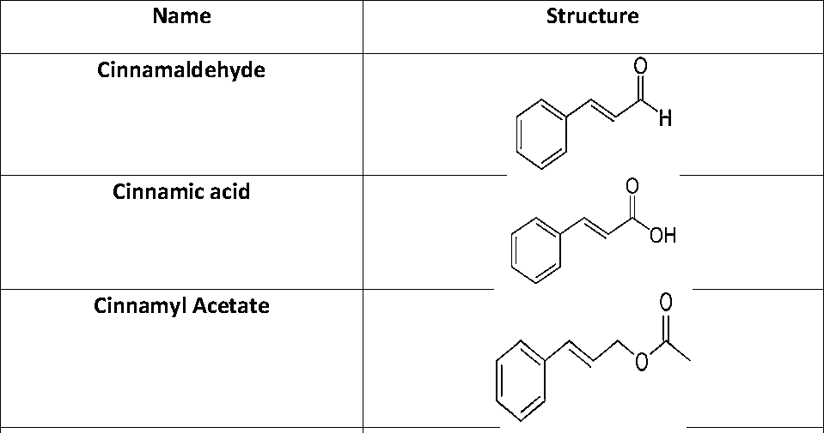

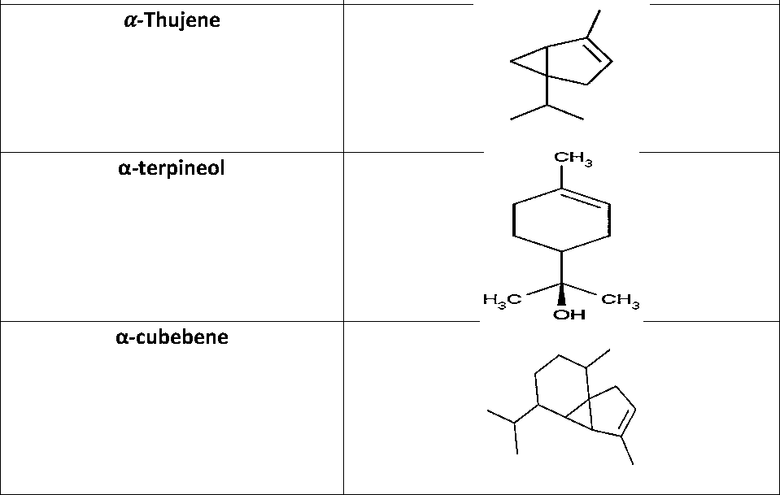


Besides its role as a spice and flavoring agent, cinnamon finds application in flavoring chewing gums, thanks to its mouth- refreshing effects and capability to combat bad breath.

Cinnamon also has the potential to enhance colon health, thereby lowering the risk of colon cancer. (Wondiak 2010)
Cinnamon functions as a coagulant, preventing bleeding. Cinnamon additionally enhances blood circulation in the uterus and promotes tissue regeneration. While playing a crucial role as a spice, this plant's essential oils and other constituents exhibit significant activities, including antimicrobial, antifungal, antioxidant, and antidiabetic properties. (Gende 2008)
Cinnamon has been employed as an anti-inflammatory, antitermitic, nematicidal, mosquito larvicidal, insecticidal, antimycotic, and anticancer agent. Traditionally, cinnamon has been utilized as tooth powder to address toothaches, dental problems, oral microbiota, and bad breath (Aneja 2009).

Cinnamon has been found to possess anti-inflammatory properties in numerous studies focusing on medicinal plants and their constituents. Several studies have documented the anti-inflammatory properties exhibited by cinnamon and its essential oils. As of now, numerous flavonoid compounds such as gossypin, gnaphalin, hesperidin, hibifolin, hypolaetin, oroxindin, and quercetin have been identified and exhibit anti-inflammatory properties. (Garia-lafuente 2009)
- recent research study revealed that 2-
hydroxycinnamaldehyde, derived from C. cassia bark, demonstrated inhibitory effects on nitric oxide production by suppressing the activation of nuclear factor kappa-light-chain-

enhancer of activated B cells (NF-𝜅
B). This suggests its

potential as an anti-inflammatory agent. The ethanolic extract from C. cassia demonstrated notable anti-inflammatory effects

by decreasing the activation of Src/spleen-tyrosine-kinase-

(Src/Syk-) mediated NF-𝜅
B. Compounds found in C. ramulus

exhibit anti-inflammatory properties by inhibiting the expression of inducible nitric oxide synthesis (iNOS), cyclooxygenase-2 (COX-2), and nitric oxide (NO) production in the central nervous system (CNS). This suggests that C.ramulus has the potential to be utilized for therapeutic treatment or prevention of neurodegenerative diseases associated with inflammation. Moreover, the cinnamon's aqueous extract reduces the levels of tumor necrosis factor-α in the serum induced by lipopolysaccharide. Alzheimer's disease results in a significant decrease in 56 kDa. An oligomer, leading to a reduction in plaques and enhancement of cognitive performance in transgenic mouse models (Frydman-Marom, 2011).
Another research found that the water-based extract from C. zeylanicum has the potential to diminish tau aggregation and

filament formation, key characteristics of Alzheimer’s disease. Additionally, the extract promotes the complete fragmentation of recombinant tau filaments and induces significant alterations in the morphology of paired helical filaments derived from Alzheimer’s disease brains. (Peterson, 2009)

The HPLC-derived aqueous extract and cinnamon fraction rich in procyanidins effectively hinder the kinase activity of vascular endothelial growth factor subtype 2 (VEGFR2), consequently impeding angiogenesis associated with cancer. Findings suggest the potential utility of cinnamon in cancer prevention. Cinnamaldehydes were synthesized and assessed for their inhibitory effects on angiogenesis. Jeong and colleagues discovered that CB403, a compound derived from 2- hydroxycinnamaldehyde found in cinnamaldehyde, demonstrated the ability to hinder tumor growth. The findings

from both animal-based and cell culture studies suggest the potential use of cinnamon as an anticancer agent due to the antitumor and growth-inhibitory properties of CB403. (Jeong 2003)
According to Cabello and colleagues (2009) the cinnamic

aldehyde hinders NF-𝜅
- activity and suppresses the

production of interleukin-8 (IL-8) induced by tumor necrosis factor alpha (TNFα-) in A375 cells. This restraint further reinforces the overlooked potential of cinnamic acid in its role as a potential anticancer agent.
Antioxidants found in food are essential for human health, serving as protective agents. Apart from their crucial role, antioxidants are integral additives in fats and oils. In the food processing industry, they are utilized to extend the shelf life and prevent spoilage. Spices and medicinal plants are gaining quick

recognition as valuable sources of antioxidants with potential health benefits against various diseases. [49] Antioxidants play a crucial role in sustaining human and animal life by combating free radicals and addressing damage associated with metabolic diseases and age-related syndromes. (Halliwel, 2011)

To identify and qualitatively screen the major phytochemical groups present in the bark, such as alkaloids, glycosides, tannins, flavonoids, steroids, saponins, essential oils, and phenolic compounds.
To assess the presence of bioactive compounds that contributes to antioxidant, antimicrobial, anti-inflammatory, and other medicinal properties of cinnamon bark.
To quantify key phytochemicals like total phenols, flavonoids, tannins, and saponins to understand their abundance and potential health benefits.
To evaluate the antioxidant activity linked to these phytochemicals, which may help in scavenging free radicals and preventing diseases such as cancer.

To provide scientific evidence supporting the use of cinnamon bark as a natural source for pharmaceuticals, nutraceuticals, food additives, and cosmetics.
To investigate the safety profile by screening for toxic compounds and heavy metals to ensure the extracts suitability for medicinal and dietary use.
To explore the chemical composition of essential oils in the bark and the biological effect, including potential tissue- protective actions.

The fresh sample of plant material (cinnamonium Zeylanicum bark) was purchased at Oja Oba in Ilorin.

Here’s a list of common apparatus and Glassware used in the extraction and phytochemical testing of cinnamon bark.

- Soxhlet extractor

- Rotary evaporator

- Heating mantle

- Water bath

- Spectrophotometer (for quantitative analysis)

- Hot Plate

- Mortar and Pestle (for grinding)

*Round-bottom flask

- Conical flasks

- Beakers

- Measuring cylinders

- Pipettes

- Test tubes

- Petri dishes

All chemicals and reagents utilized in the study were of analytical grade.

Ethyl alcohol used for extraction (about 4 liters), 70% v/v (70ml absolute ethanol: 30ml distilled water).
The reagents used for detecting various phytochemical groups include Wagner’s, Dragendorffs, Hager’s reagent (for alkaloid detection), Benedicts, Feliling’s, Molisch’s reagent (for Glycosides) vanillin (for gallic acid), hydrochloric acid reagent (for tannins/phenols). Wilson’s and Alkaline reagents (for phlobatannins) lead acetate, gelatin, fecl3 reagents (for flavonoids) Absolute alcohol (for gum), Distilled water (for resins), and Biuret reagent (for proteins) (Audu S.A etal, 2007).

The plant material of cinnamonium zeylanicum was pulverized using a high powered multifunctional kitchen blender SAMSUNG (Model No:2022L) with 50ow and 32000Rp, made in Japan.

13.85g of the sample was packed into a cellulose thimble and placed in a 1L beaker. 300ml of methanol solvent was measured and transferred into the beaker to cover the sample in the thimble. A magnetic bar was placed at the bottom of the beaker. The beaker and its content were placed on a magnetic stirrer temperature regulated hot plate. (Pandey A et al., 2014).
The soxhlet extraction was done for 2hrs. the colored extract solution was removed and another 300ml of fresh methanol was added, and extraction process repeated until the sample was exhaustively extracted. All the extraction was pooled together and transferred into a 1L round bottom flask the extract solution was distilled to remove the methanol solvent. The concentrated extract was subsequently transferred into a beaker and placed in a waterbath, heating beaker and heating was done until all solvent was almost completely evaporated. The beaker and its content were left cool at ambient

temperature until it dried.

The weight of crude extract obtained was determined, from which the extract yield was calculated, the crude methanol extract of 5.21g was obtained and kept in the laboratory at ambient temperature for further analysis.

The extract was tested for the presence of bioactive compound by using the following standard methods.

the extract was mixed with 2ml of chloroform and concentrated Sulphuric acid was added along the sides of the test tube and on standing yields red color. (Trifan et al 2021).
The extract was mixed with
2ml of chloroform and few drops of acetic anhydride and 1ml

of concentrated sulphuric acid from the sides gives reddish ring at the junction of 2 layers. (sadasivam s et al 2005).

he extract was mixed with 2ml of chloroform and a few drops of acetic acid and 1ml of concentrated sulphuric acid given deep red at the junction of 2 layers.

The extract was dilute with ammonia and then extracted with chloroform solution to this dilute hydrochloric acid was added. The acid was used for chemical test of alkaloids.


 The acid layer with few drops of Mayer’s reagent given a creamy white precipitate.



The extract with a few drops of Wagner’s reagent gives reddish brown colored precipitate (Prassas et al 2008).
 (solution of iodine in potassium iodide).

The extract with Hager’s reagent gives yellow precipitate


(solution of potassium Bismuth
iodide).

The extract with a few drops of dragendoff’s reagent gives a reddish brown precipitate
Ferric chloride test

The extract with 10% ferric chloride solution gives brownish green colour.
Legals test:

The extract with the mixture of sodium nitroprusside and pyridine and treated with methanol alkali gives deep red colour.
Lead acetate test:

The extract was mixed with few drop of 10% lead acetate gives a yellow precipitate. (Raanan N. et al 2006).


Copper acetate test: The extract was mixed with copper acetate solution gives green colour.


Sodium hydroxide reagent: A small amount of alcoholic extract was dissolved in water and sodium hydroxide solution was added gives a yellow colour (Vakilwala et al 2017).


Flax extract was mixed with 2ml of distilled water in a test tube the mixture was shaking vigorously and observed for the formation of persistant confirms the and observe from that presence of saponin ( Rainsfird et al 2018)

The result of qualitative phytochemical characterization of cinnamon bark is presented in the table below.

Alkaloids | +
Triterpene | +
Tannins | -
Diterpenes | +
Sterols | +

Glycosides | -
Flavonoids | +
Lactones | +
Saponins | -
NOTES: + = PRESENT - = ABSENT

The percentage crude extract yield of phytochemical characterization of (Cinnamon) is calculated as followed.
% Extract yield = Weights of crude extract x 100 Weight of cinnamon sample

Given value
Weight of crude extract=5.21g Weight of cinnamon sample=13.85g

% Extract yield= weight = 5.21g x 100
13.85g

= 37%

Therefore, the percentage of extract yield = 37%

The dark brown sticky paste crude extract gave a percentage yield of 37%.
The result in (Table 3.1) show the phytochemical properties of cinnamon bark which involves the cinnamon bark chemical compound that contributes to its medicinal properties. These compounds that includes alkaloids steroids, tannins, flavonoids, lactones, diterpenes, glycosides, saponnins and titerpenes which are known for their antioxidant, anti-inflammatory, anticancer, anti-bacterial, anti-fungal and antimicrobial activity.
The phytochemical analysis conducted allows us to identify and qualify these bioactive compounds, providing valuable insights into the potential health benefits of the study. (Vakulwala 2017)

Cinnamon has been utilized as a spice in daily life without observable side effects. Numerous reports have delved into the diverse properties of cinnamon, including its dark, essential oils, bark powder, phenolic compounds, Flavonoids, and isolated components. Each of these properties plays a purotal role in advancing human health. Antioxidant and antimicrobial activities may result from direct action on oxidants or microbes, while anti-inflammatory, anticancer, and ant diabetic’s activities occur indirectly through receptor-mediated mechanisms. Extensive exploitation has unveiled significant health benefits across various types of cinnamon. Further investigations are required to provide additional uses of this spice against cancer and inflammatory, cardio protection, and neurological disorder.

Audu S. A., Mohammad I, Haita H. A. (2007). Phytochemical screening of the leaves of lophira lanceolate (ochanaceae). Life Science Journal. 4(4) 75-79.
Frydman-Marom, A., Levin, A. Farfara, D., et al.,(2011) “Orally administrated cinnamon extract reduces β-amyloid oligomerization and corrects cognitive impairment in Alzheimer’s disease animal models,” PLoS ONE, vol. 6, no. 1, Article ID e16564
Garia-Lafuente A. Guillamon E, Villares A, Rostagno M. A, and Martinez J. A. (2009) “Flavonoids as anti-inflammatory agents: implications in cancer and cardiovascular disease,” Inflammation Research, vol. 58, no. 9, pp. 537–552.
Peterson, D. W. George, R. C. Scaramozzino F. et al. (2009)

“Cinnamon extract inhibits tau aggregation associated with alzheimer’s disease in vitro,” Journal of Alzheimer’s Disease, vol. 17, no. 3, pp. 585–597
Jeong, H. W. Han, D. C. Son K.-H. et al.,(2003) “Antitumor effect of the cinnamaldehyde derivative CB403 through the arrest of cell cycle progression in the G2/M phase,” Biochemical Pharmacology, vol. 65, no. 8, pp. 1343–1350.
Cabello, C. M. Bair III, W. B. Lamore S. D. et al.,(2009) “Then cinnamon-derived Michael acceptor cinnamic aldehyde impairs melanoma cell proliferation, invasiveness, and tumor growth,” Free Radical Biology and Medicine, vol. 46, no.2, pp. 220–231.
Tung, Y. T Yen P. L. Lin C. Y, and Chang S. T. (2010) “Anti- inflammatory activities of essential oils and their constituents from different provenances of indigenous
cinnamon (Cinnamomum osmophloeum) leaves,”

Pharmaceutical Biology, vol. 48, no.10, pp. 1130–1136.

Halliwell, B. (2011) “Free radicals and antioxidants—quo vadis?” Trends in Pharmacological Sciences, vol. 32, no. 3, pp. 125–130
Aneja K., Joshi R., and Sharma C. (2009) “Antimicrobial activity of dalchini (Cinnamomum zeylanicum bark) extracts on some dental caries pathogens,” Journal of Pharmacy Research, vol. 2, no. 9, pp. 1387–1390.
Senanayake U. M., Lee T. H., and Wills R. B. H. (1978) “Volatile constituents of cinnamon (Cinnamomum zeylanicum) oils,”Journal of Agricultural and Food Chemistry, vol. 26, no. 4, pp. 822–824.
Gende L. B., Floris I., Fritz R., and Eguaras, M. J. (2008) “Antimicrobial activity of cinnamon (Cinnamomum zeylanicum) essential oil and its main components

against paenibacillus larvae from argentine,” Bulletin of Insectology, vol. 61, no. 1, pp. 1–4.
Wondrak, G. T. Villeneuve N. F., Lamore S. D., Bause A. S., Jiang
T. and Zhang D. D. (2010) “The cinnamon-derived dietary factor cinnamic aldehyde activates the Nrf2-dependent antioxidant response in human epithelial colon cells,” Molecules, vol. 15, no.5, pp. 3338–3355.
Jayaweera DMA, Senaratna LK. (2006) Medicinal Plants [Indigenous and Exotic] Used in Ceylon. The National Science Foundation, Sri Lanka. p-117.
Peng X., Cheng, K. W. Ma J. et al. (2008) “Cinnamon bark proanthocyanidins as reactive carbonyl scavengers to prevent the formation of advanced glycation endproducts,” Journal of Agricultural and Food Chemistry, vol. 56, no. 6,
pp. 1907–1911, 2008.

Chou, S. T. Chang, W. L. Chang, C. T Hsu, S. L. Lin, Y. C. and Shih, Y. (2013) “Cinnamomum cassia Essential Oil inhibits α-MSH induced melanin production and oxidative stress in murine B16 melanoma cells,” International Journal of Molecular Sciences, vol. 14, no. 9, pp.19186–19201
Sangal, A. (2011) “Role of cinnamon as beneficial antidiabetic food adjunct: A review,” Advances in Applied Science Research, vol. 2,no. 4, pp.440–450,
Pandey, A. and Tripathi, S. (2014) Concept of standardization, extraction and pre phytochemical screening strategies for herbal drug. Journal of Pharmacognosy and Phytochemistry 2, 115–119.
Prassas, I. and Diamandis, E.P. (2008) Novel therapeutic applications of cardiac glycosides. Nature Reviews
Drug Discovery 7, 926–935.

Rainsford, K.D. and Alamgir, A.N.M. (2018) Phytochemistry and Bioactive Compounds. http://www.springer.com/series/4857.
Ajendran, A., Rafiqkhan, M., Selvam, D. and Thangaraj, V. (2017) Pharmacognostic Profile and Phytochemical Analysis of Cinnamonum Zeylanicum Bark Extracts. Nehru E- Journal 5, 33–39.
Tiwari, P., Kumar, B., Kaur, M., Kaur, G. and Kaur, H. (2011) Phytochemical screening and Extraction: A Review. Internationale Pharmaceutica Sciencia 1, 98–106.
Trifan, A., Zengin, G., Brebu, M., Skalicka‐Woźniak, K. and Luca, S.V. (2021) Phytochemical characterization and evaluation of the antioxidant and anti‐enzymatic activity of five common spices: Focus on their essential oils and spent material extractives. Plants 10,
1–23.

Vakilwala, M. Macan, K. and Tandel, A. (2017). Phytochemical Analysis and Antimicrobial Activity of Cinnamomum Verum. International Journal of Research and Scientific Innovation IV, 69–74.
Raaman N (2006). Phytochemical techniques. New India Publishing Agency. New Dehli. 19-24

