A PROJECT REPORT ON ESTABLISHING THE RELATIONSHIP BETWEEN SOME INDEX PROPERTIES AND THE ENGINEERING PROPERTIES OF LATERITIC SOIL FROM KWARA STATE POLYTECHNIC CAMPUS.

BY
Idris Damilare ABUBAKAR
ND/23/MPE/FT/0045

BEING A RESERCH PROJECT SUBMITTED TO THE DEPARTMENT OF MINERAL AND PETROLEUM RESOURCES ENGINEERING, INSTITUTE OF TECHNOLOGY, KWARA STATE POLYTECHNIC, ILORIN.

IN PARTIAL FULFILMENT OF THE REQUIREMENTS FOR THE AWARD OF NATIONAL DIPLOMA (ND) IN MINERAL AND PETROLEUM RESOURCES ENGINEERING
AUGUST 2025

CERTIFICATION
This is to certify that this project work is the original work carried out and reported by Idris Damilare ABUBAKAR Matric No ND/23/MPE/FT/0045 Mineral and Petroleum Resources Engineering, Institute of Technology (IOT) Kwara State Polytechnic, Ilorin and it has been approved in partial fulfilment of the requirements of the award of National Diploma (ND) in Mineral and Petroleum Resources Engineering (MPE)

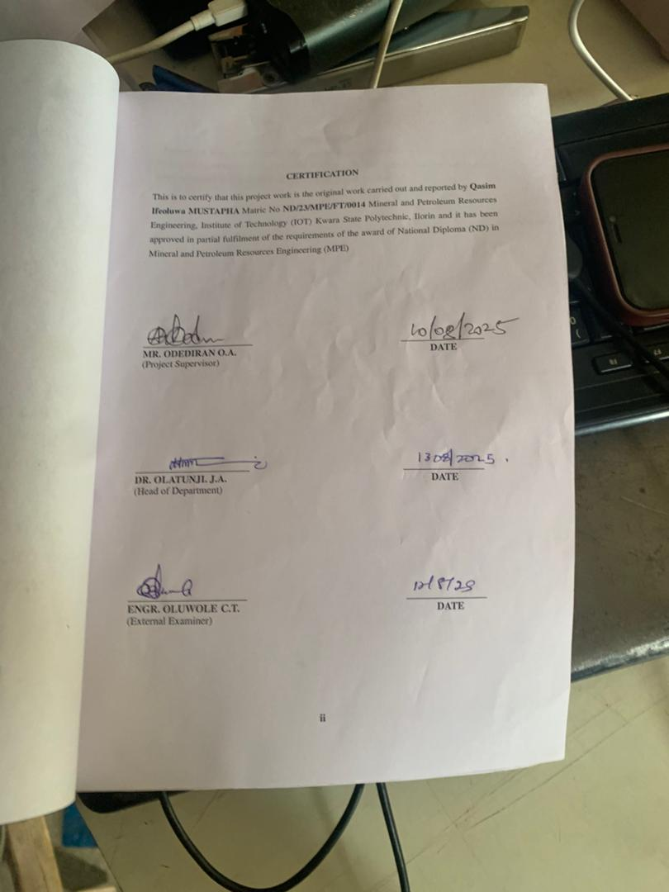

_______________________ _________________
MR. ODEDIRAN O.A. DATE
(Project Supervisor)

_______________________ ________________________________
ENGR. OLATUNJI. J.A. DATE
(Head of Department)

_______________________ ________________
ENGR. OLUWOLE .C.T. DATE
External Examiner

DEDICATION
This research work is dedicated to Almighty Allah the giver of wisdom and knowledge for his love and protection over my life throughout my national diploma and also my amazing lovely and wonderful Parent Mr. and Mrs. IDRIS for their support.

ACKNOWLEDGMENTS
My Sincere Gratitude glory and adoration goes to Almighty God, who gave me the grace and privileged to complete my academic career in this institution.
A research project of this nature cannot be successfully accomplished without the assistance of some noble persons. I would like to record my appreciation to the following individuals.
Firstly, my sincere gratitude goes to my lovely Parent MR. MRS. ABUBAKAR for their immense love, guidance, advice, prayers, belief, understanding and financial support.
May Almighty God grant you all your heart desires and opportune you to reap the fruits of your labor. I don't know where I would have been without you both. Thanks for been there for me every time and thanks for everything.
My Sincere gratitude also goes to my supervisor, ENGR. O.A. ODEDIRAN. for his enthusiasm, patience, insightful comments, helpful information, practical advice and increasing ideas that have helped me tremendously at all times in my research and writing of this thesis. His immense knowledge and profound experience has enabled me to complete this research successfully. Without this support and guidance, this project would not have been possible; I could not have imagined having a better supervisor in my study.
Also, my appreciation goes to my friends for Her support (AZIZAT), I can’t forget the good and bad memory we share together I love you all may God reward you all.

TABLE OF CONTENTS
Title page ……………………………………………….………………………………… i
Certification ……………………………………………….……………………………… ii
Dedication …………………………………………………….………………………… iii
Acknowledgments……………………………………………………...………………… iv
Table of contents …………………………………………………………………….…… v
List of Figures…………………………………………………………………................... vi
List of table ……………………………………………………………………………….. vii
Abstract……………………………………………………………………...……………. viii
CHAPTER ONE
1.0 Introduction ……………….……………………….……………………….……….. 1
1.1 Location And Accessibility ……………….……………………….………………… 1
1.2 Relief And Drainage ……………….……………………….………………………… 1
1.3 Aims And Objectives ……………….……………………….……………………… 2
1.4 Statement Of The Problem……………….……………………….………………….. 2
1.5 Justification ……………….……………………….……………………….………… 3
1.6 Scope And Limitation ……………….……………………….………………………. 3
CHAPTER TWO
2.0 Literature Review ……………….……………………….……………………….… 5
2.1 Overview Of Laterite ……………….……………………….……………………… 5
2.2 Formation And Occurrence Of Laterite ……………….……………………….…… 5
2.3 Regional Destruction Of Laterite ……………….……………………….………….. 7
2.4 Characteristic Of Laterite ……………….……………………….………………….. 8
2.5 Atterberg Limits ……………….……………………….……………………….…… 8
2.6 Sieve Analysis ……………….……………………….……………………….……… 9
CHAPTER THREE
3.0 Research Methodology ……………….……………………….……………………… 10
3.1 Collection Of Samples ……………….……………………….…………………… 10
3.2 Preparation Of Disturbed Samples ……………….……………………….……… 10
3.3 Laboratory Procedure ……………….……………………….…………………… 11
3.4 Grain Size Distributer Test ……………….……………………….………………… 11
3.5 Atterberg Limit Test……………….……………………….………………………… 11
3.6 Compaction Test……………….……………………….……………………….…… 12
3.7 Moisture Content Test……………….……………………….………………………. 12
3.8 Specific Grainly Test……………….……………………….………………………... 12
3.9 Bulk Density Test……………….……………………….……………………….…… 13
CHAPTER FOUR
4.0 Result And Discussion ……………….……………………….……………………….14
4.1 Result Of Moisture Content Test……………….……………………….………… 14
4.2 Result Of Atterberg Limit Test……………….……………………….……………… 14
4.3 Result Of Compaction Test ……………….……………………….………………… 15
4.4 Result Of Grain Size Analysis ……………….……………………….……………… 15
4.5 Results of Atterberg Limit Tests……………………………………………………… 16
4.6 Result of Grain Size Analysis…………………………………………………………. 17
4.7 Result of Compaction Test……………………………………………………………. 18
4.8 Relationship between some Index Properties of Laterite and selected
Engineering Properties …………………………………………………………………… 20
CHAPTER 5
5.0 Conclusion and Recommendation ……………………………………………… 22
5.1 Conclusion………………………………………………………………………. 22
5.2 Recommendation………………………………………………………………… 23
references………………………………………………………………………… 24

LIST OF FIGURES
Fig.1: graph showing water content………………………………………................... 28
Fig 2: Graph Showing Plasticity Chart ……………………………………………….. 31
Fig. 3: Grain Size Analysis Graph……………………….. …………………………….. 31
Fig. 4: Graph Showing Compaction Parameters………………………………………. 33

LIST OF TABLE
Table 1: Details Of Sample Locations.……………………………………………….. 23
Table2: Natural Moisture Content Test of Collected Samples……………………… 28
Table 3: Bulk Density of Collected Samples………………………………………….. 29
Table 4: Dry Density Test of collected samples………………………………………. 29
Table 5: Specific gravity test of collected samples…………………………………… 30
Table 6: Atterberg Limit Tests of collected samples…………………………………… 31
Table 7: Summary of result of Grain Size Analysis of soil…………………………….. 32
Table 8: Compaction Parameters of Maximum Dry Density (MDD) and Optimum Moisture Content (OMC)………………………………………………………… 32
Table 9: Compaction and Ratings of Unified Soil Classification for Construction (ASTM 1557-91)…………………………………………………………………………… 34
Table 10: Derived Equations…………………………………………………..35

ABSTRACT
The results of natural moisture content test are presented in table 2. the moisture content value range between 4.2% and 5.3%, indicating that the soil is relatively dry. According to Ola (1993), typical moisture content for lateritic soils range between 5% and 20% depending on the season and drainage condition. Therefore, the sample fall within the lower end of the standard range implying well drained and stable conditions. Soils from four pits are within the specified limit for LL while soil from one pit is above the limit. The CBR value of WAS shows that lateritic soils from three pits are suitable for use as subbase materials while lateritic soils from two pits are suitable for use as base materials. The result of Bulk Density Test are presented in Table3. the bulk density values range from 1.63 to 1.76g/cm³ Murthy (2002) stated that bulk densities for compacted lateritic soils usually range from 1.6 to 2.0g/cm³. hence, the values obtained are within the acceptable range, with sample C showing the highest density, indicating better compaction and higher strength.
The results of this study will be useful for road construction in Offa and its environs, thereby serving as guide for future road pavement design. Keywords: Kwara State Polytechnic Lateritic soil, Index properties, Strength properties, Subbase and Base.

CHAPTER ONE
1.0 INTRODUCTION
1.1 LOCATION AND ACCESSIBILITY
The area is located within Kwara State Polytechnic Campus, situated in Ilorin the capital of Kwara State within the tropical climate region characterized by distinct wet and dry season which significantly influence the soil formation and behavior in the area.
Generally, the campus falls within the latitude 8⁰ 29’ N and longitude 4⁰ 33’E, testing on gantry understanding terrain tropical of the guinea savannah zone. The area is underlain predominantly by pre-weather to form lateritic soil commonly used for construction purposes.
The campus is easily accessible through well connected road network, particularly along old Jebba road which lead to the central part of Ilorin. Various internal road within the polytechnic make movement across different of the campus convenient for sampling. This accessibility allowed the collection of soil samples from multiple parts across the campus, ensuring a diverse and representative analysis of the lateritic soil in the area.
1.2 RELIEF AND DRAINAGE
The relief of the Kwara state polytechnic campus is generally characterized by gently undulating terrain, with elevation ranging from approximately 290 to 340 meters above sea level. This moderately elevated land scopes contributes significantly to this formation and exposure of lateritic soils which are prevalent in tropical regions with alternating wet and dry seasons. The natural scope of the land facilities the surface run off of rain water which affects but soil formation and drainage behavior.
The drainage pattern which the campus area is largely dendritic with seasonal streams and man-made drainage channels playing a role in surface water and permeability of the soil, runoff is generally, slow allowing infiltration to dominate in some area, especially during the early stage of rainfall events. However, poorly managed or obstructed drainage channel may lead to temporary water logging, which can influence the moisture content and bearing capacity of the lateritic soils.
1.3 AIMS AND OBJECTIVES
The main aim of this study is to investigate and establish the relationship between certain index properties and the engineering properties of lateritic soil within the Kwara state polytechnic campus. This will enhance the understanding of how basic soil characteristic influence its behavior under various engineering applications. The objectives are as follows:
To identify and classify the lateritic soil samples obtained from selected locations within the Kwara state polytechnic campus based on their index properties (e.g. moisture content, Atterberg limit, specific gravity, and grain size distribution) and also to determine the engineering properties and soil samples such as compaction characteristic, California bearing ratio (CBR), permeability and unconfined compressive strength and finally to analyze the correlation between the measured index properties and the engineering behavior of the soil using statistical method.
1.4 STATEMENT OF THE PROBLEM
Lateritic soils are commonly found across tropical regions such as Nigeria and are frequently used in civil engineering projects particularly for road construction, foundations, embankments, and earthworks. However, the engineering the engineering behavior of lateritic soil can vary significantly due to differences in their index properties, which are influenced by factors like drainage, topography, climate and degree of weathering.
At present, there is limited localized data for the Kwara state polytechnic campus that connect index properties to engineering properties of its lateritic soils. This lack of correlation can lead to poor soil characterization, resulting in inappropriate design decisions foundation failures, or unnecessary soil treatment costs. Therefore, it is critical to evaluate their relationship to support more efficient and cost-effective geotechnical design in this region.
1.5 JUSTIFICATION OF THE STUDY
Lateritic soil is one of the most-widely used natural materials for construction purposes in Nigeria due to their abundance particularly, in the southwestern and central part of the country. However, their engineering performance can be highly variable, even within small geographical areas. This variability poses challenges for soil engineers and geotechnical professionals who often rely on engineering property test that are resource-intensive time consuming and sometimes impractical for large scale preliminary investigation. The justification for the research also lies in the lack of detailed local soil data specific to the Kwara state polytechnic campus. Construction activities in the area weather for roads, buildings or other infrastructure require dependable soil characterization for safe and sustainable design. Therefore, this study will assist engineers, planners, and policy makers in making informed geotechnical decision, reducing cost overturns and preventing structural failures due to soil related issues.
1.6 SCOPE AND LIMITATION
This study focuses on investigating lateritic soil samples collected from selected locations within the Kwara state polytechnic campus. The primary objectives are to determine selected index properties such as natural moisture content, Atterberg limits (liquid limit, plastic limit, plasticity index), particle sized distribution and specific gravity and engineering properties including California bearing ratio (CBR), maximum dry density (MDD), optimum moisture content (OMC), and permeability. Despite its significance, the study has some limitations ads explain on geographical limitation that soil samples are limited to the Kwara state polytechnic only, and the laboratory constraints is only selected index and engineering properties are tested due equipment availability and project scope properties like triaxial, shear strength or consolidation behavior are excluded. The explanation proceeds on the temporal variation that soil moisture and strength characteristic vary seasonally. Samples taken during one season may not reflect year-round behavior. Also, the sample size and depth explain that the number of test pits and sampling depths may be restricted by access, budget and time possibly affecting the generalization of results.

CHAPTER TWO
2.0 Literature Review
2.1 Overview of Laterite
Laterite is a reddish, clay soil or rock that is rich in iron and aluminum, formed by the prolonged weathering of rocks in tropical and subtropical regions. It is often soft when freshly carried but hardened on explosive to air.
Formation process: Laterite forms by chemical weathering or parent rock under the hot and wet tropical conditions and the step include of silica and soluble minerals and accumulation of iron and aluminum oxides and formation of a residual soil layer with a hardened crust overtime.
Types of Laterite
- Fayalitic Laterite-rich in iron
- Bauxitic Laterite-rich in aluminum (source of bauxite ore)
Uses of Laterite
- Construction- is used as building blocks and road-based materials
- Agriculture- some laterite soil support crops like rice and tea
- Ore resource- source of iron and aluminum and lastly is the landscaping used in decorative stone due to its color and texture
- Global Distribution- it is found widely in Africa, India, South east Asia, South America, and Australia especially in area with high rainfall and tropical climates (Osinubi, 1998).
2.2 Formation and Occurrence of Laterite
Laterite is a soil types that forms primary in tropical and subtropical regions under conditions of intense and prolonged weathering of the parent rock. It is typically rich in iron (FE) and aluminum (AL) oxides, which gives the soil its characteristic reddish or brownish color. And the formation of laterite soil also known as laterization, is a geotechnical process that occurs over long periods under hot and humid climatic conditions.
The chemical weathering is the decomposition of silicate minerals in the parent rock (such as granite, basalt, or gneiss) under the influence of high rainfall and temperature leads to the leaching of silica and bases like sodium, potassium, and calcium.
More so the leaching explains the tensive rainfall causes downward movement of water through the soil profile, carrying away soluble materials and leaving behind insoluble oxides of iron and aluminum. Also, the accumulation of residual minerals is overtime, the insoluble materials accumulate and enrich the soil with sesquioxides (Fe2O3 resulting in a compact hardened soil horizon in advance stages. The drainage and relief influence are a good drainage that promote of silica and bases, which accelerates the formation of laterite. Hence lateritic soils are more developed on elevated or well drained terrains.
Occurrence of laterite
Laterite is commonly found in equatorial tropical and monsoon region such as part of west Africa (including Nigeria), India, South east, Asia, and south America. In Nigeria, lateritic soils are wide spread and occur predominantly in the south west central and part of the eastern region, particularly in area like kwara, Oyo, Osun, Ogun states. At kwara state polytechnic campus, the occurrence of the lateritic soils can be attributed to the humid tropical climate, seasonal rainfall and the geological composition of the area, which include weathered, granitic and gneiss rocks.
The topography marked by the slopes and moderate elevation, also in local construction, especially the road subgrades, embankments and foundation fills, due to their relatively good load bearing characteristic when properly compacted (Ola, S.A. 1983).

2.3 Regional Distribution of Laterite
Lateritic soils are predominantly found in tropical and subtropical regions of the world, where intense weathering, high rainfall and elevated temperatures provides the idea condition for associated with climate, vegetation and parent rock material.
- West Africa- Lateritic soil are widely distributed across west Africa countries including Nigeria, especially in the south western and central regions, including kwara, Oyo Ogun, Osun, Ekiti, Ondo, kogi, and parts of Niger and plateau states. These soils support infrastructure development, particularly road construction and building foundation. Ghana, Togo, and cote d’ ivory. Also have extensive lateritic coverage, often used for traditional building material and rural roads.
- East and central Africa-countries like Uganda, Kenya, Rwanda, and the democratic republic of Congo contain large tracts of lateritic soils, particularly in high land and volcanic regions. These soils are often used for agriculture and clay-based construction.
- South and south east Asia- India is one of the prominent regions esapecially6 in karalla, Karnataka, Maharashtra, Odisha, and part of the Andhra parades. The lateritic particles are used for bricks and iron rich mining. Sri lank, Thailand, Vietnam, Indonesia, and then Philippines also poses widespread lateritic soils often associated with tropical forested areas and hilly terrain.
- South America- In brazil, Colombia, and Venezuela, lateritic soils are found in tropical rainforest and savannah regions. Brazil in particular has large iron rich lateritic crust (ferrierites)used in mineral extraction.
- Australia- laterite occur in the northern territory and western Australia where they form part of bauxite (aluminum ore) deposit and are linked to ancient weathering profiles.
- Caribbean and pacific island- island with volcanic origins such as haptic and parts of pauper, new guinea, also show lateritic development under tropical climate (Bello A.A. and Adegoke w 2010).
2.4 Characteristic of Laterite
Laterite is a residual soil formed through intense and prolonged weathering of underlying parent rock in tropical and subtropical regions. It exhibits distinct, physical, chemical and engineering, agriculture and construction. The reddish brown to dark red sometimes yellowish or grey depending on the iron and aluminum oxide content. The red coronation is primarily due to hydrated ferric oxides (Fe2O3.nH20).
Texture and Structure
Texture varies from coarse gravelly to fine silty or clayey. It can be soft and porous when freshly exposed but becomes hard and compact (indurated) on prolonged exposure to air often vesicular (contains pore and hole) in hardened form. Mineral composition is rich in iron oxides (hematite, goethite) and aluminum oxides (gibbsite) poor in alkali and alkaline earth metals due to intense leaching may contain quartz, kaolinite, or remnant of primary mineral with high porosity, although porous laterite can have compacted or cemented forms influencing drainage and infiltration.
Low silica content
Silica (SiO3) is typically leached out during formation, making laterite low in reactive silicates and rich in oxides. (BSI, 1990).
2.5 Atterberg Limits
The Atterberg limit explain that they are basic set of tests used in soil mechanics to determine the consistency and plasticity of fine grained soils. Especially clays and silty soils, including lateritic soils. These limits define the boundaries between different state of consistency of a soil as its moisture cont5ent changes. And then three main Atterberg limit are as follows:
- Liquid Limit (LL)- is known as the moisture content (%) at which soil changes from a plastic liquid state. It reflects water content (%) at which the soil transition from a semi solid to a plastic state. It is also the lowest moisture content at which the soil can be rolled into 3mm threads without breaking.
- Shrinkage Limit (SL) it is the moisture content (%) at which further loss of moisture does not result in volume reduction of the soil. It makes the transition from the solid to semi solid states.
2.6 Sieve Analysis
This is a fundamental geotechnical test used to determine soil and understand their grading, drainage, strength and permeability especially important for engineering like laterite. The purpose of sieve analysis is to qualify the position of different particle size (gravel, sand, silt) in a soil sample, and to access suitability of soil for construction, especially for use as base, subbase, or fill materials. The type of sieve analysis are as follows:
1 The dry sieve analysis- for coarse grained soils (sand and gravel particles>75µm)
2 The wet sieve analysis- for grained soil, (silt and clay particle>75µm). (BSI, 1990).

CHAPTER THREE
3.0 Research Methodology
3.1 Collection of Samples
The collection of samples is a fundamental aspect of geotechnical investigation as it ensures that laboratory test is conducted on representative and contaminated materials for this study soil samples were collected from three carefully selected locations within kwara state polytechnic campus. The samples were collected with the aid of digger and shovel. They were subsequently pack inside polythene nylon and appropriately labelled. The samples locations were defined by the global positioning system (GPS) receiver. As follows:
Table 1: Details of samples locations.
SN | LOCATION | LONGITUDE | LATITUDE | ELEVATION | DEPTH
1 | P1 | 004⁰37.682 | 08⁰33.428 | 309m | 075m
2 | P2 | 004⁰37.882 | 08⁰33.426 | 336m | 0.50m
3 | P3 | 004⁰37.883 | 08⁰33.430 | 309m | 079m

3.2 Preparation of Disturbed Samples
The preparation of disturbed soil sample is a critical phase in geotechnical investigation especially when analyzing some index and some engineering properties such is moisture content grain size distribution, Atterberg limits and compaction characteristic. Disturbed sample are those in which the natural structure of the soil has been altered through the mineral and particle composition remain intact proper preparation ensure the sample reflect them in-situ properties as accurately as possible for reliable laboratory test.

3.3 Laboratory Procedure
Laboratory testing is fundamental in determining the geotechnical characteristic of soils. The following procedures were used to analyze the index and engineering properties of laterite soils, following the standard practice for reliability and consistency and the details of samples.
- Air Drying- the soil sample were spreads thinly on trays and allowed air dry at room temperature (not in oven) to prevent alteration of clay minerals or loss of viotiloe component. This steps typically lasted 24 to 72 hours, depending on moisture content and humidity (BSI, 1990).
- Pulverization and sieving (preparation for testing)- after air drying the large clods were gently broken using a wooden or rubber mallet, avoiding excessive force that could crush particles (BSI, 1990-).
- Index properties- the moisture content is determined by dinging a representative’s soil sampling at 105-110⁰c and calculating the percentage of water lost (BSI, 1990) (ASTM D22-1698, 2005).
4) Specific gravity test- this is the pycnometer method that is used for specific gravity of silica soils by water pycnometer (ASTM. 13772-1990).
3.4 Grain Size Distribution
Grain size distribution (also known as sieve analysis) determines then proportion of different sizes in a soil samples, it helps classify soils and access like compaction behavior and load bearing capacity (Adeyemi, 2002).
3.5 Atterberg Limit Test
The Atterberg limit are fundamental soil index properties used to classify fine grained soils based on their consistency plasticity, and behavior under varying moisture conditions. The limits liquid limit (LL) plastic limit (PL) plasticity index (PL) are vital for accessing the engineering suitability of lateritic soil, which are prevalent across tropical regions like kwara state. Lateritic soils often exhibit a wide range of plasticity and moisture sensitivity due to the presence of iron and aluminum oxides and varying clay contents data for soil classification, workability and predictive behavior in construction projects.
3.6 Compaction Test
The compaction test is a key geotechnical procedure used to determine the optimum moisture content (OMC) and maximum dry density (MDD) of t5hr soil. These parameters are crucial in evaluating the load bearing capacity. Stability and suitability of lateritic soil for engineering applications, such as road subgrades, embankments, and foundations. Compaction increasing density, reducing voids and often heterogenous and moisture sensitive, understanding computing behavior is essential for predicting field performance and for correlating it with index properties like plasticity and grain size distribution (ASTM-02).
3.7 Moisture Content Test
Moisture content is the ratio of the weight of water to the weight of dry soil. It affects the strength, compressibility and workability of lateritic soils. The objectives are to determine the natural water content of lateritic soil samples from kwara state polytechnic (BSI, 1990) (ASTM, 2002).
3.8 Specific Gravity Test
The specific gravity (SGS) of soil solid is the ratio of the unit weight of soil solid to the unit weight of water. It is an important index property in geotechnical engineering that helps determine other vital soil characteristic such as void, ratio, porosity, and degree of saturation, which in turn influence the soils, compaction strength. For lateritic soils which often contains iron oxides, aluminum and silica, the specific gravity contributes to understanding how these soils perform in construction setting particularly in foundations and pavement design (ASTM (2324, 1990).

3.9 Bulk Density Test
Bulk density ism the mass of soil per unit volumes, including voids. It’s crucial for evaluating the strength, compaction and load bearing capacity of soil, particularly for construction purposes. And also, the objective is to determine the bulk and dry density of lateritic soils sample from kwara state polytechnic which the apparatus are as follows: the core cutter, hammer oven, weighing balance, and straight edge (BSI, 1991), (AST5M, 1377-2-2002)

CHAPTER FOUR
4.0 Results and Discussion
4.1 Results of Natural Moisture Content
The results of natural moisture content test are presented in table 2. the moisture content value range between 4.2% and 5.3%, indicating that the soil is relatively dry. According to Ola (1993), typical moisture content for lateritic soils range between 5% and 20% depending on the season and drainage condition. Therefore, the sample fall within the lower end of the standard range implying well drained and stable conditions.

Table2: Natural Moisture Content Test of Collected Samples
Sample A | Sample B | Sample C
5.2% | 4.3% | 4.1%

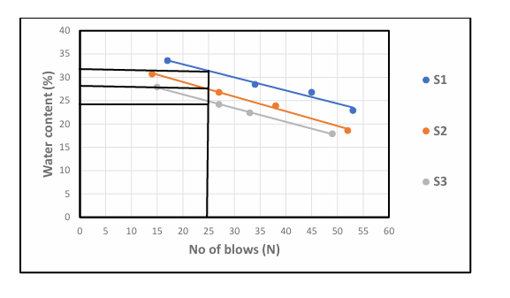
Fig.1: graph showing water content

4.2 results of bulk Density Test
The result of Bulk Density Test is presented in Table3. the bulk density values range from 1.63 to 1.76g/cm³ Murthy (2002) stated that bulk densities for compacted lateritic soils usually range from 1.6 to 2.0g/cm³. hence, the values obtained are within the acceptable range, with sample C showing the highest density, indicating better compaction and higher strength.
Table 3: Bulk Density of Collected Samples.
Sample A | Sample B | Sample C
1.63 | 1.73 | 1.76

4.3 Results of Dry Density Test
Two results of Dry Density value (1.58 - 1.69g/cm³) are also within the expected range for Engineering fill materials. According to Das (2010) dry densities for lateritic soils typically range from 1.5 to 2.0g/cm3, indicating that the test ad soils can offer adequate bearing capacity when properly compacted.
Table 4: Dry Density Test of collected samples
Sample A | Sample B | Sample C
1.58g/cm³ | 1.67g/cm³ | 1.69g/cm³

4.4 Result of Specific Gravity Tests
The specific gravity result is presented in table 5 specific gravity value ranged from 2.68 to 2.83 according to Das (2010), the typical specific gravity of lateritic soil falls between 2.60 and 2.85 which confirm that the soil predominantly mineral based with minimum organic contamination.
Table 5: Specific gravity test of collected samples
Sample A | Sample B | Sample C
2.68g/cm³ | 2.71g/cm³ | 2.83g/cm³

4.5 Results of Atterberg Limit Tests
Liquid Limit (LL): ranges from 22.3 % to 31.6% According to Das (2010), soil with liquid limit value less than 35% are classified as low plasticity soils. All the three samples fall within this category, indicating low compressibility and moderate workability.
Plastic Limit (PL): value range from 14.6% to 18.2%, which is also consistent with the range expected for lateritic soil.
Plasticity Index (PI): value, calculated as the difference between LL am PL range from 6.9% to 13.4% Ola (1983) noted that lateritic soil generally has pl value ranging from 5% to 20% depending on the degree of weathering. Hence the PL values obtained fall within the expected range, indicating moderate plasticity with Sample A being more plastic than Sample B and Sample C.
Linear Shrinkage (LS): values range from 3.7% to 6.2% According to Adeyemi (1995), values below 10% suggest that the soils have low shrinks well potential, which is desirable for most construction purpose. Sample C has the lowest shrinkage value, suggesting it will be the most suitable under moisture variation

Table 6: Atterberg Limit Tests of collected samples
Sample | Liquid Limit % | Plastic Limit % | Plastic index | Linear Shrinkage %
Sample A | 31.6 % | 18.2% | 13.4% | 6.2%
Sample B | 22.3% | 15.4% | 6.9% | 4.8%
Sample C | 24.8% | 14.6% | 10.2% | 3.7%

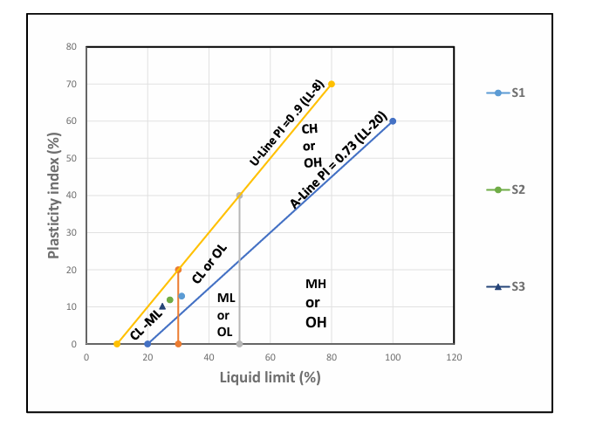
Fig 2: Graph Showing Plasticity Chart

4.6 Result of Grain Size Analysis
P1 has higher clay content (21%) hence classified has clayey sand
P2 and P3 have more silt and less clay, Thus, silty sand all sample have sand and dominant particle size making them sand-based soils.
fine (<0.075mm) is highest in P1, which support its clayey nature.
Table 7: Summary of result of Grain Size Analysis of soil
Sample Location | Gravel (%) | Sand (%) | Silt (%) | Clay (%) | Fine (%) | Soil classification
P1 | 10 | 60 | 9 | 21 | 30 | Clayey sand
P2 | 12 | 62 | 15 | 11 | 20 | Silty sand
P3 | 13 | 63 | 17 | 7 | 24 | Silty sand

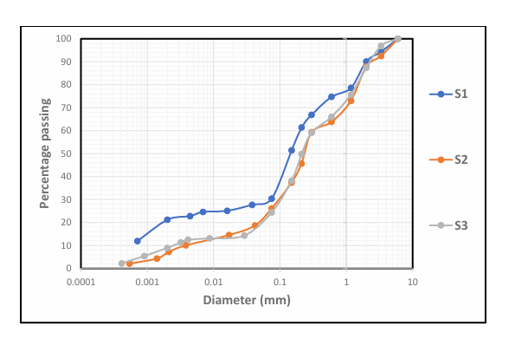
Fig. 3: Grain Size Analysis Graph
4.7 Result of Compaction Test
Table 8: Compaction Parameters of Maximum Dry Density (MDD) and Optimum Moisture Content (OMC)
Sample | MDD | OMC
A | 1.81 | 8
B | 1.89 | 7.5
C | 1.95 | 6

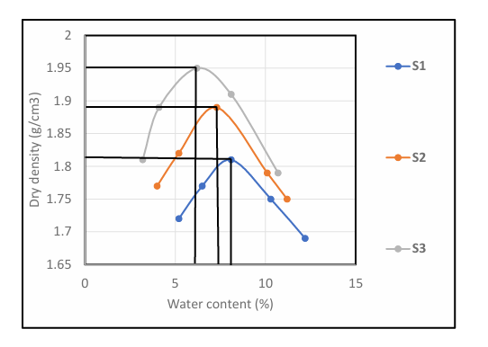
002Fig. 4: Graph Showing Compaction Parameters
Table 9: Compaction and Ratings of Unified Soil Classification for Construction (ASTM 1557-91)
Visual Description | Maximum Dry Density (MDD)(g/cm³) | Optimum Moisture Content (OMC)(g/cm³) | Anticipated embankment performance | Value as Subgrade material | Value as Base Course
Granular material | 2.00 - 2.27 | 7 – 15 | Good to Excellent | Excellent | Good
Granular material with soil | 1.76 - 2.16 | 9 – 18 | Fair to Excellent | Good | Fair to Poor
Fine sand and sand | 1.76 - 1.84 | 9 – 15 | Fair to Good | Good to Fair | Poor
Sandy silts and silts | 1.36 -1.60 | 10 – 20 | Poor to Good | Fair to Poor | Not suitable
Elastic silts and clay | 1.36 - 1.60 | 20 -35 | Unsatisfactory | Poor | Not suitable
Silty clay | 1.52 - 1.92 | 10 – 30 | Poor to Good | Fair to Poor | Not suitable

Table 9: present the compaction parameters of collected samples. The (MDD) Maximum Dry Density for sample A is 1.81 for sample B 1.89 while sample C is 1.95. for Optimum Moisture Content (OMC), sample A is 8, Sample B is 7.5 sample C is 6. The three sample being sandy in nature can be range as range fair to good for embankment performance it is fair to poor for subgrade material are not suitable for base course.

4.8 Relationship between some Index Properties of Laterite and selected Engineering Properties
Due to limitations on laterite in the course of carrying out this project, only one compaction parameters are considered this selection for the relationships between their specific gravity (SG), plastic limit (PL), and liquid limit (LL), were related to the compaction parameters (MDD) and optimum moisture content (OMC). From table 10 it can be observed that the coefficient the relationships. One quite high, range from 0.689 for OMC and PL to 0.998 for MDD and LL. This shows that a good relationship exists between the selected index properties and compact in parameters may be reasonable predicted from the resulting equation.

Table 10: Derived Equations
S/N | Equations | Coefficient of Determination
1 | MDD=0.309X SG-0.334 | 0.836
2 | MDD=0.576X PL+10.54 | 0.965
3 | MDD=0.022X LL+2.497 | 0.998
4 | OMC= -13.09X SG+43.04 | 0.997
5 | OMC=0.45X PL-0.177 | 0.689
6 | OMC=0.302X LL-1.215 | 0.848

CHAPTER 5
5.0 CONCLUSION AND RECOMENDATIONS
5.1 CONCLUSION
The study successfully investigated the relationship between selected index properties and engineering properties of lateritic soils collected from different locations within the Kwara State Polytechnic campus. Key index properties such as moisture content, Atterberg limits, grain size distribution, and specific gravity were examined and compared with engineering properties like compaction characteristics, bulk density, and shear strength.
From the laboratory tests conducted, it was observed that:
• The lateritic soils generally exhibited moderate to high plasticity, suggesting a fair to good binding quality.
• The moisture content had a notable influence on the compaction behavior, with the optimum moisture content (OMC) and maximum dry density (MDD) values varying based on soil composition.
• Grain size distribution revealed that the soils were well-graded in some locations and poorly graded in others, which significantly impacted strength and compaction properties.
• The plasticity index (PI) showed a direct correlation with shear strength, implying that soils with higher PI demonstrated better load-bearing capacity, especially under controlled moisture conditions.
• The specific gravity and bulk density were within the typical range for lateritic soils, confirming their suitability for civil engineering applications like subgrade and bank materials.

In summary, a strong relationship exists between the index properties and engineering behavior of the soils studied. This implies that basic soil classification and index tests can provide useful predictions of soil performance in engineering applications, especially in the absence of advanced testing facilities.
5.2 RECOMMENDATIONS
Based on the findings of this research, the following recommendations are made:
i. Soil Classification Should Be Prioritized: Engineers and construction professionals working within the Kwara State Polytechnic campus should always carry out proper soil classification and index testing before using lateritic soils for construction projects.
ii Use of Index Properties for Preliminary Assessment: Since strong correlations exist between index and engineering properties, index tests can serve as a cost-effective and efficient tool for preliminary site evaluation, especially in resource-limited settings.
iii. Compaction Control on Site: It is recommended that compaction be carried out at or near the determined optimum moisture content to achieve maximum dry density, thereby enhancing soil strength and stability.
iv Soil Stabilization Where Necessary: For locations where soils show high plasticity or poor grading, chemical or mechanical stabilization methods (e.g., lime or cement stabilization) should be considered to improve their engineering properties.
v Further Studies: More extensive studies covering other parts of the campus and including other engineering parameters such as permeability, CBR (California Bearing Ratio), and consolidation characteristics should be conducted to develop a comprehensive soil map for the institution.
vi Adoption of Local Soil for Construction: Given the favorable results in some areas, the use of local lateritic soil should be encouraged in road construction, foundation fills, and other geotechnical works, after adequate testing and processing.

REFERENCES
Aashto (2000). Standard Specifications for Transportation Materials and Methods of Sampling and Testing.
Adeyemi, G.O. (2002). Geotechnical properties of lateritic soils in southwestern Nigeria. Engineering Geology, 63(1-2), 71–81.
Aiban, S.A. (1995). The engineering characteristics of residual soils in Saudi Arabia. Engineering Geology, 39(3-4), 219–231.
Alabo, E.H., & Akinbinu, V.A. (2014). Geotechnical assessment of lateritic soils for road construction. Journal of Civil Engineering Research, 4(3A), 50–55.
Attoh-Okine, N.O. (1995). An overview of laterite soil engineering. Journal of Transportation Engineering, 121(6), 469–474.
Bello, A.A., & Adegoke, C.W. (2010). Evaluation of geotechnical properties of lateritic soils in parts of southwestern Nigeria. Pacific Journal of Science and Technology, 11(2), 617– 624.
Bello, A.A. (2012). Plasticity and strength behavior of lateritic soil stabilized with lime and cement. Electronic Journal of Geotechnical Engineering, 17, 3655–3672.
Blight, G.E. (2012). Unsaturated Soil Mechanics in Geotechnical Practice. CRC Press.
Gidigasu, M.D., & El-Sohby, M.A. (1985). Engineering significance of lateritic soils. Transportation Research Record, 1031, 35–40.
Gidigasu, M.D. (1976). Laterite Soil Engineering. Elsevier.
Head, K.H. (1992). Manual of Soil Laboratory Testing, Vol. 1. Pentech Press.
Lambe, T.W., & Whitman, R.V. (1969). Soil Mechanics. Wiley.
Nigerian Building and Road Research Institute (NBRRI) (2006). Manual for the Identification and Classification of Nigerian Soils for Engineering Purposes.
Ola, S.A. (1983). Geotechnical properties and behavior of some Nigerian lateritic soils. Engineering Geology, 19(2), 1–13.
Osinubi, K.J. (1999). Evaluation of admixture stabilization of Nigerian black cotton soil. Nigerian Society of Engineers Technical Transactions, 34(3), 88–96.
Oyediran, I.A., & Kalejaiye, M. (2011). Geotechnical investigation of a site in Ilorin, Nigeria. RMZ – Materials and Geoenvironment, 58(2), 143–162.
Sk6empton, A.W. (1953). The colloidal activity of clays. Géotechnique, 3(1), 30–53.
Terzaghi, K., Peck, R.B., & Mesri, G. (1996). Soil Mechanics in Engineering Practice. Wiley.
Uddin, K., & Taha, M.R. (2007). Engineering behavior of cement-treated Malaysian residual soil. Geotechnical and Geological Engineering, 25(4), 343–358.
Whitlow, R. (2001). Basic Soil Mechanics. 4th ed., Pearson Education.

