A PROJECT REPORT
ON
PROPOSED AUTOMOBILE WORKSHOP
FOR
LANRE SHITTU MOTOR
AT
AKEREBIATA HARMONY ESTATE, ILORIN, KWARA STATE.
BY
MUSA FATIMOH
HND/23/ARC/FT/0071

SUMMITED TO

DEPARTMENT OF ARCHITECTURAL TECHNOLOGY INSTITUTE OF ENVIRONMENTAL STUDIES (I.E.S), KWARA STATE. POLYTECHNIC, ILORIN

IN PARTIAL FULFILLMENT OF THE REUIREMENTS FOR THE AWARD OF HIGHER NATIONAL DIPLOMA (HND) IN ARCHITECHTURAL TECHNOLOGY, KWARA STATE POLYTECHNIC, ILORIN, KWARA STATE.

JULY, 2025



ii

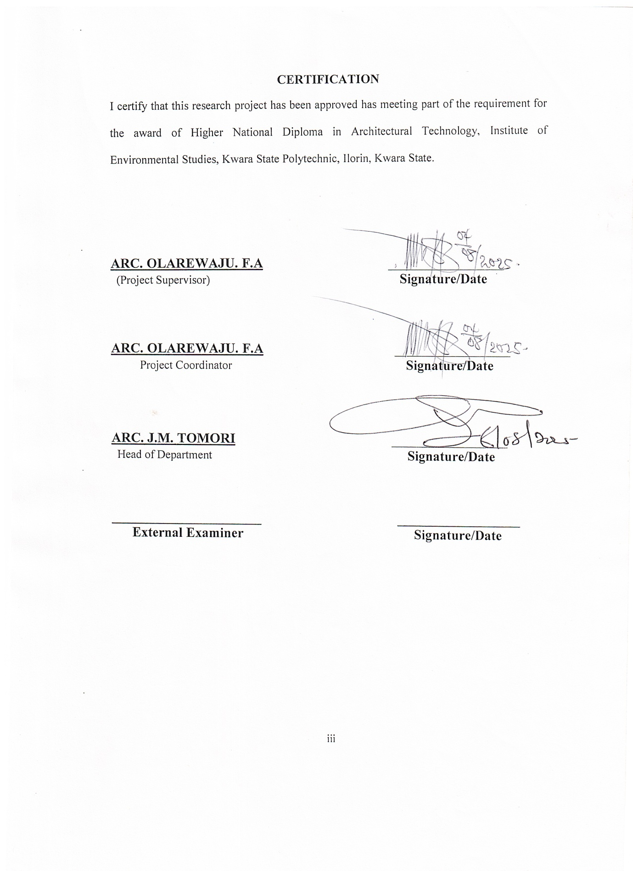

iii
DEDICATION
This project is fully dedicated to the almighty Allah, who is the source of my strength and guidance all the praises to him alone, I also dedicate this project to my parent, Mr. Zubair Musa and Mrs. Musa Misturah for their uncompromising moral and financially support throughout my educational career.

iv
ACKNOWLEDGEMENT
My first appreciation goes to the almighty Allah the beginning and the end, the knowing of all things and the most knowledgeable one, for his abundant blessing and protection over me.
Inspiration is Mostly from god, Motivation from Man, for the inspiration and motivation singularly given to me by project supervisor in person of Arc. Olarewaju F.A i cannot thank you enough but surely Almighty God shall reward you abundantly.
My sincere appreciation also goes to all academic and non academic members of architectural technology department and my able HOD in person of Arc. J.M. Tomoritoward a successful completion of this programme (HND).
My special appreciation goes to my beloved parent Mr. And Mrs. Musa for their support both financially and morally, I pray allah will grant them good health and long life to eat the fruit of their labour (Amin).
I will like to express my appreciation to school friends the likes of Hamzat aisha, usman patiko, Tijani quadri, Naallah abdullateef, Hammed shamsudeen, mohammed abdulrahmon and others who has always been there for me , I say a big thank you all.
Finally I want to use this medium to appreciate everybody that has contributed in one way or the other to this success, I say a big thanks, once again and God bless you all .

v

TABLE OF CONTENT
Title Page
DECLARATION II
CERTIFICATION III
DEDICATION………………………………………………………………….IV
ACKNOWLEDGMENT …………………………V
TABLE OF CONTENT VI
LIST OF PLATES VII
LIST OF TABLES VIII
LIST OF FIGURES……………………………………………………………
LIST OF APPENDICES……………………………………………………..
ABSTRACT IX

CHAPTER ONE
1.0 INTRODUCTION 1
1.1 HISTORICAL BACKGROUND OFTHE PROJECT 2
1.2 PROJECT DEFINITION 2
1.3 STATEMENT OFDESIGN PROBLEM 3
1.4AIM AND OBJECTIVES OFTHESTUDY 4
1.5PROJECTJUSTIFICATION 5
1.6 CLIENTS BACKGROUND 5
1.7 SCOPEOFTHESTUDY 6
1.8LIMITATION OFDESIGN 9
1.9RESEARCH METHODOLOGY 10

CHAPTER TWO:
2.0 REVIEW OFRELEVANT LITERATURE 11

CHAPTER THREE
CASE STUDY 8
CASESTUDY1 8
BRIEF HISTORY . 9
MERIT AND DEMERIT. 9

vi
CASE STUDY 2.......................................................................................................10
BRIEF HISTORY ……………………...........……………….………….10
MERIT AND DEMERIT. 10
CASESTUDY3 13
BRIEF HISTORY .4 13
MERIT AND DEMERIT. 14
CASE STUDY4… 17
ONLINE CASE STUDY 1… 19
ONLINE CASE STUDY 2 20
3.7 DEDUCTION FROM CASESTUDY 29

CHAPTER FOUR
4.0 BRIEF HISTORY
4.2 HISTORICAL BACKGROUND OF SELECTED LOCATION LGA 32
4.7 SITE LOCATION, TOPOGRAPHY, SITEANALYSIS 35
4.7.1 SITE SELECTION/JUSTIFICATION 35
4.55 PLANNING PRINCIPLE

CHAPTER FIVE
5.3DESIGN APPRAISAL 45
5.5BUILDING STRUCTURE 47
5.6SERVICE REQUIRED, CIRCULATION, VENTILATION, LIGHTING AND PLUMBING AND ELECTRICAL INSTALLATION………………………………
6.0 SUMMARY AND CONCLUSION 54
6.1 SUMMARY 54
6.2 CONCLUSION 54
REFERENCES 56
APPENDIX

LIST OF PLATES
PLATE 2.1 Location plan 38
PLATE 2 Site inventory 38
PLATE 2 Site analysis 39
PLATE 2 Functional relationship 43
PLATE 2 Space calculation 44
PLATE 2 Site plan 58
PLATE 2 Floor plan administrative building 59-60
PLATE 2 Roofplan 60
PLATE 2 Elevations 61
PLATE 2 Floor plan workshop building I 62
PLATE 2 Roofplan 63
PLATE 2Section 64-65
PLATE 2 Elevations 65-66

vii

ABSTRACT
The increasing demand for automotive services in Nigeria, fueled by the rapid rise in vehicle ownership, highlights the critical need for functional, safe, and sustainable automobile workshop facilities. However, most existing workshops in urban centers are plagued by poor spatial organization, substandard infrastructure, and a lack of accommodation for emerging technologies such as electric vehicle servicing. This study focuses on the architectural design of a modern automobile workshop that integrates functionality, structural stability, environmental sustainability, and user comfort. Using qualitative methods including literature review, site analysis, stakeholder interviews, and case studies such as Taflad Motors in Osogbo, Osun State, the research identifies key deficiencies in current workshop designs and proposes architectural solutions. The design incorporates effective zoning, proper vehicle and personnel circulation, appropriate material selection, and sustainable building practices. The proposed facility aims to meet contemporary standards and set a new benchmark for industrial workshop design in Nigeria, contributing to safer urban infrastructure, enhanced service delivery, and readiness for future automotive advancements.
Key design considerations include proper ventilation, natural and artificial lighting, fire safety measures, sound structural systems, and the use of durable, low-maintenance building materials. Additionally, the design integrates sustainable elements such as rainwater harvesting, solar energy systems, and waste oil management to reduce environmental impact and operational costs. The spatial layout is flexible and scalable, allowing the workshop to adapt to future developments in vehicle technology, including electric vehicles and computerized diagnostics.
viii

CHAPTER ONE
1.0 INTRODUCTION
1.1 BACK GROUND OF THE STUDY
The automobile industry plays a critical role in the economic and social development of modern societies, with workshops serving as essential support facilities for vehicle maintenance, repair, and overall functionality. As the number of vehicles on Nigerian roads continues to increase, the demand for well-organized and professionally equipped automobile workshops has also grown significantly. In many urban centers, however, workshops are often characterized by poor spatial planning, inadequate infrastructure, substandard construction materials, and unsafe working conditions. These deficiencies not only affect service delivery and safety but also diminish the overall aesthetic and functional quality of the urban environment.
In response to these challenges, there is a growing need to design automobile workshops that meet modern standards of functionality, structural stability, environmental sustainability, and user comfort. A well-designed workshop must address several key considerations, including efficient zoning of workspaces, proper circulation for vehicles and staff, durable materials, adequate ventilation, lighting, and compliance with health and safety regulations. Integrating these features into workshop design enhances not only the efficiency and safety of operations but also the overall client experience.
This project, therefore, seeks to develop a comprehensive architectural design for an automobile workshop that addresses these needs. It aims to provide a facility that is not only functional and structurally sound but also visually appealing and adaptable to future technologies, such as electric vehicle servicing. The study contributes to the broader discourse on sustainable and user-centered design in industrial architecture, with the goal of setting a standard for future workshop developments in Nigeria and beyond.
1.2 Project Definition
An automobile workshop is a facility equipped for the maintenance, repair, and servicing of motor vehicles. It typically includes service bays, diagnostic tools, mechanical equipment, and trained personnel who handle tasks such as engine repair, oil changes, electrical diagnostics, brake servicing, and general vehicle maintenances.
1.3 Statement of Design Problem
Despite the growing number of vehicles on Nigerian roads and the increasing demand for automotive services, many automobile workshops across the country remain poorly designed, functionally inadequate, and structurally substandard. These facilities often operate in congested, disorganized environments, lacking proper spatial zoning, adequate ventilation, safe circulation routes, and modern infrastructure. As a result, they not only compromise operational efficiency and worker safety but also contribute to environmental degradation and urban blight.
Furthermore, most existing workshops are not equipped to accommodate emerging technologies such as computerized diagnostics or electric vehicle servicing, nor do they consider sustainable design principles such as energy efficiency, water management, or material durability. The lack of professional architectural input in the planning and construction of these workshops has led to widespread issues such as poor workflow, insufficient storage, inadequate lighting, fire hazards, and lack of customer-friendly spaces.
There is therefore a critical need for a purpose-built, architecturally sound automobile workshop that addresses these deficiencies. Such a facility must integrate functional design with structural balance, environmental responsibility, and adaptability to future industry developments. This project seeks to provide a design solution that responds to these challenges and sets a new standard for workshop planning in Nigeria.
1.4 Aim
To design a modern automobile workshop that provides functional efficiency, structural stability and environmental sustainability
Objectives
- To analyze the spatial and functional requirements of a standard automobile workshop, including zoning for service bays, administration, customer areas, and storage.
- To develop a design layout that ensures efficient circulation for both vehicles and personnel, minimizing congestion and maximizing safety.To select appropriate construction materials and structural systems suitable for industrial use, ensuring durability, load-bearing capacity, and low maintenance.
- To incorporate sustainable design strategies, such as natural lighting and ventilation, renewable energy integration, and efficient waste management.
- To ensure compliance with relevant building regulations and safety standards, including fire safety, accessibility, and environmental guidelines.
- To create a workshop environment that is aesthetically pleasing and reflective of a modern, professional automotive service facility.
1.5 Justification
I justify that harmony estate has no standards automobile workshop, i hereby proposed design of a comprehensive automobile Workshop that will provide an in-depth guide for various persons and groups involved in automobile repair in Nigeria.
1.6 Client Background
The client for this project is Lanre motors., a leading automobile company in Nigeria. With a strong commitment to innovation, sustainability, and quality service delivery, lanre motors specializes in delivering an autombile work shop The company’s interest in developing an automobile workshop reflects its broader vision of creating functional and high-standard infrastructure that meets growing market needs while contributing to urban development.
1.7 Scope of Study
This project focuses on the architectural design of a standard automobile workshop facility, incorporating administrative offices, reception and customer waiting areas, multiple service bays, parts storage, mechanical rooms, staff facilities, and external works such as driveways and parking. The study covers site analysis, spatial planning, structural system selection, material specification, integration of building services (MEP), and sustainable design strategies. It also includes compliance with relevant regulations and design standards applicable to light industrial buildings.
1.8 Limitation of Design
The limitation experienced during this course of study include:
- Time constraint
- Finance: funding of the project research and the project itself has been asurmountable task which God has intervened in its management.
- Research materials: There have not been enough local sources of informationand getting the proper architectural plans required for assessment during case studies was not very easy.

1.9 Research Methodology

Case Study
This chapter presents the methodology adopted for conducting the research on the design of a modern automobile workshop. The approach is primarily qualitative, using case study analysis to gather in-depth, context-specific information. The methodology is structured to align with architectural design processes and aims to generate design solutions grounded in real-world needs and user experiences.
- Oral Interview
A qualitative research approach was adopted for this study. This approach is suitable for gaining in-depth understanding of human experiences, behaviors, and perceptions, which are essential in designing user-centered architectural spaces. The oral interview method enabled direct interaction with key stakeholders such as workshop owners, technicians, and customers.
- Literature Review
This chapter explains the methodology used to gather and analyze relevant information for the architectural design of a modern automobile workshop. The research is qualitative in nature, with literature review forming a major part of the data collection process. The review provided the theoretical and contextual background necessary to understand standards, best practices, and evolving trends in automobile workshop design.

CHAPTER TWO
2.0 Literature review
  - Introduction
In this chapter, Definition of an automobile workshop, history, benefit of an automobile of workshop and other related literatures are discussed.
The automobile workshop has evolved alongside the history of motor vehicles. The earliest workshops emerged in the late 19th and early 20th centuries, when automobiles were a new invention and repairs were mostly done by blacksmiths, machinists, and inventors who had the mechanical knowledge to work on early motor engines. As the automobile industry grewparticularly with the mass production of vehicles by Henry Ford in the early 1900sthere became a need for dedicated repair facilities. These early workshops were simple garages or converted sheds where basic repairs and maintenance were carried out.
By the mid-20th century, automobile workshops began to develop into more organized service centers, with designated work bays, specialized tools, diagnostic equipment, and trained technicians. The advent of electrical systems, computerized engines, and later, hybrid and electric vehicles, further expanded the scope of workshop services. Modern automobile workshops are now highly specialized facilities that integrate mechanical, electrical, and software diagnostics, and are often designed with safety, efficiency, and environmental standards in mind.
Due to having a more knowledgeable and networked contemporary society, designers are being required to deal with building occupiers of different cultures and various professional backgrounds. As a result, the traditional design knowledge is no longer enough in solving complex client demands (Manzini, 2009). Therefore, the continued utilization of design knowledge based on traditional processes will result in unsatisfied client demands as the complexity increases. This increase in complexity also affects facilities management (FM) operations which are directly linked to the facility type and purpose of use. But it is only the analysis of best practices in facilities management that can provide an innovative input to the supportive functionof buildingdesign" (Brochner, 2003, p. 23). The above statement illustrates the idea behind the need to enhance the supportive role of a building's design through integrating FM requirements when designing. Qualitative non- financial factors on top of the conventional cost, profit, and output concerns (Pitt & Tucker, 2008) will have to be considered.
In order to discuss facilities management and design integration, the two facility-related disciplines and their role should be introduced first, followed by a discussion on the nature of integration and content of FM input into design. In other words, this literature review starts with discussing facilities management, its components and relation to an organization's core business. Facility design is handled next, elaborating on the various design stages and revealing the correlation between facility users' needs and design processes. Facilities management requirements, their identification and communicationto designers are then presented to conclude the description of the research topic.
Based on the literature review, a research problem is identified leading to the identification of a gap in the knowledge presented.
This is a process whereby the opinion of authorities in the field of architecture and other work includes the regular participant of Automobile Workshop were soughtasregardstheneed forthe Automobile Workshop.
2.2 Benefit of Automobile Workshop In Nigeria
Automobile workshops play a critical role in maintaining the efficiency, safety, and longevity of vehicles. They provide essential services such as routine maintenance, diagnostics, repairs, and part replacements, ensuring that vehicles operate reliably and within environmental regulations. Workshops contribute to road safety by identifying and correcting mechanical issues before they result in accidents. Economically, they create employment opportunities for technicians, engineers, and administrative staff, and support local economies through the supply of parts and services. Additionally, modern workshops serve as hubs for technical innovation and training, helping to develop skilled labor and promote technological advancement in the automotive sector. In well-planned urban settings, properly designed workshops also contribute to organized infrastructure, reducing congestion caused by informal roadside mechanics.
Automobile workshops are important public building provided in maintaining and repairing automobiles.
1. Increases car's lifespan: This is the big one! Routine preventative servicing extends the life of your machine, ensuring that the vehicle lasts you a long time offering maximum value for money.
2. It Detect and Solve Minor Issues: The mechanic will detect and solve minor issues before they become more prominent, more costly, and life-threatening problems.
3. It improved Precision, Safety Reliability: It ensures that your car is always performing at its best. Imagine getting more stable steering, excellent engine starts, and tires with better traction? All this increases the car's precision and reliability, which increases your safety on the road.
4. It reduced Spare Parts and Service Charges : This can substantially cut auto spare parts and service charges. Unexpected breakdowns can mean paying mechanics over time and having to pay extra for emergency auto repair services.
2.3Definition
An automobile workshop is a facility equipped for the maintenance, repair, and servicing of motor vehicles. It typically includes service bays, diagnostic tools, mechanical equipment, and trained personnel who handle tasks such as engine repair, oil changes, electrical diagnostics, brake servicing, and general vehicle maintenance.
Architecturally, an automobile workshop is a specialized industrial building designed to accommodate vehicle repair operations. It includes functional zoning for vehicle movement, mechanical work areas, administrative offices, storage spaces, and customer reception areas. The design prioritizes spatial efficiency, safety, durability, and ease of circulation for both people and vehicles.
According to automotive industry standards, an automobile workshop is a technical service environment where certified professionals carry out repairs, diagnostics, and periodic vehicle inspections using specialized tools and technology. It can range from small-scale local garages to large-scale service centers affiliated with manufacturers or dealerships.

2.4 Historical development of an automobile workshop
The development of the automobile workshop is closely tied to the evolution of the automobile itself. In the late 19th century, when the first internal combustion engine vehicles were introduced, there were no formal service centers for repairs. Instead, early automobile owners relied on blacksmiths, bicycle repairers, and machinists to fix and maintain their vehicles. These early repair practices were mostly informal and took place in garages or sheds, often with rudimentary tools and limited technical knowledge.
With the introduction of mass production techniques by Henry Ford in the early 20th century particularly the Model T in 1908 automobile ownership became more widespread, leading to increased demand for professional maintenance and repair services. This era marked the beginning of more organized automobile workshops, often attached to dealerships or petrol stations. These workshops provided specialized services and employed mechanics trained to work on specific vehicle models.
By the mid-20th century, the automobile workshop had evolved into a more structured and technologically advanced facility. The rise of electrical systems, automatic transmissions, and computerized engine management systems in vehicles demanded the use of diagnostic tools and skilled labor. Workshops began to include designated service bays, hoists, tool storage, and administrative offices. In developed countries, automotive repair became a regulated profession with training standards, certification, and safety regulations.
In recent decades, technological advancement has transformed the modern automobile workshop into a highly specialized service environment. Today, workshops use digital diagnostic tools, software-based service records, and advanced machinery to service hybrid and electric vehicles. Sustainable practices, such as waste oil recycling, energy-efficient lighting, and proper ventilation systems, are now increasingly integrated into workshop design. The modern workshop is not just a repair facility but a vital part of the vehicle lifecycle and a hub for technical innovation and skill development.

2.5 Automobile workshop In Nigeria
I n Nigeria, the history of automobile workshops dates back to the colonial era, when foreign engineers and mechanics serviced vehicles owned by the colonial government and private enterprises. Early workshops were primarily located in port cities like Lagos and Port Harcourt. As urbanization and vehicle ownership expanded after independence, informal workshops, often called "roadside mechanics," began to dominate the automotive repair landscape. These informal workshops still play a significant role in Nigeria's automobile servicing industry due to their affordability and accessibility.
However, with the advancement of automotive technology and an increasing need for professional standards, there has been a gradual shift toward more structured and formalized workshops. Automobile dealerships, vocational training centers, and private investors are establishing better-equipped service centers with trained personnel and diagnostic tools. Despite this progress, many workshops still suffer from poor planning, lack of safety standards, and inadequate infrastructure, highlighting the need for modern, professionally designed automobile workshop facilities across the country

2.6 Concept of an Automobile Workshop
An automobile workshop is a specialized facility designed for the maintenance, repair, diagnosis, and servicing of vehicles, typically including both mechanical and electrical systems. It functions as a critical support infrastructure in the transportation and mobility sector by ensuring vehicles remain safe, functional, and roadworthy.
From an architectural standpoint, an automobile workshop is considered an industrial building typethat demands careful planning for functionality, durability, safety, and workflow efficiency. It typically comprises various spatial components such as service bays, inspection pits, diagnostic rooms, lubrication bays, parts storage, administrative offices, and customer reception areas. Each component serves a distinct function and must be well-integrated into the overall design to ensure smooth and efficient operations (Adeyemi & Ojo, 2020).

Functional Perspective
Functionally, an automobile workshop provides a range of services including:
- Routine maintenance (oil changes, filter replacements, tire rotation)
- Mechanical repairs (engine overhauls, brake repairs, suspension tuning)
- Electrical diagnostics (battery testing, wiring repair, sensor replacement)
- Vehicle inspection (roadworthiness checks, emissions testing)
- Bodywork and painting (in more advanced workshops)
These operations require spaces that supportheavy-duty equipment, vehicle movement, and tool organization, making spatial zoning and structural considerations essential.

2.7 Design and Operational Considerations
An effective workshop design must take into account:
- Zoning and Layout: Clear separation of dirty zones (repair bays) from clean zones (reception, office). Workspaces must be arranged to avoid cross-contamination and workflow disruptions.
- Circulation: Smooth movement paths for both vehicles and personnel are vital. Driveways, turning radii, and access points must be calculated and tested.
- Lighting and Ventilation: Workshops require good natural and artificiallighting to ensure visibility and safety. Proper cross-ventilation is also important to dispel fumes, dust, and heat generated during repairs.
- Durability and Load-Bearing Capacity: The structure should be built with materials that can withstand oil spills, heat, and vibration. Floors should support vehicle lifts, hoists, and heavy machinery.
- Safety and Compliance: Safety is a core requirement, with fire protection, exit access, signage, drainage systems, and noise control all regulated in most jurisdictions (Obadiah & Ezeh, 2020).

2.8 Architectural Relevance
Architecturally, the design of an automobile workshop is more than just creating a space for fixing cars. It involves:
- User-centered planning: considering the needs of technicians, administrative staff, and customers.
- Technological integration: accommodating modern diagnostic tools and future readiness for electric vehicles (EVs).
- Sustainability: using eco-friendly materials, energy-efficient lighting, and water recycling systems.
- Aesthetics: creating a modern and professional environment that promotes brand identity and customer trust.

2.9 Broader Social and Economic Role
In the urban infrastructure, automobile workshops are significant for the following reasons:
- Public safety: ensuring vehicles on the road are well-maintained and safe to operate.
- Economic development: creating skilled employment opportunities in mechanical, electrical, and administrative sectors.
- Training and innovation hubs: often serving as centers for vocational education and technical training.
- Urban aesthetics and order: professionally designed workshops reduce the proliferation of unregulated roadside mechanics and contribute to better-organized city layouts (Akinpelu, 2021).

Types of Automobile Workshops
Automobile workshops can generally be categorized into:
- Informal workshops: Often called "roadside mechanics," lacking formal structure, located in open spaces or makeshift shelters.
- Formal workshops: Professionally designed facilities, usually affiliated with car dealerships or franchises, offering structured services with standard equipment and certified personnel.
- Hybrid models: Small-scale workshops with semi-formal setups transitioning toward modern workshop designs.

CHAPTER THREE

3.1 Case Study
According to Yin, R. K. (2018). Case Study Research and Applications: Design and Methods (6th ed.). Sage Publications. case study is a detailed, in-depth examination of a specific subject such as an event, individual, group, organization, or project within its real-life context. It is commonly used in qualitative research to explore complex issues where multiple variables are involved and where generalizing from a larger population is not the goal, but understanding particular dynamics is essential.
3.3.2 Case Study 1: Taflad Motor at Offa Road, Osogbo, Osun STATE
Taflad Motors located at osun Ido osun in osogbo osun State was Foundedin the 2012 and they specialized on car Repair automobile Sales and sevicing industry offering both new and used vehicle
Location: OFFA TEDO ROAD OSOGBO, OSUN STATE
Merit
- The building is visually appealing
- A conducive Workshop for both manual and computerized machines
Demerits
- Insufficient storage space.
- Not Easy to locate.
- No permanent structure

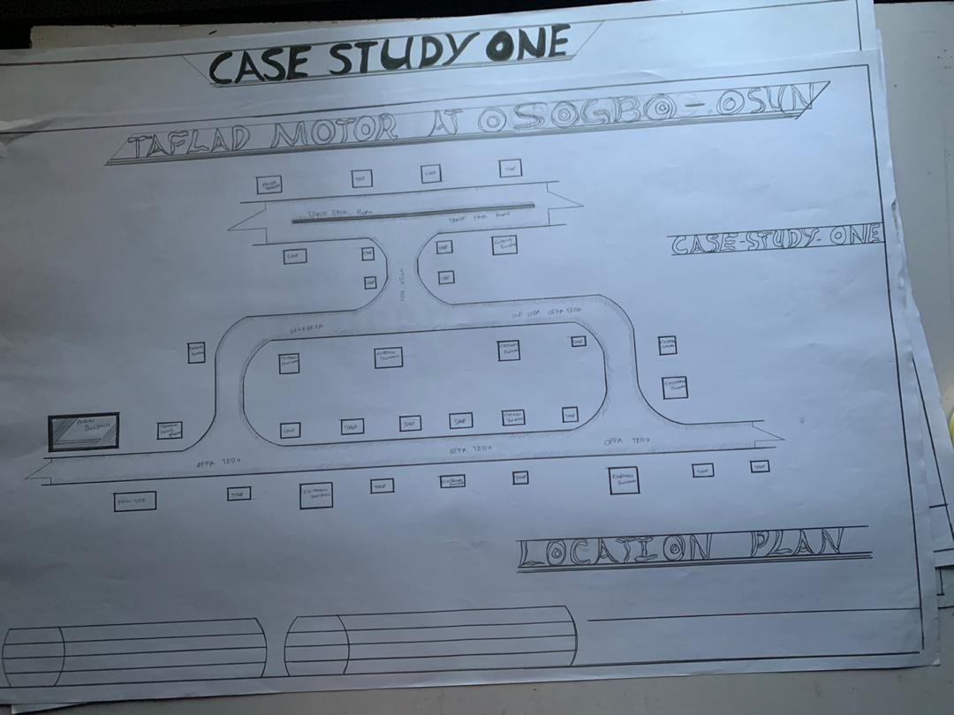
FIG 3.1.1: SHOWING THE LOCATION PLAN OF CASE STUDY ONE
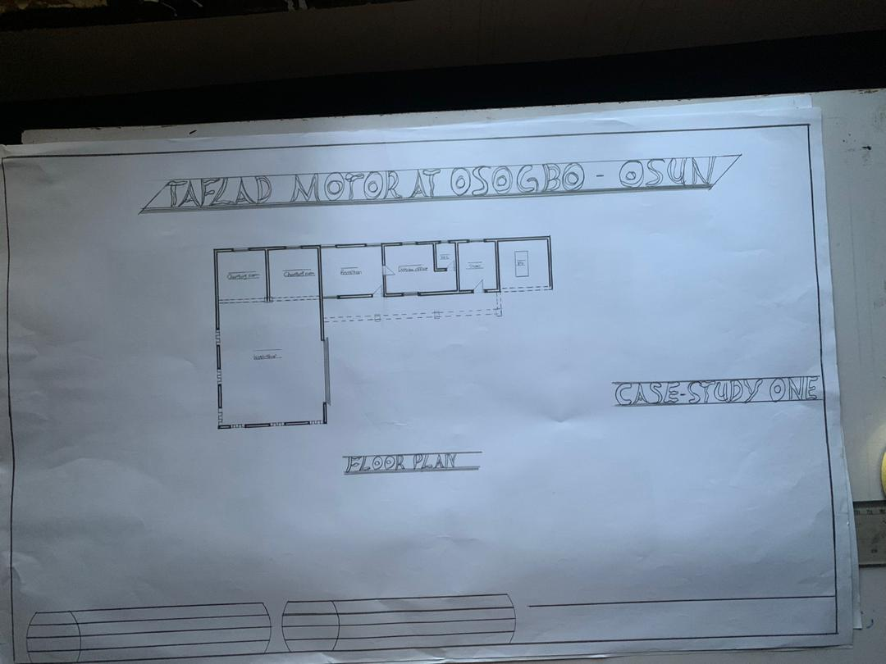
FIG 3.1.2: SHOWING THE GROUND FLOOR PLAN OF CASE STUDY ONE
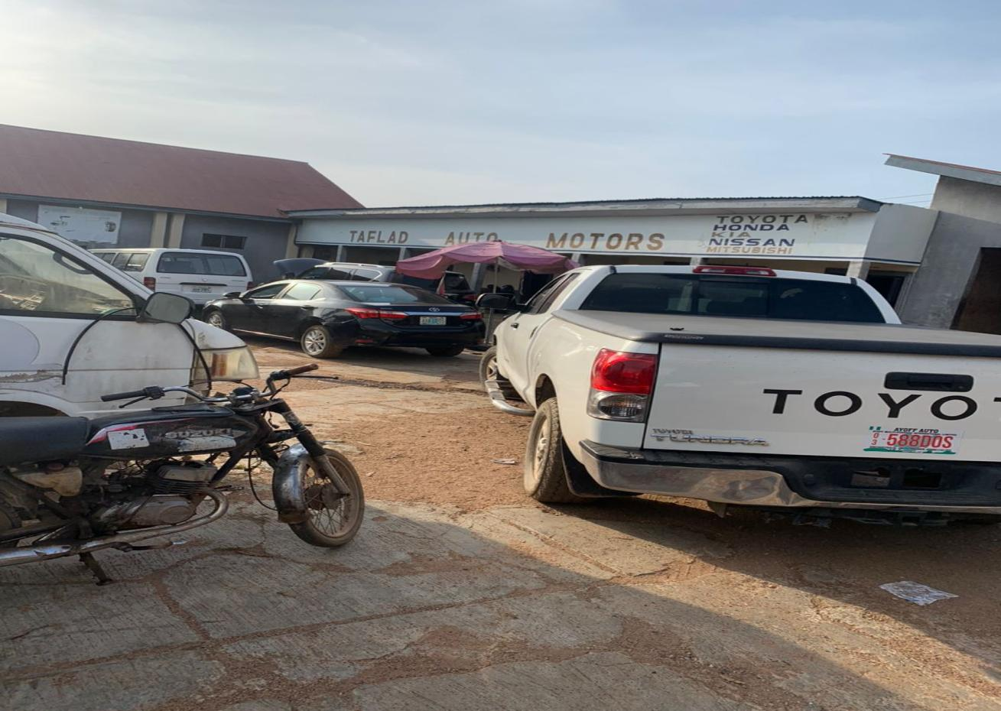
PLATE 3.1.1: SHOWING THE FRONT VIEW OF CASE STUDY ONE

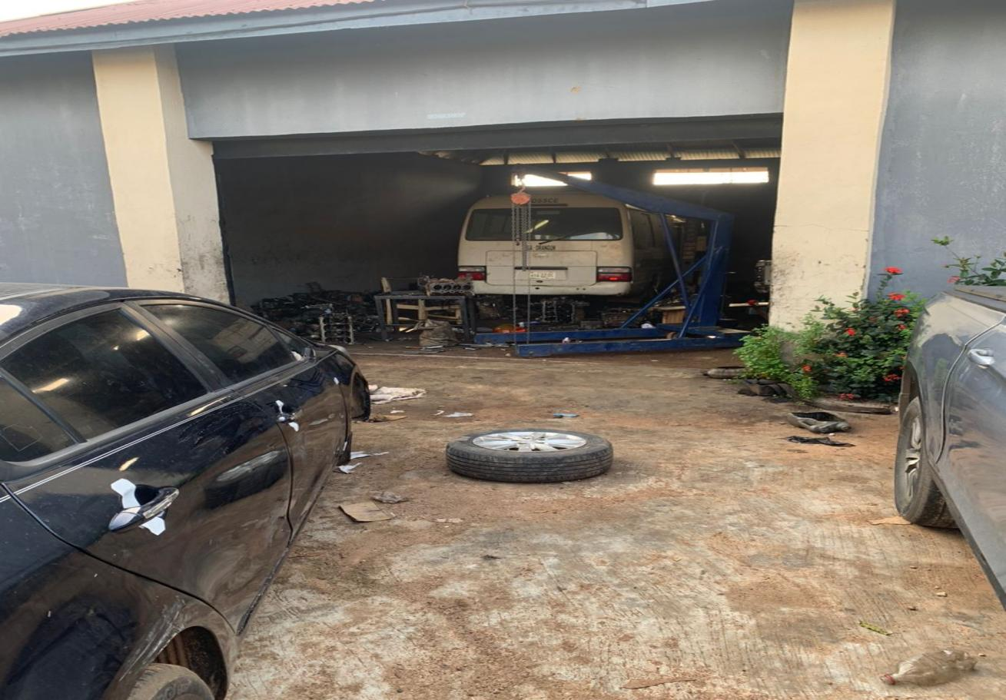

3.3.3 Case Study 2: lutonian tech at orita naira ogbomoso, oyo state
Lutotan tech located at orita naira in ogbomoso oyo state is an automobile repair work it was founded 2011 which they are specialized on repairing cars.
Location: ORITA NAIRA OGBOMOSO, OYO STATE.
Merits
- Strategic Location
- Variety of Services
- Offered Adequate Lighting.
Demerits
- Poor Infrastructure
- Inadequate Safety Measures
- Lack of Proper Zoning

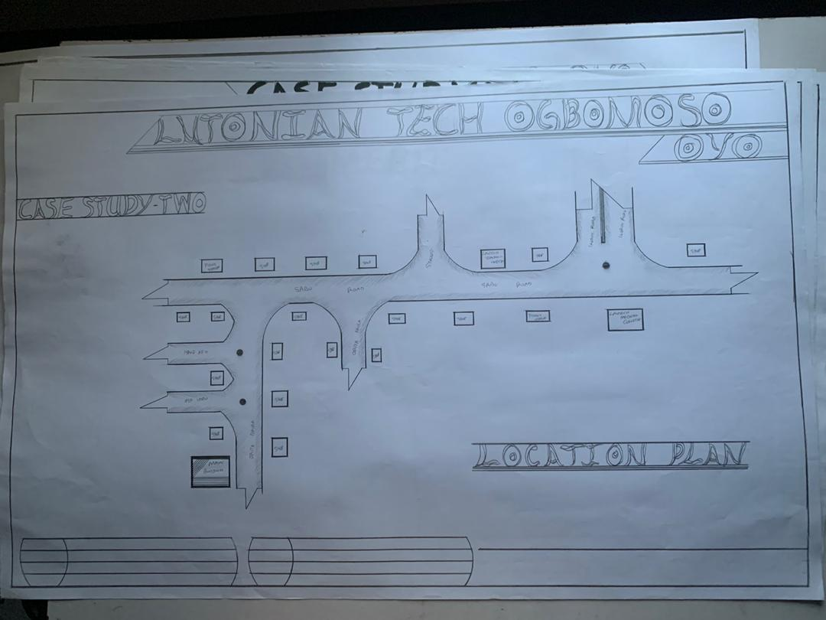
FIG 3.2.3: SHOWING LOCATION PLAN OF CASE STUDY TWO
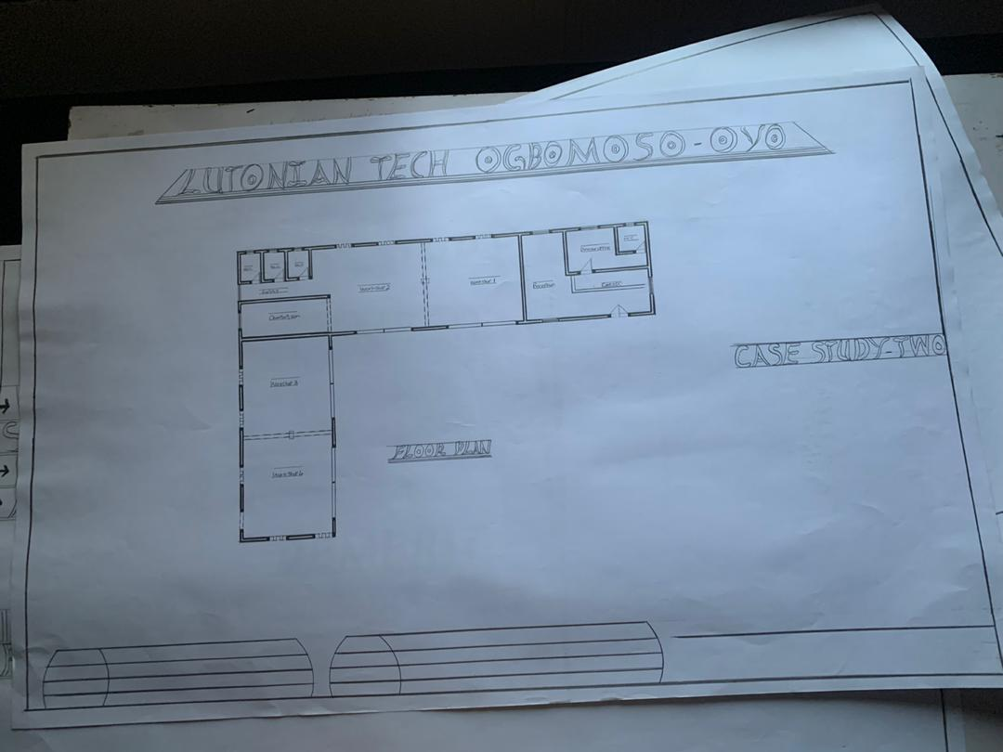

3.4 Case Study 3: KAYUS AUTOS AT IMMIGRATION ROAD OSOGBO, OSUN STATE.
Kayus Autos located at IMMIGRATION Road, Osogbo, Osun State was founded in the year of 2015 and they specialized on cars repair, car sales and servicing.
Location: KAYUS AUTOS AT IMMIGRATION ROAD OSOGBO, OSUN STATE.
Merits
- A good Flow of space for easy movement
- It is easy to locate
Demerits
- No permanent Structure.
- No permanent build workshop.

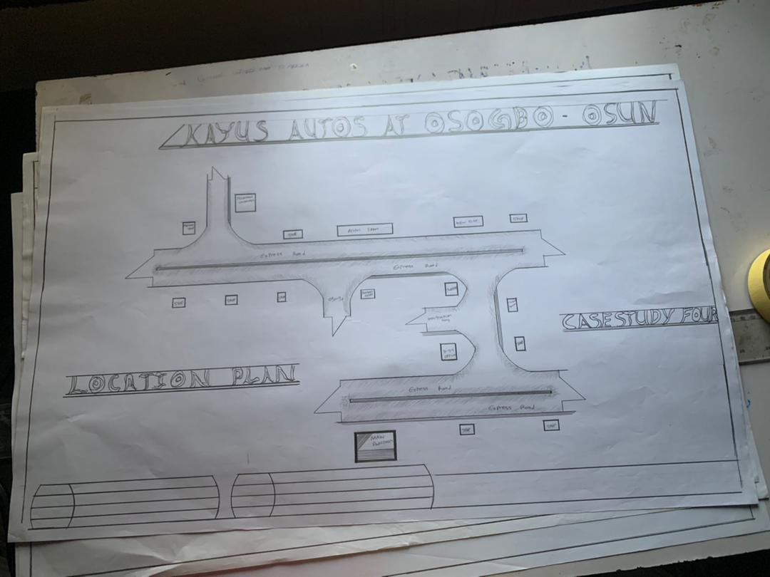
FIG 3.2.4: SHOWING LOCATION PLAN OF CASE STUDY THREE

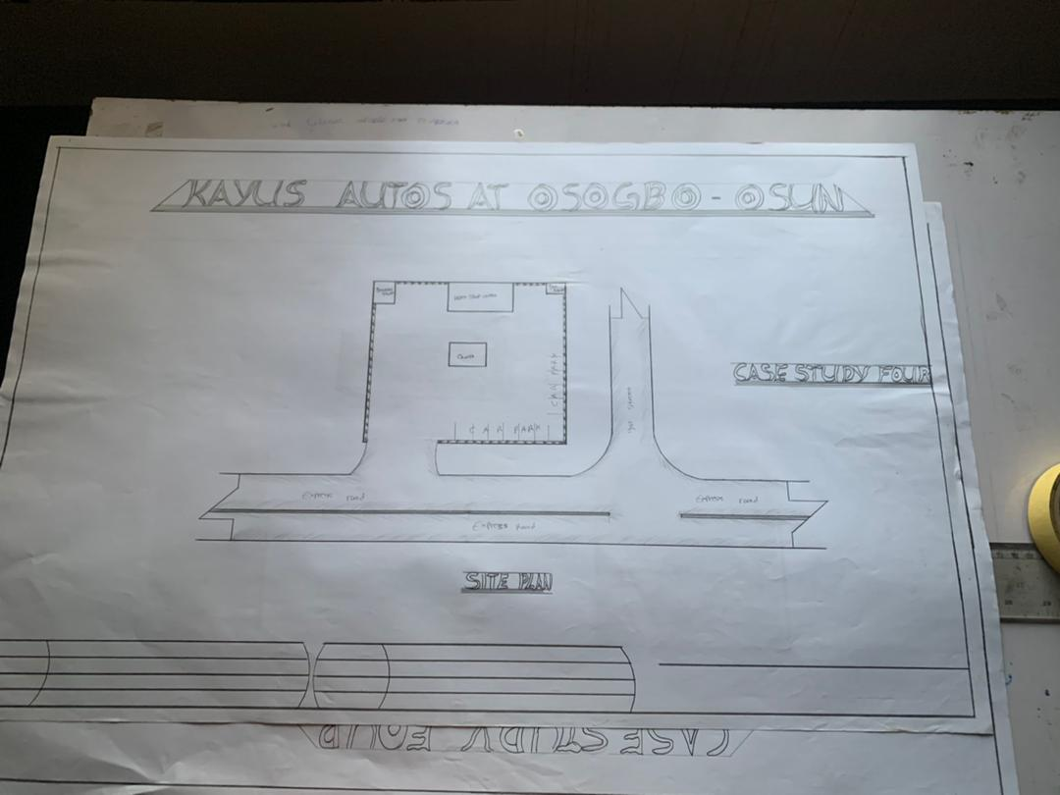
FIG 3.3.5: SHOWING FLOOR PLAN OF CASE STUDY THREE

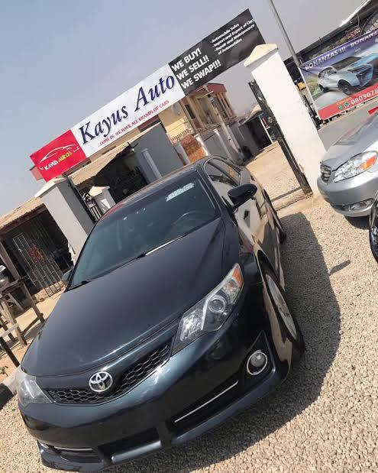
PLATE 3.2.4: SHOWING THE FRONT VIEW OF CASE STUDY THREE
PLATE 3.2.4: SHOWING THE FRONT VIEW OF CASE STUDY TWO

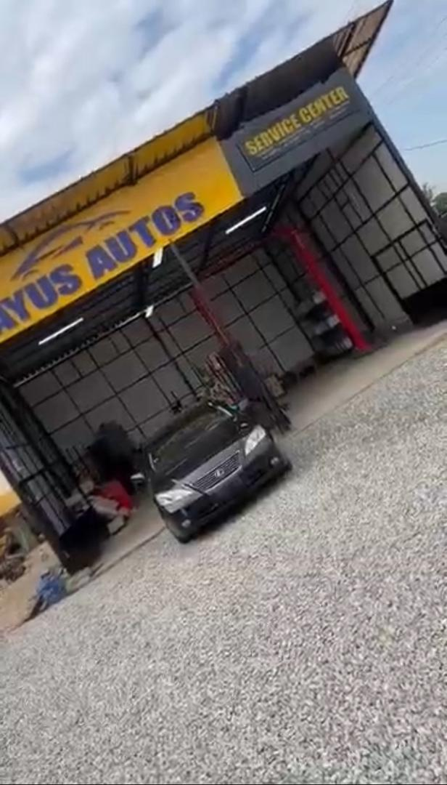
SHOWING THE INTERNAL VIEW OF CASE STUDY FOUR

3.5 Case Study 4 (Online) canada Automobile worshop
SHOWING FRONT VIEW OF CASE STUDY FOUR
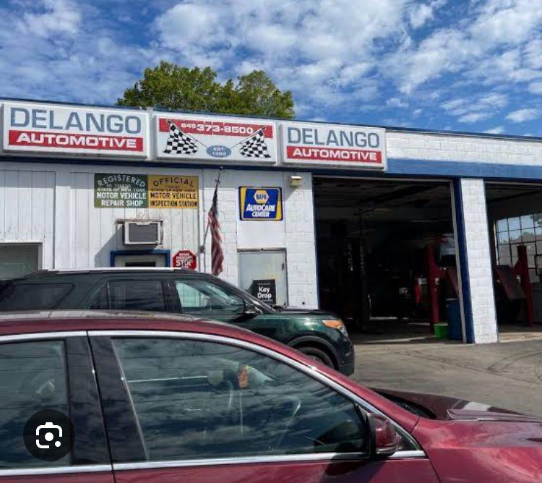
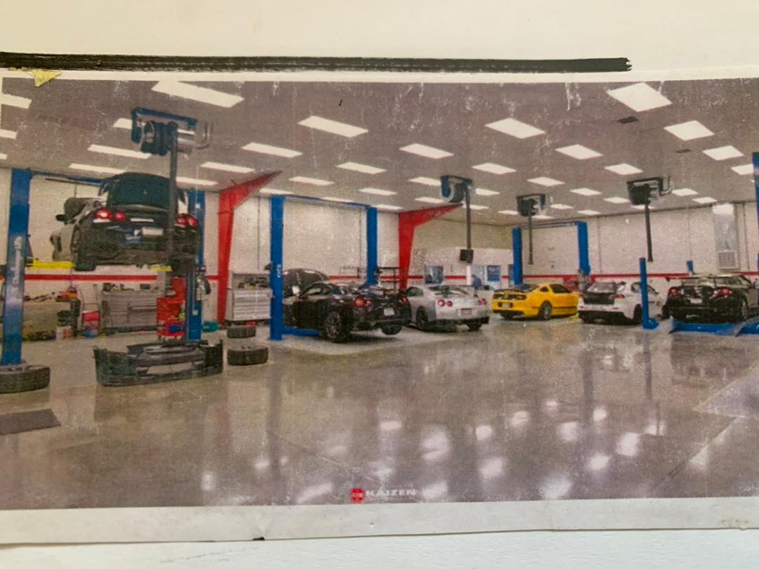
SHOWING INTERNAL VIEW OF CASE STUDY FOUR
3.5 Case Study 5 (Online)
Location: GERMANY

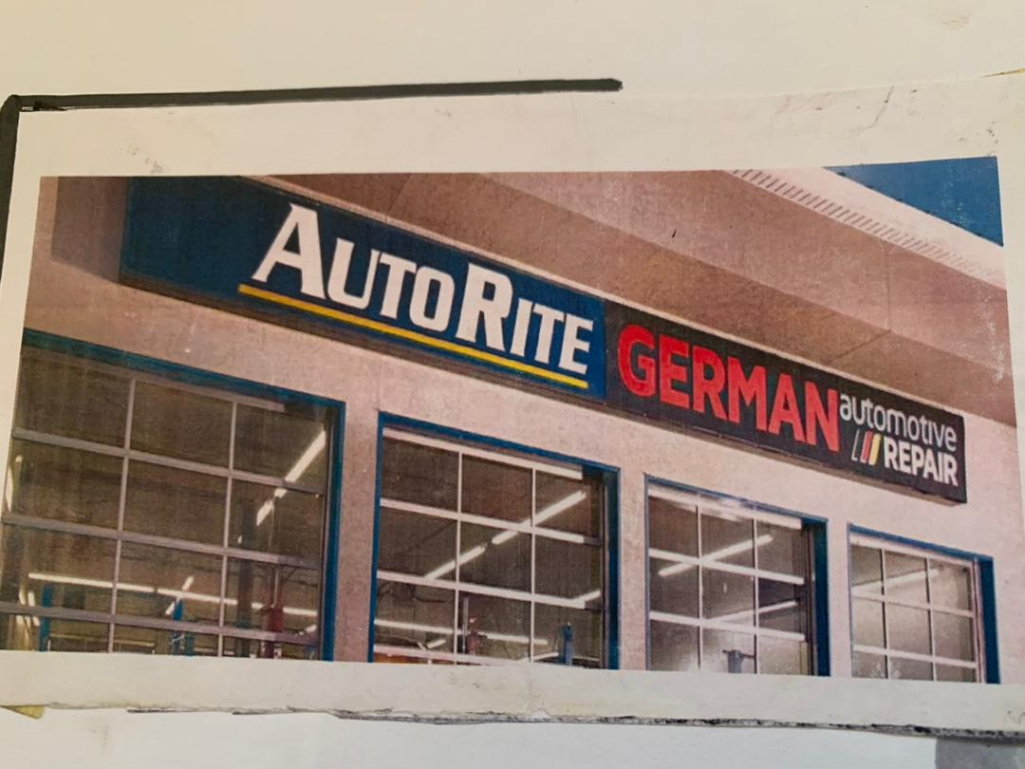
SHOWING THE FRONT VIEW OF CASE STUDY FIVE
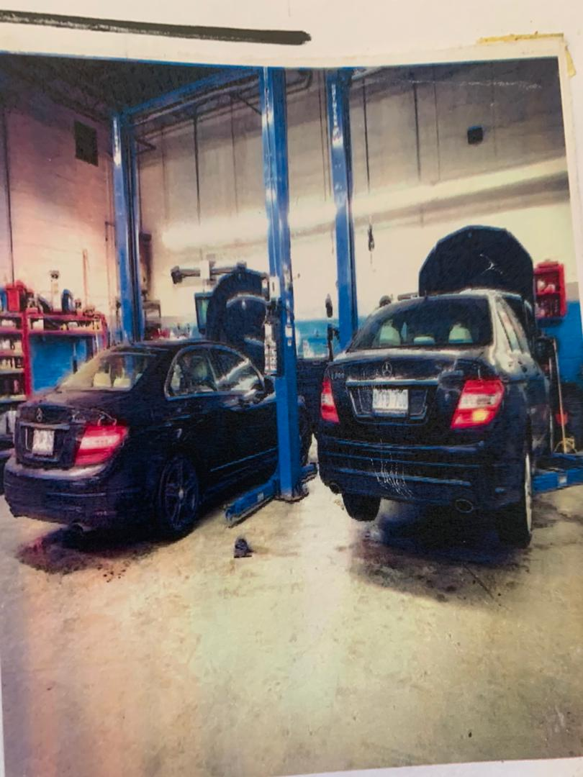
SHOWING THE INTERNAL VIEW OF CASE STUDY FIVE

CHAPTER FOUR
Design Proposal
4.0 Introduction
This chapter discuss and analyse the proposed site, analysis of its location and an in-depth study into the reasons for the selection of the particular site for the design. Site analysis of the proposed site will be carried out to show suitability of the proposed site for the design of anautomobile work shop.
4.1 Brief history
Ilorin, the capital of Kwara State in Nigeria, was founded around 1450 by a Yoruba hunter named Ojo Isekuse, who settled in the area due to its rich natural environment and fertile land. Originally a small Yoruba village, Ilorin grew in importance due to its strategic location between the northern and southern regions of Nigeria.
In the early 19th century, Ilorin underwent a significant transformation when it came under the influence of the Fulani jihad led by Sheikh Alimi, an Islamic scholar from Sokoto. His son, Abd al-Salam, became the first Emir of Ilorin, aligning the town with the Sokoto Caliphate and shifting its cultural identity from primarily Yoruba to a blend of Yoruba and Fulani traditions.
Ilorin became a major Islamic center and played a significant role in trans-Saharan trade, serving as a hub between the Hausa-Fulani of the north and the Yoruba of the south. Under colonial rule, Ilorin was incorporated into the Northern Protectorate by the British, despite its cultural ties to the Yoruba-speaking southwest.
Today, Ilorin is known for its religious harmony, educational institutions (notably the University of Ilorin), and its role as a commercial and administrative center in Nigeria.
4.2 Site Location
The site is located at The site is located along Harmony estate road, Beside abba nura filling station , Ilorin, Kwara State is one of the states in Nigeria, at coordinates 6.5244N, 3.3792E located in the southwest of Nigeria.

4.2.1 Site Location Map
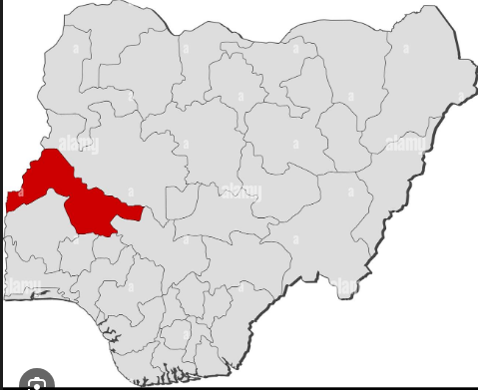
Figure 4.1 Map of Nigeria showing location of kwara State
Source: Google images

4.2.2 Site Selection Criteria
The site was selected based on the following category;
- Location
- Ease of access
- Availability of enough land
- Security
- Nature of the site and vegetation
- Good infrastrutures
- Business district

- Location:
The site is located along harmony Estate Road, Beside abba Nura filling station , Ilorin, Kwara State.
- Ease of Access:
The site can be accessed easily as there is an existing road that leads to it.
- Availability of Enough land:
To adequately provide for the various facilities required in the building and on the site, the area of land required for the project must be adequate. Therefore, the site was selected because it is wide enough to accommodate the proposed design.
- Security:
The site is located in well secured area in the part of the state .
- Nature of Site and Vegetation:
The topography of the site is fairly levelled and the slightly unlevelled part can be adequately levelled. The sub soil is mainly red lateritic soilwith barches of sandy soil. The site also contains few trees and shrubs, which can help enhance the landscape of the site.
- Good infrastructure:the proposed site is positioned in a well developed considering the availability of good roads networkings, availability dranages e.t.c
- Business district:the proposed site is within or near a central business district (CBD) or established commercial hub which provides visibity, accessibility and enable synergy with nearby corprate.

4.3 Site Characteristics
4.3.1 Soil type
The site is characterized bysandy, loam soil, suitable for medium to highrise structures. A geotechnical investigation confirmed the soil bearing capacity is adequate for the proposed building’s structural loads.
4.3.2 Vegetation
The vegetation on the site consists of few trees of different species and shrubs. Some trees and shrubs will be retained to enhance the landscape of the site, and also act as wind-breakers and dust filters during the harmattan.
4.3.3 Topography
The topography of the site is fairly levelled and the slightly unlevelled part can be adequately levelled.

4.3.4 Drainage
There is no existing drainage on the site, so drainage would be constructed.
4.3.5 Accessibility
The site is accessible by an existing road along the adjoining buildings which leads to the site.
4.3.6 Climate
kwara is one of the cold regions in Nigeria with an average daily high temperature of only 31 degrees centigrade. High humidity and hot temperatures make the weather at times pleasant but also tropical humid. It is warm to hot all year round and invites to bathe at average water temperatures of 27 degrees. Due to the lesser rain the best time for traveling is from November to March. Most precipitation decrease from June to October.
- Hours of sunshine per day

Figure 4.3 Hours of Sunshine per day
Source; Worlddata.info
The number of hours of sunshine refers to the time when the sun is actually visible. That is, without any obstruction of visibility by clouds, fog or mountains. With 7 hours per day, February is the sunniest month in the state of kwara. In August the sun shines the shortest.
- Rainy days per month
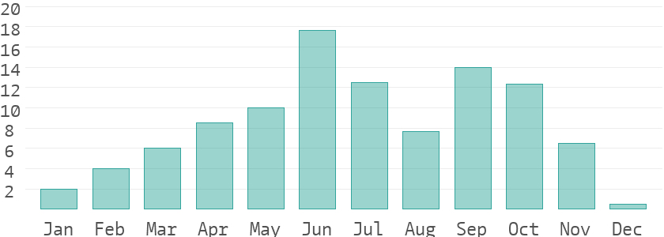
Figure 4.4 Rainy days per month
Source; Worlddata.info
A rainy day is a day on which at least an amount of 0.1 mm precipitation (=0.1 liter) per square meter falls. This can be rain, snow, hail or even dew. So it does not have to rain the whole day. With 18 rainy days, June offers the most number of rainy days, and in December the least.
- Precipitation in mm/day

Figure 4.5 Precipitation in mm/day
Source; Worlddata.info
The amount of precipitation is measured in millimeters per square meter. Thus, at two mm/day, two litres of water fall on one square meter within 24 hours. With only 0.4 mm, the least rain falls in December. June, on the other hand, has the most rain.

- Water temperature
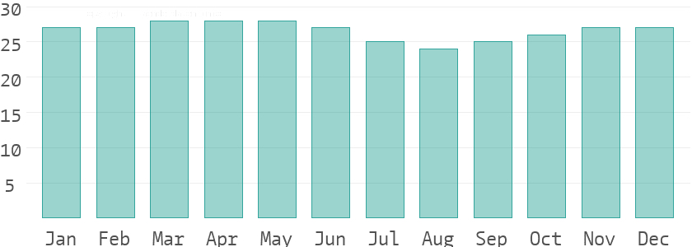
Figure 4.6 Water temperature
Source; Worlddata.info
Water temperature depends not only on solar radiation within the same region, but also on ocean currents. For example, depending on the season, cold or warm water masses are moved from other areas. The warmest temperatures in kwara are in March, when the water is 28 °C.
- Relative humidityin %
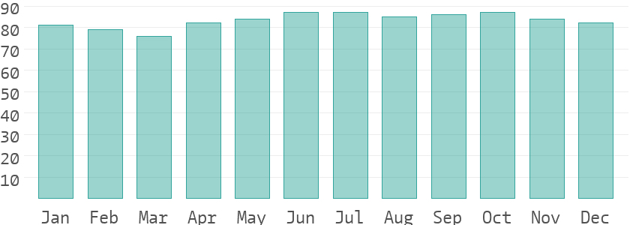
Figure 4.7 Water temperature
Source; Worlddata.info
Warm air can absorb more moisture than cold air. The relative humidity indicates how much moisture of the physically possible is actually contained in the air. At high humidity, the person feels uncomfortable and perceives this as oppressive. In general, a relative humidity of 40-60% gives as pleasant. With humidity averaging 87%, June is the most uncomfortable. In March, on the other hand, it is easier to endure.
4.3.7 Site Features and Infrastructure
The site features electrical lines which proposes that open power supply is promptly accessible inside the site.
Perfectly drained soil; soils water moves through easily to allow good soil aeration and at the same time sufficient amount is retained for plant growth.
Other features are water supply and an access road.
4.3.8 Noise Sources
There are no much noises on the site but the few noises that can be heard comes from the adjacent structures which are the existing around the site.
4.4 Site Analysis.
A site analysis involving a study of the site is carried out, it takes into consideration natural and man-made components present in and around the site, as well as climatic conditions of Lagos state. The plate below shows a schematic summary of the analysis of the proposed site.
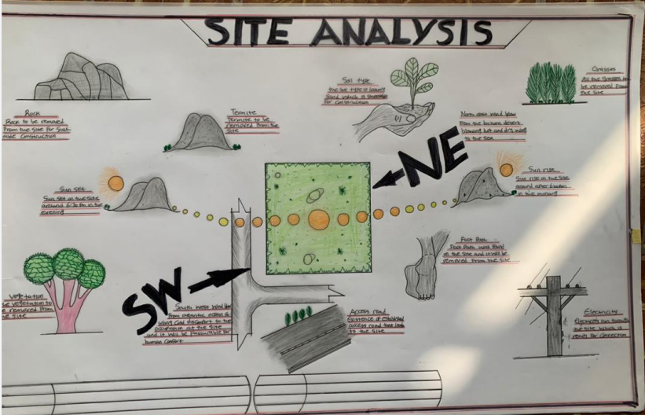
Plate 4.2 Site Analysis
Source; Authors fieldwork

- Rainfall:
Minimum rainfalls are recorded in December, while June offers the most amount of rainfall.
- Vegetation and Topography:
The vegetation on the site consists of few trees of different species and few shrubs. The site is relatively gentle sloping and has a high load bearing capacity soil.
- Prevailing Wind Direction & Sun-Path Angles
The two predominant winds blowing across this area are the South West Trade wind and the North East Trade wind. The former, which blows across the Atlantic Ocean, is characteristically cold and results in the wet season. Being a cold wind, it is capable of holding much moisture contents across the ocean, and hence an increase in relative humidity of the area affected. However, the North East Trade wind, which blows across the Sahara Desert, is dusty and dry wind. Consequently, the two predominant seasons experienced in this area are characteristically marked by the two wind types. The summer (the season between spring autumn when the sun is hot and there are many flowers) is experienced between April and September, when the south west Trade wind is more predominant, while the winter season is shortly marked between November and March, when the north east trade wind is more predominant. This later season {winter} is however characterized by cool and hazy mornings, couple with dusty afternoons, because of the dust particles it brings forth from the desert. To reduce the effects of wind driven, trees were planted.

- Sunrise and sunset:
The sun rises from the east in the early hours of the morning at about 6:30am - 7:00 am and sets in the west at about 6:45 pm in the evening daily.
- Accessibility:
The site is accessible by an existing road along the adjoining buildings which leads to the site.
- Man-made features

- Electricity: Electricity is supply to the site through overhead cables along the site boundary.
- Footpath: There areexisting footpaths on the site which will remove from the site
- Noises: Caused by adjacent structures
  - Proposed Design
The proposed design of the office complex building is conceptualized to reflect a modern, environmentally responsive, and highly functional workspace tailored to meet the dynamic needs of contemporary businesses. The design is rooted in the core objectives of sustainability, flexibility, functionality, and aesthetic excellence, while also responding sensitively to the environmental, infrastructural, and socio-economic context of the selected site.​
4.5.1 Design Considerations:
The following are the factors considered when designing the building;
- Site planning and zoning: Sustainability is a core design principle, with strategies aimed at reducing the building’s environmental impact over its lifecycle. E.g Use of locally available and renewable materials, Natural lighting and ventilation to reduce energy demand.
- Functionality: In any architectural design, functionality plays major role, design must be functional to meet the taste and convenience of the occupants.
- Ventilation: This includes the orientation of the building, sizes and locations of fenestrations, vegetation.
- Circulation and Zoning: Appropriate and well-articulated pattern of circulation in a building alleviates confusion and at the same time tailor the movement of students to their respective destination.
- Landscaping: The form of landscaping in the building is aimed at satisfying user requirements, having aesthetic value and improving environmental comfort. Hence, landscaping will be considered in the design
- Security: The provision of security in the office complex buildinginvolves the protection of the students, the building and its contents.
4.5.2 Design Concept
The design approach was based on functionalism, which is an architectural principle that says that building should be designed based solely on purpose and function of the building.
4.5.3 Brief Analysis
The proposed design is the design of a Automobile with emphasis on sustainable and aesthetically pleasing.
The office complex building is to provide the business and services with accommodation facilities and other functional spaces and facilities. These facilities include:
- Entrance
- Reception
- Manager Office
- Accountant Office
- Control Room
- Conference Room
- Work Shop
- Changing Room
- Stores
- Workshop Supervisor Office
- Toilets
- Exits
4.5.4 Schedule of Accommodation
Table 6.1 Schedule of Accommodation
S/NO | SPACE | UNITS | DIMENSION(M) | AREA(M2)
1 | Entrance | 1 | 1.5*1.5 | 2.25
2 | Reception | 1 | 11.0*7.0 | 77.0
3 | Director Office | 1 | 4.0*2.5 | 10.0
4 | Accountant Office | 1 | 4.0*2.5 | 10.0
5 | Manager Office | 1 | 5.0*3.0 | 15.0
6 | Conference Room | 1 | 5.0*.9 | 9.75
7 | Control Room | 1 | 4.0*5.0 | 20.0
8 | Store | 1 | 4.0*.5 | 12.0
9 | Toilet | 4 | 2.0*1.5 | 3.0
10 | Lobby | 1 | 2.0*5.0 | 10.0
11 | Changing Room | 4 | 5.0*2.5 | 12.5
12 | W-Store | 1 | 5.0*8.0 | 40.0
13 | W-Supervisor | 1 | 3.0*3.0 | 9.0
14 | W-Waiting Area | 1 | 5.0*5.0 | 25.0
15 | W-Toilet | 6 | 1.5*1.5 | 2.25
16 | Mechanical Units | 18 | 4.0*7.0 | 28.0
17 | W-Entrance | 2 | 5.0*1.0 | 5.0
Source: Author’s fieldwork (2025)
4.6 Specifications and Construction
4.6.1 Material and Finishes
The materials and finishes used plays a vital role to the level of sustainability in the building. To also enhance fire safety in the building, several factors need to be considered in the selection of material and finishes. Material and finishes to be used will be discussed further.

4.6.1.1 Walls
Block work will be used in conjunction with reinforced concrete columns. For each fire compartment the blocks will be filled with concrete to increase its resistance to fire and also reduce the spread. Stone trowel paint or graphitex trowel paint can be used as finishes on the wall as natural stone definitely has inherent fire resistance.
4.6.1.2 Floors
The flooring system is designed to handle heavy loads and resist oil, chemical spills, and abrasion. In the service areas, polished reinforced concrete with epoxy resin or hardener finish will be used. Non-slip tiles or vinyl flooring will be applied in administrative, toilet, and customer areas for safety and hygiene.
4.6.1.3 Ceiling
Ceilings in the administrative and customer areas will feature suspended acoustic panels to control noise and conceal services. In the workshop and service zones, open ceilings will be used with exposed structural and mechanical elements, treated with protective coatings to ensure durability and ease of maintenance.
      - Roof
the roof will be constructed using lightweight steel trusses and covered with long-span insulated metal roofing sheets for thermal comfort. Provision will be made for skylights and roof ventilators to enhance natural lighting and airflow within the workshop.
      - Windows and Door
Windows will be aluminum-framed with louvered or sliding sections, fitted with shatterproof glass for safety and ventilation. Doors will vary in material and functionsteel roller shutters for service bay entrances, flush doors for offices and restrooms, and tempered glass doors for customerfacing areas.
4.6.2 Structural System
The structural systems of the proposed project (divided into sub-structure and super-structure) include foundation, walls, columns, beams, roof, etc.
- Sub-structure (Foundation)
A foundation is the lower portion of a building structure or substructure that transfers all coming load of the structure to the ground. The foundation system must distribute vertical loads and hold the super structure of the building against uplift and racking forces.
The nature, texture and composition of the soil in the site show that it has a high load bearing capacity. The use of a deep strip foundation is being proposed.
- Super-structure
The super-structural systems such as walls, floors and roofs of the proposed office complex buildingshall be constructed with adherence to the specifications already stated under the materials and finishes section.
  - Chapter Summary
This chapter has detailed the construction specifications and material selections for the automobile workshop, emphasizing durability, functional performance, and compliance with safety and environmental standards. The structural system and integrated building services support the operational requirements, while landscaping contributes to the external environment and brand perception.
  - Planning Principle
The planning of the automobile workshop is guided by principles that ensure functionality, safety, accessibility, and sustainability. The layout is zoned to separate public, semi-public, and technical areas, allowing for a smooth and efficient workflow. Vehicle and pedestrian circulation are clearly defined to minimize conflicts and enhance operational flow. Safety is prioritized through the inclusion of proper ventilation, drainage systems, emergency exits, and security features such as perimeter fencing and controlled access. The design also allows for flexibility and future expansion by adopting a modular layout that can accommodate technological upgrades, such as electric vehicle servicing. Environmental sustainability is integrated through the use of natural lighting and ventilation, rainwater harvesting, and renewable energy sources. Aesthetic considerations are also addressed to present a modern and professional image, while the entire plan complies with local building regulations and planning standards to ensure structural and legal integrity.

CHAPTER FIVE

5.0 Design appraisal
5.1Introduction
This chapter provides a detailed evaluation of the proposed design for the automobile workshop. It covers critical aspects such as the design appraisal, structural system, and building services that support the facility's functionality and efficiency. Each component is assessed in terms of how well it aligns with the project’s objectives of functionality, structural integrity, and operational sustainability. The chapter concludes with a summary of key findings and a final conclusion that reflects on the overall success and readiness of the design for implementation.
5.2 Design appraisal
The design of the proposed automobile workshop is appraised based on its functionality, spatial organization, aesthetics, and compliance with architectural standards. The layout demonstrates a clear separation of spaces, with distinct zones for reception, administrative offices, service bays, storage areas, and customer waiting areas, thereby ensuring an efficient and uninterrupted workflow. Circulation for both vehicles and pedestrians is well planned, promoting ease of movement and safety within the facility. The design adopts durable, low-maintenance materials suited to the heavy-duty nature of the operations, while structural elements are arranged to allow wide, open service bays free of obstructions. Attention is given to natural lighting and ventilation through the use of skylights and louvered openings, reducing energy consumption and enhancing the internal environment. Aesthetically, the design maintains a professional and modern appearance, reinforcing the identity and credibility of the workshop. Overall, the appraisal reflects a design that is practical, flexible, and well-suited to the operational and environmental needs of a contemporary automobile service facility.

5.3Building Service

- Power Supply.
The main source of power supply to the proposed building will be from the University’s PHCN. Due to the fluctuation in power from PHCN, it will be connected to the university independent power source to cater for the requirements of the hostel.
- Lighting
The effect of natural lighting was greatly considered within the building. This factor is one which is largely considered in buildings. Adequate fenestration is provided within each space for effective luminosity, the courtyards also aid natural lighting flow, artificial lighting will be in the form of incandescent luminaries which will maximize direct light into the space.
- Ventilation
Natural ventilation also is achieved in the building spaces through cross openings in all spaces provided with special interest on the direction of the southwest wind on site. Courtyard, Large air spaces and adequate openings are some design strategies put in place to achieve proper ventilation within the building. The ventilation system is a hybrid of both natural and artificial means. Temperature is controlled actively with the use of mechanical fans.
- Plumbing and Electrical Installation
Mechanical and electrical installations within the building are done through conduits pipes passed through specially moulded conduit wall; this is in other to ensure that services are concealed in the walls therefore giving the walls neater finish.
- Water Supply
The major source of water supply for the site is through the use of bore holes channeled to other parts of the building and site through the use of pipes. Consequently, overhead water storage tank will also be utilized as a storage facility and use in time of water shortage on campus. This will help in fighting fire in case of any outbreak.

- Drainage and Sewage Disposal
Surface water will be drained out to the direction of flow towards the topography of the site while an underground system of sewage disposal such as inspection chambers, septic tanks and soak away pit shall be utilized through the connection of 300mm poly vinyl chloride (PVC) channels and pipes.
- Refuse Disposal
Solid waste from site is collected by placing dustbins, open cans and baskets at strategic positions in every facility provided in the hostel.
​5.3.1 Landscaping and External Works
External works will include well-paved driveways, parking bays for staff and customers, and green areas for environmental appeal and stormwater management. Landscaping will consist of hardy, low-maintenance plants suited to the local climate. Signage, perimeter fencing, drainage systems, and lighting will enhance both security and aesthetics.

5.3 summary and conclusion
This chapter has provided a detailed assessment of the proposed design for the automobile workshop, focusing on its functional layout, structural system, and essential building services. The design appraisal confirmed that the spatial planning effectively separates public, semi-public, and technical areas, ensuring efficient workflow and safe circulation for both vehicles and personnel. The structural design adopts durable materials and a wide-span system suitable for heavy-duty operations, while the building servicesincluding lighting, ventilation, plumbing, and fire safetyare well-integrated to support smooth and sustainable operation.
In conclusion, the design meets the key objectives of functionality, durability, safety, and adaptability. It incorporates principles of modern architecture while addressing the practical needs of an automotive facility. The building is also designed to accommodate future expansion and emerging technologies, such as electric vehicle servicing. Overall, the proposed automobile workshop stands as a functional, efficient, and future-ready facility, capable of delivering long-term value to its users and stakeholders.

5.4 summary
Chapter Five presents a comprehensive evaluation of the proposed automobile workshop design. It begins with a detailed design appraisal, which highlights the effectiveness of the spatial layout, circulation, material selection, and aesthetic value of the project. The chapter also examines the structural system, emphasizing its stability, durability, and adaptability to the functional needs of the workshop. In addition, the required building services such as electrical supply, water systems, mechanical ventilation, and fire safety installations are discussed, showing how they support smooth and safe operations within the facility. Multiple summaries are provided to reinforce key observations from the design appraisal, structural analysis, and service integration. Altogether, this chapter confirms that the design is functionally sound, structurally efficient, and operationally ready to meet both current demands and future expansions.
5.5 Conclusion
The evaluation presented in this chapter confirms that the proposed design for the automobile workshop successfully addresses the critical aspects of functional efficiency, structural integrity, service integration, and environmental responsiveness. The design demonstrates a well-organized spatial layout that supports smooth operational flow, user safety, and comfort. The selected structural system and materials provide durability and flexibility, while the inclusion of essential building services ensures that the facility can operate effectively and sustainably. Aesthetic considerations and compliance with regulatory standards further strengthen the design’s viability. In conclusion, the proposed workshop design stands as a comprehensive and practical solution capable of meeting present needs and accommodating future developments in the automotive industry.

REFERENCES

Kohn, M., Katz, W., & Kohn Pedersen Fox Associates (2002). Office Buildings: a Design Manual. Birkhäuser define an office complex building as and open planed areas that accommodates multiple office.
Adebayo, A. A. (2000). Climate design for energy efficiency in buildings. Journal of Environmental Design, 1(2), 56–63.
Ajayi, M. T., & Afolabi, A. O. (2019). Design and sustainability: An assessment of Nigerian office buildings. International Journal of Architecture and Built Environment, 7(1), 35–47.
Chudley, R., & Greeno, R. (2016). Building Construction Handbook (11th ed.). Routledge.
Edwards, B. (2005). Rough Guide to Sustainability: A Design Primer. RIBA Publishing.
Federal Republic of Nigeria. (2006). National Building Code. Lagos: Federal Ministry of Housing and Urban Development.
Meek, J. (2014). Office Buildings: A Design Manual. Birkhäuser.
Mohammed, A. B. (2012). Sustainable development in architectural design: A case study of selected office buildings in Abuja. Nigerian Journal of Sustainable Design, 3(2), 18–26.
Ogunsemi, D. R. (2001). The Construction Industry and its Socio-economic Significance. Akure: FUTA Press.
Oluyemi, A., & Odusami, K. T. (2013). Modern office design and user satisfaction in Lagos. Nigerian Journal of Architecture, 11(4), 22–33.
Smith, P. F. (2001). Architecture in a Climate of Change: A Guide to Sustainable Design. Architectural Press.
U.S. Green Building Council. (2013). LEED v4 for Building Design and Construction. Retrieved from https://www.usgbc.org
Unwin, S. (2014). Analysing Architecture (4th ed.). Routledge.
Neufert, E., & Neufert, P. (2012). Architects’ Data (4th ed.). Wiley-Blackwell.
Otegbulu, A. C. (2011). Greening the Nigerian built environment: Barriers and opportunities. Journal of Sustainable Development in Africa, 13(2), 172–184.
Oyedepo, S. O., & Adeyemo, S. A. (2014). Energy efficiency and sustainability in commercial buildings in Nigeria. Energy and Environment Research, 4(2)

APPENDIX
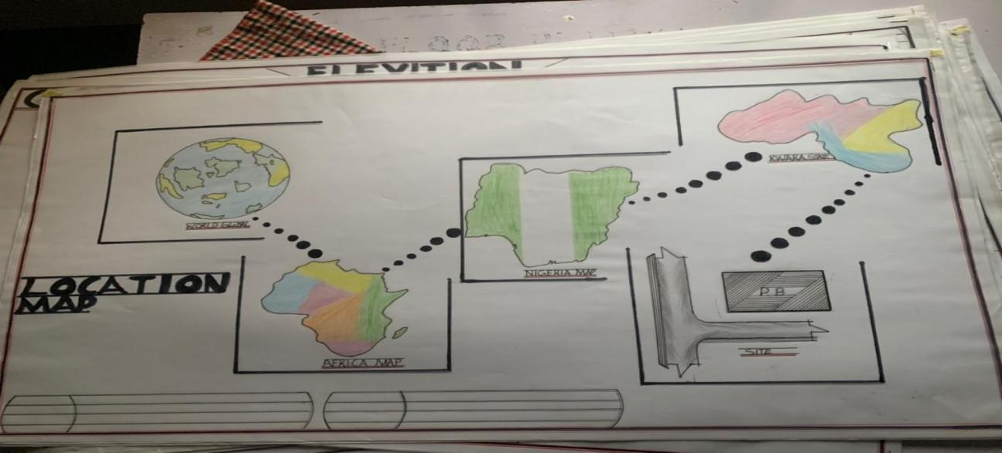

LOCATION MAP

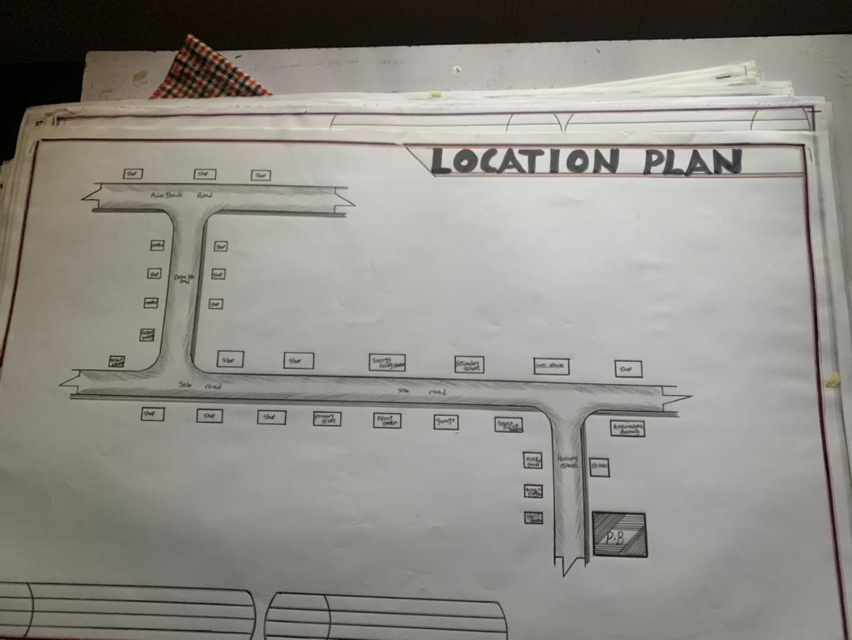

LOCATION PLAN
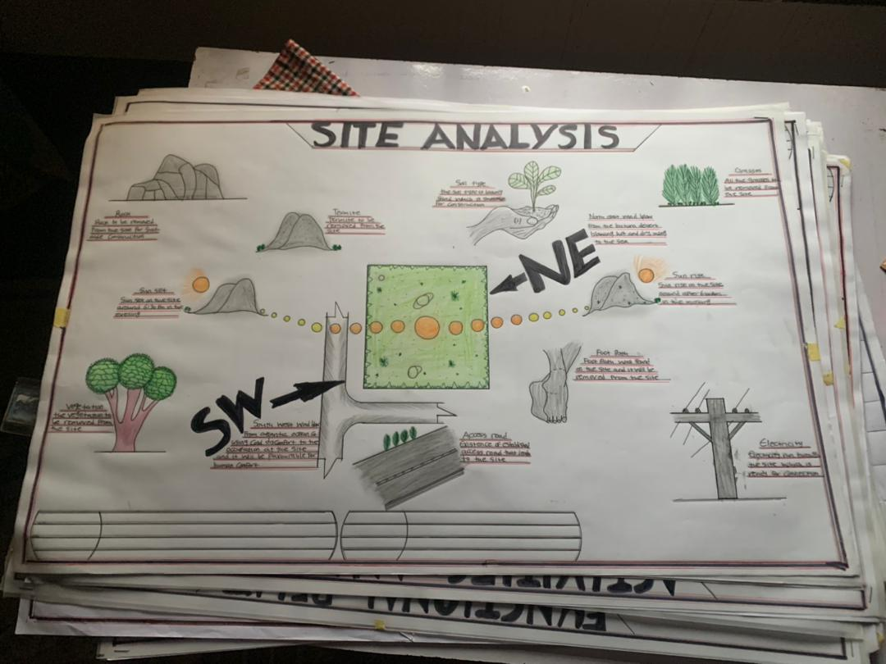

SITE ANALYSIS

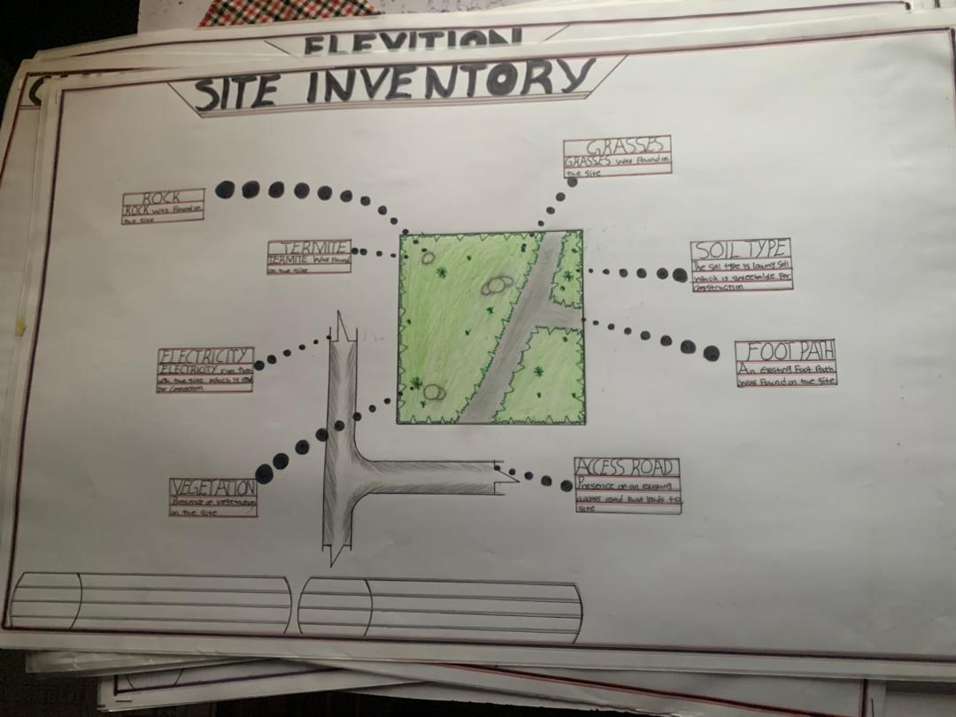

SITE INVENTORY

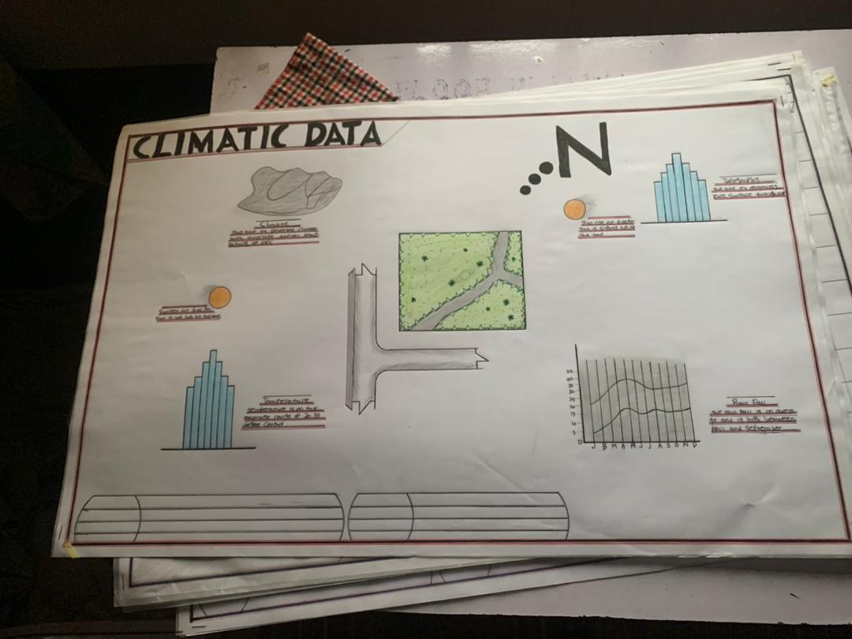
CLIMATIC DATA
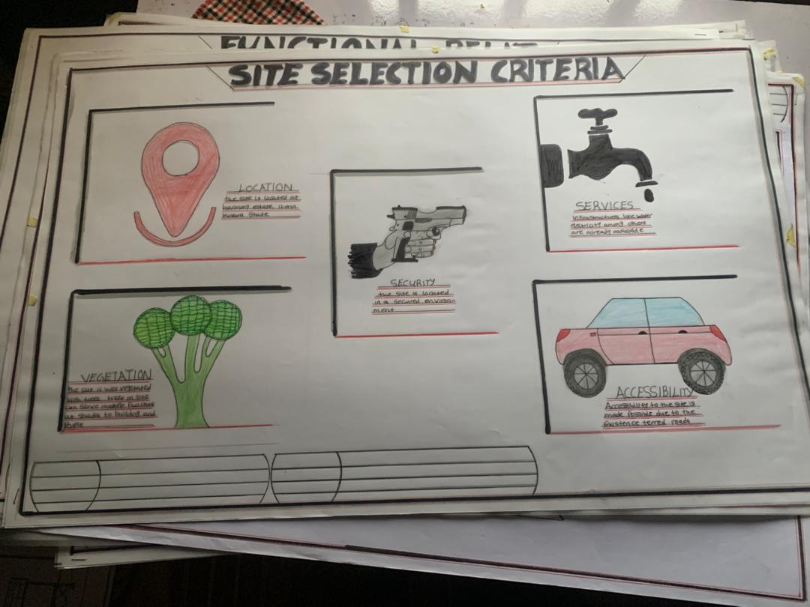
SITE SELECTION CRITERIA

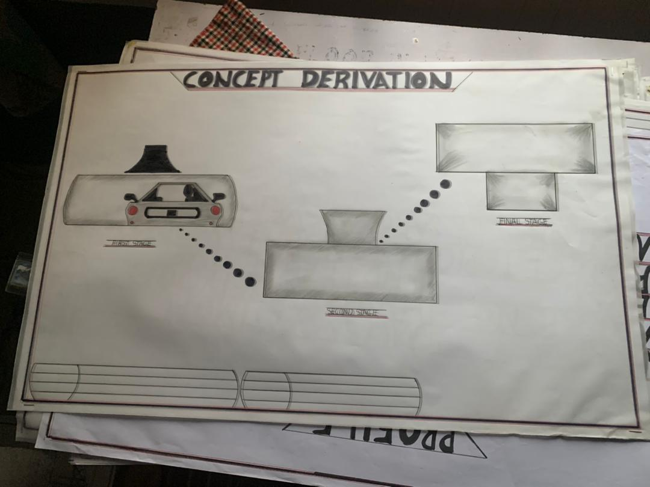
CONCEPT DERIVATION
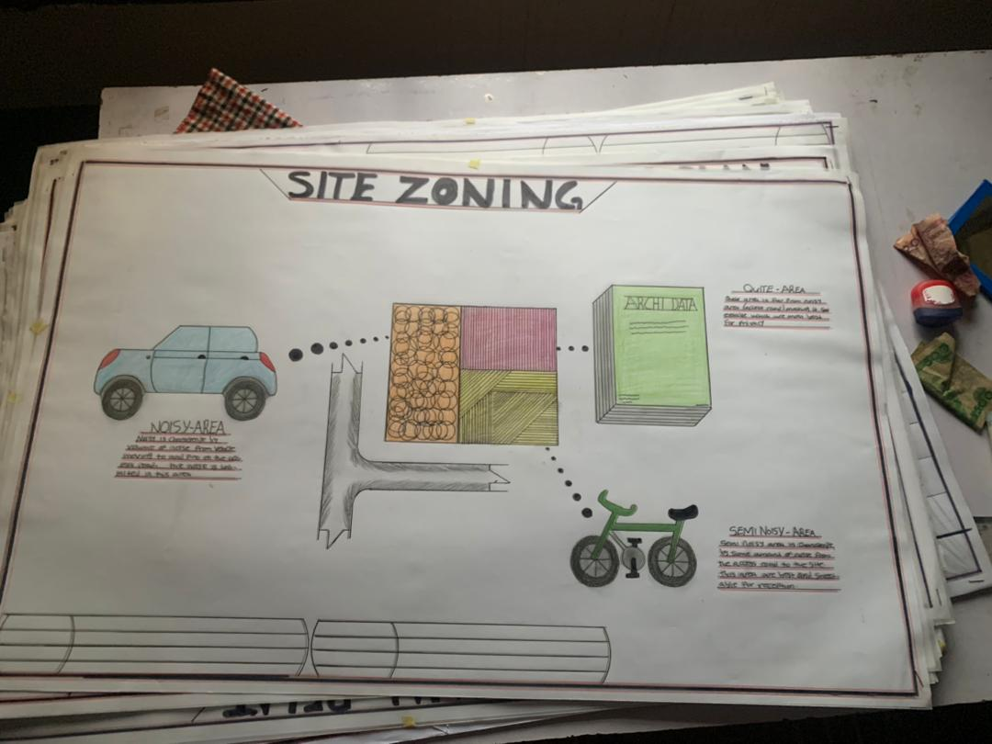
SITE ZONING

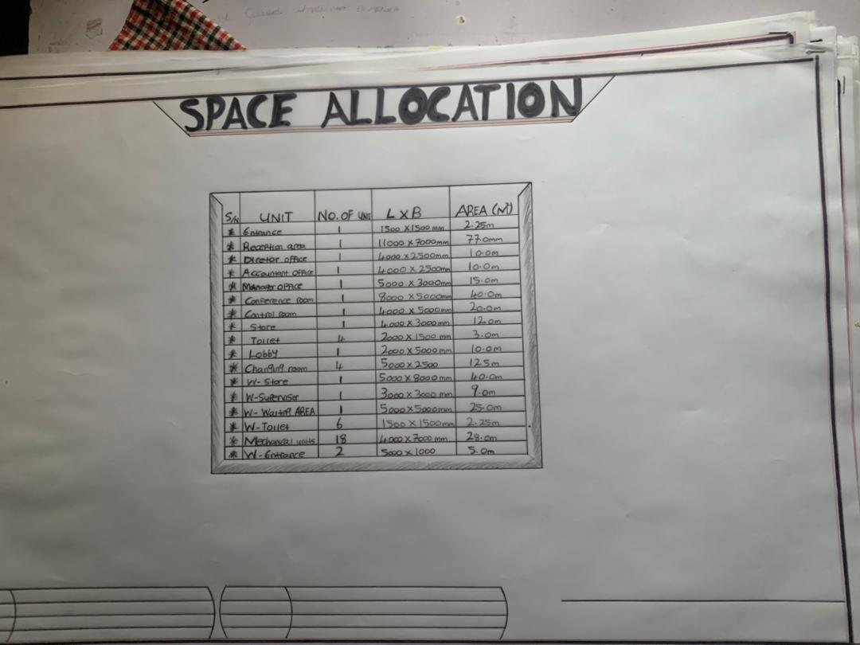
SPACE ALLOCATION
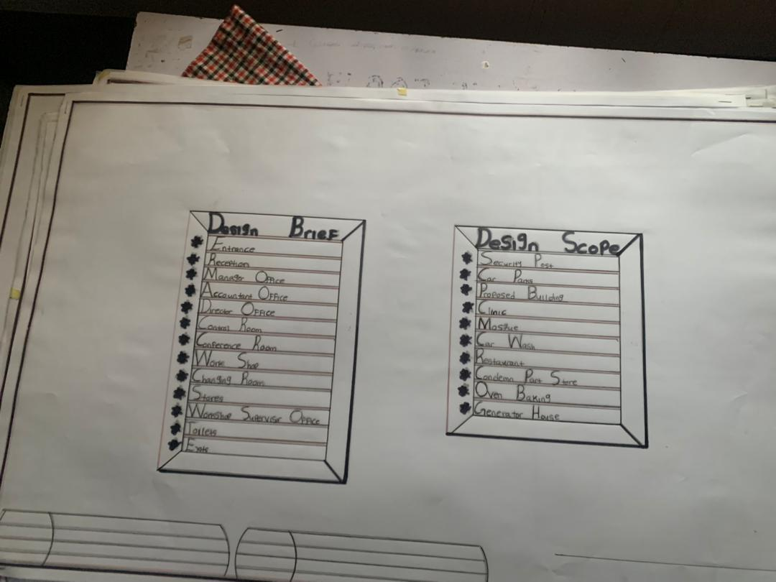
BRIEF AND SCOPE

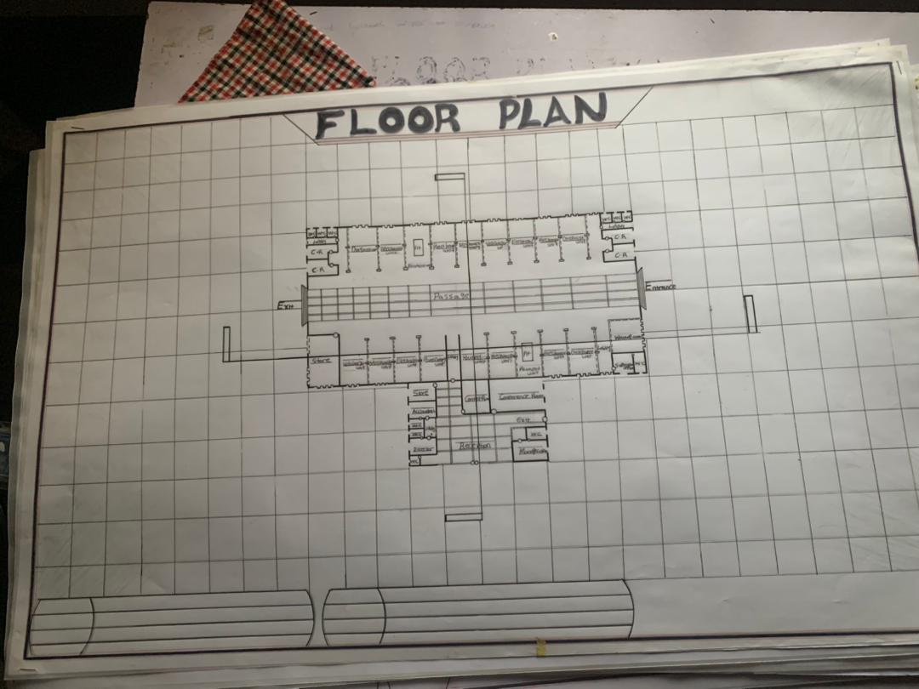
FLOOR PLAN
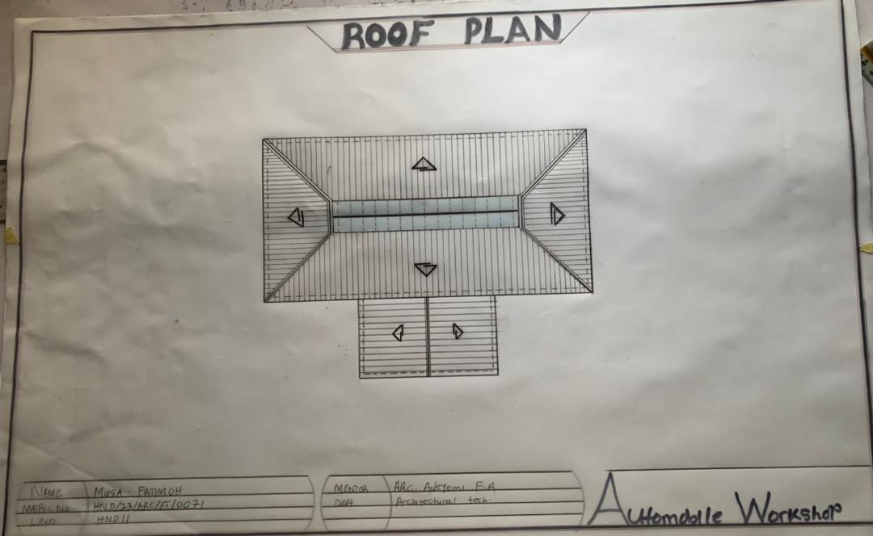
ROOF PLAN

ELEVATION
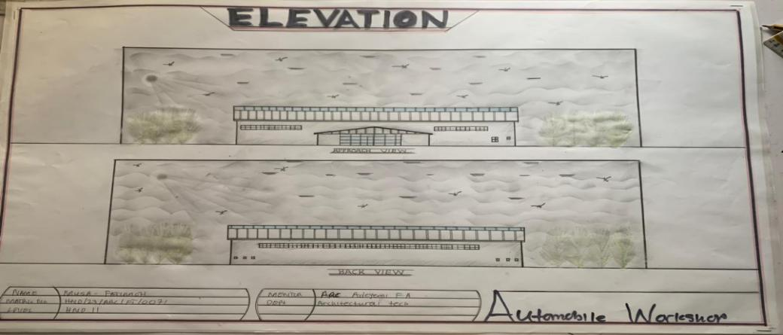

ELEVATION
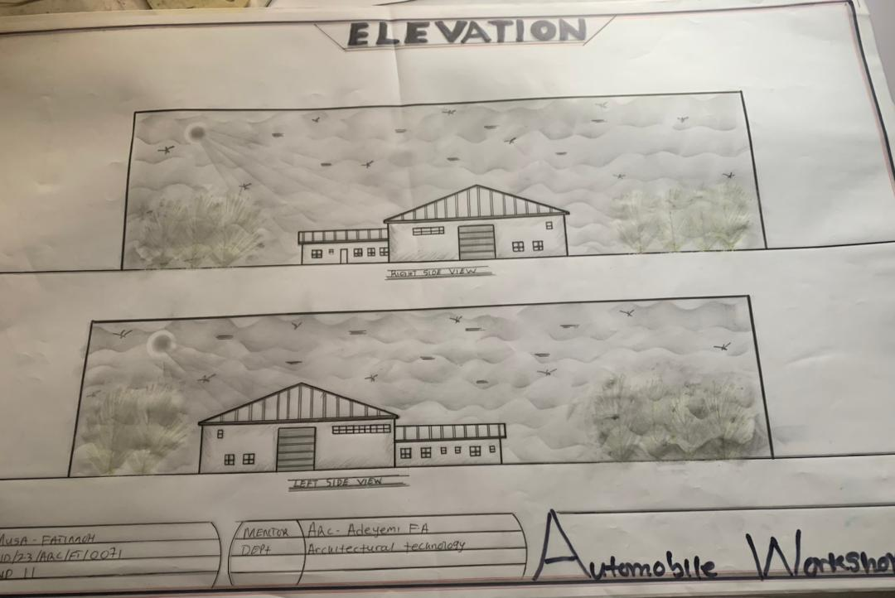

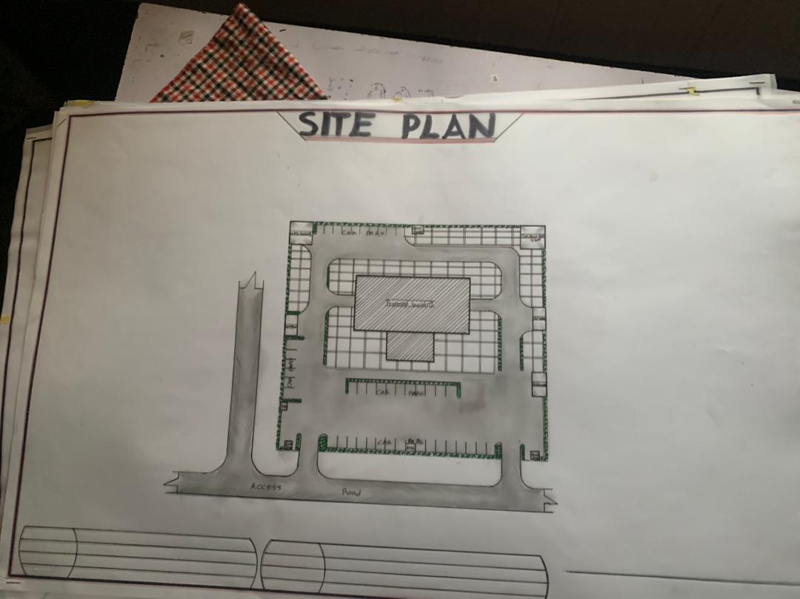
SITE PLAN
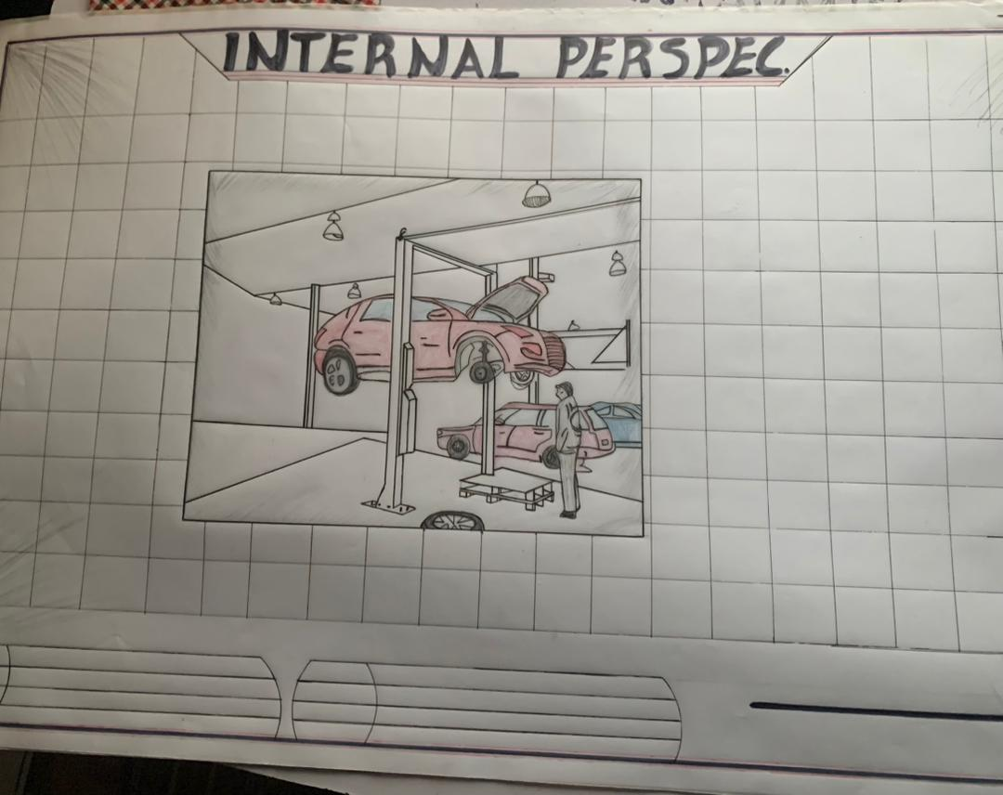
INTERNAL PERSPECTIVE

