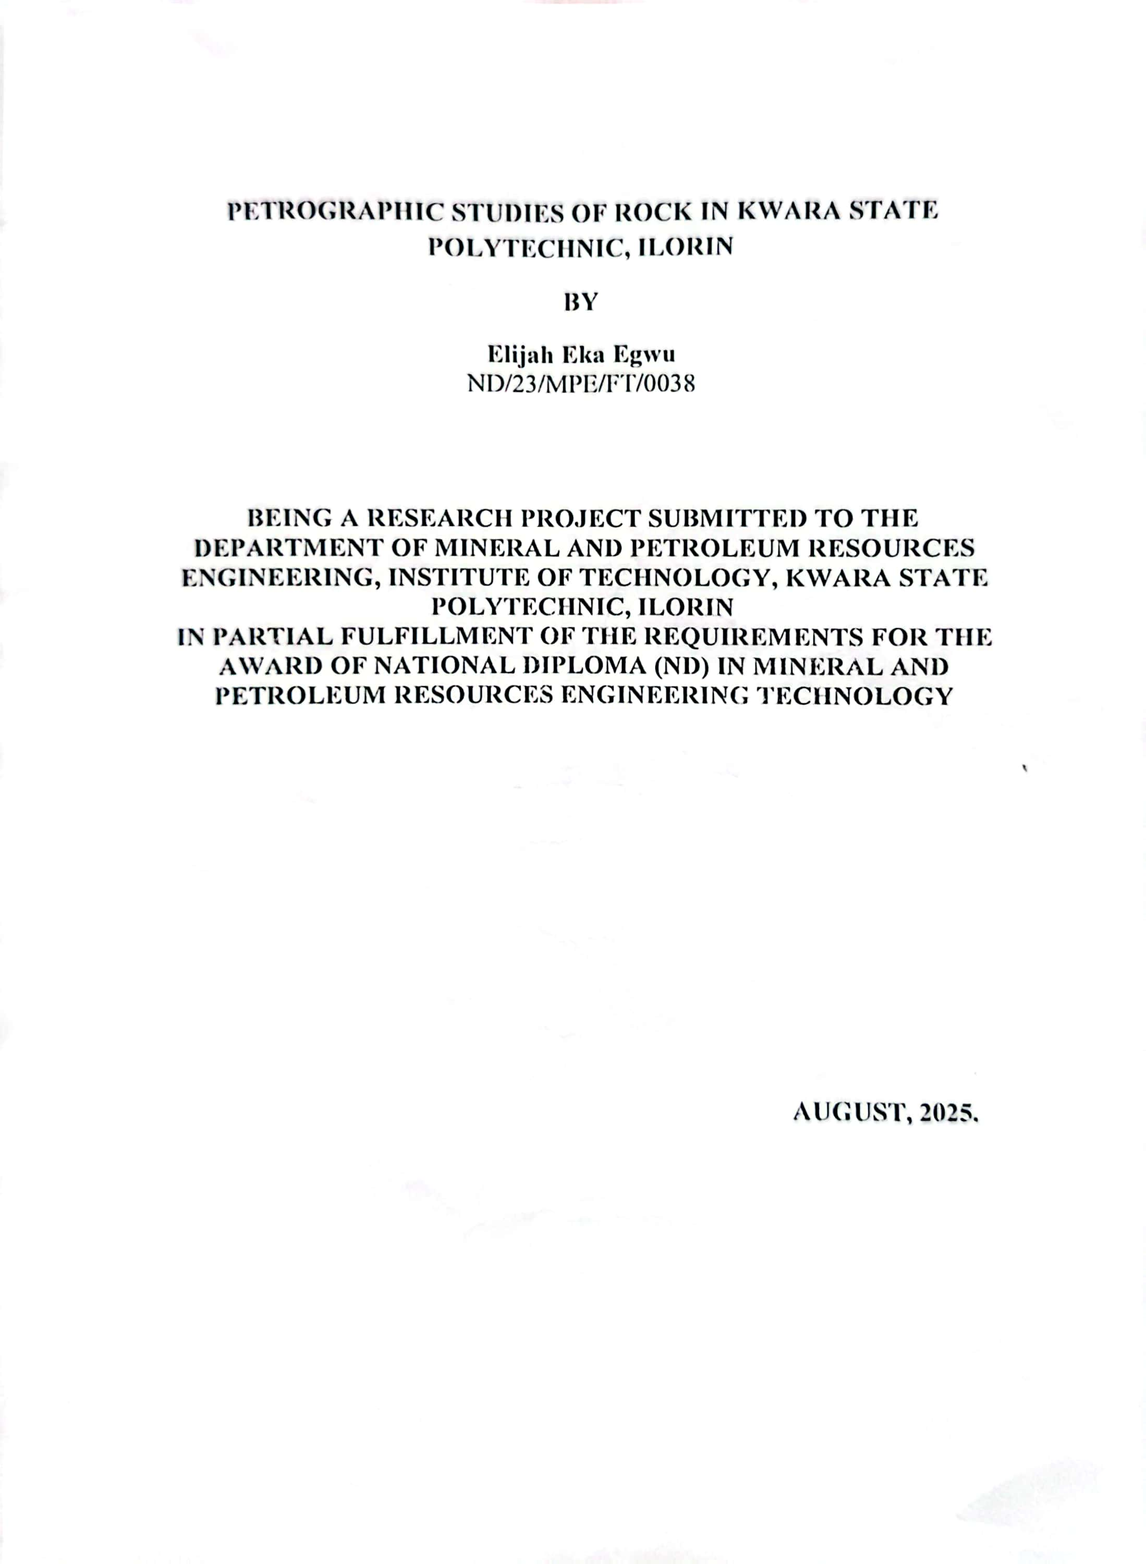
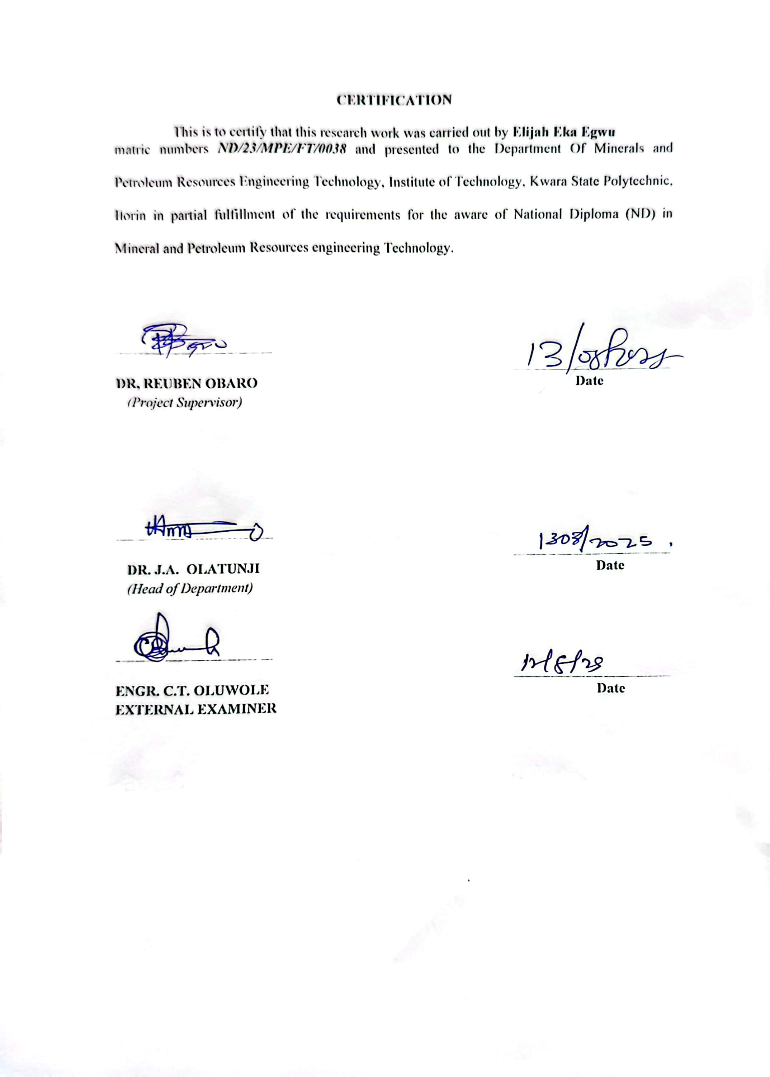
DEDICATION
I am delighted to dedicate this project to Almighty GOD, the creator of all universe who gave me the grace and opportunity to complete my National Diploma program and this research, may His name be glorified.

ACKNOWLEDGEMENTS
I give all the glory and adoration to Almighty GOD, the beginning and the End, for his greatest protection and love given to me as a privilege to start and complete this research work.
I wholeheartedly extend my special thanks to my amiable supervisor Dr. Reuben Obaro for his professional guidance and support towards the success of this project.

ABSTRACT
This study presents a detailed petrographic analysis of rock samples collected from various locations within Kwara State, Nigeria. The investigation aims to identify the mineralogical composition, texture, and classification of the rocks, as well as to infer their geological history and potential economic significance. Thin section petrography under a polarizing microscope was used to analyze the mineral constituents and textural relationships within the rocks. The findings reveal the presence of igneous, and metamorphic, with migmatite gneiss, porphyritics granite and biotite granite. The missed composite includes quarts, plagioclase and orthoclase feidspar, biotite, and hornblende which are all predominant in the studied area. The mineral assemblages indicate a complex geological evolution involving multiple tectonic and metamorphic events.Economically, the sampled rocks (Migmatite Gneiss, Porphyritic Granite and Biotite Granite) in the studied area have good potentials for engineering purposes. Industrially,the quartzite can be used as industrial silica sand, silicon and silicon carbide. It can also be used as decorative stone used to cover walls. It is also useful in flooring, star steps and as roofing tiles. It is sometimes used as railway ballast and also in road construction purposes such as bridges, building houses, road pavement.

TABLE OF CONTENTS
Title Page i
Certification ii
Dedication iii
Acknowledgement iv
Abstract v
Table of Contents vi
List of Figures ix
List of Tables x
CHAPTER ONE 1
1.0 Introduction 1
1.1 Background of the Study 1
1.2 Aim of the Study 2
1.3 Objectives of the Study 2
1.4 Problem Statement 2
1.5 Justification of the Study 2
1.6 Scope of the Study 2
CHAPTER TWO 3
2.0 LITERATURE REVIEW 3
2.1 Review of Previous Work 3
2.2 Occurrence of Rock 3
2.2.1 Occurrence of Igneous Rock 4
2.2.2 Lava Flows and Domes 4
2.3 Formation of Rock 5
2.4 Properties of Rock 7
2.4.1 Physical Properties of Rock 7
2.4.2 Chemical Properties of Rock 8
2.4.3 Mineralogical Composition of Rock 9
2.5 Economic Importance of Rock 11
CHAPTER THREE 13
3.0 MATERIALS AND METHODS 13
3.1 Geology of Nigeria 13
3.2 Geology of the Study Area 15
3.3 Sample Collection 16
3.4 Sample Preparation 17
CHAPTER FOUR 18
4.0 RESULTS AND DISCUSSION 18
4.1 Results of Petrographic Studies of the Thin Sections 18
4.2 Discussion on Petrographic Studies of Migmatite Gneiss 18
4.3 Petrographic Description of some of the Prominent Minerals in the Migmatite 19
4.3.1 Quartz (SiO₂) 19
4.3.2 Plagioclase Feldspar (Na₂AlSi₃O₈.Ca₂Al₂Si₂O₈) 19
4.3.3 Orthoclase Feldspar 19
4.3.4 Microcline Feldspar 20
4.3.5 Muscovite (KF)₂(Al₂O₃)₃(SiO₂)₆ 20
4.3.6 Biotite (Mg,Fe)₃ AlSi₃O₁₀(OH,F)₂ 20
4.3.7 Hornblende (Ca₂(Mg,Fe)₅(AI,Si)₈O₂₂(OH)₂ 20
4.4 Discussion on Petrographic Studies of Porphyritic Granite (Sample B) 23
4.5 Discussion on Petrographic Studies of Biotite Granite (Sample C) 25
4.6 Economic Potential of the Rocks 27
CHAPTER FIVE 28
5.0 Conclusion and Recommendation 28
5.1 Conclusion 28
5.2 Recommendation 29 References 30

List of Figures
Figure 3.1: Geological Map of Nigeria (Modified from Africa Atlases, 2007) 14
Figure 3.2: Location Map of the Study Area (modified after Olasehinde et al., 1998) 16

List of Plates
Plate 4.1. Photomicrograph of migmatite gneiss under Crossed Polarized Light 22
Plate 4.2. Photomicrograph of migmatite gneiss under Plane Polarized Light 22
Plate 4.3. Photomicrograph of porphyritic granite under Crossed Polarized Light 24
Plate 4.4. Photomicrograph of porphyritic granite under Plane Polarized Light 24
Plate 4.5. Photomicrograph of Biotite granite under Crossed Polarized Light 26
Plate 4.6. Photomicrograph of porphyritic granite under Plane Polarized Light 26

CHAPTER ONE
INTRODUCTION
1.1 Background of the Study
Petrographic study involves detailed description of rock to respect to its mineral content and textural relationship within the rock. The petrographic analysis of any given rock sample aids in the classification aid the classification of rock. (Danbatta et al., (2020). The petrographic and the geochemical analysis of sedimentary rock and also describe the history leading to the formation and evaluation of petrological and textural composition (Bahiti, 1983). Petrographic and Geochemical analysis have been the part of the methods used use in the evaluation of natural resources of which sedimentary rock is one Beemalingeswara and Tadesse (2009).
According to Williams et al., (1982) found that the petrographic analysis interpretation of the origin of rock is known to rely on the field relationship, structure, texture and chemical composition as well as size and proportion of different kind of mineral that are most important feature of rock pertinent to it origin affecting the density, porosity, permeability, strength and behavior.
Based on Jafarzadeh and hosseini-Barzi (2008) found that the petrography study provide information whether to undertake an in-depth appraisal or not. The combination of petrographic and the geochemical analysis of sedimentary rock can reveal the nature of the source region, the tectonic settings of sedimentary basin.
1.2 Aim of the Study
The aim of this project is to examine the petrographic study of rocks in Kam quarry in Kwara state

1.3 Objective of the Study
The objective of this study includes:
i. to carry out the petrographic study of rock.
ii. to determine the mineralogical constituents of rock
iii. to establish its importance for industrial purpose.
1.4 Statement of Problem
Lack of petrographic and mineralogical studies of rock in Kam quarry has not been established which has resulted to its lack of exploitation. It has also been observed that there are little laboratory analysis in the study area. This study seeks to address this situation and give necessary recommendation in this regard.
1.5 Justification of the Study
This research work is quite necessary not only on petrographic study and mineralogical composition but also to make emphasis on the economic importance of the rock.
1.6 Scope of the Study
The scope of this project will be restricted to structural features observed on the field and also detail petrographic study of rock using the thin sectioning unit. The Global positioning System will also be used to take the coordinates of the area.

CHAPTER TWO
LITERATURE REVIEW
2.1 Review of Previous Work
Several researchers has reported the petrographic study of rocks. According to Nwachukwu et al.(2011) on petrographic analysis and classification of an igneous rock reported that intrusive bodies have clom-like shape arching the overlying sediments, and can be described as massive laccolithic and it is being speculated the mode of crystallization at some stage as shown by darker rock sample at near surface depths. Ndikumana et al.(2015) receive attention on field and petrographic study of rock and revealed that the processing on the field stimulated the efficient identification of ore, alteration, rock types, and the mineralogical composition and other geological features containing some mineral like, olivine, pyroxene, plagioclase and also some new mineral. Ekelema et al.(2014) investigated petrographic evaluation of rock and revealed that the intrusion which include dolerite and pegmatite are relatively the younger rock units in the area since they are found to be intruding the basement rock. Ibrahim et al.(2015) assess the geological characteristic and petrographic analysis of rock and concluded that rock encounter includes migmatite gnesis and the mineralogical composition of rock include biotite, mica, K-feldspar and it is characterized by structure such as fold, joint mineral lineation and the study area is said to be fairly good for quarry activities.
2.2 Occurrence of Rock
Igneous rocks are formed when molten hot material cool and solidifies. Igneous rock can also be made a couple of different ways. When they are formed inside earth, they are called intrusive, or plutonic, igneous rock. If they are formed outside or on top of Earth’s crust, they are called extrusive, or volcanic, igneous rock. Granite and diorite are example of common intrusive rock. They have a coarser texture with large mineral grains, indicating that they have spent thousands or millions of years cooling down inside the earth, a time course that allow large mineral crystal to grow. Alternatively, rock like basalt and obsidian, have very small grain and relatively fine texture. This happen because when magma erupts into lava, it cools more quickly than it would if it stayed inside the earth, giving crystal less time to form.
2.2.1 Occurrence of Igneous Rock
Magmas erupted from volcanoes are either poured out as coherent fluidal lava flows or blown out as fragment of various sizes. A body of magma may also be emplaced and cool beneath the surface of the Earth. Igneous rocks result from the final solidification of magma at the surface or at variable depths within the Earth, as well as from the eventual consolidation of fragmented debris. Igneous rocks thus occur in two ways, either as “extrusive” (on the surface) rocks or as “intrusive” (below the surface) bodies. Intrusive rocks are also called “Plutonic” (Pluto, the Greek god of infernal regions, therefore deep seated) and extrusive rock “volcanic”. The terms intrusive and extrusive only refer to the place where the rock solidified. Extrusive rocks cool rapidly because they have erupted at the Earth’s surface, but intrusive rocks cool more slowly within an insulating blanket of surrounding rocks into which they have been emplaced. The rapid cooling of magma gives a fine-grained rock, which may even be glassy, whereas slower cooling gives coarse-grained rock with large crystals.
2.2.2 Lava Flows and Domes
In its upward movement, magma may be erupted at the surface from fissures or volcanic vents. Fundamentally, differences in magma composition and volatile content are responsible for all variations between the extremes of quiet lava effusion and catastrophic explosion. Some volcanic eruptions are short and sharp, whereas others drag on for months through various phases with different eruptive styles. Effusive activity is dominated by passive emission of “lavas”. Lavas may be emitted from fissures or central vents. Several central eruptions may line up along a great fracture or fissure zone. Lava flows extruded on the earth’s surface range from a few centimeters to a few hundred meters in thickness. The area may be a few square meters or many square kilometers. Extrusions display a wide range of forms, depending upon their mobility or apparent viscosity. Lava flows are tabular igneous bodies, generally thin compared with their horizontal extent. The attitude corresponds in a general way to that of the surface upon which they are erupted. On flat plains, the lava flows are more or less horizontal; but on the slopes of volcanoes, they may consolidate with a considerable inclination. Relatively low-viscosity or fluid flows (basaltic magmas) spread out from the vent as thin extensive sheets, whereas viscous rhyolite lavas are thick and short. At the largest scale, there is a clear separation between effusive and explosive styles by composition. Large-volume basaltic eruptions are almost exclusively effusive; large-volume silicic eruptions are exclusively explosive. In general terms, if a volcano is built up by a single eruption, it is called “monogenetic”. If there are repeated episodes of activity from the vent, a bigger “polygenetic” volcano result.
2.3 Formation of Rock
Sedimentation rocks are formed through the gradual accumulation of sediments; for example, sand on a beach or mud on a river bed. As the sediments are buried, they get compacted as more and more material is deposited on top. Eventually the sediments will become so dense that they would essentially form a rock. This process is known as lithification.
Igneous rocks have crystallized from a melt or magma. The melt is made up a various component of pre-existing rocks which have been subjected to melting either at subduction zones or within the Earth’s mantle. The melt is hot and so passes upward through cooler country rock. As it moves, it cools and various rock types will form through a process known as fractional crystallization. Igneous rocks can be seen at mid-ocean ridges, areas of island arc volcanism or in intra-plate hotspots. Metamorphic rocks once existed as igneous or sedimentary rocks, but have been subjected to varying degrees of pressure and heat within the Earth’s crust. The composition and fabric of the rock and their original nature is often hard to distinguish. Igneous rocks form when magma (molten rock) cools and crystallizes, either at volcanoes on the surface of the Earth or while the melted rock is still inside the crust. All magma develops underground, in the lower crust or upper mantle, because of the intense heat there. Igneous rocks can have many different compositions, depending on the magma they cool from. They can also look different based on their cooling conditions. For example, two rocks from identical magma can become either rhyolite or granite, depending on whether they cool quickly or slowly. The two main categories of igneous rocks are extrusive and intrusive. Extrusive rocks are formed on the surface of the Earth from lava, which is magma that has emerged from underground. Intrusive rocks are formed from magma that cools and solidifies within the crust of the planet.
When lava comes out of a volcano and solidifies into extrusive igneous rock, also called volcanic, the rock cools very quickly. Crystals inside solid volcanic rocks are small because they do not have much time to form until the rock cools all the way, which stops the crystal growth. These fine-grained rocks are known as Aphanitic-from a Greek word meaning “invisible”. They are given this name because the crystals that form within them are so small, they can be seen only with microscope. If lava cools almost instantly, the rocks that form are glassy with no individual crystals, like obsidian. There are many other kinds of extrusive igneous rocks. For example, Pele’s hair is long, extremely thin strands of volcanic glass, while pahoehoe is smooth lava that forms shiny, rounded piles.
Intrusive rocks, also called Plutonic Rocks, cool slowly without ever reaching the surface. They have large crystals that are usually visible without a microscope. This surface is known as Phaneritic texture. Perhaps the best-known phaneritic rock is granite. One extreme type of phaneritic rock is called pegmatite, found often in the U.S. state of Maine. Pegmatite can have a huge variety of crystal shapes and sizes, including some larger than a human hand.
2.4 Properties of Rock
All rocks on Earth can be classified into three types of rocks. Each type of rock made in a different way, Distinctive features which can be classified into three main groups which are igneous rock, sedimentary rock and metamorphic rock.
2.4.1 Physical Properties of Rock
Because the physical properties of mineral are determined by its chemical composition and internal atomic structure, they can be used diagnostically, the way a runny nose and sore throat can be used to diagnose a cold. There are many physical properties of minerals that are testable with varying degrees of ease, including colour, crystal form (or shape), hardness, luster (or shine), density, and cleavage or fracture (how the mineral breaks). In addition, many minerals have unique properties, such as radioactivity, fluorescence under black light, or reaction to acid. In most cases, it is necessary to observe a few properties to identify a mineral; to extend the medical analogy even further, a runny nose is a symptom of a cold virus, allergies, or a sinus infection among other things, so we have to use other symptoms to diagnose the problem – a headache for the watery eyes, and so on. Since rocks are aggregates of mineral grains or crystals, their properties are determined in large part by the properties of their various constituent minerals. In a rock these general properties are determined by averaging the relative properties and sometimes orientations of the various grains or crystals. As a result, some properties that are anisotropic (i.e., differ with direction) on a submicroscopic or crystalline scale are fairly isotropic for a large bulk volume of the rock. Because many rocks exhibit a considerable range in these factors, the assignment of representative values for a particular property is often done using a statistical variation. Some properties can vary considerably, depending on whether measured in situ (in place in the subsurface) or in the laboratory under simulated conditions. Electrical resistivity, for example, is highly dependent on the fluid content of the rock in situ and the temperature condition at the particular depth.
2.4.2 Chemical Properties of Rock
Mineral can be identified using a number of properties. These include physical and chemical properties such as hardness, density, cleavage, and colour, crystallography, electrical conductivity, magnetism, radio activities and fluorescence. Also, the chemical properties of minerals depend on their chemical formular and crystal structure. Solubility and melting point are chemical properties commonly used to describe a mineral.
- Solubility refers the ability of a substance to dissolve in a solvent at a specified temperature. For example, biotite, a mineral commonly found in igneous rocks, is soluble in both acid and base solutions. The dissolution releases the loosely-bound potassium ions in the mineral.
- Melting point refers to the temperature at which solid turns into liquid. Minerals composed of atoms that are tightly bonded within the crystal structure have high melting points. For example, quartz melts above 1670 degree Celsius.In the laboratory, the composition and crystal structure of minerals can be analyzed through chemical and instrumental analysis.
- Crystallographic techniques such as X-ray diffraction are performed to determine the crystal structure of the mineral.More than45 percent silica is generally above approximately 14 weight percent, with the greatest abundance occurring at an intermediate silica content of about 56 weight percent.Because of the importance of silica content, it has become common practice to use this feature of igneous rocks as a basis for subdividing them into the following groups: silicic or felsic (or acid, an old and discredited but unfortunately entrenched term), rocks having more than 66 percent silica; intermediate, rock with 55 to 66 percent silica; and sub-silicic, rocks containing less than 55 percent silica. The letter may be further divided into two groups: mafic, rocks with 45 to 55 percent silica and ultramafic, those containing less than 45 percent. The sub-silicic rocks, enriched as they are iron (Fe) and magnesium (Mg), are termed femic (from ferrous iron and magnesium), whereas the silicic rocks are referred to as sialic (from silica and aluminum, with which they are enriched) or salic (from silica and aluminum). The terms mafic (from magnesium and ferrous iron) and felsic (feldspar and silica) are used interchangeably with femic and sialic.
2.4.3 Mineralogical Composition of Rock
The major mineralogical component of igneous rock can be divided into two groups; felsic (from feldspar and silica) and mafic (from magnesium and ferrous iron). The felsic mineral include quartz, tridymite, cristobalite, feldspars because felsic mineral lack iron and magnesium, they are generally light in colour and consequently are referred to as such or as leucocratic. The mafic minerals include olivine, pyroxene, amphiboles, and biotite, all of which are dark in colour. Mineral are said to be melanocratic. These terms can be applied to rock depending on the relative proportion of each type of mineral present. In this regard, the term colour index, which refer to the total percentage of rock occupied by mafic minerals, is useful. Felsic rock has a colour index less than 50, while the colour is above 50. Those rocks that have colour index above 90 are referred to as ultramafic mineralogical content of igneous rock because they do not necessarily correlate directly with chemical term. Igneous rocks are classified based on texture and composition. Texture describes the physical characteristics of minerals, such as grain size. This relates to the cooling history of the molten magma from which it came. Composition refers to the rock’s specific mineralogy and chemical composition. Cooling history is also related to changes that can occur to the composition of igneous rocks. This texture, which indicates a very slow crystallization, is called pegmatitic. A rock that chiefly consists of pegmatitic texture is known as a pegmatite. Some igneous rocks have a mix of coarse-grained minerals surrounded by a matrix of fine-grained material in a texture called porphyric. The large crystals are called phenocrysts and the fine-grained matrix is called the groundmass or matrix. Porphyritic texture indicates the magma body underwent a multi-stage cooling history, cooling slowly while deep under the surface and later rising to a shallower depth or the surface where it cooled more quickly. Residual molten material expelled from igneous intrusions may form veins or masses containing very large crystal of minerals like feldspar, quartz, beryl, tourmaline, and mica.
All magmas contain gases dissolved in a solution called volatiles. As the magma rises to the surface, the drop in pressure causes the dissolved volatiles to come bubbling out of solution, like the fizz in an opened bottle of soda. The gas bubbles become trapped in the solidifying lava to create a vesicular texture, with the hole specifically called vesicles. The type of volcanic rock with common vesicles is called scoria.An extreme version of scoria occurs when volatile-rich lava is very quickly quenched and becomes a meringue-like froth of glass called pumice. Some pumice is so full of vesicles that the density of the rock drops low enough that it will float. Lava that cools extremely quickly may not form crystals at all, even microscopic ones. The resulting rock is called volcanic glass.
When lava is extruded onto the surface, or intruded into shallow fissures near the surface and cools, the resulting igneous rocks have a fine-grained or aphanitic texture, in which the grains are too small to see with the unaided eye. The fine-grained texture indicates the quickly cooling lava did not have time to grow large crystals. These tiny crystals can be viewed under a petrographic microscope. In some cases, extrusive lava cools so rapidly it does not develop crystal at all. This non-crystalline mineral is not classified as minerals but as volcanic glass. This is a common component of volcanic ash and rocks like obsidian. Obsidian is a rock consisting of volcanic glass. Obsidian as a glassy rock shows an excellent example of conchoidal fracture similar to the mineral quartz.If magma cools slowly, deep within the crust, the resulting rock is called intrusive or plutonic. The slow cooling process allows crystals to grow large, giving the intrusive igneous rock a coarse-grained or phaneritic texture. The individual crystals in phaneritic texture are readily visible to the unaided eye.
2.5 Economic Importance of Rock
The economic importance of rocks are numerous and this include the following:
- SOURCE OF MINERIALS: Some rocks are a source of a mineral such a gold, diamond, limestone and petroleum etc. which can be exported to provide foreign exchange to a country, petroleum, coal, limestone and derived from sedimentary rocks while gold, diamond and tin are derived from igneous and metamorphic rock.
- SOURCE OF FUEL: Sedimentary rocks like petroleum and local are a source of fuel for domestic and industrial uses.
- CONSTRUCTION PURPOSE: Some rocks like granite and sandstone are quarried and used for road, bridge and building construction.
- TOURIST CENTRE: Huge rock masses on the mountain serve as tourist centre e.g Olumo rock in Abeokuta and Zuma rock in Suleja.
- AS ORNAMENTAL: Some beautiful rocks such as marble can be polished as an ornament for decorating floors, walls of building, churches and tombstones.
- SOURCE OF FOOD NUTRIENTS: Rock salt such as sodium chloride from sedimentary rocks provide minerals used in cooking.
- FORMATION OF SOIL: Soil are formed from the disintegration of rocks which can be used as agricultural purposes.
- SOURCE OF METALS: Rocks are source of metals which are derived from mines such as gold. Iron and aluminum.

CHAPTER THREE
MATERIALS AND METHODS
3.1 Geology of Nigeria
Nigeria is divided into two three which are basement rock, younger granite, sedimentary rock. (Fig 3.1). It forms the southern part of the trans Saharan mobile belt east of the east Africa Carton and North East of Congo Craton (Caby, 1989) and also explained to be the Tuareg shielding (Black, 1980). This basement complex comprises Archean and Proterozoic rock which is believed to be the result of the three major organ cycle of deformation, metamorphism and remobilization and basement reactivation corresponding to them radiometric ages by Librarian (2700 + 200ma) Eburnean (ca 2000Ma). Pan African (600Ma) which resulted from plate coil is ion between the passive continental margin of the West Africa Carton and the active continental margin (Grant and Dada, 1970).
Nigeria younger Granite were formed from peralkaline melt by fusion of local basement rocks. It is also suggested that the associated metal aluminous trend is caused simply by more complete melting and that peraluminous granite developed during subsequence cooling. When feldspar normative composition of younger granite is plotted in the quartz saturated, ternary feldspar system, they support a cyclic event of fusion and cooling to account for the variation in the rock type (James and Hanulton, 1969).
Nigeria is underlain by seven major sedimentary Basin (from the oldest) the Calabar flank, the Benue trough, the Chad, Lullemenden (Sokoto), Dahomey and Niger Delta. Sedimentary succession in this area is of middle Mesozoic to Paleozoic age. Older sedimentary deposit was not preserved, probably because during the Paleozoic (Oyawoye,1959).

Figure 3.1: Geological Map of Nigeria (Modified from Africa Atlases, 2007)
3.2 Geology of the Study Area
The study area is Kam Quarry, Ilorin South in Kwara State. It is located within latitude N08⁰ 33¹.18.2¹¹ and longitude E004⁰ 45¹33. 011. Geologically, the area (Fig. 2.2) lies in the Precambrian Basement complex of north central Nigeria and is underlain by rock of metamorphic and igneous type (Figure2.1). However, migmatite predominantly underlies the rocks in the area while other principal rocks include granites and gneisses which are emplaced by Precambrian time and have overtime subjected to tectonic activities characterized by large changes on temperature and resulting in folding and fractures such as joints, faults and fractures within the basement complex rock. (Ibrahim et al., 2012). The mineralogical composition in these rocks include quartz, feldspar, mica (muscovite and biotite), hornblende.

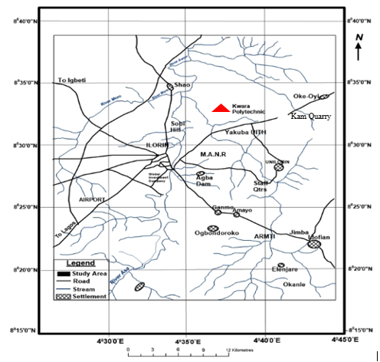
Figure 3.2: Location Map of the Study Area (modified after Olasehinde et al., 1998)

3.3 Sample Collection
Fresh representative samples of Migmatite Gneiss tagged Sample A, Porphyritic Granite tagged Sample B and Biotite Granite (Sample C) were collected on the open-cast mine site on outcrops. Structural features were observed based on tectonic activities and visual studies were also carried out to identify the different types of rocks. The Global Positioning System was used to take the coordinate of the different locations where the samples are taken. Other equipment used includes hammer, chisel, sampling bags, paper tape and marker. The three sample were separated in different sample bags and transported to University of Ilorin, Geology and Mineral Sciences Laboratory for detailed analysis.
3.4 Sample Preparation
The laboratory analysis was carried out on three different types of rocks labeled Sample A (Migmatite Gneiss), Sample B (Porphyritic Granite) and Sample C (Biotite Granite). The petrographical analysis carried out include thin section analysis and optical observations. During the preparation of thin sections analysis for all the samples, a thickness of 1.0 cm of a square shape of each of the rock sample was cut with the cutting machine. Applying emery cloth and caborundum powder, the specimen is further flattening to a thickness of about 0.04 mm. This flattened specimen is overlaid by the boiled Canada basalm and it is covered with a cover slip and left for about a day, then it is washed, rinsed with spirit and later with water. A total of six (6) thin sections (2 slides from each rock sample) were prepared from the samples for effective analysis and control. The analyses were subjected to microscopic examinations. Petrographic studies of the selected samples were made with the aid of a polarizing microscope. Some of the major minerals were observed under the microscopic examinations.

CHAPTER FOUR
RESULTS AND DISCUSSION
4.1 Results of Petrographic studies of the Thin Sections
The results based on petrographic studies of the thin sections revealed the various mineral distributions such as quartz, biotite, hornblende and feldspar (orthoclase, plagioclase and microcline). The quartz and feldspar constitute almost 88% of the thin section with other accessory minerals in both plane polarized and cross polarized light.
4.2 Discussion on Petrographic Studies of Migmatite Gneiss
The migmatite gneiss is the oldest type of rock in the study area. According to Abba (1983) gneiss occurs as the most widespread lithological unit in basement terrains and the imprints of the Pan – African deformation were evident by regional metamorphism, migmatization, extensive granitization and gneissification which produce syntectonic granites and homogeneous gneisses. It is common and appears to demonstrate undifferientiated pattern within the area. They are depicted generally by alternating light and dark coloured bands. The felsic bands of the rock consist of quartz, plagioclase and orthoclase feldspar with large percentage composition while the hornblende, muscovite or biotite constitutes smaller percentage of minerals in mafic bands. Based on mineral assemblages, quartz is however a dominant minerals while others such as feldspar and biotite are also making up a vital part. It has textural classification of fine to medium grained. In addition, the rock has undergo numerous orogenic cycles which has essentially lead to large scale deformation (Obaje, 2009). The imprints has been widely reported in the Precambrian rocks of Nigeria (Rahaman, 1989). The macro and micro structures is as a result of fracturing (Olayinka, 1992) such as folding, jointing, veins, intrusions, foliations and mineral lineations which were found in the study area.
4.3 Petrographic Description of some of the Prominent Minerals in the Migmatite Gneiss
The studied thin section with the aid of petrological microscope and slides were analyzed under plane polarized light and crossed nicol. The studied minerals include quartz, feldspar, biotite and hornblende.
4.3.1 Quartz (SiO₂)
The quartz is colourless in plane polarized light and shaped in euhedal. In coss polarized light, the quartz is colourless, reddish and conchoidal fracture with anhedral shape (Plate 4.1 and 4.2). It also display pleinchoism crystal of quartz that exhibit low relief and sometimes exhibit undulose extinction indicative of deformation or straining (Obini and Omietimi, 2020).
4.3.2 Plagioclase Feldspar (Na₂AlSi₃O₈.Ca₂Al₂Si₂O₈)
The feldspar mineral observed are plagioclase feldspar which is clearly from Albite twining characteristics (Ojelokun and Fawole, 2019) which is as a result of angle parallel to the large crystals in plane polarized light is colourless (Plate 4.1) but it demonstrate first order grey colour when the polar is crossed. It can be characterized from other types of feldspar because of its polysynthetic twining visible in the crystal. Some of the plagioclase in the slides occur as phenocryst (Plate 4.2).
4.3.3 Orthoclase Feldspar
The orthoclase feldspar under plane polarized light and crossed polarized light (XPL) appears cloudy and colourless (Plate 4.1 and 4.2). The crystals have low relief and are anhedral in shape. It is often colourless crystals with grey and reddish. The darker portion in the thin section suggest weathered feldspar with no definite cleavage.

4.3.4 Microcline Feldspar
The microcline feldspar exhibit a cystal system known as triclinic. This mineral is colourless under plane polarized light (PPL) and appears milky white under cross polarized light (XPL) with higher relief to quartz and orthoclase plate (Plate 4.1 and 4.2). The physical and chemical composition of microcline feldspar can be compare with the orthoclase feldspar. A thin section study implies large anhedral to subhedral microperthitic microcline with good polysynthetic crosshatched crystals with elongated crystals that exhibit subhedral habit.
4.3.5 Muscovite (KF)₂(Al₂O₃)₃(SiO₂)₆
The muscovite appears colourless under plane polarized light (PPL) (Plate 4.1) and has a pale green appearance under cross polarized light (XPL) (Plate 4.2) which makes it pleochroic. It exhibit parallel extinction with high relief and perfect cleavage in all direction. However, many of the crystals has twining and those near to the extinction shows position display appearance which is characteristics of mica family.
4.3.6 Biotite (Mg,Fe)₃ AlSi₃O₁₀(OH,F)₂
The colour of the biotite is between grey to brown colouration with subhedral to anhedral shape and has no twining. It has a directional cleavage. The mineral plate does not have extinction angles but form interstitial lamellae which may occur as linear aggregates with alteration to chlorite. It exhibits different pleonchoic orientation. The biotite has some inclusion of accessory minerals like zicon, rutile and apatite (Plate 4.1 and 4.2). It has strong birefringence under crossed polarised light, interference colour of dark green with symmetrical extinction and polysynthetic twinning.

4.3.7 Hornblende (Ca₂(Mg,Fe)₅(AI,Si)₈O₂₂(OH)₂
The colour of hornblende under plane polarized light is greenish black and it also displays pleochroism from green to brown.Under plane polarized light, a few of the hornblende crystals showed the characteristics shape and two cleavages. Under crossed nicol, twinning was seen in a few hornblende crystals and the highest interference colour seen is a second-order blue.

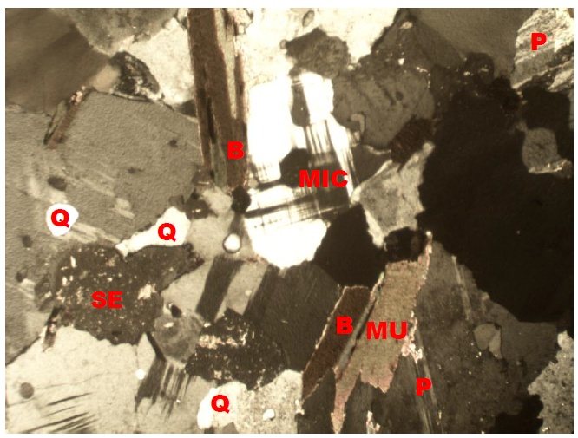
Plate 4.1: Photomicrograph of migmatite gneiss under Crossed Polarized Light (XPL), showing quartz (Q), biotite (B), plagioclase feldspar (P).
Plate 4.2: Photomicrograph of migmatite gneiss under Plane Polarized Light (PPL) showing the various shades of colours of mineral grains, Quartz (Q), Biotite (B), Plagioclase feldspar.
4.4 Discussion on Petrographic Studies of Porphyritic Granite (Sample B)
Porphyritic granite is the second most abundant rock type in the study area and it exhibits the characteristics of both slow and rapid rates of cooling magma. This has resulted to large or giant crystals of minerals (Phenocrysts) due to slow cooling, nevertheless, it has been subjected to further rapid cooling as the magma eventually move to the surface to form finer groundmass in which the phenocryst are embedded to form porphyritic texture (Saad and Baba, 2017). The major mineral constituents that occur include quartz, biotite, hornblende and plagioclase feldspar. The quartz in the porphyritic granite is euhedral in shape and it displays undulose extinction. The biotite exhibits different pleonchoic orientation. The biotite has some inclusion of accessory minerals like zircon, rutile and apatite. The plagioclase feldspar occurs as phenocrysts with lamellar twinning within the groundmass. Accessory minerals in the rock include zircon, apathite, magnetite and titanite (Plate 4.3 and 4.4)

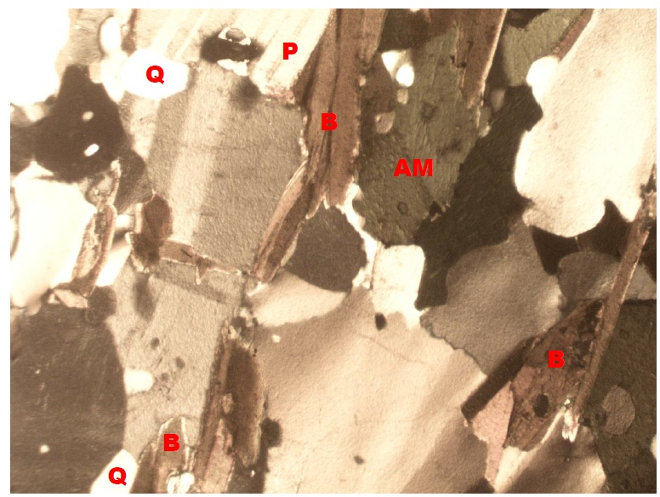
Plate 4.3: Photomicrograph of porphyritic granite under Crossed Polarized Light (XPL), showing quartz (Q), biotite (B), plagioclase feldspar (P).

Plate 4.4: Photomicrograph of porphyritic granite under Plane Polarized Light (PPL) showing the various shades of colours of mineral grains, Quartz (Q), Biotite (B), Plagioclase feldspar.
4.5 Discussion on Petrographic Studies of Biotite Granite (Sample C)
The biotite granite is a medium to coarse grained rock. The colour has resulted from the disintegration of biotite to fom chlorite (Aga and Haruna, 2019). Biotite is pleochroic form green to brown and are subhedral in shape (Plate 4.5 and Plate 4.6). The chlorite that occurs within the fractures has light green colouration and occurs mainly in cracks present within mineral matrixes. The crystal form of the chlorite is anhedral and occurs as a different product. However, the quartz in the biotite granite is euhedral to crystal in shape with crypto crystalline inclusions. It displays undulose extinction. This essentially proves that the rocks were highly deformed. The huge tectonic activities that took place or occur might have led to the exposure of the rocks to the surface of the study area. The occurrence of feldspar in the biotite granite is known as plagioclase feldspar and it is an irregular formed perthite with patches of it formed at the surface.The iron oxide occurs as tiny black patches in some biotite crystals and it is less abundant in the sample.

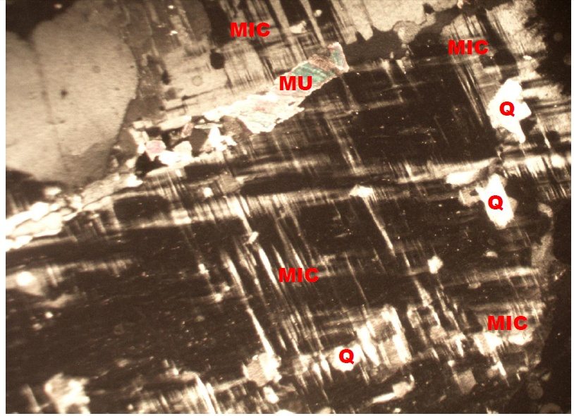
Plate 4.5: Photomicrograph of Biotite granite under Crossed Polarized Light (XPL), showing quartz (Q), biotite (B), plagioclase feldspar (P).
Plate 4.6: Photomicrograph of porphyritic granite under Plane Polarized Light (PPL) showing the various shades of colours of mineral grains, Quartz (Q), Biotite (B), Plagioclase feldspar.
4.6 Economic Potential of the Rocks
Economically, the sampled rocks (Migmatite Gneiss, Porphyritic Granite and Biotite Granite) in the studied area have good potentials for engineering purposes. Industrially, the quartzite can be used as industrial silica sand, silicon and silicon carbide. It can also be used as decorative stone used to cover walls. It is also useful in flooring, star steps and as roofing tiles. It is sometimes used as railway ballast and also in road construction purposes such as bridges, building houses, road pavement etc. The petrographic analysis examined indicate that mineral distribution quality are essentially made up economic minerals quartz, feldspar, biotite, muscovite and other accessory minerals. It is important to reiterates that these minerals are conspicuously present in both rocks and it is evidenced that the minerals presents are randomly distributed in accordance to their lithological variations (Ajali, 1997). Feldspar can be mined as profit by ceramics and glass industries for making product. The feldspar (plagioclase and orthoclase) can also be mined for fertilizers and cements.

CHAPTER FIVE
Conclusion and Recommendation
5.1 Conclusion
Petrographic studies and geochemical analysis of two different rock samples were carried out in the study area. Petrographically, the granitic rocks in the study area are composed of major rock forming silicate minerals such as quartz, biotite mica, and feldspars. The geochemical analysis on the rocks in the study area shows that the rocks are mineralogically composed of quartz, orthoclase and plagioclase feldspar, albite, microcline and other minor constituents such as hornblende and biotite. The rocks in the study area are chemically characterized by high percentage of silica (SiO₂), alumino-silicate minerals and the ferromagnesian compounds (Fe₂O₃ and MgO) which have varying low amount in both rock samples with calcium oxide which could be attributed to the calc-alkaline nature of the magma which serves as the precursor of the rocks. The chromium oxide (Cr₂O₃), phosphorus oxide (P₂O₅), sulphide (SO₃), manganese oxide (MnO), titanium oxide (TiO₂), zinc oxide (ZnO) and copper oxide (CuO) are the least abundant mineral with very low percentage weight composition of less than 1% in both samples. Economically, the various rocks in the area have good potentials for engineering purposes. The petrographic analysis examined indicate that mineral distribution quality are essentially made up economic minerals quartz, feldspar, biotite, muscovite and other accessory minerals.

5.2 Recommendation
The federal government should establish and equip the existing laboratories to carry out detailed analysis particularly on petrographic analysis of rocks for engineering construction purposes.
Measures should also be put in place to exploit and explore solid mineral resources in order to enhance industrialization and boost the economy of the country.

REFERENCES
Africa Atlases (2007). Atlas of Nigeria. 2nd Edition. 156.
Aga, T. and Haruna, A. .I. (2019).The Field and Petrographic Studies of the Sara-Fier Granite Suite, Central Nigeria. Medwell Online Journal of Earth Sciences 13 (1): 1–9, 1991-7708
Ayodele, O. S and Ajayi, C. A. (2016). Petrology, Mineralogy and Geochemistry of the Precambrian Rocks around Ikere-Ekiti, Southwestern Nigeria. Journal of Chemical and Petrochemical Technology (JCPT) 2, 1, 1-2
Bahiti M.R (1983) Plate tectonic and geochemical composition of granite.J Geol J 91:611-627
Bheemalingeswara K. and Tadess, N. (2009). Petrographic and geochemical study of sedimentary Rock around Negash Tigray, Northern Ethiopia. J Geol 2:106-132
Caby, P.T. (1989). Geochemistry of Basement Rocks from NW Nigeria 19th Annual Report.
Danbatti, U.A., Ovwasa, M.O., Shaibu, I., Chiwuko, A.I., Shuaibu, A.N. 2020. Petrographic Study and Geochemical Analysis of Basement Rock in Federal University Guasu and its Environment, Zamfara State, North western Nigeria. J Geol Geophys 9:472.10.35248/23818719.20.9.473
Ekelema I.A., Uzoegbu M. U., Abalaka I. E. and Olorunyomi, A. E. (2017).Petrographic Evaluation of Rock, International Journal of Geology and Mining, 3(1), 103-109.
Grant, P.A and Dada, O. (1970). The Basement Complex Of Nigeria and it Mineral Resource Ibadan. 38-43.
Ibrahim K.O., Olasehinde, P.I., Akinmade, A. O. and Isa, A. (2012): Geological Sounding to Investigate Groundwater Potential of Orisunibare Village in Ilorin South Area of Kwara state, Nigeria. Journal of Environment, 1101.0.1 1. Issue 01, 21-25.
Ibrahim, A., Toyin A. and Sanniz, J. (2005). Geological Characteristic and Petrographic analysis of Rock, International Journal of Applied Science, 1, 4.
Jafarzadeh M, Hosseini-Barzi M (2008) Petrography and Geochemistry of Ahwag Granite, Iran: Implication on Provenance and Tetonic settings. Rev Mex de sci GEOL 25:247-312
James, Z. and Hanulton, M.S. (1969). Geochemistry Characteristics and Petrogenesis. Cont. Min. 95.407-419.

Kankara, I. A. (2018). Geology and Petrographic Analysis of Porphyritic Biotite Granite Rocks in Funtua Sheet 78, Ne, North-western Nigeria. International Journal of Advanced Scientific Research |IJASRInternational Journal of Scientific Research in Technology, Applied Sciences & Health Studies | IJSRTASHS, 2579-1036 | 9-1044. 3,1.
Lillie, R. J. (2005).Park and Plate, the Geology of our National Park, Monuments and Seashores (1st Ed.), New York, Norton 5(1), 42-50.
Ndikumana, J. and Mugerwa, T. (2015). Field and Petrographic Study of Rock, International Research Journal of Earth Science, India, 3(10), 14-23.
Nigeria Geological Survey Agency, NGSA, (2008). Geological and Mineral Resources Map of Nigeria. Ministry of Mines and Steel Development, Abuja. Nigeria.
Nwachukwu, A., Chukwuemeka, C. and Maureen I, (2011).Petrographic analysis for Naming and Classifying an Igneous Intrusive Rock, Journal of Geology and Mining Researcher, Nigeria, 3(3), 63-72.
Obini, N. and Omietimi, E. J (2020)Geological Mapping, Petrographic and Structural Attributes of Basement Rocks at Eiyenkorin Area, Southwestern Nigeria International Journal of Scientific and Research Publications, 10, 5, 187 2250-3153 DOI:10.29322/IJSRP.10.05.2020.p10122
Ojedokun, R. O. and Fawole, O.A. (2019).Geological Mapping, Petrological Study andStructural Analysis of Complex Rocks in Ife-South Local Government Area of Osun State South Western Nigeria. International Journal of Research and Scientific Innovation (IJRSI) | 2321–2705. www.rsisinternational.org. 137
Saad, A. S. and Baba, S (2017). Geology and Petrographic Study of the Granitic Rocks of Kaltungo Inlier, Northeastern Nigeria. IOSR Journal of Applied Geology and Geophysics (IOSR-JAGG, 2321–0982.5, Issue 1 Ver. I. PP 75- 83. www.iosrjournals.orgDOI: 10.9790/0990-0501017583 www.iosrjournals.org
Williams H, Turner FJ, Gilbert C.M (1982) Petrography: an introduction to study of rock in thin section. W.H. Freeman San Francisco

