
A PROJECT REPORT
ON
GREEN SYNTHESIS OF SILVER NANOPARTICLES USING MORINDA LUCIDA LEAVE EXTRACT

BY
ADELEGAN ABIMBOLA VICTORIA
HND/23/SLT/FT/1166

BEING A PROJECT REPORT SUBMITTED TO THE DEPARTMENT OF SCIENCE LABORATORY TECHNOLOGY (BIOCHEMISTRY UNIT),
INSTITUTE OF APPLIED SCIENCES,
KWARA STATE POLYTECHNIC ILORIN

IN PARTIAL FULFILMENT OF THE REQUIREMENTS FOR THE AWARD OF HIGHER NATIONAL DIPLOMA (HND) IN SCIENCE LABORATORY TECHNOLOGY (SLT), KWARA STATE POLYTECHNC, ILORIN, KWARA STATE.

SUPERVISED BY:
MR. ABDULRAHMAN B.D
JULY, 2025

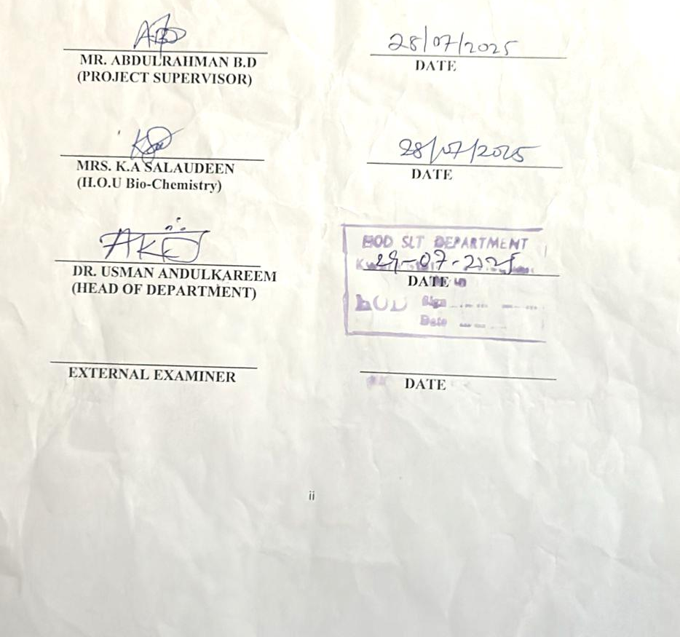
CERTIFICATION
This is to certify that this project work was carried out and submitted by ADELEGAN ABIMBOLA VICTORIA with matriculation number: HND/23/SLT/FT/1166 to the Department of Science Laboratory Technology, Bio-Chemistry Unit, Kwara State Polytechnic, Ilorin, and has been read and approved in accordance to the partial fulfillment of the requirement for the Award of Higher National Diploma (HND) in SLT.

DEDICATION
I dedicate this project to Almighty Allah, the most merciful and benevolent who granted me the strength, wisdom and perseverance to complete this work. I am eternally grateful for his guidance and blessings throughout my academic journey

ACKNOWLEDGEMENTS
I am deeply grateful to my supervisor, Mr Abdulrahmon , for his unwavering support and expert guidance throughout this project. Their insightful feedback and encouragement helped shape the direction of this research and pushed me to achieve my best. I also appreciate the contributions of my colleagues and peers, who provided valuable discussions, critiques, and camaraderie. Additionally, I acknowledge the institution of applied science for providing the necessary resources and infrastructure to facilitate this project. Lastly, I thank my family and friends for their patience, understanding, and encouragement, which sustained me throughout this journey. This project would not have been possible without the collective efforts of these individuals and organizations, and I am honored to have had the opportunity to work with them

Title page i
Certification Page ii
Dedication iii
Acknowledgement iv
Table of Content v
Abstract vi
CHAPTER ONE: INTRODUCTION
1.1 Background of the Study 9
1.2 Statement of Problem 14
1.3 Aim and Objectives 14
1.3.1 Objectives 14
1.4 Significance of the Study 15
CHAPTER TWO: LITERATURE REVIEW
2.1 About Nanotechnology, Nanoscience and Nanoparticles 16
2.1.1 Types/Classification of Nanoparticles 17
2.1.3 Based on the composition, nanoparticles are classified as: 17
2.1.2.2 Inorganic nanoparticles 18
2.1.2.3 Organic –inorganic hybrids 19
2.1.2.4 Carbonaceous nanostructure 21
2.1.2.5 Liposome that can filled with specific materials 21
2.1.2 Physical Approach 22
2.1.3 Chemical Approach 23
2.1.4 Biological Approach 25
2.4 Plant in Nanoparticles Synthesis 25
2.5 Application of Nanoparticles (NPs) 26
2.5.1 Diagnostic Applications 26
2.5.2 Use as a biomarker in Cancer Treatment 28
2.5.3 Biomedical Applications 28
2.5.3.1 Antimicrobial activity (anti-fungal and anti-bacterial) 28
2.6 Use in Water Treatment 31
2.7 Use in Cosmetics 33
2.8 Use in Agriculture 33
2.9 Morinda Lucida 34
2.10 Phytochemical Composition of Morinda Lucida 35
2.11 Nutritional Composition 36
2.12 Pharmacological Properties 37
2.12.1 Medicinal Properties 37
2.4.1 Antibacterial Properties 39
CHAPTER THREE:MATERIAL AND METHOD 41
3.1 Equipment used 41
3.2 Reagent used 41
3.3 Sample Preparation 41
3.4 Preparation of Leave Extract of Morinda Lucida 41
3.5 Preparation of 1mM Silver 41
3.6 Preparation of Sliver Nanoparticle 41
CHAPTER FOUR:RESULT AND DISCUSSION 43
4.1 Fourier Transform Spectroscopy Result 43
4.2 Discussion 44
4.3 Scanning Electron Microscopy Results 44
4.4 Discussion 45
4.5 XRD Analysis Results 46
4.5 Discussion 46
CONCLUSION 48
REFERENCES 49

ABSTRACT
we report the green synthesis of silver nanoparticles (AgNPs) using the aqueous leaf extract of Morinda Lucida, commonly known as bitter leaf. The synthesis process involves the reduction of silver nitrate (AgNO₃) by bioactive compounds present in the leaf extract, resulting in the formation of AgNPs. The synthesized nanoparticles were characterized using Fourier Transform Infrared Spectroscopy (FTIR), Scanning Electron Microscopy (SEM), and X-ray Diffraction (XRD) techniques.
FTIR analysis revealed the presence of functional groups such as hydroxyl, aliphatic, aromatic, and amine groups, indicating the involvement of phytochemicals in the reduction and stabilization of AgNPs. SEM images showed that the nanoparticles were predominantly spherical, with a size range of 10-50 nm, and exhibited minimal agglomeration. XRD patterns confirmed the crystalline nature of the AgNPs, with distinct peaks corresponding to the face-centered cubic structure of silver.
The results demonstrate that Vernonia amygdalina leaf extract is an effective bioreductant and stabilizing agent for the green synthesis of silver nanoparticles. This eco-friendly approach not only minimizes the use of hazardous chemicals but also leverages the medicinal properties of the plant, potentially enhancing the antimicrobial and therapeutic applications of the synthesized nanoparticles. The findings of this study contribute to the growing field of green nanotechnology, providing a sustainable alternative for the synthesis of metal nanopartic

Background of the Study
CHAPTER ONE INTRODUCTION

Nanotechnology is a multidisciplinary science concerned with the design, synthesis, and application of materials at the nanometer scale, typically ranging from 1 to100 nanometers. Among the various nanoparticles synthesized, silver nanoparticles (AgNPs) have gained significant attention due to their unique physical, chemical, and biological properties. These nanoparticles are well known for their remarkable antimicrobial, anticancer, antioxidant, and catalytic activities (Ahmed et al., 2016). Traditionally, the synthesis of nanoparticles has relied on physical and chemical methods that often require high energy input, use of toxic chemicals, and generate hazardous by- products. These conventional techniques pose substantial environmental and biological risks, limiting their applications, especially in biomedical and pharmaceutical fields (Mittal et al., 2013).
To overcome these challenges, green synthesis methods have been introduced, which utilize biological systems such as microorganisms, enzymes, and plant extracts to synthesize nanoparticles in an environmentally benign manner. Among these, plant- mediated synthesis has emerged as the most promising approach due to its simplicity, low cost, eco-friendliness, and ability to produce nanoparticles with desirable physicochemical properties. Plant extracts are rich in bioactive phytochemicals, including phenolics, flavonoids, alkaloids, tannins, terpenoids, and saponins, which can function as reducing, stabilizing, and capping agents during nanoparticle formation (Iravani, 2011).
Morinda lucida, a medicinal plant widely distributed across tropical Africa, belongs to the Rubiaceae family. It is traditionally used in folk medicine to treat various ailments such as malaria, diabetes, hypertension, infections, and gastrointestinal disorders (Ogunwande et al., 2006). The phytochemical composition of Morinda lucida includes a variety of compounds such as anthraquinones, flavonoids, and alkaloids, which not only

Contribute to its medicinal properties but also render it suitable for nanoparticle synthesis. The presence of such compounds in the leaf extract can mediate the reduction of silver ions (Ag⁺) to metallic silver (Ag⁰), thus facilitating the biosynthesis of silver nanoparticles (Akinmoladun et al., 2010).
The green synthesis of AgNPs using Morinda lucida leaves presents a dual benefit: it promotes sustainable nanotechnology and simultaneously leverages the medicinal properties of the plant. This method offers a nontoxic, scalable, and environmentally sustainable route for producing AgNPs, potentially usable in antimicrobial formulations, drug delivery systems, and water purification technologies (Kuppusamy et al., 2016). Moreover, the nanoparticles synthesized via green methods tend to have improved biocompatibility and enhanced biological activity compared to those produced by conventional routes (Gurunathan et al., 2014).
The emergence of nanotechnology represents one of the most promising scientific advances of the 21st century, offering groundbreaking opportunities in multiple fields including medicine, environmental science, agriculture, and materials engineering. At the core of nanotechnology lies the synthesis and application of nanoparticles materials that exhibit dimensions ranging between 1 and 100 nanometers. Among various types of metal-based nanoparticles, silver nanoparticles (AgNPs) have attracted substantial attention due to their exceptional physicochemical and biological properties. These properties include high thermal and electrical conductivity, chemical stability, catalytic efficiency, and notable antimicrobial activity (Ahmed et al., 2016; Franci et al., 2015).
Silver has been historically known for its therapeutic value, and its nanoscale version amplifies these benefits due to its high surface area to volume ratio and the quantum effects that govern interactions at the nanoscale (Rai et al., 2012). Silver nanoparticles are now widely used in wound dressings, drug delivery systems, diagnostic

tools, water treatment agents, and even in textiles and cosmetics. However, the method by which AgNPs are synthesized significantly affects their biocompatibility, toxicity, cost-effectiveness, and environmental sustainability.
Traditional physical and chemical synthesis methods, although efficient, often require extreme conditions such as high temperatures, high pressure, and the use of hazardous chemicals such as hydrazine, sodium borohydride, or formaldehyde (Iravani, 2011). These methods pose considerable risks to both human health and the environment. Moreover, the high cost and complex procedures associated with conventional synthesis techniques limit their scalability and accessibility, particularly in developing regions.
In response to these challenges, green nanotechnology has emerged as a safer and more environmentally benign approach. Green synthesis involves the use of biological systems such as plants, bacteria, fungi, and algae to reduce metal salts into nanoparticles. Among these, plant-mediated synthesis stands out due to its simplicity, rapidity, and the rich phytochemical composition of plant extracts, which act as both reducing and capping agents (Mittal et al., 2013). Unlike microbial methods, plant-based synthesis avoids the need for aseptic conditions and is more suitable for large-scale production (Iravani et al., 2014).
Plant extracts contain a diverse array of bioactive compounds such as flavonoids, tannins, terpenoids, alkaloids, phenolics, and saponins, which play a critical role in the reduction of silver ions (Ag⁺) to elemental silver (Ag⁰), as well as in stabilizing the synthesized nanoparticles (Bar et al., 2009). These biomolecules offer an additional advantage: they may confer bioactivity to the nanoparticles, potentially enhancing their antimicrobial, antioxidant, or anticancer properties. Hence, green synthesis not only reduces environmental impact but also yields nanoparticles with enriched functionality.
The selection of appropriate plant species is crucial in green synthesis. Morinda lucida, a tropical plant belonging to the Rubiaceae family, is widely distributed in West Africa and is traditionally used in herbal medicine for treating malaria, diabetes, infections, hypertension, and gastrointestinal issues (Ogunwande et al., 2006). The

leaves, bark, and roots of Morinda lucida are known to contain a range of phytochemicals including flavonoids, anthraquinones, alkaloids, glycosides, and tannins, which are well documented for their medicinal and antimicrobial activities (Akinmoladun et al., 2010; Salawu et al., 2011). These same phytochemicals, due to their redox properties, make Morinda lucida an excellent candidate for the green synthesis of silver nanoparticles.
Given the abundance and ethnopharmacological significance of Morinda lucida, especially in regions like Nigeria where it is used as a common medicinal herb, its application in nanotechnology presents a compelling case for further investigation. Using such a plant in green synthesis not only promotes sustainable technology but also valorizes traditional knowledge systems, providing a socio-economic boost to local communities involved in herbal medicine or agriculture. Furthermore, Morinda lucida- mediated AgNPs may exhibit synergistic antimicrobial effects derived from both the silver ions and the inherent bioactivity of the plant metabolites.
Previous studies have demonstrated that silver nanoparticles synthesized from plant extracts possess considerable antibacterial activity against both Gram-positive and Gram-negative bacterial strains, including drug-resistant pathogens (Loo et al., 2018; Singh et al., 2015). The mechanism of antimicrobial action of AgNPs involves multiple pathways such as disruption of the bacterial cell membrane, generation of reactive oxygen species (ROS), and interference with DNA replication and protein synthesis (Liao et al., 2019). When synthesized using medicinal plant extracts, these effects can be further potentiated by the phytochemical constituents, making plant-based AgNPs particularly effective and promising for pharmaceutical and environmental applications.
Despite the promising potential of green synthesis using plants, relatively few studies have focused on Morinda lucida, especially in the context of nanoparticle synthesis in West Africa. Most existing literature on this plant focuses on its ethnomedicinal uses, antioxidant properties, or anti-plasmodial activity, leaving a research gap in the application of Morinda lucida in nanotechnology. This study, therefore, seeks to bridge this gap by exploring the use of Morinda lucida leaf extract for

the green synthesis of silver nanoparticles and evaluating their structural and antimicrobial properties.
In essence, this research aligns with global goals for sustainable development and responsible innovation in nanotechnology. It integrates indigenous botanical knowledge with cutting-edge scientific techniques, creating opportunities for eco-friendly technology transfer, local enterprise development, and improved public health outcomes. By promoting green synthesis methods, the study contributes to reducing the environmental footprint of nanoparticle production and offers a viable pathway for producing biocompatible nanomaterial’s with wide-ranging applications.
The concept of nanotechnology though considered a modern science has its history dating back to the 9th century. Nanoparticles of gold and silver were used by the artisans of Mesopotamia to generate a glittering effect on pots. The first scientific description of nanoparticles was provided by Michael Faraday in 1957 in his famous paper ―Experimental Relations of Gold (and other metals) to Light‖ as deduced from the paper Faraday, (1957).
Ahmed et al, (2003) the first time the idea of nanotechnology was introduced was in 1959, when Richard Feynman, a physicist at Caltech, gave a talk called "There's Plenty of Room at the Bottom." Though he never explicitly mentioned "nanotechnology," Feynman suggested that it will eventually be possible to precisely manipulate atoms and molecules. Moreover, in an even more radical proposition, he thought that, in principle, it was possible to create "nano-scale" machines, through a cascade of billions of factories. According to the physicist, these factories would be progressively smaller scaled versions of machine hands and tools. He proposed that these tiny "machine shops" would then eventually be able to create billions of tinier factories. In these speculations, Balaji et al, (2009) also suggested that there are various factors, which uniquely affect the nano-scale level. Specifically, he suggested that as the scale got smaller and smaller, gravity would become more negligible, while both Van Der Waals attraction and surface tension would become very important. In the end, Feynman's talk has been viewed as the first academic

talk that dealt with a main tenet of nanotechnology, the direct manipulation of individual atoms
Modern nanotechnology is quite new, nanoscale materials have been used for centuries. Alternative-sized gold and silver particles created colours in the stained glass windows of medieval churches years ago. The artists back then didn’t know that the process they used to create these beautiful works of art actually led to changes in the composition of the materials they were working with. Today, scientists and engineers are finding a wide variety of ways to deliberately make materials at the nanoscale to take advantage of their enhanced properties such as higher strength, lighter weight, increased control of light spectrum and greater chemical reactivity than other materials on the macroscale and microscale. It is hard to imagine just how small nanoparticles are. One nanometer is a billionth of a meter or 10‾⁹ of a meter.

Statement of Problem
The functions of individual atoms and molecules can be improved upon and nanoscience poses to be the newest frontier in science that seeks to manipulate the structure, sizes and functions of individual atoms and molecules which then automatically affects their application. This research is intended to determine the degree to which silver
can be manipulated using Morinda Lucida as a reducing and capping agent.
Also considering that other methods of synthesis of nanoparticles; chemical, physical etc. are considered more toxic, in this work I will be performing the green synthesis which is less toxic and eco-friendly.

Aim and Objectives
To synthesise of silver nanoparticles using leaf (Morinda Lucida) in selected solvents and it’s characterization by spectroscopic methods and scanning electron microscopy.

Objectives
      - To determine the degree of reduction of silver ion (Ag⁺) to metallic nanosilver (Ag⁰).

      - To determine the morphology of the sample formed
      - To determine which of the solvent extractions will yield the best result.

Significance of the Study
The significance of this study is to benefit the science community by providing evidence based conclusions on the ability of Morinda Lucida to facilitate the development and activity of nanoparticles. Morinda Lucida was used because it is cost effective and its diverse health benefits.

CHAPTER TWO

LITERATURE REVIEW

2.1 About Nanotechnology, Nanoscience and Nanoparticles
Nanotechnology and nanoparticles are increasingly recognized for their potential applications in environmental remediation, medical healthcare, consumer products and many more areas. Nanoscience has been set up as a new interdisciplinary science. Silver nanoparticles are nanoparticles of silver having size between 1 nm and 100 nm. (Graf, et al., 2003). While frequently described as being 'silver' some are composed of a large percentage of silver oxide due to their large ratio of surface-to bulk silver atoms. Numerous shapes of nanoparticles can be constructed depending on the application at hand. Commonly used are spherical silver nanoparticles but diamond, octagonal and thin sheets are also popular (Graf, et al., 2003). At the moment nanochemistry is the fastest growing area of nanoscience, (Sergeev and Shabatina, 2008). Nanometer-size metallic particles show unique and considerably changed physical, chemical and biological properties compared to their macro scaled counterparts, due to their high surface-to- volume ratio. Thus, these nanoparticles have been the subject of substantial research in recent years (Li et al., 2001). The novel properties of NPs have been exploited in a wide range of potential applications in medicine, cosmetics, renewable energies, environmental remediation and biomedical devices (Ghosh and Paria, 2012). Among them, silver nanoparticles (AgNPs) have attracted increasing interest due to their unique physical, chemical and biological properties compared to their macro-scaled counterparts (Sharma. et al., 2009). AgNPs exhibit broad spectrum bactericidal and fungicidal activity (Ahamed, et al., 2010) that has made them extremely popular in a diverse range of consumer products, including plastics, soaps, pastes, food and textiles, increasing their market value (García Barrasa, et al., 2011). To date, AgNPs technologies have appeared in a variety of manufacturing processes and end products. AgNPs can be used in a liquid form, such as a colloid (coating and spray) or contained within a shampoo (liquid) and can also appear embedded in a solid such as a polymer master batch or be suspended in a bar of soap

(solid). AgNPs can also be utilized either in the textile industry by incorporating it into the fiber (spun) or employed in filtration membranes of water purification systems. In many of these applications, the technological idea is to store silver ions and incorporate a time- release mechanism. This usually involves some form of moisture layer that the silver ions are transported through to create a long-term protective barrier against bacterial/fungal pathogens (García-Barrasa, et al., 2011).

Types/Classification of Nanoparticles
According to Siegel (1994), nanostructured materials are classified as; Zero dimensional, one dimensional (Graphene, thin film).
      - Two dimensional (carbon nanotubes).
      - Three dimensional (quantum dots or nanoparticles and Fullerene) nanostructures. Based on their structure, nanoparticles can be classified into; Nanocapsules Nanospheres.

2.1.3 Based on the composition, nanoparticles are classified as:
      - Organic nanoparticles
Organic nanoparticles (ONPs) are synthesized from organic molecules, with examples including dendrimers, micelles, liposomes, and ferritin, known for their biodegradability and non-toxicity, some with hollow cores like nanocapsules.

Examples of Organic Nanoparticles:
Organic nanoparticles, typically ranging from 1 to 100 nanometers in size, include structures such as dendrimers, micelles, liposomes, ferritin, nanogels, and polymeric nanoparticles. Dendrimers are highly branched synthetic polymers with potential for drug delivery, while micelles and liposomes both featuring hollow core structures—are effective in encapsulating and transporting molecules due to their amphiphilic nature and sensitivity to heat and light. Ferritin, a natural iron-storage protein, serves as a useful model for nanoparticle behavior. Generally, organic nanoparticles are biodegradable, non-toxic, and ideal for biomedical and targeted therapeutic applications.

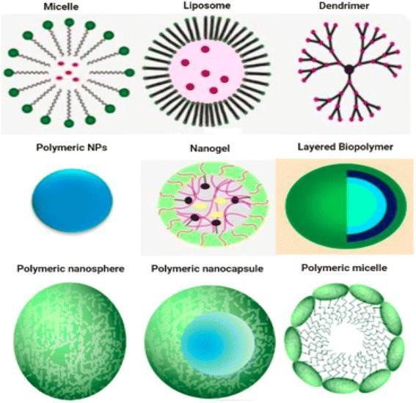

Inorganic nanoparticles
Inorganic nanoparticles are materials with two or more dimensions and a size between 1 and 100 nanometers, lacking carbon atoms and typically classified as metal- based or metal oxide-based, with examples including gold, silver, iron oxide, and silica nanoparticles.

Examples of Inorganic Nanoparticles:
Inorganic nanoparticles, typically 1–100 nanometers in size, include a wide range of materials such as metal-based (e.g., gold, silver, copper, iron, zinc), metal oxide-based (e.g., ZnO, Fe₂O₃, TiO₂), and other specialized forms like quantum dots, carbon nanotubes, mesoporous silica, and magnetic nanoparticles. They exhibit diverse shapes spherical, tubular, conical, or irregular and can be crystalline or amorphous. Their surface properties, such as charge, porosity, and area-to-volume ratio, significantly influence their functionality. Many are surface-functionalized to suit specific applications, and examples like nanowires may be composed of metals, semiconductors, or dielectrics, making inorganic nanoparticles highly versatile for industrial, biomedical, and electronic uses.

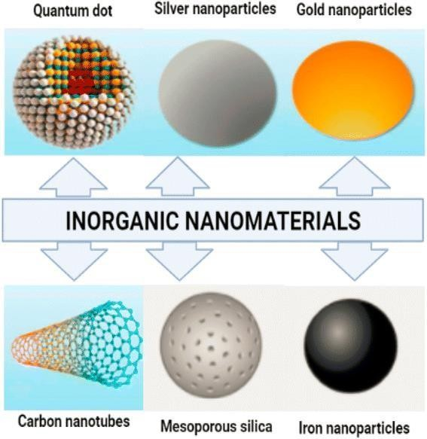

Organic –inorganic hybrids
Organic-inorganic hybrid materials combine organic and inorganic components, offering unique properties and applications. Examples include silica- based materials, hybrid polymers, and metal-organic frameworks (MOFs), with structures ranging from layered arrangements to sol-gel networks.

Examples and Structures:
Hybrid nanoparticles combine both organic and inorganic components to form materials with enhanced and customizable properties. Examples include silica-based materials, where techniques like sol-gel processing, grafting, and co-condensation allow integration of organic molecules into a silica matrix. Hybrid polymers can also be formed through sol-gel methods or self-assembly of organic and inorganic components. Metal-organic frameworks (MOFs), composed of metal ions linked with organic molecules, create porous structures ideal for various applications. Additionally, layered hybrid structures can be formed with alternating organic and inorganic layers, such as in haloplumbate compounds.
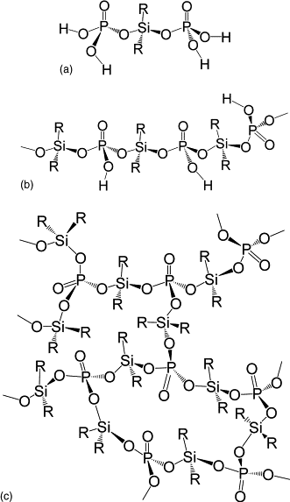

Carbonaceous nanostructure
Carbonaceous nanostructures are carbon-based nanomaterials with unique properties and diverse applications, including graphene, carbon nanotubes (CNTs), fullerenes, and carbon nanofibers. These structures can be classified by their dimensionality (0D, 1D, 2D, and 3D) and have various applications in fields like electronics, energy storage, and materials science.

Liposome that can filled with specific materials
Liposomes are small, spherical vesicles composed of phospholipid bilayers that can encapsulate substances, acting as drug delivery systems, and are classified based on their structure and composition.Liposomes are made of natural or synthetic phospholipids (like phosphatidylcholine, phosphatidylethanolamine) and can include cholesterol to improve bilayer characteristics. They are spherical vesicles with one or more lipid bilayers surrounding an aqueous core. Based on the number of bilayers, liposomes are classified as: Single-layer vesicles and Multiple concentric lipid layers.

Methods of Synthesising Nanoparticles
There are two methods for the production of nanoparticles which is summarized below:

Top-Down Approach
The principle behind the top-down approach is to take a bulk piece of the material and then modify it into the wanted nanostructure and subsequent stabilization of the resulting nanosized metal nanoparticles by the addition of colloidal protecting agents. Cutting, grinding and etching are typical fabrication techniques, which have been developed to work on the nano scale. The sizes of the nanostructures which can be produced with top-down techniques are between 10 to 100 nm. (Fouda, 2012)
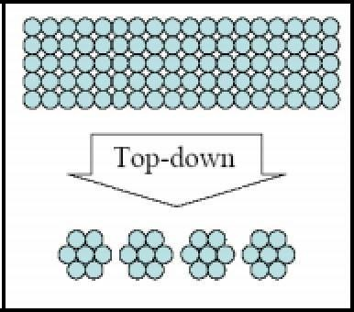

Figure 1: Description of Top-Down Approach

- Bottom-Up Self Assembly
This refers to the construction of a structure atom by atom, molecule-by molecule or cluster- by-cluster. Colloidal dispersion used in the synthesis of nanoparticles is a good example of a bottom-up approach. An advantage of the bottomup approach is the better possibilities to obtain nanostructures with less defects and more homogeneous chemical compositions. (Fouda, 2012)
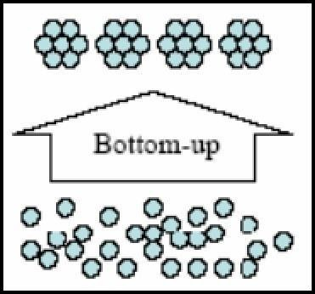

Figure 2: Description of Bottom-Up Approach
These two techniques contain three sub methods to synthesis silver nanoparticles:

Physical Approach
Some physical approaches include evaporation-condensation and laser ablation. Various metal nanoparticles such as silver, gold, lead sulphide, cadmium sulphide, and fullerene have previously been synthesized using the evaporation condensation method. The absence of solvent contamination in the prepared thin films and the uniformity of nanoparticles distribution are the advantages of physical approaches in comparison with chemical processes (Kruis, et al., 2000; Magnusson, et al., 1999). It was demonstrated that AgNPs could be synthesized via a small ceramic heater with a local heating source (Jung, et al., 2006). The evaporated vapour can cool at a suitable rapid rate, because the temperature gradient in the vicinity of the heater surface is very steep in comparison with that of a tube furnace. This akes possible the formation of small nanoparticles in high
concentration. This physical method can be useful as a nanoparticle generator for long- term experiments for inhalation toxicity studies, and as a calibration device for nanoparticle measurement equipment (Jung, et al., 2006). AgNPs could be synthesized by laser ablation of metallic bulk materials in solution (Mafune, et al., 2000). The ablation efficiency and the characteristics of produced AgNPs depend upon many factors such as the wavelength of the laser impinging. The metallic target, the duration of the laser pulses (in the femto-, pico- and nanosecond regime), the laser fluence, the ablation time duration and the effective liquid medium, with or without the presence of surfactants (Tarasenko, et al., 2006). One important advantage of laser ablation technique compared to other methods for production of metal colloids is the absence of chemical reagents in solutions. Therefore, pure and uncontaminated metal colloids for further applications can be prepared by this technique (Tsuji, et al., 2002).

2.1.3 Chemical Approach
The most common approach for synthesis of silver nanoparticles is chemical reduction by organic and inorganic reducing agents. In general, different reducing agents such as sodium citrate, ascorbate, sodium borohydride (NaBH4), elemental hydrogen, polyol process, Tollens reagent, N, Ndimethylformamide (DMF), and poly (ethylene glycol) block copolymers are used for reduction of silver ions (Ag+) in aqueous or non- aqueous solutions. The aforementioned reducing agents reduce silver ions (Ag+) and lead to the formation of metallic silver (Ag⁰),
Ag⁺ Ag⁰

which is followed by agglomeration into oligomeric clusters. These clusters eventually lead to formation of metallic colloidal silver particles (Merga, et al., 2007). It is important to use protective agents to stabilize dispersive nanoparticles (NPs) during the course of metal nanoparticle preparation, and protect the NPs that can be absorbed on or bind onto nanoparticle surfaces, avoiding their agglomeration (Oliveira, et al., 2005). The presence of surfactants comprising functionalities (e.g., amines, acids, and alcohols) for

interactions with particle surfaces can stabilize particle growth, and protect particles from sedimentation, agglomeration, or losing their surface properties.
Recently, a simple one-step process, Tollens method, has been used for the synthesis of AgNPs with a controlled size. In the modified Tollens procedure, silver ions are reduced by saccharides in the presence of ammonia, yielding AgNP films (50-200 nm), silver hydrosols (20-50 nm) and silver nanoparticles of different shapes (Yin, et al., 2002).

2.1.4 Biological Approach
Recently, the development of efficient green chemistry methods employing natural reducing, capping, and stabilizing agents to prepare AgNPs with desired morphology and size have become a major focus of researchers. Biological methods can be used to synthesize AgNPs without the use of any harsh, toxic and expensive chemical substances (Ahmad, et al., 2003). The bioreduction of metal ions by combinations of biomolecules found in the extracts of certain organisms (e.g., enzymes/proteins, amino acids, polysaccharides, and vitamins) is environmentally benign, yet chemically complex.
Many studies have reported successful synthesis of silver nanoparticle using organisms (microorganisms and biological systems) (Iravani, 2011.)

2.4 Plant in Nanoparticles Synthesis
The use of plants for the synthesis of NPs is better, as the protocols involving plant sources are free from toxic chemicals; moreover, natural capping agents are readily supplied by the plants. Further, gold nanotriangles and AgNPs were synthesized using Aloe Vera plant extracts (Halimani , et al., 2009). Most reports available on the synthesis of silver or gold nanoparticles states the use of broths resulting from boiling fresh plant leaves. A simple green synthesis method for production of well-defined silver nanowires was reported by Lin et al. (2011) The method involves reduction of silver nitrate with the broth of sundried Cassia fistula leaf at room temperature without using any additive. Studies indicated that the reducing phytochemical in the leaf extract consisted of mainly terpenoids. It was found that these reducing components also served as capping and

stabilizing agent in addition to reduction. Also the leaf extracts containing number of biomolecules such as proteins, enzymes, polysaccharides, amino acid and vitamins. Various plants/plant tissues used for synthesis AgNPs, yield good results.

2.5 Application of Nanoparticles (NPs)
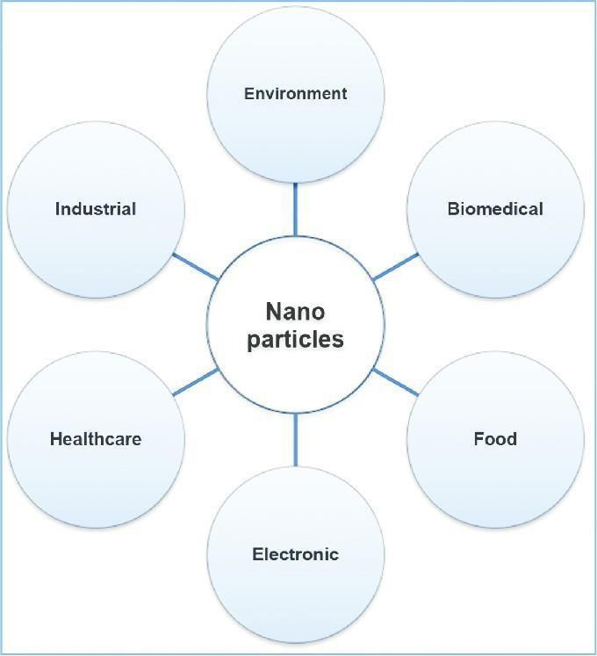
Figure 3: Application of nanoparticles in various fields

2.5.1 Diagnostic Applications
AgNPs are used in biosensors and numerous assays where the silver nanoparticle materials can be used as biological tags for quantitative detection. The individual genetic variability as a consequence of silver nanoparticles has been associated with individual susceptibility to several multifactorial diseases such as cancer (Silva, et al., 2005), diabetes (Kavvoura, et al., 2005) and also with individual response to therapeutics. Similarly, nucleotide sequence screening has paved the way for the development of robust and widespread molecular diagnostics platforms that assist in the detection of pathogen agents, such as bacteria, viruses, parasites (Leroy, and Raoult, 2010). Molecular

diagnostics requires highly paralleled and miniaturized assays capable of incorporating the vast information made available by the genome sequencing and genome analysis projects. Also, most diagnostic methods focus on detection of the response mechanisms of disease (Nanguzgambo et al., 2011).

2.5.2 Use as a biomarker in Cancer Treatment
Early diagnosis to any disease condition is vital to ensure that early treatment is started and perhaps resulting in a better chance of cure. This is particularly true for cancer. Lin. et al., 2011 had reported silver nanoparticle based Surface-enhanced Raman spectroscopy (SERS) in non-invasive cancer detection. This approach is highly promising and may prove to be an indispensable tool for the future.
In terms of therapeutics, one of the most well documented and commonly used application of AgNPs is in wound healing. Compared with other silver compounds, many studies have demonstrated the superior efficacy of AgNPs in healing time, as well as achieving better cosmetic after healing. Although the exact mechanisms for these biological effects has not yet been elucidated (Kwan, et al., 2011).
For oncology, Tse, et al., (2011) had presented a novel method to selectively destroy cancer cells. Human epidermoid cancer cell line was targeted with folated silver- dendrimer composite nanodevices and the labeled cancer cells were subsequently destroyed by the microbubbles generated through increased uptake of laser light energy by AgNps.

2.5.3 Biomedical Applications
AgNPs, exhibit antifungal and antibacterial properties which are discussed
below;

2.5.3.1 Antimicrobial activity (anti-fungal and anti-bacterial)
AgNPs are incorporated in apparel, footwear, paints, wound dressings, appliances, cosmetics, and plastics for their antibacterial properties. The antibacterial properties of the hydrogels containing AgNPs were determined through the protocol developed by (Prokopovich et al., 2013).Due to the potent activities of AgNPs, they can

be promisingly used in treating infectious pathogens and preventing microbial infections.
To examine the bacterial growth or killing kinetics in the presence of AgNPs, Escherichia coli cells were grown in 100 ml of NB supplemented with different doses of nanosilver content at 37°C with continuous agitation (Sondi, and Salopek-Sondi. 2004). It has been noted that the introduction of AgNPs has shown to have synergistic activity with common antibiotics already used today, such as; penicillin G, ampicillin, erythromycin, clindamycin, and vancomycin against Escherichia Coli and Staphylococcus aureus (Shahverdi et al., 2007). In medical equipment, it has been shown that AgNPs drastically lower the bacterial count on devices used. However, the problem arises when the procedure is over and a new one must be done. In the process of washing the instruments a large portion of the AgNPs become less effective due to the loss of silver ions. They are more commonly used in skin grafts for burn victims as the AgNPs embedded with the graft provide better antimicrobial activity and result in significantly less scarring of the victim. Jain and Pradeep, 2005 also show promising application as water treatment method to form clean potable water.
As the AgNPs come in contact with the bacteria, they adhere to the cell wall and cell membrane (Klasen, 2000). Once bound, some of the silver passes through to the inside, and interacts with phosphate-containing compounds like DNA and RNA, while another portion adheres to the sulphur-containing proteins on the membrane (Klasen, 2000). The silver- sulphur interactions at the membrane cause the cell wall to undergo structural changes, like the formation of pits and pores through these pores, cellular components are released into the extracellular fluid, simply due to the osmotic difference.
Within the cell, the integration of silver creates a low molecular weight region where the
DNA then condenses. Having DNA in a condensed state inhibits the cell’s replication proteins contact with the DNA. Thus the introduction of AgNPs inhibits replication and is sufficient to cause the death of the cell. Further increasing their effect, when silver comes in contact with fluids; it tends to ionize which increases the nanoparticles bactericidal activity (Feng, et al., 2000). This has been correlated to the

suppression of enzymes and inhibited expression of proteins that relate to the cell’s ability to produce ATP (Yamanaka, et al., 2005).
Although it varies for every type of cell proposed, as their cell membrane composition varies greatly, It has been seen that in general, AgNPs with an average size of 10 nm or less show electronic effects that greatly increase their bactericidal activity (Pal, et al., 2007). This could also be partly due to the fact that as particle size decreases, reactivity increases due to the surface area to volume ratio increasing.
AgNPs show potential antimicrobial effects against infectious organisms, including Escherichia coli, Bacillus subtilis, Vibria cholera, Pseudomonas aeruginosa, Syphillis typhus, and S. aureus (Cho, et al., 2005). Similar studies were also done to determine the relationship between free radical and antimicrobial activity and the result showed that free radical may be derived from the surface of AgNPs and could be responsible for its antimicrobial properties (Kim, et al., 2007). These nanoparticles had significant antifungal activities against trichophyton mentagrophytes and Candida species. Silver nanoparticles disrupt fungal envelope structure and lead to significant damage to fungal cells (Mehnert, et al., 2001). AgNPs kill bacteria by damaging the cell wall of bacteria (Prabhu, and Poulose, 2012). The antimicrobial efficacy of the nanoparticles depends on the size of the nanoparticles. Lower the particle size more efficacious they become (Agnihotri, 2014). Efficacy also changes with method of preparation of nanoparticles. For example AgNPs prepared with alginate having an average size of 7.6 nm exhibited the highest antibacterial activity among silver nanoparticles solution.
AgNPs have been tested in various fields of biological sciences viz. drug delivery, wound treatment, binding with HIV gp120 protein (Elchiguuerra et al., 2005). It is well known that silver ion and silver-based compounds are highly toxic to microorganisms (Slawson et al., 1992) and they are used as antibacterial compounds (Jain and Pradeep 2005).

2.6 Use in Water Treatment
Contamination of drinking water and the subsequent outbreak of waterborne diseases are the leading cause of death in many developing nations (Pradeep 2009). Moreover, the spectrum and incidence of some infectious diseases are increasing worldwide, therefore, there is an enormous need for treatments to control the microbial contamination of water and decrease the number of waterborne diseases. Significant interest has arisen in the use of AgNPs for water disinfection. The chemically produced nanosilver (chem-Ag-NPs) can be uniformly decorated onto porous ceramic materials to form a Ag-NPs–porous ceramic composite by using 3-aminopropyltriethoxysilane (APTES) as a connecting molecule (Chen, et al., 2016). This composite can be stored for long periods and is durable under washing without loss of nanoparticles. The sterilization property of Ag-NPs–porous ceramic composite as an antibacterial water filter was tested with E. coli. It was found that at a flow rate of 0.01 l min⁻¹ the output count of E. coli was zero when the input water had a bacterial load of ~10⁵ CFU ml⁻¹. It also proved that the connection between the chem-Ag-NPs and the ceramic bases on the coordination bonds between the –NH2 group at the top of the APTES molecule and the silver atoms on the surface of the NPs. This kind of connect ion ensured that the chem-Ag- NPs were tightly fixed to the interior channel walls of the porous ceramic so that they can release a sufficient quantity of silver ions for antibiosis. Such Ag-NPs– porous ceramic composites were successfully tested in drinking water purification (Yakub, and Soboyejo 2012). Additionally, the chem-Ag-NPs can be coated on common polyurethane (PU) foams by overnight exposure of the foams to chem-AgNPs colloid (Jain, and Pradeep, 2005). The NPs are stable on the foam and are not washed away by water. Morphology of the foam was retained after coating. The NPs binding is due to its interaction with the nitrogen atom of the PU. At a flow rate of 0.5 l min⁻¹, after few seconds the output count of E. coli was nil when the input water had a bacterial load of 10⁵ CFU ml⁻¹.
Also, the chem-Ag-NPs were successfully formed on to the macroporous methacrylic acid copolymer beads for disinfection of water (Gangadharan, et al., 2010).

This showed that the chem-Ag-NPs formed on these copolymer beads by chemical reduction method were stable under water washing and their stability was due to the interaction of the chem-Ag-NPs with the –COO⁻ carboxylic functional group on the copolymer beads. Polymeric microspheres containing chem-Ag-NPs displayed highly effective disinfection against two gram-negative bacteria (E. coli, P. aeruginosa) and two gram-positive bacteria (B. subtilis, S. aureus).
The chem-Ag-NPs bound copolymer beads performed efficiently in bringing down the bacterial count to zero for all the tested strains. The bacterial adsorption/adhesion tested revealed that copolymer beads containing chem-Ag-NPs do not have any adsorption/adhesion of bacterial cell.
Recently a new class of polyethersulfone (PES) hybrid ultrafiltration membranes bending with modified halloysite nanotubes (HNTs) loaded with the chem-Ag-NPs for water purification was reported (Zhang, et al., 2012). The results of antibacterial activity tests showed that the hybrid membrane had a good antibacterial property, and the antibacterial rates against E. coli and S. aureus were about 99.9 and 99.8%, respectively. Noticeably, this novel hybrid ultrafiltration membrane was observed to exhibit both organic antifouling and antibacterial properties by addition of the chem-Ag-NPs.
Along with the use of the chem-Ag-NPs for bacterial disinfection in water, some reports for use of the biologically produced nanosilver (bio-Ag-NPs) for virus disinfection in water were also given (De Gusseme, et al., 2011).
In a nutshell, the silver-based NPs are very ideal for use in water disinfection. The silver based NPs can be incorporated to core materials and polymeric membranes to disinfect the water contaminated with the bacteria and viruses. The application of silver- based NPs is of utmost importance to prevent outbreaks of waterborne diseases related to poor treatment of drinking water. Moreover, the addition of silver-based NPs could prevent bacterial/viral attachment and biofilm formation in filtration medium (De Gusseme, et al., 2010).
The effects of AgNPs on planktonic cells were different to those on wastewater

biofilms. Biofilm bacteria treated as isolated pure culture are much more sensitive to AgNPs, compared with mixture of bacteria in the biofilm. The contamination of groundwater sources by pathogenic bacteria poses a public health concern to communities who depend totally on this water supply. Very recently, novel cost effective filter materials coated with chem-AgNPs were developed for the disinfection of groundwater (Mpenyana-monyatsi, et al., 2012).

2.7 Use in Cosmetics
AgNPs may have potential for use as a preservative in cosmetics. The effects of recently synthesized AgNPs were investigated on microorganisms, along with the skin permeability and the cytotoxicity in human keratinocytes under UVB-irradiation. AgNPs were found to be very stable, showed sufficient preservation efficacy against mixed bacteria and mixed fungi, and did not penetrate normal human skin. AgNPs appear to be suitable for use as a preservative in cosmetics (Kokura, et al., 2010). Due to antibacterial properties of silver nanoparticles it can be used as preservatives in cosmetics, and in anti- acne preparation. For example, AgNPs, which have antibacterial activity, are also being incorporated into toothpastes and shampoos as preservatives. Silver nanoparticles inhibit the growth of dermatophytes, making them potential antiinfective agent (Noorbakhsh, 2011).

2.8 Use in Agriculture
One of the potential applications in which AgNPs can be utilized is in management of plant diseases. Since AgNPs display multiple modes of inhibitory action to microorganisms, they may be used for controlling various plant pathogens in a relatively safe way compared to synthetic fungicides (Kim, et al., 2009). The antifungal mechanism of AgNPs may be due to the fact that the formation of free radicals produced from the nanoparticles could disturb the membrane lipids and then finally spoil the membrane functions (Danilczuk et al., 2006). (Sondi and SalopekSondi, 2004) have depicted a new finding that the membrane could be deteriorated by the formation of pits on the surface of the cell wall membrane of microorganisms. The formation of pits on the

membrane leads to increase in the permeability and irregular transport that result in the death of the cells. So, the green-synthesized silver nanoparticle is a good source, which is easily produced and extensively useful in agricultural applications.

2.9 Morinda Lucida
Morinda Lucida is a common shrub or small tree that grows in tropical Africa. They are well distributed also in Asia and are commonly found along drainage lines and in natural forest or commercial plantation. It belongs to the Asteraceae family and popularly called „African Brimstone Leaf‟ in Africa, Morinda lucida, commonly known as the brimstone tree, also has various local names in different regions, including "Oruwo" in Yoruba, "Eze-ogu" in Igbo, and "Njisi" in Hausa. The leaves are green in colouration with a characteristic odour and bitter taste (Akpaso, et al., 2011). The leaves of Morinda Lucida are used as soup condiments after washing and boiling to get rid of the bitter taste (Hamzah, et al., 2013). Specifically, it is used to prepare the popular Nigerian Brimstone Leaf soup, ―Onugbo‖ and as spice in the
Cameroon dish called ―Ndole‖ (Ho, et al., 2012). In some part of the Africa continent like Nigeria, the plant is made into tonic and drank for medicinal purposes (Igile, et al., 1994). Other popular use of Morinda Lucida in Africa includes traditional treatment of diseases, such as malaria, infertility, diabetes, gastrointestinal problems and sexually transmitted diseases (Farombi and Owoeye, 2011). Their traditional use is not limited to human alone as it added to horse feed to provide a strengthening or fattening tonic called „Chusan Dokin‟ in Northern Nigeria (Hamzah, et al., 2013). In another instance, Morinda Lucida had been reported in the treatment of parasite related disease in wild chimpanzee in Tanzania (Huffman and Seifu, 1989). Anthelmintic, antimalarial, antitumourigenic as well as bacteriostatic and bactericidal effect on some bacteria properties of Morinda Lucida extracts has been employed (Izevbigie et al., 2004). Specifically, Nwanjo (2005) reported the hypoglycaemic and hypolipidaemic effect of the leave extracts in vivo. Also, traditional care givers recommend its aqueous extract for the treatment of their patients in varieties of ailment ranging from emesis, nausea,

diabetes, loss of appetite, dysentery, gastrointestinal tract problems to sexual transmitted diseases and diabetes mellitus among others (Argheore et al.,1998). These observations necessitate studies to ascertain the efficacy of different part of the plant in managing a wide array of ailments claims as well as it nutraceutical values.

2.10 Phytochemical Composition of Morinda Lucida
Phytochemicals are natural occurring bioactive compounds known for their health benefits. They are majorly responsible for the colour, flavour and aroma of fruits and notably vegetables. Bioactive compounds have been shown to prevent the advent of many chronic diseases such as cancer, diabetes, heart and Alzheimer’s disease. The presence of phytochemicals such as saponins, flavonoids, alkaloids and hydrocyanic acids in the roots and barks extracts of Morinda Lucida was reported by Eyong et al. (2011). This study agrees with the report of Argheore et al. (1998) on the study of the leaf extracts of Morinda Lucida on detection of phytochemicals. Phytochemicals in Morinda Lucida contains bioactive compounds which are antiviral in nature as well as having prophylactic and therapeutic effect against cancer cells (Noumedem, et al., 2013). While the report of Ghamba, et al. (2014) establishes the presence of phytochemicals in Morinda Lucida, Udochukwu, et al. (2015) evaluated the concentration (mg/100g) of some of this aforementioned phytochemicals and observed Morinda Lucida to contained higher levels of bioactive compounds than Ocium gratissimum save for phytate and cyanogenic glycosides.

Table 1: Phytochemical Components of Ethanoic Extracts of Morinda Lucida

(mg/100g)*

Phytochemicals | Morinda Lucida
Oxalate | 3.84
Phytate | 3.95
Tannins | 9.62
Saponins | 5.97
Flavonoid | 4.89
Cyanogenic glycoside | 1.11
Alkaloids | 2.16
Anthraquinone | 0.14
Steroid | 0.38
Phenol | 3.24
Source Udochukwu et al. (2015)

2.11 Nutritional Composition
Quite a number of researches have established the nutritional content of Morinda Lucida. Proximate composition of Morinda Lucida reveals the presence of protein, carbohydrate, moisture, ash, fibre and fat as reported by Argheore, et al. (1998). The analysed moisture content (%) as reported by Argheore ,et al. (1998) was 10.55% which was higher than that reported (10.02%) by Asaolu, et al. (2012). Variation was suggested to be due to soil nutrients and environmental factors which have effects on the nutrients availabilities for plants. The crude fibre content of Morinda Lucida is 8.78% which is within the ranged for some Nigerian vegetables. Also, ash content indicates 4.28% which is lower than values reported by Asaolu, et al. (2012) for Brimstone Leaf (9.56%) and scent leaf (13.01%). The presence of ash in Brimstone Leaf is a confirmation of the presence of mineral elements. The crude protein (18.75%) was higher than the protein contents of some leafy vegetables such as Momordica balsamina (11.29%). This result

affirms the report of Adewole, et al. (2015), and Sodimic, et al. (2006). Observe minerals contents in Morinda Lucida in the trend;
K > Na > Ca > Mg > Fe >Zn > Cu > Mn
Potassium was the predominant mineral element detected while manganese was the least detected minerals element. Inorganic mineral elements such as potassium and calcium are known to play important roles in the maintenance of normal glucosetolerance and in the release of insulin from beta cells of islets of Langerhans which helps to control the glucose level of the human body (Kadiri, & Olawoye 2016).

2.12 Pharmacological Properties
Morinda Lucida leaves have been used by traditional medical practitioners in the treatment of malaria over the decade. WHO (2003) recognises the role played by traditional medicine in rural communities in the provision of health care in the absence of an efficient public health care system. Njan (2013) reports the leaf extract of Morinda Lucida leaves to treat wister rats infected with rodent malaria (Plasmodium berghei). The leaves extracts also showed analgesic activity with clear and significant anti-plasmodia effects in mice. Toxicity in rats, incidental findings below or above standard reference levels were all within control values based on historical reference ranges. It was suggested that the findings might explain the pharmacological basis for the successes in pain and malaria treatment claimed by traditional healers who use Morinda Lucida.

2.12.1 Medicinal Properties
Traditional health workers in Africa recommend the aqueous extracts of Morinda Lucida as treatment for varieties of ailments ranging from emesis, nausea, diabetes, loss of appetite, dysentery and other gastrointestinal tract problems to sexually transmitted diseases and diabetes mellitus among others (Argheore, et al. 1998). Some of these claims have been verified experimentally and documented while others are yet to be validated.
Farombi and Owoeye (2011) observes phytochemicals compounds such as

saponins and alkaloids, terpenes, steroids, coumarins, flavonoids, phenolic acids, lignans, xanthones, anthraquinones, edotides, sesquiterpenes extracted and isolated from Morinda Lucida to elicit various biological effects in humans including cancer chemoprevention. The chemopreventive properties of Morinda Lucida was attributed to their abilities to scavenge free radicals, induce detoxification, inhibit stress response proteins and interfere with DNA binding activities of some transcription factors. Isolated dotides and sesquiterpene lactones form the leaf of Morinda Lucida are now known to elicit remarkable antioxidant and chemo-preventive properties in cell cultures and rodent models. Prominent among the biochemical and molecular mechanisms of action of these isolated compounds were elevation of phase II enzymes activities, inhibition of cell proliferation and suppression of proinflammatory mediators. These mechanisms were also observes to play pivotal role in chemoprevention which appears to be a more pragmatic and rational approach to prevention of cancer. Morinda Lucida leaf along with Garcina kola were said to be possible future chemo-preventive agents though necessary longterm clinical trials was suggested to verify this finding. Extracts of Morinda Lucida had also been reported to reduce lipid and cholesterol profile, both risk factor in hyperlipidaemia and atherosclerotic plague. Extracts of Morinda Lucida causes a slight decrease in the lipid profile of experimental rats (Argheore, et al., 1998) which is in agreement with previous findings of Erasto et al., 2007. Administration of an aqueous Morinda Lucida leaf extract to hyperlipidaemia animals decrease plasma total cholesterol, low density lipo protein, and very low density lipoprotein in a study conducted by Oboh and Enobhayisobo, 2009. These findings shows that aqueous Morinda Lucida leaf extract may be useful in the control of blood lipids, prevention and treatment of coronary heart disease.

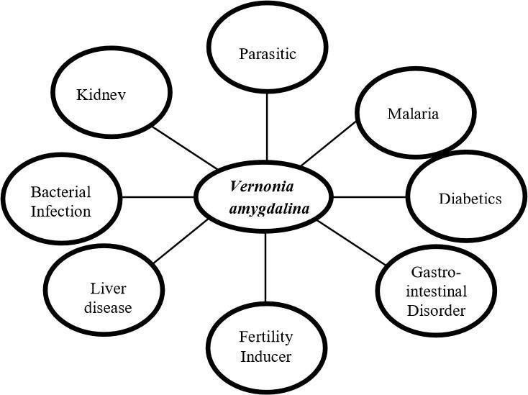

Figure 4: traditional uses of Morinda Lucida (Brimstone Leaf)

Antibacterial Properties
The aqueous extract of the leaves has inhibitory effect on the growth of gram +ve bacterium; Staphylococcus aureus and the gram –ve bacterium; Escherichia coli in a report by (Oboh and Enobhayisobo, 2009). Staphylococcus aureus and Escherichia coli exhibited sensitivity to Morinda Lucida extract, each giving a zone of inhibition of 0.8cm. This agrees with more recent report of Udochukwu, et al. (2015). Water and Ethanol extracts of Morinda Lucida have been reported to possess antibacterial action against pure culture of clinical bacterial isolates. Udochukwu, et al. (2015) reported the inhibitory effect of Morinda Lucida and Ocimum gratissimum extracts against pure cultures of clinical isolates of Staphylococcus aureus, Pseudomonas aeruginosa and Escherichia coli. Water and ethanol were used for the plants‟ active constituents‟ extraction and method employed was the Agar diffusion method in the determination of the antibacterial effects of both plant extract on the test organisms. The minimum inhibitory concentrations (MIC) of water and ethanol extracts on the test organisms ranged between 25–50 µL/mL.

Similarly, the zone of inhibition of the plant extract diameters at concentration of 100µL/mL ranged between 7.5 – 5.0 mm and 11.5 – 7.0 mm for water and ethanol extracts respectively on the test organisms (Udochukwu, et al., 2015). Water extract of Morinda Lucida was more effective on Pseudomonas aeruginosa than of Ocium gratissimum. Ethanolic extract of Ocium gratissimum was also reported to be more effective than ethanolic extract of Morinda Lucida on same bacteria strains. Extracts showed zones of inhibition higher than some selected antibiotics (Amoxicillin, Tetracycline, Doxycycline, Ampiclox and Septrin) at 400µL/mL. The author justify the use of the leaf as therapeutic agent in traditional medicine practice and suggested ethanol extracts at a concentration up to 100µL /mL as a better treatment margin. A prior study by Ghamba, et al. (2014) on the leaves of Morinda Lucida extracts showed strong antimicrobial activities against tested clinical isolates which agrees with recent study of Udochukwu, et al. (2015) on the antimicrobial activities of Morinda Lucida leaf extract. Ghamba, et al. (2014) suggested that the antimicrobial activity of these leaves makes it a potential herb for drug development due to its inhibition effects on bacterial growth. Foo et al. (2014) suggested contradictory view on the effects of Morinda Lucida extracts on E.coli strains though difference in susceptibility was said to be likely due to genetic diversity of the pathogen which gives rise to different resistant mechanisms (Noumedem, et al., 2013).

CHAPTER THREE

METHOD AND MATERIAL

3.1 Equipment used
Beaker, Conical flask, Standard flask, Pipette, Weighing balance, Centrifuge, Water bath, Muslin cloth, Foil paper, Masking tape, Magnetic stirrer, and Blender

3.2 Reagent used
Morinda Lucida (powdered sample)/ silver nitrate (AgNO₃), Distilled water and deionized water

3.3 Sample Preparation
The leaf of pawpaw (Morinda Lucida) was gotten from the Ara, in Moro Local Government, Ilorin Kwara State. The leaves were washed and air dried for 7 days. The midribs were removed by hand picking. The dried leaves were grinded using a silver crest blender into a fine powered form.

3.4 Preparation of Leave Extract of Morinda Lucida
A 30g of the powdered sample was weighed using a weighing balance and transferred into a 500ml beaker, The 300ml of distilled water was added to make a solution. The resulting solution was stirred for 60 minutes at 12,000 rpm at 80ºC using a magnetic stirrer and then, heated for 30 minutes in the water bath. The solution was allowed to cool, then it was filtered with muslin cloth, the extract was kept for further us.

3.5 Preparation of 1mM Silver
0.17g of silver nitrate (AgNO₃) was weighed and transferred into a 500ml volumetric flask, 50ml of distilled water was added and the mixture was shaken to dissolve the solid silver nitrate, the solution was topped with distilled water to the marked point to make a 1mM solution.

3.6 Preparation of Sliver Nanoparticle
The 1mM silver nitrate solution was added to the plant extract in a 9:1 mean, the resulting mixture gave a deep yellow coloration and it was kept for 24hours, the resulting solution then gave a dark brown coloration which shows that silver nanoparticles has been synthesized. Fig. 3.1 summarizes the steps taken in the synthesis of silver nanoparticles.
.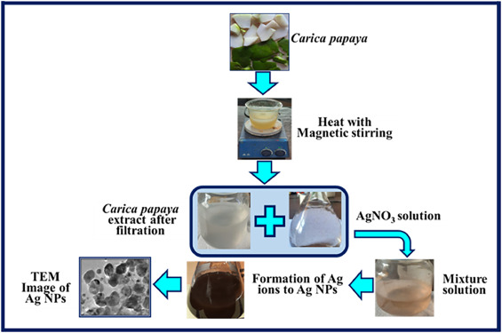
Fig. 3.1: Synthesis Pathway of Silver Nanoparticles from Leave Extract of Morinda Lucida

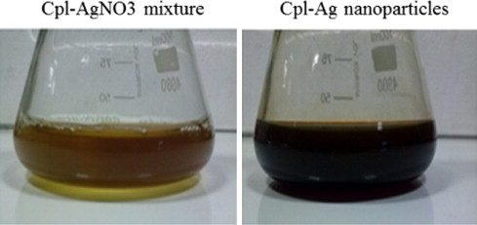
Before (a)
After (b)

Fig. 3.2: (a) The colour of mixture of Morinda Lucida leave and silver nitrate (b) Show the formation of silver nanoparticles

CHAPTER FOUR:

RESULT AND DISCUSSION

4.1 Fourier Transform Spectroscopy Result
The FTIR spectrum of silver nanoparticles (AgNPs) synthesized using Morinda Lucida leaf extract showed characteristic peaks at 3420, 2920 cm-1,1630 cm-1, and 1380 cm-1.

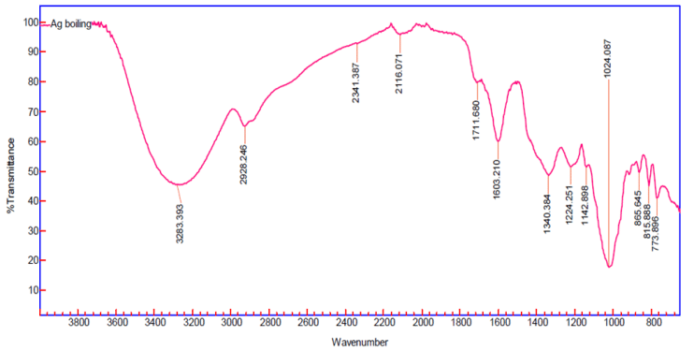
Fig 4.1: FT-IR Spctra of AgNPs from Vernomia Amygdalina

4.2 Discussion
This broad peak at 32830 cm-1 corresponds to the O-H stretching vibration, indicating the presence of hydroxyl groups, likely from phenolic compounds in the leaf extract another peak at 2928 cm-1 is attributed to C-H stretching vibrations, suggesting the presence of aliphatic compounds. The sharp peak at 1603 cm-1 corresponds to C=C stretching vibrations, indicative of aromatic compounds. The peak at 1340 cm-1 corresponds to C-N stretching vibrations, suggesting the presence of amines.
The presence of these functional groups suggests that compounds like flavonoids, terpenoids, and alkaloids in Morinda Lucida leaf extract play a crucial role in the reduction of Ag⁺ ions to AgNPs and stabilization of the nanoparticles.

4.3 Scanning Electron Microscopy Results
The SEM images revealed that the silver nanoparticles synthesized using Morinda Lucida leaf extract are predominantly spherical with a size range of 10-50 nm. The nanoparticles were well-dispersed with minimal agglomeration.


Fig 4.2: SEM Image of Vernomia Amygdalina

4.4 Discussion
The spherical morphology of the AgNPs indicates effective capping and stabilization by the phytochemicals present in the leaf extract. The size range of 10-50 nm suggests that the synthesis method is effective in producing nanoparticles within the desired nano-size range. The minimal agglomeration observed in the SEM images further confirms the efficiency of the Morinda Lucida leaf extract in preventing particle aggregation, which is crucial for maintaining the stability and functionality of the nanoparticles.

4.5 XRD Analysis Results
The XRD pattern of the synthesized AgNPs displayed distinct peaks at 2θ values of 38.1°, 44.3°, 64.5°, and 77.5°, corresponding to the (111), (200), (220), and (311).
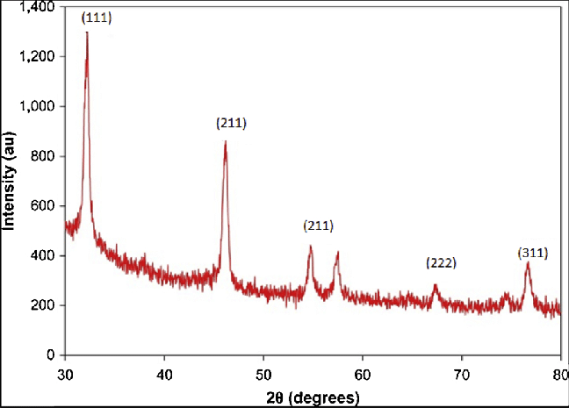
Fig 4.3: XRD Spectra of Morinda Lucida leaves extract

4.5 Discussion
The XRD peaks at 33.1°, 44.3°, 56.2°, 57.3, 66.4 and 77.5° confirm the crystalline nature of the silver nanoparticles and are in good agreement with the standard diffraction pattern of fcc silver (JCPDS card no. 04-0783). The high intensity of the (111) peak suggests a preferred orientation along this plane, which is commonly observed in silver nanoparticles synthesized using biological methods.

CONCLUSION
The FTIR, SEM, and XRD analyses collectively confirm the successful green synthesis of silver nanoparticles using Morinda Lucida leaf extract. The presence of various functional groups in the FTIR spectrum indicates that phytochemicals in the leaf extract act as both reducing and capping agents. The SEM analysis demonstrates that the nanoparticles are predominantly spherical and well-dispersed, with a size range suitable for various applications. The XRD results further confirm the crystalline nature and purity of the synthesized AgNPs, validating the effectiveness of this green synthesis method. This approach not only provides an eco-friendly alternative to conventional chemical synthesis methods but also leverages the medicinal properties of Morinda Lucida, potentially enhancing the biomedical applications of the synthesized AgNPs.

REFERENCES
Adewole, E., Ojo, A., Ogunmodede, O. T., & Adewumi, D. F. (2015). Antioxidant Activities and Nutritional Compositions of Vernoni Amygdalina. International Journal of Basic and Applied Science, 4(01), 9-16.
Agnihotri, S., Mukherji, S., & Mukherji, S. (2014). Size-controlled silver nanoparticles synthesized over the range 5–100 nm using the same protocol and their antibacterial efficacy. Rsc Advances, 4(8), 3974-3983.
Ahamed, M., AlSalhi, M. S., & Siddiqui, M. K. J. (2010). Silver nanoparticle applications and human health. Clinica chimica acta, 411(23-24), 1841-1848.
Ahmad, A., Mukherjee, P., Senapati, S., Mandal, D., Khan, M. I., Kumar, R., & Sastry,
M. (2003). Extracellular biosynthesis of silver nanoparticles using the fungus Fusarium oxysporum. Colloids and surfaces B: Biointerfaces, 28(4), 313-318.
Akpaso, M. I., Atangwho, I. J., Akpantah, A., Fischer, V. A., Igiri, A. O., & Ebong,
P. E. (2011). Effect of Combined Leaf Extracts of Morinda Lucida
(Brimstone Leaf) and Gongronema latifolium (Utazi) on the Pancreatic [beta] Cells of Streptozotocin- Induced Diabetic Rats. British Journal of Medicine and Medical Research, 1(1), 24.
Aregheore, E. M., Makkar, H. P. S., & Becker, K. (1998). Feed value of some browse plants from the central zone of Delta State, Nigeria. Trop. Sci, 38, 97104.
Asaolu, S. S., Adefemi, O. S., Oyakilome, I. G., Ajibulu, K. E., & Asaolu, M. F. (2012). Proximate and mineral composition of Nigerian leafy vegetables. Journal of food Research, 1(3), 214.
Assessment, W. H. O. (2003). Monitoring of antimalarial drug efficacy for the treatment of uncomplicated falciparum malaria. Geneva: World Health Organization; 2003. WHO/HTM/RBM.

Balaji, D. S., Basavaraja, S., Deshpande, R., Mahesh, D. B., Prabhakar, B. K., & Venkataraman, A. (2009). Extracellular biosynthesis of functionalized silver nanoparticles by strains of Cladosporium cladosporioides fungus. Colloids and surfaces B: biointerfaces, 68(1), 88-92.
Chen, C. C., Wu, H. H., Huang, H. Y., Liu, C. W., & Chen, Y. N. (2016). Synthesis of High Valence Silver-Loaded Mesoporous Silica with Strong Antibacterial Properties. International journal of environmental research and public health, 13(1), 99.
Cho, K. H., Park, J. E., Osaka, T., & Park, S. G. (2005). The study of antimicrobial activity and preservative effects of nanosilver ingredient. Electrochimica Acta, 51(5), 956- 960.
Danilczuk, M., Lund, A., Sadlo, J., Yamada, H., & Michalik, J. (2006). Conduction electron spin resonance of small silver particles. Spectrochimica Acta Part A: Molecular and Biomolecular Spectroscopy, 63(1), 189-191.
De Gusseme, B., Hennebel, T., Christiaens, E., Saveyn, H., Verbeken, K., Fitts, J. P.,... & Verstraete, W. (2011). Virus disinfection in water by biogenic silver immobilized in polyvinylidene fluoride membranes. water research, 45(4), 1856-1864.
De Gusseme, B., Sintubin, L., Baert, L., Thibo, E., Hennebel, T., Vermeulen, G., ... & Boon,
N. (2010). Biogenic silver for disinfection of water contaminated with viruses. Applied and Environmental Microbiology, 76(4), 1082-1087.

