EFFECT OF CEMENT BRAND AND WATER CEMENT RATIO ON THE SLUMP OF FRESH CONCRETE

BY
ODULELE ISMAIL AYOMIDE ND/23/CEC/PT/0235

A PROJECT SUBMITTED TO THE DEPARTMENT OF
CIVIL ENGINEERING INSTITUTE OF TECHNOLOGY,
KWARA STATE POLYTECHNIC, ILORIN.

IN PARTIAL FULFILLMENT OF THE REQUIREMENTS
FOR THE AWARD OF ORDINARY NATIONAL DIPLOMA(OND)
IN CIVIL ENGINEERING.

August, 2025

CERTIFICATION
This is to certify that this project was conducted by ODULELE ISMAIL AYOMIDE (ND/23/CEC/PT/0235) and had been read and approved as meeting the requirements for the award of Nation Diploma (ND) in Civil Engineering of the department of Civil Engineering, Institute of Technology, Kwara State Polytechnic, Ilorin.

_______________________________ _______________
ENGR. M. A. WOPA DATE
(PROJECT SUPERVISOR)

_______________________________ _______________
ENGR. N.A NAALLAH DATE
(HEAD OF DEPARTMENT)

_______________________________ _______________
ENGR. ABDULHAMEED ABDULRASAQ ADUAGBA
(EXTERNAL SUPERVISOR) DATE

DEDICATION
This project is dedicated to Almighty God who by his mercy guided and protected me throughout my course of study

ACKNOWLEDGEMENT
My special thanks goes to Almighty Allah, the creator and commander of the world for his guidance and protection over me throughout my living career with courage and effort to complete this course successfully despite all the difficulties.
My inestimable appreciation goes to my wonderful and irreplaceable parent MR & MRS ODULELE and my rare gold, my one in a million who have been taking care of me from my childhood you are such a good, loving, and wonderful mom, special thanks to brother Rasheed, sister Kausarat and also my friend Ibrahim and Basirat, thanks for all you do.
I genuinely appreciate their persistence and support toward my education career. If not for their insistence support. I would not have been a student of this prestigious institution. I pray to almighty God that you shall eat the fruit of your labour and you shall witness our testimony in Allah name (Amen).
My sincere gratitude goes to my supervisor Engr. A.W Mansur for his valuable suggestions, comments, observation and encouragement throughout the completion of this project, may Almighty God bless you and your family.
And also, all my lecturer in the department of Civil Engineering, Kwara state polytechnic, Ilorin, I express my gratitude to them for their good work, may God be with you and your family.

ABSTRACT
This research examines the influence of cement brand and water-cement ratio on the workability of fresh concrete using the slump test. Two prominent Nigerian cement brands, Dangote and BUA, were tested under laboratory conditions. Concrete was prepared using two standard mix ratios (1:2:4 and 1:1.5:3), with water-cement ratios of 0.4, 0.5, and 0.6. The results indicated that increasing the water-cement ratio led to higher slump values, signifying improved workability. Dangote cement consistently produced greater slump compared to BUA under similar conditions, while the richer mix (1:1.5:3) yielded higher slumps than the leaner mix (1:2:4). These findings demonstrate that both cement brand and water-cement ratio significantly affect the fresh concrete properties. The study recommends a water-cement ratio of 0.5 for optimal workability in typical construction applications.

Keywords: Cement brand, Water-cement ratio, Slump test, Workability, Fresh concrete, Dangote, BUA, Mix ratio

TABLE OF CONTENT
CONTENT
Title Page i
Certification ii
Dedication iii
Acknowledgement iv
Abstract v
Table of contents vi
List of tables viii
List of figures viii

CHAPTER ONE
Introduction 1-3
1.1 Statement of the problem 3
1.2 Aim and Objectives of the project 3
1.3 Scope of the project 4
1.4 Justification of the project 4

CHAPTER TWO: LITERATURE REVIEW
2.1 Introduction 5-9
2.2 Cement 10
2.3 Cement content and workability 10
2.4 Cement content and durability 10
2.5 Water 11
2.6 Effect of water/cement ratio 11
2.8 Admixture 12
2.8 Applications of cement 12

CHAPTER THREE: MATERIALS AND METHODOLOGY
3.1 Procurement of materials 14
3.2 Methods 15
3.2.1. Materials characterization 15
3.2.2. Consistency of the cement 15
3.3. Setting time test of cement 15
3.4 Mixing of the aggregate with cement to form concrete paste 16
3.5 Slump test for fresh concrete (workability test slump) 16

CHAPTER FOUR: DATA ANALYSIS
4.0 Result and Discussion 19
4.1 Experimental setup 20
4.2 Results of slump test 21
4.3 Analysis of results 22

CHAPTER FIVE: CONCULSION AND RECOMMENDEDSTION
5.1 Conclusion 23
5.2 Recommendation 24
Reference 25
Plate 27

LIST OF TABLES
Table Page
4.1: Slump Values for Mix Ratio 1:2:4 19
4.2: Slump Values for Mix Ratio 1:15:3 21

LIST OF FIGURES
Figures Page
4.1: Slump Values for Mix Ratio 1:2:4 20
4.2: Slump Values for Mix Ratio 1:15:3 21

CHAPTER ONE
INTRODUCTION
Concrete as the most widely used man-made construction materials is second only to water as the most utilized substance on the planet. It is obtained by mixing cementitious materials, water and aggregate (and sometimes admixtures) in required proportion. According to Bamigboye, et al., (2015), concrete is composed of aggregates embedded in a cement matrix which fill the space between the aggregates and bind them together. Concrete is a very strong building material and the use of concrete predates back before the Roman Empire. (John, 2023)
Concrete mixture when placed in form and allowed to cure hardens into rock-like mass known as concrete. In it harden state, concrete should have the following properties; strength, durability, impermeability, and it should have minimum dimensional changes. The strength, durability, and other characteristics of concrete depends upon the properties of its ingredients, proportion of mix, method of compaction and other controls during placing, compaction and curing. Among the various properties of the concrete, its compressive strength is considered to be the most important and it is taken as an index of its overall quality. (John, 2023)
Concrete is the most widely used construction material across the world. The popularity of concrete is primarily due to the ready accessibility of the raw materials required to manufacture it and because, when it is properly mixed and installed, concrete will be immensely strong and durable. A critical component in concrete mix design is the ratio between the water and cement in the concrete. The ratio between water and cement, measured by mass, is referred to as the water to cement ratio, or w/c ratio, or simply w/c (Eric, 2024).
The binding quality of Portland cement paste is due to the chemical reaction between the cement and water (Raheem and Bamigboye, 2013). The degree of cement hydration which is a function of water to cement ratio has a direct impact on the porosity and consequently on the strength. The richness of the mix is one of the factors that affect the rate of strength development in concrete mix and is a direct function of the quality and quantity of the cementitious material. This implies that cement is one of the most important ingredients influencing strength properties of concrete.
Water hydrates cement in order to form the products of hydration, which bond the aggregates together to form concrete. Any water included in the mix beyond that needed to hydrate the cement creates capillary pores in the structure of the paste. If enough excess water is used, these pores will grow and become an interconnected network of voids that significantly reduce the strength and durability of the concrete. There is a minimum w/c ratio that provides enough water to hydrate the cement, but no excess water to create voids in the paste structure. A concrete made with that that minimum w/c would too stiff to install so a w/c above the minimum is always used in practice (Eric, 2024).
Moreover, there are various brands of Portland cement available in markets which are used in construction industries. There have been sentimental and unconfirmed analyses by various groups in the construction industry comparing between the available brands of cement on setting time, workability, fineness and compressive strength. In other to tackle the discrepancy in concrete compressive strength produced by different brands of Portland cement available in the market, this study will therefore evaluate the effect of selected brands of Portland cement on mechanical properties of concrete.

1.2 STATEMENT OF PROBLEM
Cement as one of the most important constituents influencing the strength of concrete ranges in different brands in Nigeria. There have been speculations by various groups in the construction industry that the mechanical properties of concrete especially the strength properties vary appreciably with the brand of cement used for the concrete production (Ige, 2013).

1.3 AIM AND OBJECTIVES
Aim
The aim of the project is to investigate the effect of cement brand and water-cement ratio on the slump of fresh concrete.
Objectives:
The aim of this project was achieved through the following specific objectives
- To establish the effect of different brand of cement on the slump of fresh concrete.
- To determine the effect of varying water-cement ration (0.4, 0.5, 0.6) on the slump of fresh concrete.
- To establish the effect cement ratio on the compressive strength of concrete:

1.3 SCOPE OF THE STUDY
This study was focused on the investigation to determine the effect of therefore, slump test procedure was used to determine the cement densities and workability as well as the consistency of our fresh concrete.

1.4 JUSTIFICATION OF THE STUDY
Concrete remains the most widely used construction material globally, especially in developing countries like Nigeria. The quality and performance of fresh concrete depend significantly on its workability, which directly affects ease of placement, compaction, and overall structural performance. Among various tests for workability, the slump test is the most commonly used due to its simplicity, speed, and reliability for site conditions.
In practice, multiple brands of cement are available in the Nigerian market, with Dangote and BUA being two of the most popular and widely used. However, due to possible variations in chemical composition, fineness, and manufacturing processes, different cement brands may influence the workability of concrete in distinct ways, even under the same mix conditions.
CHAPTER TWO
2.0 LITERATURE REVIEW
2.1 INTRODUCTION
Portland cement concrete is a composite material composed of fine and coarse aggregate bonded together with a fluid cement (cement paste) that hardens over time most frequently in the past a lime-based cement binder, such as lime putty, but sometimes with other hydraulic cements, such as a calcium aluminate cement or Portland cement. It is distinguished from other, non- cementitious types of concrete binding some form of aggregate together, including asphalt concrete with a bitumen binder, which is frequently used for road surfaces, and polymer concretes that use polymers as a binder.

According to John Nnabuenyi (2023), investigate effects of selected brands of Portland cement on compressive strength of concrete. The study was undertaken to assess the compressive strength of concrete produced with selected brands of Portland cement obtainable within south east Nigeria. Four different brands of Portland cement namely: Bua, Dangote 3x, Unicem and Lafarge were adopted for the study. The slump of the fresh concrete produced with different brands of Portland cement ranged from 40mm – 55mm. The hardened density and compressive strength of the concrete produced with Bua, Dangote 3x, Unicem and Lafarge were 2347kg/m3, 2345kg/m3, 2393kg/m3 and 2361 kg/m3 and 24.18N/mm2, 24.81N/mm2, 27.47N/mm2, 27.15N/mm2. It was observed that the highest dry density and compressive strength was recorded for concrete produced with Unicem while the lowest dry density and compressive strength was recorded for concrete produced with Dangote 3x cement. In the light of the findings, this study therefore recommends the use of Unicem cement for production of both structural and non- structural concrete due to significant attainment in dry density and compressive strength.
Omotola, et. al (2011), look on to the effects of water-cement ratios on the compressive strength and workability of concrete and lateritic concrete mixes. The variations of the compressive strengths of concrete and lateritic concrete mixes with water cement ratios of range 0.55 and 0.80, within 7 to 28 days after casting, were experimentally investigated in this research work. The experiment was carried out at the same ambient temperature and the compressive strengths of both concrete and lateritic concrete mixes were found to increase with age but decrease as the water-cement ratio increases. However, water-cement ratio above 0.65 was observed to have a very significant reduction effect on the compressive strength of the lateritic concrete mixes.

Huseyin, et. al (2007), Effects of cement type, water/cement ratio and cement content on sea water resistance of concrete. In this study, effects of cement type, cement content and water/cement (W/C) ratio level on the sea water resistance of concrete were investigated. Test samples were exposed to sea water by wetting– drying manner. Residual splitting tensile and compressive strength, and chloride penetration depths of specimens after exposure were determined. Besides, energy dispersive spectrometer (EDS) analyses were performed on scanning electron microscope (SEM) images of selected mixtures. Test results indicate that blast furnace slag cement (SC) mixtures have considerably greater resistance to sea water than portland cement (PC) mixtures both from the point of mechanical properties and chloride penetration.

Burak, et. al (2007), investigate the effect of water/cement ratio on the fresh and hardened properties of self-compacting concrete. The use of self-compacting concrete (SCC) with its improving production techniques is increasing every day in concrete production. However, mix design methods and testing procedures are still developing. Mix design criterions are mostly focused on the type and mixture proportions of the constituents. Adjustment of the water/cement ratio and superplasticizer dosage is one of the main key properties in proportioning of SCC mixtures. In this study, five mixtures with different combinations of water/cement ratio and superplasticizer dosage levels were investigated. Several tests such as slump flow, V-funnel, L-box were carried out to determine optimum parameters for the self-compactibility of mixtures. Compressive strength development, modulus of elasticity and splitting tensile strength of mixtures were also studied.

According to Marar and Özgür (2011), Investigates the effects of cement content and water/cement ratio on workable fresh concrete properties with slump changing between 90 to 110 mm, and determines the relations among fresh concrete properties such as slump, compacting factor, Ve-Be, unit weight and setting times of mortar with temperature history. The experiments were conducted under laboratory conditions on eight different concrete mixtures prepared from ordinary Portland cement (cement contents of 300, 350, 400, 450, 500, 550, 600 and 650 kg/m3) and crushed limestone coarse and fine aggregates. Relations such as (a) Ve-Be time/unit weight/slump/K-slump/compacting factor/w/c ratio for cement content, (b) K-slump/compacting factor/unit weight/Ve-Be time for slump, (c) aggregate/cement ratio/unit weight/Ve-Be time for compacting factor, and (d) penetration resistance for elapsed time were determined. It was observed that increasing the cement content causes increase in the slump, K slump, compacting factor and fresh concrete unit weight, and reduces Ve-Be time. Proposed fresh concrete relationships are quite appropriate for concretes without using any mineral or chemical admixtures.

Nikbin, et. al (2007), Investigation into the effect of water to cement ratio and powder content on mechanical properties of self-compacting concrete. as an innovative construction material in concrete industry, offers a safer and more productive construction process due to favorable rheological performance which is caused by SCCs different mixture composition. This difference may have remarkable influence on the mechanical behavior of SCC as compared to normal vibrated concrete (NVC) in hardened state. Therefore, it is vital to know whether the use of all assumptions and relations that have been formulated for NVC in current design codes are also valid for SCC. Furthermore, this study presents an extensive evaluation and comparison between mechanical properties of SCC using current international codes and predictive equations proposed by other researchers. Thus, in this experimental study, key mechanical properties of SCC are investigated for sixteen SCC mixes with different w/c ratios and different powder contents. In the present study, an extensive data reported by many researchers for SCC and NVC has been used to validate the obtained results.

2.1 CEMENT
Cement, in general, adhesive substances of all kinds, but, in a narrower sense, the binding materials used in building and civil engineering construction. Cements of this kind are finely ground powders that, when mixed with water, set to a hard mass. Setting and hardening result from hydration, which is a chemical combination of the cement compounds with water that yields submicroscopic crystals or a gel-like material with a high surface area. Because of their hydrating properties, constructional cements, which will even set and harden under water, are often called hydraulic cements.

Cement plays a major role within a concrete mixture and affects most important aspects of the mix, such as: workability, compressive strength, drying shrinkage, and durability. Through the process of hydration, cement particles react with water, binding the aggregate, and the strength matrix develops (Fapohunda, 2020). Around the world. many standards and specifications call for the overdesign of the concrete elements under the assumption that this creates another factor of safety (Fapohunda, Adigo, and jeje 2020).
However, recent research has shed light on the relationship between cement
content and cracking and how overdesigning may be detrimental to concrete. As cement content in a mix increases, the compressive strength usually increases as well. However, costs also increase due to the high cost of cement relative to other concrete ingredients and lone-term effects caused by crack maintenance. This cracking is likely a result of increased drying shrinkage and heat of hydration in the early age concrete with higher cement content (Fapohunda et.al, 2020).

2.3 CEMENT CONTENT AND WORKABILITY
Cement content and cement fineness play crucial roles in affecting the workability of concrete. I1 a mix has too much cement in relation to its water content, the mix was difficult to place. However, with too much water the mixture was segregated, making it equally difficult to use for the intended purpose on the job. Thus, selecting the required amount of cement for a mix is integral to the concrete mixture design, affecting workability and overall construction costs. Finer cement requires increased water contents to hydrate a larger surface area and generally causes higher temperature during hydration (Famodimu, Adigo, Fapohunda 2020). Thus, adjusting cement quantities and fineness within mixes prior to placement can help to improve workability protects the concrete from additional cracking within its interfacial transition zone due to excessive heat and drying strain created during the curing process.
2.4 CEMENT CONTENT AND DURABILITY
Cement also plays a major role in the durability of a concrete mix. Durability is the way the concrete resists weathering and deterioration while retaining its form, quality, and properties when under exposure (ACI Committee 201. Durability of Concrete), Cracks are a problem for durability and can decrease service life. An increase in cement can lead to an increase in cracking density, which can ultimately lower the durability of concrete substantially (Darwin et al., 2004). Additionally. increased cement often leads to more paste which has been shown to increase shrinkage and permeability Eamodimu and Jeje, 2020). It has also been seen that the use of fly ash or slag cement in mixes can reduce permeability (Fapohunda and Adigo, 2020).

2.5 WATER
Being the most essential resource in the universe, it was an important role in the preparation on the concrete. Impurity in water may interfere the setting of the cement and may adversely affect the strength of the properties. The chemical constituents present in the water may participate in the chemical reaction and thus affect the setting, hardening and strength development of mixture. The IS: 456(2000) codes stipulate the water quality standard for mixing and curing. In some arid areas local drinking water is impure and may contain an excessive amount of salt due to contamination by industrial waste.

2.6 EFFECT OF WATER/CEMENT RATIO
Basically w/e ratio control strength, durability and permeability of concrete and does not control the rate of corrosion but 'permeability' which is a function of w/e ratio affect the corrosion of rebar. The depth of penetration of a particular chloride threshold value increase with an increase in w/c ratio. Carbonation depth was found to be linearly Increasing with an increase in w/c ratio. The oxygen diffusion coefficient is also found to be increasing with an increase in w/c ratio. In a study it was observe that the permeability of hardened cement pasts in increase 100 folds by increase the w/c ratio from 0.35 to 0.45 and the time of initiation of reinforcement corrosion in a sample with a w/c ratio 0.4 is 2.15 to 1.77 times more as compared to a sample with a e/c ratio of 0.55. under accelerated corrosion testing.

2.7 ADMIXTURE
They are used in concrete mixture to improve certain qualities such as workability, durability compressive strength. water tightness and wear resistance while still providing high strength and good performance. They maybe also be added to reduce segregation, reduce the heat of hydration, entrain air and accelerate or retard setting and hardening.

2.8 APPLICATIONS OF CEMENT
Cements may be used alone (i.e., “neat,” as grouting materials), but the normal use is in mortar and concrete in which the cement is mixed with inert material known as aggregate. Mortar is cement mixed with sand or crushed stone that must be less than approximately 5 mm (0.2 inch) in size. Concrete is a mixture of cement, sand or other fine aggregate, and a coarse aggregate that for most purposes is up to 19 to 25 mm (0.75 to 1 inch) in size, but the coarse aggregate may also be as large as 150 mm (6 inches) when concrete is placed in large masses such as dams. Mortars are used for binding bricks, blocks, and stone in walls or as surface renderings. Concrete is used for a large variety of constructional purposes. Mixtures of soil and portland cement are used as a base for roads. Portland cement also is used in the manufacture of bricks, tiles, shingles, pipes, beams, railroad ties, and various extruded products. The products are prefabricated in factories and supplied ready for installation.

CHAPTER THERE
3.0 MATERIALS AND METHODOLOGY
3.1 PROCUREMENT OF MATERIALS
Coarse Aggregate: A common type of intrusive igneous rock that is granular in texture.
They can be predominantly White, Pink or gray in colour depending on their mineralogy.
The aggregate is normal weight, irregular shaped and was sourced from a quarry in Ilorin, Kwara state Nigeria.
Fine Aggregate: They are also known as builders’ sand, refers to sand that has a gritty texture. They are often mixed with concrete for a number of different construction application. Proper inspection was carried out to ensure that fine aggregate was free from all materials that are not useful or could be harmful. The amount of silt present in it was determined. The fine aggregate (river sand) was obtained from Ilorin environment, Ilorin, Kwara state.
Cement: Cement is a binder, a substance that sets and harden and bind other
materials together. Portland lime stone cement type which was used for general construction purpose where special property is not required and also whose composition and properties is following the Nigeria Standard. It will be sourced from a cement depot at challenge, Kwara state.
Water: the water that will be used with borehole water and will inspect to make sure it clean, free from dirt and various particles.it will be source from Ilorin, kwara State.

3.2 METHODS
3.2.1. MATERIALS CHARACTERIZATION
Preliminary investigation was conducted to determine the physical properties of aggregate such as the density, specific gravity, water absorption, moisture content, and particle size distribution, for both the fine and coarse aggregate. Chemical analysis was also conducted to determine the oxides composition of the Portland limestone cement.

3.2.2. CONSISTENCY OF THE CEMENT
The standard consistency of a cement paste is defined as that consistency which will permit the Vicat plunger to penetrate in the cement paste to a point 5 to 7mm from the bottom of the Vicat mould. This test was performed to determine the quantity of water needed to produce a cement paste of standard consistency as per IS: 4031 (Part 4) -1988.

3.3. SETTING TIME TEST OF CEMENT
Setting time of cement is divided into two categories:
- Initial Setting Time: Initial Setting Time of Cement is the time period after which cement paste starts hardening. For Ordinary Portland Cement (OPC) initial setting time is 30 minutes.
- Final setting Time: Final Setting time of cement is the time at which the cement paste completely loses its plasticity and becomes hard. The final setting time for Ordinary Portland cement is 10 hours (600 minutes).
- Strength test of the cement: The most common strength test of cement is the Compressive Strength Test and Tensile Strength Test. The following tests were carried Out to determine the strength of cement:
- Cement mortar cube test (For Compressive strength)
- Briquette test (For Tensile Strength)
- Split tensile test (For Tensile Strength)

3.4 MIXING OF THE AGGREGATE WITH CEMENT TO FORM CONCRETE PASTE
This is the process of stirring, turning and rotating the mix being to coat the surface of the entire aggregate particle with cement paste and to blend all the ingredients of concrete into uniform mass.

Apparatus
Shovel
Head pan
Weighing balance
Mould mold (150x 150x150) mm material dimensions

Procedure:
The head pan, scoop, shovel was well properly cleaned with brush. The weight of the empty pan was taken and recorded. The quantity of sand and cement needed was weighed and pour in the pan. The weight of the coarse aggregate was taken and pour in the pan. the material was then properly mixed in dry form. Then the already water was Poured in the dry mix and form wet concrete.

3.5 SLUMP TEST FOR FRESH CONCRETE (WORKABILITY TEST SLUMP)
The workability of fresh concrete can be defined as the amount of useful internal work which is necessary to produce a compacted concrete, the degree of compaction of concrete determine its porosity which affect the strength of hardened concrete. workability concrete must not segregate but must have the ability to flow around the reinforcement (BS EN 12350 - 2:2019)

Apparatus:
- Slump cone
- Ordinary Portland cement
- Measuring tape
- Tamping rod (16mm diameter and 600mm long).
- Mixing tray

Materials Used
- Cement Brands: Dangote and BUA
- Fine Aggregate: River sand (clean and well-graded)
- Coarse Aggregate: Crushed granite (max. size: 20 mm)
- Water: Clean potable water
Procedure
The slump cone was moist with oil and the base, the cone was then placed on the base plate firmed. Mixed concrete was poured in cone and then tamped 25 times for three equal layers and the cone was filled and the surface was leveled, the cone was little gently vertically v and slump failure was measured.

CHAPTER FOUR
4.0 RESULT AND DISCUSSION
4.1 EXPERIMENTAL SETUP
The materials used include Ordinary Portland Cement (Dangote and BUA brands), fine and coarse aggregates, and potable water. The mix ratio was (1:2:4), (1:1.5:3), and water-cement ratios of 0.4, 0.5, and 0.6 were used. For each water-cement ratio, slump tests were conducted for both cement brands under the same environmental and procedural conditions.

4.2 RESULTS OF SLUMP TEST
Table 4.2.1: Slump Values for Mix Ratio 1:2:4
WATER-CEMENT RATIO | SLUM (mm) DANGOTE CEMENT | SLUM (mm) BUA CEMENT
0.4 | 28 | 22
0.5 | 48 | 40
0.6 | 65 | 60

figure 4.2.1: Slump Values for Mix Ratio 1:2:4

Quantity of cement = 3000g
Fine aggregate = 6000g
Coarse aggregate = 12000g
Water-cement ration = 0.4 x 3000
=1200g
Water-cement ration = 0.5 x 3000
=2000g
Water-cement ration = 0.6 x 3000
=1800g
Consistency = 25%
cement =400g
water = 25 x 400/100 = 100

Table 4.2.2: Slump Values for Mix Ratio 1:15:3
WATER-CEMENT RATIO | SLUM (mm) DANGOTE CEMENT | SLUM (mm) BUA CEMENT
0.4 | 35 | 30
0.5 | 55 | 48
0.6 | 72 | 67

figure 4.2.2: Slump Values for Mix Ratio 1:15:3

Quantity of cement = 3000g
Fine aggregate = 4500g
Coarse aggregate = 9000g
Water-cement ration = 0.4 x 3000
=1200g
Water-cement ration = 0.5 x 3000
=2000g
Water-cement ration = 0.6 x 3000
=1800g
Consistency = 28%
cement =400g
water = 28 x 400/100 = 110

4.3 ANALYSIS OF RESULTS
- Effect of Water-Cement Ratio: For all combinations, the slump value increased with an increase in the water-cement ratio. This aligns with standard workability behavior—higher water content increases fluidity and ease of placement.
- Effect of Cement Brand: Dangote cement consistently produced higher slump values than BUA cement at the same water-cement ratio and mix ratio, suggesting slightly better workability characteristics.
- Effect of Mix Ratio: The 1:1.5:3 mix ratio produced higher slump values than the 1:2:4 mix ratio at each water-cement level. This is expected, as the richer cement content in 1:1.5:3 improves the cohesiveness and plasticity of the mix.

CHAPTER FIVE
  - CONCLUSION AND RECOMMENDATION
  - CONCLUSION
This study examined how cement brand and water-cement ratio affect the workability of fresh concrete, using slump tests under two mix ratios (1:2:4 and 1:1.5:3). From the experimental results, the following conclusions are drawn:
- Water-cement ratio has a direct and significant effect on slump values: higher ratios yield higher slumps.
- Dangote cement consistently provided better workability compared to BUA cement under identical conditions.
- Richer mixes (1:1.5:3) demonstrated higher slump values than leaner mixes (1:2:4), showing better flow and ease of compaction.
- A water-cement ratio of 0.5 offered a balanced workability suitable for most general construction works.

  - RECOMMENDATION
This study examined how cement brand and water-cement ratio affect the workability of fresh concrete, using slump tests under two mix ratios (1:2:4 and 1:1.5:3). From the experimental results, the following recommendation are drawn:
- Optimal Water-Cement Ratio: A water-cement ratio of 0.6 is recommended for general construction as it balances workability and strength potential.
- Cement Selection: Dangote Cement may be preferred where higher workability is required without increasing water content.
- Site-Specific Testing: On-site trial mixes should always be conducted, as factors like aggregate type and ambient temperature can affect workability.
- Caution Against Excess Water: While higher water content improves workability, it may reduce concrete strength. Hence, proper proportioning and curing should always follow high slump mixes.

REFERENCE
(BS 1881: Part 108:1983). Testing Concrete Part 108 Method for making test-cubes from fresh concrete.
(BS 188l: Part III: 1983). Testing Concrete Part III. Method of normal curing.
(BS EN 12350 - 2:2019). Testing Fresh Concrete Slump test.
15:4031 (Part 4): 1988- Methods of Physical tests for hydraulic cement (Determination of consistency of standard cement paste).
Gambhir, M. L. (2013). Concrete Technology Theory and Practice. International Journal of the Physical Sciences Vol. 6(24), pp. 5752-5765, 16 October, 2011.
McGraw Hill Higher Education (India) Private Limited, India.
Macias, A: ánd Goni, S., *Characterization of Admixture as Plasticizer or Superplasticizer by Deflocculation Test", ACI Material Journal, V. 96. No. 1. January-February 1999, pp 40-46.
Neville, A. M (2011). Properties of concrete. Pearson Education, London, UK.
Wiken, Eric Edwin, "Determination of the water to cement ratio of Fresh Concrete Using Nir Hyperspectral Imagery" (2024). Theses and Dissertations. 6397.

PLATE

Plate 1: Batching Plate 2: mixing

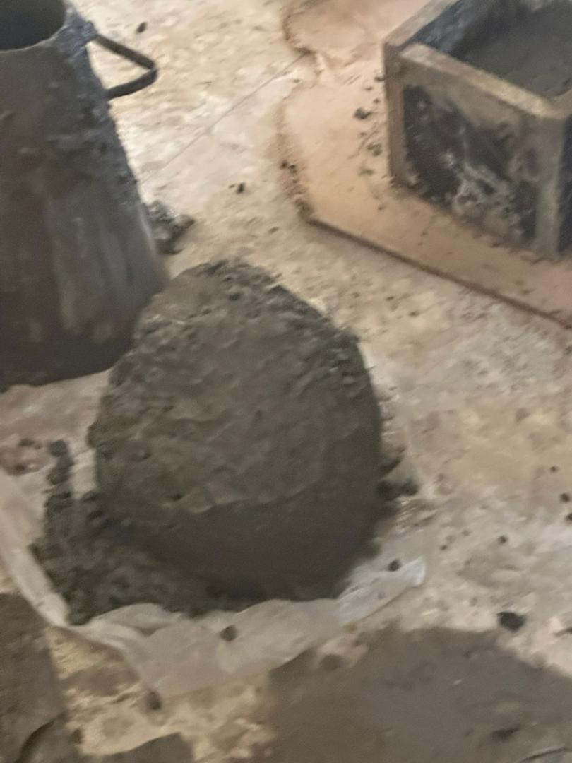
Plate 3: casting Plate 4: slump measuring

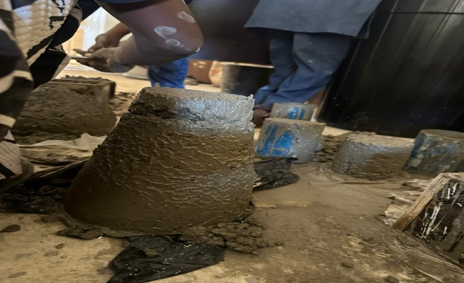
Plate 5: sample 1 Plate 6: sample 2

