COMPARATIVE STUDIES OF SOME GEOTECHNICAL PROPERTIESOF LATERITESOILINOSHIN,ILORINSOUTHL.G.A.ANDALAGBAA,ILORIN EAST L.G.A OF KWARA STATE

BY

ANIFOWOSHESAHEED FEMI

ND/23/MPE/FT/0042

A PROJECT SUBMITTED TO THE DEPARTMENT OF MINERALS AND PETROLEUMRESOURCESENGINEERING,INSTITUTEOFTECHNOLOGY, KWARA STATE POLYTECHNIC, ILORIN, NIGERIA.

INPARTIALFULFILLMENTFORTHEAWARDOFNATIONALDIPLOMA(ND)IN MINERAL AND PETROLEUM RESOURCES ENGINEERING TECHNOLOGY. AUGUST, 2025

I

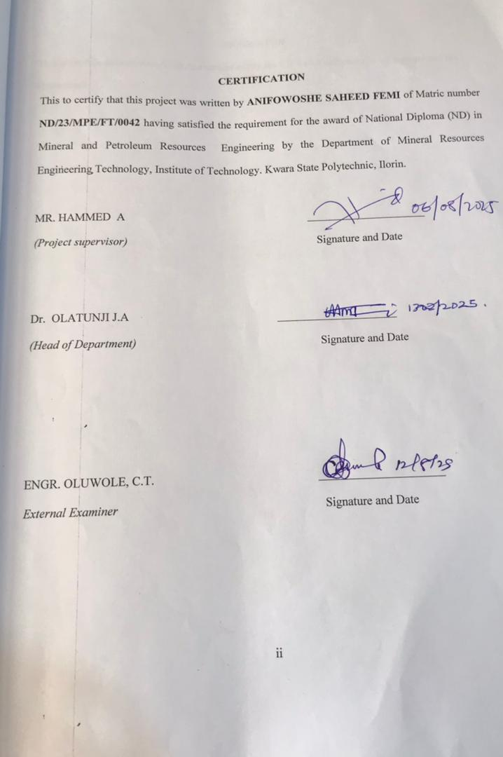
DEDICATION
ThisprojectisdedicatedtoAllah,thecreatorofmysoul.It’salsodedicatedtomyparentsand my entire family.

iii
ACKNOWLEDGEMENT
First and foremost, I express my sincere gratitude to the Almighty Allah for His grace, protection, and guidance throughout the course of my academic journey and the successful completion of
thisproject.
Iextendmyprofoundappreciationtomyprojectsupervisor,MrAHammed,forhisinvaluable support, encouragement, and expert guidance. His constructive criticisms, suggestions, and commitment to excellence greatly enhanced the quality of this research work.
IamalsogratefultomyH.O.DinpersonofDr.OlatunjiJ.A,alsomyprofoundgratitudegoestomy lecturers in person of Dr. ReubenObaro,Mr. I. S.Usman,Engr.S.AAgbalajobi,andMr.Odediran for their dedication and knowledge impacted during my study
My heartfelt thanks also go to all the lecturers and staff of the Department of Mineral and PetroleumResourcesEngineering,whoseteachingsandmentorshiphavecontributedimmensely to my academic and personal development.
Iamalsogratefultomyfamilyfortheirunwaveringlove,prayers,andfinancialsupport.Their encouragement gave me the strength to persevere through challenges during this project.
I acknowledge the assistance of friends and colleagues, especially my coursemates, who shared ideas,offeredsupport,andcollaboratedinvariousways.Yourcontributionsdidnotgounnoticed and are deeply appreciated.
Finally,Iwould like to thankeveryone who,in oneway or another, contributed tothe successful completion of this project. May God bless you all abundantly.

iv
ABSTRACT
This study presents a comparative geotechnical analysis of laterite soils obtained from Oshin in Ilorin South Local Government Area and Alagbaa in Ilorin East Local Government Area of Kwara State, Nigeria. The research was conducted to evaluate the engineering properties of these soils to determine their suitability for construction purposes, particularly in road pavement subgrades and building foundations. Laboratory tests, including specific gravity, Atterberg limits, grain size distribution, compaction characteristics, and California Bearing Ratio (CBR), were performed following ASTM and British Standard procedures.

Results revealed that both soil samples exhibited similar geotechnical behavior, with specific gravity values of 2.70 and 2.78, indicating inorganic soil characteristics. The Atterberg limits showed moderate plasticity indices of 20.9% and 21.9% for Oshin and Alagbaa soils, respectively, suggesting a moderate potential for volume change. Grain size analysis classified both samples as sandy gravels, suitable for subgrade and sub-base applications. Compaction tests revealed maximum dry densities of 1.80 g/cm³ and 1.83 g/cm³ with optimum moisture content of 15% for both locations. However, CBR values for soaked samples indicated poor to very poor ratings, limiting their usage to subgrade materials under soakedconditions, while unsoaked conditions showed potential for sub-base applications.
The study emphasizes the importance of site-specific geotechnical investigations in infrastructure development to mitigate risks of structural failures and supports the use of locally sourced laterite soils in sustainable construction, provided appropriate stabilization techniques are employed.

v

TABLE OF CONTENT
Title page i
Certification ii
Dedication iii
Acknowledgement iv
Abstract v
Table of contents vi
List of Figures ix
List of Tables x
CHAPTER ONE 1
Introduction 1
1.1 Background of the study 1
1.2 Statement of problem 2
1.3 Aim of the project 2
1.4 Objectives of the project 2
1.5 Significance of the study 3
1.6 Scope and limitation 3
CHAPTER TWO 5
Literature review 5
2.1 previous studies on laterite soil 5
2.2 Origin of lateritic soil 6
2.3 Geology of Nigeria 6
2.4 Geology of the study area 9
2.5 Formation of lateritic soil 11
2.6. Economic importance of laterite. 11
CHAPTER THREE 12
Material and methods. 12
3.1 Sample collection and preparation 12
3.2 Laboratory analysis 12
3.3 Determination of grain size analysis 12
3.3.1 Mechanical sieve method 12
3.3.2 Hydrometer sieve method 13
3.4 Determination of atterberg limit test 13
3.4.1 Liquid limit determination 13
3.4.2 Plastic limit determination 13
3.4.3 Determination of linear shrinkage 14
3.5 Compassion test 14
3.6 Determination of shear box test 14
3.7 California bearing ratio (CBR) 15
CHAPTER FOUR 16
Result and discussion. 16
4.1 Results of Natural Water Determination 16
4.2 Discussion on Natural Water Determination 16
4.3 Results of Specific Gravity 18
4.4 Discussion on Specific Gravity Determination 18
4.5 Results of Grain Size Analysis 19
4.6 Discussion of Grain Size Analysis 20
4.7 Results of Atterberg Limit Determination 25
4.8 Discussion on Atterberg Limit Determination 28
4.9 Results of Compaction tests 32
4.10 Discussion on Compaction results 36
4.11 Results of California Bearing Ratio 38
4.12 Discussion of CBR Results 43
CHAPTER FIVE 44
5.0 Conclusion and Recommendation 44
5.1 Conclusion 44
5.2 Recommendation 44
References 45

List of Figures
Fig. 2.1: Geology of Nigeria 8
Fig. 2.2: Location of the study area 10
Fig. 4.1: Grain Size Analysis for Sample A 21
Fig. 4.2: Grain Size Analysis for Sample B 23
Fig. 4.3: Plots of Sample A and B on Plasticity Chart 29
Fig. 4.4: Compaction Curves for Sample A 33
Fig. 4.5: Compaction Curves for Sample B 35
Fig. 4.7: Plots of California Bearing Ratio for Sample A 39
Fig. 4.8: Plots of California Bearing Ratio for Sample B 41

List of Tables
Table 4.1: Natural Water Content Determination for Sample A and B 16
Table 4.2. Specific Gravity Determination for Sample A and B 18
Table 4.3. Typical Values of Specific Gravity of Soil Samples 19
Table 4.4: Grain Size Analysis for Sample A and B 20
Table 4.5: Unified Soil Classification System (USCS) 24
Table 4.6: Liquid Limit Determination for Sample A 25
Table 4.6.1. Plastic Limit Determination for Sample A 26
Table 4.6.2: Liquid Limit Determination for Sample B 27
Table 4.6.3: Plastic Limit Determination for Sample B 28
Table 4.6.4: Relationship between Atterberg limit and Volume Change Potential 30
Table 4.6.5: Engineering Used Chart (After Wagner, 1957) 31
Table 4.7: Compaction Tests for Sample A (Standard Proctor) 32
Table 4.7.1: Compaction Tests for Sample A (Modified Proctor) 34
Table 4.7.2: Presentation of Compaction Results 34
Table 4.7.3: Compaction Characteristics and Rating of Unified Soil Classification Classes for Construction 36
Table 4.8.1: California Bearing Ratio tests for Sample A 38
Table 4.8.2: California Bearing Ratio tests for Sample B 40
Table 4.8.3: Summary of CBR Results for Standard Proctor 42
Table 4.8.4: Summary of CBR Results for Modified Proctor 42
Table 4.8.5: General Rating for Soil Based on CBR Values (AfterAsphalt Institute, 1962) 43

CHAPTER ONE
INTRODUCTION
1.1 Background of the study
Laterite soil contribute economy of the regions where they found their scope is very wide and include geological engineering civil engineering, mining research (Iron, aluminum and manganese) deposits. The evaluation of laterite soil is most engineering structure require that adequate information about the engineering properties of the soil and subsurface soil condition of that particular area is known. This is vital for the engineering planning. Design and construction of such foundation to be base on concrete geotechnical parameters. This is more important especially in the design and construction of highway, where there is need for a good adequate knowledge of the geotechnical and engineering properties of the sub-grade and more importantly, the construction material’ properties for certain engineering decision to be taken. Jackson (1980) established that laterite soils have been used mostly as base and sub-base material in road construction. Alao,(1983) studies the engineering properties of some soil sample from Ilorin area and discovered that they could be stabilized by compaction and that their sample could yield maximum strength if they are compacted on the dry side of their optimum moisture content. The mineralogical composition of the laterite soil has an influence on the geotechnical parameters such as specific gravity shear strength, atterberg limits, bearing capacity and petrographic properties (Amadi et al., 2012). A literature review has revealed that the geotechnical characteristics and engineering behavior of red soils depends mainly on the genesis and degree of weathering (i.e. decomposition, laterization, desiccation and hard erring). Morphological characteristics as well as the type and convened of secondary minerals are another genetic characteristic (Agbede 1992). Good understandings of the basement soil on which highways and other transportation. Facilities are constructed are very important. Saltar (1998) said the performance of a high-way pavement is influenced to a very considerable extent by the sub-grade material.
1.2 Statement of the Problem
The performance of soil in construction depends heavily on it geotechnical properties. Their abundance and cost- effectiveness make them a common choice for road sub-grade embankment, and building foundation. However, laterite soil are highly variable in terms of geotechnical behaviour due to difference in mineral composition, degree of weathering, drainage and environmental condition. In Kwara state, and particularly within Ilorin south and Ilorin East Local Government Area. Laterite soil are commonly exploited for engineering application without sufficient geotechnical investigation. As a result, Inappropriate or generalized design. Assumption are often made, leading to premature structural failures, road deterioration and increased maintenance cost.
The challenge is further compounded by the limited availability of localized geotechnical data that compares laterite soil across different part of the state. Soils obtain from oshin in Ilorin south may differ significantly in strenht, plasticity, and bearing capacity from those found in Alagbaa, Ilorin East, despite their apparent physical similarity. Without detailed comparative data, civil engineers, contractors, and decision-makes risk using unsuitable material for critical infrastructure project.
1.3 Aim of the Study
The primary aim of this research is to conduct, and compare a comparative investigation of the geotechnical properties of laterite soil obtained from Oshin in Ilorin south L.G.A and Alagbaa in Ilorin East L.G.A of Kwara State.
1.4 Objectives of the study
i. Identifying difference and similarity in their geotechnical behaviour (Umar et al, 2022)
ii. To determine key geotechnical properties of the soil samples such as Natural moisture content, Atterberg Limit (Liquid limit, Plastic limit, plasticity limit), Particle size distribution Specific gravity
iii. To identify the structure, weakness and potential engineering uses of the soil in those two region, thereby guiding engineers, builders planners and policy-maker in appropriate selection and treatment of the soil for construction and to compare the result obtained from the two locations. Compaction characteristic (MDD and OMC) California Bearing ratio (CBR)
1.5 Significance of the Study
Laterite soil are among the most commonly used natural materials in engineering construction access Nigeria and other tropical regions due to their abundance and relative affordability. However, their geotechnical properties are highly location dependent, which means that assumption based on one location may not be valid for another even within the same state (Osinubi et al, 2020). As noted by Nnochiri & Eze (2021) engineering failures often occur due to reliance on outdated or non-site specific soil date. Support sustainable construction practice and many infrastructure failure in Nigeria are linked to poor understanding or misclassification of local soil properties Ogunribido & Oyedele, 2019) by conducting a comparative analysis between two distinct geographical regions, this research can serve as a reference point for site specific geotechnical planning and reduce the risk of structure failure due to unsuitable subsoil condition.
1.6 Scope of the Study
This study focuses on the comparative analysis of selected geotechnical properties of laterite soils obtained from two locations within Kwara State, Nigeria: Oshin in Ilorin South Local Government Area and Alagbaa in Ilorin East Local Government Area. The research is designed to assess the suitability of these soils for potential use in civil engineering and construction projects, especially in foundation works, road construction, and other structural applications. The primary aim is to determine the suitability of these soils for construction and civil engineering purposes, especially in areas such as road pavement subgrade, embankments, and building foundations.

CHAPTER TWO
LITERATURE REVIEW
  - Previous Studies on Laterite Soil
Laterite soil are extensively found in tropical and sub-tropical region and are often used as construction materials for roads, embankments, and foundations. These soils derived from intense weathering of parent rock under humid condition, display unique geotechnical properties that vary significantly with location due to difference in mineralogy, drainage, climate and vegetation-understanding these variation is critical for civil engineering design, especially in road construction and foundation engineering.Aliyu & Bamidele (2018) conducted a study on the stabilization of laterite soils across three location and reported significant variability in alter berg unit and C.B.R values. Obaro R.I,& Obaro, N.T (2019) conclude that laterite soil bearing capacity due to low chesion and high angle of internal friction hence they are good as engineering construction. This paper examine the geotechnical properties of laterite soil in Otun area in Ekiti State, Sourt western Nigeria. Okonta & Ochepo (2020) reported stabilization of laterites soil with coconut shell. The study evaluate the potential of coconut ash (CSA) a waste product as a stabilization agent for laterite soil used in road construction, the studies introduce an eco-friendly and sustainable approach for improving laterite soil properties, reducing reliance on tranditional stabilize like cement or line. Onvelowe et al. (2021) reported that rice husk ash stabilization of laterite soil. To explore the uses of rice husk ash (RHA) and cement in stabilizing laterite the role of agro-industrial by product in enhancing the geotechnical properties of laterite soil prompting circular economy principle in civil engineering. Eberemu et al. (2021) Stated that characterization of laterite soil for sustainable road construction Geotechnical characterization of compacted laterite soil for geomechanics whereby review that to assess the suitability of compacted laterite from central Nigeria for use in sub-base and subgrade layer of pavement. The studies provided detailed geotechnical data on lateritic soil across a wide geographic region helping engineers select appropriate material for road design and construction. Umar et al. (2022) reported a comparative Geotechnical analysis of laterite soils. The research compare the geotechnical properties of laterite soils collected from different regions in Northern Nigeria for road construction suitability. The study reinforced the necessity of site-specific geotechnical evaluation rather than assuming uniformity in laterite soil behaviour across regions.
2.2 Origin of Laterite Soil
Laterite soil are residual soil that form in tropical and sub-tropical region under condition of high temperature, heavy rainfall, and good drainage. Their origin is deeply linked to a prolonged process of chemical weathering of parent rock such as basalt, granite, gneiss and other igneous or metamorphic formation. This intense weathering, coupled with teaching, removes silica and enriched the soil with iron and aluminum oxide, giving laterite it’s characteristics reddish to brown coloration (Ojo et al. 2021). Laterite soil is primarly a pedogenic process, meaning it accurs in a place through the natural transformation of rock into soil over long period of time.

Geology of Nigeria
Nigeria is geologically diverse and features, a variety of rock type, structure and mineral resources that have characteristic of both Precambrian and phanorozonic eras. Obaje, (2019). The geology of Nigeria can broadly categorized into three major litho logical unit.
The Nigeria basement complex is part of the Precambrian shield of wet Africa. And it compose mainly of Migmatites, Gneisses, Granites, Schists, Quartzites. These rock date back to more than 600million years ago (Precambrian era), the basement complex occupies over 50% of Nigeria’s surface, especially in the southwestern central and Northern part of the country. The Young Granites are of Jurassic in age (150 million years ago) and are found in North central Nigeria, especially in Jos plateau. They are formed by igneous instructions and are associated with mineralization, especially tin (cassiterite), Columbite, and tantalite. The Sedimentary Basin cover about 30-40% of the country, mainly in the southern and Northeastern parts. Southern and Northeastern parts. The major sedimentary include Niger delta basin, Benue trough, Chad basin, Sokoto basin, Anambra basin, Dahomey basin. These basin are mostly filled with Cretaceous to Tertiary sediments. The Niger delta basin in particular is of economic importance due to it rich hydrocarbon (oil and Gas) deposit (Fig. 2.1).

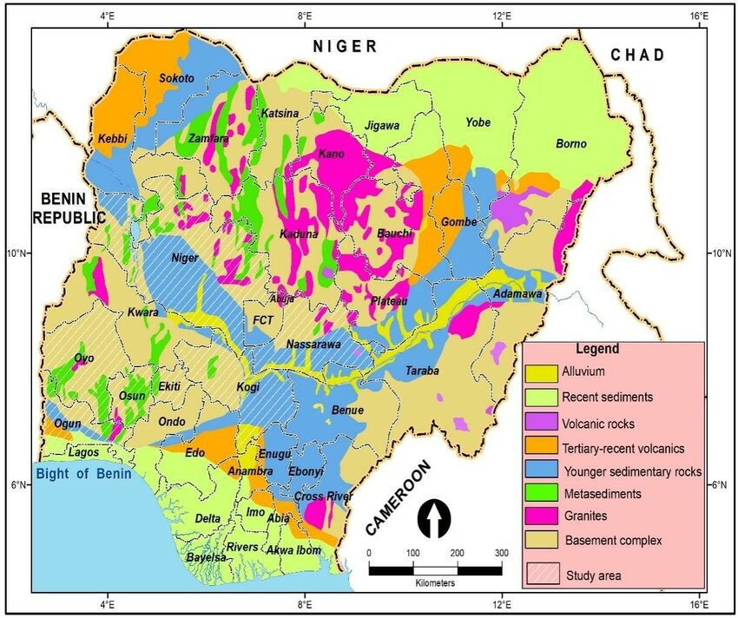
Fig. 2.1. Geology of Nigeria

2.3 Geology of the Study Area
The study area falls within the Precambrian of North-central, Nigeria, which is a part of Nigeria basement complex. The location is Oshin and Alagbaa (Fig. 2.2) in Kwara State. It is situated on the undifferentiated Precambrian basement complex of granitic and metamorphic origin and form part of the regional north western highlands running through north-west to south-east parallel to the river Niger. Some of these rocks include the migmatite, granites and gneiss. The climate of the area is characterized by wet and dry season each lasting between 1,250mm and 1350mm. the area is underlain by rocks of Precambrian basement complex, the rocks are principally granites and gneisses which are emplaced by Precambrian time and have overtime subjected to tectonic activities characterized by large changes on temperature and resulting in fractures like joints faults and fractures within the basement complex rock.

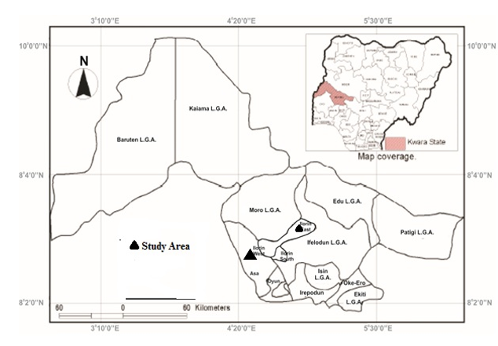
Fig. 2.2. Location of the study areas

  - Formation of Laterite Soil
Laterite soil is formed primarily through the intense and prolonged chemical weathering of silizate rock under tropical climate conditions. This process occurs in region characterized by high temperatures, abundant rainfall, and alternating wet and dry season such as those found in most parts of Nigeria (Obaje, 2019). During the formation it’s governed primarily by climate, parent rock, topography, time and biological activity-whereby the process responsible for the formation soil is known as laterization. Laterization is the prolonged and intense chemical weathering of rock in tropical and sub-tropical climate resulting to the (teaching) removal of silicaluminum oxide in the soil. This process is transforms the original rock into a residual soil in sequioxide (Fe₂O₃ and Al₂O₃).
2.4 Economic Importance of Laterite Soil
Laterite is not just a common tropical soil it’s a strategic economic resources. It’s uses in construction, mining, Agriculture and environmental management contribute significantly to the development of both rural and urban economic with proper processing and stabilization laterite can be a sustainable alternative to more expensive or imported material making it vital assest in many developing nation. Laterite soil posses favorable geotechnical properties for various engineering application. Its relatively high strength, low permeability and moderate plasticity Akintorinwa & Akinluyi (2021) There are many importance of lateritic soil. These include; Building and construction material, Sources of iron and Aluminum ore, Soil for road construction, Agriculture etc.

CHAPTER THREE
MATERIALS AND METHODS
3.1 Sample collection and preparation
Soil samples were collected at different locations, Oshin and Alagbaa in Ilorin, Kwara State, using a systematic sampling approach to ensure representativeness. Disturbed and undisturbed samples were obtained from depths of 0.5-1.5m using hand augers and core cutters, respectively. The samples were placed in airtight polyethylene bags to preserve the moisture content and transported to the laboratory within 24hours. In the laboratory, samples were air-dried pulverized, and sieved to remove debris and organic matter. Disturbed samples were used for physical tests while undisturbed samples were used for mechanical tests according to ASRM (2014).
3.2 Laboratory analysis
Laboratory analyses were conducted to determine the physical and mechanical properties of the soil samples. Tests included specific gravity, moisture content, grain size analysis, atterberg limits, linear shrinkage, compaction and California bearing ratio, which are all performed in accordance with British standards (BS 2003). All equipment was collaborated prior to testing, and tests were conducted in triplicate to ensure accuracy and repeatability. Details were recorded and analyzed in the laboratory.
3.3 Determination of grain size analysis
Grain size analysis was performed to classify the soil based on particle size distribution. Two methods were employed the mechanical sieve method for coarse-grained soils and the hydrometer method for fine grained soils
3.3.1 Mechanical sieve method
The mechanical sieve method was used to determine the particle size distribution of coarse-grained soils (sand and gravel), A200g oven. Dried oven-dried soil sample was passed through a stack of sieve with aperture size ranging from 4.75mm to 0.075mm following ASTM D6913. (D6913M-17(ASTM 2017). The sieve were shaken mechanically for 10minutes using a sieve shaker. The weight of soil retained on each sieve was recorded and the percentage passing was calculated to plot the particle size distribution curve
3.3.2 Hydrometer sieve method
For fine-grained soils (silt and clay), the hydrometer method was used to determine the particle size distribution as outlined in ASRM D7928-21 (ASTM, 2021). A 50g soil sample was mixed with a dispersing agent (sodium hexametaphosphate) and water to form a suspension. The hydrometer was used to measure (2, 3, 15, 30, 60, 240, and 1440 minutes). Particles sizes were calculated used stokes law and the percentage of particles finer than a given was determined.
3.4 Determination of atterberg limit test
Atterberg limit test were conducted to determine the plasticity characteristics of fine-grained soils, following BS 1377-2:2003 (BSI, 2003). These tests included the liquid limit, plastic limit, and linear shrinkage.
3.4.1 Liquid limit determination
The liquid limit was determined using the Casagrande apparatus, as per ASTM D4318-17 (ASTM, 2017). A 250g soil sample passing through a 0.42mm sieve was mixed with distilled water to form a paste. The paste was placed in the Casagrande cup, and a groove was made using a standard grooving tool. The number of blows required to close the groove over a 12.7mm distance was recorded at varying moisture contents. The moisture content at 25 blows was taken as the liquid limit.
3.4.2 Plastic limit determination
The plastic limit was determined by rolling a 20g soil sample into threads of approximately 3mm diameter, as described in ASTM S4318-17 (ASTM, 2017). The soil was rolled until it crumbled, and the moisture content at this point was measured by oven-drying the sample at 105⁰C for 24 hours. The plastic limit was calculated as the average moisture content of three trials.
3.4.3 Determination of linear shrinkage
Linear shrinkage was determined using BS 1377-2:2003 (BSI, 2003). A soil paste was prepared at the liquid limit and placed in a shrinkage mold (140mm long). The mold was oven-dried at 105⁰C for 24 hours, and the reduction in length was measured using a vernie caliper. Linear shrinkage was calculated s the percentage reduction in length relative to the original length.
3.5 Compaction test
The standard proctor compaction test was conducted to determine the maximum dry density (MDD) and optimum moisture content (OMC) of the soil following ASTM D698-12 (ASTM, 2012). A 2.5kg soil sample passing through a 4.75mm sieve was compacted in a 1000cm³ mold in three layers, each receiving 25 blows from a 2.5kg rammer dropped from a height of 300mm. the rest was repeated at different moisture contents (ranging from 4% to 20%) and the dry density was calculated for each trial. The MDD and OMC were determined by plotting the dry density against moisture content.
3.6 Determination of shear box test
The direct shear test was conducted to determine the shear strength parameters (cohesion and angle of internal friction) of the soil, following (ASTM, 2011). An undisturbed soil sample (60mm x 60mm x 20mm) was placed in a shear box apparatus. Normal stresses of 50, 100 and 150 Kpa were applied at a constant rate of 0.5mm/min. the shear stress at failure was recorded and Mohr. Coulomb failure were used to calculate cohension (c) and friction angle (ⱷ)
3.7 California bearing ratio (CBR)
The CBR test was performed to elevate the strength of the soil for pavement design, as per ASTM1998-21 (ASTM, 2021). A soil sample was compacted at the opinion moisture content in a CBR mols (150mm diameter) using a 4.5kg rammer. The sample was subjected to penetration by a 50mm diameter plunger at a rate of 1.25mm/min under surcharge loads. The CBR value was calculated as the ratio of the load sustained by the soil to that of a standard crushed rock at 2.5mm and 5.0mm penetration.

CHAPTER FOUR
RESULTS AND DISCUSSION
4.1 Results of Natural Water Determination
The results of natural water determination are shown in table 4.1 below.
Table 4.1: Natural Water Content Determination for Sample A and B
SAMPLE A SAMPLE B
Boring no.
Container no (Cup)
Wt of cup + Wet soil (g) | 134.5 | 135.0 |  | 162.5 | 118.0
Wt of cup + dry soil (g) | 128.0 | 129.5 |  | 154.5 | 112.5
Wt of cup (g) | 25.5 | 25.0 |  | 34.5 | 24.5
Wt of dry soil. (g) | 102.5 | 104.5 |  | 120.0 | 88.0
Wt of water (g) | 6.5 | 5.5 |  | 8.0 | 5.5
Water content % | 6.3 | 5.3 |  | 6.7 | 6.3
Average water content (%) = 5.8% 6.5%
4.2 Discussion on Natural Water Determination
The natural water determination for sample A and Sample B is 5.8% and 6.5% respectively. It is to determine the amount of water present in a quantity of soil in terms of its dry weight. The natural water determination of various soils varies generally ranging from about 10 to15% for sand, 15 to 30% for silt and 30 to 50% for clay. The low value of natural water determination content for Sample A and B indicates that the water table fluctuates during the dry season (Sidi et al., 2015).
4.3 Results of Specific Gravity
The results of Specific Gravity is shown in Fig. 4.2 below
Table 4.2. Specific Gravity Determination for Sample A and B
SAMPLE A SAMPLE B
SAMPLE LABEL
WT OF EMPTY BOTTLE (g) (W1) | 103.0 | 103.0
WT OF EMPTY BOTTLE+1/3 OF SOIL (g) (W2) | 153.0 | 153.0
WT OF EMPTY BOTTLE+1/3 OF SOIL+WATER (g) (W3) | 229.5 | 230.0
WT OF EMPTY BOTTLE+WATER ONLY (g) (W4) | 198.0 | 198.0
SPECIFIC GRAVITY = | 2.70 | 2.78

4.4 Discussion on Specific Gravity Determination
The specific gravity of the soil depends on the amount of sand and also depends on their mineral constituents and mode of formation of the soil. The results of the specific gravity analysis on soil samples of Sample A and Sample B are 2.70 and 2.78 respectively. Comparing these specific gravity values to some common soil types from (Lambe, 1969). (Table 4.3) shows the specific gravity of each soil type. It can be deduced from Table 4.3 that the specific gravity of soil sample A and B can be described as inorganic soil.

Table 4.3. Typical Values of Specific Gravity of Soil Samples (Lambe and Whiteman, 1969)
SOIL TYPES | SPECIFIC GRAVITY
Sand | 2.65 – 2.67
Silty sand | 2.67 – 2.70
Inorganic soil | 2.70 – 2.80
Soil with mica or iron | 2.75 – 3.00
Organic | Variable but may be under 2.0

4.5 Results of Grain Size Analysis
The results of grain size analysis are shown in table 4.4 below.
Table 4.4: Grain Size Analysis for Sample A and B
Sieve analysis and Grain Size A Sieve analysis and Grain Size B
Sieve No | Diam. (mm) | Wt. retained | % retained | % passive | Diam. (mm) | Wt. retained | % retained | % passive
 | 19.00 |  |  |  | 19.00 | 0.0 | 0.0 | 100.0
 | 16.00 | 0.0 | 0.0 | 100.0 | 16.00 | 12.5 | 2.5 | 97.5
 | 8.00 | 68.5 | 13.7 | 86.3 | 8.00 | 67.0 | 13.4 | 84.1
 | 4.75 | 141.0 | 28.2 | 58.1 | 4.75 | 111.0 | 22.2 | 61.9
 | 2.36 | 134.0 | 26.8 | 31.3 | 2.36 | 149.5 | 29.9 | 32.0
 | 1.00 | 88.0 | 17.6 | 13.7 | 1.00 | 124.0 | 24.8 | 7.2
 | 0.50 | 37.0 | 7.4 | 6.3 | 0.50 | 29.0 | 5.8 | 1.4
 | 0.425 | ------- | --------- | -------- | 0.425 | --------- | --------- | ---------
 | 0.30 | 12.0 | 2.4 | 3.5 | 0.30 | 3.0 | 0.6 | 0.8
 | 0.25 | 5.0 | 1.0 | 2.9 | 0.25 | 0.2 | 0.04 | 0.76
 | 0.150 | 6.5 | 1.3 | 1.6 | 0.150 | 0.2 | 0.04 | 0.72
 | 0.090 | ------- | ------- | ------- | 0.090 | ------- | ------- | -------
 | 0.75 | 5.5 | 1.1 | 0.5 | 0.075 | 1.0 | 0.2 | 0.52
 | PAN | 2.0 | 0.4 |  | PAN | 1.0 | 0.2

4.6 Discussion of Grain Size Analysis
The graphical representation of the results of the grain size analysis (Fig. 4.1) of Sample A indicates that the Gravel is of high dominance with percentage of 72%, followed by Sand with percentage of 28% while Sample B (Fig. 4.2) contains 73% gravel and the sand is 27%, this as such is classified as sandy gravels in accordance to the USCS classification (Table 4.5).
In accordance to the USCS classification. On the Unified Soil Classification Chart (Table 4.5), sample A and Sample B have the group symbol SW and are classified as pervious, and it has an excellent shear strength when compacted and saturated, negligible compressibility when compacted and saturated and has excellent workability as construction material which can resist erosion.

Fig. 4.1: Grain Size Analysis for Sample A

100100
9090
8080
7070
6060
5050
4040
3030
2020
1010
00
SILTSILT
0.0020.002
0.0030.003
0.0040.004
0.0060.006
0.0080.008
0.0100.010
0.0150.015
0.0200.020
0.0300.030
0.0400.040
0.0500.050
0.0600.060
0.0950.095
0.1050.105
0.1250.125
0.1500.150
0.2120.212
0.2500.250
0.3000.300
0.4250.425
0.5000.500
0.5000.500
1.001.00
1.181.18
1.201.20
2.02.0
2.362.36
4.04.0
6.256.25
8.08.0
9.309.30
12.5012.50
16.7516.75
13.7513.75
25.025.0
31.531.5
37.537.5
37.537.5
38.038.0
39.539.5
40.040.0
42.542.5
45.545.5
50.050.0
100100
9090
8080
7070
6060
5050
4040
3030
2020
1010
00
TineTine
MediumMedium
CoarseCoarse
FineFine
MediumMedium
CoarseCoarse
SandSand
GraveGrave
PERCENTAGE FINER THAN 0PERCENTAGE FINER THAN 0

Fig. 4.2: Grain Size Analysis for Sample B

Table 4.5: Unified Soil Classification System (USCS)
Major divisions | Subdivisions | USCS Symbol | Typical names | Laboratory classification criteria
Coarse gained soils (more than 50% retained on no. 200 sieve) | Gravels (more than 50% of coarse fraction retained on no. 4 sieve | GW | Well graded gravels or gravel-sand mixture, little or no fines | Less than 5% fines
 |  | GP | Poorly graded gravels or gravel-sand mixture, little or no fines | Less than 5% fines
 |  | GM | Silty gravels, gravel-sand-silt mixtures | More than 12% fines
 |  | GC | Clayey gravels, gravel-sand-clay mixtures | More than 12% fines
 | Sands (50% or more coarse fraction passing no. 4 sieve | SW | Well graded sands or gravel-sand, little or no fines | Less than 5% fines
 | Sands (50% or more coarse fraction passing no. 4 sieve | SP | Poorly graded sands or gravel-sand mixture, little or no fines | Less than 5% fines
 | Sands (50% or more coarse fraction passing no. 4 sieve | SM | Silty sand, sand-silt mixture | More than 12% fines
 | Sands (50% or more coarse fraction passing no. 4 sieve | SC | Clayey sand, sand-clay mixture | More than 12% fines
Fine grained soils (50% or more passes the no. 200 sieve) | Silts and Clays  (liquid limit less than 50%) | ML | Inorganic silts, rock flour, silts of low plasticity | Inorganic soils
Fine grained soils (50% or more passes the no. 200 sieve) | Silts and Clays  (liquid limit less than 50%) | CL | Inorganic clays of low plasticity, gravelly clays, sandy clays, etc | Inorganic soils
Fine grained soils (50% or more passes the no. 200 sieve) | Silts and Clays  (liquid limit less than 50%) | OL | Organic silts and organic clays of low plasticity | Organic soils
Fine grained soils (50% or more passes the no. 200 sieve) | Silts and Clays (liquid limit 50% or more) | MH | Inorganic silts, micaceous silts, silts of high plasticity | Inorganic soils
Fine grained soils (50% or more passes the no. 200 sieve) | Silts and Clays (liquid limit 50% or more) | CH | Inorganic highly plastic clays, fat clays, silty clays, etc | Inorganic soils
Fine grained soils (50% or more passes the no. 200 sieve) | Silts and Clays (liquid limit 50% or more) | OH | Organic silts and organic clays of high plasticity | Organic soils
Peat | Highly organic | PT | Peat and other highly organic soils | Primarily organic matter, dark in colour and organic odour

4.7 Results of Atterberg Limit Determination
The results of Atterberg Limit Determination are shown below.
Table 4.6: Liquid Limit Determination for Sample A
Can no. | 26 | 12 | K5 | AA
Container no (Cup)
Wt of Wet soil + can (g) | 36.5 | 35.5 | 35.5 | 32.5
Wt of dry soil + can (g) | 34 | 32.5 | 33 | 30
Wt can (g) | 24.5 | 24 | 25.5 | 24
Wt moisture (g) | 9.5 | 8.5 | 7.5 | 6
Water content, w% | 26.3 | 37.5 | 33.3 | 41.7
No of blows N | 45 | 34 | 22 | 16
50
40
30
20
10
0
10
15
20
25
30
35
40
50
60
70
80
WATER CONTENT W%
NO. OF BLOWS N

Flow index F1 =
Liquid limit = 37.0%
Plastic limit = 16.1%
Plasticity Index Ip = 20.9%
IP = LL - PL= 37 - 16.1 = 20.9
Table 4.6.1. Plastic Limit Determination for Sample A
Can no. | 25 | E1
Wt. of Wet soil + can (g) | 31 | 30
Wt. of dry soil + can (g) | 30 | 29
Wt. of can (g) | 23.5 | 23
Wt. of dry soil | 6.5 | 6
Wt. of moisture (g) | 1 | 1
Water content. w% = w | 15.4 | 16.7

Table 4.6.2: Liquid Limit Determination for Sample B
Can no. | T1 | A1 | H3 | G2
Wt. of Wet soil + can (g) | 34 | 32.5 | 32.5 | 31.5
Wt. of dry soil + can (g) | 31.5 | 29.5 | 30 | 29
Wt. can (g) | 25 | 22.5 | 25.5 | 24
Wt. of dry soil | 6.5 | 7 | 4.5 | 5
Wt. moisture (g) | 2.5 | 3 | 2.5 | 2.5
Water content, w% | 38.5 | 42.9 | 55.6 | 50.0
No of blows N | 40 | 22 | 20 | 10
50
40
30
20
10
0
10
15
20
25
30
35
40
50
60
70
80
WATER CONTENT wt%
NO. OF BLOWS
60

Flow index F1 =
Liquid limit = 43.0%
Plastic limit = 21.1%
Plasticity index Ip = 21.9%
IP = LL - PL
= 43.0% - 21.1% = 21.9%
Table 4.6.3: Plastic Limit Determination for Sample B
Can no. | D4 | 24
Wt. of Wet soil + can (g) | 24 | 24.5
Wt. of dry soil + can (g) | 23 | 23.5
Wt. of can (g) | 18.5 | 18.5
Wt. of dry soil | 4.5 | 5
Wt. of moisture (g) | 1 | 1
Water content. w% = w | 22.2 | 20.0

4.8 Discussion on Atterberg Limit Determination
The results of Atterberg consistency limits carried out on the soil sample, Sample A gave the following values: liquid limit of 37.0%, plastic limit of 16.1%, plasticity index of 20.9%, while Sample B has the following values for each of the parameter: liquid limit of 43.0%, plastic limit of 21.1% and plasticity Index of 21.9%. According to Holtz and Cubbs, Volume change potential, 1936) as having a moderate volume change (Table 4.6.4). Drawing inferences from these values, the soil samples suggests that they have moderate potential to swell or shrink (Madedor, 1983). The plot of the result on the plasticity chart for both samples A and B falls within the CL zone (Fig. 4.3). According to engineering use chart (Table 4.6.5) they are impervious, inorganic clays which can be used as a dam construction.
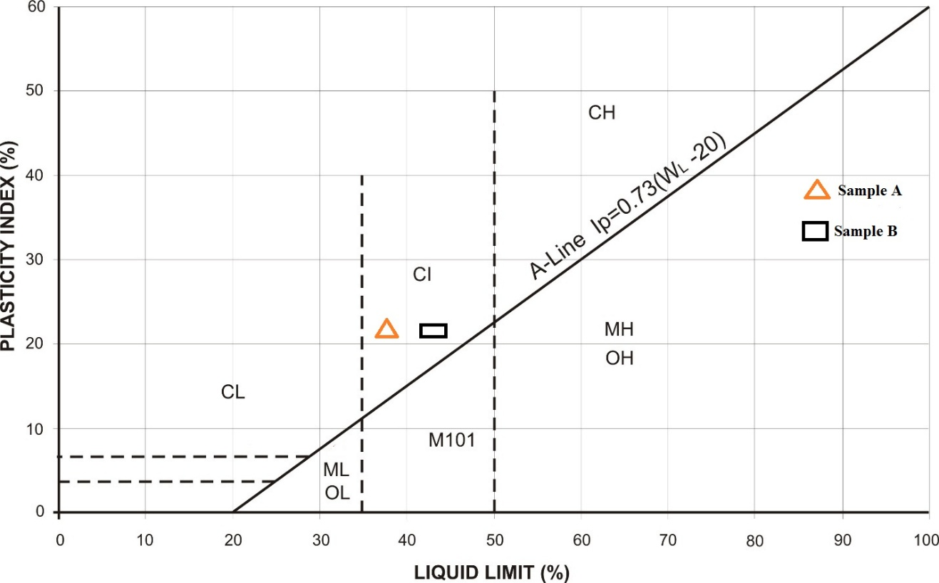
Fig. 4.3: Plots of Sample A and B on Plasticity Chart

Table 4.6.4: Relationship between Atterberg limit and Volume Change Potential (After Holtz and Cubbs, 1936)
Volume Change  Potential | Plasticity Index Ip |  | Shrinkage
Volume Change  Potential | Arid Area | Humid Area
Little | 0 – 15 | 0 – 30 | < 12
Moderate | 15 – 30 | 30 – 50 | 10 – 12
High | >30 | >50 | >10

Table 4.6.5: Engineering Used Chart (After Wagner, 1957)
Typical names of Soil groups | Group Symbols | Important Properties
Typical names of Soil groups | Group Symbols | Permeability when compacted | Shearing strength with compacted and saturated | Compressibility when compacted and saturated | Workability as a construction material
Well graded gravels or gravel-sand mixture, little or no fines | GW | Pervious | Excellent | Negligible | Excellent
Poorly graded gravels or gravel-sand mixture, little or no fines | GP | Very pervious | Good | Negligible | Good
Silty gravels, gravel-sand-silt mixtures | GM | Semi-pervious to impervious | Good | Negligible | Good
Clayey gravels, gravel-sand-clay mixtures | GC | Impervious | Good to fair | Very low | Good
Well graded sands or gravel-sand, little or no fines | SW | Pervious | Excellent | Negligible | Excellent
Poorly graded sands or gravel-sand mixture, little or no fines | SP | Pervious | Good | Very low | Fair
Silty sand, sand-silt mixture | SM | Semi-pervious to impervious | Good | Low | Fair
Clayey sand, sand-clay mixture | SC | Impervious | Good to fair | Low | Good
Inorganic silts, rock flour, silts of low plasticity | ML | Semi-pervious to impervious | Fair | Medium | Fair
Inorganic clays of low plasticity, gravelly clays, sandy clays, etc | CL | Impervious | Fair | Medium | Good to fair
Organic silts and organic clays of low plasticity | OL | Semi-pervious to impervious | Poor | Medium | Fair
Inorganic silts, micaceous silts, silts of high plasticity | MH | Semi-pervious to impervious | Fair to poor | High | Poor
Inorganic highly plastic clays, fat clays, silty clays, etc | CH | Impervious | Poor | High | Poor
Organic silts and organic clays of high plasticity | OH | Impervious | Poor | High | Poor

4.9 Results of Compaction tests
The results of Compaction tests are shown below for Sample A and B
Table 4.7: Compaction Tests for Sample A (Standard Proctor)
Sample no | 1 |  | 2 |  | 3 |  | 4
Moisture can no | 7 | P8 | TB | 33 | P14 | Y2 | E8 | 4
Wt. of can + wet soil | 73 | 1/7 | 72.5 | 78 | 178 | 173.5 | 169.5 | 179.5
Wt. of can + dry soil (g) | 68.5 | 11.2 | 67.5 | 72.5 | 162 | 158 | 148.5 | 158
Wt. of can (g) | 4.5 | 5 | 5 | 5.5 | 16 | 15.5 | 21 | 21.5
Wt. of can (g) | 20 | 51.5 | 23.5 | 24.5 | 58.5 | 57 | 25 | 34
Wt. of dry soil (g) | 48.5 | 54.5 | 44 | 48 | 103.5 | 101 | 123.5 | 124
Water content w% | 9.3 | 9.2 | 11.4 | 11.5 | 15.5 | 15.3 | 17.0 | 17.3
DENSITY DETERMINATION
Assumed water content (g) |  | 9.5 | 11.5 |  |  | 15.5 | 17.0
Average water content% |  | 9.3 | 11.5 |  |  | 15.4 | 17.2
Wt. of soil + mould (g) |  | 4693 | 4912 |  |  | 5044 | 4961
Wt. of mould (g) |  | 2976 | 2976 |  |  | 2976 | 2976
Wt. of soil in mould (g) |  | 1717 | 1936 |  |  | 2068 | 1985
Wet Density, DW (g/cm³) |  | 1.717 | 1.936 |  |  | 2.068 | 1.985
Dry density (g/cm³) |  | 1.571 | 1.736 |  |  | 1.792 | 1.694

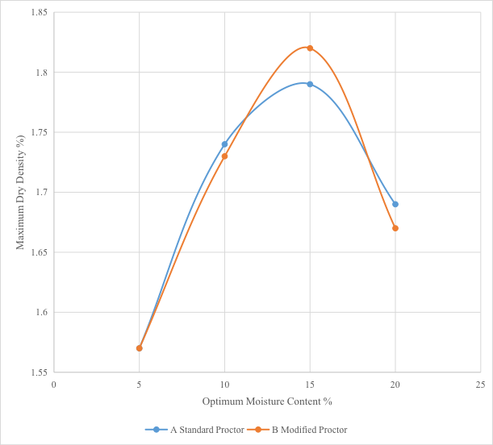

Fig. 4.4: Compaction Curves for Sample A

Table 4.7.1: Compaction Tests for Sample A (Modified Proctor)
WATER CONTENT DETERMINATION
Sample no | 1 |  | 2 |  | 3 |  | 4
Moisture can no | Bo | J | 3 | LA | 1 | 5 | 2 | 4
Wt of can + wet soil | 99.5 | 94.5 | 120.5 | 122 | 174.5 | 206.5 | 254.5 | 246.5
Wt. of can + dry soil (g) | 95 | 89.5 | 110 | 110.5 | 155.5 | 184.5 | 218.5 | 210
Wt of can (g) | 4.5 | 5 | 10.5 | 11.5 | 19 | 22 | 36 | 36.5
Wt of can (g) | 32.5 | 25 | 19 | 15 | 18.5 | 18 | 19 | 19.5
Wt of dry soil (g) | 62.5 | 64.5 | 91 | 95.5 | 137 | 166.5 | 199.5 | 190.5
Water of content w% | 7.2 | 7.8 | 11.5 | 12.0 | 13.9 | 13.2 | 18.0 | 19.2

DENSITY DETERMINATION
Assumed water content(g) | 7.5 | 11.8 | 13.5 | 18.5
Average water content% | 7.5 | 11.8 | 13.6 | 18.6
Wt. of soil + mould (g) | 4658 | 4904 | 5038 | 4952
Wt. of mould (g) | 2976 | 2976 | 2976 | 2976
Wt. of soil in mould (g) | 1682 | 1928 | 2062 | 1976
Wet density, DW(g/cm³) | 1.682 | 1.928 | 2.062 | 1.976
Dry density (g/cm³) | 1.565 | 1.725 | 1.815 | 1.666

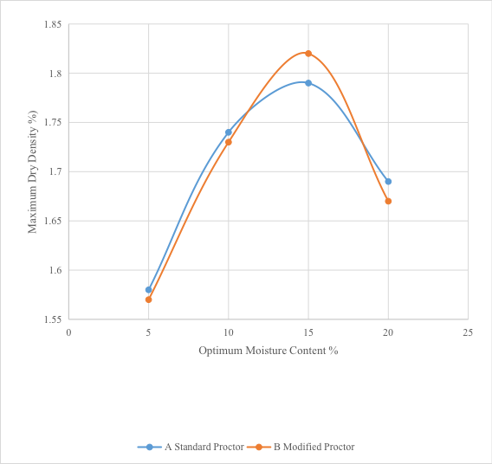
Fig. 4.5: Compaction Curves for Sample B

Table 4.7.2: Presentation of Compaction Results
SAMPLE NO | STANDARD PROCTOR |  | MODIFIED PROCTOR
 | Optimum Moisture Content (OMC) % | Maximum Dry Density (MDD) g/cm³ | Optimum Moisture Content OMC (%) | Maximum Dry Density (MDD) g/cm³
Sample A | 15.0 | 1.80 | 15.0 | 1.83
Sample B | 15.0 | 1.83 | 15.0 | 1.79

4.10 Discussion on Compaction results
The discussion of relationship between the dry density and the optimum moisture content of the soil samples are shown in Fig 4.2. The compaction curves show that dry density increases with further increase water content. From compaction tests carried out, at the energy of standard proctor, sample A has 15.0% and 1.80 g/cm³ as optimum moisture content and maximum dry density respectively, while at the energy of modified proctor, it has 15.0 % and 1.83 g/cm³ as optimum moisture content and maximum dry density respectively. Sample B has 15.0% and 1.83 g/cm³ as optimum moisture content and maximum dry density respectively, while at the energy of modified proctor, it has 15.0 % and 1.79 g/cm³ as optimum moisture content and maximum dry density respectively.
The compaction characteristics and ratings of the Unified soil classification classes for soil construction (ASTM, 1557-91) (Table 4.7.2), from the values obtained, it can be concluded that soil samples A and B have a fair to good performance as an embankment material and can be used as a subgrade material with a good to fair performance as base course material.

Table 4.7.3: Compaction Characteristics and Rating of Unified Soil Classification Classes for Construction (ASTM, 1557-91)
Visual Description | Maximum Dry-Weight Range (g/cm³) | Optimum Moisture Range (%) | Anticipated Embankment Performance | Value as Subgrade Material | Value as base course
Granular material | 2.00-2.27 | 7-15 | Good to excellent | Excellent | Good
Granular material with soil | 1.76-2.16 | 9-18 | Fair to Excellent | Good | Fair to Poor
Fine sand and sand | 1.76-1.84 | 9-15 | Fair to Good | Good to fair | Poor
Sandy silts and silts | 1.52-2.08 | 10-20 | Poor to Good | Fair to Poor | Not suitable
Elastic silts and Clays | 1.36-1.60 | 20-35 | Unsatisfactory | Poor | Not suitable
Silty-Clays | 1.52-1.92 | 10-30 | Poor to Good | Fair to Poor | Not suitable

4.11 Results of California Bearing Ratio
The results of California Bearing Ratio tests are shown below for Sample A and B
Table 4.8.1: California Bearing Ratio tests for Sample A

Penetration of Plunger (mm) | TOP Piston Load on Plunger (KN) |  | BOTTOM Piston Load on Plunger (KN)
0.00 | 2.9 | 0 | 0 | 0
0.50 | 26 | 76 | 33 | 96
1.00 | 51 | 149 | 60 | 175
1.50 | 67 | 196 | 75 | 219
2.00 | 81 | 237 | 92 | 269
2.50 | 90 | 263 | 106 | 310
3.00 | 96 | 281 | 114 | 334
4.00 | 103 | 301 | 121 | 354
5.00 | 108 | 316 | 126 | 359
6.00 | 11.6 | 339 | 130 | 380
7.00 | 120 | 351 | 134 | 392

400
300
200
100
0
LOAD ON PLUNGER (KN)
0
1.0
2.0
3.0
4.0
5.0
6.0
PENETRATION (MM)
7.0
8.0

Fig. 4.7: Plots of California Bearing Ratio for Sample A

Table 4.8.2: California Bearing Ratio tests for Sample B
Penetration of Plunger (mm) | TOP Piston Load on Plunger (KN) |  | BOTTOM Piston Load on Plunger (KN)
0.00 | 0 | 0 | 0 | 0
0.50 | 19 | 55 | 27 | 79
1.00 | 37 | 108 | 48 | 140
1.50 | 53 | 155 | 69 | 202
2.00 | 70 | 205 | 87 | 254
2.50 | 83 | 243 | 99 | 290
3.00 | 89 | 260 | 105 | 307
4.00 | 94 | 275 | 112 | 328
5.00 | 99 | 290 | 116 | 339
6.00 | 102 | 298 | 121 | 354
7.00 | 107 | 313 | 125 | 366

400
300
200
100
0
LOAD ON PLUNGER (KN)
0
1.0
2.0
3.0
4.0
5.0
6.0
PENETRATION (MM)
7.0
8.0

Fig. 4.8: Plots of California Bearing Ratio for Sample B

Table 4.8.3: Summary of CBR Results for Standard Proctor
SAMPLE NUMBER | CBR VALUES | PENETRATION AVERAGE VALUE (%)
 |  | 2.5mm | 5.0mm
Sample A | SOAKED | 2 | 2
Sample A | UNSOAKED | 4 | 3
Sample B | SOAKED | 2 | 1
Sample B | UNSOAKED | 3 | 2

Table 4.8.4: Summary of CBR Results for Modified Proctor
SAMPLE NUMBER | CBR VALUES | PENETRATION AVERAGE VALUE (%)
 |  | 2.5mm | 5.0mm
Sample A | SOAKED | 2 | 2
Sample A | UNSOAKED | 5 | 4
Sample B | SOAKED | 2 | 2
Sample B | UNSOAKED | 4 | 3

Table 4.8.5: General Rating for Soil Based on CBR Values (After The Asphalt Institute,
1962)
CBR NO | GENERAL RATING | USES | CLASSIFICATION UNIFIED | SYSTEM AASTHO
0-3 | Very poor | Sub-grade | OH, CH, MH, OL | A5, A6, A7
3-7 | Poor-fair | Sub-base | OH, CH, MH, OL | A4, A5, A6, A7
7-20 | Fair | Base | OL ,CL, ML, SC, SM, SP | A2, A4, A6, A7
20-50 | Good | Asphalt material | GM, GL, SIN, SM, SP, GP, W,GM | Aib, A2-5, A3, Al,A2-4 ,A3

4.12 Discussion of CBR Results
The CBR values for Sample A unsoaked sample for Standard Proctor and Modified Proctor were 4% and 5% respectively. For Sample A SOAKED for standard Proctor and modified Proctor were 2% and 2% respectively. For UNSOAKED sample B for Standard Proctor and Modified Proctor were 3% and 4% respectively, while for SOAKED Sample B Standard Proctor and modified Proctor were 2% and 2% respectively. Table 4.8.3 shows the general rating of soil material based on the CBR values of the material. Soil meet requirement better when they are classified based on the CBR value of soaked materials. Sample A CBR indicate a very poor general rating based on it CBR values which means that it can only be used as subgrade material in road construction. Sample B also have a general poor rating based on its soaked CBR values means it is only good for subgrade material in road construction. The UNSOAKED modified CBR test result shows that Sample A can be used as a sub base material in road construction and Sample B can be used as both subgrade and sub base material in road construction based on the UNSOAKED modified CBR value of both sample which were 5% and 4% respectively.

CHAPTER FIVE
CONCLUSION AND RECOMMENDATIONS
5.1 CONCLUSION
Comparative studies of laterite soils has been carried out in compliance with the regulatory standard. Grain size distribution for Sample A and Sample B obtained shows that they are poorly graded and on the basis both soil samples will be suitable for use as a road sub-base materials. The Atterberg consistency limits, shows that the both samples meet the requirement to be used as a sub-base material. The compaction properties possessed by Sample A and Sample B makes them good engineering construction materials based on the MDD and OMC values obtained at both energies Standard Proctor and Modified Proctor. According to The Asphalt Institute (1962), both Sample A and Sample B have CBR which are considered to be very poor to poor and can only be used as sub-grade and sub-base material and also both samples possess fairly high initial and long term stability when used in dam or embankment construction. In conclusion from the tests carried out, it can be deduce that Sample A and Sample B can be used as construction material such as road, dam, foundation and embankment.
5.2 RECOMMENDATION
i. Geotechnical properties of laterite soil should be analyzed and recommended as a suitable material for civil engineering purpose particularly for construction of infrastructural facility.
ii. Further investigation and analysis such as Triaxial test and permeability should be carried out on laterite soil before construction begins.

REFERENCES
Akinwunmi, A.S., Oloruntoba, D.A., & Olaseni, A.M. (2019). Site-specific geotechnical soil characterization for road projects. Journal of Civil and Environmental Systems Engineering, 4(1), 14–22.
Akintorinwa, O.J., & Akinluyi, F.O. (2021). Geotechnical suitability of lateritic soils for civil engineering applications. Environmental and Earth Sciences Research Journal, 8(2), 69–75.
Alao, A.A. (1983). Engineering properties of soils in the Ilorin area. Nigerian Journal of Mining and Geology, 20(2), 29–34.
Aliyu, M., & Bamidele, S.O. (2018). Stabilization of lateritic soils with agricultural waste. Nigerian Journal of Technological Development, 15(2), 50–57.
Amandi, R., Yusuf, A., & Lawal, A. (2018). Variability of lateritic soils in tropical environments.
International Journal of Civil Engineering Research, 9(3), 45–51.
British Standards Institution (BSI). (2003). BS 1377-2: Methods of test for soils for civil engineering purposes – Part 2: Classification tests. London: BSI.
Eberemu, A.O., Osinubi, K.J., & Gambo, A.D. (2020). Geotechnical assessment of laterite for pavement construction. Nigerian Journal of Engineering, 26(2), 55–68.
Eberemu, A.O., Osinubi, K.J., & Ijimdiya, T.S. (2021). Characterization of compacted lateritic soils for sustainable road construction. Nigerian Journal of Geotechnical Engineering, 11(1), 39–52.
International Union of Soil Sciences (IUSS) Working Group WRB. (2022). World reference base for soil resources 2022: International soil classification system for naming soils and creating legends for soil maps.
Rome: FAO.

Jackson, J.A. (1980). Glossary of Geology. American Geological Institute, Falls Church, Virginia.

Nnochiri, E.S., & Eze, C.N. (2021). Engineering failures and the role of site-specific soil data in Nigeria.
Journal of Civil Engineering and Management, 27(6), 445–453.

Obaje, N.G. (2019). Geology and mineral resources of Nigeria. Springer Science & Business Media.
Obaro, R.I., & Obaro, N.T. (2019). Geotechnical characterization of lateritic soils in southwestern Nigeria.
International Journal of Civil Engineering Research and Development, 10(2), 19–30.
Ogunribido, T.H.T., & Oyedele, M.O. (2019). Misclassification of soil properties and construction failures in Nigeria. African Journal of Environmental Science and Technology, 13(4), 123–130.
Ojo, O.S., Ajayi, O.O., & Lawal, M.A. (2021). The origin and pedogenesis of lateritic soils in Nigeria. Journal of Earth Sciences, 9(1), 25–36.

Okonta, F.N., & Ochepo, J.A. (2020). Stabilization of lateritic soil using coconut shell ash. Construction and Building Materials Journal, 241, 118050.
Olasele, O.O., & Olutoge, F.A. (2020). Comparative analysis of geotechnical data for foundation design in southwestern Nigeria. Nigerian Journal of Engineering Research, 18(3), 88–95.
Onyelowe, K.C., Edeh, J.E., & Chukwu, M.C. (2021). Performance of agro-waste stabilized lateritic soils for subgrade applications. International Journal of Geotechnical Engineering, 15(5), 532–541.
Osinubi, K.J., Eberemu, A.O., & Alhassan, M. (2020). Understanding the geotechnical properties of tropical soils: A Nigerian perspective. Geotechnical Research Journal, 7(3), 208–218.
Rahaman, M.A. (2019). The basement complex of Nigeria: Geology and evolution. Nigerian Journal of Earth Science Research, 15(2), 74–85.
Umar, A., Ibrahim, H., & Dauda, B. (2022). Comparative geotechnical evaluation of lateritic soils in Northern Nigeria. Nigerian Journal of Geotechnical Engineering, 10(1), 13–22. ASTM International. (2011–2021). Various standards used in soil testing:

- ASTM D3080/D3080M-11 – Standard test method for direct shear test
- ASTM D4318-17 – Standard test methods for liquid limit, plastic limit, and plasticity
index
  - ASTM D698-12 – Standard test method for laboratory compaction (Proctor)
  - ASTM D6913/D6913M-17 – Standard test method for particle-size distribution
    - ASTM D7928-21 – Standard test method for hydrometer analysis
    - ASTM D422-01/D4220M-14 – Standard for soil sample preservation
    - ASTM 1998-21 – Standard test method for California Bearing Ratio (CBR)

