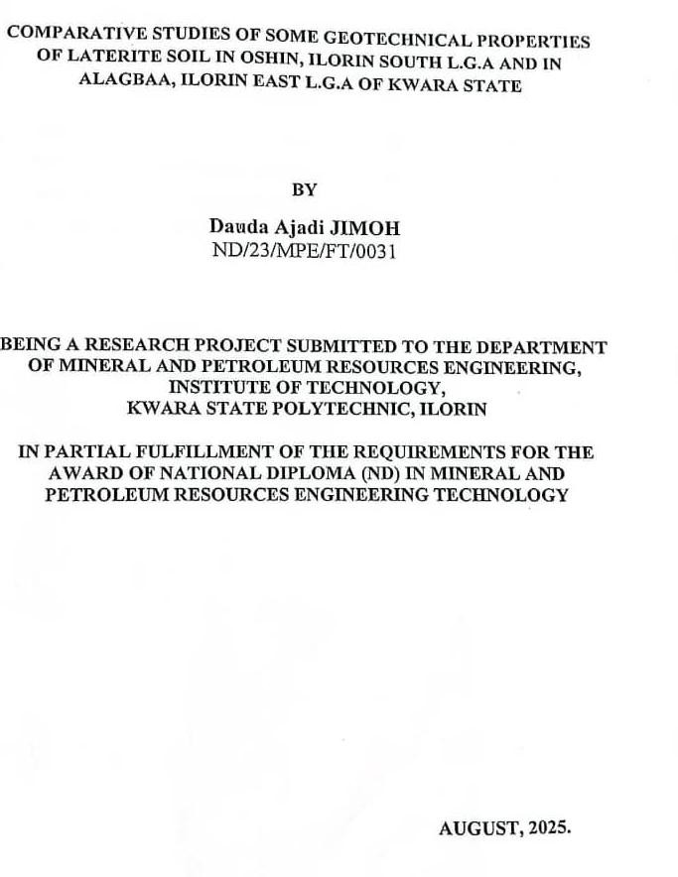

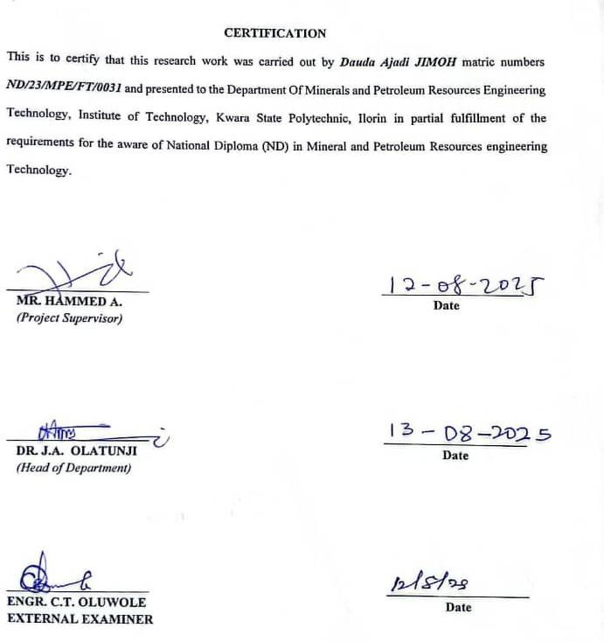

DEDICATION

This work is dedicated to the ALMIGHTY GOD, who saw me to this point despite all odds. Also, this work is dedicated to my Amazing Parents and Siblings for their constants love and support.

ACKNOWLEDGEMENT

I would like to express my sincere gratitude to all those who have supported me throughout the course of this project.
My sincere appreciation goes to my supervisor, Mr. Abdullahi Hammed, for their invaluab le advice, constructive criticism, patience, and encouragement which have been instrumental to the successful completion of this work.
I am also grateful to my H.O.D in person of Dr. Olatunji J.A, also my profound gratitude goes to my lecturers in person of Dr. Reuben Obaro, Engr. S. A. Agbalajobi, Mr. Odediran, Mr. S. Usman. For their dedication and knowledge impacted during my course study.
I would like to thank my mother/guardians for their moral and financial support throughout my academic pursuit. Special thanks to my friends and colleagues for their support, suggestions and companionship which made this project a success.
Finally I appreciate everyone who, in one way or another, contributed to the successful completio n of this project. God bless you all.

ABSTRACT

Lateritic soils are widely utilized in civil engineering works in tropical regions due to their abundance and low cost. However, variations in their geotechnical properties can significa ntly affect the performance and durability of construction projects. This study investigates and compares the geotechnical properties of laterite soils from two distinct locations: Oshin in Ilorin South Local Government Area and Alagbaa in Ilorin East Local Governme nt Area, Kwara State, Nigeria. Soil samples were collected from both sites and subjected to laboratory tests includ ing natural moisture content, specific gravity, grain size analysis, Atterberg limits, compaction, direct shear, and California Bearing Ratio (CBR) tests, in accordance with ASTM and BS standards. The results revealed that both samples predominantly consist of sandy gravel with good compaction characteristics. Sample A showed a maximum dry density (MDD) of 1.80 g/cm³ at 15% optimum moisture content (OMC), while Sample B recorded a slightly higher MDD of 1.83 g/cm³ at the same OMC. The plasticity indices of both samples (20.9% and 21.9%) suggest moderate volume change potential. CBR values indicate that the soils are generally suitable for subgrade and sub- base applications but not ideal for base course without stabilization. The study concludes that although both lateritic soils exhibit similar general engineering behavior, site-specific conditions such as moisture content and compaction energy can affect their performance in construction. It is recommended that further tests including triaxial and permeability analysis be conducted for more comprehensive soil characterization and that appropriate soil stabilization methods be adopted where necessary.

TABLE OF CONTENT

Title page i

Certification ii
Dedication iii
Acknowledgement iv
Abstract v
Table of contents vi
List of Figures ix
List of Tables x
List of Appendix xi
CHAPTER ONE 1
  - INTRODUCTION 1
  - Location and Accessibility 1
  - Climate and Vegetation 2
  - Drainage and Relief 2
  - Aim and Objectives 2
  - Statement of the Problem 3
  - Justification 3
  - Scope and Limitation
CHAPTER TWO 7
  - LITERATURE REVIEW 7
  - Review of Previous Studies 4
  - Overview of Lateritic Soil 5
  - Geology of Nigeria 6
  - Geology of the Study Area 7
  - Origin of Lateritic Soil 9
  - Formation of Lateritic Soil 10
  - Strength of Lateritic Soil 10
CHAPTER THREE 12
  - MATERIALS AND METHODS 12
  - Sample collection and preparation 12
  - Laboratory analysis 12
  - Determination of grain size analysis 12
    - Mechanical sieve method 13
    - Hydrometer sieve method 13
  - Determination of Atterberg limit test 13
    - Liquid limit determination 13
    - Plastic limit determination 14
    - Determination of linear shrinkage 14
  - Compassion test 14
  - Determination of shear box test and California bearing test 15
  - California bearing ratio (CBR) 15
CHAPTER FOUR 16
  - RESULTS AND DISCUSSION 16
  - Results of Natural Water Determination 16
  - Discussion on Natural Water Determination 16
  - Results of Specific Gravity 17
  - Discussion on Specific Gravity Determination 17
  - Results of Grain Size Analysis 19
  - Discussion of Grain Size Analysis 20
  - Results of Atterberg Limit Determination 24
  - Discussion on Atterberg Limit Determination 27
  - Results of Compaction tests 31
  - Discussion on Compaction results 36
  - Results of California Bearing Ratio 38
  - Discussion of CBR Results 44
CHAPTER FIVE 45

5.0 | Conclusion | and Recommendation | 45
5.1 | Conclusion |  | 45

5.2 Recommendation 45
References 46

List of Figures
Fig. 2.1: Geology of Nigeria 7
Fig. 2.2: Location of the study area 8
Fig. 4.1: Grain Size Analysis for Sample A 21
Fig. 4.2: Grain Size Analysis for Sample B 22
Fig. 4.3: Plots of Sample A and B on Plasticity Chart 28
Fig. 4.4: Compaction Curves for Sample A 32
Fig. 4.5: Compaction Curves for Sample B 35
Fig. 4.7: Plots of California Bearing Ratio for Sample A 39
Fig. 4.8: Plots of California Bearing Ratio for Sample B 41

List of Tables
Table 4.1: Natural Water Content Determination for Sample A and B 16

Table 4.2. Specific Gravity Determination for Sample A and B |  | 17
Table 4.3. Typical Values of Specific Gravity of Soil Samples |  | 18
Table 4.4: Grain Size Analysis for Sample A and B |  | 19
Table 4.5: Unified Soil Classification System (USCS) |  | 23
Table 4.6: Liquid Limit Determination for Sample A |  | 24
Table 4.6.1. Plastic Limit Determination for Sample A |  | 25
Table 4.6.2: Liquid Limit Determination for Sample B |  | 26
Table 4.6.3: Plastic Limit Determination for Sample B |  | 27
Table 4.6.4: Relationship between Atterberg limit and Volume Change Potential |  | 29
Table 4.6.5: Engineering Used Chart (After Wagner, 1957) |  | 30
Table 4.7: Compaction Tests for Sample A (Standard Proctor) |  | 31
Table 4.7.1: Compaction Tests for Sample A (Modified Proctor) |  | 33
Table 4.7.2: Presentation of Compaction Results |  | 36
Table 4.7.3: Compaction Characteristics and Rating of Unified Soil Classification
Classes for Construction |  | 37
Table 4.8.1: California Bearing Ratio tests for Sample A |  | 38
Table 4.8.2: California Bearing Ratio tests for Sample B |  | 40
Table 4.8.3: Summary of CBR Results for Standard Proctor |  | 42
Table 4.8.4: Summary of CBR Results for Modified Proctor |  | 42
Table 4.8.5: General Rating for Soil Based on CBR Values (After Asphalt Institute, | 1962) | 43

CHAPTER ONE INTRODUCTION
Laterite soil is a type of tropical soil that is commonly found in regions with high temperatures and heavy rainfall. It is characterized by its high iron and aluminum content, which gives it a distinctive reddish – brown colour (Gidigasu, 1976). Laterite soil is often used a construction material, particularly in tropical regions where it is abundant. However, its geotechnical properties can be challenging to predict, and its behaviour under different loading condition is not well understood (Ola, 1977).
Understanding the geotechnical properties of laterite soil is essential for designing safe and effective engineering structures such as foundations, roads and dams. Several studies have investigated the geotechnical properties of laterite soil, including its physical, mechanical and hydraulic properties (Osinubi, 2005) (Sridran, 2006). However, more research is needed to fully understand the behaviour of laterite soil under different loading conditions.

Location and Accessibility
Ilorin South and East Local Government Areas are situated in the heart of Kwara State, Nigeria. The area is strategically located, with Ilorin, the state capital, serving as a major hub for commerce, education and healthcare. The area is easily accessible through major roads, including the Ilorin – Lagos highway and the Ilorin – Abuja highway (Adebayo, 2017). According to (Agbede, 2019), Ilorin South and East Local Government Areas have a combined land area of approximately 479km2, making it a significant region for economic and social development. The accessibility of the area is further enhanced by the presence of several major roads, including the Ilorin – Ibadan highway and the Ilorin – Kaduna highway (Ojo, 2020).

Climate and Vegetation

The study area experiences a tropical climate, characterized by two distinct seasons: the wet season and the dry season. The wet season typically lasts from April to October, while the dry season lasts from November to March (O laniran, 2018). The vegetation in Ilorin South and East is characterized by Savannah grassland with scattered trees, which is typical of the Guinea. Savannah zone of Nigeria (Keitumetse, 2016). The climate and vegetation of the area have significant implications for agricultural activities, with crops such as maize, yam and cassava being commonly cultivated (Adebayo, 2017).

Drainage and Relief

The study area is drained by several rivers, including the Asa River and Osin River, which play important roles in the hydrological cycle and support aquatic life (Adeyemo, 2019). The relief of Ilorin South and East is generally flat, with some areas having gentle slopes, which can affect the drainage and soil properties of the area (Adebayo, 2017). The drainage and relief features of the area have significant implications for urban planning and development, with proper drainage systems being essential for preventing flooding and erosion (Ojo, 2020).

Aim and Objectives

The aim of this study is to investigate the geotechnical properties of laterite so il in Ilorin South and East Local Government Areas for use as mineral seal in waste disposal landfills.
The specific objective are to:

- Determine the grain size distribution of the laterite soil

- Determine the Atterberg limits of the laterite soil

- Determine the compaction characteristics of the laterite soil

- Determine the coefficient of permeability of the laterite soil.

These objectives will be achieved through a combination of field and laboratory investigations, including soil sampling and testing (Afolaya n, 2018).

State of the Problem
The disposal of waste is a major environmental problem in many urban areas, including Ilorin. The use of landfills as a means of waste disposal requires careful consideration of the geotechnical properties of the soil to prevent contamination of groundwater (Osinubi, 2017). This study seeks to investigate the suitability of laterite soil in Ilorin South and East Local Government Areas for use as mineral seal in waste disposal landfills. This study will provide valuable insights into the geotechnical properties of the soil and its potential use in waste disposal landfills.

Justification

The study is justified by the need to ensure that waste disposal landfills are designed and constructed to prevent environmental pollution. The findings of this study will contribute to the body of knowledge on the geotechnical properties of laterite soil and its suitability for use as mineral seal in waste disposal landfills (Afolayan, 2018). The study will also provide valuable information for policymakers and engineer involved in waste disposed and environmental management.

Scope and Limitation
This study will focus on the geotechnical properties of laterite soil in Ilorin South and East Local Government Areas. The study will be limited to the collection and analysis of soil samples from the study area. The findings of the study may not be generalizable to other areas with different soil properties and geological conditions.

CHAPTER TWO LITERATURE REVIEW

Review of Previous Studies
The review of previous studies provides a comprehensive examination of past research related to lateritic soils and their geotechnical properties. This section highlights the key findings, methodologies, and conclusions of researchers who have contributed significantly to the understanding of lateritic soils, particularly in Nigeria and other tropical regions.
Osinubi and Eberemu (2006) in their study titled (Effect of Bagasse. Ash on the engineering properties of laterite soil) Osinubi and Eberemu investigated the influence of agricultural waste (bagasse ash) on the engineering behaviour of typical lateritic soil in Nigeria. The study revealed that the inclusion of bagasse ash improved the compaction characteristics and strength properties (especially California bearing ratio) of the soil. Their findings suggested potential environmental and economic benefits for soil stabilization using waste materials.
Gidigasu (1976) supported lateritic soils provided a foundational understanding of the origin, classification, and engineering behaviour of these tropical residual soils. It was emphasized the importance of geological processes and climatic conditions in the formation of laterites and discussed their use in pavement and foundation design. His research remains widely cited in both academic and field practice.
Ola (1983) studies lateritic soils from different parts of Nigeria and found that their properties vary by location. He emphasized testing soil before using it in projects.
Bello (2020) investigated the compaction and shear strength; behaviour of lateritic soils treated with varying amounts of time. The study found that time treatment significantly increased the shear strength of the soil and reduced its plasticity index, making it more suitable for

construction purposes. The research supports the stabilization of weak soils for engineering application using locally available materials.
Ijimdiya and Fadugba (2015) their study, geotechnical properties of laterite soil stabilized with cement and sugarcane bagasse. Ash, evaluated how industrial by-production could enhance the load-bearing capacity of lateritic soils. The results demonstrated improvement in unconfined compressive strength (UCS), BR, and a decrease in plasticity. This promotes sustainable construction using agro-industrial waste.
Amu, Bamisaye, and Komolafe (2011) in their research, they explored the improvement of lateritic soil with cement and wood ash. The study showed that up to 10% replacement of cement with wood ash enhanced the strength and stability of lateritic soil. The study is notable for advocating the partial replacement of cement, reducing costs and environmental impacts.

Overview of Lateritic Soil

Lateritic soil is often referred to as laterite. It is reddish iron and aluminum – rich soil forming in tropical and subtropical regions through intense and prolonged weathering (Mangomuya, 1987). Characterized by high sesquioxides content (Fe2 O3, A12, O3), this soil exhibits unique physical and chemical properties influenced by the parent, climate and weathering duration.
The term “laterite” is derived from the Latin word “later”, meaning brick, and was first used in 1807 by Buchanan to describe the red tropical soil found in Southern India (Balassubramaniam, 1985).
Laterite soil deposit are widely distributed in tropical Africa, Asia, Australia, and South America (Lai, 1987). The soil profile varies from location to location depending on the geological domain of parent deposition and the degree of weathering. A major complexity in laterite soil

characterization is the mineralogical variability and local environmental influences, making standard classification for engineering purpose necessary.
Ola et al. (2005) focus on behavior of lateritic soils in Southwestern Nigeria and recommend stabilization or enhancement techniques for road and building applications.

Geology of Nigeria

Nigeria’s geology, spanning Achaean to recent, complex comprises the Precambrian basement complex and several sedimentary basins, shaped by the Pan-African Orogeny (Ca.600 Ma), cretaceous rifting, and Cenozoic sedimentation. These geological processes have resulted in a complex framework that supports significant hydrocarbon and mineral resources, notably within the Niger Delta, Basin and the Benue Trough (Rahaman, 1988; Obaje, 2009; Akande et al. 2005) Delineated Areas:
- Jos Plateau and Oban Massif: tertiary volcanic episodes, granitic intrusions, and mineralization (tin, columbite)
- Hydrothermal mineralization (e.g. Pb – zn veins) Geological Framework

- Nigeria’s geology is divided into the Aro Geological Units, predominately basement complex and sedimentary basins.
- Precambrian Basement Complex; migmatite – Gneiss Complex: oldest (Achaean – paleoproterozoic), includes biotite gneiss, granite gneiss, and migmatite. (Rahaman, 1988).
- Older Granites: Pan-African (Ca.600 Ma) intrusive granites granodiorites and syenites (McCurry, 1997).
- Schist Belts: Proterozoic (2.5 – 0.6 Ga) phyllites and sedimentary – derived schists (e.g.
Birnin Gwari, Igarra Anka, Zungeru belts) (Oyawoye 2020).

- Younger Granite: Jurassic (150 – 180 ma) alkaline intrusions in Jos Plateau. Cring complexes of Ropp, Nasarawa etc.) (Courson, 2023).
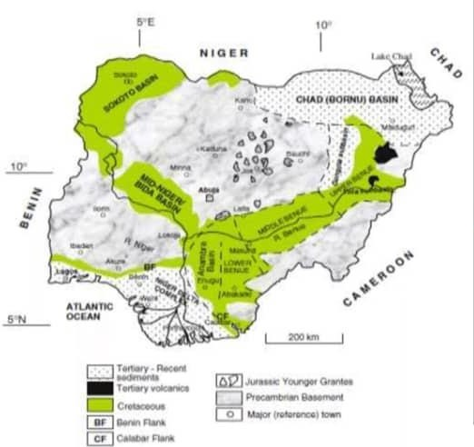

Fig. 2.1: Geological Map of Nigeria (after Obaje, 2004).

Geology of the Study Area

The geology of a study area refers to the natural earth materials, rock formations, and geological processes that have shaped the landscape and influenced the soil and subsoil characteristics.

Understanding the geology of a study area is crucial in geotechnical investigations, as it directly affects the physical, chemical and engineering properties of the soil (O la, 1983). According to Rahaman (1988), the Nigerian basement complex comprises both migmatite – gneiss – quartzite complexes and older granites. The weathering of those rocks produces residual soils that are generally well-drained iron-rich, and often from red to reddish-brown lateritic.
The geology of Ilorin and its surrounding areas such as Oshin in Ilorin South Local Government Area and Yakuba in Aja, Ilorin East Local Government Area is marked by deeply weathered profiles with varying depths of lateritic soil overlying the bed rock. These lateritic soils vary in composition and texture depending on the degree of weathering and mineral content of the pare nt rock (Esu, 2005).
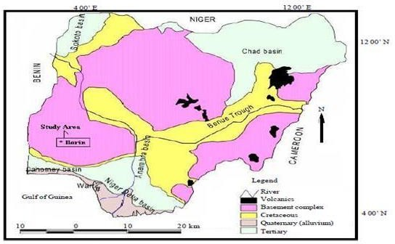

Fig. 2.2: Geology of the Study Area (Esu, 2005)

Origin of Lateritic Soil

Lateritic soil is a type of residual soil that forms under tropical climates through prolonged weathering of rocks rich in iron and aluminum. The origin of lateritic soil is fundamentally tied to geological, climatic and pedogenic processes that influence the decomposition and transformation of patent rocks into iron and aluminum oxide-rich soil. These soils are widespread in tropical regions, including large parts of Nigeria, due to favorable weathering conditions.
Gidigasu (1976) explains that lateritic soils originate from the intense chemical weathering of silicate rocks such as granite, basalt, gneiss and schist. The breakdown of feldspars and ferromagnesian minerals under tropical climate conditions leads to the removal of silicate and bases (Ca, Mg, K, Na), while iron and aluminum are left behind due to their lower solubility.
These elements then precipitate to form hydrated oxides, resulting in iron-rich soils. The formation process includes:
- Hydrolysis of silicate minerals,

- Oxidation of iron-bearing minerals,

- Leaching of soluble compounds,

- Residual accumulation of Fe and A1 oxides.

The soil typically develops in well-drained environments where water percolation promotes leaching but prevents waterlogging, which is essential for oxidation. Lateritic soils originate from long-term chemical weathering in warm, wet climates. The selective removal of silica and bases and the residual concentration of iron and aluminum oxides the key processes leading to laterite formation.

Formation of Lateritic Soil

The formation of lateritic soil is a result of intense and prolonged chemical weathering of rocks in tropical and subtropical environments. These soils are characterized by a high concentration of iron and aluminum oxides, formed through processes involving leaching, hydrolysis, oxidation, and biological activity. Lateritic soils commonly develop in regions with high temperature, heavy rainfall, and good drainage, which facilitate the breakdown and removal of silica and base- forming cautions, while enriching the soil in iron and aluminum sesquioxides.
Gidigasu (2005) emphasized that the formation of lateritic soil involves several pedogenetic processes, which include:
- Hydrolysis of silicate minerals, especially feldspar and ferromagnesian minerals, resulting in the formation of clay minerals such as kaolinite.
- Leaching, which removes silica, sodium, potassium, calcium and magnesium ions.

- Oxidation, where ferrous iron (fe2+) is converted into ferric iron (fe3+), leading to the precipitation of iron oxides such as hematite and goethite.
The climatic conditions needed include a minimum temperature of 250C, annual rainfall above 100mm, and well-drained conditions that allow vertical water movement. These conditions make tropical regions, likes West African, suitable zones for laterite formation.
Laterite soil formation is governed by intense weathering, leaching of silica and bases, and residual accumulation of Fe and A1 oxides. These processes are active in humid tropical climate and lead to the development of deep well-structured lateritic profiles.

Strength of Laterite Soil

The strength of lateritic soil refers to its ability to withstand external leads without undergoing failure or excessive deformation. In geotechnical engineering, this strength is a critical parameter

that influences the suitability of lateritic soil for use in foundations, road construction, embankments, and earthworks (Aiban, 1998),
The strength properties of lateritic soils vary widely depending on factors such as mineral composition, moisture content, compaction, soil structure, and cementation due to iron oxide. Lateritic soils generally exhibit moderate to high strength in dry conditions due to the presence of iron/aluminum oxides, but their strength tends to reduce significantly when saturated. Engineering test used to evaluate their strength include Unconfined Compressive Strength (UCS), California Beating Ration (CBR) Shear Strength and Triaxial Tests (Gidigasu, 1976).
Osinubi (2006) conducted a detailed study on the mechanical behavior of lateritic soil under varying compactive efforts and with cement stabilization. The study found that the Unconfined Compressive Strength (UCS) of the soil increase with:
- Higher compactive effort (more energy during compaction).
- Lower moisture content at compaction.
- Addition of cement (2.6%), which improved both cohesion and bounding between soil particles.
It was observed that natural lateritic soils exhibit low to moderate UCS (100 – 300 KN/m2) in their untreated state, but when stabilized and well-compacted, the strength could improve significantly (up to 1500 KN/m2).
The strength of lateritic soil can be significantly improved through proper compactio n and stabilization. Cement-treated lateritic soil exhibit increased compressive and shear strength, making them suitable for use in pavement sub-bases and foundations.

CHAPTER THREE MATERIALS AND METHODS

Sample collection and preparation
Soil samples were collected at different locations, Oshin and Alagbaa in Ilorin, Kwara State, using a systematic sampling approach to ensure representativeness. Disturbed and undisturbed samples were obtained from depths of 0.5-1.5m using hand augers and core cutters, respectively. The samples were placed in airtight polyethylene bags to preserve the moisture content and transported to the laboratory within 24hours. In the laboratory, samples were air-dried pulverized, and sieved to remove debris and organic matter. Disturbed samples were used for physical tests while undisturbed samples were used for mechanical tests according to ASRM (2014).

Laboratory analysis

Laboratory analyses were conducted to determine the physical and mechanical properties of the soil samples. Tests included specific gravity, moisture content, grain size analysis, atterberg limits, linear shrinkage, compaction and California bearing ratio, which are all performed in accordance with British standards (BS 2003). All equipment was collaborated prior to testing, and tests were conducted in triplicate to ensure accuracy and repeatability. Details were recorded and analyzed in the laboratory.

Determination of grain size analysis

Grain size analysis was performed to classify the soil based on particle size distribution. Two methods were employed the mechanical sieve method for coarse-grained soils and the hydrometer method for fine grained soils

Mechanical sieve method

The mechanical sieve method was used to determine the particle size d istribution of coarse- grained soils (sand and gravel), A200g oven. Dried oven-dried soil sample was passed through a stack of sieve with aperture size ranging from 4.75mm to 0.075mm following ASTM D6913. (D6913M-17(ASTM 2017). The sieve were shaken mechanically for 10minutes using a sieve shaker. The weight of soil retained on each sieve was recorded and the percentage passing was calculated to plot the particle size distribution curve

Hydrometer sieve method
For fine- grained soils (silt and clay), the hydrometer method was used to determine the particle size distribution as outlined in ASRM D7928-21 (ASTM, 2021). A 50g soil sample was mixed with a dispersing agent (sodium hexametaphosphate) and water to form a suspension. The hydrometer was used to measure (2, 3, 15, 30, 60, 240, and 1440 minutes). Particles sizes were calculated used stokes law and the percentage of particles finer than a given was determined.

Determination of atterberg limit test

Atterberg limit test were conducted to determine the plasticity characteristics of fine-grained soils, following BS 1377-2:2003 (BSI, 2003). These tests included the liquid limit, plastic limit, and linear shrinkage.

Liquid limit determination
The liquid limit was determined using the Casagrande apparatus, as per ASTM D4318-17 (ASTM, 2017). A 250g soil sample passing through a 0.42mm sieve was mixed with distilled water to form a paste. The paste was placed in the Casagrande cup, and a groove was made using a standard grooving tool. The number of blo ws required to close the groove over a 12.7mm

distance was recorded at varying moisture contents. The moisture content at 25 blows was taken as the liquid limit.

Plastic limit determination
The plastic limit was determined by rolling a 20g soil sample into threads of approximately 3mm diameter, as described in ASTM S4318-17 (ASTM, 2017). The soil was rolled until it crumbled, and the moisture content at this point was measured by oven-drying the sample at 1050C for 24 hours. The plastic limit was calculated as the average moisture content of three trials.

Determination of linear shrinkage
Linear shrinkage was determined using BS 1377-2:2003 (BSI, 2003). A soil paste was prepared at the liquid limit and placed in a shrinkage mold (140mm long). The mold was oven-dried at 1050C for 24 hours, and the reduction in length was measured using a vernie caliper. Linear shrinkage was calculated s the percentage reduction in length relative to the original length.

Compaction test
The standard proctor compaction test was conducted to determine the maximum dry density (MDD) and optimum moisture content (OMC) of the soil following ASTM D698-12 (ASTM, 2012). A 2.5kg soil sample passing through a 4.75mm sieve was compacted in a 1000cm3 mold in three layers, each receiving 25 blows from a 2.5kg rammer dropped from a height of 300mm. the rest was repeated at different moisture contents (ranging from 4% to 20%) and the dry density was calculated for each trial. The MDD and OMC were determined by plotting the dry density against moisture content.

Determination of shear box test

The direct shear test was conducted to determine the shear strength parameters (cohesion and angle of internal friction) of the soil, following (ASTM, 2011). An undisturbed soil sample (60mm x 60mm x 20mm) was placed in a shear box apparatus. Normal stresses of 50, 100 and 150 Kpa were applied at a constant rate of 0.5mm/min. the shear stress at failure was recorded and Mohr. Coulomb failure were used to calculate cohension (c) and friction angle (ⱷ)

California bearing ratio (CBR)

The CBR test was performed to elevate the strength of the soil for pavement design, as per ASTM1998-21 (ASTM, 2021). A soil sample was compacted at the opinion moisture content in a CBR mols (150mm diameter) using a 4.5kg rammer. The sample was subjected to penetration by a 50mm diameter plunger at a rate of 1.25mm/min under surcharge loads. The CBR value was calculated as the ratio of the load sustained by the soil to that of a standard crushed rock at
2.5mm and 5.0mm penetration.

CHAPTER FOUR RESULTS AND DISCUSSION
  - Results of Natural Water Determination
The results of natural water determination are shown in table 4.1 below.

Table 4.1: Natural Water Content Determination for Sample A and B SAMPLE A SAMPLE B
Boring no.
Container no (Cup)
Wt of cup + Wet soil (g) | 134.5 | 135.0 |  | 162.5 | 118.0
Wt of cup + dry soil (g) | 128.0 | 129.5 |  | 154.5 | 112.5
Wt of cup (g) | 25.5 | 25.0 |  | 34.5 | 24.5
Wt of dry soil. (g) | 102.5 | 104.5 |  | 120.0 | 88.0
Wt of water (g) | 6.5 | 5.5 |  | 8.0 | 5.5
Water content % | 6.3 | 5.3 |  | 6.7 | 6.3
Average water content (%) = 5.8% 6.5%

Discussion on Natural Water Determination

The natural water determination for sample A and Sample B is 5.8% and 6.5% respectively. It is to determine the amount of water present in a quantity of soil in terms of its dry weight. The natural water determination of various soils varies generally ranging from about 10 to15% for sand, 15 to 30% for silt and 30 to 50% for clay. The low value of natural water determination

content for Sample A and B indicates that the water table fluctuates during the dry season (Sidi

et al., 2015).

Results of Specific Gravity
The results of Specific Gravity is shown in Fig. 4.2 below Table 4.2. Specific Gravity Determination for Sample A and B
SAMPLE A SAMPLE B

SAMPLE LABEL
WT OF EMPTY BOTTLE (g) (W1) | 103.0 | 103.0
WT OF EMPTY BOTTLE+1/3 OF SOIL (g) (W2) | 153.0 | 153.0
WT OF EMPTY BOTTLE+1/3 OF SOIL+WATER  (g) (W3) | 229.5 | 230.0
WT OF EMPTY BOTTLE+WATER ONLY (g) (W4) | 198.0 | 198.0
SPECIFIC GRAVITY = ^{𝑊}2𝑊 1  (𝑊4−𝑊1)(𝑊3−𝑊2) | 2.70 | 2.78

Discussion on Specific Gravity Determination
The specific gravity of the soil depends on the amount of sand and also depends on their mineral constituents and mode of formation of the soil. The results of the specific gravity analysis on soil samples of Sample A and Sample B are 2.70 and 2.78 respectively. Comparing these specific gravity values to some common soil types from (Lambe, 1969). (Table 4.3) shows the specific gravity of each soil type. It can be deduced from Table 4.3 that the specific gravity of soil sample A and B can be described as inorganic soil.

Table 4.3. Typical Values of Specific Gravity of Soil Samples (Lambe and Whiteman, 1969)

SOIL TYPES | SPECIFIC GRAVITY
Sand | 2.65 – 2.67
Silty sand | 2.67 – 2.70
Inorganic soil | 2.70 – 2.80
Soil with mica or iron | 2.75 – 3.00
Organic | Variable but may be under 2.0

Results of Grain Size Analysis
The results of grain size analysis are shown in table 4.4 below. Table 4.4: Grain Size Analysis for Sample A and B
Sieve analysis and Grain Size A Sieve analysis and Grain Size B

Sieve No | Diam. (mm) | Wt. retained | %  retained | %  passive | Diam. (mm) | Wt. retained | %  retained | %  passive
 | 19.00 |  |  |  | 19.00 | 0.0 | 0.0 | 100.0
 | 16.00 | 0.0 | 0.0 | 100.0 | 16.00 | 12.5 | 2.5 | 97.5
 | 8.00 | 68.5 | 13.7 | 86.3 | 8.00 | 67.0 | 13.4 | 84.1
 | 4.75 | 141.0 | 28.2 | 58.1 | 4.75 | 111.0 | 22.2 | 61.9
 | 2.36 | 134.0 | 26.8 | 31.3 | 2.36 | 149.5 | 29.9 | 32.0
 | 1.00 | 88.0 | 17.6 | 13.7 | 1.00 | 124.0 | 24.8 | 7.2
 | 0.50 | 37.0 | 7.4 | 6.3 | 0.50 | 29.0 | 5.8 | 1.4
 | 0.425 |  |  |  | 0.425
 | 0.30 | 12.0 | 2.4 | 3.5 | 0.30 | 3.0 | 0.6 | 0.8
 | 0.25 | 5.0 | 1.0 | 2.9 | 0.25 | 0.2 | 0.04 | 0.76
 | 0.150 | 6.5 | 1.3 | 1.6 | 0.150 | 0.2 | 0.04 | 0.72
 | 0.090 | ------- | ------- | ------- | 0.090 | ------- | ------- | -------
 | 0.75 | 5.5 | 1.1 | 0.5 | 0.075 | 1.0 | 0.2 | 0.52
 | PAN | 2.0 | 0.4 |  | PAN | 1.0 | 0.2

Discussion of Grain Size Analysis

The graphical representation of the results of the grain size analysis (Fig. 4.1) of Sample A indicates that the Gravel is of high dominance with percentage of 72%, followed by Sand with percentage of 28% while Sample B (Fig. 4.2) contains 73% gravel and the sand is 27%, this as such is classified as sandy gravels in accordance to the USCS classification (Table 4.5).
In accordance to the USCS classification. On the Unified Soil Classification Chart (Table 4.5), sample A and Sample B have the group symbol SW and are classified as pervious, and it has an excellent shear strength when compacted and saturated, negligible compressibility when compacted and saturated and has excellent workability as construction material which can resist erosion.

0 0 0 0

0 0 0

0 0 0 0 0 0

0 0 0 0

0 0 0

- 0 . . .
. 1 1 1 5 1

. . . .
. . .
. . . . . .
. . . .
. . .
. . 0 1 2 0 .
0 0 .
2
2 6 3 . .
7 7 8
9 0 2 5 0

0 0 0 0
0 0 0
0 0 0 0 0 0
- 1 1 2
- 3 4
5 5 0 8 0
3 5 3 . .
. 0 5 .
. . . . . . .

0 0 0 0
1 2 3 4 6
N 0
T 0
A 0

G
E
0

F
I
N 0

E R
0

T H
A 0

N
0 0

0

0

0
0 1 1
8 0 5
2 3 4 5 6 9
0 0 0 0 0 5
0 2 5 1
5 5 0 2
5 0 2 0 0
0 0 5 0 0
6 0 5 7 7
0 5 5
5 5 0
5 0 5 5 0

0

0

0

0

0

0

0

0

0

1
um um 0
0

Fig. 4.1: Grain Size Analysis for Sample A

0 0 0 0

0 0 0

0 0 0 0 0 0

0 0 0 0

0 0 0

0 0 1 1 1
6 1 1 1 2 3

. . . . . . . . . . . . . . . . . . . . . . . . . 2 2 4 . 8 9 2 6 3 5 1 3 3 3 3 4 4 4 5
0 0 0 0 0 0 0 0 0 0 0 0 0 1 1 1 2 2 3 4 5 5 0 1 2 . . . . . . . . 7 7 8 9 0 2 5 0
. .
2
0 0 0 0 0 1 1 2 3 4 5 6 9 0 2 5 1 5 0 2 0 0 0 8 0 0 3 0 5 0 3 5 7 7 0 5 . . . . . . . .

1 2 3 4 6
6 . 0
3
P 0
E 0
R 9
C 0
E 9
N 8
T 0
A 8
G 7
E 0
7
6
F 0
I 6

N
E 5
0
R
5
4
T
0
H 4
A 3
N 0
3
0 2
P 0
E 2
R 1
C 0
E 1
0
8 0 5
0 0 0 0 0 5
5 5 0 2
0 0 5
0 0 1 1 1
2 6 4 8 0 5 5 2
. 2 . 9
5 5 0
- 3 3
5 0 5
3 4 4
5 0
- 5 0
0

1
0
1
2
0
2
3
0
3
4
0
4
5
0
5
6
0
6
7
0
7
8
0
8
9
0
9
1

0
SILTSILT
TineTi ne
Mediu mMedi
SandSa nd
Coarse Coarse
FineFin e
Mediu mMedi
Grave Grave
Coarse 0
Coarse 0

Fig. 4.2: Grain Size Analysis for Sample B

TABLE 4.5: Unified Soil Classification System (USCS)

Major divisions | Subdivisions | USCS  Symbol | Typical names | Laboratory classification criteria
Coarse gained soils (more  than 50% retained on no. 200 sieve) | Gravels (more than 50% of  coarse fraction retained on no. 4 sieve | GW | Well graded gravels or  gravel-sand mixture, little or no fines | Less than 5% fines
 |  | GP | Poorly graded gravels or gravel-sand mixture, little or no fines | Less than 5% fines
 |  | GM | Silty gravels, gravel-sand- silt mixtures | More than 12% fines
 |  | GC | Clayey gravels, gravel-sand-  clay mixtures | More than 12% fines
 | Sands (50% or more coarse fraction passing no. 4 sieve | SW | Well graded sands or gravel- sand, little or no fines | Less than 5% fines
 | Sands (50% or more coarse fraction passing no. 4 sieve | SP | Poorly graded sands or gravel-sand mixture, little or no fines | Less than 5% fines
 | Sands (50% or more coarse fraction passing no. 4 sieve | SM | Silty sand, sand-silt mixture | More than 12% fines
 | Sands (50% or more coarse fraction passing no. 4 sieve | SC | Clayey sand, sand-clay mixture | More than 12% fines
Fine grained soils (50% or more passes the no. 200 sieve) | Silts and Clays  (liquid limit less than 50%) | ML | Inorganic silts, rock flour, silts of low plasticity | Inorganic soils
Fine grained soils (50% or more passes the no. 200 sieve) | Silts and Clays  (liquid limit less than 50%) | CL | Inorganic clays of low plasticity, gravelly clays, sandy clays, etc | Inorganic soils
Fine grained soils (50% or more passes the no. 200 sieve) | Silts and Clays  (liquid limit less than 50%) | OL | Organic silts and organic  clays of low plasticity | Organic soils
Fine grained soils (50% or more passes the no. 200 sieve) | Silts and Clays (liquid limit 50% or more) | MH | Inorganic silts, micaceous silts, silts of high plasticity | Inorganic soils
Fine grained soils (50% or more passes the no. 200 sieve) | Silts and Clays (liquid limit 50% or more) | CH | Inorganic highly plastic clays, fat clays, silty clays, etc | Inorganic soils
Fine grained soils (50% or more passes the no. 200 sieve) | Silts and Clays (liquid limit 50% or more) | OH | Organic silts and organic  clays of high plasticity | Organic soils
Peat | Highly organic | PT | Peat and other highly organic soils | Primarily organic matter, dark in colour and organic odour

Results of Atterberg Limit Determination
The results of Atterberg Limit Determination are shown below. Table 4.6: Liquid Limit Determination for Sample A
Can no. | 26 | 12 | K5 | AA
Container no (Cup)
Wt of Wet soil + can (g) | 36.5 | 35.5 | 35.5 | 32.5
Wt of dry soil + can (g) | 34 | 32.5 | 33 | 30
Wt can (g) | 24.5 | 24 | 25.5 | 24
Wt moisture (g) | 9.5 | 8.5 | 7.5 | 6
Water content, w% | 26.3 | 37.5 | 33.3 | 41.7
No of blows N | 45 | 34 | 22 | 16
NO. OF BLOWS N
8
7
6
5
4
3
3
2
2
1
1
0
40
30

20
10
0
T E R C O N T
W 50
A

Flow index F1 = Liquid limit = 37.0% Plastic limit = 16.1%
Plasticity Index Ip = 20.9%

IP = LL - PL= 37 - 16.1 = 20.9

Table 4.6.1. Plastic Limit Determination for Sample A

Can no. | 25 | E1
Wt. of Wet soil + can (g) | 31 | 30
Wt. of dry soil + can (g) | 30 | 29
Wt. of can (g) | 23.5 | 23
Wt. of dry soil | 6.5 | 6
Wt. of moisture (g) | 1 | 1
Water content. w% = w | 15.4 | 16.7
15.4 + 16.7
2

Table 4.6.2: Liquid Limit Determination for Sample B
W
60
AT50 ER CO40
NT30
EN T 20
wt
% 10
0
1 1
2
2
NO. OF BLOWS
3
3 4 5
6 7
8

Can no. | T1 | A1 | H3 | G2
Wt. of Wet soil + can (g) | 34 | 32.5 | 32.5 | 31.5
Wt. of dry soil + can (g) | 31.5 | 29.5 | 30 | 29
Wt. can (g) | 25 | 22.5 | 25.5 | 24
Wt. of dry soil | 6.5 | 7 | 4.5 | 5
Wt. moisture (g) | 2.5 | 3 | 2.5 | 2.5
Water content, w% | 38.5 | 42.9 | 55.6 | 50.0
No of blows N | 40 | 22 | 20 | 10

Flow index F1 = Liquid limit = 43.0% Plastic limit = 21.1%
Plasticity index Ip = 21.9% IP = LL - PL
= 43.0% - 21.1% = 21.9%

Table 4.6.3: Plastic Limit Determination for Sample B

Can no. | D4 | 24
Wt. of Wet soil + can (g) | 24 | 24.5
Wt. of dry soil + can (g) | 23 | 23.5
Wt. of can (g) | 18.5 | 18.5
Wt. of dry soil | 4.5 | 5
Wt. of moisture (g) | 1 | 1
Water content. w% = w | 22.2 | 20.0

Discussion on Atterberg Limit Determination
The results of Atterberg consistency limits carried out on the soil sample, Sample A gave the following values: liquid limit of 37.0%, plastic limit of 16.1%, plasticity index of 20.9%, while Sample B has the following values for each of the parameter: liquid limit of 43.0%, plastic limit of 21.1% and plasticity Index of 21.9%. According to Holtz and Cubbs, Volume change potential, 1936) as having a moderate volume change (Table 4.6.4). Drawing inferences from

these values, the soil samples suggests that they have moderate potential to swell or shrink (Madedor, 1983). The plot of the result on the plasticity chart for both samples A and B falls within the CL zone (Fig. 4.3). According to engineering use chart (Table 4.6.5) they are impervious, inorganic clays which can be used as a dam construction.
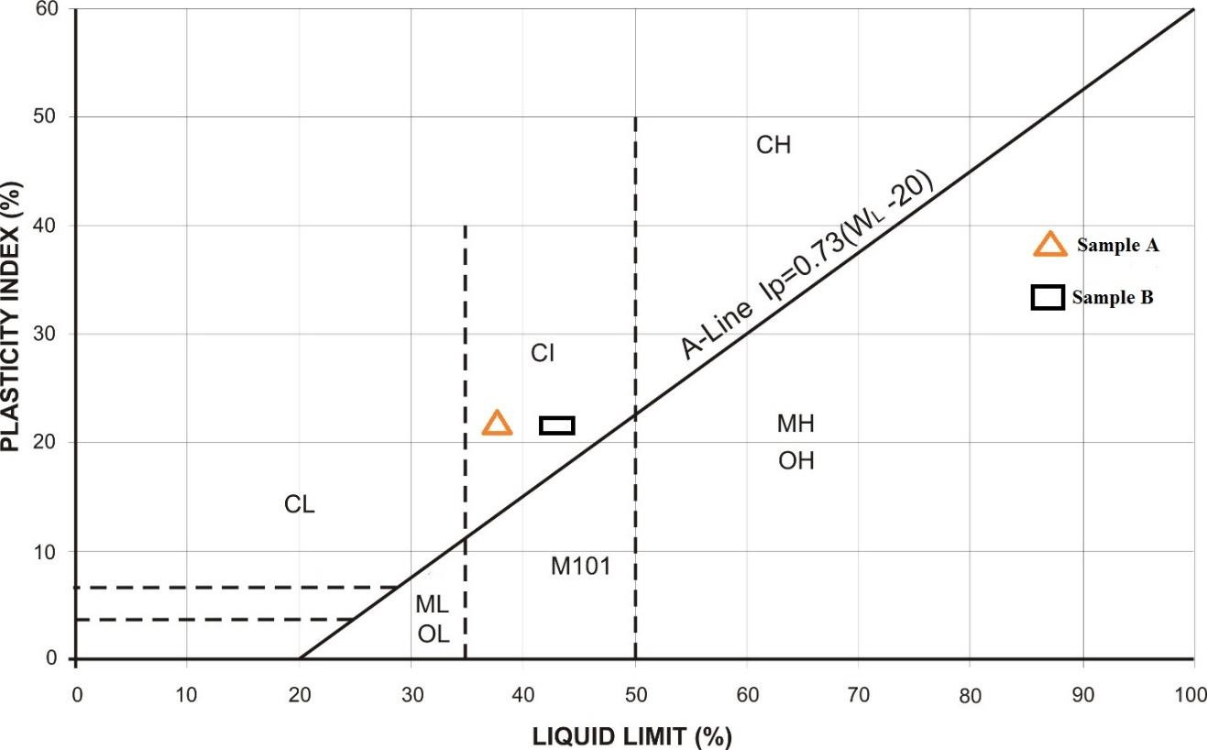

Fig. 4.3: Plots of Sample A and B on Plasticity Chart

Table 4.6.4: Relationship between Atterberg limit and Volume Change Potential (After Holtz and Cubbs, 1936)

Volume Change Potential | Plasticity Index Ip |  | Shrinkage
Volume Change Potential | Arid Area | Humid Area
Little | 0 – 15 | 0 – 30 | < 12
Moderate | 15 – 30 | 30 – 50 | 10 – 12
High | >30 | >50 | >10

Table 4.6.5: Engineering Used Chart (After Wagner, 1957)
Typical names of Soil groups | Group Symbols | Important Properties
Typical names of Soil groups | Group Symbols | Permeability when compacted | Shearing strength with compacted and saturated | Compressibility when compacted and saturated | Workability as a construction material
Well graded gravels or gravel- sand mixture, little or no fines | GW | Pervious | Excellent | Negligible | Excellent
Poorly graded gravels or gravel-sand mixture, little or no fines | GP | Very pervious | Good | Negligible | Good
Silty gravels, gravel-sand-silt mixtures | GM | Semi-pervious to impervious | Good | Negligible | Good
Clayey gravels, gravel-sand- clay mixtures | GC | Impervious | Good to fair | Very low | Good
Well graded sands or gravel- sand, little or no fines | SW | Pervious | Excellent | Negligible | Excellent
Poorly graded sands or gravel- sand mixture, little or no fines | SP | Pervious | Good | Very low | Fair
Silty sand, sand-silt mixture | SM | Semi-pervious to impervious | Good | Low | Fair
Clayey sand, sand-clay mixture | SC | Impervious | Good to fair | Low | Good
Inorganic silts, rock flour, silts of low plasticity | ML | Semi-pervious to impervious | Fair | Medium | Fair
Inorganic clays of low plasticity, gravelly clays, sandy clays, etc | CL | Impervious | Fair | Medium | Good to fair
Organic silts and organic clays of low plasticity | OL | Semi-pervious to impervious | Poor | Medium | Fair
Inorganic silts, micaceous silts, silts of high plasticity | MH | Semi-pervious to impervious | Fair to poor | High | Poor
Inorganic highly plastic clays, fat clays, silty clays, etc | CH | Impervious | Poor | High | Poor
Organic silts and organic clays of high plasticity | OH | Impervious | Poor | High | Poor

Results of Compaction tests

The results of Compaction tests are shown below for Sample A and B

Table 4.7: Compaction Tests for Sample A (Standard Proctor)

Sample no | 1 |  | 2 |  | 3 |  | 4
Moisture can no | 7 | P8 | TB | 33 | P14 | Y2 | E8 | 4
Wt. of can + wet soil | 73 | 1/7 | 72.5 | 78 | 178 | 173.5 | 169.5 | 179.5
Wt. of can + dry soil (g) | 68.5 | 11.2 | 67.5 | 72.5 | 162 | 158 | 148.5 | 158
Wt. of can (g) | 4.5 | 5 | 5 | 5.5 | 16 | 15.5 | 21 | 21.5
Wt. of can (g) | 20 | 51.5 | 23.5 | 24.5 | 58.5 | 57 | 25 | 34
Wt. of dry soil (g) | 48.5 | 54.5 | 44 | 48 | 103.5 | 101 | 123.5 | 124
Water content w% | 9.3 | 9.2 | 11.4 | 11.5 | 15.5 | 15.3 | 17.0 | 17.3
DENSITY DETERMINATION
Assumed water content (g) |  | 9.5 | 11.5 |  |  | 15.5 | 17.0
Average water content% |  | 9.3 | 11.5 |  |  | 15.4 | 17.2
Wt. of soil + mould (g) |  | 4693 | 4912 |  |  | 5044 | 4961
Wt. of mould (g) |  | 2976 | 2976 |  |  | 2976 | 2976
Wt. of soil in mould (g) |  | 1717 | 1936 |  |  | 2068 | 1985
Wet Density, DW (g/cm³) |  | 1.717 | 1.936 |  |  | 2.068 | 1.985
Dry density (g/cm³) |  | 1.571 | 1.736 |  |  | 1.792 | 1.694

Maximum Dry Density %)

Fig. 4.4: Compaction Curves for Sample A
B Modified Proctor
A Standard Proctor
Optimum Moisture Content %
25
20
15
10
5
0
1.55
1.6
1.65
1.7
1.75
1.8
1.85

Table 4.7.1: Compaction Tests for Sample A (Modified Proctor) WATER CONTENT DETERMINATION

Sample no | 1 |  | 2 |  | 3 |  | 4
Moisture can no | Bo | J | 3 | LA | 1 | 5 | 2 | 4
Wt of can + wet soil | 99.5 | 94.5 | 120.5 | 122 | 174.5 | 206.5 | 254.5 | 246.5
Wt. of can + dry soil (g) | 95 | 89.5 | 110 | 110.5 | 155.5 | 184.5 | 218.5 | 210
Wt of can (g) | 4.5 | 5 | 10.5 | 11.5 | 19 | 22 | 36 | 36.5
Wt of can (g) | 32.5 | 25 | 19 | 15 | 18.5 | 18 | 19 | 19.5
Wt of dry soil (g) | 62.5 | 64.5 | 91 | 95.5 | 137 | 166.5 | 199.5 | 190.5
Water of content w% | 7.2 | 7.8 | 11.5 | 12.0 | 13.9 | 13.2 | 18.0 | 19.2

DENSITY DETERMINATION
Assumed water content(g) | 7.5 | 11.8 | 13.5 | 18.5
Average water content% | 7.5 | 11.8 | 13.6 | 18.6
Wt. of soil + mould (g) | 4658 | 4904 | 5038 | 4952
Wt. of mould (g) | 2976 | 2976 | 2976 | 2976
Wt. of soil in mould (g) | 1682 | 1928 | 2062 | 1976
Wet density, DW(g/cm3) | 1.682 | 1.928 | 2.062 | 1.976
Dry density (g/cm3) | 1.565 | 1.725 | 1.815 | 1.666

Maximum Dry Density %)

Fig. 4.5: Compaction Curves for Sample B
B Modified Proctor
A Standard Proctor
Optimum Moisture Content %
25
20
15
10
5
0
1.55
1.6
1.65
1.7
1.75
1.8
1.85

Table 4.7.2: Presentation of Compaction Results

SAMPLE NO | STANDARD PROCTOR |  | MODIFIED PROCTOR
 | Optimum | Maximum | Optimum | Maximum
 | Moisture | Dry Density | Moisture | Dry Density
 | Content | (MDD) | Content | (MDD)
 | (OMC) % | g/cm3 | OMC (%) | g/cm3
Sample A | 15.0 | 1.80 | 15.0 | 1.83
Sample B | 15.0 | 1.83 | 15.0 | 1.79

Discussion on Compaction results

The relationship between the dry density and the optimum moisture content of the soil samples are shown in Fig 4.2. The compaction curves show that dry density increases with further increase water content. From compaction tests carried out, at the energy of standard proctor, sample A has 15.0% and 1.80 g/cm3 as optimum moisture content and maximum dry density respectively, while at the energy of modified proctor, it has 15.0 % and 1.83 g/cm3 as optimum moisture content and maximum dry density respectively. Sample B has 15.0% and 1.83 g/cm3 as optimum moisture content and maximum dry density respectively, while at the energy of modified proctor, it has 15.0 % and 1.79 g/cm3 as optimum moisture content and maximum dry density respectively.
The compaction characteristics and ratings of the Unified soil classification classes for soil construction (ASTM, 1557-91) (Table 4.7.2), from the values obtained, it can be concluded that soil samples A and B have a fair to good performance as an embankment material and can be used as a subgrade material with a good to fair performance as base course material.

Table 4.7.3: Compaction Characteristics and Rating of Unified Soil Classification Classes for Construction (ASTM, 1557-91)

Visual Description | Maximum Dry-Weight Range (g/cm3) | Optimum Moisture Range (%) | Anticipated Embankment Performance | Value as Subgrade Material | Value as base course
Granular material | 2.00-2.27 | 7-15 | Good to excellent | Excellent | Good
Granular material with soil | 1.76-2.16 | 9-18 | Fair to Excellent | Good | Fair to Poor
Fine sand and sand | 1.76-1.84 | 9-15 | Fair to Good | Good to fair | Poor
Sandy silts and silts | 1.52-2.08 | 10-20 | Poor to Good | Fair to Poor | Not suitable
Elastic silts and Clays | 1.36-1.60 | 20-35 | Unsatisfactory | Poor | Not suitable
Silty-Clays | 1.52-1.92 | 10-30 | Poor to Good | Fair to Poor | Not suitable

Results of California Bearing Ratio
The results of California Bearing Ratio tests are shown below for Sample A and B Table 4.8.1: California Bearing Ratio tests for Sample A

Penetration of Plunger (mm) | TOP Piston Load on Plunger (KN) |  | BOTTOM Piston Load on Plunger (KN)
0.00 | 2.9 | 0 | 0 | 0
0.50 | 26 | 76 | 33 | 96
1.00 | 51 | 149 | 60 | 175
1.50 | 67 | 196 | 75 | 219
2.00 | 81 | 237 | 92 | 269
2.50 | 90 | 263 | 106 | 310
3.00 | 96 | 281 | 114 | 334
4.00 | 103 | 301 | 121 | 354
5.00 | 108 | 316 | 126 | 359
6.00 | 11.6 | 339 | 130 | 380
7.00 | 120 | 351 | 134 | 392

L O A D O N P L U N G E R (
40
30

20

10
0
0
1.0
2.0
3.0
4.0
5.0
6.0
7.0
8.0
PENETRATION (MM)

Fig. 4.7: Plots of California Bearing Ratio for Sample A

Table 4.8.2: California Bearing Ratio tests for Sample B

Penetration of Plunger (mm) | TOP Piston Load on Plunger (KN) |  | BOTTOM Piston Load on Plunger (KN)
0.00 | 0 | 0 | 0 | 0
0.50 | 19 | 55 | 27 | 79
1.00 | 37 | 108 | 48 | 140
1.50 | 53 | 155 | 69 | 202
2.00 | 70 | 205 | 87 | 254
2.50 | 83 | 243 | 99 | 290
3.00 | 89 | 260 | 105 | 307
4.00 | 94 | 275 | 112 | 328
5.00 | 99 | 290 | 116 | 339
6.00 | 102 | 298 | 121 | 354
7.00 | 107 | 313 | 125 | 366

L O A D O N P L U N G E R
40
30

20

10
0
0
1.0
2.0
3.0
4.0
5.0
6.0
7.0
8.0
PENETRATION (MM)
Fig. 4.8: Plots of California Bearing Ratio for Sample B

Table 4.8.3: Summary of CBR Results for Standard Proctor

SAMPLE NUMBER | CBR VALUES | PENETRATION AVERAGE VALUE (%)
 |  | 2.5mm | 5.0mm
Sample A | SOAKED | 2 | 2
Sample A | UNSOAKED | 4 | 3
Sample B | SOAKED | 2 | 1
Sample B | UNSOAKED | 3 | 2

Table 4.8.4: Summary of CBR Results for Modified Proctor

SAMPLE NUMBER | CBR VALUES | PENETRATION AVERAGE VALUE (%)
 |  | 2.5mm | 5.0mm
Sample A | SOAKED | 2 | 2
Sample A | UNSOAKED | 5 | 4
Sample B | SOAKED | 2 | 2
Sample B | UNSOAKED | 4 | 3

Table 4.8.5: General Rating for Soil Based on CBR Values (After The Asphalt Institute, 1962)
CBR NO | GENERAL RATING | USES | CLASSIFICATION UNIFIED | SYSTEM AASTHO
0-3 | Very poor | Sub-grade | OH, CH, MH, OL | A5, A6, A7
3-7 | Poor-fair | Sub-base | OH, CH, MH, OL | A4, A5, A6, A7
7-20 | Fair | Base | OL ,CL, ML, SC, SM, SP | A2, A4, A6, A7
20-50 | Good | Asphalt material | GM, GL, SIN, SM, SP, GP, W,GM | Aib, A2-5, A3, Al,A2-4 ,A3

Discussion of CBR Results

The CBR values for Sample A unsoaked sample for Standard Proctor and Modified Proctor were 4% and 5% respectively. For Sample A SOAKED for standard Proctor and modified Proctor were 2% and 2% respectively. For UNSOAKED sample B for Standard Proctor and Modified Proctor were 3% and 4% respectively, while for SOAKED Sample B Standard Proctor and modified Proctor were 2% and 2% respectively. Table 4.8.3 shows the general rating of soil material based on the CBR values of the material. Soil meet requirement better when they are classified based on the CBR value of soaked materials. Sample A CBR indicate a very poor general rating based on it CBR values which means that it can only be used as subgrade material in road construction. Sample B also have a general poor rating based on its soaked CBR values means it is only good for subgrade material in road construction. The UNSOAKED modified CBR test result shows that Sample A can be used as a sub base material in road construction and Sample B can be used as both subgrade and sub base material in road construction based on the UNSOAKED modified CBR value of both sample which were 5% and 4% respectively.

CHAPTER FIVE CONCLUSION AND RECOMMENDATIONS
  - CONCLUSION
Comparative studies of laterite have been carried out in compliance with the regulatory standard. Grain size distribution for Sample A and Sample B obtained shows that they are poorly graded and, on the basis, both soil samples will be suitable for use as a road sub-base material. The Atterberg consistency limits, shows that the both samples meet the requirement to be used as a sub-base material. The compaction properties possessed by Sample A and Sample B makes them good engineering construction materials based on the MDD and OMC values obtained at both energies Standard Proctor and Modified Proctor. According to The Asphalt Institute (1962), both Sample A and Sample B have CBR which are considered to be very poor to poor and can only be used as sub- grade and sub-base material and also both samples possess fairly high initial and long-term stability when used in dam or embankment construction. In conclusion from the te sts carried out, it can be deducing that Sample A and Sample B can be used as construction material such as road, dam, foundation and embankment.

RECOMMENDATION

- Geotechnical properties of laterite soil should be analyzed and recommended as a suitable material for civil engineering purpose particularly for construction of infrastructural facility.
- Further investigation and analysis such as Triaxial test and permeability should be carried out on laterite soil before construction begins.

REFERENCES

Abebe, B, Tadesse, S., & Tsige, D. (2020). Engineering Properties of Lateritic Soils in Ethiopia For Road Construction. Journal of African Earth Sciences, 171, 103964.
Adebayo, A. J. et al. (2017). Delineation of Heavy Metals in Soils from Auto-Mechanic Workshops. International Research Journal of Public and Environmental Health, 4(7), 136–147.
Adeyemo, K. A. & Bello, A. A. (2022). Cleaner Materials, 3, 100045.

Adeyemo, K. A. et al. (2019, 2022). Studies on cassava peel ash treatment of soils.

Adeyemo, K. A., Yunusa, G. H., & Bello, A. A. (2019). Uni Osun Journal of Engineering and Environmental Sciences, 1(1), 11–18.
Afolayan, A. A. et al. (2018, 2019, 2020). Research on agricultural waste and steel slag effects on soil.
Agbede, O. A. (2019). General geographical and soil references to Ilorin South/East. Aiban, S. A. (1998). Environment International, 24(2–3), 153–161.
Akande, S. O., et al. (2005). Journal of African Earth Sciences, 41(5), 394–406.

Alado, A. J., & Amu, O. O. (2024). International Journal of Civil and Geotechnical Engineering,

Aleva, G.J.J. (1994). Laterites: Concepts, Geology, Morphology, And Chemistry. Catena, 2(2-3), 155-172.
Alexander, L. T., & Cady, J.G. (1962). Genesis and Hardening of Laterite in Soils. Technical Bulletin No. 1282, USDA
Amedi, T. A. (2021). Journal of Applied Soil Engineering, 7(1), 35–42.

American Society for Testing and Material: (2021): Standard Test Method for Particle. Size Distribution (Gradation) Of Fine-Grained Soils Using the Sedimentation (Hydrometer) Analysis ASTM International.

American Society for Testing and Materials (2011). ASTM D3080/D3080M-11: Standard Test Method for Direct Shear Test of Soils Under Consolidated Drained Conditions. ASTM International.
American Society for Testing and Materials (2012). ASTM D698-12: Standard Test Methods for Laboratory Compaction Characteristics of Soil Theory Standard Effort. ASTM International.
American Society for Testing and Materials (2017), ASTM S69131D6913M-17: Standard Test Method for Particle Size Distributing (Graduation) Of Soils Using Sieve Analysis. ASTM International
American Society for Testing and Materials (2017). ASTM D2937-17: Standard Test Method for Density of Soil in Place by The Drive Cylinder Method. ASTM International.
American Society for Testing and Materials (2017). ASTM D4318-17: Standard Test Methods for Liquid Limit, Plastic Limit and Plasticity Index of Soils. ASTM International.
American Society for Testing and Materials (2021). ASTM D1883-21: Standard Test Method for California Bearing Ratio (CBR) Of Laboratory. Compacted Soils. ASTM International.
American Society for Testing and Materials. (2014).: Standard Practice for Preserving and Transporting Soil Sample. ASTM International.
Amu, O. O., Bamisaye, O. A., & Komolafe, P. O. (2011). International Journal of Pure and

ASTM D2487. (2017). Standard Practice for Classification of Soils for Engineering Purposes (Unified Soil Classification System). ASTM International
Balasubramanian, A. S. et al. (1985). Engineering Behavior of Tropical Residual Soils. Bello, A. (2020). Study on compaction and shear strength of treated lateritic soils.
Brady, N.C., & Weil, R.R. (2016). The Nature and Properties of Soils (15th Ed.). Pearson.

British Standards Institution (2003). 1377-2:2003: Methods of Test for Soils for Civil Engineering Purpose. Classification Test. BSI

Buchanam F. (1807). A Journey from Madras Through the Countries of Mysore Canara, And Malabar. London: East India Company.
Das, B. M. (2010). Principles of Geotechnical Engineering (7th Edition). Cengage Learning.

Esu, I. E. (2005). Characterization, Classification and Management Problems of Major Soil Orders in Nigeria.
Eswaran, H., & Bin, W.G (1978). A Study of Deep Weathering in Laterite Profile. Geoderma, 20(I), 1-15.
Gidigasu, M. D. (1976). Laterite Soil Engineering: Pedogenesis and Engineering Principles. Elsevier Scientific Publishing Company.
Gidigasu, M.D. (1972). Laterite Soil Formation and Its Engineering Characteristics. Journal of Soil Science, 23(4); 466-475.
Gunn, J. (Ed.). (2004). Encyclopedia of Caves and Karst Science. Taylor & Francis. Head, K. H. (2000). Manual of Soil Laboratory Testing: Vol. 3. Whittles Publishing.
Ijimdiya, T. S., & Fadugba, O. G. (2015). Electronic Journal of Geotechnical Engineering, 20,

Kasthurba, A.K., Santhanam, M., & Achyathan, H. (2007). Investigation of Laterite Stones for Building Purpose from Malabar Region, Kerala, India. Construction and Building Materials, 21(6): 1272-1280
Keitumetse, S. O. (2016). African Heritage Conservation and Management. Springer. Lai, J. S. (1987). Regional lateritic soils engineering properties.
Lambe, T.W. & Whitman, R.V. (2000). Soil Mechanics and Foundation Journal of Geotechnical and Geo-Environmental Engineering, 126(1). 1-10.
Lambe, T.W., & Whitman, R.V (2008) Soil Mechanics. John Wilev & Sons.

Lemougna, P.N. Wang, K.T., Tang, Q., & CNI, X.M (20110. Recent Developments on Laterite Based Geopolymers. Applied Clay Science. 53(2), 220-227.

Maegnan, M. (1988). Laterites: Concepts, Geology, Morphology, and Chemistry. Geological Society of Malaysia.
Mangomuya, H. A. (1987). African Soils, 25(2), 119–128. McCurry, P. (1976). Geology of Nigeria.
Murty, V.R. (2022). Enhancing Weak Laterite Soil for Road Foundations Using Metakaolin Bischopire- Allalinzation Additives: Mechanical and Microstructural Characterization. Transportation Geotechnics, 35, 100781.
Nixon, 1.K. & Skipp, B.O (1957). Laterite as A Construction Material in Tropical Regions. Geotechnique, 7(3), 108-120.
Obaje, N. G. (2009). Geology and Mineral Resources of Nigeria. Springer.

Ojefia, D. E. (2021, 2022). Nigerian Journal of Technology, International Journal of Engineering Science Invention.
Ojetia, J. O. (2022). FUOYE Journal of Engineering and Technology, 7(2), 114–118.

Ojo, J. O. (2020). Road Access and Infrastructure Development in Ilorin Metropolis. Kwara Journal of Geography, 5(1), 65–72.
Ojuri, O. O. (2013). International Journal of Advanced Scientific and Technical Research, 3(4), 229–244.
Ola, S. A. (1977, 1983, 2005). Studies on lateritic soils from various parts of Nigeria. (Multiple mentions across both chapters.)
Olaniran, O. J. (2018). Climate and Human Activities in Nigeria: Impacts on Land Resources. Nigerian Journal of Environmental Studies, 26(1), 45–56.
Osinubi, K. J. (2005, 2006, 2017). Studies on the geotechnical behavior of lateritic soil and cement stabilization.
Oyawoye, M. O. (2020). General study on schist belts and basement complex.

Oyelami, C.A., & Van Rooy, J.L. (2016). Characterization of Laterite Soil and Its Use in Construction Applications: A Review. Environmental Earth Science, 75(18). 1-12.
Paton, T.R., Humphreys, G.S., Mitchell, P.B. (1995). Soils: A New Global View. Yale University Press.
Rahaman, M. A. (1988). Precambrian Geology of Nigeria.

Schellmann, W. (1982). A New Definition of Laterite. Geological Survey of India, Memoir 120, 1–7
Sridran, G. (2006). Geotechnical Behavior of Lateritic Soils in Tropical Regions. Journal of Geotechnical Engineering, 132(5), 478–489.
Tardy, Y (1997), Petrology of Laterites and Tropical Soils, Rotterdam: AA Balkema.

Tardy, Y., & Roquin C. (1992). Geochemistry and Evolution of Lateritic Landscape In I.P Marthi & W. Chesworth (Eds), Weathering, Soils & Paleosols.
Terzaghi, K., Peck, R.B. & Mesri, G. (1996). Soil Mechanics in Engineering Practice (3rd Ed). John Willey & Sons.
Terzaghi, K., Peck, R.B., & Mesri, G. (1996). Soil Mechanics in Engineering Practice (3rd Ed.). Geotechnical and Geological Engineering, 14 (3), 189–196.
Tuncer, E.R., & Lohnes, R.A. (1978). Engineering Properties of Lateritic Soils in West Africa Engineering Geology, 12(3), 197-212.
Widdeowson, M. (2007). Laterite and Ferricrete. In D.J. Nash & S.J. Mclareen (Eds). Geochemical Sediments and Landscapes, Blackwell Publishing.
Widdowson, M. (2009). Laterite. In Gornitz, V. (Ed.), Encyclopedia of Paleoclimatology and Ancient Environments Springer.
Yoder, E. J., & Witczak, M. W. (1995). Principles of Pavement Design (2nd Edition). Wiley.

Plate 1. Can Plate 2. Weigh Balance
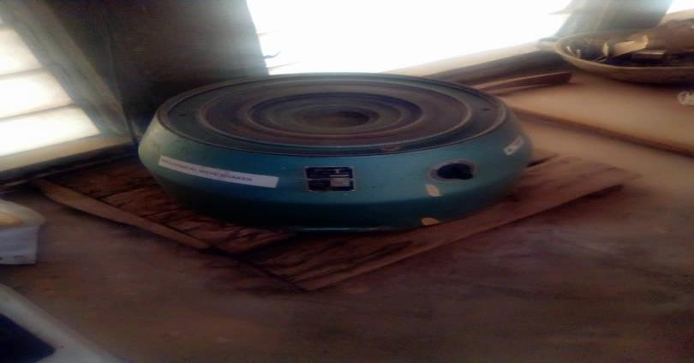
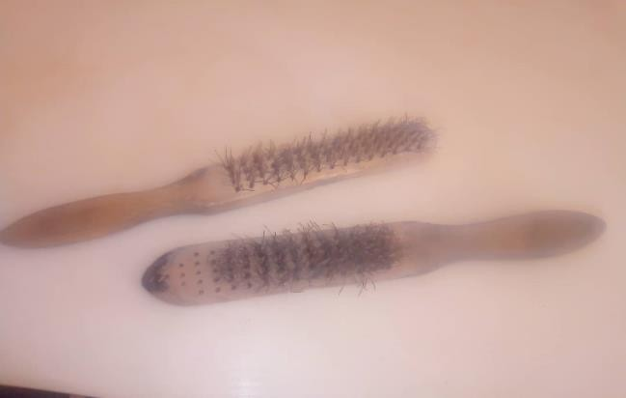
Plate 3. Mechanical Sieve Shaker Plate 4. Wire Brush
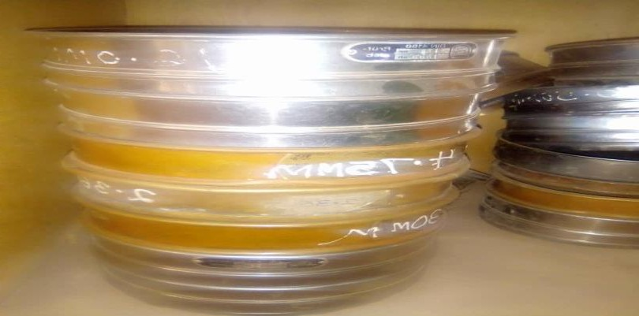
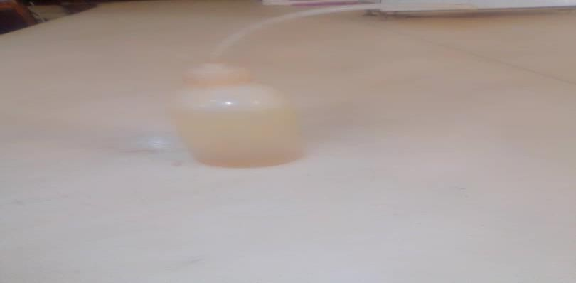
Plate 5. Sieves Plate 6. Washing Bottle
