PETROGRAPHIC STUDIES OF ROCK IN KWARA STATE POLYTECHNIC, ILORIN

By

Aliyu Ayinla, MUSA
ND/23/MPE/FT/0084

SUBMITTED TO:
THE DEPARTMENT OF MINERALS AND PETROLEUM RESOURCES ENGINEERING TECHNOLOGY INSTITUTE OF TECHNOLOGY, KWARA STATE POLYTECHNIC, ILORIN
IN PARTIAL FULFILLMENT OF THE REQUIREMENT FOR THE AWARD OF NATIONAL DIPLOMA (ND) IN MINERALS AND PETROLEUM RESOURCES ENGINEERING TECHNOLOGY

AUGUST, 2025

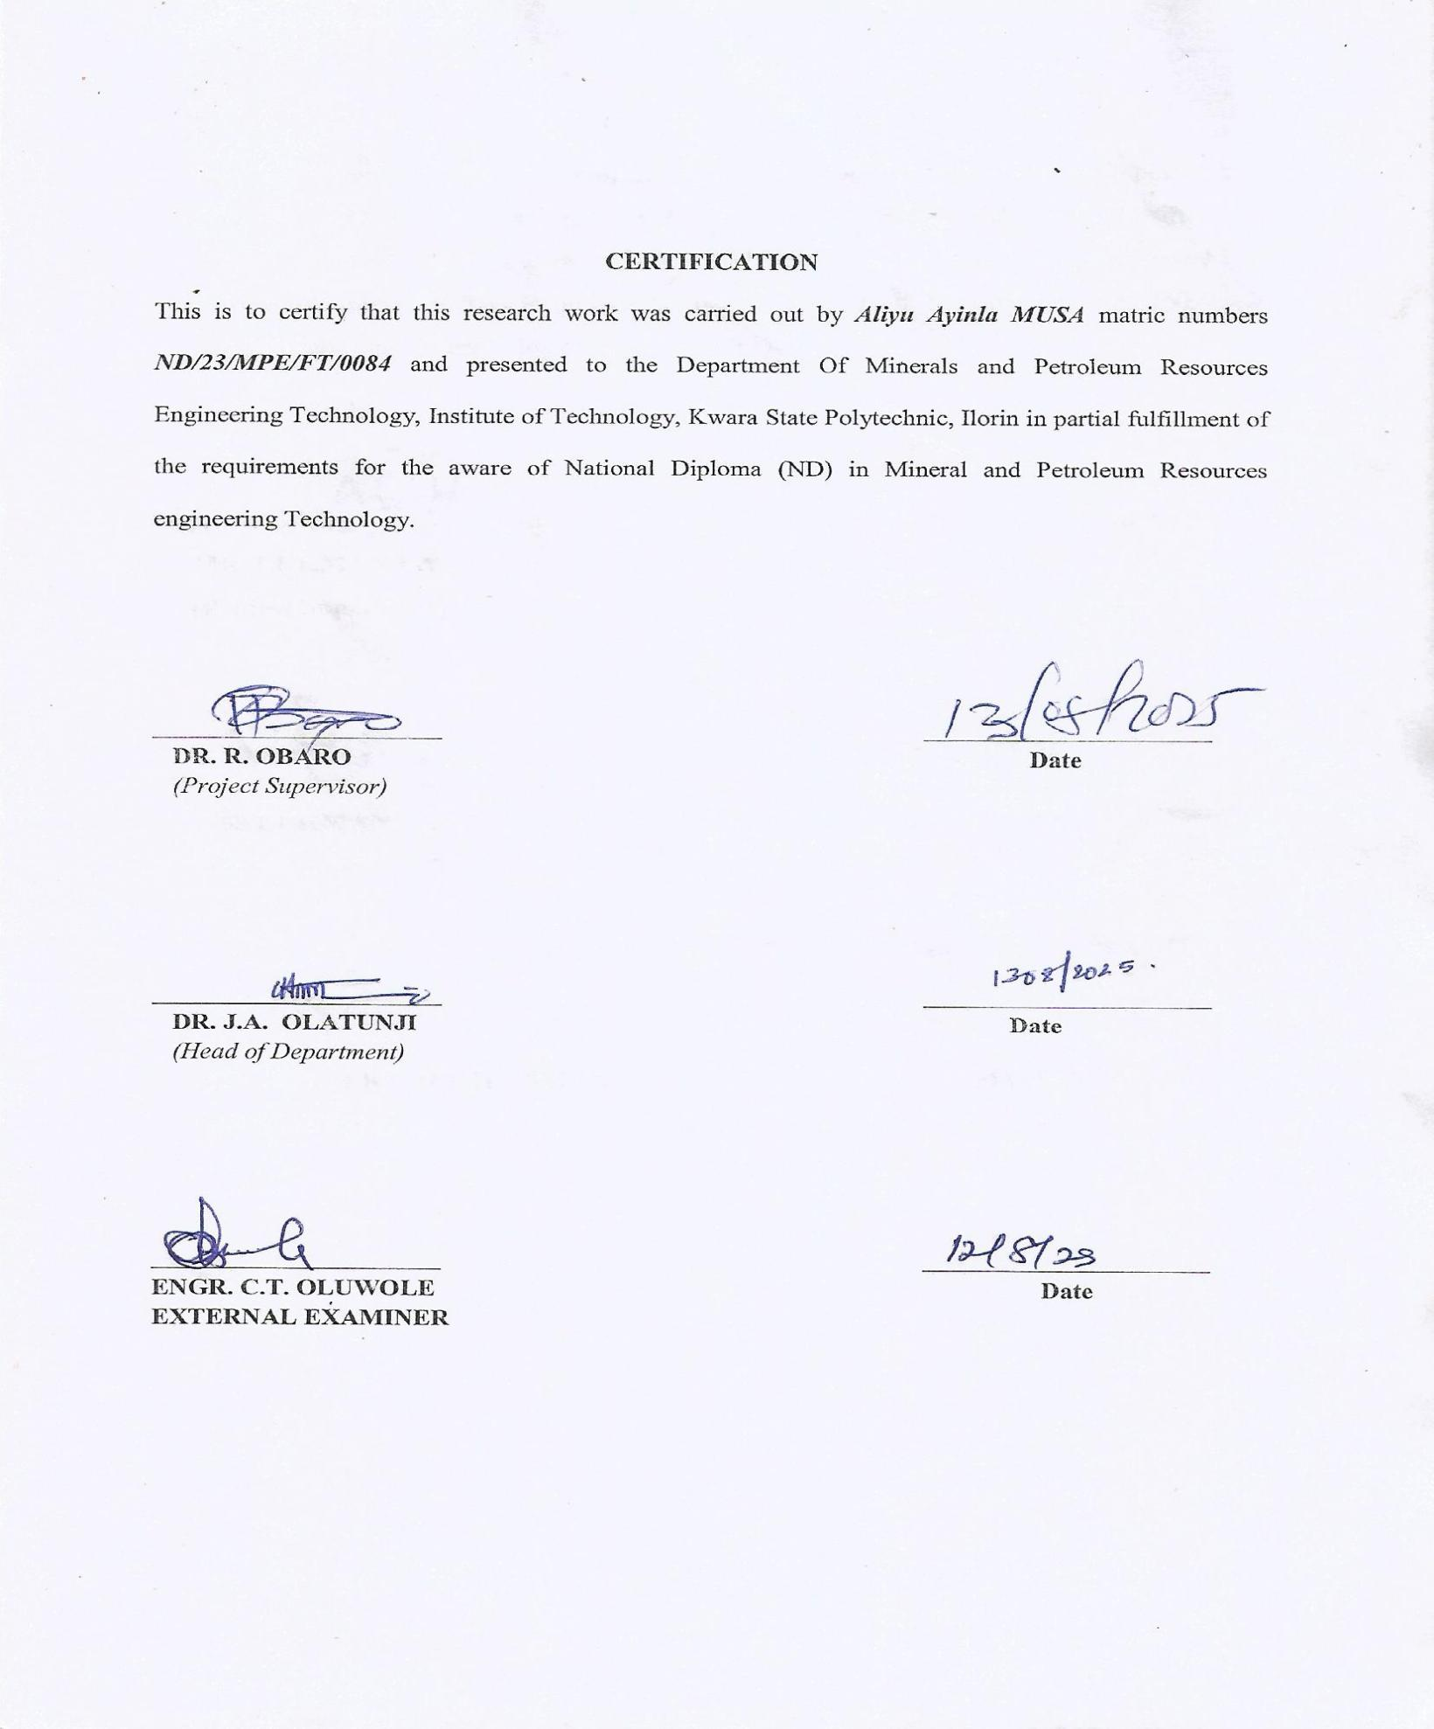

Dedication
I am delighted to dedicate this project to Almighty GOD, the creator of all universe who gave me the grace and opportunity to complete my National Diploma program and this research, may His name be glorified.

Acknowledgements
I give all the glory and adoration to Almighty GOD, the beginning and the End, for his greatest protection and love given to me as a privilege to start and complete this research work.
I wholeheartedly extend my special thanks to my amiable supervisor Dr. Reuben Obaro for his professional guidance and support towards the success of this project.

Abstract
This project presents a detailed petrographic study of rock samples collected from Kwara State Polytechnic, Ilorin, Nigeria. The study aims to investigate the mineralogical composition, texture, and classification of the rocks within the study area to better understand their origin, geological history, and potential applications. Fieldwork involved systematic sampling of exposed rock units across strategic locations within the polytechnic campus. Laboratory analysis was carried out using thin-section petrography under a polarizing microscope. The observations focused on identifying constituent minerals, their grain relationships, textural features, and alteration patterns. Preliminary results indicate the dominance of igneous and metamorphic rocks, primarily granite and gneiss, with varying mineral assemblages including quartz, feldspar, biotite, and hornblende. The textural characteristics suggest a complex geological history influenced by multiple tectonic and thermal events. This petrographic study not only contributes to the geological mapping of the area but also provides insight into the material properties of local rocks, which can guide future construction, engineering, and academic research within the institution. The study reinforces the significance of petrography in regional geological investigations and resource management.
Keywords: Petrography, Rock Analysis, Kwara State Polytechnic, Ilorin, Thin Section, Mineralogy, Granite, Gneiss, Igneous Rocks, Metamorphic Rocks, Polarizing Microscope, Geological Mapping, Rock Texture, Nigeria Geology.

Table of Contents
Title page i
Certification ii
Dedication iii
Acknowledgement iv
Abstract v
Table of content vi
List of Figures ix
List of Tables x
CHAPTER ONE 1
1.0 Introduction 1
1.1 Background of the study 1
1.2 Aim of the study 2
1.3 Objectives of the study 3
1.4 Problem Statement 3
1.5 Justification of the study 3
1.6 Scope of the study 3
1.7 Limitations of the study 4
CHAPTER TWO 5
LITERATURE REVIEW 5
2.1 Review of Previous Works 5
2.2 Composition of Rocks 9
2.3 Physical Composition of Rocks 11
2.4 Chemical Composition of Rocks 11
2.5.1 Major Element Geochemistry 12
2.5.2 Trace Elements and Tectonic Significance 12
2.6 Mineralogical Composition of Rocks 13
2.7 Economic Importance of Rocks in Nigeria 14
CHAPTER THREE 19
3.0 MATERIALS AND METHODS 19
3.1 Geology of Nigeria 19
3.2 Geology of the Study Area 22
3.3 Sample Collection 24
3.4 Sample Preparation 24
CHAPTER FOUR 25
4.0 RESULTS AND DISCUSSION 25
4.1 Results of Petrographic studies of the Thin Sections 25
4.2 Discussion on Petrographic Studies of Migmatite Gneiss 25
4.3 Petrographic Description of some of the Prominent Minerals in the Migmatite 26
4.3.1 Quartz (SiO₂) 26
4.3.2 Plagioclase Feldspar (Na₂AlSi₃O₈.Ca₂Al₂Si₂O₈) 26
4.3.3 Orthoclase Feldspar 26
4.3.4 Microcline Feldspar 27
4.3.5 Muscovite (KF)₂(Al₂O₃)₃(SiO₂)₆ 27
4.3.6 Biotite (Mg,Fe)₃ AlSi₃O₁₀(OH,F)₂ 27
4.3.7 Hornblende (Ca₂(Mg,Fe)₅(AI,Si)₈O₂₂(OH)₂ 28
4.4 Discussion on Petrographic Studies of Porphyritic Granite (Sample B) 30
4.5 Discussion on Petrographic Studies of Biotite Granite (Sample C) 32
4.6 Economic Potential of the Rocks 34
CHAPTER FIVE 35
5.0 Conclusion and Recommendation 35
5.1 Conclusion 35
5.2 Recommendation 36 References 37

List of Figures
Figure 3.1: Geological Map of Nigeria (Modified from Africa Atlases, 2007) 21
Figure 3.2: Location Map of the Study Area (modified after Olasehinde et al., 1998) 23

List of Plates
Plate 4.1. Photomicrograph of migmatite gneiss under Crossed Polarized Light 29
Plate 4.2. Photomicrograph of migmatite gneiss under Plane Polarized Light 29
Plate 4.3. Photomicrograph of porphyritic granite under Crossed Polarized Light 31
Plate 4.4. Photomicrograph of porphyritic granite under Plane Polarized Light 31
Plate 4.5. Photomicrograph of Biotite granite under Crossed Polarized Light 33
Plate 4.6. Photomicrograph of porphyritic granite under Plane Polarized Light 33

CHAPTER ONE
INTRODUCTION
1.1 Background of the study
Petrography is a branch of geology that focuses on the detailed description and classification of rocks, primarily through microscopic analysis of thin sections. It is a critical tool for understanding the origin, composition, and history of rocks, as well as the processes that shaped them. Nigeria, located within the West African Craton, is endowed with a wide variety of rock types including igneous, metamorphic, and sedimentary rocks that reflect a complex geological history. This study focuses on the petrographic analysis of rocks from various regions of Nigeria in order to reveal their mineralogical composition, texture, and structural characteristics. Nigeria’s geology is dominated by three major lithological units: The Precambrian Basement Complex, the Younger Granites of the Jos Plateau, and the sedimentary basins (Christopher et al. 2022). The Precambrian Basement Complex, which underlies much of western and northern Nigeria, consists of migmatites, gneisses, schists, and granitoids. The Younger Granites, emplaced during the Jurassic period, are known for their ring complexes and mineralization. The sedimentary basins such as the Niger Delta, Benue Trough, and Chad Basin contain various types of sedimentary rocks and are of great economic importance due to their hydrocarbon potential. Despite these resources, there is a need for a more detailed petrographic characterization of rocks across the country to better understand their properties, origins, and implications for natural resource development (Oyediran and Fohgi; 2019). Petrography, the branch of geology dedicated to the detailed description and classification of rocks, is fundamental in understanding the Earth's crustal composition and the geological processes that have shaped it over time. By meticulously examining thin sections of rocks under polarizing microscopes, geologists can identify mineral constituents, textures, and structures, thereby gaining profound insights into the history and conditions of rock formation. The extensive geological studies conducted in Nigeria, there remains a significant gap in comprehensive petrographic analyses of many rock units. Detailed petrographic studies are essential for accurate geological mapping, mineral exploration, and understanding the tectonic evolution of the region. Adeagbo et al. (2017) analyzed structural elements and mineralogical compositions of rocks in parts of Oke Ogun, contributing to the understanding of the region's geological history.
The advent of advanced analytical techniques has significantly enhanced petrographic studies. Usman and Ibrahim (2017) conducted petrographic and geochemical analyses of rocks in the northern part of the Wonaka Schist Belt, providing insights into the area's geological history and mineralization potential. Similarly, Chukwu and Obiora (2012) examined the whole-rock geochemistry of basic and intermediate intrusive rocks in the Ishiagu area, offering valuable data on their petrogenesis. Furthermore, petrographic data contribute to studies on soil formation, erosion processes, and natural hazard assessments, providing insights into environmental implications. Iliya and Ma’aji (2021) conducted petrographic studies of rocks around Arum and its environs, offering valuable data on mineral compositions relevant to environmental assessments.
1.2 Aim of the Study
The aim of this project is to examine the petrographic study of rocks in Kam quarry in Kwara state

1.3 Objective of the Study
The objective of this study includes:
i. to carry out the petrographic study of rock.
ii. to determine the mineralogical constituents of rock
iii. to establish its importance for industrial purpose.
1.4 Problem Statement
The abundance and diversity of rock types in Nigeria, many areas remain underexplored in terms of their petrographic characteristics. This lack of detailed microscopic analysis can lead to inaccurate geological mapping, misinterpretation of rock origins, and poor understanding of subsurface structures. Such gaps in knowledge can affect exploration, engineering, and construction activities. A systematic petrographic study is therefore essential to fill these knowledge gaps and provide a resource assessment.
1.5 Justification of the study
Petrographic studies are crucial for various applications in geology, including mineral exploration, geotechnical engineering, and academic research. By examining rocks in thin section, detailed information about their mineralogy, texture, and history that cannot be observed macroscopically. This study will contribute to a better understanding of the geological framework of the study area.
1.6 Scope of the study
It will include fieldwork for sample collection, laboratory preparation of thin sections, and microscopic analysis for mineralogical and textural identification.
The study will cover petrographic analysis of selected rock samples from representative geological zones in Nigeria.
Rocks will be classified into igneous, metamorphic, and sedimentary categories based on their petrographic features.
1.7 Limitations of the study
This study aimed to carry out comprehensive petrographic analysis involving fieldwork, laboratory preparation, and microscopic examination of rock samples from the study area.

CHAPTER TWO
LITERATURE REVIEW
2.1 Review of Previous Works
Petrographic studies in Nigeria have significantly advanced our understanding of the country's diverse lithological units. Early foundational work by Oyawoye (2018) provided a comprehensive overview of the Nigerian Basement Complex, emphasizing its Precambrian origins and complex metamorphic history. Rahaman (2019) further detailed the structural and metamorphic evolution of southwestern Nigeria, highlighting the significance of the Pan-African orogeny in shaping the region's geology. Recent studies, such as those by Iliya et al. (2021), have focused on the petrographic characteristics of rocks in North Central Nigeria, revealing insights into their mineralogical compositions and tectonic implications. Similarly, Bodunwa (2016) conducted petrographic analyses around Ogale in Kogi State, identifying key mineral assemblages and their geological significance. These studies collectively underscore the importance of petrography in unraveling Nigeria's complex geological history. Isah Umar (2021) Petrographic Studies of Rocks around Arum and Its Environs, North Central Nigeria Isah Umar concluded that by identifying the need to examine the lithological and mineralogical characteristics of the Arum area, located within the Kurra Sheet 189 SW of North Central Nigeria. This area forms part of the Nigerian Basement Complex, which is known for its complex metamorphic and igneous history. The research focused on bridging knowledge gaps through detailed geological field mapping at a scale of 1:12,500 and subsequent petrographic analysis of rock samples. The introduction emphasized that understanding the textural and mineralogical composition of rocks provides vital insights into the geologic history and potential mineral resources of the area. The study aimed to identify the primary rock units and understand their spatial distribution and metamorphic evolution using both megascopic and microscopic methods. Isah Umar’s study successfully identified four major rock units—granite, porphyritic granite, granitic gneiss, and porphyroblastic gneiss. Among these, porphyritic granite was the most widespread. Petrographic analysis revealed mineral assemblages dominated by quartz, feldspar, and biotite, indicating a complex metamorphic origin. The findings not only revealed the lithological diversity of the region but also highlighted the evolutionary geological processes, such as regional metamorphism and magmatic intrusion. Ultimately, the study contributed to a better understanding of the metamorphic evolution of the Nigerian Basement Complex and highlighted areas with potential for mineral exploration. Akinwumi (2022) worked Geology and Petrographic Studies of Rocks around Ogale, Ijumu Akinwumi’s study introduced the Ogale area in Ijumu LGA, part of the southwestern Nigerian Basement Complex, as a geologically rich region requiring in-depth petrographic and structural analysis. The introduction outlined the need for geological mapping supported by macroscopic observations and petrographic examination to document the area’s rock types, mineral compositions, and structural features. The objective was to analyze and understand the mineralogical diversity and the tectonic structures such as joints, fractures, and foliation that influence the region’s geological development and resource potential. The study concluded with the identification of key lithological units including granite gneiss, biotite granite, and pegmatite. Petrographic analysis showed the presence of minerals like plagioclase, quartz, biotite, and hornblende, with most mineral grains exhibiting subhedral textures. Structural analysis revealed a dominant NE–SW foliation trend, along with joints and fractures, which have significant implications for hydrogeological studies. These findings provided new insights into the complex structural geology of the area and suggested potential zones for groundwater exploration and mineral development. Mohammed (2024) Geologic and Petrographic Studies of the Rocks in Dumne Area, Northeastern Nigeria Mohammed’s study introduced the Dumne area of Northeastern Nigeria as part of the Nigerian Basement Complex that had not been extensively studied in petrographic detail. The introduction highlighted the need for detailed geological field mapping and petrographic analysis to understand the mineralogical and textural characteristics of the rocks in the area. The goal was to determine the magmatic or metamorphic origin of the granitic rocks and assess their potential economic significance. The study concluded that the granitic rocks in the Dumne area are coarse-grained and magmatic in origin. Petrographic analysis revealed quartz, orthoclase, biotite, microcline, hornblende, muscovite, iron oxide, zircon, and ilmenite. The quartz exhibited low relief and weak birefringence, while accessory minerals such as zircon and ilmenite indicated a complex magmatic evolution. These findings enhanced the geological understanding of the region, suggesting potential for economic mineralization and aiding in future mineral exploration projects in Northeastern Nigeria. Adekeye (2024) Petrographic and Structural Analysis of Exposed Rocks of Bishini Sheet Adekeye began by emphasizing the importance of integrating petrographic and structural analyses in understanding the tectonometamorphic history of the Bishini Sheet Block 2 area. The study was designed to document the various rock types and structural deformations—such as folds, joints, and faults—that shape the geology of this part of North Central Nigeria. The introduction outlined the purpose of mapping the rock exposures and analyzing thin sections to investigate mineralogical assemblages and textural features. It was identified that major rock types including quartzite, granite gneiss, and schist. Petrographic analysis revealed minerals and textures characteristic of high-grade metamorphic conditions, while structural analysis recorded significant deformation events evidenced by folding and faulting. These findings provided a clearer understanding of the tectonic forces that have acted upon the Nigerian Basement Complex and served as a foundation for further regional geological investigations and resource evaluations. Adepoju (2023) Field and Petrographic Studies of Basement Complex Rocks in Saigbe Environs, Minna Area. He stressed the geological complexity of the region and the need to characterize its rock units to understand the metamorphic and magmatic processes at play. The main objective was to conduct preliminary geological mapping and analyze thin sections of rock samples to determine mineralogy and textures. The study concluded that the Saigbe area is dominated by granite, migmatite, and schist, which reflect a history of metamorphism and partial melting. Petrographic analysis revealed quartz, feldspar, biotite, and muscovite, with textural relationships confirming intense metamorphic transformation. The research added valuable data to the geological understanding of the Minna area and suggested directions for further mineral exploration and geochemical studies. Alhassan (2024) Geology and Petrography of the Rocks Around Gulani Area, Northeastern Nigeria Alhassan introduced the Gulani area in Northeastern Nigeria as a location of both igneous and sedimentary rock units that merited detailed geological and petrographic study. The introduction underscored the goal of identifying the mineral composition of granitic rocks, diorite, and sandstones from the Bima and Yolde formations to understand the magmatic and sedimentary history of the region. The petrographic analysis revealed that the diorite primarily consisted of andesine and hornblende, while the granites contained quartz, orthoclase, microcline, and minor biotite. The sandstones featured quartz, microcline, plagioclase, and accessory minerals. These results indicated a blend of magmatic and sedimentary geological processes that shaped the region. The study provided insights into the area’s geologic evolution and informed future mineral and hydrocarbon exploration efforts. Oladipo (2023) Geology and Petrography of the Basement Complex Rocks at Pagadna Area, North Central Nigeria Oladipo’s study focused on the Pagadna area within the Paiko Sheet 185, part of the Nigerian Precambrian Basement Complex. The introduction outlined the objective to perform detailed geological mapping and petrographic analysis to identify the mineral assemblages and textural features of the rocks, which are predominantly metamorphic in origin. The petrographic investigation identified granite, migmatite, and schist as the main rock types, composed of minerals such as quartz, feldspar, biotite, and muscovite. These assemblages and their textures confirmed a history of high-grade metamorphism and partial melting, suggesting a complex tectonic history. The study significantly enhanced the geological knowledge of the Pagadna area and established a baseline for future geological and mineralogical research in the region.
2.2 Composition of Rocks
The lithological composition of rocks in the study area is a complex integration of metamorphic, igneous, and sedimentary components, each revealing significant clues about the tectonic and geological evolution of Nigeria. These rock types, documented through various petrographic investigations, have been studied extensively in both thin-section analysis and field mapping. Omanayin et al. (2023) emphasized the dominance of the Migmatite-Gneiss Complex in North-Central Nigeria, composed of migmatites, banded gneisses, and amphibolites. These rocks, common in the Basement Complex, often exhibit foliated textures and mineralogical assemblages including quartz, feldspar, biotite, muscovite, and hornblende, indicating high-grade metamorphic conditions and multiple deformation phases. Tijani (2023) explains that the gneisses, with alternating felsic and mafic bands, point to intense regional metamorphism and anatexis, especially in zones subjected to prolonged tectonic reworking during the Pan-African Orogeny. These rocks often display granoblastic textures under polarized light microscopy, as observed in the petrographic slides provided by the Nigerian Geological Survey Agency (NGSA). The igneous intrusions, particularly the Older Granites and Pegmatites, have been documented by Obaje (2020) to consist predominantly of quartz, orthoclase, plagioclase, and biotite. These rocks are generally medium- to coarse-grained and exhibit porphyritic textures, suggesting complex crystallization sequences. Alabere et al. (2020) further reported that the granitic rocks in the Anambra and Bida Basins are significant not only for their geological context but also for their mineralization potential, with pegmatites hosting rare-earth minerals. Obini et al. (2020) highlighted the occurrence of fine-grained volcanic rocks like basalts in southwestern Nigeria, which are often altered and exhibit amygdaloidal and intergranular textures. These are usually found in association with major fault zones and younger intrusions. From a sedimentological perspective, the region may also feature Cretaceous to Tertiary sediments composed of sandstones, siltstones, shales, and limestones. Petrographic investigations by Akande and Abiodun (2021) in the Lower Benue Trough revealed that these sedimentary rocks contain significant amounts of quartz, feldspar, clay minerals, and heavy minerals such as zircon and tourmaline, pointing to high-energy fluvial depositional systems and recycling of older continental crust. In petrographic thin sections, as described by Adepoju et al. (2021), the quartzites are shown to consist of tightly packed quartz grains with sutured contacts, indicating high-pressure metamorphism. Schists, particularly biotite and muscovite schists, show a strongly foliated texture with parallel alignment of mica minerals, supporting regional metamorphism aligned with the tectonic stress directions documented by Mohammed and Sulaiman (2022) in northwestern Nigeria. The combination of field mapping and petrographic slides from Adesina et al. (2020) has enabled the identification of critical textures such as myrmekitic intergrowths in granitic rocks, granoblastic mosaics in quartzites, and schistosity planes in pelitic metamorphic rocks. These structural and mineralogical signatures are critical for understanding rock genesis, metamorphic grade, and subsequent deformation history.
2.3 Physical Composition of Rocks
The physical composition of rocks encompasses the textural, structural, and mechanical attributes that define their formation, evolution, and response to environmental conditions. In Nigeria, the physical characteristics of rocks have been studied extensively across different geological terrains, from the Basement Complex to the sedimentary basins, highlighting variations in grain size, porosity, density, hardness, and structural fabric. A study by Olatinwo and Yusuf (2021) on the physical properties of migmatitic gneisses in the Ilesha schist belt revealed that these rocks typically exhibit medium to coarse-grained textures, well-developed foliation, and pronounced banding. The alignment of platy minerals such as biotite and muscovite contributes to a schistose or gneissose texture, which is indicative of dynamic metamorphism under directed pressure. These textural features significantly influence their strength, weathering resistance, and deformation behavior. Ehinola et al. (2020) analyzed the granite and granodiorite intrusions in north-central Nigeria and noted their porphyritic texture, where large phenocrysts of feldspar are embedded in a finer-grained matrix of quartz and biotite. The physical firmness and high compressive strength of these rocks make them suitable for use as construction materials. The presence of quartz in large proportions often correlates with increased hardness and low water absorption rates, as further corroborated by Ibrahim et al. (2022) in their mechanical study of granitic rocks in Bauchi State.
2.4 Chemical Composition of Rocks
The chemical composition of rocks forms the basis for understanding their genesis, classification, alteration patterns, and suitability for both industrial and geological applications. In Nigeria, studies focusing on geochemical characterization have provided essential insights into the tectonomagmatic evolution of the Basement Complex and sedimentary basins, particularly through major, trace, and rare earth element (REE) analyses.
2.5.1 Major Element Geochemistry
The major oxide compositions—such as SiO₂, Al₂O₃, Fe₂O₃, MgO, CaO, Na₂O, and K₂O—are vital in determining rock types and their magmatic affinities. Olawale et al. (2021), revealed high SiO₂ content (ranging from 68–75 wt%) indicating felsic composition, consistent with continental crustal derivation. Elevated K₂O/Na₂O ratios in these rocks confirmed their calc-alkaline to peraluminous nature, which is typical of post-collisional granitoids. Aliyu and Balogun (2020) analyzed basaltic flows in the Biu Plateau and noted their tholeiitic composition, based on low K₂O (<1 wt%) and moderate MgO content. This aligns with an intra-plate tectonic setting, suggesting mantle-derived magmatism. These rocks were further characterized by Fe-enrichment trends indicative of fractional crystallization processes.
2.5.2 Trace Elements and Tectonic Significance
Trace elements such as Ba, Rb, Sr, Zr, Nb, and Y serve as important indicators for petrogenesis. Ezeh et al. (2022), in their trace element investigation of metasedimentary units in the Obudu area, observed enrichment in LILEs (large-ion lithophile elements) and depletion in HFSEs (high field strength elements), suggesting a continental arc tectonic environment. Mohammed and Idris (2023) conducted trace element studies on migmatitic gneisses and charnockites from the Zaria basement and found high values of Zr (up to 350 ppm) and Y (40 ppm), pointing to crustal reworking and a possible anatectic origin. They also recorded elevated Sr contents (>500 ppm), which imply the involvement of plagioclase in the source material.
Rare Earth Elements (REEs)
REE distribution patterns offer deeper insights into the source characteristics and degree of partial melting. Nwachukwu and Adepoju (2024) analyzed REE profiles of granitic rocks from the Jos Plateau. Their results showed light REE (LREE) enrichment with a pronounced negative Eu anomaly (Eu/Eu* = 0.45), implying significant feldspar fractionation. These patterns correspond with upper crustal processes and continental magmatic arcs. In sedimentary settings, Abubakar et al. (2021) documented REE concentrations in Cretaceous sandstones from the Sokoto Basin. The sandstone samples showed a flat REE pattern with a slight negative Ce anomaly, reflecting moderate weathering and a mixed provenance of felsic and intermediate sources.
2.6 Mineralogical Composition of Rocks
The mineralogical composition of rocks in Nigeria is a critical parameter in understanding their petrogenesis, metamorphic evolution, classification, and economic potential. Through petrographic microscopy, X-ray diffraction (XRD), and scanning electron microscopy (SEM), researchers have extensively documented the minerals present in igneous, metamorphic, and sedimentary rocks across the country’s diverse geologic terrains.
Mineralogical investigations into igneous rocks of Nigeria have revealed diverse assemblages that reflect their tectonomagmatic history. Ajibade et al. (2021) conducted a thin-section and XRD analysis of granites from the Ife-Ilesha schist belt and identified quartz, microcline, plagioclase (albite-oligoclase), and biotite as the dominant constituents. Accessory minerals like zircon, apatite, and titanite were also present, suggesting a felsic, crust-derived magma source. Olaniyan and Ibrahim (2022) examined gabbroic rocks from the Lokoja-Bassa area and noted dominant pyroxene (augite), plagioclase (labradorite), and minor olivine. The presence of ilmenite and magnetite as opaque minerals indicated a mafic composition and anorogenic origin. Yahaya et al. (2023) focused on the plutonic rocks in the Hawal Massif and found a high concentration of hornblende and alkali feldspar, suggesting an intermediate magmatic suite with strong amphibole fractionation. The mineralogical texture displayed equigranular to porphyritic structures, indicating slow cooling in a plutonic environment.
The mineralogy of metamorphic rocks across Nigeria’s Basement Complex provides insights into metamorphic grade and protolith composition. Chukwu and Usman (2020) conducted a study on banded gneisses in the Kaduna region and found alternating bands of quartz, feldspar, and biotite, with garnet and sillimanite indicating amphibolite to granulite facies metamorphism. The mineral assemblage was consistent with pelitic protoliths subjected to high-pressure metamorphism. In the sedimentary environments of the Niger Delta and Sokoto Basin, Umar and Okon (2023) reported mineral assemblages dominated by quartz, kaolinite, illite, and feldspar, based on XRD and SEM analyses. These minerals reflect a moderate to intense chemical weathering of continental source rocks under humid tropical conditions. In a study of the Maastrichtian limestone deposits of the Benue Trough, Idris et al. (2024) identified calcite as the dominant mineral, with minor dolomite and traces of quartz. The petrographic analysis revealed micritic to sparitic textures, which were used to infer depositional settings ranging from lagoonal to shallow marine environments.
2.7 Economic Importance of Rocks in Nigeria
Rocks serve as an essential natural resource in Nigeria, forming the backbone of several economic sectors including construction, energy, mineral resources, ceramics, agriculture, and geotourism. The petrographic characteristics of these rocks comprising their mineralogical, chemical, and physical properties determine their industrial applications and economic value.
Chemical composition also plays a key role in evaluating rocks for industrial applications. For example, Adewale and Udo (2020) assessed marble deposits in Igbetti and found high CaO content (>52%) with low MgO and SiO₂, classifying them as high-purity calcite marbles suitable for cement production and pharmaceutical uses. Conversely, Usman and Bello (2022) found dolomitic limestones in Sokoto with higher MgO (>19%), making them more suitable for metallurgical applications. Okeke et al. (2023) further explored the chemical suitability of pegmatites in Nasarawa for ceramic and glass industries, noting high concentrations of silica (>73%) and alkali oxides (Na₂O + K₂O > 10%), which meet global industrial standards.
- Dimension Stones and Construction Materials
Igneous and metamorphic rocks in Nigeria, especially granites, gneisses, and quartzites, are widely used as dimension stones, aggregates, and building materials. Petrographic studies by Oyelami and Van Rooy (2021) on granitic rocks from Ekiti State confirmed high quartz and feldspar content with minimal microfractures, making them ideal for high-strength aggregates in road and bridge construction. Ajayi et al. (2020) highlighted the economic relevance of charnockites in Akure area, demonstrating that their mineralogical toughness and resistance to weathering make them suitable for heavy-duty construction and railway ballast. Their work also emphasized the textural compactness derived from fine- to medium-grained minerals, which enhances the durability and compressive strength of these rocks.
- Cement and Lime Production
Limestone and dolomite, key sedimentary rocks, have significant economic implications for the cement and lime industries. The petrographic and geochemical study by Chima and Ofor (2023) of Ewekoro limestone showed high calcite purity (>85%), with low levels of silicate impurities. This makes the deposit highly suitable for Portland cement production, especially when blended with clay or shale. Aliyu and Yusuf (2024) conducted a comparative mineralogical analysis of limestones from Nkalagu and Ashaka, confirming their use in lime manufacturing due to high CaO content and minimal dolomitization. The homogeneity in grain texture also facilitates efficient calcination processes.
- Industrial Minerals and Ceramic Raw Materials
Rocks such as pegmatites, laterites, and kaolinitic clays contain industrial minerals essential for ceramics, glass, paint, and refractory production. Eze and Okonkwo (2021) investigated pegmatites from Ijero-Ekiti and found substantial concentrations of feldspar (orthoclase and albite), muscovite, and quartz—key ingredients in ceramics and glass industries. The absence of deleterious elements like iron and titanium enhances their industrial grade. In clay-rich sedimentary rocks, Mohammed et al. (2022) analyzed mineralogical data from Bida Basin laterites and reported kaolinite as the dominant phase. The fine-grained texture and low iron oxide content make them suitable for ceramic tiles, bricks, and fireclay applications.
- Precious and Base Metals
Several metamorphic and igneous rocks in Nigeria host economically viable metal deposits. The petrographic and geochemical assessments by Olatunji and James (2023) in the Jos Plateau pegmatites confirmed the presence of lithium-bearing spodumene and lepidolite, which are crucial for battery technologies and electronic components. The texture and zoning of the lithium minerals suggest magmatic differentiation and pegmatitic evolution. Musa et al. (2021) identified gold mineralization in quartz veins hosted by schist and phyllites in Anka, Zamfara State. Their mineralogical analyses confirmed the association of gold with pyrite and arsenopyrite, offering insight into the metallogeny of the host rocks.

- Fertilizer and Soil Amendment
Phosphate-rich rocks, particularly apatite-bearing pegmatites and phosphate shales, are vital for fertilizer industries. Garba and Okoye (2024) studied phosphate nodules in the Sokoto Basin and identified fluorapatite as the dominant mineral phase. The relatively high P₂O₅ content (~30%) and low heavy metal content indicate good potential for direct application in agriculture as phosphate fertilizers.
- Energy Resource Reservoirs
Rocks serve as reservoirs or source beds in the hydrocarbon industry. Petrographic studies of the Bima and Gombe sandstones by Yahaya and Bello (2022) revealed well-sorted, subrounded quartz grains with significant porosity, making them excellent hydrocarbon reservoir rocks. In contrast, clay-rich shales of the Abakaliki Basin have been documented as potential source rocks due to their organic richness and thermal maturity (Abubakar et al., 2023).
- Gemstone and Jewelry Industry
Nigeria is endowed with various gemstones such as tourmaline, beryl, garnet, and sapphire, which are hosted in metamorphic and pegmatitic rocks. Oni and Bamidele (2021) conducted a mineralogical evaluation of gem-bearing pegmatites in Oyo and Kwara States and found high gem-quality tourmalines and beryls, with mineral zoning and euhedral crystal habits. These features not only influence their aesthetic appeal but also the efficiency of gemstone cutting and polishing industries.
- Geotourism and Educational Value
Certain rock formations such as the Zuma Rock (granite), Olumo Rock (gneiss), and the Aso Rock (migmatite) provide immense value as tourist attractions and geological monuments. Ameh et al. (2020) emphasized the importance of preserving these geosites for educational, cultural, and recreational purposes. Petrographic mapping and mineral characterization help in documenting their origin and evolution, enhancing their appeal in academic tourism.

CHAPTER THREE
MATERIALS AND METHODS
3.1 Geology of Nigeria
Nigeria, situated within the West African sub-region, presents a geologically complex and diverse terrain that provides an excellent setting for petrographic investigations. The geological framework of the country is influenced by multiple tectonic events, ranging from the Archean through the Proterozoic to the Phanerozoic (Fig. 2.1). This complexity has resulted in the development of a broad spectrum of rock types, each bearing distinct petrographic characteristics vital for academic, economic, and industrial relevance. The bedrock geology of Nigeria can be broadly classified into three major lithological units. These include the Precambrian Basement Complex, the Phanerozoic sedimentary basins, and the Jurassic-Tertiary Younger Granites and associated volcanic intrusions. Each unit represents a specific tectonothermal evolution and rock assemblage, contributing significantly to the overall geodiversity of the nation. The Precambrian Basement Complex occupies nearly half of the country’s landmass and consists of migmatites, banded gneisses, schists, quartzites, and granitic intrusions commonly referred to as the "Older Granites". These rocks, mostly of Proterozoic age, have been subjected to multiple deformation and metamorphic episodes, particularly during the Eburnean and Pan-African orogenies. Petrographically, these rocks are characterized by mineral assemblages dominated by quartz, plagioclase, orthoclase, biotite, muscovite, and garnet, among others. The variations in texture and mineralogy reflect their complex metamorphic and tectonic history, making them critical for understanding crustal evolution in the region. The Basement Complex are extensive sedimentary formations developed within major basins such as the Niger Delta, Chad, Benue Trough, Sokoto, Anambra, and Dahomey basins. These basins are filled with Mesozoic to Tertiary clastic and carbonate sequences that were deposited in various depositional environments ranging from fluvial to deltaic and shallow marine systems. The petrographic study of rocks in these basins, particularly sandstones, limestones, and shales, reveals key insights into provenance, diagenetic processes, and reservoir quality. One of the most geologically significant features in Nigeria is the occurrence of the Younger Granite ring complexes found predominantly on the Jos Plateau in north-central Nigeria. These rocks, of Jurassic age, were emplaced during an extensional tectonic regime following the Pan-African orogeny. They are unique in their circular or elliptical intrusive forms and are commonly associated with tin and columbite mineralization. Petrographically, the Younger Granites are coarse-grained and composed mainly of alkali feldspar, quartz, biotite, and hornblende, with accessory minerals like zircon, fluorite, tourmaline, and cassiterite. Their mineralogical makeup, as revealed by thin-section studies, indicates a highly evolved magmatic system, often linked to rare-metal enrichment and economic mineralization. The volcanic rocks, which are less widespread, occur as Cenozoic lava flows and plugs, especially around the Biu Plateau and the Cameroon Volcanic Line. These volcanic units include basalts, trachytes, and rhyolites. Petrographic investigations of these volcanic rocks provide information about magma evolution, eruption dynamics, and tectonomagmatic settings. The geological evolution of Nigeria is therefore a product of complex processes, including crustal accretion, continental rifting, sedimentation, magmatism, and metamorphism. Each geological province holds distinct petrographic signatures that are critical for unraveling the tectonic and environmental conditions during rock formation. Moreover, these petrographic attributes have direct economic implications. For instance, detailed petrographic assessments have been instrumental in identifying suitable rock types for building materials, industrial applications, and resource exploration such as oil, gas, gold, limestone, and gemstones.

Figure 3.1: Geological Map of Nigeria (Modified from Africa Atlases, 2007)

3.2 Geology of the Study Area
The study area is situated within Nigeria's geologically diverse terrain, characterized by a complex interplay of Precambrian crystalline basement rocks, Mesozoic to Cenozoic sedimentary sequences, and younger intrusive bodies. This geological setting is a testament to the region's dynamic tectonic history, involving multiple orogenic events, magmatic intrusions, and sedimentary processes. (Fig. 3.2). The study area is Kam Quarry, Ilorin South in Kwara State. It is located within latitude N08⁰ 33¹.18.2¹¹ and longitude E004⁰ 45¹33. 011. The predominant lithological units in the area include the Migmatite-Gneiss Complex, which forms the core of the Nigerian Basement Complex. These rocks have undergone high-grade metamorphism and partial melting, resulting in a heterogeneous assemblage of migmatites, banded gneisses, and amphibolites. Petrographic analyses reveal mineral constituents such as quartz, feldspars, biotite, and hornblende, indicative of their metamorphic evolution (Tijani, 2023).

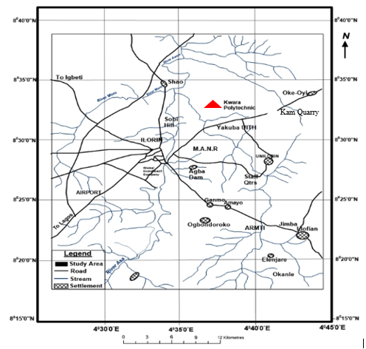
Figure 3.2: Location Map of the Study Area (modified after Olasehinde et al., 1998)

3.3 Sample Collection
Fresh representative samples of Migmatite Gneiss tagged Sample A, Porphyritic Granite tagged Sample B and Biotite Granite (Sample C) were collected on the open-cast mine site on outcrops. Structural features were observed based on tectonic activities and visual studies were also carried out to identify the different types of rocks. The Global Positioning System was used to take the coordinate of the different locations where the samples are taken. Other equipment used includes hammer, chisel, sampling bags, paper tape and marker. The three sample were separated in different sample bags and transported to University of Ilorin, Geology and Mineral Sciences Laboratory for detailed analysis.
3.4 Sample Preparation
The laboratory analysis was carried out on three different types of rocks labeled Sample A (Migmatite Gneiss), Sample B (Porphyritic Granite) and Sample C (Biotite Granite). The petrographical analysis carried out include thin section analysis and optical observations. During the preparation of thin sections analysis for all the samples, a thickness of 1.0 cm of a square shape of each of the rock sample was cut with the cutting machine. Applying emery cloth and caborundum powder, the specimen is further flattening to a thickness of about 0.04 mm. This flattened specimen is overlaid by the boiled Canada basalm and it is covered with a cover slip and left for about a day, then it is washed, rinsed with spirit and later with water. A total of six (6) thin sections (2 slides from each rock sample) were prepared from the samples for effective analysis and control. The analyses were subjected to microscopic examinations. Petrographic studies of the selected samples were made with the aid of a polarizing microscope. Some of the major minerals were observed under the microscopic examinations.

CHAPTER FOUR
RESULTS AND DISCUSSION
4.1 Results of Petrographic studies of the Thin Sections
The results based on petrographic studies of the thin sections revealed the various mineral distributions such as quartz, biotite, hornblende and feldspar (orthoclase, plagioclase and microcline). The quartz and feldspar constitute almost 88% of the thin section with other accessory minerals in both plane polarized and cross polarized light.
4.2 Discussion on Petrographic Studies of Migmatite Gneiss
The migmatite gneiss is the oldest type of rock in the study area. According to Abba (1983) gneiss occurs as the most widespread lithological unit in basement terrains and the imprints of the Pan – African deformation were evident by regional metamorphism, migmatization, extensive granitization and gneissification which produce syntectonic granites and homogeneous gneisses. It is common and appears to demonstrate undifferientiated pattern within the area. They are depicted generally by alternating light and dark coloured bands. The felsic bands of the rock consist of quartz, plagioclase and orthoclase feldspar with large percentage composition while the hornblende, muscovite or biotite constitutes smaller percentage of minerals in mafic bands. Based on mineral assemblages, quartz is however a dominant mineral while others such as feldspar and biotite are also making up a vital part. It has textural classification of fine to medium grained. In addition, the rock has undergone numerous orogenic cycles which has essentially lead to large scale deformation (Obaje, 2009). The imprints have been widely reported in the Precambrian rocks of Nigeria (Rahaman, 1989). The macro and micro structures is as a result of fracturing (Olayinka, 1992) such as folding, jointing, veins, intrusions, foliations and mineral lineations which were found in the study area.
4.3 Petrographic Description of some of the Prominent Minerals in the Migmatite Gneiss
The studied thin section with the aid of petrological microscope and slides were analyzed under plane polarized light and crossed nicol. The studied minerals include quartz, feldspar, biotite and hornblende.
4.3.1 Quartz (SiO₂)
The quartz is colourless in plane polarized light and shaped in euhedal. In coss polarized light, the quartz is colourless, reddish and conchoidal fracture with anhedral shape (Plate 4.1 and 4.2). It also display pleinchoism crystal of quartz that exhibit low relief and sometimes exhibit undulose extinction indicative of deformation or straining (Obini and Omietimi, 2020).
4.3.2 Plagioclase Feldspar (Na₂AlSi₃O₈.Ca₂Al₂Si₂O₈)
The feldspar mineral observed are plagioclase feldspar which is clearly from Albite twining characteristics (Ojelokun and Fawole, 2019) which is as a result of angle parallel to the large crystals in plane polarized light is colourless (Plate 4.1) but it demonstrate first order grey colour when the polar is crossed. It can be characterized from other types of feldspar because of its polysynthetic twining visible in the crystal. Some of the plagioclase in the slides occur as phenocryst (Plate 4.2).
4.3.3 Orthoclase Feldspar
The orthoclase feldspar under plane polarized light and crossed polarized light (XPL) appears cloudy and colourless (Plate 4.1 and 4.2). The crystals have low relief and are anhedral in shape. It is often colourless crystals with grey and reddish. The darker portion in the thin section suggest weathered feldspar with no definite cleavage.

4.3.4 Microcline Feldspar
The microcline feldspar exhibit a cystal system known as triclinic. This mineral is colourless under plane polarized light (PPL) and appears milky white under cross polarized light (XPL) with higher relief to quartz and orthoclase plate (Plate 4.1 and 4.2). The physical and chemical composition of microcline feldspar can be compare with the orthoclase feldspar. A thin section study implies large anhedral to subhedral microperthitic microcline with good polysynthetic crosshatched crystals with elongated crystals that exhibit subhedral habit.
4.3.5 Muscovite (KF)₂(Al₂O₃)₃(SiO₂)₆
The muscovite appears colourless under plane polarized light (PPL) (Plate 4.1) and has a pale green appearance under cross polarized light (XPL) (Plate 4.2) which makes it pleochroic. It exhibit parallel extinction with high relief and perfect cleavage in all direction. However, many of the crystals has twining and those near to the extinction shows position display appearance which is characteristics of mica family.
4.3.6 Biotite (Mg,Fe)₃ AlSi₃O₁₀(OH,F)₂
The colour of the biotite is between grey to brown colouration with subhedral to anhedral shape and has no twining. It has a directional cleavage. The mineral plate does not have extinction angles but form interstitial lamellae which may occur as linear aggregates with alteration to chlorite. It exhibits different pleonchoic orientation. The biotite has some inclusion of accessory minerals like zicon, rutile and apatite (Plate 4.1 and 4.2). It has strong birefringence under crossed polarised light, interference colour of dark green with symmetrical extinction and polysynthetic twinning.

4.3.7 Hornblende (Ca₂(Mg,Fe)₅(AI,Si)₈O₂₂(OH)₂
The colour of hornblende under plane polarized light is greenish black and it also displays pleochroism from green to brown. Under plane polarized light, a few of the hornblende crystals showed the characteristics shape and two cleavages. Under crossed nicol, twinning was seen in a few hornblende crystals and the highest interference colour seen is a second-order blue.

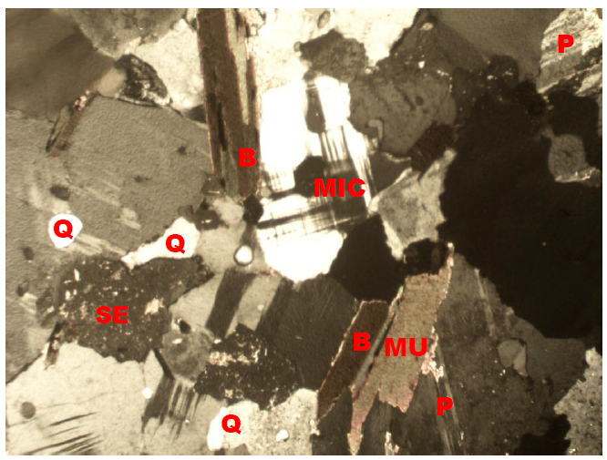
Plate 4.1: Photomicrograph of migmatite gneiss under Crossed Polarized Light (XPL), showing quartz (Q), biotite (B), plagioclase feldspar (P).
Plate 4.2: Photomicrograph of migmatite gneiss under Plane Polarized Light (PPL) showing the various shades of colours of mineral grains, Quartz (Q), Biotite (B), Plagioclase feldspar.

4.4 Discussion on Petrographic Studies of Porphyritic Granite (Sample B)
Porphyritic granite is the second most abundant rock type in the study area and it exhibits the characteristics of both slow and rapid rates of cooling magma. This has resulted to large or giant crystals of minerals (Phenocrysts) due to slow cooling, nevertheless, it has been subjected to further rapid cooling as the magma eventually move to the surface to form finer groundmass in which the phenocryst are embedded to form porphyritic texture (Saad and Baba, 2017). The major mineral constituents that occur include quartz, biotite, hornblende and plagioclase feldspar. The quartz in the porphyritic granite is euhedral in shape and it displays undulose extinction. The biotite exhibits different pleonchoic orientation. The biotite has some inclusion of accessory minerals like zircon, rutile and apatite. The plagioclase feldspar occurs as phenocrysts with lamellar twinning within the groundmass. Accessory minerals in the rock include zircon, apathite, magnetite and titanite (Plate 4.3 and 4.4)

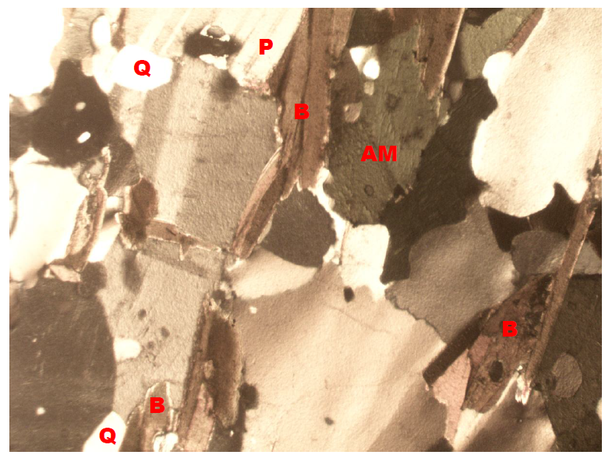
Plate 4.3: Photomicrograph of porphyritic granite under Crossed Polarized Light (XPL), showing quartz (Q), biotite (B), plagioclase feldspar (P).

Plate 4.4: Photomicrograph of porphyritic granite under Plane Polarized Light (PPL) showing the various shades of colours of mineral grains, Quartz (Q), Biotite (B), Plagioclase feldspar.
4.5 Discussion on Petrographic Studies of Biotite Granite (Sample C)
The biotite granite is a medium to coarse grained rock. The colour has resulted from the disintegration of biotite to fom chlorite (Aga and Haruna, 2019). Biotite is pleochroic form green to brown and are subhedral in shape (Plate 4.5 and Plate 4.6). The chlorite that occurs within the fractures has light green colouration and occurs mainly in cracks present within mineral matrixes. The crystal form of the chlorite is anhedral and occurs as a different product. However, the quartz in the biotite granite is euhedral to crystal in shape with crypto crystalline inclusions. It displays undulose extinction. This essentially proves that the rocks were highly deformed. The huge tectonic activities that took place or occur might have led to the exposure of the rocks to the surface of the study area. The occurrence of feldspar in the biotite granite is known as plagioclase feldspar and it is an irregular formed perthite with patches of it formed at the surface. The iron oxide occurs as tiny black patches in some biotite crystals and it is less abundant in the sample.

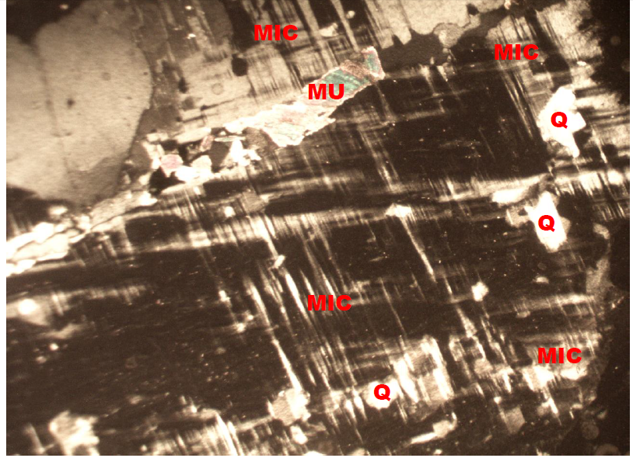
Plate 4.5: Photomicrograph of Biotite granite under Crossed Polarized Light (XPL), showing quartz (Q), biotite (B), plagioclase feldspar (P).
Plate 4.6: Photomicrograph of porphyritic granite under Plane Polarized Light (PPL) showing the various shades of colours of mineral grains, Quartz (Q), Biotite (B), Plagioclase feldspar.
4.6 Economic Potential of the Rocks
Economically, the sampled rocks (Migmatite Gneiss, Porphyritic Granite and Biotite Granite) in the studied area have good potentials for engineering purposes. Industrially, the quartzite can be used as industrial silica sand, silicon and silicon carbide. It can also be used as decorative stone used to cover walls. It is also useful in flooring, star steps and as roofing tiles. It is sometimes used as railway ballast and also in road construction purposes such as bridges, building houses, road pavement etc. The petrographic analysis examined indicate that mineral distribution quality is essentially made up economic minerals quartz, feldspar, biotite, muscovite and other accessory minerals. It is important to reiterates that these minerals are conspicuously present in both rocks and it is evidenced that the minerals presents are randomly distributed in accordance to their lithological variations (Ajali, 1997). Feldspar can be mined as profit by ceramics and glass industries for making product. The feldspar (plagioclase and orthoclase) can also be mined for fertilizers and cements.

CHAPTER FIVE
Conclusion and Recommendation
5.1 Conclusion
Petrographic studies and geochemical analysis of two different rock samples were carried out in the study area. Petrographically, the granitic rocks in the study area are composed of major rock forming silicate minerals such as quartz, biotite mica, and feldspars. The geochemical analysis on the rocks in the study area shows that the rocks are mineralogically composed of quartz, orthoclase and plagioclase feldspar, albite, microcline and other minor constituents such as hornblende and biotite. The rocks in the study area are chemically characterized by high percentage of silica (SiO₂), alumino-silicate minerals and the ferromagnesian compounds (Fe₂O₃ and MgO) which have varying low amount in both rock samples with calcium oxide which could be attributed to the calc-alkaline nature of the magma which serves as the precursor of the rocks. The chromium oxide (Cr₂O₃), phosphorus oxide (P₂O₅), sulphide (SO₃), manganese oxide (MnO), titanium oxide (TiO₂), zinc oxide (ZnO) and copper oxide (CuO) are the least abundant mineral with very low percentage weight composition of less than 1% in both samples. Economically, the various rocks in the area have good potentials for engineering purposes. The petrographic analysis examined indicate that mineral distribution quality are essentially made up economic minerals quartz, feldspar, biotite, muscovite and other accessory minerals.

5.2 Recommendation
The federal government should establish and equip the existing laboratories to carry out detailed analysis particularly on petrographic analysis of rocks for engineering construction purposes.
Measures should also be put in place to exploit and explore solid mineral resources in order to enhance industrialization and boost the economy of the country.

REFERENCES
Adeagbo, A. A., Adekoya, J. A., & Olorunfemi, M. O. (2017). Structural and mineralogical analysis of rocks in parts of Oke Ogun, Southwestern Nigeria. Journal of African Earth Sciences, 128, 160–173.
Adekeye, T. O. (2024). Petrographic and Structural Analysis of Exposed Rocks of Bishini Sheet Block 2, North Central Nigeria. Unpublished B.Sc. Thesis, Department of Geology, Federal University Minna.
Adewopo, R. A. (2023). Field and Petrographic Studies of Basement Complex Rocks in Saigbe Environs, Minna Area, Nigeria. Unpublished B.Sc. Thesis, Department of Geology, Federal University, Minna.
Akinwumi, F. B. (2022). Geology and Petrographic Studies of Rocks around Ogale, Ijumu Local Government Area, Southwestern Nigeria. Journal of Geoscience and Environmental Protection, 10(3), 112–123.
Alhassan, I. U. (2024). Geology and Petrography of the Rocks around Gulani Area, Northeastern Nigeria. Nigerian Journal of Geology and Mining Research, 7(1), 25–38.
Anyiam, A. O., Obaje, N. G., & Lar, U. A. (2017). Petrography and depositional environments of sandstones around Abuul, Ushongo area, Southern Benue Trough. Earth Science Research Journal, 21(3), 131–145.
Bodunwa, O. (2016). Petrographic analyses of basement rocks around Ogale, Kogi State. Nigerian Journal of Earth Sciences, 5(2), 77–88.
Chukwu, I. A., & Obiora, D. N. (2012). Whole-rock geochemistry of intrusive rocks in the Ishiagu area, Southeastern Nigeria: Implications for petrogenesis. Ife Journal of Science, 14(2), 193–202.
Christopher, A. A., Musa, B. O., & Sulaiman, O. A. (2022). Geological framework and petrography of Nigerian lithologies. Nigerian Journal of Geoscience, 18(4), 55–72.
Iliya, A. A., & Ma’aji, H. M. (2021). Petrographic study of rocks around Arum and its environs, North Central Nigeria. Nigerian Journal of Basic and Applied Science, 29(2), 201–210.
Isah, U. (2021). Petrographic Studies of Rocks around Arum and Its Environs, North Central Nigeria. Unpublished Undergraduate Thesis, Department of Geology, Federal University, Minna
Jimoh, M. A., Ibrahim, H., & Sani, M. (2020). Petrographic and geochemical evaluation of the Maastrichtian Gombe Formation, Gongola Basin, Northeastern Nigeria. Journal of Mining and Geology, 56(1), 45–58.
Mohammed, B. A. (2024). Geologic and Petrographic Studies of the Rocks in Dumne Area, Northeastern Nigeria. Journal of Geological Research and Exploration, 9(1), 14–29.
Nule, D. T., Ekwere, S. J., & Edet, J. J. (2024). Mineralogical and petrographic characteristics of basement rocks in parts of Ikom and Iso–Bendeghia, Southeastern Nigeria. Nigerian Journal of Earth Materials, 6(2), 80–92.
Oladipo, A. A. (2023). Geology and Petrography of the Basement Complex Rocks at Pagadna Area, North Central Nigeria. Earth and Environmental Sciences Review, 4(3), 101–115.
Oyawoye, M. O. (2018). The Basement Complex of Nigeria. In Kogbe, C. A. (Ed.), Geology of Nigeria (pp. 39–56). Rock View Publishers.
Oyediran, I. A., & Fohgi, R. B. (2019). A review of petrographic and geotechnical properties of Nigerian rocks. Nigerian Journal of Engineering Geology, 4(2), 34–47.
Rahaman, M. A. (2019). Review of the Basement Geology of Southwestern Nigeria. In A. A. Elueze (Ed.), Precambrian Geology of Nigeria. Geological Survey of Nigeria.
Suleiman, A. A., Yusuf, S. Y., & Ahmed, T. I. (2020). Integration of petrographic and geochemical data for environmental implications of rock weathering in North Central Nigeria. Environmental Earth Sciences, 79(6), 211.
Usman, M. A., & Ibrahim, A. (2017). Petrographic and geochemical study of rocks in the northern Wonaka Schist Belt, Northwestern Nigeria. Journal of African Earth Sciences, 137, 123–134.

