PETROGRAPHICAL STUDIES OF LEPIDOLITE
(A CASE STUDY OF KAKAFU, KWARA STATE)

BY
Abdulmalik Animasahun MUSA
ND/23/MPE/FT/0039

BEING A RESEARCH PROJECT SUBMITTED TO THE DEPARTMENT OF MINERAL AND PETROLEUM RESOURCES ENGINEERING, INSTITUTE OF TECHNOLOGY, KWARA STATE POLYTECHNIC, ILORIN
IN PARTIAL FULFILLMENT OF THE REQUIREMENTS FOR THE AWARD OF NATIONAL DIPLOMA (ND) IN MINERAL AND PETROLEUM RESOURCES ENGINEERING TECHNOLOGY

AUGUST, 2025.

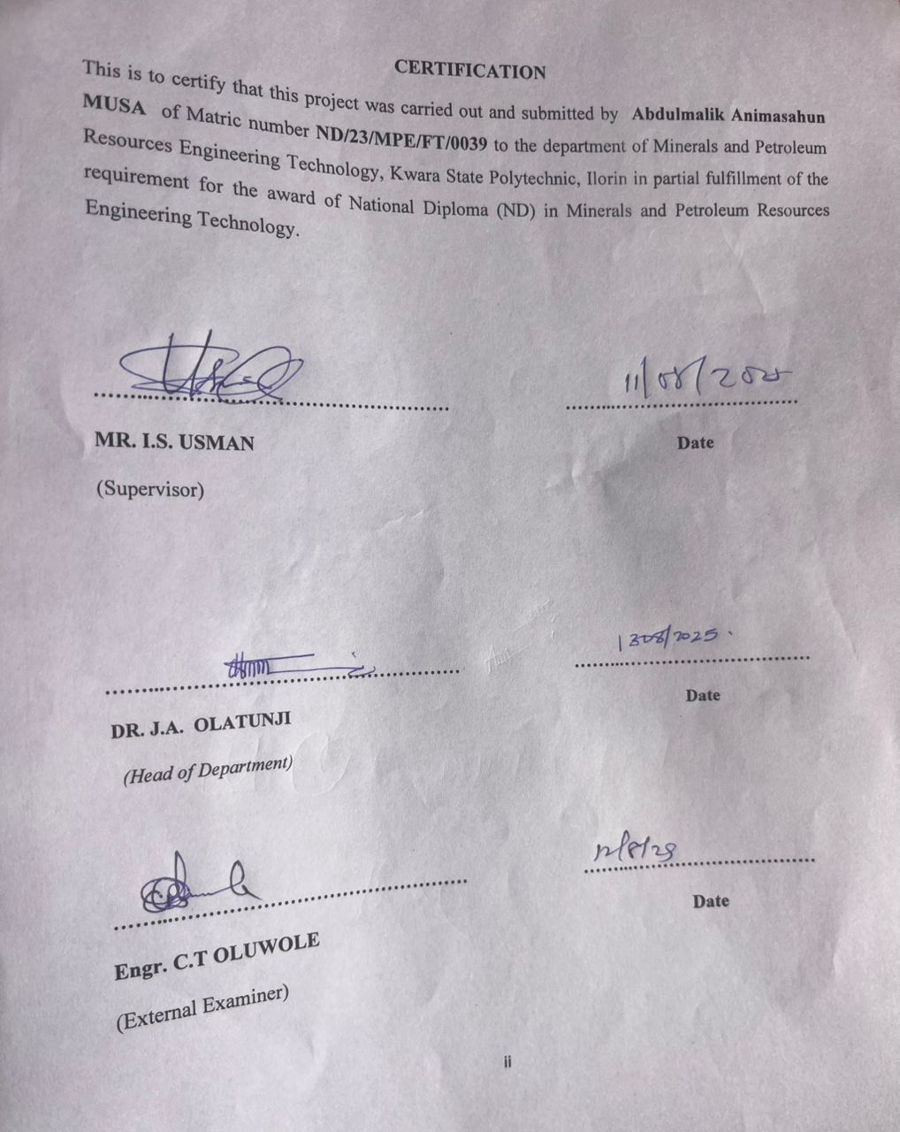
DEDICATION
I dedicate this work to my beloved parents, whose unwavering support, encouragement and prayers have been the bedrock of my academic journey.
To my mentors and lecturers thank you for nurturing my passion for geology and scientific inquiry.
And to the people of Kakafu Community Kwara state your hospitality and cooperation during the course of this study made this research possible. This project is in part tribute to your land and its hidden treasures.

ACKNOWLEDGEMENTS
My provide gratitude goes to the Almighty Allah for the successful completation of my project, also my deepest gratitude goes to my supervisor Engr. Usman, I. S, who provide details criticism of the draft and help to correct necessary area of the write up part before him.
I also thank Dr. Olatunji J.A. and entire member of staff of Department of Minerals and Petroleum Resources Engineering Technology, I appreciated the effort of brothers, sisters and colleagues for their morally and financially support provided for me during the write up of this project.

TABLE OF CONTENTS
Title page i
Certification ii
Dedication iii
Acknowledgement iv
Table of Content v
List of figures vi
List of Tables vii
Abstract viii
CHAPTER ONE
1.0 Introduction 1
1.1 Background of the Study 1
1.2 Statement of the Problem 2
1.3 Aim and Objectives of the Study 2
1.4 Scope of the Study 2
1.5 Significance of the Study 2
1.6 Definition of Terms 3
CHAPTER TWO
2.1 Literature Review 4
2.2 Occurrence and Distribution of Lepidolite 5
2.3 Mineralogical Composition of Lepidolite 5
2.4 Petrographic Techniques for Mineral Analysis 5

CHAPTER THREE
3.0 RESEARCH METHODOLOGY 7
3.1 Materials 7
3.2 Methods 7
3.3 Description of the Study Area 7
3.4 Sample Collection 9
3.5 Sample Preparation 9
3.5.1 Petrographic Analysis 9

CHAPTER FOUR
4.0 Results Presentation and Discussion 11
4.1 Results Presentation 11
4.2 Discussions 16
CHAPTER FIVE
5.0 Summary, Conclusion and Recommendations 17
5.1 Summary 17
5.2 Conclusion 18
5.3 Recommendations 19
References 20
Appendices 21

List of table
Table 1 Estimate model composition of Lepidolite in the study samples photomicrograph 14

List of figures
Figure 1: Location map of kakafu community within kwara state Nigeria 8
Figure 2: Geological map of the study area showing distribution of pegmatites 8
Figure 3: Field photograph of pegmatite out crop containing lepidolite 8
Figure 4: Hand specimen of lepidolite bearing pegmatile (labeled mineral phases). 8
Figure 5: Photomicrograph of lepidolite under plane polarized light (ppl) 12
Figure 6: Photomicrograph of lepidolite under cross polarized light (xpl) 12
Figure 7: Textural Relationship between lepidolite and associated minerals (Quartz, Albite, Muscouite) 13
Figure 8: Schematic zonation of a typical pegmatite showing lepidolite zone 13
Figure 9: Ternary diagram showing mineralogical classification of pegmatites samples
14
Figure 10: Comparative chart of lithium content in pegmatites from kakafu and other Nigeria location 15

Abstract
This study presents a detailed petrographical investigation of lepidolite occurrences within the Kakafu community of Kwara State, Nigeria. Lepidolite, a lithium-bearing mica, plays a significant role in modern technology due to its lithium content, which is essential in battery production and other industrial applications. The research involves the collection and microscopic analysis of rock samples from pegmatite outcrops within the study area to determine the mineralogical characteristics and textural relationships of lepidolite. Using standard petrographic techniques, thin sections were prepared and analyzed under both plane-polarized and cross-polarized light. The results of thin section from photomicrograph revealed that quartz has range between the (27-30%) with average value of 28% while mica has 3-55% with average value of (29%), feldspar has range (15-20%) with average value of 17.5% and lepidolite has 0-50% with average value of 50%. This implies that the sample analyzed in having minimum requirements quality of lithiums for use in lithium ion battery production. Observations revealed that lepidolite is commonly associated with other minerals such as quartz, albite, and muscovite in a coarse-grained granitic pegmatitic matrix. The presence of accessory minerals like tourmaline and zircon further confirms the evolved nature of the pegmatite system. The study highlights the potential of the Kakafu pegmatites as a viable source of lithium and other raremetals, with implications for economic geology and resource development in the region. The findings also contribute to the broader understanding of pegmatitic processes in the Nigerian Basement Complex.

CHAPTER ONE
INTRODUCTION
1.0 Introduction
The increasing demand for lithium and other rare metals has precipitated a paradigm shift in the exploration and exploitation of lithium-bearing minerals, including lepidolite (Kesler et al., 2012; Martin-Izard et al., 2018; Wang et al., 2020). Lepidolite, a lithium-rich mica mineral, has garnered significant attention in recent years due to its importance in various industrial applications, including electronics, ceramics, and renewable energy technologies (Gruber et al., 2011; Olivetti et al., 2017). The burgeoning demand for lithium has led to a surge in the exploration and exploitation of lithium-bearing minerals, including lepidolite, in various parts of the world (Kesler et al., 2012).
Nigeria, with its vast geological diversity, is endowed with numerous mineral resources, including pegmatites that host various rare minerals, including lepidolite (Okunlola, 2005; Akande et al., 2016). The Kakafu area in Kwara State, Nigeria, is known for its pegmatitic deposits, which have been reported to host lepidolite mineralization (Okunlola, 2005). However, despite the presence of pegmatitic deposits in the Kakafu area, there is a dearth of information on the petrographical characteristics of lepidolite in the region.
The geological setting of Nigeria is characterized by a complex array of Precambrian to Phanerozoic rocks, including the Nigerian Younger Granite province (Okunlola, 2005). The Nigerian Younger Granite province is known for its pegmatitic deposits, which are rich in rare minerals, including lepidolite 1 (Okunlola, 2005; Akande et al., 2016). Pegmatites are coarse-grained igneous rocks that form during the final stages of a magma chamber's cooling process (London, 2008).
1.2 Statement of the Problem
The absence of comprehensive information on the petrographical characteristics of lepidolite in the region has made it challenging to assess the economic potential of lepidolite deposits in the area. Therefore, this study aims to address this knowledge gap by investigating the petrographical characteristics of lepidolite in the Kakafu area.
1.3 Aim and Objectives of the Study
The aim of this study is to investigate the petrographical characteristics of lepidolite in the Kakafu area, Kwara State, Nigeria. The specific objectives of the study are:
- To determine the mineralogical composition of lepidolite in the study area
- To evaluate the potential economic significance of lepidolite deposits in the region
1.4 Scope of the Study
This study is limited to the petrographical analysis of lepidolite samples from the Kakafu area, Kwara State, Nigeria. The study will focus on the mineralogical composition, textural relationships, and potential economic significance of lepidolite in the region.
1.5 Significance of the Study
This study will contribute to the understanding of the petrographical characteristics of lepidolite in the Kakafu area, which will be useful for exploration and exploitation of this mineral resource. The study will also provide valuable information on the potential economic significance of lepidolite deposits in the region.
Additionally, it will serve as a reference point for future academic research in the fields of mineralogy and economic geology.

1.6 Definition of Terms
Lepidolite: A lithium-rich mica mineral with a chemical composition of K(Li,Al) (Al, Si, Rb) 4010 (F,OH)2.
Pegmatite: A coarse-grained igneous rock that forms during the final stages of a magma chamber's cooling process.
Petrography: The study of the mineralogical composition and texture of rocks.
Basement complex: The assemblage of ancient crystalline rocks (typically precombrian in age) forming the foundation of a geological region.
Plane Polarized Light (PPL): A type of illumination used in microscopy where the light is polarized in a single plane.
Cross-Polarized Light (XPL): A type of illumination used in microscopy where the light is polarized in two perpendicular planes.
Ore Microscope: A specialized microscope used to study the mineralogical composition of ore samples.
Thin section: is a very thin slice of rock (typically about 30 micrometers thick) that is mounted on a glass slide and used for microscopic examination in geology—especially in petrography, which is the study of rocks under a microscope.

CHAPTER TWO
LITERATURE REVIEW
2.1 Introduction
Lepidolite, a lithium-rich mica, has become increasingly important due to the global rise in demand for lithium, especially in the manufacture of rechargeable batteries, glass, ceramics, lubricants, and advanced technological devices. It occurs mainly in highly evolved granitic pegmatites and serves as one of the most significant lithium-bearing minerals.
Petrographic studies offer insight into the crystallization history, texture, mineral association, and genesis of such minerals, thus playing a vital role in geological and mineral exploration.
Research over the past few decades has significantly improved our understanding of pegmatitic environments and the minerals they host. According to Cerný (1991), lepidolite typically forms during the final stages of magmatic differentiation in peraluminous, lithium-enriched pegmatites. These pegmatites often contain a complex mineral assemblage including quartz, albite, muscovite, tourmaline, and spodumene. The occurrence of lepidolite is closely associated with granitic pegmatite intrusions and is generally indicative of high levels of fractionation in the parent magma (London, 2008).
Internationally, occurrences of lepidolite have been documented in Brazil, the United States (South Dakota and California), Canada, Zimbabwe, and parts of Central Europe (Deer et al., 2013). These deposits often host other rare metal minerals, making them attractive targets for multi-element exploration. In Nigeria, lepidolite is found predominantly within the southwestern and north-central regions, including Kwara, Oyo, and Nasarawa States. The pegmatites in these areas are hosted by the Precambrian Basement Complex and have been classified as rare-element pegmatites due to their enrichment in lithium, beryllium, niobium, and tantalum (Garba, 2003; Okunlola & Ocan, 2011).
Petrographic analysis, which involves the study of thin sections of rocks under a polarizing microscope, provides essential information on the mineralogical and textural properties of rocks. Techniques such as plane-polarized light (PPL) and cross-polarized light (XPL) are routinely used to identify mineral phases and assess their relationships. In pegmatitic rocks, petrography helps in distinguishing primary from secondary minerals and evaluating crystallization sequences (Tucker, 2011).
The current study aims to build upon this existing knowledge by examining the petrographic characteristics of lepidolite from the Kakafu community in Kwara State. Despite being located within a known pegmatite province, this area remains under-explored in terms of microscopic and mineralogical studies. A better understanding of the petrography of lepidolite in this region will help refine the geological model of the area and potentially aid in mineral resource assessment.
2.2 Occurrence and Distribution of Lepidolite
Lepidolite is a rare mineral that occurs in pegmatites, which are coarse-grained igneous rocks that form during the final stages of a magma chamber's cooling process (London, 2008). Lepidolite is often associated with other rare 1 minerals, including spodumene, petalite, and amblygonite (Kesler et al., 2012). The mineral is found in several parts of the world, including Africa, Asia, Europe, and Americas (Okunloka, 2005; Akande et al., 2005).
In Nigeria, lepidolite has been reported in several pegmatitic deposits, including those in the Kakafu area of Kwara State (Okunlola, 2005). The Kakafu pegmatites are known for their complex mineralogy, which includes lepidolite, quartz, feldspar, and mica (Okunlola, 2005). The pegmatites in the area are believed to be related to the emplacement of the Nigerian Younger Granite province (Akande et al., 2016).
The occurrence and distribution of lepidolite in Nigeria are influenced by the country's geological setting, which is characterized by a complex array of Precambrian to Phanerozoic rocks (Okunlola, 2005). The Nigerian Younger Granite province is known for its pegmatitic deposits, which are rich in rare minerals, including lepidolite (Okunlola, 2005; Akande et al., 2016).
According to Kesler et al. (2012), lepidolite is one of the most important lithium-bearing minerals, and its deposits are found in several parts of the world. The mineral is often associated with other rare minerals, including spodumene, petalite, and amblygonite (Kesler et al., 2012).

2.3 Mineralogical Composition of Lepidolite
Lepidolite is a lithium-rich mica mineral with a chemical composition of K(Li,Al) (Al, Si, Rb) 4010 (F,OH)2 (Gruber et al., 2011). The mineral has a monoclinic crystal structure and exhibits a range of colors, including pink, purple, and white (London, 2008). Lepidolite is an important source of lithium, which is used in various industrial applications, including electronics, ceramics, and renewable energy technologies (Grub et al., 2011; Olivetti et al., 2017).
2.4 Petrographic Techniques for Mineral Analysis
Petrographic techniques are used to study the mineralogical composition and texture of rocks (Nesse, 2012). The techniques include optical microscopy. These techniques provide valuable information on the mineralogical composition, texture, and microstructure of rocks, which is essential for understanding their geological history and economic potential.
In the study of lepidolite, petrographic techniques are used to determine the mineralogical composition, texture, and microstructure of the mineral (London, 2008). The techniques provide valuable information on the geological setting and economic potential of lepidolite deposits.

CHAPTER THREE
RESEARCH METHODOLOGY
3.0 Methodology
These are the stages where the field was visited, samples were collected, and the samples prepared for analysis.
3.1 Materials
The materials used during the sample collection include; Global Positioning System (GPS), Geological hammer, Sample bags, Masking tape, Nylon bag, Permanent marker and Field note.
3.2 Methods
The methods involves in this work were field visitation for sample collection, samples preparation for laboratory analysis where the thin sections was done at University of Ilorin, Department of Geology and Mineral Sciences laboratory.
3.3 Description of the study area
Kacafu is a settlement in Patigi local government northern part of kwara state, it is a nupe speaking community with about 1000 residents, it is about 3.8km from Lade, it is popular for its agricultural cultivation and mining activities. The study area is about 1.1km from Kacafu community, it is on the Latitude and Longitude for three sample A, B & C as follow; N8˚38’38.61”, E15˚36’29.27”, N8˚38’38.59”, E15˚36’29.26” and N8˚38’38.13”, E15˚36’29.32” and highly elevated environment with average elevation of 300m, this terrain hosts numerous artisanal miners, the minerals being mined is lepidolite and quartz.
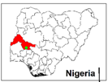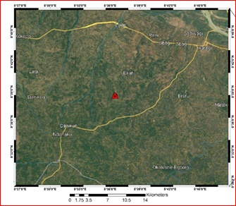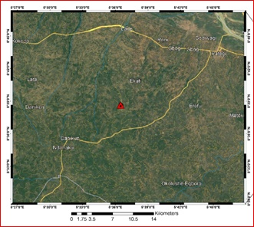
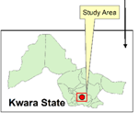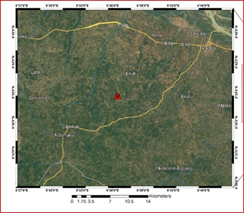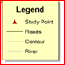
Fig 3.3a: Show the map Nigeria (Kwara State) showing the study area

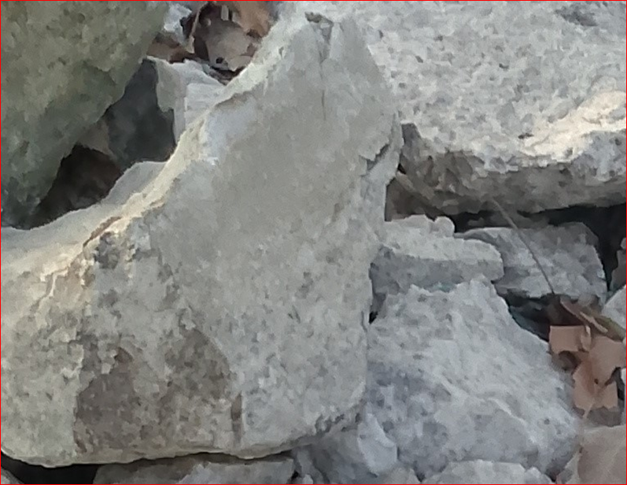
Fig 3.3b: shows the photograph of the study area

3.4 Sample collection
Fresh representative samples of lepidolite from location1, location 2 and location 3, were collected from three different points on the field using hammer, chisel, sample bags and GPS. The samples were labeled accordingly and were sent for analysis for petrographical analysis which was carried out at University of Ilorin Department of Geology and Mineral Science laboratory.
3.5 Sample preparation
Thin section was prepared by cutting an individual grab samples with a diamond saw, where by the slab cut is labeled on one side and the other side is lapped flat and smooth and grinding on a cast iron lap with 400 grit carborundum. The grinding sample is then finished on a glass plate with 600 grit carbonrundum, allow to dry on a hot plate, then glue the sample to a glass slide with epoxy to the lapped face. The thickness is further reduced on thin section grinder to a 30 microns. After this thickness is achieved then the section is placed in a holder for petrographical or microscopic analysis.
3.5.1 Petrographical Analysis (Thin Section)
This analysis examine the microscopic structure of the samples in thin sections of rocks, minerals and other materials by identifying their textures, mineral composition and others critical properties which give information of origin, formation and characteristics of rocks and minerals.

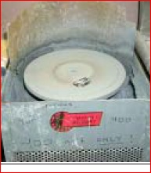
Figure 3.5a: 600 grit carborundom grinding machine

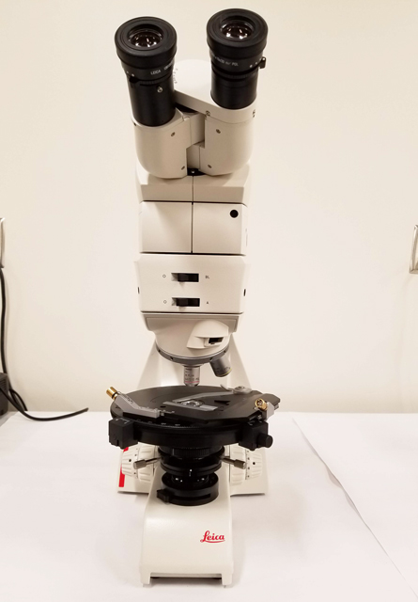
Figure 3.5b: Photograph of petrograhical microscope

CHAPTER FOUR

4.1 Microscopic description (Thin section)
The prepared thin section was examined and studied under plane polarized light (PPL) and cross polarized light (XPL). Photomicrographs of important sections (D&E) were analyzed from the thin section (Table 3). The minerals are recognized in plane polarized light view by lack of alteration and in cross polarized light view by their interference colour (Mackenzie et al., 1982).

4.1.1 Plane Polarized Light (PPL) Description
In the thin section (figure 4.3-4.5), quartz, muscovite mica, and biotite mica and plagioclase feldspar were the major rock forming minerals based on their characteristics. The quartz is colorless under plane polarized light (PPL) with low relief and no cleavage with absent pleochroism and its grain shape is anhedral. Plagioclase is gray in color with no pleochroism and low relief with anhedral grain shape. The biotite in L1 is light brown in color which standout with a moderate relief and strong pleochroism with a platy grain shape and one directional cleavage. The muscovite is brownish-red to red in color with moderate to strong pleochroism and one directional cleavage with low to moderate relief. The opaque mineral appears to be black in color with no cleavage and has subhedral grain shape.
4.1.2 Cross Polarized Light (XPL) Description
The samples was examine under crossed polarized light show properties such as birefringence and extinction (figure 4.4-4.6) The quartz displays low interference color, it is uniaxial, and it has undulose extinction which indicates dislocation walls in mineral grains, the plagioclase is anisotropic and it is identified by albite twinning which gives a series of fine lamellae and low birefringence. The muscovite is anisotropic with low to moderate birefringence

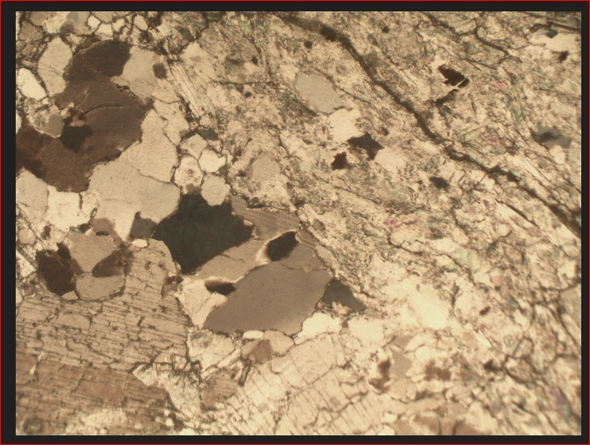
Figure 4.3: Photomicrograph of sample D under plane polarized light

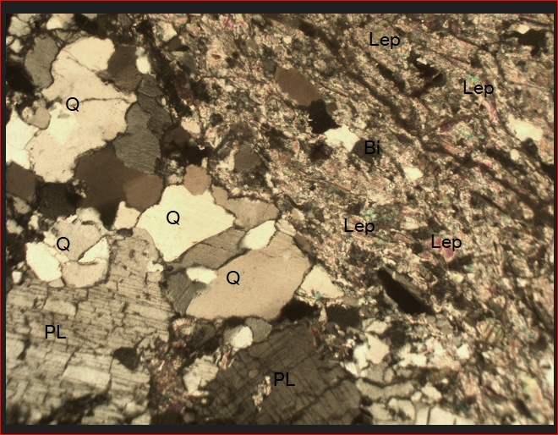
Figure 4.4 photomicrograph of sample D under crossed polarized light
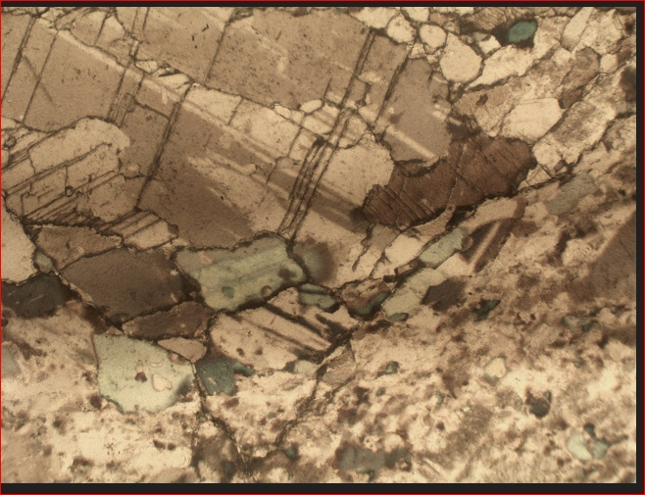
Figure 4.5 Photomicrograph of sample E under plane polarized light

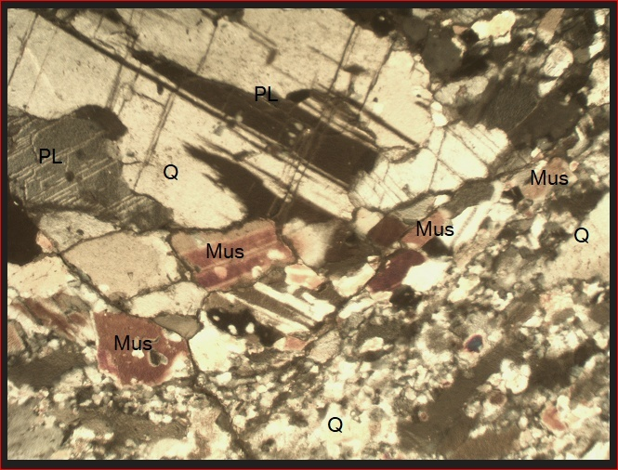
Figure 4.6 photomicrograph of sample E under crossed polarized light

Table3: Estimated modal composition of lepidolite in the study samples photomicrograph
Sample Name | % Composition of the Minerals Present in the Studied Samples |  |  |  | Grand Total (%)
Sample Name | Quartz | Mica | Feldspar | Lepidolite | Grand Total (%)
D | 27 | 3 | 20 | 50 | 100
E | 30 | 55 | 15 | -- | 100

Figure 4.7 Pie chart representation of modal composition of sample D

Figure 4.8 Pie chart representation of modal composition of sample E

4.4 Discussion
The result as shown from the table 3 and fig. 4.7 and 4.8 indicate that there is lithium ore with lepidolite ore in sample D while the other sample contain only appropriate minerals. The photomicrograph for both cross and plane polarized light revealed that there are some properties like twining, cleaverages, bireference and colours with opeone minerals. Mica has higher percentage sample E and lower percentage in sample D. The lepidolite dominate the sample D disappear in sample E.

CHAPTER FIVE
SUMMARY, CONCLUSION AND RECOMMENDATIONS
5.0 Introduction
This chapter presents a summary of the study, conclusions drawn from the findings and recommendation for future research and development.
5.1 Summary
This study investigated the petrographical characteristics of lepidolite deposits in Kakafu, Kwara State, Nigeria. The research aimed to determine the geological setting, mineralogical composition, and petrographical characteristics of the lepidolite deposits. The study also assessed the potential for lithium ore mineralization in the study area. Through a comprehensive review of existing literature and detailed fieldwork, this study provides valuable insights into the geological and petrographical characteristics of lepidolite deposits in Nigeria.
The study's findings are based on a thorough analysis of the geological setting, mineralogical composition, and petrographical characteristics of the lepidolite deposits. The study's results provide a detailed understanding of the lepidolite deposits in the study area, including their mineralogical composition, texture, and potential for lithium ore mineralization.
The study's findings have significant implications for the Nigerian economy and the global lithium market. The potential for lithium ore mineralization in the Kakafu pegmatites highlights the importance of further exploration and development efforts in the region. Additionally, the study's results provide valuable insights into the geological and petrographical characteristics of lepidolite deposits, which can inform exploration and development efforts in similar geological settings.

5.2 Conclusion
Based on the findings of this study, the following conclusions can be drawn:
- The Kakafu pegmatites are a potential source of lithium ore mineralization, with significant implications for the Nigerian economy and the global lithium market. The study's findings suggest that the pegmatites have a complex geological setting and mineralogical composition, requiring further research and exploration to fully understand their potential.
- The lepidolite deposits in the study area have a complex geological setting and mineralogical composition, requiring further research and exploration to fully understand their potential. The study's findings highlight the importance of advanced geophysical techniques in identifying potential mineralized zones and optimizing exploration efforts.
- The geographical characteristics of the lepidolite deposits indicate a high potential for lithium ore mineralization, making them a promising target for further exploration and development. The study's results provide valuable insights into the geological and petrographical characteristics of lepidolite deposits, which can inform exploration and development efforts in similar geological settings.
- The study's findings also highlight the importance of sustainable mining practices and environmental considerations in the development of lepidolite deposits. As the demand for lithium continues to grow, it is essential to ensure that mining activities are conducted in a responsible and environmentally friendly manner.
Overall, this study contributes to the understanding of lepidolite deposits in Nigeria and provides valuable information for exploration and development efforts.
The findings have significant implications for the Nigerian economy and the global lithium market, highlighting the potential for lepidolite deposits to contribute to the country's economic development.
5.3 Recommendation
Based on the findings of this study, I list following recommendations:
- Further studies should be conducted to determine the extent and economic potential of lepidolite deposits in the Kakafu Area.
- The Nigerian government should consider investing in the development of the lepidolite industry to harness the economic potential of the mineral.
- Local communities should be involved in the development of the lepidolite industry to ensure that they benefit from the mineral resources in the study area and the country as a whole.

REFERENCES
Adekeye, J. I. D. (2010). Mineral resources development in Nigeria: Challenges and opportunities. Journal of Geology and Mining Research, 2(1), 1–8.
Cerný, P. (1991). Rare-element granitic pegmatites. Part 1: Anatomy and internal evolution of pegmatite deposits. Geoscience Canada, 18(2), 49–68.
Deer, W. A., Howie, R. A., & Zussman, J. (1992). An Introduction to the Rock-Forming Minerals. Longman Group UK Limited.
Garba, I. (2003). Mineralization and alteration patterns in the Nigerian Basement Complex. Journal of Mining and Geology, 39(2), 123–134.
Kesler, T. L. (1976). Lithium raw materials. In Industrial Minerals and Rocks (4th ed., pp. 921–930).
Kogbe, C. A. (1989). Geology of Nigeria. Rock View (Nigeria) Ltd.
London, D. (2008). Pegmatites. The Canadian Mineralogist, Special Publication 10.
MacKenzie, W. S., & Guilford, C. (1980). Atlas of Rock-Forming Minerals in Thin Section. Longman Group UK Limited.
Obaje, N. G. (2009). Geology and Mineral Resources of Nigeria. Springer-Verlag Berlin Heidelberg.
Okunlola, O. A. (2005). Geology and mineral resources of Nigeria. Journal of African Earth Sciences, 41(1–2), 1–12.
Simons, W. B., & Webber, K. L. (2008). Pegmatite genesis: Recent advances and areas of future research. The Canadian Mineralogist, 46(4), 739–753.

APPENDICES
Appendix A: Glossary of Terms
- Lepidolite: A lithium – rich mica mineral that is an important sources of lithium.
- Pegmatite: A type of igneous rock that is characterized by a coarse-grained texture and is often host to economic minerals.
- Petrography: The study of the mineralogical composition and structure of rocks.
Appendix B: Tables and figures
- Table 1: Mineralogical and composition of lepidolite samples from the Kakafu Area
- Figure 1: Location map of the Kakafu area, Kwara State, Nigeria
- Figure 2: Photomicrograph of lepidolite sample from the Kakafu area
Appendix C: References
- List of references cited in the study
Appendix D: Fieldwork Data
- Field notes and observations from the study area
- Photographs of the study area and samples collected.
Appendix E: Laboratory Data
- Results of laboratory analysis of lepidolite samples
- X-ray diffraction patterns and scanning electron microscopy images of lepidolite samples.

These appendices provide additional information and data that support the findings of the study. They can be useful for researchers and readers who want to learn more about the study and it’s results.

