INFLUENCE OF MINING ACTIVITIES ON PHYSICOCHEMICAL PROPERTIES OF SOIL AT IFEWARA GOLD MINE SITE DURING DRY SEASON, OSUN STATE, NIGERIA

BUSARI IDERU DAMILARE
ND/23/MPE/FT/071

SUBMITTED TO
THE DEPARTMENT OF MINERAL AND PETROLEUM RESOURCES ENGINEERING TECHNOLOGY,
INSTITUTE OF TECHNOLOGY,
KWARA STATE POLYTECHNIC, ILORIN.

IN PARTIAL FULFILLMENTS FOR THE REQUIREMENTS OF THE AWARD OF NATIONAL DIPLOMA (ND) IN MINERAL AND PETROLEUM RESOURCES ENGINEERING TECHNOLOGY,
KWARA STATE POLYTECHNIC, ILORIN

AUGUST, 2025
This is to certify that the Influence of Mining Activities on Physicochemical Properties of Soil at Ifewara Gold Mine Site During Dry Season, Osun State, Nigeria was carried out by BUSARI IDERU DAMILARE (ND/23/MPE/FT/0071) to the Department of Mineral and Petroleum Resources Engineering Technology, Institute of Technology, Ilorin in partial fulfillment of the requirements for the award of National Diploma (ND) in Mineral and Petroleum Resources Engineering Technology.

____________________________ ________________
Engr. S.A. Agbalajobi DATE
Project Supervisor

______________________________ ________________
Dr. J. A. Olatunji DATE
Head of Department

________________________ _________________
Engr. C.T. Oluwole DATE
External Examiner
(Industrial)

DEDICATION
This project work is dedicated to Almighty God and our beloved parents. Mr. and Mrs. Busari, L.

ACKNOWLEDGEMENT
Our sincere appreciation goes to Almighty God for a successful completion of this project and all those whose effort have contributed to my success up till day. My profound gratitude goes to my supervisor Engr. S.A. Agbalajobi for his support, guide and advice on the project. Also, I will like to acknowledge my lecturer from the beginning up till today, such as HOD of Mineral and Petroleum Resources Engineering Technology Department, Dr. Olatunji, J. A. (HOD), Engr. Dr. K.J. Olatunji, Mr. Kajogbola, Mr. Odediran, Dr. Obaro and others.

ABSTRACT
Mining has recently become a significant economic activity in southwestern Nigeria; however, existing studies have largely overlooked its potential impact on the soil quality of surrounding communities. This study focused on the effect of mining on the physicochemical properties of soil at the Ifewara Gold Mining site, Osun State, Nigeria. A total of ten soil samples were randomly collected from both within the mining site and the surrounding community areas outside the site. Soil samples collected were analyzed for both physical and chemical properties that influence soil productivity. This physicochemical study of soil is based on various parameters, including pH, electrical conductivity (EC), temperature, soil organic matter, total dissolved solids (TDS), sodium, potassium, magnesium, calcium, sulphate, chloride, and total organic carbon (TOC). Additionally, concentrations of heavy metals such as Fe, Co, Zn, Ni, Pb, Cr, and Cd were analyzed using standard analytical methods. The pH values ranged from 5.1 to 6.9, electrical conductivity (EC) ranged from 1131 to 1502 μS/cm, and total dissolved solids (TDS) ranged from 186 to 319 ppm. Concentrations of sodium (Na⁺) ranged from 10.56 to 43.83 mg/kg, potassium (K⁺) from 12.59 to 38.27 mg/kg, magnesium (Mg²⁺) from 13.64 to 32.41 mg/kg, calcium (Ca²⁺) from 21.48 to 52.36 mg/kg, sulphate (SO₄²⁻) from 18.26 to 57.36 mg/kg, chloride (Cl⁻) from 3.81 to 10.46 mg/kg, and total organic carbon (TOC) ranged from 1.57% to 2.28%. Heavy metal analysis (in mg/kg) showed the following concentration ranges: Fe (8.768 – 10.58 mg/kg), Co (0.005 – 0.515 mg/kg), Zn (3.411 – 3.679 mg/kg), Ni (0.054 – 1.407 mg/kg), Pb (0.001 – 0.001 mg/kg), and Cr (0.053 – 0.124 mg/kg), Cd (0.001 – 0.088 mg/kg). The results showed significant changes in soil physicochemical properties and elevated heavy metal concentrations in samples collected within the mine perimeter, which may be attributed to mining activities and waste generated from the mine. The contamination level indices for the heavy metals in the samples could not be accurately determined due to sampling during the dry season and the leaching of contaminants.

TABLE OF CONTENT
TITLE PAGE i
CERTIFICATION ii
DEDICATION iii
ACKNOWLEDGMENT iv
ABSTRACT v
TABLE OF CONTENTS vi
LIST OF TABLES ix
LIST OF FIGURES x
LIST OF PLATES xi
CHAPTER ONE: INTRODUCTION 1
1.0 IMPORTANCE OF SOIL 2
1.1 Role of Physico-Chemical Properties in Soil Quality 3
1.1.1 pH 3
1.1.2 Texture 3
1.1.3 Moisture 3
1.1.4 Soil Temperature 4
1.1.5 Electrical Conductivity 4
1.1.6 Nitrogen 4
1.1.7 Phosphorus 5
1.1.8 Soil Organic Matter 5
1.2 AIM AND OBJECTIVE OF THE RESEARCH WORK 5
1.2.1 Aim of the Research 5
1.2.2 Objectives of the Study 5
1.3 SCOPE OF THE RESEARCH WORK 6
1.4 STATEMENT OF PROBLEM 6
1.5 JUSTIFICATION 6
CHAPTER TWO: LITERATURE REVIEW 7
2.1 PREVIOUS WORKS 7
CHAPTER THREE: MATERIALS AND METHODS 10
3.1 SAMPLE DESCRIPTION 10
3.2 SAMPLE COLLECTION 15
3.3 SAMPLE PREPARATION 16
3.4 PHYSICOCHEMICAL ANALYSIS 17
3.4.1 Measurement of Physicochemical Parameter 17
3.4.2 Electrical Conductivity (EC) 18
3.4.3 pH Test 18
3.4.4 Temperature 19
3.4.5 Total Dissolved Solid (TDS) 19
3.4.6 Major Ions 19
3.4.7 Determination of Sodium and Potassium Using AAS 20
3.4.8 Determination of Calcium Ion Using Muroxide as Indicator 20
3.4.9 Determination of Magnesium Ion (Mg²⁺) Using Erichrome as Indicator 20
3.4.10 Determination of Sulphate (So4²⁻) Using Precipitation Method 21
3.4.11 Determination of Chloride Ion (Cl⁻) Using Mohr Method 21
3.5 DETERMINATION OF HEAVY METALS 21
CHAPTER FOUR: RESULTS AND DISCUSSIONS 22
4.1 RESULTS 22
4.1.1 Physicochemical Analysis of the Samples 22
4.1.2 Variation of pH and Electrical Conductivity 23
4.1.3 Variations of Potassium, Sodium, Calcium and Magnesium (mg/kg) 23
4.1.4 Variations of Total Organic Matter, Chlorine, and Sulphide (mg/kg) 24
4.1.5 Heavy Metal Concentration of Samples 25
4.2 IMPACT OF MINING ON METALLIC ELEMENTS IN THE SOIL 28
CHAPTER FIVE: CONCLUSIONS AND RECOMMENDATIONS 31
5.1 CONCLUSIONS 31
5.2 RECOMMENDATIONS 31
REFERENCES 31

LIST OF TABLES
Table 4.1 Results of physiochemical Analysis of the soil samples from the 22
study site during wet season
Table 4.2 Result of Heavy Metal Concentration in Samples (mg/kg) 25
Table 4.3 Results of the Average heavy metals concentration in the sample (mg/kg) 26
during the wet season
Table 4.4 Concentration levels of macronutrients in Soil 30
(adapted from Hazelton and Murphy, 2016)

LIST OF FIGURES
Figure 3.1 Map of the Study Area Location Ifewara, Atakumosa Local Government 11
Area, Osun State, Nigeria.
Figure 4.1 Concentrations of Metallic Elements in Soil Samples around the mine 24
Figure 4.2 Heavy Metals Concentration of the Sample (mg/kg) 27
Figure 4.3 Heavy Metals Concentration of the Sample (mg/kg) 27
Figure 4.4 Heavy Metals Concentration of the Sample (mg/kg) for all the 28
Soil Samples

LIST OF PLATES
Plate 3.1 Typical Artisanal Small-Scale Gold Mining Process in the Study 12
Area using a Sluice Box
Plate 3.2 The Artisanal Miners Haphazardly select Artisanal Gold Mine (AGM) 12
Pit sites, where Gold-bearing Saprolitic layers are panned
Plate 3.3 Site Location with group picture with the project students and miners 13
Plate 3.4 Site Location with group picture with the project students and miners 14
Plate 3.5 Sit Location with Group picture with the project students 15

CHAPTER ONE
INTRODUCTION
1.0 IMPORTANCE OF SOIL
Soil is one of the most important resources of the nature, all living thing depends on plants and plants grow in soil for day-to-day need. All agricultural production and development of forest depends upon physico-chemical parameters of the soil used for it, soils are medium in which crop grow to food and cloth. Soil is not only important for agriculture but also have more useful for living organisms. Soil as components of the terrestrial ecosystem fulfills many functions including those that are essential for sustaining plant growth (Nwachokor, et al., 2009). The importance of soil as a reservoir of nutrients and moisture for the production of forage and plant species, has been recognized since the beginning of the forest management as a management as a science (Schlesinger, et al., 1990).
Soil formation is a constructive as we as destructive process (Pujar, et al., 2012), soil is composed of particles of broken rock that have been altered by chemical and mechanical processes that weathering and erosion. Soil has a complex function which is beneficial to human and other living organism (Sumithra, et al., 2013). Soil is not merely a group of mineral particles; it has also a biological system of living organisms as well as some other components, the climate and other factor largely affect the soil formation.
All agricultural productions and development of forest depends upon physic-chemical parameters of the soil used for its straight off a day’s need at soil testing is increased due to interest of the public in the caliber of products obtained from it and different practices carried for their output. The soil quality analysis includes an analyst of parameters and process which effects on soil to operate efficiently as a component of a sound ecosystem (Ku Smita and Sangita, 2015).

1.1 ROLE OF PHYSICO-CHEMICAL PROPERTIES IN SOIL QUALITY
1.1.1 pH
pH is a most important physical properties of soil, it having great effects on solute concentration and absorption in soil (Akpoveta, et al., 2010), soil pH is an important consideration for farmers and gardeners for several reasons, including the fact that many plants and soil life forms prefer either alkaline or acidic condition (Pandeeswari and Kalararasu, 2012). The pH is considered while analyzing any kind of soil if the pH is less than 6 then it is said to be an acidic soil, the pH ranges from 6 – 8.5 it’s a normal soul and greater than 8.5 then it is said to be alkaline soil.
1.1.2 Texture
Soil texture is a qualitative classification tool used in both the field and laboratory to determine the classes for agricultural soils based on their physical texture, soil having different textural group on basis of the proportion of different sized particles, soil texture directly influences soil – water relation aeration and root penetration. It also effects on the nutritional status of soil. Soil texture can be expressed significantly by its electrical conductivity. Clay textured is highly conductive while sandy soil are poor conductors. Texture of most of the soil was loamy and clay of yellow soil.
1.1.3 Moisture
Water content or moisture content is the quality of water contained in a material, such as soil called soil moisture; moisture is a most important physical property of soil. The absorption of nutrients depends on the moisture of the soil. The water content of soil as also much related to its texture and structure. The soil moisture commonly depends on void ratio, particles size, clay mineral, organic matter and ground water condition.

1.1.4 Soil Temperature
Temperature of the soil is an important property because it influences the chemical, physical and biological processes associated with plant growth. Soil temperature fluctuates with season, time of the day and local climate condition. The major source of heat is sun and heat generated by the chemical and biological activity of the soil and soil has a temperature range between 20ºC and 60ºC.
1.1.5 Electrical Conductivity
Electrical conductivity is also a very important property of the soil, it is used to check the quality of the soil, it is a measure of ions present in solution (Ku Smita and Sangita, 2015). Electrical conductivity varies with depth and its range of variation was less in upland profile probably occurred due to slope of land surface, high permeability and high rainfall, responsible to leach out alkali and alkaline bases.
1.1.6 Nitrogen
Nitrogen is the most critical element obtained by plants from the soil and is a bottleneck in plant growth. Nitrogen is a most important fertilizer element; plants respond quickly to application of nitrogen salts. This element encourages above ground vegetation growth and gives a deep green colour to the leaves, plant root takes up nitrogen in the form of NO₃ and NH₄ (Sumithras, et al., 2013).
1.1.7 Phosphorus
Phosphorus is a most important element present in every living cell (Ku Smitha and Sangita, 2015), it is one of the most important micronutrients essential for plant growth phosphorus most often limits nutrients remains present in plant nuclei and act as energy storage.
1.1.8 Soil Organic Matter
It is also valuable property of soil, if the soil is poor in organic matter, then it enhances the process of soil erosion (Ku Smitha and Sangita, 2015). If the soil organic matter is present in soil, then this soil is useful for the agricultural practices, organic matter maybe added in the soil in the form of animal manures, compost etc.
1.2 AIM AND OBJECTIVE OF THE RESEARCH WORK
1.2.1 Aim of the Research
The aim of this project is to investigate on the Influence of Mining Activities on physicochemical properties of soil at Ifewara gold mine site during dry season, Osun State, Nigeria.
1.2.2 Objectives of the Study
The main objectives of the study are to:
i. determines the physical and chemical parameters such as, soil pH and temperature, Electric Conductivity (EC), Total Dissolved Salt (TDS), chlorine ion, sulphide ion and nitrite ion, Mg²⁺, Na²⁺, K⁺, Ca²⁺, Also, some heavy metals contaminants such as Cobalt (Co), Cadmium (Cd), Zinc (Zn), Cr (Chromium) and Lead (Pb).
ii. ascertain the effect of mining activities of Ifewara gold mine site, Osun State on the soil quality.
1.3 SCOPE OF THE RESEARCH WORK
The study of soil sample will be collected from the mining site and adjourning undisturbed area. They physicochemical properties of the sample collected will be analyzed using standard procedures and the results will be compared with World Health Organization (WHO) and understand threshold limit.
1.4 STATEMENT OF PROBLEM
The Influence of mining activities on soil properties can damage the soils on which crops are grown and also the environmental contamination of soil can pose a significant threat to human health and aquatic life.

1.5 JUSTIFICATION
The results of this study will be recommended to the Government’s Ministry of Environment at all levels to adopt a good management approach to the incessant and inadequate mining activities going on in the study location.

CHAPTER TWO
LITERATURE REVIEW
2.1 PREVIOUS WORKS
Exploitation of mineral resources has assumed prime importance in several developing countries including Nigeria. Mineral resources are an important source of wealth for a nation but before they are harnessed, they have to pass through the stages of exploration, exploitation and processing (Ajakaye, 1985). The exploitation of minerals influences different environmental domains of the exploited areas, thereby affecting the land, air, water, socioeconomic and cultural environment. Besides this, mining greatly influences the health and sanitation condition of the area creating occupational health hazards. Mining activities lead to the environmental pollution of soil by heavy metals which adversely affect soil quality and pose a threat to human health which require a rapid and comprehensive evaluation (Figueroa et al., 2010). Human activities are numerous and each contributes in one way or the other to the pollution of the environment. It has been observed that no single activity has caused more pollution to the environment than mineral exploitation (Muhammad et al., 2011). Mining and smelting activities, tailings (heavier and larger particles settled at the bottom of the flotation cell during mining) are directly discharged into natural depressions and consequently, many kinds of risk elements enter the environment, causing serious environmental problems resulting in elevated concentrations (Figueroa et al., 2010; Muhammad et al., 2011; Sharma et al., 2007).
Studies have also shown that mining at both small and large scale has great impact on vegetation and soil, land use, livelihood foundations and geomorphology of African countries. Monitoring vegetation from space can provide relevant information quickly, repeatedly and at regular intervals of time. Since 1970s, satellite remote sensing has been commonly used for understanding the cumulative influence of man on landscape and vegetation (Wickware and Howarth, 1981). Kushwaha et al., (2011) used remote sensing data in mapping the forests Kaziranga National Park for determining habitat changes that occurred after the flood event. Gautam and Chenniah (1985) analyzed Tripura vegetation using Landsat imagery data. In Nigeria, Mesubi et al. (1999) and Ako et al., (2014) studies on extraction of gold from Igun gold ore deposit in Atakumosa West Local Government Area, Osun state, and environmental impact of artisanal gold mining in Luku, Niger state respectively.
Traditionally, the effects of gold mining have long attracted the interest of geomorphologists both in terms of their landforms, vegetation alteration and biodiversity response to change. An important goal in mapping and assessment process is to extract hidden relationships and effects between some variables. In recent year, there has also been a wider growing recognition of human impacts on the earth’s global systems (Adediji and Oluwafemi, 2007). Surface mining, for example, removes vegetation and soils, interrupts ecosystem service flows, and results in inevitable and often permanent farmland loss. Gold mining activities also frequently result in toxic waste that causes water pollution and health problems.
Environmental pollution by heavy metals adversely affects soil quality and poses a threat to human health requires a prompt and comprehensive solution. Numerous anthropogenic sources of pollutants can contaminate the soil and water environment, including inputs from waste waters flowing from mines and waste storage (Song et al., 2010). Pollution is a worldwide problem that has adverse effects on human health, animals, plants as well as the environment (Khan and Ghouri, 2011). Pollution is the prime causes of many diseases that affect human beings, plants and animals (Kanmony, 2009). Heavy metals are the most prominent pollutants in our world (Papatilippaki et al., 2008). The knowledge of the origin of heavy metals, their accumulation in the soil as well as their interaction with the soil properties and qualities are essential in environmental monitoring (Qishlaqi and Moore, 2007). This work presents Influence of Mining Activities on Physicochemical Properties of Soil at Ifewara Gold Mine Site During Dry Season, Osun State, Nigeria. This will be achieved by conducting physicochemical analysis on the soil samples as well as the accumulation of trace metals in the soil samples. The samples will be analyzed to ascertain the effect of mining activities on the soil quality of the area through physical and chemical analysis such as particle size analysis, soil pH, organic matter, organic carbon, electric conductivity, chlorine ion, sulphide ion and nitrite ion. Also, some heavy metals contaminants such as Arsenic (As), Cadmium (Cd), Copper (Cu), Zinc (Zn) and Lead (Pb) were analyzed. This type of study is essential since the mine is situated close to farm land and residence.

CHAPTER THREE
MATERIALS AND METHODS
3.1 SAMPLE DESCRIPTION
The material that was mainly used for the research was soil which was collected at the subsurface of the earth crust. The samples were collected at the mine at Ifewara, Atakumosa Local Government Area, Osun State, Nigeria. It lies within latitude 07̊ 03’ 13” N to 07̊ 03’ 22” N and longitude 04̊ 11’ 09” E to 04̊ 12’ 22” E (Figure 3.1) lies about 35 km west of Ilesa town. The area is a developing resident’s layout towards the east side of the Ifewara Township. The residents of the area are of different tribes living in their own houses. The remaining parts of the open fields, apart from the gold mining pits, are used mainly by the residents for farming and cash crop (cocoa). The topography of the area in undulating, drained by river and its tributaries, it is underlain by the rocks typical of the Basement Complex of southwest Nigeria and characterized by the tropical rain forest climate. The artisanal miners haphazardly select Artisanal Gold Mine (AGM) pit sites, where gold-bearing saprolitic layers are panned (Figure 3.3) to extract gold and associated heavy minerals. Locally fabricated sluice boxes are also employed in the beneficiation of the saprolite slurries where carpets, which act as traps, are placed in these boxes while the slurries are run over them (Figure 3.2) and Figure 3.4 and Figure 3.5 Site Location with group picture with the project students and miners.
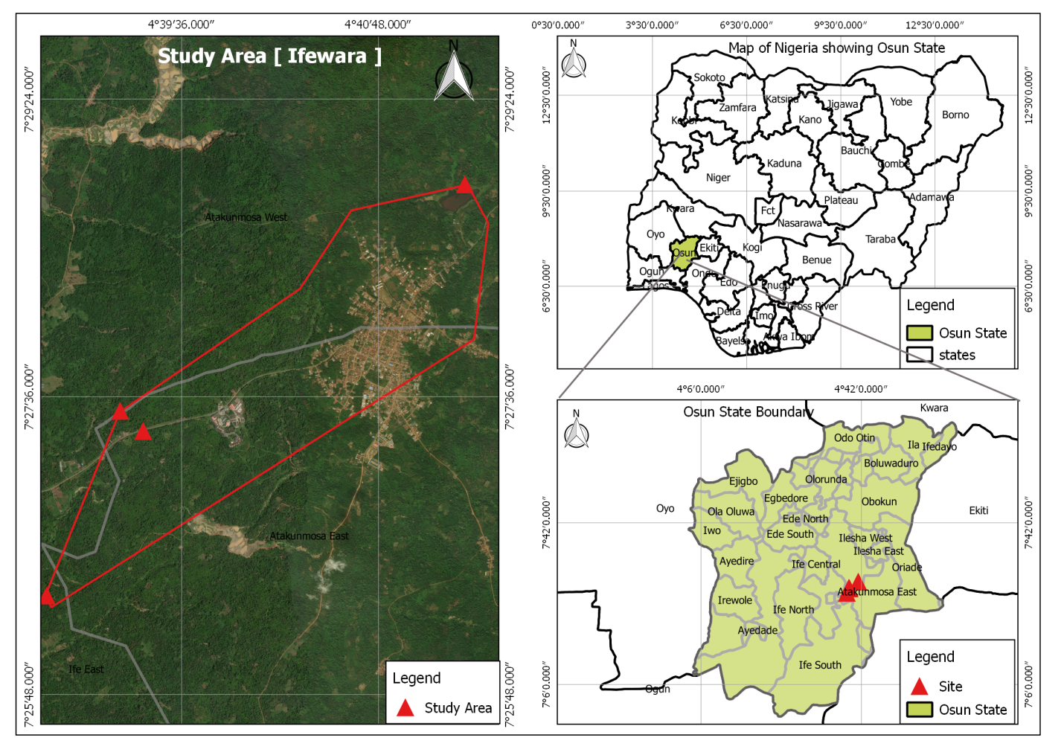
Figure 3.1: Map of the Study Area Location Ifewara, Atakumosa Local Government Area, Osun State, Nigeria.

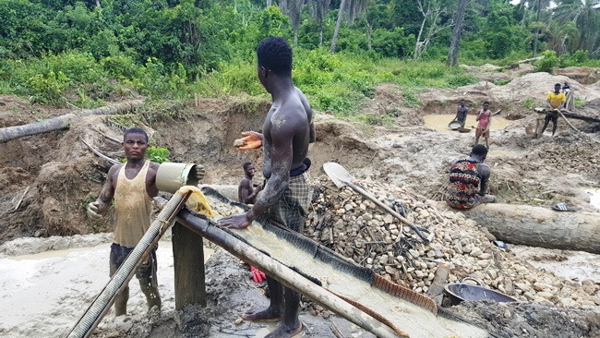
Plate 3.1: Typical Artisanal Small-Scale Gold Mining Process in the Study Area using a Sluice Box

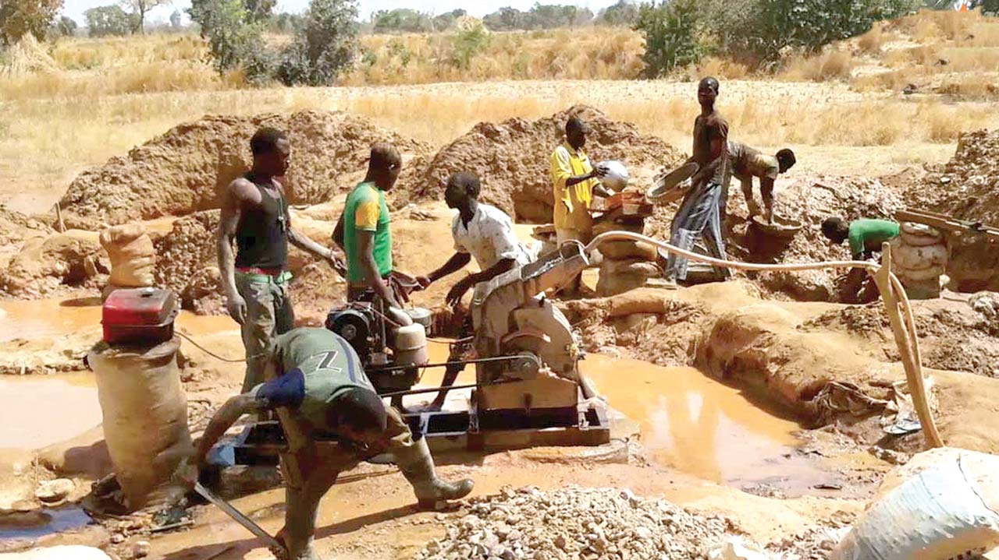
Plate 3.2: The artisanal miners haphazardly select Artisanal Gold Mine (AGM) pit sites, where gold-bearing saprolitic layers are panned.
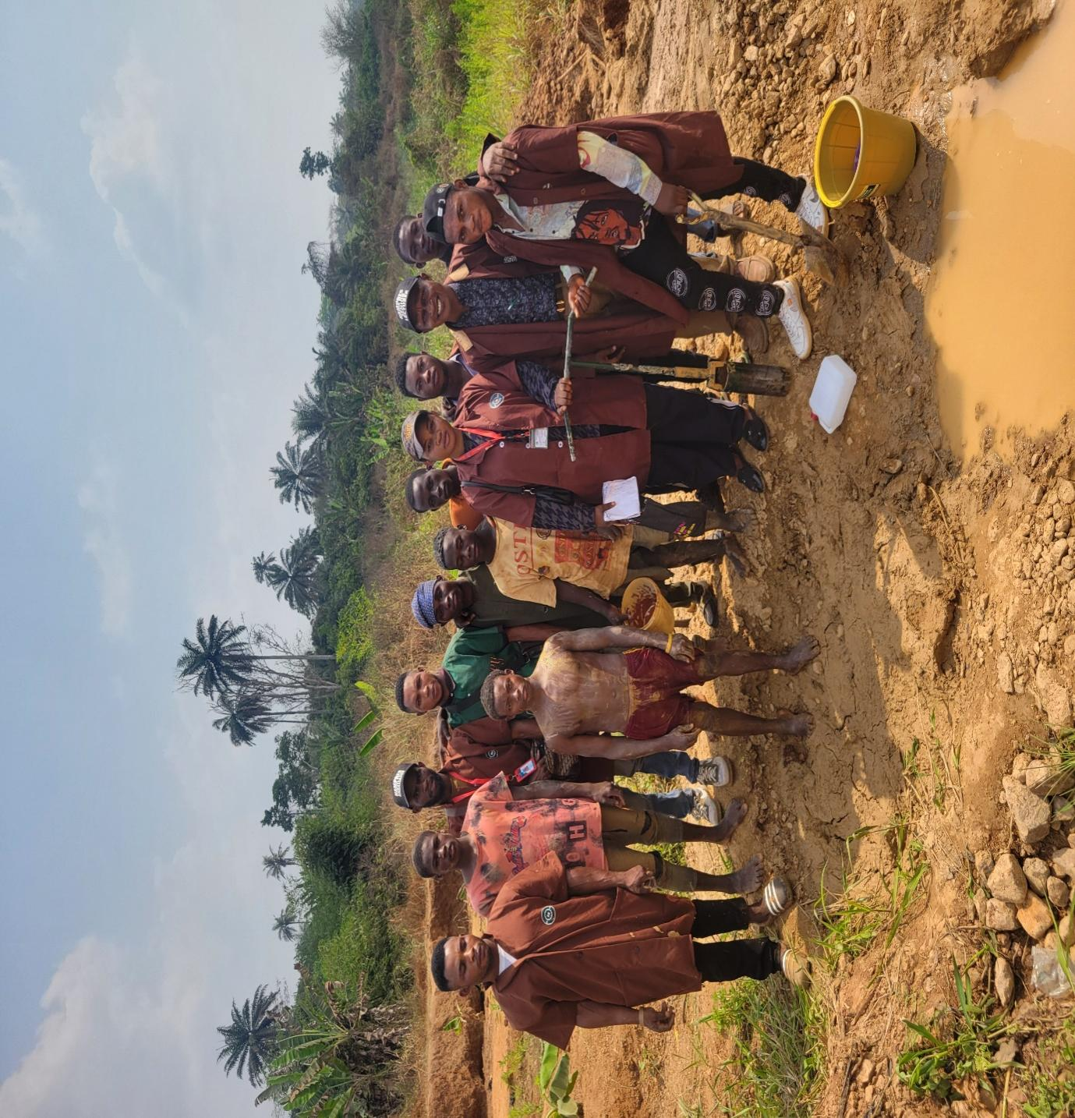

Plate 3.3: Site Location with group picture with the project students and miners

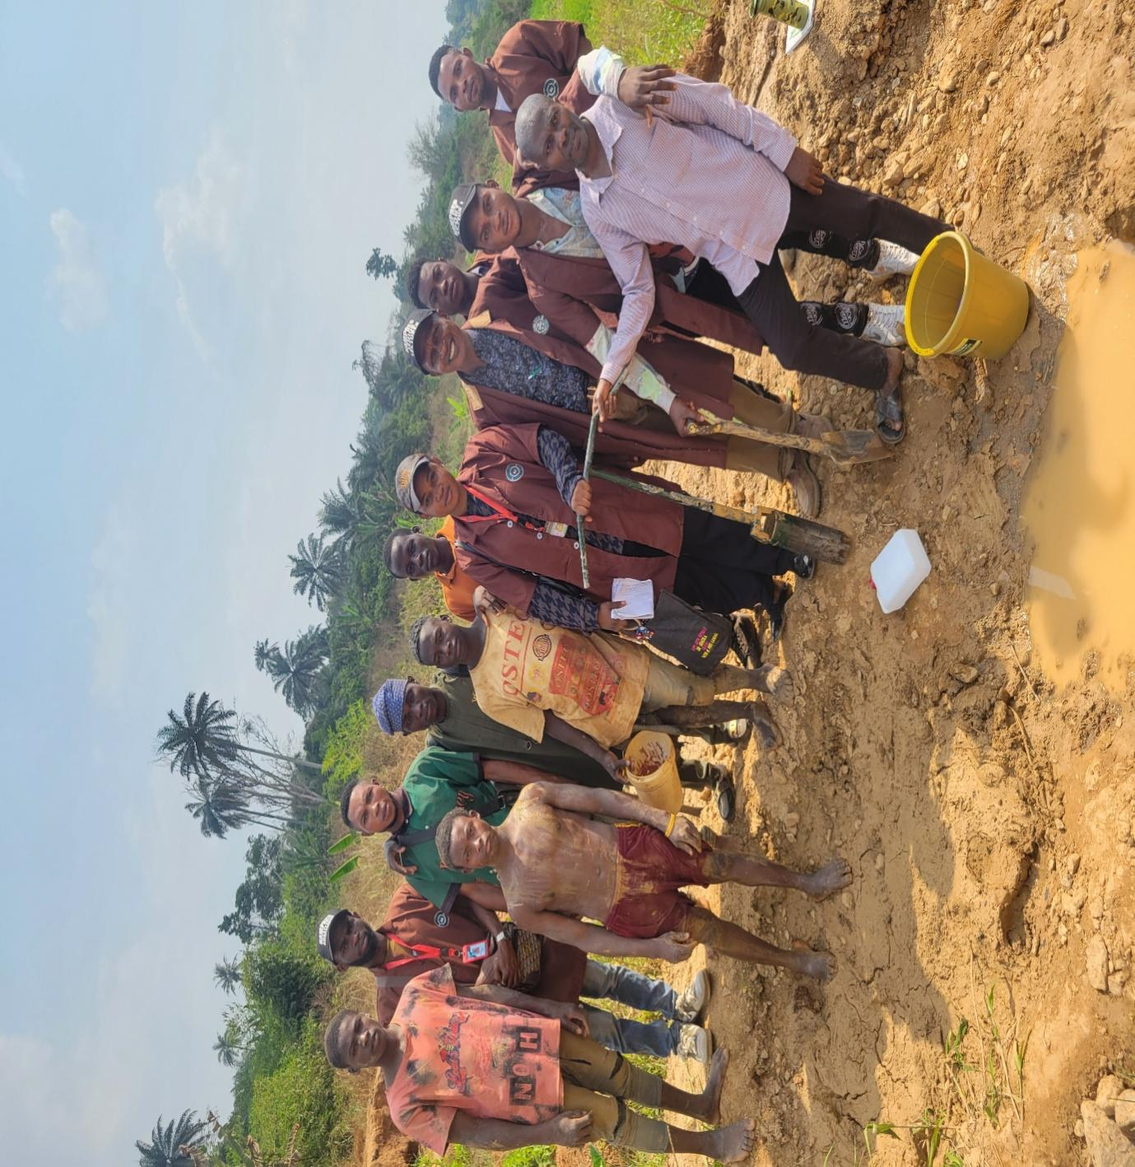

Plate 3.4: Site Location with group picture with the project students and miners

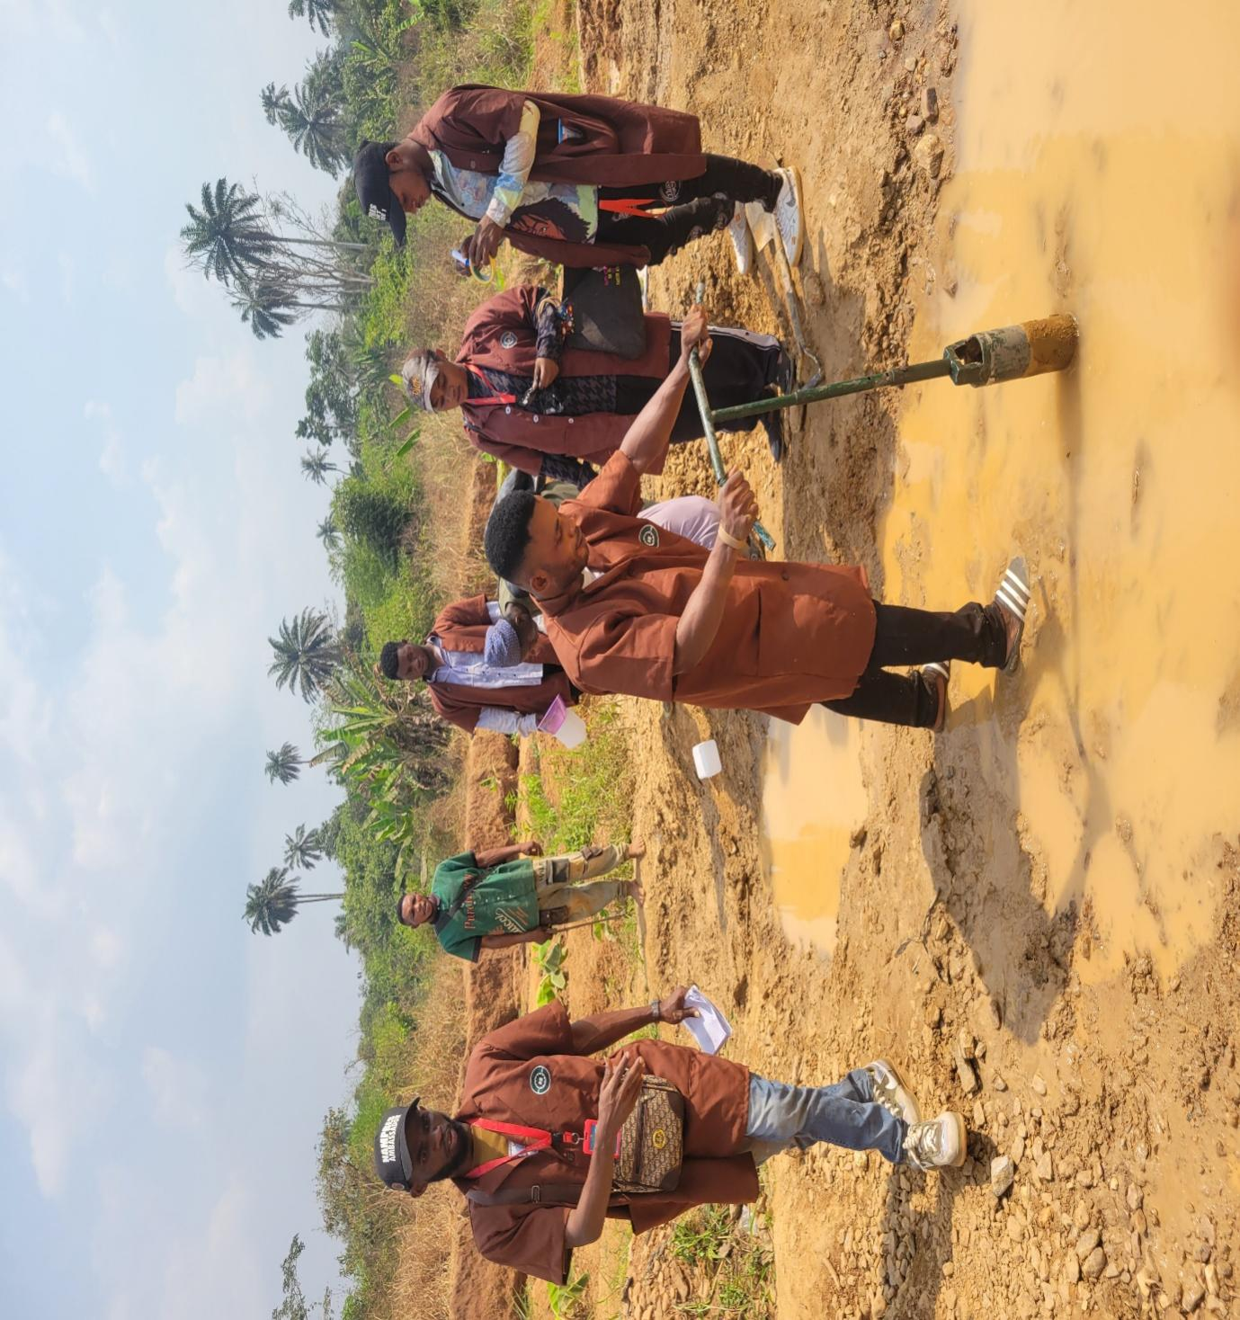
Plate 3.5: Site Location with group picture with the project students
3.2 SAMPLE COLLECTION
Soil samples were randomly collected at ten (10) different points within mine perimeter whiles the sixth, seventh and eighth location was 500m away from the mine. Ten samples were taken randomly at each sample location at a depth of 30cm with the aid of hand auger drill and were rigorously mixed together in a polythene bag. At the end of the samples collection, ten set of samples were available for laboratory analysis.
3.3 SAMPLE PREPARATION
The analyses of the soil sample to determine the composition of heavy metals were carried out. The samples collected from the surface and subsurface soil of each sampling point were later mixed to form composite sample for each sampling location. The collected samples were dried, grinded to fine powder using ball milling machine and sieved with 150μm mesh size. The sieved samples were stored in the polythene bag and labelled accordingly prior to analysis, and the residue samples were discarded.
Organic carbon was determined by dichromate oxidation method of Walkley and Black procedure (Neson and Sommers 1982), wet oxidation, and corrected to soil organic matter by multiplying with a correction factor of 1.724, particle size analysis of the soil was determined using the Bouyoucos hydrometer method. The soil samples were analyzed for the following physicochemical parameters: pH, Electrical conductivity (EC), available phosphorus, exchangeable calcium, potassium, sodium, total organic matter. Heavy metal concentrations of the sample were also determined using Atomic Absorption Spectrophotometer (ASS) for the following heavy metals: Fe (iron), Cobalt (Co), Zinc (Zn), Chromium (Cr), Nickel (Ni), Lead (Pb), and Cadmium (Cd). Available phosphorus was extracted using Bray II extractant as described by Bray and Kurtz (1945). Exchangeable Calcium, Magnesium, Sodium and Potassium were extracted with ammonium actateethylenediaminetetraacetic acid (NH₄OAC-EDTA). Calcium and Magnesium were determined using Ethylene Diamine Tetra-acetic Acid disodium salt (EDTA) titration method while Potassium and Sodium were determined by flame photometer (Rhoades, 2002). Cation exchange capacity was determined titrimetrically using 0.01N NaOH. Exchangeable acidity was determined titrimetrically using 0.05N NaOH. Bulk density was determined on the core samples by core method as described by Anderson and Ingram (2013).

3.4 PHYSICOCHEMICAL ANALYSIS
All the soil samples were subjected to tests at the Central Research Laboratory, University of Ilorin, Kwara State. The physicochemical properties of the soil samples were determined according to standard methods. Soil pH was determined using digital pH meter according to the method described by Bates (2004). Soil electrical conductivity was determined using conductivity meter according to the method outlined by Godson et al., (2002). Calcium and magnesium in soil samples were determined by versenate titration method as outlined by Piper, (1966). Potassium was determined by flame photometrically after extracting the soil with neutral normal ammonium acetate (Jackson, 2003). Available phosphorus was extracted using Bray II extraction as described by Bray and Kurtz (2015). Sodium in soil samples was determined turbidometrically. The intensity of turbidity was measured using spectrophotometer at 420nm of wavelength as outlined by Piper, (1966). Total organic matter was determined according to the method outlined by Osuji and Adesiyan, (2005).
3.4.1 Measurement of Physicochemical Parameter
During sampling, some immediate probing referred to as physical investigation was carried out on the samples in-situ by a portable water kit before the samples were sent to the laboratory for analyses. The measured physico-chemical parameters include the PH, Temperature, Electrical conductivity and Total Dissolved Solid (TDS).
3.4.2 Electrical Conductivity (EC)
Electrical conductivity is a good measure of salinity hazard to crops as it reflects the TDS in water and soil. Electrical conductivity of natural waters is determined by the presence of substances, which dissociate into cations and anions. Measurement of EC can be used to monitor and determine the degree of water pollution. The value of EC may serve as an appropriate index of the total content of the dissolved substances for the bodies of waters, which have been subjected to considerable influence run-off waters, to establish the origin and distribution of various waters in the body of water and delineation pollution zones.
The measurement of electrical conductivity in microsiemen per centimeter (us/cm) was determined using portable field conductivity meter for each of the water samples. Conductivity is a measure of the ability of water to conduct an electric current. It increases as the amount of the dissolved minerals (ions) increases.
3.4.3 pH Test
The pH of water is a measure of hydrogen ion concentration in water. It ranges from 0 to 14, with neutral water at 7. While lower of it is acidic and PH greater than 7 is known as basic. Drinking water with a pH ranging from 6.5 to 8.5 is generally considered satisfactory. It is noticed that water with low pH tends to be toxic and with high degree of pH tastes bitter. The pH of the studied water samples was measured by dipping the electrode of the pH meter into the bowl of the water samples.
3.4.4 Temperature
The temperature of the water is one of the most important characteristics which determines, to a considerable extent and tendencies of changes in the quality of water. It is taken with the aid of multifunction water kit, and measured in degree Celsius. The water temperature was taken before the other water measurements, because the temperature tends to change very rapidly after a sample is collected.
3.4.5 Total Dissolved Solid (TDS)
The concentration of impurities is often termed Total Dissolved Solid (TDS). It is often measured in ppm or mg/l and can be determined using conductivity method or TDS meter. Water has the ability to dissolve a wide range of inorganic and some organic minerals or salts such as potassium, calcium, sodium, bicarbonates, chlorides, magnesium, sulphates etc. these minerals produced unwanted taste and diluted colour in appearance of water which may be injurious to animals and plants.
3.4.6 Major Ions
The major ions analyzed in the water samples are of two groups, which are;
- Cations
- Anions
The major cations analyzed include sodium (Na⁺), potassium (K⁺) and calcium (Ca²⁺). The major anions analyzed include chloride (C^{l-}) and sulphate (SO₄²⁻).
3.4.7 Determination of Sodium and Potassium Using AAS
100mls of the water sample was measured into a clean 250mls digestion flask. 15mls of conc. nitric acid (HNO₃₎ and 5mls of conc hydrochloric acid (HCL) were added into the sample in digestion flask. The solution inside digestion flask was heated on a hot plate until all the brownish fumes (nitrogenous compound) expelled out, which confirmed that the water sample is digested and it was allowed to cool at room temperature, 2mls of distilled water was added. Then, the mixture was filtered into 50mls standard flask and it was transferred into plastic reagent bottle for atomic absorption spectrometry (A.A.S) at Central Research Laboratory University of Ilorin for determination of Na⁺ and K⁺.
3.4.8 Determination of Calcium Ion Using Muroxide as Indicator
25mls of the water sample was measured into a clean conical flask, then 2mls of dilute NaoH was added into the sample and 2 – 3 drops of muroxide indicator were added into the solution, and then titrated against 0.01m of EDTA (titrant) until a pinkish color appeared as equation 3.1.
Ca²⁺(mg/l) = Titre Value x Molarity x Molar Mass x 1000 equation 3.1
Volume of Sample

3.4.9 Determination of Magnesium Ion (Mg²⁺) Using Erichrome as Indicator
Total hardness is due to the presence of both calcium and magnesium ions so that the sum of calcium and magnesium is determined readily using erichrome as indicator. Direct titration method was used in which 25mls of the water sample was buffered to pH 10 (i.e. 5mls of ammoniacal buffer). It was then titrated against 0.01m EDTA, the end point was noted when the solution changes from purple to pure blue. Note, the mg²⁺ was determined by subtracting the already known Ca²⁺ from the total hardness as in equation 3.2 and 3.3.
Total hardness (mg/l) = Titre Value x Molarity x Molar Mass x 1000 equation 3.2
Volume of Sample
Mg²⁺(mg/l) = Total Hardness – Calcium Ion equation 3.3
3.4.10 Determination of Sulphate (So4²⁻) Using Precipitation Method
10mls of the sample was poured into a beaker, 5mls of barium chloride was added into the solution. The initial weight of the beaker together with the solution was weighed. The solution was heated on a burse burner until white precipitate formed. The beaker was removed from the burner and allowed to cool. Then, its final weight was taken in equation 3.4.
SO4²⁻(mg/l) = Change in Weight x 1000 equation 3.4
Volume of Sample
3.4.11 Determination of Chloride Ion (Cl⁻) Using Mohr Method
25mls of water sample was measured into a conical flask and placed on a white tile surface. 1ml of potassium chromate solution (K₂Cr₂O₄) as an indicator was added and a light-yellow solution appeared; it was then titrated against silver nitrate solution (AgNO₃) with constant stirring until lightest reddish coloration persists at the end point as in equation 3.5.
Cl⁻(mg/l) = Titre Value x Molarity x Molar Mass x 1000 equation 3.5
Volume of Sample
3.5 DETERMINATION OF HEAVY METALS
The concentrations of heavy metals in all the samples were determined using the BUCK Scientific ACCUSYS (Model 203) Atomic Absorption Spectrophotometer. One grams of each sample was introduced into a digesting tube then 10 ml of concentrated HNO₃ was added. The samples were placed in the digester for 8 hours at 96ºC with alternating turning. When the digestion has completed, the samples were filtered into 100 ml volumetric flask using what man filter paper. Samples were made up to 100 ml mark in the volumetric flask using distilled deionised water. The concentration of Iron (Fe), cobalt (Co), zinc (Zn), nickel (Ni), lead (Pb), chromium (cr), and cadmium (cd) in the solution were determined using Varian Spectra AA 600 Atomic Absorption Spectrophotometer (AAS) with air acetylene flame connected to it.

CHAPTER FOUR
RESULTS AND DISCUSSION
4.1 RESULTS
4.1.1 Physicochemical Analysis of the Samples
In this study, ten samples were collected within the mine perimeter at 100meter interval while a control sample was collected at 500m away from the mine parameter. The samples were labelled sample LS1, LS2, LS3, LS4, LS5, LS6, LS7, LS8, LS9 and LS10 with the control sample being labelled sample LS10. In order to understand the soil capability to retain heavy metals, geochemical soil characteristics such as pH, carbon content, electric conductivity were performed on the sample. Table 4.1 shows the results of the Physiochemical analysis of the samples.
Table 4.1: Results of physiochemical Analysis of the soil samples from the study site during dry season
Sample  Codes | Ph | EC  (μS/cm) | TDS  (ppm) | Tempº  (ºC) | Na²⁺ | K⁺ | Mg²⁺ | Ca²⁺ | SO₄²⁻ | Cl⁻ | TOC %
LS 1 | 6.1 | 1157 | 186 | 31.8 | 21.42 | 12.59 | 15.29 | 21.48 | 18.26 | 7.40 | 2.11
LS2 | 6.3 | 1388 | 287 | 32.1 | 24.08 | 17.84 | 13.64 | 44.81 | 52.09 | 6.83 | 1.76
LS3 | 5.4 | 1502 | 319 | 35.2 | 43.83 | 33.93 | 19.14 | 52.36 | 57.36 | 9.51 | 2.19
LS4 | 6.9 | 1437 | 299 | 32.3 | 34.79 | 38.27 | 13.61 | 48.99 | 48.99 | 8.23 | 1.98
LS5 | 5.6 | 1131 | 178 | 31.3 | 17.41 | 14.60 | 16.48 | 25.63 | 25.63 | 9.16 | 1.99
LS6 | 5.6 | 1191 | 199 | 35.6 | 20.06 | 15.14 | 19.72 | 33.39 | 33.39 | 8.94 | 1.70
LS7 | 6.9 | 1265 | 235 | 34.6 | 19.94 | 21.95 | 28.67 | 39.74 | 39.74 | 10.46 | 2.28
LS8 | 5.5 | 1414 | 259 | 35.9 | 13.28 | 24.42 | 32.41 | 36.63 | 36.63 | 5.31 | 1.86
LS9 | 5.3 | 1335 | 218 | 33.8 | 10.56 | 28.04 | 25.37 | 31.31 | 31.31 | 5.611 | 2.11
LS10 | 5.1 | 1243 | 286 | 35.6 | 12.71 | 26.56 | 29.51 | 29.25 | 29.25 | 3.81 | 1.57
Range | 5.1 – 6.9 | 1131  –  1502 | 186  –  319 | 31.3  –  35.6 | 10.56 – 43.83 | 12.59 –  38.27 | 13.64 – 32.41 | 21.48 – 52.36 | 18.26 – 57.36 | 3.81 – 10.46 | 1.57  –  2.28

4.1.2 Variation of pH and Electrical Conductivity
Table 4.1 show the soil pH at the eight (8) locations (LS1, LS2, LS3, LS4, LS5, LS6, LS7, LS8. LS9, LS10/control) to be 6.1, 6.3, 5.4, 6.9, 5.6, 5.6, 6.9, 5.5, 5.3, and 5.1 respectively during the dry season. The recorded values of samples value collected within the proximity of the site are lower than the pH recommended value range of 6.6 to 7.5 for optimum plant growth (Queensland Department of Environment and Heritage Protection (QDEHP), 2019), but the control sample is within the recommended limit. The results of the Electricity conductivity range from 1131 to 1502 μs/cm. The EC was observed to be higher in the sample within the mine (LS2, LS3, LS4, LS7, LS8, LS 9 and LS 10) while it was observed to be low in LS1, LS5 and LS6 which are flowing river samples. Since the EC is a measure of level of salts content in the soil and it is understood that if the EC value in soil sample increases, then more dissolve ion was being deposited from a source which could be from the mine (Yasir and Alain, 2016).
4.1.3 Variations of Potassium, Sodium, Calcium and Magnesium (mg/kg)
The results of potassium for the dry season were recorded with range from 12.59 to 38.27, potassium is not an integral part of any major plant component but it plays a key role in a vast array of physiological process vital to plant growth from protein synthesis to maintenance of plant water balance (Sumithra et al., 2013). Potassium is found in its mineral form and affect plants division, carbohydrate formation, translocation of sugar, various enzyme actions and resistance to certain plant disease (Jain et al., 2014). For Sodium the recorded value was between 10.56 – 43.83 for dry season and magnesium ranged between 13.64 – 32.41 during the dry season, the Calcium content in the soil samples was observed to be between 21.48 to 52.36 with control sample possessing the lowest calcium content value 21.48.
4.1.4 Variations of Total Organic Matter, Chlorine, and Sulphide (mg/kg)
The Total Organic Matter (TOC) ranged from 1.57% to 2.28% as shown in Table 4.2 from the result, it could be seen that all the samples within the mine perimeter have high carbon content LS10/control sample. Soil organic carbon is a key attribute in assessing soil health, generally correlating positively with crop yield (Bennett et al., 2010). The soil organic carbon affects important functional processes in soil like the storage of nutrients, mainly nitrogen, and water holding capacity (Silva and Sa-Mendonca, 2007).
The content of chlorine in the sample ranged from 3.81 to 10.46 with the control sample having the lowest CI content. This implies that the mining activities could have contributed to increment. Increase in chlorine content in the soil indicated high rate of CI in take by immediate plants which could reduce the crop yield (Onipede et al., 2020).
The results of the sulphide content ranged from 57.36 to 18.26 while the LS1 sample has value of 13.80. High waste generation in the mine could be attributed to the high level of sulphide content within the mine perimeter. Though, sulphide content in soil may be advantageous for optimal plant growth so far, the threshold limit as specified by (NCHRP, 2009) is not exceeded.

Figure 4.1: Concentrations of Metallic Elements in Soil Samples around the mine
4.1.5 Heavy Metal Concentration of Samples
The results of the heavy metal concentration of the sample are shown in Table 4.2. The average concentration of Fe present in the sample ranged from 10.508 (LS 4) to 8.789 (LS 9). The content of Fe was observed to be high in all the samples within mine perimeter with the control sample. This could also be observed in other heavy metals such as Co, Zn, Ni, Pb, Cr, and Cd with average results ranging from 0.515 (LS 3) to 0.005 (LS7); 3.679 (LS 4) – 3.411 (LS 6); 1.407 (LS 2) – 0.054 (LS 3); 0.001 – 0.001 (Constant); 0.124 (LS 2) – 0.053 (LS 5); and 0.088 (LS 4) – 0.001 (LS 2,6,7,9) respectively.
Table 4.2: Result of Heavy Metal Concentration in Samples (mg/kg) during the dry season
Sample Code | Fe |  | AVE | Co |  | AVE | Zn |  | AVE | Ni |  | AVE | Pb |  | AVE | Cr |  | AVE | Cd |  | AVE
LS 1 | 9.608 | 9.608 | 9.608 | 0.495 | 0.495 | 0.495 | 3.663 | 3.663 | 3.663 | 1.237 | 1.237 | 1.237 | 0.001 | 0.001 | 0.001 | 0.090 | 0.090 | 0.090 | 0.001 | 0.001 | 0.001
LS 2 | 9.752 | 9.752 | 9.752 | 0.514 | 0.514 | 0.514 | 3.550 | 3.550 | 3.550 | 1.407 | 1.407 | 1.407 | 0.001 | 0.001 | 0.001 | 0.095 | 0.152 | 0.124 | 0.013 | 0.013 | 0.013
LS 3 | 10.243 | 10.243 | 10.243 | 0.515 | 0.515 | 0.515 | 3.634 | 3.634 | 3.634 | 0.054 | 0.054 | 0.054 | 0.001 | 0.001 | 0.001 | 0.086 | 0.086 | 0.086 | 0.001 | 0.001 | 0.001
LS 4 | 10.508 | 10.508 | 10.508 | 0.0811 | 0.111 | 0.096 | 3.679 | 3.679 | 3.679 | 0.195 | 0.195 | 0.195 | 0.001 | 0.001 | 0.001 | 0.070 | 0.070 | 0.070 | 0.088 | 0.088 | 0.088
LS 5 | 9.173 | 9.173 | 9.173 | 0.016 | 0.016 | 0.016 | 3.545 | 3.545 | 3.545 | 0.135 | 0.135 | 0.135 | 0.001 | 0.001 | 0.001 | 0.077 | 0.029 | 0.053 | 0.022 | 0.022 | 0.022
LS 6 | 9.763 | 9.763 | 9.763 | 0.052 | 0.052 | 0.052 | 3.411 | 3.411 | 3.411 | 0.223 | 0.223 | 0.223 | 0.001 | 0.001 | 0.001 | 0.008 | 0.008 | 0.008 | 0.001 | 0.001 | 0.001
LS 7 | 10.383 | 10.383 | 10.383 | 0.005 | 0.005 | 0.005 | 3.467 | 3.467 | 3.467 | 0.325 | 0.325 | 0.325 | 0.001 | 0.001 | 0.001 | 0.038 | 0.038 | 0.038 | 0.001 | 0.001 | 0.001
LS 8 | 10.365 | 10.365 | 10.365 | 0.041 | 0.041 | 0.041 | 3.587 | 3.587 | 3.587 | 0.034 | 0.034 | 0.034 | 0.001 | 0.001 | 0.001 | 0.115 | 0.115 | 0.115 | 0.044 | 0.044 | 0.044
LS 9 | 8.789 | 8.789 | 8.789 | 0.001 | 0.001 | 0.001 | 3.501 | 3.501 | 3.501 | 0.109 | 0.109 | 0.109 | 0.001 | 0.001 | 0.001 | 0.088 | 0.081 | 0.085 | 0.001 | 0.001 | 0.001
LS 10 | 9.619 | 9.619 | 9.619 | 0.136 | 0.136 | 0.136 | 3.484 | 3.484 | 3.484 | 0.168 | 0.168 | 0.168 | 0.001 | 0.001 | 0.001 | 0.054 | 0.054 | 0.054 | 0.083 | 0.083 | 0.083

It could be observed that heavy metals concentration was high in the entire sample within the mine perimeter than that of the control samples in Figure 4.1, Figure 4.2 and Figure 4.3 respectively. It could be connoted that the mining activities have influences in the accumulation of heavy metals in the soil.
Table 4.3: Results of the Average heavy metals concentration in the sample (mg/kg) during the dry season
Sample Code | Fe  (mg/kg) | Co  (mg/kg) | Zn  (mg/kg) | Ni  (mg/kg) | Pb  (mg/kg) | Cr  (mg/kg) | Cd  (mg/kg)
LS 1 | 9.608 | 0.495 | 3.663 | 1.237 | 0.001 | 0.090 | 0.001
LS 2 | 9.752 | 0.514 | 3.550 | 1.407 | 0.001 | 0.124 | 0.013
LS 3 | 10.243 | 0.515 | 3.634 | 0.054 | 0.001 | 0.086 | 0.001
LS 4 | 10.508 | 0.096 | 3.679 | 0.195 | 0.001 | 0.070 | 0.088
LS 5 | 9.173 | 0.016 | 3.545 | 0.135 | 0.001 | 0.053 | 0.022
LS 6 | 9.763 | 0.052 | 3.411 | 0.223 | 0.001 | 0.008 | 0.001
LS 7 | 10.383 | 0.005 | 3.467 | 0.325 | 0.001 | 0.038 | 0.001
LS 8 | 10.365 | 0.041 | 3.587 | 0.034 | 0.001 | 0.115 | 0.044
LS 9 | 8.789 | 0.001 | 3.501 | 0.109 | 0.001 | 0.085 | 0.001
LS 10 | 9.619 | 0.136 | 3.484 | 0.168 | 0.001 | 0.054 | 0.083
Range | 8.768  –  10.58 | 0.005  –  0.515 | 3.411  –  3.679 | 0.054  –  1.407 | 0.001  –  0.001 | 0.053  –  0.124 | 0.001  –  0.088

Figure 4.1: Heavy Metals Concentration of the Sample (mg/kg)

Figure 4.2: Heavy Metals Concentration of the Sample (mg/kg)

Figure 4.3: Heavy Metals Concentration of the Sample (mg/kg) for all the Soil Samples

4.2 IMPACT OF MINING ON METALLIC ELEMENTS IN THE SOIL
Plants require metallic elements, such as calcium (Ca), potassium (K), magnesium (Mg), Iron (Fe), and Zinc (Zn) as nutrients to grow and develop (Tripathi et al., 2014). Disturbance or contamination of the soil could negatively impact the availability of these metals and affect the suitability of the soil for sustainable agriculture. Therefore, it is imperative to assess the impact of mining activities on the metallic elements in soil samples at the different locations around the mine are in Figure 4.1. Ca, K, and Mg are macronutrients that plants need in large quantities for growth. The concentrations of these macro-nutrients in the soil samples are interpreted using Table 4.4.
Table 4.1 presents different concentrations of macronutrients in soil (Hazelton and Murphy, 2016). Ca concentrations in all the soil samples in all the location are below the moderate concentration of Ca required for agricultural soils (Table 4.4). Ca deficiency in soil could affect the ability of legume plants to associate with nitrogen-fixing bacteria. Soil K is essential for plant growth and development and the plant’s mobility of nutrients (Adams and Shin, 2014). The Mg concentrations are below the typical concentration required for plant growth. Similarly, Onifade et al., 2020 reported a low average Mg concentration of 13.64 mg/kg around the mining site in Komu, South-western Nigeria. Generally, it can be observed that many researchers have reported the impact of mining activities on soil macronutrients (Afeni and Ibitolu, 2018; Oladipo et al., 2014; Onifade et al., 2020; Mensah et al., 2015; Wang et al., 2021). In addition, the low concentrations of these macronutrients in the soil samples could be linked to the acidity of the soil samples; macronutrients are less available in acidic soil samples; macronutrients are less available in acidic soil (Gondal et al., 2021).
Sodium concentration in the soil has little effect on plant growth, but a too-high concentration can affect plant growth and crop productivity (Maarguis, 2014; Essandoh et al., 2021). The sodium concentrations in all the Soil samples, which range from 10.56 to 43.86 mg/kg, are within the low range recommended for agricultural purposes (Table 4.4). A similar range of sodium concentration was also found in the soil of a mine site in Dunkwa East municipality of Ghana (Essadoh et al., 2021). In a mining site at Komu south-western Nigeria, Onifade et al., (2020) reported a lower average sodium concentration of 10.56 mg/kg.
Table 4.4: Concentration levels of macronutrients in Soil (adapted from Hazelton and Murphy, 2016)
Elements (mg/kg) | Low | Moderate | High
Ca | 400 – 1000 | 1000 – 2000 | 2000 – 4000
K | 78 – 117 | 117 – 273 | 273 – 780
Mg | 36 – 120 | 120 – 360 | 360 – 960
Na | 23 – 69 | 69 – 169 | 169 – 460

Iron and zinc are micronutrients because they are needed in small quantities for plant growth. Nevertheless, high concentrations of these micronutrients or their deficiencies can affect plant metabolism and growth (Chatzistathis, 2014). Iron and zinc concentrations in all the soil samples in and around the mining site are below the recommended concentrations of 100 and 20 mg/kg respectively (Epstein, 1965). Low concentrations of Fe and Zn may also relate to low soil pH in and around the mining site, as a low pH enhances the solubility of heavy metals (Arogunjo, 2007). The region’s low concentration of Fe and Zn in the studied area seems peculiar. Onifade et al., (2020) obtained a low average concentration of Fe (8.768 mg/kg) and Zn (3.411 mg/kg) from the mining site at Komu, south-western Nigeria. The study revealed relative concentration of heavy metal in the soil during the dry season at Ifewara mine site in the following order: Fe>Zn>Pb>Ni>Cr>Cd. The Iron and Zinc content of the soils was extremely low but they are needs to analysis the soil during dry season to ascertain degree of contamination assessing the trace element pollution risk evaluation and calculation of contamination factor index and potential ecological risk index.

CHAPTER FIVE
CONCLUSION AND RECOMMENDATION
5.1 CONCLUSION
This study revealed that the mining activities going on in Ifewara, Osun State, Nigeria have a negative impact on the soil by introducing heavy metal above the threshold limit and altering the soil’s physicochemical parameters; thereby causing severe pollution of the soil. There is an urgent need to develop and implement guiding principles to regulate mining activities particularly artisanal mining in this area, in order to prevent the numerous toxic effects of heavy metal contamination.
In addition, further studies are required to assess the level of contamination through both physicochemical analysis and heavy metal concentration measurements, comparing the dry and wet seasons. This is essential for evaluating the quality and accumulation of these metals in plants and humans, as well as understanding the associated health risks of mining activities to the inhabitants of the studied area.
5.2 Recommendations
Based on the findings of this study, the following recommendations are proposed:
1. The miners and the entire community of Ifewara should be educated on the health risk associated with human exposure to trace metals to prevent pollution of the soil.
2. The study also recommends the need for environmental awareness using enlightenment campaigns on illegal mining and artisanal mining activities, control and monitoring techniques in the study location will be geared toward satisfactory quality environmental conditions.
3. Intermittent monitoring of soil quality around mining sites should be encouraged at both governmental and organizational levels to consistently assess the concentrations of key soil parameters.

REFERENCES
Adams E, Shin R (2014). Transport, Signalling, and Homeostasis of Potassium and Sodium in Plants. J Integr Plant Biol 56(3):231–249.
Adediji, A.A. and Oluwafemi, O.A. (2007): Grain Size Characteristics of Overbank Deposits of Some Floodplain in Opa Reservoir Basin, SW Nigeria, International Journal of Environmental Hydrology. 15:3 – 4.
Afeni T. B., Ibitolu F., (2018). Assessment of Environmental Impact of Gemstone Mining in Ijero-Ekiti Nigeria. Min Miner Depos 12(1):1–11.
Ajakaiye D. E. (1985): Environmental Problems Associated with Mineral Exploitation in
Nigeria. Paper Presented at the 21st Annual Conference of the Nigeria Mining and Geosciences Society; Jos. 140 – 148.
Ako, T.A., Onoduku, U.S., Adamu, I. A., Ali, S. E., Mamodu A. and Ibrahim A. T. (2014).
Environmental Impact of Artisanal Gold Mining in Luku, Minna, Niger State, North Central Nigeria, Journal of Geosciences and Geomatics, 2 (1), 1 – 10.
Akpoveta, O.V., Osakwe S.A., Okoh, B.E., Otuya, B.O., (2010): Physcio Chemical Characteristics and Levels of Some Heavy Metals in Soils and Metal Scrap Dumps in Some part of Delta State, Nigeria, J. Appl. Sci. Environ Maage, 3, 23.
Arogunjo A.M., (2007). Heavy Metal Composition of some Solid Minerals in Nigeria and
their Health Implications to the Environment. Pak J Biol Sci 10:4438–4443.
Bennett, L.T., Mele, P.M., Annett, S., Kasel, S. (2010). Examining Links between Soil
Management, Soil Health, and Public Benefits in Agricultural Landscapes: An Australian Perspective. Agriculture, Ecosystems and Environment 139, 1-12.
Bray, R. H and Kurtz, L. T (2015) Determination of Total, Organic, and available Forms of Phosphorus in Soils. Soil Science, 59,39 - 45.
Chatzistathis T., (2014). Micronutrient Deficiency in Soils and Plants. Bentham Science Publishers.

Chenniah and Gautam (1985): Land-use and Land-cover Mapping and Change Detection in Tripura using Satellite LANDSAT Data, International Journal of Remote Sensing, 6:(3) 1 – 3.
Epstein E., (1965). Mineral metabolism, In: Bonner J, Varner E (eds) Plant biochemistry.
New York Academic Press, pp 438–466.
Essandoh PK, Takase M, Bryant IM (2021). Impact of Small-scale Mining Activities on Physicochemical Properties of Soils in Dunkwa East Municipality of Ghana. The Scientific World Journal.
Figueroa F, Castro-Larragoitia J, Aragón A, García-Meza J (2010): Grass Cover Density and Metal Speciation in Profiles of a Tailings-pile from a Mining Zone in Zacatecas, North-Central Mexico. Environ. Earth Sci. 60(2),395 - 407.
Gondal AH, Hussain I, Ijaz AB, Zafar A, Ch BI, Zafar H, Usama M (2021). Influence of soil pH and Microbes on Mineral Solubility and Plant Nutrition: a Review. Int J Agric Biol Sci 5(1):71–81.
Hazelton P, Murphy B (2016). Interpreting Soil Test Results: What do all the numbers mean? CSIRO Publishing, Clayton.
Jain, P. and Singh, D. (2014). Analysis the Physicochemical and Microbial Diversity of Different Variety of Soil Collected from Madhya Pradesh, India, Scholarly Journal of Agricultural Science, 4(2), 103 – 108.
Jain, S.A., Jagtap M.S., Patel, K.P. (2014). Physicochemical Characterization of farmland Soil used in some villages of Lunawadw Taluka, Dist: Mahisagar (Gujarat) India, Int. J. of Sci. and Res. Publi., 4(3), 1 – 5.
Kanmony, C. (2009): Human Right and Health Care. New Delphi, India: Mittal Publication.
Khan, A and Gbouri, A. (2011): Environmental Pollution; its Effects on Life and its
Remedies. Journal of Arts, Science and Commerce; 2, 276 - 285.
Ku Smita Tale and Sangita Ingole., (2015): A Review on Role of Physico-Chemical
Properties in Soil Quality Chem. Sci. Rev. Lett., 1, 11 – 15.
Maarguis F.J., (2014). Sodium in Plants: Perception, Signalling, and Regulation of Sodium Fuxes. J Exp Bot 65(3):849–858.
Mensah A. K, Mahiri I. O, Owusu O, Mireku OD, Wireko I, Kissi E.A., (2015). Environmental
Impacts of Mining: A Study of Mining.com (Retrieved 15 January 2023).
Mesubi, M.A., Adekola, F.A., Bello, A.A., Adekeye, J.D. and Bale, R.B. (1999): Extraction of Gold from Igun Gold Ore Deposit in Atakumosa Local Government Area, Osun State, Nigeria, Nigerian Journal and Applied Science, 14 (2):1 – 7.
Muhammad S, Tahir Shah M, Khan S (2011): Heavy Metal Concentrations in soil and Wild Plants Growing around Pb-Zn Sulphide Terrain in the Kohistan Region, Northern Pakistan. Microchem. J. 99:67 - 75.
Nelson DW, Sommers LE (1982): Total Carbon, Organic Carbon and Agronomy American Society of Agronomy, Madison, WIpp 279 - Organic matterIn Page, L. (Ed.)` Methods of Soil Analysis. Part 2. 539.
Nwachokor M.A., Uzu F.O., and Molido, W.A., (2009): Variation in Physico-chemical Properties and Productivity Implication for Four Soils in the Derived Savannah of Southern Nigeria, American-Eurasian Journal of Agronomy, 5, 66.
Oladipo OG, Olayinka A, Awotoye OO (2014). Ecological Impact of Mining on Soils of Southwestern Nigeria. Environ Exp Biol 12:179–186.
Onipede A. E., Oyelade, W. A., Omosebi J. G. and Obabire A. A. (2020). Physicochemical and Heavy metals Analysis of Soil around Palm Oil Producing Area in IllutitunOsoore, Nigeria. International Research Journal, 6 (1).
Pandeeswari, N., and Kalaiarasu, S., (2012): Studies on the Physico-chemical Properties of
the Soil Samples Collected from Different Locations of Tsunami Affected Soil of Cuddalore District of Tamil Nadu, Int. J. Current Res., 5, 29 - 30.
Papafilippaki, A; Kotti, M. and Stavroulakis, G. (2008): Seasonal Variations in Dissolved
Heavy Metals in the Keritis River Chania, Greece. Global Nest Journal; 3:320 - 325.
Pujar, K.G., Hiremath S.A., Pujar, A.S., and Yadawe M.S., (2012): Analysis of Physico- Chemical and Heavy Metal Concentration in Soil of Bijapur Taluka, Karnataka, Sci. Revs. Chem Commun., 7, 36.
Qishlaqi, A. and Moore, F. (2007): Statistical Analysis of Accumulation and Sources of
Heavy Metals Occurrence in Agricultural Soils of Khoshk River Banks, Shiraz, Iran. American – Eurasian Journal of Agriculture and Environment Science; 2:565 - 573.
Queensland Department of Environment and Heritage Protection (2019). Soil pH. www.qld.gov.au. [Retrieved 15 July 2024].
Schlesinger W.H., Reynolds J.F., Cunningham, G.L., Huemmeke L.F., Jarrell, W.M., Virginia R.A., Whiteford W.G., (1990): Biological Feedback in Global Densification, 10, 12
Sharma RK, Agrawal M, Marshall F (2007): Heavy Metal Contamination of Soil and
Vegetables in Suburban Areas of Varanasi, India. Ecotoxico. Environ. Safety. 66 (2): 258 - 266
Silva, I.R., Sa Mendonca, E. (2007). Materiaorganicado Solo = Soil Organic Matter. p. 275- 374.
Song Y, Ji J, Mao C, Yang Z, Yuan X, Ayoko GA, Fros RL (2010): Heavy Metal
Contamination in Suspended Soils of Changjiang River – Environmental Implications. Geoderma. 159:286 - 295.
Sumithra S., Ankalaiah C., Rao D., and Yamuna R.T., (2013): A Case Study of Physico- Chemical Characteristics of Soil around Industrial and Agricultural Area of
Yerraguntla, Kadapa District, A.P., India, Int. J. Geo. Earth and Environ. Sci, 1, 22.
Wang Z, Wang G, Ren T, Wang H, Xu Q, Zhang G (2021). Assessment of Soil Fertility Degradation Affected by Mining Disturbance and Land Use in a Coalfield via
Machine Learning. Ecol Ind 125:107608.
Wickware, A. and Howarth, D. (1981): Change Detection in the Peace-Athabasca Delta
Using Digital Landsat Data, Remote Sensing of Environment 11:9 – 14.
Yassir, Barkouch and Alain, Pineau (2016). Evaluation of the Impact of Mine Activity on Surrounding Soils of Draa Asfar Mine in Marrakech- Morocco. African Journal of Environmental Science and Technology, Vol. 10(1), pp. 44-49.

