ASSESSMENT OF PHYSICAL PROPERTIES OF LATERITE SOIL FOR ROAD BASE MATERIALS (BUDO EFO AND EVIRONS, ILORIN,KWARA STATE)

BY
Abdulrasheed Olalekan AKINTOLA
ND/23/MPE/FT/0019

SUBMITTED TO
DEPARTMENT OF MINERAL AND PETROLEUM RESOURCES ENGINEERING TECHNOLOGY, INSTITUTE OF TECHNOLOGY, KWARA STATE POLYTECHNIC, ILORIN.
IN PARTIAL FULFILLMENT OF THE REQUIREMENT FOR THE AWARD OF NATIONAL DIPLOMA (ND) IN MINERALS AND PETROLEUM RESOURCES ENGINEERING TECHNOLOGY

AUGUST, 2025

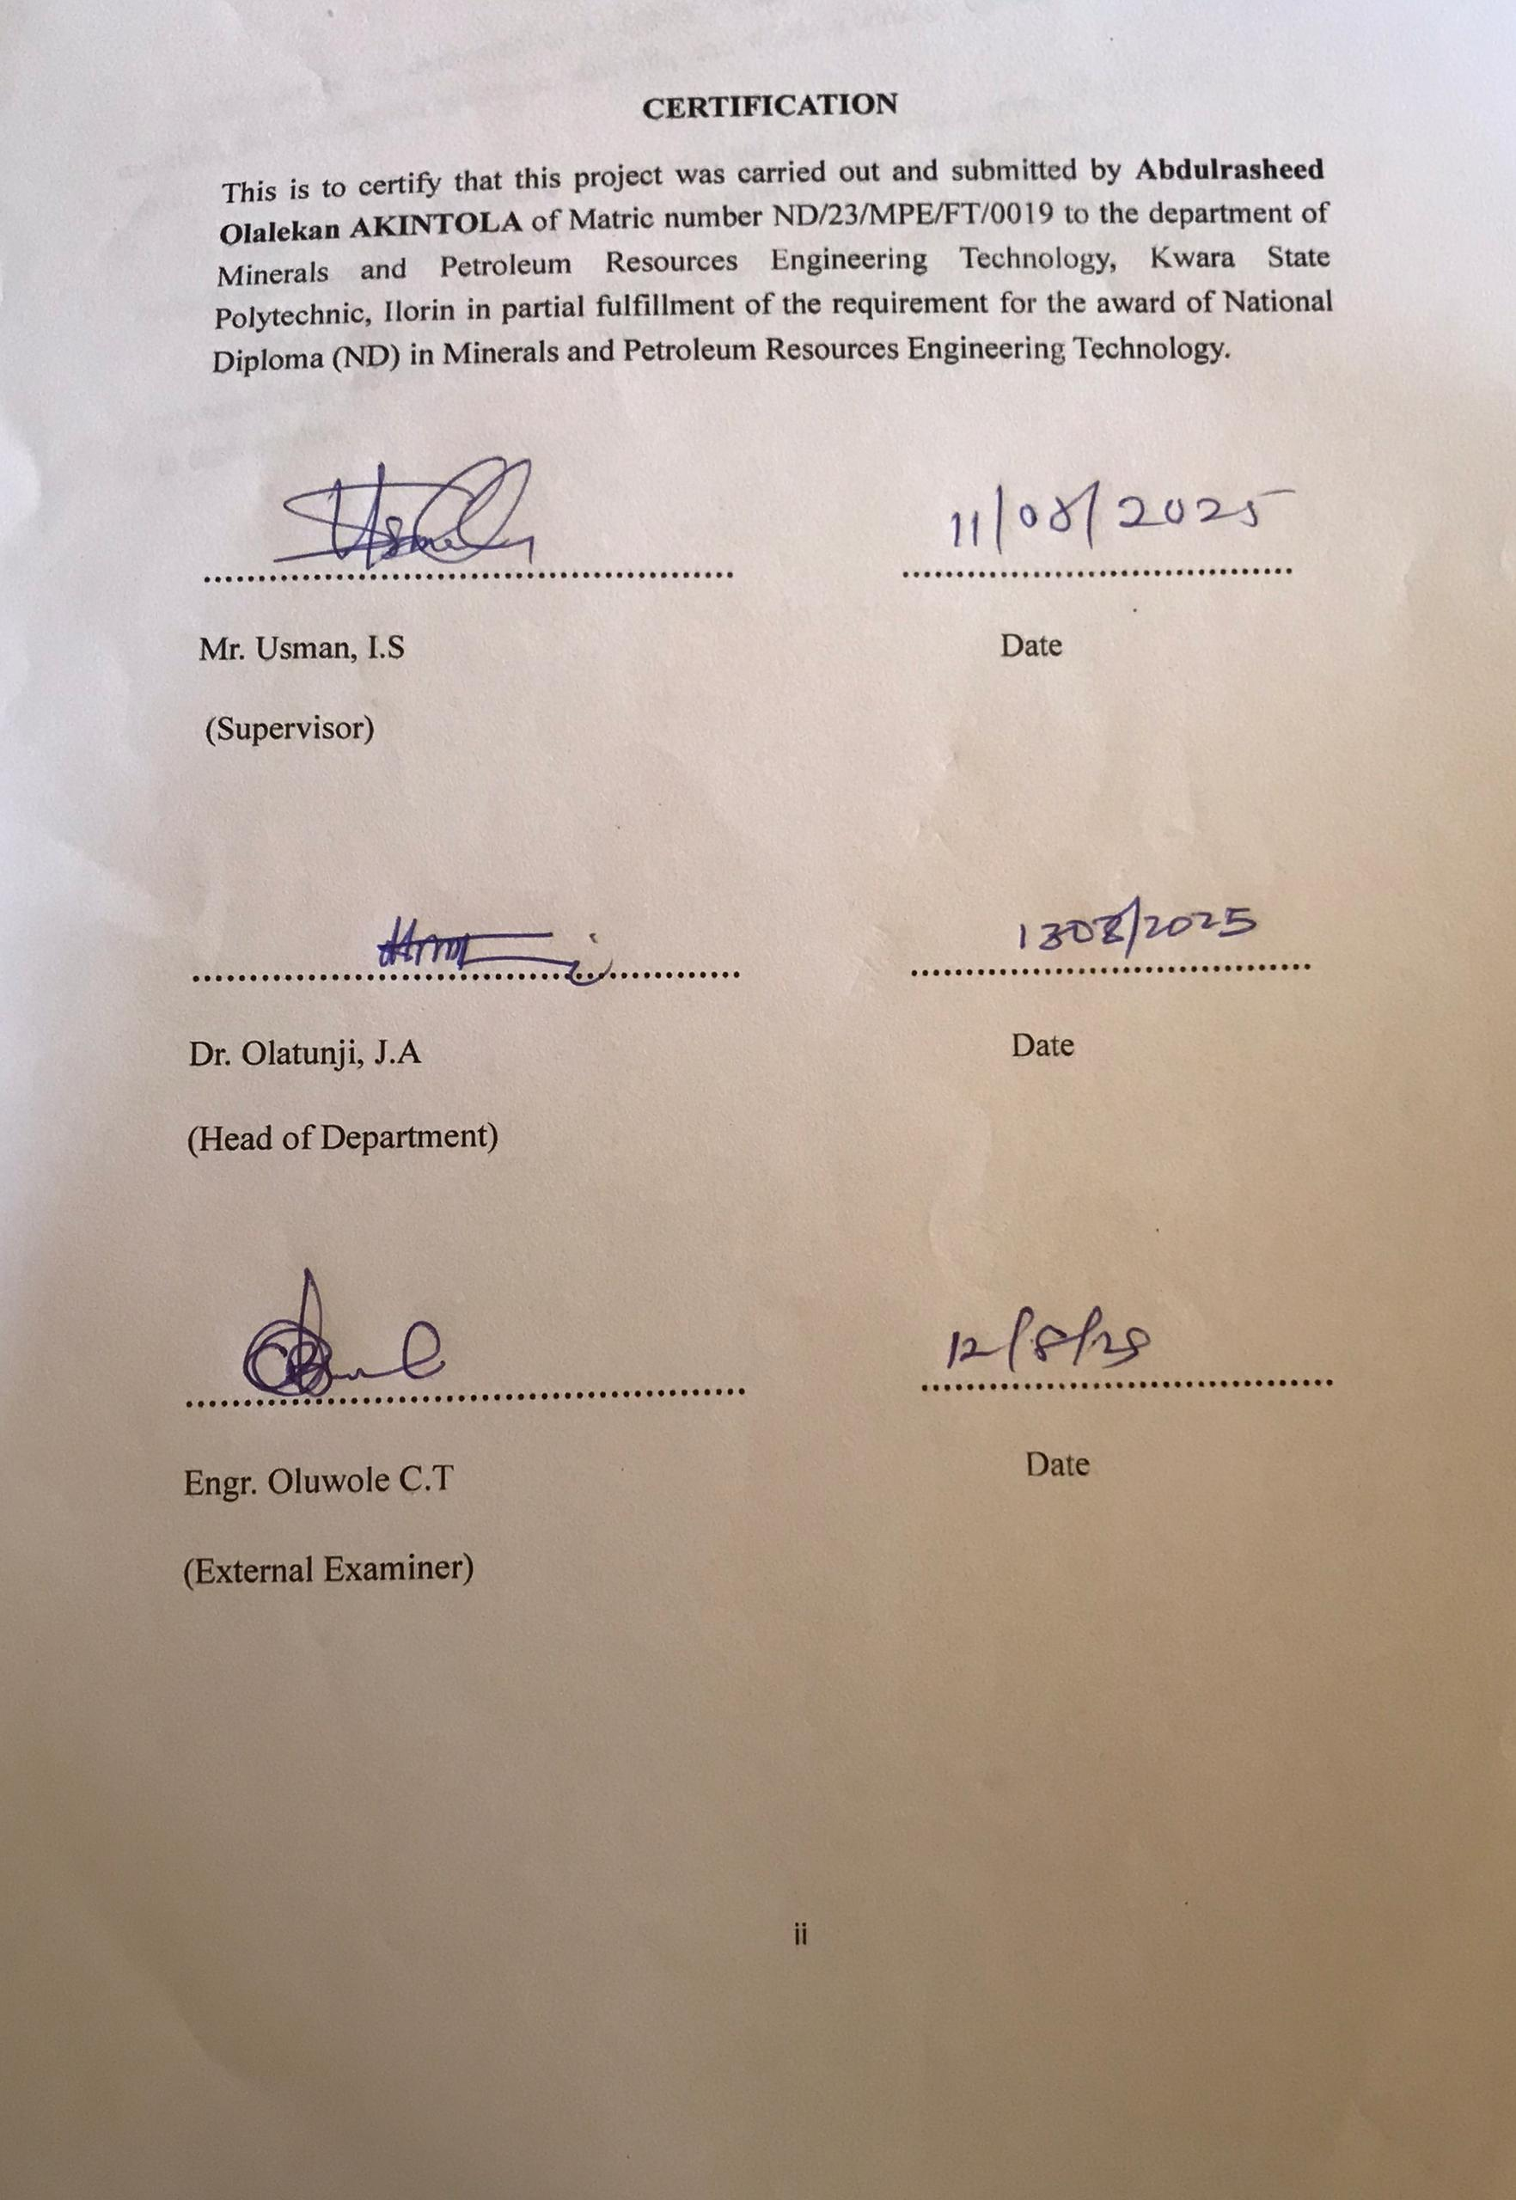

DEDICATION
This project is dedicated to Almighty Allah, The most Gracious the most merciful, for his endless guidance, strength, and wisdom through the course of this work.
I also dedicate this work to my beloved parents, whose love, prayers and support have been a constant source of encouragement in my academic journey.
Finally, this project is dedicated to all students of mineral and petroleum resources engineering technology both present and future who service for excellence in their studies.

ACKNOWLEDGEMENTS
My profound gratitude goes Almighty God for the successful completion of my program, also my deepest gratitude goes to my supervisor engr. Usman I.S, who provide detail criticism of the draft and help to correct necessary area of the write up part before him.
I also thank Dr. Olatunji J.A and entire member of staff of department of minerals and petroleum resources engineering technology.
I appreciated the effort of brother, sister and colleagues for their morally and financially support provided for me during the write up of the project.

TABLE OF CONTENTS
Cover page i
Certification ii
Dedication iii
Acknowledgements iv
Table of Contents v
List of Tables vi
List of Figures vii
Abstract viii
Chapter one
- Introduction 1
1.1 Scope of the project 2
1.2 Aim and Objectives 2
1.3 Statement Problem 3
1.4 Justification 3
Chapter two
2.0 Literature review 4
2.1 Geology of the study area 4
2.2 Occurrence of Lepidolite 7
2.3 Characteristic of Lepidolite 7
2.4 Lithium Ore 8
2.5 Application of Lithium 11
Chapter three
3.0 Materials and Methods 12
3.1 Materials 12
3.2 Methods 13
3.3 Description of study area 13
3.4 Sample collection 15
3.5 Sample preparation 15
3.5.1 Atomic Absorption Spectrometry (AAS) 16
3.5.2 Petrographical (Thin Section) analysis 17
Chapter four
4.0 Result presentation and discussions 19
4.1 Atomic Absorption Spectrometry (AAS) results 19
4.2 Petrographical (Thin sections) analysis results 19
4.3 Discussions of the result 25
Chapter five
5.0 Conclusion and recommendations 26
5.1 Conclusions 26
5.2 Recommendations 26
References 27
Appendix 28

LIST OF TABLE

Table 1: Summary of particle size distribution of the studied sample
Table 2: Summary of measured properties
Table 3:Sample composition distributions of soil in the study area
Table 4: Soil classification according to AASTHO (2019)

LIST OF FIGURE

Figure 4.1: Cumulative Particle size distribution curve for sample S1,S2&S3
Figure 4.2: Cumulative Moisture content curve for sample S1,S2&S3
Figure 4.3: Classification of the studied Lateritic soil using Casagrande plot of Liquid Limit (%) versus Plasticity Index.
Figure 4.4: Cumulative curve of dry density/water contents
Figure 4.5: Cumulative CBR for Top and Bottom A
Figure 4.6: Cumulative CBR for Top and Bottom B
Figure 4.7: Cumulative CBR for Top and Bottom C

ABSTRACT
Geotechnical analysis on Lateritic soil is done to establish the surface and sub surface conditions of the materials through their mechanical and physical properties. This study examine samples from Budo-Efo and Environs in Ilorin, Kwara State, where three samples were collected from three locations. The samples were analyzed at Department of geology and Mineral Science ,University of Ilorin. The test conducted were specific gravity, moisture content, atterberg consistency limit, compaction, shrinkage limi and California bearing ratio. The results are specific gravity range from (2.53-2.86g/cm³), moisture content (7.72-11.32%), liquid limit (17.1-31.0%), plastic limit (15.5-30.3%), plastic index (11.8-41.2%), maximum dry density (1.54-1.88 g/cm³), optimum moisture density (13.0-22.3%), shrinkage limit range between (4.6-11.8%) and un soaked CBR (24-49%) and soaked CBR (9-28%). The results obtained implies that the values were within the Nigeria Standard requirements for materials to be use as base and sub-base grade for road constructions.

CHAPTER ONE
INTRODUCTION
1.1 BACKGROUND OF THE STUDY
The condition and performance of road infrastructure are vital indicators of economic and social development, particularly in emerging nations where roads often serve as the main mode of transport for people, goods, and services. In rural and peri-urban areas like Budo Effo and its surrounding communities in Ilorin, Kwara State, roads are essential in linking farmers to markets, students to schools, and patients to healthcare. Yet, the effectiveness of these roads is closely tied to the quality of the materials used in their construction, especially the underlying soil (World Bank, 2019; Osinubi et al., 2011).
Lateritic soil, found extensively in Nigeria and other tropical countries, has become a cornerstone in road construction due to its natural abundance and low cost. It is a product of intense weathering processes in hot and humid climates, which leach away silica and enrich the soil with iron and aluminum oxides (Gidigasu, 1976; Bell, 1993). This process leaves behind a residual soil that, when dry, is firm and often usable as a construction material. In Ilorin and surrounding areas, contractors and government agencies frequently source laterite from local borrow pits to construct or rehabilitate roads, especially feeder routes linking rural areas like Budo Effo to the city (Adeyemi, 1995).
However, the engineering performance of lateritic soil is far from uniform. While it may be strong and stable in some locations, it can be weak and water-sensitive in others. Factors such as parent rock material, depth of weathering, rainfall intensity, groundwater fluctuations, and drainage conditions significantly influence its behavior (Ola, 1983; Amadi et al., 2012). For instance, some laterites exhibit high plasticity, which makes them expand and contract under wetting and drying cycles, leading to road surface cracking and deformation (Osinubi & Eberemu, 2009).
This inconsistent behavior makes it risky to rely solely on visual or local experience when selecting soil for roadworks. Roads constructed without proper assessment of the subgrade material are prone to early failure, especially in areas with seasonal rainfall and heavy vehicular loads. This problem is not theoretical — it is a recurrent issue in Budo Effo, where several roads constructed with untested lateritic materials have deteriorated within a few years due to rutting, erosion, and loss of compaction (Nwaiwu & Okeke, 2019; Hassan & Othman, 2017).
To prevent such outcomes, civil engineers must evaluate the physical and engineering properties of laterite soil before using it in road projects. These properties include grain size distribution, Atterberg limits (which indicate plasticity), moisture content, maximum dry density, optimum moisture content, and California Bearing Ratio (CBR) — all of which directly impact how the soil performs under load (Mustapha & Osinubi, 2010; Nnochiri et al., 2021). For example, a low CBR value suggests the soil cannot adequately support traffic stress, and would require stabilization or replacement.
Despite this knowledge, many rural road projects in Nigeria still proceed without adequate geotechnical testing due to budget constraints, lack of laboratory access, or urgency in project delivery. This has led to a pattern of substandard roads that require frequent maintenance, ultimately costing more in the long run (Choudhury & Das, 2019). In response, several researchers have explored ways to improve the behavior of lateritic soils through chemical stabilization, involving additives such as cement, lime, fly ash, sugarcane bagasse ash, and rice husk ash (Basha et al., 2005; Bello & Ige, 2012). These methods not only increase strength but also reduce plasticity and moisture sensitivity.
Moreover, the environmental and economic benefits of using local lateritic soils — especially when treated or modified for performance — are substantial. Locally sourced materials reduce transportation costs, cut down on carbon emissions from quarrying and hauling aggregates, and support job creation within the community (Sulaimon et al., 2018). These benefits make the proper utilization of laterite not just an engineering decision but a developmental strategy. According to Akinwumi (2014), with the right testing and treatment, even naturally weak lateritic soils can be transformed into strong, durable road bases.

In the context of Budo Effo, where laterite is often the only economically viable road material, this study becomes critically important. It seeks to assess the physical characteristics of lateritic soil in the area and determine whether it meets the requirements for road construction or whether it must be improved through stabilization. The outcome will not only guide road construction practices locally but also serve as a reference for other communities in similar geological and climatic settings.
In summary, the background of this study lies in a practical challenge faced by local authorities and engineers: how to build longer-lasting roads using the materials available. Lateritic soil holds great promise but also poses serious risks when used without proper assessment. This research aims to bridge that gap, combining geotechnical analysis, local context, and engineering best practices to support sustainable road infrastructure in Budo Effo and beyond.
1.2 Statement of the Problem
In recent years, road failure has become a persistent issue in many parts of Nigeria, particularly in rural and peri-urban areas like Budo Effo in Ilorin. Roads that are expected to last for 10 to 15 years are instead showing signs of serious distress — including cracking, rutting, potholes, and surface deformation — within just a few years of construction. These failures do not always stem from poor design or workmanship alone. In many cases, they are the result of using unsuitable or improperly assessed subgrade materials, particularly lateritic soils that haven’t undergone adequate geotechnical evaluation.
In regions where laterite is naturally abundant, there's a common practice of excavating and using it directly for subgrade or base construction — often without laboratory testing. This reliance on laterite is based more on tradition and convenience than on verified performance (Gidigasu, 1976; Nwaiwu & Okeke, 2019). However, lateritic soils vary significantly in their engineering properties depending on location, depth, weathering intensity, and mineral content (Osinubi & Eberemu, 2009). What performs well in one area may fail disastrously in another.
In Budo Effo, many road projects are implemented under time or budget pressure, leading contractors to use locally sourced soil without full characterization. The consequences of this are visible: roads become impassable during the rainy season due to water retention in the subgrade, or they develop ruts and soft spots under moderate traffic due to poor compaction or high plasticity of the soil (Choudhury & Das, 2019). These failures not only create transportation difficulties but also waste public funds and hinder regional development.
Several factors contribute to this ongoing issue:
Lack of soil testing laboratories in rural areas, making it difficult to analyze lateritic samples before construction begins.
Insufficient training and awareness among local contractors and supervisors regarding the importance of geotechnical evaluation.
Limited access to stabilizing agents like cement, lime, or industrial waste products, which could otherwise improve weak soils.
Pressure to complete projects quickly, especially under political deadlines, which often leads to shortcuts in material testing.
As a result, soil suitability assessments are often skipped, and construction moves forward based on visual inspection or outdated assumptions. This makes roads vulnerable to rapid deterioration, especially in a climate like Ilorin’s, where alternating dry and wet seasons can drastically affect soil behavior (Oloruntoba & Afolabi, 2019).
Given these challenges, it becomes clear that the problem is not simply the use of laterite — but the lack of a detailed, localized understanding of its properties. Without proper knowledge of the particle size, moisture sensitivity, compaction characteristics, and CBR values of the laterite used in Budo Effo, any road built on it is a structural gamble. This research addresses that gap by analyzing the physical characteristics of lateritic soil in the area and evaluating its fitness for road construction.
1.3 Aims and objectivee
The primary aim of this study is to evaluate the physical and geotechnical properties of lateritic soils in Budo Effo and its surrounding environment in Ilorin, to determine their suitability for use in road construction, particularly as subgrade and base materials.
To provide recommendations on the utilization of lateritic soils in the study area for road construction purposes, including suggestions for soil improvement or stabilization if necessary.
1.4 Justification of the Study
The persistent challenge of premature road failure in Nigeria — especially in rural and semi-urban areas like Budo Effo in Ilorin — calls for a more scientific and localized approach to road construction. Roads in this region are often built using lateritic soils, primarily because they are abundant, cheap, and relatively easy to work with. However, despite these advantages, many of these roads begin to fail after only a few rainy seasons, exhibiting cracks, surface erosion, and structural instability. These failures highlight a recurring problem: the inadequate evaluation and understanding of the physical properties of lateritic soils before they are used as construction materials.
1.5 scope of the study
The scope is deliberately narrowed to this location due to the area's dependence on locally sourced lateritic soil for road construction and the growing need to address recurring cases of early road failure.

CHAPTER TWO
LITERATURE REVIEW
2.1 Overview of Laterite Soil
Laterite soil is one of the most prevalent naturally occurring materials in tropical regions, especially in countries such as Nigeria, Ghana, India, and Brazil. In these areas, laterite is not just common — it is an integral part of the earth's upper crust and serves as a vital construction resource, particularly in roadworks. Its distinct reddish-brown appearance comes from its high iron and aluminum oxide content, which accumulates over time due to intense leaching and weathering of rocks (Gidigasu, 1976; Bell, 1993).
In Nigeria, especially in Ilorin and the surrounding Budo Effo area, lateritic soil is widely available and often used for road construction because it is accessible, cost-effective, and, in some cases, possesses adequate load-bearing strength when compacted. However, despite its abundance, engineers and researchers have observed significant variability in its behavior under load, moisture, and changing weather conditions (Ola, 1983; Adeyemi, 1995). These inconsistencies have made it essential to conduct localized studies before using laterite for any engineering purpose.
Because of its widespread availability, many road projects have used laterite without proper soil testing or engineering verification — a decision that often results in poor pavement performance and costly early repairs. Therefore, understanding the behavior of laterite and its suitability for specific geotechnical applications is a critical aspect of modern civil engineering practice (Osinubi & Eberemu, 2009).
2.2 Formation and Composition of Laterite Soil
Lateritic soils are residual soils, meaning they form in situ from the chemical weathering of parent rocks. Over time, rainfall and temperature changes leach out soluble minerals such as calcium, sodium, potassium, and silica, leaving behind insoluble iron and aluminum oxides, which harden to form laterite (Amu et al., 2011). The process is influenced by local climate, drainage, topography, and the mineral composition of the parent rock.
In southwestern Nigeria, lateritic soils typically derive from granite, gneiss, and schist, which produce sandy and gravelly laterites depending on the depth and intensity of weathering (Ola, 1983). These laterites may contain quartz, kaolinite, goethite, and gibbsite, each influencing plasticity, drainage capacity, and mechanical strength (Aghamelu & Okogbue, 2011).
The formation process also affects the soil's internal structure. Some lateritic soils become cemented over time due to the accumulation of iron oxides, leading to the formation of nodules or hardened crusts. These cemented layers may appear strong in their natural state but can disintegrate under load or moisture if not properly compacted and stabilized (Nnochiri et al., 2021).
Understanding the composition of laterite is essential because it affects how the soil behaves in road applications. For instance, soils with high clay content tend to swell and shrink with moisture changes, while silty laterites may offer poor drainage. These variations highlight the importance of localized geotechnical investigations before construction begins (Choudhury & Das, 2019).
2.3 Physical and Engineering Properties of Laterite Soil
The engineering application of lateritic soils depends on their physical properties, which must be thoroughly assessed before use in road construction. Key properties include:
Grain size distribution
Plasticity (Atterberg limits)
Natural moisture content
Maximum dry density (MDD)
Optimum moisture content (OMC)
California Bearing Ratio (CBR)
These tests help determine the soil’s classification, strength, and compaction behavior (Mustapha & Osinubi, 2010).
The grain size distribution helps classify the soil and determine whether it has more sand, silt, or clay. Sandy laterites generally drain better but may be less cohesive. On the other hand, clayey laterites offer better cohesion but may retain water, making them weaker under soaked conditions (Ijimdiya, 2013). The Atterberg limits — specifically the plasticity index — reveal how the soil will behave under moisture fluctuation. Soils with high plasticity indices tend to expand and contract, which can damage pavement layers over time (Bello et al., 2015).
Compaction tests such as the Standard Proctor test provide information on the maximum dry density and the moisture content required for optimal compaction. A lateritic soil with a high MDD and a low OMC is ideal for road subgrades. Meanwhile, CBR testing measures load-bearing strength. A CBR value of 10% or higher is generally acceptable for subgrade materials, though higher values are preferred for base layers (Osinubi et al., 2011).
The physical properties of lateritic soils in Budo Effo and Ilorin are likely to differ based on the site, depth of excavation, and seasonal moisture content. That’s why blanket assumptions about laterite suitability often lead to early road failure, especially during heavy rainfall.
2.4 Importance of Laterite Soil in Road Construction
Lateritic soils play a critical role in road construction in tropical regions due to their natural availability and relatively good performance when handled correctly. In rural and peri-urban communities like Budo Effo, where high-grade aggregates and processed materials may be costly or unavailable, laterite becomes the most practical solution (Agbede & Afolabi, 2007).
When lateritic soils are compacted properly, they can serve as durable and economical subgrade and subbase materials, supporting the layers above them and distributing the load from vehicle traffic. In areas where budgets are limited, this material offers a cost-effective way to develop infrastructure while still achieving reasonable performance (Alhassan, 2008).
Additionally, using locally sourced materials like laterite contributes to sustainable engineering practices. It reduces carbon emissions related to transportation, minimizes quarrying of natural rock, and supports community-based material sourcing (Akinwumi, 2014).
However, the benefits of laterite can only be realized if the material is correctly assessed and, where needed, stabilized. Roads that fail prematurely due to softening subgrades, swelling, or rutting often suffer from the misuse of untreated or unsuitable laterite (Nwaiwu & Okeke, 2019).
2.5 Factors Affecting the Suitability of Laterite Soil for Road Construction
The suitability of lateritic soil for road use is influenced by both internal and external factors. Internally, the soil’s composition — including mineralogy, grain size, moisture content, and plasticity — determines how well it can withstand the mechanical stresses of traffic and weather (Sulaimon et al., 2018).
Externally, factors such as climate, rainfall, construction method, and drainage conditions also play a role. For example, in humid climates like that of Ilorin, seasonal water infiltration can cause swelling in clayey laterite, leading to surface deformation and cracking (Choudhury & Das, 2019). Improper drainage further worsens these issues, as standing water weakens the subgrade.
The depth and method of soil collection also affect laterite behavior. Topsoil often contains organic matter, which lowers strength. It is advisable to use soil from depths of 1 to 1.5 meters, where organic material is minimal (Osinubi & Eberemu, 2009).
To address weak or moisture-sensitive soils, various stabilization techniques are used. Lime, cement, and industrial by-products like rice husk ash have been found effective in increasing strength and reducing plasticity (Basha et al., 2005). Stabilized lateritic soils can match or exceed the performance of conventional base materials when properly prepared and compacted.
2.6 Standards and Guidelines for Soil Testing in Road Construction
Reliable soil testing is the foundation of every successful road project. In Nigeria, soil evaluations for construction are guided by both local standards and international protocols such as those from AASHTO, ASTM, and the Federal Ministry of Works. These standards define acceptable soil parameters for different layers of a pavement structure — from subgrade to base course (Oloruntoba & Afolabi, 2019).
Testing typically includes particle size analysis, Atterberg limits, moisture content, compaction tests, and CBR evaluation. Results are compared against benchmarks to decide if the material is suitable or needs improvement. For instance, Nigerian road design standards recommend a minimum CBR of 10% for subgrades and 30% for base layers, depending on traffic loading.
Soils are also classified under systems like the Unified Soil Classification System (USCS) and AASHTO Soil Classification, which group soils based on plasticity and grain distribution. A lateritic soil categorized as A-2-6 under AASHTO, for example, may be suitable if properly compacted and drained (Ijimdiya, 2013).
CHAPTER THREE
MATERIALS AND METHODS
3.1 Materials
The materials involves in the samples taken were digger, spade, polytene bags, masking tape, marker, pan, Global Positioning System (GPS) and writing materials such as pen and exercise book.
3.2 Methods
3.2.1 Description of the study area
The study area is located in Budo Efo, Ilorin South Local Government area of Kwara State. The Lateritic soil is buried and exposed around in the study area, the site is on Latitude N8˚11ʹ53ʺ and Longitude E4˚47ʹ42ʺ for location A, Latitude N8˚26ʹ32ʺ and Longitude E4˚36ʹ36ʺ for location B while N8˚26ʹ39ʺ and Longitude E4˚36ʹ42ʺ for location C. The study area is accessible through local road.
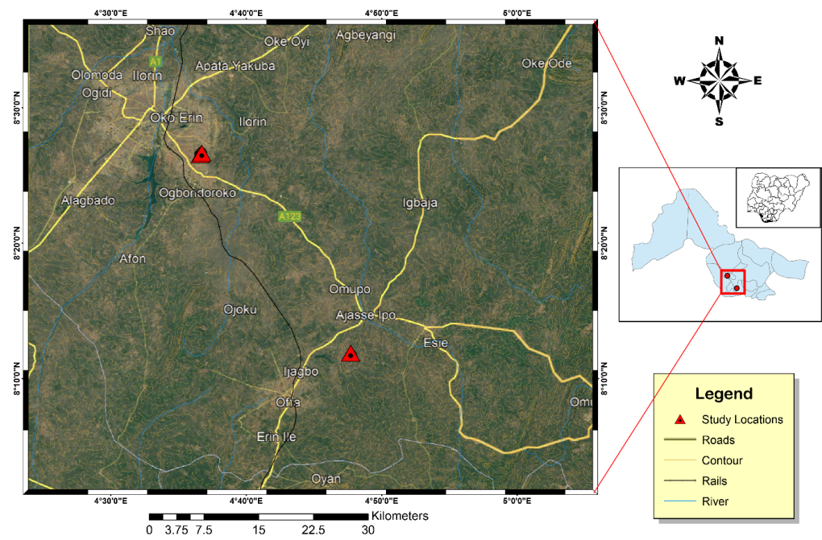

Figure 3.2a: Map showing the study area

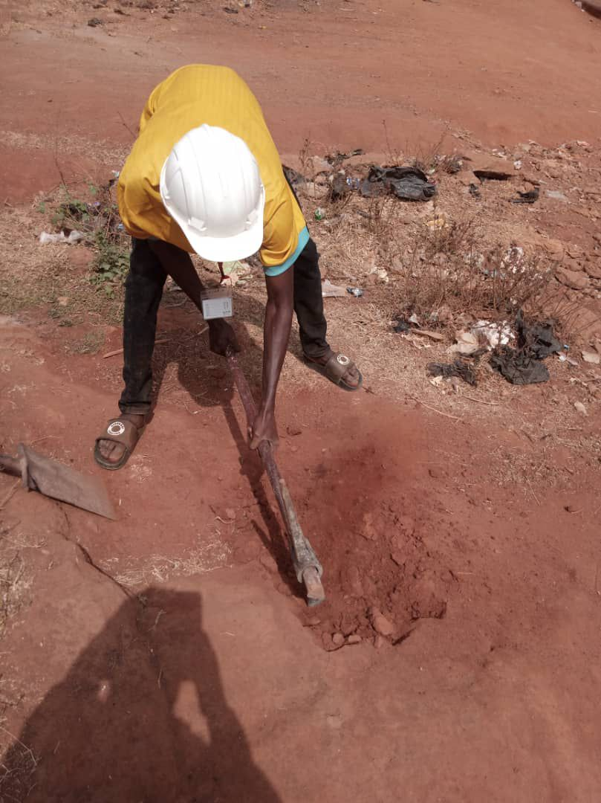
Figure 3.2b: shows the photograph of the study area
3.2.2 Sample Preparation
The samples were pulverized sieved at the department of geology and mineral sciences laboratory, University of Ilorin.
3.2.3 Sample Analysis
The samples were subjected to various analysis such as particle size distribution, atterberg consistency limit, compaction test, free swelling potential, and compressibility.

3.2.3.1 Water Content Determination
The water content of a soil is also called the natural moisture content of the soil, it is defined as the ratio of the weight of water present in a soil to the weight of the dry soil, and it is expressed in percentage. It is mathematically expressed as;
w = Ww/Ws x 100
where w = water content
Ww = weight of moisture
Ws = weight of dry soil
3.2.3.1.1 Apparatus Used
Moisture can
Drying oven
Weighing balance
Desiccator
3.2.3.1.2 Procedure
- A non-corrodible can was weighed on the weighing balance as W₁
- Soil sample was added into the can and weighed as W₂
- The sample was oven dried for 24hrs at a temperature of about 105⁰C to 110⁰C
- The sample was placed in a desiccator to cool after removal from oven
- The dried sample was then weighed as W₃
- The overall process was repeated for all the soil samples and their respective water contents were determined.

3.2.3.2 Bulk and Dry Density
3.2.3.2.1 Bulk Density
Bulk density is defined as the mass of the soil divided by its volume, it is the weight of representative wet soil sample to the volume of the mould containing such sample. It is expressed as mass per unit volume (i.e. g/cm³). It helps to determine how heavy the soil sample is and to determine the bearing capacity of the soil i.e. the mount of the load the soil can carry successfully.
3.2.3.2.1.1Apparatus Used
Mould
Weighing balance
Drying oven
Spatula and pestle
3.2.3.2.1.2 Procedure
- An empty mould is weighed (i.e. weight of mould)
- The volume of the mould was also determined (V)
- The mould is then filled with fresh soil sample, consolidated and weighed (i.e. weight of mould + soil)
- The weighed of the wet soil was calculated by subtracting the weight of empty mould from the weight of wet soil and mould
- The bulk density was deduced using the formula below:
ϒ = W/V
W = weight of representative wet soil sample
V = volume of mould

3.2.3.2.2 Dry Density
Dry density is defined as the ratio of the weight of the dry soil sample to the
volume of the mould containing the dry soil sample.
3.2.3.2.2.1 Apparatus Used
Weighing balance
Drying oven
Spatula
Pan
Desiccator
3.2.3.2.2.2 Procedure
- An empty pan was weighed
- A known volume of the mould from bulk density determination was taken (V)
- The mould with fresh soil sample being consolidated was discharged into the pan for oven drying at 110⁰C until water was completely expelled
- The weighed of the dry soil was calculated by subtracting the weight of empty pan from the weight of dry soil and pan
- The dry density was deduced using the formula below:
ϒ = W/V
W = weight of representative dry soil sample
V = volume of mould
3.2.3.3 Specific Gravity Determination
3.2.3.3.1 Apparatus Used
Density bottle
Measuring cylinder
Weighing balance
3.2.3.3.2 Procedure
- An empty measuring cylinder was weighed as (W₁)
- It is then filled with soil to about 1/3 of its volume, then its weight together with the soil was taken as (W₂)
- The water was added to the soil in the measuring cylinder, the weight of the cylinder with both soil and water was taken as (W₃)
- Empty the measuring cylinder, fill it with distilled water and its weight was taken as (W₄).
- Specific gravity was calculated using the formulae below
(W₂ -W₁)/ (W₄ -W₁) – (W₃ -W₂) X 100
3.2.3.4 Grain Size Analysis
Grain size refers to the diameter of the soil particles that make up the soil mass. This analysis covers the quantitative determination of the various sizes of these soil particles, their proportions to the nearest percentage and the distribution of the various grain sizes that makes up the soil.
Grain size analysis is a very important analysis, which is done in an attempt to describe a soil type. A roughly concluded result is made by the physical description of the soil particles grain distribution, but a more accurate result is gotten by performing the laboratory analysis. This analysis is done in order to know the accurate distribution of the various grain sizes that make up the soil, and helps to solve the problem of confusion between silt and clay. This method entails mechanical and hydrometer analyses respectively.
3..2.3.4.1 Mechanical Sieve Analysis
The sieve analysis involves shaking of the soil sample through a set of sieves that have progressively smaller openings. This method is used in the analysis of particles greater than 0.075mm in diameter. It provides a means of evaluating the different grain size types present in soil sample.
3.2.3.4.1 Apparatus Used
- Stack of sieves
- Mechanical sieve shaker
- Drying oven
- Collecting pan and cleaning brush
- Weighing balance
3.2.3.4.2 Procedure
(a) The soil particles were gently disaggregated
(b) The sieve set (i.e. stack of sieves) were arranged in descending order from the top with a retainer beneath it.
(c) 100g of the soil was weighed and poured into the sieve stack.
(d) The sieve stack was then placed on the mechanical sieve shaker for about 10 minutes
(e) The sieve stack was now separated one by one, then the soil fraction retained in each sieve was weighed and recorded
(f) A statistical data of the result of the analysis was prepared.
3.2.3.4.2 Hydrometer Analysis
This method is used in the determination of the grain distribution of fine-grained soils with soil particles of the order of clay and soil. This method is not applicable if less than 10% of the soil passes through sieve size of 0.075mm mesh size.
3.2.3.4.2.1 Apparatus Used
- Hydrometer bulb
- Measuring cylinder
- Drying oven
- Thermometer
- Evaporating dish
3.2.3.4.2.2 Procedure
(a) The sieved clay and silt from the sieve washing were collected in a container and allowed to settle
(b) The supernatant water was decanted and the mud residue was dried in the drying oven for about 24 hours
(c) The dried sample was then pulverized, 50g of it was weighed and dissolved in one liter of water in a measuring cylinder. The water has dissolved in it sodium hexametaphosphate to enhance rate of clay settlement.
(d) The hydrometer bulb is then inserted into the water in the measuring cylinder and its reading was recorded periodically.
(e) As the settling proceeds, the hydrometer sinks into the solution
(f) The temperature at each hydrometer reading was recorded and then a statistical data was produced.
(g) Then, the percentage passing was plotted against diameter to obtain the percentage composition of the studied soil samples.

      - Atterberg Consistency Limits
3.2.3.5.1 Liquid Limit Determination
3.2.3.5.1Apparatus Used
- Casagrande liquid limit device (made up of a cup, a rotating handle, counter and a cutting groove)
- Pestle and mortar
- Spatula
- Moisture can
- Wash bottle with distilled water
- Sieve 0.425mm
- Oven
- Glass plate
3.2.3.5.2 Procedure
(a) A dried, fresh soil sample is pounded using the pestle and mortal
(b) The sample was sieved using the 0.425mm sieve size, 300g of the sieved sample was weighed and water was added to it until a stiff paste was produced.
(c) The stiff paste was packed into the Casagrande apparatus and then had the surface leveled and smoothened using the spatula.
(d) A groove in the soil was made with cutting groove and rotated the handle (blows) until the groove close. (Note that the number of revolutions the handle makes blows is recorded by the counter). The minimum number of blows is 10 while the maximum is 50.
(e) A small paste was scooped into the moisture can with the spatula, weighed and dried in the drying oven for 24 hours and then reweighed in order to determine its water content.
(f) The soil is then emptied from the cup into the glass plate and water is added to the soil and the process is performed all over again.
(g)The water contents (%) were plotted against numbers of blow (N), water content corresponding to 25 number of blows is the liquid limit
        - Plastic Limit Determination
3.2.3.5.2.1 Apparatus Used
- Glass plate
- Moisture can
- Spatula
- Wash bottle with distilled water
- 0.425mm sieve
- Thermostat oven
3.2.3.5.2.2 Procedure
(a) A small part of the paste in the Casagrande cup is scooped and rolled into a ball
(b) The ball is placed on the glass plate and rolled into thread until it breaks
(c) The crumbled threads are put into two different moisture cans. Then, the cans with crumbled soil sample were oven dried for 24 hours so as to determine the moisture content of each sample, which was taken as plastic limits.
3.2.3.5.3 Linear Shrinkage Determination
(a) The soil sample was thoroughly mixed with distilled water
(b) A linear container of known length was taken and lubricated for easy removal of the soil sample
(c) The container was then filled with the soil sample and its original length was measured before it was oven dried for about 24 hours
(d) The container was allowed to cool in a desiccator, and then the final length of the dried soil sample is measured.
(e) The linear shrinkage of the studied soil samples was calculated using the formula below:
LS = change in length x 100
Original length
3.2.3.6 Compaction Test
3.2.3.6.1 Apparatus Used
- Mixing pan
- Weighing balance
- Drying oven
- Moisture can
- Spatula
- Compaction rammer and mould (consisting of base plate, cylinder mould andextension collar).
3.2.3.6.2 Procedure
(a) 3kg of soil sample was weighed and poured into the mixing pan
(b) 120cm³ (4%) of water was measured, added and mixed with the soil in the mixing pan with the use of spatula.
(c) The cylinder mould is then placed on a base plate, then a representative specimen of the soil is put into the mould and compact with 25 evenly distributed blows of rammer. This represents the first layer.
(d) After the compaction, the volume of the soil in the mould reduced, more soil specimen was added into the mould and compacted with another 25 evenly distributed blows.
(e) The extension collar is then fixed unto the mould. This is mainly for the last layer and removed after the last layer is made to be able to achieve a smooth level surface of the last layer.
(f) The mould is filled with more of the soil specimen and compacted to make the third layer.
(g) The mould with the soil is weighed and the soil sample at the top and bottom of the mould were taken for water content and dry density determination respectively.
(h) The soil in the mould is emptied into the mixing pan and another 120cm³ (4%) of water is added to the soil and mixed
(i) This process was now carried out four more times
(j) Then, the compaction curves were gotten by plotting dry densities against water contents.
3.2.3.7 California Bearing Ratio (CBR)
3.2.3.7.1 Apparatus Used
CBR mould with extension collar and base
Rammer (4.5kg)
Surcharge weight
Mixing plate
Measuring cylinder
Weighing balance
Spatula
3.2.3.7.2 Procedure
(a) 6kg of air- dried sample is measured into mixing pan.
(b) Water equivalent to the optimum moisture content (OMC) of the soil samples earlier calculated during compaction testis measured, added and well mixed with the soil.
(c)The mould is then filled with the soil and compacted with 25 evenly distributed blows on the 3 layers of the soil specimen.
(d) After making the third layer (fifth layer for modified Proctor), a surcharged weight of 2kg and 40mm thick is placed on the extension collar.
(e) The mould with the surcharge weight is placed on the CBR machine plate and the plate is adjusted until the piston of the machine makes contact with the soil inside the mould.
(f) The load and penetration gauge are set at zero just before the test proceeds by the motorized movement of the piston, and the corresponding readings on the load gauge were taken at different penetration levels. This is for the top reading.
(g) The mould was removed from the machine, turned upside down with the position of the base plate changed and then placed back on the plate of the CBR machine and repeat the procedure. This is for the bottom reading.

CHAPER FOUR
4.0 Results Presentation and Discussions
This chapter discusses the test conducted which include; particles size distribution, specific gravity, atterberg consistency limits comprises of liquid limit, plastic limit, plasticity index and shrinkage limit, water content, compaction test, and California bearing ratio (CBR) test as well as the interpretations.
4.1.1 Grain Size Analysis
Table 1: Summary of particle size distribution of the studied samples
Sample code | Dry Sieving(% passing) |  |  |  |  | Hydrometer (% passing)
Sample code | 5.0mm | 3.35mm | 2.0mm | 1.18mm | 0.6mm | 0.025mm | 0.002mm
A | 100 | 97.8 | 86.2 | 87.2 | 70.5 | 19.4 | 11.1
B | 100 | 100 | 95.2 | 88.4 | 75.6 | 26.0 | 12.5
C | 100 | 100 | 100 | 98.6 | 96.3 | 67.3 | 51.5

Table 2: Summary of measured properties
Properties of the soils | Sample A | Sample B | Sample C
Specific Gravity g/cm³ | 2.86 | 2.69 | 2.53
Moisture content (%) | 11.32 | 9.68 | 7.72
Liquid limit (%) | 27.2 | 31.0 | 17.1
Plastic limit (%) | 15.8 | 17.1 | 30.3
Plastic Index (%) | 11.4 | 13.5 | 41.2
Shrinkage limit (%) | 4.6 | 5.2 | 11.5
Maximun Dry Density | 1.88 | 1.82 | 1.54
Optimum Moisture Density | 13.2 | 14.6 | 22.3
Unsoaked CBR (%) | 49 | 47 | 24
Soaked CBR (%) | 28 | 20 | 9

Table 3: Samples composition distributions of Soils in the Study Area
Sample Location | Gravel (%) | Sand (%) | Silt (%) | Clay (%) | % Fine | Soil Classification
Sample 1 | 14 | 60 | 15 | 11 | 26 | Silty Sand
Sample 2 | 5 | 66 | 17 | 12 | 29 | Silty Sand
Sample 3 | 0 | 19 | 30 | 51 | 81 | Silty Clay

Table 4: SOIL Classification according to AASTHO (2019)
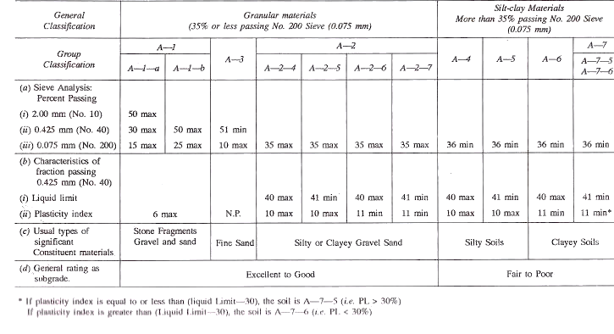

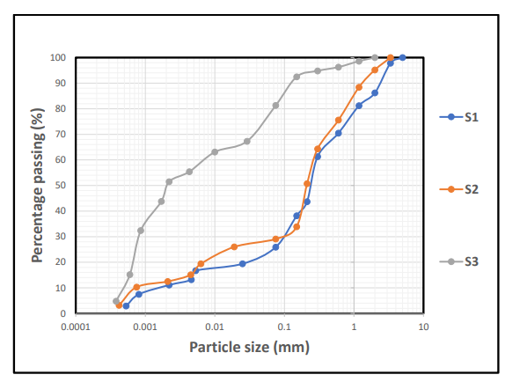
Figure 4.1: Cumulative Particle size distribution curve for sample S1,S2&S3

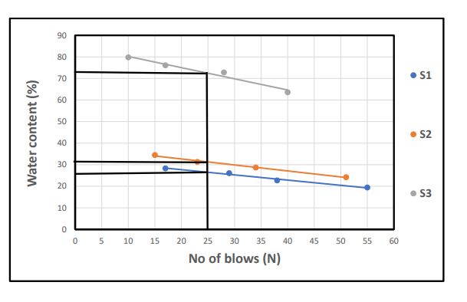
Figure 4.2: Cumulative Moisture content curve for sample S1,S2&S3

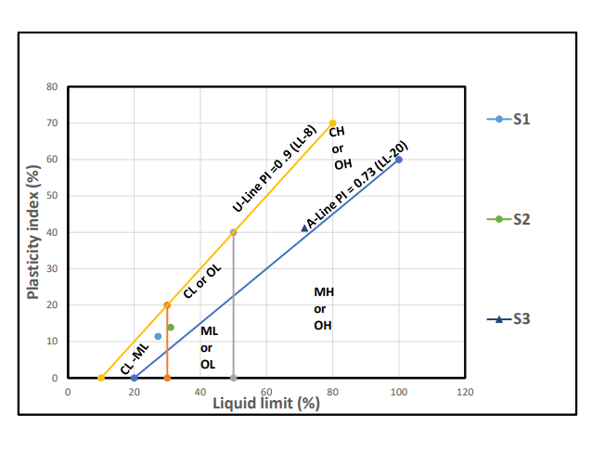
Figure 4.3: Classification of the studied Lateritic soil using Casagrande plot of Liquid Limit (%) versus Plasticity Index.
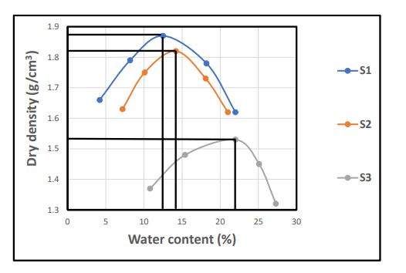
Figure 4.4: Cumulative curve of dry density/water contents

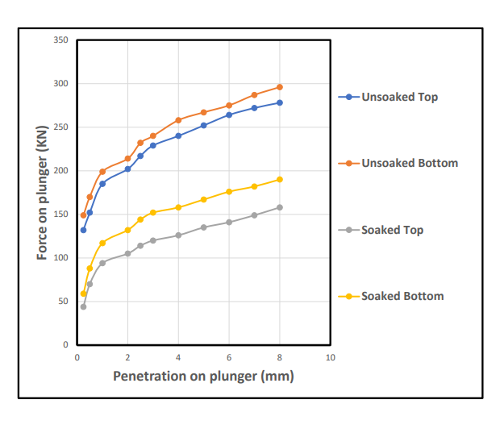
Figure 4.5: Cumulative CBR for Top and Bottom A

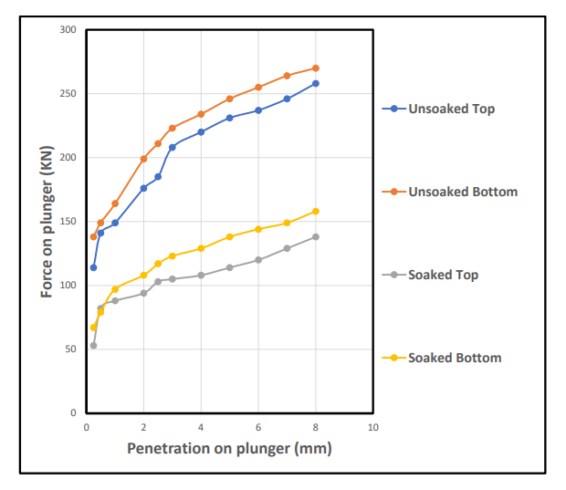
Figure 4.6: Cumulative CBR for Top and Bottom B

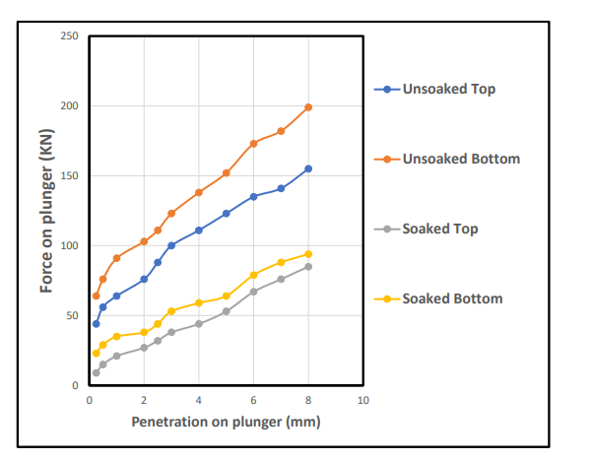
Figure 4.7: Cumulative CBR for Top and Bottom C

Discussions
The analysis carried out on lateritic soil generally have a good representation of either cohesive (i.e fine-grained portions) and cohesionless (i.e coarse-grained portions). The study samples for particle size distribution is shown in the Table 1 and Figure 4.1 with average percentage composition of sand (19-66%), silt (15-30%), Clay (11-51%), gravel (5-14%) and fine percentage range (26-81%) . Thess indicated from Table 4, that the studied sample is silty sand based on the AASHTO classification (2019). These type of materials are good for base grade and sub-base materials. The studied samples has plasticity limit (15.8-30.3%), liquid limit (17.1-31.0%), plastic index (11.4-41.2%), shrinkage limit (4.6-11.5%), specific gravity value (2.53-2.86g/cm³), moisture content (7.72-11.32%), maximum dry density (1.54-1.88Kg/m³), optimum moisture content (13.2-22.3%) and CBR (24-49%) for unsoaked while CBR value for soaked is (9-28%).The above results were suitable and found to be within the standard values for lateritic soil used for road construction as base materials.

CHAPTER FIVE
5.1 SUMMARY
This study assessed the physical and geotechnical properties of lateritic soils collected from Budo Effo and its surrounding environment in Ilorin. Laboratory investigations including water content, particle size analysis, Atterberg limits, compaction characteristics, and CBR tests — were carried out to determine the soils’ suitability for road construction.
Key findings include:
Sample S1 demonstrated superior properties, including high dry density (1.87 g/cm³), moderate plasticity (PI = 11.4%), and excellent load-bearing capacity (CBR = 49% unsoaked, 28% soaked).
Sample S2 also showed fair suitability with adequate strength and acceptable compaction characteristics, though slightly lower than S1.
Sample S3, however, exhibited high plasticity (PI = 41.2%), low dry density (1.53 g/cm³), and poor soaked CBR value (9%), indicating limited suitability unless stabilized.
5.2 Conclusion
Based on the test results, it can be concluded that lateritic soils from Budo Effo vary significantly in engineering performance. Samples S1 and S2 are generally suitable for use in subgrade or subbase layers in flexible pavement design, especially when compacted at their optimum moisture content. In contrast, Sample S3 is not ideal in its natural state due to its high clay content and moisture sensitivity.
Therefore, the use of laterite for road construction in this area must be site-specific and preceded by thorough geotechnical testing. Blanket use of untreated laterite, especially in high-clay zones like S3, is likely to lead to early road failure.
5.3 Recommendations
1. Use S1 and S2 soils for subgrade and subbase construction with proper compaction and moisture control.
2. Stabilize S3-type soils using lime, cement, or pozzolanic additives before applying them to any structural pavement layer.
3. Avoid shallow or organic-rich soil layers, as these significantly affect soil performance.
4. Ensure proper drainage design, particularly in clay-rich zones, to prevent water accumulation and subgrade failure.
5. Establish routine geotechnical testing as part of all future road construction planning in the Ilorin region to optimize material use and improve long-term durability.
6. Further studies should investigate the effect of stabilizers on S3-like soils to recommend cost-effective improvement methods for wider application.

REFERENCES
Adeyemi, G. O. (1995). The influence of parent rock on some engineering index properties of three residual lateritic soils in southwestern Nigeria. Bulletin of the International Association of Engineering Geology, 51, 5–10.
Agbede, I. O., & Afolabi, A. (2007). Improvement of the engineering properties of laterite by cement-lime mixture. Journal of Materials Research, 6(1), 103–110.
Aghamelu, O. P., & Okogbue, C. O. (2011). Geotechnical evaluation of soils from gully erosion sites in Agulu-Nanka region, southeastern Nigeria. International Journal of Environmental Sciences, 1(5), 1062–1070.
Akinwumi, I. I. (2014). Soil modification by the application of steel slag. Journal of Civil Engineering and Construction Technology, 5(5), 63–70.
Alhassan, M. (2008). Stabilization of laterite soil with sugarcane straw ash. Journal of Environmental Research and Development, 2(4), 703–711.
Amadi, A. N., Nwankwoala, H. O., Olasehinde, P. I., Okoye, N. O., Okunlola, I. A., & Alkali, Y. B. (2012). Geotechnical investigation of sub-soil for road construction around Bonny Island, Rivers State, Nigeria. Journal of Geology and Mining Research, 4(1), 61–68.
Amu, O. O., Fajobi, A. B., & Oke, B. O. (2011). Effect of egg shell powder on the stabilizing potential of lime on an expansive clay soil. Research Journal of Agriculture and Biological Sciences, 7(2), 75–83.
Basha, E. A., Hashim, R., Mahmud, H. B., & Muntohar, A. S. (2005). Stabilization of residual soil with rice husk ash and cement. Construction and Building Materials, 19(6), 448–453.
Bell, F. G. (1993). Engineering properties of soils and rocks (4th ed.). Oxford: Blackwell Scientific Publications.
Bello, A. A., & Ige, J. A. (2012). Geotechnical characterization of lateritic soils in parts of Ejigbo, southwestern Nigeria. Electronic Journal of Geotechnical Engineering, 17, 1419–1430.
Bello, A. A., Ige, J. A., & Ogunbode, A. (2015). Geotechnical properties of lateritic soil stabilized with coconut shell ash. FUTA Journal of Research in Sciences, 11(1), 150–162.
Choudhury, S., & Das, B. M. (2019). Principles of geotechnical engineering (9th ed.). Boston, MA: Cengage Learning.
Gidigasu, M. D. (1976). Laterite soil engineering: Pedogenesis and engineering principles. Amsterdam: Elsevier Scientific Publishing Company.
Hassan, M. M., & Othman, F. B. (2017). Effect of moisture content and compaction on strength of lateritic soil treated with cement kiln dust. International Journal of Engineering and Technology, 9(6), 443–448.
Ijimdiya, T. S. (2013). Effects of compactive efforts on the geotechnical characteristics of lateritic soil stabilized with bagasse ash. Electronic Journal of Geotechnical Engineering, 18, 1197–1214.
Mustapha, A. M., & Osinubi, K. J. (2010). Soil stabilization using coconut shell ash. Leonardo Electronic Journal of Practices and Technologies, 17, 85–94.
Nnochiri, E. S., Njoku, J. O., & Mba, H. C. (2021). Stabilization of lateritic soil with sawdust ash for use in highway pavement construction. Civil Engineering Journal, 7(2), 377–387.
Nwaiwu, C. M., & Okeke, U. E. (2019). Assessment of strength characteristics of cement-lime stabilized lateritic soil. International Journal of Engineering Research and Applications, 9(3), 34–41.
Ola, S. A. (1983). Geotechnical properties and behavior of some Nigerian lateritic soils. Engineering Geology, 19(2), 133–148.
Oloruntoba, E. O., & Afolabi, A. (2019). Causes and effects of road failures in Nigeria. Nigerian Journal of Technology, 38(2), 376–382.
Osinubi, K. J., & Eberemu, A. O. (2009). Effect of bagasse ash on the engineering properties of lateritic soil stabilized with cement. Journal of Applied Sciences Research, 5(11), 1602–1611.
Osinubi, K. J., Eberemu, A. O., & Moses, G. (2011). Compacted lateritic soil treated with cement kiln dust as hydraulic barrier material. Journal of Geotechnical and Geoenvironmental Engineering, 137(8), 735–744.
World Bank. (2019). Improving rural access in developing countries: Road infrastructure and development. Washington, DC: The World Bank Group.

Appendix 1
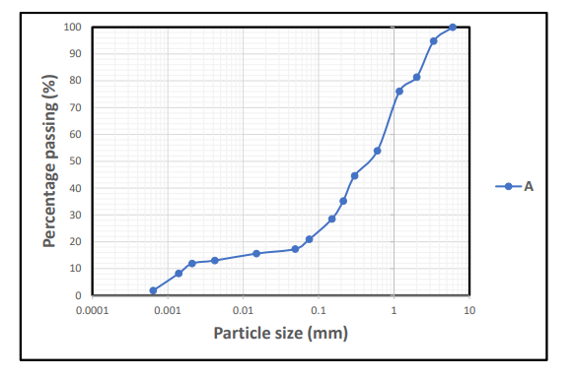

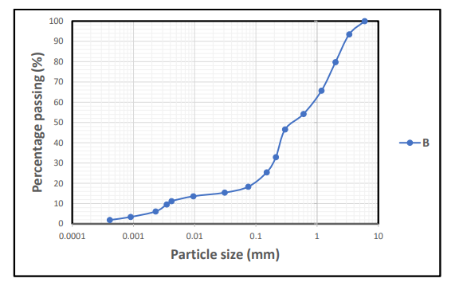

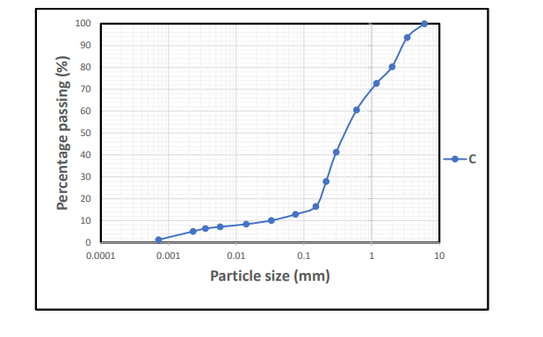
Appendix 2
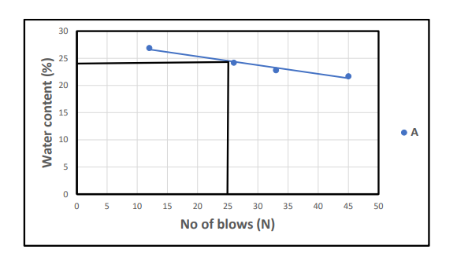

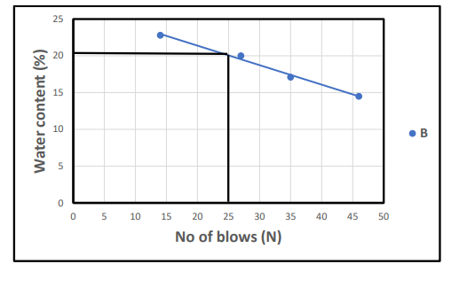

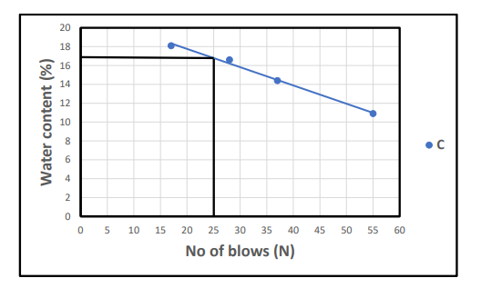

Appendix 3

