ASSESSMENT OF PHYSICAL PROPERTIES OF LATERITE SOIL FOR ROAD BASE MATERIALS (BUDO EFO AND EVIRONS, ILORIN,KWARA STATE)

BY
Abdulrasaq Kolawole JIMOH
ND/23/MPE/FT/0008

SUBMITTED TO
DEPARTMENT OF MINERALS AND PETROLEUM RESOURCES ENGINEERING TECHNOLOGY, INSTITUTE OF TECHNOLOGY, KWARA STATE POLYTECHNIC, ILORIN.
IN PARTIAL FULFILLMENT OF THE REQUIREMENT FOR THE AWARD OD HIGHER NATIONAL DIPLOMA (ND) IN MINERALS AND PETROLEUM RESOURCES ENGINEERING TECHNOLOGY

AUGUST, 2025

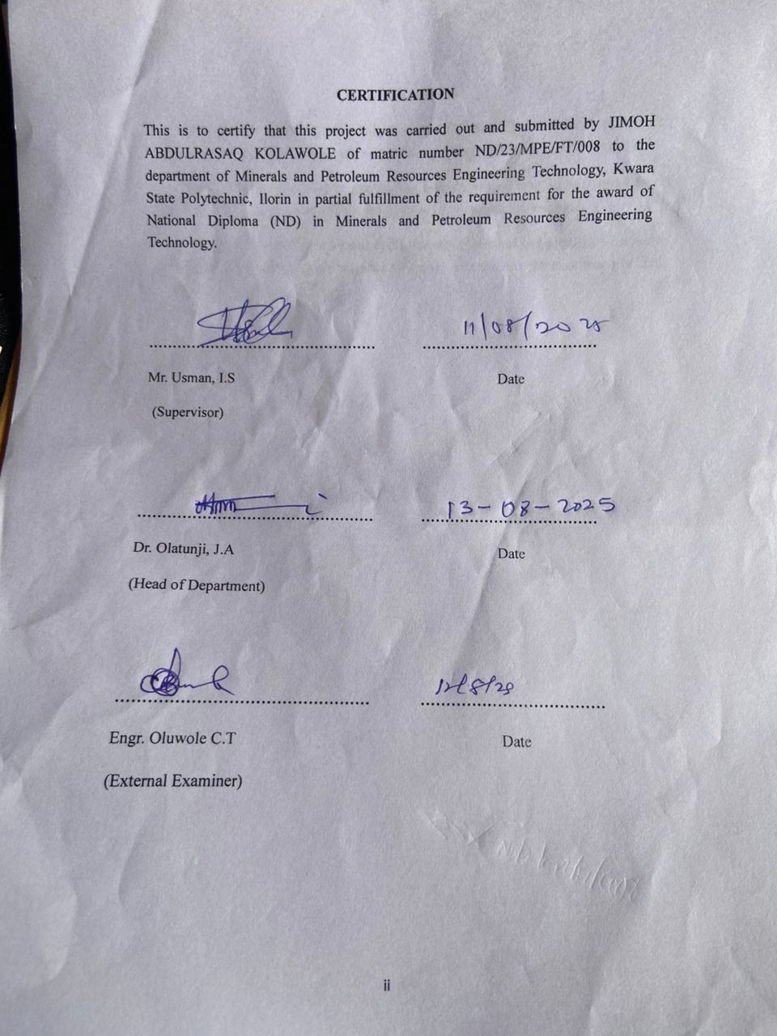

DEDICATION
This project is dedicated to Almighty Allah, The most Gracious the most merciful, for his endless guidance, strength, and wisdom through the course of this work.
I also dedicate this work to my beloved parents, whose love, prayers and support have been a constant source of encouragement in my academic journey.
Finally, this project is dedicated to all students of mineral and petroleum resources engineering technology both present and future who service for excellence in their studies.

ACKNOWLEDGEMENTS
My profound gratitude goes Almighty God for the successful completion of my program, also my deepest gratitude goes to my supervisor engr. Usman I.S, who provide detail criticism of the draft and help to correct necessary area of the write up part before him.
I also thank Dr. Olatunji J.A and entire member of staff of department of minerals and petroleum resources engineering technology.
I appreciated the effort of brother, sister and colleagues for their morally and financially support provided for me during the write up of the project.

TABLE OF CONTENTS
Cover page i
Certification ii
Dedication iii
Acknowledgements iv
Table of Contents v
List of Tables vi
List of Figures vii
Abstract viii
Chapter one
- Introduction 1
1.1 Scope of the project 2
1.2 Aim and Objectives 2
1.3 Statement Problem 3
1.4 Justification 3
Chapter two
2.0 Literature review 4
2.1 Geology of the study area 4
2.2 Occurrence of Lepidolite 7
2.3 Characteristic of Lepidolite 7
2.4 Lithium Ore 8
2.5 Application of Lithium 11
Chapter three
3.0 Materials and Methods 12
3.1 Materials 12
3.2 Methods 13
3.3 Description of study area 13
3.4 Sample collection 15
3.5 Sample preparation 15
3.5.1 Atomic Absorption Spectrometry (AAS) 16
3.5.2 Petrographical (Thin Section) analysis 17
Chapter four
4.0 Result presentation and discussions 19
4.1 Atomic Absorption Spectrometry (AAS) results 19
4.2 Petrographical (Thin sections) analysis results 19
4.3 Discussions of the result 25
Chapter five
5.0 Conclusion and recommendations 26
5.1 Conclusions 26
5.2 Recommendations 26
References 27
Appendix 28

LIST OF TABLE

Table 1: Summary of particle size distribution of the studied sample
Table 2: Summary of measured properties
Table 3:Sample composition distributions of soil in the study area
Table 4: Soil classification according to AASTHO (2019)

LIST OF FIGURE

Figure 4.1: Cumulative Particle size distribution curve for sample S1,S2&S3
Figure 4.2: Cumulative Moisture content curve for sample S1,S2&S3
Figure 4.3: Classification of the studied Lateritic soil using Casagrande plot of Liquid Limit (%) versus Plasticity Index.
Figure 4.4: Cumulative curve of dry density/water contents
Figure 4.5: Cumulative CBR for Top and Bottom A
Figure 4.6: Cumulative CBR for Top and Bottom B
Figure 4.7: Cumulative CBR for Top and Bottom C

ABSTRACT

Geotechnical analysis on Lateritic soil is done to establish the surface and sub surface conditions of the materials through their mechanical and physical properties. This study examine samples from Budo-Efo and Environs in Ilorin, Kwara State, where three samples were collected from three locations. The samples were analyzed at Department of geology and Mineral Science ,University of Ilorin. The test conducted were specific gravity, moisture content, atterberg consistency limit, compaction, shrinkage limi and California bearing ratio. The results are specific gravity range from (2.53-2.86g/cm³), moisture content (7.72-11.32%), liquid limit (17.1-31.0%), plastic limit (15.5-30.3%), plastic index (11.8-41.2%), maximum dry density (1.54-1.88 g/cm³), optimum moisture density (13.0-22.3%), shrinkage limit range between (4.6-11.8%) and un soaked CBR (24-49%) and soaked CBR (9-28%). The results obtained implies that the values were within the Nigeria Standard requirements for materials to be use as base and sub-base grade for road constructions.

CHAPTER ONE
INTRODUCTION
1.1 Background of the Study
Soil plays a vital role in construction, especially in civil engineering projects like roads, foundations, and earth dams. In tropical countries such as Nigeria, lateritic soils are commonly used due to their abundance and relatively good strength (Ola, 1978; Cidigwu, 1976). Ola (1983) noted that laterite forms through long-term weathering of underlying rocks, which leads to the build-up of iron and aluminium oxides, giving laterite its typical red or brownish color (Bell, 1993; Balogun,
When it comes to road construction, the base course is a key layer that helps ensure structural movement strength and durability (AASHTO, 1993). Using locally available materials like laterite for this layer can cut down construction costs — an important consideration in developing countries where using imported construction materials isn't always practical (Osinubi & Beraemi, 2006; Ukochi et al., 2018). However, for the laterite to perform well as a base material, it needs to meet certain physical and engineering criteria, incuding proper partide size distribution, Atterberg limits, compaction properties, and California Bearing Ratio CBR) (BS 1377, 1990; Head, 1992).
Assessing the quality of soil before using it in road work is vital. Poor soil choices can lead to early pavement fallures, higher maintenance costs, and shorter road lifespans (Amadi, 2010; Udoyeye & Ukpong, 2012). Numerous studies have explored the properties of lateritic soils across Nigeria - from the southwest (Alao, 1998), southeast (Eze-Uzomaka & Agbede, 2001), and the middle belt (Mustapha et al., 2014). These studies consistently show that laterite behavior can vary even within short distances due to changes in underlying rock, dimate, and landscape (Rahman, 1986; Oladeji,
In Kwara State, especially around Ilorin and nearby communities like Budo-Efo, urbanization and population growth are driving the need for improved infrastructure. This has created a high demand for cost-effective and durable materials, making laterite an appealing option (Oyediran & Kalejaiye, 2011). yet, there's a lack of updated and location-specific geotechnical data on the physical properties of laterite in these areas often exists. Since soil characteristics can vary greatly from one site to another, relying on general or outdated data can lead to inaccurate conclusions (Rahman, 1986; Akinrotimi & Adeoye, 2009).
Studying the physical characteristics of laterite in Budo-Efo and surrounding areas will provide engineers, contractors, and decision-makers with the information they need to support long-lasting infrastructure. Important properties to evaluate indude moisture content, specific gravity, plasticity index, and CBR - all of which help determine if the soil is suitable for use in road bases (Holtz & Kovacs, 1981; Bowles, 1997). The CBR in particular is a well-known indicator of subgrade strength and is central to pavement design (Osinubi, 1995).
This research seeks to bridge the knowledge gap by carrying out detailed tests, laboratory testing, and analysis of samples from selected sites in Budo-Efo, Ilorin. By comparing the results with established standards and findings from related studies, we aim to make informed recommendations on whether the laterite soil is appropriate as a road base (Alao, 2005; Bello & Adegoke, 2010).
1.2 Statement of the Problem
The use of lateritic soils in road construction is often limited due to its inherent variability and unpredictable behavior. Key physical properties such as plasticity, swelling potential, and shear strength can vary significantly depending on factors like moisture content, degree of compaction, and mineral composition. This inconsistency presents considerable challenges, frequently leading to road failures, increased maintenance demands, and reduced safety standards.
1.3 Aim and Objectives of the Study
The aim of this study is to assess the physical properties of lateritic soils in relation to their suitability for road base material. The specific objectives are:
1. To determine the physical properties of lateritic soils including plasticity, swelling potential, and shear strength.
2. To investigate the effects of moisture content, compaction, and mineral composition on the physical properties of lateritic soils.
1.4 Justification of the Study
This study is justified by the need to improve the understanding of lateritic soil behavior in road construction. By assessing their physical properties and factors influencing them, the research aims to provide valuable insights for engineers, contractors, and policymakers involved in road construction projects. The findings of this study can help optimize the use of lateritic soils, reduce road failures, and enhance the overall safety and sustainability of road infrastructure.
1.5 Scope of the study
The scope is deliberately narrowed to this location due to the area's dependence on locally sourced laterite soil for road construction on the growing need to address recurring cases of early road failure.
The scope Includes the investigation of key physical and geotechnical parameters that influence the soil performance in road construction.

CHAPTER TWO
Literature Review
2.1 Overview of Laterite Soil
Laterite soils are residual soils predominantly found in tropical regions, formed through prolonged chemical weathering of parent rocks under hot and humid conditions. Their extensive distribution across tropical areas, particularly in countries like Nigeria, makes them an important material for civil engineering applications, especially In road construction. the term
"laterite" was originally introduced by Buchanan in 1807 during his exploration in India. It is now commonly used to describe highly weathered soils that are rich in iron and aluminum oxides. These soils are typically reddish in color due to the presence of iron oxides and exhibit a wide range of physical characteristics such as plasticity, strength, and moisture retention. properties that vary with dimate and geological condition (Gidigasu, 1976; Bell, 1993).
In engineering practice, lateritic soils are widely utilized for constructing subgrades, sub-bases, and base courses in flexible pavements, and base courses in flexible pavements, particularly in rural and semi-urban environments.in tropical and sub-tropical environments. Their geotechnical performance is influenced by several factors including mineralogy, moisture content and degree of compaction. Hence, a through understanding of their engineering properties is essential to ensure durability and stability in construction projects.
2.2 Formation and Composition of Laterite Soil
2.2.1 Formation of Laterite Soil
Laterite soils are primarily formed through an intensive weathering process of parent rocks in tropical climates characterized by high temperatures and significant rainfall. This process, known as laterization, involves the following key
Chemical breakdown of silicate minerals under moist, tropical conditions;
Leaching of silica and basic cations such as calcium (Ca2+), sodium (Na+), and potassium (K+);
Residual enrichment of iron (Fe) and aluminum (Al) oxides within the soil profile
Within the Soil Profile:
• Oxidation of iron compounds, which impacts the characteristics red or brown coloration of the soil.
Laterization typically occurs in regions with alternating wet and dry seasons, which enhance both leaching and oxidation. The nature of the parent rock-commonly granite, basalt, or gneiss-plays a significant role in determining the intensity and outcome of the weathering process. Over thousands of years, this leads to the development of thick soil profiles with heterogeneous properties at varying depths (Gidigasu, 1976; Amadi, 2010).
2.2.2 Composition of Laterite Soil
Laterite soils are distinguished by their high concentration of sesquioxides, particularly ferric oxide (FezO3) and aluminum oxide (AlzOz)). In addition, they contain various secondary minerals and components, induding:
Kaolinite: A day mineral that reduces soil plasticity and influences permeability.
Gibbsite: A hydrated form of aluminium oxide commonly found in highly weathered profiles;
Goethite and Hematite: Iron-bearing minerals that contribute to the soll's red hue.
Quartz: A resistant and inert mineral that often imparts a sandy texture;
Titanium and Manganese Oxides: Typically present in trace amounts.
Organic Matter: Usually minimal due to the extensive leaching processes in tropical climates.
The relative proportions of gravel, sand, sit and clay in lateritic soils vary depending on the degreeof weathering and the composition of the source rock.These variations significantly effect engineering properties such as plasticity index shear strength, compaction characteristics, and susceptibility to volumetric changes compaction characteristics, and susceptibility to volumetric changes like swelling and shrinkage (Ekundayo & Adegoroye, 1994; Aghamelu & Okogbue,2011).
2.3 Physical and engineering properties of laterite soil
The effectiveness of laterite in construction largely depends on its physical and engineering characteristics which include:
• Moisture Content: Influences compaction and strength.
. Atterberg Limits: Are a basic measure of the critical water contents of fine grained soil.
• Liquid Limit (: The water content at which soil changes from a plastic state to a liquid and plastic behavior.
. Plastic Limit (PL): The water content at which the soil changes from a semi-solid state to a plastic state.
. Shrinkage Limit (SL): The water content at which additional volume reduction of the soil .
• Partide Size Distribution: Determines soil's grading.
. Maximum Dry Density (MDD) and Optimum Moisture Content (OMC): Derived from compaction tests.
. California Bearing Ratio (CBR): Evaluates the load-bearing capacity.
Lateritic soils usually display moderate strength and low plasticity. These properties can be enhanced through stabilization methods when needed (Adegoroye, 2002)
2.4 Importance of laterite soil in road based material
Laterite soil holds a vital position in road construction, especially in tropical areas such as Nigeria, where it is readily available in large quantities. Its favorable geotechnical characteristics make it a common choice for use in various pavement layers including the subgrade, sub-base, and base course. Utilizing laterite soil helps reduce construction expenses since it can typically be sourced locally, thus minimizing the need for costly transportation over long distances (Gidigasu, 1976; Ola, 1983).
Key advantages of laterite soil for road-based material:
1. Availability and Economic Advantage:laterite soils are widely distributed throughout Nigeria, making them a cost-effective material option for road building projects (Adegoroye, 2002)
2. Load-bearing Strength:
With proper compaction, lateritic soils can provide sufficient strength for subgrade and sub-base applications. Their load-bearing capacity can be further improved through stabilization methods involving lime, cement, or other additives (Osinubi, 1999).
3. Ease of Workability and Compaction:
Lateritic soils generally demonstrate good workability and respond effectively to efficient compaction processes, which is crucial for achieving the required pavement strength (Amado, 2010).
4. Environmental Sustainability:
Being a natural material, lateritic soil offers an environmentally friendly alternative to industrial materials, supporting more sustainable construction practice (Amuetal.2005).
5. Adaptability to Stabilization:
Lateritic soils exhibit favourable when subjected various stabilization techniques, enhancing its suitability for diverse engineering applications and improving performance its performance in areas with poor soil conditions (Bello & ige 2015).
Nevertheless, it is important to assess the soil's physical and mechanical properties prior to use, as certain lateritic soils may contain excessive fines, exhibit poor drainage, or have high plasticity, which could render them unsuitable without appropriate treatment (Ola, 1983)
2.5 Factors Affecting the Suitability of Lateritic Soil for Road-based Material
Various factors impact the appropriateness of lateritic soll for use in roadwork including:
- Mineralogical Composition: Certain day minerals can affect stability and plasticity.
- Moisture Content: Influences both compaction and strength.
- Soll Structure and Texture: Play a role in determining load-bearing capacity.
- Organic Matter Content: Can weaken the soil and reduce stability.
- Topography and drainage conditions: affect the long-term durability and performance.
A thorough understanding of these factors is critical for assessing suitability and determining whether stabilization is required.
2.6 Standards and Guidelines for Soil Testing in Road-Based Materials
To ensure safety and effectiveness in road construction, standardized procedures are followed to evaluate soil properties.
The British Standard - BS 1377 (1990) specifies laboratory testing methods for parameters such as moisture content, Atterberg limits, compaction, and CBR values. Additionally, the AASHTO classification system is widely employed to categorize soils according to their road construction suitability. These standards assist engineers in determining whether a soil meets the necessary criteria for use as base or sub-base material.
CHAPTER THREE
MATERIALS AND METHODS
3.1 Materials
The materials involves in the samples taken were digger, spade, polytene bags, masking tape, marker, pan, Global Positioning System (GPS) and writing materials such as pen and exercise book.
3.2 Methods
3.2.1 Description of the study area
The study area is located in Budo Efo, Ilorin South Local Government area of Kwara State. The Lateritic soil is buried and exposed around in the study area, the site is on Latitude N8˚11ʹ53ʺ and Longitude E4˚47ʹ42ʺ for location A, Latitude N8˚26ʹ32ʺ and Longitude E4˚36ʹ36ʺ for location B while N8˚26ʹ39ʺ and Longitude E4˚36ʹ42ʺ for location C. The study area is accessible through local road.
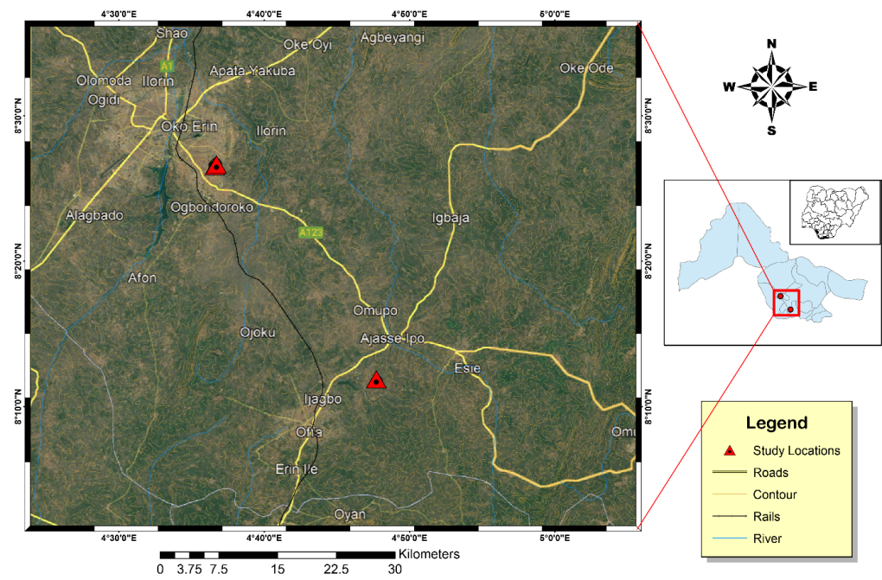

Figure 3.2a: Map showing the study area

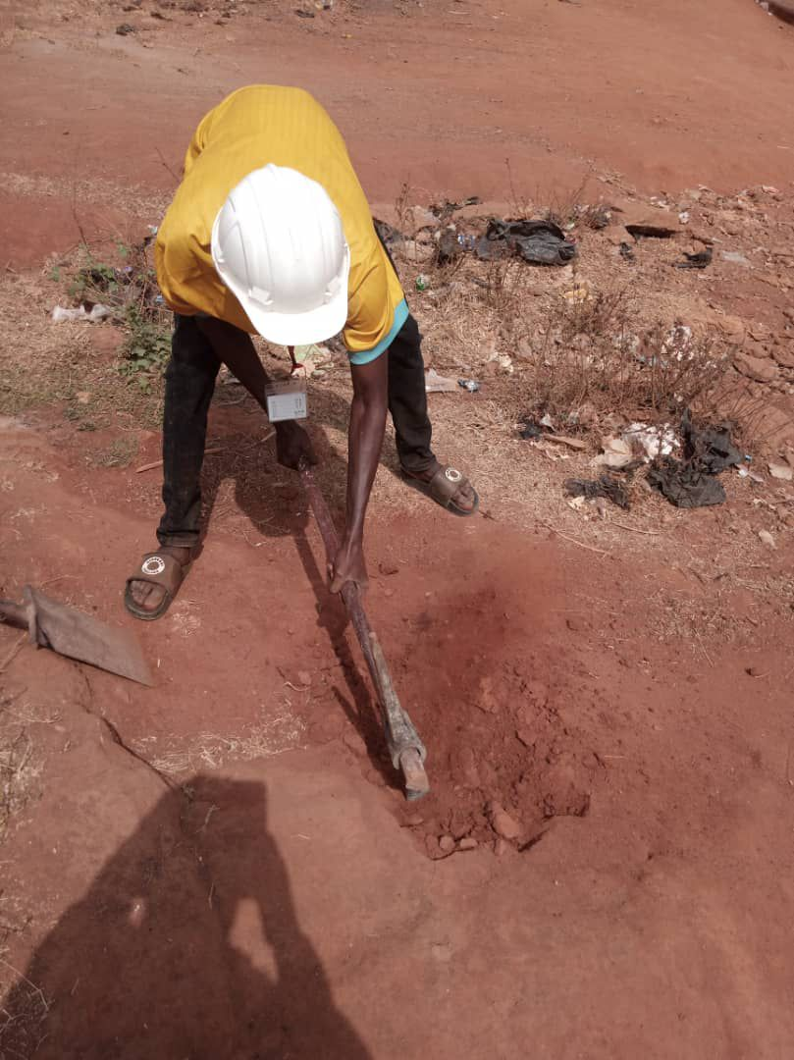
Figure 3.2b: shows the photograph of the study area
3.2.2 Sample Preparation
The samples were pulverized sieved at the department of geology and mineral sciences laboratory, University of Ilorin.
3.2.3 Sample Analysis
The samples were subjected to various analysis such as particle size distribution, atterberg consistency limit, compaction test, free swelling potential, and compressibility.

3.2.3.1 Water Content Determination
The water content of a soil is also called the natural moisture content of the soil, it is defined as the ratio of the weight of water present in a soil to the weight of the dry soil, and it is expressed in percentage. It is mathematically expressed as;
w = Ww/Ws x 100
where w = water content
Ww = weight of moisture
Ws = weight of dry soil
3.2.3.1.1 Apparatus Used
Moisture can
Drying oven
Weighing balance
Desiccator
3.2.3.1.2 Procedure
- A non-corrodible can was weighed on the weighing balance as W₁
- Soil sample was added into the can and weighed as W₂
- The sample was oven dried for 24hrs at a temperature of about 105⁰C to 110⁰C
- The sample was placed in a desiccator to cool after removal from oven
- The dried sample was then weighed as W₃
- The overall process was repeated for all the soil samples and their respective water contents were determined.

3.2.3.2 Bulk and Dry Density
3.2.3.2.1 Bulk Density
Bulk density is defined as the mass of the soil divided by its volume, it is the weight of representative wet soil sample to the volume of the mould containing such sample. It is expressed as mass per unit volume (i.e. g/cm³). It helps to determine how heavy the soil sample is and to determine the bearing capacity of the soil i.e. the mount of the load the soil can carry successfully.
3.2.3.2.1.1Apparatus Used
Mould
Weighing balance
Drying oven
Spatula and pestle
3.2.3.2.1.2 Procedure
- An empty mould is weighed (i.e. weight of mould)
- The volume of the mould was also determined (V)
- The mould is then filled with fresh soil sample, consolidated and weighed (i.e. weight of mould + soil)
- The weighed of the wet soil was calculated by subtracting the weight of empty mould from the weight of wet soil and mould
- The bulk density was deduced using the formula below:
ϒ = W/V
W = weight of representative wet soil sample
V = volume of mould
3.2.3.2.2 Dry Density
Dry density is defined as the ratio of the weight of the dry soil sample to the
volume of the mould containing the dry soil sample.
3.2.3.2.2.1 Apparatus Used
Weighing balance
Drying oven
Spatula
Pan
Desiccator
3.2.3.2.2.2 Procedure
- An empty pan was weighed
- A known volume of the mould from bulk density determination was taken (V)
- The mould with fresh soil sample being consolidated was discharged into the pan for oven drying at 110⁰C until water was completely expelled
- The weighed of the dry soil was calculated by subtracting the weight of empty pan from the weight of dry soil and pan
- The dry density was deduced using the formula below:
ϒ = W/V
W = weight of representative dry soil sample
V = volume of mould
3.2.3.3 Specific Gravity Determination
3.2.3.3.1 Apparatus Used
Density bottle
Measuring cylinder
Weighing balance
3.2.3.3.2 Procedure
- An empty measuring cylinder was weighed as (W₁)
- It is then filled with soil to about 1/3 of its volume, then its weight together with the soil was taken as (W₂)
- The water was added to the soil in the measuring cylinder, the weight of the cylinder with both soil and water was taken as (W₃)
- Empty the measuring cylinder, fill it with distilled water and its weight was taken as (W₄).
- Specific gravity was calculated using the formulae below
(W₂ -W₁)/ (W₄ -W₁) – (W₃ -W₂) X 100
3.2.3.4 Grain Size Analysis
Grain size refers to the diameter of the soil particles that make up the soil mass. This analysis covers the quantitative determination of the various sizes of these soil particles, their proportions to the nearest percentage and the distribution of the various grain sizes that makes up the soil.
Grain size analysis is a very important analysis, which is done in an attempt to describe a soil type. A roughly concluded result is made by the physical description of the soil particles grain distribution, but a more accurate result is gotten by performing the laboratory analysis. This analysis is done in order to know the accurate distribution of the various grain sizes that make up the soil, and helps to solve the problem of confusion between silt and clay. This method entails mechanical and hydrometer analyses respectively.
3..2.3.4.1 Mechanical Sieve Analysis
The sieve analysis involves shaking of the soil sample through a set of sieves that have progressively smaller openings. This method is used in the analysis of particles greater than 0.075mm in diameter. It provides a means of evaluating the different grain size types present in soil sample.
3.2.3.4.1 Apparatus Used
- Stack of sieves
- Mechanical sieve shaker
- Drying oven
- Collecting pan and cleaning brush
- Weighing balance
3.2.3.4.2 Procedure
(a) The soil particles were gently disaggregated
(b) The sieve set (i.e. stack of sieves) were arranged in descending order from the top with a retainer beneath it.
(c) 100g of the soil was weighed and poured into the sieve stack.
(d) The sieve stack was then placed on the mechanical sieve shaker for about 10 minutes
(e) The sieve stack was now separated one by one, then the soil fraction retained in each sieve was weighed and recorded
(f) A statistical data of the result of the analysis was prepared.
3.2.3.4.2 Hydrometer Analysis
This method is used in the determination of the grain distribution of fine-grained soils with soil particles of the order of clay and soil. This method is not applicable if less than 10% of the soil passes through sieve size of 0.075mm mesh size.
3.2.3.4.2.1 Apparatus Used
- Hydrometer bulb
- Measuring cylinder
- Drying oven
- Thermometer
- Evaporating dish
3.2.3.4.2.2 Procedure
(a) The sieved clay and silt from the sieve washing were collected in a container and allowed to settle
(b) The supernatant water was decanted and the mud residue was dried in the drying oven for about 24 hours
(c) The dried sample was then pulverized, 50g of it was weighed and dissolved in one liter of water in a measuring cylinder. The water has dissolved in it sodium hexametaphosphate to enhance rate of clay settlement.
(d) The hydrometer bulb is then inserted into the water in the measuring cylinder and its reading was recorded periodically.
(e) As the settling proceeds, the hydrometer sinks into the solution
(f) The temperature at each hydrometer reading was recorded and then a statistical data was produced.
(g) Then, the percentage passing was plotted against diameter to obtain the percentage composition of the studied soil samples.
      - Atterberg Consistency Limits
3.2.3.5.1 Liquid Limit Determination
3.2.3.5.1Apparatus Used
- Casagrande liquid limit device (made up of a cup, a rotating handle, counter and a cutting groove)
- Pestle and mortar
- Spatula
- Moisture can
- Wash bottle with distilled water
- Sieve 0.425mm
- Oven
- Glass plate
3.2.3.5.2 Procedure
(a) A dried, fresh soil sample is pounded using the pestle and mortal
(b) The sample was sieved using the 0.425mm sieve size, 300g of the sieved sample was weighed and water was added to it until a stiff paste was produced.
(c) The stiff paste was packed into the Casagrande apparatus and then had the surface leveled and smoothened using the spatula.
(d) A groove in the soil was made with cutting groove and rotated the handle (blows) until the groove close. (Note that the number of revolutions the handle makes blows is recorded by the counter). The minimum number of blows is 10 while the maximum is 50.
(e) A small paste was scooped into the moisture can with the spatula, weighed and dried in the drying oven for 24 hours and then reweighed in order to determine its water content.
(f) The soil is then emptied from the cup into the glass plate and water is added to the soil and the process is performed all over again.
(g)The water contents (%) were plotted against numbers of blow (N), water content corresponding to 25 number of blows is the liquid limit
        - Plastic Limit Determination
3.2.3.5.2.1 Apparatus Used
- Glass plate
- Moisture can
- Spatula
- Wash bottle with distilled water
- 0.425mm sieve
- Thermostat oven
3.2.3.5.2.2 Procedure
(a) A small part of the paste in the Casagrande cup is scooped and rolled into a ball
(b) The ball is placed on the glass plate and rolled into thread until it breaks
(c) The crumbled threads are put into two different moisture cans. Then, the cans with crumbled soil sample were oven dried for 24 hours so as to determine the moisture content of each sample, which was taken as plastic limits.
3.2.3.5.3 Linear Shrinkage Determination
(a) The soil sample was thoroughly mixed with distilled water
(b) A linear container of known length was taken and lubricated for easy removal of the soil sample
(c) The container was then filled with the soil sample and its original length was measured before it was oven dried for about 24 hours
(d) The container was allowed to cool in a desiccator, and then the final length of the dried soil sample is measured.
(e) The linear shrinkage of the studied soil samples was calculated using the formula below:
LS = change in length x 100
Original length
3.2.3.6 Compaction Test
3.2.3.6.1 Apparatus Used
- Mixing pan
- Weighing balance
- Drying oven
- Moisture can
- Spatula
- Compaction rammer and mould (consisting of base plate, cylinder mould andextension collar).
3.2.3.6.2 Procedure
(a) 3kg of soil sample was weighed and poured into the mixing pan
(b) 120cm³ (4%) of water was measured, added and mixed with the soil in the mixing pan with the use of spatula.
(c) The cylinder mould is then placed on a base plate, then a representative specimen of the soil is put into the mould and compact with 25 evenly distributed blows of rammer. This represents the first layer.
(d) After the compaction, the volume of the soil in the mould reduced, more soil specimen was added into the mould and compacted with another 25 evenly distributed blows.
(e) The extension collar is then fixed unto the mould. This is mainly for the last layer and removed after the last layer is made to be able to achieve a smooth level surface of the last layer.
(f) The mould is filled with more of the soil specimen and compacted to make the third layer.
(g) The mould with the soil is weighed and the soil sample at the top and bottom of the mould were taken for water content and dry density determination respectively.
(h) The soil in the mould is emptied into the mixing pan and another 120cm³ (4%) of water is added to the soil and mixed
(i) This process was now carried out four more times
(j) Then, the compaction curves were gotten by plotting dry densities against water contents.
3.2.3.7 California Bearing Ratio (CBR)
3.2.3.7.1 Apparatus Used
CBR mould with extension collar and base
Rammer (4.5kg)
Surcharge weight
Mixing plate
Measuring cylinder
Weighing balance
Spatula
3.2.3.7.2 Procedure
(a) 6kg of air- dried sample is measured into mixing pan.
(b) Water equivalent to the optimum moisture content (OMC) of the soil samples earlier calculated during compaction testis measured, added and well mixed with the soil.
(c)The mould is then filled with the soil and compacted with 25 evenly distributed blows on the 3 layers of the soil specimen.
(d) After making the third layer (fifth layer for modified Proctor), a surcharged weight of 2kg and 40mm thick is placed on the extension collar.
(e) The mould with the surcharge weight is placed on the CBR machine plate and the plate is adjusted until the piston of the machine makes contact with the soil inside the mould.
(f) The load and penetration gauge are set at zero just before the test proceeds by the motorized movement of the piston, and the corresponding readings on the load gauge were taken at different penetration levels. This is for the top reading.
(g) The mould was removed from the machine, turned upside down with the position of the base plate changed and then placed back on the plate of the CBR machine and repeat the procedure. This is for the bottom reading.

CHAPER FOUR
4.0 Results Presentation and Discussions
This chapter discusses the test conducted which include; particles size distribution, specific gravity, atterberg consistency limits comprises of liquid limit, plastic limit, plasticity index and shrinkage limit, water content, compaction test, and California bearing ratio (CBR) test as well as the interpretations.
4.1.1 Grain Size Analysis
Table 1: Summary of particle size distribution of the studied samples
Sample code | Dry Sieving(% passing) |  |  |  |  | Hydrometer (% passing)
Sample code | 5.0mm | 3.35mm | 2.0mm | 1.18mm | 0.6mm | 0.025mm | 0.002mm
A | 100 | 97.8 | 86.2 | 87.2 | 70.5 | 19.4 | 11.1
B | 100 | 100 | 95.2 | 88.4 | 75.6 | 26.0 | 12.5
C | 100 | 100 | 100 | 98.6 | 96.3 | 67.3 | 51.5

Table 2: Summary of measured properties
Properties of the soils | Sample A | Sample B | Sample C
Specific Gravity g/cm³ | 2.86 | 2.69 | 2.53
Moisture content (%) | 11.32 | 9.68 | 7.72
Liquid limit (%) | 27.2 | 31.0 | 17.1
Plastic limit (%) | 15.8 | 17.1 | 30.3
Plastic Index (%) | 11.4 | 13.5 | 41.2
Shrinkage limit (%) | 4.6 | 5.2 | 11.5
Maximun Dry Density | 1.88 | 1.82 | 1.54
Optimum Moisture Density | 13.2 | 14.6 | 22.3
Unsoaked CBR (%) | 49 | 47 | 24
Soaked CBR (%) | 28 | 20 | 9

Table 3: Samples composition distributions of Soils in the Study Area
Sample Location | Gravel (%) | Sand (%) | Silt (%) | Clay (%) | % Fine | Soil Classification
Sample 1 | 14 | 60 | 15 | 11 | 26 | Silty Sand
Sample 2 | 5 | 66 | 17 | 12 | 29 | Silty Sand
Sample 3 | 0 | 19 | 30 | 51 | 81 | Silty Clay

Table 4: SOIL Classification according to AASTHO (2019)
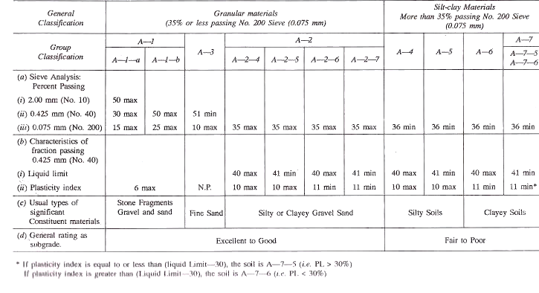

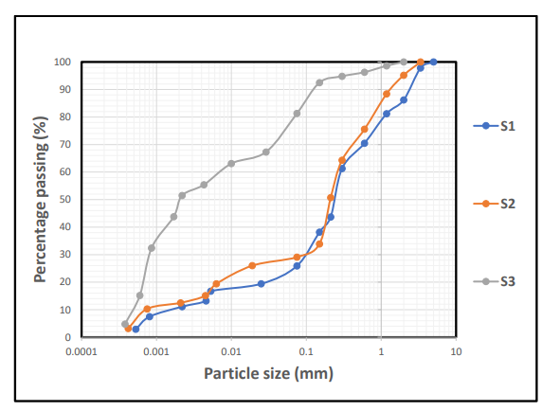
Figure 4.1: Cumulative Particle size distribution curve for sample S1,S2&S3

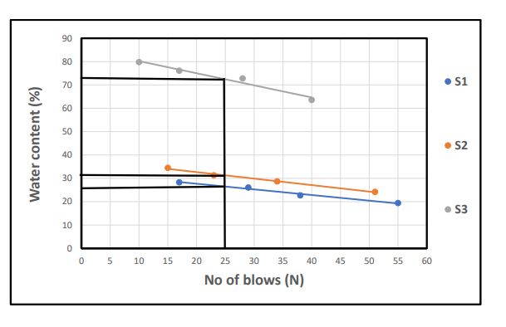
Figure 4.2: Cumulative Moisture content curve for sample S1,S2&S3

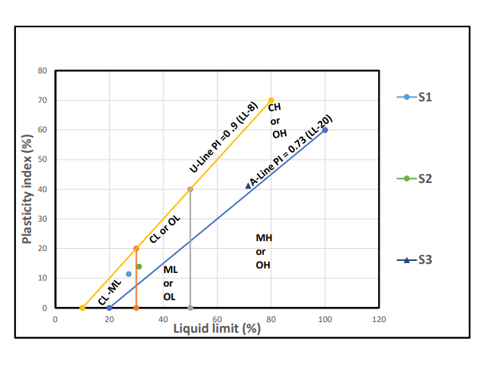
Figure 4.3: Classification of the studied Lateritic soil using Casagrande plot of Liquid Limit (%) versus Plasticity Index.
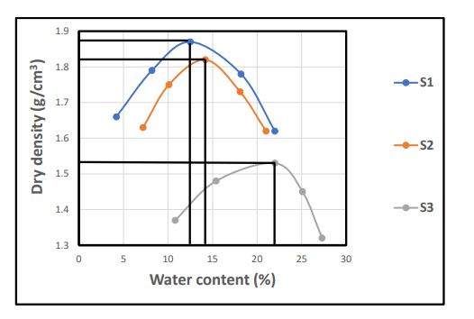
Figure 4.4: Cumulative curve of dry density/water contents

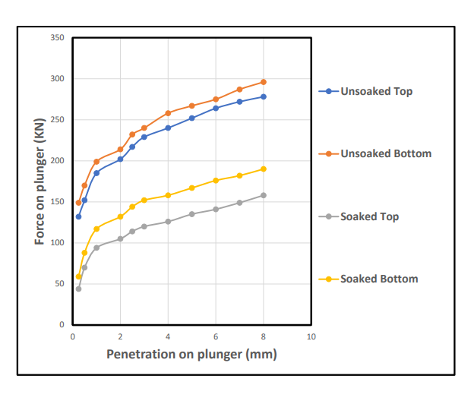
Figure 4.5: Cumulative CBR for Top and Bottom A

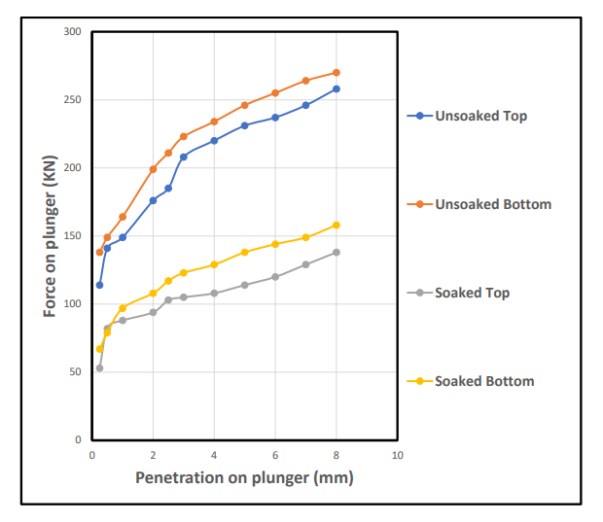
Figure 4.6: Cumulative CBR for Top and Bottom B

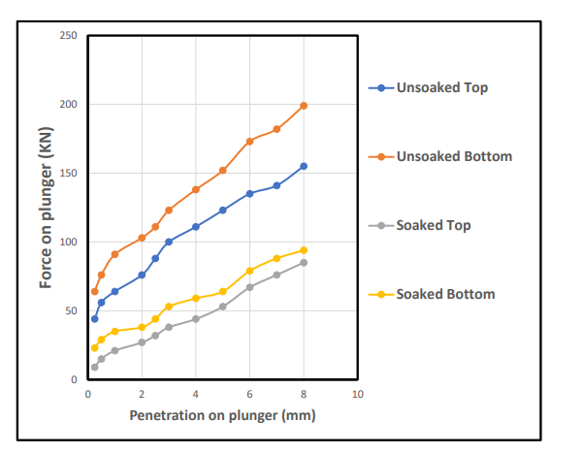
Figure 4.7: Cumulative CBR for Top and Bottom C

Discussions
The analysis carried out on lateritic soil generally have a good representation of either cohesive (i.e fine-grained portions) and cohesionless (i.e coarse-grained portions). The study samples for particle size distribution is shown in the Table 1 and Figure 4.1 with average percentage composition of sand (19-66%), silt (15-30%), Clay (11-51%), gravel (5-14%) and fine percentage range (26-81%) . Thess indicated from Table 4, that the studied sample is silty sand based on the AASHTO classification (2019). These type of materials are good for base grade and sub-base materials. The studied samples has plasticity limit (15.8-30.3%), liquid limit (17.1-31.0%), plastic index (11.4-41.2%), shrinkage limit (4.6-11.5%), specific gravity value (2.53-2.86g/cm³), moisture content (7.72-11.32%), maximum dry density (1.54-1.88Kg/m³), optimum moisture content (13.2-22.3%) and CBR (24-49%) for unsoaked while CBR value for soaked is (9-28%).The above results were suitable and found to be within the standard values for lateritic soil used for road construction as base materials.

CHAPTER FIVE
5.1 SUMMARY
This study assessed the physical and geotechnical properties of lateritic soil from Budo-Efo and its use in llorin to determine its suitability as a base material in road construction. The research was
divided into five chapters. Chapter One introduced the background, aim, and objectives of the study, highlighting the challenges of premature road failure due to poor soil evaluation. Chapter Two provided a detailed literature review on the formation, composition, and engineering behavior of lateritic soils, while also reviewing standards like BS 1377, AASHTO, and FMWH for soil classification. Chapter Three described the methods used to test the soil, including moisture content, Atterberg limits, specific gravity, grain size analysis, compaction, and CBR tests. In Chapter Four, the results showed that most soil samples exhibited moderate plasticity, acceptable moisture content, and CBR. Values above 20%, indicating that they are suitable for use base grade materials.
Where properties were inadequate, stabilization techniques like lime or cement were recommended.
Overall, the study concluded that with proper testing and treatment, lateritic soils from Budo-Efo areviable for road construction. More detailed investigation is needed with more tests on the soil before construction to ensure long-term road performance.
5.2 CONCLUSION
The findings of this study indicate that:
- The lateritic soils from Budo-Efo contain substantial amounts of sand and gravel suggesting
favorable drainage characteristics and good shear strength potential.
- The Atterberg limits (liquid limit, plastic limit, and plasticity index) of most samples fall within the acceptable range for road base materials.
• The maximum dry density (MDD) value in many instances exceeds 1,7g/cm*, meeting the standard compaction requirements for base materials (OLA, 1983).
Samples exhibiting high plasticity or excessive fines may require stabilization using lime, cement, or other additives to comply with standard specification (Amu et al., 2005; Amadi, 2010).
Therefore, it can be concluded that, with minimal treatment, lateritic soils from the study area are
•potentially suitable for use as base materials in road construction.

5.3 RECOMMENDATION
Based on the outcomes of this research, the following recommendations are proposed:
1. Conduct site-specific testing: Prior to utilizing lateritic soil in road construction, comprehensive geotechnical investigations should be carried out at the project site to verify its suitability.
2. Implement soil stabilization,measures: Where California Bearing Ratio (CBR) values or plasticity indices fall below acceptable standards, stabilization using chemical additives such as lime or
cement is recommended to enhance the soil’s strength and durability (Amu et al., 2005).
3. Ensure proper compaction: Compaction at the optimum moisture content is essential to maximize the load-bearing capacity of lateritic soils (Osinubi, 1998).
4. Incorporate effective drainage: As lateritic soils are susceptible to strength loss when saturated
adequate drainage systems should be integrated into road designs to prevent water accumulation
(Gidigasu, 1976).
5. Promote training and capacity building: Local engineers and contractors should receive training in best practices for identifying and utilizing lateritic soils to improve the quality and longevity of rural road infrastructure.
6. Encourage sustainable use: Locally available laterite should be promoted in civil engineering projects to reduce construction costs and support sustainable development.
7. Ensure quality control: Rigorous quality control procedure’s should be applied on construction sites to ensure that the soil materials conform to specified engineering standards (Aghamelu &
Okogbue, 2011).
- Undertake periodicmaintenance and monitoring: Roads constructed with lateritic materials shouldbe routinely inspected for signs of distress, deformation or failure, particularly in response to seasonal environmental changes (Adeyemi, 2002).
9. Pursue further research: Future studies should include detailed chemical and mineralogical analyses of the lateritic soils in the study area to deepen understanding of its long-term performance characteristics.
10. Comply with established standards: Construction agencies must adhere to recognized standards such as those set by AASHTO, FMWH, and BS 1377 for the classification and use of soils in road construction.

5.4 REFERENCES
1. Gidigasu, M. D. (1976). Laterite Soil Engineering: Pedogenesis and Engineering Principles.
Elsevier.
2. Ola, S. A. (1983). Geotechnical Properties and Behavior of Some Nigerian Lateritic Soils. QUEG,
* 16(2), 145-160.
• 3. Osinubi, K. J. (1999). Evaluation of Lateritic Soil Stabilized with Cement. Journal of Transportation
•Engineering, 125(6), 465-469.
4. Amadi, A. A. (2010). CBR Characteristics of Laterites for Roadwork. Leonardo Journal of
Sciences.
5. Amu, O. O., Fajobi, A. B., & Oke, B. O. (2005). Effect of Stabilization on Expansive Soil.
Research Journal of Engineering Sciences, 1(1), 80-84.
6. Adeyemi, G. O. (2002). Suitability of Laterites for Road Construction in Nigeria. Bulletin of
• Engineering Geology, 61(4), 423-428.
7. Aghamelu, O. P., & Okogbue, C. O. (2011). Geotechnical Evaluation of Some Lateritic Soils in Southeastern Nigeria. Nigerian Journal of Earth Sciences, 1(2), 45-55.
8. Federal Ministry of Works and Housing (FMWH). (1997). Highway Manual Part 1 – Pavement and Materials. Lagos, Nigeria.
9. American Association of State Highway and Transportation Officials (AASHTO). (2000). Standard Specifications for Transportation Materials and Methods of Sampling and Testing.
10. British Standards Institution (1990). BS 1377: Methods of Testing Soils for Civil Engineering London BSI

Appendix 1
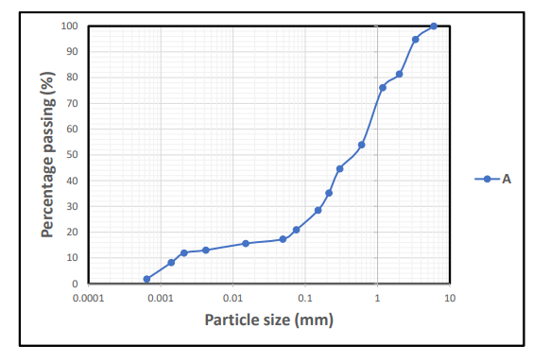

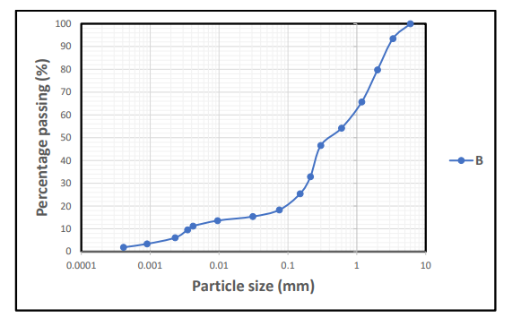

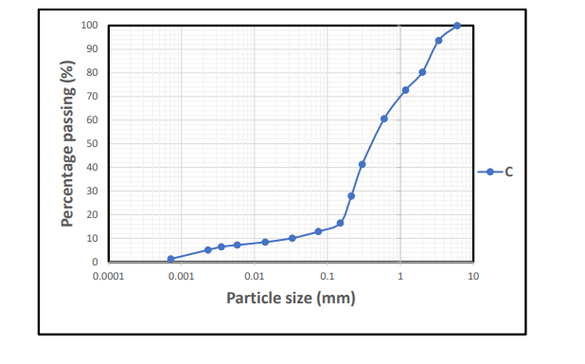
Appendix 2
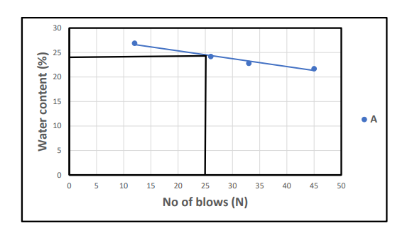

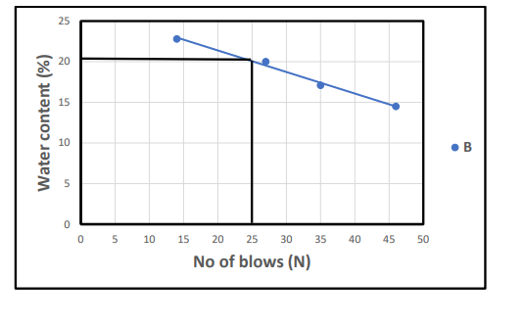

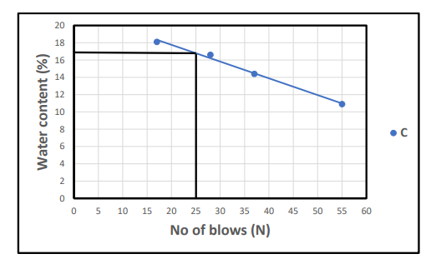

Appendix 3

