ASSESSMENT OF PHYSICAL PROPERTIES OF LATERITE SOIL FOR ROAD BASE MATERIALS (BUDO EFO AND EVIRONS, ILORIN,KWARA STATE)

BY
Airat Ayoola BALOGUN
ND/23/MPE/FT/0030

SUBMITTED TO
DEPARTMENT OF MINERALS AND PETROLEUM RESOURCES ENGINEERING TECHNOLOGY, INSTITUTE OF TECHNOLOGY, KWARA STATE POLYTECHNIC, ILORIN.
IN PARTIAL FULFILLMENT OF THE REQUIREMENT FOR THE AWARD OF NATIONAL DIPLOMA (ND) IN MINERALS AND PETROLEUM RESOURCES ENGINEERING TECHNOLOGY

AUGUST, 2025

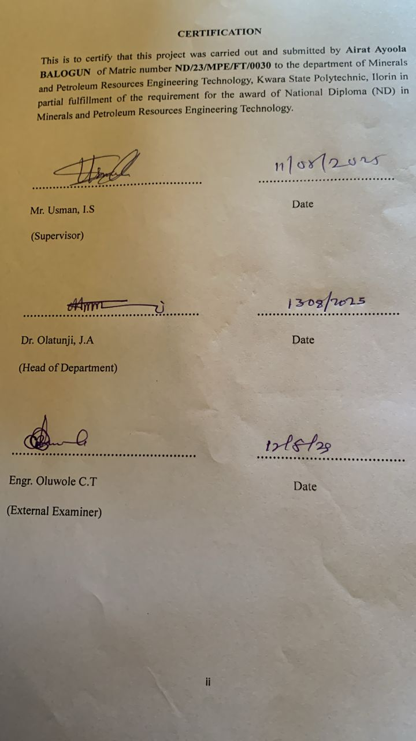

DEDICATION
This project is dedicated to Almighty Allah, The most Gracious the most merciful, for his endless guidance, strength, and wisdom through the course of this work.
I also dedicate this work to my beloved parents, whose love, prayers and support have been a constant source of encouragement in my academic journey.
Finally, this project is dedicated to all students of mineral and petroleum resources engineering technology both present and future who service for excellence in their studies.

ACKNOWLEDGEMENTS
My profound gratitude goes Almighty God for the successful completion of my program, also my deepest gratitude goes to my supervisor engr. Usman I.S, who provide detail criticism of the draft and help to correct necessary area of the write up part before him.
I also thank Dr. Olatunji J.A and entire member of staff of department of minerals and petroleum resources engineering technology.
I appreciated the effort of sister, my sibling and colleagues for their morally and financially support provided for me during the write up of the project.

TABLE OF CONTENTS
Cover page i
Certification ii
Dedication iii
Acknowledgements iv
Table of Contents v
List of Tables vi
List of Figures vii
Abstract viii
Chapter one
- Introduction 1
1.1 Scope of the project 2
1.2 Aim and Objectives 2
1.3 Statement Problem 3
1.4 Justification 3
Chapter two
2.0 Literature review 4
2.1 Geology of the study area 4
2.2 Occurrence of Lepidolite 7
2.3 Characteristic of Lepidolite 7
2.4 Lithium Ore 8
2.5 Application of Lithium 11
Chapter three
3.0 Materials and Methods 12
3.1 Materials 12
3.2 Methods 13
3.3 Description of study area 13
3.4 Sample collection 15
3.5 Sample preparation 15
3.5.1 Atomic Absorption Spectrometry (AAS) 16
3.5.2 Petrographical (Thin Section) analysis 17
Chapter four
4.0 Result presentation and discussions 19
4.1 Atomic Absorption Spectrometry (AAS) results 19
4.2 Petrographical (Thin sections) analysis results 19
4.3 Discussions of the result 25
Chapter five
5.0 Conclusion and recommendations 26
5.1 Conclusions 26
5.2 Recommendations 26
References 27
Appendix 28

LIST OF TABLE

Table 1: Summary of particle size distribution of the studied sample
Table 2: Summary of measured properties
Table 3:Sample composition distributions of soil in the study area
Table 4: Soil classification according to AASTHO (2019)

LIST OF FIGURE

Figure 4.1: Cumulative Particle size distribution curve for sample S1,S2&S3
Figure 4.2: Cumulative Moisture content curve for sample S1,S2&S3
Figure 4.3: Classification of the studied Lateritic soil using Casagrande plot of Liquid Limit (%) versus Plasticity Index.
Figure 4.4: Cumulative curve of dry density/water contents
Figure 4.5: Cumulative CBR for Top and Bottom A
Figure 4.6: Cumulative CBR for Top and Bottom B
Figure 4.7: Cumulative CBR for Top and Bottom C

ABSTRACT
Geotechnical analysis on Lateritic soil is done to establish the surface and sub surface conditions of the materials through their mechanical and physical properties. This study examine samples from Budo-Efo and Environs in Ilorin, Kwara State, where three samples were collected from three locations. The samples were analyzed at Department of geology and Mineral Science ,University of Ilorin. The test conducted were specific gravity, moisture content, atterberg consistency limit, compaction, shrinkage limi and California bearing ratio. The results are specific gravity range from (2.53-2.86g/cm³), moisture content (7.72-11.32%), liquid limit (17.1-31.0%), plastic limit (15.5-30.3%), plastic index (11.8-41.2%), maximum dry density (1.54-1.88 g/cm³), optimum moisture density (13.0-22.3%), shrinkage limit range between (4.6-11.8%) and un soaked CBR (24-49%) and soaked CBR (9-28%). The results obtained implies that the values were within the Nigeria Standard requirements for materials to be use as base and sub-base grade for road constructions.

CHAPTER ONE
INTRODUCTION
1.1 BACKGROUND OF THE STUDY
Laterite soil is a type of that is rich in iron and aluminum oxides as revealed in (Arinze and Ibe 2015) and is commonly found in tropical and subtropical regions as revealed in (Tijaniet Al 2017 ).It is formed through weathering of rocks particularly igneous and metamorphic rocks , wonder high temperatures and humidity (Rahardijo et Al 2004) . The Nigerian government has shown a great interest improving the road infrastructures , in Nigeria due to economic importance according to (Olaniyan at Al 2019).it is generally known that soil such as laterite soil are usually sub base and based materials in road construction (Aginament al 2014) revealed that the weathering of rocks of the formation of laterite soils involve the progressive chemical changes of the main minerals which result in the discharge of iron and aluminum.According to (Enaworu et al 2017) showed further that laterite soils contain high amounts of kaolinite and quartz with no silicate properties.Lateritic soils from an engineering view without laboratory testing as the results from tropical weathering with red ,reddish brown or dark color.
Laterite soil can be used for road constructions building foundations, bricks and blocks .
The physical properties may include
1) color: Laterite soils typical have a reddish color due to the presence of iron oxides
2) Texture :the texture of laterite soil can vary , but it’s often clayey or silty clay in nature , with high amount of clay fracture.
3) Structure: laterite soils can have a moderate structure ranging from granular to subangular blocky or angular blocky
4)Specific Gravity: The specific gravity of laterite soil typically ranges from 2.57 to 2.89
5) Particle size distribution: laterite soils often consist of a mix of sand , silt and clay particles , with varying proportions
6) Density: The maximum Dry density of laterite soil can range from 1.48 to 1.81mg/m ,while the optimum moisture content can range from 18.20 to 28 .30%
1.2 STATEMENT OF THE STUDY
Despite the abundance of laterite soil in budo effo area , there is limited research on it’s physical properties and how they influence it’s usage in construction and land management .This lack of information posses challenges for local builders, engineers and policy makers in making informed decisions. Additionally, environmental concerns regarding soil erosion , land degradation, and improper construction practices need to be addressed to promote sustainable utilization.
1.3 AIM AND OBJECTIVE OF THE STUDY
AIM
To evaluate the physical properties of laterite soil in budo effo and ilorin for its suitability as a road construction material
OBJECTIVE
1)Determine the particle size distribution. evaluate the proportion of sand , silt , clay particles in the laterite soil
2) To access the plasticity index : Determine the soils ability to deform without cracking

1.4 JUSTIFICATION OF THE STUDY
It will fill the knowledge gap regarding the physical properties of laterite soil in Budo Effo , contributing to local and regional geotechnical databases.
By Understanding the soil’s characteristics, this research will support environmental preservation and effective land management practices.
1.5 SCOPE OF The STUDY
Collection and analysis of laterite soil sample from different locations with in Budo Effo .
Laboratory testing to evaluate key physical properties , including composition, compaction , permeability and shear strength.
Examination of the implications of those properties for construction and Road base materials.
Recommendations based on the findings for stakeholders in construction and land utilization in ilorin.

CHAPTER TWO
LITERATURE REVIEW
2.1 OVERVIEW OF LATERITE SOIL
Laterite soil is distinctly characterized by its reddish color, high iron content, and clay-rich structure. Formed in tropical climates through intense weathering of parent rock, laterite is an essential type of soil notable for its use in construction, particularly in road building. This layer of soil is often rich in minerals including aluminium and iron oxides, which contribute to its unique properties.
The term "laterite" originates from the Latin later (brick) as it hardens irreversibly when exposed to air (Bouma, 1973).
Key processes:
- Leaching: Silica and soluble nutrients are washed away, leaving behind iron and aluminum oxides.
- Accumulation: Iron (Fe₂O₃) and aluminum (Al₂O₃) oxides dominate, giving laterite its red/brown color.
- Induration: Exposure to wet & dry cycles leads to hardening (Tardy, 1992).
Characteristics
Laterite soils exhibit distinct physical and chemical properties:
- Color: Reddish-brown due to hematite/goethite (Scheidegger & Taylor, 1989).
- Texture: Ranges from clay to gravelly (Lal, 1976).
- pH: Acidic (4.5–5.5) due to leaching (Smyth, 2004).
2.2 Formation and Composition of Laterite Soil
Laterite soil forms through intense chemical weathering of parent rocks in tropical and subtropical climates characterized by:
- High temperatures (25–35°C)
- Heavy rainfall (2000–4000 mm/year)
- Alternating wet and dry seasons
Stages of laterization (according to Brammer, 1967; Ollier & Paton, 1976):
1. Leaching of silica and bases
- Minerals (e.g., K2O, CaO, Na2O, and SiO2) dissolve and are washed away by percolating rainwater. This process is called desilication (Tardy, 1997).
2. Relative accumulation of iron & aluminum oxides
- Insoluble Fe2O3 (hematite) and Al2O3 (gibbsite) remain, increasing in concentration. Ferruginization (iron enrichment) occurs (Buchanan, 1807; Tardy, 1997).
3. Induration (Hardening)
- Upon exposure to air, laterite hardens irreversibly due to dehydration of iron oxides (Buchanan, 1807).
Composition of Laterite Soil
Mineralogical Composition:
| Component | Composition | Key Minerals
| Iron oxides | 20–50% | Hematite (Fe₂O₃), Goethite (FeO·OH) |
| Aluminium oxides | 10–30% | Gibbsite (Al(OH)₃), Boehmite (AlO(OH)) |
| Silica (SiO₂) | 5–36% | Quartz, kaolinite |
| Other minerals | ≤10% | Titanium oxides (TiO₂), Manganese oxides |
Chemical Composition:
- pH: 4.0–6.5 (strongly acidic due to leaching) (Schellmann, 1981)
- Low cation exchange capacity: ≤ 10 Cmol(+)kg⁻¹ (Van Wambeke, 1972)
- Organic matter: <1% (rapid decomposition in tropics) (Dalal, 1979)
2.3 Physical and Engineering Properties of Laterite Soil
2.3.1 Physical Properties
i. Texture: Sandy clay to gravelly, with iron/aluminum oxide concretions
ii. Color: Reddish-brown (due to hematite/goethite)
iii. Consistency: Low–moderate plasticity (LL: 30–50%, PI: 7–25%)
iv. Structure: Hardens irreversibly upon air drying (Induration)
(Calligana, 1976; Abam & Abah, 2002)
2.3.2 Engineering Properties
i. Strength: Moderate UCS (400–500 kPa) and CBR (15–30%)
ii. Compaction: Optimum at 12–18% moisture, MDD: 1.6–1.9 g/cm³
iii. Durability: Low shrink–swell potential (vs. clays) but erode easily
iv. Stabilization: Untreated = CBR: 25–50%, Strength (UCS: 500–800 kPa)
(Calligana, 2012; Joel et al., 2023; Fashola–Ige & Williams, 1991)
Chemical Composition:
- pH: 4.0–6.5 (strongly acidic due to leaching) (Schellmann, 1981)
- Low cation exchange capacity: ≤ 10 Cmol(+)kg⁻¹ (Van Wambeke, 1972)
- Organic matter: <1% (rapid decomposition in tropics) (Dalal, 1979)
2.4 Importance of Laterite Soil in Road Construction
i. Cost efficiency: Locally abundant in tropics, reducing material transport cost by 30–50% vs. imported aggregates (Abam & Abah, 2002)
ii. Engineering properties: Self-cementing, hardens when dried (induration); provides stable subgrade/base layers (CBR: 15–30%)
iii. Low plasticity (PI: 7–25%) minimizes cracking (Calligana, 2002)
2.5 Factors affecting the suitability of laterite soil for road construction
(a) Mineral composition
- Optimal: >25% Fe₂O₃ + Al₂O₃ (enhances lateritization)
- Poor: High quartz (>30%) or organic matter

(b) Physical properties
- Texture: Sand/clay (gravelly, loam) vs. clay, loam (shrink/swell)
- Plasticity Index (PI): PI < 20% (low rutting risk), PI > 20% (prone to low strength)
(c) Engineering performance
- Unsoaked CBR > 20% (suitable for subgrade)
- Linear shrinkage < 8% (prevents cracking) [see Parsons 1992]
(d) Environmental factors
- Rainfall: >2500 mm/year increases leaching and requires good binders
- Drying/wetting cycles cause degradation if unstabilized (Oluremi 1991)
(e) Stabilization response
- Best with 3–8% cement (need UCS > 500 kPa or 1.5 MPa soaked CBR)
(UCS: Unconfined Compressive Strength)
- (1.8R2 > 97% OMC) (Akinwumi et al., 2021)
- Stabilize if CBR < 20%, swell > 1%
2.6 Standards and Guidelines for Soil Testing in Road Construction
Reliable soil testing is the foundation of every successful road project. In Nigeria, soil evaluations for construction are guided by both local standards and international protocols such as those from AASHTO, ASTM, and the Federal Ministry of Works. These standards define acceptable soil parameters for different layers of a pavement structure — from subgrade to base course (Oloruntoba & Afolabi, 2019).
Testing typically includes particle size analysis, Atterberg limits, moisture content, compaction tests, and CBR evaluation. Results are compared against benchmarks to decide if the material is suitable or needs improvement. For instance, Nigerian road design standards recommend a minimum CBR of 10% for subgrades and 30% for base layers, depending on traffic loading.
Soils are also classified under systems like the Unified Soil Classification System (USCS) and AASHTO Soil Classification, which group soils based on plasticity and grain distribution. A lateritic soil categorized as A-2-6 under AASHTO, for example, may be suitable if properly compacted and drained (Ijimdiya, 2013).

CHAPTER THREE
MATERIALS AND METHODS
3.1 Materials
The materials involves in the samples taken were digger, spade, polytene bags, masking tape, marker, pan, Global Positioning System (GPS) and writing materials such as pen and exercise book.
3.2 Methods
3.2.1 Description of the study area
The study area is located in Budo Efo, Ilorin South Local Government area of Kwara State. The Lateritic soil is buried and exposed around in the study area, the site is on Latitude N8˚11ʹ53ʺ and Longitude E4˚47ʹ42ʺ for location A, Latitude N8˚26ʹ32ʺ and Longitude E4˚36ʹ36ʺ for location B while N8˚26ʹ39ʺ and Longitude E4˚36ʹ42ʺ for location C. The study area is accessible through local road.
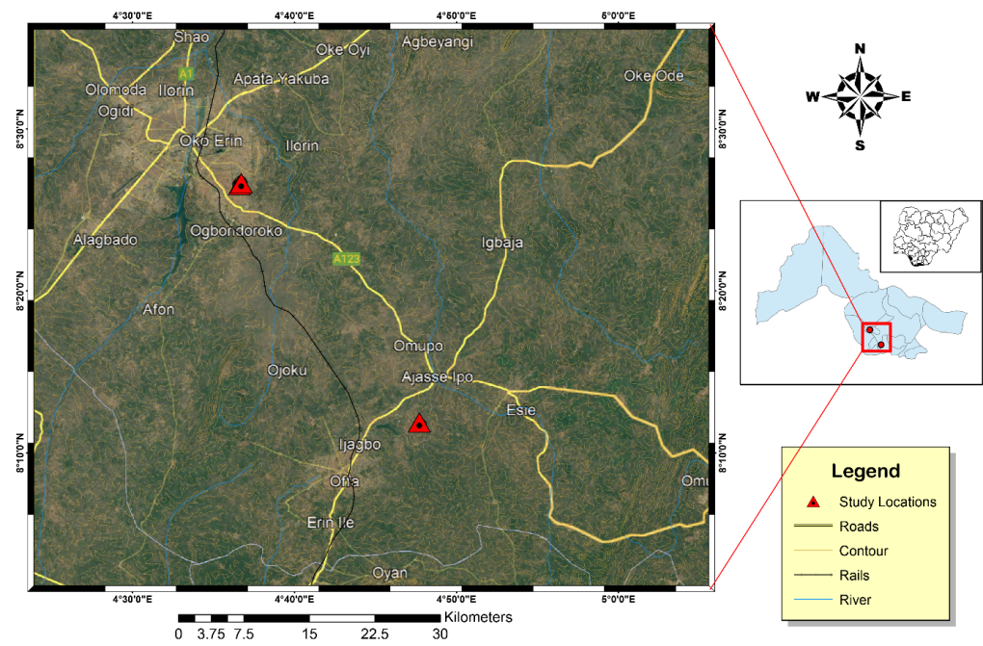

Figure 3.2a: Map showing the study area

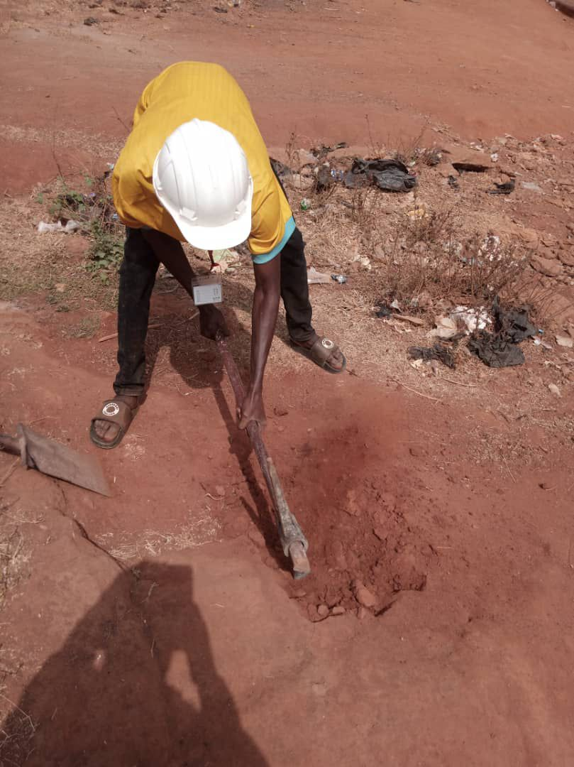
Figure 3.2b: shows the photograph of the study area
3.2.2 Sample Preparation
The samples were pulverized sieved at the department of geology and mineral sciences laboratory, University of Ilorin.
3.2.3 Sample Analysis
The samples were subjected to various analysis such as particle size distribution, atterberg consistency limit, compaction test, free swelling potential, and compressibility.

3.2.3.1 Water Content Determination
The water content of a soil is also called the natural moisture content of the soil, it is defined as the ratio of the weight of water present in a soil to the weight of the dry soil, and it is expressed in percentage. It is mathematically expressed as;
w = Ww/Ws x 100
where w = water content
Ww = weight of moisture
Ws = weight of dry soil
3.2.3.1.1 Apparatus Used
Moisture can
Drying oven
Weighing balance
Desiccator
3.2.3.1.2 Procedure
- A non-corrodible can was weighed on the weighing balance as W₁
- Soil sample was added into the can and weighed as W₂
- The sample was oven dried for 24hrs at a temperature of about 105⁰C to 110⁰C
- The sample was placed in a desiccator to cool after removal from oven
- The dried sample was then weighed as W₃
- The overall process was repeated for all the soil samples and their respective water contents were determined.

3.2.3.2 Bulk and Dry Density
3.2.3.2.1 Bulk Density
Bulk density is defined as the mass of the soil divided by its volume, it is the weight of representative wet soil sample to the volume of the mould containing such sample. It is expressed as mass per unit volume (i.e. g/cm³). It helps to determine how heavy the soil sample is and to determine the bearing capacity of the soil i.e. the mount of the load the soil can carry successfully.
3.2.3.2.1.1Apparatus Used
Mould
Weighing balance
Drying oven
Spatula and pestle
3.2.3.2.1.2 Procedure
- An empty mould is weighed (i.e. weight of mould)
- The volume of the mould was also determined (V)
- The mould is then filled with fresh soil sample, consolidated and weighed (i.e. weight of mould + soil)
- The weighed of the wet soil was calculated by subtracting the weight of empty mould from the weight of wet soil and mould
- The bulk density was deduced using the formula below:
ϒ = W/V
W = weight of representative wet soil sample
V = volume of mould

3.2.3.2.2 Dry Density
Dry density is defined as the ratio of the weight of the dry soil sample to the
volume of the mould containing the dry soil sample.
3.2.3.2.2.1 Apparatus Used
Weighing balance
Drying oven
Spatula
Pan
Desiccator
3.2.3.2.2.2 Procedure
- An empty pan was weighed
- A known volume of the mould from bulk density determination was taken (V)
- The mould with fresh soil sample being consolidated was discharged into the pan for oven drying at 110⁰C until water was completely expelled
- The weighed of the dry soil was calculated by subtracting the weight of empty pan from the weight of dry soil and pan
- The dry density was deduced using the formula below:
ϒ = W/V
W = weight of representative dry soil sample
V = volume of mould
3.2.3.3 Specific Gravity Determination
3.2.3.3.1 Apparatus Used
Density bottle
Measuring cylinder
Weighing balance
3.2.3.3.2 Procedure
- An empty measuring cylinder was weighed as (W₁)
- It is then filled with soil to about 1/3 of its volume, then its weight together with the soil was taken as (W₂)
- The water was added to the soil in the measuring cylinder, the weight of the cylinder with both soil and water was taken as (W₃)
- Empty the measuring cylinder, fill it with distilled water and its weight was taken as (W₄).
- Specific gravity was calculated using the formulae below
(W₂ -W₁)/ (W₄ -W₁) – (W₃ -W₂) X 100
3.2.3.4 Grain Size Analysis
Grain size refers to the diameter of the soil particles that make up the soil mass. This analysis covers the quantitative determination of the various sizes of these soil particles, their proportions to the nearest percentage and the distribution of the various grain sizes that makes up the soil.
Grain size analysis is a very important analysis, which is done in an attempt to describe a soil type. A roughly concluded result is made by the physical description of the soil particles grain distribution, but a more accurate result is gotten by performing the laboratory analysis. This analysis is done in order to know the accurate distribution of the various grain sizes that make up the soil, and helps to solve the problem of confusion between silt and clay. This method entails mechanical and hydrometer analyses respectively.
3..2.3.4.1 Mechanical Sieve Analysis
The sieve analysis involves shaking of the soil sample through a set of sieves that have progressively smaller openings. This method is used in the analysis of particles greater than 0.075mm in diameter. It provides a means of evaluating the different grain size types present in soil sample.
3.2.3.4.1 Apparatus Used
- Stack of sieves
- Mechanical sieve shaker
- Drying oven
- Collecting pan and cleaning brush
- Weighing balance
3.2.3.4.2 Procedure
(a) The soil particles were gently disaggregated
(b) The sieve set (i.e. stack of sieves) were arranged in descending order from the top with a retainer beneath it.
(c) 100g of the soil was weighed and poured into the sieve stack.
(d) The sieve stack was then placed on the mechanical sieve shaker for about 10 minutes
(e) The sieve stack was now separated one by one, then the soil fraction retained in each sieve was weighed and recorded
(f) A statistical data of the result of the analysis was prepared.
3.2.3.4.2 Hydrometer Analysis
This method is used in the determination of the grain distribution of fine-grained soils with soil particles of the order of clay and soil. This method is not applicable if less than 10% of the soil passes through sieve size of 0.075mm mesh size.
3.2.3.4.2.1 Apparatus Used
- Hydrometer bulb
- Measuring cylinder
- Drying oven
- Thermometer
- Evaporating dish
3.2.3.4.2.2 Procedure
(a) The sieved clay and silt from the sieve washing were collected in a container and allowed to settle
(b) The supernatant water was decanted and the mud residue was dried in the drying oven for about 24 hours
(c) The dried sample was then pulverized, 50g of it was weighed and dissolved in one liter of water in a measuring cylinder. The water has dissolved in it sodium hexametaphosphate to enhance rate of clay settlement.
(d) The hydrometer bulb is then inserted into the water in the measuring cylinder and its reading was recorded periodically.
(e) As the settling proceeds, the hydrometer sinks into the solution
(f) The temperature at each hydrometer reading was recorded and then a statistical data was produced.
(g) Then, the percentage passing was plotted against diameter to obtain the percentage composition of the studied soil samples.

      - Atterberg Consistency Limits
3.2.3.5.1 Liquid Limit Determination
3.2.3.5.1Apparatus Used
- Casagrande liquid limit device (made up of a cup, a rotating handle, counter and a cutting groove)
- Pestle and mortar
- Spatula
- Moisture can
- Wash bottle with distilled water
- Sieve 0.425mm
- Oven
- Glass plate
3.2.3.5.2 Procedure
(a) A dried, fresh soil sample is pounded using the pestle and mortal
(b) The sample was sieved using the 0.425mm sieve size, 300g of the sieved sample was weighed and water was added to it until a stiff paste was produced.
(c) The stiff paste was packed into the Casagrande apparatus and then had the surface leveled and smoothened using the spatula.
(d) A groove in the soil was made with cutting groove and rotated the handle (blows) until the groove close. (Note that the number of revolutions the handle makes blows is recorded by the counter). The minimum number of blows is 10 while the maximum is 50.
(e) A small paste was scooped into the moisture can with the spatula, weighed and dried in the drying oven for 24 hours and then reweighed in order to determine its water content.
(f) The soil is then emptied from the cup into the glass plate and water is added to the soil and the process is performed all over again.
(g)The water contents (%) were plotted against numbers of blow (N), water content corresponding to 25 number of blows is the liquid limit
        - Plastic Limit Determination
3.2.3.5.2.1 Apparatus Used
- Glass plate
- Moisture can
- Spatula
- Wash bottle with distilled water
- 0.425mm sieve
- Thermostat oven
3.2.3.5.2.2 Procedure
(a) A small part of the paste in the Casagrande cup is scooped and rolled into a ball
(b) The ball is placed on the glass plate and rolled into thread until it breaks
(c) The crumbled threads are put into two different moisture cans. Then, the cans with crumbled soil sample were oven dried for 24 hours so as to determine the moisture content of each sample, which was taken as plastic limits.
3.2.3.5.3 Linear Shrinkage Determination
(a) The soil sample was thoroughly mixed with distilled water
(b) A linear container of known length was taken and lubricated for easy removal of the soil sample
(c) The container was then filled with the soil sample and its original length was measured before it was oven dried for about 24 hours
(d) The container was allowed to cool in a desiccator, and then the final length of the dried soil sample is measured.
(e) The linear shrinkage of the studied soil samples was calculated using the formula below:
LS = change in length x 100
Original length
3.2.3.6 Compaction Test
3.2.3.6.1 Apparatus Used
- Mixing pan
- Weighing balance
- Drying oven
- Moisture can
- Spatula
- Compaction rammer and mould (consisting of base plate, cylinder mould andextension collar).
3.2.3.6.2 Procedure
(a) 3kg of soil sample was weighed and poured into the mixing pan
(b) 120cm³ (4%) of water was measured, added and mixed with the soil in the mixing pan with the use of spatula.
(c) The cylinder mould is then placed on a base plate, then a representative specimen of the soil is put into the mould and compact with 25 evenly distributed blows of rammer. This represents the first layer.
(d) After the compaction, the volume of the soil in the mould reduced, more soil specimen was added into the mould and compacted with another 25 evenly distributed blows.
(e) The extension collar is then fixed unto the mould. This is mainly for the last layer and removed after the last layer is made to be able to achieve a smooth level surface of the last layer.
(f) The mould is filled with more of the soil specimen and compacted to make the third layer.
(g) The mould with the soil is weighed and the soil sample at the top and bottom of the mould were taken for water content and dry density determination respectively.
(h) The soil in the mould is emptied into the mixing pan and another 120cm³ (4%) of water is added to the soil and mixed
(i) This process was now carried out four more times
(j) Then, the compaction curves were gotten by plotting dry densities against water contents.
3.2.3.7 California Bearing Ratio (CBR)
3.2.3.7.1 Apparatus Used
CBR mould with extension collar and base
Rammer (4.5kg)
Surcharge weight
Mixing plate
Measuring cylinder
Weighing balance
Spatula
3.2.3.7.2 Procedure
(a) 6kg of air- dried sample is measured into mixing pan.
(b) Water equivalent to the optimum moisture content (OMC) of the soil samples earlier calculated during compaction testis measured, added and well mixed with the soil.
(c)The mould is then filled with the soil and compacted with 25 evenly distributed blows on the 3 layers of the soil specimen.
(d) After making the third layer (fifth layer for modified Proctor), a surcharged weight of 2kg and 40mm thick is placed on the extension collar.
(e) The mould with the surcharge weight is placed on the CBR machine plate and the plate is adjusted until the piston of the machine makes contact with the soil inside the mould.
(f) The load and penetration gauge are set at zero just before the test proceeds by the motorized movement of the piston, and the corresponding readings on the load gauge were taken at different penetration levels. This is for the top reading.
(g) The mould was removed from the machine, turned upside down with the position of the base plate changed and then placed back on the plate of the CBR machine and repeat the procedure. This is for the bottom reading.

CHAPER FOUR
4.0 Results Presentation and Discussions
This chapter discusses the test conducted which include; particles size distribution, specific gravity, atterberg consistency limits comprises of liquid limit, plastic limit, plasticity index and shrinkage limit, water content, compaction test, and California bearing ratio (CBR) test as well as the interpretations.
4.1.1 Grain Size Analysis
Table 1: Summary of particle size distribution of the studied samples
Sample code | Dry Sieving(% passing) |  |  |  |  | Hydrometer (% passing)
Sample code | 5.0mm | 3.35mm | 2.0mm | 1.18mm | 0.6mm | 0.025mm | 0.002mm
A | 100 | 97.8 | 86.2 | 87.2 | 70.5 | 19.4 | 11.1
B | 100 | 100 | 95.2 | 88.4 | 75.6 | 26.0 | 12.5
C | 100 | 100 | 100 | 98.6 | 96.3 | 67.3 | 51.5

Table 2: Summary of measured properties
Properties of the soils | Sample A | Sample B | Sample C
Specific Gravity g/cm³ | 2.86 | 2.69 | 2.53
Moisture content (%) | 11.32 | 9.68 | 7.72
Liquid limit (%) | 27.2 | 31.0 | 17.1
Plastic limit (%) | 15.8 | 17.1 | 30.3
Plastic Index (%) | 11.4 | 13.5 | 41.2
Shrinkage limit (%) | 4.6 | 5.2 | 11.5
Maximun Dry Density | 1.88 | 1.82 | 1.54
Optimum Moisture Density | 13.2 | 14.6 | 22.3
Unsoaked CBR (%) | 49 | 47 | 24
Soaked CBR (%) | 28 | 20 | 9

Table 3: Samples composition distributions of Soils in the Study Area
Sample Location | Gravel (%) | Sand (%) | Silt (%) | Clay (%) | % Fine | Soil Classification
Sample 1 | 14 | 60 | 15 | 11 | 26 | Silty Sand
Sample 2 | 5 | 66 | 17 | 12 | 29 | Silty Sand
Sample 3 | 0 | 19 | 30 | 51 | 81 | Silty Clay

Table 4: SOIL Classification according to AASTHO (2019)
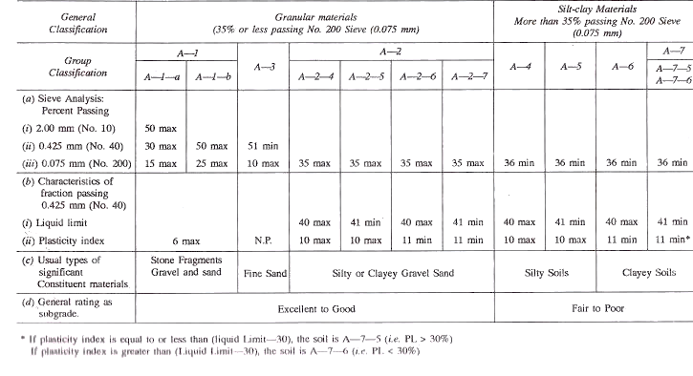

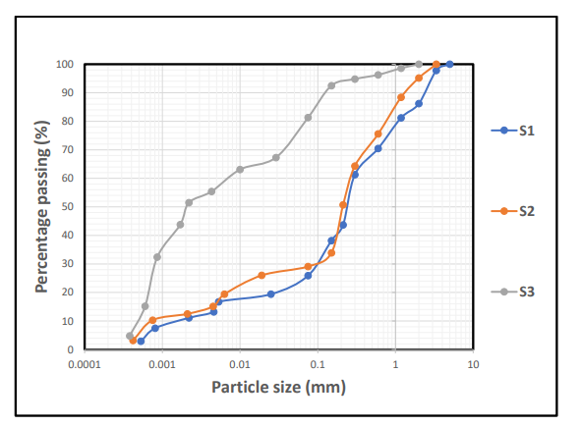
Figure 4.1: Cumulative Particle size distribution curve for sample S1,S2&S3

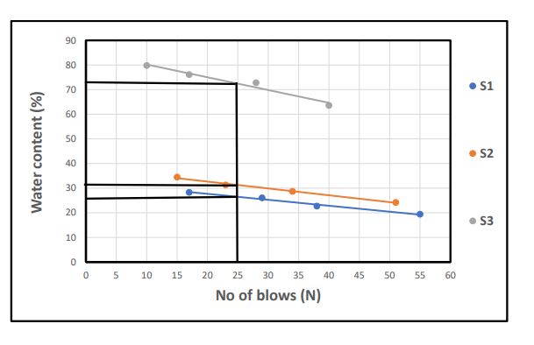
Figure 4.2: Cumulative Moisture content curve for sample S1,S2&S3

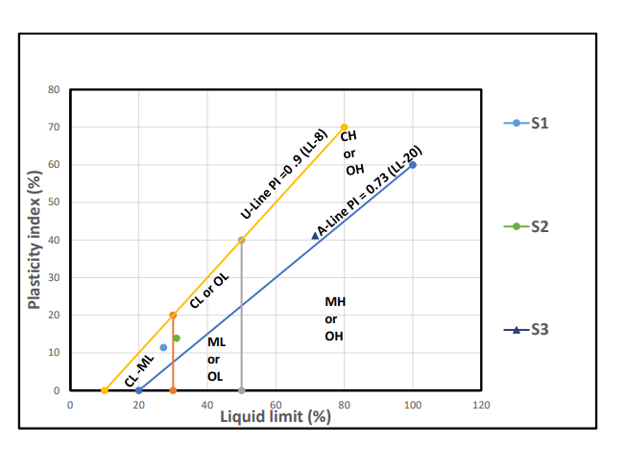
Figure 4.3: Classification of the studied Lateritic soil using Casagrande plot of Liquid Limit (%) versus Plasticity Index.
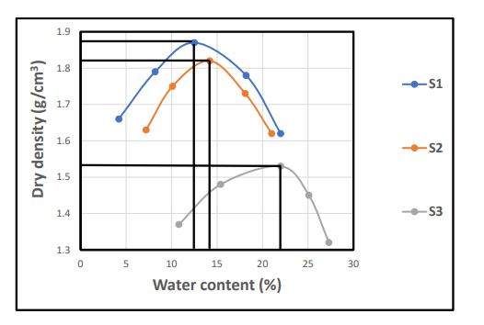
Figure 4.4: Cumulative curve of dry density/water contents

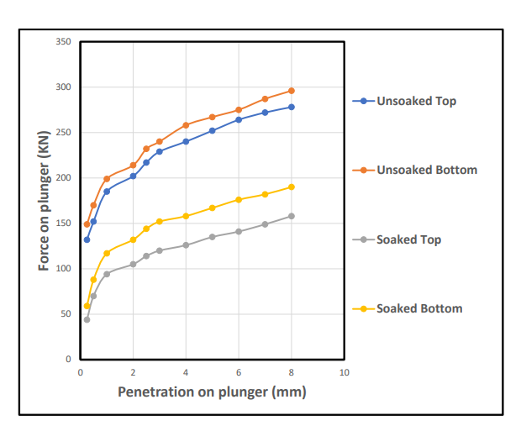
Figure 4.5: Cumulative CBR for Top and Bottom A

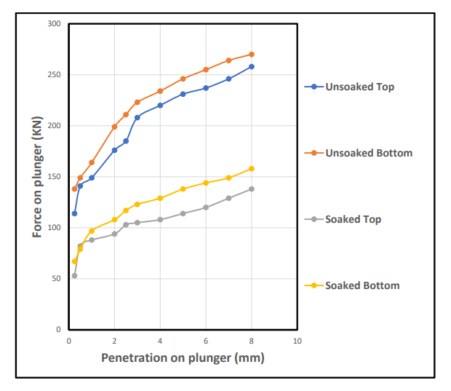
Figure 4.6: Cumulative CBR for Top and Bottom B

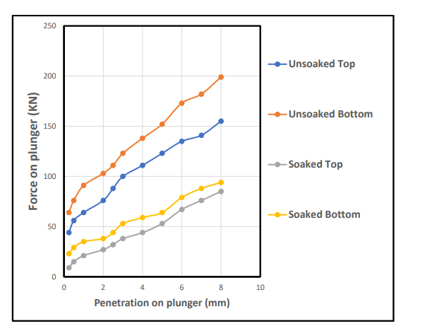
Figure 4.7: Cumulative CBR for Top and Bottom C

Discussions
The analysis carried out on lateritic soil generally have a good representation of either cohesive (i.e fine-grained portions) and cohesionless (i.e coarse-grained portions). The study samples for particle size distribution is shown in the Table 1 and Figure 4.1 with average percentage composition of sand (19-66%), silt (15-30%), Clay (11-51%), gravel (5-14%) and fine percentage range (26-81%) . Thess indicated from Table 4, that the studied sample is silty sand based on the AASHTO classification (2019). These type of materials are good for base grade and sub-base materials. The studied samples has plasticity limit (15.8-30.3%), liquid limit (17.1-31.0%), plastic index (11.4-41.2%), shrinkage limit (4.6-11.5%), specific gravity value (2.53-2.86g/cm³), moisture content (7.72-11.32%), maximum dry density (1.54-1.88Kg/m³), optimum moisture content (13.2-22.3%) and CBR (24-49%) for unsoaked while CBR value for soaked is (9-28%).The above results were suitable and found to be within the standard values for lateritic soil used for road construction as base materials.

CHAPTER FIVE
5.1 SUMMARY
This study assessed the physical and geotechnical properties of lateritic soils collected from Budo Effo and its surrounding environment in Ilorin. Laboratory investigations including water content, particle size analysis, Atterberg limits, compaction characteristics, and CBR tests — were carried out to determine the soils’ suitability for road construction.
Key findings include:
Sample S1 demonstrated superior properties, including high dry density (1.87 g/cm³), moderate plasticity (PI = 11.4%), and excellent load-bearing capacity (CBR = 49% unsoaked, 28% soaked).
Sample S2 also showed fair suitability with adequate strength and acceptable compaction characteristics, though slightly lower than S1.
Sample S3, however, exhibited high plasticity (PI = 41.2%), low dry density (1.53 g/cm³), and poor soaked CBR value (9%), indicating limited suitability unless stabilized.
5.2 Conclusion
Based on the test results, it can be concluded that lateritic soils from Budo Effo vary significantly in engineering performance. Samples S1 and S2 are generally suitable for use in subgrade or subbase layers in flexible pavement design, especially when compacted at their optimum moisture content. In contrast, Sample S3 is not ideal in its natural state due to its high clay content and moisture sensitivity.
Therefore, the use of laterite for road construction in this area must be site-specific and preceded by thorough geotechnical testing. Blanket use of untreated laterite, especially in high-clay zones like S3, is likely to lead to early road failure.
5.3 Recommendations
1. Use S1 and S2 soils for subgrade and subbase construction with proper compaction and moisture control.
2. Stabilize S3-type soils using lime, cement, or pozzolanic additives before applying them to any structural pavement layer.
3. Avoid shallow or organic-rich soil layers, as these significantly affect soil performance.
4. Ensure proper drainage design, particularly in clay-rich zones, to prevent water accumulation and subgrade failure.
5. Establish routine geotechnical testing as part of all future road construction planning in the Ilorin region to optimize material use and improve long-term durability.
6. Further studies should investigate the effect of stabilizers on S3-like soils to recommend cost-effective improvement methods for wider application.

REFERENCES
AASHTO (2018) standard specification for transportation materials and methods of sampling and testing (36th Ed )
Abam T.k.s &Aboh I j (2002) .Laterite soil characteristics and its relevance in road construction.journal of applied sciences,2(1),34-39
Abe I .O (2025) geotechnical properties of laterite soil in northern part of Nigeria international journal, edition 22,21 vol 80.Pp205
Aginamen et al (2014 ) Weathering of rocks and formation of laterite soils .
Andrew lees (2023) . What are laterite soil ? Tensar
Arinze I.E ., & S.C (2015). Geotechnical properties of laterite soil in Nigeria ASTM
Buchanan( 1807) a journal frommadias through my sore , canara, and malabar. London . Bulmer &co ( first definition of laterite )
Chandrassi et al (2021) scientific reports( 2024)
Enaworu ,E O .et al (2017) Mineralogical composition of laterite soils .
Federal highway administration ( FHWA 2020) geotechnical aspects of pavements ( NIH course No 132040)
Gidigasu, M. D (1976) laterite soil engineering.Elverisier
Gupta, p.k and sahu,R (2015). Engineering characteristics of laterite soil “Imternational journal of civil and structural engineering, 6(3):245-251
International (2023) annual book of ASTM standards vol 04 .08 Joel et al (2025)
Mahalinga-iyer &williams , (1991)
Mcfarlane M.J (1976) laterite and landscape . Academic press (formation processes)
Olaniyan,O.S et al . (2019 ) . Road infrastructure development in Nigeria
Ollier, C.D & pain C.F (1996) Regolith , soils and landforms wiley (weathering stages )
Sanchez , P. A. (2019) properties and management of soils in the tropics . Cambridge university press
Schwertmann, U .& Taylor , R.M (1989) iron oxides in soils SSSSA book series

Appendix 1
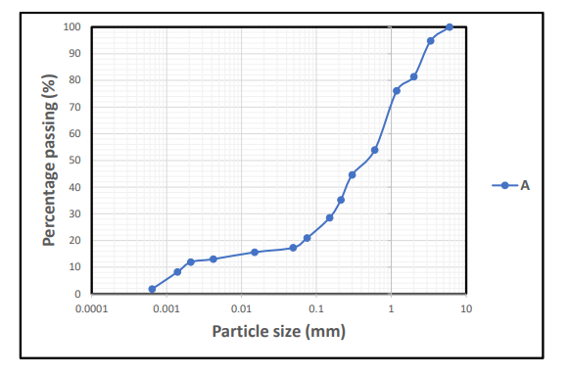

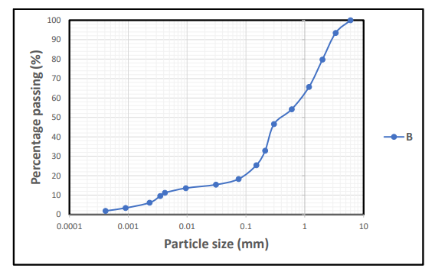

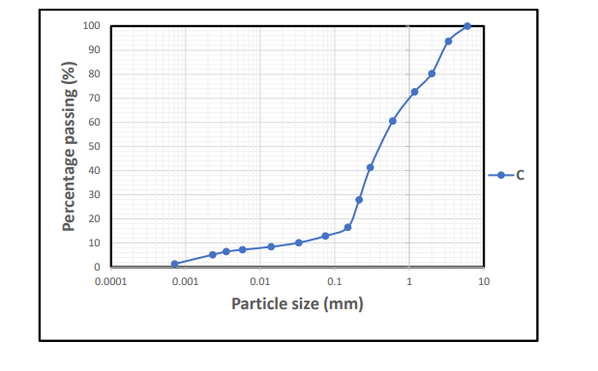
Appendix 2
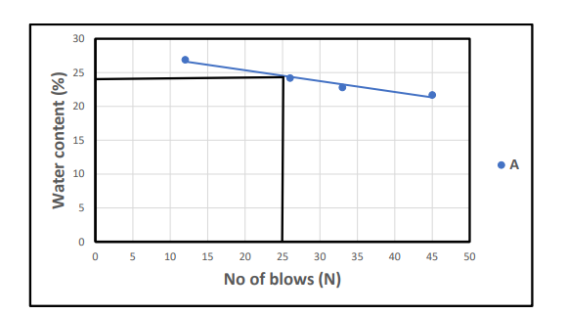

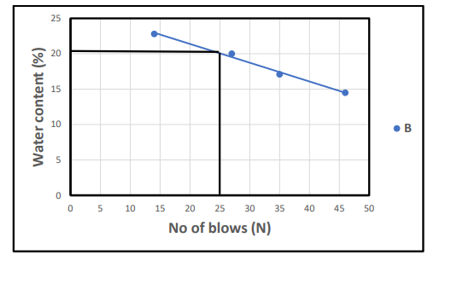

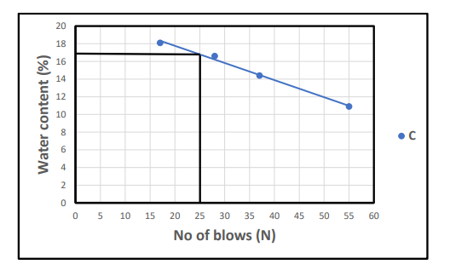

Appendix 3

