COMPARATIVE STUDIES OF SOME GEOTECHNICAL PROPERTIES OF LATERITE SOIL IN OSHIN, ILORIN SOUTH L.G.A. AND ALAGBAA, ILORIN EAST L.G.A OF KWARA STATE

BY

IBRAHIM ABUBAKAR OLAWALE
ND/23/MPE/FT/0020

A PROJECT SUBMITTED TO THE DEPARTMENT OF MINERALS AND PETROLEUM RESOURCES ENGINEERING, INSTITUTE OF TECHNOLOGY, KWARA STATE POLYTECHNIC, ILORIN, NIGERIA.

IN PARTIAL FULFILLMENT FOR THE AWARD OF NATIONAL DIPLOMA (ND) IN MINERAL AND PETROLEUM RESOURCES ENGINEERING TECHNOLOGY
AUGUST, 2025

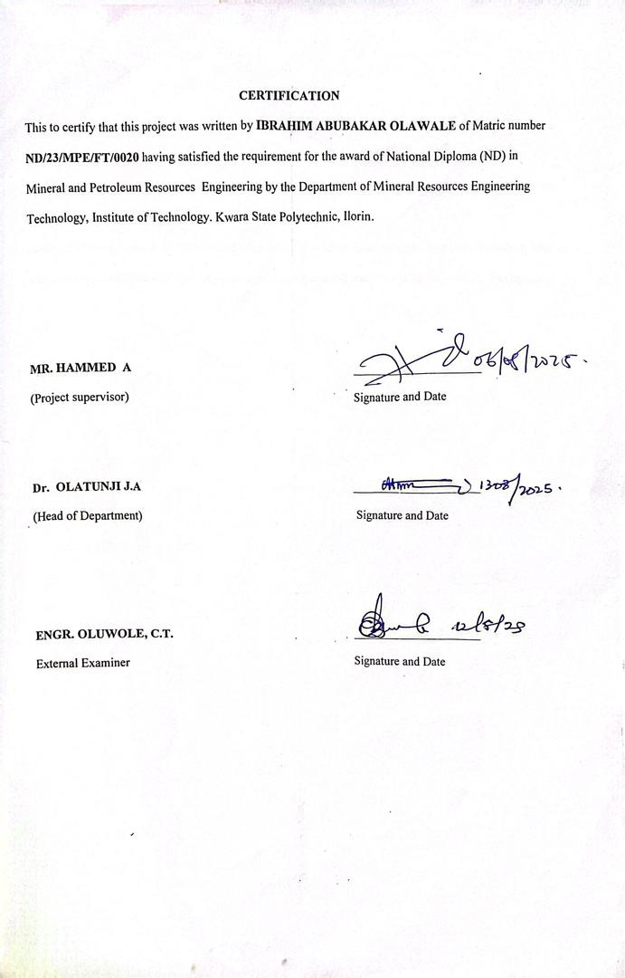
Dedication
This project is dedicated to Almighty God for His guidance, wisdom, and strength throughout the course of this research.
It is also dedicated to my parents and family, whose love, encouragement, and sacrifices have been the foundation of my academic journey.
Finally, I dedicate this work to all future civil engineering students who will continue to explore and advance knowledge in geotechnical engineering for sustainable development.

ACKNOWLEDGEMENT
I express my sincere gratitude to the Almighty Allah for His grace, protection, and guidance throughout the course of my academic journey and the successful completion of this project.
I extend my profound appreciation to my project supervisor, Mr A Hammed, for his invaluable support, encouragement, and expert guidance. His constructive criticisms, suggestions, and commitment to excellence greatly enhanced the quality of this research work.
I am also grateful to my H.O.D in person of Dr. Olatunji J.A, also my profound gratitude goes to my lecturers in person of Dr. Reuben Obaro, Mr. I. S. Usman, Engr. S.A Agbalajobi, and Mr. Odediran for their dedication and knowledge impacted during my study
My heartfelt thanks also go to all the lecturers and staff of the Department of Mineral and Petroleum Resources Engineering, whose teachings and mentorship have contributed immensely to my academic and personal development.
I am also grateful to my family for their unwavering love, prayers, and financial support. Their encouragement gave me the strength to persevere through challenges during this project.
I acknowledge the assistance of friends and colleagues, especially my coursemates, who shared ideas, offered support, and collaborated in various ways. Your contributions did not go unnoticed and are deeply appreciated.
Finally, I would like to thank everyone who, in one way or another, contributed to the successful completion of this project. May God bless you all abundantly.

Abstract

This study compares the geotechnical properties of lateritic soils from Oshin (Ilorin South L.G.A) and Alagbaa (Ilorin East L.G.A), Kwara State, to assess their suitability for engineering purposes. Soil samples were tested for natural moisture content, specific gravity, grain size distribution, Atterberg limits, compaction, and California Bearing Ratio (CBR) in accordance with BS 1377 (1990). Results showed natural moisture contents of 5.8% and 6.5%, and specific gravities of 2.70 and 2.78, classifying both as inorganic soils. Grain size analysis placed both samples in the sandy gravel category. Plasticity indices were 20.9% and 21.9%, indicating moderate volume change potential. Maximum dry densities ranged from 1.80–1.83 g/cm³ with optimum moisture content of 15.0%. Soaked CBR values were low (2–3%), suggesting poor subgrade quality, while unsoaked values (3–5%) indicated marginal suitability for sub-base. The study concludes that both soils are suitable for subgrade and sub-base applications when properly compacted or stabilized.

TABLE OF CONTENTS
TITLE PAGE i
CERTIFICATE ii
DEDICATION iii
ACKNOWLEDGE iv
ABSTRACT v
TABLE OF CONTENTS vi
LIST OF TABLES viii
LIST OF FIGURES ix
LIST OF APPENDIX x
CHAPTER ONE
INTRODUCTION
1.1 Location and Accessibility 1
1.2 Aim and objectives 2
1.3 Statement of the Problem 3
1.4 Justification of the study 3
1.5 Scope and Limitation 4
1.6 Location and Accessibility of Laterite 5
1.7 Climate and Vegetation of the Study Area 6
1.8 Drainage and Relief of the Study Area 7
CHAPTER TWO
LITERATURE REVIEW
2.1 Review of previous of studies 9
2.2 Overview of lateritic soil 9
2.3 Geology of Nigeria 10
2.4 Geology of the studies 12
2.5 Origin of lateritic soil 14
2.6 Formation of lateritic soil 14
2.7 Strength of lateritic soil 15
CHAPTER THREE
3.0 Materials and method 16
3.1 Sample collection and preparation 16
3.2 Laboratory analysis 17
3.3.1 Determination of grain size distribution 17
3.3.2 Mechanical sieve analysis 18
3.3.3 Hydrometer sieve method 19
3.4 Determination of atterberg limits test 20
3.4.1 Liquid limit determination 20
3.4.2 Plastic limits determination 21
3.5 Compaction test 21
3.6 Determination of compaction ratio 22
3.7 California bearing Ratio 22
CHAPHR FOUR
4.0 Results and Discussion 24
4.1 Results of Natural water determination 24
4.2 Discussion of Natural water Determination 24
4.3 Results of Specific Gravity 25
4.4 Discussion on specific Gravity Determination 25
4.5 Results of Grain Size Analysis 26
4.6 Discussion of Grain Size Analysis 27
4.7 Result of Atterberg Limit Determination 31
4.8 Discussion on Atterberg Limit Determination 34
4.9 Results of compaction tests 38
4.10 Discussion on Compaction results 42
4.11 Results of Califonia Bearing Ratio 44
4.12 Discussion CBR Results 49
CHAPTER FIVE
5.0 Conclusion and Recommendation 50
5.1 Conclusion 50
5.2 Recommendation 50

List of Figures
Fig. 2.1: Geology of Nigeria
Fig. 2.2: Location of the study area
Fig. 4.1: Grain Size Analysis for Sample A
Fig. 4.2: Grain Size Analysis for Sample B
Fig. 4.3: Plots of Sample A and B on Plasticity Chart
Fig. 4.4: Compaction Curves for Sample A
Fig. 4.5: Compaction Curves for Sample B
Fig. 4.7: Plots of California Bearing Ratio for Sample A
Fig. 4.8: Plots of California Bearing Ratio for Sample B

INTRODUCTION
1.1 Background of the study
Laterite soil is one of the most widely distributed residual soils in tropical and subtropical regions. Formed under conditions of high rainfall and temperature, lateritic soils are the result of intensive and prolonged weathering of the underlying parent rock, often leading to the concentration of iron and aluminum oxides (Osinubi, 1998). These soils exhibit varying geotechnical properties depending on their location, depth, and the mineralogical composition of the parent material (Gidigasu, 1976). Their widespread availability and relatively good engineering properties make them commonly used in civil engineering projects such as road bases, embankments, and foundations (Ola, 1983).
Understanding the geotechnical behavior of laterite soils is critical for the safe and cost-effective design of civil engineering structures. Key properties such as Atterberg limits, grain size distribution, compaction characteristics, shear strength, and California Bearing Ratio (CBR) influence the suitability of these soils for construction purposes (Adebayo & Afolayan, 2020). However, due to differences in geology, topography, and environmental conditions, the properties of laterite soils can vary significantly even within short geographical distances.
This study focuses on the comparative analysis of some geotechnical properties of laterite soils obtained from two different locations within Kwara State—Oshin in Ilorin South Local Government Area and Alagbaa in Ilorin East Local Government Area. Though both areas lie within the same climatic and geological region, micro-environmental factors may lead to variations in their soil characteristics. Such comparative studies are essential in determining the appropriate engineering applications for each soil type and in guiding construction decisions at the local level.
The aim of this project is to analyze and compare key geotechnical parameters of laterite soil samples from both locations through laboratory testing. The findings are expected to provide a better understanding of the engineering behavior of lateritic soils in these regions and to support their efficient use in construction practices.
1.2 Aim and Objectives
Aim of the Study
The aim of this study is to compare the geotechnical properties of lateritic soils from Oshin (Ilorin South L.G.A) and Alagbaa (Ilorin East L.G.A) in Kwara State, with a view to determining their suitability for civil engineering and construction purposes.
Objectives of the Study
To achieve the aim, the following specific objectives are set:
1. To identify and collect representative lateritic soil samples from the two study areas.
2. To determine the geotechnical properties of the soils, including:
- Moisture content
- Atterberg limits (Liquid Limit, Plastic Limit, and Plasticity Index)
- Grain size distribution
- Specific gravity
- Compaction characteristics
- California Bearing Ratio (CBR)
3. To compare the geotechnical properties of soils from Oshin and Alagbaa.
4. To evaluate the suitability of the soils for engineering applications such as road construction, foundation works, and embankments.
5. To recommend possible soil improvement methods if deficiencies are found in the soil properties.
1.3 Statement of the Problem
Lateritic soils are among the most commonly used natural materials for civil engineering works in Nigeria, especially in road construction, foundation systems, and earthworks. Despite their widespread use, lateritic soils exhibit considerable variability in geotechnical properties from one location to another, even within the same geographical region. This variation can lead to unexpected construction failures, such as pavement distress, foundation settlement, and slope instability, if not properly understood and accounted for.
In the areas of Oshin (Ilorin South L.G.A) and Alagbaa (Ilorin East L.G.A) of Kwara State, ongoing infrastructural developments rely heavily on locally sourced lateritic soil. However, there is a lack of comparative geotechnical data to guide engineers and builders on the quality and suitability of the soils from these specific locations. Without such data, there is a risk of using substandard materials that may compromise the safety, durability, and cost-effectiveness of engineering projects.
1.4 Justification of the Study
Lateritic soils are one of the most widely used materials in civil engineering and construction projects in Nigeria, particularly for road construction, embankments, and foundation works. However, their geotechnical properties can vary significantly from one location to another due to differences in parent rock, weathering conditions, drainage, and mineral composition. These variations influence the soil’s strength, stability, and overall suitability for engineering purposes.
The two selected study areas—Oshin in Ilorin South L.G.A and Alagbaa in Ilorin East L.G.A—are both active regions experiencing infrastructural development. Yet, there is limited comparative data on the geotechnical behavior of lateritic soils in these locations. Understanding the differences in soil properties will assist engineers, planners, and developers in making informed decisions when selecting construction materials or designing foundations and pavements.
1.5 Scope and Limitation
Scope of the Study
This study focuses on the comparative analysis of selected geotechnical properties of lateritic soils obtained from two locations within Kwara State: Oshin in Ilorin South Local Government Area and Alagbaa in Ilorin East Local Government Area. The geotechnical investigation includes field sampling and laboratory testing of the following properties:
- Natural moisture content
- Atterberg limits (liquid limit, plastic limit, and plasticity index)
- Particle size distribution
- Specific gravity
- Compaction characteristics (maximum dry density and optimum moisture content)
- California Bearing Ratio (CBR)
- The study evaluates and compares these parameters to determine the suitability of lateritic soils from both areas for construction and engineering purposes, particularly for use in foundations, road subgrades, and earthworks.
Limitation of the Study
Despite its relevance and applicability, the study is subject to certain limitations:
1. Geographical limitation – Only two locations within Kwara State are investigated, which may not fully represent all lateritic soils in the region.
2. Depth of sampling – Soil samples are collected only at specific shallow depths, potentially excluding variations at greater depths.
3. Laboratory resources – The range of geotechnical tests is limited to those feasible within the available laboratory facilities.
4. Time constraints – The project is conducted within an academic timeframe, which may limit the extent of sampling and number of test repetitions.
5. Environmental factors – Seasonal changes in moisture content and weathering conditions may affect the soil behavior but are not fully captured due to the time of sampling.
1.6 Location and Accessibility of Laterite
The study was conducted in two selected locations within Kwara State, Nigeria: Oshin in Ilorin South Local Government Area and Alagbaa in Ilorin East Local Government Area. These areas were chosen due to their active use of lateritic soil for local construction projects and their accessibility for field investigation and sample collection.
Oshin – Ilorin South L.G.A
Oshin is situated in the southern part of Ilorin, the capital city of Kwara State. It lies within a well-drained and moderately undulating terrain characterized by residential and infrastructural development. The lateritic soil in this area is readily exposed along road cuts, erosion sites, and borrow pits. Accessibility to the location is made easy through tarred and untarred roads branching off major highways, notably the Ilorin–Ajase Ipo Road.
Alagbaa – Ilorin East L.G.A
Alagbaa is located northeast of central Ilorin, within Ilorin East L.G.A. The area is semi-urban, with a mix of agricultural and residential activities. Lateritic soils are exposed in erosion-prone areas, farm paths, and road construction sites. The site is accessible via the Ilorin–Shaare Road, with connecting feeder roads leading to the sampling points.
Both locations fall within the tropical climatic zone and the Precambrian Basement Complex, which significantly influences the formation and characteristics of lateritic soil. The easy access to the sampling points and the presence of active laterite exposures make these locations suitable for geotechnical investigation and comparative analysis.
1.7 Climate and Vegetation of the Study Area
The study areas—Oshin (Ilorin South L.G.A) and Alagbaa (Ilorin East L.G.A)—are located within the Southern Guinea Savannah zone of Nigeria, characterized by a tropical wet and dry climate. This climatic condition plays a significant role in the weathering process of rocks and the formation of lateritic soils in the region.
Climate
The climate of the area is governed by two main air masses: the tropical maritime air mass from the Atlantic Ocean and the tropical continental air mass from the Sahara Desert. The weather pattern is bimodal, consisting of:
- Rainy Season: Typically from April to October, with an annual rainfall ranging from 1000 mm to 1500 mm. The highest rainfall occurs between July and September.
- Dry Season: Spanning November to March, accompanied by dry Harmattan winds from the northeast.
- Temperature: The area experiences high temperatures year-round, with mean annual temperatures between 25°C and 30°C.

These climatic conditions promote intense chemical weathering of basement rocks, leading to the development of thick lateritic profiles rich in iron and aluminum oxides.
Vegetation
The vegetation of the study areas is dominated by savannah grassland interspersed with scattered trees and shrubs. The natural vegetation has been significantly altered due to human activities such as farming, urbanization, and road construction. The vegetation helps stabilize the soil, but its removal can expose the land to erosion, influencing the distribution and characteristics of lateritic soils in the region.
The interaction between climate and vegetation strongly affects the moisture regime, organic content, and weathering depth of soils in both Oshin and Alagbaa.
1.8 Drainage and Relief of the Study Area
Relief
The relief of both Oshin (Ilorin South L.G.A) and Alagbaa (Ilorin East L.G.A) is characterized by gently undulating terrain typical of areas underlain by the Precambrian Basement Complex. Elevations generally range between 250 and 400 meters above sea level, with minor variations due to localized hills and valleys.
The terrain promotes moderate runoff and influences soil development, particularly the laterization process. The presence of slopes in some areas enhances erosion, exposing lateritic layers, especially in road cuttings and borrow pits. These natural exposures are ideal for geotechnical sampling.
Drainage
The study areas are drained by a network of seasonal streams and rivers, many of which are tributaries of the Asa River, the major drainage channel within Ilorin and its environs. These watercourses flow primarily during the rainy season and often dry up in the dry season. The drainage pattern is dendritic, typical of regions with relatively homogeneous and resistant rock types.
In Oshin, surface runoff from surrounding elevations drains into shallow valleys and stream channels, creating erosional gullies in some parts. Alagbaa exhibits a similar drainage pattern with intermittent streams and seasonal wetlands that influence surface hydrology.

CHAPTER TWO
LITERATURE REVIEW
2.1 Review of previous studies
Soil is the unconsolidated material composed of minerals, organic matter, water, and air that lies above the bedrock and serves as the natural medium for plant growth and construction activities. In geotechnical engineering, soil is considered a natural material used for supporting structural loads, making it a crucial factor in the design and performance of buildings, roads, embankments, and other civil infrastructure.
Soils are formed through the weathering of rocks and can vary widely in their physical and engineering properties depending on the parent rock material, climatic conditions, topography, biological activity, and time. The weathering process leads to the disintegration and decomposition of rocks, resulting in soil particles of various sizes and compositions (Das, 2010).
Soils are generally classified based on their grain size (coarse-grained or fine-grained), plasticity, mineral composition, and origin (residual or transported). Coarse-grained soils include gravel and sand, while fine-grained soils include silt and clay. Residual soils, such as laterite, form in place from the weathering of underlying rock, while transported soils are carried by wind, water, or ice and deposited elsewhere (Craig, 2004).
2.2 Overview of Lateritic Soil
Lateritic soils are residual soils that form under conditions of high temperature and heavy rainfall, particularly in tropical and subtropical regions. They are the result of prolonged chemical weathering of parent rock materials, during which silica is leached out and iron and aluminum oxides accumulate. This process is known as laterization, and it produces soils rich in sesquioxides (Fe₂O₃ and Al₂O₃), giving laterite its characteristic reddish or yellowish color (Gidigasu, 1976; Ola, 1983).
Lateritic soils are widely distributed across West Africa and play a crucial role in civil engineering and construction due to their abundance, workability, and relatively good load-bearing properties when properly compacted. In Nigeria, laterite is extensively used as a sub-base and base material in road construction, as well as for fill and foundation material in both rural and urban projects (Osinubi, 2000).
2.3 Geology of Nigeria
Nigeria’s geology is marked by diverse rock formations that have evolved over millions of years, making the country geologically complex and significant within the West African subregion. Broadly, the geological framework of Nigeria can be classified into four major units:
- The Basement Complex
- Younger Granites
- Sedimentary Basins
- Volcanic Rocks (Tertiary to Recent)
1. The Basement Complex
The Precambrian Basement Complex underlies approximately 60% of Nigeria’s landmass, especially in the southwestern, central, and northern parts of the country. It comprises a mix of igneous and metamorphic rocks, such as:
- Granite
- Gneiss
- Schist
- Migmatite
- Quartzite

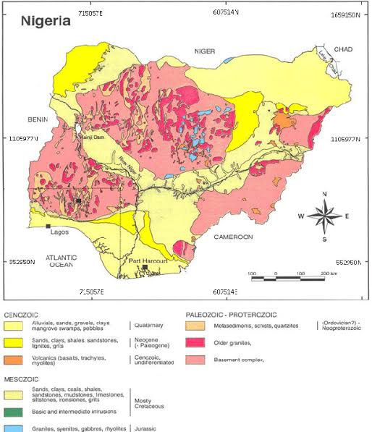
Figure 2.1 Geological Map of Nigeria
These rocks are the result of multiple geological events, including regional metamorphism, migmatization, and tectonic deformation (Rahaman, 1988). The intense weathering of these rocks in tropical conditions gives rise to lateritic soils, especially in regions like Kwara State, where Oshin and Alagbaa are located.

2.4 Geology of the Study Areas
The study areas, Oshin in Ilorin South Local Government Area and Alagbaa in Ilorin East Local Government Area of Kwara State, are both located within the Precambrian Basement Complex of southwestern Nigeria. This geological formation is a dominant component of the Nigerian shield and is composed primarily of crystalline igneous and metamorphic rocks such as granites, migmatites, gneisses, and schists (Rahaman, 1988).
These rocks have undergone extensive weathering and alteration processes under tropical climatic conditions, resulting in the development of deep lateritic soil profiles. The presence of high rainfall, elevated temperatures, and good drainage conditions in the region promotes the chemical breakdown of silicate minerals and the subsequent leaching of mobile elements, leaving behind iron and aluminum oxides that accumulate to form lateritic soils (Gidigasu, 1976).
In Oshin, Ilorin South L.G.A, the geology is primarily underlain by biotite granite and granite gneiss, which are highly susceptible to laterization. The weathering of these rocks produces coarse-grained lateritic soils with relatively stable engineering characteristics when compacted. The area features gently undulating terrain, facilitating good drainage and enhancing the quality of lateritic soils (Ola, 1983).

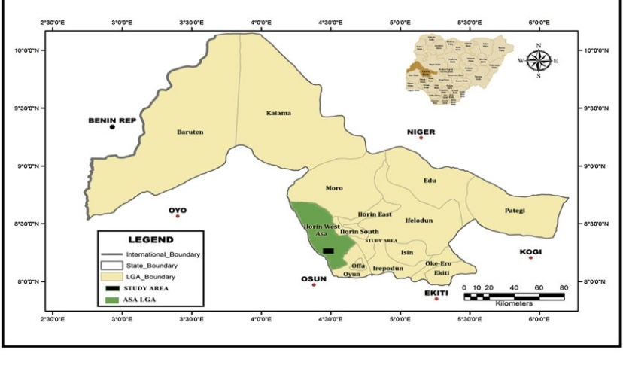
Figure 2.2 Location of the study Area

2.5 Origin of Lateritic Soil
Lateritic soils originate from the in-situ chemical weathering of rocks in tropical and subtropical regions, under specific environmental conditions of high temperature, heavy rainfall, and good drainage. The term “laterite” was first introduced by Buchanan in 1807 to describe the iron-rich, reddish soil observed in southern India. Since then, the term has been broadly applied to similar soil types across the tropical world, including large parts of West Africa and Nigeria (Gidigasu, 1976).
The process of laterization involves the intensive leaching of silica and bases such as calcium, sodium, and potassium from the parent rock, which leads to the residual concentration of iron and aluminum oxides, as well as kaolinitic clays. These oxides, primarily in the form of goethite, hematite, and gibbsite, give lateritic soil its characteristic red or yellow-brown coloration and contribute to its cementing and load-bearing properties (Bell, 1993).
2.6 Formation of Lateritic Soil
Lateritic soils are formed through a natural and complex process called laterization, which involves the prolonged chemical weathering of rocks under specific climatic and environmental conditions. This process typically occurs in tropical and subtropical regions, where high temperatures, intense rainfall, and good drainage conditions promote the breakdown of silicate minerals and the leaching of soluble elements such as silica, sodium, potassium, calcium, and magnesium (Gidigasu, 1976).
As these soluble components are removed, insoluble oxides of iron (Fe₂O₃) and aluminum (Al₂O₃) become concentrated in the soil profile. Over time, these oxides give the soil its distinct reddish or yellowish color and contribute to its cementing properties, especially upon exposure to air (Bell, 1993). The intensity and duration of weathering, as well as the composition of the parent rock, largely determine the final characteristics of the lateritic soil.

2.7 Strength of Lateritic Soil
The strength of lateritic soil refers to its ability to withstand external loads and resist deformation or failure under various stress conditions. This property is critical in civil engineering applications such as road construction, embankment stability, and foundation design. Lateritic soils, when properly compacted and drained, often exhibit moderate to high strength characteristics, making them suitable for use in a variety of geotechnical and structural applications (Ola, 1983).
Factors Influencing the Strength of Lateritic Soil
The strength of lateritic soils depends on several factors, including:
- Moisture content: Excess water can reduce soil cohesion and internal friction, leading to a loss in strength.
- Grain size distribution: Well-graded laterites with a good mix of gravel, sand, and fines usually exhibit better strength than poorly graded ones.
- Clay mineral content: Soils with high kaolinite content tend to be stronger and less expansive than those rich in smectite.
- Degree of compaction: Proper compaction increases dry density and shear strength, reducing voids and improving load-bearing capacity.
- Cementation: The presence of iron oxides can create natural bonds between particles, improving cohesion and shear resistance.

CHAPTER THREE
MATERIALS AND METHODS
This chapter details the field procedures and laboratory techniques used to characterise the lateric soils from the two study areas in lorin kwara State.
3.1 Sample Collection and Preparation
The effectiveness and accuracy of any grotechnical
Investigation greatly depent on the mathod and quality of soil sample collection and preparation.
For this study both disturbed and undisturbed lateritic soir samples were collected from solected sites in oshin (ILorin South L.G.A) and Yakuba in Ajia (Ilorin East L. G. A) Of kwara state, Nigeria.
The collection and preparation procedure followed standard practices in accordance with BS 1377 (2016) and were also supposed by relevant Scholarly Studies•
Before the Sampling exercise, a reconnerssance survey was conducted to locate accessible and repressentative lateritic soil exposure. Trial pits were then excavated to a depth of 1.5 meters to obtain samples at Various Horizons (0-5m intervals).
Two types of samples were collected
I. Disturbed Samples:
These were collected using hand tools such as shovels and diggers and placed in thick polytheme bags. They were used for laboratory tests like grain size distribution, Atterberg limits, compaction, and permeability tests. Collected samples were preserved immediately after collected in prevent moisture loss and contamination Disturbed samples were sealed in polythene bags, While undisturbed sample were Wrapped in soil paper and wax - sealed. The samples were them store in plastic containers and transported to the laboratory within 24 hour ta minimize alterantions in physical properties, as recommended by etuke etal. (2023).
3.2 Laboratory Analysis
Laboratory analysis is essential in geotechnical Investigations as it provides the basis for understanding the Engineering behavior Of soil. In these Study, Various laboratory tests? were conducted to determine the physical and mechanical Properties Of the lateritic soil samples Collected from Oshin (ilorin south L. G. A) and yakuba, Ajia (ilorin East L. G. A) Kwara state the laboratory Procedures were carried out in accordance with British Standard Bs 1377 (2016) and ASTM specifications, ensuring the accuracy and reliability of results.
the laboratory analysis included the following geotechnical test!
- Grain size bistribution (mechanical Sieve and Hydrometer methods)
- Atterberg Limits (liquid Limit, Plastic Limit, and Linear Strinkerge)
- Compaction Test (standard Proctor method)
Each test was carefully selected to analyze specific properties ot the lateritic soil and provide data useful for engineering application such as road construction, foundation design and Slope stability.
Disturbed Samples were used for Classification Compaction, and permeability test while undisturbed samples were Utilized for strength analysis. The test result Obtained from these analyses provided a comprehensive understanding of the lateritic soils across the two study locations.
These procedures follow the same scientific principles and Practices used by Adewumi ard Abdulhakeem (2023) in their evaluation of lateritic soils for road design in kwara state Nigeria.
3.3.1 Determination Of Grain Size Distribution
Grain size distribution us a fundamental property used to classify soils and to understand their engineering behavior such as permeabinity, Shear Strength, and compaction Characteristics.
In this study, the grain size distribution of lateritic soir Samples from oshin (ilorin south L. G. A) in kwara state. was determined using two standard methods: Mechanical Sieve Analysis and Hydrometer Analysis, in accordance with BS 1377: Part 2 (2016) and ASTM D422- (2007).
These methods help to determine the proportions of graves, sand, silt, and clay in the soil which are essential for soil Classification under the united soil Classification system (uses) and AASHTO Classification systems.
3.3.2 Mechanical Sieve Analysis
The sieve analysis method was used to determine the particle size distribution of the coarse and medium fractions (particles greater than 75 microns).
The process involved the following stops:

- Air- drying and weighing Approximately 500g of Each disturbed soil sample was air dried weighed accurately
- Sieving procedure; The soil was placed if a stock of Standard BS sieves arranged in descending Order Of aperture size eranging from 4.75 mm to 75 km). The sieve Stack was mounted on a mechanical Stanker and agitated for about 10-15 minutes
- Weighing retained materials: The soil retained on each sieve was carefully weighing and the cumulative percentage retained was calculated.
- Plotting grain size curve! The percentage passing was plotted against the sieve size on a semi - logarithmic graph to obtain to particle size distribution curves.
The Outcome of the test was used so classify the soil based on the relative proportions of gravel, sand, and fines.
According to Ojetia (2022), this method is effective in indentifying well-graded and poorly - graded soils, which is essential for Engineering use such as pavement layers and earth dams.

3.3.3 Hydrometer sieve method
The hydrometer analysis was used to determine the particle size distribution of the fine grained Portion of the soil samples (particles smaller than 75 Microns, Which Could not be evaluated using mechanical sieve analysis. (BS 1377 - 67, 2023).
These method is basket on the principle of sedimentation, as governed by stokes law, which states that particles settle at different velocities depending on their size, shape and specific gravity when suspended in a liquid (BS 1377-2, 2020 ASTM DH22- 63, 2009).
Proceduce of hydrometer sieve method
I. Sample Preparation
Approximately 50 grams 0f air- dried soil passing throngh
a 75 hm sieve was weighed and placed into a dispersion cup. A dispersing agent, typically sodium hexametaphospate (calgon), was added to prevent flocculation Of clay and silt particles. The soil dispersant mixture was throughly mixed using a mechanical Stirrer or electrical Shaker for about 10-15 minutes to ensure complete dispersion (Etuke et al 2023).
ii. Sedimentation
The disposed soil suspension was transferred into a
1- liter graduated sedimentation Cylinder and filled up to the mark with distilled water. (Adewumi & Abdu|hakeem, 2023).
The result were then plotted on a semi-logarithmic graph of particle size Versus Percentage finer, forming the grain size distribution Curves For the soil's fine fraction (ojefia, 2022; ASTM DA22-63, 2007)
3.4 Determination of Atterberg Limits Test
The Atterberg limits are a set of tests used to determine the consistency and plasticity Characteristics of fine-grained soils: These limits define the boundaries between the different states of soil from liquid to plastics to solid. They are essential for soil Classification and for understanding the Workability's compressibility, and strength Of soils, especially in construction and foundation Engineering. ASTM D427-63 (2007)
The three Principal Atterberg limits determined in this study were:
Liquid Limit (LL), Plastic Limit (PL) This is demand which is derived as: PI = LL - PL
These tests were conducted according to the Britist Standard BS1377: Part2 (2016) and followed procedures used in past studies such as eleke et al. (2023) and Ojefia (2022), Which analyzed the plasticity characteristics Of lateritic Soils in Nigeria.
3.4.1 Liquid Limit Determination
The liquid limit is the water Content at which the Soil Changes from a liquid to a plastic state. it was determined using the casagrande apparatus jefia (2021).
Procedure:
i. ﻿﻿A paste Of soil was Prepared and placed in the brass Cup Of the Casagrande device.
ii. A groove was cut through the center using a grooving tools.
iii. The cup was dropped repeatedly from a height of 100nm at a rate Of two drops per second.
iv. The number of blows required to close the groove over a distance of 13mm was recorded
v. This process was repeated for different moisture Contents,
The liquid limit was taken as the moisture Content Corresponding to 25 blows.
vi. This. Method is widely accepted and has been used in research by Alado and Amu (2024) to assess the plasticity Of lateritic soils for, road sub- base materials.
3.4.2 Plastic Limit Determination
- The plastic limit is the lowest water Content at which the soil can bo rolled into threads of 3mm diameter without Crumbling: procedure:
- A pation of the soil paste was faken and rotted manually on a glass plate.
- The soil was continuously rolled Until it Crumbled at approximately 3mm diameter.
- The water content at which crumbling occurred was recorded.
- The test was repeated three times and the average value was taken as the plastic limit.
This test helps to understand how workable and moldable the soil is at lower moisture levels.(Amedi, 2021)
The soils with high plastic limits tend to do more ductile and resist sudden Changes in volume (Strink/ Swell behavior), which is a concern in foundation design (ojuri, 2013).
3.5 Compaction Test
The compaction test is a fundamental geotechnical test used to determine the maximum dry density (MDD) and Optimum moisture content (OMC) Of soil.
These two parameters are essential for assesing how won a soil can bs compacted in the field to achieve maximum Strength and Stability. BS 1377: Part 4 (2016).
Compaction improves soil properties such as strength Stiffness and Permeability, making it Suitable for foundation works, roads subgrades, embankments, and earth dams.
In this study the Standard proctor Compaction Test was Conducted in accordance with BS 1377: Part4 (2016) and ASTM D698 standards, and the procedures were modeled after Studies such as Adewumi and Abdulhakeem (2023) and juri (2013), which evaluation lateritic soils in tropical regions Of Nigeria.

3.6 Determination of compaction Ratio
The compaction Ratio also referred to as relative Compaction or degree of Compaction is a critical parameter used to assess the effectiveness of soil compaction in the field. it is define as the ratio of the field dry density to the maximum dry density obtained from laboratory Compaction tests (Holtz & Kovacs 1998). This ratio is essential for evaluating whether compaction efforts satisty design specifications, particularly in geotechnical application such as highway construction, embankments, and foundation works.
Achieving adequate compaction ratio is fundamental to enhancing soil performance, as it Contributes to improved shear strength, reduce Compressibility lower Permeability and overall stability under Structural loads (Das, 2010). the test procedures were carried out in accordance with BS 1377(2016) and ASTM D1557 (2012) Consistent with methodologies applied in studies by ojuri (2013) and Etuke etal (2023).
3.7 California Bearing Ratio
The California Bearing Ratio (CBR) test is a standardized penetranion test developed by the California Division of Highways to assess the Strength Of subgrade Soils and base materials used in the construction of roads and air fields (Yoder & witczak, 1995).
It remain One Of the most widely applied empirical methods for evaluating the load bouring Capacity of soils and plays a key role in the design of flexible pavements, embankments, and subgrade layers (Das, 2010).
The CBR value reflects the Shear Strength of a soil and it's resistance to penetration under load and, it is expressed as percentage Of the resistance of a standard crushed stone material under similar conditions (Head, 2000). Higher CBR Values indicate, Stronger, more Stable materials Suitable for structural applications in Geotechnical and highway engineering.
CHAPTER FOUR
RESULTS AND DISCUSSION
4.1 Results of Natural Water Determination
The results of natural water determination are shown in table 4.1 below.
Table 4.1: Natural Water Content Determination for Sample A and B
SAMPLE A SAMPLE B
Boring no.
Container no (Cup)
Wt of cup + Wet soil (g) | 134.5 | 135.0 |  | 162.5 | 118.0
Wt of cup + dry soil (g) | 128.0 | 129.5 |  | 154.5 | 112.5
Wt of cup (g) | 25.5 | 25.0 |  | 34.5 | 24.5
Wt of dry soil. (g) | 102.5 | 104.5 |  | 120.0 | 88.0
Wt of water (g) | 6.5 | 5.5 |  | 8.0 | 5.5
Water content % | 6.3 | 5.3 |  | 6.7 | 6.3
Average water content (%) = 5.8% 6.5%
4.2 Discussion on Natural Water Determination
The natural water content for Sample A and Sample B was found to be 5.8% and 6.5%, respectively. This parameter measures the amount of water present in the soil relative to its dry weight. Typically, natural water contents range from about 10–15% for sand, 15–30% for silt, and 30–50% for clay. The comparatively low water contents recorded for both samples indicate that the soils are relatively dry and that the water table in the study areas likely fluctuates significantly during the dry season (Sidi et al., 2015).
4.3 Results of Specific Gravity
The results of Specific Gravity is shown in Fig. 4.2 below
Table 4.2. Specific Gravity Determination for Sample A and B
SAMPLE A SAMPLE B
SAMPLE LABEL
WT OF EMPTY BOTTLE (g) (W1) | 103.0 | 103.0
WT OF EMPTY BOTTLE+1/3 OF SOIL (g) (W2) | 153.0 | 153.0
WT OF EMPTY BOTTLE+1/3 OF SOIL+WATER (g) (W3) | 229.5 | 230.0
WT OF EMPTY BOTTLE+WATER ONLY (g) (W4) | 198.0 | 198.0
SPECIFIC GRAVITY = | 2.70 | 2.78

4.4 Discussion on Specific Gravity Determination
The specific gravity of a soil is influenced by its sand content, mineral composition, and mode of formation. The specific gravity values obtained for Samples A and B were 2.70 and 2.78, respectively. When compared with the typical ranges for various soil types provided by Lambe (1969) in Table 4.3, these values fall within the range for inorganic soils. This classification suggests that both samples are primarily composed of mineral particles with minimal organic matter, making them potentially suitable for engineering applications where strength and stability are required.

Table 4.3. Typical Values of Specific Gravity of Soil Samples (Lambe and Whiteman, 1969)
SOIL TYPES | SPECIFIC GRAVITY
Sand | 2.65 – 2.67
Silty sand | 2.67 – 2.70
Inorganic soil | 2.70 – 2.80
Soil with mica or iron | 2.75 – 3.00
Organic | Variable but may be under 2.0

4.5 Results of Grain Size Analysis
The results of grain size analysis are shown in table 4.4 below.
Table 4.4: Grain Size Analysis for Sample A and B
Sieve analysis and Grain Size A Sieve analysis and Grain Size B
Sieve No | Diam. (mm) | Wt. retained | % retained | % passive | Diam. (mm) | Wt. retained | % retained | % passive
 | 19.00 |  |  |  | 19.00 | 0.0 | 0.0 | 100.0
 | 16.00 | 0.0 | 0.0 | 100.0 | 16.00 | 12.5 | 2.5 | 97.5
 | 8.00 | 68.5 | 13.7 | 86.3 | 8.00 | 67.0 | 13.4 | 84.1
 | 4.75 | 141.0 | 28.2 | 58.1 | 4.75 | 111.0 | 22.2 | 61.9
 | 2.36 | 134.0 | 26.8 | 31.3 | 2.36 | 149.5 | 29.9 | 32.0
 | 1.00 | 88.0 | 17.6 | 13.7 | 1.00 | 124.0 | 24.8 | 7.2
 | 0.50 | 37.0 | 7.4 | 6.3 | 0.50 | 29.0 | 5.8 | 1.4
 | 0.425 | ------- | --------- | -------- | 0.425 | --------- | --------- | ---------
 | 0.30 | 12.0 | 2.4 | 3.5 | 0.30 | 3.0 | 0.6 | 0.8
 | 0.25 | 5.0 | 1.0 | 2.9 | 0.25 | 0.2 | 0.04 | 0.76
 | 0.150 | 6.5 | 1.3 | 1.6 | 0.150 | 0.2 | 0.04 | 0.72
 | 0.090 | ------- | ------- | ------- | 0.090 | ------- | ------- | -------
 | 0.75 | 5.5 | 1.1 | 0.5 | 0.075 | 1.0 | 0.2 | 0.52
 | PAN | 2.0 | 0.4 |  | PAN | 1.0 | 0.2

4.6 Discussion of Grain Size Analysis
The grain size analysis results, presented in Figure 4.1 for Sample A, show a high dominance of gravel at 72%, followed by sand at 28%. Similarly, Sample B (Figure 4.2) contains 73% gravel and 27% sand. Based on the Unified Soil Classification System (USCS) in Table 4.5, both samples are classified as sandy gravels. On the USCS chart, Sample A and Sample B fall under the group symbol SW (well-graded sands or gravel-sand mixtures with little or no fines). Soils in this category are pervious, possess excellent shear strength when compacted and saturated, exhibit negligible compressibility under the same conditions, and have excellent workability as construction materials. They are also resistant to erosion, making them suitable for various engineering applications.

Fig. 4.1: Grain Size Analysis for Sample A

100100
9090
8080
7070
6060
5050
4040
3030
2020
1010
00
SILTSILT
0.0020.002
0.0030.003
0.0040.004
0.0060.006
0.0080.008
0.0100.010
0.0150.015
0.0200.020
0.0300.030
0.0400.040
0.0500.050
0.0600.060
0.0950.095
0.1050.105
0.1250.125
0.1500.150
0.2120.212
0.2500.250
0.3000.300
0.4250.425
0.5000.500
0.5000.500
1.001.00
1.181.18
1.201.20
2.02.0
2.362.36
4.04.0
6.256.25
8.08.0
9.309.30
12.5012.50
16.7516.75
13.7513.75
25.025.0
31.531.5
37.537.5
37.537.5
38.038.0
39.539.5
40.040.0
42.542.5
45.545.5
50.050.0
100100
9090
8080
7070
6060
5050
4040
3030
2020
1010
00
TineTine
MediumMedium
CoarseCoarse
FineFine
MediumMedium
CoarseCoarse
SandSand
GraveGrave
PERCENTAGE FINER THAN 0PERCENTAGE FINER THAN 0

Fig. 4.2: Grain Size Analysis for Sample B

Table 4.5: Unified Soil Classification System (USCS)
Major divisions | Subdivisions | USCS Symbol | Typical names | Laboratory classification criteria
Coarse gained soils (more than 50% retained on no. 200 sieve) | Gravels (more than 50% of coarse fraction retained on no. 4 sieve | GW | Well graded gravels or gravel-sand mixture, little or no fines | Less than 5% fines
 |  | GP | Poorly graded gravels or gravel-sand mixture, little or no fines | Less than 5% fines
 |  | GM | Silty gravels, gravel-sand-silt mixtures | More than 12% fines
 |  | GC | Clayey gravels, gravel-sand-clay mixtures | More than 12% fines
 | Sands (50% or more coarse fraction passing no. 4 sieve | SW | Well graded sands or gravel-sand, little or no fines | Less than 5% fines
 | Sands (50% or more coarse fraction passing no. 4 sieve | SP | Poorly graded sands or gravel-sand mixture, little or no fines | Less than 5% fines
 | Sands (50% or more coarse fraction passing no. 4 sieve | SM | Silty sand, sand-silt mixture | More than 12% fines
 | Sands (50% or more coarse fraction passing no. 4 sieve | SC | Clayey sand, sand-clay mixture | More than 12% fines
Fine grained soils (50% or more passes the no. 200 sieve) | Silts and Clays  (liquid limit less than 50%) | ML | Inorganic silts, rock flour, silts of low plasticity | Inorganic soils
Fine grained soils (50% or more passes the no. 200 sieve) | Silts and Clays  (liquid limit less than 50%) | CL | Inorganic clays of low plasticity, gravelly clays, sandy clays, etc | Inorganic soils
Fine grained soils (50% or more passes the no. 200 sieve) | Silts and Clays  (liquid limit less than 50%) | OL | Organic silts and organic clays of low plasticity | Organic soils
Fine grained soils (50% or more passes the no. 200 sieve) | Silts and Clays (liquid limit 50% or more) | MH | Inorganic silts, micaceous silts, silts of high plasticity | Inorganic soils
Fine grained soils (50% or more passes the no. 200 sieve) | Silts and Clays (liquid limit 50% or more) | CH | Inorganic highly plastic clays, fat clays, silty clays, etc | Inorganic soils
Fine grained soils (50% or more passes the no. 200 sieve) | Silts and Clays (liquid limit 50% or more) | OH | Organic silts and organic clays of high plasticity | Organic soils
Peat | Highly organic | PT | Peat and other highly organic soils | Primarily organic matter, dark in colour and organic odour

4.7 Results of Atterberg Limit Determination
The results of Atterberg Limit Determination are shown below.
Table 4.6: Liquid Limit Determination for Sample A
Can no. | 26 | 12 | K5 | AA
Container no (Cup)
Wt of Wet soil + can (g) | 36.5 | 35.5 | 35.5 | 32.5
Wt of dry soil + can (g) | 34 | 32.5 | 33 | 30
Wt can (g) | 24.5 | 24 | 25.5 | 24
Wt moisture (g) | 9.5 | 8.5 | 7.5 | 6
Water content, w% | 26.3 | 37.5 | 33.3 | 41.7
No of blows N | 45 | 34 | 22 | 16
50
40
30
20
10
0
10
15
20
25
30
35
40
50
60
70
80
WATER CONTENT W%
NO. OF BLOWS N

Flow index F1 =
Liquid limit = 37.0%
Plastic limit = 16.1%
Plasticity Index Ip = 20.9%
IP = LL - PL= 37 - 16.1 = 20.9
Table 4.6.1. Plastic Limit Determination for Sample A
Can no. | 25 | E1
Wt. of Wet soil + can (g) | 31 | 30
Wt. of dry soil + can (g) | 30 | 29
Wt. of can (g) | 23.5 | 23
Wt. of dry soil | 6.5 | 6
Wt. of moisture (g) | 1 | 1
Water content. w% = w | 15.4 | 16.7

Table 4.6.2: Liquid Limit Determination for Sample B
Can no. | T1 | A1 | H3 | G2
Wt. of Wet soil + can (g) | 34 | 32.5 | 32.5 | 31.5
Wt. of dry soil + can (g) | 31.5 | 29.5 | 30 | 29
Wt. can (g) | 25 | 22.5 | 25.5 | 24
Wt. of dry soil | 6.5 | 7 | 4.5 | 5
Wt. moisture (g) | 2.5 | 3 | 2.5 | 2.5
Water content, w% | 38.5 | 42.9 | 55.6 | 50.0
No of blows N | 40 | 22 | 20 | 10
50
40
30
20
10
0
10
15
20
25
30
35
40
50
60
70
80
WATER CONTENT wt%
NO. OF BLOWS
60

Flow index F1 =
Liquid limit = 43.0%
Plastic limit = 21.1%
Plasticity index Ip = 21.9%
IP = LL - PL
= 43.0% - 21.1% = 21.9%
Table 4.6.3: Plastic Limit Determination for Sample B
Can no. | D4 | 24
Wt. of Wet soil + can (g) | 24 | 24.5
Wt. of dry soil + can (g) | 23 | 23.5
Wt. of can (g) | 18.5 | 18.5
Wt. of dry soil | 4.5 | 5
Wt. of moisture (g) | 1 | 1
Water content. w% = w | 22.2 | 20.0

4.8 Discussion on Atterberg Limit Determination
The Atterberg consistency limit tests for Sample A yielded a liquid limit (LL) of 37.0%, a plastic limit (PL) of 16.1%, and a plasticity index (PI) of 20.9%. For Sample B, the LL was 43.0%, PL was 21.1%, and PI was 21.9%. Based on the classification by Holtz and Gibbs (1936) in Table 4.6.4, these PI values indicate a moderate volume change potential, meaning the soils have a moderate tendency to swell or shrink (Madedor, 1983). When plotted on the plasticity chart (Figure 4.3), both samples fall within the CL zone, which corresponds to inorganic clays of low plasticity. According to the engineering use chart (Table 4.6.5), soils in this classification are impervious inorganic clays that are suitable for applications such as dam construction and other structures requiring low permeability and good stability.
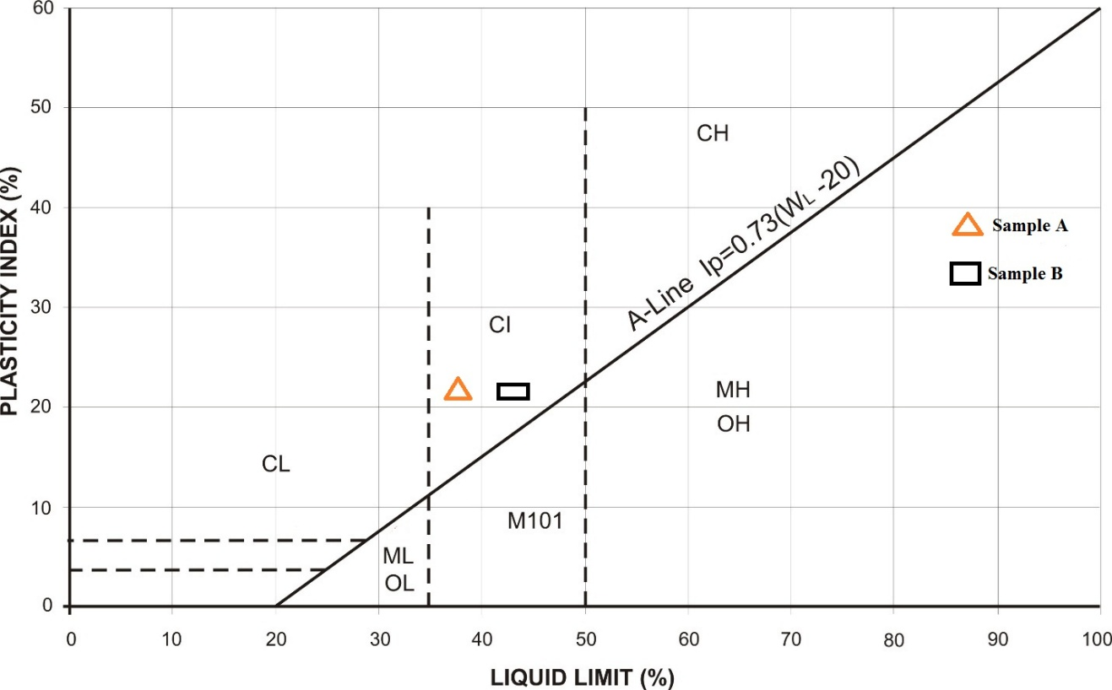
Fig. 4.3: Plots of Sample A and B on Plasticity Chart
Table 4.6.4: Relationship between Atterberg limit and Volume Change Potential (After Holtz and Cubbs, 1936)
Volume Change  Potential | Plasticity Index Ip |  | Shrinkage
Volume Change  Potential | Arid Area | Humid Area
Little | 0 – 15 | 0 – 30 | < 12
Moderate | 15 – 30 | 30 – 50 | 10 – 12
High | >30 | >50 | >10

Table 4.6.5: Engineering Used Chart (After Wagner, 1957)
Typical names of Soil groups | Group Symbols | Important Properties
Typical names of Soil groups | Group Symbols | Permeability when compacted | Shearing strength with compacted and saturated | Compressibility when compacted and saturated | Workability as a construction material
Well graded gravels or gravel-sand mixture, little or no fines | GW | Pervious | Excellent | Negligible | Excellent
Poorly graded gravels or gravel-sand mixture, little or no fines | GP | Very pervious | Good | Negligible | Good
Silty gravels, gravel-sand-silt mixtures | GM | Semi-pervious to impervious | Good | Negligible | Good
Clayey gravels, gravel-sand-clay mixtures | GC | Impervious | Good to fair | Very low | Good
Well graded sands or gravel-sand, little or no fines | SW | Pervious | Excellent | Negligible | Excellent
Poorly graded sands or gravel-sand mixture, little or no fines | SP | Pervious | Good | Very low | Fair
Silty sand, sand-silt mixture | SM | Semi-pervious to impervious | Good | Low | Fair
Clayey sand, sand-clay mixture | SC | Impervious | Good to fair | Low | Good
Inorganic silts, rock flour, silts of low plasticity | ML | Semi-pervious to impervious | Fair | Medium | Fair
Inorganic clays of low plasticity, gravelly clays, sandy clays, etc | CL | Impervious | Fair | Medium | Good to fair
Organic silts and organic clays of low plasticity | OL | Semi-pervious to impervious | Poor | Medium | Fair
Inorganic silts, micaceous silts, silts of high plasticity | MH | Semi-pervious to impervious | Fair to poor | High | Poor
Inorganic highly plastic clays, fat clays, silty clays, etc | CH | Impervious | Poor | High | Poor
Organic silts and organic clays of high plasticity | OH | Impervious | Poor | High | Poor

4.9 Results of Compaction tests
The results of Compaction tests are shown below for Sample A and B
Table 4.7: Compaction Tests for Sample A (Standard Proctor)
Sample no | 1 |  | 2 |  | 3 |  | 4
Moisture can no | 7 | P8 | TB | 33 | P14 | Y2 | E8 | 4
Wt. of can + wet soil | 73 | 1/7 | 72.5 | 78 | 178 | 173.5 | 169.5 | 179.5
Wt. of can + dry soil (g) | 68.5 | 11.2 | 67.5 | 72.5 | 162 | 158 | 148.5 | 158
Wt. of can (g) | 4.5 | 5 | 5 | 5.5 | 16 | 15.5 | 21 | 21.5
Wt. of can (g) | 20 | 51.5 | 23.5 | 24.5 | 58.5 | 57 | 25 | 34
Wt. of dry soil (g) | 48.5 | 54.5 | 44 | 48 | 103.5 | 101 | 123.5 | 124
Water content w% | 9.3 | 9.2 | 11.4 | 11.5 | 15.5 | 15.3 | 17.0 | 17.3
DENSITY DETERMINATION
Assumed water content (g) |  | 9.5 | 11.5 |  |  | 15.5 | 17.0
Average water content% |  | 9.3 | 11.5 |  |  | 15.4 | 17.2
Wt. of soil + mould (g) |  | 4693 | 4912 |  |  | 5044 | 4961
Wt. of mould (g) |  | 2976 | 2976 |  |  | 2976 | 2976
Wt. of soil in mould (g) |  | 1717 | 1936 |  |  | 2068 | 1985
Wet Density, DW (g/cm³) |  | 1.717 | 1.936 |  |  | 2.068 | 1.985
Dry density (g/cm³) |  | 1.571 | 1.736 |  |  | 1.792 | 1.694

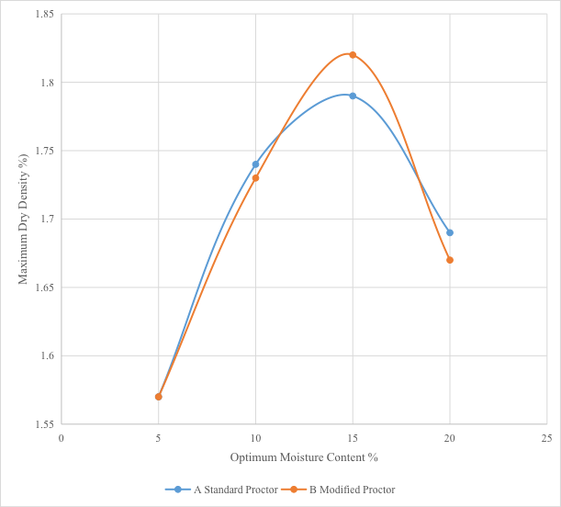

Fig. 4.4: Compaction Curves for Sample A

Table 4.7.1: Compaction Tests for Sample A (Modified Proctor)
WATER CONTENT DETERMINATION
Sample no | 1 |  | 2 |  | 3 |  | 4
Moisture can no | Bo | J | 3 | LA | 1 | 5 | 2 | 4
Wt of can + wet soil | 99.5 | 94.5 | 120.5 | 122 | 174.5 | 206.5 | 254.5 | 246.5
Wt. of can + dry soil (g) | 95 | 89.5 | 110 | 110.5 | 155.5 | 184.5 | 218.5 | 210
Wt of can (g) | 4.5 | 5 | 10.5 | 11.5 | 19 | 22 | 36 | 36.5
Wt of can (g) | 32.5 | 25 | 19 | 15 | 18.5 | 18 | 19 | 19.5
Wt of dry soil (g) | 62.5 | 64.5 | 91 | 95.5 | 137 | 166.5 | 199.5 | 190.5
Water of content w% | 7.2 | 7.8 | 11.5 | 12.0 | 13.9 | 13.2 | 18.0 | 19.2

DENSITY DETERMINATION
Assumed water content(g) | 7.5 | 11.8 | 13.5 | 18.5
Average water content% | 7.5 | 11.8 | 13.6 | 18.6
Wt. of soil + mould (g) | 4658 | 4904 | 5038 | 4952
Wt. of mould (g) | 2976 | 2976 | 2976 | 2976
Wt. of soil in mould (g) | 1682 | 1928 | 2062 | 1976
Wet density, DW(g/cm³) | 1.682 | 1.928 | 2.062 | 1.976
Dry density (g/cm³) | 1.565 | 1.725 | 1.815 | 1.666

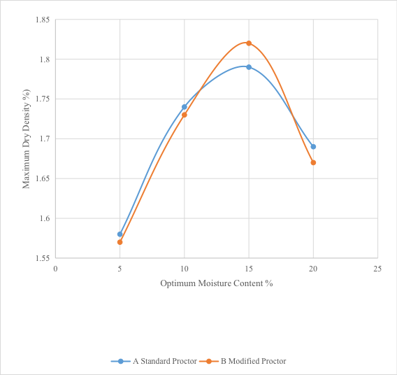
Fig. 4.5: Compaction Curves for Sample B

Table 4.7.2: Presentation of Compaction Results
SAMPLE NO | STANDARD PROCTOR |  | MODIFIED PROCTOR
 | Optimum Moisture Content (OMC) % | Maximum Dry Density (MDD) g/cm³ | Optimum Moisture Content OMC (%) | Maximum Dry Density (MDD) g/cm³
Sample A | 15.0 | 1.80 | 15.0 | 1.83
Sample B | 15.0 | 1.83 | 15.0 | 1.79

4.10 Discussion on Compaction results
The relationship between dry density and optimum moisture content (OMC) for the soil samples is presented in Figure 4.2. The compaction curves indicate that dry density increases with increasing moisture content up to the OMC, after which it begins to decline. From the compaction tests, at Standard Proctor energy, Sample A recorded an OMC of 15.0% and a Maximum Dry Density (MDD) of 1.80 g/cm³, while at Modified Proctor energy, it maintained an OMC of 15.0% with an MDD of 1.83 g/cm³. For Sample B, the Standard Proctor test yielded an OMC of 15.0% and an MDD of 1.83 g/cm³, while the Modified Proctor test gave the same OMC but a slightly lower MDD of 1.79 g/cm³. Based on the compaction characteristics and the Unified Soil Classification ratings (ASTM 1557-91) presented in Table 4.7.2, both soils can be classified as having fair to good performance for embankment construction, suitable for subgrade applications, and with good to fair performance when used as base course material.

Table 4.7.3: Compaction Characteristics and Rating of Unified Soil Classification Classes for Construction (ASTM, 1557-91)
Visual Description | Maximum Dry-Weight Range (g/cm³) | Optimum Moisture Range (%) | Anticipated Embankment Performance | Value as Subgrade Material | Value as base course
Granular material | 2.00-2.27 | 7-15 | Good to excellent | Excellent | Good
Granular material with soil | 1.76-2.16 | 9-18 | Fair to Excellent | Good | Fair to Poor
Fine sand and sand | 1.76-1.84 | 9-15 | Fair to Good | Good to fair | Poor
Sandy silts and silts | 1.52-2.08 | 10-20 | Poor to Good | Fair to Poor | Not suitable
Elastic silts and Clays | 1.36-1.60 | 20-35 | Unsatisfactory | Poor | Not suitable
Silty-Clays | 1.52-1.92 | 10-30 | Poor to Good | Fair to Poor | Not suitable

4.11 Results of California Bearing Ratio
The results of California Bearing Ratio tests are shown below for Sample A and B
Table 4.8.1: California Bearing Ratio tests for Sample A

Penetration of Plunger (mm) | TOP Piston Load on Plunger (KN) |  | BOTTOM Piston Load on Plunger (KN)
0.00 | 2.9 | 0 | 0 | 0
0.50 | 26 | 76 | 33 | 96
1.00 | 51 | 149 | 60 | 175
1.50 | 67 | 196 | 75 | 219
2.00 | 81 | 237 | 92 | 269
2.50 | 90 | 263 | 106 | 310
3.00 | 96 | 281 | 114 | 334
4.00 | 103 | 301 | 121 | 354
5.00 | 108 | 316 | 126 | 359
6.00 | 11.6 | 339 | 130 | 380
7.00 | 120 | 351 | 134 | 392

400
300
200
100
0
LOAD ON PLUNGER (KN)
0
1.0
2.0
3.0
4.0
5.0
6.0
PENETRATION (MM)
7.0
8.0

Fig. 4.7: Plots of California Bearing Ratio for Sample A

Table 4.8.2: California Bearing Ratio tests for Sample B
Penetration of Plunger (mm) | TOP Piston Load on Plunger (KN) |  | BOTTOM Piston Load on Plunger (KN)
0.00 | 0 | 0 | 0 | 0
0.50 | 19 | 55 | 27 | 79
1.00 | 37 | 108 | 48 | 140
1.50 | 53 | 155 | 69 | 202
2.00 | 70 | 205 | 87 | 254
2.50 | 83 | 243 | 99 | 290
3.00 | 89 | 260 | 105 | 307
4.00 | 94 | 275 | 112 | 328
5.00 | 99 | 290 | 116 | 339
6.00 | 102 | 298 | 121 | 354
7.00 | 107 | 313 | 125 | 366

400
300
200
100
0
LOAD ON PLUNGER (KN)
0
1.0
2.0
3.0
4.0
5.0
6.0
PENETRATION (MM)
7.0
8.0

Fig. 4.8: Plots of California Bearing Ratio for Sample B

Table 4.8.3: Summary of CBR Results for Standard Proctor
SAMPLE NUMBER | CBR VALUES | PENETRATION AVERAGE VALUE (%)
 |  | 2.5mm | 5.0mm
Sample A | SOAKED | 2 | 2
Sample A | UNSOAKED | 4 | 3
Sample B | SOAKED | 2 | 1
Sample B | UNSOAKED | 3 | 2

Table 4.8.4: Summary of CBR Results for Modified Proctor
SAMPLE NUMBER | CBR VALUES | PENETRATION AVERAGE VALUE (%)
 |  | 2.5mm | 5.0mm
Sample A | SOAKED | 2 | 2
Sample A | UNSOAKED | 5 | 4
Sample B | SOAKED | 2 | 2
Sample B | UNSOAKED | 4 | 3

Table 4.8.5: General Rating for Soil Based on CBR Values (After The Asphalt Institute,
1962)
CBR NO | GENERAL RATING | USES | CLASSIFICATION UNIFIED | SYSTEM AASTHO
0-3 | Very poor | Sub-grade | OH, CH, MH, OL | A5, A6, A7
3-7 | Poor-fair | Sub-base | OH, CH, MH, OL | A4, A5, A6, A7
7-20 | Fair | Base | OL ,CL, ML, SC, SM, SP | A2, A4, A6, A7
20-50 | Good | Asphalt material | GM, GL, SIN, SM, SP, GP, W,GM | Aib, A2-5, A3, Al,A2-4 ,A3

4.12 Discussion of CBR Results
The California Bearing Ratio (CBR) results for Sample A showed unsoaked values of 4% (Standard Proctor) and 5% (Modified Proctor), while the soaked values were 2% for both compaction energies. For Sample B, the unsoaked values were 3% (Standard Proctor) and 4% (Modified Proctor), with soaked values of 2% for both tests. According to the general rating in Table 4.8.3, soils are more reliably classified based on their soaked CBR values. For Sample A, the soaked CBR results indicate a very poor rating, making it suitable only as subgrade material in road construction. Similarly, Sample B’s soaked CBR values classify it as suitable for subgrade use only. However, the unsoaked Modified Proctor results suggest that Sample A can be used as a sub-base material, while Sample B, with its unsoaked Modified CBR value of 4%, could be used for both subgrade and sub-base applications in road construction, provided appropriate compaction is achieved.

CHAPTER FIVE
CONCLUSION AND RECOMMENDATIONS
5.1 CONCLUSION
A comparative study of lateritic soils was conducted in accordance with regulatory standards. The grain size distribution results for Samples A and B indicate that both are poorly graded; however, based on their gradation, they are suitable for use as road sub-base materials. The Atterberg limit results further confirm that both samples meet the requirements for sub-base applications. The compaction characteristics of Samples A and B, reflected in their Maximum Dry Density (MDD) and Optimum Moisture Content (OMC) values from both Standard Proctor and Modified Proctor tests, classify them as good engineering construction materials. According to The Asphalt Institute (1962), the California Bearing Ratio (CBR) values for both samples fall within the very poor to poor range, limiting their use primarily to subgrade and sub-base layers. Nevertheless, the soils exhibit relatively high initial and long-term stability, making them suitable for dam and embankment construction. Overall, the results suggest that Samples A and B can be used in various civil engineering works such as roads, dams, foundations, and embankments.
5.2 RECOMMENDATION
i. The geotechnical properties of lateritic soil should be thoroughly evaluated to determine its suitability for various civil engineering applications, particularly in the construction of infrastructural facilities.
ii. Additional advanced laboratory tests, such as triaxial shear tests and permeability tests, should be conducted on lateritic soils prior to construction to ensure accurate assessment of their engineering performance and long-term stability.

REFERENCES
Adebayo, B. M., & Afolayan, J. O. (2020). Geotechnical properties of lateritic soil and their suitability for engineering purposes. Nigerian Journal of Technology, 39(2), 356–363.
Bell, F. G. (1993). Engineering Properties of Soils and Rocks. Oxford: Blackwell Science.
Craig, R. F. (2004). Soil Mechanics (7th ed.). London: Spon Press.
Das, B. M. (2010). Principles of Geotechnical Engineering (7th ed.). Cengage Learning.
Gidigasu, M. D. (1976). Laterite Soil Engineering: Pedogenesis and Engineering Principles. Amsterdam: Elsevier Scientific Publishing Company.
Gidigasu, M. D. (1976). Laterite Soil Engineering: Pedogenesis and Engineering Principles. Amsterdam: Elsevier.
Goki, N. G. & Adebayo, B. A. (2020). Geological Influence on the Engineering Behavior of Lateritic Soils in Southwestern Nigeria. Journal of Applied Geology, 5(1), 22–31.
Obaje, N. G. (2009). Geology and Mineral Resources of Nigeria. Springer Science & Business Media.
Ola, S. A. (1983). Geotechnical properties and behavior of some Nigerian lateritic soils. Quarterly Journal of Engineering Geology and Hydrogeology, 16(2), 145–160.
Ola, S. A. (1983). Geotechnical properties and behavior of some Nigerian lateritic soils. In S. A. Ola (Ed.), Tropical Soils of Nigeria in Engineering Practice. Rotterdam: A. A. Balkema.
Osinubi, K. J. (1998). Influence of compactive effort and compaction delays on the properties of lime-treated soil. Journal of Transportation Engineering, 124(2), 149–155.
Osinubi, K. J. (2000). Stabilization of Lateritic Soils with Cement and Pulverized Coal Bottom Ash Mixtures. NSE Technical Transactions, 35(4), 13–21.
Rahaman, M. A. (1988). Recent Advances in the Study of the Basement Complex of Nigeria. In: Oluyide, P.O. et al. (Eds.), Precambrian Geology of Nigeria. Geological Survey of Nigeria, pp. 11–43.

- ASTM D3080/D3080M-11 – Standard test method for direct shear test
- ASTM D4318-17 – Standard test methods for liquid limit, plastic limit, and plasticity
index
  - ASTM D698-12 – Standard test method for laboratory compaction (Proctor)
  - ASTM D6913/D6913M-17 – Standard test method for particle-size distribution
    - ASTM D7928-21 – Standard test method for hydrometer analysis
    - ASTM D422-01/D4220M-14 – Standard for soil sample preservation
    - ASTM 1998-21 – Standard test method for California Bearing Ratio (CBR)

