SUITABILITY OF LATERITIC SOIL OF GEOTECHNICAL PROPERTIES FOR FOUNDATION APPLICATIONS
(A CASE STUDY OF MAYA, ILORIN EAST LOCAL GOVT. AREA, KWARA STATE)

BY
Joseph Timilehin ABEJIDE
ND/23/MPE/FT/0029

BEING A RESEARCH PROJECT SUBMITTED TO THE DEPARTMENT OF MINERAL AND PETROLEUM RESOURCES ENGINEERING, INSTITUTE OF TECHNOLOGY, KWARA STATE POLYTECHNIC, ILORIN
IN PARTIAL FULFILLMENT OF THE REQUIREMENTS FOR THE AWARD OF NATIONAL DIPLOMA (ND) IN MINERAL AND PETROLEUM RESOURCES ENGINEERING TECHNOLOGY

AUGUST, 2025



DEDICATION
This project is dedicated to Almighty God for his unfailing guidance and mercy toward me, because HE is a solid pillar behind me. I also dedicate this to my ever loving parents.

ACKNOWLEDGEMENT
Firstly my sincere gratitude goes to God Almighty God for his provision and protection throughout my program.
I’m grateful to my Project Supervisor Eng. Kajogbola and Eng, Usman who out of his tight schedule still find time to go through my manuscript and provide useful suggestions and corrections for the successful completion of this project.
A very big thank you to the entire management and staffs of Minerals and Petroleum Resources Engineering Department Kwara State Polytechnic Ilorin for had been there for me. They have been a successful, mechanically advantaged incubator for the young potential mining students of this millennium and generation to come.

I am filled with a cloud of healthy desire and uncontrollable urge to recognize with gratitude the value of incomparable gem whose life’s value is worthy more than an exemplary character in person of Mr & Mrs Abejide who have done so much, I also appreciate my parent for their support morally and financially.
I am strongly honored in greeting my brothers and sisters for their labour forces that jerked up and kept the project going until its destination.

TABLE OF CONTENT
Title page i
Certification ii
Dedication iii
Acknowledgement iv
Table of Content v
List of figures vi
List of Tables vii
Abstract viii
CHAPTER ONE
1.0 INTRODUCTION 1
1.1 Background of the Study 1
1.2 Statement of the Problem 2
1.3 Aim 3
1.4 Objectives 3
1.5 Justification of the Study 3
1.6 Scope of the study 4
CHAPTER TWO
2.0 LITERATURE REVIEW 5
2.1 Overview of Lateritic Soil 5
2.2 Formation and Composition of Lateritic Soil 6
2.3 Physical and Engineering Properties of Lateritic Soil 6
2.4 Importance of Lateritic Soil in Road Construction 6
2.5 Factors Affecting the Suitability of Lateritic Soil for Road Construction 6
2.6 Standards and Guidelines for Soil Testing in Road Construction 7
CHAPTER THREE
3.0 MATERIALS AND METHODS 8
3.1 Description of Study Area (Muni LGA and Environs Ilorin) 8
3.2 Sample Collection and Preparation 10
3.3 Laboratory Test for Physical Properties 12
3.3.1 Particle Size Distribution (Sieve Analysis) 12
3.3.2 Atterberg Limits (Liquid Limit, Plastic Limit, and Plasticity Index) 14
3.3.3 Compaction Test (Proctor Test) 18
3.3.4 California Bearing Ratio (CBR) Test 18
3.3.5 Specific Gravity Test 18
3.3.6 Moisture Content Determination 19
CHAPTER FOUR
4.0 RESULT PRESENTATION AND DISCUSSION 21
4.1 Presentation of Result 21
4.2 Discussion of Findings 29
4.3 Comparison with Standard Specification for Road Construction 29
4.4 Implications of Findings on Road Construction in the Study Area 29
CHAPTER FIVE:
5.0 CONCLUSION & RECOMMENDATION 30
5.1 Conclusion 30
5.2 Recommendation 31
References 32
Appendix 35

LIST OF FIGURE
Figure 3.2a: Map showing the study area 9
Figure 3.2b: Shows the photograph of the study area 10
Figure 4.1: Cumulative Particle size distribution curve for sample A,B&C 22
Figure 4.2: Cumulative Moisture content curve for sample A,B&C 22
Figure 4.3: Classification of the studied Lateritic soil using Casagrande plot of Liquid Limit (%) versus Plasticity Index. 24
Figure 4.4: Cumulative curve of dry density/water contents 25
Figure 4.5a: Direct shear strength curve for soil sample 26
Figure 4.5b: Direct shear strength gradient curve for sample A 26
Figure 4.6a: Direct Shear Strength curve of the soil sample 27
Figure 4.6b: Direct shear strength gradient curve for sample B 27
Figure 4.7a: Direct Shear Strength curve of the soil sample 28
Figure 4.7b: Direct shear strength gradient curve for sample C 28

LIST OF TABLE
Table 1: Summary of particle size distribution of the studied samples 21
Table 2: Summary of measured properties 21
Table 3: Samples composition distributions of Soils in the Study Area 22
Table 4: SOIL Classification according to AASTHO (2019) 29

ABSTRACT
The study investigate lateritic soil samples from Maya community in Ilorin, Kwara State, Nigeria with the aim of utilizing in accordance with regulatory standard of Nigeria and geotechnical properties of lateritic soil asland filling and foundation materials forconstruction. Three bulk samples were collected at 0.3m deep from three different locations of which were subjected to laboratory analysis/test; specific gravity, particle size analysis, atterberg limit, shrinkage limit, moisture content test, compaction test and direct shear test. The result shows that specific gravity ranged from 2.89-3.02g/cm³, particle size analysis ranged for gravel (19-34%), sand (53-60%), silt (8-10%), clay (5-12%) and with fine percentages ranged from (13-21%), liquid limit (16.2-24.8%), plastic limit (11.3-14.6%), plasticity index (4.9-10.2%), shrinkage limit ranged from (3.4-5.1%), dry density (1.72-1.95%), direct shear test ranged from (16-598KN/m²). This result implies that the soil samples can be use as land fill and foundation in construction and soil classified as gravelly sand soil.

CHAPTER ONE
INTRODUTION
1.1 BACKGROUND OF THE STUDY
Laterite has been defined as a highly weathered material rich in secondary oxides of iron, aluminium or both, void or nearly void of basic primary silicates, which may contain large amounts of quartz. The term "laterite" (meaning brick earth) was first introduced by Buchanan (1807), in academic literature; it was used to describe the soil nature of the mountainous region of Malabar, India. (Buchanan 1807; Simpson, 1911). Lateritic soil is the leached residue resulting from natural process of laterisation in tropical and sub-tropical regions (Malcom, 1906; Maclaren, 1906). There are two main factors, geological and atmospheric conditions that influence the process of laterization. The lateritic soil is generally formed where the parent rock is rich in aluminia, iron and silica. (Sivarajasingham et al, 1962 - Maignien, 1966).
Therefore lateritic soil contains major portions of aluminum and iron sesquioxides. Laterization occurs where the atmospheric conditions prevail moderate to high, for both temperature and rainfall in both dry and wet seasons. (Akpokodje et al. 1992, 1994; Achyuthan, 1996; Bourman, 2007)
Laterization is a long process that comprises three stages as follows
- The minerals contained in parent rock are scattered due to weathering and as a result, subsequent change in their chemical composition.
- The transition phase involves removal of silica and lime along with organic matters, nitrogen and phosphate by leaching and deposition of sesquioxides of iron, alumina as a consequent of precipitation. The high intensity of rainfall has a great impact to initiate the transition phase of formation (martin and Doyne, 1927).
- The final stage of lateritisation involves dehydration and crystallization of resulting products. Lateritisation process also causes adverse effects to the surrounding ecosystem as a consequent of weathering and chemical intensive process. The profile of lateritic soil is influenced by climate, topography, rates of chemical weathering, drainage and technique processes (Warth and Warth, 1903). Due to removal of silica and lime along with organic matter, nitrogen and phosphate, lateritic soil tends to be of low fertility (Liu et al, 2010; Bishworjit and Athokpam, 2013; Malavath et al, 2013).
The construction sector is currently facing a huge demand of sand aggregates due to drastic growth of infrastructure. Since aggregates is most commonly used in construction raw materials for making building and road products. However, the current production rate of natural sand/aggregates is lower than its current demand rate for construction sectors that is causing sustainability issue to the society. Lateritic soil having rich iron content along with high corroded kaolinite of amorphous nature is used as precursor material for making geopolymeters through alkaline activation that would be green and sustainable binder to control the CO2 emission from the cement industry (Kaze et al, 2017). The importance of lateritic soil in most civil engineering constructions cannot be overemphasized, as most of the failures have been attributed to wrong or wrong materials for engineering application, it is therefore pertinent to assess the geotechnical properties of lateritic soil for design and construction purposes over the years, many researchers (Ola, 1998; Agbede, 1992; Adeyemii, 2002; Oladeji and Raheem, 2002; Adewoye et al, 2004; Bello and Adegoke, 2010) have investigated the geotechnical properties of lateritic soil. This is to add to the body of knowledge and for engineers in constructors in the selection of suitable materials for engineering projects.
1.2 STATEMENT OF THE PROBLEM
Lateritic soil are widely used in construction projects particularly in tropical regions but their variability in geotechnical properties and the potential instability can lead to engineering problems, such as settlement, erosion, and failure of structures. Despite their abundance and potential benefits, the lack of standardized specifications and inadequate understanding of their behaviour under different environmental conditions can result in poor performance and increased maintenance costs. Lack of standardization is therefore a need for standardized specifications and guidelines for using lateritic soils in construction projects cause it can exhibit significant variability in their geotechnical properties making it challenging to predict their behaviour.
1.3 AIM
The aim of this study is to investigate the geotechnical properties and application of lateritic soil for foundation
1.4 OBJECTIVES
(i) To determine the physical properties of the lateritic soil.
(ii) To determine the economy potential of the deposit.

1.5 JUSTIFICATION OF THE STUDY
The study of lateritic soil for construction purposes is essential due to its widespread occurrence in tropical and subtropical regions and its unique engineering properties. Lateritic soil, rich in iron and aluminium oxides, exhibits high strength and durability when properly compacted and stabilized, making it a viable material for road subgrades, embankments, and low-cost building constructions. Understanding its behaviour under varying moisture conditions, load bearing capacity and compaction characteristics, is crucial for ensuring structural stability and longevity.
1.6 SCOPE OF THE STUDY
The scope of study on lateritic soil for construction purposes encompasses the investigation of its physical, chemical and geotechnical properties to determine its suitability as a construction material. This includes evaluating its strength, compaction characteristics, permeability, plasticity, load bearing capacity, as well as its behaviour under different moisture conditions. The study aims to assess how lateritic soil can be effectively stabilized or modified using materials such as lime, cement or fly ash for use in foundational works, road constructions, embankments, and other civil engineering applications. Additionally, the research considers the environmental and economic benefits of using locally available lateritic soils to promote sustainable and cost-effective construction practices.

CHAPTER 2
LITERATURE REVIEW
2.1 OVERVIEW OF LATERITIC SOIL
Laterite is a soil and rock in iron and aluminum commonly found in India and wet tropical areas. Almost all laterites are of rusty-red color due to the high iron oxide content. They are referred to as soil types as well as rock types. Laterites are formed from the leaching of parent soil and rocks, metamorphic rocks and igneous rocks which leaves more insoluble ions of mostly iron and aluminum. Although some investigators prefer to label laterite as a rock or part of a soil (L2). Lateritic soil develops in the surface layers weathering of the final weathered parent rock leading to prolonged weathering interaction, which is a slow process of chemical weathering that creates a gradient variation in the thickness of soil. Formations are mineralogy of the Subsoil and quartz soil (Akinwamimo & Aiyelabegan, 2023). These soils develop through leaching of silica and bases from the parent rock, leaving behind oxides of iron and aluminum that impart a reddish or yellowish colour (Suri & Patel, 2011). Lateritic soil are commonly found in countries like India, Nigeria, Ghana, Brazil and parts of Southeast Asia (Sherman & Das, 2011). The Reviews of Lateritic Soil:- Uzuegbunam et al. (2012) examined both the effects of moisture content on compaction and shear strength, showing that lateritic soil performs well under optimal moisture conditions.- Adegani & Akinwamimo (2018) highlighted that the spatial variability and suggested detailed site-specific testing for construction projects.- Sherman & Das (2016) investigated environmental impacts of lateritic soil mining and recommended sustainable extraction methods.- Jain & Patel (2017) discussed erosion control measures for lateritic soil slopes and embankments.

2.2 FOUNDATION AND COMPOSITION OF LATERITIC SOIL
Laterite forms through prolonged chemical weathering of rock under hot, humid conditions. This process makes soluble materials leach out, leaving behind iron and alumina oxides. The soil’s composition depends on parent rock and environmental factors, typically including quartz, kaolinite, and sesquioxides.

2.3 PHYSICAL AND ENGINEERING PROPERTIES OF LATERITIC SOIL
Key properties include:
- Grain Size Distribution: Ranges from clay to gravel.
- Atterberg Limits: Indicates plasticity; affects workability.
- Moisture Content: Influences compaction and strength.
- Compaction Characteristics: Determines load-bearing capacity.
- California Bearing Ratio (CBR): Assesses suitability for sub-base layers.

2.4 IMPORTANCE OF LATERITIC SOIL IN FOUNDATION APPLICATION
Laterite is widely used in foundation applications for subgrade and sub-base layers due to its strength when compacted and cost-effectiveness. Its local availability reduces transportation costs and, with proper treatment, it provides a stable foundation.

2.5 FACTORS AFFECTING THE SUITABILITY OF LATERITIC SOIL FOR FOUNDATION APPLICATION
- Moisture Content: High moisture can reduce strength.
- Plasticity Index: High plasticity may lead to swelling.
- Grading and Fines Content: Affects compaction and drainage.
- Organic Matter: Presence can weaken the soil structure.
- Stabilization Needs: May require additives like cement or lime to enhance properties.

2.6 STANDARDS AND GUIDELINES FOR SOIL TEST IN FOUNDATION APPLICATION
- Standard sources: AASHTO and ASTM provide guidelines for testing soil properties like CBR, Atterberg Limits, and compaction.
- These tests ensure the soil meets the necessary criteria for use in foundation applications, ensuring durability and performance.

CHAPTER THREE
MATERIALS AND METHODS
3.1 MATERIALS
The materials involves in the samples taken were digger, spade, polytene bags, masking tape, marker, pan, Global Positioning System (GPS) and writing materials such as pen and exercise book.
3.2 METHODS
3.2.1 Description of the study area
The study area is located in Manya, East Local Government area of Kwara State. The Lateritic soil is buried and exposed around in the study area, the site is on Latitude N8˚11ʹ53ʺ and Longitude E4˚47ʹ42ʺ for location A, Latitude N8˚26ʹ32ʺ and Longitude E4˚36ʹ36ʺ for location B while N8˚26ʹ39ʺ and Longitude E4˚36ʹ42ʺ for location C. The study area is accessible through local road.
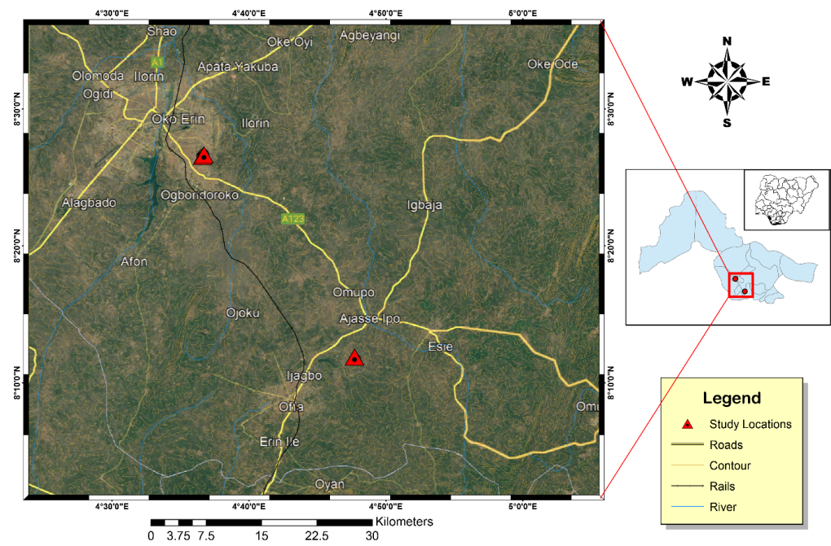
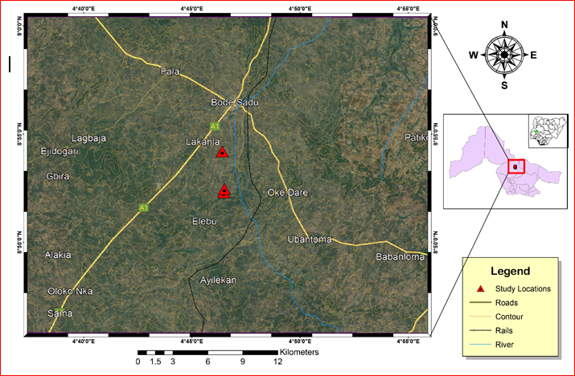
Figure 3.2a: Map showing the study area

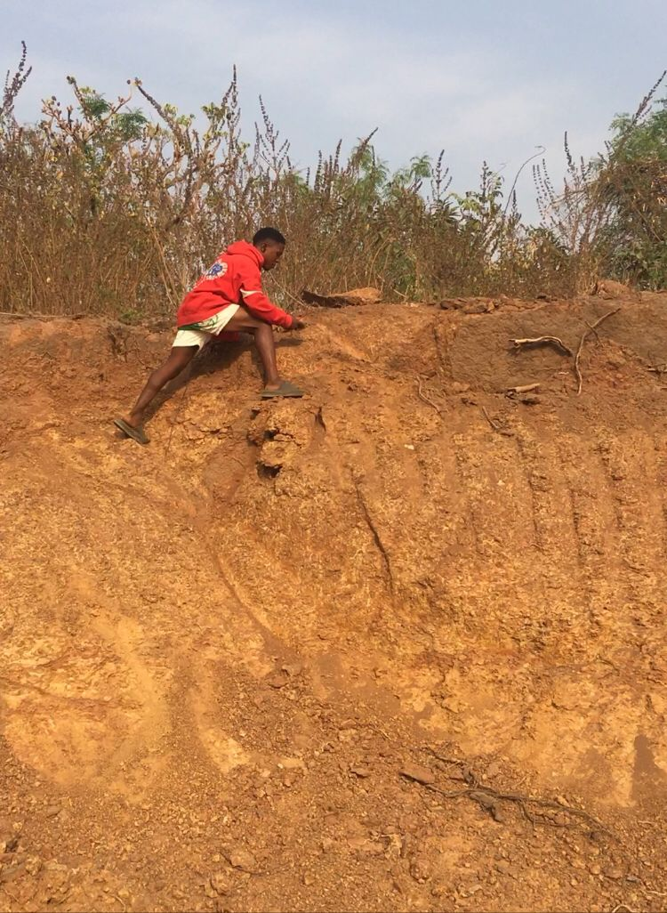
Figure 3.2b: shows the photograph of the study area
3.2.2 Sample Preparation
The samples were pulverized sieved at the department of geology and mineral sciences laboratory, University of Ilorin.
3.2.3 Sample Analysis
The samples were subjected to various analysis such as particle size distribution, atterberg consistency limit, compaction test, free swelling potential, and compressibility.
3.2.3.1 BULK AND DRY DENSITIES
3.2.3 .1.1 Bulk DENSITY
Bulk density is defined as the mass of the soil divided by its volume, it is the weight of representative wet soil sample to the volume of the mould containing such sample. It is expressed as mass per unit volume (i.e. g/cm³). It helps to determine how heavy the soil sample is and to determine the bearing capacity of the soil i.e. the mount of the load the soil can carry successfully.
APPARATUS USED
Mould
Weighing balance
Drying oven
Spatula and pestle
PROCEDURE
An empty mould is weighed (i.e. weight of mould)
- The volume of the mould was also determined (V)
- The mould is then filled with fresh soil sample, consolidated and weighed (i.e. weight of mould + soil)
- The weighed of the wet soil was calculated by subtracting the weight of empty mould from the weight of wet soil and mould
- The bulk density was deduced using the formula below:
ϒ = W/V
W = weight of representative wet soil sample
V = volume of mould
3.2.3.2 DRY DENSITY
Dry density is defined as the ratio of the weight of the dry soil sample to the volume of the mould containing the dry soil sample.

APPARATUS USED
Weighing balance
Drying oven
Spatula
Pan
Desiccator
PROCEDURE
- An empty pan was weighed
- A known volume of the mould from bulk density determination was taken (V)
- The mould with fresh soil sample being consolidated was discharged into the pan for oven drying at 110⁰C until water was completely expelled
- The weighed of the dry soil was calculated by subtracting the weight of empty pan from the weight of dry soil and pan
- The dry density was deduced using the formula below:
ϒ = W/V
W = weight of representative dry soil sample
V = volume of mould
3.2.3.3 SPECIFIC GRAVITY DETERMINATION
APPARATUS USED
Density bottle
Measuring cylinder
Weighing balance

PROCEDURE
- An empty measuring cylinder was weighed as (W₁)
- It is then filled with soil to about 1/3 of its volume, then its weight together with the soil was taken as (W₂)
- The water was added to the soil in the measuring cylinder, the weight of the cylinder with both soil and water was taken as (W₃)
- Empty the measuring cylinder, fill it with distilled water and its weight was taken as (W₄).
- Specific gravity was calculated using the formulae below
(W₂ -W₁)/ (W₄ -W₁) – (W₃ -W₂) X 100
3.2.3.4 GRAIN SIZE ANALYSIS
Grain size refers to the diameter of the soil particles that make up the soil mass. This analysis covers the quantitative determination of the various sizes of these soil particles, their proportions to the nearest percentage and the distribution of the various grain sizes that makes up the soil.
Grain size analysis is a very important analysis, which is done in an attempt to describe a soil type. A roughly concluded result is made by the physical description of the soil particles grain distribution, but a more accurate result is gotten by performing the laboratory analysis. This analysis is done in order to know the accurate distribution of the various grain sizes that make up the soil, and helps to solve the problem of confusion between silt and clay. This method entails mechanical and hydrometer analyses respectively.
3.2.3.4.1 MECHANICAL SIEVE ANALYSIS
The sieve analysis involves shaking of the soil sample through a set of sieves that have progressively smaller openings. This method is used in the analysis of particles greater than 0.075mm in diameter. It provides a means of evaluating the different grain size types present in soil sample.
APPARATUS USED
- Stack of sieves
- Mechanical sieve shaker
- Drying oven
- Collecting pan and cleaning brush
- Weighing balance
PROCEDURE
(a) The soil particles were gently disaggregated
(b) The sieve set (i.e. stack of sieves) were arranged in descending order from the top with a retainer beneath it.
(c) 100g of the soil was weighed and poured into the sieve stack.
(d) The sieve stack was then placed on the mechanical sieve shaker for about 10 minutes
(e) The sieve stack was now separated one by one, then the soil fraction retained in each sieve was weighed and recorded
(f) A statistical data of the result of the analysis was prepared.
3.2.3.4.2 HYDROMETER ANALYSIS
This method is used in the determination of the grain distribution of fine-grained soils with soil particles of the order of clay and soil. This method is not applicable if less than 10% of the soil passes through sieve size of 0.075mm mesh size.
APPARATUS USED
- Hydrometer bulb
- Measuring cylinder
- Drying oven
- Thermometer
- Evaporating dish
PROCEDURE
(a) The sieved clay and silt from the sieve washing were collected in a container and allowed to settle
(b) The supernatant water was decanted and the mud residue was dried in the drying oven for about 24 hours
(c) The dried sample was then pulverized, 50g of it was weighed and dissolved in one liter of water in a measuring cylinder. The water has dissolved in it sodium hexametaphosphate to enhance rate of clay settlement.
(d) The hydrometer bulb is then inserted into the water in the measuring cylinder and its reading was recorded periodically.
(e) As the settling proceeds, the hydrometer sinks into the solution
(f) The temperature at each hydrometer reading was recorded and then a statistical data was produced.
(g) Then, the percentage passing was plotted against diameter to obtain the percentage composition of the studied soil samples.

      - ATTERBERG CONSISTENCY LIMITS
3.2.3.5.1 LIQUID LIMIT DETERMINATION
APPARATUS USED
- Casagrande liquid limit device (made up of a cup, a rotating handle, counter and a cutting groove)
- Pestle and mortar
- Spatula
- Moisture can
- Wash bottle with distilled water
- Sieve 0.425mm
- Oven
- Glass plate
PROCEDURE
(a) A dried, fresh soil sample is pounded using the pestle and mortal
(b) The sample was sieved using the 0.425mm sieve size, 300g of the sieved sample was weighed and water was added to it until a stiff paste was produced.
(c) The stiff paste was packed into the Casagrande apparatus and then had the surface leveled and smoothened using the spatula.
(d) A groove in the soil was made with cutting groove and rotated the handle (blows) until the groove close. (Note that the number of revolutions the handle makes blows is recorded by the counter). The minimum number of blows is 10 while the maximum is 50.
(e) A small paste was scooped into the moisture can with the spatula, weighed and dried in the drying oven for 24 hours and then reweighed in order to determine its water content.
(f) The soil is then emptied from the cup into the glass plate and water is added to the soil and the process is performed all over again.
(g)The water contents (%) were plotted against numbers of blow (N), water content corresponding to 25 number of blows is the liquid limit
        - PLASTIC LIMIT DETERMINATION
APPARATUS USED
- Glass plate
- Moisture can
- Spatula
- Wash bottle with distilled water
- 0.425mm sieve
- Thermostat oven
PROCEDURE
(a) A small part of the paste in the Casagrande cup is scooped and rolled into a ball
(b) The ball is placed on the glass plate and rolled into thread until it breaks
(c) The crumbled threads are put into two different moisture cans. Then, the cans with crumbled soil sample were oven dried for 24 hours so as to determine the moisture content of each sample, which was taken as plastic limits.
3.2.3.5.3 LINEAR SHRINKAGE DETERMINATION
(a) The soil sample was thoroughly mixed with distilled water
(b) A linear container of known length was taken and lubricated for easy removal of the soil sample
(c) The container was then filled with the soil sample and its original length was measured before it was oven dried for about 24 hours
(d) The container was allowed to cool in a desiccator, and then the final length of the dried soil sample is measured.
(e) The linear shrinkage of the studied soil samples was calculated using the formula below:
LS = change in length x 100
Original length
3.2.3.5 COMPACTON TEST
APPARATUS USED
- Mixing pan
- Weighing balance
- Drying oven
- Moisture can
- Spatula
- Compaction rammer and mould (consisting of base plate, cylinder mould andextension collar).
PROCEDURE
(a) 3kg of soil sample was weighed and poured into the mixing pan
(b) 120cm³ (4%) of water was measured, added and mixed with the soil in the mixing pan with the use of spatula.
(c) The cylinder mould is then placed on a base plate, then a representative specimen of the soil is put into the mould and compact with 25 evenly distributed blows of rammer. This represents the first layer.
(d) After the compaction, the volume of the soil in the mould reduced, more soil specimen was added into the mould and compacted with another 25 evenly distributed blows.
(e) The extension collar is then fixed unto the mould. This is mainly for the last layer and removed after the last layer is made to be able to achieve a smooth level surface of the last layer.
(f) The mould is filled with more of the soil specimen and compacted to make the third layer.
(g) The mould with the soil is weighed and the soil sample at the top and bottom of the mould were taken for water content and dry density determination respectively.
(h) The soil in the mould is emptied into the mixing pan and another 120cm³ (4%) of water is added to the soil and mixed
(i) This process was now carried out four more times
(j) Then, the compaction curves were gotten by plotting dry densities against water contents.
3.2.3.6 DIRECT SHEAR STRENGTH
The shear strength of a soil may be defined as the resistance to shearing stresses and a consequent tendency for shear deformation. This test involves putting the soil specimen into a box that splits across its middle with a confined pressure alongside a shear force applied to the soil so as to cause a relative displacement between the two parts of the box i.e. the failure plane is made to occur at a predetermined location. A normal stress, which is due to an applied vertical load and a shearing stress, which is due to the confining pressure, acts on the failure plane. Granular soils of sands derive their shear strength from resistance due to interlocking of particles and frictional resistance between the individual soil grains, while fine grained soils exhibit their shear strength from frictional resistance between the individual soil grains and adhesion or cohesion between soil particles (Poulas, 1982). The shear strength test was performed in order to determine the shear strength parameters which are the angle of internal friction and the cohesion of the soil samples. The angle of internal friction is largely dependent on the internal density of the soil and it reduces with increase in confined pressure.
APPARATUS USED
- Direct shear machine
- Compaction mould
- Compaction rammer
- Surcharge weight
- Mixing pan
PROCEDURE
(a) 3kg of the soil sample was weighed and mixed with the corresponding optimum moisture content for the standard proctor for each soil sample.
(b) The soil samples were then compacted, a square sampler was gently used to collect a representative sample from each sample, then the collected sample was placed in a shear box and a load was placed on top of it. The dial gauges were set at zero.
(c) A set of normal loads of 5kg, 10kg, 15kg and 20kg were applied one after the other in successive tests
(d) The readings on the load dial units are taken, and the procedure is repeated for all the soils.
(e) The plots of shear stress against normal stress for all the soil sample were made to deduce both the angle of internal friction and cohesion.

CHAPTER FOUR
4.0 RESULTS PRESENTATION AND DISCUSSIONS
This chapter discusses the test conducted which include; particles size distribution, swelling properties, consistency index, atterberg consistency limits comprises of liquid limit, plastic limit, plasticity index and shrinkage limit water content, compaction test, and shear strength test as well as the interpretations.
4.1.1 GRAIN SIZE ANALYSIS
Table 1: Summary of particle size distribution of the studied samples
Sample code | Dry Sieving(% passing) |  |  |  |  | Hydrometer (% passing)
Sample code | 6.0mm | 3.3mm | 2.0mm | 1.18mm | 0.6mm | 0.048mm | 0.002mm
A | 100 | 94.8 | 81.4 | 76.1 | 53.9 | 17.3 | 11.9
B | 100 | 93.5 | 79.8 | 65.7 | 54.2 | 13.4 | 6.1
C | 100 | 93.7 | 80.3 | 72.7 | 60.6 | 10.1 | 5.1

Table 2: Summary of measured properties
Properties | Sample A | Sample B | Sample C
Specific Gravity g/cm³ | 2.89 | 2.92 | 3.06
Moisture content (%) | 11.32 | 9.68 | 7.72
Liquid limit (%) | 24.8 | 19.6 | 16.2
Plastic limit (%) | 14.6 | 12.1 | 11.3
Plastic Index (%) | 10.2 | 7.5 | 4.8
Shrinkage limit (%) | 5.1 | 4.8 | 3.4
Direct Shear Strength(KN/m²) | 45 | 40 | 26
Dry Density (g/cm³) | 1.84 | 1.89 | 2.01
Table 3: Samples composition distributions of Soils in the Study Area
Sample code | Gravel (%) | Sand (%) | Silt (%) | Clay (%) | % Fine | Soil Classification
A | 19 | 60 | 9 | 12 | 21 | Gravelly Sand
B | 24 | 58 | 10 | 8 | 18 | Gravelly Sand
C | 34 | 53 | 8 | 5 | 13 | Gravelly Sand

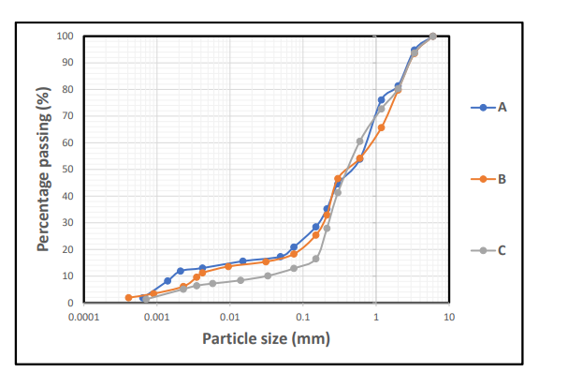
Figure 4.1: Cumulative Particle size distribution curve for sample A,B&C

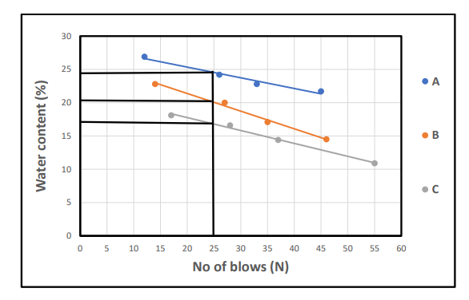
Figure 4.2: Cumulative Moisture content curve for sample A,B&C
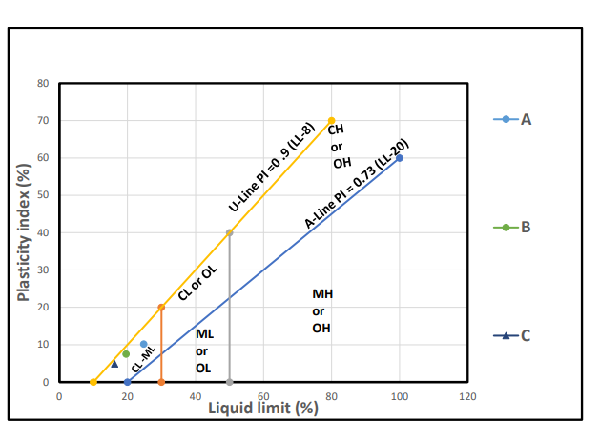
Figure 4.3: Classification of the studied Lateritic soil using Casagrande plot of Liquid Limit (%) versus Plasticity Index.

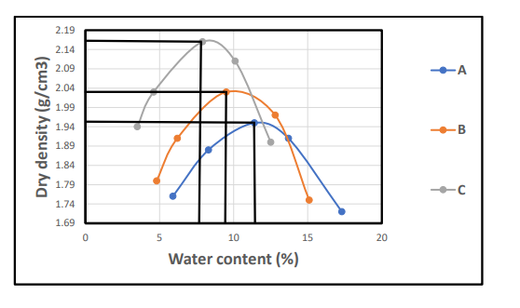
Figure 4.4: Cumulative curve of dry density/water contents

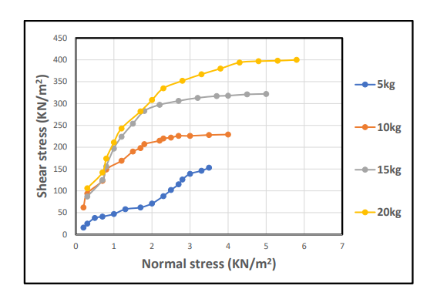
Figure 4.5a: Direct shear strength curve for soil sample
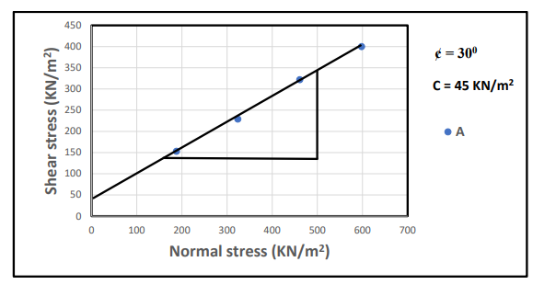
Figure 4.5b: Direct shear strength gradient curve for sample A
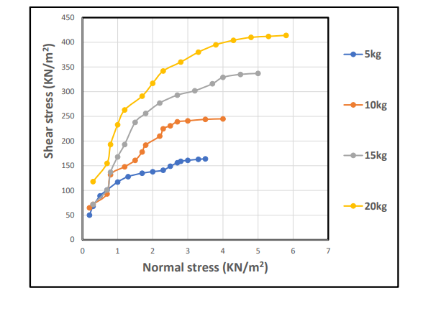
Figure 4.6a: Direct Shear Strength curve of the soil sample
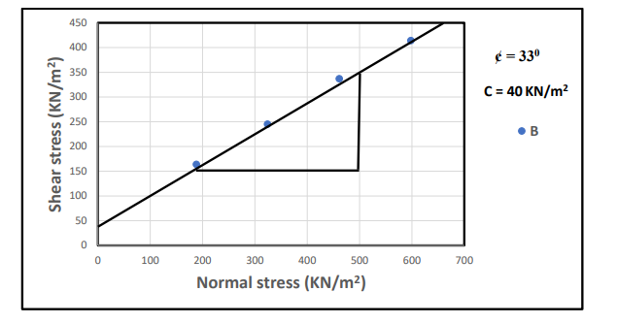
Figure 4.6b: Direct shear strength gradient curve for sample B

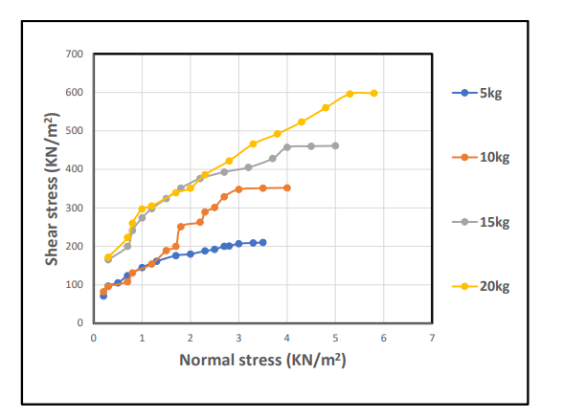
Figure 4.7a: Direct Shear Strength curve of the soil sample
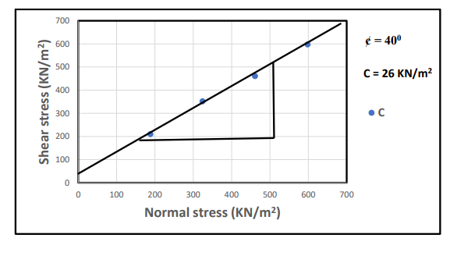Figure 4.7b: Direct shear strength gradient curve for sample C
Discussions
The analysis carried out on the study samples for particle size distribution is shown in the Table 1 and Figure 4.1 with average percentage composition of sand 57%, silt 9%, clay with 8.3%, gravel is 25.7% and fine percentage is 17.3% . This indicate that the studied sample is gravelly sand due to the lower percentage of fines with plasticity index less than 30% according to AASHTO classification (2019). These type of materials are good for sanitary landfills. The studied samples has low plasticity limit range from 11.3% to 14.6%, liquid limit from 16.2 to 24.8%, shrinkage limit values from 3.4 to 5.1%, specific value range from 2.89 to 3.06gcm³, direct shear strength range from 26 to 45KN/m² and less effect in engineering structures.
Table 3: Samples composition distributions of Soils in the Study Area
Sample code | Gravel (%) | Sand (%) | Silt (%) | Clay (%) | % Fine | Soil Classification
A | 19 | 60 | 9 | 12 | 21 | Gravelly Sand
B | 24 | 58 | 10 | 8 | 18 | Gravelly Sand
C | 34 | 53 | 8 | 5 | 13 | Gravelly Sand

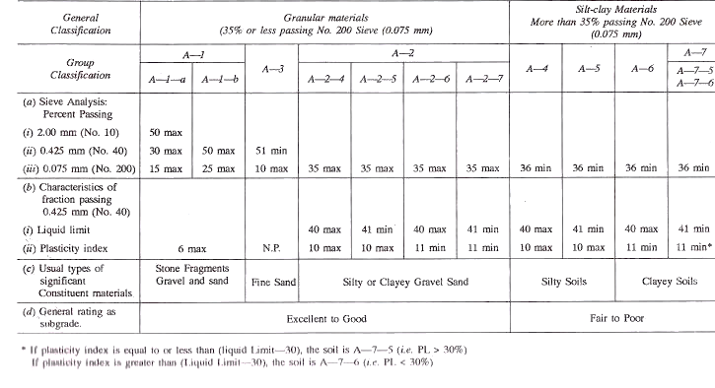
Table 4: SOIL Classification according to AASTHO (2019)

CHAPTER FIVE
CONCLUSION AND RECOMMENDATIONS

5.1 Conclusion
This study focused on the geotechnical characterization of Lateritic soils from three locations (A, B, and C) in Maya, Ilorin East Local Government Area, Kwara State. Based on the laboratory analyses performed, the following conclusions can be drawn:
- Soil Classification: The soil samples predominantly classify as gravelly sand with varying proportions of gravel, sand, silt, and clay. The percentage of fines (silt and clay) is generally low, ranging from 13% to 21%, consistent with gravelly sand as per AASHTO classification (2019).
- Particle Size Distribution: The soils show a well-graded distribution with sand being the major fraction (~57%), gravel (~25.7%), and fines less than 30%. This distribution indicates good drainage properties and mechanical stability for engineering applications.
- Consistency and Plasticity: The soils exhibit low plasticity with liquid limits between 16.2% and 24.8%, and plasticity indices ranging from 4.8% to 10.2%. These properties imply low susceptibility to shrink-swell behavior and moderate compressibility.
- Density and Strength Properties: Dry densities ranged from 1.84 to 2.01 g/cm³, indicating moderate compaction levels. Direct shear strength results revealed cohesion values and internal friction angles suitable for supporting light to moderate loads. Sample A had the highest shear strength (45 kN/m²), while sample C had the lowest (26 kN/m²).
- Engineering Implications: The soils' physical and mechanical characteristics suggest they are suitable for use as fill materials in sanitary landfills and shallow foundations, given their relatively high strength and low plasticity. However, site-specific evaluation is recommended before heavy construction.

5.2 RECOMMENDATIONS
Based on the findings of this study, the following recommendations are made:
- Further Site Investigation: Although this study provides preliminary soil characterization, detailed in-situ tests such as Standard Penetration Tests (SPT) or Cone Penetration Tests (CPT) should be conducted to assess field conditions more accurately.
- Soil Improvement Measures: For applications requiring higher strength or lower compressibility, stabilization techniques (e.g., lime or cement treatment) can be considered, especially for soils with relatively higher fines content.
- Drainage Considerations: Since the soils are well-drained, structures should be designed to prevent water accumulation which could alter soil properties and reduce bearing capacity over time.
- Construction Practices: Proper compaction at optimum moisture content is critical to achieving the desired soil strength. Field compaction should be regularly monitored using moisture-density relationships derived from laboratory compaction tests.
- Environmental Impact Assessment: Due to the potential use in sanitary landfills, environmental impact assessments should be carried out to ensure that leachate management and soil contamination risks are minimized

REFERENCES
Achyuthan, H. (1996). Lateritisation and its effects in the humid tropics.

Adegbede, O. (1992). Geotechnical characteristics of lateritic soils in southwestern Nigeria.

Adewoye, A. O., Oladeji, O. O., & Raheem, A. A. (2004). Assessment of lateritic soils for engineering applications.

Adeyemi, G. O. (2002). Suitability of lateritic soils for construction purposes in tropical regions.

Adegani, K. A., & Akinwamimo, A. O. (2018). Spatial variability of lateritic soils and implications for engineering designs.

Adegani, K. A., & Akinwamimo, A. O. (2019). Challenges in using lateritic soils in construction and need for site-specific studies.

Akpokodje, E. G., Eze, C. L., & Etu-Efeotor, J. O. (1992). Geotechnical properties of residual soils derived from various basement rocks in southeastern Nigeria.

Akinwamimo, A. O., & Aiyelabegan, A. T. (2023). Mineralogy and classification of lateritic soils in Nigeria.

Arom, R. A., Ogwuche, S. O., & Ogbole, J. O. (2019). Shrink-swell behaviour of lateritic soils in North-Central Nigeria.
Bello, A. A., & Adegoke, C. W. (2010). Engineering characteristics of compacted lateritic soils for road construction.

Bishworjit, N., & Athokpam, H. (2013). Fertility and nutrient deficiency in lateritic soils.

Bourman, R. P. (2007). Laterites and lateritization processes in tropical environments.Buchanan,

F. (1807). A Journey from Madras through the Countries of Mysore, Canara and Malabar. Vol. 2.

Eze, C. L., Akpokodje, E. G., & Osadebe, N. N. (2014). Suitability of lateritic soils for road construction in southeastern Nigeria.

Jain, A. K., & Patel, S. K. (2017). Erosion control measures for lateritic slopes.

Kaze, C. R., Kamga, R., & Tchuindjang, J. N. (2017). Geopolymer binders from lateritic soils: A sustainable alternative to cement.

Liu, H., Zhang, Z., & Wang, D. (2010). Properties and engineering use of lateritic soils.

Maclaren, A. D. (1906). The Geology and Soils of the Malabar Region.

Malavath, P., Rajesh, V., & Rao, A. V. (2013). Soil fertility challenges in red and lateritic soils of India.

Malcolm, C. (1906). On the Origin of Laterite.

Maignien, R. (1966). Review of Research on Laterite. Natural Resources Research IV, UNESCO, Paris.

Martin, J. P., & Doyne, H. C. (1927). The formation and properties of lateritic soils in West Africa.

Okeke, O. C. (2014). Cost analysis of using locally sourced lateritic soils for road construction.

Ola, S. A. (1998). Geotechnical properties and behavior of some Nigerian lateritic soils.

Oladeji, O. O., & Raheem, A. A. (2002). Engineering behavior of lateritic soils under varying conditions.

Oyelami, C. A., Akinwamimo, A. O., & Oyinloye, A. O. (2015). Compaction characteristics

Oyekede, A., & Bankole, J. A. (2011). Bearing capacity of tropical lateritic soils: A case study.

Ravikumar, C. M., & Ramesh, H. N. (2019). Effect of stabilization on the strength characteristics of lateritic soil.

Sherman, R., & Das, B. M. (2011). Lateritic soils in tropical engineering practice.

Sherman, R., & Das, B. M. (2016). Environmental impact of lateritic soil mining in developing countries.

Simpson, E. S. (1911). Laterite and its Formation in India.

Sivarajasingham, S., Alexander, L. T., Cady, J. G., & Cline, M. G. (1962). Laterite: Soil Science, 93(1), 19–31.

Suri, A. K., & Patel, A. K. (2011). Coloration and mineral composition of lateritic soils in India.

Swepillana, A., Bawa, A. A., & Edache, J. E. (2012). Permeability variation in compacted lateritic soil samples.

Uzuegbunam, A. O., Okeke, O. C., & Onuoha, E. O. (2012). Shear strength and compaction characteristics of lateritic soils.

Warth, H., & Warth, E. (1903). The Laterites of India and Their Engineering Applications.

Younoussa, A., Bawa, M., & Dapila, A. A. (2008). Optimization of road base course materials using lateritic soils.

APPENDIX 1
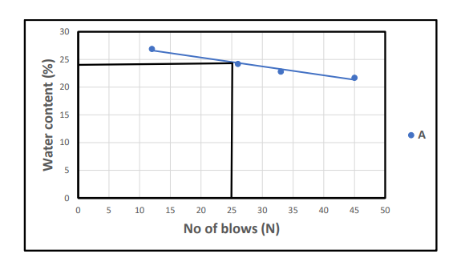

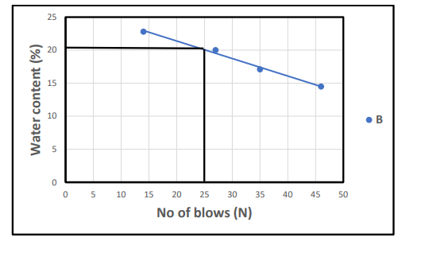

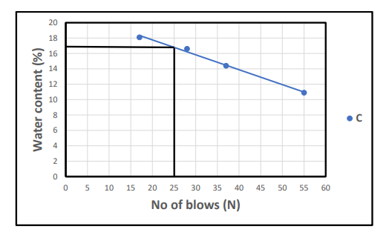

APPENDIX 2

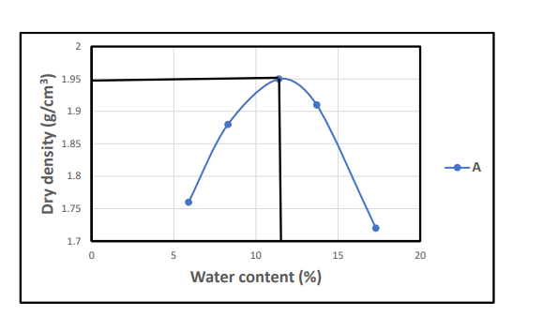

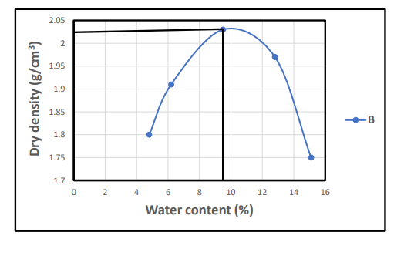

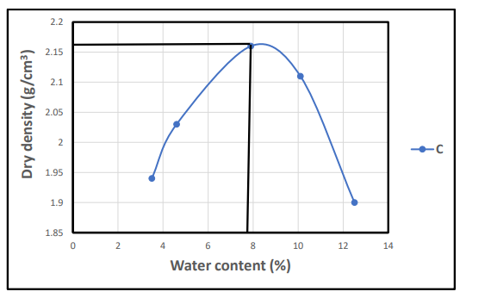
APPENDIX 3

