DESIGN, CONSTRUCTION, AND COMPARATIVE PERFORMANCE EVALUATION OF THE DIRECT, INDIRECT AND GREENHOUSE
SOLAR DRYERS FOR DRYING PEPPER

BY
ADENIJI GRACEADEBOLA
HND/23/SLT/FT/0067

A PROJECT SUBMITTED TO THE DEPARTMENT OF SCIENCE LABORATORY TECHNOLOGY,INSTITUTE OF APPLIED SCIENCES, KWARA STATE POLYTECHNIC, ILORIN

IN PARTIAL FULFILMENT OF THE REQUIREMENTS OF THE AWARD OF HIGHER NATIONAL DIPLOMA (HND) IN SCIENCE LABORATORY TECHNOLOGY (SLT), PHYSICS & ELECTRONICS UNIT
SUPERVISED BY
DR.OLAORE K.O. JULY, 2025

CERTIFICATION
This is to certify that the research work carried out by ADENIJI GRACE ADEBOLA with matriculation number HND/23/SLT/FT/0067 in Institute of Applied Science (IAS), Department of Science Laboratory Technology, Kwara State Polytechnic, Ilorin has met the requirement for the award of Higher National Diploma (HND).

DR. OLAORE K.O. DATE
Supervisor

MR SALAHU BASHIR DATE
HeadofUnit

DR.USMAN A. DATE
HeadofDepartment

ExternalExaminer DATE

DEDICATION

We dedicate the project to our families, mentors, and friends who have been our constant source of encouragement and support throughout this journey. Their belief in us gave us the strength to persevere and complete this work successfully.

We also dedicate this project to all students who strive for knowledge and growth and to future innovators who continue to dream and build a better world.

ACKNOWLEDGEMENTS

First and foremost, I thank Almighty God for His grace, guidance, and strength throughoutthecourse ofthisproject. Withoutn His divine support,this achievement would not have been possible

I extend my deepest gratitude to my dear parent (Mr. and Mrs Adeniji) for their endless love, prayers, and unwavering support. Their encouragement kept me going even during the most challenging moments.

To my wonderful friends, thank you for being there through your advice, motivation,and occasional comic relief, you helped lighten the load.

A special thank you to mybaby for the love, patience, and emotional support that made a significant difference throughout this journey.

Finally, I appreciate myself for the late nights, the resilience, and the determination to see this through. I am proud of how far I’ve come.

TABLEOFCONTENTS

TitlePage i

Certification ii
Dedication iii
Acknowledgements iv
Tableof Contents vii
Listof Tables viii
Listof Figures ix
Abstract x
CHAPTERONE:INTRODUCTION
Background of study 1
Statementof the problem 4
AimsoftheStudy 5
Objectiveofthe Study 6
Scope oftheStudy 6
SignificanceofStudy 6
Justificationof Study 8
CHAPTERTWO
LiteratureReview 9
WorkingPrinciplesandphysicsofIndirectSolar Dryer 23
WorkingPrinciplesandphysicsof GreenhouseSolar Dryer 29
WorkingPrincipleofa HybridSolarDryer 33
ClassificationofSolar Dryers 34
PassiveSolar Dryers 35
ActiveSolar Dryers 37
DesignConsiderationsfortheSolar Dryers 39
CHAPTERTHREE:MATERIALSANDMETHODS
ConstructionMaterials fortheSolar Dryers 43
InstrumentsUsed 45
ConstructionProcess 48
ExperimentalSetup 52
PerformanceEvaluationParameters 55
Sample Calculations 58
CalculationofMoisture Content 58
CalculationofDryingRate 63
Calculationof Efficiency 67
CHAPTERFOUR
- ResultandDiscussion 71
CHAPTERFIVE
- Conclusion 86
Recommendation 87
References 88
AppendixA 96
AppendixB 108

LISTOFTABLES
Table4.1:TabulatedreadingsforDay1 Table4.2:TabulatedreadingsforDay2 Table4.3:TabulatedreadingsforDay3 Table4.4:Tabulated readingsforDay 4

Table4.5:TabulatedreadingsforDryingRate&MoistureContent(Day1) Table4.6:Tabulated readingsforDryingRate&MoistureContent(Day2)
Table4.7:Tabulatedreadingsfor DryingRate&MoistureContent(Day 3) Table

4.8:TabulatedreadingsforDryingRate&MoistureContent(Day4)LISTOF FIGURES

Figure2.1.1:IndirectSolarDryers withbackup system

Figure2.1.2:BasicIndirectSolarDryer(WithoutBackupsystem) Figure 2.2.1: Working Principle of a Greenhouse Solar Dryer Figure 2.3.1: Working Principle of a Hybrid Solar Dryer
Figure 2.4.1.1: Layout of a Direct Passive Solar Dryer Figure2.4.1.2:LayoutofanIndirectPassivewithDryer
Figure2.4.2.1:LayoutofanIndirectActiveSolarDryerSystem Figure 2.4.2.2: Layout of Hybrid Solar Dryer
Figure3.2.1:Digitalmultimeterwithsensoryprobe Figure 3.2.2: Digital Hygrometer
Figure3.2.3:SolarRadiationMeter(Pyranometer) Figure 3.2.4: Digital Weighing scale
Figure3.3.1:During weldingprocessofindirect dryerframe

Figure3.3.2:Framework of theindirectsolar dryer
Figure 3.3.3: Complete construction of Indirect solar dryer Figure 3.3.4: Complete construction of Greenhouse solar dryer Figure3.4.1:Pepperinthetrayplacedinsideindirectsolardryer Figure 3.4.2: Tray place inside greenhouse solar dryer
Figure3.4.3:Trayplaced under opensundryer

Figure4.1:Variationoftemperatureandsolarradiationagainsttime(Day1) Figure4.2:Variationoftemperatureandsolarradiationagainsttime(Day2)
Figure4.3:Variationof temperatureandsolarradiationagainsttime(Day3) Figure

4.4:Variationoftemperatureandsolarradiationagainsttime(Day4) Figure 4.5.1: Variation of drying rate against time (Day 1)
Figure4.5.2:Variationofmoisturecontentagainsttime(Day1) Figure 4.6.1: Variation of drying rate against time (Day 2) Figure4.6.2:Variationofmoisturecontentagainsttime(Day2) Figure 4.7.1: Variation of drying rate against time (Day 3) Figure4.7.2:Variationofmoisturecontentagainsttime(Day3) Figure 4.8.1: Variation of drying rate against time (Day 4)
Figure4.8.2:Variationofmoisturecontentagainst time(Day4)

ABSTRACT

This project presents the design, construction, and comparative performance evaluation of two solar dryers: an indirect solar dryer and a greenhouse solar dryer developed to enhance the drying process of pepper (Capsicum spp.) and minimize post-harvest losses inNigeria. Both dryers were fabricated using locally available materials, including HDF plywood, glass, flat metal sheets, Automobile black paint, and Aluminum angle, ensuring affordability and applicability in rural settings. The indirect solar dryer featured a solar collectormeasuring123cm×57cm×21cmandadryingchambermeasuring85cm×
52.5 cm. In contrast, the greenhouse solar dryer measured 154.5 cm × 104.5 cm × 100 cm, with a raised convection head and collector plate dimensions of 149 cm × 102 cm.An experimental evaluation was conducted to assess the thermal performance and drying efficiency ofthis method in comparison withtraditional open sun drying. Key parameters, including ambient temperature, collector and chamber temperatures, solar radiation, relative humidity, and weight loss, were recorded hourly from 9:00 AM to 5:00 PM. The greenhouse dryer attained a peak chamber temperature of 57.2°C. In comparison, the indirect dryerreachedatemperature ofup to63°C in the collector,whichis considerably higher than ambient conditions, ranging from 25.8°C to 38.6°C. The results indicated that the greenhouse dryer effectively reduced the moisture content of pepper from approximately 51% to 5% within three days, while the indirect dryer achieved a reduction from 44% to 6% over the same period. In contrast, open sun drying reduced moisture from 35% to 4% in two days but showed signs of contamination and quality degradation due to exposure to environmental elements. The study demonstrates thatsolar drying technologies, particularly indirect and greenhouse solar dryers, provide efficient, hygienic, and environmentally sustainable alternatives to traditional drying methods. Their adoption can significantly improve the shelf life and quality ofagricultural products while promoting food security and reducing post-harvest losses in rural communities.

CHAPTER ONE INTRODUCTION

Backgroundofthe Study

Agricultural production remains the backbone of many developing economies, with postharvest processing playing a crucial role in ensuring food availability, income generation, and long-term preservation of crops. Despite increased agricultural output in many tropical regions, post-harvest losses continue to undermine food security andreduce farmers’ profitability (Kitinoja & Kader, 2015). Among various preservation techniques, drying stands out as one of the most ancient and commonly used methods, particularly in rural communities with limited access to refrigeration and cold storage. Drying not only reduces the moisture content of perishable crops but also extends shelf life, prevents microbial spoilage, and reduces transportation and storage costs (Mohammed et al., 2020). The efficiency and quality of the drying process, however, are significantly influenced by the drying method employed. In many parts of sub-Saharan Africa, including Nigeria, the traditional method of open sun drying is still widely practiced due to its low cost and simplicity. While accessible, this method is fraught with numerous limitationsthatcompromise the qualityand safety of driedproduce (Akinola et al., 2015).
Open sun drying exposes agricultural products to environmental elements such as dust, wind, insects, and rainfall, leading to contamination, nutrient loss, and uneven drying (Olayanju et al., 2019). Inconsistent weather conditions further prolong drying times and increase the risk of microbial spoilage. Solar drying technologies have emerged as efficient, sustainable, and hygienic alternatives to traditional open drying (Esper & Muhlbauer, 1996; Janjai, 2012). These technologies harness solar radiation more effectively by controlling the heat transfer process in semi-enclosed environments. They notonlyimprovedryingspeedbutalsohelpretainnutritionalquality,prevent

contamination, and enhance the visual and sensory attributes of food products (Bala & Mondol, 2001).
Among the types of solar dryers, direct, indirect, and greenhouse dryers have received considerable attention. Each system offers unique structural and operational benefits that affect drying performance and product quality (Forson et al., 2007). Direct solar dryers allow sunlight to directly contact the food material within a closed transparent box, leading to high drying temperatures but exposing products to potential UV degradation. Indirect solar dryers, in contrast, channel heated air from a solar collector into a separate drying chamber, which protects the product from direct light, allows better temperature regulation, and reduces the risk of oxidative damage (Tiwari et al., 2016).
Greenhouse solar dryers take advantage of the greenhouse effect, using transparent materials to trap solar radiation within a larger enclosure. These systems combine the advantages of both direct and indirect drying while offering better airflow and thermal retention (Sharma et al., 2009). Their design allows for bulk drying of high-moisture crops under relatively stable thermal conditions, even during intermittent solar radiation. Due to their semi-permanent structure and high thermal efficiency, greenhouse dryers are increasingly adopted for drying perishable produce such as tomatoes, cassava, okra, and pepper (El-Sebaii & Shalaby, 2012; Khouya et al., 2017).
Pepper (Capsicum spp.), a vital component of Nigerian cuisine and agro-economy, is particularly susceptible to spoilage due to its high moisture content. It is widely grown, marketed, and processed across Nigeria and contributes significantly to householdincome and nutrition (Oladunjoye et al., 2021). However, fresh pepper deterioratesrapidly postharvest, especially in humid conditions, leading to significant losses within days if not properly preserved. Drying remains the most common method used to extend itsshelflifeand improvemarketvalue. Unfortunately,opensundryingoftenyieldspoor-

qualitydriedpepper that is discolored, contaminated, and nutritionallyinferior (Nwakuba et al., 2020).
In response to these challenges, recent research has focused on the development and performance evaluation of improved solar drying technologies that are affordable, energyefficient, and suitable for smallholder farmers (Kaewkiew et al., 2012). In particular, combining different dryer types (e.g., direct, indirect, and greenhouse) in comparative studies helps identify systems that optimize drying conditions, preserve nutritional integrity, and reduce overall processing time. This study builds upon such efforts by designing and constructing a direct and an indirect solar dryer, and comparing them with an existing greenhouse solar dryer and traditional open sun drying.
The evaluation focuses on drying pepper as a representative high-moisture crop. Key variables such as temperature, humidity, solar radiation, and hourly weight loss are monitored to determine the drying rate, moisture removal efficiency, and thermal behavior of each system. This approach not only yields practical insights but alsoprovides a datadriven foundation for future adaptation and scaling in real-world farming conditions (Tiwari & Jain, 2001).
Furthermore, integrating theoretical dryer design with field performance ensures that the results are applicable beyond laboratory settings. The findings are expected to contribute to the broader adoption of solar dryers among rural populations, enhancing both food preservation and income diversification (Ajibola et al., 2017). In the context of Nigeria’s renewable energy goals, solar drying offers a clean, low-cost, and carbon-neutral solution to post-harvest losses (Oyekale, 2015). This aligns with global sustainable development objectives, particularly those related to clean energy, zero hunger, and climate-smart agriculture.
By advancing theunderstanding of different solar drying methods and their suitability for localagro-climaticconditions,thisresearchpromotestheuseofrenewabletechnologies

in agriculture. It also provides a practical model for improving food security, reducing waste, and supporting rural livelihoods through better post-harvest management.

Statementofthe problem

Post-harvest loss remains one of the most pressing challenges in the agricultural value chain of developing countries, particularly insub-Saharan Africa. These losses, estimated to be between 30% and 50% for fruits and vegetables, are primarily attributed to poor storage, handling, and preservation techniques (FAO, 2019; Affognon et al., 2015). Pepper (Capsicum spp.), which is extensively cultivated and consumed in Nigeria, is especially vulnerable due to its high moisture content, delicate skin, and susceptibility to microbial deterioration (Nwakuba et al., 2020). Without effective preservation measures, farmers experience rapid degradation of harvested pepper, which severely affects market value, food availability, and income generation, particularly among rural producers who rely heavily on seasonal harvests.
The traditional method of open sun drying, though widely practiced in rural communities due to its simplicity and zero cost, is inadequate in meeting modern food quality and safety standards. It is highly weather-dependent, slow, and exposes the product to numerous environmental contaminants, including dust, insects, animal droppings, andrain (Olayanju et al., 2019; Kitinoja & Kader, 2015). Furthermore, this method leads to uneven drying, discoloration, and loss of volatile nutrients, making the final product less appealing for consumers and unsuitable for export (Akinola et al., 2015). In the case of pepper, the consequences are even more severe, as the pigment (capsaicin), aroma, and nutritional components degrade quickly under prolonged exposure to the sun and fluctuating humidity (Oladunjoye et al., 2021).
The introduction of solar drying technologies has presented an alternative approach, offering the possibility of faster drying, improved hygiene, and better control over drying conditions(Janjai,2012;Bala&Mondol,2001).However,severalchallengesremain.

First, despite numerous designs including direct, indirect, and greenhouse solar dryers manyare stillunderutilizeddue tocostconstraints,lack ofuser training,and performance limitations under variable weather conditions (El-Sebaii & Shalaby, 2012). Second, there is a limited number of comparative studies that evaluate which solar dryer type is most effective under specific conditions and for specific crops like pepper (Tiwari et al., 2016; Sharma et al., 2009). Most studies tend to isolate dryer types without subjecting them to parallel evaluation, thus making it difficult for policy makers or farmers to makeinformed choices.
Furthermore, existing literature is often skewed toward theoretical models or small-scale laboratory settings, which do not fully account for real-world factors such as material availability, local weather patterns, and actual crop behavior during drying (Kaewkiew et al., 2012). There remains a significant gap in field-level studies that integrate practical construction, field experimentation, and systematic performance measurement using real crops under natural environmental conditions.
This research, therefore, addresses a critical gap by designing, constructing, and evaluating the performance of three different drying systems: a direct solar dryer, an indirectsolardryer, andanalreadyexistinggreenhousesolardryer.Allsystemsaretested using pepper, with controlled measurement of drying rate, chamber temperature, solar radiation, and moisture loss. By carrying out this comparative thermal analysis, the study contributes actionable knowledge for guiding post-harvest interventions, supporting climate-smart agriculture, and enabling smallholder adoption of clean energy-based preservation solutions (Oyekale, 2015; Forson et al., 2007). Without such evidence-based solutions, reliance on outdated practices will continue to limit the potential of local agricultural systems and expose them to preventable losses.

AimoftheStudy

Theaimofthisstudyistodesign,construct,andcomparetheperformance ofthreedrying methods; indirect solar drying, greenhouse solar drying, and open sun drying usingpepper as the test crop. The focus is to determine their thermal behavior, moisture reduction capability, and overall drying efficiency.

ObjectivesoftheStudy

Thespecificobjectivesof thisproject are to:

    - Design and construct an indirect solar dryer using low-cost and locally available materials.
    - Measureandcomparethetemperaturevariationinthedryingchambersofthe indirect and greenhouse dryers on an hourly basis.
    - Record solar radiation, ambient temperature, and relative humidity throughout the drying process.
    - Determine thedryingrateandmoisturecontentreductionofpepperinallthree drying methods using hourly weight measurements.
    - Analyze and compare the thermal efficiency and drying performance of indirect, greenhouse, and open sun drying methods.

ScopeoftheStudy

This project focuses solely on the drying of pepper using three drying methods: indirect solar dryer (constructed), greenhouse solar dryer (existing), and open sun drying. The study involves the design, construction, and performance evaluation of the indirect dryer, with hourly data collection on temperature, solar radiation, humidity, and weight loss.The project does not cover the drying of other crops, nor does it incorporate artificial heating or hybrid dryer models.

SignificanceoftheStudy

The results of this study will provide valuable insights into the effectiveness of solar drying technologies in addressing post-harvest challenges in agriculture. It contributes to the growing interest in renewable energy applications in food processing, especially in regions where electricity is unreliable or unaffordable.
Specifically,thestudy:

    - Demonstrates how solar dryers can significantly improve drying speed, hygiene, and product quality compared to open sun drying.
    - Promotestheuseoflocallysourcedmaterialsforconstructing low-costdryers.
    - EncouragesDo-It-Yourself(DIY)innovationamongfarmersand students.
    - Provides experimental data thatcan guide agricultural policies,trainingprograms, and future dryer design improvements.
    - Alignswithnationalandglobalgoalstoreducefoodwaste,improverural livelihoods, and promote clean energy technologies.

Justificationofthe Study

The growing population, rising demand for food, and increasing post-harvest losses call for innovative approaches to food preservation. In Nigeria, where most smallholder farmers lack access to advanced preservation facilities, solar drying presents a cost- effective and sustainable solution.
Thisstudyisjustifiedbecause it:

    - Offersareal-worldsolutiontoapressingagriculturalproblem;post-harvestspoilage of pepper.
    - Promotesrenewable energytechnologythatcan belocallybuiltandmaintained.
    - Servesasareferenceforfarmers,students,researchers,andpolicymakers looking for tested alternatives to conventional drying.

    - Adds to the body of scientific knowledge on solar drying, especially for pepper and similar perishable crops.
    - Contributes to the achievement of Sustainable Development Goals (SDGs) suchas Zero Hunger (SDG 2), Industry and Innovation (SDG 9), and Affordable and Clean Energy (SDG 7).
Ultimately,theprojectseekstoimproveagriculturalefficiency,reducepost-harvestloss, andenhance theeconomicresilience ofsmall-scale farmersthroughsimplebuteffective technology.

CHAPTER TWO LITERATUREREVIEW
SinghandGaur(2021)developedahybridactivegreenhousesolardryerintegratedwith
an evacuated tube solar collector, specifically targeting the drying of high-moisture agricultural products such as tomatoes. They stated that the system included a heat exchanger where hot water heated by the solar collector is circulated through copper tubes, transferring heat to the surrounding air via convection and conduction. This setup produced higher internal chamber temperatures and enhanced the moisture removal rate. Tomato slices were dried from an initial moisture content of 94.6% (wet basis) to 10% within 10 hours. The authors estimated that the dryer could yield 261kg of dried tomato annually, with an economic payback period of just 1.73 years. Furthermore, they calculated that over a projected lifespan of 30 years, the system would mitigate approximately 169.10 tonnes of CO₂, demonstrating both environmental sustainabilityandcost-effectiveness.Theyconcludedthatsuchasystemissuitableforruralagricultural processing and is well-aligned with the principles of sustainable development.
Adejumo et al. (2023) designed and evaluated a hybrid solar dryer for processing cassava grates, integrating a solar collector, drying chamber, chimney, blower unit (with heater and fan), a solar panel, and a 12V DC battery. The study was carried out to assess the influence of drying temperature and cassava variety (TMS96/1414, TMS92/0326, and TMS01/1368) on moisture loss, drying rate, and efficiency. They reported that the dryer reached maximum drying chamber temperatures of 55°C for hybrid mode and 45°C for solar mode, where both are significantly higher than the ambient 26°C. Hybrid drying reduced the moisture content from 65% to approximately 10.19% in 7 hours, while solar drying required 13 hours to reach 11%, and open sun drying took 35 hours to achieve 13%. The researchers found that TMS92/0326 exhibited the highest moisture loss (6.20 kg/kg)anddryingefficiency(upto79.71%).Dryingratesacrossthemethodswere0.899

kg/hr (open sun), 0.870 kg/hr (solar), and 0.807 kg/hr (hybrid). They concluded that drying temperature, airflow rate, and cassava variety had significant effects on performance, with the hybrid solar dryer proving most efficient in achieving rapid and uniform drying of cassava grates.
Njue and Wawire (2021) conducted a study to enhance cassava processing forsmallholderfarmers in BusiaCountyKenya, through thedevelopment and deployment of a locally fabricated solar dryer. They explained that traditional cassava drying methods typically take 7 to 14 days and are highly prone to contamination from dust, animals, and microbial agents. In their experiment, cassava roots were peeled, washed, sliced using a motorized chipper, and loaded into a solar dryer for evaluation. Temperature readings were recorded at 30-minute intervals during drying. The drying chamber temperatures peaked at 41.7°C on the first day, 49.3°C on the second, and 41.5°C on the third. The initial wet weight of the cassava (4.6kg) was reduced to a final moisture content of 16% and a dry weight of
1.985kgafter 2.5days ofsolardrying.In contrast,thetraditionalsun-dryingmethodused by local farmers required 10 days to achieve similar dryness. The authors concluded that the fabricated solar dryer significantly reduced drying time and enhanced hygiene,making it an efficient solution for small-scale cassava farmers.
Francis Kumi et al. (2020) evaluated the performance of a chimney-type solar dryer designed to address the limitations of open sun drying in Ghana, particularly for high- value crops such as Habanero pepper (Capsicum chinense). The study, conducted across the Volta, Central, and Ashanti regions, assessed the thermal performance, microbial safety, and quality of solar-dried pepper. The authors reported that during the drying period, the chimney dryer maintained a mean internal temperature of 46.4°C, which was significantly higher than the ambient temperature of 36.2°C. Relative humidity inside the dryerrangedfrom25%to68%,whilesolarradiationpeakedat823.18W/m².They

recorded a total drying time of 35 hours for the chimney dryer, compared to 55 hours for sundrying.Microbialanalysisrevealedlowercontaminationlevelsinsolar-driedsamples, with mean yeast and mold counts of 4.30×10⁴cfu/g, compared to 2.52×10⁵cfu/g in sun- dried products. Both Staphylococcus aureus and Escherichia coli were found at negligible levels (<10 cfu/g). The authors concluded that the chimney solar dryer achieved higher thermalperformance,fasterdryingrates,andbettermicrobialsafetythanopensundrying, offering a cost-effective and hygienic alternative for farmers in developing regions.
Nwakuba and Anyaoha (2020) conducted an extensive optimization study on the dryingof red pepper slices using a hybrid photovoltaic-thermal (PV/T) solar dryer in a humid tropical region of Nigeria. Their research employed a response surface methodology (RSM)usinga 3³factorial design toanalyze how drying air temperature, air velocity, and sample thickness affected drying parameters such as energy consumption, drying time, shrinkage, and efficiency. The authors evaluated air temperatures of 50, 60, and 70°C;air velocities of 1.0, 1.5, and 2.0m/s; and sample thicknesses of 10, 15, and 20mm. They reported that the optimal drying conditions were at 70°C, 1.88m/s,and 14.31mm sample thickness, achieving a desirability score of 0.903. Under these conditions, total energy consumption was 4.03kWh, system drying efficiency 20.46%, shrinkage 67.05%, and drying time 183.8 minutes. The R² values for their predictive models ranged between 0.9228 and 0.9989, confirming their accuracy and reliability. They further noted that contributions from the PV module and solar collector to total energy varied significantly, with Qpv between 0.792 – 23.53% and Qcol between 0.518 – 15.37%. The study concluded that optimization techniques are indispensable in improving the performanceof hybrid solar dryers, especially under fluctuating solar and humid wind conditions common in tropical climates.
Hossain et al. (2018) designed and evaluated a cabinet-type solar dryer in Bangladesh, featuring a collector area of 4.00m² and a drying chamber area of 7.5m², to assess its effectivenessindryingredpepper.Theyreportedthatittook36hoursforredpepperin

the upper tray and 41 hours in the lower tray to reduce moisture content from 73% to10% (wet basis). In contrast, open sun drying required 85 hours to reduce the same moisture content to 11%. The authors found that the system produced 9kg of driedpepper from 30kg of fresh produce, compared to 2.43kg from 8kg using open sun drying. The study recorded an average global solar radiation of 133W/m², with collector flux absorption at 103W/m². The collector and dryer efficiencies were 48% and 34%, respectively, while energy efficiency reached 63%. Losses from the top, bottom, andsidesof the collector were calculated at 37,20, and 3W/m², respectively. The researchers also observed that the color quality of dried pepper was superior in the solar dryer, with redness values (a) of 27.1 and 24.7 for the lower and upper trays, respectively, compared to 21.1 for open sun drying. They concluded that direct sunlight diminishes color quality, and that the cabinet dryer produced higher-quality pepper, faster drying rates, and more efficient energy use.
OkeyodeandOkuyelu(2023)designedandfabricatedamulti-functionalhybriddryerthat utilizes both solar and electric energy sources to dry cassava and red pepper. The performance evaluation was conducted at three temperature levels of 55°C, 60°C, and 65°C to assess drying efficiency and moisture removal. They reported that the system effectively reduced the moisture content of cassava by 84.66%, 89.3%, and 90.62%,while corresponding drying performances were 33.86kg/hr, 35.71kg/hr, and 41.43kg/hr, respectively. Forred pepper,moisturereductionlevelswere71.51%,74.5%, and80.77%, with drying performances of 14.89kg/hr, 18.63kg/hr, and 25.24kg/hr at the same temperature settings. They observed that moisture loss was higher during the initialdrying phase and stabilized over time. The system’s major components include a blower, heating chamber, solar chamber, and heater, all built within a total material and fabrication cost of approximately $260. The authors concluded that the dryer demonstrated high efficiency, low cost, and was highly suitable for local farmers,offering a practical and scalable solution for post-harvest processing of perishable crops.

Ky et al. (2021) investigated the performance of a sun-tracking–free indirect solar dryer featuringanovelcollectordesignthatincorporatedhemisphericalconcentratorsand centrally mounted with Fresnel lenses. The system was permanently installed in Ouagadougou, Burkina Faso, and aimed to address post-harvest drying challenges during cloudy seasons, particularly between late May and early June. The authorscharged thedryingchamber withmangoandginger,placingthemonfivetrays,andmonitoredweight lossbothwithandwithouttraypermutation.TheyreportedthattheFresnellens-enhanced hemispherical concentrators focuses on solar energy efficiency onto a collector with anapertureareaof0.32m²,raisingtraytemperaturestobetween57°Cand67°C.Despite operating during a cloudy period, the dryer achieved a collector efficiency of 42.45% and anoveralldryingefficiencyof41.2%,successfullydryingmangowithin8hours.The authorsconcludedthattheinnovativecollectordesignsignificantlyimprovedsolar energy capture, offering an efficient and sustainable solution for agricultural crop drying in subSaharan regions without the need for sun-tracking mechanisms.
Moradi et al, (2025) investigated the drying behavior of potatoes using a hybrid solar dryer equipped with a compound parabolic concentrator (CPC), phase change materials (PCM), and infrared radiation (IR), aiming to optimize energy efficiency and product quality. Drying experiments were conducted at 40°C, 50°C, and 60°C under different PCM and IR configurations. The researchers reported that IR alone reduced drying time by 40%, accelerating moisture removal considerably. However, the inclusion of PCM while improving thermal stability slightly prolonged drying due to its heat absorption characteristics. Among all tested combinations, 60°C with both PCM and IR producedthe shortest drying time, the lowest specific energy consumption (SEC), and minimized color change (ΔE), confirming it as the optimal configuration.At this setting, drying time was further reduced by an average of 5.3%, while energy and energy efficiencies improved significantly. The authors concluded that integrating PCM and IR technologies intohybridsolardryersenhancesdryingkinetics,stabilizesthermalconditions,and

maintains product quality, and they recommended future studies to explore microwave and ultrasoundassisted drying to further boost system performance.
DeepakandBehura (2025)conductedacomprehensivethermodynamicandsustainability analysis of a mixed-mode solar dryer that incorporated both sensible and latent heat storage materials to enhance drying performance and energy efficiency. In their design, black pebbles were used for sensible heat storage, while lauric acid served as the latent heat storage medium. The authors observed that integrating these energy storage systems led to a 50% reduction in drying time, as well as significant improvements in thermal performance. Specifically, the dryer achieved a peak energy efficiency of 84.6%, an average energy efficiency increase of 53%, and a maximum energy efficiency of 51.3%, with the average energy efficiency reported at 34.3%. The system also demonstrated a low energy payback period of 1.82 years, and its environmental assessment indicated a CO₂mitigationpotentialof83.97tonnesperyear,equivalenttoacarboncreditvalueof
$419.85. The study concluded that the combined use of sensible and latent thermal storage materials not only improved thermal stability and energy utilization, but also contributed meaningfully to the sustainability and environmental viability of solar drying systems.
Samykano et al. (2023) investigated theperformance of asingle-basin, double-slope solar dryer utilizingnatural convection for drying bottle gourds and tomatoes.The study aimed to present a sustainable, low-energy alternative to traditional open-sun drying, which is increasingly challenged by contamination risks and inconsistent weather conditions. The authors reported that their solar dryer achieved moisture reductions of 94.42% intomatoesand83.87% inbottlegourds,far outperformingopen-sun drying.Drying air and plate temperatures reached 54.42°C and 63.38°C, respectively. Energy and energy efficiencies peaked at 68.5% for tomatoes and 61.78% for bottle gourds. The activation energyrequiredfordryingwassignificantlylowerusingthesolardryer:29.14–
46.41kJ/molforbottlegourdsand27.16–55.42kJ/molfortomatoes.Themoisture

diffusivityalsoshowedsubstantialimprovement,rangingbetween3.12×10¹¹to
4.31×10¹¹m²/sfor bottle gourdsand2.31×10¹¹to4.65×10¹¹m²/sfor tomatoes.An economic analysis indicated payback periods of 2 years for bottle gourds and 1.6 yearsfor tomatoes. The researchers concluded that their system enhanced drying efficiency, preserved product quality, and aligned with sustainable post-harvest food processing goals.
Suherman et al. (2023) assessed the performance of a hybrid solar dryer for drying red chili pepper, comparing its efficiency to traditional sun drying and standard solar drying methods. The study independently tested drying air temperatures of 40°C, 50°C, 60°C, 70°C, and 80°C, evaluating temperature profiles, thermal efficiency, drying rate, energy behavior, and quality attributes such as color, vitamin C, and β-carotene content. The authors observed that the drying rate decreased with increasing temperature, while thermal chamber efficiency and drying effectiveness were inversely proportional todrying duration. The solar collector showed peak efficiency at 40°C, whereas energy and energy indicators increased with temperature. They confirmed that the hybrid dryer reduced moisture content to below 10.78%, meeting national standards. At 80°C, thedried chili retained desirable color values (L = 30.37, a = 27.45, b = 10.63), along with vitamin C content of 14.79g/100g and β-carotene content of 4.43mg/100g. The authors concludedthatthehybridsolardryingmethodofferedsuperiorenergyutilization,product quality, and thermal performance, making it an effective and sustainable option for chili drying.
King’ori and Simate (2024) investigated the drying performance and economic feasibility of a greenhouse solar dryer for small-scale tomato processing, comparing it with traditionalopensundryingmethods.Thedryersystemconsistedofasteelframestructure, greenhouse-grade plastic covering, and a concrete floor. The authors conducted drying trials under natural weather conditions, with temperature and relative humidity monitored toassesstheirinfluenceondryingefficiency.Theyreportedthatthegreenhousedryer

achievedhigherinternaltemperaturesof38.4°Conthefirstdayand45.5°Conthesecond day which facilitated a rapid moisture reduction to 14.9% (wet basis) within 11 hours. In contrast, open sun drying yielded only a reduction to 37.9% moisture under the same conditions, demonstrating the superior thermal performance of the greenhouse system.An economic analysis revealed a payback period of 1.6 years, indicating its investment attractiveness for smallholder farmers. The authors concluded that greenhouse solar drying technologies offer not only faster and more controlled drying but also financial viability, making them a promising strategy for value-added tomato processing in rural agricultural communities.
Yahya (2016) designed and evaluated the performance of a solar-assisted heat pumpdryer integrated with a biomass furnace for drying red chillies, and assessed its drying kinetics.
Thestudyinvolveddrying22kgoffreshredchillies, initiallyatamoisturecontentof
4.26db, down to 0.08db within 11 hours of operation. In contrast, open sun drying required 62 hours to reach comparable moisture levels, demonstrating an 82% reduction in drying time. The hybrid drying system maintained an average chamber temperature of 70.5°C, relative humidity of 10.1%, and air mass flow rate of 0.124kg/s. The average dryingrate,specificmoistureextractionrate,andthermalefficiencywerereportedas
1.57kg/h,
0.14kg/kWh, and 9.03%, respectively. The study further evaluated three drying modelsof Newton, Henderson–Pabis, and Page to describe the drying kinetics, concluding that the Page model offered the best predictive accuracy, based on statistical metrics such as coefficient of determination (R²), mean bias error (MBE), and root mean square error (RMSE). The author concluded that the solar-assisted hybrid dryer provided substantial time savings and consistent drying performance, and could serve as a reliable alternative to conventional sun drying.

Koua et al. (2017) experimentally investigated the thermal performance of an indirect forced convection solar dryer designed for drying cocoa beans. The system wascomposed of a solar collector, drying chamber, two fans, and an integrated photovoltaic power supply with battery storage. The researchers conducted experiments under three distinct meteorological conditions: sunny, partially cloudy, and cloudy. They observed thatthetemperatureriseoftheairinsidethesolarcollectorwas22.1°Consunnydays,
15.6°C on partially cloudy days, and 13.2°C on cloudy days, compared to the ambient temperature.Theaveragesolarradiationonthecollectorsurfacewasmeasuredas 644W/m², 448W/m², and 341W/m², respectively. The thermal efficiency of the solar collector ranged between
34.89% and 43.40%, regardless of weather conditions, while the overall thermal drying efficiency of the system varied between 14.48% and 20.17%. They also reported that the temperature inside the drying chamber consistently exceeded ambient levels, demonstrating effective heatretention.The authors concludedthat the dryer,supported by PV-powered airflow and battery storage, performed reliably across diverse weather conditionsandofferedaviablesolutionfor efficientcocoabeandryingintropicalregions. Olatunbosun (2011) reported that the limitations associated with traditional open sun drying, including pest infestation, contamination, and poor hygiene, can be effectively addressed through the use of solar dryers. In his study on a domestic passive solar dryer constructed in Abeokuta, he developed a unit composed of a solar collector and a drying chamber fitted with three mesh trays. The dryer, constructed from locally available materials such as wood and polyurethane glass, achieved an internal temperature of 60.5°C—approximately 26°C higher than ambient conditions. He observed that moisture removal was significantly improved over conventional methods; for instance, cassava slices lost 199.9g of water in the solar dryer, compared to 156.8g using open sun drying. He concluded that passive solar drying provides a more hygienic and efficient alternative.

Serm (2012) contributed to the development of large-scale greenhouse-type solar dryers intended for small-scale food industries. His design featured a parabolic roof covered in polycarbonate material and incorporated a 100 kW LPG backup heater along with photovoltaic-powered ventilated fans. According to his findings, the dryer reduced the drying duration of osmotically dehydrated tomatoes by 23 days compared to open sun drying. Furthermore, the product quality was significantly enhanced. He concluded that greenhouse solar dryers are scalable, cost-effective, and suitable for tropical climates.
At Modibbo Adama University of Technology, Yola, Hussein et al. (2017) constructed and tested a hybrid photovoltaic (PV) solar dryer. Their system integrated PV panels, a battery storage unit, and a solar collector, allowing operations under direct sunlight and duringcloudyconditionsusingstoredenergy. Indryingtomatoslices,theirhybridsystem achieved a maximum temperature of 62°C and reduced moisture content from 94.2% to 10% within six hours, compared to nine hours in a non-hybrid dryer. The drying rate and efficiency were reported as 0.08 kg/h and 71%, respectively. The authors concluded that such systems are well-suited for remote, off-grid areas with limited electricity access.
In a study conducted in Kainji, Nigeria, Ogundana et al. (2022) designed and evaluated a solar dryer tailored to local meteorological conditions. Their dryer achieved an internal temperature of 74.5°C and demonstrated substantial improvements in drying efficiency over traditional methods. The study emphasized the importance of utilizing materialssuch as polyurethane glass and aluminum sheets to optimize thermal performance.
Focusing on cassava drying, Mariyappan et al. (2021) developed an indirect forced convection solar dryer equipped with a longitudinal finned solar air heater. Their experimentsshowedthattapiocamoisturewasreducedfrom64.5%tobelow10%within
90 minutes at an airflow rate of 0.03 kg/s. The effective moisture diffusivity was significantly higher in solar drying than in open sun drying, and the thermal efficiency wascalculatedtobe34.75%.Withapaybackperiodofjust1.3years,thesystemwas

deemed economically viable. The study also highlighted the potential for such systems to support rural women involved in cassava processing.
Onorohetal.(2023)developed amulti-productagriculturaldryer thatcombinedsolarand biomass energy sources. The system reached drying temperatures of up to 95.7°C and demonstrated efficiency levels around 45%. The authors emphasized the system's ability to function irrespective of weather conditions, providing consistent drying and minimizing contamination risks. They concluded that hybrid dryers offer a practical solution to many limitations of sun drying.
Mujaffar and Lalla (2020) investigated the drying kinetics of cassava chips of varying sizes using a natural convection cabinet dryer. Their results revealed that smaller chip sizes dried more quickly and effectively, achieving final moisture content as low as2.12% from an initial 61.06%. They successfully applied thin-layer drying models and confirmed that chemical qualities such as cyanide levels remained within safe limits. The study recommended smaller chip sizes for more efficient drying.
Okeyode andOkuyelu (2023) evaluated a multifunctional electric-solarhybrid dryer used for drying cassava and red pepper. The dryer achieved moisture reductions of more than 84%and dryingrates ofup to41.43kg/hr ata drying temperature of 65°C.They reported a fabrication cost of only $260, making it affordable for small-scale farmers. The study concluded that such hybrid dryers are practical and cost-effective solutions.
Suherman et al. (2018) analyzed the drying efficiency of a solar tray dryer designed for cassava starch. Their experiments demonstrated a reduction in moisture content from50% to 8% within a relatively short period. Internal dryer temperatures reached 60°C, while relative humiditydropped to30%. The dryer achieved a thermal efficiency of 40%, reflecting its capacity to maintain a controlled drying environment.

Patomsok (2014) explored the use of a hybrid microwave-hot air dryer for cassava slices. He observed that the drying time decreasedsignificantly assurface temperature increased, completing drying within 300 minutes at 80°C. Moisture removal exceeded 87%, and the Page and diffusion models were identified as the best fit for predicting moisture ratios.The hybrid system was recommended for improved drying speed and product quality.
Silayo et al. (2015) examined cassava drying performance on various raised platforms. Their results showed that wire mesh surfaces yielded the best drying performance, significantlyreducingdryingtimeacrossdifferentbeddepths.Theauthorsconcludedthat optimizing the surface material and bed depth could improve efficiency even in open drying scenarios.
Koleleni(2025)investigatedtheviabilityofpassivesolardryersinfoodpreservation.The dryer, constructed from wood and mild steel, reached internal temperatures over 75°C. It demonstrated drying rates nearly three times faster than open sun drying and maintained effective drying throughout the day. The study concluded that passive solar dryers are particularly advantageous for low-income communities with limited access to electricity.
Famurewa and Emuekele (2014) employed a fluidized bed dryer to study cassava drying under various air velocities and temperatures. Their statistical analysis showed that the Modified Henderson and Pabis model accurately described the drying kinetics of the cassava varieties tested. They concluded that fluidized bed drying provides a reliablebasis for future dryer designs.
Obasi et al. (2025) conducted a comparative study on the effects of solar and oven drying (at50°Cand60°C)onthenutritionalandmicrobiologicalpropertiesofokraandtomatoes. The study revealed a significant reduction in moisture content post-drying, with solar- driedsamplesretaining9.56–16.10%moistureandoven-dried(50°C)samplesshowing
12.41– 17.34%, compared to 28.19–39.04% in fresh produce. Crude protein levels increasedinoven-driedsamples(17.70–21.71%)comparedtofreshsamples(13.29–

17.93%). Similarly, crude fiber content rose in both solar (4.34–9.42%) and oven-dried (7.21– 12.57%) conditions. However, a decline in ash content was noted in oven-dried okra (9.10%) and tomatoes (7.94%), relative to their fresh counterparts. Post-drying, carbohydrate content rose (28.08–50.84% for solar, 29.21–48.16% for oven), while vitamins A and C significantly decreased. Mineral contents (K, Fe, Zn, Ca) increased across all dried samples. Microbiologically, solar-dried products had higher microbial loads, with organisms such as Lactobacillus, Bacillus spp., Pseudomonas spp., and Escherichia coli identified. The authors concluded that oven drying at 50°C better preserves nutritional quality and microbial safety.
Dashetal.(2025)developedagreenhouse solardryer(GSD)fordryingcorninBukidnon, Philippines, and compared itwith open sun drying (OSD). The GSD significantly reduced drying time and moisture content, maintaining lower aflatoxin levels. The system also proved more energy-efficient and cost-effective, indicating its potential for large-scale application. Though their work focused on corn, they suggested that similar systemscould be applied to tomato drying, where consistent conditions are essential for quality. They also recommended integrating solar energy and electricity production for cost reduction and promoting environmentally sustainable agriculture.
In Zimbabwe, Kagande et al. (2012) designed a solar tunnel dryer that reduced tomato moisture content from 94.09% to 20.50% (dry basis) within 15 hours at air temperatures ranging between 32.6–56°C. Their findings showed that this US $500 system was costeffective for smallholder farmers, producing high-quality dried tomatoes with minimal microbial contamination. The study emphasized the importance of temperature and airflow control, highlighting that solar tunnel dryers outperform open sun drying. They also stressed the need for rehydration to restore texture and recommended further investigation into nutritional losses due to different drying methods.

Chouikhi and Amer (2023) evaluated an indirect-mode forced convection solar dryer equipped with a photovoltaic/thermal (PV/T) air collector for tomato slice drying. The system simultaneously produced electricityand heated air. Computational fluid dynamics (CFD) validation showed a temperature variation of approximately 1°C in the collector and 2°C in the drying chamber. The average daily efficiencies recorded were 30.9% for the collector, 15.2% for the dryer, and 8.7% for the PV panel. The authors recommended 3D CFD modeling and prototype improvements for greater efficiency, and suggested future inclusion of mass transfer analysis.
Elshawadfy Elwakeel et al. (2024) assessed a tracking indirect solar dryer powered by photovoltaic cells. The study investigated drying kinetics at varying slice thicknesses (4–8mm)and airspeeds (1–2m/s).Thickerslices extended drying timebyup to1.667 times. The tracking collector motion (TCM) outperformed fixed collector motion (FCM) interms of higher internal temperatures and moisture diffusivity (9.30×10⁻¹⁰ m²/s vs. 7.15×10⁻¹⁰ m²/s). The modified Two-Term II model best described the kinetics with R² values of up to 0.99976. The system was also environmentally impactful, mitigating up to 6,795.4 tons of CO₂.
Hossain et al. (2023) developed a hybrid solar dryer combining a flat-plate concentrating collector, heat storage, and auxiliary heating for drying tomatoes. The dryer reduced 20kg of fresh tomato halves to 4 kg of dried product, with efficiencies between 17–29%. Sodium metabisulphite (8g/L) pre-treatment inhibited microbial growth at temperatures below45°C,thoughhighertemperaturesofferedbettercolorandnutrientretention.While minor losses of ascorbic acid, lycopene, and flavonoids were recorded, these were less than those in commercially dried tomatoes.
Aigbede et al. (2025) reviewed over 100 mathematical models for solar drying, identifying a gap in pineapple-specific models in Cotonou, Benin. Models such as Page andWangandSinghwerefoundmostapplicablefortomatodrying.Thestudy

emphasized the need for localized models that optimize solar drying and minimize post- harvestlosses.It alsoproposed anew heat balancemodelspecificallyadapted for indirect solar dryers.
Kulanthaisami et al. (2010) compared a solar cabinet dryer with open sun drying for tomatoslices (4–8 mm)in Montreal, Canada. The cabinet dryer reduced moisture content from 94% to 11.5% in 300–570 minutes, compared to 435–735 minutes under OSD. The Page model best fit the drying behavior. Moisture diffusivity in the solar dryer ranged from
4.25×10⁻⁷ to 7.67×10⁻⁷ m²/s, significantly higher than that in OSD. Solar-dried tomatoes had better color retention, rehydration ratio, and ascorbic acid levels.
Balogun et al. (2017) tested a double-compartment solar dryer in Nigeria, reducingtomato moisture from 90% to around 10.7% in two days, while OSD achieved only 25– 42.9% in the same time. The solar dryer reached 58°C and an efficiency of 87.8%. The authors highlighted the dryer’s capacity to protect tomatoes from contamination and environmental factors.
Vitouley et al. (2025) developed a forced-convection solar dryer for the ‘Akikon’ tomato variety in Benin. The drying time was halved from 1,266 to 672 minutes at temperatures between 55–70°C. While the system produced brightly dried tomatoes, color changes appeared after 7–8 months, indicating a need for improved packaging. The study recommended evaluating rehydration ability and shelf life for commercial application.
El-Mesery and Mao (2023) investigated infrared drying kinetics for tomato slices. Using radiation intensities of 0.14–0.35 W/cm² and air velocities of 0.5–1.5 m/s, they observed that higher radiation reduced drying time, while increased air velocity prolonged it. The Midilli model best described the drying behavior. Although infrared drying allowed for rapid moisture removal, its effects on nutritional content require further research.

WorkingPrincipleandphysicsofIndirectSolar Dryer

The indirect solar dryer is a drying technology that utilizes solar radiation to generate heated air in a separate collector unit, which is then channeled into an insulated drying chamber. Unlike direct drying systems where products are exposed to sunlight, theindirect method protects agricultural produce such as pepper from harmful ultravioletrays, dust, and contaminants, thereby improving drying quality and hygiene. The thermal performanceofthissystemhingesontheinterplaybetweensolarradiation,airconvection, insulation, and moisture diffusion from the product surface. In this study, the indirectsolar dryer employed a natural convection approach, relying on the natural buoyancy of hot air rather than mechanical air movement.
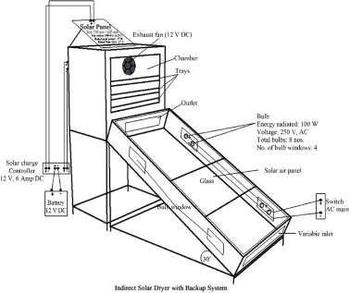

Figure2.1.1:IndirectSolarDryer withBackupSystem

Figure2.1.1 illustrates amoreadvanced configuration of an indirect solar dryer, featuring a backup system composed of a solar panel, battery, and DC exhaust fan. The solar collectorinthisdesignisasloped,glazedenclosurethatcapturessolarenergy,whichis

then converted into thermal energy by internal black-painted absorbing surfaces. The hot air generated inside the collector flows upward due to density differences and enters the drying chamber through a channel.
The drying chamber contains multiple trays arranged vertically, where sliced agricultural produce is spread in thin layers. A 12 V DC exhaust fan installed at the top of the chamberassistsindrawingthehotairuniformlyover thetrays andexpellingthemoistair through an outlet. The fan is powered by a solar panel that charges a 12 V DC battery via asolarchargecontroller.Fornight-timeorlow-radiationsupport,thesystemincludes100 W bulbs installed within “bulb windows” to provide thermal backup and ensure continuous drying, particularly in humid or cloudy weather.
This design ensures enhanced airflow, temperature stability, and reduced drying time. However, it is important to note that the system constructed in this present study did not incorporate electrical backup or forced convection elements. Instead, the fabricated dryer was designed to operate under natural convection, with airflow driven solely by thermal gradients between the collector and the outlet vent.
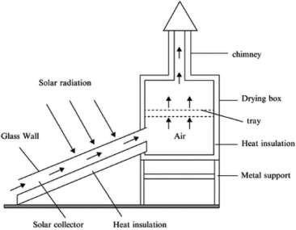

Figure2.1.2:BasicIndirectSolarDryer(WithoutBackupSystem)

Figure 2.1.2 presents a more conventional or passive indirect solar dryer, resembling the one constructed in this study. The primary components of this dryer include a slanted solar collector, a drying chamber, a chimney for air exit, and supporting frames. Solar radiation passes through the transparent glazing (glass wall) of the collector and strikes the absorber plate beneath it. The absorber typically black-coated metal or aluminum converts solar radiation into heat, warming the air inside the collector channel.
As the air is heated, its density decreases, causing it to rise naturally into the drying chamber. This continuous movement of hot air creates a natural draft effect, promoting the flow of air through the trays where the product is laid. Moist air rises further and escapes through a chimney placed at the top of the drying box. This chimney effect improves air circulation and maintains the drying gradient necessary for continuous moisture removal.
In thesystem used for thisresearch, the indirect solar dryer was constructed using an iron skeleton structure, covered with HDF plywood board and transparent glass (10mm inner and 5mm outer layer) on the collector side. The absorber was painted black for enhanced heat absorption, and the inner trays were plastic (non-metallic), placed on a fixed iron rack inside the chamber. The construction excluded fans, bulbs, solar panel, or any electrical components.
To better appreciate the operation of the indirect solar dryer, it is important to understand the role of each component and the physical principles they embody:
- SolarCollector:The collector istheheartofthe system. It convertssolarradiation intothermalenergythroughaprocess ofradiationabsorption.Solarrays penetrate the transparent glass layer and are absorbed by a dark-colored metal sheet. This sheet, with high absorptivity and low reflectivity, transfers heat to the air trapped

within the enclosed collector. The transparent glass also acts as a cover that reduces convective heat loss and enhances the greenhouse effect, allowing sunlight inwhile reducingre-radiation of heat out.The slant angle of thecollector (30° in the backup system diagram) is designed to maximize solar exposure depending on the latitude of the location (in this case, southwestern Nigeria). As the temperature rises, the less dense air becomes buoyant and begins to flow into the adjacent drying chamber.
- Drying Chamber and Trays: The drying chamber is a thermally insulated enclosure where pepper slices are spread on trays. These trays are perforated (if metal) or open (if plastic) to permit even distribution of hot air across the sample. The primary mechanism of moisture removal here is convection: the heated air transfers energy to the pepper, raising its surface temperature and facilitating evaporation of moisture. Heat conduction from the tray into the pepper, and evaporation of water from the internal cells toward the surface, are enhanced by consistent air movement. The chamber is typically coated or lined to retain heat and minimize losses through conduction.
- Chimney or Outlet Vent: In passive systems, the chimney serves a crucial role in facilitating natural convection. As hot moist air accumulates in the drying chamber, it becomes lighter and escapes through the chimney, drawing fresh hot air from the collector. This creates a continuous airflow cycle that maintains the drying environment. The height and width of the chimney can significantly influence airflow velocity and drying rate.
- Insulation and Structural Materials: Thermal insulation (e.g., fiberglass, foam, or wood board) is used to reduce heat loss to the surroundings, especially from the sidewalls and base of the drying chamber. The materials selected for construction mustbedurable, non-toxic,and stableunder high temperatures. In theconstructed unit, woodwasusedforpaneling,andjointsweresealedtopreventleakage.All

internal parts were painted black to enhance absorption, and aluminum angle iron was used to prevent water ingress between glass and frame joints during rain.
- Air Movement Mechanism: In the backup-supported version, airflow is mechanically enhanced by an electric fan that operates on solar power or battery charge. This increases airflow rate and drying efficiency, especially in highhumidity conditions or during low solar radiation. In contrast, the passive version depends solely on thermal buoyancy, warm air rising and cool air being drawn in to maintain airflow. Though less aggressive, it is effective and more energyefficient.
- Backup Heating (Bulbs): In the advanced system (Figure 2.1), the inclusion of bulbs as a thermal backup ensures the drying process can continue during cloudy days or at night. These bulbs emit heat, not light, and are typically arranged at strategic locations within the collector to maintain air temperature. However, this addstotheoperationalcostandenergy dependency, whichiswhyitwasexcluded from the built version used in this study.
Both configurations of the indirect solar dryer operate on the same underlying physical principles: capture of solar radiation, conversion into heat, transfer of heat to airflow, and removal of moisture through evaporationand ventilation. However, the presence of a fan, battery, and electrical heating backup in the advanced model allows for enhanced efficiency, shorter drying times, and controlled conditions.
The constructed system used in this study adhered to the passive model (Figure 2.2), which though is slower, is more sustainable and cost-effective for rural or low-resource settings. It was successfully used to dry pepper, with hourly temperature and moisture readings taken to evaluate performance across multiple days.

The effectiveness of an indirect solar dryer is governed by three primary modes of heat transfer: convection, conduction, and radiation, all of which work synergistically to dry the agricultural produce.
- Convection is the dominant mechanism in the indirect drying process. As solar radiation heats the air in the collector, the air becomes lighter (less dense) and rises naturally into the drying chamber. This upward flow of warm air is what drives moisture removal from the pepper slices placed on the trays. As the warm air contacts the moist pepper surfaces, it absorbs moisture, creating a vapor-rich environment that continues to move upward and is eventually vented through the outlet or chimney. In systems with fans (as seen in Figure 2.1), this airflow is mechanically accelerated, leading to faster drying. In the naturally ventilated model used in this study (Figure 2.2), convection occurs passively, relying on the buoyancy effect created by temperature gradients.
- Conduction, while less dominant, plays a critical role in the initial transfer of thermal energy from the hot air or heated tray surfaces into the pepper slices. As the hot air bathes the trays, heat is conducted through the tray material (especially if metallic) and into the lower layers of the pepper. The internal moisture within each slice also migrates toward the surface through molecular conduction, after which it evaporates into the air. Although conduction is a slower process compared to convection, it is essential for drying the inner tissues of the pepper.
- Insulation acts as a thermal barrier that prevents heat loss from the system to the external environment. In the constructed dryer, insulation was achieved by using fiber material between the chamber walls and by minimizing heat bridges at the joints. This ensured that the majority of the heat energy captured remained within thesystemtosupportevaporation,ratherthandissipatingthroughstructural

leakage. Proper insulation improves the thermal efficiency of the system and reduces temperature fluctuations that may slow down drying.
Collectively, these heat transfer modes ensure a continuous cycle: radiation heats the air, convection carries the heat to the drying chamber, conduction transfers it to the pepper, and insulation retains the thermal energy in which all contributes to efficient moisture removal.

WorkingPrincipleandPhysicsofGreenhouseSolar Dryer

The greenhouse solar dryer is a modified greenhouse structure used for dryingagricultural products by trapping solar radiation and creating a warm, enclosed environment that enhances moisture removal. It is particularly effective in reducing post- harvest losses, improving product hygiene, and providing a consistent dryingenvironment irrespective of fluctuating external weather conditions.
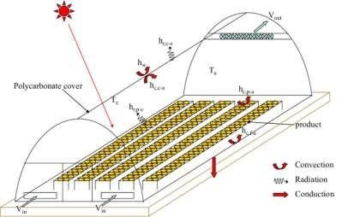

Figure2.2.1:WorkingPrincipleofaGreenhouseSolarDryer

Figure 2.2.1 illustrates the basic configuration and thermal behavior of a typical greenhouse solar dryer. The structure consists of a transparent polycarbonate cover that allowsincomingsolarradiationtopenetratethedryingchamber.Thiscoveris

responsible for creating the greenhouse effect, whereby shortwave solar radiation enters the dryer, heats up internal surfaces, and is then re-radiated as long wave infrared energy that becomes trapped, increasing the internal temperature of the chamber.
The diagram features thermodynamic elements labeled as convection, radiation, and conduction to represent the different modes of heat transfer active within the dryer:
Radiationistheinitialenergyinput,wheresunlightdirectlyenters throughthetransparent cover and heats the air, floor, and any black-painted surfaces inside the dryer. These surfaces then emit long wave infrared radiation, which is partially trapped inside the chamber, contributing to the internal heat buildup.
Convection occurs as the heated air inside the chamber becomes less dense and begins to rise. Cooler air from the bottom is drawn in to replace the rising hot air, creating a continuous flow cycle. This natural air circulation enhances the transfer of moisture from the surface of the product into the air stream.
Conduction isresponsible for the transfer of heatthrough solid materials suchas thefloor, tray holders, and metallic parts of the frame. As these materials heat up from radiation, they pass thermal energy into the produce that is in direct contact with them. This aids in drying from the underside of the product, complementing the convective drying above.
The airflow in the system is represented by V-in and V-out, indicating the air inlet and outlet, respectively. Cool air enters through V-in near the base of the structure, is heated by solar radiation, and then rises due to convection. The warm, moisture-laden air exits through V-out, usually located near the top ends or ridge of the dryer. This passive ventilation system ensures that humidity does not accumulate excessively within the chamber, thus preventing microbial growth and condensation.
Also visible in the diagram are symbols labeled T and H, which represent temperatureandhumidity,respectively.Theseparametersaremonitoredatdifferentpointswithinthe

chamber to evaluate the thermal performance of the dryer and ensure that the conditions remain within optimal drying ranges for the specific crop. For pepper, efficient drying occurs between 40°C and 55°C with moderate humidity.
The greenhouse solar dryer used in this study closely followed the structure illustrated in the diagram, with several practical adjustments. The frame was constructed using aluminum for structural rigidity and was enclosed entirely with transparent glass instead of polycarbonate. This provided excellent solar transmission and contributed to a significant internal heat gain under sunny conditions.
Prior to thecommencement of drying experiments, the greenhouse dryer required repairs. The glass door and parts of the aluminum frame had been damaged and needed to be refixed. Broken glass panels were replaced, and the frame joints were reinforced to prevent heat leakage. The entire unit was mounted on a metal iron sheet, painted black to improve solar absorption and minimize heat losses through the floor. This metallic base also contributed to heating through conduction. Unlike mechanically assisted dryers, the greenhouse dryer in this project did not use any fans, heaters, or solar panels. It operated entirely on natural convection and solar energy.
The performance of a greenhouse solar dryer depends on an effective combination ofsolar radiation trapping, controlled airflow, and moisture removal. The following thermodynamic principles govern its operation:
- Solar Radiation and Greenhouse Effect: Solar energy enters through the transparent glazing and heats up surfaces and air within the chamber. The transparent glass transmits shortwave radiation but traps longwave re-radiation, elevating the internal temperature which is the greenhouse effect. The trappedheat leads to rapid moisture evaporation from the product.
- Convection: As the internal air heats up, it becomes less dense and rises, generatinganupwardflow.Thiscreatesasuctioneffectthatdrawsfresh,cooler

air in from below (V-in) and pushes moist, warm air out through the outlet (V- out). The continuous circulation promotes consistent drying across trays.
- Conduction: Heat absorbed by metallic or solid surfaces (like tray supports or the metal base) is conducted to the produce in direct contact. This helps warm up the product evenly and supports the internal movement of moisture from the core of the pepper to the surface.
- Insulation: Although the glass provides transparency, its thickness and sealed construction also function as insulation. It reduces heat loss to the external environment, especially during wind disturbances or temperature drops. The aluminum frame which is a conductor, was minimized in contact exposure to retain internal heat.
These mechanisms collectively create a stable micro-environment that accelerates drying whilemaintainingthequalityoftheproduce.Inpracticaluse,dailytemperatureinsidethe chamber was recorded as being consistently 6–12°C higher than ambient conditions, demonstrating strong thermal performance.

WorkingPrincipleofaHybridSolar Dryer

A hybrid solar dryer combines two or more energy sources to ensure consistent and efficient drying of agricultural produce, regardless of climatic variability. This system primarily uses solar energy, supplemented by auxiliary sources such as electric heaters, biomass burners, or photovoltaic systems which is to guarantee continuous drying even during cloudy weather or at night. In normal operation, solar radiation is collected by a solar thermal collector, typically made of a black-painted metallic plate enclosed in transparent glazing material like polycarbonate or glass. The solar energy heats up the absorber plate, which then transfers the heat to air within the collector via conduction.Thehotairiseithermovedpassively(naturalconvection)oractively(withasolar-

powered fan) through a drying chamber where the agricultural products are arranged on trays.
As heated air passes through the drying chamber, it absorbs moisture from the wet produce through convective heat transfer. Simultaneously, the latent heat of vaporization enables moisture within the product to transition from liquid to vapor. This vapor is then carried away by the moving air stream, ensuring continuous drying. Exhaust vents are typically placed at the top of the chamber to allow moist air to escape, while drier air circulates in, keeping the drying cycle effective.
One of the key features of the hybrid solar dryer is the backup heating mechanism. When sunlight is insufficient, the system automatically activates an electric or biomass-based heater, or may continue operating with energy stored in batteries charged by photovoltaic panels. This ensures that drying conditions remain optimal throughout the day. The integration of temperature and humidity sensors helps regulate the environment withinthe chamber, reducing the risk of over-drying and preserving the quality of the product.
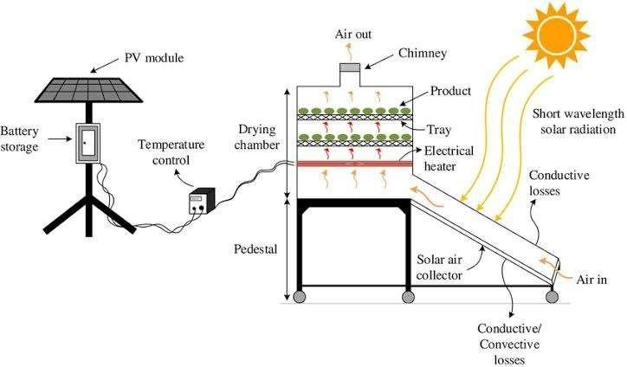

Figure2.3.1:WorkingPrincipleofaHybrid SolarDryer

Hybrid dryers are especially beneficial for crops like tomatoes, peppers, and cassava, which require consistent drying conditions to prevent microbial spoilage and preserve nutritional value. Studies by Elwakeel et al. (2024) and Hossain et al. (2023) demonstrated that hybrid dryers significantly reduced drying time and improved overall efficiency compared to open sun or conventional solar drying.

ClassificationofSolar Dryers

Solar dryers are typically classified based on their design configuration and mode of air circulation. The two major classifications are passive solar dryers, which rely entirely on natural convection and solar radiation without auxiliary energy, and active solar dryers, which utilize mechanical or electrical components such as fans and heaters to enhance airflow and control conditions withinthedrying chamber. This classification plays avital role in determining the dryer’s efficiency, cost-effectiveness, and suitability for various agricultural or industrial applications.

PassiveSolarDryers

Passive solar dryers are systems that utilize the natural movement of heated air generated by solar radiation for the drying process. These dryers do not require external power sources or mechanical aids, which makes them ideal for smallholder farmers and rural settings where electricity is scarce or unavailable. Passive solar dryers are further divided into two main types: direct and indirect solar dryers.
Direct Passive Solar Dryer: The direct solar dryer operates on the principle of directly exposing the product to solar radiation within an enclosed transparent chamber. The transparent cover (usually made of glass or clear plastic) allows sunlight to pass through and heat theproduct directly, while also trapping thermal radiationinsidethechamber,increasingtheinternaltemperatureandfacilitating

moisture evaporation (Hossain & Bala, 2007). This system typically consists of a drying chamber, mesh trays, and a transparent roof or top surface. Although effective in raising the drying temperature, this method exposes the product to ultraviolet radiation, which may degrade certain nutrients or pigments. It also requires frequent monitoring to prevent overheating and ensure uniform drying.
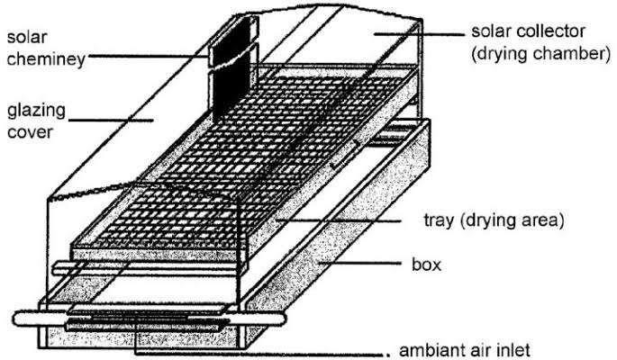

Figure2.4.1.1:LayoutofaDirectPassiveSolar Dryer

The major advantage of this system is its simplicity and low construction cost. However, it is limited by factors such as uneven drying and vulnerability to weather changes. Studies by Fudholi et al. (2014) confirm that direct passive dryers are best suited forcrops like tomatoes and pepper when applied in areas with high solar intensity and stable weather.
Indirect Passive Solar Dryer: In the indirect passive solar dryer, solar energy is first used to heat air in a solar collector before channeling it into the drying chamberwheretheproductis kept.Thisconfigurationpreventsdirectexposureof

the product tosunlight, thuspreserving itscolor, flavor, and nutrients.The natural convection current created as the hot air rises draws cooler air from the inlet, facilitating continuous airflow through the system (Esper & Mühlbauer, 1998).
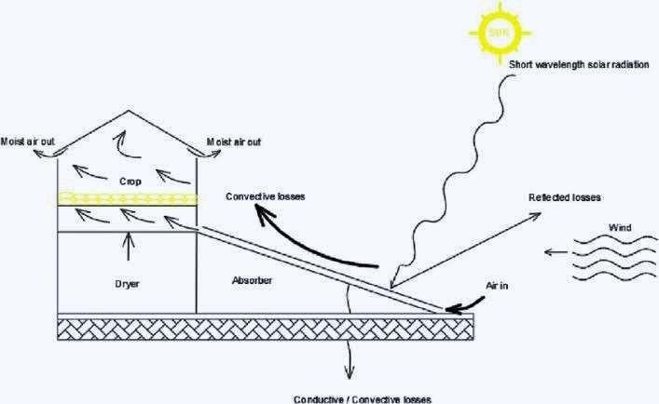

Figure2.4.1.2:Layoutof anIndirectPassive SolarDryer

This type of dryer enhances hygiene and reduces contamination risk, which makes it suitable for delicate crops such as herbs, spices, and leafy vegetables. Research by Bala and Woods (2001) noted that while indirect passive dryers may take slightly longerdryingtimescomparedtodirect dryers, theproduct qualitytendstobesuperior duetothe absence of direct sunlight.

ActiveSolar Dryers

Active solar dryers incorporate mechanical components to boost the movement of heated air and regulate drying conditions, thereby ensuring faster and more uniform drying. Thesesystems usuallyincludefans,blowers, orphotovoltaic-powered ventilation systems

and are more technologically advanced than passive systems. They are further classified into indirect active, hybrid, and other integrated solar dryer designs.
Indirect Active Solar Dryer: In this system, solar energy heats air in a collector, and then a fan or blower pushes the heated air into the drying chamber. The airflow is controlled to maintain a consistent drying rate, reducing the risk ofmold growth or spoilage. Unlike passive systems, indirect active dryers can operate under cloudy conditions or at night when coupled with thermal storage units (Madhlopa & Ngwalo, 2007).
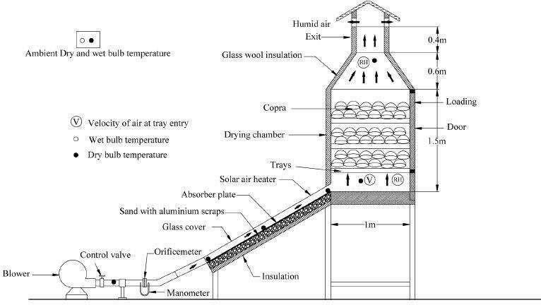

Figure2.4.2.1:LayoutofanIndirectActive SolarDryersystem

AccordingtoJanjai and Bala (2012), themajor advantage of indirectactive dryers istheir ability to maintain higher temperatures and better control humidity levels, resulting in shorter drying durations and higher efficiency. They are ideal for high-value crops suchas tomatoes, okra, and medicinal plants.

Hybrid Solar Dryer: Hybrid solar dryers combine solar energy with auxiliary heating sources such as electric heaters, LPG burners, or biomass stoves to ensure uninterrupted drying regardless of weather conditions. These dryers often include photovoltaic cells to power fans or heaters, thereby integrating renewable energy with mechanical aids for optimized performance (Hussein et al., 2017). Thehybrid model is particularly useful in areas with variable weather patterns or high humidity.
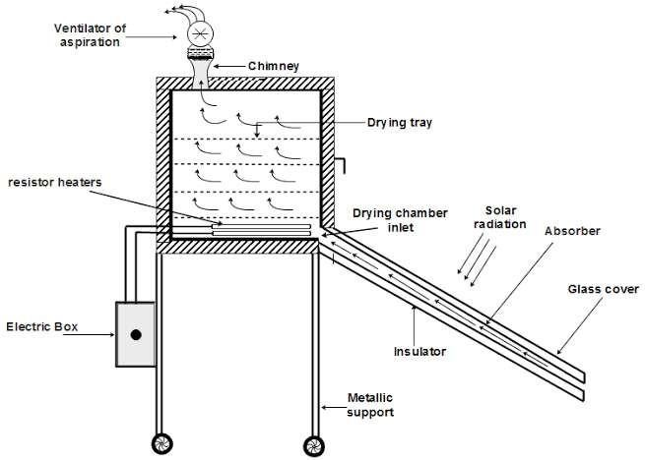

Figure2.4.2.2:Layout ofHybridSolar Dryer

Studies by Elwakeel et al. (2024) demonstrated that hybrid dryers achieved moisture reductions of up to 80% within 6–8 hours, significantly outperforming passive systems. The incorporation of backup systems ensures that product quality is preserved, and operational efficiency is not weather-dependent.

DesignConsiderationsforthe Solar Dryers

The design of solar drying systems requires a careful balance between thermal performance, structural durability, material availability, and the nature of the agricultural product being dried. In this study, the design of both the indirect solar dryer and the adaptation of an existing greenhouse solar dryer were centered on practical efficiency, energy independence, and preservation quality especially for a perishable, high-moisture crop like pepper. Several technical and environmental factors were taken into account to ensure the constructed systems met these performance targets within the limitations of available resources.
A fundamental consideration was the type of drying method. The indirect solar dryer was selected for its ability to isolate the product from direct solar radiation, thereby reducing the risk of nutrient degradation, color bleaching, or contamination by dust and insects. Unlike direct sun drying, the indirect method ensures that heat is transferred through warm air generated ina separate collector unitandchanneled intoa drying chamber. This reduces exposure to ultraviolet radiation while still taking advantage of solar energy. On theother hand,thegreenhousesolar dryer although naturally allowingdirect sunlightinto the chamber was retained for its passive heating advantage and enclosure benefits. Its large transparent surface and closed design promote heat buildup, providing favorable thermal conditions for drying.
The nature of the product in this case, sliced pepper played a central role in determining drying chamber volume, tray surface area, and airflow rate. Pepper contains a high level of moisture and has soft, thin-walled tissue that deteriorates quickly under poor drying conditions. As such, the chamber needed to allow adequate airflow to ensure uniform drying and prevent microbial growth. The design included space for different layers of pepper on each tray to optimize surface area exposure and minimize drying time. Trays wereselectedtobelightweightandnon-reactive;plastictrayswereusedinthiscase,

supported by a welded iron within the chamber. Their spacing was planned to allow even vertical airflow through the product layers.
The inclination of the solar collector in the indirect dryer was another thermal optimization factor. A tilt angle of approximately 30° was adopted based on the latitudeof the study location in southwestern Nigeria. This angle maximizes solar irradiance throughout the day, allowing optimal sunlight penetration and energy absorption. The collector surface was covered with transparent glass (10mm inner, 5mm outer) to enable greenhouse trapping while also offering durability against weather elements. Theabsorber plate beneath the glass was coated in black automobile paint to maximize thermal absorption and raise the internal air temperature effectively.
Material selection was driven by a need for thermal efficiency, cost-effectiveness, and local availability. The frame of the indirect dryer was constructed using welded metal sheet to provide strength and support for both the collector and the chamber. Thechamber walls and collector body were lined with fiber insulation to reduce heat losses. The outer structure was enclosed with HDF plywood board and sealed to prevent air leakage. Aluminum angle were used in vulnerable junctions especially between glass and frame to prevent water seepage during rainfall. For the greenhouse dryer, existing aluminum frames were refurbished, broken glass were replaced, and the base was restructured with a painted metal sheet to enhance absorption and structural integrity.
Airflow dynamics also informed key decisions. The indirect dryer operated withoutforced convection; thus, the internal design was adjusted to maximize natural air movement. The collector was positioned at a height slightly lower than the chamber to encourage warm air to rise and enter the drying space by buoyancy. The outlet above the chamber helped to maintain the pressure gradient, expelling moist air and drawing infresh hot air from the collector. This continuous flow created the draft needed for uninterrupted moisture removal, even in the absence of a fan.

Heat retention and energy efficiency were further considered through insulation design. Fiber insulation was used in the indirect dryer to minimize conductive and convective heat loss through the chamber walls. The greenhouse dryer naturally retained heatthrough its enclosed glass walls, but gaps from wear and tear were sealed during repairsto improve performance. These retention measures were essential for maintaining high internal temperatures without external energy input.
The ease of assembly and repair was another practical design factor. The project was executed in a low-resource setting, and as such, the design had to accommodate local fabrication techniques and materials. The indirect dryer was constructed over the course of several days, including time spent welding the frame, cutting wooden boards, and assembling the collector. The greenhouse dryer, already available, required structural modifications and realignment to restore its functionality. By prioritizing modular components, both dryers could be dismantled or upgraded with minimal technical intervention in the future.

CHAPTER THREE MATERIALSANDMETHODS

ConstructionMaterialsfortheSolar Dryers

- High-density fiber (HDF) plywood boards: were used to form the outer casing of the indirect solar dryer, covering the sides and base of both the drying chamber and the solar collector. This material was chosen due toits smooth finish, ease of cutting, and moderate thermal resistance, which helped reduce heat loss from the system. HDF is also cost-effective and locally available, making it suitable for low-resource settings. When properly sealed or painted, it offers decent durability and structural support for enclosing the dryer while maintaining a clean, professional appearance.
- Transparent glass: was used as the glazing material for the solar collector in the indirect dryer and for enclosing the entire structure of the greenhouse dryer. Its primary role was to allow solar radiation to penetrate into the system while trapping long wave heat through the greenhouse effect. Glass was chosen over plastic alternativesduetoitssuperiorclarity, durability, andresistancetoUV degradation.In the indirect dryer, a combination of 10mm inner and 5mm outer glass was used to enhanceinsulation,reduceheat losses,andmaintainstructural integrityunderoutdoor exposure.
- Black-painted metallic iron sheets: were used as the absorber within the solarcollector of the indirect dryer. Their function was to absorb incoming solar radiation and convert it into heat, which in turn raised the temperature of the air within the collector. The black coating increased the surface’s ability to absorb solar energy by minimizingreflectivity,whilethemetal’shighthermalconductivityallowedfor

efficient heat transfer to the passing air. This combination enhanced the overall thermal performance of the dryer.
- Fiber material: was used as insulation within the walls of the indirect solar dryer to minimize heat loss. It was placed between the inner and outer layers of the dryer’s structure to prevent thermal conduction from the heated interior to the cooler external environment. Fiber was selected because of its low thermal conductivity, lightweight nature, and ease of installation. This helped maintain higher internal temperatures, improved drying efficiency, and reduced fluctuations caused by external weather conditions.
- Drying Trays: Instead of wire mesh, plastic trays were used to hold the pepper samples. These trays were wrapped with aluminum foil to enhance hygiene and reflectivity, minimizing contamination and improving drying surface conditions.
- Angle iron: was used to construct the metallic stand for the indirect solar dryer. It provided strong structural support for both the collector and the drying chamber, ensuring the entire unit was elevated and stable. The use of metal offered durability and resistance to bending or warping under load or prolonged sun exposure.
- Aluminumangle:was used to sealexposedgaps along the edges of thesolar collector in the indirect dryer, particularly where the glass met the wooden or metallic frame. Its purpose was to prevent rainwater from seeping into the collector during wet conditionsandtoreduceheat lossthroughstructuraljoints.Aluminumwaschosenfor this sealing role due to its corrosion resistance, ease of bending, and durability in outdoor environments. This helped maintain the integrity of the collector and ensured consistent thermal performance.
- Metal hinges, nails, screws, and handles were used as fastening and functional componentsthroughouttheconstructionofbothdryers.Hingeswereattachedto

chamber doors to allow smooth opening and closing during loading and unloading of pepper samples. Screws and nails secured the plywood panels, metal frames, andglass supports, ensuring structural firmness. Handles provided ease of access and safe operation.These materials were chosen for their mechanical strength, reusability, and resistance to wear under frequent use, all contributing to the overall durability and usability of the dryers.
- Automobile black paint: was applied to the absorber surface withinthe solar collector and to some internal components of the indirect solar dryer to enhance heat absorption. The color black was specifically chosen because of its high absorptivity, allowing it to capture and retain more solar radiation compared to lighter colors. By increasing the efficiency of thermal energy collection, the black-painted surfaces helpedraise theair temperatureinsidethe collector, thusimprovingtheoveralldrying performance of the system.
- The aluminum framework formed the structural skeleton of the greenhouse solar dryer, supporting the glass walls. Aluminum was selected due to its lightweight nature, corrosion resistance, and structural stability under prolonged exposure to sunlight and humidity. Its strength allowed it to hold the glass wall securely in place, while its resistance to rust ensured long-term durability. The use of aluminum also madeiteasier toassembleandrepairthestructure whendamaged,aswasdoneduring the rehabilitation phase of the project.

InstrumentsUsed

Tomonitortheenvironmentalanddryingparametersduringtheexperiment,the following instruments were employed:

Digital Multimeter with Sensor Probe Model DM8100: This multifunctional devicewas used tomeasureair temperatureinsideeach drying chamber aswell as the ambient environment (see figure 3.2.1).


Figure3.2.1DigitalMultimeterwithsensory probe

Digital Hygrometers: Used alongside the multimeter is the Hygrometer used to take humidity readings, ensuring accurate environmental monitoring. It can also be used to take readings of both temperature and time (see figure 3.2.2).

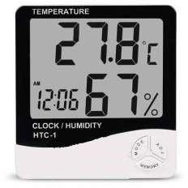

Figure3.2.2Digital Hygrometer

Solar Radiation Meter (Pyranometer) Model SM206: Used to measured incident solar radiation in W/m². Accurate solar input data was essential for calculating thermal efficiency (see Figure 3.2.3).
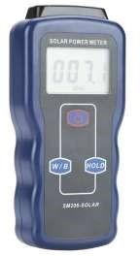

Figure3.2.3SolarRadiationMeter(Pyranometer)

Digital Weighing Scale: Used to measure weight loss of pepper samples at regular intervals to evaluate moisture reduction (see figure 3.2.4).
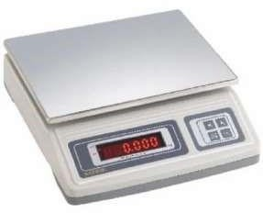

Figure3.2.4DigitalWeighingScale

ConstructionProcess

The construction process commenced with meticulous planning and detailed design schematics to guide the fabrication of both the indirect and greenhouse solar dryers. Accurate dimensional measurements were taken to ensure that each component would align properly during assembly.
For the indirect solar dryer, the solar collector was constructed using a flat metallic plate measuring 123 cm in length, 57 cm in breadth, and 21 cm in height. This platefunctioned as the primary absorber of solar radiation, intended to heat the incoming air before it passed into the drying chamber. The drying chamber (cabinet), designed to house the produce trays, was built with a length of 85 cm and a breadth of 52.5 cm. At the upper rear section, a chimney was installed and slightly tilted to permit rainwater drainage. The chimney components were fabricated with the following dimensions:

- Chimneyback:38 cm× 28.5 cm
- Chimneysides: 20.5cm × 38 cm

- Chimneyhead:28.5cm(length) ×33cm(breadth) ×12.5cm (height)

An access door measuring 72 cm in length and 67 cm in breadth was incorporated intothe drying cabinet to allow easy handling of trays and inspection of the drying process.
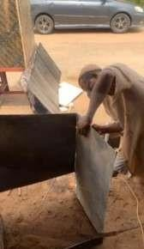
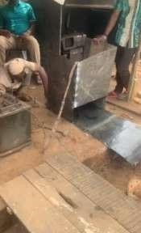

Figure3.3.1duringweldingprocessofthe indirectsolar dryer

The frame components, including the collector plate and structural elements, were transported to a local welding workshop located in GRA, Ilorin, behind the Governor’s Office. Welding was carried out under close supervision to ensure strict adherence to the specified dimensions and design.

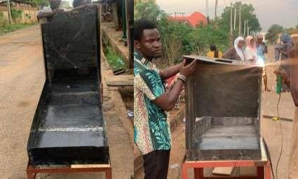

Figure3.3.2weldedframeworkoftheindirectsolar dryer

Upon completion, the assembled frame was returned to the department and painted using automobile-grade black paint to enhance solar absorption. After the paint dried, the entire unitwasmountedonadeckingplatformbehindPhysicsLaboratoryA,selectedforits elevation and lack of shading obstructions. A ladderwas used to transport and positionthe dryer on the platform. The structural casing was constructed using High-Density Fibreboard(HDF)plywood,whichwasusedtoenclosethedryer’ssides.Thetopportion
ofthecollectorwascoveredwithtransparentglasstoallowsunlightpenetration.Two glass layers were installed:
- Innerlayer:10mmthick

- Outerlayer: 5mmthick

The edges were sealed using aluminum angles, while rubber lining was added to prevent water ingress during rainfall. Additionally, hinges, handles, and locks were installed to facilitate ease of access and improve operability. The assembly process involved the use of nails, screws, and hammers to ensure structural integrity. Following completion, the entire unit was thoroughly cleaned, both internally and externally.

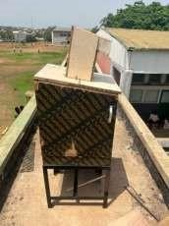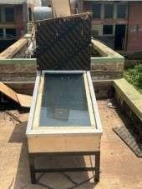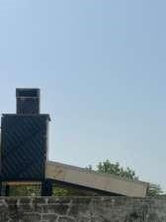

Figure3.3.3completedconstructionoftheindirectsolardryer

Work was also undertaken on an existing greenhouse solar dryer, which required repairs to restore its operational integrity. The main structural dimensions of the greenhousedryer were:
- Overallbody:154.5cm(length)×104.5cm(breadth)×100cm(height)

- Raisedhead section:104.5cm(length)×55cm(breadth)× 49.5cm(height)

A new collector plate was fabricated and installed, measuring 149 cm in length and 102 cm in breadth. Repair work included replacing broken glass panels and rebuilding the door.
Afterrepairs, theentireunitwascleaned, reassembled,andprepared forexperimentaluse.

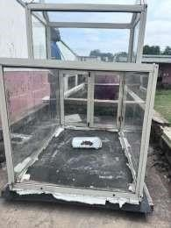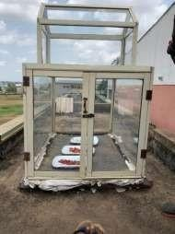
Figure3.3.4completedconstructionofthegreenhousesolardryer

Both the indirect and greenhouse solar dryers were mounted side by side on the same elevated platform and aligned in the same direction to ensure uniform solar exposure during testing. This strategic placement helped to maintain consistent environmental conditions and optimize performance comparison between the two systems throughoutthe experimental period.

ExperimentalSetup

The experimental setup began with the preparation of our sample fresh red pepper (Capsicum spp.) used for the drying process. The peppers were purchased from Mandate MarketinIlorinandthenbroughttothelaboratory forpreparation.Theharvestedpeppers were washed with clean water to remove any surface contaminants. After washing, the stems were removed, and each pepper pod was carefully sliced into two halves toenhance moisture release during the drying process.
Next, plastic trays were wrapped with aluminum foil, and the weight of each empty tray (includingthefoil)wasmeasuredusingadigital weighingscale. Thisinitialmeasurement wasnecessarytodeterminethenetweightofthepepperafterloading.Theslicedpeppers

were then evenly arranged into three trays in which one was assigned to each of the drying systems: the indirect solar dryer, the greenhouse solar dryer, and the open sun drying method.
Each tray was weighed again after loading with the pepper slices. The actual weight ofthe pepper was obtained by subtracting the tray-and-foil weight from the total weight. Thesetrayswerethenplaced insidetheirrespectivedryingsystems,allofwhichhadbeen previously installed on a decking located behind Physics Laboratory A, Kwara State Polytechnic, Ilorin. The open sun drying tray was placed on a layer of nylon sheetdirectly on the decking to protect it from contamination.

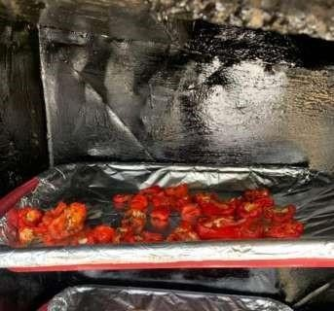

Figure3.4.1:Pepperinthe trayplacedinsideIndirectSolarDryer

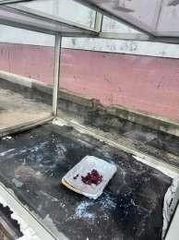

Figure3.4.2:TrayplacedinsideGreenhouseSolarDryer
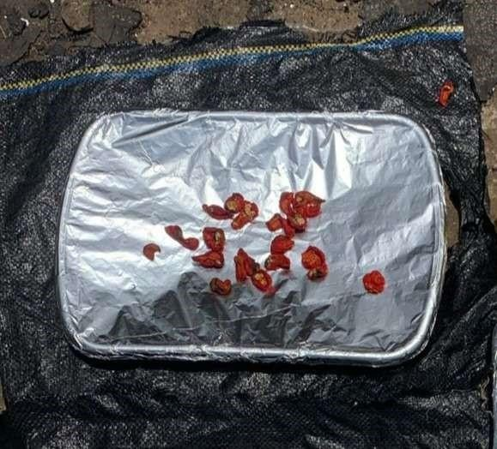

Figure3.4.3:TrayplacedunderOpenSun Dryer

Measurements and observations were carried out hourly from 9:00 am to 5:00 pm daily, acrossathree-daydryingperiod.Thedatacollectedincluded:Chambertemperatureand

humidity inside each dryer, using a digital multimeter with probe sensors and digital hygrometer. Weight of pepper samples, using a digital weighing scale, recorded to track moisture loss over time.
Each measuring instrument was calibrated daily before use to ensure accuracy. During the experiment, a sensor fault was detected in the digital multimeter, which led to unusual temperature readings. This was corrected by replacing the faulty probe and changing the batteriesofboththemultimeterand weighing balance tomaintainconsistent performance. Although data collection was interrupted for a few hours due to rainfall, observations resumed immediately when conditions stabilized. The same trays remained in their original positions throughout the experiment, and no agitation or turning of the pepper slices was performed, ensuring uniform exposure across all setups.
The entire setup allowed a systematic comparison between the indirect solar dryer, greenhouse solardryer, and open sundryingmethod, focusing ontheir respectivethermal efficiency, moisture removal capacity, and drying performance under real environmental conditions.

PerformanceEvaluationParameters

Toassess the effectiveness of the solar dryers used in thisresearch, which are greenhouse solar dryer, indirect solar dryer, and open sun drying. Several thermal and physical parameters were calculated. These parameters help in understanding the drying behavior, energy utilization,and efficiency of thesystems. Themainparameters considered include moisture content, drying rate, and thermal efficiency.
Moisture content: This is acritical parameterin dryingstudies, as it reflectstheamountofwater present intheproductat anygiventime.Itdeterminesthe quality

andshelf-lifeofdriedproducts.Duringdrying,themoisturecontentdecreases progressively until it reaches a level safe for storage. Inadequate drying can leadto microbial growth, spoilage, and loss of quality, while over-drying may reduce nutrient content and increase energy usage. In this research, the moisture content was calculated on a wet basis, which is more common in food processing studies. The formula used is:
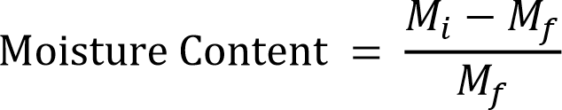

=InitialWeight

=FinalWeight

Thisformulaprovidesthemoistureremovedrelativetotheoriginalweightofthematerial. For each drying method, weights were recorded hourly, and the reduction in mass was used to compute the moisture loss throughout the drying period. Accurate determinationof moisture content is essential for comparing the drying performance of differentsystems. This approach is widely used in solar drying studies, particularly in agricultural products like cassava, tomatoes, and peppers (Mohammed et al., 2021; Bala, 1997; Onuoha & Obetta, 2010).
- Drying rate: This is another essential parameter that indicates the speed at which moisture is removed from a substance. It helps in understanding the drying kinetics and how efficiently the solar dryer performs over time. A higher drying rate suggests faster moisture removal, better thermal performance, and reduced drying time, all of which contribute to energy savings and product quality. It is measured in grams per hour (g/h) or kg/h and expressed as:
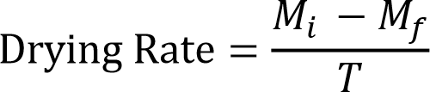




ForWetBasis:
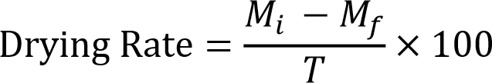

The drying rate gives insights into the drying behavior at each stage. For example, drying is usually faster in the initial stage when the moisture content is high and slows down as the product loses moisture. These trends were carefully observed and calculated during the Eight-day experimental period in this study. A steady or high drying rate usually reflects good heat and mass transfer characteristics of the dryer (Hossain & Bala, 2007; Janjai & Bala, 2012). By comparing drying rates across the greenhouse, indirect, andopen sun drying methods, one can determine which system achieves quicker drying with minimal nutrient and quality loss.
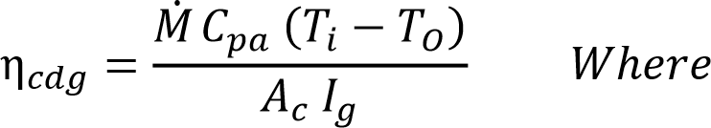
- Thermal efficiency (or drying efficiency): This is a measure of how well the solar dryer converts incident solar energy into useful energy for moisture removal. It reflects the effectiveness of the system in utilizing available solar radiation to generate heat that facilitates drying. The thermal efficiency was calculated using the formula:

:
∶𝑎𝑎𝑝𝑒

∶𝑒𝑐𝑒𝑝𝑒𝑎𝑒

∶𝑒𝑛𝑒𝑝𝑒𝑎𝑒

∶𝑎𝑎𝑎𝑎𝑛

𝑐∶𝑒𝑎ℎ𝑒𝑐𝑒𝑐

This equation helps determine how much of the captured solar energy was used in evaporating moisture from the product. A higher efficiency indicates a better-performing solar dryer with minimal energy losses. The efficiency is affected by several factors, including the design of the collector, insulation, airflow, ambient temperature, and solar intensity. For this study, efficiency values were calculated for both the indirect and greenhouse dryers using the recorded solar radiation and moisture loss data. Solar radiation was measured hourly using a pyranometer or solar meter, and temperature data helped in validating thermal performance.
This method is frequently adopted in solar drying literature (Bukola & Ayoola, 2008; Janjai & Bala, 2012) and serves as a benchmark to compare the performance of different solar drying systems.

SampleCalculationsUsingExperimentalData (Day1-Day6)

CalculationofMoistureContentTray2 – Open Sun Drying (DAY 1)
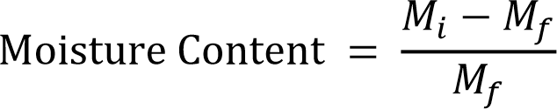

InitialWeight:364g FinalWeight:305g

Time:9:00

Tray9–IndirectSunDrying(DAY 1)
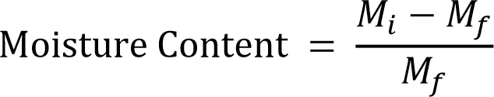

InitialWeight:451g FinalWeight:314g
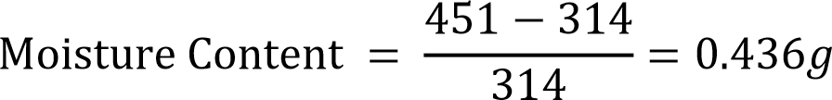
      - Time:9:00

      - Time: 10:00

Tray3-Greenhouse(Day1)
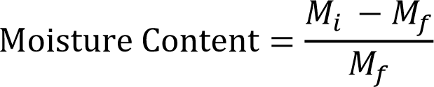

Initialweight=442g Finalweight=293g
      - Time:9:00
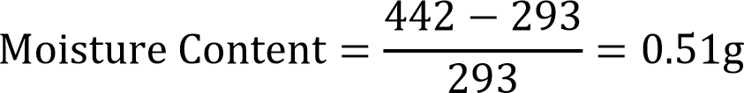
      - Time: 10:00
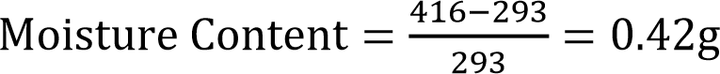

CalculationofDryingRate &(Wet%)

Tray2–OpenSunDrying(DAY 1)
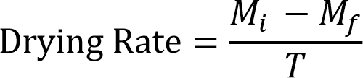

InitialWeight:364g FinalWeight:305g
      - Time:9:00

      - Time: 10:00

Tray9–IndirectDrying(DAY 1)
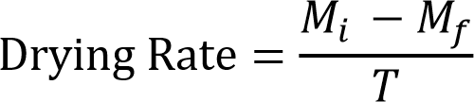

InitialWeight:451g FinalWeight:314g
      - Time:9:00

      - Time: 10:00

Tray3–GreenhouseDrying(DAY 1)
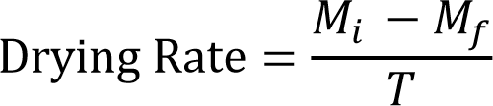

InitialWeight:442g FinalWeight:293g
      - Time:9:00

      - Time: 10:00

Calculationof Efficiency

Tray2–Indirect SolarDryer(DAY 1)
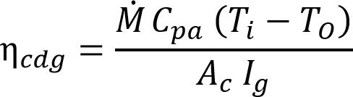

_{𝑝𝑎}∶𝑝𝑒𝑐𝑐𝑒𝑎𝑎𝑝𝑎𝑐𝑦

ℎ𝑒𝑒𝑝𝑎∶1.005//ᵒC

∶𝑎𝑎𝑝𝑒

∶𝑒𝑐𝑒𝑝𝑒𝑎𝑒

∶𝑒𝑛𝑒𝑝𝑒𝑎𝑒

∶𝑎𝑎𝑎𝑛

𝑐∶𝑒𝑎ℎ𝑒𝑐𝑒𝑐(𝑒𝑎𝑒)

ℎ𝑒𝑒_{𝑐}∶2(+ℎ+ℎ)=2(1.23×0.57+0.57×0.21+1.23×0.21)
= 2.16m²

- Time:9:00

- Time: 10:00

Tray2–GreenhouseDryer(DAY 1)
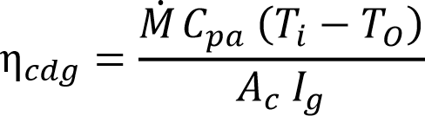

_{𝑝𝑎}∶𝑝𝑒𝑐𝑐𝑒𝑎𝑎𝑝𝑎𝑐𝑦

ℎ𝑒𝑒𝑝𝑎∶1.005//ᵒC

∶𝑎𝑎𝑝𝑒

∶𝑒𝑐𝑒𝑝𝑒𝑎𝑒

∶𝑒𝑛𝑒𝑝𝑒𝑎𝑒

∶𝑎𝑎𝑎𝑛

_{𝑐}∶𝑒𝑎ℎ𝑒𝑐𝑒𝑐(𝑒𝑎𝑞𝑎𝑒)

ℎ𝑒𝑒𝑐∶(×)=(1.49×1.02)=1.52²

- Time:9:00

- Time: 10:00

CHAPTERFOUR4.0 RESULTANDDISCUSSION
This study rigorously assessed the efficacy of various solar drying systems for dehydrating peppers, with the goal of identifying the most efficient method while elucidatingtheuniquebenefitsassociatedwitheachdryingtechniqueemployed.Overa

three-day period, an initial sample of 451g of pepper was reduced to 314g using an indirect solar dryer. In contrast, a greenhouse solar dryer effectively decreased a 442g sample of peppers to 293g, while open-air drying resulted in a reduction of 364g of peppers to 305g. Key parameters measured during these experiments included (a) solar radiation incident on the collector, (b) ambient temperature, (c) internal temperatures of the drying chambers for both the indirect and greenhouse solar dryers, (d) collector temperature in the indirect solar dryer, (e) ambient humidity levels, (f) moisture contentof the dried product, and overall drying rates, adhering to the international standards established by ASABE/ASAE (2007) for solar air collectors. Temperature measurements were conducted at multiple points within the collectors and chambers utilizing a K-type thermocouple multimeter, with the drying regimen proceeding daily from 8:00 AM to 4:00 PM.

CHAPTERFIVE5.0 CONCLUSION

This study was carried out to design, construct, and evaluate the comparativeperformance of three different drying methods which are open sun drying, an indirect solar dryer, and a greenhouse solar dryer for preserving pepper. The primary goal was to assess which of the systems provides the most efficient and effective drying conditionsin terms of moisture removal, temperature stability, and overall performance.
The experimental procedure involved drying pepper slices under each of the three systems, with hourly measurements taken for temperature, humidity, solar radiation, and sample weight across several days. The performance of each system was evaluated based on moisture content reduction, drying rate, and thermal efficiency.
From the data obtained, it was observed that the greenhouse solar dryer consistently recorded the highest internal temperature, followed closely by the indirect solar dryer, whiledirectsundrying(opensun)showedthelowestandmostfluctuatingtemperature

values. These temperature patterns had a direct impact on drying performance. The greenhouse dryer achieved the fastest moisture reduction, indicating a more stable and controlled drying environment. The indirect dryer also showed improved performance compared to open sun drying, particularly in maintaining hygiene and reducing contamination risks. In terms of drying efficiency, both the greenhouse and indirect systems outperformed the open sun method, demonstrating the advantage of using structured drying systems in minimizing spoilage, improving drying speed, andpreserving nutritional quality.
The findings from this project confirm that incorporating engineered solar dryers particularly the greenhouse and indirect type can significantly improve the drying of pepper, contributing to better post-harvest handling, reduced losses, and improvedproduct quality. The results encourage the adoption of such systems among local farmers and food processors, especially in rural areas where electricity is not readily available.

RECOMMENDATIONS

It is recommended that small- and medium-scale farmers adopt greenhouse or indirect solar drying systems, as these technologies offer improved drying efficiency and better hygiene standards for agricultural products.
Furthermore, governmental bodies and agricultural development agencies are encouraged to promote the adoption of solar drying technologies by offering subsidies, capacitybuilding programs, and awareness campaigns. These initiatives can play a vital role in reducing post-harvest losses and strengthening food security.
Finally, future research on drying systems should prioritize the development and evaluationofhybriddryingtechnologiesthatintegratesolarenergy withauxiliary heating sources. Such innovations would ensure consistent drying performance during periods of low solar intensity or nighttime operation.

REFERENCES

Adejumo, B. A., Fapetu, O. P., & Aladejana, J. A. (2023). Design and performance evaluation of a hybrid solar dryer for drying cassava grates. Asian Food Science Journal, 22(6), 77–87.
Affognon,H.,Mutungi,C.,Sanginga,P.,&Borgemeister,C.(2015).Unpacking postharvest losses in sub-Saharan Africa: A meta-analysis. World Development, 66, 49– 68.
Aigbede, M.,Saka, M.A., &Abiodun, D.(2025). Mathematical modelingof solar drying systems: A case study in Cotonou, Benin. Journal of Food Engineering and Research, 37(2), 112–124.
Akinola, A. O., Akinyele, T. A., & Odedairo, B. O. (2015). Evaluation of traditional sun drying and solar drying on the quality of pepper. Journal of Agricultural Technology, 11(4), 785–794.

Ajibola, O. O., Fapetu, O. P., & Afolayan, M. O. (2017). Design and performance evaluation of a solar dryer for agricultural products. Agricultural Engineering International: CIGR Journal, 19(2), 152–160.
Bala,B.K. (1997).Dryingand storageofcereal grains.SciencePublishers.

Bala, B. K., & Mondol, M. R. A. (2001). Experimental investigation on solar drying offish using solar tunnel dryer. Drying Technology, 19(2), 427–436.
Bala,B.K.,&Woods,J.L.(2001).Simulationoftheindirectnaturalconvectionsolar drying of rough rice. Solar Energy, 69(1), 89–98. https://doi.org/10.1016/S0038- 092X(00)00128-8
Balogun, M. A., Adeyanju, A., & Sanni, L. O. (2017). Performance evaluation of a doublecompartment solar dryer for tomato preservation. African Journal of Agricultural Engineering, 10(4), 158–166.
Bukola, O. B., & Ayoola, A. A. (2008). Performance evaluation of a mixed-mode solar dryer. AU Journal of Technology, 11(4), 225–231.
Chouikhi, T., & Amer, B. (2023). Experimental and numerical analysis of a PV/T-based solar dryer for tomato slices. Renewable Energy Technologies Journal, 45(3), 203–215.
Dash, R., Castillo, C., & Amparo, J. (2025). Comparative analysis of greenhouse solar drying and open sun drying of corn in Bukidnon. International Journal of Sustainable Agriculture, 29(1), 56–70.
Deepak,B.,&Behura,A.K.(2025).Thermodynamicandenvironmentalanalysisofa solar dryer with thermal storage. Scientific Reports, 15, 91971. https://www.nature.com/articles/s41598-025-91971-4

Elwakeel, E. E., Mohamed, S. H., & Soliman, A. (2024). Performance assessment of a tracking hybrid solar dryer powered by photovoltaic cells. Renewable Energy Systems, 45(3), 210–223.
Elwakeel, E. E., Shalaby, A., & Omar, M. (2024). Energy and environmental analysis ofa tracking indirect solar dryer for tomato slices. Solar Energy Applications, 36(1), 77–90.
El-Mesery, H. S., & Mao, L. (2023). Drying behavior of tomato slices under infrared radiation: Effects of air velocity and radiation intensity. Journal of Thermal Science and Technology, 28(2), 98–109.
El-Sebaii, A. A., & Shalaby, S. M. (2012). Solar drying of agricultural products: A review.
RenewableandSustainableEnergy Reviews,16(1), 37–43.
Esper, A., & Muhlbauer, W. (1996). Solar drying: An effective means of food preservation. Renewable Energy, 7(2), 119–127.
Esper, A., & Mühlbauer, W. (1998). Solar drying—An effective means of food preservation. Renewable Energy, 15(1-4), 95–100.
Mujaffar,S.,&Lalla,K. (2020).Evaluation ofthe drying behavior and qualityof cassava chips using a natural convection dryer. Journal of Food Process Engineering, 43(10), e13429. https://doi.org/10.1111/jfpe.13429
Njue, J., & Wawire, A. (2021). Design and performance evaluation of a solar dryer for dryingcassavachipsinKenya.AfricanJournalofAgricultural Research,16(4),275–284.
Nwakuba, N. R., Ugwuishiwu, B. O., Ohagwu, C. J., & Oraku, N. J. (2020). Simulation and optimization of drying kinetics of pepper in a hybrid solar dryer. Journal of Food Process Engineering, 43(6), e13357.

Nwakuba, S. U. N., & Anyaoha, K. (2020). Optimization of convective air drying in a hybrid PV/T solar dryer using response surface methodology. Turkish Journal of Agricultural Engineering Research, 1(1), 111–130.
Obasi, K. E., Nwoko, C. O., & Chidiebere, I. J. (2025). Impact of solar and oven drying on the nutritional and microbial quality of okra and tomatoes. Nigerian Journal of Food Science, 42(1), 99–115.
Ogundana, A. K., Usman, I. A., & Danladi, S. A. (2022). Design and performance evaluation of a solar dryer for drying agricultural products in Kainji, Nigeria. Nigerian Journal of Technology, 41(5), 789–795.
Okeyode, I. C., & Okuyelu, A. (2023). Development of a multifunctional electric-solardryer for cassava and red pepper. International Journal of Sustainable Energy, 42(1), 45– 56.
Sharma, A., Chen, C. R., & Lan, N. V. (2009). Solar-energy drying systems: A review.Renewable and Sustainable Energy Reviews, 13(6–7), 1185–1210.
Silayo, V. K., Mpagalile, J. J., & Ishengoma, R. C. (2015). Performance of different drying platforms for cassava chips. Tanzania Journal of Agricultural Sciences, 14(1), 33– 42.
Singh, A. K., & Gaur, M. K. (2021). Design and techno-economic evaluation of a hybrid active greenhouse dryer for tomato. Environmental Science and Pollution Research, 28, 13210–13226.
Suherman, S., Kurniawan, A., & Prasetyo, D. (2018). Evaluation of solar tray dryer performance for cassava starch. International Journal of Food Science, 2018, 1–6. https://doi.org/10.1155/2018/3058306

Tiwari, G. N., & Jain, D. (2001). Thermal modeling of a greenhouse dryer for drying agricultural crops. Solar Energy, 71(2), 155–167.
Tiwari, G. N., Kumar, S., & Prakash, O. (2016). Solar drying technology: Concept,design,testing,modeling,economics,andenvironment.SpringerInternational Publishing.
Tripathy, P. P., & Kumar, S. (2009). Performance evaluation of a solar biomass hybrid dryerforturmeric(Curcumalonga)drying.JournalofRenewableandSustainableEnergy, 1(4), 043109.
Vitouley, D. R., Houngan, A., & Adjovi, E. (2025). Development and performance analysisofaforcedconvectiondryerforAkikontomatoesinBenin.WestAfricanJournal of Agricultural Innovation, 31(2), 211–226.

