A PROJECT REPORT
ON
PROPOSED POULTRY FARM FOR ILESHA WEST LOCAL GOVERNMENT, OSUN STATE
BY
OGUNDARE AYOMIPOSI SAMUEL
ND/23/ARC/PT/0003

SUBMITTED TO THE DEPARTMENT OF ARCHITECTURAL TECHNOLOGY, INSTITUTE OF ENVIRONMENTAL STUDIES KWARA STATE POLYTECHNIC, ILORIN

IN PARTIAL FULFILMENT OF THE REQUIREMENTS
FOR THE AWARD OF NATIONAL DIPLOMA IN
ARCHITECTURAL TECHNOLOGY
JULY 2025
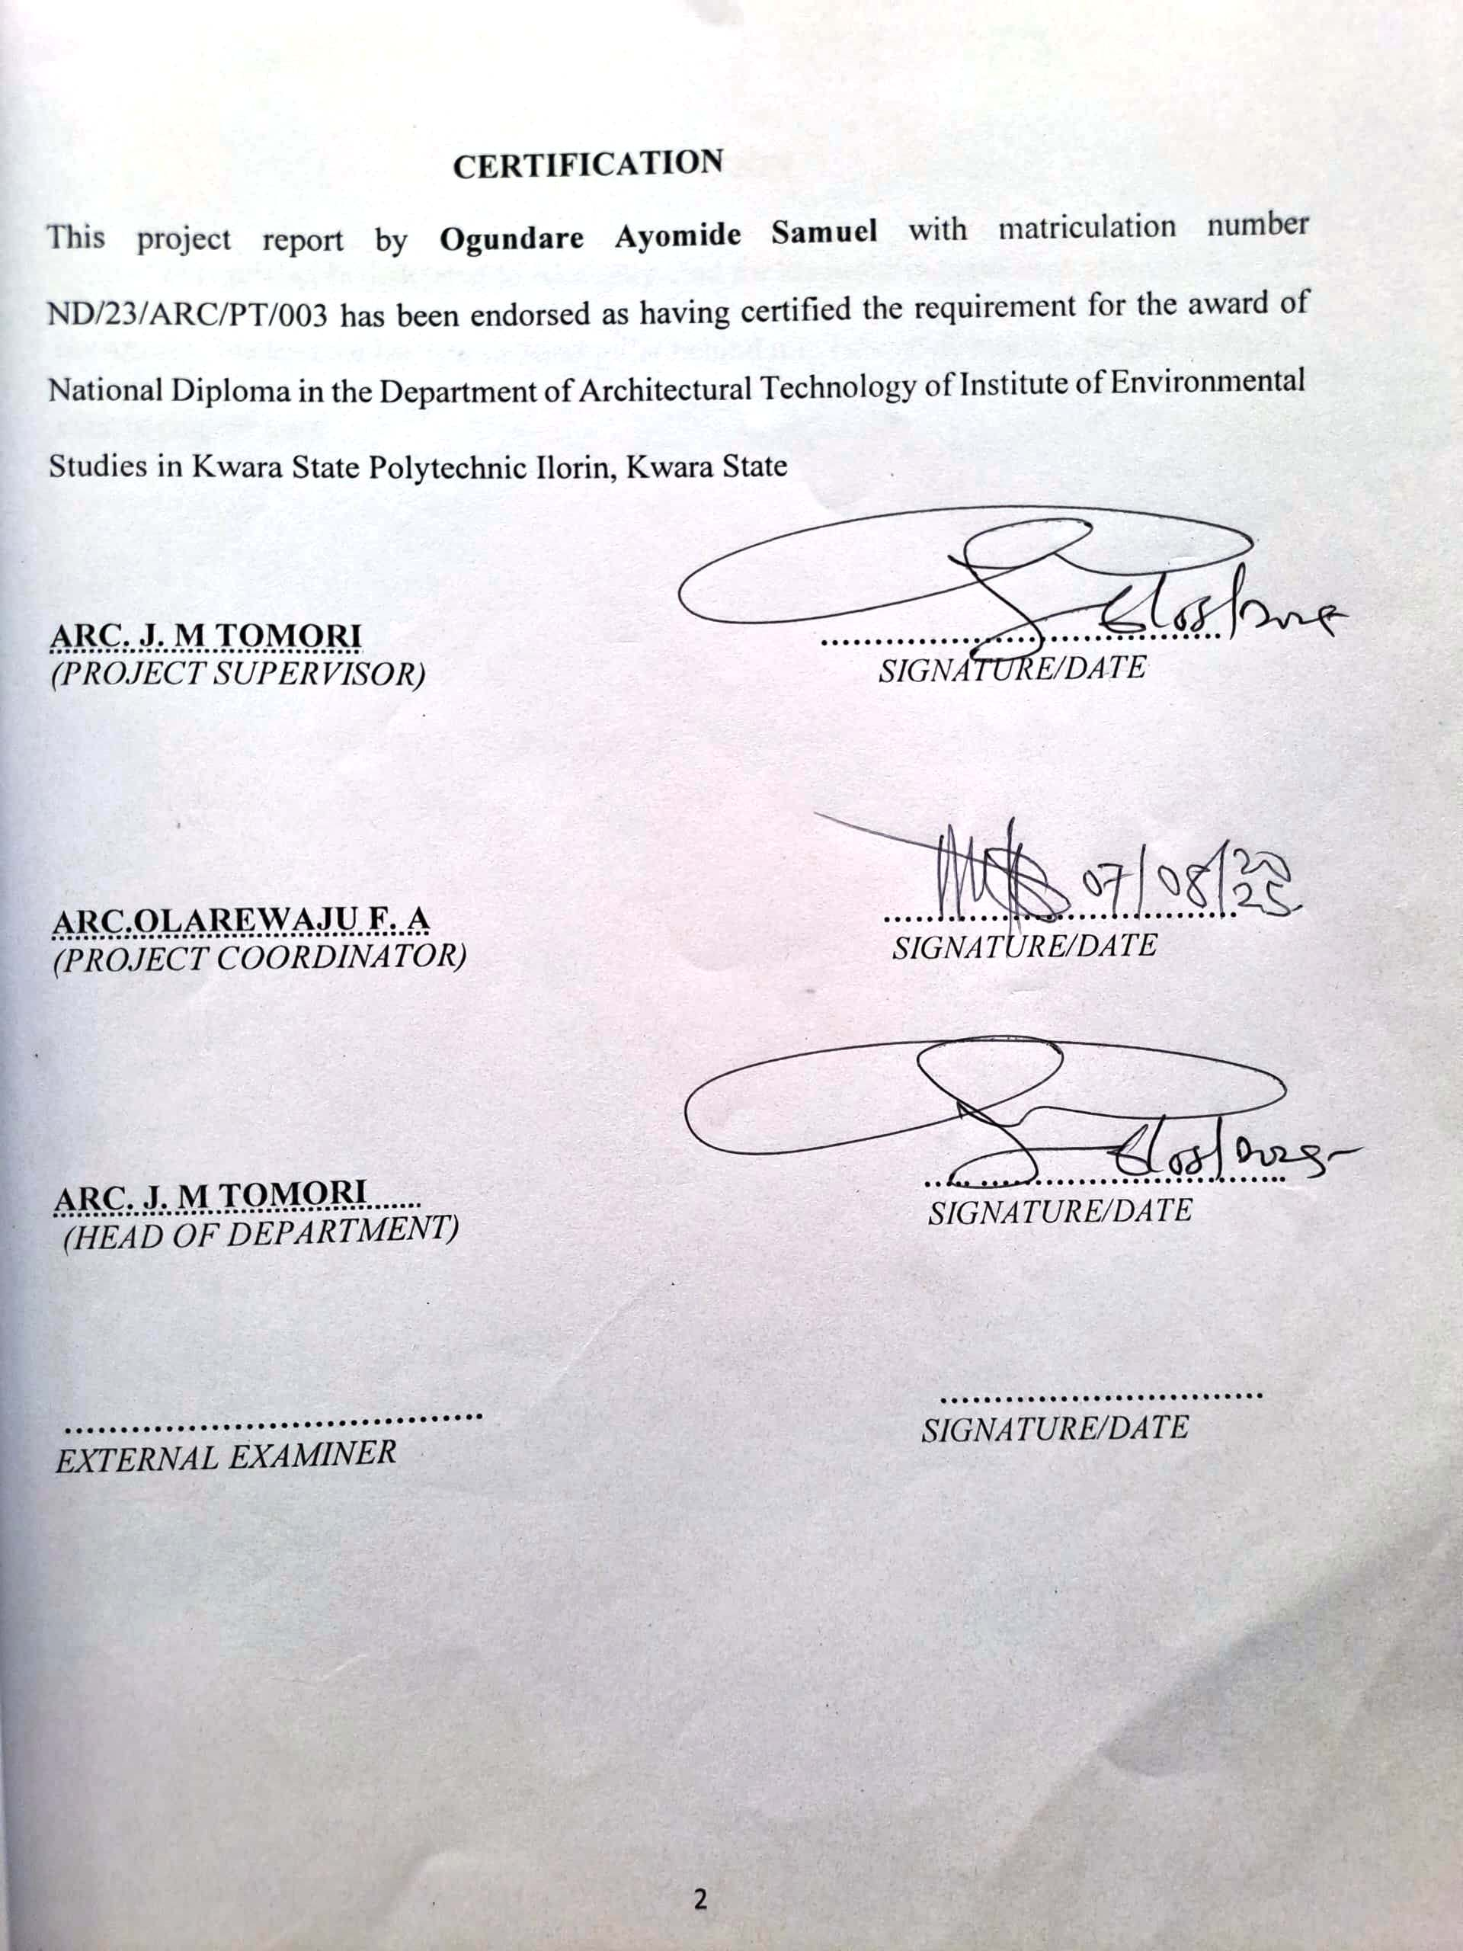

DECLARATION
I, Ogindare Samuel Ayomipo, hereby declare that this project/dissertation is the result of my independent research work. It has not been previously submitted for the award of any diploma or degree in any polytechnic or institution of higher learning. All ideas, observations, comments, and suggestions expressed herein are my own, except where due acknowledgment has been given in line with standard academic conventions.

OGUNDARE AYOMIPOSI SAMUEL
ND/23/ARC/PT/003

..........................................
Signature & Date

DEDICATION
This project is dedicated to Almighty God for his unfailing guidance and mercy toward me, because he has been a solid pillar behind me. I also dedicate this project to my ever-loving parents.

ACKNOWLEDGEMENT
I am filled with immense gratitude and deep appreciation for the invaluable support and exemplary character of Mr. and Mrs. Ogundare, whose contributions have been truly remarkable. I am also deeply thankful to my parents for their unwavering moral and financial support.
I extend my heartfelt thanks to my Project Supervisor, Arc. Tomori J. M., who, despite his busy schedule, took the time to review my manuscript and provide invaluable suggestions and corrections, ensuring the successful completion of this project.
A very big thank you to the entire management and staff of the Architectural Department at Kwara State Polytechnic, Ilorin, for their continuous support. They have been an exceptional nurturing ground for young, aspiring architects of this generation and those to come.
I am also grateful to my friends who stood by me in times of need, providing moral and emotional support. Your collective efforts were instrumental in achieving this success. May God bless you all.
Lastly, I am deeply honoured to acknowledge my siblings for their relentless support and efforts in ensuring the progress and completion of this project.

TABLE OF CONTENTS
TITLE PAGE i
DECLARATION ii
CERTIFICATION iii
DEDICATION iv
ACKNOWLEDGEMENTS v
TABLE OF CONTENTS vi
LIST OF TABLES vii
LIST OF FIGURES viii
LIST OF PLATES ix
LIST OF APPENDICES x
ABSTRACT xi
CHAPTER ONE
- INTRODUCTION 1
1.1 BACKGROUND INFORMATION 1
1.2 PROBLEM STATEMENT 2
1.3 AIM AND OBJECTIVES 2
1.3.1 AIM 2
1.3.2 OBJECTIVES 2
1.4 SCOPE OF THE PROJECT 3
1.5 LIMITATION 3
1.6RESEARCH METHODOLOGY 3

CHAPTER TWO
2.0 LITERATURE REVIEW 5
2.1 INTRODUCTION 5
2.2 FUNCTIONALITY AND SPACE UTILIZATION 5
2.3 SECURITY CONSIDERATIONS 5
2.4 COMMUNITY INTEGRATION AND ACCESSIBILITY 6
2.5 SUSTAINABILITY AND ENERGY EFFICIENCY 6
2.6 TECHNOLOGICAL INTEGRATION 6
2.7 CONCLUSION 7
CHAPTER THREE
3.0 CASE STUDIES 8
3.1 INTRODUCTION 8
3.1.1 IMPORTANCE OF CASE STUDY IN ARCHITECTURAL DESIGN 8
3.2 CASE STUDY ONE 8
3.3 CASE STUDY TWO 12
3.4 CASE STUDY THREE 15
CHAPTER FOUR
4.0 STUDY AREA AND DESIGN CRITERIA 20
4.1 INTRODUCTION TO OSUN STATE 20
4.1.1 ABOUT ILESHA 20
4.1.2 SITE DESCRIPTION 21
4.2 SITE ANALYSIS 21
4.2.1 ACCESSIBILITY 21
4.2.2 SERVICES 21
4.2.3 SITE CLIMATIC CONDITIONS 21
4.3 SITE SELECTION CRITERIA 22
4.4 DESIGN CRITERIA 22
4.4.1 THE SITE 22
4.5 DESIGN BRIEF 22
4.6 ANALYSIS OF THE BRIEF 22
2.60 SPACE REQUIREMENTS 23
4.1 PUBLIC SPACES 23
4.2 STAFF AREAS 23
4.3 SUPPORT SPACES 23
4.4 EXTERNAL SPACES 23
4.7 SPACE ALLOCATION/SCHEDULE OF ACCOMMODATION 24
4.8 FUNCTIONAL RELATIONSHIP 24
4.9 CONCEPTUAL DEVELOPMENT 24
4.10 DESIGN ANALYSIS 24
4.10.1 GENERAL SERVICES 24
4.10.2 BUILDING SERVICES 24
CHAPTER FIVE
5.0 PROJECT APPRAISAL 26
5.1 CONSTRUCTION METHOD AND MATERIAL 26
5.1.1 SUBSTRUCTURE 26
5.1.2 SUPERSTRUCTURE 26
5.1.3 FLOORS 26
5.1.4 WALLS 26
5.1.5 EXPANSION JOINTS 27
5.1.6 ROOFS 27
5.1.7 CEILING 27
5.1.8 DOORS 27
5.1.9 WINDOWS 27
5.1.10 FINISHES 27
5.2 SERVICES 27
5.2.1 ACOUSTIC AND LIGHTING PROVISIONS 28
5.3 MECHANICAL SERVICES 28
5.4 ELECTRICAL SERVICES 28
5.5 PLUMBING SERVICES 28
5.6 FIRE PRECAUTION 29
5.7 EXTERNAL WORKS 29
5.8 BUILDING REQUIREMENTS 29
5.9 STABILITY 29
5.10 MAINTENANCE CULTURE 30
REFERENCES 31

LIST OF PLATES
PLATE 3.1: Picture the back view of case study 1………………………………………......14
PLATE 3.2: Picture showing the front view of case study 1 ………………………………...14
PLATE 3.3: Picture showing the rear view of case study 2………… …………………..…..18
PLATE 3.4: Picture showing the left view of case study 2 ………………………………….18
PLATE 3.5: Picture showing the rear view of case study 3………… …………………..…..22
PLATE 3.6: Picture showing the left view of case study 3 ………………………………….22

LIST OF FIGURES
FIGURE 3.1: Site Plan of Case Study one 14
FIGURE 3.2: Floor Plan of case study one 14
FIGURE 3.3: Location Plan of Case Study two 15
FIGURE 3.4: Site Plan of Case Study two 16
FIGURE 3.5: Floor Plan of Case Study two 16
FIGURE 3.6: Poultry Farm Layout Plan of case study three 19
FIGURE 3.7: Poultry Farm Floor Plan of case study three 19
FIGURE 3.8: Location Plan of case study four 22
FIGURE 3.9: Poultry Farm Floor Plan of case study Four 22

ABSTRACT
This study explores the architectural design of modern poultry facilities, with a focus on improving production efficiency, animal welfare, environmental sustainability, and operational functionality. Poultry farming plays a vital role in food security and rural economic empowerment, especially in developing regions where the demand for poultry products is rapidly increasing. Therefore, a well-designed poultry structure is essential not only for the health and productivity of the birds but also for the efficiency and sustainability of the farming operation.The research investigates existing poultry farm structures, identifying prevalent challenges such as poor ventilation, inadequate lighting, improper waste management, and lack of biosecurity measures. Surveys and interviews were conducted with local poultry farmers, veterinarians, and agricultural experts to understand the practical needs of both birds and workers. Based on this analysis, the study proposes a set of architectural design guidelines that prioritize airflow, temperature regulation, sanitation, accessibility, and ease of maintenance.A conceptual poultry farm design is presented, integrating functional zoning, biosecurity protocols, sustainable material selection, and efficient spatial planning. The design also incorporates renewable energy options and water recycling systems, ensuring long-term operational viability. By addressing current structural inadequacies, this study aims to provide a comprehensive architectural framework that enhances productivity, ensures animal welfare, and promotes sustainable poultry farming practices in Ilorin, Kwara State, and similar agro-ecological zones
CHAPTER ONE
1.0 INTRODUCTION
1.1 BACKGROUND INFORMATION
Poultry farming has emerged as a significant agricultural activity contributing to food production, nutrition, employment, and income generation across Nigeria. As the population continues to grow, so does the demand for poultry products such as eggs and chicken meat. This has necessitated the development of modern, efficient, and hygienic poultry facilities to support increased production and improve livestock management practices.
Traditionally, many poultry farms in Nigeria operate with improvised or poorly planned structures, which often result in issues such as disease outbreaks, low productivity, high mortality rates, and unsanitary conditions. These problems are largely due to a lack of architectural planning that addresses essential elements such as ventilation, insulation, lighting, waste disposal, and biosecurity.
Architectural design plays a crucial role in enhancing poultry production by providing suitable environments that promote animal health, reduce operational costs, and optimize labor efficiency. A well-designed poultry structure supports the welfare of the birds through climate-responsive elements like cross-ventilation, thermal insulation, and natural lighting. Moreover, the integration of sustainable features such as solar panels, rainwater harvesting, and proper drainage systems ensures environmental responsibility.
In modern poultry farm design, attention must be paid to space allocation for different activities such as brooding, feeding, egg collection, waste management, and staff operations. Each component of the farm must be strategically located to promote biosecurity, reduce the risk of contamination, and ensure a smooth workflow.
This study seeks to address these challenges by providing a comprehensive architectural approach to poultry farm design, tailored to the climatic and social context of Ilorin, Kwara State, Nigeria.
1.2 PROBLEM STATEMENT
The rapid growth of poultry farming in Nigeria has not been matched by a corresponding advancement in the architectural planning of poultry facilities. Many poultry farms are built without regard to critical factors such as disease control, ventilation, waste management, and access circulation. This often leads to poor bird health, inefficient farm operations, and increased economic losses.
Additionally, the absence of standardized design guidelines results in haphazard construction that fails to meet both the practical and environmental needs of modern poultry farming. There is a clear need for an innovative architectural framework that addresses these issues by integrating biosecurity, functionality, sustainability, and productivity into the design process.
1.3 AIM AND OBJECTIVES
1.3.1 Aim
The aim of this study is to develop an architectural design framework for a modern poultry farm that enhances bird welfare, operational efficiency, and environmental sustainability.
1.3.2 Objectives
- To propose a conceptual architectural design for a modern poultry farm.
- To identify and integrate essential design elements such as ventilation, lighting, and waste management.
- To develop spatial planning and zoning principles for improved workflow and biosecurity.
- To incorporate sustainable practices such as water harvesting, solar energy use, and eco-friendly materials.
- To assess the suitability of proposed design strategies within the climatic context of Ilorin, Kwara State.
1.4 SCOPE OF THE PROJECT
The proposed poultry farm design will include the following components:
- Entrance and security post
- Brooding house
- Grower/Layer pens
- Feed storage and preparation area
- Egg collection and sorting area
- Veterinary unit and isolation room
- Staff offices and resting area
- Manure disposal system and compost zone
- Water storage and solar-powered utility area
1.5 LIMITATIONS
This study is limited to the design of a poultry facility located in Ilorin, Kwara State, and does not cover other aspects of poultry production such as feed formulation or poultry marketing. Other limitations encountered during the course of the research include:
- Limited access to proprietary farm layouts for security and confidentiality reasons.
- Reluctance of some poultry operators to disclose detailed operational information.
- Financial constraints which limited site visits to only a few selected farms.

1.6 RESEARCH METHODOLOGY
To achieve a comprehensive and context-specific poultry farm design, the following research methods were employed:
- Case Studies: Analysis of existing poultry farm designs within and outside Kwara State.
- Photography: Visual documentation of farm layouts and environmental conditions.
- Internet Review: Review of international standards and modern design trends in poultry architecture.
- Oral Interviews: Discussions with poultry farmers, veterinary professionals, and farm managers.
- Review of Published Materials: Consultation of academic journals, textbooks, and agricultural extension publications.

CHAPTER TWO
2.0 LITERATURE REVIEW
2.1 INTRODUCTION
Poultry farming is one of the most significant sectors in agriculture, contributing substantially to food security, employment, and rural development. The architectural design of poultry farms plays a critical role in optimizing productivity, animal welfare, biosecurity, and environmental sustainability. An efficient poultry facility must address specific needs such as ventilation, temperature regulation, waste management, feeding systems, and space management. This literature review examines the various architectural considerations involved in designing modern poultry farms, drawing from academic research, field observations, and best industry practices. The chapter explores key themes such as spatial planning, environmental control, biosecurity measures, sustainability, and technological integration.
2.2 FUNCTIONALITY AND SPACE UTILIZATION
Functionality is a foundational element in the architectural design of poultry farms. The layout must support a smooth operational flow that minimizes labour and maximizes efficiency. According to Adekunle & Oloruntoba (2019), poultry houses should be zoned to separate clean and dirty areas, including feed storage, brooding units, grow-out areas, and waste management zones. Proper space utilization ensures optimal bird stocking density, which is vital for the health and growth of poultry. The National Animal Production Research Institute (NAPRI) recommends that layer birds be allocated a minimum of 0.14 m² per bird, while broilers require about 0.06–0.09 m² per bird.
A flexible and modular design approach is also advisable, enabling the expansion or reconfiguration of the farm based on production needs or changes in bird type. Walkways, feed delivery paths, and vehicle access routes should be clearly defined to ensure easy access for farm workers and logistics operations.
2.3 ENVIRONMENTAL CONTROL AND VENTILATION
Maintaining a stable internal environment is essential for the health and productivity of poultry. Temperature, humidity, and air quality must be regulated to meet the physiological needs of the birds. According to Olawuyi et al. (2020), improper ventilation can lead to ammonia buildup, respiratory issues, and poor feed conversion. Architectural features such as ridge ventilators, sidewall curtains, exhaust fans, and open-sided designs are employed to facilitate natural and mechanical ventilation.
The orientation of poultry buildings should take prevailing wind directions and solar angles into account. A north-south orientation, for instance, reduces direct solar radiation and helps in regulating indoor temperatures. Roof overhangs and insulation materials like polyurethane panels also contribute to maintaining optimal thermal conditions inside the structure.
2.4 BIOSECURITY AND SANITATION
Biosecurity is a critical aspect of poultry farm design, aimed at preventing the introduction and spread of diseases. Architectural planning should incorporate designated entry and exit points, footbaths, changing rooms, and disinfection zones. According to FAO guidelines (2017), physical barriers such as perimeter fences and buffer zones between production units significantly reduce disease transmission risks.
Buildings should also be designed for easy cleaning and disinfection, using non-porous materials like concrete for floors and washable panels for walls. The internal layout must facilitate efficient waste removal and litter management. Proper drainage systems are essential to avoid water pooling and reduce pathogen proliferation.
2.5 SUSTAINABILITY AND ENERGY EFFICIENCY
Sustainable design practices are gaining traction in poultry farm architecture due to rising environmental concerns and energy costs. Incorporating renewable energy systems, such as solar panels for lighting and heating, reduces operational expenses and dependence on fossil fuels. Rainwater harvesting systems can supply water for cleaning and irrigation of surrounding vegetation.
Insulated roofing and walls help reduce the energy demand for cooling and heating. The use of local and recycled materials also supports environmental sustainability and reduces construction costs. According to the World Poultry Science Association (2020), environmentally conscious designs not only minimize the carbon footprint but also improve the overall economic viability of poultry operations.
2.6 TECHNOLOGICAL INTEGRATION
Modern poultry farms rely heavily on automation and digital monitoring systems to enhance productivity and animal welfare. The architectural layout must accommodate technologies such as automatic feeders, waterers, climate control systems, and real-time data monitoring sensors. These systems require infrastructure support including proper cabling, control rooms, and adequate ventilation for electrical equipment.
Integrating technology into building design enables precision farming, which allows farmers to monitor parameters like temperature, humidity, feed intake, and bird weight. This results in better decision-making and minimizes wastage of resources. Additionally, CCTV cameras and access control systems enhance security and farm oversight.
2.7 COMMUNITY AND ECONOMIC INTEGRATION
Poultry farms are often located in rural or peri-urban settings and can significantly impact their local communities. Designing with consideration for nearby settlements, road access, and water sources fosters positive relations and supports community integration. Projects that provide employment opportunities and contribute to local food systems are more likely to gain community support and operate smoothly.
Sound architectural design also considers the aesthetics of the farm to improve its image and acceptance within the community. Landscaping, fencing, and proper signage contribute to a professional and organized appearance.
2.8 CONCLUSION
The architectural design of poultry farms is a multidisciplinary challenge that involves balancing biological, environmental, technological, and economic factors. This literature review highlights that functional planning, environmental control, biosecurity, sustainability, and technological integration are essential components of effective poultry architecture. By understanding and implementing these principles, architects and poultry farm developers can create efficient, resilient, and humane farming environments that support both animal welfare and economic success.

CHAPTER THREE
CASE STUDIES
3.0 INTRODUCTION
In architectural design, a case study serves as a detailed examination of existing projects or buildings to extract practical insights and best practices. For poultry farm design, case studies provide an invaluable means of understanding how real-world poultry facilities are planned, constructed, and operated. They offer designers a clearer view of how architectural elements can be tailored to optimize animal welfare, biosecurity, productivity, and sustainability. Through case studies, lessons are drawn from the successes and shortcomings of actual poultry projects to inform new designs that are both efficient and context-sensitive.
3.1 IMPORTANCE OF CASE STUDY IN POULTRY FARM ARCHITECTURE
Case studies in poultry farm architecture serve multiple purposes:
- Learning from Existing Designs: Case studies reveal the design logic, structural systems, and functional layouts that contribute to the success of poultry facilities.
- Contextual Understanding: They help architects understand the environmental, cultural, and regulatory context of farm locations.
- Innovation and Adaptation: By studying various case examples, architects can discover unique solutions adapted to different climatic and economic conditions.
- Evidence-Based Planning: Real-life data from case studies improve evidence-based decision-making during design development.
- Benchmarking: Case studies provide benchmarks for efficiency, bird welfare, and environmental performance.

3.2 CASE STUDY ONE
LOCATION: University of Ilorin Teaching and Research Poultry Farm, Ilorin, Kwara State
Brief History and Background
The University of Ilorin Teaching and Research Poultry Farm was established as a practical training ground for students and as a resource for agricultural research and extension services. With a focus on sustainable poultry production, the farm supports broiler and layer production, integrating research, teaching, and commercial objectives.
The facility serves as a model for academic and commercial poultry farming, aiming to demonstrate best practices in biosecurity, space planning, ventilation, and sustainable energy usage.
Facilities Available
- Layer and Broiler Production Houses
- Brooding Section for Chicks
- Feed Mill and Feed Storage Areas
- Vaccination and Medication Units
- Egg Collection and Sorting Room
- Waste Management System (Manure Drying Slabs and Composting Unit)
- Administrative Block and Staff Lounge
- Quarantine Unit

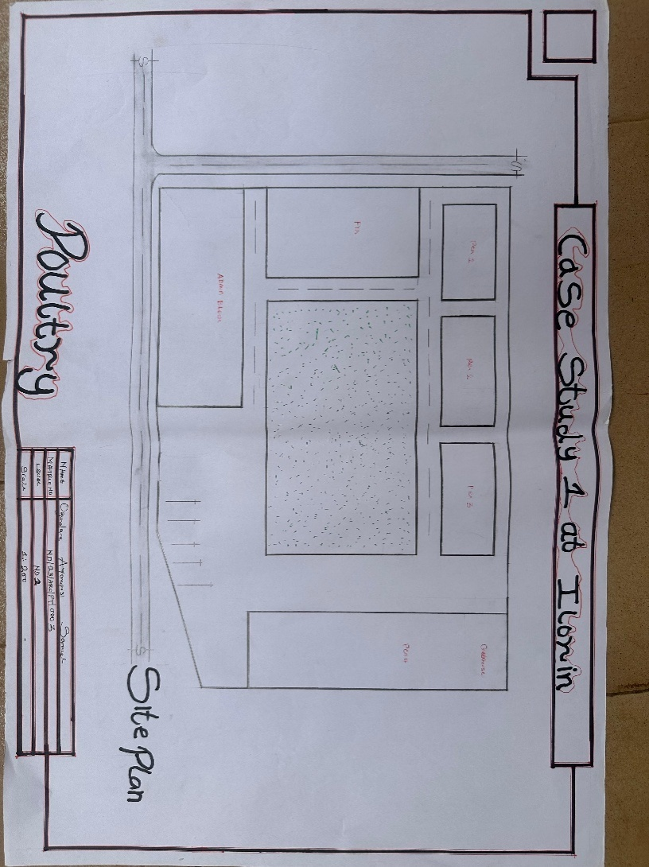
FIGURE 3.1: Site Plan of Case Study one
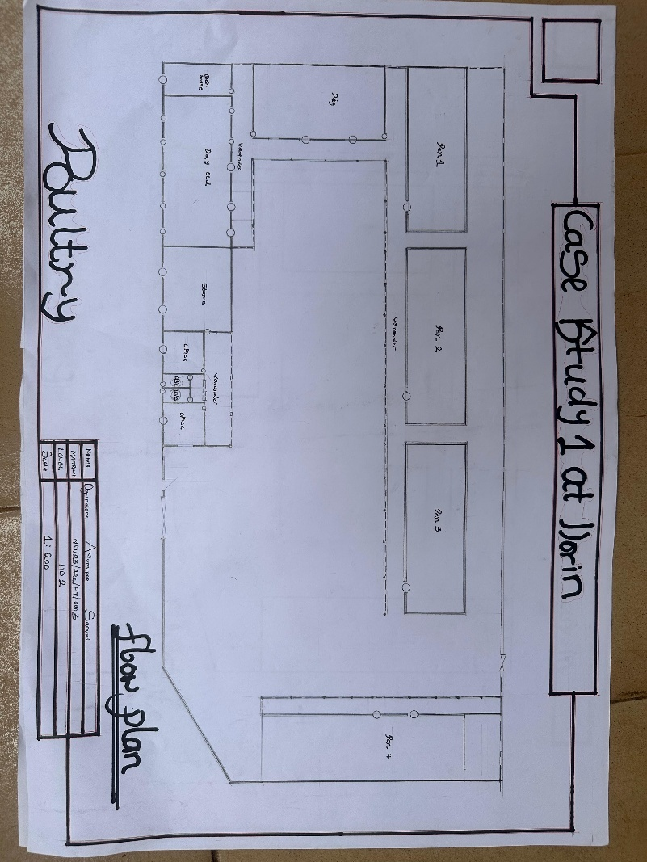
FIGURE 3.2: Floor Plan of case study one

PLATE 3.1: Exterior View of the Poultry Units
PLATE 3.2: Interior View of the Layer Unit

Merits
- Well-ventilated poultry houses
- Functional zoning for clean and dirty operations
- Energy-saving design with natural lighting
- Adequate staff support areas
- Efficient feed distribution systems
Demerits
- Limited expansion space
- Manual waste handling in some areas
- Inadequate automation in egg collection
3.3 CASE STUDY TWO
LOCATION: Agric Farm Ventures Poultry, Ilesa, Osun State
Brief History and Background
Agric Farm Ventures is a medium-scale commercial poultry operation located in a semi-urban part of Osun State. The farm was established to meet the growing demand for eggs and chicken meat in the region while employing best practices in poultry architecture and management.
The facility uses deep litter systems and battery cages, employing both traditional and semi-automated management methods. It serves as an example of how small to medium farms can be economically viable with proper planning and investment.
Facilities Available
- Battery Cage Houses for Layers
- Deep Litter House for Broilers
- Feed Store and Mixing Room
- Water Reservoir and Distribution Tank
- Generator House and Backup Solar System
- Egg Collection Unit and Cold Room
- Incinerator for Dead Birds and Wastes
- Security Gate and Staff Quarters
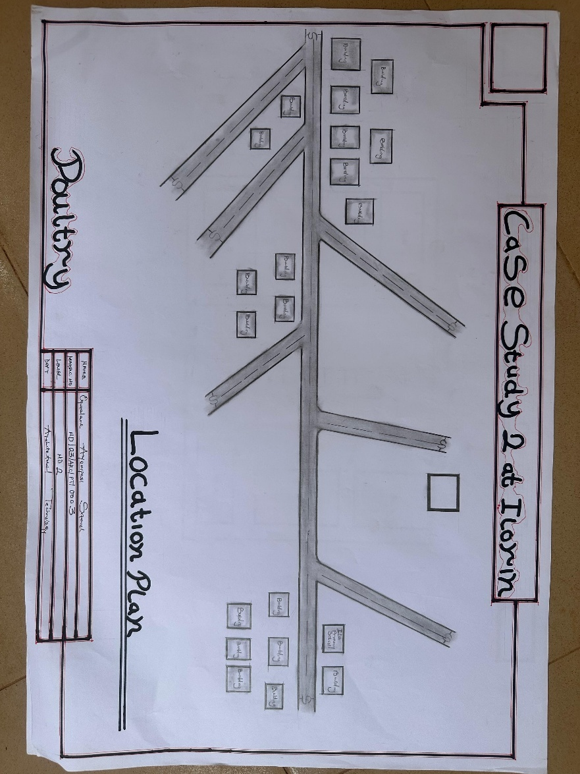
FIGURE 3.3: Location Plan of Case Study two

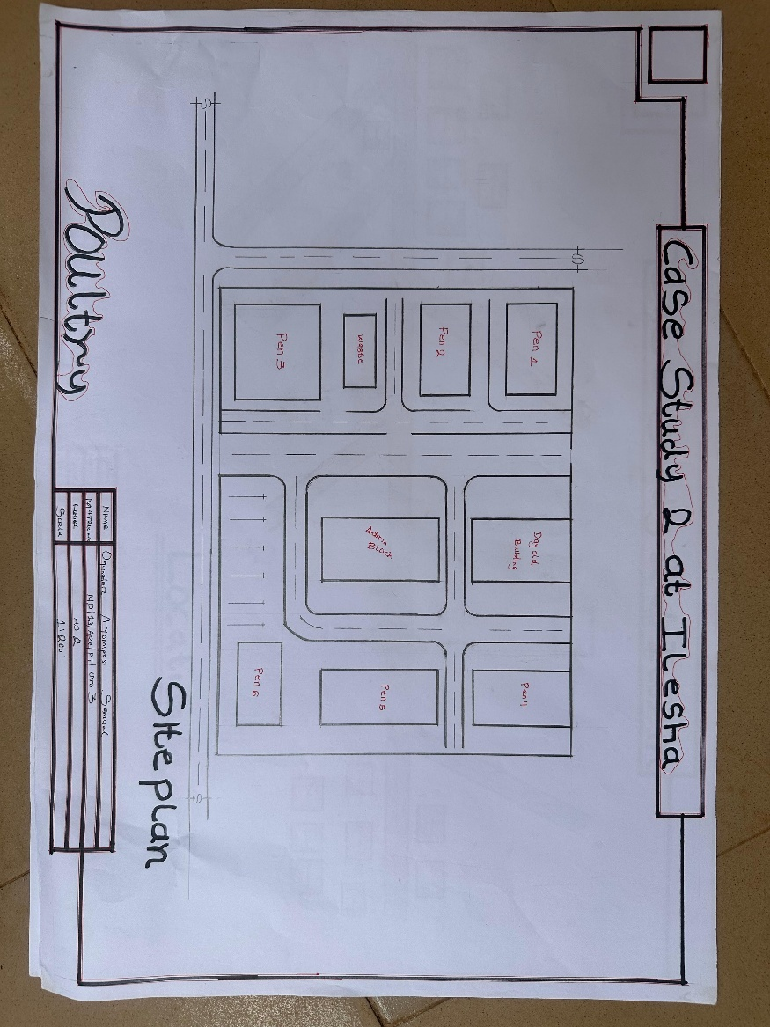
FIGURE 3.4: Site Plan of Case Study two
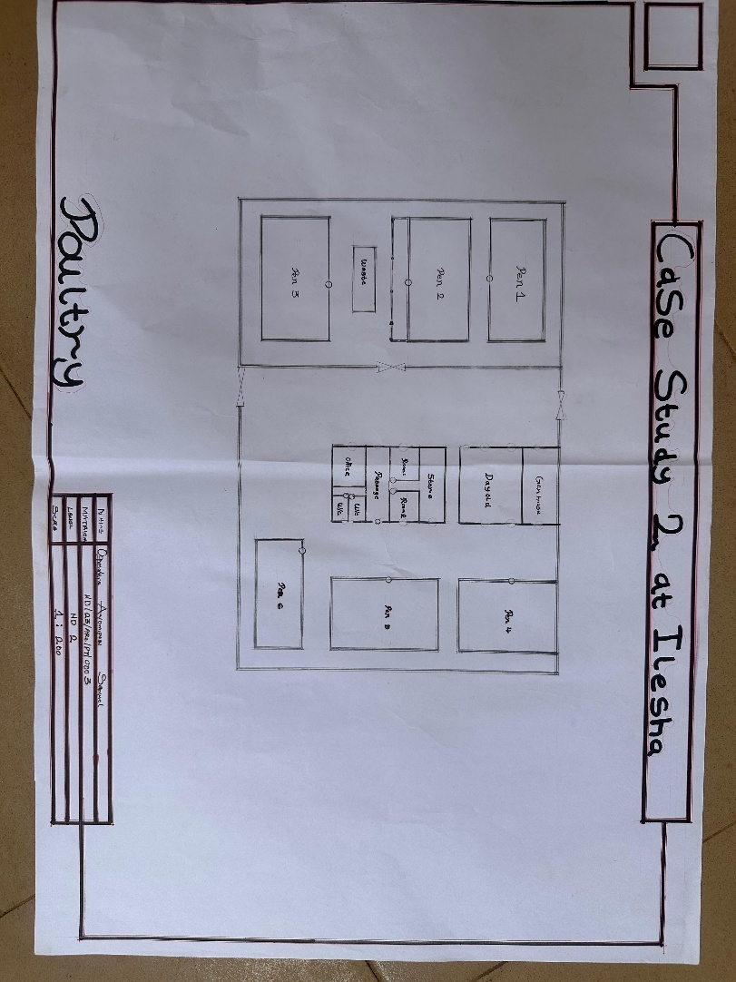
FIGURE 3.5: Floor Plan of Case Study two
PLATE 3.4: Exterior View of Battery Cage Facility
PLATE 3.5: Broiler Pen and Feed Mill Area

Merits
- Semi-automated feed and water systems
- Rainwater harvesting integrated
- Adequate space for vehicle movement and bird loading
- Energy backup using solar panels
Demerits
- Biosecurity zoning not clearly demarcated
- Odor management needs improvement
- Inadequate waste recycling system
3.4 CASE STUDY THREE
LOCATION: Imo Hill Farm Ilesha
Brief History and Background
Imo Hill Farm The farm is known for its strong emphasis on biosecurity, sustainability, and the use of local construction materials. It operates both brooding and grow-out systems and has a growing presence in poultry training and extension services.
Facilities Available
- Chick Brooding Room
- Grow-out House for Broilers
- Battery Cage for Layers
- Veterinary Room
- Manure Collection and Compost Pit
- Egg Sorting and Packing Unit
- Staff Restrooms and Changing Area
- Security Office and Perimeter Fence
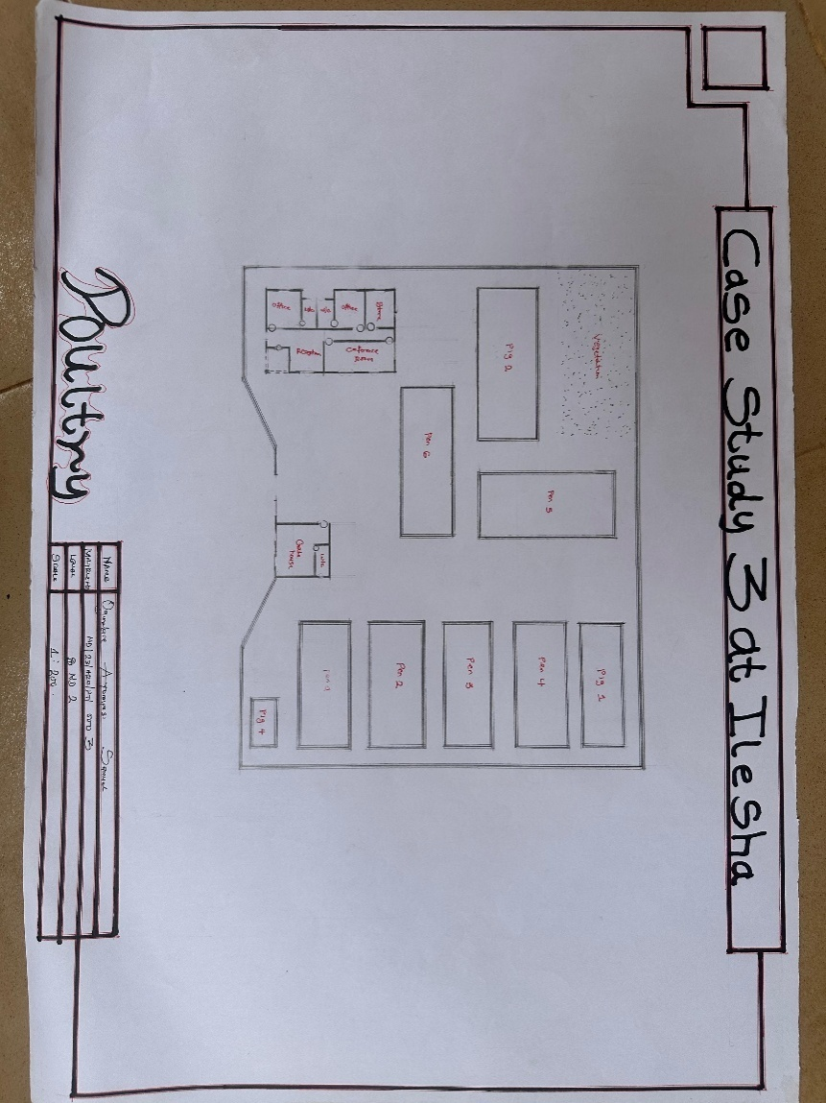
FIGURE 3.6: Poultry Farm Layout Plan of case study three
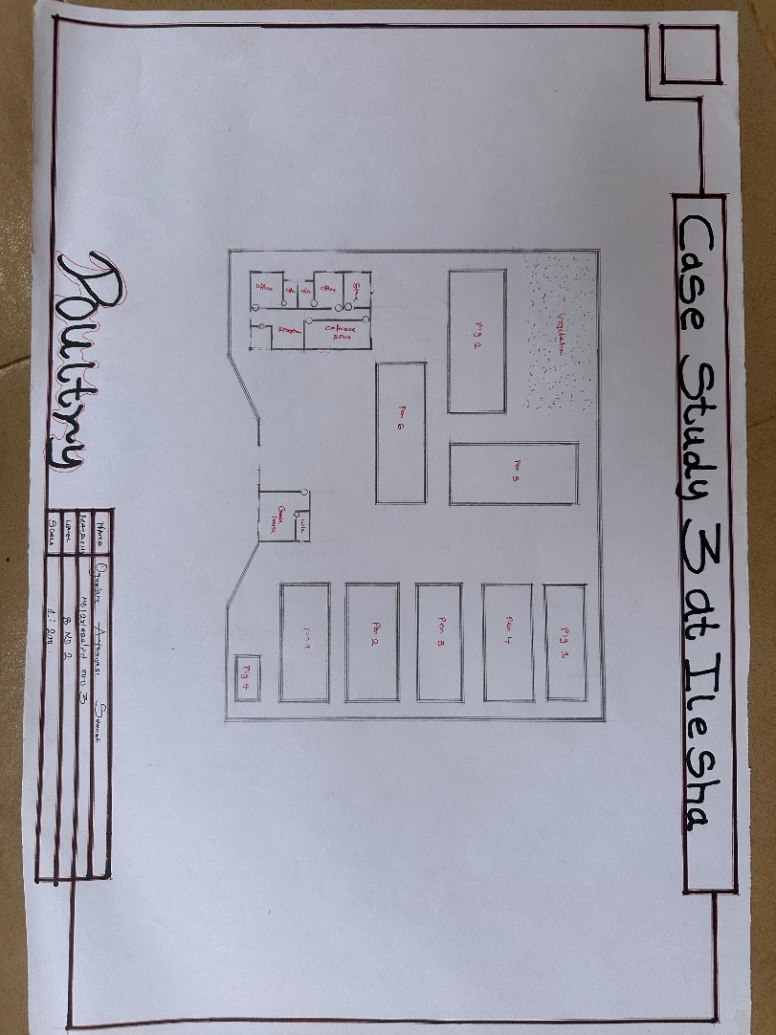
FIGURE 3.7: Poultry Farm Floor Plan of case study three

PLATE 3.6: Farm Gate and Security House
PLATE 3.7: Brooding Section Interior

Merits
- Clear site zoning with minimal cross-contamination
- Solar-powered lighting system
- Functional composting facility for manure reuse
- Natural ventilation techniques well implemented
Demerits
- No automation in feeding and egg collection
- Security house lacks CCTV integration
- Irregular electricity supply impacts operation during peak production
CASE STUDY FOUR
LOCATION: Ajikobi Integrated Poultry Farm, Ilorin, Kwara State
Brief History and Background
Ajikobi Integrated Poultry Farm was established to supply local markets with fresh poultry meat and eggs. The farm is known for its strong emphasis on biosecurity, sustainability, and the use of local construction materials. It operates both brooding and grow-out systems and has a growing presence in poultry training and extension services.

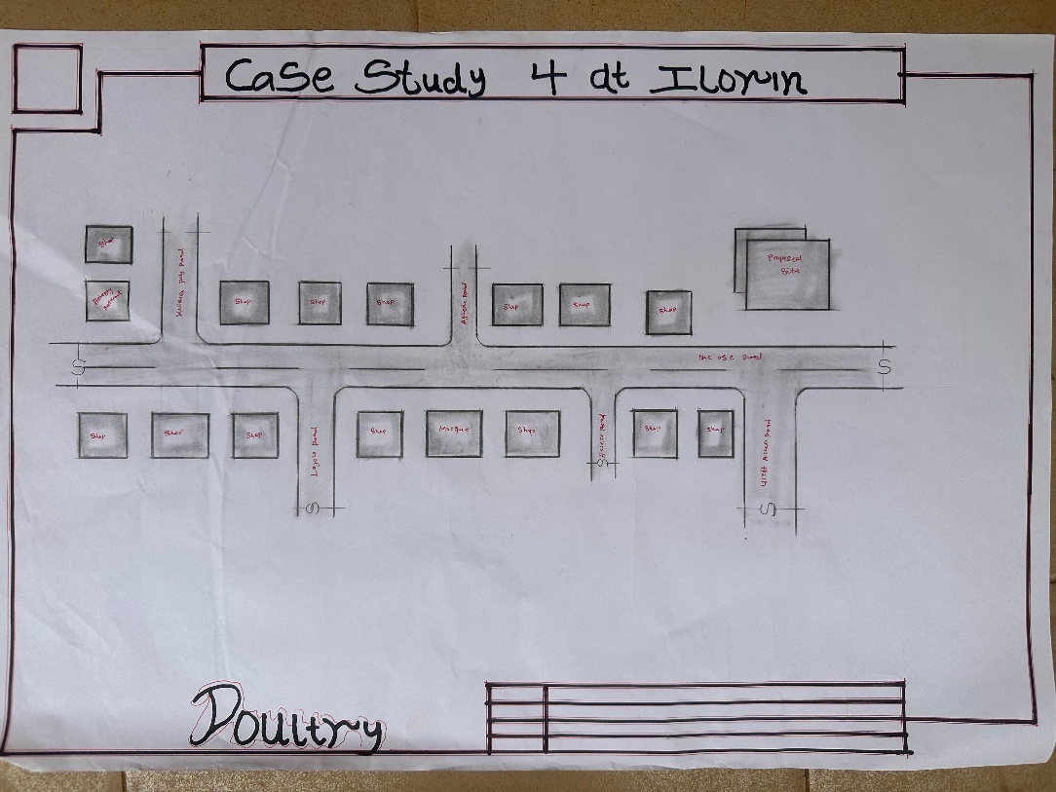
FIGURE 3.8: Location Plan of case study four

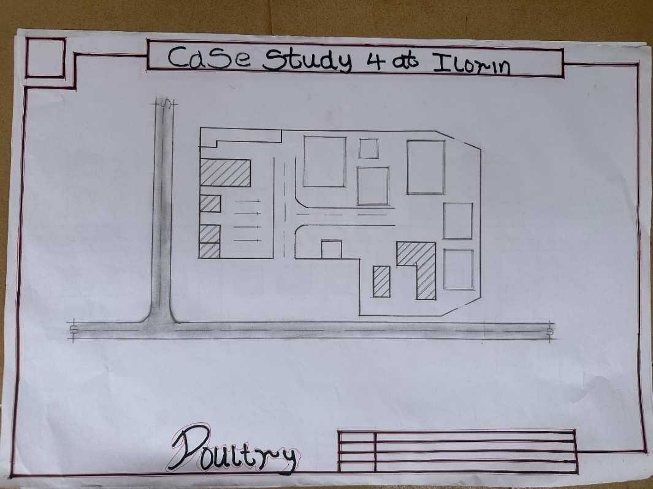
FIGURE 3.9: Poultry Farm Floor Plan of case study Four

PLATE 3.8: Elevation of case study four
PLATE 3.9: Elevation of pen of case study four

CASE STUDYFOUR
Merit
1. The production block is well designed
2. Pens are big enough, and convenience walking areas are produced in it
3. The store is well designed
4. The waste area is very far from the administrative block
Demerit
1. The quarters have no toilet facilities
2. Poor personal hygiene
3. Inadequate ventilation
4. Poor provision of security post
5. Conference hall is not in the administrative block
3.5 CONCLUSION
The three case studies reviewed provide valuable insights into various scales and approaches to poultry architectural design. From academic research-oriented farms to commercial mid-sized operations, certain trends emerge, including the prioritization of ventilation, space optimization, and environmental sustainability. However, each case also highlights areas for improvement, particularly in automation, biosecurity zoning, and waste management. These lessons inform the proposed design by identifying what works, what doesn’t, and how architectural planning can enhance productivity and biosecurity in poultry farming.

CHAPTER FOUR
4.0 STUDY AREA AND DESIGN CRITERIA
4.1 INTRODUCTION TO OSUN STATE
Osun State is one of the southwestern states in Nigeria, created on August 27, 1991, out of the old Oyo State. Named after the Osun River, a symbolic and sacred river in Yoruba cosmology, Osun State has its capital in Osogbo and is rich in culture, history, and natural resources. The state is bounded by Oyo State to the north, Ekiti and Ondo States to the east, Ogun State to the south, and Kwara State to the northwest.
Osun State comprises thirty local government areas (LGAs) and is predominantly agrarian, with a significant portion of its population engaged in agriculture, trading, and local craftsmanship. The climate and vegetation are conducive for both arable and livestock farming, making it an ideal location for agricultural enterprises such as poultry farming. According to the 2006 population census, Osun State had a population of over 3.4 million people, and it continues to grow steadily. The state's favorableagro-ecological conditions support the establishment of sustainable poultry operations.
4.1.1 ABOUT ILESHA
Ilesha, a prominent town in Osun State, serves as the headquarters of Ilesa East and West LGAs. It is historically significant as the traditional homeland of the Ijesha people, a subgroup of the Yoruba ethnic group. Ilesha is well connected by road and enjoys proximity to major cities like Akure, Osogbo, and Ibadan. The town is known for its educational institutions, rich cultural heritage, and active commercial markets.
The proposed poultry farm site is located on the outskirts of Ilesha, in a semi-rural zone ideal for agricultural activities. The area benefits from good road access, a stable electricity supply, favourable topography, and a peaceful community setting, all of which support poultry production.
4.2 SITE ANALYSIS
4.2.1 LOCATION AND ACCESSIBILITY
The proposed site is situated on a farmland zone approximately 5 kilometers from central Ilesha, along the Ilesha-Ijebu Jesa rural access road. The location is easily accessible via a laterite road that connects to the main tarred highway, facilitating the transportation of inputs (e.g., feed, chicks) and distribution of poultry products (e.g., eggs, broilers).
4.2.2 SERVICES
The site is within the reach of essential services:
- Electricity: Power supply from the Ibadan Electricity Distribution Company (IBEDC) with the provision for a standby generator.
- Water Supply: Borehole water and rainwater harvesting will be used for drinking, washing, and cooling systems within the poultry house.
- Telecommunication: Strong mobile network signals are present for administrative coordination, record-keeping, and security surveillance.
4.3 SITE CLIMATIC CONDITIONS
RAINFALL
Ilesha experiences a tropical wet and dry climate, with an annual rainfall ranging between 1,200 mm and 1,500 mm. There are two main rainy seasons:
- Long wet season (March to July)
- Short wet season (September to October)
The August break provides a short dry spell. Rainfall patterns must be factored into the design of the drainage and roofing systems to prevent waterlogging and moisture accumulation that could affect poultry health.
TEMPERATURE
Average temperatures range from 21°C to 33°C, with mean annual temperature around 27°C. Proper ventilation and insulation are necessary to manage heat stress in poultry houses, especially during the hot dry season.
WIND
The prevailing southwesterly wind during the rainy season and the northeasterly harmattan wind during the dry season must be considered in orienting poultry buildings to allow for cross-ventilation and prevent odour concentration.
4.4 SITE SELECTION CRITERIA
The following were considered before selecting the site:
- Proximity to feed suppliers and markets
- Accessibility to transportation routes
- Adequate land size for future expansion
- Low population density (to reduce odor impact and biosecurity risk)
- Availability of water and power supply
- Conformance with local agricultural zoning and building regulations
4.5 DESIGN CRITERIA
4.5.1 FUNCTIONALITY OF THE SITE
The design ensures logical movement patterns: vehicular access for delivery trucks, separation of pedestrian paths for workers, and adequate setbacks for biosecurity. The layout allows for:
- Isolation of poultry houses
- Buffer zones with vegetation
- Separate zones for feed storage, egg collection, staff area, and waste management
4.6 DESIGN BRIEF
The poultry farm is designed to support commercial-scale egg and meat production, with a projected capacity of 5,000 layers and 2,000 broilers per cycle. It aims to provide an efficient, hygienic, and sustainable farming environment.
Key design intentions:
- Maximize natural lighting and ventilation
- Reduce disease transmission through zoning
- Ensure worker safety and comfort
- Incorporate green technologies like solar panels and rainwater harvesting
4.7 ANALYSIS OF THE BRIEF
SPACE REQUIREMENTS
4.7.1 Production Units
- Layer House (2 Nos.): Capacity of 2,500 birds each; automated feeding and watering systems
- Broiler Pen: Capacity of 2,000 birds; designed for fast turnover cycles
- Hatchery (optional): Space allocated for future development
- Feed Mill Room: For on-site mixing and storage of poultry feed
4.7.2 Support Facilities
- Office Block: Includes farm manager's office, records room, and meeting area
- Veterinary Room: Health checkup and vaccination area
- Staff Quarters: Accommodation for workers and supervisors
- Toilets and Changing Rooms: For sanitation and hygiene
- Water Tanks: For storage and pressure supply
- Incinerator and Manure Pit: For waste and dead bird management
- Security Post: With surveillance and perimeter fencing
4.7.3 External Spaces
- Parking Lot: For delivery vans, staff motorcycles, and visitors
- Access Roads: For smooth internal circulation
- Landscaping: Windbreak trees and flowerbeds to improve aesthetics and reduce dust
4.8 SPACE ALLOCATION / SCHEDULE OF ACCOMMODATION
Designated areas include:
- Poultry Houses: 30%
- Support Facilities: 20%
- Open Space (circulation and expansion): 25%
- Landscaping and Buffer Zone: 15%
- Utilities (water tank, incinerator): 10%
4.9 FUNCTIONAL RELATIONSHIP
A bubble diagram (not shown here) defines the spatial relationship between key components:
- Feed mill should be close to poultry houses
- Veterinary unit adjacent to pens for quick access
- Manure pit downwind and farthest from living quarters
- Security post at the entrance gate

4.10 CONCEPTUAL DEVELOPMENT
The conceptual strategy is focused on:
- Zoning for hygiene and workflow
- Orientation of poultry buildings along east-west axis
- Use of passive ventilation (ridge vents, louvre windows)
- Modular design for easy expansion
4.11 DESIGN ANALYSIS
4.11.1 GENERAL SERVICES
- Water Supply: Borehole with overhead tanks and piping to pens
- Electricity: IBEDC connection with solar backup and generator
- Drainage: Concrete-lined drains and soakaway pits
- Solid Waste: Composting manure and incinerating mortalities
- Security: Fencing with CCTV monitoring
4.11.2 BUILDING SERVICES
- Electrical Wiring: Conduit wiring with standby power
- Lighting: High-level natural lighting with LED artificial lighting
- Ventilation: Ridge ventilation and open-sided pens
- Noise Control: Acoustic buffers and vegetation
- Fire Safety: Extinguishers and water hoses in key areas
- Walkways/Parking: Concrete paving and demarcated zones
This design proposal for a poultry farm in Ilesha, Osun State, addresses the critical needs of commercial poultry production, combining functionality, biosecurity, and sustainability within a well-thought-out architectural and environmental context.
CHAPTER FIVE
5.0 PROJECT APPRAISAL
This chapter presents a comprehensive appraisal of the proposed poultry farm development in Ilesha, Osun State, with a specific focus on the adopted construction methods, materials, building services, fire precautions, and landscape integration. The project is tailored to support intensive poultry production while ensuring environmental sustainability, functionality, and ease of maintenance.
5.1 CONSTRUCTION METHODS AND MATERIALS
The construction of a poultry farm requires a methodical approach that ensures biosecurity, durability, functionality, and adaptability to climatic conditions. Specialized contractors and consultants, particularly structural and mechanical engineers, are integral to ensuring structural integrity, service efficiency, and compliance with agricultural building standards.
5.1.1 Substructure
The substructure includes all components below ground level. Given the clayey-sandy soil of Ilesha, and based on preliminary geotechnical reports, the use of a strip or pad foundation system is recommended. Trenches will be excavated to a minimum of 900mm below the natural ground level, depending on the load requirements of each poultry building.
- Concrete mix ratio: 1:2:4 (cement:sand:gravel), with well-compacted blinding to reduce upward moisture movement.
- Damp-proof membranes (DPM) will be laid beneath the slabs to prevent rising damp, which could affect poultry litter and create unsanitary conditions.

5.1.2 Superstructure
The superstructure will be constructed with framed structures using reinforced concrete columns and beams to support lightweight block infill. For the poultry houses (layer and broiler pens), steel portal frames with trusses are preferable due to:
- Large clear spans required for open ventilation
- Ease of prefabrication and assembly
- Resistance to corrosion with proper coating
This method allows for flexibility in future expansion and modification.
5.1.3 Floors
- Ground floors: Cast in-situ reinforced concrete slab on compacted hardcore. The surface will be finished with non-slip concrete screed to ease cleaning and manure removal.
- Biosecurity flooring (in pens): Coated with epoxy resin or acid-resistant paint for sanitation.
- Office/admin blocks: Tiled floors (ceramic or terrazzo) for aesthetics and comfort.
5.1.4 Walls
- Poultry house walls: Constructed with hollow sandcrete blocks (225mm), rendered and painted with washable emulsion paint. Lower 1 meter will be finished with tiled skirting or hard cement render for easy cleaning.
- Office and residential units: Standard sandcrete walls with internal plaster and emulsion paint.

5.1.5 Expansion Joints
Expansion joints will be introduced at every 25–30 meters using pre-formed joint fillers to accommodate temperature-induced movements and prevent cracking, especially in long-span poultry houses.
5.1.6 Roof
- Poultry pens: Long-span galvanized steel roofing sheets with ridge ventilation. Roof slope at 26–30° for rapid water runoff.
- Admin buildings: Aluminum long-span roofing with roof insulation and ceiling finishes for thermal comfort.
5.1.7 Ceiling
- Poultry houses will have open roof trusses with no ceiling, promoting cross ventilation and heat escape.
- Admin, storage, and residential areas will use suspended acoustic ceilings (e.g., POP or fiberboard), contributing to noise control and aesthetics.
5.1.8 Doors
- Poultry pens: Steel doors with secure locking systems and insect screens.
- Office areas: Aluminum and hardwood flush panel doors with durable handles.
- Storehouses: Reinforced metal double doors for security.
5.1.9 Windows
- Poultry pens: Openable steel-framed louvre windows with galvanized wire mesh for ventilation and pest control.
- Offices: Sliding aluminum windows with tinted glass to reduce glare.

5.1.10 Finishes
- Walls: Internal walls in pens and wet areas will be finished with hard cement render or ceramic tiles.
- Floors: In pens – epoxy-coated concrete; In admin – ceramic tiles or terrazzo.
- External walls: Weather-resistant textured paint.
5.2 BUILDING SERVICES
5.2.1 Acoustic and Lighting Provisions
Poultry are sensitive to excessive noise and inconsistent lighting. To address these:
- Acoustic buffering: Vegetative setbacks and acoustic fencing near access roads to absorb noise.
- Natural lighting: Maximized through open walls and transparent roofing sheets.
- Artificial lighting: Energy-efficient LED bulbs will be used to simulate daylight and manage laying cycles in layers. Light intensity and duration will be controlled using timers and dimmers.
5.3 MECHANICAL SERVICES
- CCTV security systems in all strategic zones including entrances, feed mill, hatchery (if any), and egg collection units.
- Ventilation fans and foggers in poultry houses to maintain temperature and air quality.
- Automatic feeders and waterers to ensure consistent poultry feeding schedules.
- Locks, hinges, handles, and other mechanical components will be of rust-resistant materials and meet industrial-grade specifications.

5.4 ELECTRICAL SERVICES
The farm will be connected to the public electricity grid (IBEDC) with:
- A 25–50KVA standby diesel generator
- Solar PV units to power low-voltage lighting in poultry houses
- Distribution boards in each block
- Proper earthing systems for safety
5.5 PLUMBING SERVICES
- Borehole and elevated tank system to supply water to drinkers, bathrooms, and cleaning systems
- PVC piping network for water and waste management
- Soak-away and septic tank systems for office and residential blocks
- Dedicated drainage channels for poultry waste water and rainfall runoff
5.6 FIRE PRECAUTION
Fire prevention is critical due to the use of combustible materials like feed and litter:
- Dry chemical extinguishers and fire buckets positioned in each block
- Fire alarms and smoke detectors in office and generator rooms
- Monthly fire drills for staff
- Emergency exits and signage clearly marked in all zones
5.7 EXTERNAL WORKS (LANDSCAPING)
5.7.1 Soft Landscaping
- Tree planting (e.g., neem or pawpaw) for windbreaks and temperature regulation
- Shrubs and flower beds near office areas for aesthetics
- Grassed zones for dust reduction and erosion control
5.7.2 Hard Landscaping
- Concrete-paved driveways and walkways
- Parking lots for staff, delivery trucks, and visitors
- Drainage channels along the perimeter
- Fencing with barbed wire on top for security
5.8 BUILDING REQUIREMENTS
All works will adhere to:
- British Standards (BS) and Nigerian Building Codes (NBC)
- FAO animal housing guidelines
- National Environmental Standards and Regulations Enforcement Agency (NESREA) for poultry waste management
5.9 STRUCTURAL STABILITY
- Use of grid-based layout for load balancing
- Steel and reinforced concrete ensure resilience against storm winds and structural fatigue
- Roof anchorage and wall ties are integrated to reduce wind uplift during storms
5.10 MAINTENANCE CULTURE
The facility is designed for easy and cost-effective maintenance:
- Smooth floor and wall finishes allow for regular washing and disinfection
- Removable poultry slats for deep cleaning
- Accessible ducts for plumbing and electrical servicing
- Use of common local materials ensures easy replacement without special tools or skills
This appraisal demonstrates that the proposed poultry farm in Ilesha is designed not only for production efficiency and biosecurity, but also for longevity, worker safety, environmental compatibility, and ease of future expansion. The chosen construction methods and materials are tailored to the site's climatic conditions and economic viability, ensuring a sustainable poultry business.

REFERENCES
Adekunle, R. A., & Oloruntoba, A. B. (2019). Design Considerations in Poultry Farm Layouts. Nigerian Journal of Agriculture.
Alhassan, A., & Asare, F. (2016). Customer perception and satisfaction towards the services
of microfinance institutions in Ghana. International Journal of Research in Business Studies and Management, 3(4), 12-24.
FAO. (2017). Biosecurity Guidelines for Poultry Farms. Food and Agriculture Organization.
Garcia, M. T. (2018). The role of technology in enhancing microfinance bank operations.
Journal of Financial Services Technology, 6(1), 45-60.
Kumar, S., & Mohan, V. (2017). Spatial organization in banking architecture: A study of
functional efficiency. Journal of Architectural Planning, 5(2), 100-110.
Olawuyi, T. A., et al. (2020). Ventilation and Air Quality in Nigerian Poultry Houses. West
African Journal of Animal Science.
NAPRI. (2018). Poultry Housing and Welfare Guidelines. National Animal Production
Research Institute.
Nawi, M. N., Baluch, N., & Bahaudin, A. Y. (2014). Community integration in building
design: A case study of microfinance banks in rural areas. Journal of Sustainable Development, 7(5), 110-122.
World Poultry Science Association. (2020). Sustainable Poultry Production: Design
Approaches and Trends.
Mwangi, W. (2015). Design considerations for microfinance banks in Kenya. Nairobi
Journal of Architecture, 2(1), 45-58.
World Bank. (2019). Sustainable building design for economic development. World Bank
Publications.

APPENDICES

