COMPARATIVE STUDIES OF SOME GEO-TECHNICAL PROPERTIES OF LATERITE SOIL IN OSHIN, ILORIN SOUTH L.G.A AND IN ALAGBAA, ILORIN EAST L.G.A OF KWARA STATE

BY:
ADEBILE JOSHUA BUKUNMI
ND/23/MPE/FT/021

A PROJECT REPORT SUBMITTED TO THE DEPARTMENT OF MINERALS AND PETROLEUM RESOURCES ENGINEERING TECHNOLOGY, INSTITUTE OF TECHNOLOGY,
KWARA STATE POLYTECHNIC, ILORIN

IN PARTIAL FULFILMENT FOR THE AWARDS OF NATIONAL DIPLOMA (ND) IN MINERAL AND PETROLEUM RESOURCES ENGINEERING TECHNOLOGY

JULY, 2025

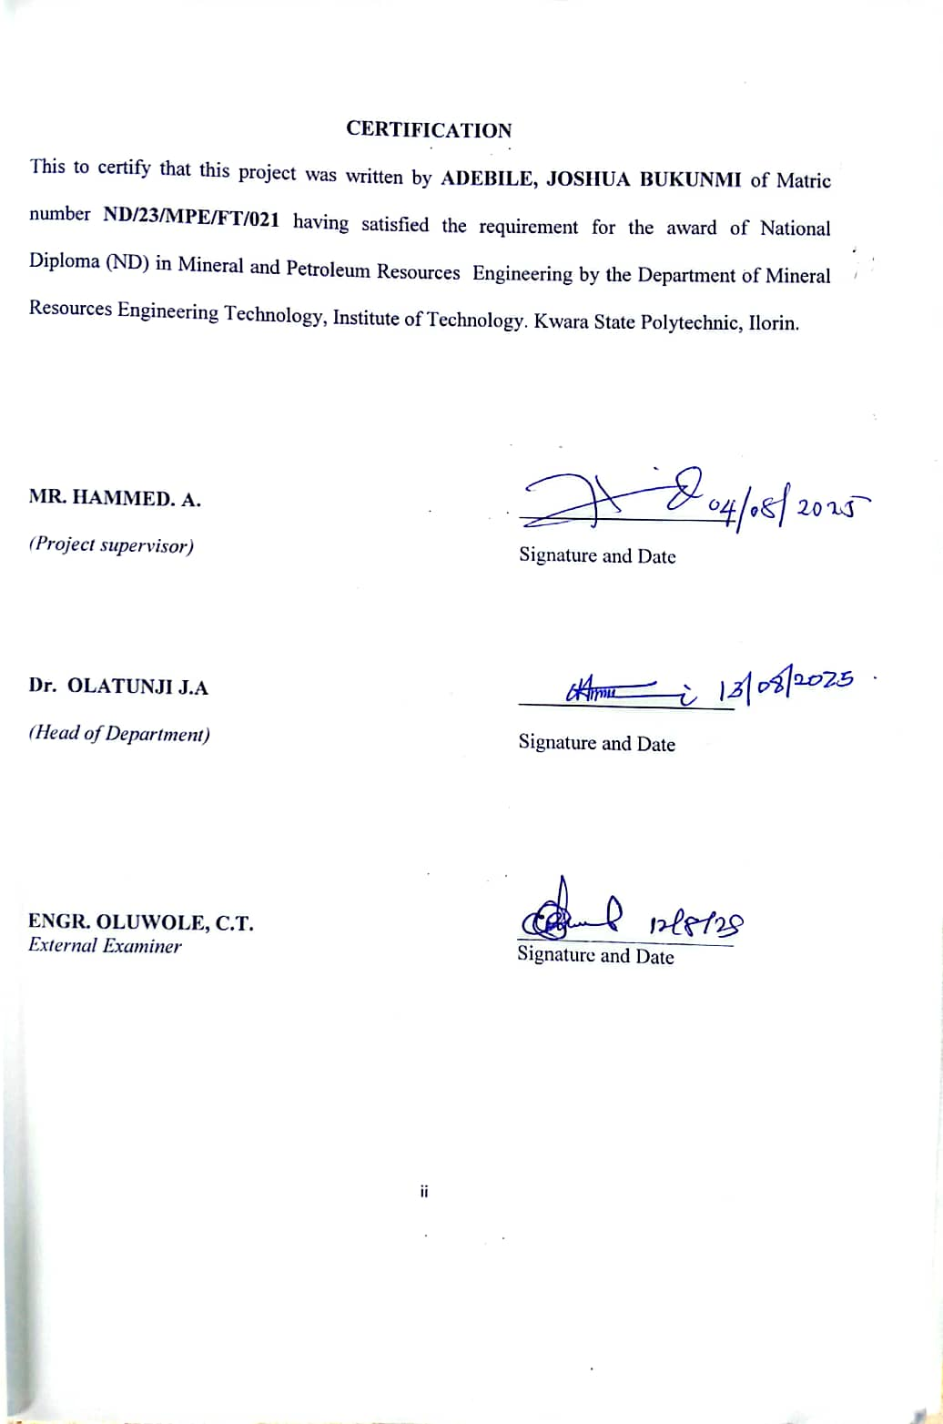DEDICATION
This work is dedicated to the ALMIGHTY GOD, who saw me to this point despite all odds. Also, this work is dedicated to my Amazing Parents and Siblings for their constants love and support.

ACKNOWLEDGEMENT
I would like to express my sincere gratitude to all those who have supported me throughout the course of this project.
My sincere appreciation goes to my supervisor, Mr. Abdullahi Hammed, for their invaluable advice, constructive criticism, patience, and encouragement which have been instrumental to the successful completion of this work.
I am also grateful to my H.O.D in person of Dr. Olatunji J.A, also my profound gratitude goes to my lecturers in person of Dr. Obaro, Engr. S.A Agbalajobi, Mr. Odediran, Mr. S. Usman. For their dedication and knowledge impacted during my course study.
I would like to thank my mother/guardians for their moral and financial support throughout my academic pursuit. Special thanks to my friends and colleagues for their support, suggestions and companionship which made this project a success.
Finally I appreciate everyone who, in one way or another, contributed to the successful completion of this project. God bless you all.


TABLE OF CONTENT
Title page
Certification
Dedication
Acknowledgement
Abstract
Table of contents
List of Tables
List of Figures
List of Appendix
CHAPTER ONE
1.0 INTRODUCTION
1.1 Background of the study
1.2 Aim of the project
1.3 Objectives of the project
1.4 Statement of problem
1.5 Justification of the study
1.6 Scope and limitation
1.7 location and accessibility
1.8 Climate and vegetation
CHAPTER TWO
2.0 LITERATURE REVIEW
2.1 Review of soil
2.2 Overview of lateritic soil
2.3 Geology of Nigeria
2.4 Geology of the study area
2.5 Origin of lateritic soil
2.6 Formation of lateritic soil
2.7 Strength of lateritic soil
2.8 Applications and challenges
CHAPTER THREE
3.0 MATERIALS AND METHODS
3.1 Sample collection and preparation
3.2 Laboratory analysis
3.3 Determination of grain size analysis
3.3.1 Mechanical sieve method
3.3.2 Hydrometer sieve method
3.4 Determination of atterberg limit test
3.4.1 Liquid limit determination
3.4.2 Plastic limit determination
3.4.3 Determination of linear shrinkage
3.5 Compassion test
3.6 Determination of shear box test and California bearing test

CHAPTER ONE
INTRODUCTION
1.1 Background of the study
Laterite is a type of highly weathered soil and rock material, rich in iron and aluminum, typically found in tropical and subtropical regions. The term was first introduced by Buchanan in 2005 when describing a red, brick-like soil in India. Laterite form in hot and humid climates where intense weathering processes leach out soluble minerals, leaving behind insoluble oxides of iron and aluminum (Tardy, 1997).
Geologically, laterites are considered residual deposits, meaning they form in situ from the prolonged chemical weathering of parent rocks such as basalt, granite, and other silicate- rich materials (Gunn, 2004). The leaching process removes elements like calcium, potassium, and silica, concentrating iron oxides (Fe₂ O₃ ) and aluminum hydroxides (Al(OH)₃), which gives laterite its characteristics reddish hue and high density. Laterite is significant both geotechnically and economically. It has been used as a building material for centuries, particularly in South Asia and Africa, where blocks are cut directly from laterite outcrops and used for construction (Paton et al., 1995). In addition, laterite serve as important sources of minerals such as bauxite (aluminium ore) and nickel (Widdowson, 2009). Lateritic soils, derived from the same weathering processes, pose agricultural challenges due to their low fertility and high acidity. However, with proper managements, they can support crops such as tea, coffee, and oil palm (Scheffer & Schachtschabel, 2010).

1.2 Aim of the project:
The aim of this project is to investigate and compare the geotechnical properties of laterite soil in Oshin (Iloriin South L.G.A) and Alagbaa (Ilorin East L.G.A) in Kwara state.
1.3 Objectives of the Project:
- To determine the physical properties (e.g, grain size distribution, Atterberg limits) of laterite soil in both locations.
- To evaluate the engineering properties (e.g. Compaction, Shear strength, permeability) of laterite soil in both locations
- To compare the geotechnical properties of the laterite soil between the two locations
- To identify potential implications for construction and engineering projects in the areas
1.4 Statement of the project
This project conducts a comparative study of the geotechnical properties of laterite soil in Oshin (Ilorin South L.G.A) and Alagbaa (Ilorin East L.G.A) in Kwara state, Nigeria, to determine similarities and differences in their physical and engineering properties.
1.5 Justification of the study
- Laterite soil is widely used in construction projects in Kwara state.
- Understanding its geotechnical properties is crucial for safe and durable infrastructure development.
- Comparative analysis between two locations can reveal site-specific variations, informing local construction practices and reducing potential risks.
1.6 Scope and limitation
This study focuses on comparing the geotechnical properties (physical and engineering) of laterite soil samples from Oshin (Ilorin South L.G.A) and Alagbaa (Ilorin East L.G.A) in kwara state Nigeria.
- Geographical scope is limited to two specific locations in Kwara state
- The study is limited to laterite soil only
- The analysis is restricted to selected geotechnical properties
1.7 Location and accessibility of laterite
Laterite deposits are predominantly found in tropical and subtropical regions, where high temperatures and heavy rainfall promote intense chemical weathering. These climatic conditions are essential for the formation of lateritic soils and rocks, which occur extensively across parts of Asia, Africa, South America, and Australia (Tardy, 1997). Countries like India, Brazil, Sri lanka, Indonesia, and parts of west and central Africa host significant laterite formations, particularly on elevated plateaus and hilltops where drainage is good and leaching processes are maximized (Gunn, 2004).
Accessibility to laterite depends largely on the terrain and infrastructure of the region. In many tropical countries, laterite can be accessed relatively easily using open-pit quarrying techniques. Its surface exposure makes it economical to extract, all through transport logistics in remote rural areas can limit its widespread use in some locations (Widdowson, 2009). Moreover, mechanized extraction is often minimal in developing regions, making laterite a low cost but labour intensive material.
1.8 Climate and vegetation of laterite
Laterite are highly weathered, iron-and aluminium-rich soils predominantly found in tropical and subtropical regions. Their formation, characteristic, and associated vegetation are intricately linked to specific climatic conditions. This article explores the climate conducive to laterite formation, the vegetation supported by these soils, and the interplay between these factors, supported by relevant scientific literature. Laterite form under warm, humid climatic conditions typically of tropical and subtropical zones. The process of laterization, which involves intense chemical weathering, requires high temperatures and significant rainfall. According to Tardy (1992), laterite formation is most pronounced in regions with mean annual temperatures above 25⁰ C and annual rainfall exceeding 1,200mm. these conditions facilitate the leaching of silica and bases (e.g. calcium, magnesium) from the soil, leaving behind iron and aluminum oxides that give laterites their characteristic reddish hue (Paton & Williams, 1972).
The climate associated with laterites is often characterized by distinct wet and dry seasons, as seen in monsoon or savanna climates. During the wet season, heavy rainfall promotes hydrolysis and leaching, while the dry season allows for the oxidation and hardening of iron oxides, forming indurated layers known as laterite crusts (Mc Farlane, 1976). Regions such as parts of India, West Africa, and northern Australia, where laterites are prevalent, experience these alternating climatic patterns. For instance, in the Deccan Plateau of India, laterites develop under a tropical monsoon climate with rainfall ranging from 1,000 to 2,500mm annually (Wadia, 1996). However, prolonged waterlogging or excessively arid conditions can inhibit laterite formation. In hyper-arid regions, insufficient moisture rainforests with constant high rainfall, excessive leaching may prevent the accumulation of iron oxides necessary for laterite development (Tardy, 1992). Thus, the ideal climatic regime for laterites balances high rainfall with seasonal drying. The vegetation associated with laterites is heavily influenced by the soil’s physical and chemical properties as well as the prevailing climate. Laterites are typically nutrient-poor due to intense leaching, with low levels of phosphorous, nitrogen and organic matter (Paton & Williams, 1972). Their high iron and aluminum content can also lead to toxicity, limiting plant growth. As a result, laterite soils often support specialized vegetation adopted to these challenging conditions.
In tropical savanna regions, where laterirtes are common, the vegetation is dominated by grasses and scattered trees, such as acacias and baobabs. These species are well adapted to seasonal drought and nutrient scarcity. For example, in the savannas of northern Australia, laterite soils support Eucalyptus-dominated woodlands with an understory of perennial grasses (MC Farlane, 1976). The open canopy allows sufficient light, penetration, fostering grass growth, while deep-rooted trees access water and nutrients from deeper soil layers.
In areas with higher rainfall, such as parts of West Africa, laterites may support tropical dry forests or woodlands. These ecosystems feature deciduous trees that shed leaves during the dry season to conserve. Species like terminalia and combretum are common, with adaptations such as thick bark to withstand seasonal fires deep roots exploit groundwater (Tardy, 1992).
The relief of laterite landscapes is shaped by the underlying geology and weathering processes. Laterites often flat-topped plateaus or duricrusts (hardened crusts) that cap hills or ridges, creating resistant landforms (Thomas, 1994). Their drainage characteristics are influenced by porosity, permeability and the degree of indurations, which vary across different laterite types (e.g Massive, Vesicular, or Nodular). Drainage in laterite terrains complex due to the material’s variable permeability and topographic setting. Laterites typically exhibit low to moderate permeability because of their compact structure or clay-rich matrix, which can impede water infiltration (Bourman, 1993). However, vesicular or fractured laterites may allow greater water movement, creating localized aquifers or perched water tables (Widdowson, 2007).
The slopes of lateritic landscapes vary from gentle to steep, depending on the degree of dissection. On gentle slopes sheet wash and rill erosion eliminate, while on steeper slopes, mass wasting and gullying are common (Thomas, 1994). The relief influences drainage by controlling runoff velocity and sediment transport, which in turn affect soil fertility and land use.
The drainage and relief of laterites have significant implication for agriculture, water management, and infrastructure development, poor drainage in flat clay-rich lateritic soils cab lead to water logging, limiting crop growth (Tardy, 1992). Conversely, well-drained lateritic slopes are prone to erosion, requiring conservation measures like terracing or reforestation. The high relief of lateric plateaus can complicate road construction and urban planning, as seen in parts of tropical Africa and South Asia (Widdowson, 2007). From a geomorphologic perspective, laterites serve as markers of past climatic conditions. Their presence indicates prolongs periods of intense weathering, often dating back to the drainage and relief helps geologists reconstruct pale environments and predict future landscape evolution under changing climatic conditions.
CHAPTER TWO
LITERATURE REVIEW
2.1 Review of previous studies
Soil is define as the unconsidered material on earth’s surface comprising mineral particles, organic matter, and water and air capable of supporting plant growth and engineering structured (Brady& Weil, 2016). Soils are classified based on their use in engineering and agriculture. The unified soil classification system (USCS) categorizes soils into coarse grained (sands, gravels) and fine grained (silts clays) types based on grain size and plasticity (ASTMD 2487, 2017). In tropical regions, soils undergo intense chemical weathering resulting in residual soils like laterites, which are rich in iron and aluminum oxides and exhibit distinct engineering behavior (Gidigasu 1972).Terzaghi et al (1996) worked on geotechnical and geological engineering (soil mechanics in engineering practice) and emphasize the importance of soil classification for engineering design. They noted that coarse-grained soils are suitable for load behaving applications due to their high sheer strength and permeability, while fine grained soils industry tropical laterites pose challenges due to their plasticity and moisture sensitivity. The study under scores the need for sites-specific testify to account for soil variability.Lambe and Whitman (2000) reported on geotechnical and geo-environmental engineering provide a comprehensive overview of soil mechanics highlighting the role of laboratory test (e.g: Triaxial shear: Altterberg limits) in characterizing soil properties. They note that tropical soils, such as laterites require specialized approaches due to high clay convent and variable strength.Gidigasu (1972) revealed on soil science, investigates the mineralogy of lateric soils reporting that iron. Rich laterites (high hematice and geothic) exhibit greater cohesion and shear strength while aluminum rich laternes (high gibb site) are more plastic and prone to swelling. The study emphasize the use of X-ray diffraction (XRD) and scanning electron microscopy (SFM) for characterizing mineralogical variation.Lemougna et al (2011) explained on clay science, explore the mineralogical properties of lateritic soil for geopolymer production. They note that the high alumina convent in laterite makes them suitable, precursor for geopolymeric materials but variation in clay mineral content affect their reactivity and mechanical performance.Aleva (1994) worked on the geological convert of lateric deposition south east Asia, highlighting their association with a sizes the need for integrated geological and geotechnical studies to characterize laterite heterogeneity for infrastructure projects. These studies establish that soil properties are highly variable particular in tropical environments, necessitating, tailored characterization and classification for engineering application.
2.2 Overview of lateratic soil
Lateritic soil, often referred to as laterite, is a reddish, iron. And aluminum rich soil form in tropical and subtropical regions through intense chemical weathering (Maegnan, 1988). Characterized by high sesquioxide content (Fs₂ O3 Al₂ O₃₎, low silica content and variable clay minerals (typically kaolinite) lateritic soils are widely distribution in regions such as sub-saharan Africa, South Asia, Australia, and South America (Tardy, 1997). The term “laterite” derives from the Latin lever meaning brick reflecting its historical use in construction (Buchanan, 1807).Oyelami and Van Rooy (2016) explained on environmental earth science provide a detailed review of lateritic soils, noting their high plasticity variable shear strength and susceptibility to moisture changes. They highlight the need for region specific studies due to variation in mineralogy and geotechnical behaviour, particularly for construction applications like roads and low cost housing.Abebe et al (2020) speaks on Africa earth sciences, examine lateritic soils in ethopia emphasizing their abundance and potential as cost effective construction materials. The study notes challenge such as high swell-shrink behaviour and recommends stabilization to enhance durability.Lateric soils are valued for their availability and low cost but require stabilization to address geotechnical limitations, making them a focal point for research in tropical regions.
2.3 Geology of Nigeria
Nigeria: geology spanning Archean to recent, comprises the precambren basemen complex and sedimentary basins, shaped by the pan-Africa progeny, cretaccovs rifting, and cenoeoic sedimentation. It supports significant hydrocarbon and mineral resources, notably in the Niger Delta and Jos Plateau. This note outlines Nigerians geological framework resources and hydrogeology.

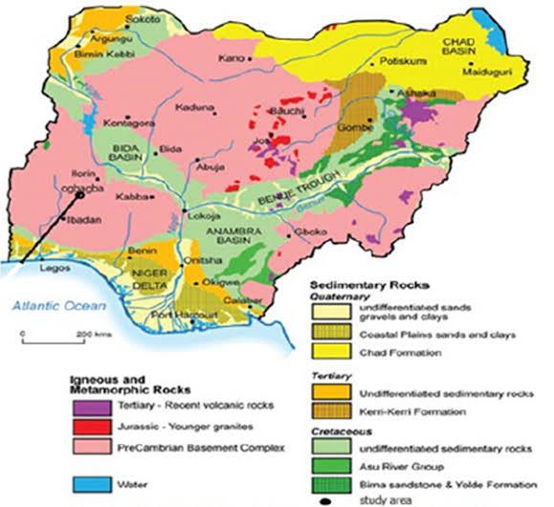

Fig. 2.1 Geology of Nigeria
Nigeria’s geology is divided into two domains. The Precambrian basement complex (50% of the country) and sedimentary basin.
Exposed in northern (Jos plateau), western (Ibadan Ilesha) and eastern (Oban Massif) Nigeria, the basement complex (3.5 Ga-600 Ma) includes migmatite-Genesis complex: Archean Paleoproterozoic (3.5-2.0 Ga) migamtites and gneisses, metamorphosed to ambhibolite granulite facies (Ajibade et al., 1987).
- Schist Bells: Proterozoic (2.0-1.0 Ga) phyllites and schistis in north west (e.g Maru) and southwest (e.g Ilesha) hosting gold (Gelba; 2003).
- Older Granites: Pan-Africa (ca 600Ma) granites, widespread in northern Nigeria, with tin and tantalite (Kinnald, 1984).
- Younger Granites: Jurassic (180-150 Ma) alkaline intrusions in the Jos Plateau hostin tin and columbite (Olade, 1980).
- Seven basins, formed cretaceous to recent include:
- Niger Delta: A global hydrocarbon province with Akata (source), Agbada (reservoir) and Benin (overburden) formations, holding 37 billion bards of oils (Tuttle et al., 1999)
- Anambra Basin: crecateous shale’s and coal with hydrocarbon potential (Obeye et al., 1999)
- Chad, sokoto, Bida, and Dahomey Basin: host hydrocarbons, phosphate, coal, and bitumen (Kogbe, 1979 . Omatsola & Adegoke,1981)
2.4 Geology of the study area
Kwara state is located in the north-central region of Nigeria and is geologically situated within the basement complex Terrain of Southwest Nigeria. The geology of the state is mainly composed of Precambrian crystalline rocks such as granite, gneiss, sehist, and magmatite, which form part of the Nigeria basement complex.
In the southern parts of Kwara state, especially around areas like Oshin and Alagbaa, there are also minor occurrences of sediments are tertiary to cretaceous in age and overlie the basement complex in some places. The basement rocks are generally deeply weathered giving rise to lateritic soils which are commonly used for construction and road works in the state. The geology significantly influences the engineering properties of soils in the area, including texture, strength and permeability.
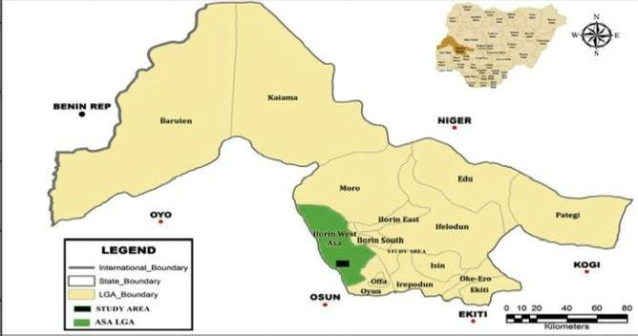
Fig. 2.2 Geology of the study area

2.5 Origin of lateritic soil
Lateritic soil is a distinctive soil type commonly found in tropical and subtropical regions, characterized by its reddish color, high iron and aluminum oxide content, and unique formation processes. Understanding the origin of lateritic soil requires an examination of its geological, chemical and environmental formation mechanisms. This note explores the processes, conditions, and factors contributing to the development of lateritic soil, providing a comprehensive understanding of its origin.
Lateritic soil is a wreathing product formed under intense chemical weathering conditions in hot, humid climates. It is rich in secondary oxides of iron (Fe₂O₃ ) and Al₂ O₃), with a low content of silica (Sio₂ ) and other soluble minerals. The term “Laterite” derives from the latin word later, meaning “brick” s these soils harden into brick-like materials when exposed to air (Gardy, 1997). Lateritic soils are typically found in regions with high rainfall, high temperatures, and well drained landscapes, such as parts of Africa, South America, Australia, and South Asia.
The origin of lateritic soil is closely tied to the process of laterization, a form of chemical weathering the occurs under specific environmental conditions.Lateritic soils form in tropical and subtropical climates with high temperatures (typically above 25⁰C) and heavy rainfall (often exceeding 1000mm annually). These conditions accelerate chemical weathering by promoting leaching, where water dissolves and removes soluble minerals like silica, calcium, and magnesium from the soil.The parent material, or bedrock, significantly influences lateritic soil formation. Common parent materials include igneous rocks (e.g, basalt) sedimentary rocks, and metamorphic rock rich in iron and aluminum content (Widdowson, 2007). Well-drained, elevated landscapes, such as plateaus or gently sloping terrains, favour lateritic formation. Poor drainage can inhibit laterazation by reducting leaching efficiency.Lateritic soils require long periods-often millions of years to form. Prolonged weathering allows for the accumulation of iron and aluminum oxides while soluble components are leached away.
2.6 Formation of lateritic soil
The formation of lateritic soil known as laterization is a complete process driven by chemical wreathing in tropical and subtropical environments. Laterization involves three stages:
- Initial weathering of parent rock
- Leaching of silice and soluble minerals
- Accumulation and induration of sesquioxides (Gardy, 1997).
The process is influenced by rainfall, warm temperature, well drained topography and time, with older laterites exhibiting greater induration (Gidigasu 1972).
(Swaran and Bin 1978), in Gaoderina, describe laterilation as a process of hydrolysis and oxidation, leading to the formation of secondary minerals like hematite gocthite and gibbgite. The study now that fully developed laterites from hand ferrierete crusts, which are resistant to erosion and suitable for construction when stabilized.
Murty (2022), in transportation geotechnics, highlights the role of microbial activity in accelerating laterization by promoting mineral dissolution and sesquioxide precipitation. The study suggest that microbial influences could be leveraged to enhance stabilization techniques an area requiring further research.
The formation process significantly influence the geotechnical properties of lateritic soils, necessitating detailed soldiers for engineering applications.
2.7 Strength of lateritic soil
The strength of lateritic soil include shear strength and unconfined compressive strength (UCS), is a critical factor for their use in construction applications such as road bases, foundations and compressed earth blocks (CEBs) strength properties are influenced by mineralogy moisture content, and degree of induration.Oyelami and Van Rooy (2016)report that iro-rich lateritic exhibits higher shear strength due to the cohesive properties of hematite and geothote, with UCS values ranging from 0.5 to 5Mpa depending on compaction and stabilization. Their high clay content makes them susceptible to strength loss under wet conditions. Murty (2022) demonstrate that stabilization with metakalin-bischofire-alkalinization (MKBA) adding increase UES by up to 30%, improving suitability for road foundation.
2.8 APPLICATIONS AND CHALLENGES
Lateritic soils have partial applications, such as use in construction (e.g laterite bricks) and as a source of iron and aluminum ores (bauxite). However, they pose challenges for agriculture elve to their low fertility, high acidity, and poor nutrient retention, requiring careful management for sustainable use.
The origin of lateritic soil is a complex interplay of climatic, geological, and chemical processes that occur over extended periods in tropical environments. The process of laterization, driven by intense weathering, leaching, and oxidation, transforms parent materials into iron and aluminum rich soils processes is crucial for leveraging lateritic soils in agriculture, construction, and resources extraction while addressing their limitations.Kasthurba et al (2007)show that laterite bricks achieve compressive strengths of 3.7Mpa when properly curved. Comparable to conventional clay bricks.Nixon and Skipp (1957)speaks on geotechnique investigate the strengths of lateritic soils in semi-arid regions, noting that indurate nature provide high compressive strength but require chemical stabilization to maintain performance under moisture fluctuation. These bodies highlight the potential of lateritic soils as construction materials bill emphasize the need for stabilization to address moisture sensatory and ensure consistence strength.

CHAPTER THREE
MATERIALS AND METHODS
3.1 Sample collection and preparation
Soil samples were collected from the soudy site using a systematic sampling approach to ensure representativeness. Disturbed and undisturbed samples were obtained from depths of 0.5-1.5m using hand augers and core cutters, respectively. The samples were placed in airtight polyethylene bags to preserve moisture content and transported to the laboratory within 24hours. In the laboratory, samples were air-dried pulverized, and sieved to remove debris and organic matter. Disturbed samples were used for grain size and atterbeg limit tests, while undisturbed samples were used for compaction and shear strength tests. ASTMD42201D4220M-14(ASRM, 2014).
3.2 Laboratory analysis
Laboratory analyses were conducted to determine the physical and mechanical properties of the soil samples. Tests included grain size analysis, atterberg limits, compaction, and shear strength tests, performed in accordance with ASTM British standards (Bs 2003). All equipment was collaborated prior to testing, and tests were conducted in triplicate to ensure accuracy and repeatability. Deltas were recorded and analyzed using statistical methods to evaluate variability.
3.3 Determination of grain size analysis
Grain size analysis was performed to classify the soil based on particle size distribution. Two methods were employed the mechanical sieve method for coarde-grained soils and the hydrometer method for fine grained soils

3.3.1 Mechanical sieve method
The mechanical sieve method was used to determine the particle size distribution of coarse-grained soils (sand and gravel), A200g oven. Dried oven-dried soil sample was passed through a stack of sieve with aperture size ranging from 4.75mm to 0.075mm following ASTM D6913. (D6913M-17(ASTM 2017). The sieve were shaken mechanically for 10minutes using a sieve shaker. The weight of soil retained on each sieve was recorded and the percentage passing was calculated to plot the particle size distribution curve
3.3.2 Hydrometer sieve method
For fine-grained soils (silt and clay), the hydrometer method was used to determine the particle size distribution as outlined in ASRM D7928-21 (ASTM, 2021). A 50g soil sample was mixed with a dispersing agent (sodium hexametaphosphate) and water to form a suspension. The hydrometer was used to measure (2,3,15,30,60,240, and 1440 minutes). Particles sizes were calculated used stokes law and the percentage of particles finer than a given was determined.
3.4 Determination of atterberg limit test
Atterberg limit test were conducted to determine the plasticity characteristics of fine-grained soils, following BS 1377-2:2003 (BSI, 2003). These tests included the liquid limit, plastic limit, and linear shrinkage.
3.4.1 Liquid limit determination
The liquid limit was determined using the casagrande apparatus, as per ASTM D4318-17 (ASTM, 2017). A 250g soil sample passing through a 0.42mm sieve was mixed with distilled water to form a paste. The paste was placed in the casagrande cup, and a groove was made using a standard grooving tool. The number of blows required to close the groove over a 12.7mm distance was recorded at varying moisture contents. The moisture content at 25 blows was taken as the liquid limit.
3.4.2 Plastic limit determination
The plastic limit was determined by rolling a 20g soil sample into threads of approximately 3mm diameter, as described in ASTM S4318-17 (ASTM, 2017). The soil was rolled until it crumbled, and the moisture content at this point was measured by oven-drying the sample at 105⁰C for 24 hours. The plastic limit was calculated as the average moisture content of three trials.
3.4.3 Determination of linear shrinkage
Linear shrinkage was determined using BS 1377-2:2003 (BSI, 2003). A soil paste was prepared at the liquid limit and placed in a shrinkage mold (140mm long). The mold was oven-dried at 105⁰C for 24 hours, and the reduction in length was measured using a vernie caliper. Linear shrinkage was calculated s the percentage reduction in length relative to the original length.
3.5 Compaction test
The standard proctor compaction test was conducted to determine the maximum dry density (MDD) and optimum moisture content (OMC) of the soil following ASTM D698-12 (ASTM, 2012). A 2.5kg soil sample passing through a 4.75mm sieve was compacted in a 1000cm³ mold in three layers, each receiving 25 blows from a 2.5kg rammer dropped from a height of 300mm. the rest was repeated at different moisture contents (ranging from 4% to 20%) and the dry density was calculated for each trial. The MDD and OMC were determined by plotting the dry density against moisture content.
3.6 Determination of shear box test
The direct shear test was conducted to determine the shear strength parameters (cohesion and angle of internal friction) of the soil, following ASTM D3080/D3080M=11 (ASTM, 2011). An undisturbed soil sample (60mm x 60mm x 20mm) was placed in a shear box apparatus. Normal stresses of 50, 100 and 150 Kpa were applied at a constant rate of 0.5mm/min. the shear stress at failure was recorded and Mohr. Coulomb failure caperlca were used to calculate cohension (c) and friction angle (ⱷ)
3.7 California bearing ratio (CBR)
The CBR test was performed to elevate the strength of the soil for pavement design, as per ASTM1998-21 (ASTM, 2021). A soil sample was compacted at the opinion moisture content in a CBR mols (150mm diameter) using a 4.5kg rammer. The sample was subjected to penetration by a 50mm diameter plunger at a rate of 1.25mm/min under surcharge loads. The CBR value was calculated as the ratio of the load sustained by the soil to that of a standard crushed rock at 2.5mm and 5.0mm penetration.

REFERENCES
Abebe, B, Tadesse, S., & Tsige, D. (2020). Engineering properties of lateritic soils in Ethiopia for road construction. Journal of African Earth Sciences, 171, 103964.
Alexander, L. T., & Cady, J.G. (1962). Genesis and hardening of laterite in soils. Technical Bulletin No. 1282, USDA
Aleva, G.J.J. (1994). Laterites: Concepts, geology, morphology, and chemistry. Catena, 2(2-3), 155-172.
American society for testing and materials (2011). ASTM D3080/D3080M-11: standard test method for direct shear test of soils under consolidated drained conditions. ASTM international.
American society for testing and materials (2012). ASTM D698-12: standard test methods for laboratory compaction characteristics of soil theory standard effort. ASTM international.
American society for testing and materials. (2014). ASTM D4220/D4220M-14: standard practice for preserving and transporting soil sample. ASTM international.
American society for testing and materials (2017), ASTM S69131D6913M-17: standard test method for particle size distriuting (graduation) of soils using sieve analysis. ASTM international
American society for testing and materials (2017). ASTM D4318-17: standard test methods for liquid limit, plastic limit and plasticity index of soils. ASTM international.
Americam society for testing and matrials (2017) ASTM D2937-17: standard test method for density of soil in place by the drive cylinder method. ASTM international.
American society for testing and material: (2021). ASTM D7928-21: Standard test method for particle. Size distribution (gradation) of fine-grained soils using the sedimentation (hydrometer) analysis ASTM international.
American society for testing and materials (2021). ASTM D1883-21: Standard test method for California bearing ratio (CBR) of laboratory. Compacted soils. ASTM international.
ASTM D2487. (2017). Standard practice for classification of soils for engineering purposes (unified soil classification system). ASTM international
Brady, N.C., & Weil, R.R. (2016). The Nature and properties of soils (15th ed.). Pearson.
British standards institution (2003). 1377-2:2003: Methods of test for soils for civil engineering purpose. Classification test. BSI
Buchanam F. (1807). A journey from Madras through the countries of Mysore canara, and Malabar. London: East India company.
Eswaran, H., & Bin, W.G (1978). A study of deep weathering in laterite profile. Geoderma, 20(i), 1-15.
Gidigasu, M.D. (1972). Laterite soil formation and its engineering characteristics. Journal of soil science, 23(4); 466-475.
Gunn, J. (Ed.). (2004). Encyclopedia of caves and karst science. Taylor & Francis.
Kasthurba, A.K., Santhanam, M.,& Achyathan, H. (2007). Investigation of laterite stones for building purpose from Malabar region, Kerala, India. Construction and Building Materials, 21(6): 1272-1280
Lambe, T.W. & Whitman, R.V. (2000). Soil mechanics and foundation journal of Geotechnical and Geoenvironmental Engineering, 126(1). 1-10.
Lambe, T.W., & Ehitman, R.V (2008) Soil mechanics. John Wilev & Sons.
Lemougna, P.N. Wang, K.T., Tang, Q., & CNi, X.M (20110. Recent developments on laterite based geopolymers. Applied clay science. 53(2), 220-227.
Maegnan, M. (1988). Laterites: concepts, Geology, Morphology, and chemistry. Geological Society of Malaysia.
Murty, V.R. (2022). Enhancing weak laterite soil dor road foundations using metakaolin bischopire- allalinzation additives: Mechanical and microstructural characterization. Transportation Geotechnics, 35, 100781.
Nixon, 1.K., & Skipp, B.O (1957). Laterite as a construction material in tropical regios. Geotechnique, 7(3), 108-120.
Oyelami, c.A., & Van Rooy, J.L. (2016). Characterization of laterite soil and its use in construction applications: A review. Environmental Earth Science, 75(18). 1-12.
Paton, T.R., Humphreys, G.S., Mitchell, P.B. (1995). Soils: A new global view. Yale University Press.
Schellmann, W. (1982). A new definition of laterite. Geological survey of India, Memoir 120, 1-7
Tardy, V. (1997). Petrology of laterites and tropical soils. CRC press.
Tardy, Y. (1997). Petrology of laterites and tropical soils. A.A. Balkema.
Terzaghi, K., Peck, R.B., & Mesri, G. (1996). Soil Mechanics in Engineering Practice (3rd ed.). Geotechnical and Geological Engineering, 14 (3), 189-196.
Terzaghi, K., Peck, R.B. & Mesri, G. (1996). Soil mechanics in engineering practice (3rd ed). John Willey & Sons.
Tuncer, E.R., & Lohnes, R.A. (1978). Engineering properties of lateritic soils in West Africa Engineering Geology, 12(3), 197-212.
Tardy, Y., & Roquin c. (1992). Geochemistry and evolution of lateric landscape in 1.p Marthi & W chesworth (Eds), Weatheing, soils & palesoils.
Tardy, Y (1997), Petrdogy of laterites and tropical soils, Rotterdam: AA Belkema Widdeowson, M. (2007). Laterite and ferricrete. In D.J. Nash & S.J. Mclareen (eds). Geochemical sediments and landscapes (pp 46-44). Blackwell publishing.
Widdowson, M. (2009). Laterite. In Gornitz, V. (Ed.), Encyclopedia of paleoclimatology and ancient environments (pp. 546-548). Springer.

