SUITABILITY OF LATERITIC SOIL OF GEOTECHNICAL PROPERTIES FOR FOUNDATION APPLICATIONS

BY
AYINDE OMOTAYO GANIYAT
ND/23/MPE/FT/0095

SUBMITTED TO THE DEPARTMENT OF MINERALS AND PETROLEUM RESOURCES ENGINEERING TECHNOLOGY, INSTITUTE OF TECHNOLOGY (IOT) KWARA STATE POLYTECHNIC, ILORIN

IN PARTIAL FULFILMENT OF THE REQUIREMENTS FOR THE AWARD OF NATIONAL DIPLOMA IN MINERALS AND PETROLEUM RESOURCES ENGINEERING, TECHNOLOGY

JULY 2025

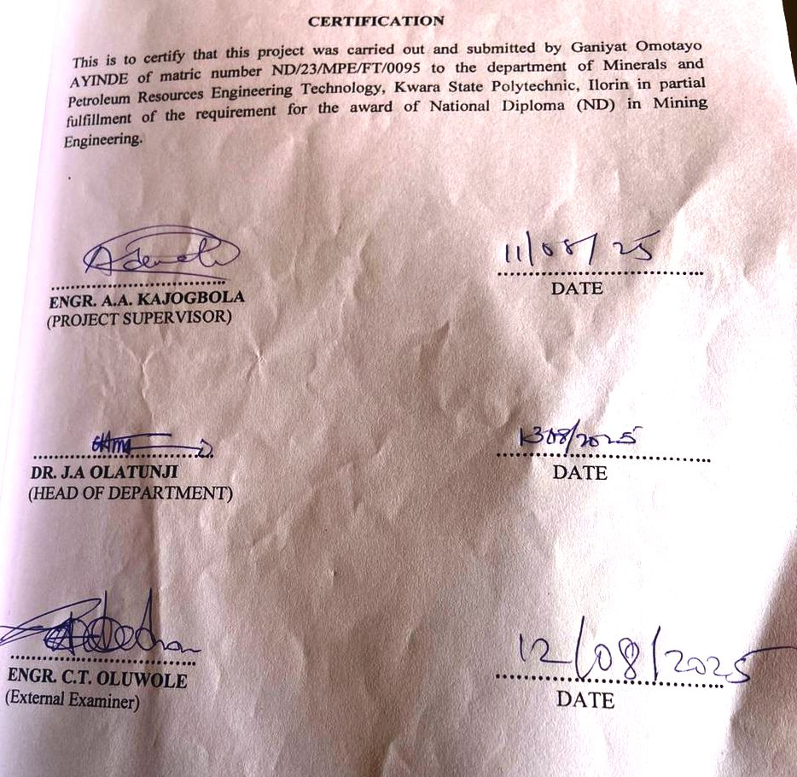

DEDICATION
This project is dedicated to Almighty Allah for his unfailing guidance and mercy toward me, because he has a solid pillar behind me. I also dedicate this to my ever loving parents.

ACKNOWLEDGEMENT
My Profound gantitude goes to the Almighty Allah for the successful completion of my program ,Also my deepest gratitude goes to my supervisor Eng, Kajogbola, and Eng, Usman, who provide detail criticism of the draft and help to correct necessary of the write up put before him.
I also thank Dr Olatunji, J.A. and entire member of staff of Department of Minerals and Petroleum Resources Engineering Technology, I appreciate the effort of brothers sisters and colleagues for their morally and financially support provided for me during the write up of this project.

TABLE OF CONTENT
Title page i
Certification ii
Dedication iii
Acknowledgement iv
Table of Content v
List of figures vi
List of Tables vii
Abstract viii
CHAPTER ONE
1.0 INTRODUCTION 1
1.1 Background of the Study 1
1.2 Statement of the Problem 2
1.3 Aim 3
1.4 Objectives 3
1.5 Justification of the Study 3
CHAPTER TWO
2.0 LITERATURE REVIEW 4
2.1 Overview of Lateritic Soil 4
2.2 Formation and Composition of Lateritic Soil 5
2.3 Physical and Engineering Properties of Lateritic Soil 5
2.4 Importance of Lateritic Soil in Road Construction 6
2.5 Factors Affecting the Suitability of Lateritic Soil for Road Construction 6
2.6 Standards and Guidelines for Soil Testing in Road Construction 6
CHAPTER THREE
3.0 MATERIALS AND METHODS 7
3.1 Description of Study Area (Muni LGA and Environs Ilorin) 7
3.2 Sample Collection and Preparation 7
3.3 Laboratory Test for Physical Properties 9
3.3.1 Particle Size Distribution (Sieve Analysis) 9
3.3.2 Atterberg Limits (Liquid Limit, Plastic Limit, and Plasticity Index) 14
3.3.3 Compaction Test (Proctor Test) 17
3.3.4 California Bearing Ratio (CBR) Test 18
3.3.5 Specific Gravity Test 18
3.3.6 Moisture Content Determination 19
CHAPTER FOUR
4.0 RESULT PRESENTATION AND DISCUSSION 20
4.1 Presentation of Result 20
4.2 Discussion of Findings 28
4.3 Comparison with Standard Specification for Road Construction 28
4.4 Implications of Findings on Road Construction in the Study Area 28
CHAPTER FIVE:
5.0 CONCLUSION & RECOMMENDATION 30
5.1 Conclusion 30
5.2 Recommendation 30
References 32
Appendix 34

LIST OF FIGURE
Figure 3.2a: Map showing the study area 8
Figure 3.2b: shows the photograph of the study area 9
Figure 4.1: Cumulative Particle size distribution curve for sample A,B&C 21
Figure 4.2: Cumulative Moisture content curve for sample A,B&C 22
Figure 4.3: Classification of the studied Lateritic soil using Casagrande
plot of Liquid Limit (%) versus Plasticity Index. 23
Figure 4.4: Cumulative curve of dry density/water contents 24
Figure 4.5a: Direct shear strength curve for soil sample 25
Figure 4.5b: Direct shear strength gradient curve for sample A 25
Figure 4.6a: Direct Shear Strength curve of the soil sample 26
Figure 4.6b: Direct shear strength gradient curve for sample B 26
Figure 4.7a: Direct Shear Strength curve of the soil sample 27
Figure 4.7b: Direct shear strength gradient curve for sample C 28

LIST OF TABLE
Table 1: Summary of particle size distribution of the studied samples 20
Table 2: Summary of measured properties 20
Table 3: Samples composition distributions of Soils in the Study Area 21
Table 4: SOIL Classification according to AASTHO (2019) 29

ABSTRACT
The study investigate lateritic soil samples from Maya community in Ilorin, Kwara State, Nigeria with the aim of utilizing in accordance with regulatory standard of Nigeria and geotechnical properties of lateritic soil asland filling and foundation materials forconstruction. Three bulk samples were collected at 0.3m deep from three different locations of which were subjected to laboratory analysis/test; specific gravity, particle size analysis, atterberg limit, shrinkage limit, moisture content test, compaction test and direct shear test. The result shows that specific gravity ranged from 2.89-3.02g/cm³, particle size analysis ranged for gravel (19-34%), sand (53-60%), silt (8-10%), clay (5-12%) and with fine percentages ranged from (13-21%), liquid limit (16.2-24.8%), plastic limit (11.3-14.6%), plasticity index (4.9-10.2%), shrinkage limit ranged from (3.4-5.1%), dry density (1.72-1.95%), direct shear test ranged from (16-598KN/m²). This result implies that the soil samples can be use as land fill and foundation in construction and soil classified as gravelly sand soil.

CHAPTER ONE
INTRODUCTION
1.1 BACKGROUND OF STUDY
Laterite is a multifaceted geological material abundant in iron and aluminum, resulting from the weathering of rocks in tropical and subtropical areas (Alexander & Candy, 1962; Maignien, 1966). The process of laterization involves the removal of silica and other soluble minerals, leading to an accumulation of iron and aluminum oxides (Ollier, 1991). Laterite is frequently encountered in Africa, Asia, and South America, where it has been utilized for centuries as a building material, soil enhancer, and iron ore source (Goudie, 2004). The formation of laterite involves intense weathering, which results in the development of a hardened crust rich in iron and aluminum oxides (Tardy, 1997). This crust can be several meters thick, providing a readily available source of iron ore (Goudie, 2004). The chemical makeup of laterite varies based on the parent rock and weathering conditions, typically comprising iron and aluminum oxides, kaolinite, and quartz (Scheumann). The distinctive properties of laterite render it an appealing material for various uses. Its high iron content imparts a characteristic reddish-brown hue and provides strength and durability (Schellmann, 1986). The porous structure of laterite also makes it suitable for water filtration and treatment (Buatta Charyaa et al., 2011). Furthermore, its capacity to retain nutrients and support plant growth makes it a valuable asset for agriculture (Lal, 2008). The potential applications of laterite are extensive, spanning from construction materials to environmental remediation (Bhattacharrya et al., 2011). Its durability and strength make it an attractive material for sustainable construction practices, while its ability to retain nutrients and support plant growth make it a valuable resource for agriculture (Onu, 2005). Moreover, laterite's porous structure and chemical properties render it useful for water filtration and pollution remediation (Bhattacharrya et al., 2011). Despite its potential, laterite remains underutilized in some regions. Research on its properties and applications has confirmed its widespread adoption (Tardy, 1997). This study seeks to address the knowledge gap and investigate the practical uses and benefits of laterite in various fields.
Road networks are vital infrastructure that significantly contribute to economic growth, facilitating the movement of people, goods, and services (Olayinyan et al., 2019). The Nigerian government has placed increasing emphasis on improving road infrastructure due to its critical role in national development. One of the commonly used materials in road construction is lateritic soil, particularly as sub-base and base layers. Lateritic soils have been extensively researched due to their chemical composition, physical behavior, and formation processes (Arinze & Ibe, 2017; Tijani et al., 2017). These soils are predominantly composed of iron and aluminum oxides and are typically found in tropical regions where intense weathering occurs. They form from the prolonged weathering of igneous, metamorphic, or sedimentary rock under suitable environmental conditions (Rahardjo et al., 2004).
1.2 STATEMENT OF THE PROBLEM
Despite the wide application of lateritic soil in road construction, there have been instances of pavement failures attributed to poor soil properties in many areas. The surrounding areas of Kwara Poly, Ilorin, are not exempted, as laterite quality demands a detailed investigation for its certainty and suitability for foundational materials.

1.3 AIM
The aim of this study is to investigate the suitability of lateritic soil of geotechnical properties for foundation applications
1.4 OBJECTIVE
- To determine the physical properties of the laterite.
- To compare the test results against standard specifications for foundational materials.
1.5 JUSTIFICATION OF STUDY
Evaluating the physical properties of lateritic soils will provide valuable data for better design and construction in the study area. It will minimize road failures, reduce maintenance costs, and enhance road safety.

CHAPTER TWO
LITERATURE REVIEW
2.1 OVERVIEW OF LATERITIC SOIL
According to G.O. Adunoye and S.A. Kolapo (2018), a geotechnical assessment of selected soils in the Central Local Government was conducted, revealing their suitability as materials for fill and subgrade in road construction. Correlations also exist between the engineering properties of unused lateritic soils. The findings were valid for the specified procedure. Further investigation is recommended to determine the suitability of other borrow pits within the Central Local Government Area for engineering applications.
Akinwumi, Ayoola, and Agbude (2023) note that recent studies have shown that the suitability of laterite soil deposits can be evaluated by assessing their diverse engineering characteristics. The performance of lateritic soil prepared for application depends on various factors. According to Amuser (2011), laterite is a surface formation in tropical and subtropical regions, enriched in iron and aluminum, and develops through intense and prolonged weathering of the underlying parent rock.
Gonzalez and Ferrer (2011) observed that high moisture content and low temperature lead to intense chemical weathering, resulting in well-developed residual soil. The geotechnical behavior of laterite is influenced by its mineralogical composition, microfabric, and geotechnical environment. In areas with high iron and aluminum content, laterites often form in low-drainage conditions, characterized by high smectite clay content. Alternate wet and dry seasons favor the formation of lateritic soils, with leaching of the parent rock occurring during the wet season and capillary action transporting solutions to the surface during the dry season.
Thompson et al. (2012) reported pronounced laterization processes in tropical regions compared to arid regions, with adaptive formation of laterite observed in southwestern Nigeria compared to the black cotton soil of northeastern Nigeria. The parent rock material was found to significantly impact the formation of lateritic soil.
2.2 FOUNDATION AND COMPOSITION OF LATERITIC SOIL
Laterite forms through prolonged chemical weathering of rock under hot, humid conditions. This process causes soluble materials to leach, leaving behind iron and aluminum oxides. The soil's composition varies based on parent rock and environmental factors, typically including quartz, kaolinite, and sesquioxides.
2.3 PHYSICAL AND ENGINEERING PROPERTIES OF LATERITIC SOIL
Key properties include:
- Grain Size Distribution: Ranges from clay to gravel.
- Atterberg Limits: Indicates plasticity; affects workability.
- Moisture Content: Influences compaction and strength.
- Compaction Characteristics: Determines load-bearing capacity.
- California Bearing Ratio (CBR): Assesses suitability for sub-base layers.

2.4 IMPORTANCE OF LATERITIC SOIL IN FOUNDATION APPLICATION
Laterite is widely used in foundation applications for subgrade and sub-base layers due to its strength when compacted and cost-effectiveness. Its local availability reduces transportation costs and, with proper treatment, it provides a stable foundation.
2.5 FACTORS AFFECTING THE SUITABILITY OF LATERITIC SOIL FOR FOUNDATION APPLICATION
- Moisture Content: High moisture can reduce strength.
- Plasticity Index: High plasticity may lead to swelling.
- Grading and Fines Content: Affects compaction and drainage.
- Organic Matter: Presence can weaken the soil structure.
- Stabilization Needs: May require additives like cement or lime to enhance properties.
2.6 STANDARDS AND GUIDELINES FOR SOIL TEST IN FOUNDATION APPLICATION
Standard sources such as AASHTO and ASTM provide guidelines for testing soil properties like CBR, Atterberg Limits, and Compaction. These tests ensure the soil meets the necessary criteria for use in foundation application, ensuring durability and performance.

CHAPTER THREE
MATERIALS AND METHODS
3.1 MATERIALS
The materials involves in the samples taken were digger, spade, polytene bags, masking tape, marker, pan, Global Positioning System (GPS) and writing materials such as pen and exercise book.
3.2 METHODS
3.2.1 Description of the study area
The study area is located in Manya, East Local Government area of Kwara State. The Lateritic soil is buried and exposed around in the study area, the site is on Latitude N8˚11ʹ53ʺ and Longitude E4˚47ʹ42ʺ for location A, Latitude N8˚26ʹ32ʺ and Longitude E4˚36ʹ36ʺ for location B while N8˚26ʹ39ʺ and Longitude E4˚36ʹ42ʺ for location C. The study area is accessible through local road.
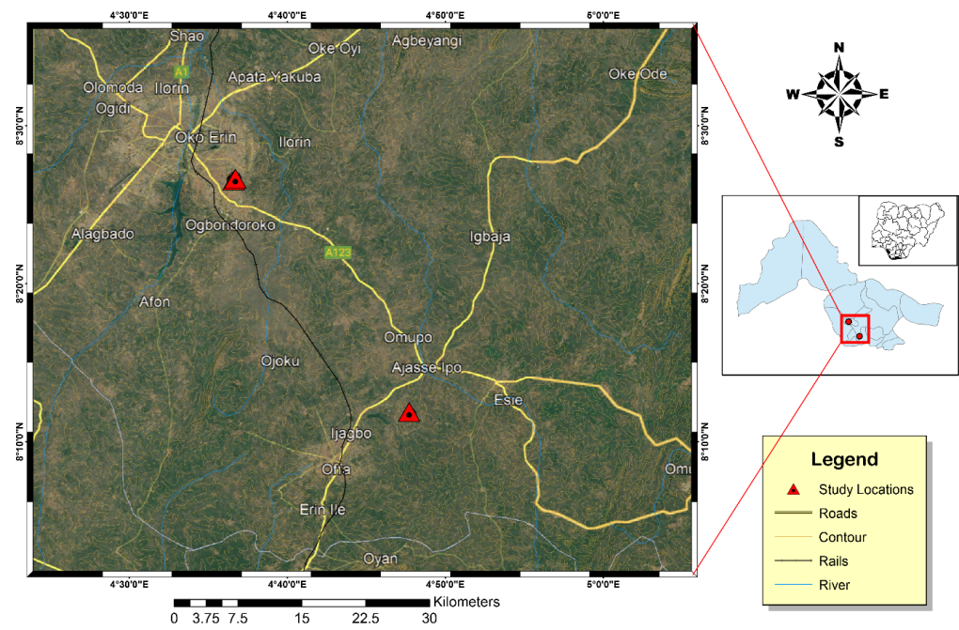
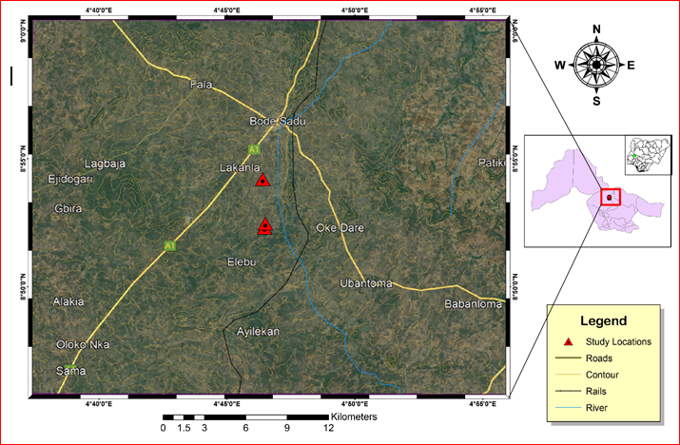
Figure 3.2a: Map showing the study area

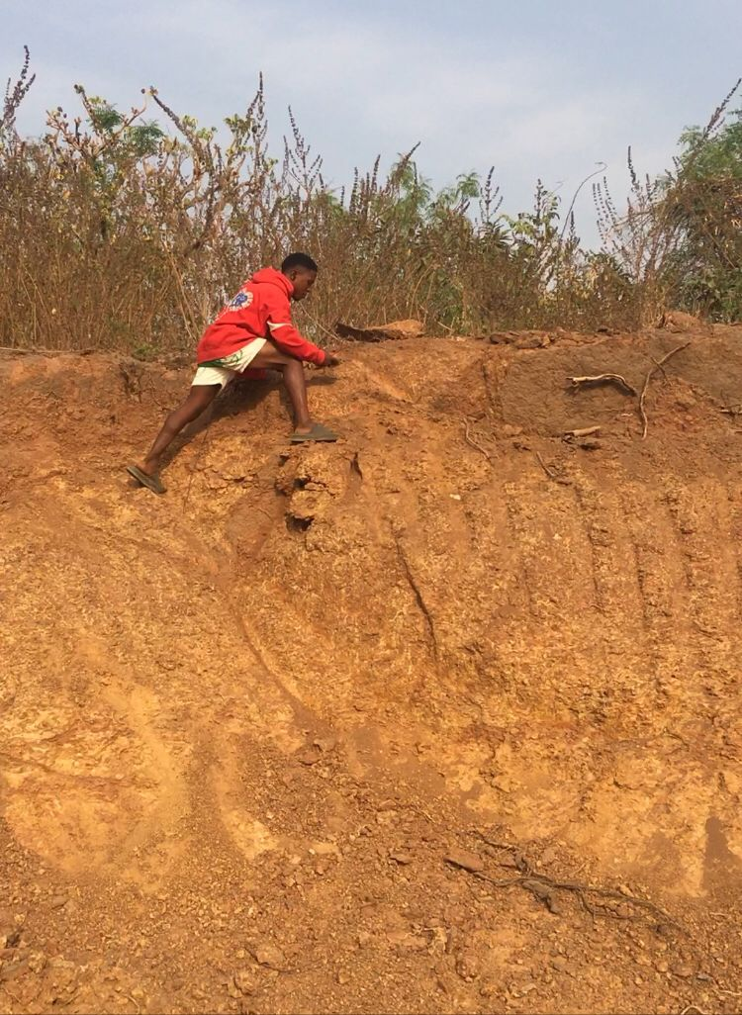
Figure 3.2b: shows the photograph of the study area
3.2.2 Sample Preparation
The samples were pulverized sieved at the department of geology and mineral sciences laboratory, University of Ilorin.
3.2.3 Sample Analysis
The samples were subjected to various analysis such as particle size distribution, atterberg consistency limit, compaction test, free swelling potential, and compressibility.
3.2.3.1 BULK AND DRY DENSITIES
3.2.3 .1.1 Bulk DENSITY
Bulk density is defined as the mass of the soil divided by its volume, it is the weight of representative wet soil sample to the volume of the mould containing such sample. It is expressed as mass per unit volume (i.e. g/cm³). It helps to determine how heavy the soil sample is and to determine the bearing capacity of the soil i.e. the mount of the load the soil can carry successfully.
APPARATUS USED
Mould
Weighing balance
Drying oven
Spatula and pestle
PROCEDURE
An empty mould is weighed (i.e. weight of mould)
- The volume of the mould was also determined (V)
- The mould is then filled with fresh soil sample, consolidated and weighed (i.e. weight of mould + soil)
- The weighed of the wet soil was calculated by subtracting the weight of empty mould from the weight of wet soil and mould
- The bulk density was deduced using the formula below:
ϒ = W/V
W = weight of representative wet soil sample
V = volume of mould
3.2.3.2 DRY DENSITY
Dry density is defined as the ratio of the weight of the dry soil sample to the volume of the mould containing the dry soil sample.

APPARATUS USED
Weighing balance
Drying oven
Spatula
Pan
Desiccator
PROCEDURE
- An empty pan was weighed
- A known volume of the mould from bulk density determination was taken (V)
- The mould with fresh soil sample being consolidated was discharged into the pan for oven drying at 110⁰C until water was completely expelled
- The weighed of the dry soil was calculated by subtracting the weight of empty pan from the weight of dry soil and pan
- The dry density was deduced using the formula below:
ϒ = W/V
W = weight of representative dry soil sample
V = volume of mould
3.2.3.3 SPECIFIC GRAVITY DETERMINATION
APPARATUS USED
Density bottle
Measuring cylinder
Weighing balance

PROCEDURE
- An empty measuring cylinder was weighed as (W₁)
- It is then filled with soil to about 1/3 of its volume, then its weight together with the soil was taken as (W₂)
- The water was added to the soil in the measuring cylinder, the weight of the cylinder with both soil and water was taken as (W₃)
- Empty the measuring cylinder, fill it with distilled water and its weight was taken as (W₄).
- Specific gravity was calculated using the formulae below
(W₂ -W₁)/ (W₄ -W₁) – (W₃ -W₂) X 100
3.2.3.4 GRAIN SIZE ANALYSIS
Grain size refers to the diameter of the soil particles that make up the soil mass. This analysis covers the quantitative determination of the various sizes of these soil particles, their proportions to the nearest percentage and the distribution of the various grain sizes that makes up the soil.
Grain size analysis is a very important analysis, which is done in an attempt to describe a soil type. A roughly concluded result is made by the physical description of the soil particles grain distribution, but a more accurate result is gotten by performing the laboratory analysis. This analysis is done in order to know the accurate distribution of the various grain sizes that make up the soil, and helps to solve the problem of confusion between silt and clay. This method entails mechanical and hydrometer analyses respectively.
3.2.3.4.1 MECHANICAL SIEVE ANALYSIS
The sieve analysis involves shaking of the soil sample through a set of sieves that have progressively smaller openings. This method is used in the analysis of particles greater than 0.075mm in diameter. It provides a means of evaluating the different grain size types present in soil sample.
APPARATUS USED
- Stack of sieves
- Mechanical sieve shaker
- Drying oven
- Collecting pan and cleaning brush
- Weighing balance
PROCEDURE
(a) The soil particles were gently disaggregated
(b) The sieve set (i.e. stack of sieves) were arranged in descending order from the top with a retainer beneath it.
(c) 100g of the soil was weighed and poured into the sieve stack.
(d) The sieve stack was then placed on the mechanical sieve shaker for about 10 minutes
(e) The sieve stack was now separated one by one, then the soil fraction retained in each sieve was weighed and recorded
(f) A statistical data of the result of the analysis was prepared.
3.2.3.4.2 HYDROMETER ANALYSIS
This method is used in the determination of the grain distribution of fine-grained soils with soil particles of the order of clay and soil. This method is not applicable if less than 10% of the soil passes through sieve size of 0.075mm mesh size.
APPARATUS USED
- Hydrometer bulb
- Measuring cylinder
- Drying oven
- Thermometer
- Evaporating dish
PROCEDURE
(a) The sieved clay and silt from the sieve washing were collected in a container and allowed to settle
(b) The supernatant water was decanted and the mud residue was dried in the drying oven for about 24 hours
(c) The dried sample was then pulverized, 50g of it was weighed and dissolved in one liter of water in a measuring cylinder. The water has dissolved in it sodium hexametaphosphate to enhance rate of clay settlement.
(d) The hydrometer bulb is then inserted into the water in the measuring cylinder and its reading was recorded periodically.
(e) As the settling proceeds, the hydrometer sinks into the solution
(f) The temperature at each hydrometer reading was recorded and then a statistical data was produced.
(g) Then, the percentage passing was plotted against diameter to obtain the percentage composition of the studied soil samples.

      - ATTERBERG CONSISTENCY LIMITS
3.2.3.5.1 LIQUID LIMIT DETERMINATION
APPARATUS USED
- Casagrande liquid limit device (made up of a cup, a rotating handle, counter and a cutting groove)
- Pestle and mortar
- Spatula
- Moisture can
- Wash bottle with distilled water
- Sieve 0.425mm
- Oven
- Glass plate
PROCEDURE
(a) A dried, fresh soil sample is pounded using the pestle and mortal
(b) The sample was sieved using the 0.425mm sieve size, 300g of the sieved sample was weighed and water was added to it until a stiff paste was produced.
(c) The stiff paste was packed into the Casagrande apparatus and then had the surface leveled and smoothened using the spatula.
(d) A groove in the soil was made with cutting groove and rotated the handle (blows) until the groove close. (Note that the number of revolutions the handle makes blows is recorded by the counter). The minimum number of blows is 10 while the maximum is 50.
(e) A small paste was scooped into the moisture can with the spatula, weighed and dried in the drying oven for 24 hours and then reweighed in order to determine its water content.
(f) The soil is then emptied from the cup into the glass plate and water is added to the soil and the process is performed all over again.
(g)The water contents (%) were plotted against numbers of blow (N), water content corresponding to 25 number of blows is the liquid limit
        - PLASTIC LIMIT DETERMINATION
APPARATUS USED
- Glass plate
- Moisture can
- Spatula
- Wash bottle with distilled water
- 0.425mm sieve
- Thermostat oven
PROCEDURE
(a) A small part of the paste in the Casagrande cup is scooped and rolled into a ball
(b) The ball is placed on the glass plate and rolled into thread until it breaks
(c) The crumbled threads are put into two different moisture cans. Then, the cans with crumbled soil sample were oven dried for 24 hours so as to determine the moisture content of each sample, which was taken as plastic limits.
3.2.3.5.3 LINEAR SHRINKAGE DETERMINATION
(a) The soil sample was thoroughly mixed with distilled water
(b) A linear container of known length was taken and lubricated for easy removal of the soil sample
(c) The container was then filled with the soil sample and its original length was measured before it was oven dried for about 24 hours
(d) The container was allowed to cool in a desiccator, and then the final length of the dried soil sample is measured.
(e) The linear shrinkage of the studied soil samples was calculated using the formula below:
LS = change in length x 100
Original length
3.2.3.5 COMPACTON TEST
APPARATUS USED
- Mixing pan
- Weighing balance
- Drying oven
- Moisture can
- Spatula
- Compaction rammer and mould (consisting of base plate, cylinder mould andextension collar).
PROCEDURE
(a) 3kg of soil sample was weighed and poured into the mixing pan
(b) 120cm³ (4%) of water was measured, added and mixed with the soil in the mixing pan with the use of spatula.
(c) The cylinder mould is then placed on a base plate, then a representative specimen of the soil is put into the mould and compact with 25 evenly distributed blows of rammer. This represents the first layer.
(d) After the compaction, the volume of the soil in the mould reduced, more soil specimen was added into the mould and compacted with another 25 evenly distributed blows.
(e) The extension collar is then fixed unto the mould. This is mainly for the last layer and removed after the last layer is made to be able to achieve a smooth level surface of the last layer.
(f) The mould is filled with more of the soil specimen and compacted to make the third layer.
(g) The mould with the soil is weighed and the soil sample at the top and bottom of the mould were taken for water content and dry density determination respectively.
(h) The soil in the mould is emptied into the mixing pan and another 120cm³ (4%) of water is added to the soil and mixed
(i) This process was now carried out four more times
(j) Then, the compaction curves were gotten by plotting dry densities against water contents.
3.2.3.6 DIRECT SHEAR STRENGTH
The shear strength of a soil may be defined as the resistance to shearing stresses and a consequent tendency for shear deformation. This test involves putting the soil specimen into a box that splits across its middle with a confined pressure alongside a shear force applied to the soil so as to cause a relative displacement between the two parts of the box i.e. the failure plane is made to occur at a predetermined location. A normal stress, which is due to an applied vertical load and a shearing stress, which is due to the confining pressure, acts on the failure plane. Granular soils of sands derive their shear strength from resistance due to interlocking of particles and frictional resistance between the individual soil grains, while fine grained soils exhibit their shear strength from frictional resistance between the individual soil grains and adhesion or cohesion between soil particles (Poulas, 1982). The shear strength test was performed in order to determine the shear strength parameters which are the angle of internal friction and the cohesion of the soil samples. The angle of internal friction is largely dependent on the internal density of the soil and it reduces with increase in confined pressure.
APPARATUS USED
- Direct shear machine
- Compaction mould
- Compaction rammer
- Surcharge weight
- Mixing pan
PROCEDURE
(a) 3kg of the soil sample was weighed and mixed with the corresponding optimum moisture content for the standard proctor for each soil sample.
(b) The soil samples were then compacted, a square sampler was gently used to collect a representative sample from each sample, then the collected sample was placed in a shear box and a load was placed on top of it. The dial gauges were set at zero.
(c) A set of normal loads of 5kg, 10kg, 15kg and 20kg were applied one after the other in successive tests
(d) The readings on the load dial units are taken, and the procedure is repeated for all the soils.
(e) The plots of shear stress against normal stress for all the soil sample were made to deduce both the angle of internal friction and cohesion.

CHAPTER FOUR
4.0 RESULTS PRESENTATION AND DISCUSSIONS
This chapter discusses the test conducted which include; particles size distribution, swelling properties, consistency index, atterberg consistency limits comprises of liquid limit, plastic limit, plasticity index and shrinkage limit water content, compaction test, and shear strength test as well as the interpretations.
4.1.1 GRAIN SIZE ANALYSIS
Table 1: Summary of particle size distribution of the studied samples
Sample code | Dry Sieving(% passing) |  |  |  |  | Hydrometer (% passing)
Sample code | 6.0mm | 3.3mm | 2.0mm | 1.18mm | 0.6mm | 0.048mm | 0.002mm
A | 100 | 94.8 | 81.4 | 76.1 | 53.9 | 17.3 | 11.9
B | 100 | 93.5 | 79.8 | 65.7 | 54.2 | 13.4 | 6.1
C | 100 | 93.7 | 80.3 | 72.7 | 60.6 | 10.1 | 5.1

Table 2: Summary of measured properties
Properties | Sample A | Sample B | Sample C
Specific Gravity g/cm³ | 2.89 | 2.92 | 3.06
Moisture content (%) | 11.32 | 9.68 | 7.72
Liquid limit (%) | 24.8 | 19.6 | 16.2
Plastic limit (%) | 14.6 | 12.1 | 11.3
Plastic Index (%) | 10.2 | 7.5 | 4.8
Shrinkage limit (%) | 5.1 | 4.8 | 3.4
Direct Shear Strength(KN/m²) | 45 | 40 | 26
Dry Density (g/cm³) | 1.84 | 1.89 | 2.01
Table 3: Samples composition distributions of Soils in the Study Area
Sample code | Gravel (%) | Sand (%) | Silt (%) | Clay (%) | % Fine | Soil Classification
A | 19 | 60 | 9 | 12 | 21 | Gravelly Sand
B | 24 | 58 | 10 | 8 | 18 | Gravelly Sand
C | 34 | 53 | 8 | 5 | 13 | Gravelly Sand

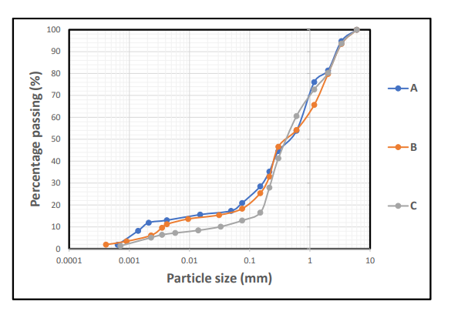
Figure 4.1: Cumulative Particle size distribution curve for sample A,B&C

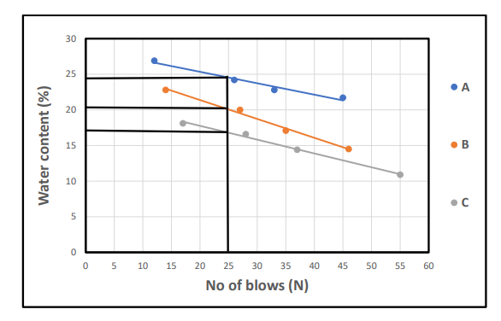
Figure 4.2: Cumulative Moisture content curve for sample A,B&C
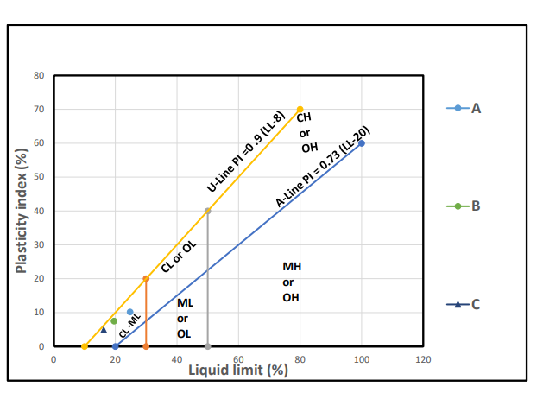
Figure 4.3: Classification of the studied Lateritic soil using Casagrande plot of Liquid Limit (%) versus Plasticity Index.

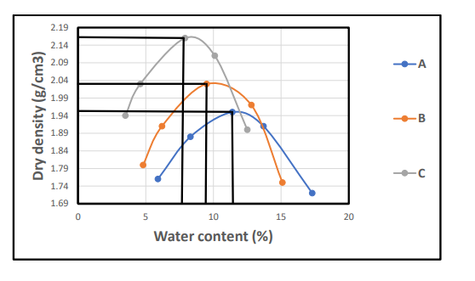
Figure 4.4: Cumulative curve of dry density/water contents

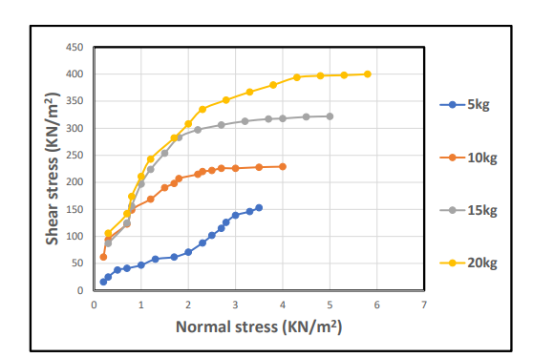
Figure 4.5a: Direct shear strength curve for soil sample
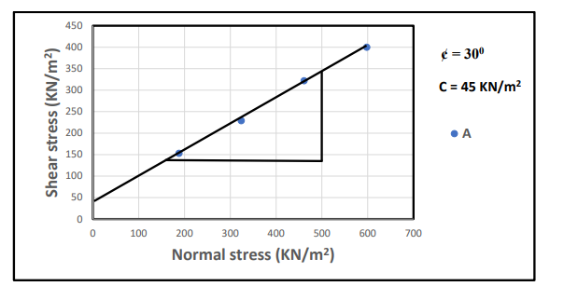
Figure 4.5b: Direct shear strength gradient curve for sample A
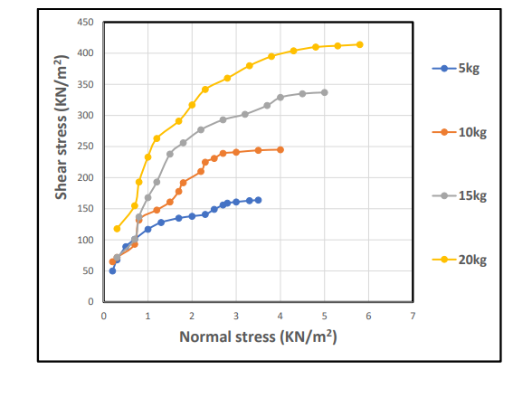
Figure 4.6a: Direct Shear Strength curve of the soil sample
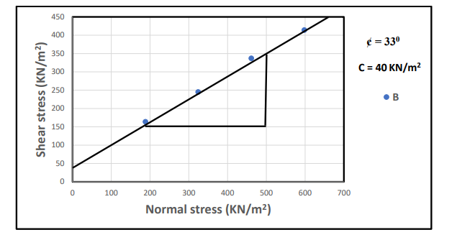
Figure 4.6b: Direct shear strength gradient curve for sample B

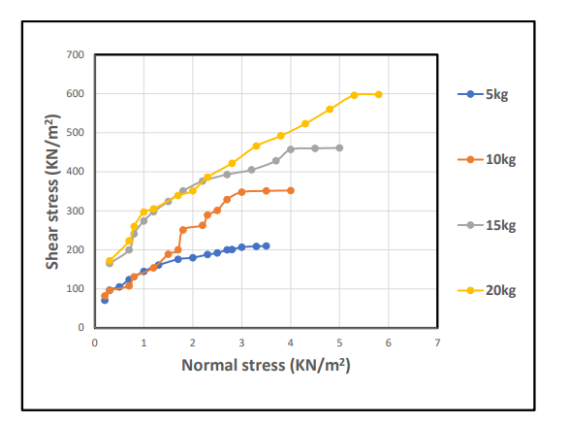
Figure 4.7a: Direct Shear Strength curve of the soil sample
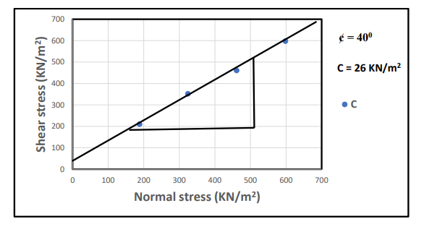Figure 4.7b: Direct shear strength gradient curve for sample C

Discussions
The analysis carried out on the study samples for particle size distribution is shown in the Table 1 and Figure 4.1 with average percentage composition of sand 57%, silt 9%, clay with 8.3%, gravel is 25.7% and fine percentage is 17.3% . This indicate that the studied sample is gravelly sand due to the lower percentage of fines with plasticity index less than 30% according to AASHTO classification (2019). These type of materials are good for sanitary landfills. The studied samples has low plasticity limit range from 11.3% to 14.6%, liquid limit from 16.2 to 24.8%, shrinkage limit values from 3.4 to 5.1%, specific value range from 2.89 to 3.06gcm³, direct shear strength range from 26 to 45KN/m² and less effect in engineering structures.
Table 3: Samples composition distributions of Soils in the Study Area

Sample code | Gravel (%) | Sand (%) | Silt (%) | Clay (%) | % Fine | Soil Classification
A | 19 | 60 | 9 | 12 | 21 | Gravelly Sand
B | 24 | 58 | 10 | 8 | 18 | Gravelly Sand
C | 34 | 53 | 8 | 5 | 13 | Gravelly Sand

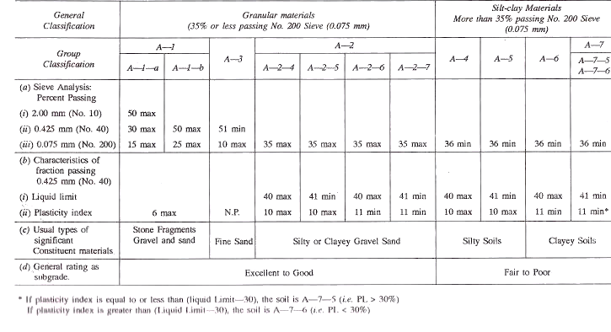
Table 4: SOIL Classification according to AASTHO (2019)

CHAPTER FIVE
5.1 CONCLUSION
Recent research has identified that the appropriateness of any type of lateritic soil deposit can usually be judged by a methodical study of the diverse engineering characteristics of the soil type relevant to a given structure. The performance of a lateritic soil type for foundation applications therefore depends on many factors.
The study on the engineering properties of lateritic soils as an important procedure of improving the performance of challenging soils makes lateritic soil perform better as civil engineering material. This is based on the effect of lime and cow bone ash. Laboratory tests were carried out to determine the effect of lime and cow bone ash as stabilization agents for the lateritic soil. It was observed that additional amounts of cow bone ash and lime caused the beneficial improvement of the result obtained from the CBR, compaction and Atterberg limit test on the lateritic soil samples. It was also observed that the mechanical properties of stabilized soil vary and depend on the percentage of stabilizers used.
The result indicates that the CBR of the sample improves optimally at 8% CBR and 5% lime stabilization additives in lateritic soil samples.
5.2 RECOMMENDATION
Lateritic materials are economically available and its energy efficiency when combined with other local stabilization materials in developing countries help in improving strength. It is recommended from the research that the stabilization of lateritic soil samples with foundation application (CBR) and lime should be explored for use in foundation applications. Consideration should be given to the following:
* Much effort should be placed on study means and materials for stabilizing lateritic soil for foundation application along this region.
* Suitable test procedures that properly evaluate these stabilization materials should be proposed for the construction of foundation.

REFERENCES
Adunoye, G. O., & Kolapo, S. A. (2018). Geotechnical assessment of selected soils in the Central Local Government.

Akinwumi, I. I., Ayoola, A. O., & Agbude, P. O. (2023). Suitability of laterite soil deposits.

Alexander, L. T., & Candy, J. (1962). Formation of laterite.

Amuser, P. (2011). Laterite formation in tropical and subtropical regions.

Arinze, I. E., & Ibe, S. C. (2017). Chemical composition and physical behavior of lateritic soils.

Bhattacharrya, P. et al. (2011). Potential applications of laterite.

Buatta Charyaa, S. et al. (2011). Water filtration and treatment using laterite.

Gonzalez, A., & Ferrer, C. (2011). Geotechnical behavior of laterite.

Goudie, A. S. (2004). Laterite as a building material and iron ore source.

Lal, R. (2008). Laterite's capacity to retain nutrients and support plant growth.

Maignien, R. (1966). Formation of laterite.

Olayinyan, O. et al. (2019). Road networks and economic growth.

Ollier, C. D. (1991). Laterization process.

Onu, G. (2005). Laterite's durability and strength.

Rahardjo, H. et al. (2004). Formation of lateritic soils.

Scheumann, K. (n.d.). Chemical composition of laterite.

Schellmann, W. (1986). High iron content and strength of laterite.

Tardy, Y. (1997). Formation of laterite and its applications.

Thompson, O. et al. (2012). Laterization processes in tropical regions.

Tijani, M. N. et al. (2017). Chemical composition and physical behavior of lateritic soils.

APPENDIX 1
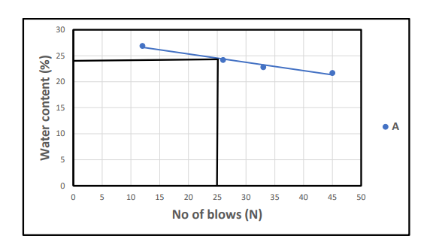

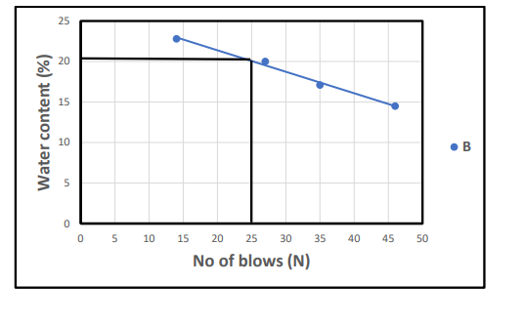

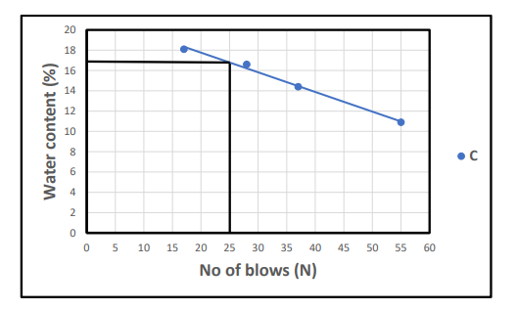

APPENDIX 2
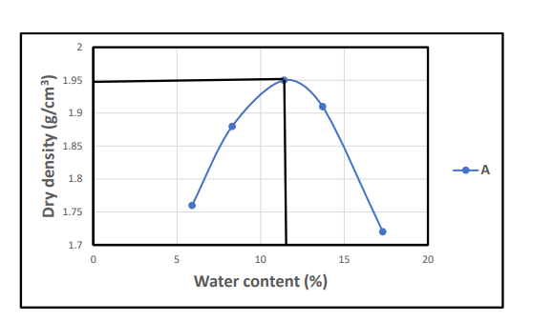

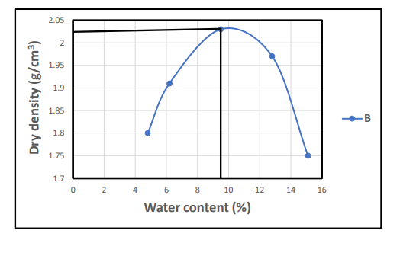

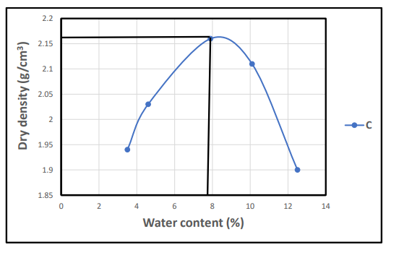

APPENDIX 3

