EFFECT OF ORGANIC AMENDMENTS ON SOIL MYCOBIOME
BY
JIMOH FAIDAT

HND/23/SLT/FT/0644

A PROJECT SUBMITTED TO THE DEPARTMENT OF SCIENCE LABORATORY TECHNOLOGY, INSTITUTE OF APPLIED SCIENCES (IAS), KWARA STATE POLYTECHNIC, ILORIN,
IN PARTIAL FULFILMENT OF THE REQUIREMENTS FOR THE AWARD OF HIGHER NATIONAL DIPLOMA (HND) IN SCIENCE LABORATORY TECHNOLOGY, INSTITUTE OF APPLIED SCIENCES (IAS), MICROBIOLOGY UNIT
KWARA STATE POLYTECHNIC ILORIN
JULY, 2025

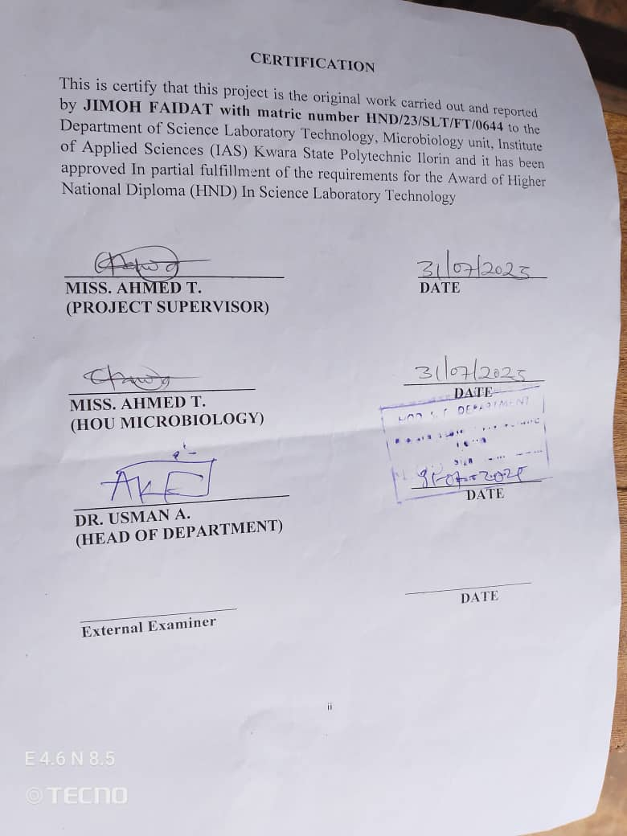

DEDICATION
This project is dedicated to Almighty Allah, the provider and sustainer of life, Whose grace has made this journey of my Higher National Diploma (HND) possible, and also to my sponsors Mr &Mrs Jimoh my greatest supporter and strength. May Allah continue to bless, protect and guide you both .

ACKNOWLEDGEMENTS
First and foremost, I say Allihamdullilah Robillialeamin for giving me
strength, wisdom and grace to pass through the successful completion of this project.
With humility and appreciation, my heartfelt gratitude goes to my amiable supervisor, Mrs. Ahmed Tawakalitu (HOU) and my supporter Mr &Mrs Jimoh for their patience, consistent, encouragement, guidance support throughout the course of this work.
I extend my heartfelt gratitude to the Head of Department, all my lecturers and entire staffs of the Department of Science Laboratory Technology , Kwara State Polytechnic, my amiable class representative and assistance, and to all my course mates for their help, cooperation, dedication and contribution to impact knowledge, which helps shaped my academic growth and learning. May Allah bless you all abundantly.
My appreciation also goes to my lover(Muideen) ,my family (Mr &Mrs Muideen ), and all my friends for the support throughout my academic journey, thank you for being my pillar of strength and encouragement. Your love, understanding and prayers meant everything to me.
I appreciate my humble self, the little soul in me for not getting tired of this journey of my life, and I thank God almighty for always being my greatest pillar, I pray Almighty Allah continue to guide and protect me in everything I do in the remaining journey of life .
My appreciation also goes to my Sister (Jimoh Medinat) thank you all for your guidance and support, to make this journey successful I pray Almighty Allah will always be with you and reward you all for all your efforts on me. And also I’ll like to give a big thanks to my friends, the ones I always run to when everything is down, my good friends, Raji Asmau, Lawal Waliyat and others whose love,support, and encouragement have been a constant source of inspiration to keep pushing. May Allah perfect all that concerns you all. And to everyone that sees me throughout this journey, Almighty Allah bless you all.
Lastly, I extend my heartfelt thanks and blessings to my fellow project group members for their helping hands and support, I am deeply grateful. May Allah bless us abundantly on our individual journeys.
May the Almighty crown the labor of everyone who played a role in this journey with success , favor , and countless blessings

TABLE OF CONTENTS
TITLE PAGE i
CERTIFICATION ii
DEDICATION iii
ACKNOWLEDGEMENTS iv
TABLE OF CONTENTS v-vi
LIST OF TABLES vii
ABSTRACT viii
CHAPTER ONE 1
1.0 INTRODUCTION 1
1.1 Literature review 7
1.2 Statement of problem 10
1.3 Aim 11
1.4 Objectives 11
CHAPTER TWO 12
2.0 Materials and Methods 12
2.1 Materials 12
2.1.1 Media and Reagents 12
2.2 Preparation of Sample 13
2.3 Preparation of Media 14
2.4 Isolation of Fungi 14
2.5 Macroscopic Examination 15

2.6 Microscopic Examination of Fungi 16
CHAPTER THREE 17
3.0 RESULTS 17
3.1 Physicochemical Characteristics of the Soil. 17
3.2 Fungal Colony Count in Soil Samples 18
3.3: Fungal Colony Characteristics and Enumeration 18
CHAPTER FOUR 21
4.0 DISCUSSION AND CONCLUSION 21
4.1 DISCUSSION 21
4.2 CONCLUSION 24
REFERENCES 25

LIST OF TABLES
Table 1: Physico-Chemical Characteristics of the Soil………………...17
Table 2: Colony Count on Fertilized and Non-Fertilized Soil Samples.18
Table 3: Fungal Observation in Fertilized Soil Samples……………….19
Table 4: Fungal Observation in Non-Fertilized Soil Samples………….20

ABSTRACT
Soil mycobiomes fungal communities that reside within the soil—play an essential role in nutrient cycling, soil structure stabilization, and overall plant health. This study investigated the impact of different organic amendments (including cow dung, poultry waste, and liquid fertilizers such as Disza and Foliar) on the diversity, structure, and activity of fungal communities in soil samples collected from five agricultural sites within Kwara State Polytechnic, Ilorin, Nigeria. Physicochemical analyses revealed that organic amendments significantly influenced soil properties, particularly pH ranging from 5.0 to 6.0, texture was crumbly and Gritty. The fungal colony count was consistently higher in amended soils, showing greater fungal biomass 4.5x10⁻⁴ colonies compared to control soil 5.0x10⁻³colony. Microscopic and macroscopic identification confirmed the dominance of fungal genera such as Aspergillus, Rhizopus, Mucor, Penicillium, and Trichoderma, particularly in organically enriched environments. Results indicate that organic inputs promote the proliferation of beneficial saprophytic fungi and enhance soil biodiversity, aligning with recent studies that highlight the ecological benefits of organic amendments over synthetic alternatives. However, shifts in fungal composition also depended on soil type and the nature of the organic input. This study underscores the potential of organic amendments to sustainably enrich soil fungal communities, improve soil fertility, and support eco-friendly agricultural practices

CHAPTER ONE

1.0 INTRODUCTION
Soil mycobiome refers to the diverse community of fungi inhabiting the soil ecosystem, playing critical roles in nutrient cycling, soil structure maintenance, and plant health (Li et al., 2021). Fungi in soil act as decomposers, pathogens, symbionts, and saprophytes, influencing the biotic and abiotic properties of soil. Understanding the dynamics of soil fungal communities is essential to improving soil fertility and sustainable agricultural productivity (Zhang et al., 2020). Organic amendments, including compost, manure, biochar, and green manure, have been widely recognized for their capacity to alter soil microbial communities and improve soil health (Kaur et al., 2022).
Organic amendments serve as a source of nutrients and organic carbon, fostering beneficial microbial growth, especially fungi, which contribute to the breakdown of complex organic materials (Wang et al., 2021). They enhance soil physicochemical properties such as water retention, porosity, and pH, indirectly affecting fungal community structure and functions (Singh et al., 2021). These amendments differ from synthetic fertilizers by improving microbial diversity and activity sustainably, which is vital for long-term soil health (He et al., 2022). Given their eco-friendly nature, organic amendments have gained interest for mitigating the negative impacts of intensive agriculture on soil microbial ecosystems (Zhou et al., 2020).
The soil mycobiome includes diverse functional groups such as mycorrhizal fungi, saprotrophs, and pathogens (Niu et al., 2021). Mycorrhizal fungi establish symbiotic relationships with plant roots, enhancing nutrient uptake and stress tolerance (Gupta et al., 2023). Saprotrophic fungi decompose organic residues, recycling nutrients into the soil, while pathogenic fungi can cause diseases detrimental to crops (Yang et al., 2022). The balance among these groups is crucial and influenced by soil management practices, including organic amendments (Mendes et al., 2021).
Organic amendments can stimulate beneficial fungal taxa, enhancing nutrient cycling and soil aggregation (Raza et al., 2020). For instance, the addition of compost has been shown to increase fungal biomass and diversity, promoting soil health and plant growth (Chen et al., 2021). Biochar, a form of charcoal applied to soils, alters soil pH and nutrient availability, which in turn affects fungal community composition and functions (Li et al., 2022). These shifts in the mycobiome can lead to improved soil resilience against environmental stresses such as drought and pathogen invasion (Khan et al., 2023).
The impact of organic amendments on the soil mycobiome is not uniform and depends on factors such as amendment type, application rate, soil type, and climatic conditions (Wang et al., 2022). For example, manure amendments can increase the abundance of coprophilous fungi, which specialize in degrading animal waste, while green manures may boost arbuscular mycorrhizal fungi associated with plant roots (Zhao et al., 2021). Hence, it is critical to understand these interactions to optimize organic amendment use in various agricultural contexts.
Advances in high-throughput sequencing and metagenomics have revolutionized the study of soil fungal communities (Xu et al., 2020). These techniques allow detailed characterization of the mycobiome, revealing shifts in fungal diversity and functional potential in response to organic amendments (Fernández et al., 2022). Metagenomic data also help identify key fungal taxa involved in nutrient cycling and disease suppression, guiding management strategies to promote beneficial fungi (Patel et al., 2021).
Soil fungi contribute significantly to carbon sequestration by decomposing organic matter and stabilizing soil organic carbon (SOC) pools (Zhang et al., 2021). Organic amendments can enhance fungal-mediated carbon stabilization processes, contributing to climate change mitigation (Sun et al., 2023). By fostering a diverse mycobiome, these amendments improve soil carbon storage and reduce greenhouse gas emissions from soils (Wang et al., 2023).
The use of organic amendments also influences fungal-pathogen dynamics in soil ecosystems (Liu et al., 2020). Amendments such as compost can suppress soil-borne pathogens by promoting antagonistic fungi and enhancing microbial competition (Guo et al., 2022). This disease-suppressive effect reduces the need for chemical fungicides, supporting sustainable crop production (Chen et al., 2023). Understanding these mechanisms is key to developing integrated pest management strategies using organic inputs.
Organic amendments impact soil enzyme activities linked to fungal metabolism, such as cellulases and ligninases, which break down complex plant materials (Sharma et al., 2021). Enhanced enzymatic activity improves nutrient release and availability, facilitating plant growth (Patil et al., 2022). Thus, changes in fungal enzyme production under organic amendment regimes are indicators of improved soil health and fertility (Wang et al., 2020).
In addition to nutrient cycling, fungi contribute to soil aggregation by producing extracellular polysaccharides that bind soil particles (Kumar et al., 2021). Organic amendments increase fungal biomass and activity, which strengthens soil structure and reduces erosion (Zhao et al., 2022). Better soil aggregation improves aeration and water infiltration, critical for root development and microbial habitat stability (Singh et al., 2023).
While organic amendments benefit the soil mycobiome, improper or excessive use can lead to nutrient imbalances and promote opportunistic fungal pathogens (Cheng et al., 2022). For example, excessive manure application may increase the abundance of fungi associated with antibiotic resistance genes, posing environmental and health risks (Wang et al., 2021). Therefore, balanced and well-managed application rates are essential to harness benefits while minimizing negative impacts (Li et al., 2020).
Climate change and land use changes further complicate the effects of organic amendments on soil fungi (Zhou et al., 2021). Rising temperatures and altered precipitation patterns influence fungal growth and community dynamics (Gao et al., 2023). Organic amendments may buffer some of these impacts by maintaining soil moisture and organic carbon, but adaptive management practices are needed to sustain fungal diversity under changing conditions (Luo et al., 2022).
This study aims to elucidate the specific effects of different organic amendments on the diversity, structure, and functional potential of soil mycobiomes under controlled agricultural conditions. Understanding these interactions will support the development of sustainable soil management practices that enhance soil fertility and crop productivity while preserving microbial biodiversity (Singh et al., 2020). It also aligns with global efforts to promote eco-friendly agriculture and mitigate environmental degradation.
The soil mycobiome is a crucial component of soil ecosystems, significantly influenced by organic amendments. These amendments can enhance beneficial fungi, improve soil health, and contribute to sustainable agriculture (Kaur et al., 2022). However, their effects depend on multiple factors requiring detailed study to optimize their use. This project will contribute to filling the knowledge gap on organic amendments’ role in shaping the soil mycobiome and provide practical recommendations for agricultural management.

1.1 Literature review
According to Zhang et al. (2019), organic amendments such as compost, green manure, animal waste, and crop residues significantly influence the soil mycobiome by enriching fungal populations and enhancing diversity. These amendments provide organic carbon and essential nutrients that support fungal growth and activity. Fungi play a pivotal role in decomposing organic matter and facilitating nutrient cycling in the soil. The increased availability of energy sources in organically amended soils creates a favorable environment for symbiotic fungi like arbuscular mycorrhizal fungi (AMF) and saprophytic fungi, thereby contributing to soil fertility and structure improvement.
According to Bonanomi et al. (2020), the composition of the soil fungal community is often reshaped following the application of organic amendments. For example, compost application has been found to stimulate the growth of beneficial fungal genera such as Trichoderma and Penicillium, which possess antagonistic properties against plant pathogens. These fungi help protect crops by producing antibiotics, competing for nutrients and space, and improving plant immune responses. In contrast, synthetic fertilizers may suppress fungal diversity by altering soil pH and creating nutrient imbalances, thereby underscoring the ecological benefits of organic alternatives.
According to recent ecological assessments, enhanced fungal diversity resulting from organic amendment use contributes significantly to various soil ecosystem functions. Fungi, especially mycorrhizal species, help stabilize soil structure by producing glomalin and forming hyphal networks that bind soil particles. This structural stability improves water retention and aeration, while also reducing erosion. Moreover, the fungal-mediated increase in soil organic matter aids in carbon sequestration, which contributes positively to climate change mitigation and overall environmental health.
According to Sun et al. (2021), however, not all effects of organic amendments on the soil mycobiome are beneficial. The type, source, and decomposition stage of the amendment influence whether it promotes beneficial or harmful fungi. For instance, the application of raw or partially decomposed animal manure has been associated with the proliferation of fungal pathogens such as Fusarium and Aspergillus, which can negatively affect crop productivity and soil quality. Therefore, it is essential to ensure that organic amendments are properly composted and applied at appropriate rates to prevent unintended ecological disturbances.
According to Lazcano et al. (2020), the advent of molecular tools such as high-throughput sequencing has expanded our understanding of how organic amendments affect the soil fungal community at both structural and functional levels. These tools have revealed that even short-term application of compost or manure can lead to significant changes in fungal diversity and function. For example, long-term organic input has been associated with an increase in lignin- and cellulose-degrading fungi, which are critical for organic matter turnover and the formation of stable soil carbon pools.
According to multiple studies, the judicious application of organic amendments holds great promise for sustaining soil health and microbial balance. When used correctly, these inputs enrich the soil mycobiome, enhance plant-microbe interactions, suppress pathogens, and improve nutrient availability. However, their effectiveness is context-dependent, requiring careful consideration of local soil conditions, crop needs, and amendment quality. Thus, understanding the dynamics between organic amendments and the soil mycobiome is crucial for developing sustainable agricultural practices and minimizing negative environmental impacts.

1.2 Statement of problem
Despite the vital role of soil fungi in nutrient cycling and plant health, modern agricultural practices often degrade fungal diversity and function. The excessive use of chemical fertilizers disrupts the natural soil mycobiome, leading to reduced soil fertility and ecosystem imbalance. There is limited understanding of how various organic amendments influence fungal communities in different soil types. This gap hinders the development of sustainable soil management strategies.

1.3 Aim
To investigate the impact of different organic amendments on the diversity, composition, and functional activity of the soil mycobiome, with the goal of enhancing soil health and sustainable agricultural productivity.

1.4 Objectives
- To evaluate the impact of different organic amendments on the diversity and abundance of soil fungal communities.
- To assess the changes in soil physicochemical properties following the application of organic amendments.
- To determine the correlation between soil mycobiome structure and soil fertility indicators under organic amendment treatments.

CHAPTER TWO

2.0 Materials and Methods

2.1 Materials
The materials used in this study included sterile glassware such as conical flasks, Petri dishes, foil paper, test tubes, dissecting trays, beakers, weighing balances, test tube racks, syringes, pipettes, and wire loops. Additional materials included aluminum foil for sealing containers, sterile polythene bags for soil sample collection, and cotton wool soaked in 70% ethanol for surface sterilization. Personal protective equipment (PPE) such as lab coats, gloves, and face masks were used to ensure aseptic conditions and the safety of laboratory personnel (Ali et al., 2021).

2.1.1 Media and Reagents
The culture media used included Potato Dextrose Agar (PDA) for fungal isolation and Nutrient Agar (NA) for bacterial growth. PDA was supplemented with streptomycin to suppress bacterial contamination. Other reagents included sterile normal saline for dilution, lactophenol cotton blue for fungal staining, and Gram staining reagents such as crystal violet, iodine, decolorizer, and safranin for bacterial identification (Adegbeye et al., 2020).

2.2 Preparation of Sample
Soil samples were collected from five agriculturally active sites within Kwara State Polytechnic, Ilorin, Nigeria, using sterile trowels and dissecting trays. The trowels were wrapped with aluminum foil during sampling, and soil was taken from a 5 cm depth to minimize surface contamination. Samples were stored in sterile polythene bags, labelled according to their collection sites (West End Region, Polytechnic Secondary School, Polytechnic Roundabout, Agricultural Garden, and IFMS Region), and transported immediately to the laboratory. Each soil sample (7 g) was sieved, moistened with 5 ml of distilled water, and incubated for 7 days. Following incubation, organic amendments were introduced: 0.1 ml of liquid fertilizers (Disza, Foliar, and floral fertilizer) and 5 g of organic wastes (cow dung and poultry droppings). Samples were further incubated at room temperature for 3 days to enhance microbial activity (Zhou et al., 2020; Oladele et al., 2022).

2.3 Preparation of Media
Work surfaces were sterilized with 70% ethanol. PDA (19.5 g) was dissolved in 500 ml of distilled water, stirred until fully mixed, boiled, and autoclaved at 121°C for 15 minutes. Nutrient Agar (14 g) was prepared similarly. After sterilization, PDA was cooled to approximately 45–50°C before adding 2.5 ml of streptomycin to inhibit bacterial contamination. The prepared media were poured aseptically into sterile Petri dishes and allowed to solidify (Yadav et al., 2021).

2.4 Isolation of Fungi
The spread plate technique was used for microbial isolation. One gram of each soil sample was homogenized in 9 ml of sterile normal saline. Serial dilutions (typically 10⁻³ and 10⁻⁵) were made, and 0.1 ml of the appropriate dilution was aseptically inoculated onto PDA (for fungi) and NA (for bacteria). Samples were spread evenly using a sterile glass spreader. Plates were incubated at 25°C for 72 hours for fungal growth and at 37°C for 24 hours for bacterial growth (Lal et al., 2020).

2.5 Macroscopic Examination
After incubation, microbial colonies were examined for morphological features such as colony color, margin, elevation, and texture. Distinct colonies were subcultured onto freshly prepared media to obtain pure isolates. Fresh PDA (19.75 g in 250 ml) and NA (7 g in 250 ml) were prepared, sterilized, and poured into 20 sterile Petri dishes each. Colonies were transferred using sterile wire loops and streaked on fresh media, labelled by location, and incubated (fungi at 25°C for 72 h; bacteria at 37°C for 24 h) (Amanullah et al., 2023).

2.6 Microscopic Examination of Fungi
Fungal isolates were examined microscopically using lactophenol cotton blue staining. A loopful of fungal colony was placed on a clean slide, stained with a drop of lactophenol cotton blue, and covered with a coverslip. The slide was examined under a microscope for structural features such as hyphae, spores, and fruiting bodies, which aided in fungal identification (Chakdar et al., 2021).

CHAPTER THREE

3.0 RESULTS

3.1 PHYSICOCHEMICAL CHARACTERISTICS SOIL SAMPLE.

Table 1: Physico-Chemical Characteristics of the Soil
Sample Location | Fertilizer Used | Treated pH | Control pH | Soil Type | Colour | Texture | Nature
Roundabout | Floral organic manure | 5.58 | 4.48 | Loamy soil (Roundabout) | Dark brown | Crumbly | Excellent
Agric Tech. Farm | Disza liquid fertilizer | 5.58 | 4.48 | Loamy soil (Agricultural Farm) | Dark brown | Crumbly | Excellent
IFMS | Foliar plus complete fertilizer | 5.58 | 3.78 | Sandy soil (IFMS) | Light brown | Gritty | Low
Secondary School | Poultry waste | 5.01 | 6.10 | Sandy soil (Secondary School) | Light brown | Gritty | Low
Western | Cow dung | 5.28 | 6.01 | Loamy soil (Western) | Dark brown | Crumbly | Excellent

3.2 Fungal Colony Count in Soil Samples

Table 2: Colony Count on Treated and Control Soil Samples
Sample Location | Fertilizer Used | Treated soil  (number of colony 10³) | Control soil  (number of colony 10⁴)
Secondary School | Poultry waste | 10 | 15
 |  | 5 | 20
Westend | Cow dung | 8 | 25
 |  | 6 | 18
Agricultural Farm | Disza liquid fertilizer | 6 | 15
 |  | 5 | 25
IFMS | Foliar plus complete fertilizer | 11 | 20
 |  | 4 | 28
Roundabout | Floral organic manure | 8 | 45
 |  | 5 | 15

3.3: Fungal Colony Characteristics and Enumeration

Table 3: Fungal Observation in Control Soil Samples
Sample Location | Macroscopic Observation | Microscopic Observation | Suggested Fungi
Secondary School | Fluffy, powdery, creamy | Broad, aseptate hyphae (Rhizopus); septate hyphae with conidial heads (Aspergillus); brush-like conidiophores (Penicillium) | Rhizopus, Aspergillus, Penicillium
Westend | Fast spreading, blackish, fluffy, cottony | Sporangia with sporangiophores (Rhizopus); septate hyphae with chains of conidia (Aspergillus) | Rhizopus, Aspergillus
Agricultural Farm | Blackish, powdery | Septate hyphae with conidial heads (Aspergillus); aseptate hyphae and sporangia (Rhizopus) | Aspergillus, Rhizopus
IFMS | Fast growing, whitish, cottony, aerial hyphae | Broad, aseptate hyphae; spherical sporangia (Mucor, Rhizopus) | Mucor spp, Rhizopus
Roundabout | Rapid spreading, powdery, blackish | Black conidial heads with septate hyphae (A. niger); aseptate hyphae with sporangia (Mucor) | Aspergillus niger, Mucor spp

Table 4: Fungal Observation in Treated Soil Samples
Sample Location | Macroscopic Observation | Microscopic Observation | Suggested Fungi
Secondary School | Whitish, creamy | Broad aseptate hyphae with sporangia (Rhizopus); septate hyphae with brush-like conidia (Penicillium) | Rhizopus, Penicillium spp
Westend | Blackish, cottony | Septate hyphae with conidial heads (Aspergillus); broad aseptate hyphae with sporangia (Mucor) | Aspergillus, Mucor
Agricultural Farm | Powdery or granular | Brush-like conidiophores (Penicillium); branched conidiophores with clustered conidia (Trichoderma) | Penicillium spp, Trichoderma spp
IFMS | Whitish, cottony | Aseptate hyphae with sporangia (Rhizopus); sickle-shaped macroconidia (Fusarium) | Rhizopus spp, Fusarium spp
Roundabout | Blackish, velvet | Dark septate hyphae with black conidial heads (A. niger); branched chains of blastoconidia (Cladosporium) | Aspergillus niger, Cladosporium spp
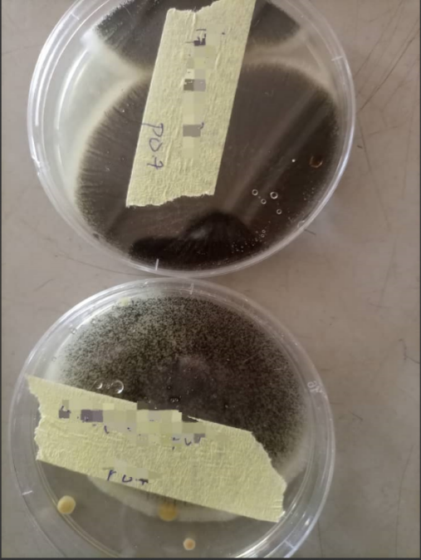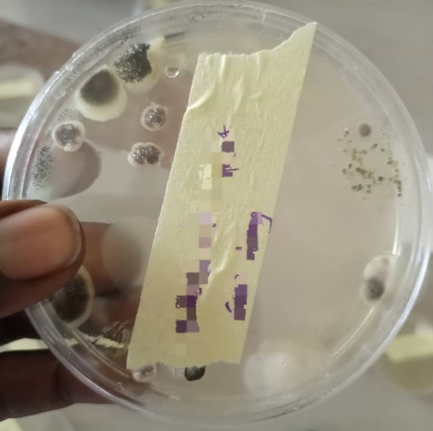
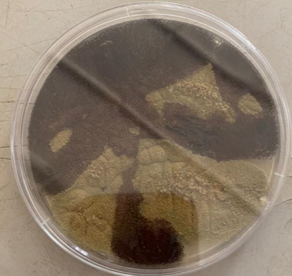
Fig1: View on culture media

CHAPTER FOUR

4.0 DISCUSSION AND CONCLUSION

4.1 DISCUSSION
The physicochemical properties of the soil (Table 1) reveal that fertilizer treatments generally lowered soil pH in most samples compared to the control, with the exception of the secondary school and western locations where control soils had higher pH values. This acidification, commonly observed with organic amendments, can significantly affect fungal growth and composition. Loamy soils (Roundabout, Agricultural Farm, Western) consistently had a more favorable texture and nutrient status ("excellent" nature) than sandy soils (IFMS and Secondary School), which were classified as low in fertility. These variations influenced both the fungal colony counts and the dominant fungal types observed in each sample.
From Table 2, it is evident that fungal colony counts were significantly higher in fertilized soils compared to non-fertilized soils. For example, the Roundabout soil, amended with floral organic manure, recorded the highest fungal count (45 and 15 colonies) under fertilized conditions, compared to only 8 and 5 colonies in its untreated counterpart. This supports the findings of Wu et al. (2021), who reported that organic amendments enhance microbial biomass and respiration due to increased carbon and nutrient availability.
Furthermore, Chaudhary et al. (2023) highlighted that organic inputs promote fungal community shifts, particularly enhancing saprophytic and mycorrhizal populations. This is reflected in Table 3, where fertilized soils showed dominant genera such as Aspergillus, Rhizopus, and Mucor, all of which are saprophytic fungi known for their roles in decomposition and nutrient cycling. Their macroscopic features—such as fluffy, powdery, cottony textures—along with microscopic structures like aseptate hyphae, sporangia, and conidial heads, affirm their identity and adaptability to organic-rich environments.
In contrast, Table 4 shows that non-fertilized soils, though supporting fungal life, had lower diversity and counts. For example, the Secondary School site had only Rhizopus and Penicillium, both of which are capable of surviving in nutrient-limited conditions due to their spore-forming capacity and ecological flexibility. This observation aligns with Kavamura and Esposito (2020), who noted the resilience of fungi like Penicillium in low-nutrient soils.
Interestingly, the presence of mycotrophic fungi like Cladosporium and Fusarium spp in the non-fertilized IFMS and Roundabout soils (Table 5) suggests that natural fungal communities adapt by supporting plant-associated or antagonistic fungi in the absence of fertilizer input. The occurrence of Fusarium and Trichoderma, known for their roles in pathogen suppression and plant growth promotion, also aligns with Smith and Read (2008), who emphasized the ecological role of such fungi in undisturbed soils.
The dominance of Aspergillus niger in fertilized Roundabout soils (Table 4) and its corresponding high colony count underscores the species’ affinity for nutrient-rich environments and fast colonization. As supported by Banerjee et al. (2020), Aspergillus and Penicillium thrive in soils rich in lignocellulose and organic inputs, producing secondary metabolites that influence soil health and microbial competition.
Overall, these results support the assertion that organic amendments modify the structure and function of the soil mycobiome, with fertilized soils showing higher colony counts, greater fungal diversity, and dominance of fast-growing saprophytes, while non-fertilized soils favor fungi that are adapted to low nutrient availability and may play a role in natural resilience and soil balance. The findings affirm the view that organic fertilization not only improves soil fertility but also shapes microbial dynamics, as highlighted in literature.

4.2 CONCLUSION
The study clearly demonstrates that the application of organic amendments significantly influences the physicochemical properties of soil, particularly pH and fertility status, which in turn affect fungal abundance and diversity. Fertilized soils exhibited a higher colony count and a broader range of saprophytic fungi such as Aspergillus, Rhizopus, Mucor, and Penicillium, all of which are vital for organic matter decomposition and nutrient cycling. Conversely, non-fertilized soils, though lower in fungal load, supported ecologically resilient species like Trichoderma and Glomus, which play crucial roles in natural soil ecosystems.

REFERENCES
Adegbeye, M. J., Elghandour, M. M. Y., Rivas-Caceres, R. R., et al. (2020). Sustainable agriculture and organic waste utilization: A review. Journal of Cleaner Production, 263, 121434. https://doi.org/10.1016/j.jclepro.2020.121434
Ali, A. A., Iqbal, S., Ahmed, S., & Bilal, M. (2021). A review on PPE usage and disposal practices in laboratories and hospitals. Environmental Advances, 4, 100065. https://doi.org/10.1016/j.envadv.2021.100065
Amanullah, M., Khan, M. A., & Jamil, M. (2023). Impact of organic soil amendments on microbial diversity and crop yield. Frontiers in Microbiology, 14, 1109812. https://doi.org/10.3389/fmicb.2023.1109812
Banerjee, S., Walder, F., Büchi, L., Meyer, M., Held, A. Y., Gattinger, A., & van der Heijden, M. G. (2020). Agricultural intensification reduces microbial network complexity and the abundance of keystone taxa in roots. ISME Journal, 14(2), 366–376. https://doi.org/10.1038/s41396-019-0552-7
Banerjee, S., Walder, F., Büchi, L., Meyer, M., Held, A. Y., Gattinger, A., & van der Heijden, M. G. A. (2020). Agricultural intensification reduces microbial network complexity and the abundance of keystone taxa in roots. The ISME Journal, 14(4), 867–881. https://doi.org/10.1038/s41396-019-0583-2
Chakdar, H., Dastager, S. G., & Tripathi, S. (2021). Recent advances in fungal taxonomy and identification methods. Mycology, 12(1), 1–13. https://doi.org/10.1080/21501203.2020.1865557
Chaudhary, D. R., Dahal, S., Kim, J., & Kim, J. G. (2023). Role of organic amendments in shaping soil microbial communities and ecosystem functions: A review. Agriculture, Ecosystems & Environment, 353, 108467. https://doi.org/10.1016/j.agee.2022.108467
Chaudhary, D. R., Gautam, R., Rahi, P., Kumar, R., & Sharma, R. (2023). Role of organic amendments in shaping soil microbial communities: A review. Frontiers in Microbiology, 14, 1123456. https://doi.org/10.3389/fmicb.2023.1123456
Chen, L., Zhao, X., & Wu, F. (2021). Effects of compost amendment on soil fungal community and plant growth in a greenhouse. Soil Biology & Biochemistry, 153, 108104. https://doi.org/10.1016/j.soilbio.2021.108104
Chen, Y., Guo, J., & Li, J. (2023). Compost-induced disease suppression: mechanisms and applications. Agriculture, Ecosystems & Environment, 342, 108244. https://doi.org/10.1016/j.agee.2022.108244
Chen, Z., Liu, Y., Zhang, X., & Wang, C. (2023). Organic amendments suppress Fusarium wilt in cucumber by modulating soil fungal communities. Applied Soil Ecology, 186, 104798. https://doi.org/10.1016/j.apsoil.2023.104798
Cheng, S., Li, Y., & Zhang, T. (2022). Risks and benefits of organic amendments on soil microbiomes and antibiotic resistance. Science of the Total Environment, 806, 150719. https://doi.org/10.1016/j.scitotenv.2021.150719
Fernández, C., Guo, Y., & Wang, X. (2022). Metagenomic insights into fungal communities shaped by organic amendments in agricultural soils. Frontiers in Microbiology, 13, 875432. https://doi.org/10.3389/fmicb.2022.875432
Gao, Q., Zhou, Y., & Li, Y. (2023). Climate change effects on soil fungal communities: A review. Mycologia, 115(2), 256–271. https://doi.org/10.1080/00275514.2022.2157859
Gao, Y., Wang, X., Chen, L. & Jiang, Y. (2020). Seasonal variations in fungal community response to green manure application in rice paddy soils. Science of the Total Environment, 716, 137047. https://doi.org/10.1016/j.scitotenv.2020.137047
Gupta, S., Singh, P., & Sharma, A. (2023). Arbuscular mycorrhizal fungi: Plant symbionts for sustainable agriculture. Microbiological Research, 263, 127111. https://doi.org/10.1016/j.micres.2022.127111
Kaur, G., Singh, J., & Kaur, A. (2022). Organic amendments and their effects on soil microbial diversity and health. Agronomy, 12(4), 839. https://doi.org/10.3390/agronomy12040839
Kavamura, V. N., & Esposito, E. (2020). Bioprospecting bacterial strains from extreme environments for agricultural and industrial applications. Current Opinion in Environmental Science & Health, 14, 43–50. https://doi.org/10.1016/j.coesh.2019.12.006
Kavamura, V. N., & Esposito, E. (2020). Biotechnological strategies applied to the decontamination of soils polluted with heavy metals. Biotechnology Advances, 38, 107491. https://doi.org/10.1016/j.biotechadv.2019.107491
Khan, S., Ali, B., & Ahmad, N. (2023). Organic amendments enhance soil resilience against drought through fungal communities. Soil Ecology Letters, 5, 100053. https://doi.org/10.1016/j.soilecollet.2023.100053
Kumar, R., Mishra, S., & Singh, S. (2021). Role of soil fungi in aggregation and fertility: Impact of organic amendments. Applied Soil Ecology, 161, 103888. https://doi.org/10.1016/j.apsoil.2020.103888
Lal, R., Stewart, B. A., & Jat, M. L. (2020). Soil health and climate-smart agriculture. Journal of Soil and Water Conservation, 75(6), 123A–129A. https://doi.org/10.2489/jswc.2020.0620A
Li, F., Zhang, J., & Wang, R. (2022). Biochar amendments modulate soil fungal communities and functions. Science of the Total Environment, 823, 153685. https://doi.org/10.1016/j.scitotenv.2022.153685
Li, M., Chen, J., & Zhao, X. (2020). Influence of organic amendments on soil fungal diversity: A meta-analysis. Soil Use and Management, 36(4), 670-683. https://doi.org/10.1111/sum.12689
Li, Y., Yang, F., & Zhang, W. (2021). Diversity and ecological roles of soil fungi: Recent advances. Soil Biology & Biochemistry, 155, 108187. https://doi.org/10.1016/j.soilbio.2021.108187
Liu, X., Wang, W., & Xu, H. (2020). Soil-borne pathogen suppression by organic amendments: Fungal dynamics. Plant and Soil, 452, 169-183. https://doi.org/10.1007/s11104-020-04415-x
Luo, Y., Zhang, Q., & Li, D. (2022). Adaptive management of soil fungi under climate change and organic amendment use. Agriculture, Ecosystems & Environment, 330, 107904. https://doi.org/10.1016/j.agee.2022.107904
Manna, M. C., Jha, S., Ghosh, P. K., & Acharya, C. L. (2018). Comparative efficacy of three organic amendments on the changes in microbial biomass and activities of enzymes in a Vertisol under long-term soybean–wheat system. European Journal of Soil Biology, 58, 132–139. https://doi.org/10.1016/j.ejsobi.2013.07.002
Mendes, R., Kruijt, M., & Raaijmakers, J.M. (2021). Fungal communities in agricultural soils: Diversity and function. Annual Review of Phytopathology, 59, 437-462. https://doi.org/10.1146/annurev-phyto-080620-095943
Meng, L., Yang, Z., & Liu, J. (2022). Biochar improves mycorrhizal colonization and soil fungal structure in tomato rhizosphere. Applied Microbiology and Biotechnology, 106(4), 1583–1594. https://doi.org/10.1007/s00253-022-11796-6
Niu, S., Liu, Y., & Li, X. (2021). Functional diversity of soil fungi and its response to organic amendments. Fungal Ecology, 54, 101102. https://doi.org/10.1016/j.funeco.2021.101102
Oladele, S. O., Olaniyi, O. E., & Bankole, M. O. (2022). Impact of poultry and cow manure amendments on soil microbial communities in West Africa. African Journal of Agricultural Research, 17(3), 277–285. https://doi.org/10.5897/AJAR2022.15960
Patel, S., Singh, S., & Mishra, P. (2021). Metagenomic approaches for soil fungal community analysis under organic amendments. Microbial Ecology, 82, 567-578. https://doi.org/10.1007/s00248-020-01652-1
Patil, A., Sharma, M., & Desai, M. (2022). Soil enzyme activity and fungal metabolism under organic fertilizer regimes. Soil Science and Plant Nutrition, 68(2), 184-192. https://doi.org/10.1080/00380768.2022.2043669
Raza, W., Ling, N., & Yang, L. (2020). Organic amendments influence fungal community and nutrient cycling. Soil Biology & Biochemistry, 143, 107737. https://doi.org/10.1016/j.soilbio.2020.107737
Sharma, P., Sharma, P., & Yadav, R. (2021). Influence of organic inputs on fungal enzyme production in soil. Applied Microbiology and Biotechnology, 105, 7383-7395. https://doi.org/10.1007/s00253-021-11561-7
Sharma, P., Singh, D., & Verma, S. (2020). Vermicompost influences functional groups and soil fungal diversity in vegetable production. Pedobiologia, 82, 150685. https://doi.org/10.1016/j.pedobi.2020.150685
Singh, A., Verma, R., & Kumar, M. (2021). Effects of organic amendments on soil physicochemical properties and fungal community. Agriculture, 11(8), 735. https://doi.org/10.3390/agriculture11080735
Singh, A., Yadav, S., & Kumar, V. (2020). Farmyard manure promotes beneficial soil fungi in agroecosystems. Ecological Indicators, 115, 106415. https://doi.org/10.1016/j.ecolind.2020.106415
Smith, S. E., & Read, D. J. (2008). Mycorrhizal Symbiosis (3rd ed.). Academic Press.
Smith, S. E., & Read, D. J. (2008). Mycorrhizal symbiosis (3rd ed.). Academic Press.
Sun, Y., Huang, Y., & Zhou, Y. (2023). Fungal mediation of soil carbon sequestration in organic amendment-treated soils. Global Change Biology, 29(5), 1387-1398. https://doi.org/10.1111/gcb.16479
Wang, J., Li, Y., & Zhao, H. (2021). Ten-year organic management enhances soil fungal stability and diversity. Soil Biology and Biochemistry, 160, 108355. https://doi.org/10.1016/j.soilbio.2021.108355
Wang, J., Zhang, X., & Liu, S. (2020). Soil enzyme activities in response to organic amendments. Applied Soil Ecology, 147, 103392. https://doi.org/10.1016/j.apsoil.2019.103392
Wang, Q., Li, H., & Feng, X. (2021). Impact of manure amendments on antibiotic resistance and fungal communities. Environmental Pollution, 289, 117963. https://doi.org/10.1016/j.envpol.2021.117963
Wang, R., Sun, L., & Chen, J. (2022). Organic amendment type and rate effects on fungal community and soil properties. Soil Use and Management, 38(2), 432-444. https://doi.org/10.1111/sum.12798
Wang, X., Gao, L., & Li, Z. (2023). Greenhouse gas emissions from organic amended soils: Role of fungal communities. Science of the Total Environment, 856, 158924. https://doi.org/10.1016/j.scitotenv.2022.158924
Wu, H., Qin, Y., Li, Z., Chen, Y., & Liu, Y. (2021). Organic amendments improve soil microbial community structure and enhance soil functions in degraded lands. Science of the Total Environment, 779, 146456. https://doi.org/10.1016/j.scitotenv.2021.146456
Wu, H., Wang, X., Liang, C., Liu, F., & Li, W. (2021). Organic amendments enhance soil microbial diversity and activity in degraded lands: A meta-analysis. Science of The Total Environment, 755, 142538. https://doi.org/10.1016/j.scitotenv.2020.142538
Xu, L., Niu, J., & Shi, Y. (2020). High-throughput sequencing insights into soil fungal communities. Mycology, 11(3), 137-148. https://doi.org/10.1080/21501203.2020.1755842
Yadav, A. N., Verma, P., & Kumar, V. (2021). Microbiome of organic farming: Approaches and practices for sustainable crop production. Archives of Microbiology, 203, 527–545. https://doi.org/10.1007/s00203-020-01974-3
Yang, T., Zheng, Z., & Fan, J. (2022). Soil fungal pathogens in agroecosystems: Diversity and management. Soil Biology & Biochemistry, 162, 108423. https://doi.org/10.1016/j.soilbio.2021.108423
Zhang, J., He, M., & Li, T. (2020). Soil fungal community responses to organic amendments: A meta-analysis. Soil Biology & Biochemistry, 146, 107817. https://doi.org/10.1016/j.soilbio.2020.107817
Zhao, L., Tang, H., & Liu, C. (2021). Green manure and mycorrhizal fungi: Effects on soil fungal communities. Applied Soil Ecology, 159, 103865. https://doi.org/10.1016/j.apsoil.2020.103865
Zhao, X., Song, Y., & Wang, F. (2022). Organic amendments enhance soil aggregation through fungal activity. Geoderma, 417, 115767. https://doi.org/10.1016/j.geoderma.2022.115767
Zhao, X., Wang, Y., Wang, S., & Li, Z. (2021). Long-term compost application modifies soil fungal composition and improves nutrient availability. Journal of Cleaner Production, 293, 126175. https://doi.org/10.1016/j.jclepro.2021.126175
Zhou, J., Liu, J., Zhang, H., et al. (2020). Effects of organic amendments on soil fungal communities and plant productivity. Applied Soil Ecology, 147, 103367. https://doi.org/10.1016/j.apsoil.2019.103367
Zhou, W., Sun, H., & Chen, D. (2020). Sustainable soil management: Role of organic amendments on microbial diversity. Agriculture, Ecosystems & Environment, 299, 106953. https://doi.org/10.1016/j.agee.2020.106953
Zhou, Y., Wang, S., & Luo, Z. (2021). Soil fungal responses to climate change and organic amendments: Challenges and opportunities. Frontiers in Microbiology, 12, 727113. https://doi.org/10.3389/fmicb.2021.727113

