ESTABLISHING THE RELATIONSHIP BETWEEN SOME INDEX PROPERTIES AND THE ENGINEERING PROPERTIES OF LATERITIC SOIL FROM KWARA STATE POLYTECHNIC CAMPUS

BY

OLALERE OLAWALE SAMUEL
ND/23/MPE/FT/0001

BEING A PROJECT REPORT SUBMITTED TO THE DEPARTMENT OF MINERALS AND PETROLEUM RESOURCES ENGINEERING, FACULTY OF ENGINEERING, KWARA STATE POLYTECHNIC ILORIN, KWARA STATE.

IN PARTIAL FULFILMENT OF THE REQUIREMENT FOR THE AWARD OF NATIONAL DIPLOMA (ND) IN THE DEPARTMENT OF MINERALS AND PETROLEUM RESOURCES ENGINEERING

AUGUST, 2025
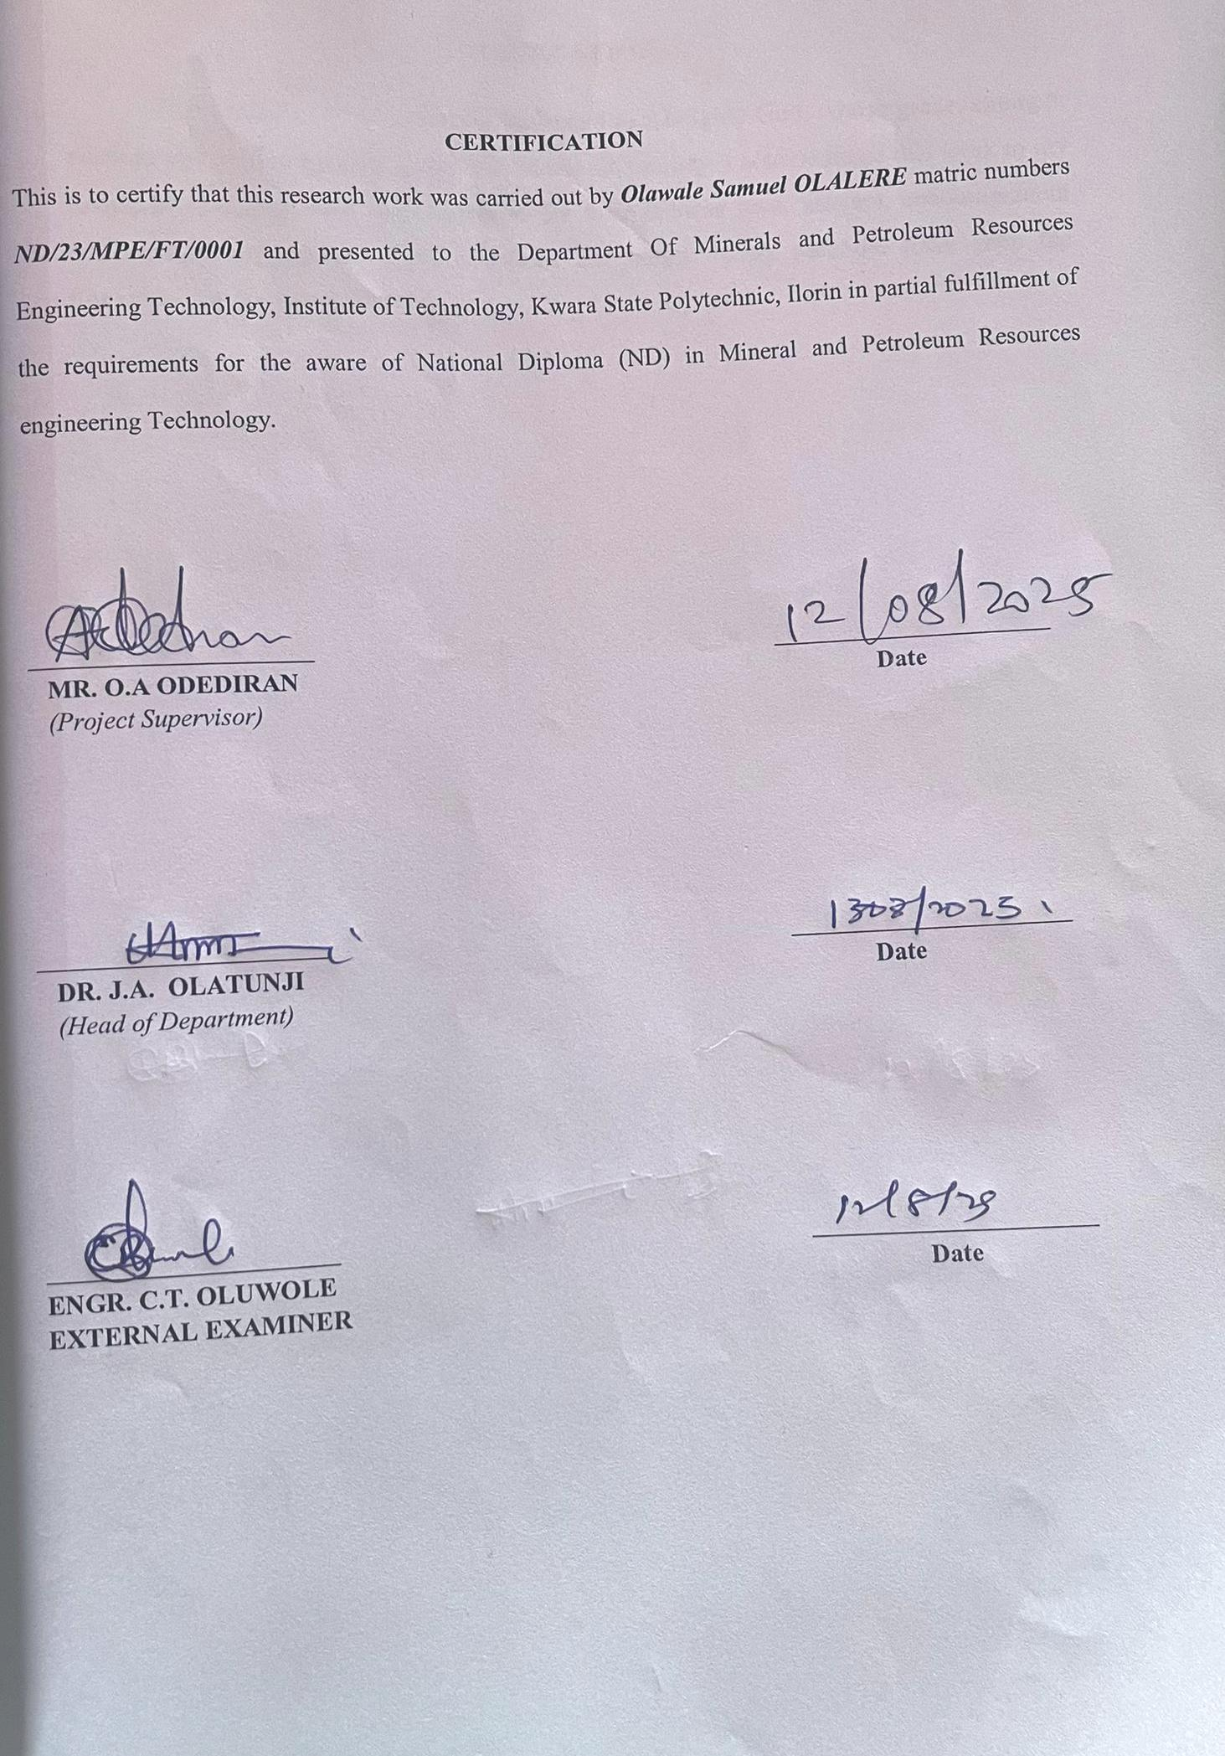DEDICATION
This project is wholeheartedly dedicated to Almighty God, whose grace, strength, wisdom and guided me throughout this academic journey. I also dedicate this work to my loving parents, Mr. and Mrs. Olalere, for their endless love, prayers, encouragement and unwavering support. Your sacrifices and belief in my potential have been the foundation of my success.

ACKNOWLEDGEMENT
All praise and glory be to Almighty Allah for His continuous mercy, strength and guidance that sustained me throughout the course of this research work.
My sincere gratitude goes to my project supervisor, MR. ODEDIRAN OLATUNBOSUN A., for his patience, constructive feedback and valuable support during this project.
I would also like to thank all my lecturers and staff of the Department of Minerals and Petroleum Resources Engineering for their contributions to my academic and personal growth.
I express my heartfelt appreciation to my dear parents Mr. and Mrs. Olalere, for their moral, financial, and emotional support. Your constant encouragement and prayers gave me the motivation to keep pushing forward.
I also acknowledge my project mate, with whom I shared ideas, challenges, and victories throughout this research. Your cooperation and teamwork played a meaningful role in this accomplishment.
To all my friends, course mate, and the respondents who participated in this study thank you so much for your support and contributions,

ABSTRACT
This research investigates the relationship between selected index properties and engineering properties of lateritic soil obtained from various locations within the Kwara State Polytechnic campus. Lateritic soils are widely used in construction across tropical regions, and understanding their behavior is essential for safe and cost-effective engineering design. Representative soil samples were collected from different test pits across the study area. The samples were subjected to a series of laboratory tests, including grain size analysis, Atterberg limits, moisture content, specific gravity, bulk density, compaction, and California Bearing Ratio (CBR) tests. The results revealed significant correlations between certain index properties (such as plasticity index, liquid limit, and grain size distribution) and engineering properties (such as maximum dry density, optimum moisture content, and CBR values). The study concluded that index properties can be effectively used to predict the engineering performance of lateritic soils in preliminary site investigations. This correlation is vital for reducing time and cost in geotechnical assessments, especially in resource-limited environments like those encountered in developing countries.
TABLE OF CONTENTS
Title Page i
Certification ii
Dedication iii
Acknowledgement iv
Table of Content v
Abstract vi
List of Figures vii
List of Tables viii
Chapter One
1.0 Introduction 1
1.1 Location and Accessibility 1
1.2 Relief and Drainage 1
1.3 Aims and Objectives 1
1.4 Statement of Problem 2
1.5 Justification 2
1.6 Scope and Limitations of the Study 2
Chapter Two
2.0 Literature Review 4
2.1 Overview of Literature 4
2.2 Formation and Occurrence of Laterite 4
2.3 Regional Distribution of Laterite 5
2.4 Characteristics of Laterite 5
2.5 Atteberg Limits 6
2.6 Sieve Analysis 7
Chapter Three
3.0 Research Methodology 8
3.1 Collection of Samples 8
3.2 Preparation of Dishanded Samples 8
3.3 Laboratory Procedures 9
3.4 Grain Size Distributer Tests 9
3.5 Atteberg Limits Test 10
3.6 Compaction Tests 10
3.7 Moisture Content Test 11
3.8 Specific Gravity Test 11
3.9 Bulk Density Test 12
Chapter Four
4.0 Results and Discussion 13
4.1 Results of Moisture Content Test 13
4.2 Results of Atteberg Limits Test 14
4.3 Results of Compaction Tests 15
4.4 Results of Gravity Size Analysis 17
4.5 Relationship Between Some Index Properties of Laterite and Selected Engineering Properties 18
Chapter Five
5.0 Conclusion and Recommendations 22
5.1 Conclusion 22
5.2 Recommendation 23
References

LIST OF TABLES
Table 4.1. Results of Natural Moisture Content
Table 4.2. Results of Atterberg Limit Tests
Table 4.3. Result of Compaction Test
Table 4.4. Result of Grain Size Analysis
Table 4.5. Relationship Between Some Index Properties of Laterite and Selected Engineering Properties

CHAPTER ONE

1.0 INTRODUCTION

1.1 Location and Accessibility

Kwara State Polytechnic is located on Ilorin, Kwara State, Nigeria (Lat.: 8.5°N, Long: 4.6°E). The campus is accessible via the Ilorin to Lagos highway and adjacent feeder roads. The terrain consists of several accessible exposure sites, test point such as borrow pits, excavation sites, and defined test pit across the campus open grounds making soil sampling practicable year-round.

1.2 Relief and Drainage

The campus lies within an area of gently sloping terrain (1-3% transition into undulating ridges - natural drainage factors direct surface water toward nearby intermittent stream channels and depressions. The moderate relief contributes to soil formation and stratification, while subsurface flow is influenced by Latere Enembal.
1.3 Aims and Objectives
The aim of this project is to establish empirical correlations between some index properties and engineering parameters of laterite soils on the Kwara Polytechnic campus.
The above-stated aim can be attained by the following objectives:
    - To determine the physical properties of the laterite samples such as moisture content, grain size analysis, specific gravity, porosity and void ratio, compaction test, permeability, etc.
    - To determine the engineering properties such as shear strength, California Bearing Ratio, permeability, consolidation test, soil resistivity, etc.
    - To establish the relationship between the index properties and the engineering properties of laterite.
1.4 Statement of the Problem
Laterite soils on Ilorin display diverse engineering behaviour complicating design without extensive testing; many on infrastructure projects inadequately address the variability, resulting in construction delays, excessive costs and performance issues. A lack of empirical correlations pertonent to campus soils impedes rapid evaluation and planning. Establishing reliable predictive relationships could streamline geotechnical processes and improve local project outcomes.

1.5 Justification

Local relevance ensures design parameters reflect actual soil conditions at kwara state polytechnic cost and time efficiency reduces reliance on long-term laboratory tests by introducing index-based predictions. Risk mitigation enhances infrastructure reliability by accounting for inherent soil variability; address contribution fills research gap on index-engineering correlations for Nigeria lateritic soils.

Sustainable use promotes effective utilization of in situ soils in earth works, reducing environmental impact from material support.

1.6 Scope and Limitations

The scope and limitations of the project is to focus on near-surface lateritic soils (upper 2m) within the main campus: findings may not apply to highly altered or deep laterite zones beyond sampling depth. The laboratory testing includes Atterberg limits, grain size analysis, standard Proctor compaction and shear tests. Collaboration of models is site specific and is utilized when extrapolating to other regions. The study is limited to soils sampled within the Polytechnic campus; the results may not be fully representative of laterite soils in other regions.Only a selected number of index and engineering tests were carried out due to time and resource constraints. Environmental factors such as seasonal moisture variation and in situ treatment were not duly explored. Soil stabilization or evaluation was not considered; only natural soil behaviour was evaluated.

LITERATURE REVIEW

2.0 LITERATURE REVIEW

2.1 Overview of Laterite
Laterite is a residual soil formed through intense weathering of underlying rocks under tropical climatic conditions. It is rich in iron and aluminum oxides, which gives a reddish or brownish color. Laterites can vary from gravelly to clay and are commonly found across Kwara State. Laterite formation is influenced by factors such as climate, high temperature and rainfall from the weathering process, while geology, the type of parent rocks and its mineral composition affect the formation of laterite. Topography, the slope and drainage patterns of the land influence the formation and distribution of laterite. Due to their widespread use in civil engineering projects, especially on subgrade and base courses for roads (laterites have attracted significant attention in geotechnical research, understanding the relationship between their index properties (i.e., Atterberg limits and grain size) and engineering properties such as California Bearing Ratio and Shear Strength) in making better construction decisions, reducing costs and ensuring stability on structures.

2.2 Formation and Occurrence of Laterite
Laterite soils form through a leaching process wherein water removes soluble minerals leaving behind oxides of iron and aluminum. The rate of formation depends on climate, drainage, vegetation and parent rock. In Kwara State, the presence of laterite is common due to the region’s humid tropical climate and geology. Laterite is commonly found on tropical regions including artificial sites, and South America.
In Nigeria, laterite is widely distributed particularly on Southwestern and Central regions. Laterite deposits can be found in various forms including residual deposits which are formed on place through weathering of parent rocks, colluvial deposits which formed through the accumulation of weathered material at the base of slopes and lastly, alluvial deposits which formed through the deposition of sediment on rivers and streams. As rainwater infiltrates the soil, it leaches away soluble components such as silica, sodium, potassium, and calcium, what remains are the soluble oxides of iron and aluminium which gradually accumulate and form a hard, rust-colored soil known as LATERITE. In some cases, the accumulation of laterite can even lead to the formation of ironstone or laterite crust when the soil is exposed and cemented by these oxides.

2.3 Regional Distribution of Laterite
In Nigeria, laterite is distributed across the southern and middle belt regions, including Kwara, Ogun, and Oyo States. In the Kwara State Polytechnic campus, preliminary surveys have identified laterite soils at shallow depths, making them relevant for geotechnical investigations on the location. The distribution of laterite varies regionally depending on factors such as climate, geology, and topography. The regional distribution of laterite is influenced by the prevailing climatic and geological conditions. Laterite soils are abundant due to the tropical climate and the region’s geology. In Kwara State Polytechnic campus areas, laterite can be found close to the surface, making it a reliable source for road construction, including foundation works and building materials. The widespread distribution and availability of laterite in these regions make it a vital material in local construction and engineering projects. Globally, laterite occurs across Africa, particularly in West Africa (Nigeria, Ghana), Africa, and South America (Brazil) has vast laterite deposits, especially in the Amazon Basin), Asia (found in India, especially in the Mahanadi region), Sri Lanka, Indonesia, and the Philippines and to a lesser extent Australia. (Notable for its laterite bauxite deposits).

2.4 Characteristics of Laterite
Lateritic soils are typically highly porous, coherent stone when moist, capable of hardening upon exposure and moderately plastic depending on moisture content. These characteristics influence compaction behaviour, load-bearing capacity, and moisture sensitivity. Laterite is characterized by its high iron and aluminum content which gives it a distinctive reddish color. Laterite was found to be a vulnerable material for construction purposes, partly for building roads and foundations. Laterite soils can possess several unique characteristics due to their formation process on tropical climate; these properties influence their performance in construction and geotechnical applications. Color (typically reddish brown to yellowish due to high iron oxide content), texture (can range from heavy clayey to gravelly or sandy, depending on the parent rocks and stage of weathering), mineral composition (rich on iron aluminum oxides, with low amounts of silica and other soluble minerals).
- Strength and Hardness: Laterites can be soft when freshly dug but harden upon exposure, making them suitable for building blocks and road use; porosity and permeability (generally low permeability due to fine grains and compaction, though this varies with texture).
- Plasticity: Laterite soils often show moderate to high plasticity, measuring sensitivity to their strength and workability can change significantly with moisture content.
- Workability: Easily workable when moist and used traditionally for building in rural areas.
- Cementation: Some laterites are naturally cemented forming laterite hardpan or ironstone layers, which may need breaching for excavation. These characteristics make laterite both useful and challenging on civil engineering, depending on how well they are understood and managed.

2.5 Atterberg Limits of Laterite

Atterberg limits define the consistency and plasticity of laterite soils: the liquid limit (LL), plastic limit (PL) and Plasticity index (PI) are crucial in classifying soil and geotechnical engineering behaviour. Studies (e.g., Ogunlade, M.O., Ogundele, O.M. and Ajayi, O.A. 2018) International Journal of Scientific and Engineering Research). Atterberg limits are important for understanding the behaviour of soils under different moisture conditions for laterite the Atterberg limits can be used to determine its plasticity and consistency. Atterberg limits help predict shrinkage well, behaviour, workability and strength characteristics.

2.6 Sieve Analysis

Sieve analysis determines the Particle Size Distribution which affects compaction, support permeability and load-bearing capacity. Well graded soils typically exhibit better engineering behaviour. Laterite soils from Ilorin region often display a mix of sandy and silty particles, with the occasional clayey content that influences the plasticity and strength. Genesis and hardening of laterite on soils. Sieve Analysis is a test used to determine the grain size distribution of soils. The test involves passing a soil sample through a series of sieves with different mesh sizes allowing for the determination of the proportion of particles of different sizes. Sieve analysis is an important tool for understanding the engineering behaviour of soils. Typical results for laterite soil may contain a high percentage of sand (coarse and fine), depending on origin. It is important in engineering to help on soil classification (e.g., using unified Soil classification system or AASHTO). It helps to determine suitability for subgrade, base course or fill, affect drainage, compaction and shear strength behaviour.

CHAPTER THREE

3.0 RESEARCH METHODOLOGY

3.1 Collection of Samples
Laterite soil samples were collected from three (3) different locations within Kwara State Polytechnic campus using auger and shovel at depths of 0.0 to 0.5 meters. Undisturbed and representative laterite soil samples were collected, stored and sealed in polythene bags. They are also labeled appropriately and subsequently transported to the laboratory for analysis. The different sample locations were also appropriately defined by the use of global positioning system receiver (GPS).
The details of the sample locations are presented in the table below:
Table: Details of Sampling Points
S/N | LOCATION | LONGITUDE | LATITUDE | ELEVATION | DEPTH
1 | Kwara Poly Campus | 004° 37.6' 82" | 08° 33. 428 | 309m | 0.50m
2 | Kwara Poly Campus | 004° 37. 882" | 08° 33. 426 | 336m | 0.75m
3 | Kwara Poly Campus | 004° 37. 883 | 08° 33. 430 | 309m | 0.79m

3.2 Preparation of Dishanded Samples

The collected samples (laterite soil samples) were air dried on the laboratory floor until dried and sieved through a 4.75mm sieve to remove large particles and ensure uniformity for testing, following the procedure the soil samples were first spread out on a clean surface and air dried at room temperature for several days. This process helped reduce the moisture content without altering the soils natural structure. The large lumps in the dried samples were gently broken down by hand using a rubber pestle to avoid crushing soil particles excessively into the soil fraction passing through the sieve was used for most laboratory tests, the preferred soil was stored on clean, labeled containers or bags to prevent contamination and ensure easy identification during testing. Contamination ensured from the surface samples and adequate preparation ensured during the index and engineering property evaluation test results.

3.3 Laboratory Procedures
Laterite Soil Samples laboratory procedures are carried out by the following tests:
- Grain Size Distribution Test
- Atterberg Limits Test
- Compaction Test
- Moisture Content Test
- Specific Gravity Test
- Bulk Density Test

3.4 Grain Size Distributed Test

The grain size distributed test was carried out to determine the proportion of different particle sizes in the laterite soil samples. The test is essential for classifying the soil and assessing its suitability for construction purposes. Procedure carried out follows, the air-dried prepared sample was weighed (typically 500g) with a set of standard sieves (sieves ranging from 4.75mm to 0.075mm) arranged in descending order. The sample was placed on the top sieve and shaken mechanically for 10-15 minutes and the weight of soil returned on each sieve was recorded while the percentage returned and cumulative percentage passing were calculated. A grain size distribution curve was plotted with Particle Size (Grain Size) on the x-axis and Percentage Passing on the y-axis. The test aids in understanding the soils behavior in terms of permeability, compaction and shear strength and relate to its engineering properties.

3.5 Atterberg Limits Test

The Atterberg limits test determined the plasticity of fine-grained soils. It identifies the consistency and liquid limit (LL), plastic limit (PL) and shrinkage limit (SL) used in classifying soils and understanding their behavior under varying conditions. Procedure are as follows using the following apparatus: Casagrande Liquid Limit Device, Porcelain bowl (Standard type), Evaporating dish, Spatula, Balance (Sensitivity), moisture cans and oven. A portion of soil passing through a 425μm sieve was mixed with distilled water to form a smooth paste. The paste was placed in the Casagrande cup and spread level at a groove was cut using the grooving tool. The handle was rotated at 2 revolutions per second until the groove closed over a length of 13mm. The number of blows was recorded. A sample was taken, weighed, oven dried for 24 hours and reweighed to determine moisture content. The steps were repeated for at least four different moisture contents. A graph of moisture content versus number of blows (log scale) was plotted. The moisture content at 25 blows was read from the curve as the liquid limit.

3.6 Compaction Test

Compaction test is to determine the maximum dry density and optimum moisture content (OMC) of laterite soil using the Standard Proctor Compaction test, which reflects how soil responds to compaction effort. Procedure are as follows using the following apparatus: Proctor compaction mold (volume 943cm³), 2.5kg rammer (drop height 300mm), Balance (accuracy ±0.1g), oven (105-110°C), straight steel tray and mixing tools, measure cans, graduated cylinder, sieve (4.75mm). Sample preparation: air dry the laterite soil and sieve through a 4.75mm sieve to remove large particles, divide into five portions, add increasing quantities of water (e.g., 8% or more) to each soil portion, mix thoroughly. Place soil into mold in three layers, each layer is compacted with 25 blows using the rammer. After the final layer, level the soil with a straight edge then weigh the mold with compacted soil and subtract mold weight to get the weight of compacted soil before sample from the compacted mold and determine moisture content by oven drying for 24 hours. Repeat the process for all moisture levels. Plot dry density and moisture content. The result point is the maximum dry corresponding moisture content is the OMC.

3.7 Moisture Content Test

Moisture content is to determine the laterite soil sample collected from Kwara State Polytechnic campus, which is a basic but essential test for understanding soil behavior under compaction, strength and consistency conditions. Procedures are as follows using. Filming apparatus: moisture cans (metal containers with lids), balance (accuracy 0.01g), oven (temperature 105°C to 110°C). The weighing 3-petiole: a weighing of a clean can with its lid and record the weight (w1), place a representative sample of moist laterite soil into the can, weigh the can with the soil and lid and record (w2), place the can (without lid) on an oven at 105°-110°C for 24 hours to ensure complete drying, remove the can (cover it immediately with the lid and cool it in a desiccator to avoid moisture absorption, weigh again and record as dry soil and can). Moisture content (%): ((w2-w3)/(w3-w1))×100. Moisture content influences compaction, strength, Atterberg limits and overall soil behavior.

3.8 Specific Gravity Test

Specific gravity test is to determine the specific gravity of soil solids from laterite soil samples collected within the Kwara State Polytechnic campus. This value is essential for calculating other engineering parameters (e.g., void ratio, porosity and compaction characteristics). Procedure are as follows: clean and dry pycnometer, weigh the empty pycnometer and record the weight as (w1), place about (5-log) of oven dried soil into the pycnometer and record the weight of the bottle plus soil (w2), add distilled water to the bottle (about half full) shake gently to remove trapped air, then fill it completely, weigh the bottle with soil and water and record as (w3), empty the bottle fill it with only distilled water and weigh again (w4). (GS $\frac{w2-w1}{w4-w1}$ - $\frac{w3-w2}{1}$). Specific gravity helps in computing void ratio degree of saturation and unit weight.

3.9 Bulk Density Test

Bulk density test to determine the laterite soil from Kwara State Polytechnic campus, which is vital for assessing compaction, strength and load bearing capacity on geotechnical engineering. Procedure are as follows using following apparatus: core cutter, steel dolly, hammer or rammer, balance (accuracy to 0.1g), oven (105-110°C), desiccator, straight edge, spatula, level the ground surface. Place the steel dolly on top of the core cutter and drive it vertically into the soil using the rammer until fully embedded, carefully excavate and remove the core cutter from the top and bottom flush using a straight edge, record the weight of the cutter filled with soil, transfer the soil to an oven and dry at 105-110°C for 24 hours, weigh the dry soil sample to determine the moisture content. Bulk density test helps in determining soil compaction stability required for calculations involving earthworks, subgrades and foundation design.

CHAPTER FOUR
4.0 RESULTS AND DISCUSSION
4.1 Results of Natural Moisture Content
The results of natural moisture content test are presented in table 2. the moisture content value range between 4.2% and 5.3%, indicating that the soil are relatively dry. According to Ola (1993), typical moisture content for lateritic soils range between 5% and 20% depending on the season and drainage condition. Therefore the sample fall within the lower end of the standard range implying well drained and stable conditions.
Table 1: Natural Moisture Content Test of Collected Samples
Sample A | Sample B | Sample C
5.2% | 4.3% | 4.1%
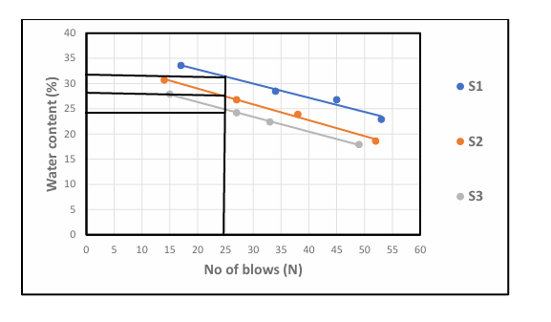Fig.1: graph showing water content
4.2 Results of Atterberg Limit Tests
- Liquid Limit (LL): ranges from 22.3 % to 31.6% According to Das (2010), soil with liquid limit value less than 35% are classified as low plasticity soils. All the three samples fall within this categories, indicating low compresibility and moderate workability.
- Plastic Limit (PL): value range from 14.6% to 18.2%, which is also consistent with the range expected for lateritic soil.
- Plasticity Index (PI): value, calculated as the difference between LL am PL range from 6.9% to 13.4% Ola (1983) noted that lateritic soil generally have pl value ranging from 5% to 20% depending on the degree of weathering. Hence the PL values obtained fall within the expected range, indicating moderate plasticity with Sample A being more plastic than Sample B and Sample C.
- Linear Shrinkage (LS): values range from 3.7% to 6.2% According to Adeyemi (1995), values below 10% suggest that the soils has low shrinks well potential, which is desirable for most construction purpose. Sample C has the lowest shrinkage value, suggesting it will be the most suitable under moisture variation

Table 2: Atterberg Limit Tests of collected samples
Sample | Liquid Limit % | Plastic Limit % | Plastic index | Linear Shrinkage %
Sample A | 31.6 % | 18.2% | 13.4% | 6.2%
Sample B | 22.3% | 15.4% | 6.9% | 4.8%
Sample C | 24.8% | 14.6% | 10.2% | 3.7%
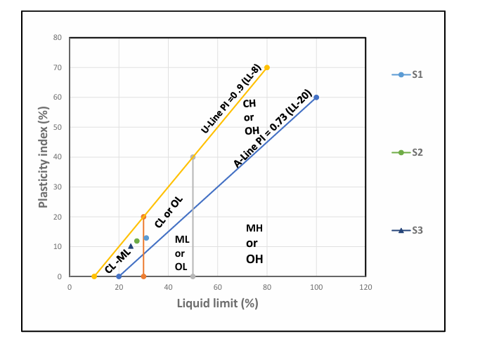
Fig 2: Graph Showing Plasticity Chart
4.3 Result of Compaction Test
Table 3: Compaction Parameters of Maximum Dry Density (MDD) and Optimum Moisture Content (OMC)
Sample | MDD | OMC
A | 1.81 | 8
B | 1.89 | 7.5
C | 1.95 | 6
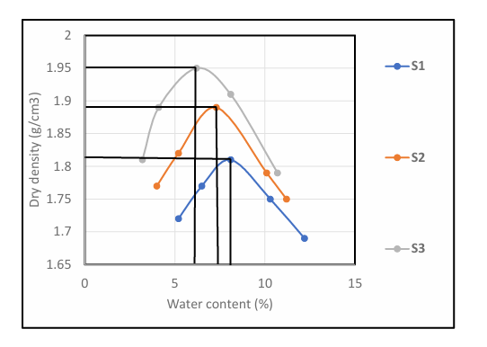
Fig. 3: Graph Showing Compaction Parameters

Table 4: Compaction and Ratings of Unified Soil Classification for Construction (ASTM 1557-91)
Visual Description | Maximum Dry Density (MDD)(g/cm³) | Optimum Moisture Content (OMC)(g/cm³) | Aticipated embankment performance | Value as Subgrade material | Value as Base Course
Granular material | 2.00 - 2.27 | 7 – 15 | Good to Excellent | Excellent | Good
Granular material with soil | 1.76 - 2.16 | 9 – 18 | Fair to Excellent | Good | Fair to Poor
Fine sand and sand | 1.76 - 1.84 | 9 – 15 | Fair to Good | Good to Fair | Poor
Sandy silts and silts | 1.36 -1.60 | 10 – 20 | Poor to Good | Fair to Poor | Not suitable
Elastic silts and clay | 1.36 - 1.60 | 20 -35 | Unsatisfactory | Poor | Not suitable
Silty clay | 1.52 - 1.92 | 10 – 30 | Poor to Good | Fair to Poor | Not suitable

Table 4: Present the compaction parameters of collected samples. The (MDD) Maximum Dry Density for sample A is 1.81 for sample B 1.89 while sample C is 1.95. for Optimum Moisture Content (OMC), sample A is 8, Sample B is 7.5 sample C is 6. The three sample being sandy in nature can be range as range fair to good for embankment performance it is fair to poor for subgrade material are not suitable for base course.
4.4 Result of Grain Size Analysis
P1 has higher clay content (21%) hence classified has clayey sand
P2 and P3 have more silt and less clay, Thus, silty sand all sample have sand and dominant particle size making them sand based soils.
fine (<0.075mm) is highest in P1, which support it’s clayey nature.
Table 5: Summary of result of Grain Size Analysis of soil
Sample Location | Gravel (%) | Sand (%) | Silt (%) | Clay (%) | Fine (%) | Soil classification
P1 | 10 | 60 | 9 | 21 | 30 | Clayey sand
P2 | 12 | 62 | 15 | 11 | 20 | Silty sand
P3 | 13 | 63 | 17 | 7 | 24 | Silty sand

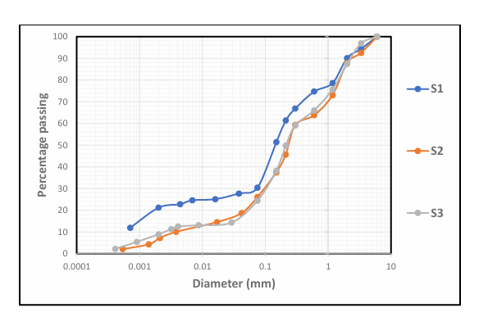
Fig. 5: Grain Size Analysis Graph

4.5 Relationship Between Some Index Properties of Laterite and Selected Engineering Properties
Due to limitation an laterite in the course of carrying out this project, only compaction parameters one considered in thus selection for the relationship between them. The specific gravity(SG), plastic limit(PL), and liquid limit(LL), were related to the compaction parameter(MDD) and optimum moistured content(OMC). From table 10 it can be observed that the coefficient the relationships. One quite high, range from 0.689 for OMC and PL to 0.998 for MDD and LL. This shows that a good relationship exist between the selected index properties and compact in parameters may be reasonable predicted from the resulting equation.
Table 6: Derived Equations
S/N | EQUATIONS | COEFICIENT OF DETERMINATIO N
1 | MDD=0.309X SG-0.334 | 0.836
2 | MDD=-0.576X PL+10.54 | 0.965
3 | MDD= -0.022XLL + 2.497 | 0.998
4 | OMC= -13.09 X SG +43.04 | 0.997
5 | OMC= 0.45X PL-0.177 | 0.689
6 | OMC=0.302 XLL -1.215 | 0.848

Figure 1: Relationship Between Maximum Dry Density (MDD) and Specific Gravity (SG)

Figure 2: Relationship Between Maximum Dry Density (MDD) and Plastic Limit (PL)

Figure 3: Relationship Between Maximum Dry Density (MDD) and Liquid Limit (LL)

Figure 4: Relationship Between Optimum Moisture Content (OMC) and Specific Gravity (SG)

Figure 5: Relationship Between Optimum Moisture Content (OMC) and Plastic Limit (PL)

Figure 6: Relationship Between Optimum Moisture Content (OMC) and Liquid Limit (LL)

CHAPTER FIVE
5.0 CONCLUSION AND RECOMMENDATIONS
5.1 Conclusion
The study successfully investigated the relationship between selected index properties and engineering properties of lateritic soils collected from different locations within the Kwara State Polytechnic campus. Key index properties such as moisture content, Atterberg limits, grain size distribution, and specific gravity were examined and compared with engineering properties like compaction characteristics, bulk density, and shear strength.
From the laboratory tests conducted, it was observed that:
- The lateritic soils generally exhibited moderate to high plasticity, suggesting a fair to good binding quality.
- The moisture content had a notable influence on the compaction behavior, with the optimum moisture content (OMC) and maximum dry density (MDD) values varying based on soil composition.
- Grain size distribution revealed that the soils were well-graded in some locations and poorly graded in others, which significantly impacted strength and compaction properties.
- The plasticity index (PI) showed a direct correlation with shear strength, implying that soils with higher PI demonstrated better load-bearing capacity, especially under controlled moisture conditions.
- The specific gravity and bulk density were within the typical range for lateritic soils, confirming their suitability for civil engineering applications like subgrade and embankment materials.
In conclusion, a strong correlation exists between the selected index properties and the engineering behavior of lateritic soils from the campus. These properties can be used reliably to predict soil performance, particularly in the absence of advanced testing facilities.
5.2 Recommendations
Based on the findings of this research, the following recommendations are made:
- Soil Classification Should Be Prioritized: Engineers and construction professionals working within the Kwara State Polytechnic campus should always carry out proper soil classification and index testing before using lateritic soils for construction projects.
- Use of Index Properties for Preliminary Assessment: Since strong correlations exist between index and engineering properties, index tests can serve as a cost-effective and efficient tool for preliminary site evaluation, especially in resource-limited settings.
- Compaction Control on Site: It is recommended that compaction be carried out at or near the determined optimum moisture content to achieve maximum dry density, thereby enhancing soil strength and stability.
- Soil Stabilization Where Necessary: For locations where soils show high plasticity or poor grading, chemical or mechanical stabilization methods (e.g., lime or cement stabilization) should be considered to improve their engineering properties.
- Further Studies: More extensive studies covering other parts of the campus and including other engineering parameters such as permeability, CBR (California Bearing Ratio), and consolidation characteristics should be conducted to develop a comprehensive soil map for the institution.
- Adoption of Local Soil for Construction: Given the favorable results in some areas, the use of local lateritic soil should be encouraged in road construction, foundation fills, and other geotechnical works, after adequate testing and processing.

REFERENCES
Osinubi, K.J., Eberemu, A.J., Bello, A.O., & Adzegah, A. (2013). Effect of fines content on the engineering properties of reconstituted lateritic soils in waste containment application. Nigerian Journal of Technology
Kalu, Z.U., Okeke, O.C., Onunkwo, A.A., Agidi, B.M., Amadi, C.C., & Onwuchekwa, C.N. (2024). Engineering behaviour of cement-stabilized lateritic soils derived from various geologic formations in Awka area, Southeastern Nigeria. Engineering Research Journal
Akpoyibo, O., Abriku, O.E., Ugbe, F.C., & Anomohanran, O. (2023). Engineering assessment of lateritic soils of Obiaruku highway sections in South-southern Nigeria. Nigerian Journal of Theoretical and Environmental Physics
Duruojinnaka, I.B., Okeke, O.C., & Amadi, C.C. (2016). Geotechnical and geochemical characterization of lateritic soil deposit derived from Ajali Sandstone in Ihube-Okigwe, Southeastern Nigeria for road construction. International Journal For Research In Mechanical & Civil Engineering
Omotosho, O.A., Ojo, O.J., & Adetolaju, K.I. (2012). Evaluation of some engineering properties of lateritic soils around Dall Quarry, Sango Area, Ilorin, Nigeria. Nigerian Journal of Technological Development
Ogunribido, T.H.T. (2023). Performance evaluation of lateritic soil as fills in road pavement stabilized with coal ash in Southwestern Nigeria. Irish Journal of Environment and Earth Sciences
Badmus, B.S. (2010). Plasticity and compressibility characteristics of lateritic soil from Southwestern Nigeria. ASSET: An International Journal (Series B)
Amadi, A.A., & Eberemu, A.O. (2013). Characterization of geotechnical properties of lateritic soil–bentonite mixtures relevant to their use as barrier in engineered waste landfills. Nigerian Journal of Technology

Omotoso, O.A., Ojo, O.J., & Adetolaju, E.T. (2012). Engineering properties of lateritic soils around Dall Quarry in Sango Area, Ilorin, Nigeria. Earth Science Research
Adebisi, N.O., Kalumba, D., & Akintayo, F.O. (2014). Index and strength characteristics of residual lateritic soils from South-Western Nigeria. Current Journal of Applied Science and Technology, 6(3), 229–238.
Gidigasu, M.D. (1976). Laterite soil engineering: Pedogenesis and engineering principles. Elsevier Scientific Publishing Company.
Ola, S.A. (1974). Need for estimated cement requirements for stabilization of lateritic soils. Journal of Transportation Engineering, 100(2), 379–388.
Ola, S.A. (1983). Geotechnical properties and behaviour of some Nigerian lateritic soils. Engineering Geology, 19(1), 1–13.
Gidigasu, M.D. (1972). Mode of formation and geotechnical characteristics of laterite materials of Ghana in relation to soil forming factors. Engineering Geology, 6(2), 79–150.
De-Graft Johnson, J.W.S., Bhatta, H.S., & Hammond, A.A. (1969). Engineering properties of lateritic soils. Proceedings of the Specialty Session on Engineering Properties of Lateritic Soils
Balogun, L.A. (1982). The physiochemical and geotechnical properties of lateritic soils from southwestern Nigeria. Proceedings of the First National Conference, Nigerian Geotechnical Association, Lagos, 42–59.
Adeyemi, G.O. (2002). Geotechnical properties of lateritic soils developed over quartz-schist in Ishara area, Southwestern Nigeria. Journal of Mining and Geology, 38(1), 65–69.
Ashworth, R. (1966). Highway engineering. Heinemann Educational Books Ltd., London.
De-Graft Johnson, J.W.S. (1972). Laterite gravel evaluation of road construction. Journal of Soil Mechanics and Foundations Div., ASCE, 98(5), 1245–1265.

Adeyemi, G.O., Ojo, A.O., & Omidiran, M.O. (1990).

