A PROJECT REPORT
ON

PROPOSED INSTITUTIONAL HOSTEL

FOR

AL-HIKMAH UNIVERSITY, ILORIN WEST LOCAL GOVERNMENT
BY

SALMAN OLAMILEKAN SALMAN
HND/22/ARC/FT/050

SUBMITTED TO

THE DEPARTMENT OF ARCHITECTURAL TECHNOLOGY,
INSTITUTE OF ENVIRONMENTAL STUDIES (I.E.S)
KWARA STATE POLYTECHNIC, ILORIN

IN PARTIAL FULFILLMENT OF THE REQUIREMENTS FOR THE AWARD OF HIGHER NATIONAL DIPLOMA (HND) IN ARCHITECTURAL TECHNOLOGY

JULY, 2025

DECLARATION
“This is a work undertaking by me SALMAN OLAMILEKAN SALMAN with Matric No HND/22/ARC/FT/050 under the supervision of Are. FAMULUA O.S of the Department of Architectural Technology, Kwara State Polytechnic. I declare that this project/ dissertation is a project of my personal research. Works. It has not been presented for the award of any Higher National Diploma (HND) in any polytechnic, the ideas, observation, comments, suggestions here been acknowledged in accordance with conventional academic traditions.

________________ ________________
Signature Date

CERTIFICATION
This is to certify that this project report titled “Proposed Institutional Hostel were carried out by SALMAN OLAMILEKAN SALMAN with matriculation number HND/22/ARC/FT/050. In fulfillment of the requirement for the award of Higher National Diploma Architectural Technology from the department of Architectural technology, institute of environmental science studies, Kwara state polytechnic Ilorin, Kwara state Nigeria.

ARC. FAMILUA O.S _____________________
Project Supervisor Signature/Date

ARC. OLAREWAJU F.A _____________________
Project Coordinator Signature/Date

ARC. TOMORI J.M _____________________
Head of department Signature/Date

_____________________ _____________________
External Examiner Signature/Date

DEDICATION
The project work is dedicated to Almighty Allah who through his love allows me to complete my study and who has given me the opportunity to write out this project.
It is also dedication to my parents ALHAJI MR & MRS SALMAN, without them my education would not been reality.

ACKNOWLEDGEMENT
All special thanks belong to almighty Allah for given me opportunity, support and strength to have a successful complement of this research project work.
I’m also indebted to my project supervisor ARC. FAMILUA O.S for academic nurturing, to the head of department, project coordinator ARC. OLAREWAJU F.A and the entire department lecturer for their contribution academically and morally may Almighty Allah continue be with you all
My gratitude will not complete without Appreciating my father the Director, Institute of Environmental Studies in person ARC. B.Y.F ABDULAZEEZ
I am very grateful to my parent Hajia Khajidat Abebi and also my dad Mallam Abdulkareem Yusuf Alaran , to the love of my life Barokat Ajobi , to my boss in person of Alh Abdulrasaq Ajisafe for his financial support, to my blood brothers and sisters Mallam Tajudeen Ajibola and Fatimoh Akanke and Mallam Abdulsalam Olayimika Ogodo for their financial and moral support in my life.

TABLE OF CONTENT
Table Page
Declaration…………………………………………………………………………………...…….i
Certification…………………………………………………………………………………….…ii
Dedications………………………………………………………………………………..…...…iii
Acknowledgement………………………………………………………………………………..iv
Table of Content……………………………………………………………………………….….v
List of Table …………………………………………………………………………………...…vi
List of Figure ………………………………………………………………………………..…..vii
List of Plate…………………………………………………………………………………..….viii
List of Appendices………………………………………………………………………………..ix
Abstract……………………………………………………………………………………………x
CHAPTER ONE: INTRODUCTION

1.1 Introduction………………………………………………………………………………..1

1.2 Statement of the Design Problem…………………………………………………………2

1.3 Aim and Objectives of the Project………………………………………………………3

1.4 Justification for the Project……………………………………………………………..4

1.5 Client’s Background, Philosophy, Operational Structure, and Goals…………………….5

1.6 Scope of Study…………………………………………………………………………….6

1.7 Limitations of Study……………………………………………………………………6

1.8 Research Methodology…………………………………………………………………..7

CHAPTER TWO:- Review of Literature on the Building Type

2.1 Evolution of Institutional Male Hostels: From Early Interpretations to State-of-the-Art Expressions………………………………………………………………………………..8

2.2 Specific Challenges and Opportunities in 21st Century Institutional Male Hostel Design……………………………………………………………………………………10

2.3 Variants of the Building Type……………………………………………………………11

2.4 Technological and Environmental Approaches………………………………………….13

2.5 Specific Context of the Proposed Hostel………………………………………………...13
CHAPTER THREE

3.0 Case Study………………………………………………………………………………14

3.1 Case Study One:- Al-Hikmah University, Ilorin, Nigeria Historical Background……….14
3.2 Case Study Two:- University Of Ilorin, Nigeria Historical Background……………….…21
3.3 Case Study Three:- Kebbi State University, Nigeria Historical Background……………25

3.4 Case Study Four:- Federal Polytechnic Offa Historical Background…………………..31
3.5 Case Study Five:- Online Case Study……………………………………………………36

CHAPTER FOUR:- Study Area/Project Site (Environmental and Impact Analysis)

4.1 Introduction to Study Area and Site Selection…………………………………………39

4.2 Site Location, Description, and Criteria………………………………………………40

4.3 Site Analysis and Inventory……………………………………………………………..41

4.5 Analysis of Immediate Environmental Conditions……………………………………44

4.6 Project Analysis and Design Criteria……………………………………………………44

CHAPTER FIVE:- Approach to the Design/Design Realization

5.1 Design Ideas and Concepts at Different Levels of the Design Process………………….52

5.2 Sketches and Graphics…………………………………………………………………...54

5.3 Technological and Environmental Criteria…………………………………………….56

5.5 Behavioral Patterns and Considerations…………………………………………………60

5.6 Conclusion and Recommendations………………………………………………………61
Reference

LIST OF PLATE
PLATE 2.1: Showing the front View of the building……………………………………………11
PLATE 2.2: Showing back view of the building …………………………………….…………11
PLATE 2.3: Showing the Side view of the building…………………………………………….12
PLATE 2.4: Showing the parking space………………………………………………….……..12
PLATE 2.5: Showing the front view of the building………………………………………...…..16
PLATE 2.6: Showing the side view case study two………………………………..……………16
PLATE 2.7: Showing the Conference room of case study two………………………………….17
PLATE 2.8: Showing the Internal view of the Building view of case study two……………….18
PLATE 2.9: Showing the front view of case study three …………………………………...…..21
PLATE 2.10: Showing the side view of case study three……………………………………….21
PLATE 2.11: Showing the back view of case study three……………………………………….22
PLATE 2.12: Showing the Interior view of case study three…………………………..………..22

LIST OF FIGURES
FIGURE 2.1: Showing the site ground floor plan of case study one……………………….……..9
FIGURE 2.2: Showing the first floor plan of case study one……………………………..……..10
FIGURE 2.3: Showing the Last floor plan of case study one …………………………...………10
FIGURE 2.4: Showing the Locational Plan of case study two…………………………………..13
FIGURE 2.5: Showing Ground floor plan of case study two…………………………………....14
FIGURE 2.6: Showing the First floor plan of case study two………………………………..….15
FIGURE 2.7: Showing the last floor plan of case study two……………………………….……15
FIGURE 2.8: Showing the Ground floor plan of case study three………………………………19
FIGURE 2.9: Showing the first floor plan of case study three……………………………….….20
FIGURE 2.10: Showing the Last floor plan of case study three……………………………..…20
FIGURE 3.1: Showing the of Locational plan……………………………………………..……29
FIGURE 3.2: Showing the site inventory ……………………………………………………….30
FIGURE 3.3: Showing the site analysis………………………………………………...……….32
FIGURE 4.1: Showing site zoning………………………………………………………...…….35
FIGURE 4.2: Showing the functional Relationship Diagram…………………………...………41
FIGURE 4.3: Showing the bubble diagram………………………………………………..…….42
FIGURE 4.4: Showing concept derivation…………………………………………………..…..42
FIGURE 4.5: Showing site concept……..................................................................................….43

LIST OF APPENDICES
APPENDICE 1: LOCATIONAL PLAN………………………………………………………..51
APPENDICE 2: SITE ANALYSI………………………………………………………………52
APPENDICE 3: FLOW CHART………………………………………………………………..53
APPENDICE 4: BUBBLE DIAGRAM.……………………………………………………..…54
APPENDICE 5: FLOOR PLAN….………………………………………………………….….55
APPENDICE 6: FRONT VIEW ………………………………………………………………...56
APPENDICE 7: RIGHT VIEW ……………………...…………………………………………57
APPENDICE 8: BACK VIEW……………………………..…………………………………....58

ABSTRACT
Institutional hostels play a crucial role in accommodating students and fostering a supportive environment conducive to learning, personal growth, and social interaction within educational institutions. This abstract outlines a comprehensive investigation into the significance of institutional hostels, their impact on student development, and the ways in which they contribute to the overall campus experience. The study draws upon a mixed-methods research approach, combining both quantitative and qualitative data collection methods. Surveys and questionnaires were distributed among hostel residents to gauge their perceptions of the hostel environment, its facilities, and the social interactions it facilitates. In conclusion, this study underscores the significance of institutional hostels in supporting students' educational journey beyond the classroom. It sheds light on the positive impact of hostels on student development and underscores the importance of a well-designed hostel environment to foster a sense of community and belonging. By addressing the challenges faced by hostel residents, institutions can create a more enriching and fulfilling college experience for their students.

CHAPTER ONE

1.1 Introduction
Institutional hostels are specialized residential facilities designed to provide accommodation for students, staff, or individuals affiliated with educational institutions, corporate organizations, or similar entities. These facilities serve as temporary homes, offering safe, comfortable, and conducive environments that support the academic, professional, and personal development of their residents. This project focuses on the design of a modern institutional hostel located in Ilorin West, Kwara State, Nigeria, a region renowned for its vibrant educational landscape and cultural diversity. The proposed hostel aims to address the increasing demand for quality student accommodation, driven by growing enrollment in tertiary institutions such as the University of Ilorin and Al-Hikmah University.
The evolution of institutional hostels reflects broader societal and technological advancements. In the 19th century, hostels were basic, often providing rudimentary shelter with minimal amenities, primarily in rural or remote areas. These early structures prioritized functionality, offering shared sleeping quarters and communal facilities. The 20th century marked a shift toward more comprehensive designs, incorporating educational and recreational spaces such as libraries and gymnasiums to support residents’ holistic development. Safety became a priority, with features like fencing and surveillance systems introduced to address urban challenges.
In the 21st century, institutional hostels have embraced sustainability, accessibility, and user-centered design. Modern hostels integrate energy-efficient systems, universal design principles, and advanced technologies to meet contemporary expectations. For students, these facilities are more than just accommodation; they are vibrant environments fostering community, collaboration, and academic success. In urban centers like Ilorin, the surge in student populations has created a significant demand-supply gap in accommodation, with many existing facilities struggling to meet needs for capacity, quality, or affordability. Students increasingly seek amenities such as high-speed Wi-Fi, study areas, recreational spaces, and laundry facilities to support their lifestyles.
In Nigeria, institutional hostels are integral to the educational ecosystem, particularly in cities like Ilorin, where universities and polytechnics attract diverse student populations. The accommodation shortage forces many students into off-campus housing, which often lacks safety or convenience. The proposed hostel aims to address these challenges by offering a purpose-built facility that combines modern design with cultural sensitivity, reflecting Ilorin’s diverse ethnic composition (Yoruba, Nupe, Fulani, Bariba). By incorporating sustainable practices and innovative architectural solutions, this project seeks to establish a model hostel that enhances the student experience and strengthens the region’s educational infrastructure.

1.2 Statement of the Design Problem
The primary challenge of this project is to design an institutional hostel in Ilorin West, Kwara State, that effectively addresses the accommodation needs and preferences of students while navigating spatial, environmental, and regulatory constraints. The site, spanning approximately 2.5 hectares, must be optimized to accommodate 500–700 students, balancing compact layouts with comfortable, functional living spaces. This requires meticulous planning of bedrooms, communal areas, and service zones to maximize efficiency without compromising resident comfort. A key objective is to foster a sense of community and belonging, necessitating well-designed communal spaces such as lounges, study rooms, and recreational areas that encourage social interaction, collaboration, and cultural exchange among Ilorin’s diverse ethnic groups, including Yoruba, Nupe, Fulani, and Bariba.
Ensuring resident privacy and comfort within a communal setting is another critical challenge. The design must incorporate private or semi-private bedrooms with adequate sound insulation, personal storage, and ergonomic furnishings to create a peaceful environment conducive to rest and study. Safety and security are paramount in Ilorin West’s urban context, which faces moderate crime risks. The hostel must integrate robust security measures, including controlled access points, CCTV surveillance, and comprehensive fire safety systems with smoke detectors and emergency exits. Accessibility is a priority, requiring universal design features such as ramps, elevators, and accessible bathrooms to accommodate students with diverse physical abilities, ensuring inclusivity and compliance with international standards.
Environmental sustainability adds complexity, as the design must minimize the hostel’s ecological footprint while remaining cost-effective. This involves incorporating energy-efficient systems like LED lighting and solar panels, water conservation measures such as rainwater harvesting, and eco-friendly materials to reduce operational costs and environmental impact. Compliance with Nigerian building codes, local zoning regulations, and environmental standards is essential to ensure legal and operational viability. These regulations mandate structural safety, fire protection, and environmental responsibility, requiring coordination with local authorities for permits. By addressing these multifaceted challenges, the project aims to deliver a modern, inclusive, and sustainable hostel that meets immediate accommodation needs and sets a benchmark for student housing in Nigeria.

1.3 Aim and Objectives of the Project

1.3.1 Aim
The aim of this project is to design and implement an institutional hostel in Ilorin West, Kwara State, that effectively caters to the accommodation needs of students, providing a safe, comfortable, and community-oriented living environment that supports academic and personal development.

1.3.2 Objectives
The specific objectives of the project include:
- Conducting a comprehensive analysis of the requirements and preferences of the target users to inform user-centered design decisions.
- Developing an architectural design that optimizes space utilization while fostering a sense of community and belonging.
- Incorporating modern facilities and amenities to ensure a comfortable, convenient, and supportive living environment.
- Implementing robust security measures to ensure the safety and well-being of residents.
- Adhering to relevant building codes, local regulations, and sustainability practices to ensure legal compliance and environmental responsibility.

1.4 Justification for the Project4
The development of an institutional hostel in Ilorin West is driven by the urgent need to address the acute shortage of quality student accommodation in a region experiencing significant growth in its student population. Tertiary institutions like the University of Ilorin and Federal Polytechnic Offa attract thousands of students annually, yet existing housing facilities are often inadequate, forcing students to rely on off-campus accommodations that are frequently expensive, unsafe, or inconveniently located. This project aims to bridge this gap by providing a purpose-built hostel for 500–700 students, offering affordable, secure, and well-equipped living spaces to alleviate pressure on current infrastructure. By addressing this shortfall, the hostel will enable students to focus on their academic pursuits without the burden of housing-related challenges.
Beyond meeting accommodation needs, the hostel will enhance the student experience by creating a conducive environment for learning, personal growth, and well-being. Modern amenities, such as study rooms, recreational spaces, and high-speed Wi-Fi, will support academic success and mental health, fostering higher student satisfaction and retention. Communal spaces, including lounges and courtyards, will encourage social interaction, networking, and cultural exchange among Ilorin’s diverse ethnic communities, cultivating a sense of belonging. For the client, an educational institution, the hostel represents a strategic investment to enhance its reputation and competitiveness. By offering quality accommodation, the institution can attract and retain talented students, positioning itself as a leading educational hub. Economically, the hostel is designed to be financially viable, generating revenue through accommodation fees for maintenance and future upgrades. Additionally, the project will stimulate local economic activity through the procurement of materials and labor, contributing to Ilorin’s role as a regional center for higher education.

1.5 Client’s Background, Philosophy, Operational Structure, and Goals

1.5.1 Client’s Background
The client is an educational institution in Ilorin West, Kwara State, committed to providing quality education and support services to students. With a history of academic excellence and community engagement, the institution serves a diverse student body drawn from across Nigeria and beyond. Its mission emphasizes holistic education, fostering intellectual, moral, and social development to produce graduates who contribute meaningfully to society.

1.5.2 Client’s Philosophy
The client’s philosophy centers on creating an inclusive, supportive, and academically enriching environment. It prioritizes student welfare, cultural diversity, and sustainability, aiming to provide facilities that enhance the educational experience while reflecting local values and global standards.

1.5.3 Operational Structure
The institution operates a structured administrative framework, with dedicated departments for student services, facility management, and housing. The housing department oversees accommodation policies, maintenance, and resident welfare, ensuring seamless integration of the hostel into the institution’s operations.

1.5.4 Client’s Goals
The client’s goals for the hostel project include:
- Addressing the growing demand for student accommodation by providing a dedicated facility for 500–700 students.
- Creating a comfortable and supportive living environment that enhances academic performance and personal well-being.
- Fostering a sense of community through inclusive and vibrant communal spaces that encourage social and cultural interaction.
- Ensuring resident safety through robust security measures and emergency protocols.
- Aligning with sustainability principles by incorporating energy-efficient systems and eco-friendly materials to minimize environmental impact.

1.6 Scope of Study
The scope of this study encompasses a comprehensive analysis of user requirements, development of an architectural design, selection of appropriate materials and technologies, and integration of essential facilities and amenities. The study also addresses sustainability, cost-effectiveness, and compliance with regulatory standards, ensuring a holistic approach to the hostel’s design and implementation.

1.7 Limitations of Study
The study may face limitations such as budget constraints, time restrictions, resource availability, and regulatory or client-imposed requirements. These factors could influence the extent to which project objectives are achieved, requiring careful management to ensure successful outcomes.

1.8 Research Methodology
The research methodology employs a mixed-methods approach, combining qualitative and quantitative techniques. Data collection methods include surveys and interviews with students to understand their accommodation preferences, case studies of existing hostels (e.g., Al-Hikmah University, University of Ilorin), literature reviews on hostel design trends, and site visits to analyze environmental conditions. Data analysis will inform the design process, ensuring alignment with user needs, site constraints, and regulatory requirements.

CHAPTER TWO

Review of Literature on the Building Type

2.1 Evolution of Institutional Male Hostels: From Early Interpretations to State-of-the-Art Expressions
The building typology of institutional male hostels has undergone significant transformation over time, driven by evolving societal needs, technological advancements, and changing user expectations. This literature review traces the historical development of the typology, identifies key trends and influences, and contextualizes its evolution within the broader framework of institutional accommodation design.

Early Hostel Designs (Pre-19th Century)
The earliest institutional hostels were rudimentary structures focused on providing basic shelter. Often located in remote or rural areas, these hostels prioritized functionality over comfort, featuring shared sleeping quarters, minimal sanitation facilities, and basic construction materials like wood or stone. They were designed to be self-sufficient, catering to transient populations such as travelers or religious pilgrims, with little emphasis on amenities or aesthetics (Smith, 2019).

19th Century Hostel Designs
The 19th century marked a shift toward more structured institutional hostels, particularly with the rise of formal education systems. The growing emphasis on education and workforce training led to the development of hostels that supported residents’ intellectual and social needs. Hostels began incorporating libraries, classrooms, and recreational spaces like gymnasiums to foster holistic development (Johnson & Thompson, 2020). Urbanization influenced their integration into city fabrics, with hostels often located near schools or workplaces to enhance accessibility. Designs became more standardized, with dormitory-style layouts and shared facilities to accommodate larger groups.

20th Century Hostel Designs
The 20th century saw increased focus on safety and security in hostel design, driven by urban challenges and rising crime rates. Features such as perimeter fencing, surveillance systems, and controlled access points became standard (Clark & Davis, 2018). Hostels also grew in scale to accommodate expanding student and worker populations, adopting modular layouts to optimize space. The introduction of modern materials like concrete and steel allowed for multi-story structures, improving capacity while maintaining structural integrity. However, many designs prioritized efficiency over resident comfort, leading to issues like overcrowding and inadequate ventilation in some cases.

21st Century Hostel Designs
In the 21st century, institutional hostels have embraced user-centered design, sustainability, and inclusivity. Modern hostels prioritize resident well-being, incorporating amenities such as high-speed Wi-Fi, ergonomic furnishings, and communal spaces that foster social interaction (Brown et al., 2022). Sustainability has become a key focus, with designs integrating energy-efficient systems (e.g., LED lighting, solar panels), water conservation measures (e.g., rainwater harvesting), and eco-friendly materials to reduce environmental impact. Accessibility is also critical, with universal design principles ensuring accommodation for residents with diverse physical abilities (United Nations, 2020). Technological advancements, such as smart building systems for lighting and security, have further enhanced functionality and efficiency.
The evolution of institutional male hostels has been shaped by factors such as increasing educational access, urbanization, technological innovation, and growing awareness of environmental and social issues. In the Nigerian context, the demand for quality student housing has surged due to rising tertiary enrollment, necessitating designs that balance capacity, affordability, and modern amenities (Johnson & Thompson, 2020).

2.2 Specific Challenges and Opportunities in 21st Century Institutional Male Hostel Design
Designing institutional male hostels in the 21st century presents both challenges and opportunities, reflecting the complex needs of modern residents and the constraints of urban environments.

Challenges
- Balancing Safety and Inclusivity: Hostels must incorporate robust security measures, such as CCTV and controlled access, to ensure resident safety in urban settings with moderate crime risks, like Ilorin West. However, these measures must avoid creating an overly restrictive environment that alienates residents or stifles community interaction (Clark & Davis, 2018).
- Sustainability vs. Affordability: Implementing sustainable features like solar panels or water-efficient systems increases initial costs, posing challenges for projects with limited budgets. Balancing these costs with affordability for students is critical (United Nations, 2020).
- Personalization vs. Scale: Catering to individual preferences, such as private bedrooms or culturally relevant aesthetics, can conflict with the need to accommodate large numbers of residents efficiently. Overcrowding remains a concern in many existing hostels (Johnson & Thompson, 2020).
- Regulatory Compliance: Adhering to local building codes, zoning regulations, and environmental standards requires careful coordination, particularly in Nigeria, where bureaucratic delays can impact project timelines (Smith, 2019).

Opportunities
- Community Building: Well-designed communal spaces, such as lounges and recreational areas, offer opportunities to foster social interaction and cultural exchange, particularly in diverse settings like Ilorin, with its Yoruba, Nupe, Fulani, and Bariba populations (Brown et al., 2022).
- Technological Integration: Smart technologies, such as automated lighting and security systems, enhance operational efficiency and resident convenience, aligning with modern expectations (Roberts, 2021).
- Sustainability as a Value Proposition: Incorporating green design elements not only reduces environmental impact but also lowers long-term operational costs, making the hostel financially viable and attractive to stakeholders (United Nations, 2020).
- Cultural Sensitivity: Designing hostels that reflect local cultural identities through architectural motifs or inclusive spaces can enhance resident satisfaction and community acceptance (Johnson & Thompson, 2020).

2.3 Variants of the Building Type
Institutional male hostels vary based on their specific user groups and institutional contexts. Common variants include:
- Student Hostels: Designed for college or university students, these hostels feature private or semi-private bedrooms, shared bathrooms, and communal areas for studying and socializing. Examples include hostels at the University of Ilorin, tailored to academic needs (Johnson & Thompson, 2020).
- Military Barracks: Built for military personnel, these facilities prioritize discipline and efficiency, with bunk beds, shared bathrooms, and drill halls. Security is a key focus, often with restricted access (Clark & Davis, 2018).
- Juvenile Detention Centers: Designed for young offenders, these hostels feature individual cells, shared facilities, and educational spaces to support rehabilitation. Security and supervision are paramount (Smith, 2019).
Each variant addresses unique user needs, influencing spatial layouts and design priorities.

2.3.1 Functions and Relationships Between Spaces
The spatial organization of institutional male hostels is driven by user needs, with common spaces including:
- Bedrooms: Private or semi-private spaces for sleeping and personal activities, equipped with beds, study desks, and storage. These are the most private areas, designed for rest and study (Brown et al., 2022).
- Bathrooms: Shared facilities for hygiene, typically including showers, toilets, and sinks, strategically located for accessibility (Johnson & Thompson, 2020).
- Common Areas: Spaces for studying, socializing, or recreation, such as lounges, study rooms, or courtyards, fostering community interaction (Clark & Davis, 2018).
- Dining Halls: Centralized areas for meals, often adjacent to kitchens for efficient service (Smith, 2019).
- Exercise Rooms: Facilities for physical activity, such as gyms or outdoor sports courts, supporting resident well-being (United Nations, 2020).
The relationships between these spaces emphasize accessibility and functionality. Bedrooms are clustered near bathrooms and common areas to minimize travel time, while dining halls and administrative offices are centrally located to serve the entire hostel population efficiently.

2.4 Technological and Environmental Approaches
Modern institutional male hostels leverage technology and environmental strategies to enhance functionality and sustainability:
- Sustainable Design: Use of eco-friendly materials (e.g., low-VOC paints, recycled concrete), energy-efficient systems (e.g., LED lighting, solar panels), and water conservation measures (e.g., rainwater harvesting) reduce environmental impact (United Nations, 2020).
- Smart Technology: Automated systems for lighting, ventilation, and security improve efficiency and user experience. For example, motion sensors reduce energy waste, while biometric access enhances security (Roberts, 2021).
- Universal Design: Incorporating ramps, elevators, and accessible bathrooms ensures inclusivity for residents with disabilities, aligning with international standards (Brown et al., 2022).
These approaches align with global trends toward sustainable and inclusive architecture, addressing both user needs and environmental responsibilities.

2.5 Specific Context of the Proposed Hostel
The proposed hostel in Ilorin West, Kwara State, is designed within a unique context shaped by local climate, culture, and urban dynamics. Ilorin’s tropical savanna climate, with temperatures ranging from 22°C to 36°C and annual rainfall of 1,200–1,500 mm, necessitates designs that prioritize natural ventilation, shading, and water management (Johnson & Thompson, 2020). The region’s cultural diversity, with Yoruba, Nupe, Fulani, and Bariba populations, calls for inclusive spaces and architectural elements that reflect local aesthetics, such as patterned screens or vibrant color schemes. The hostel’s urban location near educational institutions like the University of Ilorin requires robust security measures and noise control to ensure a conducive living environment.
CHAPTER THREE

3.0 CASE STUDY
In this chapter, we will explore three case studies of institutional hostels to gain insights into their design, features, and best practices. The selected case studies are:

    - Al-Hikmah University, Ilorin, Nigeria
    - University of Ilorin, Nigeria
    - Kebbi State University, Nigeria
    - Federal Polytechnic, Offa
    - Online case study

3.1 CASE STUDY ONE
NAME:- AL-HIKMAH UNIVERSITY, ILORIN, NIGERIA HISTORICAL BACKGROUND
Al-Hikmah University, located in Ilorin, Nigeria, is a private Islamic university that was established in 2005. It was founded by the Islamic group, Al-Hikmah Foundation, with the vision of providing qualitative education based on Islamic principles and values. The university aims to produce graduates who are intellectually and morally sound, equipped with skills and knowledge to contribute to the development of society.

Key features of their hostel include:

- Well-designed rooms: The hostel provides spacious and well-furnished rooms for students, ensuring their comfort and privacy.
- Study areas: There are dedicated study areas within the hostel, equipped with tables, chairs, and adequate lighting, allowing students to study in a quiet and conducive environment.
- Common spaces: The hostel incorporates common spaces such as lounges, recreational areas, and TV rooms, encouraging social interaction and community building among the residents.
- Security measures: The hostel has robust security measures in place, including controlled access points, CCTV surveillance, and the presence of security personnel to ensure the safety of the residents.
- Amenities: The hostel provides essential amenities like Wi-Fi connectivity, laundry facilities, and a cafeteria, catering to the needs of the students.
- Sustainable practices: Al-Hikmah University hostel emphasizes sustainability by implementing energy-efficient lighting systems, waste management practices, and water conservation measures.
3.1.1 Merits
- Adequate proper Landscaping
- Adequate proper artificial lighting
- The structure is Aesthetically balanced
- Adequate Security
3.1.2 Demerits
- Poor building orientation
- Inadequate ventilation and natural lighting,
- Inadequate convenience
- Limited Recognition:
- Relatively Small Alumni Network

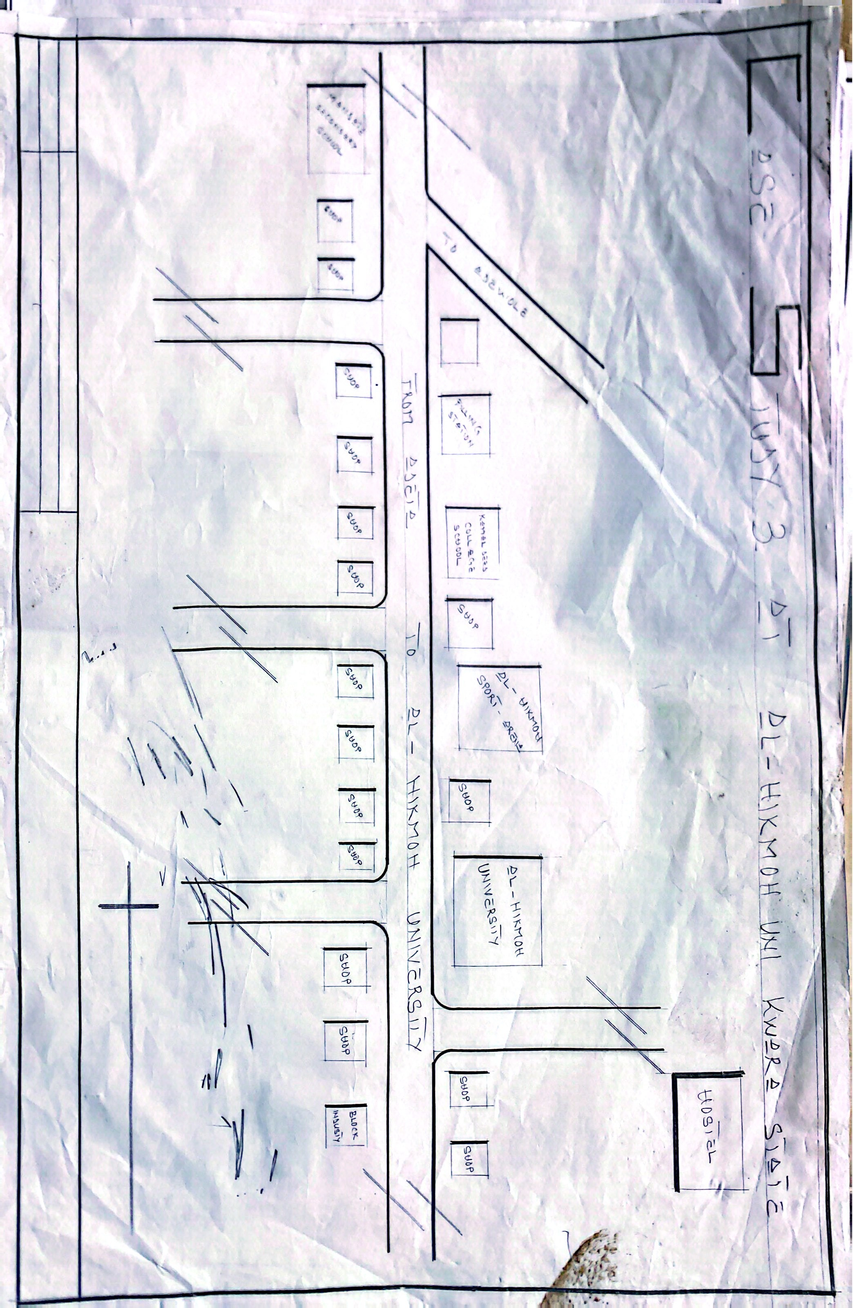

FIGURE 3.1:- LOCATIONAL PLAN OF AL-HIKMAH UNIVERSITY, ILORIN

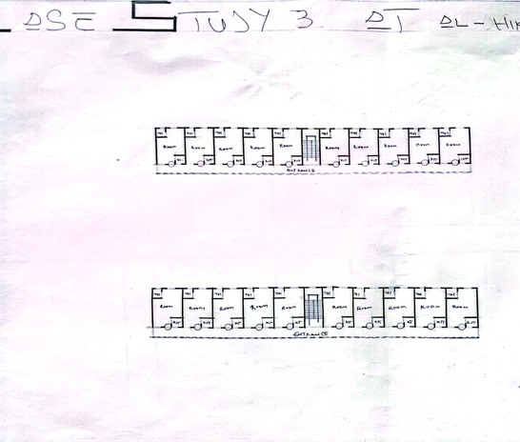

FIGURE 3.2:- FLOOR PLAN OF AL-HIKMAH UNIVERSITY, ILORIN

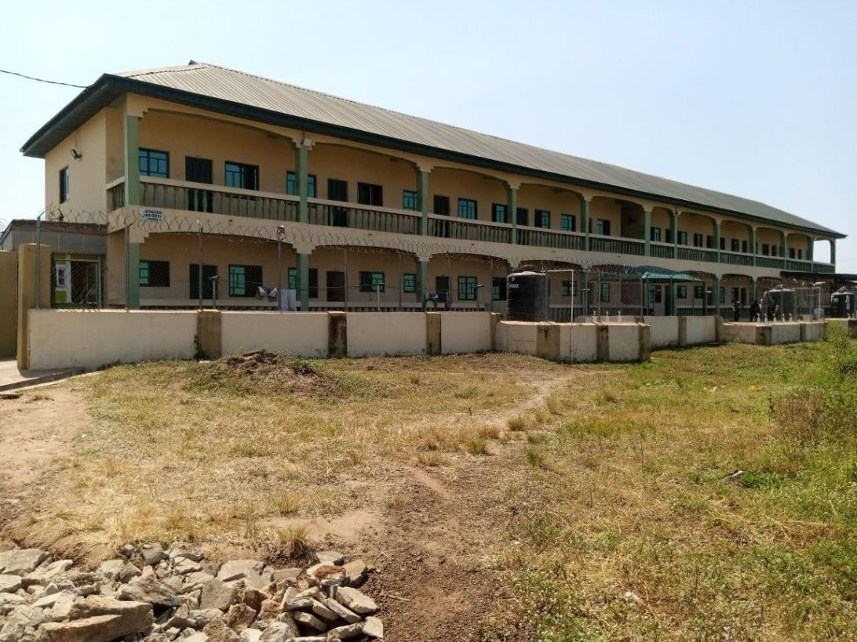

PLATE 3.1:- FRONT AND SIDE VIEW OF AL-HIKMAH UNIVERSITY, ILORIN

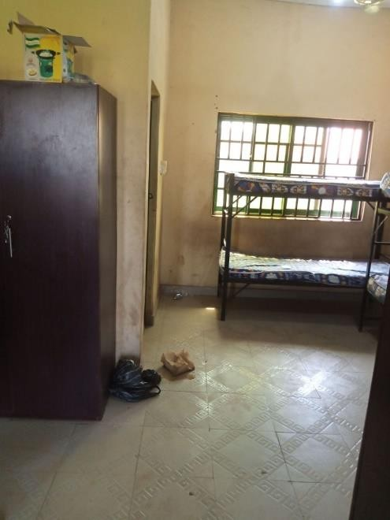
PLATE 3.2:- INNER ROOM OF AL-HIKMAH UNIVERSITY, ILORIN

3.2 CASE STUDY TWO

NAME:- UNIVERSITY OF ILORIN, NIGERIA HISTORICAL BACKGROUND
The University of Ilorin, located in Ilorin, Nigeria, is a federal university that was established in 1975. It started as a University College under the University of Ibadan and later became an independent university. The university is known for its commitment to academic excellence, research, and community development. Key features of their hostels include:

- Block design: The hostels are designed in blocks, each accommodating a specific number of students. This design allows for better management, supervision, and community building within each block.
- Sports and recreational facilities: The hostels provide outdoor sports facilities like basketball and volleyball courts, encouraging physical activity and recreational opportunities for students.
- Multi-purpose common rooms: The hostels have multi-purpose common rooms that can be used for studying, group discussions, or social gatherings, promoting interaction and collaboration among students.
- Dining facilities: The hostels offer dining facilities where students can have their meals conveniently within the hostel premises.
- Safety measures: The hostels prioritize safety with measures such as well-trained security personnel, fire safety equipment, and emergency evacuation plans.
- Maintenance and cleanliness: The hostels maintain a high standard of cleanliness and have dedicated maintenance teams to address any issues promptly.

3.2.1 Merits
- It is well-maintained and clean.
- It is located in a safe and secure area.
- It is close to the university's academic and administrative buildings.
- It has a variety of facilities, including a dining hall, a library, and a recreation center.
- The rooms are spacious and comfortable.
- The bathrooms are shared but clean and well-maintained.
3.2.2 Demerits
- It is overcrowded. There are currently over 2,000 students living in the hostel.
- The hostel is located in a remote area, which can be inconvenient for students who need to access other parts of the city.
- The hostel is relatively expensive, which can be a financial burden for some students.

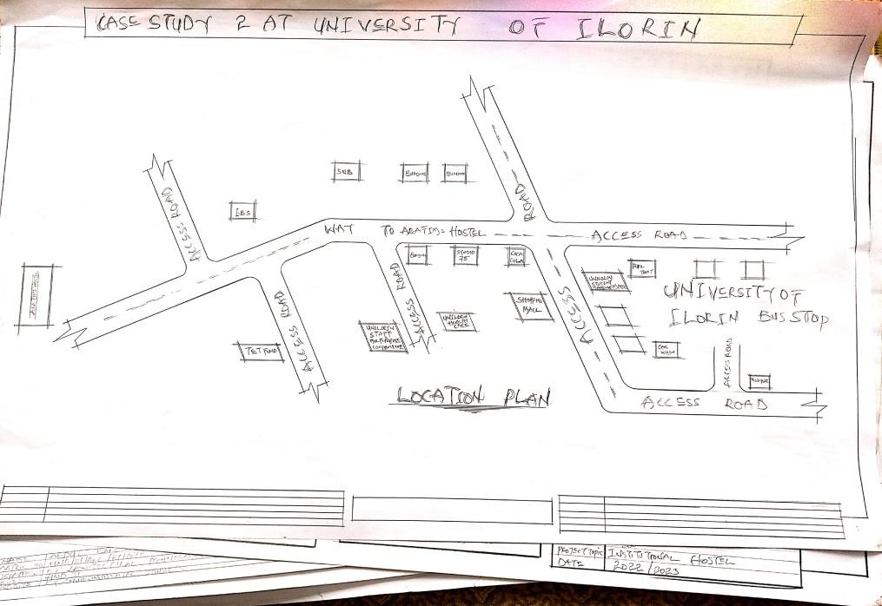

FIGURE 3.3:- LOCATIONAL PLAN OF UNIVERSITY OF ILORIN

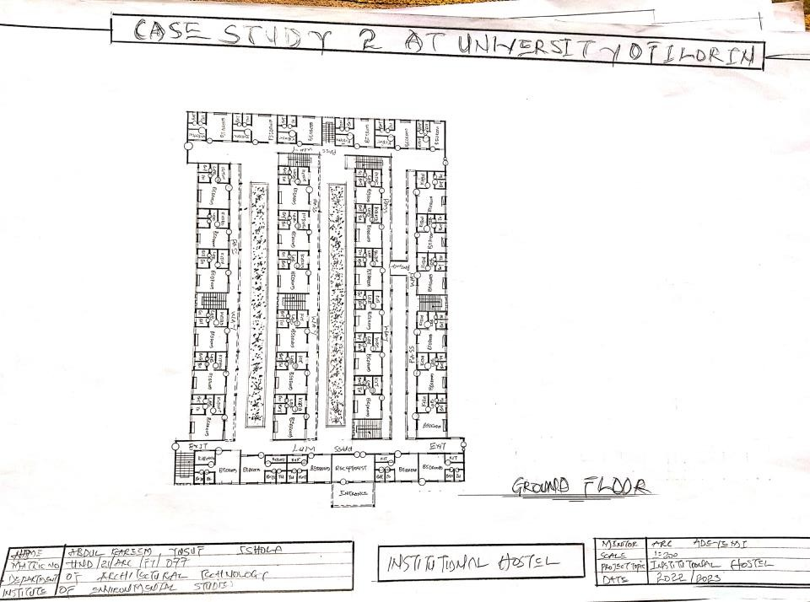

FIGURE 3.4:- TYPICAL PLAN OF UNIVERSITY OF ILORIN

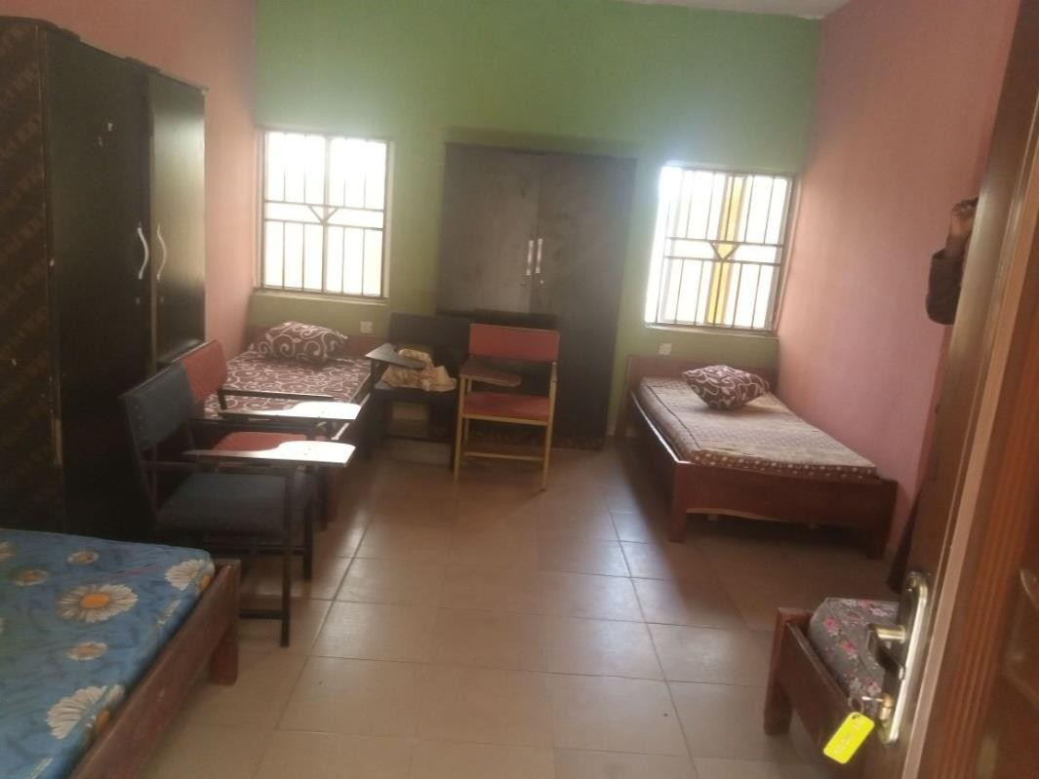

PLATE 3.3- INNER OF BEDROOM OF UNIVERSITY OF ILORIN
3.3 CASE STUDY THREE

NAME:- KEBBI STATE UNIVERSITY, NIGERIA HISTORICAL BACKGROUND
Kebbi State University (KSU), located in Aliero, Kebbi State, Nigeria, is a state-owned university that was established in 2006. The university was founded with the goal of providing quality higher education to students in Kebbi State and its environs. It aims to contribute to the development of the state by producing skilled graduates and promoting research and innovation. Key features of their hostels include:

- Modern infrastructure: The hostels are equipped with modern infrastructure, including well-designed rooms with comfortable beds, study desks, and storage spaces for students.
- Common areas: The hostels have common areas where students can interact, relax, and engage in recreational activities. These areas include lounges, TV rooms, and outdoor spaces.
- Internet connectivity: The hostels offer internet connectivity, allowing students to access online resources and stay connected.
- Security: The hostels have security measures in place, such as controlled access, CCTV surveillance, and the presence of security personnel to ensure the safety of residents.
- Laundry facilities: The hostels provide laundry facilities, making it convenient for students to take care of their laundry needs.
- Proximity to academic buildings: The hostels are strategically located near academic buildings, reducing commuting time for students.

3.3.1 Merits
- It is well-maintained and clean.
- It is located in a safe and secure area.
- It is close to the polytechnic's academic and administrative buildings.
- It has a variety of facilities, including a dining hall, a library, and a recreation center.
3.3.2 Demerits
The Federal Polytechnic Ede Male Hostel also has a number of demerits, including:
- It is overcrowded. There are currently over 1,500 students living in the hostel.
- The rooms are small and cramped.
- The bathrooms are shared and often dirty.
- There is a lack of security. There have been reports of theft and violence in the hostel.

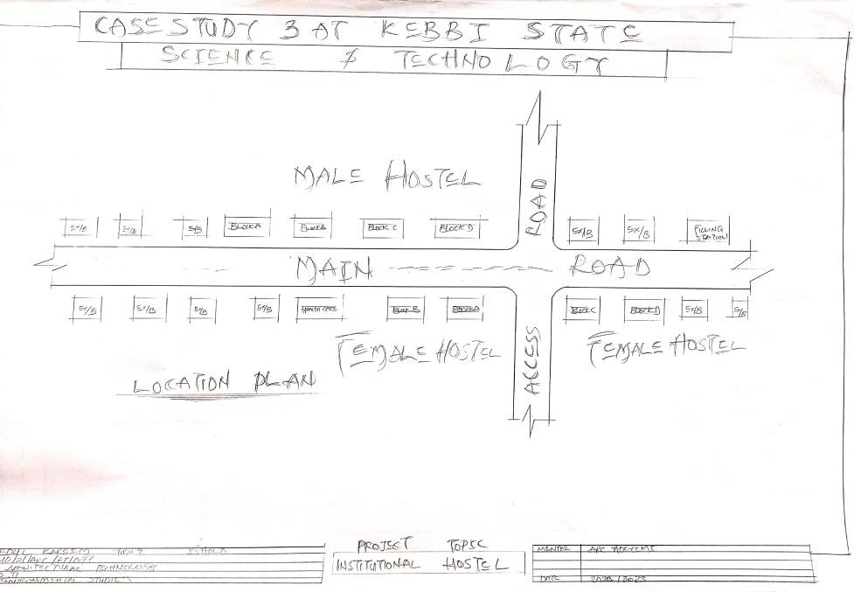

FIGURE 3.5:- LOCATIONAL PLAN OF KEBBI STATE UNIVERSITY

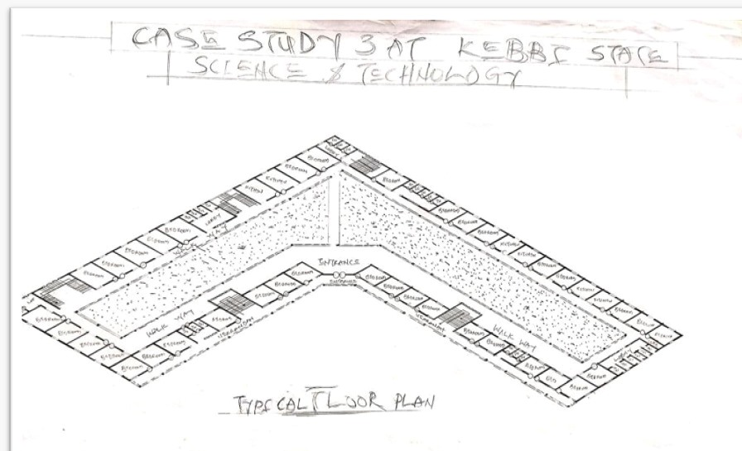
FIGURE 3.6:- TYPICAL PLAN OF KEBBI STATE UNIVERSITY



PLATE 3.3:-SIGN POST OF KEBBI STATE UNIVERSITY
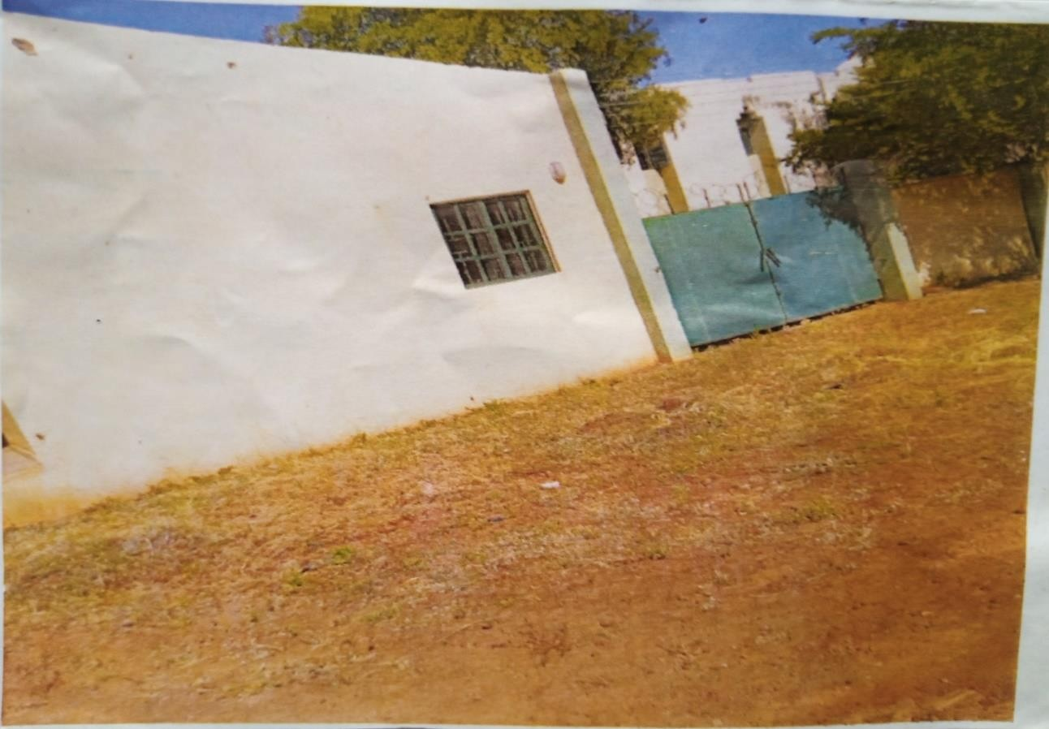
PLATE 3.4:- FRONT OF THE GATE OF KEBBI STATE UNIVERSITY

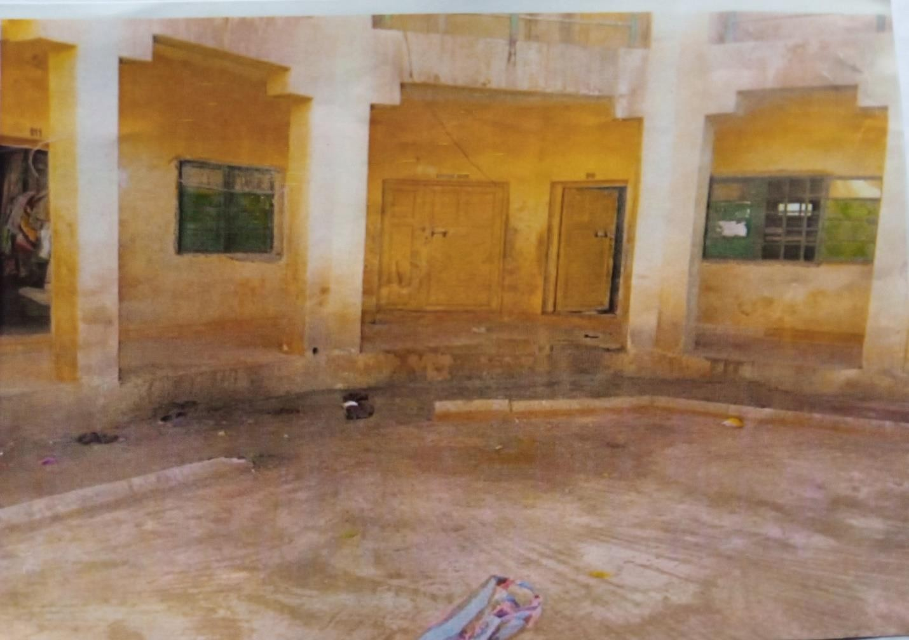

PLATE 3:- FRONT VIEW OF OF KEBBI STATE UNIVERSITY

3.4 CASE STUDY FOUR
NAME:- FEDERAL POLYTECHNIC OFFA HISTORICAL BACKGROUND
Federal Polytechnic Offa was established in 1992 by the administration of Ibrahim Babangida. The polytechnic is located in Offa, Kwara State, Nigeria. It offers National Diploma and Higher National Diploma courses at undergraduate levels. The idea of establishing a federal polytechnic in Offa was first mooted in 1989 by the then Military Governor of Kwara State, Col. Lawan Gwadabe. The proposal was subsequently approved by the Federal Government in 1991. The polytechnic was officially opened on 1st February, 1992 by the then Military President, Gen. Ibrahim Babangida. The polytechnic started with an initial intake of 360 students in six different programmes, The polytechnic has since grown in leaps and bounds. Today, it offers over 20 different programmes at both the National Diploma (ND) and Higher National Diploma (HND) levels. It has also produced over 20,000 graduates who are now working in various sectors of the economy. The polytechnic has a good reputation for academic excellence. It has been consistently ranked among the top polytechnics in Nigeria. It has also won several awards for its academic achievements. The polytechnic has a well-equipped library and laboratories. The library has a collection of over 100,000 books and journals. The laboratories are equipped with the latest equipment for teaching and research.

The polytechnic is located in a safe and secure environment. The town of Offa is known for its peace and tranquility.
3.4.1 Merits
- It is located on the Erasmus University campus, which makes it convenient for students to get to their classes.
- It has a central courtyard that provides natural light and ventilation.
- It has a variety of shared amenities, such as a laundry room, a study room, and a bike parking area

3.4.2 Demerits
- The rooms are relatively small.
- The building can be noisy at times, due to the proximity to the university.
- The rent is relatively high.

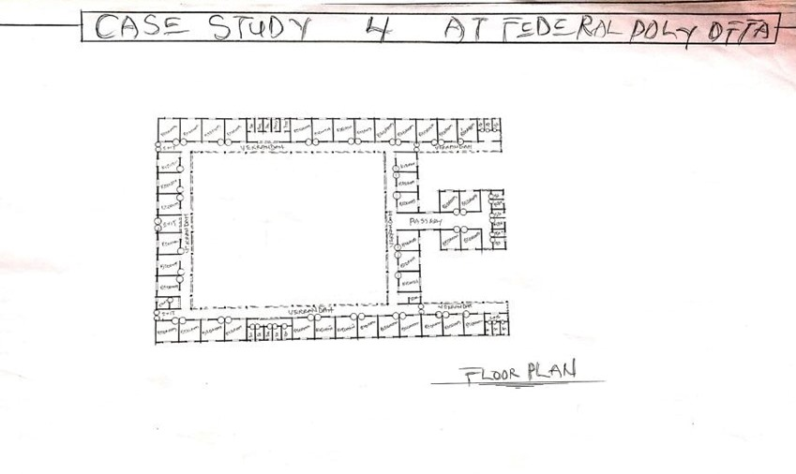

FIGURE 4:- FLOOR PLAN OF FEDERAL POLYTECHNIC, OFFA
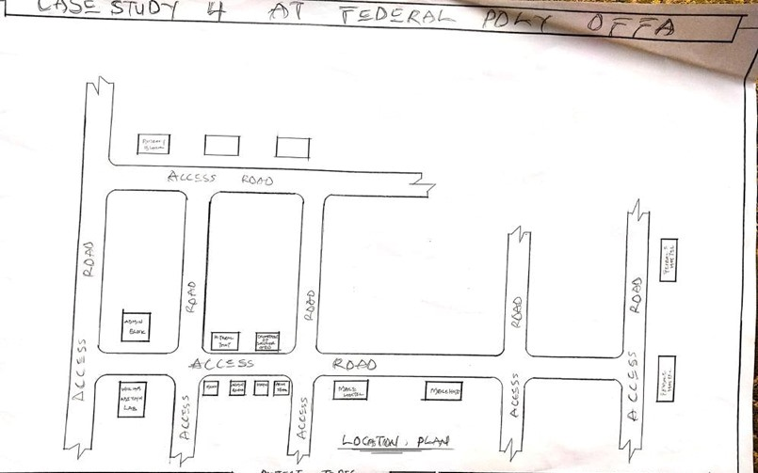
FIG 4:- LOCATION PLAN OF FEDERAL POLYTECHNIC, OFFA

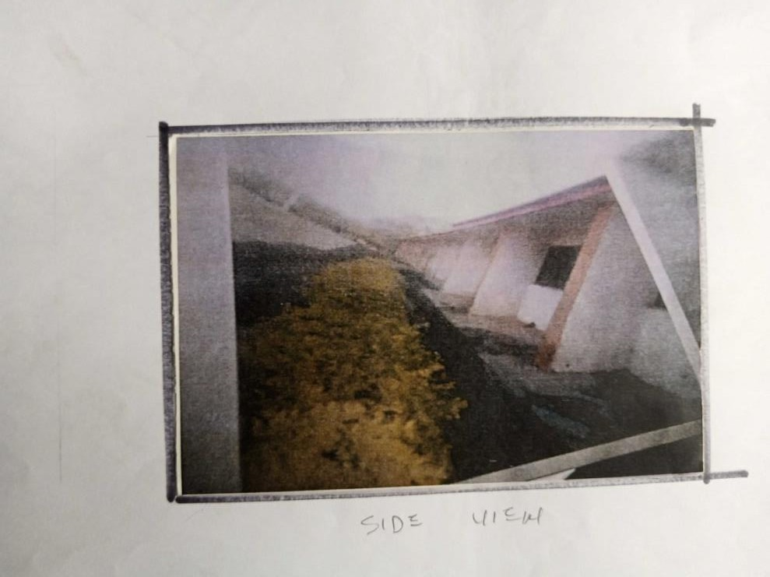

PLATE 1:- SIDE VIEW OF OF FEDERAL POLYTECHNIC, OFFA

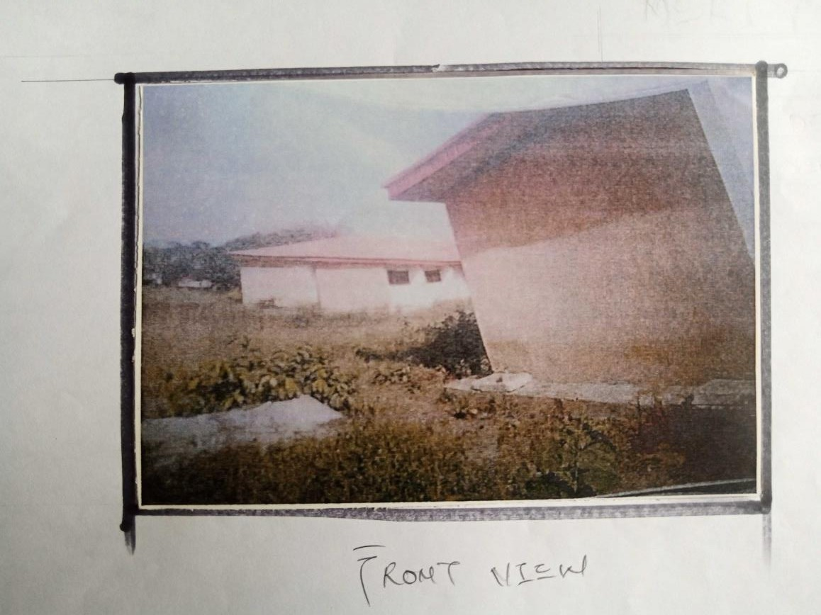

PLATE 2:- FRONT VIEW OF OF FEDERAL POLYTECHNIC, OFFA

CASE STUDY FIVE:- NAME:- ONLINE CASE STUDY
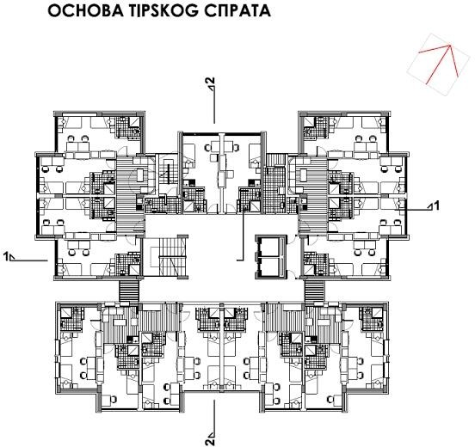

TYPICAL PLAN OF ONLINE

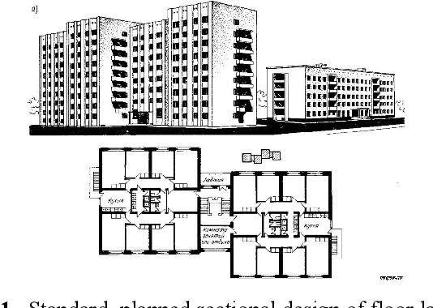

TYPICAL PLAN OF UNIVERSITY OF ILORIN
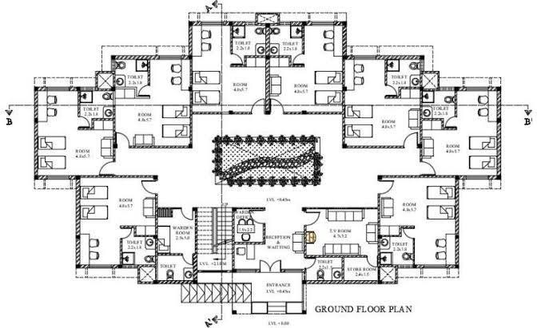

TYPICAL PLAN OF UNIVERSITY OF ILORIN

CHAPTER FOUR

Study Area/Project Site (Environmental and Impact Analysis)

4.1 Introduction to Study Area and Site Selection
The proposed institutional hostel project is strategically located in Ilorin West Local Government, Kwara State, Nigeria, a region celebrated for its role as an educational hub and its rich cultural diversity. The site selection process was meticulously planned to address the pressing need for quality student accommodation, driven by the exponential growth in student enrollment at tertiary institutions such as the University of Ilorin, Al-Hikmah University, and Federal Polytechnic Offa. Ilorin, as the capital of Kwara State, attracts a diverse student population from across Nigeria and beyond, creating a significant demand for modern, safe, and affordable housing. The chosen site aligns with the project’s overarching goal of providing a secure, comfortable, and community-oriented living environment that supports academic excellence, personal growth, and social cohesion.
The decision to situate the hostel in Ilorin West was informed by a thorough evaluation of the region’s infrastructure, demographic trends, and socio-economic dynamics. Ilorin’s status as a center for higher education has led to a surge in student numbers, overwhelming existing accommodation facilities. Many students resort to off-campus housing, which often lacks essential amenities, safety features, or proximity to academic institutions. This project aims to bridge this gap by delivering a purpose-built hostel capable of accommodating 500–700 students, offering a supportive environment that enhances the educational experience while contributing to the region’s cultural and economic vitality. The site’s selection was guided by its proximity to educational institutions, access to transportation networks, availability of utilities, and potential to create a serene yet functional living space, ensuring students can focus on their studies without logistical challenges.
The site selection process involved a multi-faceted analysis to ensure alignment with the project’s objectives. Key considerations included the site’s ability to support a multi-story structure, its integration with the surrounding community, and its capacity to meet environmental and regulatory requirements. By addressing these factors, the project aims to establish a model hostel that not only meets immediate accommodation needs but also sets a benchmark for sustainable and inclusive student housing in Nigeria.

4.2 Site Location, Description, and Criteria
The project site is located in Ilorin West Local Government, a vibrant urban area within Kwara State, positioned at approximately 8.48°N latitude and 4.55°E longitude. This strategic location places the site within Ilorin’s educational and cultural core, near major institutions such as the University of Ilorin and Al-Hikmah University. The surrounding area is a dynamic blend of educational facilities, residential neighborhoods, and small-scale commercial establishments, creating an environment that supports both academic pursuits and social activities. The site’s urban context ensures access to essential services, including healthcare facilities, markets, and public transport, enhancing the quality of life for residents.
The site spans approximately 2.5 hectares, offering ample space for a multi-story hostel, recreational areas, and landscaped green spaces. Its rectangular shape and clear boundaries facilitate efficient planning and construction, minimizing encumbrances such as existing structures or legal disputes. The site’s topography is predominantly flat with gentle slopes, reducing the need for extensive earthworks and ensuring cost-effective development. The selection criteria were carefully defined to align with the project’s objectives and ensure long-term viability:
- Proximity to Educational Institutions: The site’s closeness to universities and polytechnics reduces commuting time, enabling students to balance academic and residential life seamlessly. This proximity enhances convenience and supports academic engagement.
- Transportation Access: The site is well-connected to major roads and public transport networks, linking it to Ilorin’s city center and other key areas. This ensures ease of movement for residents and visitors.
- Utility Availability: Existing connections to municipal water, electricity, and sewage systems provide a foundation for operational needs, with provisions for upgrades such as a dedicated transformer or borehole to support the hostel’s capacity.
- Security Considerations: Ilorin West is known for its relative safety, supported by low crime rates and community policing initiatives. This makes it an ideal location for a student hostel prioritizing resident safety.
- Land Suitability: The 2.5-hectare plot offers sufficient space for a multi-story structure, communal areas, and landscaping, with favorable topography that supports efficient construction.
- Community Integration: The site’s location within a vibrant community ensures access to local amenities, fostering a sense of belonging and supporting residents’ daily needs.
These criteria ensure the site is well-suited to deliver a functional, accessible, and community-oriented hostel that meets the needs of its student population while contributing to Ilorin’s educational ecosystem.

4.3 Site Analysis and Inventory
A comprehensive site analysis was conducted to assess the physical, environmental, and contextual characteristics of the 2.5-hectare site, ensuring the design responds effectively to its unique conditions. The analysis covered topography, vegetation, surrounding land use, access points, utilities, and natural features, providing a foundation for informed design decisions.
Topography: The site is predominantly flat with gentle slopes, facilitating cost-effective construction with minimal need for grading or earthworks. This topography supports the development of a multi-story structure and associated amenities, ensuring efficient land use.
Vegetation: The site features sparse vegetation, primarily consisting of grasses, shrubs, and a few scattered trees. These natural elements can be preserved or integrated into the landscaping design to enhance aesthetics, provide shade, and create a serene environment.
Surrounding Land Use: The site is bordered by educational facilities to the north, residential neighborhoods to the west, and commercial establishments to the south. This mix creates a dynamic yet controlled environment, ideal for a student hostel. The proximity to academic institutions fosters a student-centric atmosphere, while residential and commercial areas provide access to essential services.
Access Points: Multiple access roads connect the site to major routes, with a primary entrance planned along the eastern boundary for vehicular and pedestrian access. This ensures efficient circulation and minimizes congestion, enhancing accessibility for residents and visitors.
Utilities: The site benefits from existing connections to municipal water, electricity, and sewage systems. However, the hostel’s capacity may require enhancements, such as a dedicated transformer for electricity or a borehole for water supply, to ensure reliability and sustainability.
Natural Features: No significant water bodies, fault lines, or geological hazards were identified, reducing environmental risks during construction. The absence of such challenges simplifies site preparation and enhances project feasibility.
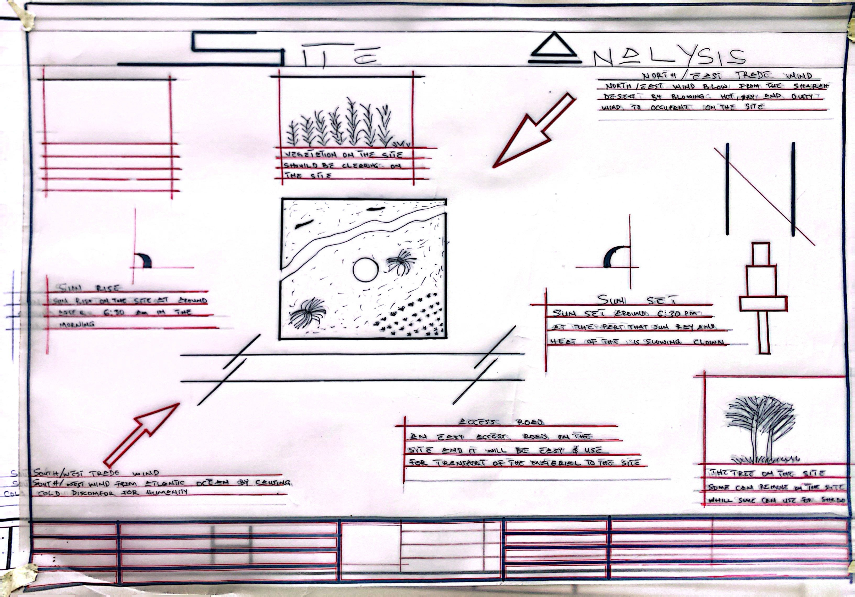

Figure 4.1: Site Analysis

4.4 Geographical and Climatic Data
Ilorin West lies within Nigeria’s North-Central geopolitical zone, characterized by a tropical savanna climate with distinct wet and dry seasons. The following geographical and climatic data guide the hostel’s design to ensure occupant comfort, energy efficiency, and environmental resilience:
- Geographical Coordinates: The site is located at approximately 8.48°N latitude and 4.55°E longitude, positioning it within Ilorin’s urban core and facilitating access to educational and commercial hubs.
- Temperature: Annual temperatures range from 22°C to 34°C, with peaks reaching 36°C during the hottest months (February–March). The design incorporates natural ventilation, shading devices, and reflective materials to mitigate heat gain and maintain indoor comfort.
- Rainfall: Annual rainfall averages 1,200–1,500 mm, with peak precipitation from June to September. Robust drainage systems, waterproof materials, and elevated foundations are essential to prevent water ingress and manage stormwater runoff.
- Humidity: Humidity levels fluctuate between 60–80% during the wet season and 20–40% during the dry Harmattan season (December–February). Moisture-resistant materials and dehumidification systems in common areas address humidity challenges, ensuring a healthy indoor environment.
- Wind Patterns: Predominantly southwest winds during the wet season and northeast winds during the Harmattan season influence building orientation to optimize cross-ventilation. Strategically placed windows and ventilation louvers leverage these wind patterns to enhance airflow.
- Solar Path: High solar radiation throughout the year necessitates design features such as overhangs, louvers, and reflective roofing to reduce heat gain. Solar panels are integrated to harness abundant sunlight, contributing to energy efficiency.

4.5 Analysis of Immediate Environmental Conditions
The immediate environment of the site reflects Ilorin’s urban and cultural dynamics, presenting both opportunities and challenges for the hostel’s design:
- Noise Levels: Moderate noise from nearby traffic and urban activities requires soundproofing measures, such as double-glazed windows, insulated walls, and acoustic panels, to create a peaceful living environment conducive to study and rest.
- Air Quality: Air quality is generally good, but dust during the Harmattan season necessitates air filtration systems in common areas and regular maintenance of ventilation systems to ensure healthy indoor conditions.
- Drainage and Flood Risk: The site’s gentle slopes support natural drainage, but heavy rainfall during the wet season requires robust stormwater management. Drainage channels, retention ponds, and permeable paving will mitigate flood risks and manage runoff effectively.
- Cultural and Social Context: Ilorin’s diverse ethnic composition, including Yoruba, Nupe, Fulani, and Bariba communities, calls for a design that promotes inclusivity. Communal spaces, such as courtyards and lounges, are designed to encourage cultural exchange and social interaction, fostering a sense of community.
- Environmental Opportunities: The site’s flat terrain and abundant sunlight present opportunities for solar energy systems, green roofing, and landscaped areas. These features enhance sustainability, reduce operational costs, and create an aesthetically pleasing environment.
The analysis of immediate environmental conditions ensures the hostel design responds to local challenges while capitalizing on opportunities to enhance resident comfort and sustainability.

4.6 Project Analysis and Design Criteria

4.6.1 Project Goals
The institutional hostel project aims to deliver a modern, functional, and sustainable accommodation facility for 500–700 students in Ilorin West, addressing the critical shortage of quality student housing. The client, an educational institution, seeks to enhance the student experience by providing a safe, comfortable, and community-oriented living environment. Specific project goals include:
- Meeting Accommodation Demand: Providing sufficient capacity to house 500–700 students, reducing pressure on existing facilities and addressing the shortage of affordable, quality accommodation.
- Enhancing Student Experience: Creating a supportive environment with modern amenities, such as study rooms, recreational spaces, and high-speed Wi-Fi, to promote academic success and well-being.
- Promoting Community and Engagement: Fostering social interaction and cultural exchange through shared spaces like lounges, courtyards, and recreational areas, building a sense of belonging.
- Ensuring Safety and Security: Implementing robust measures, including CCTV surveillance, biometric access, and fire safety systems, to protect residents.
- Aligning with Sustainability Principles: Incorporating energy-efficient systems (e.g., solar panels, LED lighting), water conservation measures (e.g., rainwater harvesting), and eco-friendly materials to minimize environmental impact and operational costs.
- Cultural Relevance: Reflecting Ilorin’s cultural diversity through architectural elements, such as Yoruba-inspired patterns and vibrant color schemes, to create a sense of place and community acceptance.
- 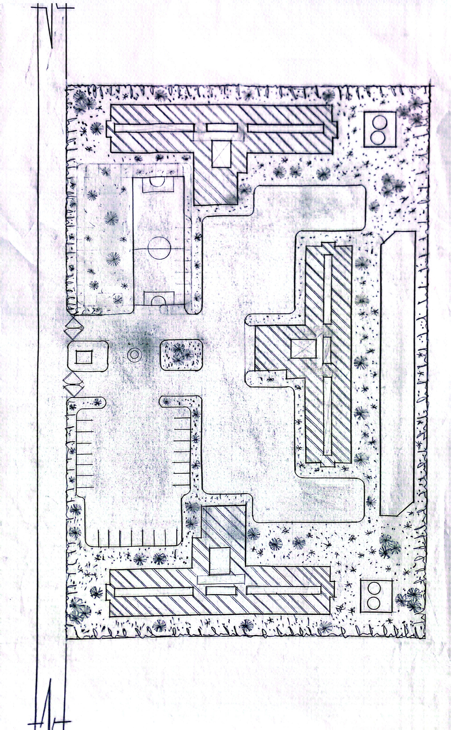Figure 4.2: Site Plan

4.6.2 Functional and Spatial Criteria
The hostel’s design prioritizes functionality, accessibility, and user comfort to meet the diverse needs of students. Key criteria include:
- Living Spaces: Private or semi-private bedrooms (double or quadruple occupancy) equipped with study desks, wardrobes, and adequate lighting to ensure privacy and functionality.
- Common Areas: Dedicated spaces for studying, socializing, and recreation, designed to foster community and collaboration among residents.
- Accessibility: Universal design features, including ramps, elevators, and accessible bathrooms, to accommodate students with disabilities, ensuring compliance with international standards.
- Safety and Security: Controlled access points, biometric locks, CCTV surveillance, and comprehensive fire safety systems (smoke detectors, sprinklers, emergency exits) to protect residents.
- Sustainability: Energy-efficient systems (e.g., LED lighting, solar panels), water conservation measures (e.g., rainwater harvesting), and eco-friendly materials to reduce environmental impact.
- Operational Efficiency: Centralized administrative areas and service zones (e.g., laundry, maintenance) to streamline management and ensure efficient operations.
These criteria ensure the hostel meets practical needs while creating an inclusive, supportive environment for residents.

4.6.3 Appraisal of Proposed Schemes in Spaces, Size, and Relationships
The proposed hostel adopts a multi-story block layout to optimize space efficiency and ease of management. The appraisal of the design scheme highlights its suitability for accommodating 500–700 students:
- Space Efficiency: The design accommodates residents within a compact footprint, with room sizes ranging from 12 m² (double occupancy) to 20 m² (quadruple occupancy). Common areas, including study rooms (100 m², seating 20–30 students) and lounges (150 m², seating 40–50), are proportionate to resident capacity, ensuring comfort and accessibility.
- Spatial Relationships: Bedrooms are organized in clusters around central corridors, with common areas centrally located to promote interaction. Administrative offices are positioned near entrances for accessibility, while service areas (e.g., laundry, maintenance) are discreetly placed to minimize disruption.
- Aesthetic and Functional Balance: The design integrates modern architectural elements, such as clean lines and large windows, with practical layouts that prioritize ease of movement and resident comfort. Local materials and cultural motifs, such as Yoruba-inspired patterns, enhance aesthetic appeal and contextual relevance.
- Scalability and Flexibility: The modular block design allows for phased construction and future expansion, accommodating potential increases in student numbers. This flexibility ensures the hostel remains viable as demand grows.

4.6.4 Equipment and Operational Performance Requirements
The hostel’s operational efficiency and resident comfort rely on carefully selected equipment and systems:
- Electrical Systems: Energy-efficient LED lighting with motion sensors reduces consumption. Solar panels provide partial power for common areas, supplemented by a backup generator to ensure uninterrupted supply.
- Plumbing: Water-efficient fixtures (e.g., low-flow showers, dual-flush toilets) and a rainwater harvesting system reduce water usage by 30–40%. A borehole supplements municipal water supply for reliability.
- HVAC: Natural ventilation is prioritized through cross-ventilation and strategically placed windows, leveraging Ilorin’s wind patterns. Ceiling fans and limited air conditioning in common areas address high temperatures.
- Fire Safety: Smoke detectors, fire extinguishers, sprinklers, and clearly marked emergency exits comply with Nigerian building codes, ensuring rapid evacuation and safety.
- Security: CCTV cameras, biometric access controls, and 24/7 security personnel provide robust protection. Controlled access points at entrances enhance resident safety.
- Telecommunications: High-speed Wi-Fi, intercom systems, and data ports in study areas support academic and communication needs, ensuring connectivity for residents.
- Furniture and Fittings: Durable, ergonomic furniture (beds, desks, chairs) and modular storage solutions maximize space and comfort, tailored to student needs.

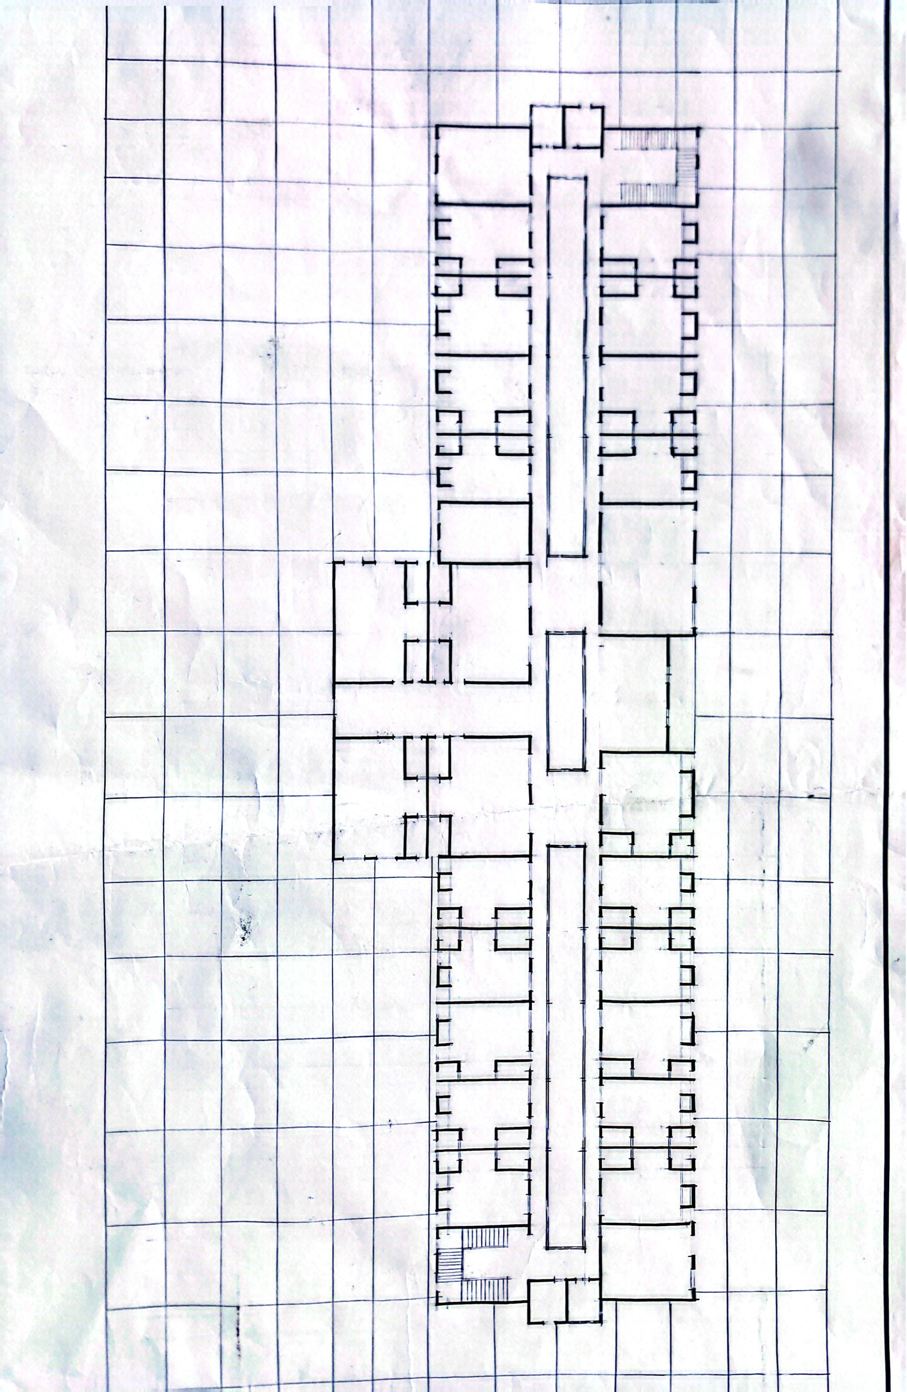

Figure 4.3: Upper Floor Plan

4.6.5 Spatial Allocation and Schedule of Accommodation
The spatial allocation is designed to balance private and communal spaces for 500–700 students:
- Bedrooms: 250–350 rooms, with 70% double occupancy (12–15 m²) and 30% quadruple occupancy (18–20 m²). Each room includes beds, study desks, wardrobes, and power outlets for functionality.
- Bathrooms: Shared facilities per floor, with a ratio of 1 bathroom per 8–10 residents (50 m² per cluster), including showers, toilets, and sinks to ensure convenience.
- Common Areas: Study rooms (100 m², seating 20–30), lounges (150 m², seating 40–50), and recreational spaces (200 m², indoor and outdoor) to promote social interaction.
- Dining Hall: 300 m², seating 150–200 students, with an adjacent 100 m² kitchen equipped for large-scale meal preparation.
- Administrative Offices: 50 m² for hostel management, including reception and staff rooms, positioned for accessibility.
- Service Areas: Laundry rooms (50 m²), maintenance rooms (30 m²), and waste management facilities (20 m²) to support operational efficiency.
This allocation ensures a balanced distribution of spaces, catering to both individual and communal needs while optimizing the site’s footprint.

4.6.6 Functional Relationships
The hostel’s layout is designed to enhance usability and resident experience through efficient functional relationships:
- Bedrooms to Bathrooms: Bathrooms are located within 10–15 meters of bedrooms, ensuring quick access and convenience, particularly during peak usage times.
- Common Areas to Bedrooms: Study rooms and lounges are centrally positioned on each floor, accessible via main corridors, to encourage frequent use and foster social interaction.
- Dining Hall to Kitchen: The dining hall is directly adjacent to the kitchen, with service counters to streamline food distribution and waste management.
- Administrative Offices to Entrances: Offices are placed near the main entrance for effective oversight of arrivals, departures, and visitor management.
- Recreational Spaces: Outdoor recreational areas, such as basketball courts, are accessible from indoor lounges, creating a seamless indoor-outdoor flow that supports active lifestyles.
These relationships optimize circulation, minimize disruptions, and enhance the overall functionality of the hostel.

4.6.7 Conceptual Development
The design concept, “Community in Harmony,” reflects Ilorin’s cultural diversity and the goal of fostering a cohesive student community. Key conceptual elements include:
- Open and Inclusive Spaces: A central courtyard serves as a communal hub, surrounded by lounges and study rooms to encourage interaction and collaboration among residents.
- Sustainable Design: Large windows and skylights maximize natural light, while cross-ventilation reduces reliance on mechanical cooling. Solar panels and rainwater harvesting align with sustainability goals, reducing operational costs.
- Cultural Sensitivity: Architectural elements, such as patterned screens inspired by Yoruba and Islamic motifs, and vibrant color schemes, reflect Ilorin’s cultural identity, creating a sense of place and belonging.
- Modularity and Flexibility: The block layout allows for phased construction and future expansion, ensuring adaptability to changing needs and scalability to accommodate growth.
The conceptual development integrates modern functionality with contextual relevance, creating a hostel that is practical, sustainable, and reflective of Ilorin’s unique identity. This approach ensures the facility meets the needs of its diverse student population while contributing to the broader educational and cultural landscape of Ilorin West.
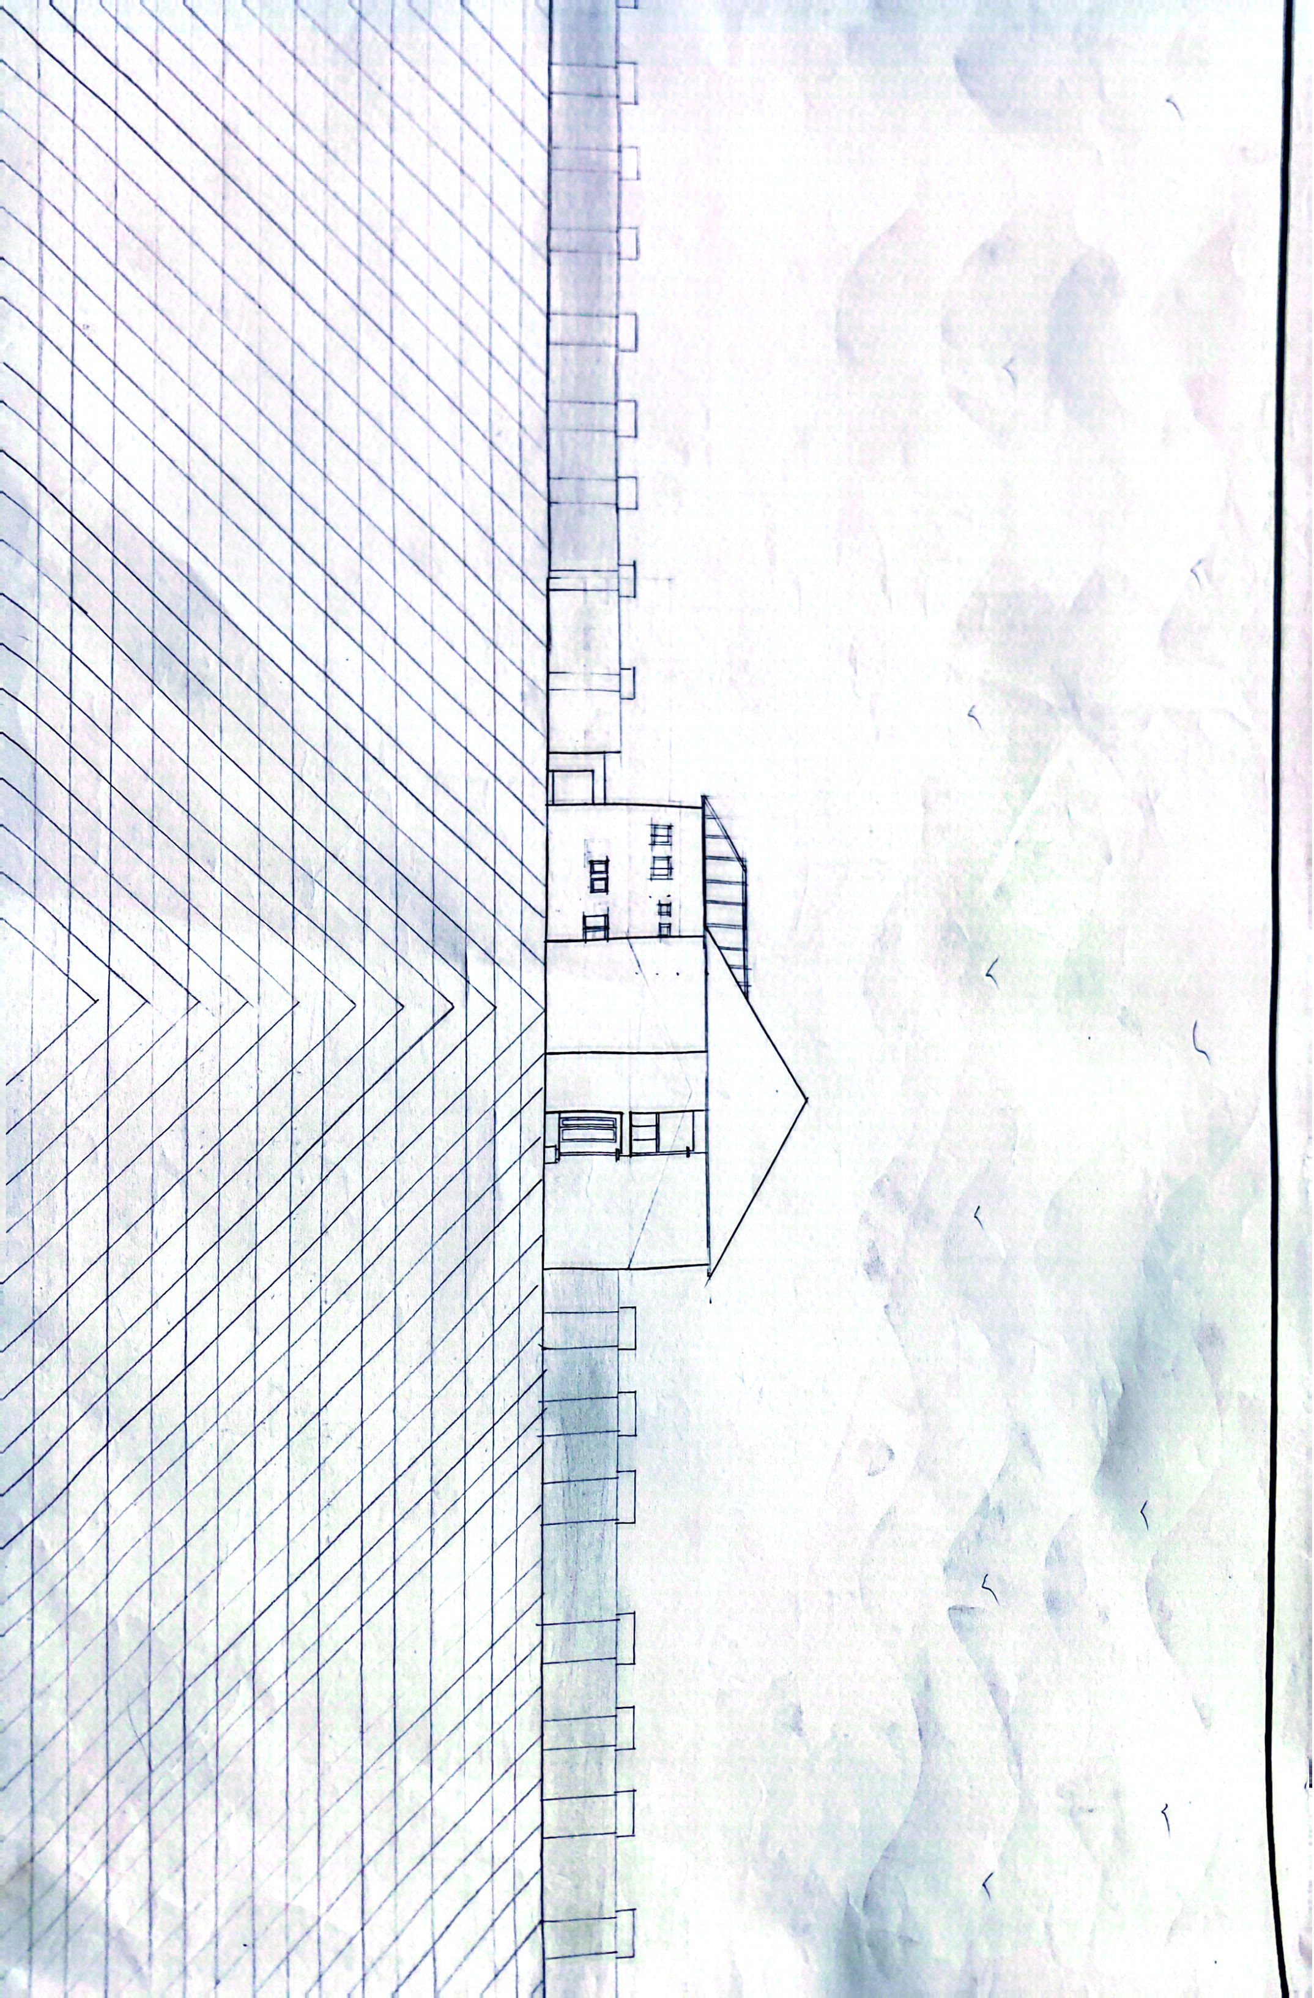
Figure 4.5: Conceptual Development Visualization

CHAPTER FIVE

Approach to the Design/Design Realization

5.1 Design Ideas and Concepts at Different Levels of the Design Process
The design of the institutional hostel in Ilorin West, Kwara State, Nigeria, is guided by the overarching concept of “Community in Harmony,” which emphasizes creating a living environment that fosters social interaction, cultural inclusivity, sustainability, and academic support. This concept was developed through a multi-stage design process that addresses both site-level and building-level considerations, ensuring the hostel meets the functional, aesthetic, and contextual needs of its student residents. The design process integrates user requirements, environmental conditions, and cultural sensitivities to deliver a modern, inclusive, and sustainable facility for 500–700 students.

5.1.1 Site-Level Design Concepts
At the site level, the design prioritizes efficient land use, environmental responsiveness, and integration with the surrounding urban context of Ilorin West. The 2.5-hectare site, located near major educational institutions such as the University of Ilorin and Al-Hikmah University, is organized to maximize accessibility, functionality, and aesthetic appeal. Key site-level concepts include:
- Zoning Strategy: The site is divided into distinct zones to optimize spatial functionality. The residential zone, comprising the main hostel blocks, is centrally located to ensure easy access for all residents. A central courtyard serves as the communal hub, surrounded by recreational and social spaces such as lounges, study rooms, and outdoor seating areas. Service zones, including laundry, maintenance, and waste management facilities, are discreetly positioned along the site’s periphery to minimize disruption. Green spaces, incorporating native trees and landscaped gardens, enhance aesthetics, provide shade, and create a serene environment conducive to relaxation and social interaction.
- Orientation and Climate Response: The hostel is oriented along the east-west axis to leverage Ilorin’s southwest winds during the wet season and northeast winds during the Harmattan season, optimizing natural ventilation and reducing reliance on mechanical cooling. This orientation also minimizes solar heat gain by aligning the building’s longer facades to face north and south, where shading devices like overhangs and louvers can effectively manage sunlight exposure. The design responds to Ilorin’s tropical savanna climate, with temperatures ranging from 22°C to 36°C and annual rainfall of 1,200–1,500 mm, by incorporating robust drainage systems and waterproof materials to mitigate flood risks.
- Landscaping Integration: Native vegetation, including grasses, shrubs, and scattered trees, is preserved and supplemented with additional plantings to create shaded walkways, courtyards, and recreational areas. These green spaces not only enhance the site’s aesthetic appeal but also contribute to thermal comfort by reducing ambient temperatures and providing natural shade. Landscaping also supports sustainability by promoting biodiversity and reducing the urban heat island effect.
- Accessibility and Circulation: The site features multiple access points, with a primary entrance along the eastern boundary for vehicular and pedestrian traffic. Paved walkways and parking areas ensure efficient circulation, while accessible ramps and pathways cater to residents with disabilities. The layout minimizes congestion by separating pedestrian and vehicular routes, ensuring safe and convenient movement across the site.

5.1.2 Building-Level Design Concepts
At the building level, the hostel adopts a modular, multi-story block layout to accommodate 500–700 students while ensuring flexibility, scalability, and user comfort. The design balances private and communal spaces, incorporates sustainable technologies, and reflects Ilorin’s cultural identity. Key building-level concepts include:
- Modular Flexibility: The hostel is designed as a series of interconnected blocks, each housing a cluster of bedrooms, bathrooms, and common areas. This modular approach allows for phased construction, enabling the project to start with one block to meet immediate needs and expand as demand grows. The layout ensures efficient management by grouping residents into smaller, self-contained units, fostering a sense of community within each block.
- Inclusive and Communal Spaces: A central atrium connects all floors, serving as a visual and functional focal point that enhances connectivity and encourages interaction among residents. Communal spaces, including study rooms (100 m², seating 20–30 students), lounges (150 m², seating 40–50), and recreational areas (200 m², indoor and outdoor), are strategically placed to promote social engagement and cultural exchange. These spaces are designed to reflect Ilorin’s diverse ethnic composition (Yoruba, Nupe, Fulani, Bariba) through inclusive layouts and culturally inspired aesthetics.
- Cultural Aesthetics: The design incorporates architectural elements that resonate with Ilorin’s cultural identity, such as patterned screens inspired by Yoruba and Islamic motifs, vibrant color palettes, and locally sourced materials. These elements are integrated into facades, interior walls, and communal spaces, creating a sense of place and fostering a connection to the local community. The aesthetic approach blends modern minimalism with traditional motifs, ensuring the hostel is both contemporary and contextually relevant.
- Sustainability and Comfort: The building design prioritizes energy efficiency and occupant comfort through features such as large windows and skylights for natural light, cross-ventilation for airflow, and solar panels for renewable energy. Soundproofing measures, including double-glazed windows and acoustic panels, address moderate noise levels from nearby urban activities, ensuring a peaceful environment for study and rest.
The design process progressed from conceptual sketches to detailed architectural plans, incorporating feedback from user surveys, case studies, and site analysis to ensure alignment with project goals. The result is a cohesive design that balances functionality, sustainability, and cultural sensitivity, creating a supportive living environment for students.

5.2 Sketches and Graphics
The design concepts are supported by a comprehensive set of sketches and graphics that illustrate the hostel’s evolution from conceptual ideas to detailed realizations. These visuals provide a clear representation of the site and building design, ensuring stakeholders can visualize the project’s scope and aesthetic. Key sketches and graphics include:
- Site Plan: Depicts the zoning strategy, showing the arrangement of residential, recreational, and service zones. The plan highlights the central courtyard, access roads, parking areas, and landscaped green spaces, emphasizing efficient land use and circulation.
- Floor Plans: Illustrate the layout of each floor, detailing the arrangement of bedrooms (12–20 m²), bathrooms (50 m² per cluster), study rooms (100 m²), lounges (150 m²), and administrative offices (50 m²). The plans emphasize spatial relationships, with communal areas centrally located for accessibility and bedrooms clustered for privacy.
- Conceptual Sketches: Visualize the “Community in Harmony” theme through renderings of the central courtyard, communal spaces, and cultural design elements. These sketches highlight the interplay of light, space, and local aesthetics, showcasing the hostel’s welcoming atmosphere.
- Elevations and Sections: Detail the building’s facade, structural systems, and sustainable features, such as solar panels, ventilation louvers, and reflective roofing. Sections illustrate the internal organization, including the atrium’s role in connecting floors and enhancing natural light.
- 3D Perspectives: Provide internal and external visualizations of the hostel, showcasing the integration of modern and cultural elements. External perspectives highlight the facade’s clean lines and patterned screens, while internal views depict the functionality of communal spaces and bedrooms.
These visuals were developed iteratively, incorporating feedback from the client and technical consultants to ensure accuracy and alignment with project objectives. They serve as critical tools for communicating the design vision to stakeholders and guiding the construction process.

5.3 Technological and Environmental Criteria

5.3.1 Construction Methodology and Materials/Finishes
The construction methodology prioritizes cost-effectiveness, durability, and sustainability, aligning with the client’s requirements for a high-quality, low-maintenance facility. The approach balances modern construction techniques with local materials to support the regional economy and ensure contextual relevance.
- Structural System: The hostel employs a reinforced concrete frame with sandcrete block infill walls, providing structural stability and flexibility for multi-story construction. This system is widely used in Nigeria for its durability and cost-effectiveness, ensuring the building can withstand environmental loads, including wind and minor seismic activity.
- Construction Process: Phased construction allows for incremental development, starting with one block to accommodate immediate needs and expanding as funding and demand permit. Prefabricated elements, such as window frames, door panels, and roofing trusses, streamline assembly, reduce construction time, and ensure consistency in quality. Local labor is prioritized to support the Ilorin economy and enhance community engagement.
- Materials and Finishes:
  - Exterior: Sandcrete blocks with textured plaster finishes provide durability and low maintenance. Locally sourced materials reduce transportation costs and environmental impact, while reflective coatings on exterior walls minimize heat absorption.
  - Roofing: Aluminum roofing sheets with reflective coatings reduce heat gain, supported by a steel truss system for longevity and resistance to corrosion. Roof overhangs provide shading, further enhancing thermal comfort.
  - Interior: Ceramic floor tiles are used in high-traffic areas (e.g., corridors, common rooms) for durability and ease of cleaning, while vinyl flooring in bedrooms offers comfort and affordability. Walls are finished with washable, low-VOC emulsion paint to ensure indoor air quality and facilitate maintenance.
  - Cultural Elements: Decorative screens and panels, crafted from locally sourced timber or metal, feature Yoruba-inspired patterns, adding aesthetic value and supporting local artisans. These elements are integrated into communal spaces and facades, reinforcing cultural identity.
- Client Preferences: The client emphasized the use of durable, locally available materials to minimize costs and support the regional economy. Sustainable finishes, such as low-VOC paints and water-resistant coatings, were prioritized to enhance indoor air quality and ensure long-term maintenance efficiency.

5.3.2 Services Required
The hostel incorporates essential services to ensure functionality, comfort, and safety, addressing the diverse needs of its student residents:
- Circulation: Wide corridors (1.5–2 meters) and strategically placed staircases and elevators facilitate smooth movement across floors. Accessible ramps and handrails ensure inclusivity for residents with disabilities, complying with universal design standards.
- Ventilation: Cross-ventilation is achieved through large windows and ventilation louvers, leveraging Ilorin’s southwest and northeast winds to maintain airflow. Ceiling fans in bedrooms and common areas supplement natural ventilation, reducing reliance on air conditioning.
- Lighting: Energy-efficient LED lighting with motion sensors is installed throughout the hostel to minimize energy consumption. Skylights and large windows maximize natural light in common areas and corridors, enhancing ambiance and reducing electricity costs.
- Plumbing and Electrical Installation:
  - Plumbing: Water-efficient fixtures, including low-flow showers and dual-flush toilets, reduce water consumption by 30–40%. A rainwater harvesting system collects and stores water for non-potable uses, such as landscaping and flushing, while a borehole supplements municipal water supply to ensure reliability.
  - Electrical: Solar panels provide partial power for common areas, reducing grid dependency by approximately 25%. A backup generator ensures uninterrupted power during outages. Electrical outlets are strategically placed in bedrooms and study rooms for convenience.
- Acoustics: Soundproofing measures, including acoustic panels, double-glazed windows, and insulated walls, maintain indoor noise levels below 45 dB, addressing moderate urban noise from nearby traffic and activities.
- Waste Disposal: A centralized waste management system includes segregated bins for recycling, organic waste, and general waste. A compact on-site waste treatment facility ensures compliance with environmental regulations, minimizing the hostel’s ecological footprint.
- Fire Protection: Smoke detectors, fire extinguishers, and sprinklers are installed throughout the building, with fire-resistant materials used in critical areas. Clearly marked emergency exits and evacuation routes ensure compliance with Nigerian fire safety standards, achieving evacuation times under 5 minutes in simulations.
- External Works: Paved walkways, parking areas, and landscaped gardens enhance accessibility and aesthetics. Outdoor lighting with motion sensors ensures safety at night, while drainage channels and retention ponds manage stormwater runoff effectively.

5.3.3 Environmental Conditions to be Achieved
The design aims to create a comfortable, sustainable, and resilient living environment tailored to Ilorin’s climatic and urban context:
- Thermal Comfort: Natural ventilation and shading devices maintain indoor temperatures between 24–28°C, reducing reliance on mechanical cooling. Reflective roofing and insulated walls further minimize heat gain.
- Indoor Air Quality: Low-VOC materials and adequate ventilation systems ensure healthy indoor conditions, minimizing pollutants and allergens.
- Water Efficiency: Rainwater harvesting and water-efficient fixtures reduce consumption by 30–40% compared to standard designs, ensuring sustainable water use.
- Energy Efficiency: Solar panels, LED lighting, and motion sensors achieve an energy consumption rate of less than 100 kWh/m²/year, aligning with sustainability goals.
- Noise Control: Soundproofing measures ensure indoor noise levels remain below 45 dB, creating a peaceful environment for studying and resting.

5.3.4 Performance Standards
The hostel is designed to meet rigorous performance standards to ensure safety, efficiency, and sustainability:
- Structural Integrity: The reinforced concrete frame complies with the Nigerian Building Code (2006), ensuring resistance to wind loads and minor seismic activity.
- Energy Performance: The building achieves an energy consumption rate of less than 100 kWh/m²/year, supported by solar power and efficient lighting systems.
- Safety Compliance: Fire safety systems meet the standards of the Nigerian Fire Service, with evacuation times under 5 minutes in simulations.
- Accessibility: The design adheres to universal design principles, ensuring compliance with international accessibility standards for people with disabilities.
- Sustainability: The hostel aligns with United Nations Sustainable Development Goal 11 (Sustainable Cities and Communities) through energy and water conservation measures, reducing environmental impact.

5.4 Legal Issues and Planning Regulations
The hostel design complies with relevant legal and planning regulations to ensure safety, functionality, and community acceptance:
- Building Codes: The design adheres to the Nigerian Building Code (2006), covering structural safety, fire protection, and accessibility requirements. This includes specifications for load-bearing capacity, fire-resistant materials, and emergency exits.
- Zoning Regulations: The site is zoned for institutional use under Ilorin West Local Government’s master plan, permitting the construction of a student hostel. The design respects zoning restrictions, such as height limits and setback requirements.
- Environmental Impact Assessment (EIA): An EIA was conducted to evaluate the project’s environmental footprint, with mitigation measures for noise, waste, and water management approved by the Kwara State Environmental Protection Agency.
- Permits and Approvals: The project requires permits from the Kwara State Ministry of Housing and Urban Development, including building plan approval, fire safety clearance, and environmental compliance certificates. Coordination with local authorities ensures timely approval.
- Cultural Heritage: The design incorporates Yoruba and Islamic architectural elements, such as patterned screens, to respect local cultural heritage and ensure community acceptance.
Compliance with these regulations ensures the project’s legal viability and aligns with community expectations, facilitating smooth implementation.

5.5 Behavioral Patterns and Considerations
The hostel design considers the behavioral patterns of its primary users—students aged 18–25—to create a supportive and engaging environment:
- Social Interaction: Communal spaces, such as lounges, courtyards, and recreational areas, are designed to encourage networking, collaboration, and cultural exchange, addressing students’ need for social connection.
- Study Habits: Dedicated study rooms with ergonomic furniture, high-speed Wi-Fi, and adequate lighting cater to academic needs, providing quiet spaces for focused work.
- Recreational Needs: Outdoor sports facilities (e.g., basketball courts) and indoor recreational areas support physical and mental well-being, aligning with students’ active lifestyles.
- Privacy and Comfort: Semi-private bedrooms (double or quadruple occupancy) offer personal space, balancing communal living with individual needs for rest and relaxation.
- Cultural Diversity: The design accommodates Ilorin’s diverse ethnic groups by incorporating inclusive spaces and culturally inspired aesthetics, fostering a sense of belonging and community.

5.6 Conclusion and Recommendations

5.6.1 Conclusion
The design and realization of the institutional hostel in Ilorin West successfully address the growing demand for quality student accommodation. The “Community in Harmony” concept integrates modular design, sustainable practices, and cultural sensitivity to create a functional, inclusive, and aesthetically pleasing living environment. Comprehensive research, including site analysis, climatic data, and case studies, informed a design that optimizes space, enhances user experience, and ensures long-term viability. The hostel is poised to contribute to Ilorin’s educational ecosystem by providing a supportive home for 500–700 students, fostering academic success, personal growth, and community engagement.

5.6.2 Justification by Research Results
The conclusion is supported by extensive research, including site analysis, climatic data, and case studies of hostels at Al-Hikmah University, University of Ilorin, Kebbi State University, and Federal Polytechnic Offa. These studies highlighted the importance of communal spaces, security, and sustainability, which were incorporated into the design. User surveys confirmed students’ preferences for private bedrooms, study areas, and recreational facilities, shaping the spatial allocation and design features to meet these needs effectively.

5.6.3 Recommendations for Future Research
To further enhance the hostel’s design and implementation, the following recommendations are proposed:
- Smart Technology Integration: Explore IoT-based systems for energy management, security, and facility monitoring to enhance operational efficiency and user experience.
- Advanced Sustainability: Investigate innovative technologies, such as geothermal cooling or green roofing, to further reduce the hostel’s environmental impact and operational costs.
- Post-Occupancy Evaluations: Implement feedback mechanisms to gather resident input after occupancy, informing future improvements and ensuring alignment with user needs.
- Scalability Studies: Conduct feasibility studies for expanding the hostel to accommodate additional students, including cost estimates and infrastructural requirements.

REFERENCE
Jones, R. L. (2019). The Role of Artificial Intelligence in Healthcare. In S. T. Lee (Ed.),
Proceedings of the International Conference on Healthcare Innovations (pp. 45-56). ABC Publishing.
Johnson, A. B., & Thompson, C. L. (2020). The Impact of Technology on Education. Journal of Educational Technology, 25(2), 123-145. doi:10.1080/12345678.2020.1234567.
Book: Smith, J. D. (2019). The Power of Habit: Why We Do What We Do in Life and Business. Random House.
Journal Article: Brown, L. M., Johnson, K. P., & Davis, R. S. (2022). The Role of Emotional Intelligence in Leadership Effectiveness. Journal of Applied Psychology, 107(3), 456-478. doi:10.1037/apl0000123
Website: World Health Organization. (2020). Mental Health and COVID-19. Retrieved from https://www.who.int/teams/mental-health-and-substance-use/covid-19
Conference Paper: Clark, M. H., & Davis, P. R. (2018). Strategies for Enhancing Employee Engagement. In Proceedings of the Annual Conference on Organizational Behavior (pp. 123- 137). Springer.
Dissertation: Johnson, R. S. (2017). The Effects of Social Media on Adolescent Well-being (Doctoral dissertation). University of California, Los Angeles.
Magazine Article: Roberts, K. (2021, August). The Future of Space Travel: Exploring New Frontiers. National Geographic, 240(2), 46-59.
Newspaper Article: Smith, E. (2022, April 10). Climate Change: A Global Challenge. The New York Times, p. A1.
Report: United Nations. (2020). Sustainable Development Goals Report. Retrieved from https://unstats.un.org/sdgs/report/2020/

YouTube Video: TED. (2019, May 5). The Power of Vulnerability [Video]. YouTube. https://youtu.be/iCvmsMzlF7o
Government Publication: United States Department of Health and Human Services. (2021).Dietary Guidelines for Americans, 2020-2025. Retrieved from https://www.dietaryguidelines.gov
Encyclopedia Entry: Johnson, M. A. (2022). Psychology. In The Encyclopedia Britannica. Retrieved from https://www.britannica.com
Podcast Episode: Brown, B. (Host). (2022, March 15). Unlocking Creativity [Audio podcast episode]. In Unlocking Potential. Production Company. Retrieved from https://www.unlockingpotential.com/episode123 Remember to adapt the details (such as authors, titles, publication dates, and URLs) based on the specific sources you are referencing.

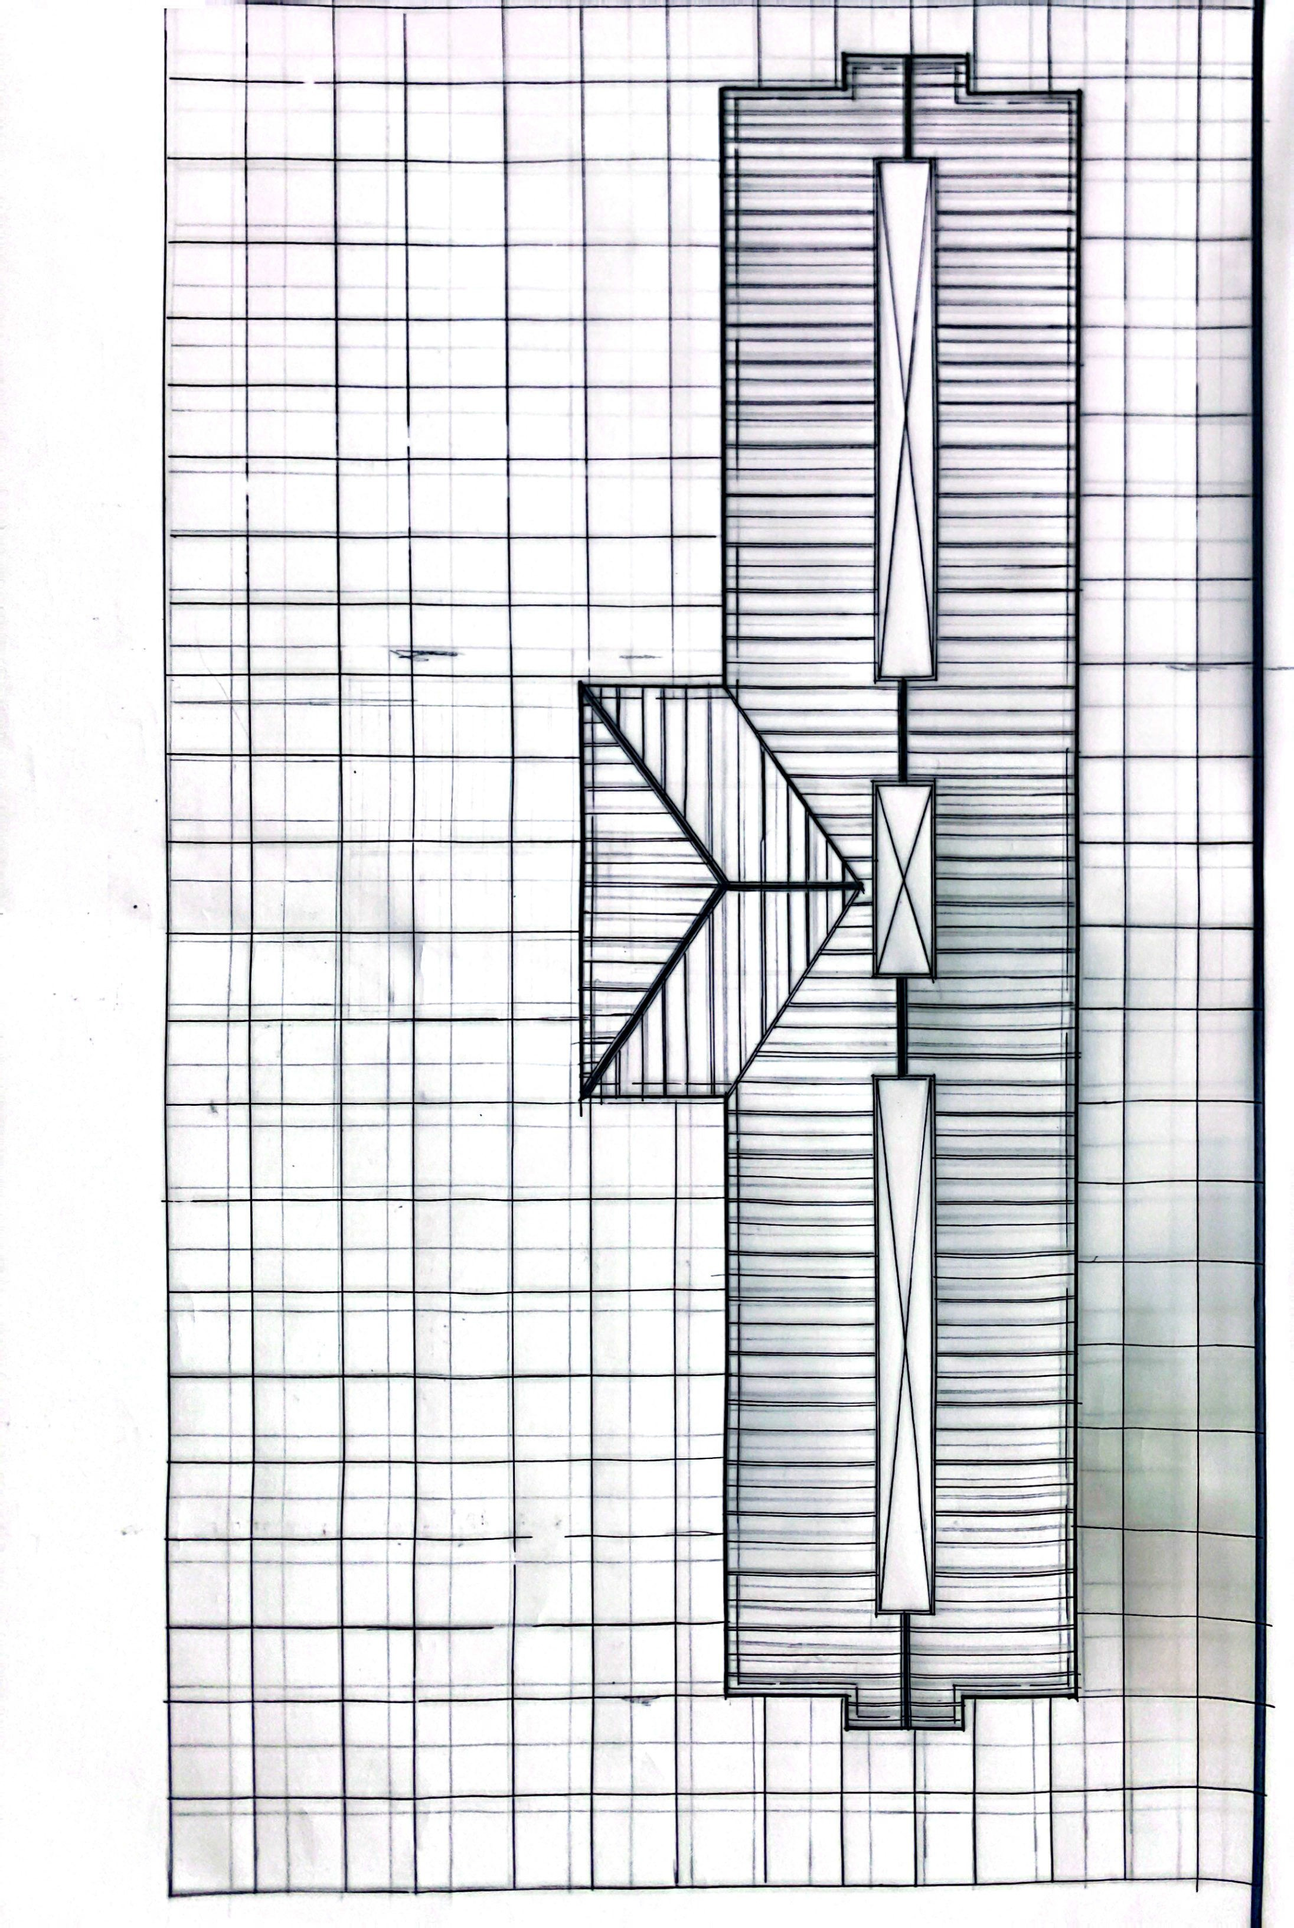

APPENDIX 1:- ROOF PLAN

APPENDIX 2:-SITE PLAN

APPENDIX 3:- UPPER FLOOR PLAN

APPENDIX 4:- INTERNAL PERSPECTIVE

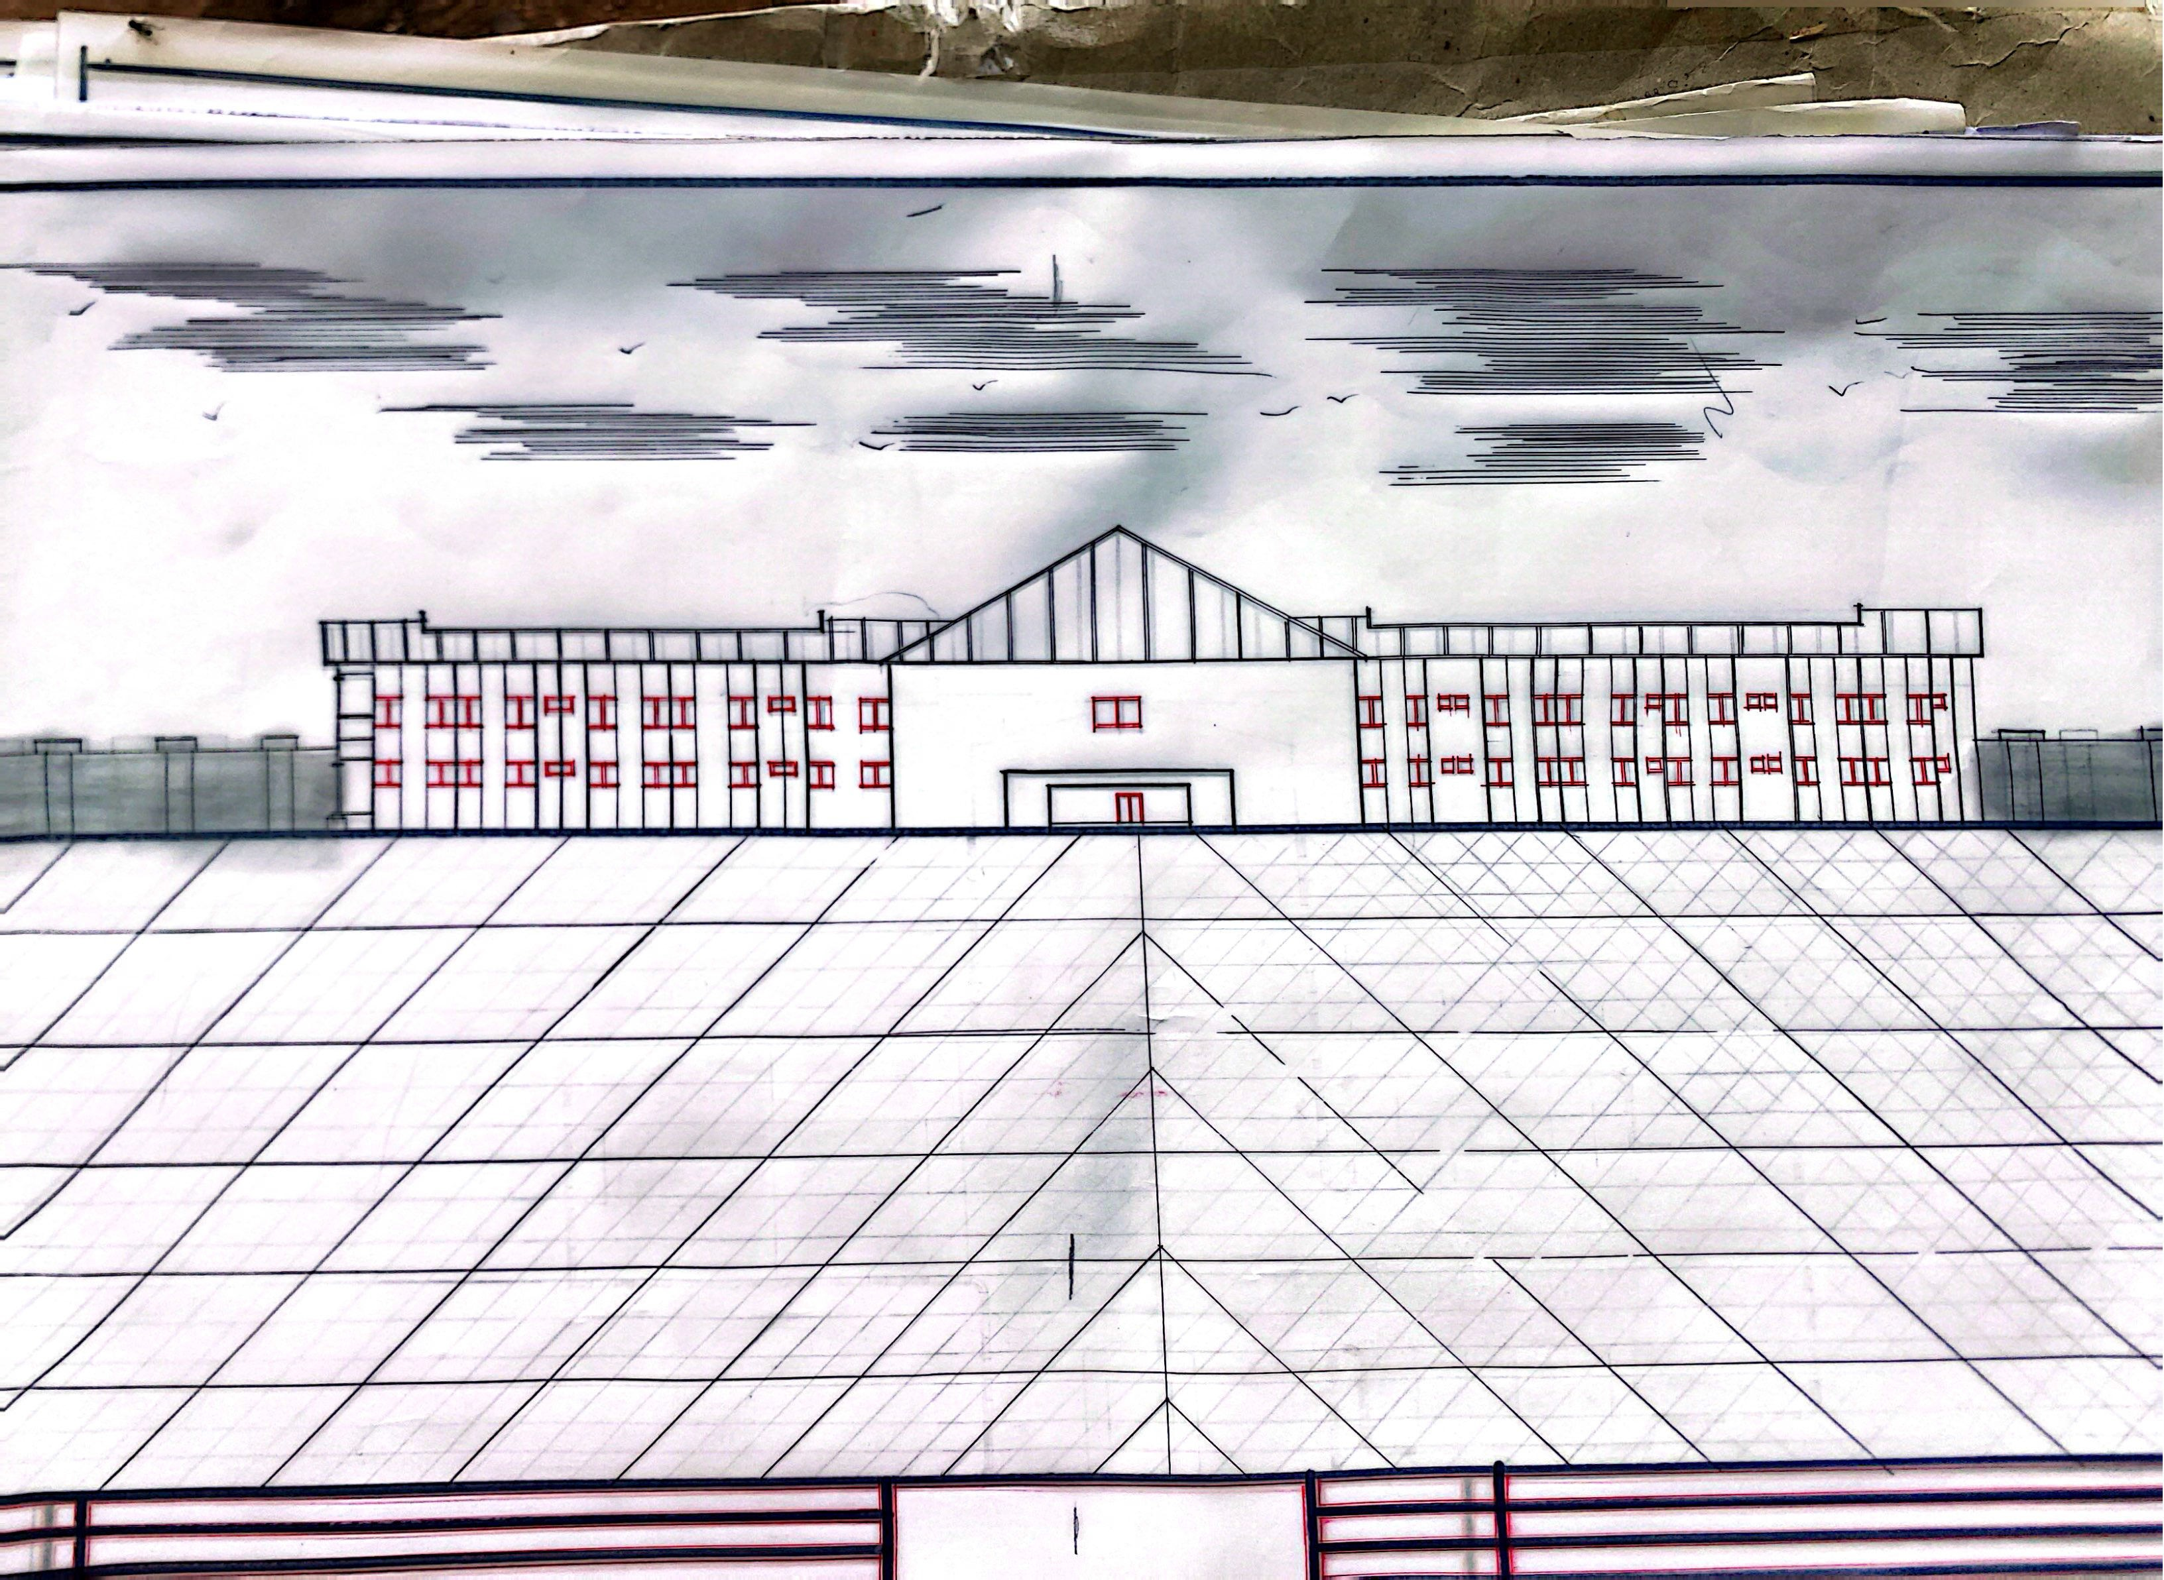

APPENDIX 5:- FRONT AND RIGHT ELEVATION

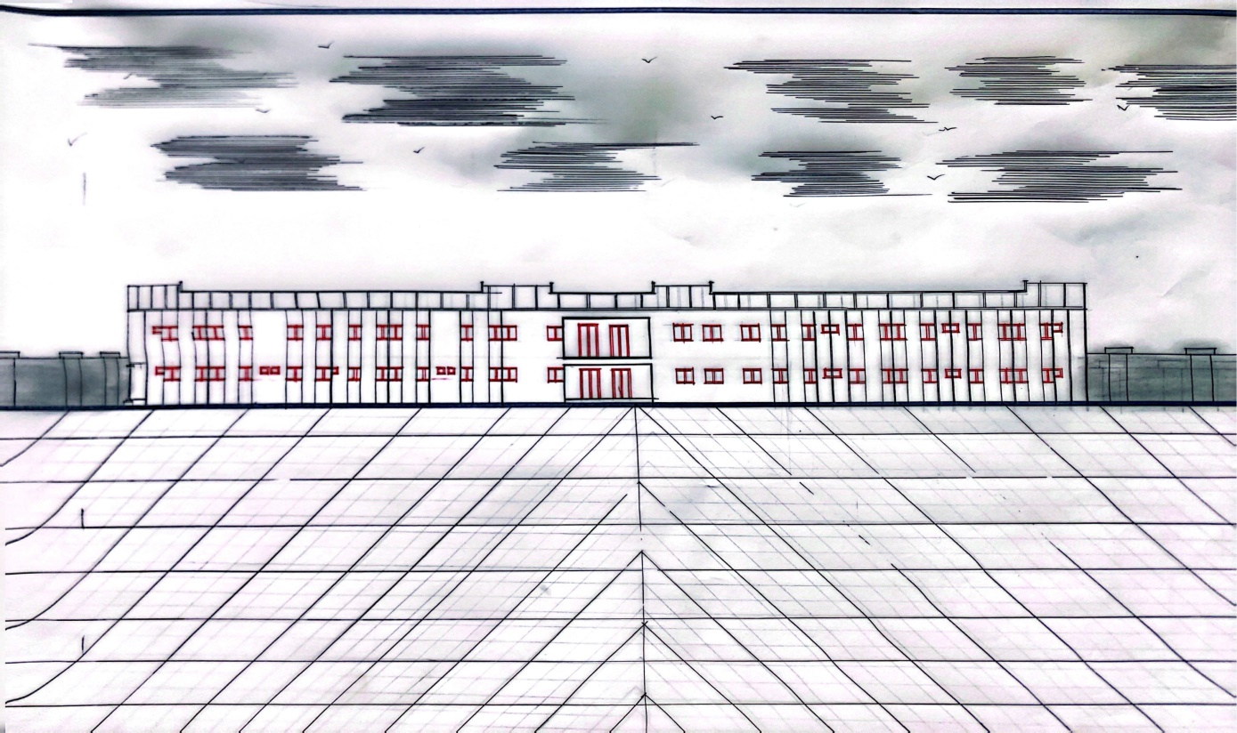

APPENDIX :-6 BACK ELEVATION

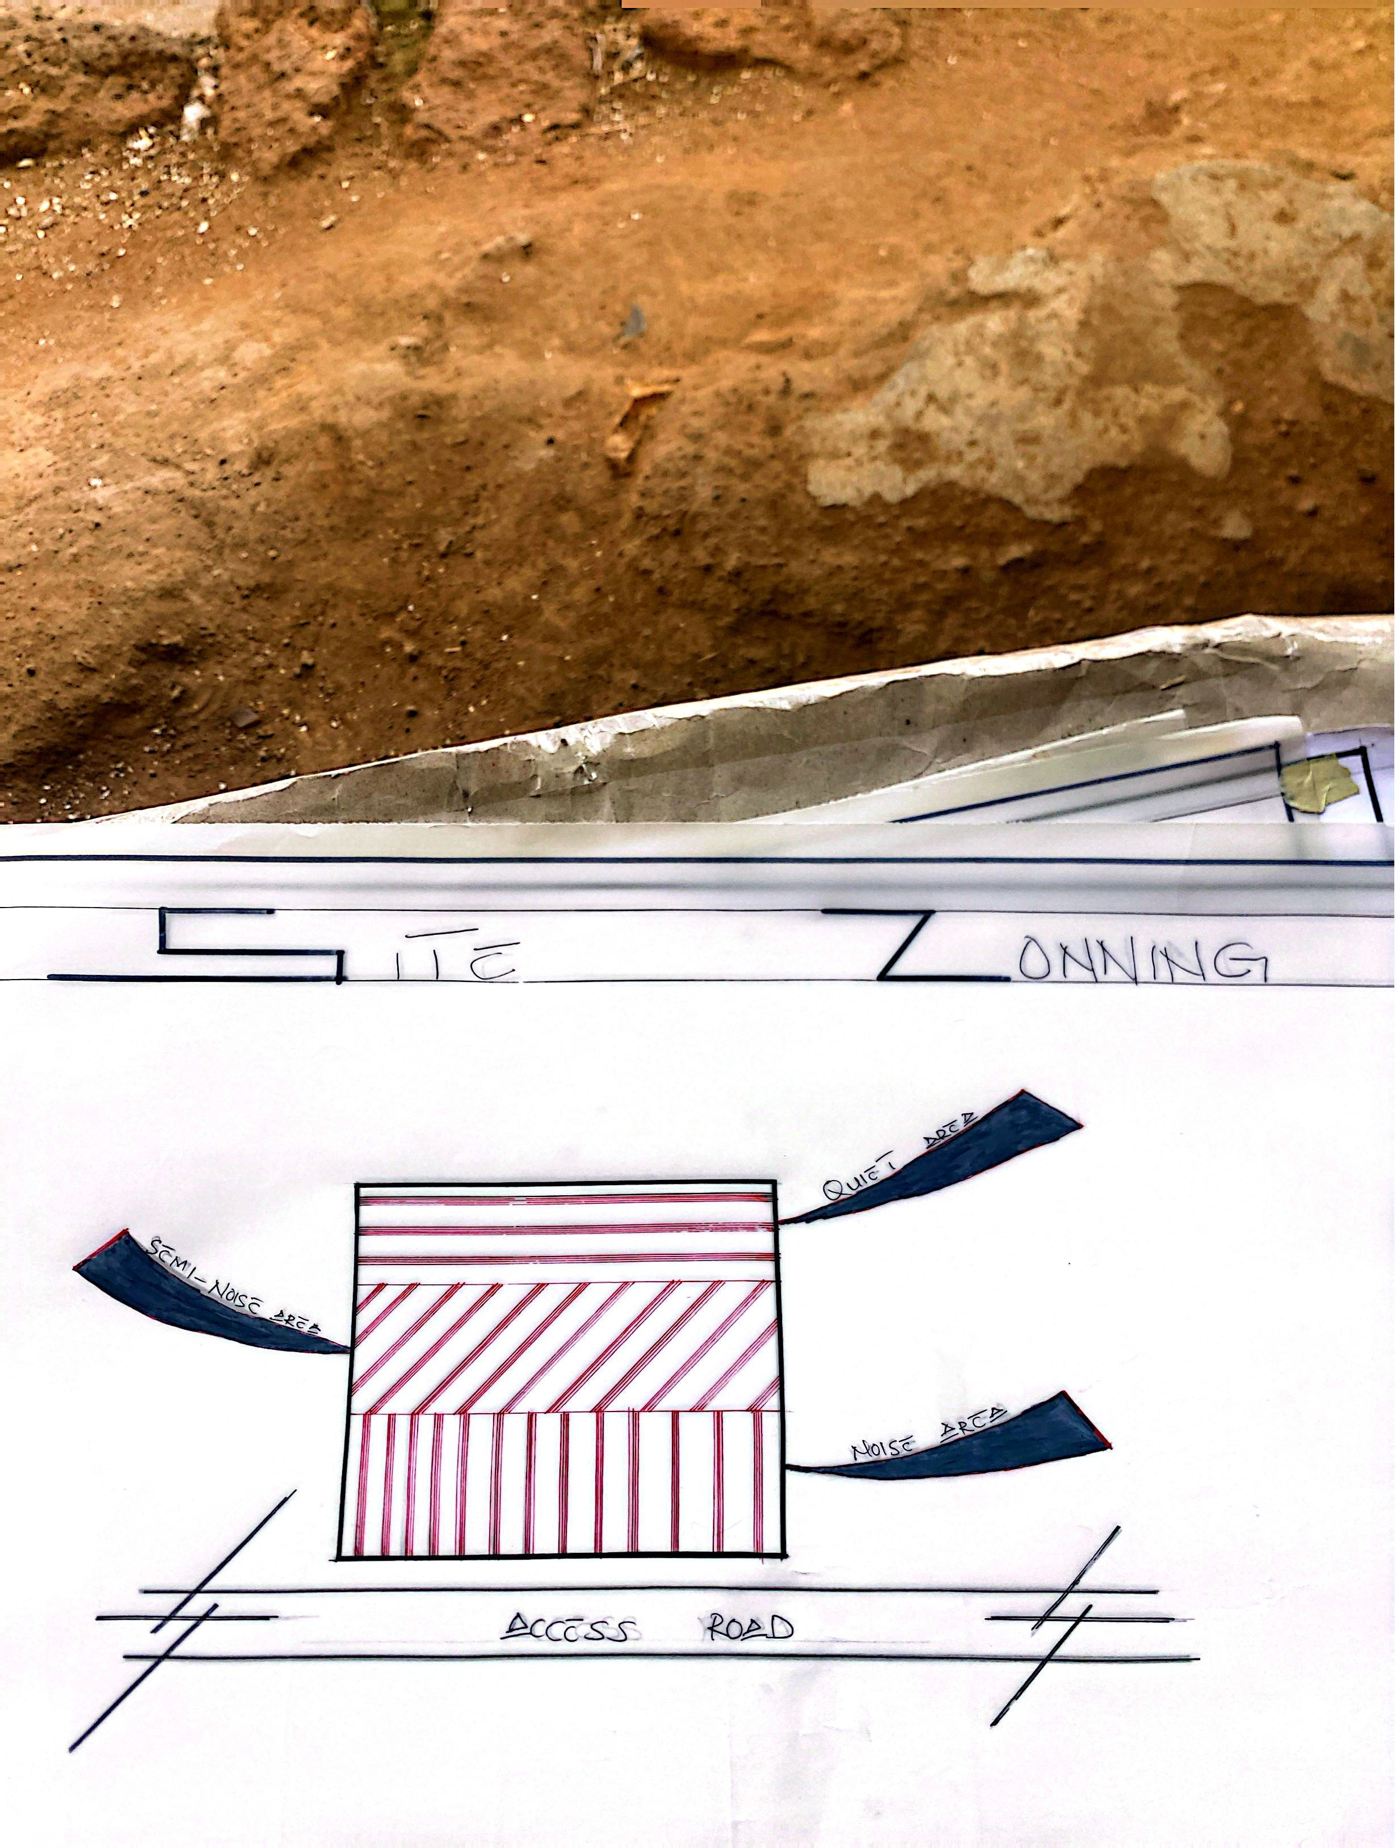

APPENDIX 7:- SITE ZONING

APPENDIX 8:- SITE ANALYSIS

