GEOTECHNICAL PROPERTIES OF LATERITE WITHIN KWARA STATE POLYTECHNIC CAMPUS.

BY
ADENIYI BOLAJI JEREMIAH
ND/23/MPE/FT/0047

BEING A RESEACH PROJECT SUBMITTED TO
THE DEPARTMENT OF MINERALS AND PETROLEUM RESOURCES ENGINEERING, INSTITUTE OF TECHNOLOGY, KWARA STATE POLYTECHNIC, ILORIN.

IN PARTIAL FULFILMENT OF THE REQUIREMENTS FOR THE AWARD OF NATIONAL DIPLOMA (ND) IN MINERAL AND PETROLEUM RESOURCES ENGINEERING
AUGUST 2025

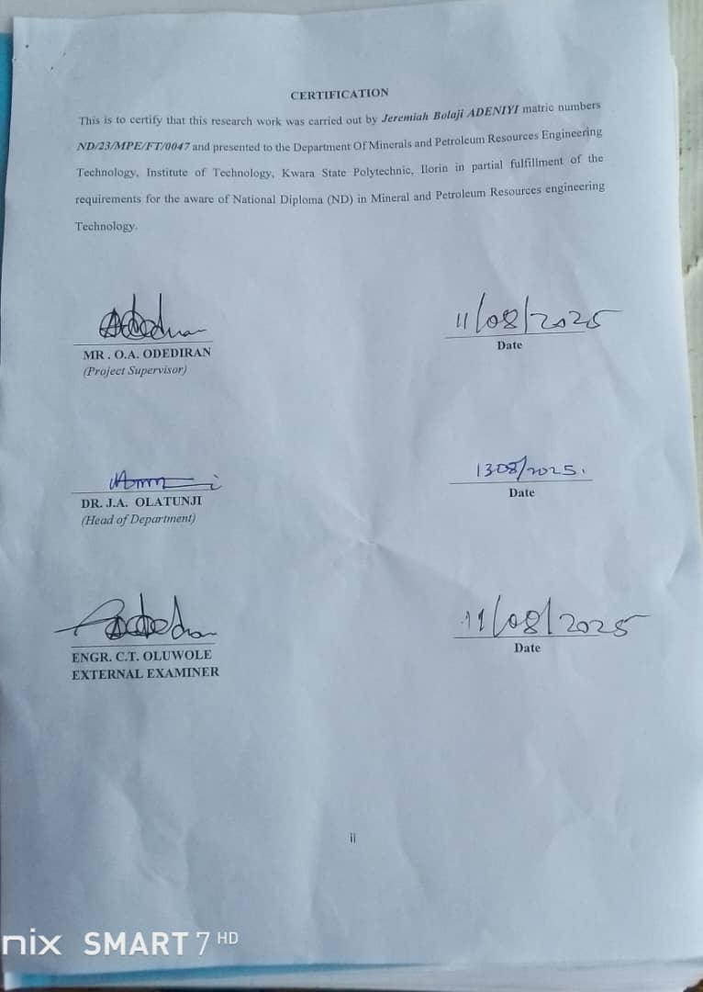

DEDICATION
This research work is dedicated to Almighty God the giver of wisdom and knowledge for his love and protection over my life throughout my National Diploma and also my amazing lovely and wonderful Parent Mr Akinola Adeniyi and Mrs. Omoiya Mosunmola for their support.

ACKNOWLEDGMENTS
My Sincere Gratitude glory and adoration goes to Almighty God, who gave me the grace and privileged to complete my academic career in this institution.
A research project of this nature cannot be successfully accomplished without the assistance of some noble persons. I would like to record my appreciation to the following individuals.
Firstly, my sincere gratitude goes to my lovely brothers for their immense love, guidance, advice, prayers, belief, understanding and financial support.
May Almighty God grant you all your heart desires and opportune you to reap the fruits of your labor. I don't know where I would have been without you both. Thanks for been there for me every time and thanks for everything.
My Sincere gratitude also goes to my supervisor, ENGR. O.A. ODEDIRAN. For his enthusiasm, patience, insightful comments, helpful information, practical advice and increasing ideas that have helped me tremendously at all times in my research and writing of this thesis. His immense knowledge and profound experience has enabled me to complete this research successfully. Without this support and guidance, this project would not have been possible; I could not have imagined having a better supervisor in my study.
My appreciation goes to my BIG DADDY MR. TUNDE MATHEW ADENIYI for his support both morally, financially, academically and his fatherly advices. My appreciation also goes to my Lovely Parent Mr. AKINOLA ADENIYI and Mrs. OMOIYA MOSUNMOLA for their Moral Support, financial support and Prayers, understanding throughout the course of my study, may you eat the fruit of your labor Amen.
Also, my appreciation goes to my one and only brother the person of DAVID ADENIYI and my friends for their support JIMOH ABDULROHEEM, YUSUF ADEWALE, OLANREWAJU BANJI, JIMOH DAUD, I cant forget the good and bad memory we share together, I love you all and may God reward you all. This project work wont be complete if I forgot to mention My brother from another another mother the person of Bro. KABIR A. HAMZA, Mr. ABDULAZEEZ SALAUDEEN ABIODUN, thanks for all you do to support me, May you found favor in all your endeavor.

TABLE OF CONTENTS
Title page . i
Certification . ii
Dedication . iii
Acknowledgments ... iv
Table of contents . v
List of Figures ................... vi
List of tables .. vii
Abstract ... . viii
CHAPTER ONE
1.0 Introduction 1
1.1 Location and Accessibility 1
1.2 Climate and Vegetation 2
1.3 Rail and Drainage 3
1.4 Aims and Objectives 3
1.5 Statements of the problems 4
1.6 Justifications 5
1.7 Scope and Limitations . 6
CHAPTER 2
2.0 Literature Review 7
2.1 Overview of Laterite .. 7
2.2 Formation and Occurrence of Laterite 8
2.3 Regional Distribution of Laterite 10
2.4 Characteristic of Laterite 13
2.5 Atterberg Limits .. 15
2.6 Compaction 17
2.7 Sieve Analysis 19
CHAPTER 3
3.0 Research Methodology 23
3.1 Collection of Samples 23
3.2 Preparation of Distribution Samples .. 24
3.3 Laboratory Procedures 24
3.4 Grain Size Distribution Test .. 24
3.5 Atterberg Limit Test .. 25
3.6 Completion Test 25
3.7 Moisture Content Test 26
3.8 Specific Gravity Test . 26
3.9 Bulk Density Test . 27
CHAPTER 4
4.0 Results and Discussion . 28
4.1 Results of Moisture Content Tests . 28
4.2 Results of Bulk Density Tests .. 29
4.3 Results of Dry Density Tests 29
4.4 Results of Specific Gravity Tests .. 30
4.5 Results of Atterberg Limit Tests ... 30
4.6 Results of Grain Size Analysis .. 31
4.7 Results of Compaction Tests 33
CHAPTER 5
5.0 Conclusion and Recommendation 35
5.1 Conclusion . 35
5.2 Recommendation 35
References 36

LIST OF FIGURES
Fig.1: graph showing water content ................... 28
Fig 2: Graph Showing Plasticity Chart .. 31
Fig. 3: Grain Size Analysis Graph .. .. 31
Fig. 4: Graph Showing Compaction Parameters . 33

LIST OF TABLE
Table 1: Details Of Sample Location ... .. 23
Table2: Natural Moisture Content Test of Collected Samples 28
Table 3: Bulk Density of Collected Samples .. 29
Table 4: Dry Density Test of collected samples . 29
Table 5: Specific gravity test of collected samples 30
Table 6: Atterberg Limit Tests of collected samples 31
Table 7: Summary of result of Grain Size Analysis of soil .. 32
Table 8: Compaction Parameters of Maximum Dry Density (MDD) and Optimum Moisture Content (OMC) 32
Table 9: Compaction and Ratings of Unified Soil Classification for Construction (ASTM 1557-91) 34

ABSTRACT
The results of natural moisture content test are presented in table 2. the moisture content value range between 4.2% and 5.3%, indicating that the soil is relatively dry. According to Ola (1993), typical moisture content for lateritic soils range between 5% and 20% depending on the season and drainage condition. Therefore, the sample fall within the lower end of the standard range implying well drained and stable conditions. Soils from four pits are within the specified limit for LL while soil from one pit is above the limit. The CBR value of WAS shows that lateritic soils from three pits are suitable for use as subbase materials while lateritic soils from two pits are suitable for use as base materials. The result of Bulk Density Test are presented in Table3. the bulk density values range from 1.63 to 1.76g/cm³ Murthy (2002) stated that bulk densities for compacted lateritic soils usually range from 1.6 to 2.0g/cm³. hence, the values obtained are within the acceptable range, with sample C showing the highest density, indicating better compaction and higher strength.
The results of this study will be useful for road construction in Kwara state polytechnic and its environs, thereby serving as guide for future road pavement design.,

CHAPTER ONE

1.0 Introduction

1.1 Location and Accessibility
Kwara State polytechnic campus is situated in the North-Central geopolitical zone of Nigeria and lies approximately between latitudes 8°05ʹN and 10°053ʹN and longitudes 2°45ʹE and 6°04ʹE. The state shares boundaries with Niger State to the north, Kogi State to the east, Ekiti and Osun States to the south, and the Republic of Benin to the west. The state covers an estimated land area of 36,825 square kilometers and has its capital in Ilorin, which serves as the commercial and administrative center (National Bureau of Statistics [NBS], 2021).
Kwara State polytechnic campus consists of both urban and rural settlements, with major towns including Offa, Omu-Aran, Lafiagi, Patigi, Share, and Kaiama. These towns are accessible via a network of federal and state roads, such as the IlorinJebba Road and the IlorinOffaOsogbo corridor. This road infrastructure makes the transportation of lateritic soil materials from borrow pits to construction sites relatively convenient.
Lateritic soils in Kwara State polytechnic campus are typically found along road cuts, farmlands, and erosion-prone areas. Their accessibility is facilitated by the presence of shallow overburden and relatively low-cost excavation processes. In many localities, especially in peri-urban and rural areas, the soils are sourced directly from natural exposures or shallow pits and used in road works, earth dams, and low-cost housing without adequate geo-technical testing or modification.
However, despite this ease of access, inconsistencies in soil properties across different locations within the state have been reported, which can pose challenges during large-scale engineering applications (Nnochiri et al., 2016). Therefore, proper site investigation and laboratory evaluation are essential to ensure the appropriate use of these materials in engineering practice.

1.2 Climate and Vegetation
Kwara State polytechnic campus experiences a tropical savanna climate characterized by alternating wet and dry seasons. The rainy season typically spans from April to October, with an annual rainfall ranging from 1,000 mm to 1,500 mm. The dry season lasts from November to March, marked by the Harmattan winds from the Sahara Desert (Adefolalu, 1986). Average temperatures range between 25°C and 35°C, with high humidity during the wet season.
This climatic variability has a significant impact on the behavior of lateritic soils. During the rainy season, infiltration of water increases the moisture content of the soils, reducing shear strength and bearing capacity, which can lead to slope failures, pavement deterioration, and foundation settlements (Gidigasu, 1976). In contrast, during the dry season, lateritic soils can become desiccated, leading to shrinkage and cracking, particularly in soils with high plasticity (Osinubi, 1998).
In road construction, especially in rural areas of Kwara State polytechnic campus, poor drainage and improper compaction often exacerbate moisture-induced damage, resulting in rutting, potholing, and surface washouts. These failures underline the importance of understanding and managing the geotechnical properties of lateritic soils under local climatic conditions.

1.3 Rail and Drainage
The rail of the kwara state polytechnic campus is generally characterized by gently undulating terrain, with elevation ranging from approximately 290 to 340m above sea level. This moderately elevated land scope contributes significantly to this formation and exposure of lateritic soils which are prevalent in tropical region with alternating wet and dry seasons. The natural scope of the land facilitates the surface run-off of rain water which affect soil formation and drainage behaviour.
The drainage pattern which the campus area is largely dendrite with seasonal stream and man-made drainage playing a role in surface water and permeability of the soil, run-off is generally slow allowing infiltration to dominate in some area, especially during the early stage of rain fall event. However, poorly manage or obstructed drainage channel may lead to temporary water logging, which can influence the moisture content and bearing capacity of the lateritic soil.

1.4 Aims and Objectives

The aim of this project is to:
To evaluate the geotechnical properties of lateritic soils in Kwara State polytechnic campus with a focus on their suitability for engineering and construction purposes.

The objectives of this project are:
- To identify and collect lateritic soil samples from selected locations within Kwara State polytechnic campus.
- To conduct laboratory tests to determine Atterberg limits, compaction characteristics, and grain-size distribution.
- To classify the soils based on relevant geo-technical standards (e.g., AASHTO, USCS).
- To assess the suitability of the soils for use in road, foundation, and embankment construction.
- To provide recommendations for improvement or stabilization where deficiencies are identified.

1.5 Statement of the Problems
Lateritic soils are widely used for civil engineering works in Kwara State polytechnic campus due to their local availability and low cost. However, their engineering performance varies significantly depending on location, mineral composition, and environmental exposure. Despite their extensive use, many infrastructure projects, particularly roads and low-rise buildings, suffer from premature failure due to inadequate understanding of the geotechnical properties of these soils (Nnochiri et al., 2016).
Issues such as low bearing capacity, excessive plasticity, high moisture sensitivity, and uneven compaction have contributed to structural instability and costly maintenance. These challenges underscore the urgent need for a comprehensive investigation into the geotechnical behavior of lateritic soils within the region to inform better design, material selection, and construction practices.

1.6 Justification
The increasing demand for infrastructure development in Kwara State polytechnic campus calls for reliable, cost-effective, and locally available construction materials. Lateritic soils, being abundant, hold potential for such applications. However, without adequate geotechnical assessment, their use may result in unsafe or short-lived structures.
This research is justified on the grounds that it provides:
- Scientific data for the classification and engineering evaluation of lateritic soils in the region.
- Guidelines for their effective use in construction, particularly in subgrade preparation, embankment filling, and low-cost housing.
- Recommendations for improvement techniques such as compaction and stabilization where necessary.
The outcome of this study will benefit engineers, policymakers, contractors, and local communities engaged in construction and infrastructure development.

1.7 Scope and Limitations
This study focuses on the geo-technical characterization of lateritic soils collected from six selected locations in Kwara State polytechnic campus. The research includes:
- Laboratory analysis to determine Atterberg limits, compaction properties, and particle size distribution.
- Soil classification using standard systems (AASHTO and USCS).
- Evaluation of suitability for construction purposes based on test results.

Limitations
- The study is limited to surface and near-surface soils (01.5 meters depth).
- Chemical stabilization and mineralogical composition analysis are beyond the scope of this work.
- Sample collection is limited to readily accessible areas and may not fully represent the entire state's soil variability.
- Laboratory testing is subject to equipment and procedural limitations, which may influence precision.
CHAPTER TWO
2.0 Literature Review

2.1 Overview of Lateritic Soils
Lateritic soils are a distinctive group of residual soils commonly found in tropical and subtropical regions, formed under intense weathering conditions. These soils are rich in iron and aluminum oxides, which impart their characteristic reddish, brownish, or yellowish color. The term laterite was first coined by (Buchanan in 1807) in India, describing a highly weathered, iron-rich soil with a hardened crust (Buchanan, 1807). Since then, the understanding and classification of lateritic soils have evolved significantly in geo-technical and engineering literature.
Lateritic soils are formed through the in-situ weathering of igneous, metamorphic, or sedimentary rocks under conditions of high rainfall, good drainage, and fluctuating wet and dry seasons. The process involves extensive leaching of silica and bases such as calcium, sodium, and potassium, leaving behind insoluble sesquioxides of iron (Fe₂O₃) and aluminum (Al₂O₃) (Gidigasu, 1976). These residual soils often have low cation exchange capacity, poor fertility (in agricultural terms), and a high degree of heterogeneity in mineral composition and engineering properties.
Geo-technically, lateritic soils are of significant interest due to their widespread use as construction material in developing countries. They are employed in the construction of roads, embankments, foundations, and as fill material due to their local abundance and relatively favorable engineering properties when compacted correctly (Bell, 1993). However, their properties are highly variable, and in some cases, they exhibit undesirable traits such as high plasticity, low permeability, or moisture sensitivity, particularly when not well-drained or compacted (Ola, 1983).
Lateritic soils typically exhibit a profile that includes:
- A hardened crust or laterite hard pan at the surface,
- A mottled zone beneath, consisting of iron nodules and clay,
- A saprolitic zone, representing the weathered parent rock.
These layers are not always present or distinct, as the soil formation depends heavily on climate, topography, vegetation, and parent rock type (Paterson & Burnham, 1970).
In Nigeria, particularly in the Middle Belt and southern regions, lateritic soils are extensively distributed and widely used for sub grades and base materials in road construction. Despite their advantages, failures in civil engineering projects have occurred due to improper understanding and usage of lateritic soils without appropriate geotechnical evaluation (Osinubi, 1998).
Therefore, understanding the fundamental nature and behavior of lateritic soils is crucial for engineers to design safe and durable structures, especially in tropical climates where they dominate the soil landscape.

2.2 Formation and Accumulation of Laterite
Laterite formation is a complex geneticist process involving the intense chemical weathering of rocks in tropical and subtropical environments. The process results in the leaching of mobile elements such as calcium (Ca), magnesium (Mg), sodium (Na), potassium (K), and silica (SiO₂), while leaving behind iron (Fe) and aluminum (Al) oxides and hydroxides (Gidigasu, 1976; Paterson & Burnham, 1970). This leads to the accumulation of iron- and aluminum-rich materials that characterize lateritic soils.

Formation Processes
The formation of laterite occurs primarily under the influence of:
- High rainfall (usually >1000 mm/year)
- High temperatures (commonly >25°C)
- Good drainage conditions
- Vegetation cover, which contributes organic acids
The dominant processes include:
- Hydrolysis  breakdown of primary minerals through interaction with water.
- Leaching  removal of soluble bases and silica from the soil profile.
- Oxidation and hydration  enrichment of residual materials with iron and aluminum oxides (e.g., hematite, goethite, gibbsite).
According to (Bell 1993), the lateritic profile typically consists of a sequence of layers:
- A hard laterite crust at the top (if present),
- A mottled zone with iron nodules and clay,
- A saprolite layer (highly weathered rock),
- And finally, the unaltered bedrock.
Each of these layers varies in thickness and composition depending on the parent rock, topography, and duration of weathering.

Accuracy in Identifying Laterite
Accurate identification and classification of lateritic soils are essential in engineering and agricultural applications. However, the term "laterite" has been used inconsistently in literature and practice. (Gidigasu 1976) emphasizes the need to distinguish between:
- True laterite (hardened crust)
- Lateritic soils (soft, clayey or gravelly materials)
- Lateritic gravels (partially cemented materials with nodules)
Classification systems such as those by Gidigasu (1976) and Maignien (1966) categorize laterite based on degree of laterization, cementation, and mineral composition.
In engineering terms, a lateritic soil may not always display a hardened crust but must demonstrate residual formation, high iron/aluminum content, and tropical weathering origin. Laboratory tests such as X-ray diffraction (XRD), scanning electron microscopy (SEM), and chemical oxide analysis (e.g., Fe₂O₃ > 20%) can be used to accurately classify soils as lateritic (Ola, 1983).
Understanding the formation processes and accurately identifying lateritic soils are critical for their proper use in road construction, foundation works, and other civil engineering projectsespecially in areas like Kwara State polytechnic campus, where they are extensively used.

2.3 Regional Distribution of Laterite
Lateritic soils are globally distributed in regions characterized by high temperatures, significant rainfall, and alternating wet and dry climatic cycles. These conditions promote the intense weathering processes that lead to laterite formation. Consequently, lateritic soils are predominantly found within the tropical and subtropical zones, particularly between latitudes 10°N and 25°S (Gidigasu, 1976; Bell, 1993).

Global Distribution
According to (Maignien 1966), the primary regions where lateritic soils are found include:
- West Africa: Nigeria, Ghana, Côte dIvoire, Senegal, Togo.
- Central and East Africa: Democratic Republic of Congo, Uganda, Tanzania.
- South and Southeast Asia: India (especially Karnataka, Kerala, and Tamil Nadu), Sri Lanka, Malaysia, and Indonesia.
- South America: Brazil, Colombia, and Venezuela.
- Australia: Northern and northeastern parts of the continent.
These areas exhibit climatic conditions conducive to laterizationhigh mean annual rainfall (typically >1000 mm), high average temperatures (>25°C), and good drainage that allows leaching of silica and bases.

Regional Distribution in Nigeria
In Nigeria, lateritic soils cover over 70% of the land area, particularly in the southern and middle-belt regions. Their distribution correlates closely with climatic zones and underlying geology. They are found in states such as Oyo, Ogun, Ondo, Ekiti, Enugu, Anambra, Kogi, Benue, Niger, and Kwara (Ola, 1983).
According to Nnochiri et al. (2016), Kwara State, located in the North-Central region of Nigeria, has widespread lateritic deposits, especially in areas like Ilorin, Omu-Aran, Offa, and parts of Baruten and Kaiama. These soils are commonly used as construction material due to their natural abundance and relatively low cost.
The variation in laterite properties across Kwara State polytechnic campus is linked to differences in:
- Parent rock types (e.g., granite, gneiss, schist),
- Topography and drainage conditions,
- Depth of weathering,
- Local vegetation and land use.
Lateritic soils in this region range from gravelly to clayey, with some areas exhibiting ironstone nodules and hardened crusts. This regional variation necessitates localized geotechnical evaluation before construction use (Osinubi, 1998).

Engineering Implications
The wide distribution and variable nature of lateritic soils make them a critical focus for engineering practice in Nigeria. In many rural and semi-urban areas, lateritic materials are used for:
- Road sub-grades and base courses
- Embankment fills
- Low-cost housing foundations
However, improper identification and use without proper compaction or stabilization can lead to infrastructure failure. Hence, understanding their spatial distribution is vital for material sourcing and construction planning.

2.4 Characteristics of Laterite
Laterite and lateritic soils exhibit a broad spectrum of physical, chemical, and engineering properties, largely influenced by their mode of formation, degree of weathering, and parent rock type. These properties are crucial in determining their suitability for geo-technical applications, particularly in road construction, embankment filling, and foundation works.

1. Physical Characteristics
Lateritic soils typically appear in shades of red, brown, or yellow, owing to the presence of hydrated iron oxides (mainly goethite and hematite). The texture ranges from gravelly to clayey, depending on the size and composition of residual particles left after weathering (Gidigasu, 1976; Bell, 1993). Common physical features include:
- Iron nodules (pisoliths or concretions),
- Porous and sometimes vesicular structure in hardened crusts,
- High bulk density in well-compacted or naturally cemented forms.
The color and structure are useful field indicators of laterization degree. A high concentration of iron oxides contributes to reddish hues and higher cementation, while yellowish tones suggest less advanced weathering (Paterson & Burnham, 1970).

2. Mineralogical and Chemical Characteristics
Lateritic soils are chemically characterized by:
- Low silica (SiO₂) content
- High iron (Fe₂O₃) and aluminum (Al₂O₃) oxides
- Low base saturation and cation exchange capacity
X-ray diffraction studies have shown that the mineralogy typically includes kaolinite, gibbsite, goethite, and hematite. Smectite and illite are rare or absent due to leaching in humid climates (Ola, 1983). The loss of silica during laterization concentrates oxides, making the soil acidic and poor in nutrientsthough this is less relevant for geotechnical than for agricultural concerns.

3. Engineering Characteristics
Lateritic soils show variable geotechnical behavior, depending on factors such as weathering depth, fines content, and compaction state. Key engineering characteristics include:
- Plasticity: Lateritic soils typically show low to moderate plasticity. Plasticity Index (PI) values range from 10% to 25% in Nigerian samples, indicating some susceptibility to volumetric changes with moisture variation (Osinubi, 1998).
- Shear Strength: Generally good when compacted but decreases significantly with increased moisture. The cohesion and internal friction angle vary with grading and cementation.
- Permeability: Typically, low to moderate. Fine-grained lateritic clay may exhibit poor drainage, while sandy or gravelly types allow moderate infiltration (Gidigasu, 1976).
- Compressibility: Often low, especially in well-compacted or naturally cemented forms. However, high-plasticity types may exhibit significant settlement unless stabilized.
- Cementation: Iron and aluminum oxides may act as natural binders, leading to hard, integrated layers known as laterite crusts. These layers can be very strong and stable but pose difficulties for excavation (Bell, 1993).

4. Variability
Lateritic soils are highly heterogeneous, even over short distances. This is due to:
- Differences in parent rock composition,
- Variations in the intensity and duration of weathering,
- Topographic and hydrological factors.
As a result, site-specific testing is essential before engineering use. Uniform classification or design assumptions can be misleading (Ola, 1983).

2.5 Atterberg Limits
The Atterberg limits, comprising the liquid limit (LL), plastic limit (PL), and plasticity index (PI), are fundamental parameters used to describe the consistency and plasticity behavior of fine-grained soils, including lateritic soils. These limits provide insight into the soils behavior under varying moisture contents and are critical for assessing the engineering suitability of lateritic materials in construction.

Definition and Importance
- The Liquid Limit (LL) is the water content at which soil changes from a plastic to a liquid state.
- The Plastic Limit (PL) is the water content at which soil changes from a semi-solid to a plastic state.
- The Plasticity Index (PI), calculated as the difference between LL and PL (PI = LL − PL), represents the range of moisture content over which the soil remains plastic.
In lateritic soils, Atterberg limits help classify soil according to the Unified Soil Classification System (USCS) or the AASHTO system, and provide important data on swelling potential, compressibility, and shear strength (Bell, 1993).

Typical Values in Lateritic Soils
Lateritic soils generally exhibit a low to medium plasticity, reflecting their clay mineralogy, mainly composed of kaolinite and gibbsite with little smectite or montmorillonite, which are highly plastic clays (Ola, 1983). Typical values reported in studies of Nigerian lateritic soils include:
- Liquid Limit (LL): 30% to 50%
- Plastic Limit (PL): 20% to 30%
- Plasticity Index (PI): 10% to 20%
These values indicate moderate plasticity, which is favorable for use in engineering as they show limited swelling and shrinkage characteristics compared to high-plasticity clays (Osinubi, 1998).

Variability and Influencing Factors
Atterberg limits in lateritic soils vary widely due to:
- Parent rock composition, influencing the clay mineral content,
- Degree of weathering and leaching, affecting particle size and mineralogy,
- Presence of iron oxides, which tend to reduce plasticity by coating clay particles,
- Organic matter content.
Therefore, localized testing is essential for design and construction, as relying on generalized values can result in inaccurate assessment of soil behavior (Gidigasu, 1976).

Engineering Implications
- Soils with low PI (<10%) generally exhibit little plasticity and are less susceptible to volumetric changes.
- Soils with medium PI (1020%) require careful compaction and moisture control to avoid strength loss.
- Higher PI values in lateritic soils may indicate a higher clay content and potential challenges with swelling or instability under moisture fluctuations.
Understanding Atterberg limits is crucial when using lateritic soils as sub grade or base materials, to ensure adequate compaction, drainage, and durability in pavement or foundation applications.

2.6 Compaction
Compaction is the process of mechanically increasing the density of soil by reducing the volume of air within the soil mass, without altering the water content significantly. It is a critical aspect of soil engineering that significantly affects the strength, compressibility, permeability, and durability of lateritic soils used in civil engineering works.
In lateritic soils, compaction is especially important because their performance in engineering applications such as road sub grades, embankments, and foundationsdepends heavily on how well they are compacted and the moisture conditions under which compaction occurs (Osinubi, 1998; Gidigasu, 1976).

Compaction Characteristics
The primary parameters used to evaluate soil compaction are:
- Maximum Dry Density (MDD)  The highest dry unit weight that a soil can attain under a given compactive effort.
- Optimum Moisture Content (OMC)  The moisture content at which the maximum dry density is achieved.
These values are determined in the laboratory using standardized compaction tests, such as:
- Standard Proctor Test (ASTM D698)
- Modified Proctor Test (ASTM D1557)
Lateritic soils typically display an OMC between 1018% and an MDD between 1.602.10 Mg/m³, depending on grain size distribution, plasticity, and mineral composition (Amu et al., 2005; Osinubi, 1998).

Factors Influencing Compaction in Lateritic Soils
- Soil Type and Texture: Clayey laterite tend to have lower MDD and higher OMC due to their fine particles and water adsorption capacity. Gravelly or sandy laterite tend to compact more easily and achieve higher densities.
- Plasticity: Highly plastic soils require more energy and moisture to achieve compaction. Lateritic soils with moderate plasticity often perform best under standard compactive effort (Ola, 1983).
- Presence of Iron Oxides: These oxides can create natural cementation that influences the compaction behavior. Iron-rich laterite may resist denitrification and exhibit brittle behavior when compacted (Gidigasu, 1976).
- Moisture Control: Moisture content is a critical factor. Compaction outside the optimum range can lead to poor strength and high permeability, increasing the risk of pavement failure or foundation settlement (Osinubi, 1998).

Engineering Significance
Proper compaction of lateritic soils:
- Increases shear strength, improving stability under loads,
- Reduces compressibility, minimizing settlement under structures,
- Decreases permeability, reducing water ingress and erosion,
- Improves bearing capacity, essential for pavements and building foundations.
In road construction, the strength of compacted lateritic soil is often assessed using the California Bearing Ratio (CBR) test. A well-compacted lateritic soil typically has a CBR value ranging from 20% to 80%, depending on soil quality and compactive effort (Nnochiri et al., 2016).

2.7 Sieve Analysis
Sieve analysis, also known as grain size distribution analysis, is a fundamental laboratory procedure used to determine the particle size distribution of soils. This analysis is essential for classifying soils, predicting their engineering behavior, and determining their suitability for various construction purposes.
For lateritic soils, sieve analysis helps distinguish between gravel, sand, silt, and clay fractions, which directly influence properties such as permeability, shear strength, compaction, and stability (Gidigasu, 1976; Bell, 1993).

Purpose of Sieve Analysis
The primary objectives of sieve analysis for lateritic soils are:
- To determine the proportion of coarse and fine particles,
- To classify the soil using systems like AASHTO or Unified Soil Classification System (USCS),
- To assess gradation, which influences work ability and performance in structural applications like road bases, embankments, and foundation layers.

Procedure
Sieve analysis for lateritic soils generally involves:
- Oven-drying a soil sample to remove moisture.
- Weighing the sample.
- Passing it through a stack of sieves with decreasing mesh sizes (e.g., 4.75 mm, 2.00 mm, 0.425 mm, 0.075 mm).
- Measuring and recording the weight of soil retained on each sieve.
- Calculating the percentage retained and percentage passing for each sieve.
- Plotting a gradation curve (grain size distribution curve) using semi-logarithmic paper.
For finer particles (passing 0.075 mm), a hydrometer analysis is typically used in conjunction.
This process follows standard methods such as:
- ASTM D422: Standard Test Method for Particle-Size Analysis of Soils,
- BS 1377-2: British Standard for Methods of Test for Soils for Civil Engineering Purposes  Classification Tests.

Typical Results in Lateritic Soils
Lateritic soils in regions like Kwara State, Nigeria, typically show a well-graded to poorly-graded profile, depending on location and degree of weathering (Osinubi, 1998; Nnochiri et al., 2016). Common findings include:
- Significant gravel (particles >2 mm) and sand fractions,
- Fines (<0.075 mm) content varying between 10% to 35%,
- Poorly graded soils with gap gradation in some areas,
- High clay content in highly weathered lateritic profiles.
The percentage of fines is especially important in determining the soils plasticity, drainage capacity, and susceptibility to swelling and shrinkage.

Engineering Implications
- Soils with well-graded distributions are generally more stable and compact better than poorly graded ones.
- Excess fines can lead to poor drainage and increased plasticity, requiring stabilization.
- The gradation curve helps predict compaction characteristics, bearing capacity, and shear strength.
- Lateritic soils with more than 35% fines are often classified as clayey or silty lateritic soils, which may need modification before use in road or foundation construction (Ola, 1983).

CHAPTER THREE
3.0 Research Methodology
3.1 Collection of Samples
Soil sampling was carried out at six various locations within Kwara State Polytechnic campus, specifically from exposed natural surfaces, borrow pits, and undeveloped plots likely to be used for construction. The selection of sampling sites was based on accessibility, exposure of soil layers, and potential relevance to future infrastructural projects within the campus.
The tools used for sample collection included:
- Hand augers
- Shovels
- Polythene bags for storage
- Permanent markers for labeling
Samples were obtained from depths ranging between 0.5 meters to 1.5 meters, targeting the lateritic layer commonly used for construction. This depth range is considered appropriate for evaluating sub-grade and foundation materials. Immediately after collection, each sample was labeled according to its location, depth, and date of extraction and was transported carefully to the geo-technical laboratory for analysis.
Table 1: Details Of Sample Locations.
SN | LOCATION | LATITUDE | LONGITUDE | ELEVATION | DEPTH
1. | P1 | N 08⁰.93.426¹ | E004^{0.}.37.882¹ | 336 | 0.50m
2. | P2 | N 08⁰.33.428¹ | E004^{0.}.37.882¹ | 309m | 0.75m
3. | P3 | N 08⁰.33.430¹ | E004^{0.}.37.882¹ | 309m | 0.79m

3.2 Preparation of Disturbed Samples
In the laboratory, the collected soil samples were air-dried at room temperature to reduce their moisture content without altering their physical structure. The dried samples were then manually broken down using a wooden mallet and gently disaggregated to avoid crushing individual soil particles.
The prepared soils were then sieved through a 4.75 mm sieve to remove larger particles, gravels, stones, and organic materials. This step was essential to standardize the soil samples and make them suitable for the various classification and strength tests. The sieved samples were stored in dry containers, ready for laboratory testing.
3.3 Laboratory Procedures
Laboratory tests were conducted to assess the physical and engineering characteristics of the lateritic soil samples. Each test followed standard protocols provided by ASTM and BS 1377, ensuring consistency and reliability. The laboratory procedures focused on the following tests:
- Grain size distribution
- Atterberg limits
- Moisture content
- Compaction characteristics
- Specific gravity
- Bulk density
Each of these tests provided critical insight into how the soil would behave under field conditions, including its workability, stability, strength, and potential for compaction.
3.4 Grain Size Distribution Test
The grain size distribution test was conducted to determine the proportion of different particle sizes within each soil sample. The test was performed using two methods:
Sieve Analysis for coarse-grained soils (sand and gravel fractions)
Hydrometer Analysis for fine-grained soils (silt and clay fractions)
In the sieve analysis, a stack of sieves with progressively smaller openings (from 4.75 mm down to 0.075 mm) was used. A known weight of soil was placed at the top and mechanically shaken for a fixed duration. The weight of soil retained on each sieve was recorded and expressed as a percentage of the total sample weight to generate a particle size distribution curve.
3.5 Atterberg Limits Test
This test was conducted to evaluate the plasticity characteristics of the fine-grained portion of the soil. The following procedures were followed:
Liquid Limit (LL): Determined using the Casagrande apparatus. Soil paste was placed in a brass cup, and a groove was cut using a grooving tool. The number of blows required to close the groove over a distance of 12 mm was recorded at different moisture contents. A flow curve was plotted to determine the moisture content corresponding to 25 blows.
Plastic Limit (PL): Determined by rolling a small portion of soil into threads of 3 mm diameter until they began to crumble. The average moisture content of the crumbled threads was recorded.
Plasticity Index (PI): Calculated using the formula: PI=LL−PL
These tests provided insight into the soil's consistency, work ability, and behavior under different moisture conditions.

3.6 Compaction Test
The Standard Proctor Compaction Test was carried out to determine the Maximum Dry Density (MDD) and Optimum Moisture Content (OMC) of the soil. The procedure involved compacting soil at various moisture contents in a mold of standard dimensions using a 2.5 kg hammer dropped from a height of 30 cm.
After compaction, the bulk density of the soil was determined, and the moisture content was measured. A compaction curve was plotted with dry density on the y-axis and moisture content on the x-axis. The peak point of this curve represented the MDD and OMC, which are crucial for field compaction requirements during construction.

3.7 Moisture Content Test
The natural moisture content of the soil samples was determined using the oven-drying method. A small sample of the soil was weighed (wet weight), placed in a moisture can, and then dried in an oven at 105°C to 110°C for 24 hours. After drying, the sample was reweighed (dry weight), and the moisture content was calculated using:
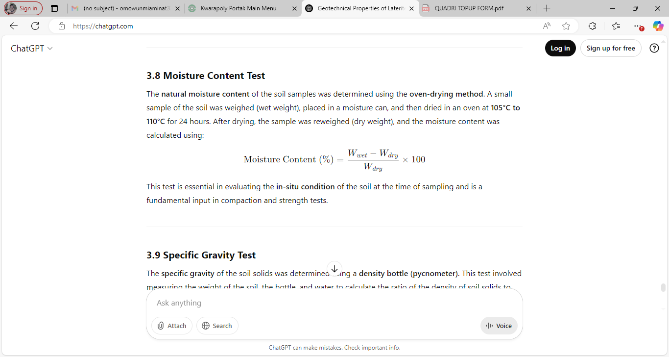
This test is essential in evaluating the in-situ condition of the soil at the time of sampling and is a fundamental input in compaction and strength tests.
3.8 Specific Gravity Test
The specific gravity of the soil solids was determined using a density bottle (pycnometer). This test involved measuring the weight of the soil, the bottle, and water to calculate the ratio of the density of soil solids to the density of water. The formula used is:
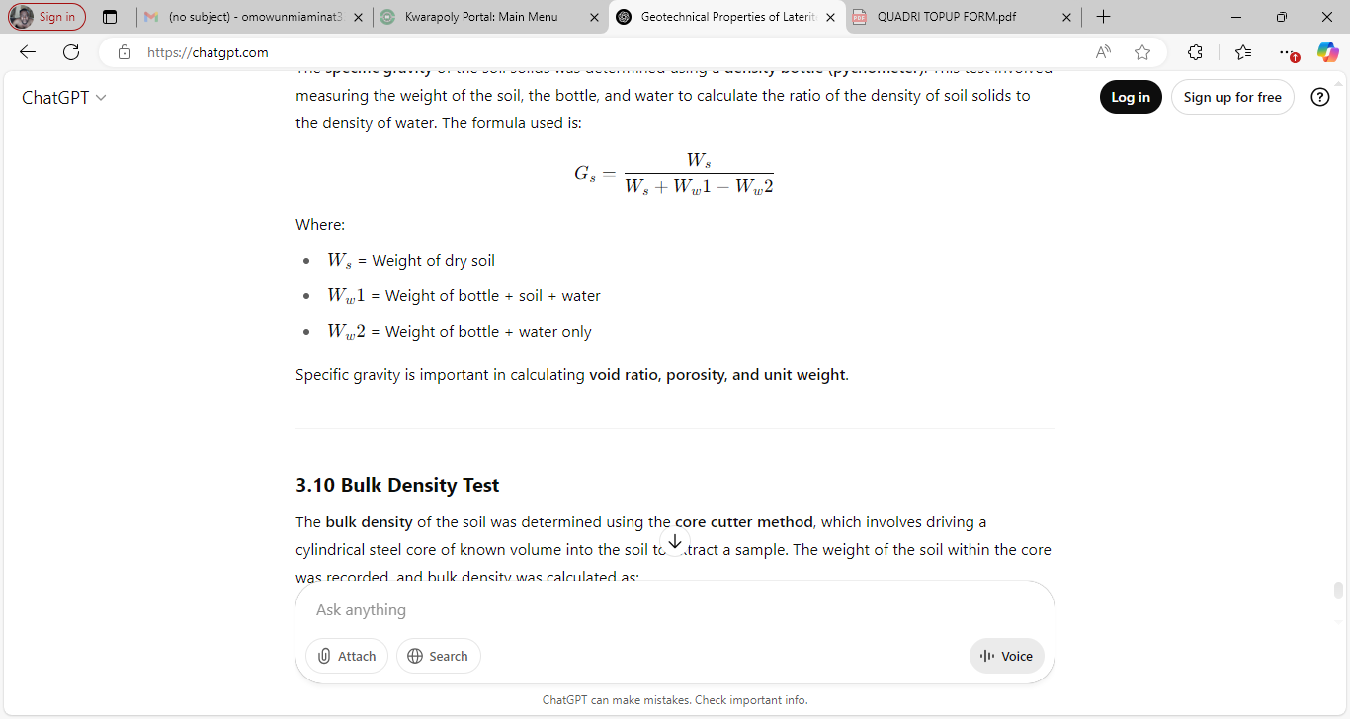

3.9 Bulk Density Test
The bulk density of the soil was determined using the core cutter method, which involves driving a cylindrical steel core of known volume into the soil to extract a sample. The weight of the soil within the core was recorded, and bulk density was calculated as:
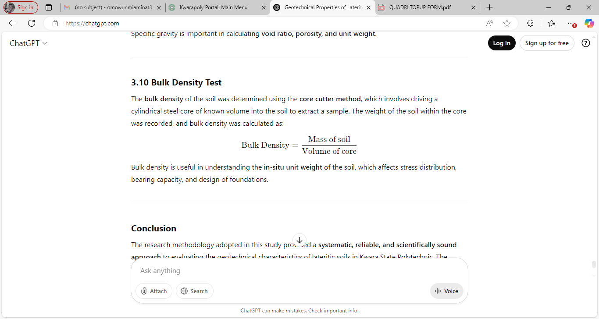
Bulk density is useful in understanding the in-situ unit weight of the soil, which affects stress distribution, bearing capacity, and design of foundations.
CHAPTER FOUR
4.0 Results and Discussion
4.1 Results of Natural Moisture Content
The results of natural moisture content test are presented in table 2. the moisture content value range between 4.2% and 5.3%, indicating that the soil is relatively dry. According to Ola (1993), typical moisture content for lateritic soils range between 5% and 20% depending on the season and drainage condition. Therefore, the sample fall within the lower end of the standard range implying well drained and stable conditions.

Table2: Natural Moisture Content Test of Collected Samples
Sample A | Sample B | Sample C
5.2% | 4.3% | 4.1%

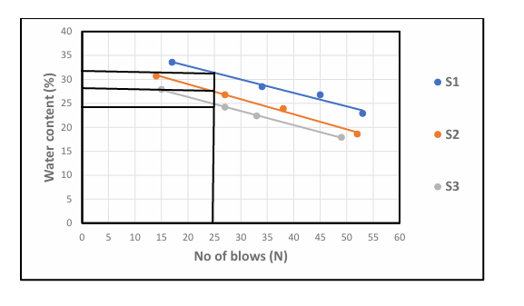
Fig.1: graph showing water content

4.2 results of bulk Density Test
The result of Bulk Density Test are presented in Table3. the bulk density values range from 1.63 to 1.76g/cm³ Murthy (2002) stated that bulk densities for compacted lateritic soils usually range from 1.6 to 2.0g/cm³. hence, the values obtained are within the acceptable range, with sample C showing the highest density, indicating better compaction and higher strength.
Table 3: Bulk Density of Collected Samples.
Sample A | Sample B | Sample C
1.63 | 1.73 | 1.76

4.3 Results of Dry Density Test
Two results of Dry Density value (1.58 - 1.69g/cm³) are also within the expected range for Engineering fill materials. According to Das (2010) dry densities for lateritic soils typically range from 1.5 to 2.0g/cm3, indicating that the test ad soils can offer adequate bearing capacity when properly compacted.
Table 4: Dry Density Test of collected samples
Sample A | Sample B | Sample C
1.58g/cm³ | 1.67g/cm³ | 1.69g/cm³

4.4 Result of Specific Gravity Tests
The specific gravity result is presented in table 5 specific gravity value ranged from 2.68 to 2.83 according to Das (2010), the typical specific gravity of lateritic soil falls between 2.60 and 2.85 which confirm that the soil predominantly mineral based with minimum organic contamination.
Table 5: Specific gravity test of collected samples
Sample A | Sample B | Sample C
2.68g/cm³ | 2.71g/cm³ | 2.83g/cm³

4.5 Results of Atterberg Limit Tests
Liquid Limit (LL): ranges from 22.3 % to 31.6% According to Das (2010), soil with liquid limit value less than 35% are classified as low plasticity soils. All the three samples fall within these categories, indicating low compressibility and moderate workability.
Plastic Limit (PL): value range from 14.6% to 18.2%, which is also consistent with the range expected for lateritic soil.
Plasticity Index (PI): value, calculated as the difference between LL am PL range from 6.9% to 13.4% Ola (1983) noted that lateritic soil generally has pl value ranging from 5% to 20% depending on the degree of weathering. Hence the PL values obtained fall within the expected range, indicating moderate plasticity with Sample A being more plastic than Sample B and Sample C.
Linear Shrinkage (LS): values range from 3.7% to 6.2% According to Adeyemi (1995), values below 10% suggest that the soils have low shrinks well potential, which is desirable for most construction purpose. Sample C has the lowest shrinkage value, suggesting it will be the most suitable under moisture variation
Table 6: Atterberg Limit Tests of collected samples
Sample | Liquid Limit % | Plastic Limit % | Plastic index | Linear Shrinkage %
Sample A | 31.6 % | 18.2% | 13.4% | 6.2%
Sample B | 22.3% | 15.4% | 6.9% | 4.8%
Sample C | 24.8% | 14.6% | 10.2% | 3.7%

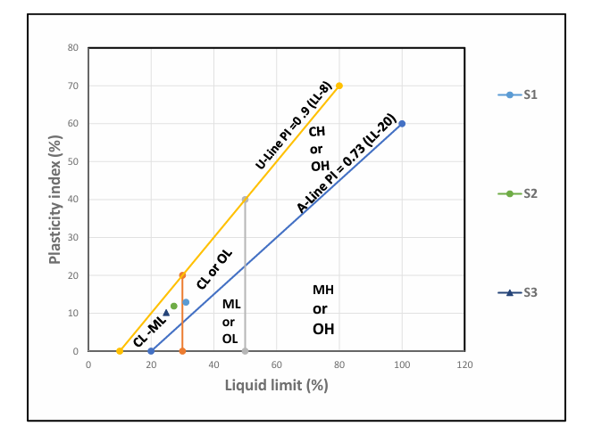
Fig 2: Graph Showing Plasticity Chart

4.6 Result of Grain Size Analysis
P1 has higher clay content (21%) hence classified has clayey sand
P2 and P3 have more silt and less clay, Thus, silty sand all sample have sand and dominant particle size making them sand-based soils.
fine (<0.075mm) is highest in P1, which support its clayey nature.
Table 7: Summary of result of Grain Size Analysis of soil
Sample Location | Gravel (%) | Sand (%) | Silt (%) | Clay (%) | Fine (%) | Soil classification
P1 | 10 | 60 | 9 | 21 | 30 | Clayey sand
P2 | 12 | 62 | 15 | 11 | 20 | Silty sand
P3 | 13 | 63 | 17 | 7 | 24 | Silty sand

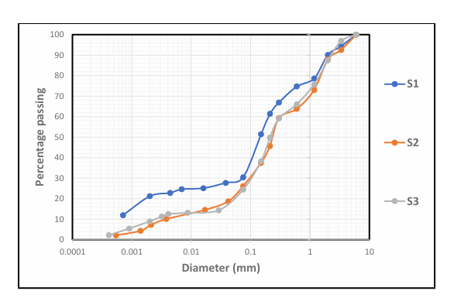
Fig. 3: Grain Size Analysis Graph

4.7 Result of Compaction Test
Table 8: Compaction Parameters of Maximum Dry Density (MDD) and Optimum Moisture Content (OMC)
Sample | MDD | OMC
A | 1.81 | 8
B | 1.89 | 7.5
C | 1.95 | 6

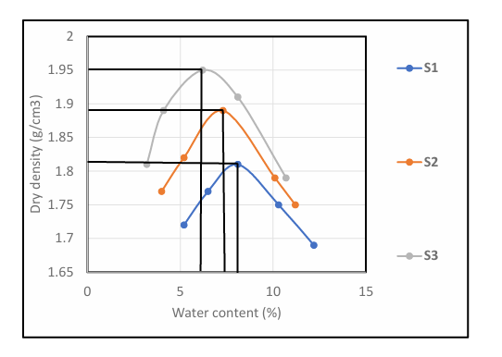
Fig. 4: Graph Showing Compaction Parameters
Table 9: Compaction and Ratings of Unified Soil Classification for Construction (ASTM 1557-91)
Visual Description | Maximum Dry Density (MDD)(g/cm³) | Optimum Moisture Content (OMC)(g/cm³) | Anticipated embankment performance | Value as Subgrade material | Value as Base Course
Granular material | 2.00 - 2.27 | 7  15 | Good to Excellent | Excellent | Good
Granular material with soil | 1.76 - 2.16 | 9  18 | Fair to Excellent | Good | Fair to Poor
Fine sand and sand | 1.76 - 1.84 | 9  15 | Fair to Good | Good to Fair | Poor
Sandy silts and silts | 1.36 -1.60 | 10  20 | Poor to Good | Fair to Poor | Not suitable
Elastic silts and clay | 1.36 - 1.60 | 20 -35 | Unsatisfactory | Poor | Not suitable
Silty clay | 1.52 - 1.92 | 10  30 | Poor to Good | Fair to Poor | Not suitable

Table 9: present the compaction parameters of collected samples. The (MDD) Maximum Dry Density for sample A is 1.81 for sample B 1.89 while sample C is 1.95. for Optimum Moisture Content (OMC), sample A is 8, Sample B is 7.5 sample C is 6. The three sample being sandy in nature can be range as range fair to good for embankment performance it is fair to poor for subgrade material are not suitable for base course.

CHAPTER FIVE
5.0 Conclusion and Recommendation
5.1 Conclusion
The geotechnical investigation of laterite within Kwara State Polytechnic campus revealed that the sampled soils possess engineering properties suitable for various civil engineering applications, especially as subgrade and fill materials. Laboratory tests such as particle size analysis, Atterberg limits, compaction indicated that the laterite falls within the acceptable range for road construction and foundation works under moderate loading conditions.
The results also show that the laterite exhibits good, moderate plasticity, and favorable compaction characteristics, making it a dependable material for use in local construction project.

5.2 Recommendation
In the view of the occurrence rampant failure in public civil structures, the suitability of fill materials (which is mostly laterite in Nigeria) must be ascertained before use.
Also the improvement of samples other than Sample C should be considered. This should be done by the addition of locally available materials e.g. limestone.

REFERENCES
Adeyemi G.O. (1995). Influence of parent rocks on some engineering index properties of residua soils in southwestern Nigeria,. Bulletin of the international; association of Engineering Geology, 52 (1), 3-10
Adeyemi, G. O. (2002). "Geo-Engineering Properties of Lateritic Soils of South-Western Nigeria." Engineering Geology, 60(1), 7182.
AASHTO (2000). Standard Specifications for Transportation Materials and Methods of Sampling and Testing. American Association of State Highway and Transportation Officials.
ASTM (2006). Standard Test Methods for Moisture, Ash, and Organic Matter of Peat and Other Organic Soils. ASTM D2974, American Society for Testing and Materials, West Conshohocken, PA.
BSI (1990). British Standard Methods of Test for Soils for Civil Engineering Purposes. BS 1377: Part 2. British Standards Institution, London.
Das, B.M. (2010). Principle s of geotechnical engineering (7th ed.). Cengage Learning.
Federal Ministry of Works and Housing (1997). General Specifications for Roads and Bridges. Volume II, Federal Government of Nigeria.
Gidigasu, M. D. (1976). Laterite Soil Engineering: Pedogenesis and Engineering Principles. Elsevier Scientific Publishing Company, Amsterdam.
Head, K. H. (1992). Manual of Soil Laboratory Testing: Volume 1 - Soil Classification and Compaction Tests. 2nd Edition, Whittles Publishing, UK.
Jegede, G. (1999). "Effect of Compaction Energy on Soil Strength." Nigerian Journal of Construction Technology and Management, 2(1), 6570.
Murthy, V. N. S. (2002). Soil Mechanics and Foundation Engineering. 7th Edition, CBS Publishers & Distributors Pvt. Ltd., New Delhi, India.

Murthy, V.N.S (2002). Geotechnical engineering: Principles and practices of soil mechanics and foundation engineering. Marcel Dekker.
Ola, S.A. (1983). Geotechnical properties and behavior of some Ngerian Lateritic soils in S.
Ola, S. A. (1983). "Geotechnical Properties and Behaviour of Some Nigerian Lateritic Soils." In Engineering Geology of Tropical Soils, A. A. Balkema, Rotterdam, 6184.
Osinubi, K. J. (1998). "Influence of Compactive Effort and Compaction Delays on the Properties of Lime-Treated Lateritic Soil." Journal of Transportation Engineering, 124(2), 149155.
Terzaghi, K., Peck, R. B., & Mesri, G. (1996). Soil Mechanics in Engineering Practice. 3rd Edition, John Wiley & Sons, New York.

