GEOTECHNICAL PROPERTIES OF LATERITE WITHIN KWARA STATE POLYTECHNIC CAMPUS

BY

AZEEZ TOHEEB OLAMILEKAN
ND/23/MPE/FT/0072
BEING A PROJECT REPORT SUBMITTED TO THE DEPARTMENT OF MINERALS AND PETROLEUM RESOURCES ENGINEERING, FACULTY OF ENGINEERING, KWARA STATE POLYTECHNIC ILORIN, KWARA STATE.

IN PARTIAL FULFILMENT OF THE REQUIREMENT FOR THE AWARD OF NATIONAL DIPLOMA (ND) IN THE DEPARTMENT OF MINERALS AND PETROLEUM RESOURCES ENGINEERING

AUGUST, 2025

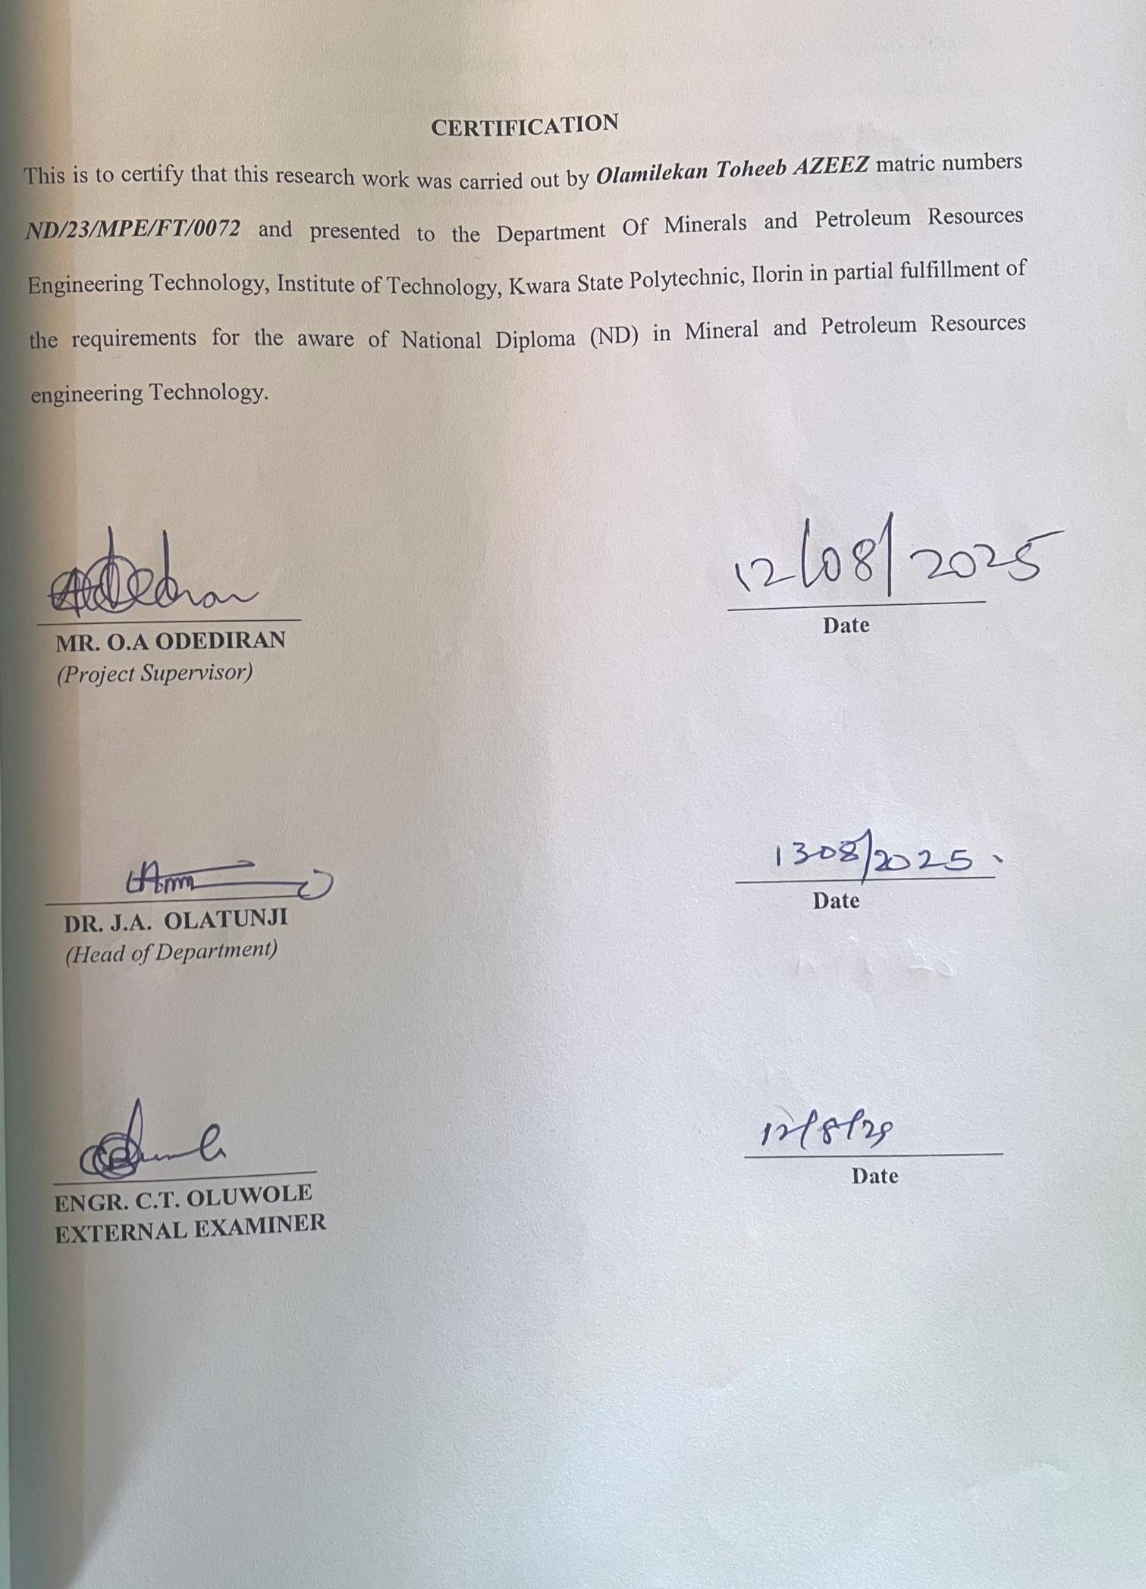
DEDICATION
This project is wholeheartedly dedicated to Almighty Allah, whose Grace, Strength, Wisdom and guided me throughout this academic journey. I also dedicate this work to my loving parents, Mr. and Mrs. Azeez, for their endless love, prayers, encouragement and unwavering support. Your sacrifices and belief in my potential have been the foundation of my success.

ACKNOWLEDGEMENT
All praise and thanks be to Almighty Allah, the Most Gracious, the Most Merciful, for granting me the gift of life, strength, wisdom, and guidance to successfully complete this project.
My heartfelt appreciation goes to my beloved parents, Mr. and Mrs. Azeez, for their endless love, support, prayers, and sacrifices, which have been the backbone of my academic journey.
I sincerely express my gratitude to my project supervisor, Mr. Odediran O.A., for his guidance, encouragement, and constructive criticisms that greatly contributed to the success of this work. My appreciation also goes to all the lecturers in the Department of Mineral and Petroleum Resources Engineering for imparting knowledge and providing the academic support that shaped my learning experience.
Special thanks to my dear siblings for their constant motivation, and to my friends for their encouragement, understanding, and companionship throughout this journey.
To everyone who has in one way or another contributed to the success of this project, I say a heartfelt thank you.

TABLE OF CONTENTS
Title Page i
Certification ii
Dedication iii
Acknowledgement iv
Table of Content v
Abstract viii
List of Tables ix
Chapter One
1.0 Introduction 1
1.1 Location and Accessibility 1
1.2 Climate and Vegetation 1
1.3 Relief and Drainage 2
1.4 Aims and Objectives 3
1.5 Statement of Problem 3
1.6 Justification 4
1.7 Scope and Limitations of the Study 5
Chapter Two
2.0 Literature Review 6
2.1 Overview of Laterite 6
2.2 Formation and Occurrence of Laterite 7
2.3 Regional Distribution of Laterite 7
2.4 Characteristics of Laterite 8
2.5 Atterberg Limits 9
2.6 Compaction 10
2.7 Sieve Analysis 11
Chapter Three
3.0 Research Methodology 13
3.1 Collection of Samples 13
3.2 Preparation of Distributed Samples 13
3.3 Laboratory Procedures 14
3.4 Grain Size Distribution Tests 15
3.5 Atteberg Limits Test 16
3.6 Compaction Tests 17
3.7 Moisture Content Test 18
3.8 Specific Gravity Test 19
3.9 Bulk Density Test 20

Chapter Four
4.0 Results and Discussion 22
4.1 Results of Moisture Content Test 22
4.2 Results of Bulk Density Test 23
4.3 Results of Dry Density Test 24
4.4 Results of Specific Gravity Test 24
4.5 Results of Atteberg Limits Test 25
4.6 Results of Gravity Size Analysis 26
4.7 Results of Compaction Tests 28
Chapter Five
5.0 Conclusion and Recommendations 30
5.1 Conclusion 30
5.2 Recommendation 30
References

ABSTRACT
Lateritic soils are widely prevalent in tropical and subtropical regions and are extensively utilized in various civil engineering applications, including road subgrades, embankments, and foundations. Despite their widespread use, the heterogeneous nature and variable engineering properties of these soils often pose significant challenges, leading to potential structural failures if not properly characterized. This research aimed to assess the geotechnical properties of lateritic soils within the Kwara State Polytechnic campus to determine their suitability for engineering and construction purposes. The study involved the collection of disturbed soil samples from selected locations, which were then subjected to a series of standard laboratory tests. These tests included the determination of natural moisture content, Atterberg limits (Liquid Limit, Plastic Limit, and Plasticity Index), compaction characteristics (Maximum Dry Density and Optimum Moisture Content), and grain size distribution (sieve analysis). The findings from this investigation are intended to provide critical baseline data for engineers and planners, enabling more informed decisions regarding foundation design, material selection, and soil improvement strategies. Ultimately, this study seeks to contribute to the development of more efficient, resilient, and sustainable construction practices tailored to the specific geotechnical conditions of the Kwara State Polytechnic campus.

LIST OF TABLES
Table 4.1. Results of Natural Moisture Content
Table 4.2. Results of Bulk Density Test
Table 4.3. Results of Dry Density Test
Table 4.4. Result of Specific Gravity Tests
Table 4.5. Results of Atterberg Limit Tests
Table 4.6. Result of Grain Size Analysis
Table 4.7. Result of Compaction Test

CHAPTER ONE
1.0 INTRODUCTION
1.1 Location and Accessibility
Kwara State Polytechnic is located in Ilorin, the capital city of Kwara State, Nigeria, It lies approximately between latitudes 8029'N and 831'N and Longitudes 4°30'E and 4°35'E. The campus is situated along the old Jebba road and is easily accessible via major roads linking it to other parts of Ilorin and neighbouring communities. It’s central location within the city makes it a strategic point for infrastructural development and academic research. It is easily accessible through major roads including the Ilorin-Ogbomosho expressway and the Sango-Tanke road. The campus is well-connected and accessible year-round, making it a suitable location for both academic and field studies, especially geotechnical field studies.
1.2 Climate and Vegetation
The climate and vegetation of a region play significant roles in the formation, slope stability, distribution, and engineering behavior of lateritic soils. According to Gidigasu (1976), laterites are typically formed under conditions of intense tropical weathering, which are closely linked to the region’s climatic and ecological characteristics.
Climate: Kwara State Polytechnic is situated in Ilorin, within the Guinea Savannah zone of Nigeria, characterized by a tropical wet-and-dry climate as per the Koppen-Geiger classification system. According to the Nigerian Meteorological Agency (NiMet) 2023:
  - Average annual rainfall: Between 1,000 mm and 1,300 mm, primarily falling between April and October.
  - Dry Season: From November to March, marked by lower humidity and the presence of harmattan winds.
  - Average annual temperature: Ranges between 25°C and 29°C.
  - Relative humidity: Peaks above 80% during the rainy season and falls to about 40% during the dry months.
These climatic conditions promote deep chemical weathering essential for laterite formation. According to Hunuakuda and Amadi (2013), the wet and dry seasons encourage the leaching of silica and the concentration of iron and aluminum.
Vegetation: The vegetation of the Kwara State Polytechnic environment is typical of the Guinea Forest-Savanna mosaic with grassy fields interspersed with deciduous trees such as Parinari. According to Apalayan (1993), this type of vegetation promotes the formation of moderately organic-rich topsoil.
Vegetation cover also impacts surface erosion (infiltration rates) and organic content in the upper soil horizons. According to Oyedele and Alatise (2009), the presence of vegetative cover affects the soil’s resistance to erosion and its load-bearing capacity—two critical parameters in geotechnical evaluations.
1.3 Relief and Drainage
The topography of the area is generally undulating with gentle slopes and low hills typical of regions underlain by precambrian basement complex rocks. According to Annor and Olasehinde (1999), the elevation within the campus ranges between 321 m and 342 m above sea level, which promotes moderate surface runoff and limits the risk of landslides or severe gully erosion. The relief supports laterite formation by allowing for surface and subsurface drainage. According to Afuintala (1986), low relief areas such as Ilorin encourage deep weathering over time, leading to thick laterite profiles that are often suitable for use in construction once properly characterized and, if necessary, stabilized.
The drainage system around the Kwara State Polytechnic campus is dendritic in nature, characterized by a network of seasonal streams that eventually drain into the Asa River, a major water body in Ilorin. According to Oyegun (1983), these ephemeral streams typically flow during the rainy season and dry up in the dry season, resulting in fluctuating water tables that can impact the moisture content and bearing capacity of the underlying soils. According to Gidigasu (1976), areas with good surface drainage tend to have better lateritic soil formation, as excess water is removed, leaving behind iron and aluminum oxides that enhance soil strength.
1.4 Aim and Objectives
The aim of this study is to determine the geotechnical properties of lateritic soils within the Kwara State Polytechnic campus assess their suitability for use in civil engineering applications such as road construction, foundations and earthworks.
The Objectives are as follows:
- To determine some index properties of the lateritic soils such as natural moisture content, grain size distribution, specific gravity, Atterberg limits, soil classification.
- To determine the engineering properties of the lateritic soils such as compaction characteristics, permeability, California bearing ratio, soil bearing capacity, shear strength parameters.
- To establish the relationship between the index properties and the engineering properties.
1.5 Statement of The Problem
Laterite soils are commonly used in construction and civil engineering works due to their widespread availability and favourable properties. However, the engineering behavior of laterite soils can vary significantly depending on local environmental and geological conditions. Within the Kwara State Polytechnic campus, construction activities such as road works, foundation excavations, and structural developments depend heavily on the local soil’s suitability. Yet, there is limited documented geotechnical data on the properties of laterite soils specific to this area. This lack of specific geotechnical information poses a challenge in making informed engineering decisions, which can lead to structural failures, increased maintenance costs, and designs. Therefore, there is a pressing need to investigate and understand the geotechnical characteristics of laterite within the campus. This study is designed to fill this knowledge gap by conducting a detailed investigation of the laterite soils within the campus.
1.6 Justification
Lateritic soils are prevalent in tropical regions and are commonly used in construction due to their availability and cost-effectiveness. However, their geotechnical properties can vary significantly based on factors such as mineral composition, degree of weathering, and environmental conditions. Within the Kwara State Polytechnic Campus, there is a lack of comprehensive data on the specific geotechnical characteristics of the local lateritic soils. This absence of detailed information poses challenges for engineers and builders in making informed decisions regarding foundation design, road construction, and other infrastructural developments. Without precise knowledge of properties like bearing capacity, compaction behavior, and moisture content, structures built on these soils may face issues such as settlement, instability, or premature failure. Thus, a thorough investigation into the geotechnical properties of laterite soils within the Kwara State Polytechnic is essential to ensure safe and sustainable construction practices.

1.7 Scope and Limitation of the Study
The Scope of this research is confined to the geotechnical evaluation of laterite soils collected from different sections of Kwara State Polytechnic Campus. The investigation covers soil sampling, laboratory testing such as particle size analysis, Atterberg limits, compaction characteristics and permeability, as well as a review of environmental factors influencing soil behaviour.
However, the study is limited by factors such as time constraints, which restrict the duration of fieldwork and laboratory analysis, and financial limitations, which may affect the number of samples tested or the depth of subsurface exploration. Furthermore, the research is conducted during the dry season, which may not fully represent the seasonal variations in soil moisture content and strength.
Despite these limitations, the findings are expected to provide valuable insights into the engineering behavior of laterite soils within the Campus.

CHAPTER TWO
2.0 LITERATURE REVIEW
2.1 Overview of Laterite
Laterite is a highly weathered soil type that is rich in iron and aluminum oxides, formed predominantly in tropical and subtropical regions under conditions of high temperature and heavy rainfall. Its formation is the result of prolonged chemical weathering of parent rocks, leading to the leaching of silica and the accumulation of sesquioxides (iron and aluminum oxides), giving it a characteristic reddish to brownish color (Gidigasu, 1976; Ola, 1983). Laterite is widely distributed in Nigeria and is commonly used as a construction material, particularly as road base, sub-base, and building blocks due to its abundance, low cost, and moderate engineering properties (Osinubi, 1998). Within Kwara State Polytechnic Campus, lateritic soils are commonly found near the surface and play a crucial role in local construction and geotechnical design.
The term "Laterite" was first used by Buchanan in 1807 to describe a red-colored Soil used for building purposes in India. Since then, Various Scholars have purposed definitions and classifications based on genesis, morphology, and engineering behavior. Ola (1983) defined laterite as "the products of tropical weathering with red, reddish-brown, or dark brown color, with or without nodules or concretions, and generally found below a hardened ferruginous crust or hardspan.
In regions like Kwara State, lateritic soils are particularly important due to their widespread use in road and building construction. However, challenges such as variability in strength, plasticity, and moisture sensitivity must be addressed through proper geotechnical investigation and, if necessary, soil stabilization techniques (Amu, 2005).
2.2 Formation and Occurrence of Laterite
Laterite forms primarily through intense and prolonged weathering of underlying parent rocks under tropical climatic conditions, characterized by high temperatures and abundant rainfall (Gidigasu, 1976). This process leads to the leaching of silica and bases (such as sodium, potassium, calcium, and magnesium) while leaving behind residual concentrations of iron and aluminum oxides which give laterite its distinctive red to brown coloration (Ola, 1983). The formation of laterite - known as “laterization” - is controlled by: Climate, Parent Rock, Topography, and drainage.
Occurrence in Nigeria and Kwara State; In Nigeria, laterites are extensively found in the Middle and Southern belts, particularly in states such as Oyo, Ondo, Kogi, Kwara, and parts of the Niger Delta. In Kwara State, lateritic soils are predominant due to the influence of the “Precambrian Basement Complex rocks” which are highly susceptible to chemical weathering (Amu, 2005).
Within the Kwara State Polytechnic Campus, visual surveys and shallow subsurface investigations reveal that lateritic deposits are widely distributed, especially in elevated and well-drained zones. These deposits often appear as reddish-brown soils with variable texture, ranging from gravelly to silty or clayey - depending on the location and degree of weathering.
2.3 Regional Distribution of Laterite
Lateritic soils are globally distributed in the tropical and subtropical regions, particularly between latitudes 25°N and 25°S. They are widespread in Africa, South America, Southeast Asia, and parts of Australia. In Africa, laterites cover substantial portions of West Africa, including Nigeria, Ghana, Ivory Coast, and Cameroon (Gidigasu, 1976). Within the Kwara State Polytechnic Campus, laterite is commonly observed at shallow depths (within 0.5-2 meters) below the topsoil. Field observations and preliminary soil surveys in and around the campus (e.g., Civil Engineering workshop area and shallow pit/unpaved surfaces) show predominantly reddish-brown, gravelly laterite in elevated areas. Clayey or silty laterite is past poorly drained zones. Varying plasticity and strength based on location and depth.
These lateritic deposits are directly derived from underlying migmatite and granite gneiss common to the Ilorin area. Due to their availability, laterites within the campus are frequently used for road maintenance, backfilling, and general construction activities.
However, due to variability in grain size, moisture sensitivity, and compaction behavior, geotechnical testing is necessary before reuse in engineering works.
2.4 Characteristics of Laterites
Laterites are highly weathered soils that are commonly found in tropical regions, especially in West Africa, including Nigeria. They are products of prolonged weathering of parent rocks under alternating wet and dry conditions. This process leads to the leaching of silica and enrichment of iron and aluminum oxides (Ogunmowo, 1975; Gidigasu, 1976).
- Physical Characteristics: Laterites typically exhibit reddish to brownish coloration due to high iron oxide content (Fe₂O₃). Their texture ranges from gravelly to clayey, depending on the degree of weathering and the parent material. In Kwara State Polytechnic Campus and similar tropical environments, laterites often exist as residual soils, forming a cap over the underlying bedrock (Osinubi and Mu’azu, 2006).
- Mineralogical Composition: Laterites are rich in sesquioxides such as goethite, hematite, and gibbsite, with low amounts of primary minerals like quartz and feldspar due to intense weathering. The dominance of iron and aluminum oxides contributes to their cementing properties, which affects compaction and strength (Gidigasu, 1976; Ola, 1983).
- Geotechnical Properties: Lateritic soils typically display the following geotechnical behaviors: high shear strength when compacted optimally, making them suitable for sub-base and base materials in road construction (Osinubi, 1998); moderate to low permeability, which reduces water infiltration and compaction; high bearing capacity but may decrease when the soil is saturated.
Plasticity; ranges from low to medium; the plasticity index (PI) helps determine their suitability for construction purposes (Mohammed and Adjei, 2020).
Influence of cementation and lateritization: Laterization leads to varying degrees of cementation. In places like Kwara State, laterites may appear as hardpan or nodular concretions, which can pose challenges during excavation but offer strength advantages in foundations (Gidigasu and Adeyemi, 1995).
2.5 Atterberg Limits
The Atterberg limits are fundamental consistency indices used in geotechnical engineering to describe the plasticity and behavior of fine-grained soils under varying moisture conditions. These limits include the "Liquid Limit (LL)", "Plastic Limit (PL)", and Plasticity Index (PI). They are especially important in characterizing lateritic soils, which are prevalent in tropical regions such as Kwara State, Nigeria (Ola, 1983).
Definition of Atterberg Limits:
- "Liquid Limit (LL)"'; The water content at which the soil changes from a plastic to a liquid state. It reflects the water-holding capacity and compressibility of the soil.
- "Plastic Limit (PL)"; The lowest moisture content at which soil remains plastic and can be rolled into threads without crumbling.
- "Plasticity Index (PI)"; The numerical difference between LL and PL, representing the range of moisture content over which the soil remains plastic. PI = LL - PL. These parameters provide insight into the soil’s strength, compressibility, and workability (Head, 1980; Bes, 1987).
Importance in Lateritic Soils: Lateritic soils typically exhibit low to medium plasticity (PI between 5% and 20%), depending on their clay content and degree of weathering. The Atterberg limits are influenced by the mineralogy of the soil, particularly the presence of kaolinite, gibbsite, and iron oxides, which dominate in laterites (Adeyemi, 1995).
Classification based on Atterberg Limits: According to the Unified Soil Classification System (USCS) and ASTM classification: "Soils with PI < 10% are considered to have low plasticity and are often more stable under load." "Soils with PI > 10% are more plastic, indicating higher clay content and potentially problematic behavior under fluctuating moisture" (Gidigasu, 1976).
2.6 Compaction
The compaction test is essential for determining the relationship between the moisture content and the dry density of soil. This test is conducted on lateritic soil samples collected from various points within the Kwara State Polytechnic campus to establish the optimum moisture content (OMC) and Maximum Dry Density (MDD). These parameters are crucial in evaluating the soil’s load-bearing capacity and suitability for use in foundations, embankments, and road construction.
- Objectives of the Test: The main aim of the compaction test is to simulate field conditions and determine the moisture content at which the soil can be compacted to achieve the highest possible dry density. This improves the soil’s strength, reduces settlement, and enhances stability.
- Equipment Used: Standard Proctor compaction mold (1000 cm³ capacity), Rammer (2.5 kg with a 300 mm drop), Balance (accurate to 0.01 g), Oven (105-110 °C), Mixing tools, Moisture Content cans, Straight edge, and Spatula.
- Significance of the test: Compaction characteristics provide valuable information about the soil’s engineering performance. MDD indicates the highest achievable density under given compaction effort, which relates to strength and stability. OMC helps in optimizing field compaction. Proper compaction reduces permeability, compressibility, and settlement while increasing shear strength.
2.7 Sieve Analysis
Sieve analysis is a fundamental laboratory procedure used to determine the particle size distribution of soils and aggregates. It plays a critical role in the classification of soils and in understanding their engineering behavior, particularly for lateritic soils commonly found in tropical regions like Kwara State, Nigeria. The process involves passing soil samples through a stack of sieves with progressively smaller mesh sizes and measuring the weight retained on each sieve (Head, 2006).
For lateritic soils, sieve analysis helps distinguish the proportions of gravel, sand, silt, and clay, which are essential in evaluating their suitability for construction purposes. The Particle size distribution directly affects the soil’s permeability, compaction characteristics, shear strength, and overall stability (Anora, 2003).
In the context of the Kwara State Polytechnic Campus, where laterite is predominantly used for civil engineering works such as road construction and foundation piling, understanding the foundation of lateritic soil is crucial. The Unified Soil Classification System (USCS) and the AASHTO soil classification system are often applied in classifying soils based on sieve analysis results (Das, 2010).
The test is typically conducted in accordance with ASTM D422 or BS 1377 standards. A representative dry sample is passed through a set of standard sieves (commonly ranging from 4.75 mm to 0.075 mm). The percentage retained on each sieve is recorded and used to plot the grain size distribution curve. Well-graded laterites exhibit a smooth and wide-spanning curve, indicating a broad range of particle sizes, which generally enhances mechanical interlock and stability (Ola, 1983).
Lateritic soils within the Kwara State Polytechnic Campus are expected to vary slightly in particle size distribution depending on the location due to varying degrees of weathering and parent rock materials. Preliminary studies in the region indicate that laterites in Southwestern Nigeria generally have a high proportion of sand-sized particles with moderate clay content (Gidigasu, 1976).

CHAPTER THREE
3.0 RESEARCH METHODOLOGY
3.1 Collection of Samples
Soil samples of laterite were collected from three (3) different locations within Kwara State Polytechnic campus by using a hand auger at a depth of 1.0 to 1.5 meters, to obtain disturbed and representative laterite soil.
Samples were sealed in polythene bags and labeled. The coordinates were taken and samples were then transported to the laboratory for a proper analysis of the soil samples taken. The details of the sampling points were presented in table below.
Table: Details of Sampling Points
S/N | LOCATION | LONGITUDE | LATITUDE | ELEVATION | DEPTH
1 | L A | E 004°37' 882" | N 08°33.426' | 336 m | 0.50m
2 | L B | E 004°37' 882" | N 08°33.428' | 309 m | 0.75m
3 | L C | E 004°37' 883" | N 08°33.430' | 309 m | 0.79m
3.2 Preparation of Distributed Samples
Initial handling and labeling upon arrival in the test record each sample ID, depth, its location, and collection date. Air-dry samples for approximately two weeks to reduce excess moisture without causing Cracking; remove stones and organic debris. Preserve fine Particles for geotechnical tests.
- Sieving and Sub-Samping: Pass Samples through 4.75 mm (No. 4) Sieve, retaining fine fraction (>4.75 mm) for index tests; homogenize the fine fraction and quarter it to obtain representative subsamples (a so-called) following standard Quartering Procedures.
- Oven Drying and Moisture Content Control: oven dry Small subsamples at 105°C to 80°C until constant weight (C 0.01g) to determine natural moisture content. BS 1377 and ASTM D2216 Protocols use this information to calculate body natural moisture content and to prepare Mixtures at optimum moisture contents for compaction CBR.
- Pulverization and Homogenization: Gently break dried lumps by hand or mortar & pestle, avoiding aggressive grinding to preserve Particle integrity; mix-thoroughly to ensure homogeneity across subsamples.
- Sample Preparation for Specific laboratory Tests: Particles Size distribution use body of air-oven-dried soil; wash and Sieve through a set of BS Sieves (4.75mm-75μm) using a mechanical Sieve Shaker; perform hydrometer analysis for Particles finer than 75μm if needed. Atterberg limits: take 200g passing 425μm Sieve; determine liquid line using Casagrande Cup and Plastic limit using thread method following BS/ASTM standards. Compaction Proctor mould in standardized layers and blow Ce 25 blows of 4.5kg hammer; use resulting OMC and MDD to prepare CBR specimens. Specific gravity: Prepare subsamples free of lumps; use Pycnometer or density bottle methods in line with BS 1377.
- Quality and Repeatability: Prepare duplicate Subsamples from each disturbed Sample for repeat test verification. Strictly follow BS 1377 and ASTM standards to ensure lab consistency and validity.
3.3 Laboratory Procedures
The laboratory testing program was carried out to determine the geotechnical properties of laterite soils obtained from different locations within the Kwara State Polytechnic Campus. The following tests were conducted in accordance with relevant British Standard (BS 1377: 1990).
3.3.1 Natural moisture content (MC) test was conducted to determine the moisture present in the soil at the time of sampling. A known weight of wet soil was dried in an oven at 105–110°C for 24 hours after which the moisture content was calculated as:
moisture content (%) = weight of water / Dry weight of soil × 100
- Particle size Distribution (Sieve analysis): This test was used to determine the grain size distribution of the soil samples. The oven-dried soil sample was passed through a stack of standard sieves.
- Atterberg Limits Test: these tests help classify the fine-grained soil based on its plasticity characteristics. Liquid limit (LL) determined using the Casagrande apparatus. Plastic limit (PL) determined by rolling soil threads by hand.
- Compaction test (Standard Proctor): This test was conducted to determine the optimum moisture content (OMC) and maximum dry density (MDD) of the lateritic soil.
- California Bearing Ratio (CBR) Test: this test was used to evaluate the strength of the soil for subgrade design. The soaked and unsoaked CBR values were determined by penetrating a piston into a compacted soil specimen and measuring the resistance.
- Specific Gravity Test: The specific gravity of the soil solids was determined using a density bottle test. Value is used in various calculations.
3.4 Grain Size Distribution Test
The grain size distribution test was carried out to determine the proportion of different particle size of the lateritic soil samples collected from various locations in the Kwara State Polytechnic Campus. The test procedure followed the Guidelines specified in BS1377: Code of practice used, mechanical Sieve shaker, Sample Container, brushes, mortar and pestle, Oven temperature lost 110°C, weight balance.
- Procedure: About 500 g of the oven-dried soil sample was weighed and recorded. The soil sample was placed in the top sieve of a stack of sieves arranged in descending order of aperture size ending with pan at the bottom. The sieve stack was placed in a mechanical sieve shaker and shaken for 10–15 minutes. After shaking, the mass of soil retained on each sieve was measured and recorded. The percentage of soil retained and the cumulative percentage passing through each sieve were calculated. Particle size distribution curve was plotted with sieve size (log scale) on the x-axis and percentage passing on the y-axis.
- Results: Interpretation, the soil gradation curves helped in classifying the laterite soils using the unified soil classification system (USCS) or AASHTO system. Standard for AASHTO (M145) classification system.
3.5 Atterberg Limit Tests
Atterberg limit test was conducted to determine the consistency characteristics of the lateritic soil samples collected from different locations within the Kwara State Polytechnic Campus. The test focused on determining the liquid limit (LL), Plastic limit (PL), and calculating the Plasticity index (PI) which provide insight into the plasticity and workability of the soil under varying moisture conditions.
  - Objective: The main purpose of this test is to assess the soil’s behavior between its solid, plastic and liquid states; this helps in evaluating the Suitability of the lateritic soils for engineering applications such as road construction, foundation materials, and early works. Equipment used: Grooving tool, Spatula, glass plate, Casagrande apparatus, weighing balance, oven, moisture tins.
  - Procedure: Liquid limit (LL) test was determined using the Casagrande cup method in accordance with BS 1377 (1990). A paste of soil was placed in Casagrande cup and divided using a grooving tool; the cup was repeatedly dropped from a height of 10mm at a rate of two drops per second. The test was repeated for different moisture contents to obtain a flow curve.
  - Plastic limit (PL) Test: A portion of soil was moulded by hand into threads on a glass plate, rolling continuously until the thread crumbles at a diameter of about 3mm. The moisture content at which this occurred was recorded as the PL.
  - Plasticity Index (PI): This value indicates the range of moisture content over which the soil remains plastic.
  - Significance: Atterberg limits are crucial in classifying soils based on plasticity, predicting potential volume changes due to soil and moisture variations. Assess soil behavior under load during construction processes. Lateritic soils from the Kwara State Polytechnic Campus are expected to show low to medium plasticity.
3.6 Compaction Test
The compaction test is essential for determining the relationship between the moisture content and the dry density of soils. This test was conducted on laterite soil samples collected from various points within the Kwara State Polytechnic campus to establish the Optimum moisture content (OMC) and maximum Dry Density (MDD).
- Objective of the Test: the main aim of the Compaction test is to simulate field compaction and determine the moisture content at which the soil can be compacted to achieve the highest possible dry density.
- Equipment used: Standard Proctor compaction mold (1000cm³ capacity), Rammer (2.5kg wt., 300mm drop), Balance, Counter, Oven (105–110°C), mixing tools, straight edge and spatula.
- Procedure (Standard Proctor method, BS 1377: Part 4, 1990): The lateritic soil was air-dried and sieved through a 20mm sieve. A known amount of soil was mixed with water at an estimated moisture content. The soil was placed in the Proctor mold in layers, each layer compacted with 25 blows from the 2.5kg rammer. A graph of dry density versus moisture content was plotted.
- Significance of the Test: Compaction characteristics provide valuable information about the soil’s engineering performance. MDD indicates the highest achievable density under given compactive effort; OMC relates to strength and stability. OMC helps in optimizing field compaction procedures.
3.7 Moisture Content Test
The moisture content test was conducted to determine the amount of water present in the laterite soil samples at the time of collection. This test is fundamental in geotechnical investigations, as the water content of soil significantly influences its strength, compressibility, plasticity, and compaction behavior.
- Objective: The purpose of the moisture content test is to determine the natural water content of the laterite sample, which is critical for understanding the behavior under load and during field construction.
- Apparatus Used: Moisture tins (clean and dry), desiccator, spatula, weighing balance (sensitive to 0.01g), Oven (set at 105–110°C).
- Test Procedure (According to BS 1377: Part 2, 1990): A clean, dry moisture tin was weighed and recorded as W1. Approximately 20–30g of moist soil was placed into the tin and weighed as W2 (can’t wet soil). The tin was placed in an oven at a temperature of 105–110°C for 24hours to ensure complete drying of the soil. The moisture content (%) was calculated using the following formula: W = weight of empty moisture tin, W1 = weight of tin + wet soil, W2 = weight of tin + dry soil.
- Relevance to Lateritic Soils: Moisture content plays a significant role in the engineering performance of laterite soils. High moisture content can lead to reduced shear strength and increased compressibility, which are undesirable in subgrade and foundation materials.
3.8 Specific Gravity Test
The specific gravity of soil solids is a critical geotechnical property used to classify soils and compute various other parameters such as void ratio, porosity, and degree of saturation. It is defined as the ratio of the weight of a given volume of soil solids to the weight of an equal volume of water at a specified temperature (usually 4°C for water).
- Apparatus: Density bottle (50ml capacity), Digital weighing balance (sensitive to 0.01g), Vacuum pump (optional), Distilled water, Thermometer, Desiccator, Oven, Drying towel, Wash bottle, Spatula.
- Test procedure (Pycnometer Method): The test procedure followed is based on BS 1377: Part 2 (1990) and ASTM D854 standards. The following steps were undertaken: A clean and dry density bottle was weighed and its mass recorded as M1. About 5–10g of oven-dried soil sample (laterite) passing through a 2mm sieve was added into the bottle and the mass recorded as M2. A similar bottle filled only with distilled water was used as a reference, and its mass was recorded as M4.
- Calculation: The gravity (G-S) of the soil solid is calculated using the formula:
Gs = ($\frac{M-M}{\left(M-M\right)- (M-M)}$
where: M = Mass of empty density bottle,
M = mass of bottle + soil + water
M = mass of bottle + dry soil
- Observation and Results: From tests carried out on laterite samples within the Kwara State Polytechnic Campus, specific gravity values were found to range between 2.60 and 2.72.
- Discussion: The values obtained suggest that the laterite soil in the study area is of relatively high specific gravity, indicating the presence of heavy minerals and good load-bearing capacity.
3.9 Bulk Density Test
The bulk density test was conducted to determine the mass of lateritic soil per unit volume, including the air spaces within the soil. Bulk density is a critical parameter for evaluating the compaction quality, strength, and load-bearing capacity of soils, particularly in construction and foundation design.
- Objective: The main objective of this test is to determine the in-situ bulk density of laterite soil values, along with moisture content, can be used to calculate dry density.
- Equipment Used: Cylindrical core cutter test steel dolly, Rammer or hammer weighing balance, straight edge, Oven.
- Test Procedure (Core Cutter Method, BS 1377: Part 2, 1990): A cylindrical core cutter was driven vertically into the ground using a steel dolly and hammer until it was fully embedded. The cutter was carefully dug out and trimmed at both ends to ensure a flush surface. The soil filled cutter was weighed to determine the wet mass (M1). A representative sample of the soil was taken and oven-dried at 105–110°C for 24 hours to determine its moisture content (C%). The volume (V) of the core cutter was known from calibration. Bulk density (P_bulk) was calculated using the formula:
P bulk = $\frac{M1}{V}$ (g/cm³ or kg/m³)
Importance of Bulk density in Geotechnical Engineering: Indicates soil compaction status and helps estimate load-bearing capacity and settlement behavior. Required for determining the unit weight of soils used in stability and foundation calculations. Helps relate field conditions to laboratory compaction results (e.g., Proctor test outcomes).
Lateritic soils in Kwara State are expected to exhibit moderate to high bulk density due to their residual nature and mineral composition, particularly when well-drained and compacted (Ola, 1983, Adeyemi, 1995).

CHAPTER FOUR
4.0 Results and Discussion
4.1 Results of Natural Moisture Content
The results of natural moisture content test are presented in table 2. the moisture content value range between 4.2% and 5.3%, indicating that the soil are relatively dry. According to Ola (1993), typical moisture content for lateritic soils range between 5% and 20% depending on the season and drainage condition. Therefore the sample fall within the lower end of the standard range implying well drained and stable conditions.

Table2: Natural Moisture Content Test of Collected Samples
Sample A | Sample B | Sample C
5.2% | 4.3% | 4.1%

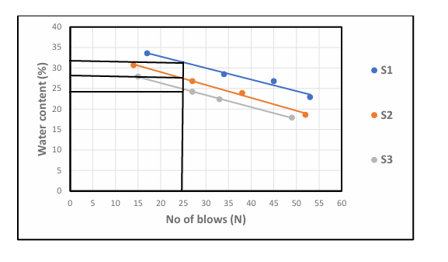
Fig.1: graph showing water content

4.2 Results of bulk Density Test
The result of Bulk Density Test are presented in Table3. the bulk density values range from 1.63 to 1.76g/cm³ Murthy (2002) stated that bulk densities for compacted lateritic soils usually range from 1.6 to 2.0g/cm³. hence, the values obtained are within the acceptable range, with sample C showing the highest density , indicating better compaction and higher strength.
Table 3: Bulk Density of Collected Samples.
Sample A | Sample B | Sample C
1.63 | 1.73 | 1.76

4.3 Results of Dry Density Test
Two results of Dry Density value (1.58 - 1.69g/cm³) are also within the expected range for Engineering fill materials. According to Das (2010) dry densities for lateritic soils typically range from 1.5 to 2.0g/cm3, indicating that the test ad soils can offer adequate bearing capacity when properly compacted.
Table 4: Dry Density Test of collected samples
Sample A | Sample B | Sample C
1.58g/cm³ | 1.67g/cm³ | 1.69g/cm³

4.4 Result of Specific Gravity Tests
The specific gravity result are presented in table 5 specific gravity value ranged from 2.68 to 2.83 according to Das (2010), the typical specific gravity of lateritic soil falls between 2.60 and 2.85 which confirm that the soil predominantly mineral based with minimum organic contamination.
Table 5: Specific gravity test of collected samples
Sample A | Sample B | Sample C
2.68g/cm³ | 2.71g/cm³ | 2.83g/cm³

4.5 Results of Atterberg Limit Tests
Liquid Limit (LL): ranges from 22.3 % to 31.6% According to Das (2010), soil with liquid limit value less than 35% are classified as low plasticity soils. All the three samples fall within this categories, indicating low compresibility and moderate workability.
Plastic Limit (PL): value range from 14.6% to 18.2%, which is also consistent with the range expected for lateritic soil.
Plasticity Index (PI): value, calculated as the difference between LL am PL range from 6.9% to 13.4% Ola (1983) noted that lateritic soil generally have pl value ranging from 5% to 20% depending on the degree of weathering. Hence the PL values obtained fall within the expected range, indicating moderate plasticity with Sample A being more plastic than Sample B and Sample C.
Linear Shrinkage (LS): values range from 3.7% to 6.2% According to Adeyemi (1995), values below 10% suggest that the soils has low shrinks well potential, which is desirable for most construction purpose. Sample C has the lowest shrinkage value, suggesting it will be the most suitable under moisture variation

Table 6: Atterberg Limit Tests of collected samples
Sample | Liquid Limit % | Plastic Limit % | Plastic index | Linear Shrinkage %
Sample A | 31.6 % | 18.2% | 13.4% | 6.2%
Sample B | 22.3% | 15.4% | 6.9% | 4.8%
Sample C | 24.8% | 14.6% | 10.2% | 3.7%

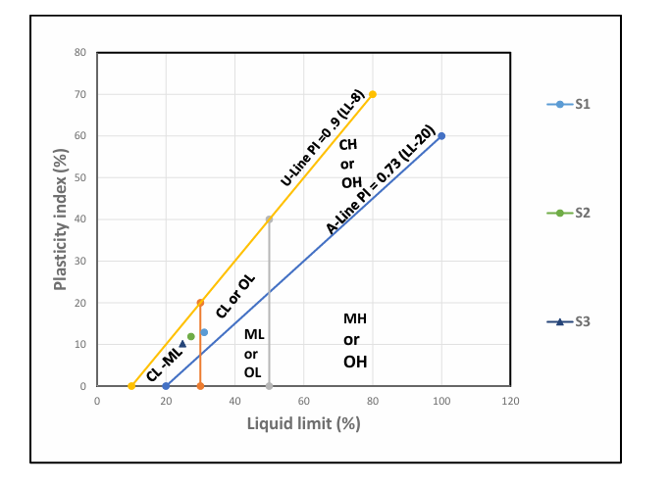
Fig 2: Graph Showing Plasticity Chart
4.6 Result of Gravity Size Analysis
P1 has higher clay content (21%) hence classified has clayey sand
P2 and P3 have more silt and less clay, Thus, silty sand all sample have sand and dominant particle size making them sand based soils.
fine (<0.075mm) is highest in P1, which support it’s clayey nature.
Table 7: Summary of result of Grain Size Analysis of soil
Sample Location | Gravel (%) | Sand (%) | Silt (%) | Clay (%) | Fine (%) | Soil classification
P1 | 10 | 60 | 9 | 21 | 30 | Clayey sand
P2 | 12 | 62 | 15 | 11 | 20 | Silty sand
P3 | 13 | 63 | 17 | 7 | 24 | Silty sand

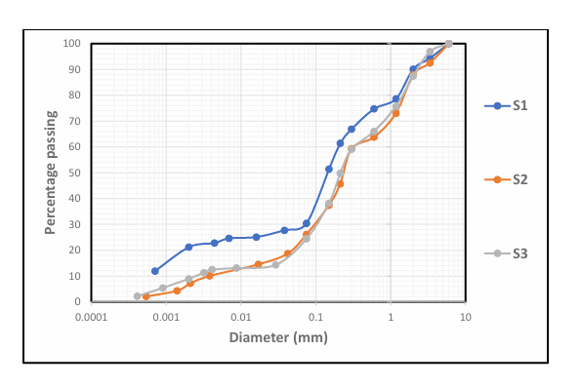
Fig. 3: Grain Size Analysis Graph

4.7 Result of Compaction Test
Table 8: Compaction Parameters of Maximum Dry Density (MDD) and Optimum Moisture Content (OMC)
Sample | MDD | OMC
A | 1.81 | 8
B | 1.89 | 7.5
C | 1.95 | 6

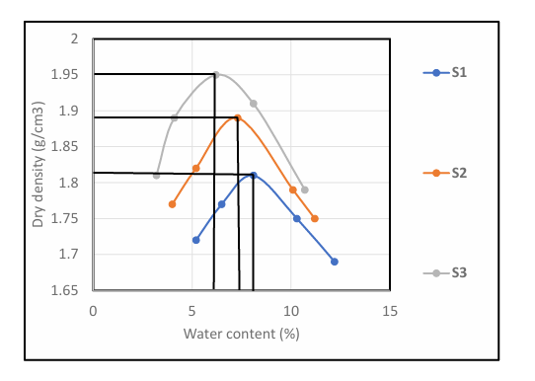
Fig. 4: Graph Showing Compaction Parameters
Table 9: Compaction and Ratings of Unified Soil Classification for Construction (ASTM 1557-91)
Visual Description | Maximum Dry Density (MDD)(g/cm³) | Optimum Moisture Content (OMC)(g/cm³) | Aticipated embankment performance | Value as Subgrade material | Value as Base Course
Granular material | 2.00 - 2.27 | 7 – 15 | Good to Excellent | Excellent | Good
Granular material with soil | 1.76 - 2.16 | 9 – 18 | Fair to Excellent | Good | Fair to Poor
Fine sand and sand | 1.76 - 1.84 | 9 – 15 | Fair to Good | Good to Fair | Poor
Sandy silts and silts | 1.36 -1.60 | 10 – 20 | Poor to Good | Fair to Poor | Not suitable
Elastic silts and clay | 1.36 - 1.60 | 20 -35 | Unsatisfactory | Poor | Not suitable
Silty clay | 1.52 - 1.92 | 10 – 30 | Poor to Good | Fair to Poor | Not suitable

Table 9: present the compaction parameters of collected samples. The (MDD) Maximum Dry Density for sample A is 1.81 for sample B 1.89 while sample C is 1.95. for Optimum Moisture Content (OMC), sample A is 8, Sample B is 7.5 sample C is 6. The three sample being sandy in nature can be range as range fair to good for embankment performance it is fair to poor for subgrade material are not suitable for base course.

CHAPTER FIVE
5.0 Conclusion and Recommendation
5.1 Conclusion

The geotechnical investigation of laterite within Kwara State Polytechnic campus revealed that the sampled soils possess engineering properties suitable for various civil engineering applications, especially as subgrade and fill materials. Laboratory tests such as particle size analysis, Atterberg limits, compaction indicated that the laterite falls within the acceptable range for road construction and foundation works under moderate loading conditions.

5.2 Recommendation
In the view of the occurance rampant failure in public civil structures, the suitability of fill materials (which is mostly laterite in Nigeria) must be ascertained before use.
Also the improvement of samples other than Sample C should be considered. This should be done by the addition of locally available materials e.g limestone.

REFERENCES
Adeyemi, G. O. (1995). Influence of parent rocks on some engineering index properties
of residual soils in southwestern Nigeria.
Adeyemi, G.O (1995). Geotechnical properties of lateritic soil developed over quartz
schist in ishara area, Southwestern Nigeria.
Afolayan, T.A (1978), “Vegetation of ilorin, Nigeria.
A journey from Madras through the countries of Mysore, canara and Malabar. London.
Akintola, J.O (1986). Rainfall Distribution in Nigeria, 1892-1983, Impact pubishees,
Ibadan.
Amu, O.O (2005). Effects of lime stabilization on lateritic soil in Ado-Ekiti Nigeria
journal of applied sciences 5(8), 1471-1474, Buchanan, F. (1807).
Amu, O.O (2005). Effects of lime stabilizationstabilization on lateritic soil in Ado-Ekiti,
Nigeria.
Annor, A E and Olasehinde, P. I (1999). Geological and Hydrological Mapping of Ilorin
and Environs. Journal of Mining and Geology, 35(2), 145-151.
Arora, K.R (2009).Soil Mechanics and foundation engineenng (6th ed).
Boules, J.E (1997), Foundation Analysis and Design. 5th edition, Gidigasu, M.D (1976),
lateritie soil engineering pedogenesis and engineering principles.
British standards institutions (1990). Methods of testing soils for civil engineering
purposes. B.S (1377), parts 1-9 London: BS.

Bulletin of the International Association of Engineering Geology, 52(1), 3-10.
https://doi.org/10.1007/BF02602650
Cengage learning., Gidigasu M.D (1976), Laterite soil engineering pedogenesis and
engineering Principles. Elsevier.
Das, B. M. (2010). Principles of geotechnical engineering (7th ed.). Cengage Learning.
Elsevier publishing, Nigerian Meteorological Agency (Nimet) (2003) Annual climate
report for ilorin zone, Nwankwoala, H.O and Amadi, A.N (2013)
Gidigasu, M.D (1976), laterite soil engineering, pedogenesis and engineering principles.
Geotechnical properties and geochemical evaluation of lateritic soils in parts of
South western Nigeria
Gidigasu, M.D (1976), Laterite soil engineering; pedogenesis and engineering principles.
Head. K.H (2006). Manual of soil Liboratry testing soil classification and compaction
tests.(vol.1). Whittles publishing.
Head, K.H (1080), Manual of soil laboratory testing volume 1, pentech press.
Head, K.H (1980), manual of soil laboratory testing volume 1; soil classification and
compaction test. Pentech press, London
Mc Graw-Hill. Das B.M (2016). Principles of geotechnical engineering 9th edition,
cengage learning.
Mohammed, H.A and Adjei, M.K (2020). Assessment of the geotechnical properties of
lateritic soils for road construction.

Murthy, V. N. S. (2002). Geotechnical engineering: Principles and practices of soil
mechanics and foundation engineering. Marcel Dekker.
Ola S.A (1983) Tropical soils of Nigeria in engineering practice. Rotterdam.
Ola S.A (1983). Geotechnical properties and behavior of some Nigerian lateritic soils.
Ogunsanwo, O. (1985). Engineering geological and geotechnical characteristics of
residual lateritic soils in Ibadan, southwestern Nigeria.
Oyedele, D.J and Alatise, M.O (2009). “Effects of vegetative cover on soil erosion in a
tropical savanna”.
Oyegun, R.A (1983). Drainage characteristics of the River basins in Kwara State Ilorin,
Gidigasu, M.D (1976). Laterite Soil Engineering Pedogenesis and Engineering Principles. Elsevier publishing
Osinubi K.J (1998). Influence of compactive effort and compaction delays on the
properties of a lateritic soil. Journal of transportation engineering ASCE, 124 (2), 149-155
Osinubi, K.J (1998) permeability of lime-treated lateritic soil.
Standard publishers, Das, B.M (2010), Principles of Geotechnical engineering (7th ed)
Quartery journal of engineering geology and hydrogeology, 16(2), 145-160.

