POTENCY OF RHIZOPUS STOLONIFER TOXIN

BY

SULYMAN MISTURA ASABI
HND/23/SLT/FT/0311

A PROJECT SUBMITTED TO THE DEPARTMENT OF SCIENCE LABORATORY TECHNOLOGY, INSTITUTE OF APPLIED SCIENCES, KWARA STATE POLYTECHNIC, ILORIN

IN PARTIAL FULFILMENT OF THE REQUIREMENTS OF THE AWARD OF HIGHER NATIONAL DIPLOMA (HND) IN SCIENCE LABORATORY TECHNOLOGY (SLT), MICROBIOLOGY UNIT

JULY, 2025
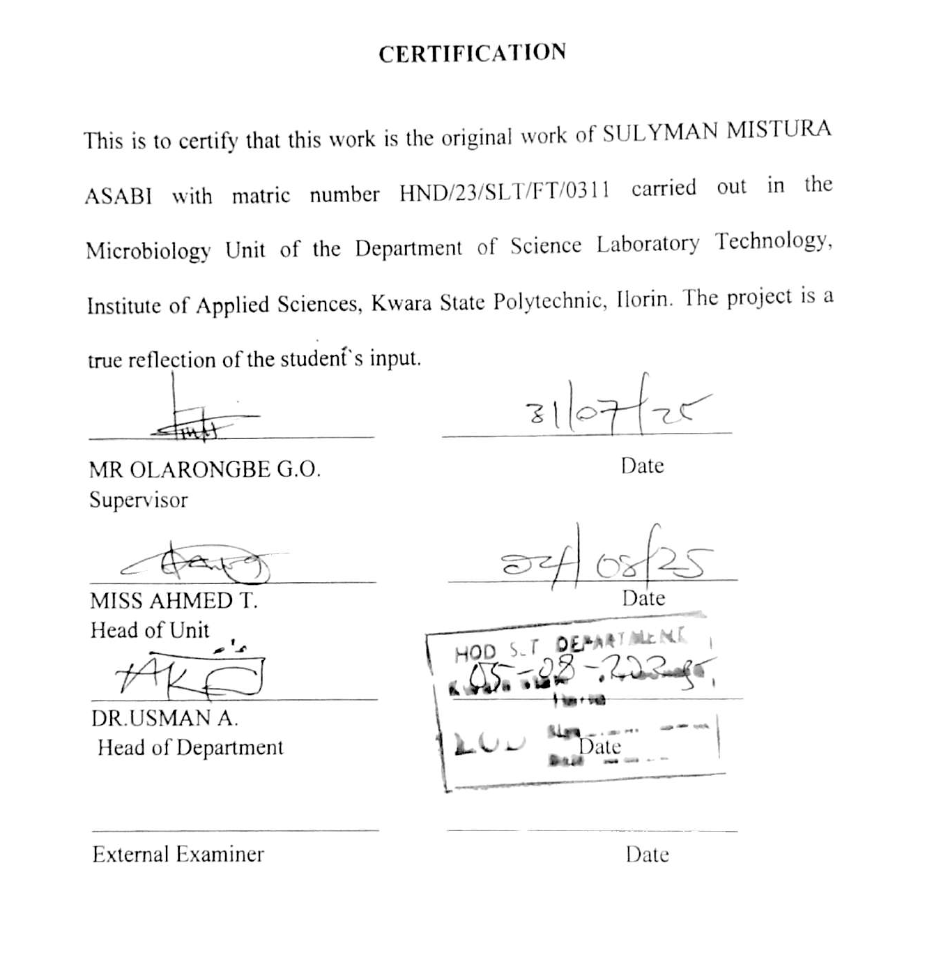

DEDICATION
This project work is dedicated to my mom: May Allah reward her abundantly for the islamic upbringing she rendered to me, you're the best mom ever I love you so much.

ACKNOWLEDGEMENTS
First and foremost our profound thanks to Almighty Allah who created us and gives us all the opportunities of life, from the beginning to this level of my life. peace and blessings of Allah be upon the prophet Muhammad (S.A.W), his family and pious companies. My unlimited gratitude and appreciation go to my able supervisor, Mr olarongbe G.O, for his cordial care and concern, guiding and directing us throughout the work. My thanks also goes to all my lecturers, Department of science laboratory technology, for teaching, guiding and counseling me throughout my academic experiences in the polytechnic. I also thanks all my family's members. To my late father may his gentle soul continue rest in peace and my mom Mrs. Suliat sulyman motunrayo I love you mom and to brothers and sisters in general, for assisting me in one way or the other I love you all. My special thanks to my darling husband Emiola taiwo surajudeen I love y'all. And lastly to my friends, colleagues, course mates may we all meet in higher place inshallah I will miss you guy's. Finally, my special appreciation to my typist (Black mayor and shift cafe) for their kindness and endurance in seeing my project work to successfully completed. May Almighty Allah reward us all and sundry and may we eat the fruits of our labor.

TABLE OF CONTENTS

TITLE PAGE ----------------------------------------------------------------------------i
CERTIFICATION -----------------------------------------------------------------------ii
DEDICATION --------------------------------------------------------------------------iii
ACKNOWLEDGEMENTS -----------------------------------------------------------iv
TABLE OF CONTENTS--------------------------------------------------------------vii
LIST OF TABLES --------------------------------------------------------------------viii
LIST OF FIGURES -------------------------------------------------------------------viii
ABSTRACT -----------------------------------------------------------------------------ix
CHAPTER ONE
1.0 Introduction -----------------------------------------------------------------------7
1.1 Literature Review-----------------------------------------------------------------9
1.2 Problem Statement---------------------------------------------------------------9
1.3 Justification of Study-----------------------------------------------------------10
1.4 Aims and Objective-------------------------------------------------------------10

CHAPTER TWO
2.0 Materials and Methods ---------------------------------------------------------11
2.1 Sterilization of Equipment and Environment -------------------------------11
2.2 Material used --------------------------------------------------------------------11
2.3 Samples Collection -------------------------------------------------------------12
2.4 Preparation of media -----------------------------------------------------------12
2.4.1 Preparation of Potato Dextrose Agar ----------------------------------------13
2.4.1 Preparation of Potato Dextrose Agar ----------------------------------------14
2.5 Isolation of Rhizopus Stolonifer from Moldy Bread--------------------------14

2.6 Characterization and Identification of Rhizopus Stolonifer -----------------15
2.7 Sub-culturing and Toxin production -------------------------------------------15
2.8 Administration and Evaluation of the Potency of the Toxin in White Rat--17
CHAPTER THREE
3.0 Results
3.1 Characterization and Identification of Fungal Isolate --------------------- 17
3.2 Weekly Clinical Observations in Experimental Rats ------------------------19
3.3 Post-Mortem Gross Pathological Findings ----------------------------------20
CHAPTER FOUR
4.0 Discussion and Conclusion
4.1 Discussion ---------------------------------------------------------------------24
4.2 Conclusion ---------------------------------------------------------------------25
REFERENCES

LIST OF TABLES
Table 1: characterization and identification of fungi isolate
Table 2: Weekly Clinical Observations in Experimental Rats
Table 3: Post-Mortem Gross Pathological Findings
LIST OF FIGURES
Figure 1: Colonies on PDA
Figure 2: Microscopic view of Rhizopus stolonifer
Figure 3: Dissected rat

ABSTRACT
Rhizopus stolonifer, commonly known as black bread mold, is a widely distributed fungus with the potential to produce harmful mycotoxins under favorable environmental conditions. This study aimed to assess the potency and toxicological effects of R. stolonifer toxins using white rats (Rattus norvegicus) as a model. The fungus was isolated from moldy bread, cultured in Potato Dextrose Broth (PDB), and its toxins extracted and analyzed. White rats were grouped and administered varying concentrations (100%, 80%, 60%, and 50%) of the extracted toxin, with a fifth group serving as a control. Clinical and behavioral observations revealed dose-dependent toxicity, including weight loss, reduced activity, dull appearance, and altered feeding and respiratory patterns. Post-mortem examinations confirmed systemic organ damage, notably in the liver, kidney, and intestines, particularly at higher toxin concentrations. These findings demonstrate that R. stolonifer produces potent toxins capable of inducing significant physiological harm in mammals, underscoring the need for effective food storage practices and regulatory monitoring to mitigate public health risks.
Keywords: Rhizopus stolonifer , mycotoxin, food safety, organ damage, fungal contamination

CHAPTER ONE
INTRODUCTION AND LITERATURE REVIEW
- INTRODUCTION
Rhizopus stolonifer, commonly known as black bread mold, is a ubiquitous filamentous fungus belonging to the phylum Zygomycota. It is renowned for its rapid growth and widespread presence in various environments, particularly in decaying organic matter. While R. stolonifer is primarily recognized for its role in food spoilage, recent studies have highlighted its potential to produce mycotoxins secondary metabolites that can be harmful to both humans and animals. These mycotoxins have been implicated in various health issues, prompting scientific investigations into their potency and effects. The toxicological profile of R. stolonifer is crucial, especially considering its prevalence in food products and the environment. This study aims to evaluate the potency of toxins produced by R. stolonifer, using white rats as a model organism to assess potential health risks associated with exposure. Mycotoxins are toxic compounds produced by certain molds, including species of Rhizopus, under specific environmental conditions. These toxins can contaminate food and feed, leading to acute or chronic health effects upon ingestion. The severity of mycotoxin-induced diseases, known as mycotoxicoses, depends on factors such as the type of toxin, exposure level, and duration. In animals, mycotoxicoses can result in reduced productivity, immune suppression, and even death. In humans, they have been linked to various health issues, including liver and kidney damage, immunosuppression, and carcinogenic effects. Given the potential health risks, it is imperative to study the specific mycotoxins produced by R. stolonifer and their effects on biological systems. Such studies can inform risk assessments and guide the development of mitigation strategies to ensure food safety and public health (Liu et al., 2024).
White rats (Rattus norvegicus) are commonly used in toxicological studies due to their physiological and genetic similarities to humans. They serve as valuable models for assessing the toxicity of various substances, including mycotoxins. By administering R. stolonifer toxins to white rats, researchers can observe potential health effects, such as changes in organ function, histopathological alterations, and behavioral responses. These observations provide insights into the potential risks posed by these toxins to human health. Furthermore, studying the effects in a controlled laboratory setting allows for the identification of specific dose-response relationships and the determination of safe exposure levels (Udoudoakpan & Effiong, 2024). This information is crucial for establishing regulatory standards and guidelines for mycotoxin contamination in food and feed. The production of mycotoxins by R. stolonifer is influenced by various environmental factors, including temperature, humidity, and substrate composition. Optimal conditions for toxin production often coincide with those favorable for fungal growth, such as warm and humid environments. This makes stored food products particularly susceptible to contamination, especially in regions with tropical climates. In Nigeria, for instance, the warm and humid conditions prevalent in many areas create an ideal environment for the growth of R. stolonifer and subsequent mycotoxin production. This underscores the importance of proper food storage and handling practices to minimize the risk of contamination. Additionally, understanding the environmental factors that promote toxin production can aid in developing targeted interventions to prevent mycotoxin contamination. Previous studies have identified several mycotoxins produced by R. stolonifer, including ochratoxin A, zearalenone, and patulin. These toxins have been associated with various toxic effects in animals and humans. For example, ochratoxin A is known to cause kidney damage and has been classified as a possible human carcinogen. Zearalenone exhibits estrogenic activity, leading to reproductive disorders, while patulin is associated with immunotoxicity and neurotoxicity. The presence of these toxins in food products poses significant health risks, necessitating thorough investigations into their occurrence and effects. By studying the specific toxins produced by R. stolonifer and their impacts on white rats, researchers can better understand the potential health hazards and develop appropriate risk management strategies (Toigo et al., 2022).
The methodology for assessing the toxicity of R. stolonifer toxins in white rats involves several key steps. First, the fungus is cultured under controlled laboratory conditions to induce toxin production. The resulting mycotoxins are then extracted and quantified using analytical techniques such as high-performance liquid chromatography (HPLC) or Spectrophotometer. Subsequently, the toxins are administered to white rats through various routes, such as oral gavage or intraperitoneal injection, at different dosage levels. The rats are monitored for clinical signs of toxicity, changes in body weight, food and water intake, and behavioral alterations. At the end of the exposure period, the animals are euthanized, and their organs are examined for histopathological changes (Abdelhameed & Khalifa, 2024). The findings from such studies have significant implications for public health and food safety. If R. stolonifer is confirmed to produce potent mycotoxins that cause adverse health effects in white rats, it suggests a potential risk to humans, especially in regions where the fungus is prevalent. This information can inform regulatory agencies and policymakers in establishing maximum allowable levels of these toxins in food and feed products. Furthermore, it highlights the need for routine monitoring of food products for R. stolonifer contamination and the implementation of preventive measures to reduce fungal growth and toxin production. Public awareness campaigns can also be initiated to educate consumers and food handlers about the risks associated with mold contamination and the importance of proper food storage practices. In addition to public health considerations, understanding the toxicity of R. stolonifer mycotoxins has economic implications. Contamination of food and feed products with mycotoxins can lead to significant economic losses due to product recalls, reduced livestock productivity, and trade restrictions. By identifying the specific toxins produced by R. stolonifer and their effects, stakeholders in the agricultural and food industries can develop targeted strategies to mitigate these risks. This may include the development of resistant crop varieties, improved storage facilities, and the use of antifungal agents. Moreover, research into the mechanisms of toxin production can lead to innovative approaches for controlling fungal growth and mycotoxin synthesis, thereby enhancing food security and economic stability (Li et al., 2021).
The use of white rats in toxicity studies also provides a foundation for further research into the mechanisms of action of R. stolonifer mycotoxins. By examining the molecular and cellular pathways affected by these toxins, researchers can gain insights into their modes of toxicity. This knowledge can contribute to the development of therapeutic interventions and antidotes for mycotoxin poisoning. Additionally, it can aid in the identification of biomarkers for early detection of exposure, facilitating prompt medical responses. Understanding the mechanisms of toxicity also has broader implications for toxicology and pharmacology, as it can reveal novel targets for drug development and contribute to the field of risk assessment. Furthermore, the study of R. stolonifer mycotoxins in white rats can serve as a model for investigating other fungal toxins and their effects. The methodologies and findings can be applied to studies of other mycotoxin-producing fungi, enhancing our overall understanding of fungal toxicology. This comparative approach can identify common pathways of toxicity and potential cross-reactivities, informing comprehensive risk assessments (Wang et al., 2025). It also underscores the importance of interdisciplinary collaboration, integrating mycology, toxicology, pathology, and public health to address the complex challenges posed by mycotoxins. By building a robust body of knowledge, researchers and policymakers can develop effective strategies to protect public health and ensure food safety. The investigation into the potency of Rhizopus stolonifer toxins using white rats as a model organism is a critical step in understanding the potential health risks associated with this common fungus. Given its widespread presence in the environment and food products, elucidating the toxicological profile of R. stolonifer is essential for public health, food safety, and economic stability. Through comprehensive studies involving toxin extraction, administration, and assessment of health effects in white rats, researchers can provide valuable data to inform regulatory standards and preventive measures. This research not only addresses immediate health concerns but also contributes to the broader scientific understanding of mycotoxins and their impacts on biological systems. Continued efforts in this field are necessary to safeguard human and animal health against the threats posed by fungal toxins (Alamer & Abdelkhalig, 2023).
1.1 LITERATURE REVIEW
According to Mlikota Gabler et al. (2004), Rhizopus stolonifer, commonly known as black bread mold, is a ubiquitous fungus that can produce spores capable of surviving under various environmental conditions. Their study demonstrated that the spores of R. stolonifer exhibit significant resistance to ethanol and heat treatments, with an estimated 50% inhibition of spore germination (LD₅₀) occurring at 20.6% ethanol concentration at 40°C. This resilience suggests that R. stolonifer can persist in diverse environments, potentially leading to contamination of food products and subsequent exposure to its metabolites. While the study focused on the survival of spores rather than toxin production, the ability of R. stolonifer to withstand common decontamination methods raises concerns about its potential to produce harmful metabolites that could affect both human and animal health. According to Zimmermann et al. (1978), mycotoxins produced by certain fungal species, such as Aspergillus ochraceus, can induce severe toxic effects in animal models. In their study, rats fed diets containing cultural products of A. ochraceus exhibited reduced weight gain, high mortality rates, and significant organ damage, including liver necrosis and kidney discoloration. Although this study did not specifically investigate R. stolonifer, it highlights the potential for fungal metabolites to cause systemic toxicity in mammals. Given that R. stolonifer is also known to produce secondary metabolites, there is a plausible risk that its toxins could elicit similar adverse effects in animal models, such as white rats. According to Kępińska-Pacelik and Biel (2021), mycotoxins are secondary metabolites produced by fungi that pose significant health risks to both humans and animals. These compounds are resistant to common food processing methods, such as cooking and baking, making them persistent contaminants in the food supply. The study emphasizes that even low levels of mycotoxins can lead to serious health consequences, including immunosuppression, reproductive issues, and increased susceptibility to diseases. While R. stolonifer is not among the most commonly studied mycotoxin-producing fungi, its widespread presence and potential to produce harmful metabolites necessitate further investigation into its toxicological impact on animal models. According to Nešić et al. (2021), biological control methods have been explored as strategies to mitigate mycotoxin contamination in food and feed. Their review discusses the use of microorganisms, such as bacteria and non-toxigenic fungi, to degrade or adsorb mycotoxins, thereby reducing their bioavailability and toxicity. Although R. stolonifer has been studied for its potential in biodegradation processes, its role as a mycotoxin producer raises concerns about its dualistic nature. Understanding the conditions under which R. stolonifer produces toxins versus when it contributes to mycotoxin degradation is crucial for assessing its safety and potential applications in food safety interventions. According to the study by the Department of Pharmacognosy at Misr University for Science and Technology (2024), Rhizopus stolonifer exhibits pharmacological activities, including antimicrobial and antidiabetic effects. The research involved administering ethanolic extracts of R. stolonifer to diabetic mice, resulting in significant reductions in blood glucose levels and protective effects on pancreatic beta cells. While these findings suggest potential therapeutic applications, they also underscore the complexity of R. stolonifer's metabolic profile. The same organism capable of producing beneficial compounds may also synthesize harmful toxins under different conditions, highlighting the importance of comprehensive toxicological assessments, particularly when considering its effects on animal models like white rats.
STATEMENT OF THE PROBLEM
The potential health risks posed by fungal toxins remain underexplored, particularly those produced by Rhizopus stolonifer. This study investigates the toxic effects of Rhizopus stolonifer toxin on white rats to assess its potency and implications for food safety.

JUSTIFICATION OF THE STUDY
This study is justified by the need to evaluate the potential health risks associated with exposure to Rhizopus stolonifer toxins. Investigating its effects on white rats provides insight into possible toxicological impacts on mammals, including humans. OBJECTIVES TO THE STUDY
The primary objective of this research project is to assess the potency of Rhizopus stolonifer toxin and its toxic effects on white rats. Specifically, the study aims to:
- Investigate the toxicity of Rhizopus stolonifer on white rats, focusing on the effects of toxin exposure
- Evaluate the potential physiological and biochemical impacts of the toxin on the rats' health and organ functions

CHAPTER TWO
2.0 MATERIALS AND METHODS
2.1 STERILIZATION OF GLASSWARES
All glassware were washed with soap and rinsed with distilled water. All the glassware were drained out and packed with aluminum foil to prevent the entry of air and to avoid contamination and they were packed into the hot air oven. Then the oven was maintained at 45°c for 15 minutes of sterilization. Others were cleaned and properly kept in a carton. The autoclave and centrifuge were properly covered. Inoculating loop was heat to redness with spirit lamp and workbench was wiped with 70% ethanol.
2.2 MATERIALS USED
The following materials will be used during the course of the research: Petri dishes, Ethanol, Bursen burner, Potato dextrose agar, Conical flask, Beaker, Weigh balance Distilled water, Test tubes, Inoculating loop, Cotton wool, Gloves, Nose mask, Measuring cylinder, Stirring rod ,Spatula, Reagent bottles, Potato Dextrose broth(PDB) , Scapel, Buffer solution, Normal saline, Centrifuge, Test tube rack, Pipette, Kovac’s reagent, Methyl red, Barritt’s A and B reagent, Magnetic stirrer, Mortar and pistil, lactophenol cotton blue stain, Bread, Peptone water, cover slip, microscope, Syringe, incubator, Spectrophotometer and needle
2.3 SAMPLE COLLECTION
Samples of Rhizopus stolonifer were isolated from visibly moldy bread that had been stored under moist conditions to promote fungal growth. The collected fungal specimens were carefully transferred into sterile containers and immediately transported to the microbiology laboratory under refrigerated conditions to maintain their viability. Upon arrival, the samples were stored at 4 °C until further processing. To ensure experimental consistency, only fresh and actively growing fungal cultures were selected for toxin extraction. All procedures involving sample handling were conducted under strict aseptic conditions to preserve the purity of the isolates for subsequent toxicological experiments on white rats.
2.4 PREPARATION OF MEDIA
Media were prepared according to manufacturer′s instruction and then autoclave at 121⁰ C for 15 minutes. The following are the media used during the laboratory bench work
- Potato Dextrose Agar (PDA)
- Potato Dextrose Broth (PDB)

2.4.1 PREPARATION OF POTATO DEXTROSE AGAR (PDA)
Potato Dextrose Agar (PDA) was prepared by dissolving 39 grams of commercially available PDA powder in 1 liter of distilled water. The mixture was stirred thoroughly to ensure even distribution of the components and then heated gently to allow complete dissolution. The pH was adjusted to approximately 5.6 to favor fungal growth. The solution was poured into clean conical flasks, covered with cotton wool and aluminum foil, and sterilized in an autoclave at 121°C for 15 minutes. After sterilization, the medium was allowed to cool to about 45°C before being aseptically dispensed into sterile Petri dishes and left to solidify. The solidified agar plates were stored at room temperature or refrigerated until used for fungal isolation and culturing.

2.4.2 PREPARATION OF POTATO DEXTROSE BROTH (PDB)
Potato Dextrose Broth (PDB) was prepared by dissolving 24 grams of dehydrated PDB powder in 1 liter of distilled water in a clean conical flask. The mixture was stirred until fully dissolved and the pH adjusted to around 5.6 for optimal fungal growth. The flask was then covered with cotton wool and aluminum foil and sterilized in an autoclave at 121°C for 15 minutes. After cooling to room temperature, the sterile broth was used for sub-culturing Rhizopus stolonifer and for the extraction of fungal metabolites, including toxins, by allowing the fungus to grow under stationary conditions for several days.

2.5 ISOLATION OF RHIZOPUS STOLONIFER FROM MOLDY BREAD
To isolate Rhizopus stolonifer, visibly moldy bread samples showing characteristic black or grayish fungal growth were selected, as such discoloration often indicates the presence of the fungus. The surface of the moldy bread was gently cleaned using sterile forceps to remove loose debris. Small portions of the contaminated areas were then cut using a sterile scalpel and crushed into smaller fragments with a sterile mortar and pestle. The resulting material was suspended in sterile normal saline and subjected to serial dilution up to 10⁻⁴ (four dilution levels). From each dilution, 1 ml was aseptically transferred and spread onto the surface of prepared and solidified Potato Dextrose Agar (PDA) plates. The inoculated plates were incubated at 28 °C for 4 to 5 days. Fungal growth was monitored daily, with special attention given to colonies exhibiting the typical morphology of Rhizopus stolonifer, such as fast-growing, fluffy mycelia and the formation of black sporangia. Colonies with these features were sub-cultured onto fresh PDA plates to obtain pure isolates for further identification and subsequent toxin analysis.

2.6 CHARACTERIZATION AND IDENTIFICATION OF RHIZOPUS STOLONIFER
Preliminary identification of the fungal isolates was based on cultural and microscopic characteristics. The colony color, growth rate, and texture were observed on PDA. Microscopic identification was done by preparing lactophenol cotton blue mounts and observing under a microscope. Features such as macroconidia shape, number of septa, and hyphal structure were compared with standard taxonomic keys to confirm the presence of Rhizopus stolonifer.
2.7 SUB-CULTURING AND EXTRACTION OF RHIZOPUS STOLONIFER
After characterization, fungi identified as Rhizopus stolonifer in the isolates were sub-cultured in Potato Dextrose Broth (PDB) and incubated in a shaking incubator at room temperature for 7 days to support toxin production, which was indicated by changes in color and the development of cloudiness in the broth. Following incubation, the liquid culture was centrifuged to separate the fungal biomass, and the supernatant presumed to contain the toxin was carefully decanted. This decanted supernatant was then subjected to spectrophotometric analysis to assess the presence and concentration of the produced toxin.

2.8 ADMINISTRATION AND EVALUATION OF THE POTENCY OF THE TOXIN IN WHITE RATS
To evaluate the potency of the Rhizopus stolonifer, a controlled experiment was conducted involving white rats. The rats were divided into four groups, with each group receiving a different concentration of the toxin. The toxin was administered orally at varying concentrations: 100%, 80%, 60%, and 50%, with a volume of 0.5 ml administered per rat, the 5th rat was not injected serving as a control. Each group consisted of four rats. The rats were closely monitored for any signs of toxicity, including behavioral changes, physical symptoms, and mortality. After the administration period, the rats were assessed for any physiological alterations that might indicate the presence of the toxin and its effects on health. The results of these evaluations helped to determine the relative toxicity and the potency of the Rhizopus stolonifer toxin at different concentrations.
CHAPTER THREE
3.1 Characterization and Identification of Fungal Isolate
Table 1: Characterization and Identification of Fungal Isolate
Cultural Features on PDA | Microscopic Characteristics
Colonies appear white to grayish with a cottony or woolly texture. | Non-septate hyphae with large, spherical sporangia containing numerous spores.
Presence of horizontal hyphae (stolons) spreading across the medium. | Rhizoids (root-like structures) present beneath the sporangiophores, anchoring the mycelium.
Fluffy, rapid-growing mycelium covering the surface of the plate. | Sporangiophores arise from stolons and are typically unbranched and erect.
Distinct zones of aerial mycelium and submerged hyphae observed. | Sporangia are dark-colored when mature, containing sporangiospores.

Fig. A Showing colony on PDA Fig. B Showing microscopic view
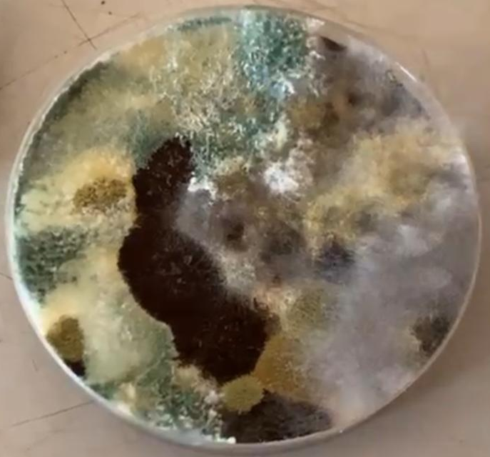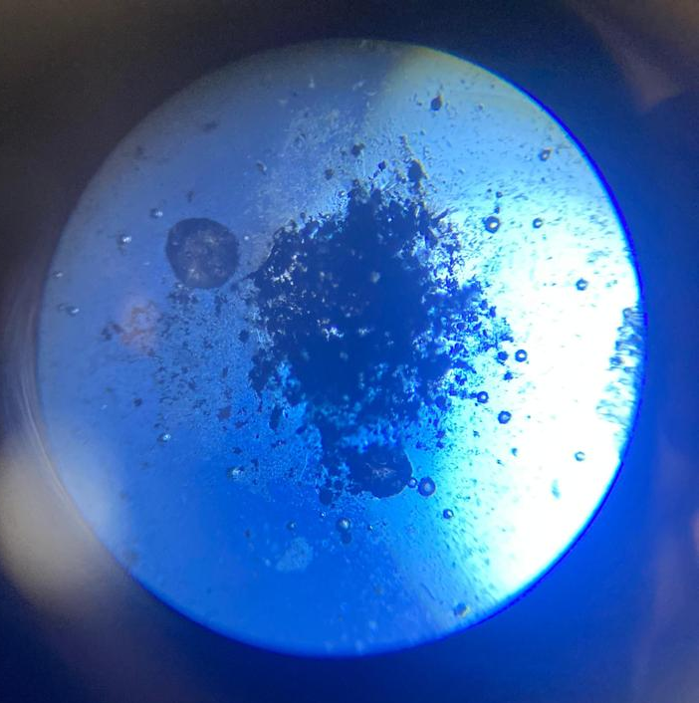

TABLE 2: Weekly Clinical Observations in Experimental Rats
RAT ID | GEN. APPEARANCE | BEHAVIOUR | LOCOMOTION | FEEDING | RESPIRATORY  SIGNS | EYES & NOSE
Black | Loose weight | Active | Sleeping | High | Normal | The eye is more red
Blue | Loose weight | Active
Green | Loose weight | Active
Red | Loose weight | Aggressive
Black | Loose weight | Active | Sleeping and calm | High | Normal | More red
Blue | Loose weight | Active
Green | Loose weight | Active
Red | Loose weight | More active
Black | Normal body lean | Active | Calm and sleeping | Feeding well | Normal | Eye point out
Blue | Normal body lean | Calm
Green | Normal body lean | Active
Red | Normal body lean | Calm but active
Black | Weight reduced | Energetic | Calm and active | High | Swelling stomach | Red eye
Blue
Green |  |  |  |  | Normal | Red eye
Red
Black | Muscle gain | Less active | Dull and calm | Normal | Normal | Dull eye
Blue
Green
Red
Black | Skinny body | Appear calm & dull | Sleeping & week | No feeding | Normal | Sharp but not clear eye
Blue | Skinny body | Appear calm & dull | Sleeping & week | Normal | Normal | Sharp but not clear eye
Green
Red
Key:
Black – 100%
Red – 80%
Green – 60%
Blue – 50%
Table 2: Post-Mortem Findings in Experimental Rats
Organ | Green (60%) | Red (80%) | Blue (50%) | Black (100%)
Intestine | Small, brown | Merged and intermixed | Small, brown | No pigmentation, blended
Liver | Brownish (vs control) | Dark | Light red | Very dark (vs control)
Kidney | Small, pale | Tiny, dark brown | Brown (vs control) | Dark, compact
Heart | Normal, slightly darker | Dark | Normal | Abnormal (vs control)
Lungs | Small, dark | Mini, pale | Dark pink | Swollen, unusually small
Blood | Dark | Pitch black, low volume | Black | Little to no blood
Key: vs = versus
Black – 100%
Red – 80%
Green – 60%
Blue – 50%

Fig.3
(a) (b)
Dissected Experimental Rat Dissected Experimental Rat (Control)
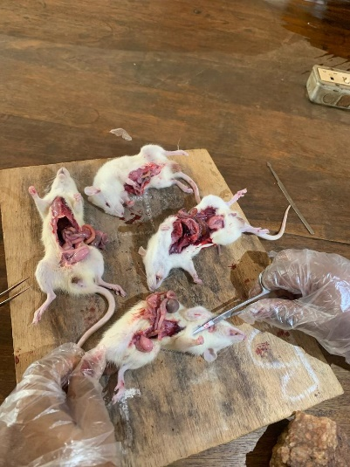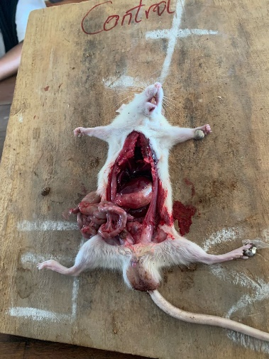

CHAPTER FOUR
4.0 DISCUSSION AND CONCLUSION
4.1 DISCUSSION
The characterization and identification of the fungal isolate observed on Potato Dextrose Agar (PDA) revealed morphological features consistent with Rhizopus stolonifer (Table 1). Macroscopically, the colonies exhibited a cottony, fluffy appearance with a white to grayish coloration, which became darker as the fungus matured. The presence of stolons horizontal hyphae connecting nodal points and rhizoids beneath the sporangiophores further supported the identification. Microscopically, non-septate hyphae and large spherical sporangia filled with sporangiospores were key diagnostic features. This morphology aligns with findings from earlier studies that described R. stolonifer as a fast-growing zygomycete with prominent aerial and submerged hyphae (Singh et al., 2021). Figures 1 and 2 visually confirm both the microscopic and cultural appearance of the isolate, supporting the identification.
The clinical observations from the experimental rats exposed to R. stolonifer revealed a range of physiological and behavioral responses that suggest systemic toxicity (Table 2). In particular, rats in the “Black” group (100% exposure) consistently showed signs of distress such as weight loss, calm or dull behavior, increased sleep duration, and red or dull eyes. These symptoms were less pronounced but still evident in the “Red” (80%) and “Green” (60%) groups, while the “Blue” (50%) group showed the least alterations. Locomotion and feeding behavior were impaired in higher-exposure groups, with some animals appearing weak, skinny, or inactive. Such behavioral changes are consistent with fungal toxicosis, especially from mycotoxins known to be produced by Rhizopus spp., which may affect metabolic and neurological functions (Jain & Agrawal, 2020).
The post-mortem examination reinforced the toxic effects of R. stolonifer exposure on internal organs (Table 2). The most severely affected group, “Black” (100%), exhibited notable pathology, including blended, depigmented intestines, very dark livers, compact dark kidneys, abnormal heart tissue, and swollen or unusually small lungs. The presence of little or no blood also suggests internal bleeding or circulatory compromise. In contrast, organs in the “Blue” (50%) and “Green” (60%) groups appeared closer to normal, although some discoloration and reduction in organ size were noted. The discoloration of the liver and kidneys is a typical marker of mycotoxin accumulation and damage, potentially implicating secondary metabolites like rhizoxin and furan compounds previously reported in Rhizopus species (Papp et al., 2020).
Figures 3a and 3b provide visual evidence of the pathological effects on dissected rats, highlighting the stark contrast between toxin-exposed and control specimens. In Figure 1a, swelling, discoloration, and abnormal tissue texture are evident in the experimental group, particularly affecting the gastrointestinal and hepatic structures. Conversely, the control rat in Figure 3b maintained normal organ coloration and morphology. These findings are in line with the histopathological alterations reported in rats exposed to fungal metabolites in previous toxicological studies (Oluwafemi et al., 2020).
The results indicate that Rhizopus stolonifer, while commonly known for food spoilage, possesses significant biological potency capable of inducing systemic toxicity in mammals. The extent of clinical symptoms and organ damage was dose-dependent, suggesting a threshold beyond which exposure becomes acutely harmful. These findings may have implications for food safety and environmental health, particularly in poorly stored or contaminated foodstuffs where Rhizopus species are prevalent.

4.2Conclusion
The findings from both clinical observation and post-mortem examination suggest that Rhizopus stolonifer produces a potent toxin with significant systemic toxicity in rats, especially at higher concentrations. The severity of both external symptoms and internal organ damage increased with toxin concentration. These results demonstrate the need for further biochemical and histopathological studies to characterize the toxin components and mechanisms of toxicity, especially regarding liver, kidney, and respiratory involvement. Proper handling and monitoring of food or environments contaminated with Rhizopus stolonifer are crucial to prevent potential mycotoxin exposure.

REFERENCES
Abdelhameed, S. M., & Khalifa, B. A. (2024). Mycobiota contaminating some market cake samples with reference to their toxin and enzyme. BMC microbiology, 24(1), 209.
Alamer, S. S., & Abdelkhalig, S. M. (2023). Inhibitory Effect of Natural Honey on The Growth of Rhizopus stolonifer, Mucor spp., and Aspergillus niger. SAR J Pathol Microbiol, 4(3), 30-34. Jain, A., & Agrawal, R. (2020). Fungal toxins and their adverse effects: A review. Journal of Mycology and Medical Mycology, 30(2), 78–84.
Department of Pharmacognosy, College of Pharmaceutical Sciences and Drug Manufacturing, Misr University for Science and Technology. (2024). Screening of pharmacological activities of Rhizopus stolonifer (black bread mold). Journal of Pharmaceutical Sciences and Drug Manufacturing, 1(2), 69–75. https://jpsdm.journals.ekb.eg/article_347758.htmljpsdm.journals.ekb.eg
Kępińska-Pacelik, J., & Biel, W. (2021). Alimentary risk of mycotoxins for humans and animals. Toxins, 13(11), 822. https://doi.org/10.3390/toxins13110822PMC
Li, L., Zhang, M., Sun, H. N., & Mu, T. H. (2021). Contribution of ultrasound and conventional hot water to the inactivation of Rhizopus stolonifer in sweet potato. Lwt, 148, 111797.
Liu, Q., Chen, Q., Liu, H., Du, Y., Jiao, W., Sun, F., & Fu, M. (2024). Rhizopus stolonifer and related control strategies in postharvest fruit: A review. Heliyon.
Mlikota Gabler, F., Mansour, M. F., Smilanick, J. L., & Mackey, B. E. (2004). Survival of spores of Rhizopus stolonifer, Aspergillus niger, Botrytis cinerea, and Alternaria alternata after exposure to ethanol solutions at various temperatures. Journal of Applied Microbiology, 96(6), 1354–1360. https://doi.org/10.1111/j.1365-2672.2004.02280.xEnvironmental Microbiology
Nešić, K., Habschied, K., & Mastanjević, K. (2021). Possibilities for the biological control of mycotoxins in food and feed. Toxins, 13(3), 198. https://doi.org/10.3390/toxins13030198NCBI
Oluwafemi, F., Adedayo, T., & Arinola, O. (2020). Toxicological effects of fungal metabolites in rodents: A histopathological and biochemical approach. African Journal of Biomedical Research, 23(4), 339–345.
Papp, T., Vágvölgyi, C., & Kredics, L. (2020). Rhizopus species as opportunistic human pathogens. Medical Mycology Journal, 61(3), 112–120.
Singh, R., Sharma, P., & Kumar, N. (2021). Morphological and molecular identification of fungal isolates from spoiled food: Emphasis on Rhizopus stolonifer. International Journal of Microbiology Research, 13(1), 12–19.
Toigo, S. E. M., Fernandes, C. C., & Miranda, M. L. D. (2022). Promising antifungal activity of two varieties of Capsicum chinense against Sclerotinia sclerotiorum, Rhizopus stolonifer and Colletotrichum goleosporoides. Food Science and Technology, 42, e52722.
Udoudoakpan, I. F., & Effiong, B. N. (2024). Accessing the Antimicrobial Potency of Piper guineense (ODUSA) Seed Extracts on Bread Spoilage Organisms. Research Journal of Food Science and Quality Control (RJFSQC) E-ISSN, 2756, 5483.
Wang, K., Li, C., Cao, S., Lei, C., Ji, N., Zou, Y., ... & Gao, H. (2025). VOZ‐dependent priming of salicylic acid‐dependent defense against Rhizopus stolonifer by β‐aminobutyric acid requires the TCP protein TCP2 in peach fruit. The Plant Journal, 121(1), e17176.
Zimmermann, J. L., Carlton, W. W., & Tuite, J. (1978). Mycotoxicosis produced in rats by cultural products of an isolate of Aspergillus ochraceus. Food and Cosmetics Toxicology, 16(5), 449–461. https://doi.org/10.1016/S0015-6264(78)80303-4PMC

