GEOTECHNICAL PROPERTIES OF LATERITE WITHIN KWARA STATE POLYTECHNIC CAMPUS

BY:

Mariam Konyinsola ATANDA
ND/23/MPE/FT/0003

BEING A RESEACH PROJECT SUBMITTED TO THE DEPARTMENT OF MINERAL AND PETROLEUM RESOURCES ENGINEERING, INSTITUTE OF TECHNOLOGY, KWARA STATE POLYTECHNIC, ILORIN.

IN PARTIAL FULFILLMENT OF THE REQUIREMENT FOR THE AWARD OF NATIONAL DIPLOMA (ND) IN MINERAL AND PETROLEUM RESOURCES ENGINEERING.

AUGUST, 2025.

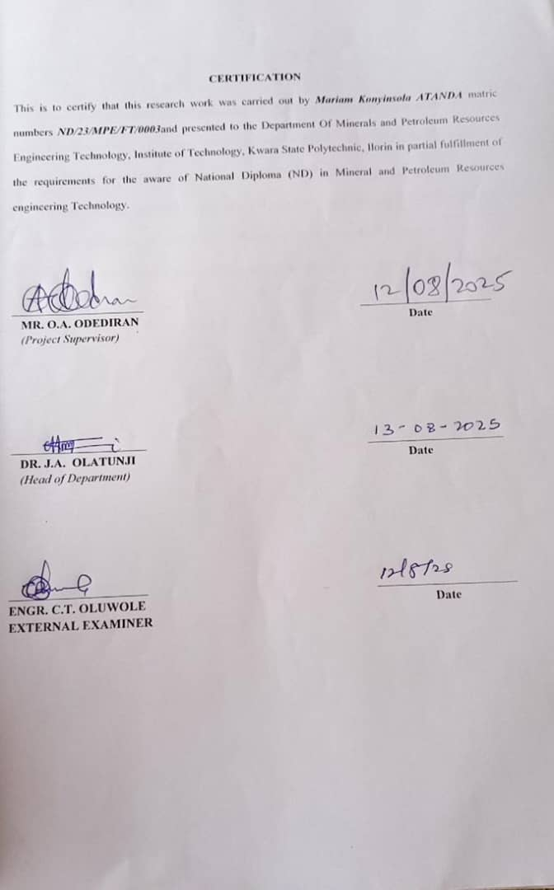

DEDICATION
This project work is dedicated to Almighty Allah for the gift of knowledge, wisdom, protection, guidance, blessing and strength have seen me through the course of my studies and successful completion of this work.
Also to my wonderful and adorable parents and family for their constant support, encouragement, and prayers throughout my academic journey.
To all my friends and colleagues who have been part of this academic experience, I say thank you.

ACKNOWLEDGEMENTS
First and foremost, I give thanks to the almighty God for granting me the strength, knowledge, and perseverance to successfully complete this project.
Moreso, my sincere appreciation goes to my supervisor, Mr.Odediran. O.A,for his guidance, mentorship, and invaluable insights throughout the entire duration of this project.
My gratitude also goes to the entire staff of the department of Mineral and Petroleum Engineering, Kwara State Polytechnic, for their academic support and for creating an enabling environment for leaning and research.
I would like to express my heartfelt appreciation to my family and friends for their unwavering support, prayers, and encouragement throughout the course of this project.
Lastly, I extend my thanks to all those who contributed, directly or indirectly, to the completion of this research work. Your contributions are deeply appreciated.

ABSTRACT
This project deals specifically with Geotechnical properties of Lateritic soils from selected locations within the campus of Kwara State Polytechnic.
Different tests were carried out to determine the engineering properties of the soil samples according to British and ASTM Standards.
Properties tested for include, atterberg limit(liquid and plastic limits), compaction parameters, grain size, natural moisture and specific gravity.The result of this research shows a liquid limit range from 22.3% to 31.6%, plastic limit range from 14.6% to 18.2%, plasticity index range from 6.9 to 13.4%, linear shrinkage range from 3.7% to 6.2%, natural moisture content range from 4,1% to 5.2%,dry density range from 1.58 g/cm³ to 1.69 g/cm^{3,} bulk density range from 1.63 g/cm³ to 1.76 g/cm³ optimum moisture content range from 6% to 8% while maximum dry density range from 1.81% to 1.95%. From the analyses of the results of tests sample C seems most suitable for construction purposes while others may be improved.

TABLE OF CONTENTS
Title Page i
Certification ii
Dedication iii
Acknowledgments iv
Abstract v
Table of Contents vi
List of Tables viii
List of Figure ix

CHAPTER ONE:
1.0 Introduction 1
1.1 Location and accessibility 1
1.2 Climate and Vegetation 1-2
1.3 Relief and Drainage 2
1.4 Aims and Objectives 3
1.5 Statement of the Problems 3
1.6 Justification 3-4
1.7 Scope and Limitation 4
CHAPTER TWO:
2.0 LITERATURE REVIEW 6
2.1 Overview of Laterite 6
2.2 Formation and Occurrence of Laterite 7
2.3 Rigional Distribution of Laterite 8
2.4 Characteristic of Laterite 8-9
2.5 Atterberg Limits 9-10
2.6 Compaction 10-11
2.6 Sieve Analysis 12
CHAPTER THREE:
3.0 RESEARCH METHODOLOGY 13
3.1 Collection of Sample 13-14
3.2 Preparation of Disturbed Samples 14-15
3.3 Laboratory of Procedures 15
3.4 Grain Size Distribution Test 15-16
3.5 Atterberg Limit Tests 16
3.6 Compaction Test 16
3.7 Moisture Content Test 16
3.8 Specific Gravity Test 17
3.9 Bulk Density Test 17
CHAPTER FOUR:
4.0 Results and Discussion 18
4.1 Results of Moisture ContentTests 18
4.2 Results of Bulk Density Tests 19
4.3 Results of Dry Density Tests 19
4.4 Results of Specific Gravity Tests 20
4.5 Results of Atterberg limits Tests 20-21
4.6 Results of Grain size analyses 22
4.7 Results of compaction Tests 23-24
CHAPTER FIVE:
5.0 Conclusion and Recommendations
5.1 Conclusion 26
5.2 Recommendations 26
References 27-28

LIST OF TABLES
Table 1: Details of sample location. 13
Table2: Natural Moisture Content Test of Collected Samples 18
Table 3: Bulk Density of Collected Samples. 19
Table 4: Dry Density Test of collected samples 19
Table 5: Specific gravity test of collected samples 20
Table 6: Atterberg Limit Tests of collected samples 21
Table 7: Summary of result of Grain Size Analysis of soil 22
Table 8: Compaction Parameters of Maximum Dry Density
(MDD) and Optimum Moisture Content (OMC) 23
Table 9: Compaction and Ratings of Unified Soil
Classification for Construction (ASTM 1557-91) 24

LIST OF FIGURE
Fig.1: Graph Showing Water Content 18
Fig 2: Graph Showing Plasticity Chart 21
Fig. 3: Grain Size Analysis Graph 22
Fig. 4: Graph Showing Compaction Parameters 23

CHAPTER ONE
1.0 Introduction
1.1 Location and Accessibility
The study was carried out within the Kwara state polytechnic campus located in Ilorin, the capital city of Kwara state, Nigeria the polytechnic is situated in south western part of Ilorin and occupies a large land area that include both developed and undeveloped zones such as classrooms, administrative buildings, networks and open fields.
Kwara state polytechnic lies approximately between latitude 8.4790°N and longitude 4.5418°E and it is easily accessible through various entry points within Ilorin metropolis.
The accessibility of the study area made it possible to transport equipment and personal and from different sampling point internal road networks and foot paths allowed easy movement access the campus. Which facilitate smooth soil sample collection without restrictions the location was also considered ideal due to the presence of undisturbed natural lateritic soil at various spots within the campus especially in less developed areas.
1.2 Climateand Vegetation
The climate of Ilorin where kwara state polytechnic is located experience a tropical wet and dry climate with distinct rainy and dry seasons. The rainy season typically lasts from april to October while the dry season spans from November to march. Average annual rainfall is between 1,200mm and 1,500mm, and temperatures range from 22°octo35°c. (Nimet, 2003)
The vegetation in the kwara state polytechnic area falls withins the guinea savannah zone, characterized by a mix of grassland and scattered trees such as locust bean, shea butter, and baobab. This savannah vegetation support seasonal farming and influences soil development and erosion patterns (Areola, 1982).
1.3 Relief and Drainage
The relief of kwara state polytechnic campus is generally undulating, ranging from gently sloping to moderately steep terrains. This variation in elevation encourages surface runoff and reduces water logging, which helps to minimize erosion in many parts of the study area (areola, 1982).
The drainage system in this area is mainy natural, with rainwater flowing through semi-developed channels and shallow depressions, especially during the rainy season in some parts of the campus, manmade drains have been constructed to improve surface water flow and prevent erosion these drainage and relief condition significantly influence the moisture content and overall performance of the lateritic soil found in this area (Ofomata, 1975).

1.4 Aims and Objectives
The aim of this project is to investigate the geotechnical properties of lateritic soil within the kwara state polytechnic campus.
Objectives are as stated below:
(i). to determine soil moisture content such as, atterberg limits, grain size distribution, compaction parameters and califonia bearing ratio (CBR)
(ii). to analyze the test results and assess the engineering properties of soil
(iii). to evaluate the suitability of the lateritic soil for use in construction projects within the campus
1.5 Statement of The Problems
Laterite is the most common soil found within kwara state polytechnic: ditto in tropical areas it is often used in construction project like road and foundations, however there is not enough detailed information about its geotechnical properties in this specific area this lack of proper understanding can lead to poor construction outcomes such as crucks settlements or even failure of structures in order to avoid those problems, it’s important. To study the soil and understand how suitable it is for construction work on campus.
1.6 Justification
Understanding the geotechnical properties of lateritic within the kwara state polytechnic campus is important because this soil is widely used for construction in the area without proper testing using laterite can lead to weak foundations road failures or other structural issues. By studying it’s properties, engineers and builders can make better decision reduce risk, and ensure safer, more durable construction this project will also add useful data that can be refereed in two future development within the campus and nearby areas.
1.7 Scope and Limitation
The study focuses on investigating the geotechnical properties of laterite within selected locations on kwara state polytechnic campus . the research covers soil sampling laboratory testing and analysis of parameter such as moisture content, atterberg limits particles size distribution permeability compaction characteristic and sheer strength the aim is to determine the suitability of laterite in the area for various construction purpose, particularly for road works and foundation design
The study limited to laterite sample collected only within the kwara state polytechnic campus which may not fully represent laterite behaviour in surrounding regions.

CHAPTER TWO
2.0 Literature Review
2.1 Overviewof Literite
Laterite is a reddish, iron and aluminium-rich soil commonly found in tropical and subtropical regions. It typically forms through intense weathering of parent rock such as granite, basalt, and gnesis under hot, humid climate condition during this process,. Soluble, silica is leached out while insoluble iron and aluminium oxide is accumulates, giving laterite it’s distinct color and engeering properties. (Gidigasu, 1976, Madu & Akpokodje, 2011)
Laterite soil are prevalent across Nigeria especially in the south western region including kwara state their abundance how cost, and work ability make them visibly used for road construction, foundation fill and other geotechnical applications (osinubi & eberemu, 2006, ola 1983).
In addition to engineering relevance, the physical and chemical behaviour of laterite depends on its formation environment mineralogy and degree of weathering (bell, 1993). This properties influence its lead bearing capacity, permeability and suitability for soil stabilization techniques.

2.2 Formation and Occurrence of Laterite
Parent rock weathering process begins with the break down of silicae mineral in the parent rock overtime mineral like feldspar, quartz, and mica cro weathered into clay minerals, oxides and hydro oxide of aluminum and iron (Bhat, 2008)
Leaching the heavy rainful in tropical regions leads to hearing which removes soluble elements like potassium, calcium and magnesium this process leaves behind iron and aluminium, which eventually form oxides (Duchaufaur, 2006).
Iron and aluminium accumulation as leaching content, iron and aluminium accumulation in the soil the iron gives laterite its characteristics red or reddish brown colour (Bhat, 2008)
Clay and iron cementation over time the clay minerals and iron oxides cement together, forming a hard compact layer known as “lateritic” soil or rock (Raj & kukkadapo, 2004).
Maturation in regions with onstent weathering conditions laterite layers mature and become increasingly hard and durable often forming a rock like structure (torrence, 2002).
Laterite is primarily found in tropical and subtropical regions, where high temperature and abundant rainfall facilitate intense weathering common regions include.
The amazon in south American, west and central Africa (e.g nigeria, gana and the congo), india and south east asia (e.g india Indonesia, and the philppines) northern Australia (bhat, 2008).
2.3 Regional Distributionof Laterite
Laterite soil are widely distributed in tropical and subtropical region at the world especially in areas where high temperatures and heavy rainfall promote intense chemical weathering of rocks (duchaufaur, 2006). Countries such as india, brazil, Ghana and nigeria have large deposits of laterite soil (torrence, 2002).
In Nigeria, lateritic soils are extensively found across the southern, western and middle belt regions they occur in state like oyo, osun, ogun, ondo, ekiti, kwara, kogi and part of the federal capital territory. These region experience alternating wet and dry season which favour the chemical wethering process responble for laterite formation (Raj & kukudupu, 2004).
The distribution and abundance of laterite in those region make it a commonly used material for construction activities such as road works foundation filling and land scaping, it’s properties, however, very significance depending on the degree of weathering parent rock and local drainage conditions this variation under scores the importance of site specific studies in determining the sutability of lateritic soil for engineering applications.
2.4 Characteristicsof Laterite
Laterite is a soil type formed under conditions of high rainfall and temperature, which causes intense leaching and weathering of rocks it is typically red or brown in color due to the presence of iron oxides the soil is reach in iron and aluminium but poor in essential knutrients and silica. (paton, et, al, 1995).
Laterite soil are known for their porus nature low fertility and variable texture ranging from gravelly to clayey forms when moist laterite may be soft and workable but it becomes hard and compact upon exposure to air. This harding make it usefull for construction purposes, especially in rural areas where it is often used for road bases and building materials (terdy. 1997).
The bearing capacity and strength of laterite depends on factors like depth, weathering stage and moisture content in engineering it is valued when stabilized but untreated laterite may lose strength during the rainy season due to its moisture sensitivity (balasub namaniam & bergado 2004).
2.5 Atterberg Limits
These are basic measures of the critical water contents of the grained soils these limits define the boundaries between different state of consistency solid, semi solid plastic and liquid (craig, 2004).
Liquid Limit (LL): This is the water content at which the soil change from a plastic to a liquid state it is determined using either the casa grand cup method or the cone penetromotr method (ASTEM D 4815) at this limit, the soil begins to under its own weight (Das, 20016).
Plastic Limit (PL): These limit is the water content at which soil changes from a semi solid to a plastic state it is measured by rolling the soil into threads until they crumble at a diameter of about 3mm (budhu, 2011).
Shrinkage Limit (SL): The shrinkgo limit is the water content at which futher loss of moisture does not cause a decrease in the soil volume (craig 2004) this represents the transition from a semi soid to a solid state.
An important index measures the range of moistro contents over which the soil remains plastic a high PL indicates higher clay content and more plasticity
PI = LL – Pl
In the study of lateritic soil within kwara state polytechnic campus the atterberg limits are essential in understanding the soils plasticity workability and behaviour under varying moisture conditions this result help engineering determine if the soil is suitable for use in foundation embarkment and road construction
2.6 Compaction
This is the process of mechanically increasing the density of soil by reducing the amount of air between soil lkparticles it is a very important method used in contruction to improve the strength stability and load bearing capacity of soils proper compaction help to minimize settlement redue water seepage, and prevent soil erosion for lateritic soil found in kwara state polytechnic campus.
Compaction is essential because it improves. The engineering properties making them more suitable for construction purposes like road bases foundation and embankments (Algbodion, 1991).

Factors affecting soil compaction
- Moisture Content:
The amount of water present in the soil significantly influences how easily the particles can rearrange themselves during compaction there is an optimum moisture content at which maximum dry density is achieved (craig, 2004).
- Compactive Effort:
The type and amount of energy applied (e.g, rammer rollers, number of passes) affect the degree of compaction (Bowles, 1996).
- Soil Type:
Lateritic soils with a mix of fine and coarse particles tend to compact better than soils that are either too sandy or too clayey (Ola, 1983).
The compaction characteristic of soils are especially determined through laboratory tests such as.
- Standard proctor test
- Modified proctor test
These test help in finding the optimum moisture content (omc) and the maximum dry density (MDD) of the soil (Das, 2010)
Lateritic soil within kwara state polytechnic campus typically shows good compaction behaviour when worked at or near its optimum moisture content, making them useful for various engineering projects on the campus (Ajayi & oke, 2014).
2.7 Sieve Analyses
In classifying soil types based on the proportion of different grain size levels (such as gravel, sand, silt, and clay) sieve analysis is a crucial test. Understanding the particles size distribution is important because it affects soil strength compaction potential, permeability and general engineering behaviour (Das, 2010: craig, 2004).
The process involves passing a dry soil sample through a series of sieves of different mesh sizes. The amount of soil retained on each sieves is weighed and recorded.
A graph, known as a gradation curve is usually plotted to show the distribution of particle size (ASTM, 2009, Bsi, 1990). S
In geological studies, soils are often classified as: well graded soils: soil that have a good mix of different particle sizes
Poorly graded soils: soils that consist mostly of particle of the same size.
For the lateritic soil found within kwara state polytechnic campus, sieve analysis helps determine whether the soil is predominantly sandy, gravelly or contains finer material this information is important when deciding the soil can be used for construction works like road bases for construction workd like road bases, embarkments or as subgrade materials (Ola, 1983, ajayi & oko 2014).
Sieve analysis is often combined with hydromotor analysis if the soil contains significant fine particles (silts and clays) that pass through the smallest sieve sizes (Holtz et, al, 2011).
CHAPTER THREE
3.0 Research Methodology
3.1 Collection of Sample
The collection of soil sample was carried out systematically to ensure that representative sample of lateritic within the kwara state polytechnic campus were obtained a total of (insert numbers) sampling points were selected based on accebility, visible laterite exposure, and variation in topography. At each location, both disturbed and undisturbed soil sample were collected.The details of the sample location are presented in Table 1:
Table 1:Details of sample location.
S/N | Location | Latitude | Longitude | Elevation | Depth
 | P1 | N 08^{0.}33.426¹ | E 004⁰.37.882¹ | 336m | 0.50m
 | P2 | N O8⁰.33.428¹ | E 004⁰.37882¹ | 309m | 0.75m
 | P3 | N O8⁰.33.430¹ | E 004⁰.37882¹ | 309m | 0.79m

Disturbed samples these were obtained by digging to a depth of about (0 to 1.5 meters using a hand auger and shovel. The disturbed samples were placed in polythene bags labeled with location, depth, and date, and secured to prevent loss of moisture.
Undisturbed samples for tests requiring natural soil structure (e.g compaction and C.B.R tests) undisturbed sample were extracted using a core cutter method the core sample were carefully removed to avoid disturbance and placed in aluminium containers, covered, and labeled appropriately.
All procedures followed the guideline of BS 5930:2015 code of practice for site investigation and ASTM D422-63 (2007)
3.2 Preparationof Distributed Samples
The disturbed soil samples collected from various locations within the kwara state polytechnic campus were carefully prepared in the geotechnical laboratory for testing. The preparation process involved the following steps.
Air Drying: the disturbed samples were first spread on a clean flat surface and allowed to air dry at room temper nature. This helped reduce excess moisture content without altering the soils natural properties.
Breaking down dumps: after dying, the samples were gently crushed using a wooden mallet to break down large lumps core was take to avoid crusing individual soil particles
Removal of debris: organic matter, roots, stones and other foreign materials were manually removed from the soil samples to ensure purity and consistency during testing.
Sieving: the dried and cleaned soil was passed through a 4.75 mm sieve to obtain the portion required for fine grained soil tests the sieved soil was stored in airtight containers
Labeling and storage: each prepared sample sample was placed in a clean dry container labeled for collection the samples were then stored in a cool dry place to maintain their condition before laboratory to sting
3.3 Laboratory Procedures
The laboratory test were conducted to determine the geotechnical properties of lateritic soil samples collection from selected locations within the kwara state polytechnic campus all procedures were carried out in accordance with the british standard (BS 1377, 1990) for soil testing.
The test include.
Natural moisture content
Sieve analysis (grain size distribution)
Atterberg limits
Specific gravity
Compaction test
Califonia bearing ratio

3.4 Grain Size DistributionTest
This test determined the particle size distribution of soil the air dried soil was passed through a stack of sieves arranged in decreasing sizes the percentage retained on each sieve was recorded to classify the soil. BS 1377-2:1990, clause 9.2 ASTM D4 22-63 (reapproved 2007).
3.5 Atterberg Limit Test
This include:
Liquid limit (LL) measured using the Basa grande apparatus
Plastic limit (PL) determined by roving soil thread until they crumple
Plasticity index (PL) calculated as Pl = LL – PL
These values help assess soil consistency and behaviour under varying moisture conditions Bs 1377 – 2: 1990, clause 4.3; ASTM D4 318 – 17
3.6 Compaction Test (Standard Proctor Test)
This test was used to determine the maximum dry density (MDD) and optimum moisture content (OMC). The soil was compacted in layers in a mold and weighed the process was repeated for different moisture level to draw a compaction curve. BS 1377 – 4:1990, clause 3.3; ASTM D698 -12e2
3.7 Moisture Content Test
This test was conducted to determine the amount of water present in the soil at the time of collection the soil sample was weighed over dried at 105°c - 110°c for 24 hours and weighed again the difference was used to calculate the moisture content using.
Moisture content (%) = W_{wet} – W_{dry}x 100
W_{dry}
3.8 Specific Gravity Test
The test determined the ratio of density of soil solids to the density of water using a pycnometer it gives insight into the mineral content and composition of the soil. BS 1377 – 2:1990, clause 6.3 ASTM D85414
3.9 Bulk Density Test
The bulk density test was carried out to determine the mass of soil per unit volume including the pore space. This property is important for understanding the weight bearing capacity and compaction characteristics of the soil
The procedure involve folling a cylindrical motal container to known volume with soil either in its natural state or compacted condition the soil was carefully labeled and the container with soil was weighed
The bulk density was calculated using the formula
Bulk Density = mass of soil (g)
Volume of container (cm³)
Bulk density is usually expressed in g/cm³ or kn/m³ it provides useful information for extimating compaction and converting between weight and volume in soil engineering application.

CHAPTER FOUR
4.0 Results and Discussion
4.1 Results of Natural Moisture Content
The results of natural moisture content test are presented in table 2. the moisture content value range between 4.2% and 5.3%, indicating that the soil are relatively dry. According to Ola (1993), typical moisture content for lateritic soils range between 5% and 20% depending on the season and drainage condition. Therefore the sample fall within the lower end of the standard range implying well drained and stable conditions.

Table2: Natural Moisture Content Test of Collected Samples
Sample A | Sample B | Sample C
5.2% | 4.3% | 4.1%

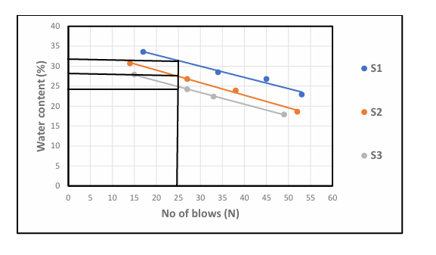
Fig.1: graph showing water content

4.2 results of bulk Density Test
The result of Bulk Density Test are presented in Table3. the bulk density values range from 1.63 to 1.76g/cm³ Murthy (2002) stated that bulk densities for compacted lateritic soils usually range from 1.6 to 2.0g/cm³. hence, the values obtained are within the acceptable range, with sample C showing the highest density , indicating better compaction and higher strength.
Table 3: Bulk Density of Collected Samples.
Sample A | Sample B | Sample C
1.63 | 1.73 | 1.76

4.3 Results of Dry Density Test
Two results of Dry Density value (1.58 - 1.69g/cm³) are also within the expected range for Engineering fill materials. According to Das (2010) dry densities for lateritic soils typically range from 1.5 to 2.0g/cm3, indicating that the test ad soils can offer adequate bearing capacity when properly compacted.
Table 4: Dry Density Test of collected samples
Sample A | Sample B | Sample C
1.58g/cm³ | 1.67g/cm³ | 1.69g/cm³

4.4 Result of Specific Gravity Tests
The specific gravity result are presented in table 5 specific gravity value ranged from 2.68 to 2.83 according to Das (2010), the typical specific gravity of lateritic soil falls between 2.60 and 2.85 which confirm that the soil predominantly mineral based with minimum organic contamination.
Table 5: Specific gravity test of collected samples
Sample A | Sample B | Sample C
2.68g/cm³ | 2.71g/cm³ | 2.83g/cm³

4.5 Results of Atterberg Limit Tests
Liquid Limit (LL): ranges from 22.3 % to 31.6% According to Das (2010), soil with liquid limit value less than 35% are classified as low plasticity soils. All the three samples fall within this categories, indicating low compresibility and moderate workability.

Plastic Limit (PL): value range from 14.6% to 18.2%, which is also consistent with the range expected for lateritic soil.

Plasticity Index (PI): value, calculated as the difference between LL am PL range from 6.9% to 13.4% Ola (1983) noted that lateritic soil generally have pl value ranging from 5% to 20% depending on the degree of weathering. Hence the PL values obtained fall within the expected range, indicating moderate plasticity with Sample A being more plastic than Sample B and Sample C.
Linear Shrinkage (LS): values range from 3.7% to 6.2% According to Adeyemi (1995), values below 10% suggest that the soils has low shrinks well potential, which is desirable for most construction purpose. Sample C has the lowest shrinkage value, suggesting it will be the most suitable under moisture variation

Table 6: Atterberg Limit Tests of collected samples
Sample | Liquid Limit % | Plastic Limit % | Plastic index | Linear Shrinkage %
Sample A | 31.6 % | 18.2% | 13.4% | 6.2%
Sample B | 22.3% | 15.4% | 6.9% | 4.8%
Sample C | 24.8% | 14.6% | 10.2% | 3.7%

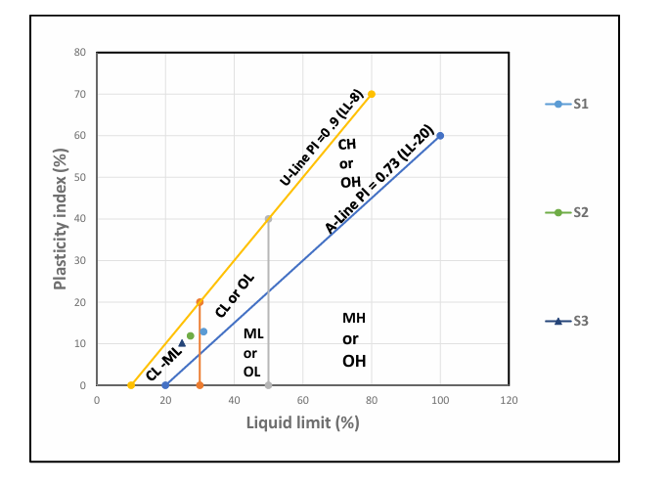
Fig 2: Graph Showing Plasticity Chart

4.6 Result of Grain Size Analysis
P1 has higher clay content (21%) hence classified has clayey sand
P2 and P3 have more silt and less clay, Thus, silty sand all sample have sand and dominant particle size making them sand based soils.
fine (<0.075mm) is highest in P1, which support it’s clayey nature.

Table 7: Summary of result of Grain Size Analysis of soil
Sample Location | Gravel (%) | Sand (%) | Silt (%) | Clay (%) | Fine (%) | Soil classification
P1 | 10 | 60 | 9 | 21 | 30 | Clayey sand
P2 | 12 | 62 | 15 | 11 | 20 | Silty sand
P3 | 13 | 63 | 17 | 7 | 24 | Silty sand

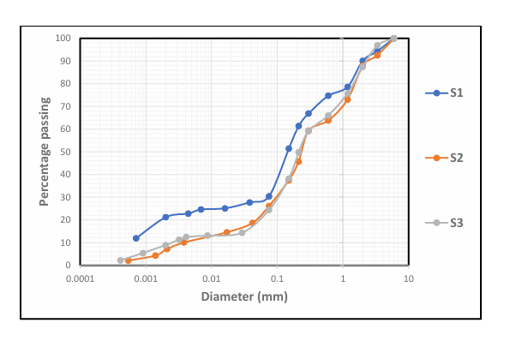
Fig. 3: Grain Size Analysis Graph
4.7 Result of Compaction Test
Table 8: Compaction Parameters of Maximum Dry Density (MDD) and Optimum Moisture Content (OMC)
Sample | MDD | OMC
A | 1.81 | 8
B | 1.89 | 7.5
C | 1.95 | 6

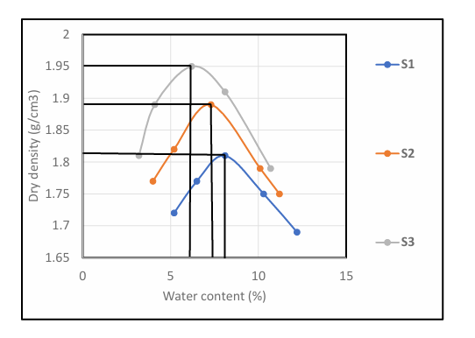
Fig. 4: Graph Showing Compaction Parameters
Table 9: Compaction and Ratings of Unified Soil Classification for Construction (ASTM 1557-91)
Visual Description | Maximum Dry Density (MDD)(g/cm³) | Optimum Moisture Content (OMC)(g/cm³) | Aticipated embankment performance | Value as Subgrade material | Value as Base Course
Granular material | 2.00 - 2.27 | 7 – 15 | Good to Excellent | Excellent | Good
Granular material with soil | 1.76 - 2.16 | 9 – 18 | Fair to Excellent | Good | Fair to Poor
Fine sand and sand | 1.76 - 1.84 | 9 – 15 | Fair to Good | Good to Fair | Poor
Sandy silts and silts | 1.36 -1.60 | 10 – 20 | Poor to Good | Fair to Poor | Not suitable
Elastic silts and clay | 1.36 - 1.60 | 20 -35 | Unsatisfactory | Poor | Not suitable
Silty clay | 1.52 - 1.92 | 10 – 30 | Poor to Good | Fair to Poor | Not suitable

Table 9: present the compaction parameters of collected samples. The (MDD) Maximum Dry Density for sample A is 1.81 for sample B 1.89 while sample C is 1.95. for Optimum Moisture Content (OMC), sample A is 8, Sample B is 7.5 sample C is 6. The three sample being sandy in nature can be range as range fair to good for embankment performance it is fair to poor for subgrade material are not suitable for base course.

CHAPTER FIVE
5.0 Conclusion and Recommendation
5.1 Conclusion

The geotechnical investigation of laterite within Kwara State Polytechnic campus revealed that the sampled soils possess engineering properties suitable for various civil engineering applications, especially as subgrade and fill materials. Laboratory tests such as particle size analysis, Atterberg limits, compaction indicated that the laterite falls within the acceptable range for road construction and foundation works under moderate loading conditions.
The results also show that the laterite exhibits good shear strength, moderate plasticity, and favorable compaction characteristics, making it a dependable material for use in local construction project.

5.2 Recommendation
In the view of the occurance rampant failure in public civil structures, the suitability of fill materials (which is mostly laterite in Nigeria) must be ascertained before use.
Also the improvement of samples other than Sample C should be considered. This should be done by the addition of locally available materials e.g limestone.

REFERENCES
Adeyemi, G. O. (1995). Influence of parent rocks on some engineering index properties
of residual soils in southwestern Nigeria. Bulletin of the International Association of Engineering Geology, 52(1), 3-10.
Aigbodion, J. O. (1991) lateritics soil and their stabilization for road construction.
Nigeria Journal of construction technology
Arora, K. R. (2003) – Soil Mechanicals and Foundation Engineering. Standard
Publishers Distributors, New Delhi.
Araola, O (1982) soil and vegetation patterns in Nigeria Ibadan University press.
ASTM D4318 (2018) Standard Test Method for liquid limit, plastic limit, plasticity
index of soil.
ASTM1377-4(1990)- Method of Test for Civil Engineering Purpose - Part 4:
Compaction Related Test, British Standard Institution, London .
ASTM D4318-17- Standard Test Method for Liquid Limit, Plastic Limit and Plasticity
Index of Soils. ASTM International
ASTM D422-63 (2007)- Standard Test Method for Particle Size Analysis of Soil.
ASTM International
ASTM,( 2009). ASTM D6913 Standard Test Method for Particles Size
Distribution(Gradation) of Soils Using Sieve Analysis. ASTM Standard.
Balasubramaniam, A. S., & Bergado, D. t. (2004). Strength and deformation
charateritics of tropical soils. Asian Journal of civil engineering, 5(2), 101-118.
Bowles, J. E. (1996). Foundation analysis and design 5th edition, McGraw-Hill.
BSI(1990). BS 1377-2:Method of Soil for Civil Engineering Purpose- Part 2:
Classification Test. British Standards Institution.
Budhu, M. (2011). Soil Mechanics and foundation (3rd edition). Wiley.
Craig, R. F. (2004) Soil mechanics (7th edition) spoon press.
Das, B. M. (2010) Principle of geotechnical engineering (7th edition) cengage learning
Das, B. M. (2016) Principle of geotechnical engineering (9th edition) cengage learning
Gidasu M. D. (1976) laterite soil Enginering pedogenesis and Engineering principle,
scientific publishing.
Humphruys, B. S. and Mitchell, P. B. (1995) soils: A new global view. UCL Press.
Kukadapu, R. K & Raji A. Y. (2004) Chemical weathering and formation of lateritics
soil. Journal of tropical soil. 10 (2), 123-130
Murthy, V. N. S. (2002). GeotechnicL ENGINEERING: Principles and practices of soil
mechanics and foundation engineering. Marcel Dekker.
Ofomata G. E. K (1975) Nigeria in maps Eastern State Ethics Publishing House.
Ola, S. A. (1983) Geotechnical properties and behavior of some Nigeria lateritic soil.
Quarterly journal of engineering geology, 16 (2), 145-160.Paton, T. R,
Osinubi, K. J. and Eberemu A. O. (2006) stabilization of lateritic soil with element and
lime for engineering use. Nigeria journal and environmental research.
Tardy, Y. (1997). Petrology of laterites and tropical soils. Balkema.

