DESIGN AND IMPLEMENTATION OF AN ONLINE GOOD ORDERING SYSTEM AND DELIVERY SYSTEM USING GENETICS ALGORITHM

( A CASE STUDYOF GIG LOGISTIC)

BY

ADEBAYO BLESSING ISACC
HND/23/COM/FT/0041

A PROJECT SUBMITTED TO
THE DEPARTMENT OF COMPUTER SCIENCE,
INSTITUTE OF INFORMATION AND COMMUNICATION TECHNOLOGY

KWARA STATE POLYTECHNIC, ILORIN.
IN PARTIAL FULFILLMENT OF THE REQUIREMENTS FOR THE AWARD OF HIGHER NATIONAL DIPLOMA (HND) IN
COMPUTER SCIENCE

JUNE, 2025.

CERTIFICATION
This is to certify that this project work is carried out and it has been read and approved as meeting the requirements for the award of Higher National Diploma in the Department of Compute Science, Institute of Information and Communication Technology (IICT), Kwara State Polytechnic Ilorin, Kwara State.

…………………………………. ….………………………
MR. ABIODUN E.T. Date
Project Supervisor

…………………………………. ….………………………
MR. OYEDEPO F.S Date
Head of Department

…………………………………. ….………………………
External Examiner Date

DEDICATION
I dedicate this project work to Almighty God who inspired me and directed my ways during my academic stay in the polytechnic.

.

ACKNOWLEDGEMENT
I give thanks to Almighty God for granting me success for the completion of my programme.
My utmost appreciation goes to my able supervisor Mr. Abiodun E.T. for his fatherly support and his moral advice throughout this project. My profound appreciation goes to the Head of Department (H.O.D) Mr Oyedepo. for his fatherly support and also my gratitude goes to other lecturers Mr. Sidiq, Dr Agboola, Mr. Raji, Mr. Muritala, Mrs. Akanbi, Mrs. Olusi, and all the staff of the Computer Science Department both teaching and non-teaching staff.
My sincere gratitude also goes to my beloved parents for their moral and financial support throughout this project. I say a big thank you and may God bless you abundantly (Amen).

LIST OF FIGURES
Figure 4.1: Index Page Output Design 12
Figure 4.2: Members Table Page 13
Figure 4.3: List of Product Page 14
Figure 4.4: List Of Product Table 14
Figure 4.5: Order Table 14
Figure 4.6: User Table 15
Figure 4.7: Messages Table 15
Figure 4.8: Admin Login Page 15
Figure 4.9: Add Product Page 16
Figure 4.10: Add User Page 16
Figure 4.11: Customer Login 17
Figure 4.7: Customer Signup Page 17

LIST OF TABLES
Table 4.1: User Table 18
Table 4.2: Product Table 18
Table 4.3: Order Table 18

TABLE OF CONTENTS
Title page………………………………………………………………………….....i
Certification………………………………………………………………………....ii
Dedication…………………………………………………………………………...iii
Acknowledgement…………………………………………………………………..iv
Table of contents……………………………………………………………............v
List of Tables (if any)……………………………………………………………….vi
List of Figures (if any)………………………………………………………...........vii
Abstract……………………………………………………………………………..viii
CHAPTER ONE: GENERAL INTRODUCTION
1.1 Introduction…………………………………………………………………….1
1.2 Statement of the Problem………………………………………………..........2
1.3 Aim and Objectives ……………………………………………………..........2
1.4 Significance of the Study……………………………………………………...2
1.5 Scope of the Study………………………………………………………........2
1.6 Organization of the Report……………………………………………………3
CHAPTER TWO: LITERATURE REVIEW
2.1 Review of Related Work………………………………………………………5
2.2 Systems that is similar with Order and Support System……………………....7
2.2.1PCDepot System………………………………………………………..8
2.2.2Lenovo System…………………………………………………………..10
2.3 Overview of Online Ordering System…………………………………………….11
2.4 Concept of Genetic Algorithm…………………………………………………....12
CHAPTER THREE: METHODOLOGY AND ANALYSIS OF THE SYSTEM
  - Research Methodology……………………………………………………….14
  - Analysis of the Existing System…………………………………………......14
  - Problem of the Existing System……………………………………………...14
  - Analysis of the Proposed System…………………………………………….15
  - Advantages of the Propose System…………………………………………..15
CHAPTER FOUR: DESIGN AND IMPLEMENTATION OF THE SYSTEM
  - Design of the System…………………………………………………………16
    - Output Design………………………………………………………...16
    - Input Design…………………………………………………………..19
    - Database Design…………………………………………………........22
    - Procedure Design……………………………………………………...23
  - Implementation of the System ……………………………………………....24
    - Choice of programming language…………………………………….24
    - Hardware support …………………………………………………....24
    - Software Support……………………………………………………..25
    - Implementation Techniques used in Details…….…………………...25
  - System Documentation ……………………………………………………...25
    - Program Documentation……………………………………………...25
    - Operating the System…………………………………………………25
    - Maintaining the System……………………………………………….26
CHAPTER FIVE: SUMMARY, CONCLUSION AND RECOMMENDATION
5.1 Summary ……………………………………………………………………..27
5.2 Conclusion ……………………………………………………………….......27
5.4 Recommendations ……………………………………………………………27
References
APPENDICES
APPENDIX 1: SYSTEM FLOWCHART 24
APPENDIX 2: SPLASH FLOWCHART 25
APPENDIX 3: LOGIN FLOWCHART 26
APPENDIX 4: MAINMENU FLOWCHART 27
APPENDIX 5: RETURN GOODS FLOWCHART 28
APPENDIX 6: ORDER GOODS FLOWCHART 29
APPENDIX 7: REPORT FLOWCHART 30
APPENDIX 8: SOURCE CODE 31

ABSTRACT
Maintaining paper bills is always a tedious job and there is always a chance of missing the goods orders or even the payment dates. But, using an online goods ordering system makes it easier to enter and maintain the correct information. The main objective of this application is to keep track of all the goods orders made by customers. All the goods orders can be made just by one click by using the online goods ordering system. The user needs to register with the website letting the admin know if he is an authorized user. Once the userhad registered on the website, the user can then order for goods. He can also make the payment by providing the funding source through which the order will be paid. Additionally, there exists an Admin user who can manage/ view users and edit their details according to the information provided by the user. The website was designed in Adobe CS4 Dreamweaver web development package which involves the use of PHP server-side scripting language, MYSQL for database management and HTML (with other embedded functionalities) for the page design and layout settings. Hence, the program testing simply involves running it directly from a Mozilla Firefox web browser on local host server provided by Apache 2.0 inWampServer 2.0 application.

CHAPTER ONE
GENERAL INTRODUCTION
1.1 BACKGROUND TO THE STUDY
Today’s technology is progressing faster than anyone has ever expected and is changing the way that we live our lives. The most influenced technology throughout the years is the internet technology. It has become so popular in many ways and simplifies our life in many things. The use of the internet is becoming no wide that we can do almost everything on the internet. We can download, search for information, online shopping and many more. The advantages of internet have attracted most of the business companies to make full use of the internet services. They expand their business through the internet by product selling and advertisement.
Normally we buy things at shop, but technology nowadays allowed us to purchase things at internet easily by just a few clicks. Most of us will feel that it is more suitable if we order or buy something on the spot. This is because we try to understand the use and everything of the product before we make the decision before we buy or order. The communication between the customer and the salesperson is a must during the buying or ordering process. This is to make sure customer fully understand the product and then make a decision either to take it or not. So when we converted the process into a service and put it on the internet, the process of communicates between seller and buyer become harder. The process changing the voice into words would be the great challenge for the research work.
Some enterprise is a local company, income of such enterprise decrease dramatically due to competency with others company in some area. Due to that reason, I have come out with the idea by expanding businesses through internet by producing services, technical support and product selling in order to keep business on tracks. Online shopping market increased very fast since the early of 1990’s and it has been indicated that the internet are changing the way of customers purchasing. According to a recent report by Forrester and Shop.org, the value of online sales in US was $219.9 billion in 2006, which are representing 6%of total retail sales in 2006 (Li, 2009). Through ecommerce, customers not only can save their time and cost, at the same time they can get what they wanted as well. Not only that, through ecommerce, company managed to evaluate all aspects of organization and performance (Tan et al., 2009).
Therefore, the Order and Support system is developed to provide online services. The system will provide orders that can receive business from consumers. Users can view the product in the product page. Besides that, the system also will provide Support system is to help users to solve their problem by providing professionals and expert’s advice, through discussion. The system will also provide basic information and background of the company. For examples, information of the enterprise, the location of enterprise and the contact number of the enterprise. The system is strictly controlled by the admin. Only registered customers are allowed to maintain membership and registration is open to public. Admin are authorized to add, update or delete any information in the database.

1.2 STATEMENT OF THE PROBEM
Some enterprise is a company that sells product and produces technical support in shop. They deal with the local customer around the area. Some enterprise facing financial problem due to the competency with other company and the enterprise need to increase profit to prevent from bankrupt. I finally come to a conclusion to expand their business on network, through internet. In this investment, those enterprise can improve their visibility and thus enlarge their business to gain more profit in return.

1.3 AIM AND OBJECTIVES
The aim of this study is to develop an online ordering system using Genetic algorithm
The objectives of this project are as follows:
i) To develop an Order and Support system for some Enterprise.
ii) To design and develop a private admin-customer chat room for advisory support.

1.4 SIGNIFIANCE OF THE STUDY
The main importance of this study is that it helps customers to make order with just a click i.e make order online, without going through many stress in that are encountered in the manual method.

1.4 SCOPE AND LIMITATION OF THE STUDY
The scopes of this project are:
i) User
a. The system can register the customers in the database and manage by admin.
b. The system can provide online stocks overview that allows customers to order.
c. The system can provide customers to make appointment for further discussion or to collect their order.
d. Customer can manage and update their profile themselves.
e. The system can provide support forum platform for customers to discuss critical issues or giving and getting feedback from others.
ii) Admin
a. The system can provide simple basic information and the background of the company.
b. Current products specification can be updated and new items can be added by admin too.
c. Appointment will have to wait to be approved by admin.
d. The forum topic and comment is control and manage by admin.
e. Admin can manage their members and their sales.
This project is limited to online ordering system, it does not go beyond this.
1.6 ORGANIZATION OF REPORT
This report is divided to five chapters as stated below. Chapter one deals with the general introduction and overview of the whole research. It also discusses the statement of the problem, aim and objectives of the proposed system, significance of the study, scope and limitations of the project as well as organization of the report.
Chapter two deals with the literature review, it reviews the related topics to the project, discussion of related aspect of the project topic relative to computer technology is also treated.
Chapter three deals with analysis of the system which include the data collection method employed, the description of the existing system and its problems and the description of the proposed system and possible advantages it will provide the will solve problems encountered in the existing manual system.
While chapter four deals with the design, implementation and the description of the proposed system. It also covers description of the output design, input design, database design and procedure design. The implementation techniques used, the programming language used in developing the new system and system requirements for running the system. And also talks about the program documentation as well user documentation.
Finally, chapter five presents a brief summary of the work done, experience gained and problems encountered in the course of the project, conclusion and recommendation. Other appendices included after the references used are; algorithm, system flowchart, program flowchart, program source listing and generated computer output.

CHAPTER TWO
LITERATURE REVIEW
2.1 REVIEW OF RELATED WORKS
Nitro (2021) prepared a journal on “Online Ordering System” Online Ordering System of LIDO Enterprise is an web-based system that helps LIDO Enterprise to manage their business digitally, and allow customer to make order online. As a fast growing company, online enterprise system becoming a need compared to manual method. Therefore, this system has been developed to helps LIDO Enterprise to manage their sales and services online. It is a better approach to optimize the relationship between LIDO Enterprise and customers. There are two target users in this system, admin staff and the customers of LIDO Enterprise. The system consists of ten modules: login and registration, customize stock specification, manage order and profile, search product, manage stock and specification, approve order, advisory administration for admin side function and LiveChat. Rapid Application Development (RAD) model has been used in this project. The four phases are requirements planning, user design, construction and cutover. The implementation of interface and coding to each module in the system has been completed. The testing shows that the acceptance criteria of the system has achieve the objectives of this project. (Nitro, 2021)
John (2020) prepared a journal on “Online Ordering” We began setting up online ordering sites for our customers in 2019 to create a better system of document storage, proofing, and managing orders. Since then, we’ve expanded to maintaining over 50 sites for some of the largest companies and organizations in our region; and with great success. Our online ordering system has proven time and again to increase accuracy, enhance job flow, and reduce cost for our customers. We want to be an extension of your business. With online ordering, we create a flexible environment for you and your employees to manage and customize your print materials. It’s time to make the switch to online ordering. (John, 2020)
Mayurkumar (2019) prepared a journal on “Online Food Order System for Restaurants” Online food order system is a website designed primarily for use in the food delivery industry. This system will allow hotels and restaurants to increase scope of business by reducing the labor cost involved. The system also allows to quickly and easily manage an online menu which customers can browse and use to place orders with just few clicks. Restaurant employees then use these orders through an easy to navigate graphical interface for efficient processing. (Mayurkumar, 2019)
Daisy, Bryan and Bryan (2021) prepared a journal on “A Web and Mobile-based Ordering System for Food Businesses” This system is primarily for the improvement of the existing ordering systems of food businesses. The study focuses on the design and development of current ordering system to alleviate the burdensome operations of the marketing personnel involved like the customer service representative. This system allows the customers to order via mobile or web, may it be for delivery or for pick-up. PHP, Android, MySQL Server and XAMPP are the primary resources being used from design to development. After thorough implementation and testing, high level of security and user-specification are ensured to be met. During deployment, the system allows users to access the system through the mobile app and website. The system will\ then allow users to login as part of the security purposes. After user authentication, the users can then order food from various food businesses that availed of our system. After the order has been made, order details will then be passed to our server, and then a copy will be passed to the particular food business branch. If the details have reached to the side of the client, the customer will be notified that the order for delivery has already reached the branch, and has already been processed. Reports and statistics will be generated for whoever requests, provided that they have the legal grounds for requesting it. We can provide any kind of reports as long as we have the data that they need. (Daisy, Bryan & Bryan, 2021)
Yanbo, Xin, Xiaohui, Zhao and Mingxi (2019) prepared a journal on “An online food ordering system for people in university” With the increasing popularity of food delivery in colleges and universities, the traditional telephone order food has inconvenience to the customers and the food delivery store. How to make the food-delivery more quickly and conveniently has become a concern of many college students. So this report explores and develops new takeaway apps that are easier and more object-oriented than existing apps. Food-delivery app has easy and simple features, but now the food-delivery app is no more convenient for students or working staff, the overall is relatively old, not novel enough, cannot attract new users. Based on this feature, we decided to design a system for students and staff. The food-delivery should be timely, convenient and comprehensive, many food-delivery systems today, but the function is not comprehensive, and some did not meet the requirements of timely delivery, for international students, not \friendly enough. Payment is too simple, layout is too rigid, and the update of information is not timely enough. While we are developing new systems, we keep the basic on-time features that take-out systems have to offer, along with new, new features specifically for students and staff -delivered on time and more comprehensive recommendations. We first picked three representative people, then use induction and the guidance of Nielson's to development and improvement app .Through three different types of people for the design, the improvement of each, and finishing integration to meet the three types of people ordering food. In the communication with three people, found deficiencies, and make improvements. Using induction and the guidance of Nielson's to analysis in ten convenient. The new takeaway system makes it easier for students and staff to meet the needs of most people, with a more innovative layout and more appealing to new users. (Wen, Xin, Xiaohui, Zhao& Mingxi, 2019)
Sinha (2022) also illustrate psychological customers are not ready to pay for expensive food transportation costs. (DoorDash edits 20% more restaurant listings in the restaurant menu, so customers will not be "starved of stickers").on the contrast, it will also be a problem if spent a lot of money on hiring delivery driver. These costs continue to grow as the company grows. (Sinha, 2017)
Lora(2019) has proven that remove the rush increase customer loyalty, improve restaurant branding, increase flow of orders and minimizes errors during processing orders are more important technology that the system are desirable to have, in some case, the right direction ordering system software is the solution to allow user apply and enjoy a steady flow of online orders. Also. As the research show over 50 percent people just want to use the app roughly once a month. Design simpler and valuable information of app is other problem that could make user friendly. (Lora, 2019)

2.2 OVERVIEW OF ONLINE ORDERING SYSTEM
In the past, many restaurant chains are more up market and independent and they do not offer the takeaways or home deliveries, however, recent year the specialist areas will take the vital role of intermediaries in the provision of home delivery system according to two core subjects (restaurants and customers) and replace the traditional system of customer using the phone communicate with restaurants instead of design websites or mobile app with multiple choices. Thus, Jemima demonstrate the study of the four trends
1)many companies within the industry will integer and expand market penetration, as the huge amount of market demands and unsaturated online food ordering market still need to explore the innovative and suitable application for user to apply it. Because of exploit the online food ordering potential the second trend need extrapolated is:
2) The growing period of online food ordering system into the more niche markets, the 2015 fortune article highlight the market space available, and it reveal no one product will take over the whole market, however, Noah Karesh provide the new design idea that they could be make chef to serve meal wherever they want, whether is in the pop-up venue, for dinners, we are attempt to create the next global restaurant. So combine with trend 2, there will fetch the next trend:
3) Proper financing and technical knowledge properly scale up will allow the online food delivery system success to remaining the few in the strategically corner the market, e-commerce article, this pattern predict already appear in the internationally from 2016. And the next trend is:
4) Speed of delivery and flexibility and quality of product options will become the main streams methods to maintain customer-responsive, evolving business model. However, recent database and published there still lack of guaranteed or standardized quality assurance in many services, but, it is also represent the market is quite open-ended, hence, continuous evolving the food-delivery system is worth
2.3 CONCEPT OF GENETIC ALGORITHM
In computer science and operations research, a genetic algorithm (GA) is a meta heuristic inspired by the process of natural selection that belongs to the larger class of evolutionary algorithms (EA). Genetic algorithms are commonly used to generate high-quality solutions to optimization and search problems by relying on bio-inspired operators such as mutation, crossover and selection. John Holland introduced genetic algorithms in 1960 based on the concept of Darwin’s theory of evolution; afterwards, his student Goldberg extended GA in 1989.
In a genetic algorithm, a population of candidate solutions (called individuals, creatures, or phenotypes) to an optimization problem is evolved toward better solutions. Each candidate solution has a set of properties (its chromosomes or genotype) which can be mutated and altered; traditionally, solutions are represented in binary as strings of 0s and 1s, but other encodings are also possible.
The evolution usually starts from a population of randomly generated individuals, and is an iterative process, with the population in each iteration called a generation . In each generation, the fitness of every individual in the population is evaluated; the fitness is usually the value of the objective function in the optimization problem being solved. The more fit individuals are stochastically selected from the current population, and each individual's genome is modified (recombined and possibly randomly mutated) to form a new generation. The new generation of candidate solutions is then used in the next iteration of the algorithm . Commonly, the algorithm terminates when either a maximum number of generations has been produced, or a satisfactory fitness level has been reached for the population.

CHAPTER THREE
METHODOLOGY AND ANALYSIS OF THE EXISTING SYSTEM
3.1 RESEARCH METHODOLOGY
Method of data collection refers to the practices and techniques in research used to gather, process, and manipulate information that can then be used to test ideas and theories about social life. Types of methodologies include interview, textbooks and internet research. The main type of method employed in this system is observation on the ways in which message is been sent and not known may be it delivered or not. The method is achieved through the following steps:
- Online ordering system using genetic algorithm was proposed
- An Order and Support system for some Enterprise was developed.
- A private admin-customer chat room for advisory support was developed.
- A user-friendly application was proposed.
- The system was designed with HTML and CSS, JavaScript for form validation, SQL for database provision for querying the database and phpMyAdmin as the database management system.
3.2 ANALYSIS OF EXISTING SYSTEM
The whole process of ordering goods and services is done in some places manually till date. Ordering goods and services take time when it’s done manually. The shops or restaurants main form of ordering is through manual method.

  - PROBLEMS OF EXISTING SYSTEM
The whole process of ordering goods and services is done in some places manually till date. Ordering goods and services take time when it’s done manually
- The existing system is time consuming.
- It is very difficult.
- Some enterprise is a local company, income of such enterprise decreasedramatically due to competency with others company in some area.
3.4 DESCRIPTION OF THE PROPOSED SYSTEM
Online Ordering System is a web-based system that helps Enterprise to manage their business digitally, and allow customer to make order online. As far as technology is concerned, online ordering system is becoming a need compared to manual method. Therefore, this system has been developed to helps Enterprise to manage their sales and services online. It is a better approach to optimize the relationship between Enterprise and customers. There are two target users in this system, admin staff and the customers of an Enterprise. The system consists of ten modules: login and registration, customize stock specification, manage order and profile, search product, manage stock and specification, approve order, advisory administration for admin side function and LiveChat. Rapid Application Development (RAD) model has been used in this project. The four phases are requirements planning, user design, construction and cutover. The implementation of interface and coding to each module in the system has been completed. The testing shows that the acceptance criteria of the system has achieve the objectives of this project.

3.5 ADVANTAGES OF THE PROPOSED SYSTEM
The proposed system is design to replace the manual method; the proposed system has a lot of advantage over the existing system,
- It is user-friendly.
- It is not time consuming.
- It allows staff to easily know where to concentrate when it comes to ordering.

CHAPTER FOUR
DESIGN, IMPLEMENTATION AND DOCUMENTATION OF THE SYSTEM
4.1 DESIGN OF THE SYSTEM
Generally, all efforts are geared toward designing a system program that eliminates all the setbacks of the existing manual method. This new approach is simple, efficient and guaranteed.
The proposed is designed in order to meet the goal and objective of the organization. The design of the system is intended to solve the various problems of online goods ordering
4.1.1 OUTPUT DESIGN
It refers to the report expected to be generated from files in database. The generated reports are lists of view, index page e.t.c.. Below are the snapshot of the output designs

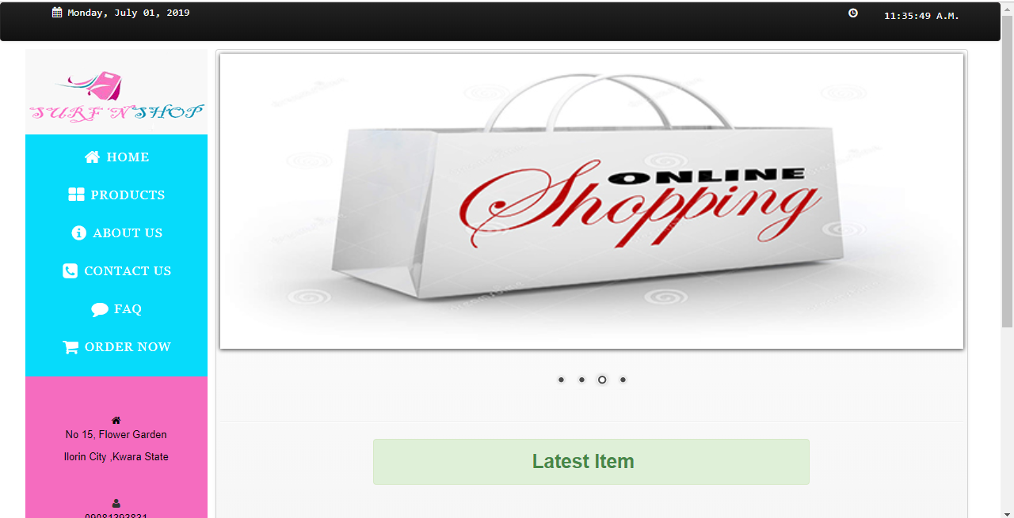
FIGURE 4.1: Index page output design: This is the user welcome page
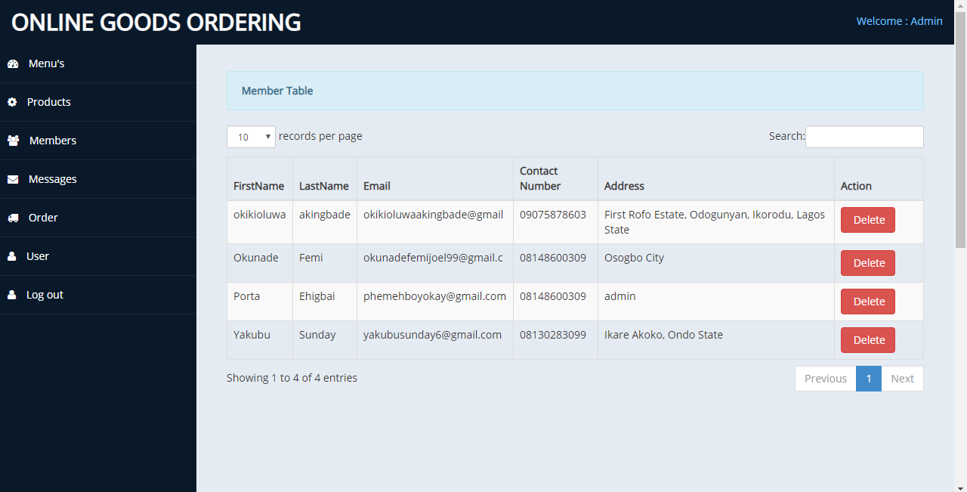
FIGURE 4.2: Members Table Page: This is the output of every member that register on the system
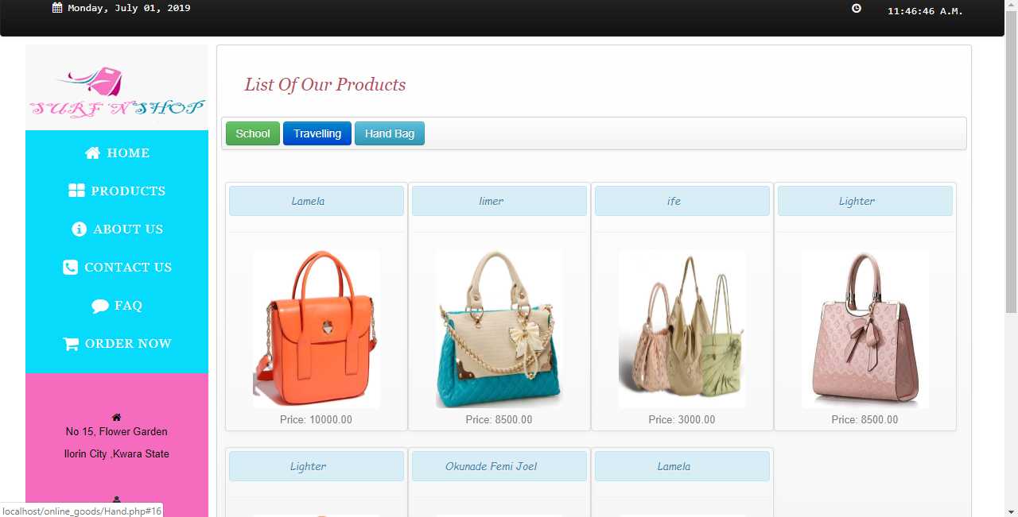

FIGURE 4.3: List of product Page: This is the output of every product added by the admin, it comprises of three categories which are school, travelling and handbag.
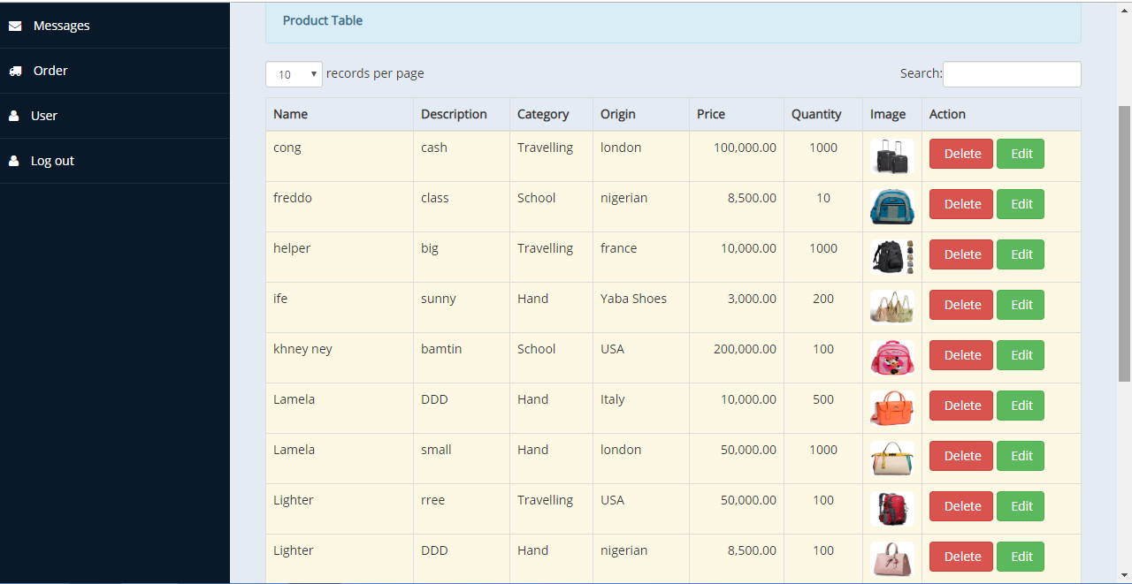
FIGURE 4.4: List of product table: This is the output of every product added by the admin
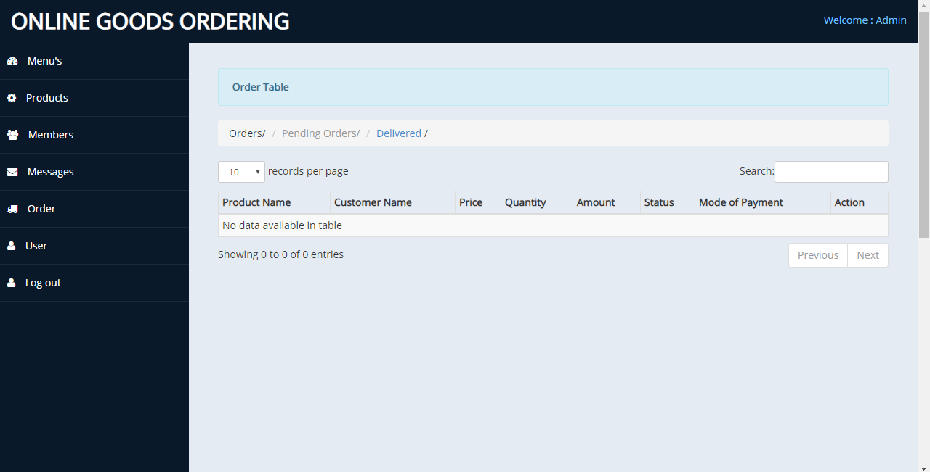

FIGURE 4.5: Order Table: This is where every order made by user is displayed

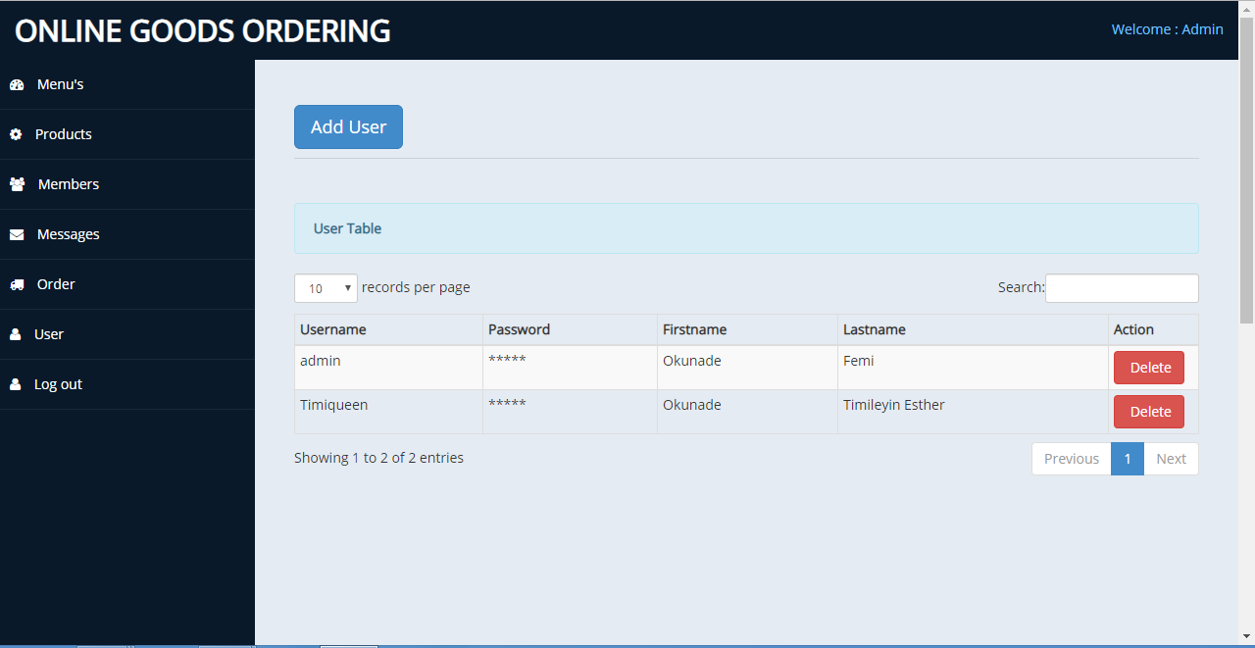
FIGURE 4.6: User Table: This is where every users added by the admin are displayed.
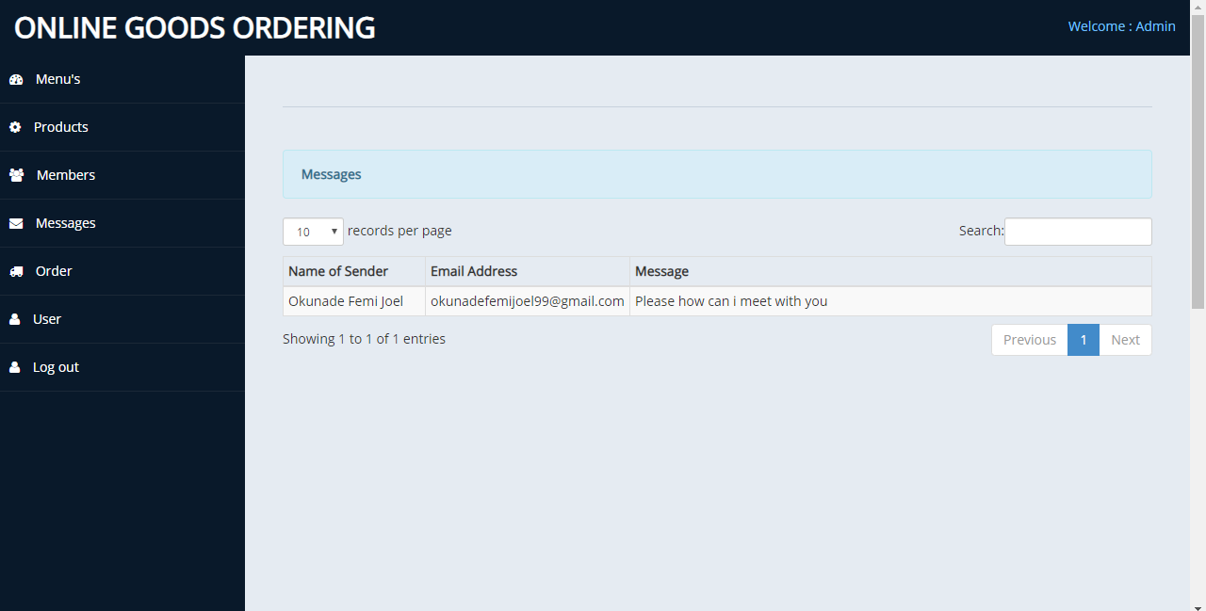
FIGURE 4.7: Messages table: This is where every messages sent by the registered users are displayed.

4.1.2 INPUT DESIGN
Design is a way of mapping and arranging part into a whole, which satisfies the objective involved. The input design refers to the type of all data used to feed information into the database via the program and the format and the input used for the system. Below are the snapshots of the input designs

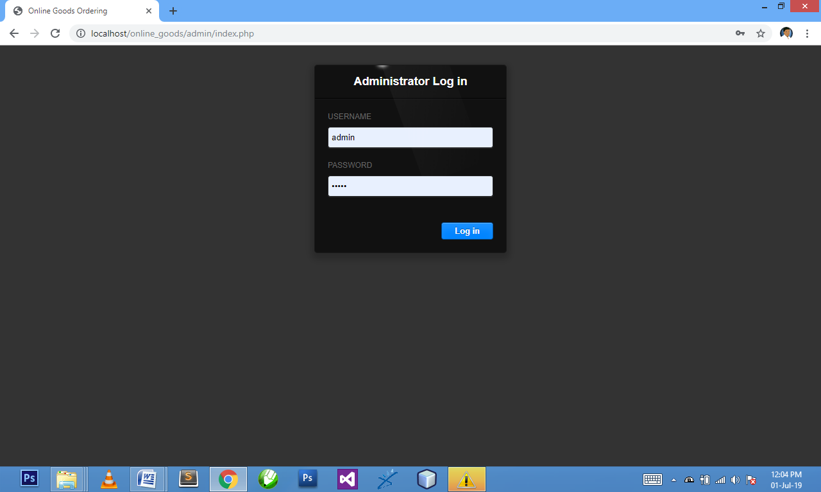

Figure 4.8: Admin Login Page: This is the admin login page.
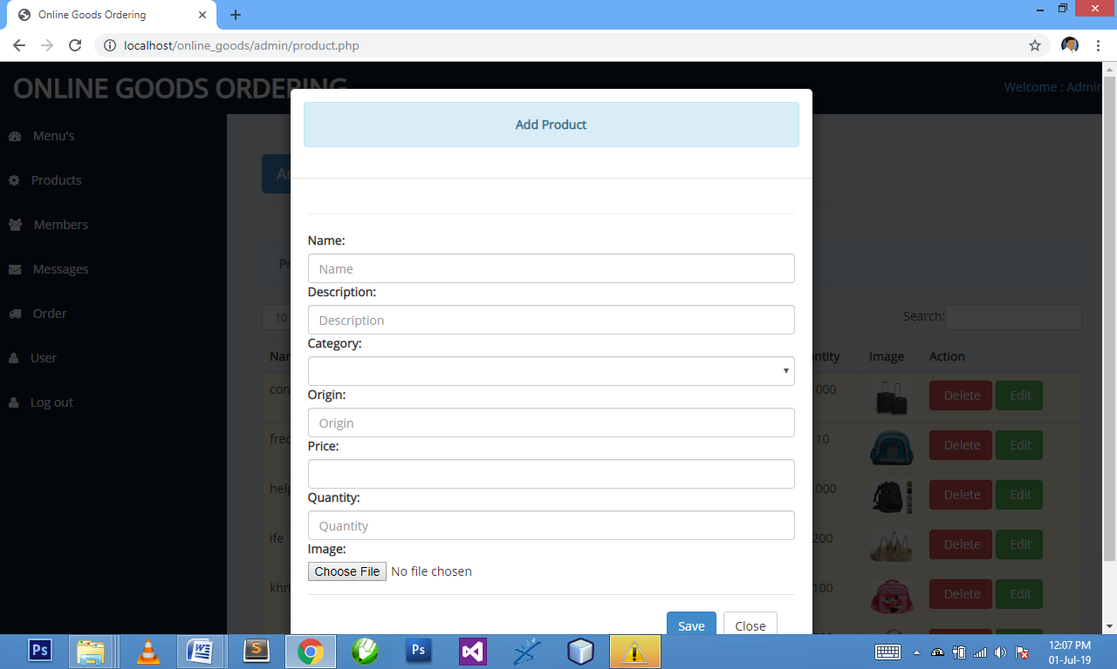

Figure 4.9: Add Product Page: This is where admin add product.
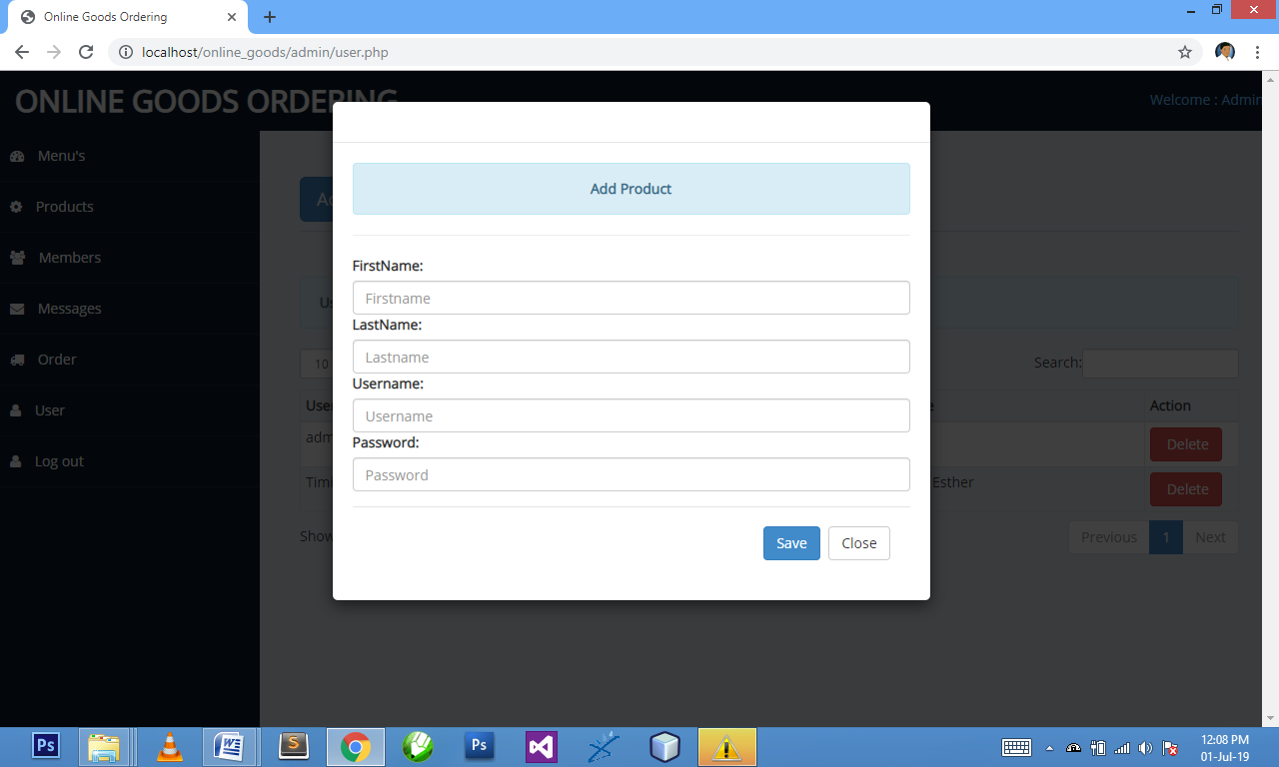
Figure 4.10: Add User Page: This is where admin add new user that can have access to the admin page.
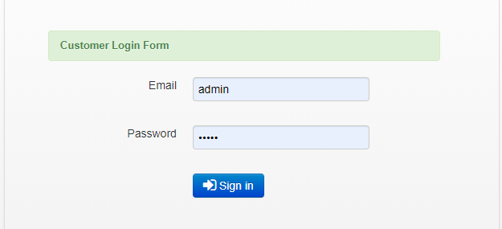

Figure 4.11: Customer Login Page: This is where customer enter their email and password to order for goods.

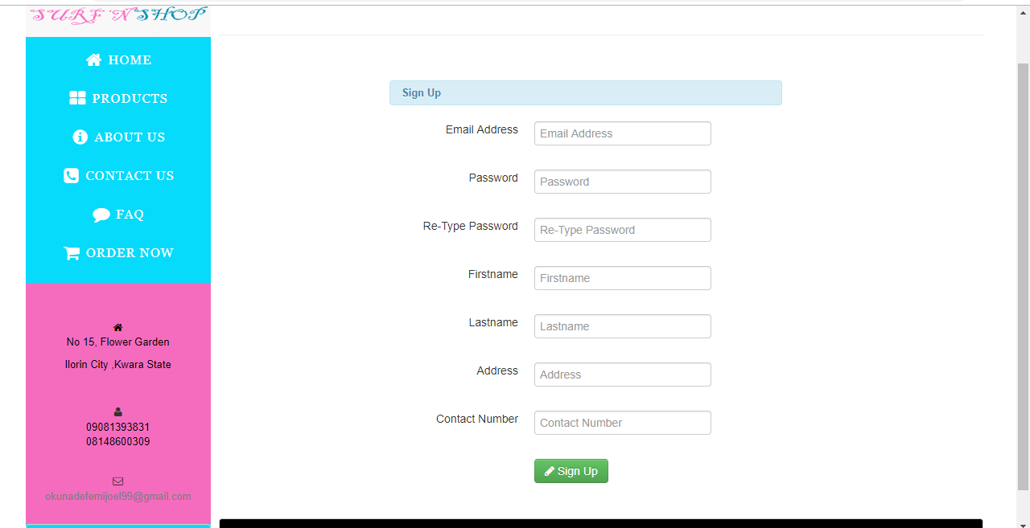
Figure 4.12: Customer Signup Page: This is where customers register their details before proceeding to the login page.
4.1.3 DATABASE DSIGN
Database entails the organization and access mode that are implemented in carrying out our specified operations upon the records of the file.
The files used in this system have records that have been organized randomly (random organization) and for this purpose, it will be more appropriate to access the records of the files randomly (random access mode).
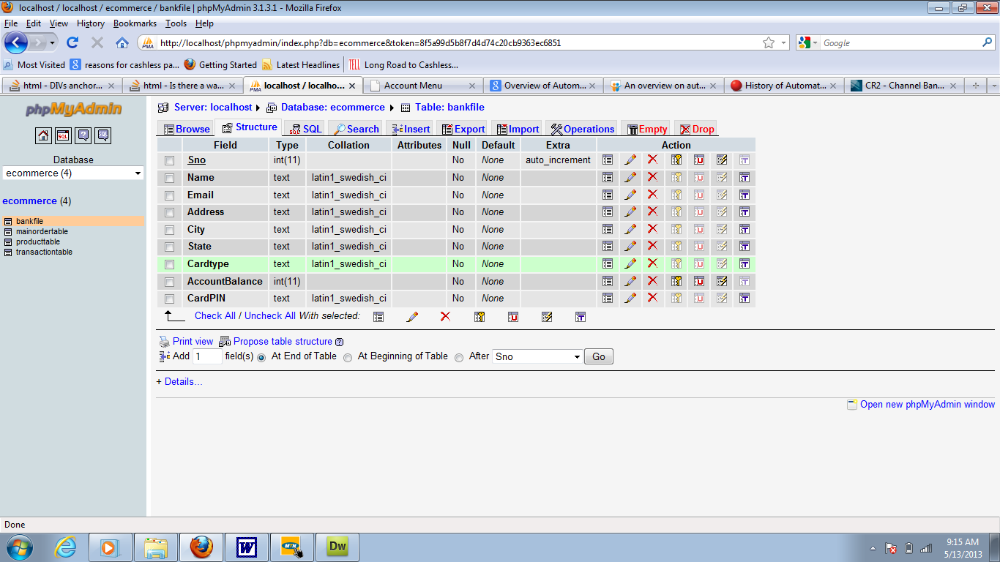
Table 4.1: User table: This is a user table where all user information entry or data are displayed are stored.

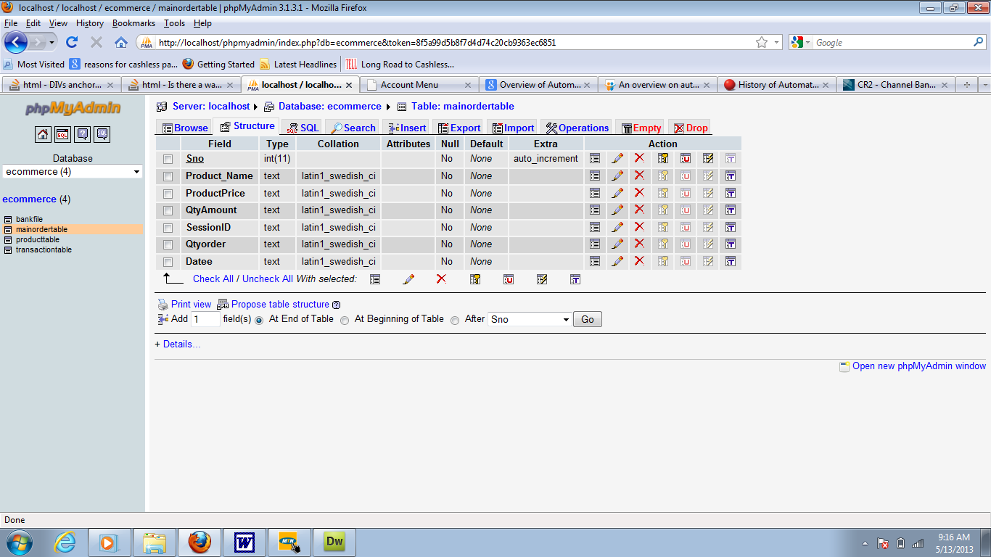

Table 4.2: Product table: This is product table where user product data are stored and retrieved.
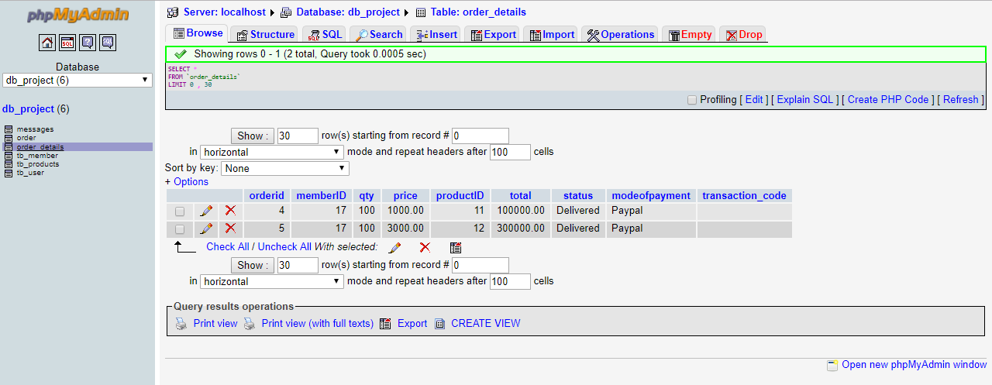
Table 4.3: Order table: This is an order table where order data are stored and retrieved.

4.1.3 PROCEDURE DESIGN
Procedures are steps which verify the whole process i.e which are everything put together to produce the desired output. This involves the organization of the source document and end with the output result.
Documents are sent to various departments to be filled by the employees and later returned to the personnel department which are analysed to determine which record goes into the computer.
After selecting the necessary data, this serves as input to the computer system.
4.2 IMPLEMENTATION OF THE SYSTEM
It is always good to develop new ideas, to implement them on a computer and eventually to relish the satisfaction of achieving a successful result. The implementation process involves converting the system design into a complete and tested EDP that is fully operational and that can be used by the system users to meet their business needs. During implementation phase, the hardware and the software must be implemented.
Implementation of a system can be explained in six steps:-
1. Review design specification
2. Code, test and document programs
3. Train users
4. Perform system test
5. Convert to new system
6. Evaluate and maintain the new system

4.2.1 CHOICE OF PROGRAMMING LANGUAGE
The application is designed in Adobe CS4 Dreamweaver web development package which involves the use of PHP server-side scripting language, MYSQL for database management and HTML (with other embedded functionalities) for the page design and layout settings. Hence, the program testing simply involves running it directly from a Mozilla Firefox web browser on local host server provided by Apache 2.0 in WampServer 2.0 application.
In preparation for the installation of the new system, the method of changeover is given serious consideration to determine the success of the new system. Suitable changeover technique for this system is pilot changeover. The pilot changeover operates by applying the new system bit-by-bit until it covers the whole of the operations. The result obtained from using the pilot method on a small portion of the operations would be used in determining the suitability of the need system for the rest of the operations. This method is similar to testing small sample of a distribution if the test yields a good result then the whole system because fully operational and the manual/existing system is eliminated.
4.2.2 HARDWARE SUPPORT
The computer configuration required to run the software is;
Computer/memory processor PC with a 48dx, MHZ or Pentium, Intel or higher processor required.
Memory: 2GB of RAM
Cache memory: 512KB
Hard disk Minimum size 500GB
Recommended 200GB
Virtual Memory 32Bits
Cache memory 512KB

4.2.3 SOFTWARE
I. Interface Design Language, windows Notepad for help interface design Hypertext Mark-up Language (HTML)
ii. MY SQL Database Management Software
iii. Programming PHP (Hypertext Pre-processor)
iv. Operating system window 07 professional
v. Graphic software paint shop and choosing these two formats GIF (Graphic Image Format)
vi. Scanner software, Mira scans
- Web browser software MOZILLA

4.3 PROGRAM DOCUMENTATION
4.3.1 OPERATING THE SYSTEM
Step 1: Boot your computer and click on start button on task bar
Step 2: Launch WampServer
Step 3: Locate Online_goods
Step 4: Click on Options
4.1 Click on Product (to view available product)
4.2 Click on About Us (to view the about us page)
4.3 Click on Contact Us (to send message to the admin)
4.4 Click on Order Now (to order for your bags)
Step 5: Logout.

4.3.2 MAINTAINING THE SYSTEM
The use of the term maintenance for software is different from other references to maintenance. Unlike the tires on your car, software does not “wear out”. If this is the case, then why does software maintenance account for such a high percentage of the Total Cost of Ownership for software?
The software maintenance definition refers to changes for defect correction, performance improvements, or adaptations to a changed environment (enhancements). According to this definition, if we build software that is defect-free, performs well, and contains user-controlled parameters to adjust processing rules in response to changing requirements then most maintenance would not be necessary.
Why does this happen? There are many reasons but the most common reasons are time constraints and lack of experience. Adding validation logic takes time. So, people make assumptions about the quality of in-bound data. Assumptions are also made about the volume of transactions and the impact on performance and the stability of the automated business processes. Finally, it is common for new software to be developed by younger developers who don’t understand the maintenance impacts of their designs.
The reality is that business requirements change and most of these assumptions are flawed. Transaction volumes increase, changing business processes require new transactions or new validation criteria, and software users will use the software incorrectly. The cost of software maintenance and the total cost of ownership can dramatically be reduced if developers build software that adjusted to changes in transaction volumes; validated all inbound data and provide user-configurable options for decision logic and data validation.

CHAPTER FIVE
SUMMARY, CONCLUSION AND RECOMMENDATION
5.1 SUMMARY
In summary, orders can be made just by one click by using the online ordering system. The user needs to register with the website letting the admin know if he is an authorized user. Once the admin gives the required permission, the user can then create a new purchase order from the desired vendor registered with the department. He can also make the payment by providing the funding source through which the order will be paid. Then the orders are finalized and provided with an invoice in a PDF format which can also be printed.
5.2 CONCLUSION
Online ordering system has been designed and developed to serve the purpose of web application and user friendly interface. This application has various features to view, edit or update the purchase orders, easily manageable, editable and updatable profile. The Administrator has other features like managing the users.
5.3 RECOMENDATION
I recommend that we extend this application to be more users friendly by giving full access to the user itself to make the purchase orders. Drag and drop of PO’s into the cart can be added.

REFERENCES
Abousaeidi, M.,Fauzi,R.&Muhamad,R.(2016).GeographicInformationSystem (GIS) modeling approach to determine the fastest delivery routes, Saudi Journal of Biological Sciences.Vol. 1. Pp. 4-5.
Beckeman, M. & Skjöldebrand, C. (2017). Clusters/Networks Promote Food Innovations. Journal of Food Engineering, Vol. 79, Issue: 7. Pp. 1418-1425. http://dx.doi.org/10.1016/j.jfoodeng.
Beni, L. H., Villeneuve, S., LeBlanc, D. I. & Delaquis, P. (2011). A GIS-based Approach in Support of an Assessment of Food Safety Risks. Transaction in GIS, Vol. 15. Pp. 95-108. http://dx.doi.org/10.1111/j.1467-9671.
Bosona, T. G. & Gebresenbet, G. (2011). Cluster Building and Logistics Network Integration of Local Food Supply Chain. Biosystems Engineering, Vol. 10. Issue: 8. Pp. 293-302. http://dx.doi.org/10.1016/j.biosystemseng.
Bosona, T. & Gebresenbet, G. (2013). Food Traceability as an Integral Part of Logistics Management in Agricultural Supply Chain. Food Control, Vol. 33, Pp. 32-48. http://dx.doi.org/10.1016/j.foodcont.
EL-Raoui, H., Oudani, M & Alaoui, E. (2018). ABM-GIS simulation for urban freight distribution of perishable food, MATEC Web of Conferences 200, Pp. 234-236. doi.org/10.1051/matecconf/201820000006.
Farahani, R. Z. & Hekmartfar, M. (2019). Facility Location: Concepts, Models, AlgorithmsandCasestudies(1sted.).Heidelberg,Germany: Springer-Verlag.
Fisher, C. (2018). Trust and Communication in European Agri-food Chains.Supply Chain Management: An International Journal, Vol. 18, Issue: 2. Pp. 208-218. http://dx.doi.org/10.1108/13598541311318836.
Gebresenbet, G., Nordmark, I., Bosona, T., & Ljungberg, D. (2019). Potential for Optimised Food Deliveries in and around Uppsala city, Sweden. Journal of Transport Geography. Vol. 19. Pp. 1456-1464. http://dx.doi.org/10.1016/j.jtrangeo.2011.08.005.
Gunawan, D., Marzuki,I.&Candra,A.(2018).StandaloneMobileApplicationfor Shipping Services Based on Geographic Information System and A-Star Algorithm,2ndInternationalConferenceonComputingand.

APPENDIX 1: SYSTEM FLOWCHART
Stop
Main Menu
Login
Splash Screen

Start

ORDER GOOD
RETURN GOODS
Logout
AVAILABLE GOODS
Report

APPENDIX 2: SPLASH SCREEN FLOWCHART
Close Database

Open Database

Stop
Display Splash
Start

APPENDIX 3: LOGIN FLOWCHART
Close Database

Open Database

Return
Main Menu
Enter Username and Password
Start

Is any field empty?
All field are required to proceed
Yes

No
Invalid Username and Password
No
Is Username and Password Correct?

Yes

APPENDIX 4: MAIN MENU FLOWCHART
Is it option Logout?
Yes
Order Goods

No
Yes
Return Goods
No
Yes
Report
Is it option Report
t?
No
Yes
Registration
Is it option Registration?
No
Yes
No
Close Database

Return
End Select
No
No
Logout
Open Database

Select option
Start

Is it option availableorder
?

Is itoption Borrow book
?

APPENDIX 5: RETURN GOODS FLOWCHART
Display Goods Contents
Close Database

Open Database

All Field are required to Proceed
Is any Field Empty
?
Enter Goods Contents
Return
Start
Yes

No
Display Goods Content

Save to Database

APPENDIX 6: ORDER GOODS FLOWCHART
Start
View Order Goods
Close Database

Open Database

Stop

APPENDIX 7: REPORT FLOWCHART
Close Database

Open Database

Stop
Start
Report

APPENDIX 8: SOURCE CODE
HOME PAGE
<!DOCTYPE html PUBLIC "-//W3C//DTD XHTML 1.0 Transitional//EN" "http://www.w3.org/TR/xhtml1/DTD/xhtml1-transitional.dtd">
<html xmlns="http://www.w3.org/1999/xhtml">
<head>
<meta http-equiv="Content-Type" content="text/html; charset=utf-8" />
<meta http-equiv="Page-Enter" content="revealTrans(Duration=0.5,Transition=12)" />
<meta http-equiv="Page-Exit" content="revealTrans(Duration=0.5,Transition=12)" />
<title>Student Learning Archive</title>
<link href="css/style.css" rel="stylesheet" type="text/css" />
</head>

<body>

<div id="home-user-bar">
<a href="login">Log in/Register</a>
</div>

<div id="home_container">
<div id="home_sitename">
<p><span class="head">Student Learning Archive</span></p>
<p><span class="for">for</span></p>
<p><span class="other">Faculty of Communication and Information Science,<br />
University of Ilorin, Nigeria.
</span></p>
</div>
<div id="home_quick_links">
<a href="recent" class="recent1">
<div class="recent">
<p><img src="images/recent.png" alt="Recently Added" /></p>
<p> Recent Uploads</p>
</div></a>
<a href="popular" class="popular1">
<div class="popular">
<p><img src="images/hits.png" alt="Most Popular Archives" /></p>
<p>Most Popular</p>
</div></a>
</div>
<div id="home_search">
<form id="form1" name="form1" method="post" action="search">
<div class="search_div">
<label for="searchWord"></label>
<input type="text" name="searchWord" id="searchWord" placeholder="Search the archive" /><input name="button" type="submit" id="button" value=" " />
</div>
</form>
</div>
</div>
</body>
</html>
REGISTRATION PAGE
<!DOCTYPE html PUBLIC "-//W3C//DTD XHTML 1.0 Transitional//EN" "http://www.w3.org/TR/xhtml1/DTD/xhtml1-transitional.dtd">
<html xmlns="http://www.w3.org/1999/xhtml">
<head>
<meta http-equiv="Content-Type" content="text/html; charset=utf-8" />
<meta http-equiv="Page-Enter" content="revealTrans(Duration=0.5,Transition=12)" />
<meta http-equiv="Page-Exit" content="revealTrans(Duration=0.5,Transition=12)" />

<link rel="stylesheet" type="text/css" href="css/tooltip/tooltipster.css" />

<script type="text/javascript" src="js/jquery.js"></script>
<script type="text/javascript" src="js/tooltip/jquery.tooltipster.min.js"></script>

<script type="text/javascript" src="js/functions.js"></script>
<title>Register | Student Learning Archive</title>
<link href="css/style.css" rel="stylesheet" type="text/css" />

<script>
$(document).ready(function() {
$('.tooltip').tooltipster();
});
</script>
</head>

<body>
<div id="wrapper">
<div id="in-wrapper">
<div id="sitename">
Student Learning Archive<br />
<span class="other1">for
CIS Faculty,
Unilorin, Nigeria.
</span>
</div>
<div id="after-sitename">
<div id="user-bar">
<a href="login">Log in/Register</a>
</div>
<div id="search-bar">
<form id="form1" name="form1" method="post" action="search">
<div class="search_div">
<label for="searchWord"></label>
<input type="text" name="searchWord" id="searchWord" placeholder="Search the archive" value="" /><input name="button" type="submit" id="button" value=" " />
</div>
</form>
</div>
</div> <div id="container">
<div id="left-column">
<ul>
<li><a href="images/..">Home</a></li>
<li><a href="recent">Recently Uploaded</a></li>
<li><a href="popular">Most Popular Docs</a></li>
</ul> </div>
<div id="main-container">
<h1 align="center">User Registration</h1>
<p align="center">All fields marked <span class="colo-red">*</span> are compulsory</p>
<div id="reply">
</div>
<form action="" method="post" id="userReg" name="userReg"><table border="0" align="center" cellpadding="5" cellspacing="0">
<tr>
<td align="right">Name <span class="colo-red">*</span></td>
<td><label for="sname"></label>
<input type="text" name="sname" id="sname" title="<br>Surname" placeholder="Surname" onblur="validate(this.name,this.value)" class="tooltip all_a" /></td>
<td><label for="mname"></label>
<input name="mname" type="text" class="all_a" id="mname" title="Middlename" placeholder="Middlename" onblur="validate(this.name,this.value)" /></td>
<td><label for="lname"></label>
<input name="lname" type="text" class="all_a" id="lname" title="Lastname" placeholder="Lastname" /></td>
</tr>
<tr>
<td align="right">Sex<span class="colo-red"> *</span></td>
<td colspan="3"><select name="sex" class="all_a" id="sex">
<option value="male">Male</option>
<option value="female">Female</option>
</select></td>
</tr>
<tr>
<td align="right">Phone Number 1 <span class="colo-red">*</span></td>
<td colspan="3"><label for="telephone1"></label>
<input name="telephone1" type="text" class="all_a" id="telephone1" title="Phone Number 1" onblur="validate(this.name,this.value)" placeholder="Phone Number 1" />
<div id="fone1_reply">
</div>
</td>
</tr>

