DESIGN, CONSTRUCTION, AND COMPARATIVE PERFORMANCE
EVALUATION OF THE DIRECT, INDIRECT AND GREENHOUSE
SOLAR DRYERS FOR DRYING PEPPER
BY
MAKUN TINA ONAEI
HND/23/SLT/FT/0371
A PROJECT SUBMITTED TO THE DEPARTMENT OF SCIENCE LABORATORY TECHNOLOGY, INSTITUTE OF APPLIED SCIENCES, KWARA STATE POLYTECHNIC, ILORIN

IN PARTIAL FULFILMENT OF THE REQUIREMENTS OF THE AWARD OF HIGHER NATIONAL DIPLOMA (HND) IN SCIENCE LABORATORY TECHNOLOGY (SLT), PHYSICS & ELECTRONICS UNIT SUPERVISED
BY
DR. OLAORE K.O.
JULY, 2025

CERTIFICATION
This is to certify that the research work carried out by MAKUN TINA ONAEI with matriculation number HND/23/SLT/FT/0371 in Institute of Applied Science (IAS), Department of Science Laboratory Technology, Kwara State Polytechnic, Ilorin has met the requirement for the award of Higher National Diploma (HND).
_______________________ | ____________________ DR.
OLAORE K.O.  Supervisor | DATE
_______________________ | ____________________ MR
SALAHU BASHIR  Head of Unit | DATE
_______________________ DR.USMAN A. | ____________________
Head of Department | DATE
_______________________ | ____________________
External Examiner | DATE

DEDICATION
We dedicate the project to our families, mentors, and friends who have been our constant source of encouragement and support throughout this journey. Their belief in us gave us the strength to persevere and complete this work successfully.
We also dedicate this project to all students who strive for knowledge and growth and to future innovators who continue to dream and build a better world.

ACKNOWLEDGEMENTS
First and foremost, I thank Almighty God for His grace, guidance, and strength throughout the course of this project. Without His divine support, this achievement would not have been possible
I extend my deepest gratitude to my dear mother (Makun Chineke Chinasa Patient) for her endless love, prayers, and unwavering support. Her encouragement kept me going even during the most challenging moments.
To my wonderful friends, thank you for being there through your advice, motivation, and occasional comic relief, you helped lighten the load.
A special thank you to my baby for the love, patience, and emotional support that made a significant difference throughout this journey.
Finally, I appreciate myself for the late nights, the resilience, and the determination to see this through. I am proud of how far I’ve come.

TABLE OF CONTENTS
Title Page -------------------------------------------------------------------------------- i
Certification ---------------------------------------------------------------------------ii
Dedication --------------------------------------------------------------------------------iii
Acknowledgements ---------------------------------------------------------------------iv
Table of Contents -----------------------------------------------------------------------vii
List of Tables --------------------------------------------------------------------------viii
List of Figures ---------------------------------------------------------------------------ix
Abstract ------------------------------------------------------------------------------------x

CHAPTER ONE: INTRODUCTION
1.1 Background of study ----------------------------------------------------------------1
1.2 Statement of the problem -----------------------------------------------------------4
1.3 Aims of the Study --------------------------------------------------------------------5
1.4 Objective of the Study----------------------------------------------------------------6
1.5 Scope of the Study -------------------------------------------------------------------6
1.6 Significance of Study-----------------------------------------------------------------6
1.7 Justification of Study ---------------------------------------------------------------8

CHAPTER TWO
2.0 Literature Review ------------------------------------------------------------------9
2.1 Working Principles and physics of Indirect Solar Dryer ----------------------23
2.2 Working Principles and physics of Greenhouse Solar Dryer -----------------29
2.3 Working Principle of a Hybrid Solar Dryer -------------------------------------33
2.4 Classification of Solar Dryers -----------------------------------------------------34
2.4.1 Passive Solar Dryers ---------------------------------------------------------------35
2.4.2 Active Solar Dryers ----------------------------------------------------------------37
2.5 Design Considerations for the Solar Dryers ------------------------------------39

CHAPTER THREE: MATERIALS AND METHODS
3.1 Construction Materials for the Solar Dryers -----------------------------------43
3.2 Instruments Used ------------------------------------------------------------------45
3.3 Construction Process --------------------------------------------------------------48
3.4 Experimental Setup ----------------------------------------------------------------52
3.5 Performance Evaluation Parameters --------------------------------------------55
3.6 Sample Calculations ---------------------------------------------------------------58
3.6.1 Calculation of Moisture Content ----------------------------------------------58
3.6.2 Calculation of Drying Rate ----------------------------------------------------63
3.6.3 Calculation of Efficiency ------------------------------------------------------67
CHAPTER FOUR
4.0 Result and Discussion-----------------------------------------------------------71

CHAPTER FIVE
5.0 Conclusion ------------------------------------------------------------------------86
5.1 Recommendation ---------------------------------------------------------------- 87
References ---------------------------------------------------------------------------------88
Appendix A---------------------------------------------------------------------------------96
Appendix B---------------------------------------------------------------------------------108

LIST OF TABLES
Table 4.1: Tabulated readings for Day 1
Table 4.2: Tabulated readings for Day 2
Table 4.3: Tabulated readings for Day 3
Table 4.4: Tabulated readings for Day 4
Table 4.5: Tabulated readings for Drying Rate & Moisture Content (Day 1)
Table 4.6: Tabulated readings for Drying Rate & Moisture Content (Day 2)
Table 4.7: Tabulated readings for Drying Rate & Moisture Content (Day 3) Table
4.8: Tabulated readings for Drying Rate & Moisture Content (Day 4) LIST OF

FIGURES
Figure 2.1.1: Indirect Solar Dryers with backup system
Figure 2.1.2: Basic Indirect Solar Dryer (Without Backup system)
Figure 2.2.1: Working Principle of a Greenhouse Solar Dryer
Figure 2.3.1: Working Principle of a Hybrid Solar Dryer
Figure 2.4.1.1: Layout of a Direct Passive Solar Dryer
Figure 2.4.1.2: Layout of an Indirect Passive with Dryer
Figure 2.4.2.1: Layout of an Indirect Active Solar Dryer System
Figure 2.4.2.2: Layout of Hybrid Solar Dryer
Figure 3.2.1: Digital multimeter with sensory probe
Figure 3.2.2: Digital Hygrometer
Figure 3.2.3: Solar Radiation Meter (Pyranometer)
Figure 3.2.4: Digital Weighing scale
Figure 3.3.1: During welding process of indirect dryer frame
Figure 3.3.2: Framework of the indirect solar dryer
Figure 3.3.3: Complete construction of Indirect solar dryer
Figure 3.3.4: Complete construction of Greenhouse solar dryer
Figure 3.4.1: Pepper in the tray placed inside indirect solar dryer
Figure 3.4.2: Tray place inside greenhouse solar dryer
Figure 3.4.3: Tray placed under open sun dryer
Figure 4.1: Variation of temperature and solar radiation against time (Day 1)
Figure 4.2: Variation of temperature and solar radiation against time (Day 2)
Figure 4.3: Variation of temperature and solar radiation against time (Day 3) Figure
4.4: Variation of temperature and solar radiation against time (Day 4)
Figure 4.5.1: Variation of drying rate against time (Day 1)
Figure 4.5.2: Variation of moisture content against time (Day 1) Figure 4.6.1: Variation of drying rate against time (Day 2)
Figure 4.6.2: Variation of moisture content against time (Day 2) Figure 4.7.1: Variation of drying rate against time (Day 3)
Figure 4.7.2: Variation of moisture content against time (Day 3) Figure 4.8.1: Variation of drying rate against time (Day 4)
Figure 4.8.2: Variation of moisture content against time (Day 4)

ABSTRACT
This project presents the design, construction, and comparative performance evaluation of
two solar dryers: an indirect solar dryer and a greenhouse solar dryer developed to enhance the drying process of pepper (Capsicum spp.) and minimize post-harvest losses in Nigeria. Both dryers were fabricated using locally available materials, including HDF plywood, glass, flat metal sheets, Automobile black paint, and Aluminum angle, ensuring affordability and applicability in rural settings. The indirect solar dryer featured a solar collector measuring 123 cm × 57 cm × 21 cm and a drying chamber measuring 85 cm × 52.5 cm. In contrast, the greenhouse solar dryer measured 154.5 cm × 104.5 cm × 100 cm, with a raised convection head and collector plate dimensions of 149 cm × 102 cm. An experimental evaluation was conducted to assess the thermal performance and drying efficiency of this method in comparison with traditional open sun drying. Key parameters, including ambient temperature, collector and chamber temperatures, solar radiation, relative humidity, and weight loss, were recorded hourly from 9:00 AM to 5:00 PM. The greenhouse dryer attained a peak chamber temperature of 57.2°C. In comparison, the indirect dryer reached a temperature of up to 63°C in the collector, which is considerably higher than ambient conditions, ranging from 25.8°C to 38.6°C. The results indicated that the greenhouse dryer effectively reduced the moisture content of pepper from approximately 51% to 5% within three days, while the indirect dryer achieved a reduction from 44% to 6% over the same period. In contrast, open sun drying reduced moisture from 35% to 4% in two days but showed signs of contamination and quality degradation due to exposure to environmental elements. The study demonstrates that solar drying technologies, particularly indirect and greenhouse solar dryers, provide efficient, hygienic, and environmentally sustainable alternatives to traditional drying methods. Their adoption can significantly improve the shelf life and quality of agricultural products while promoting food security and reducing post-harvest losses in rural communities.

CHAPTER ONE

INTRODUCTION

1.1 Background of the Study
Agricultural production remains the backbone of many developing economies, with postharvest processing playing a crucial role in ensuring food availability, income generation, and long-term preservation of crops. Despite increased agricultural output in many tropical regions, post-harvest losses continue to undermine food security and reduce farmers’ profitability (Kitinoja & Kader, 2015). Among various preservation techniques, drying stands out as one of the most ancient and commonly used methods, particularly in rural communities with limited access to refrigeration and cold storage. Drying not only reduces the moisture content of perishable crops but also extends shelf life, prevents microbial spoilage, and reduces transportation and storage costs (Mohammed et al., 2020). The efficiency and quality of the drying process, however, are significantly influenced by the drying method employed. In many parts of sub-Saharan Africa, including Nigeria, the traditional method of open sun drying is still widely practiced due to its low cost and simplicity. While accessible, this method is fraught with numerous limitations that compromise the quality and safety of dried produce (Akinola et al., 2015).
Open sun drying exposes agricultural products to environmental elements such as dust, wind, insects, and rainfall, leading to contamination, nutrient loss, and uneven drying (Olayanju et al., 2019). Inconsistent weather conditions further prolong drying times and increase the risk of microbial spoilage. Solar drying technologies have emerged as efficient, sustainable, and hygienic alternatives to traditional open drying (Esper & Muhlbauer, 1996; Janjai, 2012). These technologies harness solar radiation more effectively by controlling the heat transfer process in semi-enclosed environments. They not only improve drying speed but also help retain nutritional quality, prevent contamination, and enhance the visual and sensory attributes of food products (Bala & Mondol, 2001).
Among the types of solar dryers, direct, indirect, and greenhouse dryers have received considerable attention. Each system offers unique structural and operational benefits that affect drying performance and product quality (Forson et al., 2007). Direct solar dryers allow sunlight to directly contact the food material within a closed transparent box, leading to high drying temperatures but exposing products to potential UV degradation. Indirect solar dryers, in contrast, channel heated air from a solar collector into a separate drying chamber, which protects the product from direct light, allows better temperature regulation, and reduces the risk of oxidative damage (Tiwari et al., 2016).
Greenhouse solar dryers take advantage of the greenhouse effect, using transparent materials to trap solar radiation within a larger enclosure. These systems combine the advantages of both direct and indirect drying while offering better airflow and thermal retention (Sharma et al., 2009). Their design allows for bulk drying of high-moisture crops under relatively stable thermal conditions, even during intermittent solar radiation. Due to their semi-permanent structure and high thermal efficiency, greenhouse dryers are increasingly adopted for drying perishable produce such as tomatoes, cassava, okra, and pepper (El-Sebaii & Shalaby, 2012; Khouya et al., 2017).
Pepper (Capsicum spp.), a vital component of Nigerian cuisine and agro-economy, is particularly susceptible to spoilage due to its high moisture content. It is widely grown, marketed, and processed across Nigeria and contributes significantly to household income and nutrition (Oladunjoye et al., 2021). However, fresh pepper deteriorates rapidly postharvest, especially in humid conditions, leading to significant losses within days if not properly preserved. Drying remains the most common method used to extend its shelf life and improve market value. Unfortunately, open sun drying often yields poorquality dried pepper that is discolored, contaminated, and nutritionally inferior (Nwakuba et al., 2020).
In response to these challenges, recent research has focused on the development and performance evaluation of improved solar drying technologies that are affordable, energyefficient, and suitable for smallholder farmers (Kaewkiew et al., 2012). In particular, combining different dryer types (e.g., direct, indirect, and greenhouse) in comparative studies helps identify systems that optimize drying conditions, preserve nutritional integrity, and reduce overall processing time. This study builds upon such efforts by designing and constructing a direct and an indirect solar dryer, and comparing them with an existing greenhouse solar dryer and traditional open sun drying.
The evaluation focuses on drying pepper as a representative high-moisture crop. Key variables such as temperature, humidity, solar radiation, and hourly weight loss are monitored to determine the drying rate, moisture removal efficiency, and thermal behavior of each system. This approach not only yields practical insights but also provides a datadriven foundation for future adaptation and scaling in real-world farming conditions (Tiwari & Jain, 2001).
Furthermore, integrating theoretical dryer design with field performance ensures that the results are applicable beyond laboratory settings. The findings are expected to contribute to the broader adoption of solar dryers among rural populations, enhancing both food preservation and income diversification (Ajibola et al., 2017). In the context of Nigeria’s renewable energy goals, solar drying offers a clean, low-cost, and carbon-neutral solution to post-harvest losses (Oyekale, 2015). This aligns with global sustainable development objectives, particularly those related to clean energy, zero hunger, and climate-smart agriculture.
By advancing the understanding of different solar drying methods and their suitability for local agro-climatic conditions, this research promotes the use of renewable technologies in agriculture. It also provides a practical model for improving food security, reducing waste, and supporting rural livelihoods through better post-harvest management.

1.2 Statement of the problem
Post-harvest loss remains one of the most pressing challenges in the agricultural value chain of developing countries, particularly in sub-Saharan Africa. These losses, estimated to be between 30% and 50% for fruits and vegetables, are primarily attributed to poor storage, handling, and preservation techniques (FAO, 2019; Affognon et al., 2015). Pepper (Capsicum spp.), which is extensively cultivated and consumed in Nigeria, is especially vulnerable due to its high moisture content, delicate skin, and susceptibility to microbial deterioration (Nwakuba et al., 2020). Without effective preservation measures, farmers experience rapid degradation of harvested pepper, which severely affects market value, food availability, and income generation, particularly among rural producers who rely heavily on seasonal harvests.
The traditional method of open sun drying, though widely practiced in rural communities due to its simplicity and zero cost, is inadequate in meeting modern food quality and safety standards. It is highly weather-dependent, slow, and exposes the product to numerous environmental contaminants, including dust, insects, animal droppings, and rain (Olayanju et al., 2019; Kitinoja & Kader, 2015). Furthermore, this method leads to uneven drying, discoloration, and loss of volatile nutrients, making the final product less appealing for consumers and unsuitable for export (Akinola et al., 2015). In the case of pepper, the consequences are even more severe, as the pigment (capsaicin), aroma, and nutritional components degrade quickly under prolonged exposure to the sun and fluctuating humidity (Oladunjoye et al., 2021).
The introduction of solar drying technologies has presented an alternative approach, offering the possibility of faster drying, improved hygiene, and better control over drying conditions (Janjai, 2012; Bala & Mondol, 2001). However, several challenges remain.
First, despite numerous designs including direct, indirect, and greenhouse solar dryers many are still underutilized due to cost constraints, lack of user training, and performance limitations under variable weather conditions (El-Sebaii & Shalaby, 2012). Second, there is a limited number of comparative studies that evaluate which solar dryer type is most effective under specific conditions and for specific crops like pepper (Tiwari et al., 2016; Sharma et al., 2009). Most studies tend to isolate dryer types without subjecting them to parallel evaluation, thus making it difficult for policy makers or farmers to make informed choices.
Furthermore, existing literature is often skewed toward theoretical models or small-scale laboratory settings, which do not fully account for real-world factors such as material availability, local weather patterns, and actual crop behavior during drying (Kaewkiew et al., 2012). There remains a significant gap in field-level studies that integrate practical construction, field experimentation, and systematic performance measurement using real crops under natural environmental conditions.
This research, therefore, addresses a critical gap by designing, constructing, and evaluating the performance of three different drying systems: a direct solar dryer, an indirect solar dryer, and an already existing greenhouse solar dryer. All systems are tested using pepper, with controlled measurement of drying rate, chamber temperature, solar radiation, and moisture loss. By carrying out this comparative thermal analysis, the study contributes actionable knowledge for guiding post-harvest interventions, supporting climate-smart agriculture, and enabling smallholder adoption of clean energy-based preservation solutions (Oyekale, 2015; Forson et al., 2007). Without such evidence-based solutions, reliance on outdated practices will continue to limit the potential of local agricultural systems and expose them to preventable losses.

1.3 Aim of the Study
The aim of this study is to design, construct, and compare the performance of three drying methods; indirect solar drying, greenhouse solar drying, and open sun drying using pepper as the test crop. The focus is to determine their thermal behavior, moisture reduction capability, and overall drying efficiency.

1.4 Objectives of the Study
The specific objectives of this project are to:
- Design and construct an indirect solar dryer using low-cost and locally available materials.
- Measure and compare the temperature variation in the drying chambers of the indirect and greenhouse dryers on an hourly basis.
- Record solar radiation, ambient temperature, and relative humidity throughout the drying process.
- Determine the drying rate and moisture content reduction of pepper in all three drying methods using hourly weight measurements.
- Analyze and compare the thermal efficiency and drying performance of indirect, greenhouse, and open sun drying methods.

1.5 Scope of the Study
This project focuses solely on the drying of pepper using three drying methods: indirect solar dryer (constructed), greenhouse solar dryer (existing), and open sun drying. The study involves the design, construction, and performance evaluation of the indirect dryer, with hourly data collection on temperature, solar radiation, humidity, and weight loss. The project does not cover the drying of other crops, nor does it incorporate artificial heating or hybrid dryer models.

1.6 Significance of the Study
The results of this study will provide valuable insights into the effectiveness of solar drying technologies in addressing post-harvest challenges in agriculture. It contributes to the growing interest in renewable energy applications in food processing, especially in regions where electricity is unreliable or unaffordable.
Specifically, the study:
- Demonstrates how solar dryers can significantly improve drying speed, hygiene, and product quality compared to open sun drying.
- Promotes the use of locally sourced materials for constructing low-cost dryers.
- Encourages Do-It-Yourself (DIY) innovation among farmers and students.
- Provides experimental data that can guide agricultural policies, training programs, and future dryer design improvements.
- Aligns with national and global goals to reduce food waste, improve rural livelihoods, and promote clean energy technologies.

1.7 Justification of the Study
The growing population, rising demand for food, and increasing post-harvest losses call for innovative approaches to food preservation. In Nigeria, where most smallholder farmers lack access to advanced preservation facilities, solar drying presents a costeffective and sustainable solution.
This study is justified because it:
- Offers a real-world solution to a pressing agricultural problem; post-harvest spoilage of pepper.
- Promotes renewable energy technology that can be locally built and maintained.
- Serves as a reference for farmers, students, researchers, and policy makers looking for tested alternatives to conventional drying.
- Adds to the body of scientific knowledge on solar drying, especially for pepper and similar perishable crops.
- Contributes to the achievement of Sustainable Development Goals (SDGs) such as Zero Hunger (SDG 2), Industry and Innovation (SDG 9), and Affordable and Clean Energy (SDG 7).
Ultimately, the project seeks to improve agricultural efficiency, reduce post-harvest loss, and enhance the economic resilience of small-scale farmers through simple but effective technology.
CHAPTER TWO

LITERATURE REVIEW
Singh and Gaur (2021) developed a hybrid active greenhouse solar dryer integrated with an evacuated tube solar collector, specifically targeting the drying of high-moisture agricultural products such as tomatoes. They stated that the system included a heat exchanger where hot water heated by the solar collector is circulated through copper tubes, transferring heat to the surrounding air via convection and conduction. This setup produced higher internal chamber temperatures and enhanced the moisture removal rate. Tomato slices were dried from an initial moisture content of 94.6% (wet basis) to 10% within 10 hours. The authors estimated that the dryer could yield 261 kg of dried tomato annually, with an economic payback period of just 1.73 years. Furthermore, they calculated that over a projected lifespan of 30 years, the system would mitigate approximately 169.10 tonnes of CO₂, demonstrating both environmental sustainability and cost-effectiveness. They concluded that such a system is suitable for rural agricultural processing and is well-aligned with the principles of sustainable development.
Adejumo et al. (2023) designed and evaluated a hybrid solar dryer for processing cassava grates, integrating a solar collector, drying chamber, chimney, blower unit (with heater and fan), a solar panel, and a 12V DC battery. The study was carried out to assess the influence of drying temperature and cassava variety (TMS96/1414, TMS92/0326, and TMS01/1368) on moisture loss, drying rate, and efficiency. They reported that the dryer reached maximum drying chamber temperatures of 55°C for hybrid mode and 45°C for solar mode, where both are significantly higher than the ambient 26°C. Hybrid drying reduced the moisture content from 65% to approximately 10.19% in 7 hours, while solar drying required 13 hours to reach 11%, and open sun drying took 35 hours to achieve 13%. The researchers found that TMS92/0326 exhibited the highest moisture loss (6.20 kg/kg) and drying efficiency (up to 79.71%). Drying rates across the methods were 0.899 kg/hr (open sun), 0.870 kg/hr (solar), and 0.807 kg/hr (hybrid). They concluded that drying temperature, airflow rate, and cassava variety had significant effects on performance, with the hybrid solar dryer proving most efficient in achieving rapid and uniform drying of cassava grates.
Njue and Wawire (2021) conducted a study to enhance cassava processing for smallholder farmers in Busia County Kenya, through the development and deployment of a locally fabricated solar dryer. They explained that traditional cassava drying methods typically take 7 to 14 days and are highly prone to contamination from dust, animals, and microbial agents. In their experiment, cassava roots were peeled, washed, sliced using a motorized chipper, and loaded into a solar dryer for evaluation. Temperature readings were recorded at 30-minute intervals during drying. The drying chamber temperatures peaked at 41.7°C on the first day, 49.3°C on the second, and 41.5°C on the third. The initial wet weight of the cassava (4.6 kg) was reduced to a final moisture content of 16% and a dry weight of
1.985 kg after 2.5 days of solar drying. In contrast, the traditional sun-drying method used by local farmers required 10 days to achieve similar dryness. The authors concluded that the fabricated solar dryer significantly reduced drying time and enhanced hygiene, making it an efficient solution for small-scale cassava farmers.
Francis Kumi et al. (2020) evaluated the performance of a chimney-type solar dryer designed to address the limitations of open sun drying in Ghana, particularly for highvalue crops such as Habanero pepper (Capsicum chinense). The study, conducted across the Volta, Central, and Ashanti regions, assessed the thermal performance, microbial safety, and quality of solar-dried pepper. The authors reported that during the drying period, the chimney dryer maintained a mean internal temperature of 46.4°C, which was significantly higher than the ambient temperature of 36.2°C. Relative humidity inside the dryer ranged from 25% to 68%, while solar radiation peaked at 823.18 W/m². They recorded a total drying time of 35 hours for the chimney dryer, compared to 55 hours for sun drying. Microbial analysis revealed lower contamination levels in solar-dried samples, with mean yeast and mold counts of 4.30 × 10⁴ cfu/g, compared to 2.52 × 10⁵ cfu/g in sundried products. Both Staphylococcus aureus and Escherichia coli were found at negligible levels (<10 cfu/g). The authors concluded that the chimney solar dryer achieved higher thermal performance, faster drying rates, and better microbial safety than open sun drying, offering a cost-effective and hygienic alternative for farmers in developing regions.
Nwakuba and Anyaoha (2020) conducted an extensive optimization study on the drying of red pepper slices using a hybrid photovoltaic-thermal (PV/T) solar dryer in a humid tropical region of Nigeria. Their research employed a response surface methodology (RSM) using a 3³ factorial design to analyze how drying air temperature, air velocity, and sample thickness affected drying parameters such as energy consumption, drying time, shrinkage, and efficiency. The authors evaluated air temperatures of 50, 60, and 70°C; air velocities of 1.0, 1.5, and 2.0 m/s; and sample thicknesses of 10, 15, and 20 mm. They reported that the optimal drying conditions were at 70°C, 1.88 m/s, and 14.31 mm sample thickness, achieving a desirability score of 0.903. Under these conditions, total energy consumption was 4.03 kWh, system drying efficiency 20.46%, shrinkage 67.05%, and drying time 183.8 minutes. The R² values for their predictive models ranged between 0.9228 and 0.9989, confirming their accuracy and reliability. They further noted that contributions from the PV module and solar collector to total energy varied significantly, with Qpv between 0.792 – 23.53% and Qcol between 0.518 – 15.37%. The study concluded that optimization techniques are indispensable in improving the performance of hybrid solar dryers, especially under fluctuating solar and humid wind conditions common in tropical climates.
Hossain et al. (2018) designed and evaluated a cabinet-type solar dryer in Bangladesh, featuring a collector area of 4.00 m² and a drying chamber area of 7.5 m², to assess its effectiveness in drying red pepper. They reported that it took 36 hours for red pepper in the upper tray and 41 hours in the lower tray to reduce moisture content from 73% to 10% (wet basis). In contrast, open sun drying required 85 hours to reduce the same moisture content to 11%. The authors found that the system produced 9 kg of dried pepper from 30 kg of fresh produce, compared to 2.43 kg from 8 kg using open sun drying. The study recorded an average global solar radiation of 133 W/m², with collector flux absorption at 103 W/m². The collector and dryer efficiencies were 48% and 34%, respectively, while energy efficiency reached 63%. Losses from the top, bottom, and sides of the collector were calculated at 37, 20, and 3 W/m², respectively. The researchers also observed that the color quality of dried pepper was superior in the solar dryer, with redness values (a) of 27.1 and 24.7 for the lower and upper trays, respectively, compared to 21.1 for open sun drying. They concluded that direct sunlight diminishes color quality, and that the cabinet dryer produced higher-quality pepper, faster drying rates, and more efficient energy use.
Okeyode and Okuyelu (2023) designed and fabricated a multi-functional hybrid dryer that utilizes both solar and electric energy sources to dry cassava and red pepper. The performance evaluation was conducted at three temperature levels of 55°C, 60°C, and 65°C to assess drying efficiency and moisture removal. They reported that the system effectively reduced the moisture content of cassava by 84.66%, 89.3%, and 90.62%, while corresponding drying performances were 33.86 kg/hr, 35.71 kg/hr, and 41.43 kg/hr, respectively. For red pepper, moisture reduction levels were 71.51%, 74.5%, and 80.77%, with drying performances of 14.89 kg/hr, 18.63 kg/hr, and 25.24 kg/hr at the same temperature settings. They observed that moisture loss was higher during the initial drying phase and stabilized over time. The system’s major components include a blower, heating chamber, solar chamber, and heater, all built within a total material and fabrication cost of approximately $260. The authors concluded that the dryer demonstrated high efficiency, low cost, and was highly suitable for local farmers, offering a practical and scalable solution for post-harvest processing of perishable crops.
Ky et al. (2021) investigated the performance of a sun-tracking–free indirect solar dryer featuring a novel collector design that incorporated hemispherical concentrators and centrally mounted with Fresnel lenses. The system was permanently installed in
Ouagadougou, Burkina Faso, and aimed to address post-harvest drying challenges during cloudy seasons, particularly between late May and early June. The authors charged the drying chamber with mango and ginger, placing them on five trays, and monitored weight loss both with and without tray permutation. They reported that the Fresnel lens-enhanced hemispherical concentrators focuses on solar energy efficiency onto a collector with an aperture area of 0.32 m², raising tray temperatures to between 57°C and 67°C. Despite operating during a cloudy period, the dryer achieved a collector efficiency of 42.45% and an overall drying efficiency of 41.2%, successfully drying mango within 8 hours. The authors concluded that the innovative collector design significantly improved solar energy capture, offering an efficient and sustainable solution for agricultural crop drying in subSaharan regions without the need for sun-tracking mechanisms.
Moradi et al, (2025) investigated the drying behavior of potatoes using a hybrid solar dryer equipped with a compound parabolic concentrator (CPC), phase change materials (PCM), and infrared radiation (IR), aiming to optimize energy efficiency and product quality. Drying experiments were conducted at 40°C, 50°C, and 60°C under different PCM and IR configurations. The researchers reported that IR alone reduced drying time by 40%, accelerating moisture removal considerably. However, the inclusion of PCM while improving thermal stability slightly prolonged drying due to its heat absorption characteristics. Among all tested combinations, 60°C with both PCM and IR produced the shortest drying time, the lowest specific energy consumption (SEC), and minimized color change (ΔE), confirming it as the optimal configuration. At this setting, drying time was further reduced by an average of 5.3%, while energy and energy efficiencies improved significantly. The authors concluded that integrating PCM and IR technologies into hybrid solar dryers enhances drying kinetics, stabilizes thermal conditions, and maintains product quality, and they recommended future studies to explore microwave and ultrasoundassisted drying to further boost system performance.
Deepak and Behura (2025) conducted a comprehensive thermodynamic and sustainability analysis of a mixed-mode solar dryer that incorporated both sensible and latent heat storage materials to enhance drying performance and energy efficiency. In their design, black pebbles were used for sensible heat storage, while lauric acid served as the latent heat storage medium. The authors observed that integrating these energy storage systems led to a 50% reduction in drying time, as well as significant improvements in thermal performance. Specifically, the dryer achieved a peak energy efficiency of 84.6%, an average energy efficiency increase of 53%, and a maximum energy efficiency of 51.3%, with the average energy efficiency reported at 34.3%. The system also demonstrated a low energy payback period of 1.82 years, and its environmental assessment indicated a CO₂ mitigation potential of 83.97 tonnes per year, equivalent to a carbon credit value of $419.85. The study concluded that the combined use of sensible and latent thermal storage materials not only improved thermal stability and energy utilization, but also contributed meaningfully to the sustainability and environmental viability of solar drying systems.
Samykano et al. (2023) investigated the performance of a single-basin, double-slope solar dryer utilizing natural convection for drying bottle gourds and tomatoes. The study aimed to present a sustainable, low-energy alternative to traditional open-sun drying, which is increasingly challenged by contamination risks and inconsistent weather conditions. The authors reported that their solar dryer achieved moisture reductions of 94.42% in tomatoes and 83.87% in bottle gourds, far outperforming open-sun drying. Drying air and plate temperatures reached 54.42°C and 63.38°C, respectively. Energy and energy efficiencies peaked at 68.5% for tomatoes and 61.78% for bottle gourds. The activation energy required for drying was significantly lower using the solar dryer: 29.14–
46.41 kJ/mol for bottle gourds and 27.16–55.42 kJ/mol for tomatoes. The moisture diffusivity also showed substantial improvement, ranging between 3.12 × 10¹¹ to 4.31 × 10¹¹ m²/s for bottle gourds and 2.31 × 10¹¹ to 4.65 × 10¹¹ m²/s for tomatoes. An economic analysis indicated payback periods of 2 years for bottle gourds and 1.6 years for tomatoes. The researchers concluded that their system enhanced drying efficiency, preserved product quality, and aligned with sustainable post-harvest food processing goals.
Suherman et al. (2023) assessed the performance of a hybrid solar dryer for drying red chili pepper, comparing its efficiency to traditional sun drying and standard solar drying methods. The study independently tested drying air temperatures of 40°C, 50°C, 60°C, 70°C, and 80°C, evaluating temperature profiles, thermal efficiency, drying rate, energy behavior, and quality attributes such as color, vitamin C, and β-carotene content. The authors observed that the drying rate decreased with increasing temperature, while thermal chamber efficiency and drying effectiveness were inversely proportional to drying duration. The solar collector showed peak efficiency at 40°C, whereas energy and energy indicators increased with temperature. They confirmed that the hybrid dryer reduced moisture content to below 10.78%, meeting national standards. At 80°C, the dried chili retained desirable color values (L = 30.37, a = 27.45, b = 10.63), along with vitamin C content of 14.79 g/100 g and β-carotene content of 4.43 mg/100 g. The authors concluded that the hybrid solar drying method offered superior energy utilization, product quality, and thermal performance, making it an effective and sustainable option for chili drying.
King’ori and Simate (2024) investigated the drying performance and economic feasibility of a greenhouse solar dryer for small-scale tomato processing, comparing it with traditional open sun drying methods. The dryer system consisted of a steel frame structure, greenhouse-grade plastic covering, and a concrete floor. The authors conducted drying trials under natural weather conditions, with temperature and relative humidity monitored to assess their influence on drying efficiency. They reported that the greenhouse dryer achieved higher internal temperatures of 38.4°C on the first day and 45.5°C on the second day which facilitated a rapid moisture reduction to 14.9% (wet basis) within 11 hours. In contrast, open sun drying yielded only a reduction to 37.9% moisture under the same conditions, demonstrating the superior thermal performance of the greenhouse system. An economic analysis revealed a payback period of 1.6 years, indicating its investment attractiveness for smallholder farmers. The authors concluded that greenhouse solar drying technologies offer not only faster and more controlled drying but also financial viability, making them a promising strategy for value-added tomato processing in rural agricultural communities.
Yahya (2016) designed and evaluated the performance of a solar-assisted heat pump dryer integrated with a biomass furnace for drying red chillies, and assessed its drying kinetics.
The study involved drying 22 kg of fresh red chillies, initially at a moisture content of 4.26 db, down to 0.08 db within 11 hours of operation. In contrast, open sun drying required 62 hours to reach comparable moisture levels, demonstrating an 82% reduction in drying time. The hybrid drying system maintained an average chamber temperature of 70.5°C, relative humidity of 10.1%, and air mass flow rate of 0.124 kg/s. The average drying rate, specific moisture extraction rate, and thermal efficiency were reported as 1.57 kg/h,
0.14 kg/kWh, and 9.03%, respectively. The study further evaluated three drying models of Newton, Henderson–Pabis, and Page to describe the drying kinetics, concluding that the Page model offered the best predictive accuracy, based on statistical metrics such as coefficient of determination (R²), mean bias error (MBE), and root mean square error (RMSE). The author concluded that the solar-assisted hybrid dryer provided substantial time savings and consistent drying performance, and could serve as a reliable alternative to conventional sun drying.
Koua et al. (2017) experimentally investigated the thermal performance of an indirect forced convection solar dryer designed for drying cocoa beans. The system was composed of a solar collector, drying chamber, two fans, and an integrated photovoltaic power supply with battery storage. The researchers conducted experiments under three distinct meteorological conditions: sunny, partially cloudy, and cloudy. They observed that the temperature rise of the air inside the solar collector was 22.1°C on sunny days, 15.6°C on partially cloudy days, and 13.2°C on cloudy days, compared to the ambient temperature. The average solar radiation on the collector surface was measured as 644 W/m², 448 W/m², and 341 W/m², respectively. The thermal efficiency of the solar collector ranged between
34.89% and 43.40%, regardless of weather conditions, while the overall thermal drying efficiency of the system varied between 14.48% and 20.17%. They also reported that the temperature inside the drying chamber consistently exceeded ambient levels, demonstrating effective heat retention. The authors concluded that the dryer, supported by PV-powered airflow and battery storage, performed reliably across diverse weather conditions and offered a viable solution for efficient cocoa bean drying in tropical regions. Olatunbosun (2011) reported that the limitations associated with traditional open sun drying, including pest infestation, contamination, and poor hygiene, can be effectively addressed through the use of solar dryers. In his study on a domestic passive solar dryer constructed in Abeokuta, he developed a unit composed of a solar collector and a drying chamber fitted with three mesh trays. The dryer, constructed from locally available materials such as wood and polyurethane glass, achieved an internal temperature of 60.5°C—approximately 26°C higher than ambient conditions. He observed that moisture removal was significantly improved over conventional methods; for instance, cassava slices lost 199.9g of water in the solar dryer, compared to 156.8g using open sun drying.
He concluded that passive solar drying provides a more hygienic and efficient alternative.
Serm (2012) contributed to the development of large-scale greenhouse-type solar dryers intended for small-scale food industries. His design featured a parabolic roof covered in polycarbonate material and incorporated a 100 kW LPG backup heater along with photovoltaic-powered ventilated fans. According to his findings, the dryer reduced the drying duration of osmotically dehydrated tomatoes by 23 days compared to open sun drying. Furthermore, the product quality was significantly enhanced. He concluded that greenhouse solar dryers are scalable, cost-effective, and suitable for tropical climates.
At Modibbo Adama University of Technology, Yola, Hussein et al. (2017) constructed and tested a hybrid photovoltaic (PV) solar dryer. Their system integrated PV panels, a battery storage unit, and a solar collector, allowing operations under direct sunlight and during cloudy conditions using stored energy. In drying tomato slices, their hybrid system achieved a maximum temperature of 62°C and reduced moisture content from 94.2% to 10% within six hours, compared to nine hours in a non-hybrid dryer. The drying rate and efficiency were reported as 0.08 kg/h and 71%, respectively. The authors concluded that such systems are well-suited for remote, off-grid areas with limited electricity access.
In a study conducted in Kainji, Nigeria, Ogundana et al. (2022) designed and evaluated a solar dryer tailored to local meteorological conditions. Their dryer achieved an internal temperature of 74.5°C and demonstrated substantial improvements in drying efficiency over traditional methods. The study emphasized the importance of utilizing materials such as polyurethane glass and aluminum sheets to optimize thermal performance.
Focusing on cassava drying, Mariyappan et al. (2021) developed an indirect forced convection solar dryer equipped with a longitudinal finned solar air heater. Their experiments showed that tapioca moisture was reduced from 64.5% to below 10% within 90 minutes at an airflow rate of 0.03 kg/s. The effective moisture diffusivity was significantly higher in solar drying than in open sun drying, and the thermal efficiency was calculated to be 34.75%. With a payback period of just 1.3 years, the system was deemed economically viable. The study also highlighted the potential for such systems to support rural women involved in cassava processing.
Onoroh et al. (2023) developed a multi-product agricultural dryer that combined solar and biomass energy sources. The system reached drying temperatures of up to 95.7°C and demonstrated efficiency levels around 45%. The authors emphasized the system's ability to function irrespective of weather conditions, providing consistent drying and minimizing contamination risks. They concluded that hybrid dryers offer a practical solution to many limitations of sun drying.
Mujaffar and Lalla (2020) investigated the drying kinetics of cassava chips of varying sizes using a natural convection cabinet dryer. Their results revealed that smaller chip sizes dried more quickly and effectively, achieving final moisture content as low as 2.12% from an initial 61.06%. They successfully applied thin-layer drying models and confirmed that chemical qualities such as cyanide levels remained within safe limits. The study recommended smaller chip sizes for more efficient drying.
Okeyode and Okuyelu (2023) evaluated a multifunctional electric-solar hybrid dryer used for drying cassava and red pepper. The dryer achieved moisture reductions of more than 84% and drying rates of up to 41.43 kg/hr at a drying temperature of 65°C. They reported a fabrication cost of only $260, making it affordable for small-scale farmers. The study concluded that such hybrid dryers are practical and cost-effective solutions.
Suherman et al. (2018) analyzed the drying efficiency of a solar tray dryer designed for cassava starch. Their experiments demonstrated a reduction in moisture content from 50% to 8% within a relatively short period. Internal dryer temperatures reached 60°C, while relative humidity dropped to 30%. The dryer achieved a thermal efficiency of 40%, reflecting its capacity to maintain a controlled drying environment.
Patomsok (2014) explored the use of a hybrid microwave-hot air dryer for cassava slices. He observed that the drying time decreased significantly as surface temperature increased, completing drying within 300 minutes at 80°C. Moisture removal exceeded 87%, and the Page and diffusion models were identified as the best fit for predicting moisture ratios.
The hybrid system was recommended for improved drying speed and product quality.
Silayo et al. (2015) examined cassava drying performance on various raised platforms. Their results showed that wire mesh surfaces yielded the best drying performance, significantly reducing drying time across different bed depths. The authors concluded that optimizing the surface material and bed depth could improve efficiency even in open drying scenarios.
Koleleni (2025) investigated the viability of passive solar dryers in food preservation. The dryer, constructed from wood and mild steel, reached internal temperatures over 75°C. It demonstrated drying rates nearly three times faster than open sun drying and maintained effective drying throughout the day. The study concluded that passive solar dryers are particularly advantageous for low-income communities with limited access to electricity.
Famurewa and Emuekele (2014) employed a fluidized bed dryer to study cassava drying under various air velocities and temperatures. Their statistical analysis showed that the Modified Henderson and Pabis model accurately described the drying kinetics of the cassava varieties tested. They concluded that fluidized bed drying provides a reliable basis for future dryer designs.
Obasi et al. (2025) conducted a comparative study on the effects of solar and oven drying
(at 50°C and 60°C) on the nutritional and microbiological properties of okra and tomatoes. The study revealed a significant reduction in moisture content post-drying, with solardried samples retaining 9.56–16.10% moisture and oven-dried (50°C) samples showing 12.41– 17.34%, compared to 28.19–39.04% in fresh produce. Crude protein levels increased in oven-dried samples (17.70–21.71%) compared to fresh samples (13.29–
17.93%). Similarly, crude fiber content rose in both solar (4.34–9.42%) and oven-dried (7.21– 12.57%) conditions. However, a decline in ash content was noted in oven-dried okra (9.10%) and tomatoes (7.94%), relative to their fresh counterparts. Post-drying, carbohydrate content rose (28.08–50.84% for solar, 29.21–48.16% for oven), while vitamins A and C significantly decreased. Mineral contents (K, Fe, Zn, Ca) increased across all dried samples. Microbiologically, solar-dried products had higher microbial loads, with organisms such as Lactobacillus, Bacillus spp., Pseudomonas spp., and Escherichia coli identified. The authors concluded that oven drying at 50°C better preserves nutritional quality and microbial safety.
Dash et al. (2025) developed a greenhouse solar dryer (GSD) for drying corn in Bukidnon, Philippines, and compared it with open sun drying (OSD). The GSD significantly reduced drying time and moisture content, maintaining lower aflatoxin levels. The system also proved more energy-efficient and cost-effective, indicating its potential for large-scale application. Though their work focused on corn, they suggested that similar systems could be applied to tomato drying, where consistent conditions are essential for quality. They also recommended integrating solar energy and electricity production for cost reduction and promoting environmentally sustainable agriculture.
In Zimbabwe, Kagande et al. (2012) designed a solar tunnel dryer that reduced tomato moisture content from 94.09% to 20.50% (dry basis) within 15 hours at air temperatures ranging between 32.6–56°C. Their findings showed that this US $500 system was costeffective for smallholder farmers, producing high-quality dried tomatoes with minimal microbial contamination. The study emphasized the importance of temperature and airflow control, highlighting that solar tunnel dryers outperform open sun drying. They also stressed the need for rehydration to restore texture and recommended further investigation into nutritional losses due to different drying methods.
Chouikhi and Amer (2023) evaluated an indirect-mode forced convection solar dryer equipped with a photovoltaic/thermal (PV/T) air collector for tomato slice drying. The system simultaneously produced electricity and heated air. Computational fluid dynamics (CFD) validation showed a temperature variation of approximately 1°C in the collector and 2°C in the drying chamber. The average daily efficiencies recorded were 30.9% for the collector, 15.2% for the dryer, and 8.7% for the PV panel. The authors recommended 3D CFD modeling and prototype improvements for greater efficiency, and suggested future inclusion of mass transfer analysis.
Elshawadfy Elwakeel et al. (2024) assessed a tracking indirect solar dryer powered by photovoltaic cells. The study investigated drying kinetics at varying slice thicknesses (4– 8 mm) and air speeds (1–2 m/s). Thicker slices extended drying time by up to 1.667 times. The tracking collector motion (TCM) outperformed fixed collector motion (FCM) in terms of higher internal temperatures and moisture diffusivity (9.30×10⁻¹⁰ m²/s vs. 7.15×10⁻¹⁰ m²/s). The modified Two-Term II model best described the kinetics with R² values of up to 0.99976. The system was also environmentally impactful, mitigating up to 6,795.4 tons of CO₂.
Hossain et al. (2023) developed a hybrid solar dryer combining a flat-plate concentrating collector, heat storage, and auxiliary heating for drying tomatoes. The dryer reduced 20 kg of fresh tomato halves to 4 kg of dried product, with efficiencies between 17–29%. Sodium metabisulphite (8g/L) pre-treatment inhibited microbial growth at temperatures below 45°C, though higher temperatures offered better color and nutrient retention. While minor losses of ascorbic acid, lycopene, and flavonoids were recorded, these were less than those in commercially dried tomatoes.
Aigbede et al. (2025) reviewed over 100 mathematical models for solar drying, identifying a gap in pineapple-specific models in Cotonou, Benin. Models such as Page and Wang and Singh were found most applicable for tomato drying. The study emphasized the need for localized models that optimize solar drying and minimize postharvest losses. It also proposed a new heat balance model specifically adapted for indirect solar dryers.
Kulanthaisami et al. (2010) compared a solar cabinet dryer with open sun drying for tomato slices (4–8 mm) in Montreal, Canada. The cabinet dryer reduced moisture content from 94% to 11.5% in 300–570 minutes, compared to 435–735 minutes under OSD. The Page model best fit the drying behavior. Moisture diffusivity in the solar dryer ranged from
4.25×10⁻⁷ to 7.67×10⁻⁷ m²/s, significantly higher than that in OSD. Solar-dried tomatoes had better color retention, rehydration ratio, and ascorbic acid levels.
Balogun et al. (2017) tested a double-compartment solar dryer in Nigeria, reducing tomato moisture from 90% to around 10.7% in two days, while OSD achieved only 25– 42.9% in the same time. The solar dryer reached 58°C and an efficiency of 87.8%. The authors highlighted the dryer’s capacity to protect tomatoes from contamination and environmental factors.
Vitouley et al. (2025) developed a forced-convection solar dryer for the ‘Akikon’ tomato variety in Benin. The drying time was halved from 1,266 to 672 minutes at temperatures between 55–70°C. While the system produced brightly dried tomatoes, color changes appeared after 7–8 months, indicating a need for improved packaging. The study recommended evaluating rehydration ability and shelf life for commercial application.
El-Mesery and Mao (2023) investigated infrared drying kinetics for tomato slices. Using radiation intensities of 0.14–0.35 W/cm² and air velocities of 0.5–1.5 m/s, they observed that higher radiation reduced drying time, while increased air velocity prolonged it. The Midilli model best described the drying behavior. Although infrared drying allowed for rapid moisture removal, its effects on nutritional content require further research.

2.1 Working Principle and physics of Indirect Solar Dryer
The indirect solar dryer is a drying technology that utilizes solar radiation to generate heated air in a separate collector unit, which is then channeled into an insulated drying chamber. Unlike direct drying systems where products are exposed to sunlight, the indirect method protects agricultural produce such as pepper from harmful ultraviolet rays, dust, and contaminants, thereby improving drying quality and hygiene. The thermal performance of this system hinges on the interplay between solar radiation, air convection, insulation, and moisture diffusion from the product surface. In this study, the indirect solar dryer employed a natural convection approach, relying on the natural buoyancy of hot air rather than mechanical air movement.
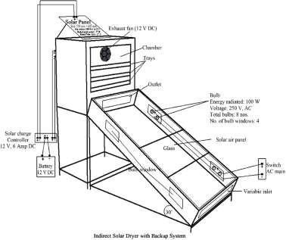

Figure 2.1.1: Indirect Solar Dryer with Backup System
Figure 2.1.1 illustrates a more advanced configuration of an indirect solar dryer, featuring a backup system composed of a solar panel, battery, and DC exhaust fan. The solar collector in this design is a sloped, glazed enclosure that captures solar energy, which is then converted into thermal energy by internal black-painted absorbing surfaces. The hot air generated inside the collector flows upward due to density differences and enters the drying chamber through a channel.
The drying chamber contains multiple trays arranged vertically, where sliced agricultural produce is spread in thin layers. A 12 V DC exhaust fan installed at the top of the chamber assists in drawing the hot air uniformly over the trays and expelling the moist air through an outlet. The fan is powered by a solar panel that charges a 12 V DC battery via a solar charge controller. For night-time or low-radiation support, the system includes 100 W bulbs installed within “bulb windows” to provide thermal backup and ensure continuous drying, particularly in humid or cloudy weather.
This design ensures enhanced airflow, temperature stability, and reduced drying time. However, it is important to note that the system constructed in this present study did not incorporate electrical backup or forced convection elements. Instead, the fabricated dryer was designed to operate under natural convection, with airflow driven solely by thermal gradients between the collector and the outlet vent.
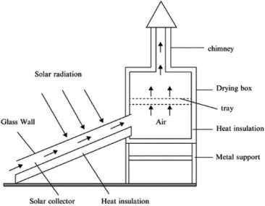

Figure 2.1.2: Basic Indirect Solar Dryer (Without Backup System)
Figure 2.1.2 presents a more conventional or passive indirect solar dryer, resembling the one constructed in this study. The primary components of this dryer include a slanted solar collector, a drying chamber, a chimney for air exit, and supporting frames. Solar radiation passes through the transparent glazing (glass wall) of the collector and strikes the absorber plate beneath it. The absorber typically black-coated metal or aluminum converts solar radiation into heat, warming the air inside the collector channel.
As the air is heated, its density decreases, causing it to rise naturally into the drying chamber. This continuous movement of hot air creates a natural draft effect, promoting the flow of air through the trays where the product is laid. Moist air rises further and escapes through a chimney placed at the top of the drying box. This chimney effect improves air circulation and maintains the drying gradient necessary for continuous moisture removal.
In the system used for this research, the indirect solar dryer was constructed using an iron skeleton structure, covered with HDF plywood board and transparent glass (10mm inner and 5mm outer layer) on the collector side. The absorber was painted black for enhanced heat absorption, and the inner trays were plastic (non-metallic), placed on a fixed iron rack inside the chamber. The construction excluded fans, bulbs, solar panel, or any electrical components.
To better appreciate the operation of the indirect solar dryer, it is important to understand the role of each component and the physical principles they embody:
- Solar Collector: The collector is the heart of the system. It converts solar radiation into thermal energy through a process of radiation absorption. Solar rays penetrate the transparent glass layer and are absorbed by a dark-colored metal sheet. This sheet, with high absorptivity and low reflectivity, transfers heat to the air trapped within the enclosed collector. The transparent glass also acts as a cover that reduces convective heat loss and enhances the greenhouse effect, allowing sunlight in while reducing re-radiation of heat out. The slant angle of the collector (30° in the backup system diagram) is designed to maximize solar exposure depending on the latitude of the location (in this case, southwestern Nigeria). As the temperature rises, the less dense air becomes buoyant and begins to flow into the adjacent drying chamber.
- Drying Chamber and Trays: The drying chamber is a thermally insulated enclosure where pepper slices are spread on trays. These trays are perforated (if metal) or open (if plastic) to permit even distribution of hot air across the sample. The primary mechanism of moisture removal here is convection: the heated air transfers energy to the pepper, raising its surface temperature and facilitating evaporation of moisture. Heat conduction from the tray into the pepper, and evaporation of water from the internal cells toward the surface, are enhanced by consistent air movement. The chamber is typically coated or lined to retain heat and minimize losses through conduction.
- Chimney or Outlet Vent: In passive systems, the chimney serves a crucial role in facilitating natural convection. As hot moist air accumulates in the drying chamber, it becomes lighter and escapes through the chimney, drawing fresh hot air from the collector. This creates a continuous airflow cycle that maintains the drying environment. The height and width of the chimney can significantly influence airflow velocity and drying rate.
- Insulation and Structural Materials: Thermal insulation (e.g., fiberglass, foam, or wood board) is used to reduce heat loss to the surroundings, especially from the sidewalls and base of the drying chamber. The materials selected for construction must be durable, non-toxic, and stable under high temperatures. In the constructed unit, wood was used for paneling, and joints were sealed to prevent leakage. All internal parts were painted black to enhance absorption, and aluminum angle iron was used to prevent water ingress between glass and frame joints during rain.
- Air Movement Mechanism: In the backup-supported version, airflow is mechanically enhanced by an electric fan that operates on solar power or battery charge. This increases airflow rate and drying efficiency, especially in highhumidity conditions or during low solar radiation. In contrast, the passive version depends solely on thermal buoyancy, warm air rising and cool air being drawn in to maintain airflow. Though less aggressive, it is effective and more energyefficient.
- Backup Heating (Bulbs): In the advanced system (Figure 2.1), the inclusion of bulbs as a thermal backup ensures the drying process can continue during cloudy days or at night. These bulbs emit heat, not light, and are typically arranged at strategic locations within the collector to maintain air temperature. However, this adds to the operational cost and energy dependency, which is why it was excluded from the built version used in this study.
Both configurations of the indirect solar dryer operate on the same underlying physical principles: capture of solar radiation, conversion into heat, transfer of heat to airflow, and removal of moisture through evaporation and ventilation. However, the presence of a fan, battery, and electrical heating backup in the advanced model allows for enhanced efficiency, shorter drying times, and controlled conditions.
The constructed system used in this study adhered to the passive model (Figure 2.2), which though is slower, is more sustainable and cost-effective for rural or low-resource settings. It was successfully used to dry pepper, with hourly temperature and moisture readings taken to evaluate performance across multiple days.
The effectiveness of an indirect solar dryer is governed by three primary modes of heat transfer: convection, conduction, and radiation, all of which work synergistically to dry the agricultural produce.
- Convection is the dominant mechanism in the indirect drying process. As solar radiation heats the air in the collector, the air becomes lighter (less dense) and rises naturally into the drying chamber. This upward flow of warm air is what drives moisture removal from the pepper slices placed on the trays. As the warm air contacts the moist pepper surfaces, it absorbs moisture, creating a vapor-rich environment that continues to move upward and is eventually vented through the outlet or chimney. In systems with fans (as seen in Figure 2.1), this airflow is mechanically accelerated, leading to faster drying. In the naturally ventilated model used in this study (Figure 2.2), convection occurs passively, relying on the buoyancy effect created by temperature gradients.
- Conduction, while less dominant, plays a critical role in the initial transfer of thermal energy from the hot air or heated tray surfaces into the pepper slices. As the hot air bathes the trays, heat is conducted through the tray material (especially if metallic) and into the lower layers of the pepper. The internal moisture within each slice also migrates toward the surface through molecular conduction, after which it evaporates into the air. Although conduction is a slower process compared to convection, it is essential for drying the inner tissues of the pepper.
- Insulation acts as a thermal barrier that prevents heat loss from the system to the external environment. In the constructed dryer, insulation was achieved by using fiber material between the chamber walls and by minimizing heat bridges at the joints. This ensured that the majority of the heat energy captured remained within the system to support evaporation, rather than dissipating through structural leakage. Proper insulation improves the thermal efficiency of the system and reduces temperature fluctuations that may slow down drying.
Collectively, these heat transfer modes ensure a continuous cycle: radiation heats the air, convection carries the heat to the drying chamber, conduction transfers it to the pepper, and insulation retains the thermal energy in which all contributes to efficient moisture removal.

2.2 Working Principle and Physics of Greenhouse Solar Dryer
The greenhouse solar dryer is a modified greenhouse structure used for drying agricultural products by trapping solar radiation and creating a warm, enclosed environment that enhances moisture removal. It is particularly effective in reducing postharvest losses, improving product hygiene, and providing a consistent drying environment irrespective of fluctuating external weather conditions.
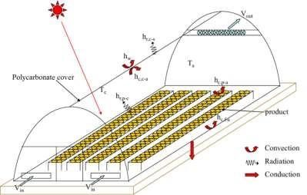

Figure 2.2.1: Working Principle of a Greenhouse Solar Dryer
Figure 2.2.1 illustrates the basic configuration and thermal behavior of a typical greenhouse solar dryer. The structure consists of a transparent polycarbonate cover that allows incoming solar radiation to penetrate the drying chamber. This cover is responsible for creating the greenhouse effect, whereby shortwave solar radiation enters the dryer, heats up internal surfaces, and is then re-radiated as long wave infrared energy that becomes trapped, increasing the internal temperature of the chamber.
The diagram features thermodynamic elements labeled as convection, radiation, and conduction to represent the different modes of heat transfer active within the dryer:
Radiation is the initial energy input, where sunlight directly enters through the transparent cover and heats the air, floor, and any black-painted surfaces inside the dryer. These surfaces then emit long wave infrared radiation, which is partially trapped inside the chamber, contributing to the internal heat buildup.
Convection occurs as the heated air inside the chamber becomes less dense and begins to rise. Cooler air from the bottom is drawn in to replace the rising hot air, creating a continuous flow cycle. This natural air circulation enhances the transfer of moisture from the surface of the product into the air stream.
Conduction is responsible for the transfer of heat through solid materials such as the floor, tray holders, and metallic parts of the frame. As these materials heat up from radiation, they pass thermal energy into the produce that is in direct contact with them. This aids in drying from the underside of the product, complementing the convective drying above.
The airflow in the system is represented by V-in and V-out, indicating the air inlet and outlet, respectively. Cool air enters through V-in near the base of the structure, is heated by solar radiation, and then rises due to convection. The warm, moisture-laden air exits through V-out, usually located near the top ends or ridge of the dryer. This passive ventilation system ensures that humidity does not accumulate excessively within the chamber, thus preventing microbial growth and condensation.
Also visible in the diagram are symbols labeled T and H, which represent temperature and humidity, respectively. These parameters are monitored at different points within the chamber to evaluate the thermal performance of the dryer and ensure that the conditions remain within optimal drying ranges for the specific crop. For pepper, efficient drying occurs between 40°C and 55°C with moderate humidity.
The greenhouse solar dryer used in this study closely followed the structure illustrated in the diagram, with several practical adjustments. The frame was constructed using aluminum for structural rigidity and was enclosed entirely with transparent glass instead of polycarbonate. This provided excellent solar transmission and contributed to a significant internal heat gain under sunny conditions.
Prior to the commencement of drying experiments, the greenhouse dryer required repairs. The glass door and parts of the aluminum frame had been damaged and needed to be refixed. Broken glass panels were replaced, and the frame joints were reinforced to prevent heat leakage. The entire unit was mounted on a metal iron sheet, painted black to improve solar absorption and minimize heat losses through the floor. This metallic base also contributed to heating through conduction. Unlike mechanically assisted dryers, the greenhouse dryer in this project did not use any fans, heaters, or solar panels. It operated entirely on natural convection and solar energy.
The performance of a greenhouse solar dryer depends on an effective combination of solar radiation trapping, controlled airflow, and moisture removal. The following thermodynamic principles govern its operation:
- Solar Radiation and Greenhouse Effect: Solar energy enters through the transparent glazing and heats up surfaces and air within the chamber. The transparent glass transmits shortwave radiation but traps longwave re-radiation, elevating the internal temperature which is the greenhouse effect. The trapped heat leads to rapid moisture evaporation from the product.
- Convection: As the internal air heats up, it becomes less dense and rises, generating an upward flow. This creates a suction effect that draws fresh, cooler
air in from below (V-in) and pushes moist, warm air out through the outlet (Vout). The continuous circulation promotes consistent drying across trays.
- Conduction: Heat absorbed by metallic or solid surfaces (like tray supports or the metal base) is conducted to the produce in direct contact. This helps warm up the product evenly and supports the internal movement of moisture from the core of the pepper to the surface.
- Insulation: Although the glass provides transparency, its thickness and sealed construction also function as insulation. It reduces heat loss to the external environment, especially during wind disturbances or temperature drops. The aluminum frame which is a conductor, was minimized in contact exposure to retain internal heat.
These mechanisms collectively create a stable micro-environment that accelerates drying while maintaining the quality of the produce. In practical use, daily temperature inside the chamber was recorded as being consistently 6–12°C higher than ambient conditions, demonstrating strong thermal performance.

2.3 Working Principle of a Hybrid Solar Dryer
A hybrid solar dryer combines two or more energy sources to ensure consistent and efficient drying of agricultural produce, regardless of climatic variability. This system primarily uses solar energy, supplemented by auxiliary sources such as electric heaters, biomass burners, or photovoltaic systems which is to guarantee continuous drying even during cloudy weather or at night. In normal operation, solar radiation is collected by a solar thermal collector, typically made of a black-painted metallic plate enclosed in transparent glazing material like polycarbonate or glass. The solar energy heats up the absorber plate, which then transfers the heat to air within the collector via conduction. The hot air is either moved passively (natural convection) or actively (with a solarpowered fan) through a drying chamber where the agricultural products are arranged on trays.
As heated air passes through the drying chamber, it absorbs moisture from the wet produce through convective heat transfer. Simultaneously, the latent heat of vaporization enables moisture within the product to transition from liquid to vapor. This vapor is then carried away by the moving air stream, ensuring continuous drying. Exhaust vents are typically placed at the top of the chamber to allow moist air to escape, while drier air circulates in, keeping the drying cycle effective.
One of the key features of the hybrid solar dryer is the backup heating mechanism. When sunlight is insufficient, the system automatically activates an electric or biomass-based heater, or may continue operating with energy stored in batteries charged by photovoltaic panels. This ensures that drying conditions remain optimal throughout the day. The integration of temperature and humidity sensors helps regulate the environment within the chamber, reducing the risk of over-drying and preserving the quality of the product.
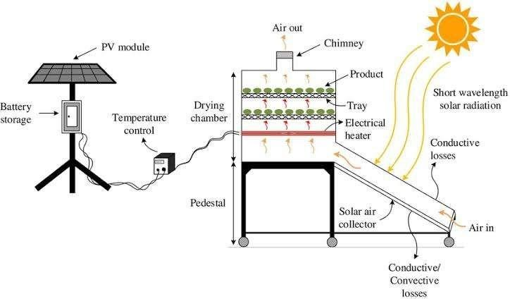

Figure 2.3.1: Working Principle of a Hybrid Solar Dryer
Hybrid dryers are especially beneficial for crops like tomatoes, peppers, and cassava, which require consistent drying conditions to prevent microbial spoilage and preserve nutritional value. Studies by Elwakeel et al. (2024) and Hossain et al. (2023) demonstrated that hybrid dryers significantly reduced drying time and improved overall efficiency compared to open sun or conventional solar drying.

2.4 Classification of Solar Dryers
Solar dryers are typically classified based on their design configuration and mode of air circulation. The two major classifications are passive solar dryers, which rely entirely on natural convection and solar radiation without auxiliary energy, and active solar dryers, which utilize mechanical or electrical components such as fans and heaters to enhance airflow and control conditions within the drying chamber. This classification plays a vital role in determining the dryer’s efficiency, cost-effectiveness, and suitability for various agricultural or industrial applications.

2.4.1 Passive Solar Dryers
Passive solar dryers are systems that utilize the natural movement of heated air generated by solar radiation for the drying process. These dryers do not require external power sources or mechanical aids, which makes them ideal for smallholder farmers and rural settings where electricity is scarce or unavailable. Passive solar dryers are further divided into two main types: direct and indirect solar dryers.
Direct Passive Solar Dryer: The direct solar dryer operates on the principle of directly exposing the product to solar radiation within an enclosed transparent chamber. The transparent cover (usually made of glass or clear plastic) allows sunlight to pass through and heat the product directly, while also trapping thermal radiation inside the chamber, increasing the internal temperature and facilitating moisture evaporation (Hossain & Bala, 2007). This system typically consists of a drying chamber, mesh trays, and a transparent roof or top surface. Although effective in raising the drying temperature, this method exposes the product to ultraviolet radiation, which may degrade certain nutrients or pigments. It also requires frequent monitoring to prevent overheating and ensure uniform drying.
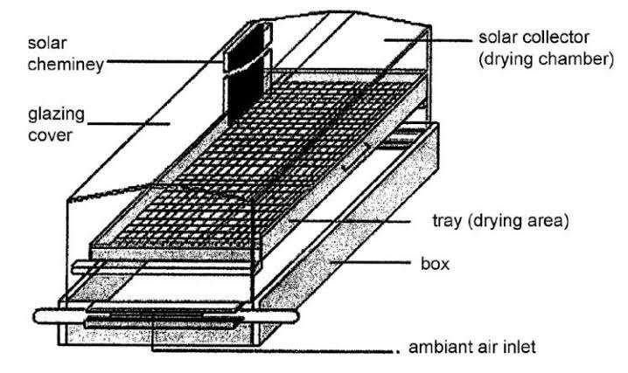

Figure 2.4.1.1: Layout of a Direct Passive Solar Dryer
The major advantage of this system is its simplicity and low construction cost. However, it is limited by factors such as uneven drying and vulnerability to weather changes. Studies by Fudholi et al. (2014) confirm that direct passive dryers are best suited for crops like tomatoes and pepper when applied in areas with high solar intensity and stable weather.
Indirect Passive Solar Dryer: In the indirect passive solar dryer, solar energy is first used to heat air in a solar collector before channeling it into the drying chamber where the product is kept. This configuration prevents direct exposure of the product to sunlight, thus preserving its color, flavor, and nutrients. The natural convection current created as the hot air rises draws cooler air from the inlet, facilitating continuous airflow through the system (Esper & Mühlbauer, 1998).
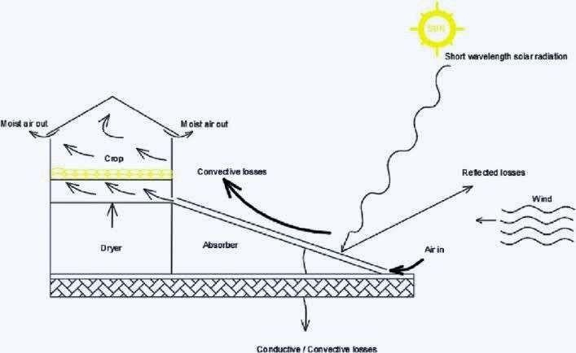

Figure 2.4.1.2 : Layout of an Indirect Passive Solar Dryer
This type of dryer enhances hygiene and reduces contamination risk, which makes it suitable for delicate crops such as herbs, spices, and leafy vegetables. Research by Bala and Woods (2001) noted that while indirect passive dryers may take slightly longer drying times compared to direct dryers, the product quality tends to be superior due to the absence of direct sunlight.

2.4.2 Active Solar Dryers
Active solar dryers incorporate mechanical components to boost the movement of heated air and regulate drying conditions, thereby ensuring faster and more uniform drying. These systems usually include fans, blowers, or photovoltaic-powered ventilation systems and are more technologically advanced than passive systems. They are further classified into indirect active, hybrid, and other integrated solar dryer designs.
Indirect Active Solar Dryer: In this system, solar energy heats air in a collector, and then a fan or blower pushes the heated air into the drying chamber. The airflow is controlled to maintain a consistent drying rate, reducing the risk of mold growth or spoilage. Unlike passive systems, indirect active dryers can operate under cloudy conditions or at night when coupled with thermal storage units (Madhlopa & Ngwalo, 2007).
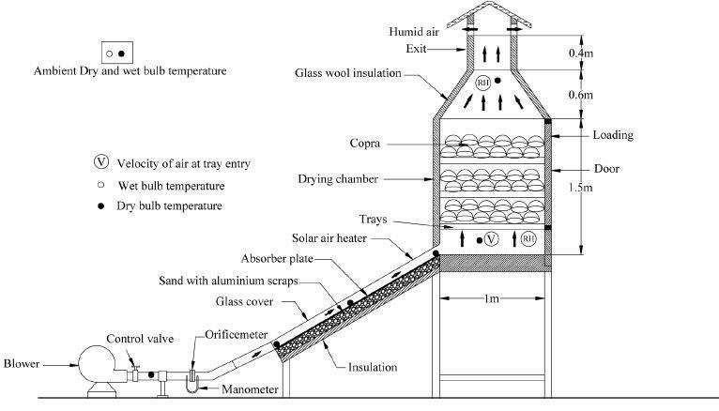

Figure 2.4.2.1: Layout of an Indirect Active Solar Dryer system
According to Janjai and Bala (2012), the major advantage of indirect active dryers is their ability to maintain higher temperatures and better control humidity levels, resulting in shorter drying durations and higher efficiency. They are ideal for high-value crops such as tomatoes, okra, and medicinal plants.
Hybrid Solar Dryer: Hybrid solar dryers combine solar energy with auxiliary heating sources such as electric heaters, LPG burners, or biomass stoves to ensure uninterrupted drying regardless of weather conditions. These dryers often include photovoltaic cells to power fans or heaters, thereby integrating renewable energy with mechanical aids for optimized performance (Hussein et al., 2017). The hybrid model is particularly useful in areas with variable weather patterns or high humidity.
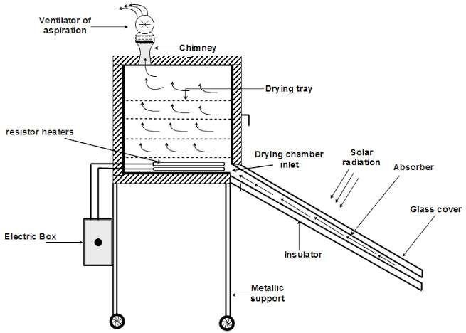

Figure 2.4.2.2: Layout of Hybrid Solar Dryer
Studies by Elwakeel et al. (2024) demonstrated that hybrid dryers achieved moisture reductions of up to 80% within 6–8 hours, significantly outperforming passive systems. The incorporation of backup systems ensures that product quality is preserved, and operational efficiency is not weather-dependent.

2.5 Design Considerations for the Solar Dryers
The design of solar drying systems requires a careful balance between thermal performance, structural durability, material availability, and the nature of the agricultural product being dried. In this study, the design of both the indirect solar dryer and the adaptation of an existing greenhouse solar dryer were centered on practical efficiency, energy independence, and preservation quality especially for a perishable, high-moisture crop like pepper. Several technical and environmental factors were taken into account to ensure the constructed systems met these performance targets within the limitations of available resources.
A fundamental consideration was the type of drying method. The indirect solar dryer was selected for its ability to isolate the product from direct solar radiation, thereby reducing the risk of nutrient degradation, color bleaching, or contamination by dust and insects. Unlike direct sun drying, the indirect method ensures that heat is transferred through warm air generated in a separate collector unit and channeled into a drying chamber. This reduces exposure to ultraviolet radiation while still taking advantage of solar energy. On the other hand, the greenhouse solar dryer although naturally allowing direct sunlight into the chamber was retained for its passive heating advantage and enclosure benefits. Its large transparent surface and closed design promote heat buildup, providing favorable thermal conditions for drying.
The nature of the product in this case, sliced pepper played a central role in determining drying chamber volume, tray surface area, and airflow rate. Pepper contains a high level of moisture and has soft, thin-walled tissue that deteriorates quickly under poor drying conditions. As such, the chamber needed to allow adequate airflow to ensure uniform drying and prevent microbial growth. The design included space for different layers of pepper on each tray to optimize surface area exposure and minimize drying time. Trays were selected to be lightweight and non-reactive; plastic trays were used in this case, supported by a welded iron within the chamber. Their spacing was planned to allow even vertical airflow through the product layers.
The inclination of the solar collector in the indirect dryer was another thermal optimization factor. A tilt angle of approximately 30° was adopted based on the latitude of the study location in southwestern Nigeria. This angle maximizes solar irradiance throughout the day, allowing optimal sunlight penetration and energy absorption. The collector surface was covered with transparent glass (10mm inner, 5mm outer) to enable greenhouse trapping while also offering durability against weather elements. The absorber plate beneath the glass was coated in black automobile paint to maximize thermal absorption and raise the internal air temperature effectively.
Material selection was driven by a need for thermal efficiency, cost-effectiveness, and local availability. The frame of the indirect dryer was constructed using welded metal sheet to provide strength and support for both the collector and the chamber. The chamber walls and collector body were lined with fiber insulation to reduce heat losses. The outer structure was enclosed with HDF plywood board and sealed to prevent air leakage. Aluminum angle were used in vulnerable junctions especially between glass and frame to prevent water seepage during rainfall. For the greenhouse dryer, existing aluminum frames were refurbished, broken glass were replaced, and the base was restructured with a painted metal sheet to enhance absorption and structural integrity.
Airflow dynamics also informed key decisions. The indirect dryer operated without forced convection; thus, the internal design was adjusted to maximize natural air movement. The collector was positioned at a height slightly lower than the chamber to encourage warm air to rise and enter the drying space by buoyancy. The outlet above the chamber helped to maintain the pressure gradient, expelling moist air and drawing in fresh hot air from the collector. This continuous flow created the draft needed for uninterrupted moisture removal, even in the absence of a fan.
Heat retention and energy efficiency were further considered through insulation design. Fiber insulation was used in the indirect dryer to minimize conductive and convective heat loss through the chamber walls. The greenhouse dryer naturally retained heat through its enclosed glass walls, but gaps from wear and tear were sealed during repairs to improve performance. These retention measures were essential for maintaining high internal temperatures without external energy input.
The ease of assembly and repair was another practical design factor. The project was executed in a low-resource setting, and as such, the design had to accommodate local fabrication techniques and materials. The indirect dryer was constructed over the course of several days, including time spent welding the frame, cutting wooden boards, and assembling the collector. The greenhouse dryer, already available, required structural modifications and realignment to restore its functionality. By prioritizing modular components, both dryers could be dismantled or upgraded with minimal technical intervention in the future.

CHAPTER THREE

MATERIALS AND METHODS

3.1 Construction Materials for the Solar Dryers
- High-density fiber (HDF) plywood boards: were used to form the outer casing of the indirect solar dryer, covering the sides and base of both the drying chamber and the solar collector. This material was chosen due to its smooth finish, ease of cutting, and moderate thermal resistance, which helped reduce heat loss from the system. HDF is also cost-effective and locally available, making it suitable for low-resource settings. When properly sealed or painted, it offers decent durability and structural support for enclosing the dryer while maintaining a clean, professional appearance.
- Transparent glass: was used as the glazing material for the solar collector in the indirect dryer and for enclosing the entire structure of the greenhouse dryer. Its primary role was to allow solar radiation to penetrate into the system while trapping long wave heat through the greenhouse effect. Glass was chosen over plastic alternatives due to its superior clarity, durability, and resistance to UV degradation. In the indirect dryer, a combination of 10mm inner and 5mm outer glass was used to enhance insulation, reduce heat losses, and maintain structural integrity under outdoor exposure.
- Black-painted metallic iron sheets: were used as the absorber within the solar collector of the indirect dryer. Their function was to absorb incoming solar radiation and convert it into heat, which in turn raised the temperature of the air within the collector. The black coating increased the surface’s ability to absorb solar energy by minimizing reflectivity, while the metal’s high thermal conductivity allowed for efficient heat transfer to the passing air. This combination enhanced the overall thermal performance of the dryer.
- Fiber material: was used as insulation within the walls of the indirect solar dryer to minimize heat loss. It was placed between the inner and outer layers of the dryer’s structure to prevent thermal conduction from the heated interior to the cooler external environment. Fiber was selected because of its low thermal conductivity, lightweight nature, and ease of installation. This helped maintain higher internal temperatures, improved drying efficiency, and reduced fluctuations caused by external weather conditions.
- Drying Trays: Instead of wire mesh, plastic trays were used to hold the pepper samples. These trays were wrapped with aluminum foil to enhance hygiene and reflectivity, minimizing contamination and improving drying surface conditions.
- Angle iron: was used to construct the metallic stand for the indirect solar dryer. It provided strong structural support for both the collector and the drying chamber, ensuring the entire unit was elevated and stable. The use of metal offered durability and resistance to bending or warping under load or prolonged sun exposure.
- Aluminum angle: was used to seal exposed gaps along the edges of the solar collector in the indirect dryer, particularly where the glass met the wooden or metallic frame. Its purpose was to prevent rainwater from seeping into the collector during wet conditions and to reduce heat loss through structural joints. Aluminum was chosen for this sealing role due to its corrosion resistance, ease of bending, and durability in outdoor environments. This helped maintain the integrity of the collector and ensured consistent thermal performance.
- Metal hinges, nails, screws, and handles were used as fastening and functional components throughout the construction of both dryers. Hinges were attached to chamber doors to allow smooth opening and closing during loading and unloading of pepper samples. Screws and nails secured the plywood panels, metal frames, and glass supports, ensuring structural firmness. Handles provided ease of access and safe operation. These materials were chosen for their mechanical strength, reusability, and resistance to wear under frequent use, all contributing to the overall durability and usability of the dryers.
- Automobile black paint: was applied to the absorber surface within the solar collector and to some internal components of the indirect solar dryer to enhance heat absorption. The color black was specifically chosen because of its high absorptivity, allowing it to capture and retain more solar radiation compared to lighter colors. By increasing the efficiency of thermal energy collection, the black-painted surfaces helped raise the air temperature inside the collector, thus improving the overall drying performance of the system.
- The aluminum framework formed the structural skeleton of the greenhouse solar dryer, supporting the glass walls. Aluminum was selected due to its lightweight nature, corrosion resistance, and structural stability under prolonged exposure to sunlight and humidity. Its strength allowed it to hold the glass wall securely in place, while its resistance to rust ensured long-term durability. The use of aluminum also made it easier to assemble and repair the structure when damaged, as was done during the rehabilitation phase of the project.

3.2 Instruments Used
To monitor the environmental and drying parameters during the experiment, the following instruments were employed:
Digital Multimeter with Sensor Probe Model DM8100: This multifunctional device was used to measure air temperature inside each drying chamber as well as the ambient environment (see figure 3.2.1).


Figure 3.2.1 Digital Multimeter with sensory probe
Digital Hygrometers: Used alongside the multimeter is the Hygrometer used to take humidity readings, ensuring accurate environmental monitoring. It can also be used to take readings of both temperature and time (see figure 3.2.2).
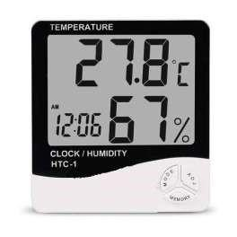

Figure 3.2.2 Digital Hygrometer
Solar Radiation Meter (Pyranometer) Model SM206: Used to measured incident solar radiation in W/m². Accurate solar input data was essential for calculating thermal efficiency (see Figure 3.2.3).
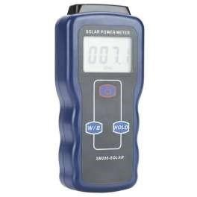

Figure 3.2.3 Solar Radiation Meter (Pyranometer)
Digital Weighing Scale: Used to measure weight loss of pepper samples at regular intervals to evaluate moisture reduction (see figure 3.2.4).
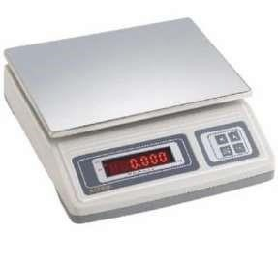

Figure 3.2.4 Digital Weighing Scale

3.3 Construction Process
The construction process commenced with meticulous planning and detailed design schematics to guide the fabrication of both the indirect and greenhouse solar dryers. Accurate dimensional measurements were taken to ensure that each component would align properly during assembly.
For the indirect solar dryer, the solar collector was constructed using a flat metallic plate measuring 123 cm in length, 57 cm in breadth, and 21 cm in height. This plate functioned as the primary absorber of solar radiation, intended to heat the incoming air before it passed into the drying chamber. The drying chamber (cabinet), designed to house the produce trays, was built with a length of 85 cm and a breadth of 52.5 cm. At the upper rear section, a chimney was installed and slightly tilted to permit rainwater drainage. The chimney components were fabricated with the following dimensions:
- Chimney back: 38 cm × 28.5 cm
- Chimney sides: 20.5 cm × 38 cm
- Chimney head: 28.5 cm (length) × 33 cm (breadth) × 12.5 cm (height)
An access door measuring 72 cm in length and 67 cm in breadth was incorporated into the drying cabinet to allow easy handling of trays and inspection of the drying process.
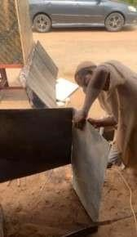

Figure 3.3.1 during welding process of the indirect solar dryer
The frame components, including the collector plate and structural elements, were transported to a local welding workshop located in GRA, Ilorin, behind the Governor’s Office. Welding was carried out under close supervision to ensure strict adherence to the specified dimensions and design.
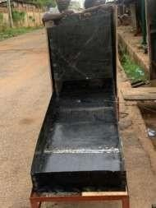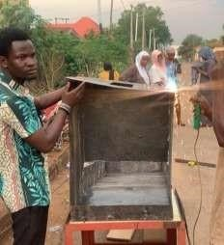

Figure 3.3.2 welded framework of the indirect solar dryer
Upon completion, the assembled frame was returned to the department and painted using automobile-grade black paint to enhance solar absorption. After the paint dried, the entire unit was mounted on a decking platform behind Physics Laboratory A, selected for its elevation and lack of shading obstructions. A ladder was used to transport and position the dryer on the platform. The structural casing was constructed using High-Density
Fibreboard (HDF) plywood, which was used to enclose the dryer’s sides. The top portion of the collector was covered with transparent glass to allow sunlight penetration. Two glass layers were installed:
- Inner layer: 10 mm thick
- Outer layer: 5 mm thick
The edges were sealed using aluminum angles, while rubber lining was added to prevent water ingress during rainfall. Additionally, hinges, handles, and locks were installed to facilitate ease of access and improve operability. The assembly process involved the use of nails, screws, and hammers to ensure structural integrity. Following completion, the entire unit was thoroughly cleaned, both internally and externally.
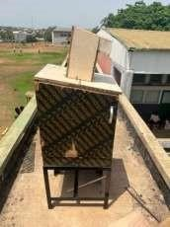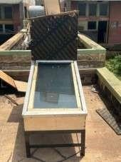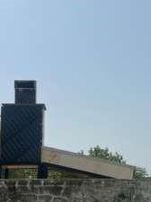

Figure 3.3.3 completed construction of the indirect solar dryer
Work was also undertaken on an existing greenhouse solar dryer, which required repairs to restore its operational integrity. The main structural dimensions of the greenhouse dryer were:
- Overall body: 154.5 cm (length) × 104.5 cm (breadth) × 100 cm (height)
- Raised head section: 104.5 cm (length) × 55 cm (breadth) × 49.5 cm (height)
A new collector plate was fabricated and installed, measuring 149 cm in length and 102 cm in breadth. Repair work included replacing broken glass panels and rebuilding the door.
After repairs, the entire unit was cleaned, reassembled, and prepared for experimental use.
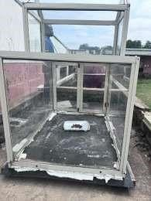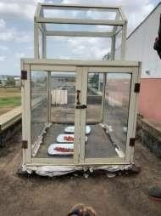

Figure 3.3.4 completed construction of the greenhouse solar dryer
Both the indirect and greenhouse solar dryers were mounted side by side on the same elevated platform and aligned in the same direction to ensure uniform solar exposure during testing. This strategic placement helped to maintain consistent environmental conditions and optimize performance comparison between the two systems throughout the experimental period.

3.4 Experimental Setup
The experimental setup began with the preparation of our sample fresh red pepper (Capsicum spp.) used for the drying process. The peppers were purchased from Mandate Market in Ilorin and then brought to the laboratory for preparation. The harvested peppers were washed with clean water to remove any surface contaminants. After washing, the stems were removed, and each pepper pod was carefully sliced into two halves to enhance moisture release during the drying process.
Next, plastic trays were wrapped with aluminum foil, and the weight of each empty tray (including the foil) was measured using a digital weighing scale. This initial measurement was necessary to determine the net weight of the pepper after loading. The sliced peppers were then evenly arranged into three trays in which one was assigned to each of the drying systems: the indirect solar dryer, the greenhouse solar dryer, and the open sun drying method.
Each tray was weighed again after loading with the pepper slices. The actual weight of the pepper was obtained by subtracting the tray-and-foil weight from the total weight. These trays were then placed inside their respective drying systems, all of which had been previously installed on a decking located behind Physics Laboratory A, Kwara State Polytechnic, Ilorin. The open sun drying tray was placed on a layer of nylon sheet directly on the decking to protect it from contamination.
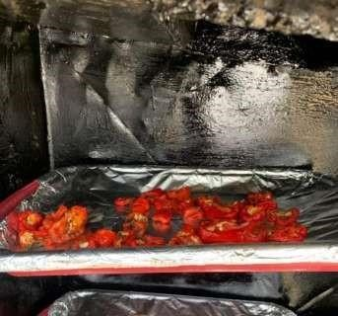

Figure 3.4.1: Pepper in the tray placed inside Indirect Solar Dryer
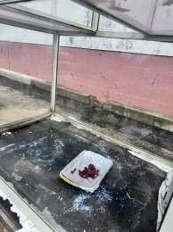

Figure 3.4.2: Tray placed inside Greenhouse Solar Dryer
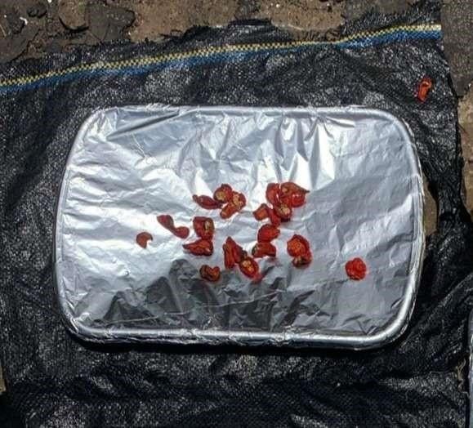

Figure 3.4.3: Tray placed under Open Sun Dryer
Measurements and observations were carried out hourly from 9:00 am to 5:00 pm daily, across a three-day drying period. The data collected included: Chamber temperature and humidity inside each dryer, using a digital multimeter with probe sensors and digital hygrometer. Weight of pepper samples, using a digital weighing scale, recorded to track moisture loss over time.
Each measuring instrument was calibrated daily before use to ensure accuracy. During the experiment, a sensor fault was detected in the digital multimeter, which led to unusual temperature readings. This was corrected by replacing the faulty probe and changing the batteries of both the multimeter and weighing balance to maintain consistent performance. Although data collection was interrupted for a few hours due to rainfall, observations resumed immediately when conditions stabilized. The same trays remained in their original positions throughout the experiment, and no agitation or turning of the pepper slices was performed, ensuring uniform exposure across all setups.
The entire setup allowed a systematic comparison between the indirect solar dryer, greenhouse solar dryer, and open sun drying method, focusing on their respective thermal efficiency, moisture removal capacity, and drying performance under real environmental conditions.

3.5 Performance Evaluation Parameters
To assess the effectiveness of the solar dryers used in this research, which are greenhouse solar dryer, indirect solar dryer, and open sun drying. Several thermal and physical parameters were calculated. These parameters help in understanding the drying behavior, energy utilization, and efficiency of the systems. The main parameters considered include moisture content, drying rate, and thermal efficiency.
Moisture content: This is a critical parameter in drying studies, as it reflects the amount of water present in the product at any given time. It determines the quality and shelf-life of dried products. During drying, the moisture content decreases progressively until it reaches a level safe for storage. Inadequate drying can lead to microbial growth, spoilage, and loss of quality, while over-drying may reduce nutrient content and increase energy usage. In this research, the moisture content was calculated on a wet basis, which is more common in food processing studies.
The formula used is:
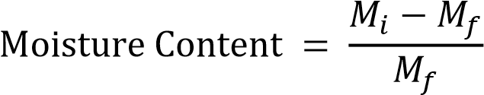
= Initial Weight
= Final Weight
This formula provides the moisture removed relative to the original weight of the material. For each drying method, weights were recorded hourly, and the reduction in mass was used to compute the moisture loss throughout the drying period. Accurate determination of moisture content is essential for comparing the drying performance of different systems. This approach is widely used in solar drying studies, particularly in agricultural products like cassava, tomatoes, and peppers (Mohammed et al., 2021; Bala, 1997; Onuoha & Obetta, 2010).
- Drying rate: This is another essential parameter that indicates the speed at which moisture is removed from a substance. It helps in understanding the drying kinetics and how efficiently the solar dryer performs over time. A higher drying rate suggests faster moisture removal, better thermal performance, and reduced drying time, all of which contribute to energy savings and product quality. It is measured in grams per hour (g/h) or kg/h and expressed as:
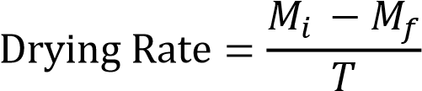


For Wet Basis:
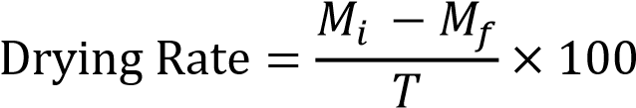
The drying rate gives insights into the drying behavior at each stage. For example, drying is usually faster in the initial stage when the moisture content is high and slows down as the product loses moisture. These trends were carefully observed and calculated during the Eight-day experimental period in this study. A steady or high drying rate usually reflects good heat and mass transfer characteristics of the dryer (Hossain & Bala, 2007; Janjai & Bala, 2012). By comparing drying rates across the greenhouse, indirect, and open sun drying methods, one can determine which system achieves quicker drying with minimal nutrient and quality loss.
- Thermal efficiency (or drying efficiency): This is a measure of how well the solar dryer converts incident solar energy into useful energy for moisture removal. It reflects the effectiveness of the system in utilizing available solar radiation to generate heat that facilitates drying. The thermal efficiency was calculated using the formula:
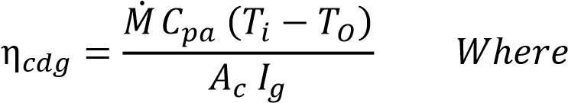:
∶ 𝑀 𝑀𝑎𝑚
∶ 𝑚 𝑚𝑎𝑀𝑚
∶ 𝑚 𝑚𝑎𝑀𝑚
∶ 𝑀 𝑀 𝑀𝑀𝑏
∶ 𝑚 ℎ 𝑚
This equation helps determine how much of the captured solar energy was used in evaporating moisture from the product. A higher efficiency indicates a better-performing solar dryer with minimal energy losses. The efficiency is affected by several factors, including the design of the collector, insulation, airflow, ambient temperature, and solar intensity. For this study, efficiency values were calculated for both the indirect and greenhouse dryers using the recorded solar radiation and moisture loss data. Solar radiation was measured hourly using a pyranometer or solar meter, and temperature data helped in validating thermal performance.
This method is frequently adopted in solar drying literature (Bukola & Ayoola, 2008; Janjai & Bala, 2012) and serves as a benchmark to compare the performance of different solar drying systems.

3.6 Sample Calculations Using Experimental Data (Day 1 - Day 6)
3.6.1 Calculation of Moisture Content Tray 2

– Open Sun Drying (DAY 1)
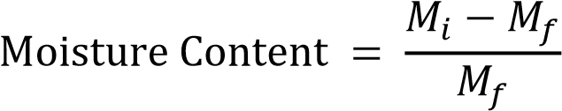
Initial Weight : 364g
Final Weight : 305g
Time: 9:00

Tray 9 – Indirect Sun Drying (DAY 1)
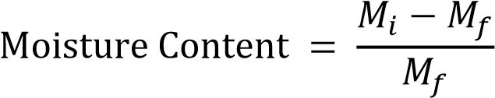
Initial Weight : 451g
Final Weight : 314g
- Time: 9:00
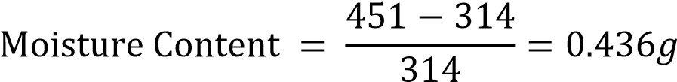
- Time: 10:00

Tray 3- Greenhouse (Day 1)
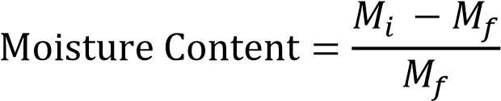
Initial weight = 442g
Final weight = 293g
- Time: 9:00
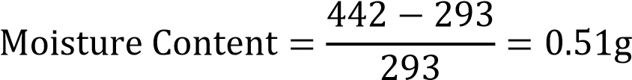
- Time: 10:00
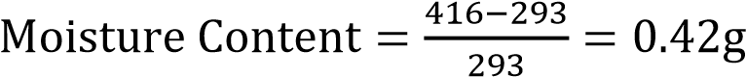

3.6.2 Calculation of Drying Rate & (Wet %) Tray 2 – Open Sun Drying (DAY 1)
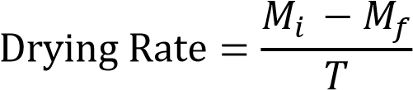
Initial Weight : 364g
Final Weight : 305g
- Time: 9:00
- Time: 10:00

Tray 9 – Indirect Drying (DAY 1)
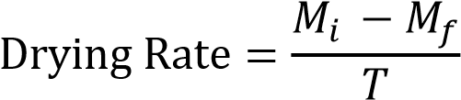
Initial Weight : 451g
Final Weight : 314g
- Time: 9:00
- Time: 10:00

Tray 3 – Greenhouse Drying (DAY 1)
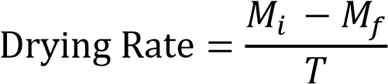
Initial Weight : 442g
Final Weight : 293g
- Time: 9:00
- Time: 10:00
3.6.3 Calculation of Efficiency

Tray 2 – Indirect Solar Dryer (DAY 1)
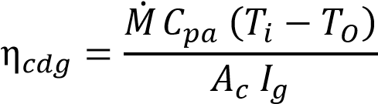
∶ 𝑎𝑙 𝑚 𝑀𝑎
ℎ𝑚 ∶ 1.005 //ᵒC
∶ 𝑀 𝑀𝑎𝑚
∶ 𝑚 𝑚𝑎𝑀𝑚
∶ 𝑚 𝑚𝑎𝑀𝑚
∶ 𝑀 𝑀𝑀𝑏
∶ 𝑚 ℎ 𝑚 (𝑚 𝑚)
ℎ𝑚 ∶ 2 ( + ℎ + ℎ) = 2 (1.23 × 0.57 + 0.57 × 0.21 + 1.23 × 0.21)
= 2.16m²
- Time: 9:00
- Time: 10:00

Tray 2 – Greenhouse Dryer (DAY 1)
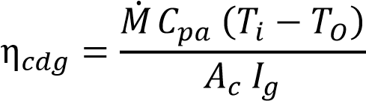
∶ 𝑎𝑙 𝑚 𝑀𝑎
ℎ𝑚 ∶ 1.005 //ᵒC
∶ 𝑀 𝑀𝑎𝑚
∶ 𝑚 𝑚𝑎𝑀𝑚
∶ 𝑚 𝑚𝑎𝑀𝑚
∶ 𝑀 𝑀𝑀𝑏
∶ 𝑚 ℎ 𝑚 (𝑚 𝑠𝑀𝑚)
ℎ𝑚 ∶ ( × ) = (1.49 × 1.02) = 1.52²
- Time: 9:00
- Time: 10:00

CHAPTER FOUR 4.0

RESULT AND DISCUSSION
This study rigorously assessed the efficacy of various solar drying systems for dehydrating peppers, with the goal of identifying the most efficient method while elucidating the unique benefits associated with each drying technique employed. Over a three-day period, an initial sample of 451g of pepper was reduced to 314g using an indirect solar dryer. In contrast, a greenhouse solar dryer effectively decreased a 442g sample of peppers to 293g, while open-air drying resulted in a reduction of 364g of peppers to 305g. Key parameters measured during these experiments included (a) solar radiation incident on the collector, (b) ambient temperature, (c) internal temperatures of the drying chambers for both the indirect and greenhouse solar dryers, (d) collector temperature in the indirect solar dryer, (e) ambient humidity levels, (f) moisture content of the dried product, and overall drying rates, adhering to the international standards established by ASABE/ASAE (2007) for solar air collectors. Temperature measurements were conducted at multiple points within the collectors and chambers utilizing a K-type thermocouple multimeter, with the drying regimen proceeding daily from 8:00 AM to 4:00 PM.

CHAPTER FIVE 5.0

CONCLUSION
This study was carried out to design, construct, and evaluate the comparative performance of three different drying methods which are open sun drying, an indirect solar dryer, and a greenhouse solar dryer for preserving pepper. The primary goal was to assess which of the systems provides the most efficient and effective drying conditions in terms of moisture removal, temperature stability, and overall performance.
The experimental procedure involved drying pepper slices under each of the three systems, with hourly measurements taken for temperature, humidity, solar radiation, and sample weight across several days. The performance of each system was evaluated based on moisture content reduction, drying rate, and thermal efficiency.
From the data obtained, it was observed that the greenhouse solar dryer consistently recorded the highest internal temperature, followed closely by the indirect solar dryer, while direct sun drying (open sun) showed the lowest and most fluctuating temperature values. These temperature patterns had a direct impact on drying performance. The greenhouse dryer achieved the fastest moisture reduction, indicating a more stable and controlled drying environment. The indirect dryer also showed improved performance compared to open sun drying, particularly in maintaining hygiene and reducing contamination risks. In terms of drying efficiency, both the greenhouse and indirect systems outperformed the open sun method, demonstrating the advantage of using structured drying systems in minimizing spoilage, improving drying speed, and preserving nutritional quality.
The findings from this project confirm that incorporating engineered solar dryers particularly the greenhouse and indirect type can significantly improve the drying of pepper, contributing to better post-harvest handling, reduced losses, and improved product quality. The results encourage the adoption of such systems among local farmers and food processors, especially in rural areas where electricity is not readily available.

5.1 RECOMMENDATIONS
It is recommended that small- and medium-scale farmers adopt greenhouse or indirect solar drying systems, as these technologies offer improved drying efficiency and better hygiene standards for agricultural products.
Furthermore, governmental bodies and agricultural development agencies are encouraged to promote the adoption of solar drying technologies by offering subsidies, capacitybuilding programs, and awareness campaigns. These initiatives can play a vital role in reducing post-harvest losses and strengthening food security.
Finally, future research on drying systems should prioritize the development and evaluation of hybrid drying technologies that integrate solar energy with auxiliary heating sources. Such innovations would ensure consistent drying performance during periods of low solar intensity or nighttime operation.

REFERENCES
Adejumo, B. A., Fapetu, O. P., & Aladejana, J. A. (2023). Design and performance evaluation of a hybrid solar dryer for drying cassava grates. Asian Food Science Journal, 22(6), 77–87.
Affognon, H., Mutungi, C., Sanginga, P., & Borgemeister, C. (2015). Unpacking postharvest losses in sub-Saharan Africa: A meta-analysis. World Development, 66, 49– 68.
Aigbede, M., Saka, M. A., & Abiodun, D. (2025). Mathematical modeling of solar drying systems: A case study in Cotonou, Benin. Journal of Food Engineering and Research, 37(2), 112–124.
Akinola, A. O., Akinyele, T. A., & Odedairo, B. O. (2015). Evaluation of traditional sun drying and solar drying on the quality of pepper. Journal of Agricultural Technology, 11(4), 785–794.
Ajibola, O. O., Fapetu, O. P., & Afolayan, M. O. (2017). Design and performance evaluation of a solar dryer for agricultural products. Agricultural Engineering International: CIGR Journal, 19(2), 152–160.
Bala, B. K. (1997). Drying and storage of cereal grains. Science Publishers.
Bala, B. K., & Mondol, M. R. A. (2001). Experimental investigation on solar drying of fish using solar tunnel dryer. Drying Technology, 19(2), 427–436.
Bala, B. K., & Woods, J. L. (2001). Simulation of the indirect natural convection solar drying of rough rice. Solar Energy, 69(1), 89–98. https://doi.org/10.1016/S0038-
092X(00)00128-8
Balogun, M. A., Adeyanju, A., & Sanni, L. O. (2017). Performance evaluation of a doublecompartment solar dryer for tomato preservation. African Journal of Agricultural Engineering, 10(4), 158–166.
Bukola, O. B., & Ayoola, A. A. (2008). Performance evaluation of a mixed-mode solar dryer. AU Journal of Technology, 11(4), 225–231.
Chouikhi, T., & Amer, B. (2023). Experimental and numerical analysis of a PV/T-based solar dryer for tomato slices. Renewable Energy Technologies Journal, 45(3), 203–215.
Dash, R., Castillo, C., & Amparo, J. (2025). Comparative analysis of greenhouse solar drying and open sun drying of corn in Bukidnon. International Journal of Sustainable Agriculture, 29(1), 56–70.
Deepak, B., & Behura, A. K. (2025). Thermodynamic and environmental analysis of a solar dryer with thermal storage. Scientific Reports, 15, 91971.
https://www.nature.com/articles/s41598-025-91971-4
Elwakeel, E. E., Mohamed, S. H., & Soliman, A. (2024). Performance assessment of a tracking hybrid solar dryer powered by photovoltaic cells. Renewable Energy Systems, 45(3), 210–223.
Elwakeel, E. E., Shalaby, A., & Omar, M. (2024). Energy and environmental analysis of a tracking indirect solar dryer for tomato slices. Solar Energy Applications, 36(1), 77–90.
El-Mesery, H. S., & Mao, L. (2023). Drying behavior of tomato slices under infrared radiation: Effects of air velocity and radiation intensity. Journal of Thermal Science and Technology, 28(2), 98–109.
El-Sebaii, A. A., & Shalaby, S. M. (2012). Solar drying of agricultural products: A review.
Renewable and Sustainable Energy Reviews, 16(1), 37–43.
Esper, A., & Muhlbauer, W. (1996). Solar drying: An effective means of food preservation. Renewable Energy, 7(2), 119–127.
Esper, A., & Mühlbauer, W. (1998). Solar drying—An effective means of food preservation. Renewable Energy, 15(1-4), 95–100.
Mujaffar, S., & Lalla, K. (2020). Evaluation of the drying behavior and quality of cassava chips using a natural convection dryer. Journal of Food Process Engineering, 43(10), e13429. https://doi.org/10.1111/jfpe.13429
Njue, J., & Wawire, A. (2021). Design and performance evaluation of a solar dryer for drying cassava chips in Kenya. African Journal of Agricultural Research, 16(4), 275–284.
Nwakuba, N. R., Ugwuishiwu, B. O., Ohagwu, C. J., & Oraku, N. J. (2020). Simulation and optimization of drying kinetics of pepper in a hybrid solar dryer. Journal of Food Process Engineering, 43(6), e13357.
Nwakuba, S. U. N., & Anyaoha, K. (2020). Optimization of convective air drying in a hybrid PV/T solar dryer using response surface methodology. Turkish Journal of Agricultural Engineering Research, 1(1), 111–130.
Obasi, K. E., Nwoko, C. O., & Chidiebere, I. J. (2025). Impact of solar and oven drying on the nutritional and microbial quality of okra and tomatoes. Nigerian Journal of Food Science, 42(1), 99–115.
Ogundana, A. K., Usman, I. A., & Danladi, S. A. (2022). Design and performance evaluation of a solar dryer for drying agricultural products in Kainji, Nigeria. Nigerian Journal of Technology, 41(5), 789–795.
Okeyode, I. C., & Okuyelu, A. (2023). Development of a multifunctional electric-solar dryer for cassava and red pepper. International Journal of Sustainable Energy, 42(1), 45– 56.
Sharma, A., Chen, C. R., & Lan, N. V. (2009). Solar-energy drying systems: A review. Renewable and Sustainable Energy Reviews, 13(6–7), 1185–1210.
Silayo, V. K., Mpagalile, J. J., & Ishengoma, R. C. (2015). Performance of different drying platforms for cassava chips. Tanzania Journal of Agricultural Sciences, 14(1), 33– 42.
Singh, A. K., & Gaur, M. K. (2021). Design and techno-economic evaluation of a hybrid active greenhouse dryer for tomato. Environmental Science and Pollution Research, 28, 13210–13226.
Suherman, S., Kurniawan, A., & Prasetyo, D. (2018). Evaluation of solar tray dryer performance for cassava starch. International Journal of Food Science, 2018, 1–6.
https://doi.org/10.1155/2018/3058306
Tiwari, G. N., & Jain, D. (2001). Thermal modeling of a greenhouse dryer for drying agricultural crops. Solar Energy, 71(2), 155–167.
Tiwari, G. N., Kumar, S., & Prakash, O. (2016). Solar drying technology: Concept, design, testing, modeling, economics, and environment. Springer International Publishing.
Tripathy, P. P., & Kumar, S. (2009). Performance evaluation of a solar biomass hybrid dryer for turmeric (Curcuma longa) drying. Journal of Renewable and Sustainable Energy, 1(4), 043109.
Vitouley, D. R., Houngan, A., & Adjovi, E. (2025). Development and performance analysis of a forced convection dryer for Akikon tomatoes in Benin. West African Journal of Agricultural Innovation, 31(2), 211–226.

