DESIGN,CONSTRUCTIONANDCOMPARATIVETHERMALANALYSISOF SOLAR DRYERS FOR DRYING CASSAVA USING DIRECT SUN DRYING, INDIRECT AND GREENHOUSE METHODS
PREPAREDBY

AKANBI SEGUN
HND/23/SLT/FT/0007

SUBMITTEDTOTHE

DEPARTMENTOFSCIENCELABORATORYTECHNOLOGY(PHYSICSAND ELECTRONICSUNIT),INSTITUTEOFAPPLIEDSCIENCES,KWARASTATE POLYTEHNIC, ILORIN.
INPARTIALFULFILMENTFORTHEAWARDOFHIGHERNATIONAL DIPLOMA (HND) IN SCIENCE LABORTORY TECHNOLOGY
SUPERVISED BY:

DR.OLAORE K.O.
2024/2025 SESSION

CERTIFICATION

This is to certify that this project work has been written by AKANBI SEGUN with matric numbers HND/23/SLT/FT/0007 and has been read and approved as meeting the parts of the requirements for the award of Higher National Diploma (HND) in Science Laboratory technology Department (Physics and Electronics Unit), Institute of Applied Sciences, Kwara State Polytechnic.

DR.OLAOREK.O. DATE
(ProjectSupervisor)

MRSALAHU BASHIR DATE
(Headof Unit)

DR.USMANA. DATE
(Headof Department)

EXTERNALEXAMINER DATE

DEDICATION
This work is dedicated to Almighty God, for his grace, mercy and guidance over me before, during and after the completion of my academic pursuit. All Glory to God and my Supervisor (Dr.OlaoreK.O.) also to my parent, and friends who has never failed to give me financial and moral support for all my needs during the time I developed my systems and for teaching me that even the largest task can be accomplished if it is done one step as a time.

ACKNOWLEDGEMENT
I express my sincere gratitude to God Almighty for the success of this project. I also express our sincere gratitude to my parents, my siblings and friends for supporting me through the cause of this project. My gratitude to Dr. Olaore K.O. for his time and supporting in monitoring and supervising me through this project. Thank you for shaping this project and enhancing my learning experience.
Futhermore, my special thanks goes to the Head of Department of Science Laboratory Technology Dr. Usman A. and my Head of Physics and Electronics Unit Mr. Salahu Bashir for been there for me all in time.
May God bless and keep you all (amen).

TABLE OFCONTENT

TitlePage i
Certification ii
Dedication iii
Acknowledgement iv
Table OfConent v
List ofTables vi
List ofFigures vii
Abstract viii
CHAPTERONE
Introduction 1
BackgroundOfThe Study 1
ProblemStatement 5
AimoftheStudy 7
Objectivesof theStudy 7
Scopeofthe Study 7
Justificationof theStudy 8
CHAPTERTWO
LiteratureReview 10
SolarDrying Technology 24
Classificationof SolarDryers 26
PassiveSolarDryers 26
ActiveSolarDryers 29
WorkingPrincipleand physicsofIndirectSolar Dryer 31
WorkingPrincipleand Physicsof GreenhouseSolar Dryer 38
WorkingPrinciple ofa Hybrid Solar Dryer 41
Design ConsiderationsfortheSolarDryers 43
MaterialSelectionandDurabilityinSolarDryer Fabrication 45
CHAPTERTHREE
MaterialsAndMethod 47
Materials 47
DirectSunDryingSystem 47
IndirectSolarDryer 47
HighDensityFibreboard(HDF) 47
TransparentCover 48
Collector Casing 49
CollatorCasing Insulation(Fibre) 50
DryingTrays 51
SupportingFrames 51
TheAbsorberPlate 52
AluminiumAngleIron 53
AutomobileBlackPaint 54
Greenhouse 54
DataCollection Instruments 55
ConstructionProcess 57
Experimental Setup 61
PerformanceEvaluation 64
DeterminationofMoistureContentReduction ofthesample(cassava) 64
Determinationof DryingRateofthe sample(cassava) 64
DeterminationofThermalEfficiency 65
SampleCalculationsUsingExperimentalData(Day1-Day6) 65
CHAPTERFOUR
- ResultsAnd Discussion 78
CHAPTERFIVE
- Conclusion 95
Recommendation 95
Reference 97
Appendix A 105
AppendixB 117

LISTOFTABLES
Table4.1:TabulatedreadingsforDay1 Table4.2:TabulatedreadingsforDay2 Table4.3:TabulatedreadingsforDay3 Table4.4:TabulatedreadingsforDay4 Table4.5:TabulatedreadingsforDay5 Table4.6:TabulatedreadingsforDay6
Table4.7:TabulatedreadingsforDryingRate&MoistureContent(Day1) Table4.8:TabulatedreadingsforDryingRate&MoistureContent(Day2)

Table4.9:TabulatedreadingsforDryingRate&MoistureContent(Day3) Table4.10:TabulatedreadingsforDryingRate&MoistureContent(Day4) Table4.11:TabulatedreadingsforDryingRate&MoistureContent(Day5)

LISTOF FIGURES

Figure2.1.Totalhorizontalsolarinsolationforsomedevelopingcountries Figure 2.2.1.1: Layout of a Direct Passive Solar Dryer
Figure 2.2.1.2 : Layout of an Indirect Passive Solar Dryer Figure2.2.2.1:LayoutofanIndirectActiveSolarDryersystem Figure 2.2.2.2: Layout of Hybrid Solar Dryer
Figure2.3.1:IndirectSolar DryerwithBackup System

Figure2.3.2:BasicIndirectSolarDryer(WithoutBackupSystem) Figure 2.4.1: Working Principle of a Greenhouse Solar Dryer Figure 2.5.1: Working Principle of a Hybrid Solar Dryer
Fig.3.1.2.1:HighDensityFibreboard Fig.3.1.2.3: Collector Casing
Fig.3.1.2.4:CollectorCasingInsulation(Fibre )

Fig.3.1.2.5: Drying Trays Fig.3.1.2.6: Supporting Frames Fig.3.1.2.7:TheAbsorberPlates

Fig.3.1.2.7: The Absorber Plates
Figure3.2.1DigitalMultimeterwithsensoryprobe Figure 3.2.2 Digital Hygrometer
Figure3.2.3Solar RadiationMeter(Pyranometer)

Figure 3.2.4Digital Weighing Scale Figure3.3.1 during welding process
Figure3.3.2frameworkoftheindirectsolar dryer
Figure 3.3.3 Complete construction of the indirect solar dryer Figure 3.3.4 Complete construction of the greenhouse solar dryer Figure3.4.1:CassavainthetrayplacedinsideIndirectSolarDryer Figure 3.4.2: Tray placed inside Greenhouse Solar Dryer
Figure3.4.3:Trayplaced underOpen Sun Dryer
Figure4.1.Variationoftemperatureandsolarradiationagainsttime(day1) Figure4.3.Variationoftemperatureandsolarradiationagainsttime(day2) Figure4.3.Variationoftemperatureandsolarradiationagainsttime(day3) Figure4.4.Variationoftemperatureandsolarradiationagainsttime(day4) Figure4.5.Variationoftemperatureandsolarradiationagainsttime(day5) Figure4.6.Variationoftemperatureandsolarradiationagainsttime(day6) Figure 4.7.1 Variation of drying rate against time(day 1)
Figure4.7.2Variationofmoisturecontentagainsttime(day1) Figure 4.8.1 Variation of drying rate against time(day 2) Figure4.8.2Variationofmoisturecontentagainsttime(day2)

Figure 4.9.1 Variation of drying rate against time(day 3) Figure 4.9.2 Variation of moisture content against time(day 3) Figure 4.10.1 Variation of drying rate against time(day 4) Figure4.10.2Variationofmoisturecontentagainsttime(day4) Figure 4.11.1 Variation of drying rate against time(day 5) Figure4.11.2Variationofmoisturecontentagainsttime(day5)

ABSTRACT
This study presents the development and evaluation of innovative solar drying systems designed to utilize solar energy for the effective drying of agricultural products, particularly cassava (Manihot esculenta Crantz), thereby minimizing post-harvest losses inNigeria.Traditionalsundryingtechniquesfacesignificantchallenges,includingdirect exposure to varying weather conditions, susceptibility to pests and rodents, inadequate monitoring facilities, and the prohibitive costs associated with mechanical drying technologies. To address these challenges, two distinct solar drying systems, an indirect solar dryer and a greenhouse solar dryer, were conceptualized, fabricated, and assessed for their drying performance. The design of both dryers employed locally sourced materials, ensuring cost-effectiveness and suitability for rural applications. The indirect solar dryer was constructed with dimensions of 1.23m × 0.57m × 0.21m for the solar collector and a drying chamber measuring 0.85m × 0.525m. In contrast, the greenhouse solar dryer was larger, with dimensions of 1.545m × 1.045m × 1m. This configuration includedaraisedconvectionheadandacollectorplatewithdimensionsof1.49m×1.02 mtoenhanceaircirculationanddryingefficiency.Theprimaryobjectiveofthisresearch was to determine the most effective drying methodology, focusing on key performance parameters such as solar radiation incident on the collector, ambient and chamber temperatures, humidity levels, moisture content of the dried product, and overall drying rates. The drying process was systematically implemented, starting at 8:00 AM and concluding at 4:00 PM each day, over three consecutive days. Results from the drying experimentsindicatedthatthegreenhousesolardryersignificantlydecreasedthemoisture content of cassava from an initial value of approximately 79% to a final value of 5%. Meanwhile,theindirectsolardryershowedacomparablereduction,decreasingmoisture from81%to6%.Incontrast,opensundrying, despiteachievinga reductionfrom95%to 5% over two days, demonstrated considerable quality degradation and risk of contamination due to environmental exposure. The greenhouse dryer recorded peak chamber temperatures reaching 53.6°C, while the indirect solar dryer achieved even highertemperaturesofupto86.1°Cinthecollector.Thesetemperaturesweresubstantially abovetheambientrangeof25.2°Cto39.2°C,showcasingtheenhancedheatingcapability ofthesolardryingsystems.Thefindingsofthisstudyhighlighttheefficacyofsolardrying technologies as viable, high-quality alternatives for dehydrating agricultural products, particularlyinregionswheresignificantpost-harvestlossesoccur.Theadvantagesofboth the indirect and greenhouse solar dryers offer promising solutions tailored to local conditionsandresources.Futureresearchisencouragedtofocusonoptimizingthese

drying processes for improved efficiency and product quality across diverse climatic environments, thereby supporting sustainable agricultural practices and food security initiatives.

CHAPTERONE

INTRODUCTION

BackgroundoftheStudy
Agriculture comprises a significant portion of the economies in most African nations, employing 80-90% of the workforce. Despite this extensive involvement in agriculture, foodproductioncontinuestofallshortofmeetingthecountry’sdemands.Acrucialfactor contributing to this shortfall is the inadequate preservation and storage systems, resulting in substantial food losses and a pronounced decline in food supply. The challenges posed bycropfailuresandconsiderableseasonalfluctuationsinfoodavailabilitycanbemitigated through effective food conservation techniques, such as drying. Sun drying is notablythe predominant method utilized for food preservation across numerous African countries, attributed to the region’s high levels of solar irradiance prevailing for most of the year. However,traditionalsun dryingmethodssuchas spreadingcropsonmats,trays,orpaved surfaces and exposingthem to sunlight and windhave inherent drawbacks. These include the potential for contamination from dust and insects, enzymatic degradation, and microbial infections, which can adversely affect food quality (Ekechukwu and Norton 1999). Furthermore, the traditional process is labor-intensive and time-consuming, requiring crops to be covered at night and during inclement weather, while also necessitating constant vigilance to protect against domestic animals. Inadequate and inconsistent drying results in further crop deterioration during storage, particularly problematic in humid tropical areas where certain crops must be dried during the rainy season.Tosecureareliablefoodsupplyfortheburgeoningpopulationandenablefarmers to produce high-quality, marketable products, the development of efficient and cost- effective drying methods is essential. Research indicates that even small-scale, oil-fired batchdryersarenotfeasibleformostfarmersduetofinancialconstraintsandlimitedaccess to energy required for their operation. The high-temperature dryers employed in industrialized nations are economically viable primarily on large plantations or within extensivecommercialenterprises.Consequently,theintroductionoflow-cost,locally

manufacturedsolardryerspresentsaviablealternativetosignificantlyreducepost-harvest losses.Producinghigh-qualitymarketablegoodsnotonlyenhancesproductvaluebutalso offersfarmersanopportunitytoimprovetheireconomiccircumstances.However,thehigh initial investment associated with solar dryers remains a formidable obstacle for widespread adoption, given the limited income among rural populations in developing regions (Forson et al 2007). The drying process is critical for the preservation of various materials,asitfacilitatestheevaporationofwaterorsolvents,therebyreducingweightand volume while enhancing product stability and quality. Drying relies on two principal mechanismsofenergytransfer:heattransfer,whichelevatesthetemperatureoftheproduct to facilitate evaporation, and mass transfer, which enables moisture to migrate from the product’sinteriortoitssurfaceandsubsequentlyintothesurroundingair.Thermalenergy, which governs the temperature within a drying system, can be explored within the realm of thermodynamics, focusing on energy transformations in closed systems. This concept encompasses several definitions, includingenergyat a particulate level, heat transfer, and internalenergyorenthalpy.Withinruralcontexts,sundryingremainsacommonplace yet laborious method that risks compromising product quality due to exposure to environmental contaminants. While alternatives like hot air drying can yield superior results, they typically demand significant energy inputs and financial investment, accounting for a considerable portion of industrial energy consumption in developed nations. Solar energy, however, offers a vast and largely untapped potential for drying applications, although challenges in energy capture and storage remain. Historically, sun drying has been widely practiced; however, the industrial demand for more controlled drying processes has surged in 21st-century agriculture, emphasizing the need to maintain product quality(Khouya et al 2017).
To improve drying efficiency and product quality, solar dryers have been developed and promoted as sustainable alternatives to traditional methods. These systems utilize solar radiation,afreelyavailableandrenewableenergysource,todrycropsinamorecontrolled andhygienicenvironment.Therearethreemajortypesofsolardryers:opensun(direct

exposure),indirectsolardryers,andgreenhousesolardryers.Eachoffersvaryinglevelsof efficiency, cost, and technical complexity.

Open sun drying exposes agricultural products to environmental elements such as dust, wind, insects, and rainfall, leading to contamination, nutrient loss, and uneven drying (Olayanju et al., 2019). Inconsistent weather conditions further prolong drying times and increase the risk of microbial spoilage. Solar drying technologies have emerged as efficient, sustainable, and hygienic alternatives to traditional open drying (Esper&Muhlbauer, 1996; Janjai, 2012). These technologies harness solar radiation more effectively by controlling the heat transfer process in semi-enclosed environments. They not only improve drying speed but also help retain nutritional quality, prevent contamination, and enhance the visual and sensory attributes of food products (Bala&Mondol, 2001).
Among the types of solar dryers, direct, indirect, and greenhouse dryers have received considerable attention. Each system offers unique structural and operational benefits that affect drying performance and product quality (Forson et al., 2007).
Direct solar dryers allow sunlight to directly contact the food material within a closed transparentbox,leadingtohighdryingtemperaturesbutexposingproductstopotentialUV degradation.Indirectsolardryers,incontrast,channelheatedairfromasolarcollectorinto a separate drying chamber, which protects the product from direct light, allows better temperature regulation, and reduces the risk of oxidative damage (Tiwari et al., 2016).
Greenhouse solar dryers take advantage of the greenhouse effect, using transparent materials to trap solar radiation within a larger enclosure. These systems combine the advantages of both direct and indirect drying while offering better airflow and thermal retention(Sharmaetal.,2009).Theirdesignallowsforbulkdryingofhigh-moisturecrops underrelativelystablethermal conditions, even duringintermittent solar radiation. Dueto

their semi-permanent structure and high thermal efficiency, greenhouse dryers are increasingly adopted for drying perishable produce such as tomatoes, cassava, okra, and pepper (El-Sebaii&Shalaby, 2012; Khouya et al., 2017).
Cassava(ManihotesculentaCrantz)standsoutasahighlyvaluedagriculturalcommodity, accounting for approximately 40% of the dietary intake in many developing countries across Africa, Latin America, and Asia (FAO, 2019). The roots of cassava possess a dry matter content of about 30-40%, primarily composed of starch, sugar, and vitamin C, making it integral for animal feed and industrial raw materials. Cassava is predominantly cultivated in the lowland tropical regions along the equatorial belt, bounded by latitudes 30°Nand30°S,andthrivesatelevationsbelow2000m,withannualrainfallrangingfrom 200 to 2000 mm (RMRDC, 2004). Notably, Nigeria is the world’s largest producer of cassava,contributingover70%oftotalproductioninWestAfricaandapproximately40% of global output (Deepak and Behura 2025). Cassava chips, which are irregularly sliced driedpiecesofcassava,typicallymeasurenomorethan5-6cminlength(Kyetal.2021), while cassava flour represents the most common form in which dried cassava roots are marketed, with exporting countries predominantly producing it.
The drying process for cassava is not merely a preservation technique; it is a crucial step intransformingcassavaintosafe,storable,andtransportableforms.Poordryingpractices can lead to mold growth, cyanide retention, and economic loss. Furthermore, inefficient dryingcontributestogreenhousegasemissions,asfarmerssometimesresorttofuelwood- based methods during the rainy season(Mahmoud et al 2019).
In response to these challenges, this project seeks to contribute practical and sustainable solutionsbyfocusingonthedesignandconstructionofanindirectsolardryer,specifically tailored to cassava drying in local conditions. It further conducts a comparative thermal analysis between:
- theconstructedindirectsolar dryer,
- anexistinggreenhousesolardryer, and

- theconventionalopensundryingmethod.
The study involves the measurement of solar radiation, drying chamber temperature, ambient temperature, and cassava weight loss over time. These data sets are used to calculatedryingrates,moistureloss,andthermalperformance,providingan objectivebasis for comparing the effectiveness of each drying method(Mohammed et al 2020).
Beyonditstechnicalobjectives,thisresearchalignswithbroaderglobalgoals:
- It supports climate-resilient agriculturebypromotingclean energysolutions.
- ItcontributestoGoal2(ZeroHunger),Goal7(AffordableandCleanEnergy),and Goal 12 (Responsible Consumption and Production) of the United Nations Sustainable Development Goals (SDGs).
- It empowers rural farmers with accessible technologies that improve product quality, reduce waste, and enhance income.
The project also draws on key principles of physics, especially in thermodynamics (heat andenergytransfer),fluiddynamics(airflowthroughthedryingsystem),andsolarenergy engineering. By applying these concepts to real-world agricultural problems, the study bridges theoretical knowledge and practical innovation.
In summary, the development and analysis of solar dryers in this project aim to advance low-cost,sustainable,andefficientmethodsforcassavapreservationtherebyhelpingrural communities adapt to modern agricultural demands while preserving traditional crops through science-backed solutions.

ProblemStatement
Cassava(ManihotesculentaCrantz),thoughhighlyvaluableandwidelyconsumed,remains one of the most perishable staple crops in Nigeria and across sub-Saharan Africa. Within 48–72 hours after harvest, cassava roots begin to deteriorate rapidly due to microbial activity, enzymatic breakdown, and moisture loss. As a result, a significant portion of the harvested cassavaislostbeforeitcan beprocessed,stored, or soldwhich then contributes

to food insecurity, financial loss, and increased post-harvest waste(FAO, 2019; Affognon et al., 2015).
Traditionally,manyruralfarmersrelyonopensundryingastheprimarymethodofcassava preservation. While this technique is easy to implement and cost-free, it is also time- consuming, weather-dependent, and prone to contamination. Crops are often exposed to dust,pests,rainfall,andunevensunlight,leadingtopoordryinguniformity,discoloration, microbial infection, and potential toxicity due to retained cyanogenic compounds in improperly dried cassava. These quality issues limit the marketability of cassava and reduce its shelf life, affecting both food safety and farmer income.
To overcome the limitations of traditional sun drying, various solar drying technologies havebeenintroduced. Amongthese, greenhouse andindirect solardryers offerpromising advantages by providing enclosed, cleaner, and more thermally efficient environments. However, the adoption of these technologies is still limited in many rural areas due to factors such as lack of local fabrication skills, limited performance data, and uncertainty about their comparative effectiveness under different environmental conditions.
Furthermore, while greenhouse solar dryers have gained attention in some regions, there remainsagapinlocallydeveloped,low-costindirectsolardryersdesignedspecificallyfor cassava and other high-moisture crops. Additionally, few studies have provided detailed thermal performance comparisons among the three main drying methods which are open sun,greenhouse, andindirectsystemsespeciallyusingconsistentexperimentalconditions andreal-timemeasurementsofsolarradiation,temperaturevariation,andweightlossover time.
This project seeks to address these issues by designing and constructing an indirect solar dryer using affordable, locally available materials. The dryer’s performance will be evaluatedalongsideanalreadyexistinggreenhousesolardryerandthetraditionalopensun dryingmethod,withcassavaasthetestcrop.Byconductingcomparativethermalanalysis andcalculatingmoisturelossanddryingratesundernaturalenvironmentalconditions,this

study aims to identify the most efficient, practical, and scalable drying solution for rural communities.
Indoingso,theprojectnotonlycontributestoreducingpost-harvestlossesandimproving cassava quality but also supports the transition to renewable energy-based agricultural technologies, especially in the context of rising energy costs, climate variability, and the need for sustainable rural development.

Aimofthe Study
Thisprojectaimstoanalyzeandcomparethethermalperformanceofthedirectandindirect solar dryers by calculating the moisture loss and drying rate of the cassava.

Objectivesof theStudy
Thespecificobjectives of this study are:
    - Todesign andconstruct adirectsolardryerandanindirectsolardryer.
    - Toevaluatethethermalperformanceofthedirectandindirectsolardryersbytaking hourly measurements of the temperature in the chambers of the dryers.
    - To takehourlymeasurementsof thesolarradiation.
    - To calculate the drying rate of the direct and indirect solar dryers through hourly measurement of the weight of the cassava.
    - Tocarryoutacomparativestudyofthethermalperformanceofthedirectand indirect solar dryers.

Scopeofthe Study
Thisstudyfocuses onthedryingofcassavausing solarenergyas asustainablealternative to traditional preservation methods. It involves the design and construction of an indirect solar dryer, which is then evaluated alongside an already existing greenhouse solar dryer andthecommonlypracticedopensundryingmethod,whichinthiscaseisconsideredthe direct drying method.
The choice of cassava as the sample crop is informed by its high perishability and its significantroleintheNigeriandietandeconomy.Bynarrowingtheinvestigationto

cassava, the study provides a more focused assessment of how solar drying technologies can be applied to reduce post-harvest losses of a staple crop.
The experimental process includes the measurement of key variables such as chamber temperature, solar radiation, and the rate of moisture loss in the drying of cassava. These parametersaremonitoredathourlyintervalsduringdaylightperiodsundernaturalweather conditions,withnoadditionalartificialheatormechanical airflow introduced.The dryers aretestedinanatural outdoorenvironmenttoensurereal-lifeapplicability, particularlyin rural and off-grid settings.
This work does not extend to the drying of other agricultural produce, nor does it involve the integration of hybrid systems such as electrical or biomass backup. Additionally, microbiologicalorchemicalanalysisofthedriedproductisoutsidethescope,asthefocus remains on the thermal and physical performance of the dryers in terms of temperature behavior, drying time, and weight reduction.
Through this defined scope, the study aims to offer practical insights into the efficiency and suitability of solar drying technologies for cassava processing in rural communities, where access to modern energy and drying equipment is limited.

Justificationof theStudy
This study is justified by the growing need to reduce post-harvest losses of cassava in Nigeria,especiallyinruralcommunitieswherefarmersrelyheavilyontraditionalmethods of drying. Cassava, being highly perishable, begins to deteriorate within 48 to 72 hours after harvest if not properly processed. The most widely used method open sun drying is slow, weather-dependent, and exposes the crop to contamination by dust, pests, and rodents. These limitations often result in poor product quality, reduced shelf life, and economic losses for farmers.
Given these challenges, there is an increasing demand for low-cost, efficient, and sustainable drying systems that can be adapted for use in rural and off-grid areas. While mechanicalorfuel-baseddryersexist,theirhighenergyrequirementsandoperationalcosts maketheminaccessibletosmall-scalefarmers.Incontrast,solardryingtechnologies

providearenewable,clean,andaffordablealternativethatcanimproveboththeefficiency and hygiene of the drying process.
This project is particularly relevant because it goes beyond theoretical comparison. It involves the actual design and construction of an indirect solar dryer, using locally available materials, and then evaluates its performance alongside two other drying methods: greenhouse solar drying (using an existing system) and open sun drying (as the conventionalmethod).Byanalyzingcriticalparameterssuchaschambertemperature,solar radiation, and cassava moisture loss, the study offers evidence-based insights into the thermal performance of each system.
Furthermore, the project applies core physics concepts, especially in heat transfer, thermodynamics, and energy conversion, to address a real-world agricultural issue. The practical integration of scientific theory with hands-on experimentation strengthens its academic relevance as a final-year project in applied physics or renewable energy.
In addition to its scientific value, the study aligns with broader developmental priorities suchasfoodsecurity,climateresilience,andruraltechnologyempowerment.Thefindings have the potential to inform community-level interventions, support farmer cooperatives, and guide policy recommendations for improved post-harvest practices.
Insummary,thisstudyisjustifiedbyitsdirectimpactonrurallivelihoods,itscontribution to sustainable energy use in agriculture, and its academic grounding in physical science and engineering principles.

CHAPTERTWO

LITERATURE REVIEW
A study conducted by Irtwange and Adebayo (2021) investigated the performance of a direct mode natural convection solar dryer designed for drying tomatoes under tropical climate conditions. The researchers constructed a wooden solar chamber enclosed with transparentpolythenesheetandmountedablackabsorberplateatthebasetoenhancesolar heat capture. Their methodology involved slicing fresh tomatoes and drying them over a 5-day period while monitoring parameters such as ambient temperature, drying chamber temperature, and moisture loss. Theyobserved that the average dryingtemperature inside the chamber was 42.6°C, significantly higher than ambient, and reported a reduction of moisture content from 92% to 14%. The authors concluded that direct sun drying, though effective, poses limitations such as exposure to dust and pests, suggesting that it be improved with protective enclosures.
Focusing on cassava drying, Mariyappan et al. (2021) developed an indirect forced convection solar dryer equipped with a longitudinal finned solar air heater. Their experimentsshowedthattapiocamoisturewasreducedfrom64.5%tobelow10%within
90 minutes at an airflow rate of 0.03 kg/s. The effective moisture diffusivity was significantlyhigherinsolardryingthaninopensundrying,andthethermalefficiencywas calculated to be 34.75%. With a payback period of just 1.3 years, the system was deemed economically viable. The study also highlighted the potential for such systems to support rural women involved in cassava processing.
Onorohetal.(2023)developedamulti-productagriculturaldryerthatcombinedsolarand biomass energy sources. The system reached drying temperatures of up to 95.7°C and demonstrated efficiency levels around 45%. The authors emphasized the system's ability tofunctionirrespectiveofweatherconditions,providingconsistentdryingandminimizing contamination risks. They concluded that hybrid dryers offer a practical solution to many limitations of sun drying.

MujaffarandLalla(2020)investigatedthedryingkineticsofcassavachipsofvaryingsizes usinganaturalconvectioncabinetdryer.Theirresultsrevealedthatsmallerchipsizesdried more quickly and effectively, achieving final moisture content as low as 2.12% from an initial 61.06%. They successfully applied thin-layer drying models and confirmed that chemical qualities such as cyanide levels remained within safe limits. The study recommended smaller chip sizes for more efficient drying.
AgrawalandSarkar(2020)presentedacomparativethermalanalysisofagreenhousesolar dryerandanopensundryingsetupfortomatoesinaridregionsofIndia.Theirmethodology included designing a tunnel-shaped greenhouse dryer using UV-stabilized polyethylene film with forced air circulation, while placing identical tomato slices under open sun simultaneously. Parameters like solar radiation, temperature variation, relative humidity, anddryingtimewererecorded.Itwasobservedthatthegreenhousedryerachievedaverage internal temperatures 10–15°C aboveambient and reduced dryingtimeby40%. The final moisturecontentreachedwas10%,comparedto22%underopensundrying.Theauthors concluded that greenhouse dryers offer superior protection, faster drying, and better product quality.
DeepakandBehura(2025)conductedacomprehensivethermodynamicandsustainability analysisofamixed-modesolardryerthatincorporatedbothsensibleandlatentheatstorage materials to enhance drying performance and energy efficiency. In their design, black pebbles were used for sensible heat storage, while lauric acid served as the latent heat storagemedium.Theauthorsobservedthatintegratingtheseenergystoragesystemsledto a 50% reduction in drying time, as well as significant improvements in thermal performance. Specifically, the dryer achieved a peak energy efficiency of 84.6%, an average energy efficiency increase of 53%, and a maximum energy efficiency of 51.3%, withtheaverageenergyefficiencyreportedat34.3%.Thesystemalsodemonstratedalow energy payback period of 1.82 years, and its environmental assessment indicated a CO₂ mitigationpotentialof83.97tonnesperyear,equivalenttoacarboncreditvalueof

$419.85.Thestudyconcludedthatthecombineduseofsensibleandlatentthermalstorage materials not only improved thermal stability and energy utilization, but also contributed meaningfully to the sustainability and environmental viability of solar drying systems.
Ky et al. (2021) investigated the performance of a sun-tracking–free indirect solar dryer featuring a novel collector design that incorporated hemispherical concentrators and centrally mounted with Fresnel lenses. The system was permanently installed in Ouagadougou, Burkina Faso, and aimed to address post-harvest drying challenges during cloudy seasons, particularly between late May and early June. The authors charged the dryingchamberwithmangoandginger,placingthemonfivetrays,andmonitoredweight lossbothwithandwithouttraypermutation.TheyreportedthattheFresnellens-enhanced hemispherical concentrators focuses on solar energy efficiency onto a collector with an aperture area of 0.32m², raising tray temperatures to between 57°C and 67°C. Despite operating duringa cloudy period, the dryer achieved a collector efficiency of 42.45% and an overall drying efficiency of 41.2%, successfully drying mango within 8 hours. The authorsconcludedthattheinnovativecollectordesignsignificantlyimprovedsolarenergy capture, offering an efficient and sustainable solution for agricultural crop drying in sub- Saharan regions without the need for sun-tracking mechanisms.
In anotherstudy, AdeyanjuandFapetu(2019) constructedand evaluatedtheperformance of an indirect natural convection solar dryer for tomato drying. The system featured a black-painted metal absorber plate, a transparent glass cover, and a drying chamber connected via insulated ducting. Using thermocouples and a digital hygrometer, they recordedthetemperatureprofileacrossthecollectoranddryingchamberwhilemonitoring weight loss of tomato slices. Their findings showed that the dryer maintained a stable drying temperature range of 40–50°C and achieved 80% moisture reduction within 12 hours, compared to 20 hours for sun drying. The authors observed that indirect dryers reduce product contamination and allow better control of drying conditions.

Chaudhari et al. (2022) explored the design and thermal optimization of a hybrid solar dryer using a combination of solar energy and electrical backup for drying tomatoes. The hybridsystemincludedaflatplatecollector,adryingchamber,andaphotovoltaic-powered heaterformaintainingtemperatureduringcloudyconditions.Intheirexperimentaldesign, tomatoesweredriedunderthreeconditions:solar-only,hybrid,andelectrical-onlymodes. It was observed that the hybrid dryer maintained a consistent temperature of 55°C and reduced drying time by 35% compared to solar-only mode. The authors emphasized the role of hybrid designs in ensuring drying reliability in variable weather conditions and recommended it for semi-commercial tomato processing applications.
Obasi et al. (2025) conducted a comparative studyon the effects of solar and oven drying (at50°Cand60°C)onthenutritionalandmicrobiologicalpropertiesofokraandtomatoes. Thestudyrevealedasignificantreductioninmoisturecontentpost-drying,withsolar-dried samples retaining 9.56–16.10% moisture and oven-dried (50°C) samples showing 12.41– 17.34%, compared to 28.19–39.04% in fresh produce. Crude protein levels increased in oven-dried samples (17.70–21.71%) compared to fresh samples (13.29–17.93%). Similarly, crude fiber content rose in both solar (4.34–9.42%) and oven-dried (7.21– 12.57%) conditions. However, a decline in ash content was noted in oven-dried okra (9.10%) and tomatoes (7.94%), relative to their fresh counterparts. Post-drying, carbohydrate content rose (28.08–50.84% for solar, 29.21–48.16% for oven), while vitamins A and C significantly decreased. Mineral contents (K, Fe, Zn, Ca) increased across all dried samples. Microbiologically, solar-dried products had higher microbial loads, with organisms such as Lactobacillus, Bacillus spp., Pseudomonas spp., and Escherichiacoliidentified.Theauthorsconcludedthatovendryingat50°Cbetterpreserves nutritional quality and microbial safety.
Dashetal.(2025)developedagreenhousesolardryer(GSD)fordryingcorninBukidnon, Philippines,andcompareditwithopensundrying(OSD).TheGSDsignificantlyreduced dryingtimeandmoisturecontent,maintainingloweraflatoxinlevels.Thesystemalso

proved more energy-efficient and cost-effective, indicating its potential for large-scale application.Thoughtheirworkfocusedoncorn,theysuggestedthatsimilarsystemscould be applied to tomato drying, where consistent conditions are essential for quality. They also recommended integrating solar energy and electricity production for cost reduction and promoting environmentally sustainable agriculture.
OkeyodeandOkuyelu(2023)designedandfabricatedamulti-functionalhybriddryerthat utilizes both solar and electric energy sources to dry cassava and red pepper. The performanceevaluationwasconductedatthreetemperaturelevelsof55°C,60°C,and65°C toassessdryingefficiencyandmoistureremoval.Theyreportedthatthesystemeffectively reduced the moisture content of cassava by 84.66%, 89.3%, and 90.62%, while corresponding drying performances were 33.86kg/hr, 35.71kg/hr, and 41.43kg/hr, respectively.Forredpepper,moisturereductionlevelswere71.51%,74.5%,and80.77%, with drying performances of 14.89kg/hr, 18.63kg/hr, and 25.24kg/hr at the same temperaturesettings.Theyobservedthatmoisturelosswashigherduringtheinitialdrying phaseandstabilizedovertime.Thesystem’smajorcomponentsincludeablower,heating chamber,solarchamber,andheater,allbuiltwithinatotalmaterialandfabricationcostof approximately $260. The authors concluded that the dryer demonstrated high efficiency, low cost, and was highly suitable for local farmers, offering a practical and scalable solution for post-harvest processing of perishable crops.
Hossain et al. (2018) designed and evaluated a cabinet-type solar dryer in Bangladesh, featuring a collector area of 4.00m² and a drying chamber area of 7.5m², to assess its effectivenessindryingredpepper.Theyreportedthatittook36hoursforredpepperinthe uppertrayand41hoursinthelowertraytoreducemoisturecontentfrom73%to10%(wet basis).Incontrast,opensundryingrequired85hourstoreducethesamemoisturecontent to 11%. The authors found that the system produced 9kg of dried pepper from 30kg of fresh produce, compared to 2.43kg from 8kg using open sun drying. The study recorded anaverageglobalsolarradiationof133W/m²,withcollectorfluxabsorptionat103W/m².

The collector and dryer efficiencies were 48% and 34%, respectively, while energy efficiency reached 63%. Losses from the top, bottom, and sides of the collector were calculatedat37,20,and3W/m²,respectively.Theresearchersalsoobservedthatthecolor qualityof driedpepper wassuperior inthesolar dryer,with rednessvalues (a)of27.1and
24.7 for the lower and upper trays, respectively, compared to 21.1 for open sun drying. They concluded that direct sunlight diminishes color quality, and that the cabinet dryer produced higher-quality pepper, faster drying rates, and more efficient energy use.
NjueandWawire(2021)conductedastudytoenhancecassavaprocessingforsmallholder farmers in Busia County Kenya, through the development and deployment of a locally fabricated solar dryer. They explained that traditional cassava drying methods typically take7to14daysandarehighlypronetocontaminationfromdust,animals,andmicrobial agents. In their experiment, cassava roots were peeled, washed, sliced using a motorized chipper,andloadedintoasolardryerforevaluation.Temperaturereadingswererecorded at 30-minute intervals during drying. The drying chamber temperatures peaked at 41.7°C on the first day, 49.3°C on the second, and 41.5°C on the third. The initial wet weight of the cassava (4.6kg) was reduced to a final moisture content of 16% and a dry weight of 1.985kgafter2.5daysofsolardrying.Incontrast,thetraditionalsun-dryingmethodused by local farmers required 10 days to achieve similar dryness. The authors concluded that thefabricatedsolardryersignificantlyreduceddryingtimeandenhancedhygiene,making it an efficient solution for small-scale cassava farmers.
Francis Kumi et al. (2020) evaluated the performance of a chimney-type solar dryer designedtoaddressthelimitationsofopensundryinginGhana,particularlyforhigh-value crops such as Habanero pepper (Capsicum chinense). The study, conducted across the Volta, Central, and Ashanti regions, assessed the thermal performance, microbial safety, and quality of solar-dried pepper. The authors reported that during the drying period, the chimneydryermaintainedameaninternaltemperatureof46.4°C,whichwassignificantly higher thantheambienttemperatureof36.2°C.Relativehumidityinsidethedryerranged

from 25% to 68%, while solar radiation peaked at 823.18W/m². They recorded a total drying time of 35 hours for the chimney dryer, compared to 55 hours for sun drying. Microbialanalysisrevealedlower contaminationlevelsinsolar-driedsamples,withmean yeast and mold counts of 4.30×10⁴cfu/g, compared to 2.52×10⁵cfu/g in sun-dried products.BothStaphylococcusaureusandEscherichiacoliwerefoundatnegligiblelevels (<10 cfu/g). The authors concluded that the chimney solar dryer achieved higher thermal performance,fasterdryingrates,andbettermicrobialsafetythanopensundrying,offering a cost-effective and hygienic alternative for farmers in developing regions.
A performance evaluation was carried out byOlayanju et al. (2023) on three solar drying methods—direct,indirect,andgreenhouse—fordryingtomatoesinSouthwesternNigeria. Theresearchers constructed identical-sized dryers with differing configurations and dried tomato slices under similar climatic conditions. Data collected included chamber temperatures, weight loss, and drying time. Their analysis revealed that the greenhouse dryerhadthehighestaveragechambertemperature(47.8°C),followedbytheindirectdryer (44.2°C), and the direct dryer (42.0°C). Moisture content was reduced to 12%, 14%, and 17% respectively. It was concluded that while all systems were effective, the greenhouse dryer provided the best drying efficiency and product color retention.
A study by Ndukwu et al. (2020) examined the thermal performance and drying kinetics of a passive solar greenhouse dryer designed for tomato dehydration in Southeastern Nigeria.Theresearchersconstructedasemi-cylindricalgreenhousedryerusingtransparent polyethylene,withsolarabsorbertrayspaintedblack.Theirexperimental designinvolved drying thinly sliced tomatoes over several days, recording hourly temperature, humidity, and weight loss data. The results showed that the greenhouse dryer consistently achieved chambertemperatures12–16°Caboveambientandreducedtomatomoisturecontentfrom 93% to 14% within 3 days, compared to 5 days under open sun drying. They concluded thatgreenhousesolardryersnotonlyenhancedryingspeedbutalsomaintainbetterproduct hygiene and nutritional quality.

Moradietal,(2025)investigatedthedryingbehaviorofpotatoesusingahybridsolardryer equippedwithacompoundparabolicconcentrator (CPC),phasechangematerials(PCM), and infrared radiation (IR), aiming to optimize energy efficiency and product quality. Dryingexperimentswereconductedat40°C,50°C,and60°CunderdifferentPCMandIR configurations. The researchers reported that IR alone reduced drying time by 40%, accelerating moisture removal considerably. However, the inclusion of PCM while improving thermal stability slightly prolonged drying due to its heat absorption characteristics.Amongalltestedcombinations,60°CwithbothPCMandIRproducedthe shortest dryingtime,the lowest specific energyconsumption (SEC),and minimized color change (ΔE), confirming it as the optimal configuration. At this setting, drying time was further reduced by an average of 5.3%, while energy and energy efficiencies improved significantly.TheauthorsconcludedthatintegratingPCMandIRtechnologiesintohybrid solardryersenhancesdryingkinetics,stabilizesthermalconditions,andmaintainsproduct quality, and they recommended future studies to explore microwave and ultrasound- assisted drying to further boost system performance.
NwakubaandAnyaoha(2020)conductedanextensiveoptimizationstudyonthedryingof redpepperslicesusingahybridphotovoltaic-thermal(PV/T)solardryerin ahumidtropical regionofNigeria.Theirresearchemployed aresponsesurfacemethodology(RSM)using a 3³ factorial design to analyze how drying air temperature, air velocity, and sample thicknessaffecteddryingparameterssuchasenergyconsumption,dryingtime,shrinkage, and efficiency. The authors evaluated air temperatures of 50, 60, and 70°C; air velocities of 1.0, 1.5, and 2.0m/s; and sample thicknesses of 10, 15, and 20mm. They reported that the optimal drying conditions were at 70°C, 1.88m/s, and 14.31mm sample thickness, achieving a desirability score of 0.903. Under these conditions, total energy consumption was4.03kWh,systemdryingefficiency20.46%,shrinkage67.05%,anddryingtime183.8 minutes. The R² values for their predictive models ranged between 0.9228 and 0.9989, confirmingtheiraccuracyandreliability.Theyfurthernotedthatcontributionsfromthe

PV module and solar collector to total energy varied significantly, with Qpv between 0.792–23.53% and Qcol between 0.518–15.37%. The study concluded that optimization techniques are indispensable in improving the performance of hybrid solar dryers, especiallyunderfluctuatingsolarandhumidwindconditionscommonintropicalclimates.
Bala et al. (2018) analyzed the performance of a solar traydryer for cassava starch. Their findingsshowedadecreaseinmoisturefrom50%to8%withinashortdryingperiod,with internal temperatures reaching 60°C. The thermal efficiency of the dryer was recorded at 40%, and relative humidity dropped to 30%, demonstrating the system’s capacity to maintain a controlled drying environment.
Fudholi et al. (2018) carried out a thermal efficiency analysis of a double-pass solar collector integrated with an indirect dryer for tomato dehydration. The system was tested under Malaysian tropical conditions, where the tomato slices were placed in a drying chamberconnectedtoasolarairheaterwithtwoairchannels.Usingdigitalanemometers, thermocouples, and data loggers, the researchers monitored inlet/outlet temperatures, airflow, and moisture loss. They observed that the double-pass configuration resulted in higherheat retention and fastermoistureremoval, achievingfinal moisture content below 15% within 10 hours. The authors reported that thermal efficiency peaked at 61.2% and recommended the system for improving solar drying performance in humid climates.
In an experimental study conductedbyRajput et al. (2019),theperformanceof acabinet- typesolardryerwascomparedwithtraditionalsundryingfortomatoes.Thecabinetdryer was made of wood and transparent glass, equipped with ventilating holes and metallic trays. The research team evaluated moisture content, drying time, and microbial load. It was found that the cabinet dryer dried tomato slices to 13% moisture content in 14 hours, whereas sun drying took over 24 hours. Additionally, microbial load was significantly lower in the cabinet-dried samples. The study concluded that cabinet dryers are practical for small-scale tomato processors, offering improved drying efficiency and hygiene.

Onyebuchi et al. (2021) designed and analyzed a forced convection indirect solar dryerwith a solar collector plate and a DC fan powered by a small PV panel. The system was applied to tomato drying during off-peak sunshine periods. In their approach, tomatoeswere dried over a 3-day period, with airflow and temperature regulated by the fan. Thestudyrecordedimproveddryingrates,withinternaldryertemperaturesreachingupto 52°C.Itwasobservedthattheforcedairflowacceleratedmoisturelossandreduceddrying time by about 25% compared to natural convection designs. The authors concluded that incorporating PV-powered fans enhances system efficiency in low-insolation regions According to Sharma and Kumar (2022), a tray-type indirect solar dryer was developed anditsthermalperformanceevaluatedfortomatoslicesinnorthernIndia.Thedryer consisted ofanaluminumabsorber platepaintedblack,enclosedinaglasscover,with dryingtraysmadeofstainlesssteelmesh.Theexperimentcompareddryeroutputonsunny versuscloudydays.Theaveragecollectorefficiencyrangedfrom35%to48%,and tomatoesweredriedtoasafestoragemoisturelevelof13%within12hoursonsunnydays. The authors noted significant quality retention in color and texture and recommended the system for domestic tomato preservation.
In a performance optimization study, Yusuf and Okonkwo (2020) analyzed the impact of absorber platematerials onthethermalbehavior ofanindirectsolar dryer usedfor drying tomatoes.Theauthorstestedthreeabsorberplates;aluminum,mildsteel,andcopperunder identical drying conditions. Tomatoes were sliced uniformly and loaded into the drying chamber, and thermal data were collected using thermocouples and data loggers. It was observed that the copper plate produced the highest dryingtemperatures, leadingto faster drying (11 hours) compared to mild steel (13 hours) and aluminum (15 hours). The study concluded that material selection plays a significant role in improving dryer efficiency, especially when designing cost-effective systems for tomato preservation.
MahmoudandEl-Sebaii(2019)carriedoutanexperimentalandtheoreticalstudyoftomato dryingkineticsinanaturalconvectiongreenhousedryer.Thedryerwasconstructedusing asemi-circularpolycarbonateenclosurewithventilatorsandblackaluminumflooringto

enhancethermalcapture.Theauthorsusedthin-layerdryingmodelstofitthemoistureratio data against dryingtime. Results indicated that thePage and Modified Henderson models best described the drying behavior. Drying time was reduced by 30% compared to open sundrying,withconsistentinternaltemperaturesaround50–60°C.Theauthorsconcluded that combiningmodeling with experimental testingaids in predictingdryingperformance and optimizing dryer geometry.
Rahmanetal.(2021)developedandtestedasolartunneldryerforruraltomatofarmersin Bangladesh, focusing on affordability and efficiency. The system consisted of a long tunnel-shaped chamber, covered with UV-stabilized polyethylene film and fitted with passive vents. Tomatoes were pre-treated with salt to improve drying uniformity, and drying was conducted over a 3-day period. Observations showed that the tunnel dryer maintained internal temperatures 8–12°C higher than ambient, and achieved over 85% reductioninmoisturecontentwithin24hoursofeffectivesunshine.Theauthorsconcluded that the design offered a scalable solution for post-harvest losses among smallholder tomato producers.
Bala and Mondol (2018) conducted a thermal and economic evaluation of a solar photovoltaic (PV) powered forced convection greenhouse dryer for tomatoes. Their experimentalsetupincludedPVpanelsconnectedtoaDCblowerthatensuredcontinuous airflow inside the greenhouse. Tomatoes were dried over a period of 2–3 days and monitored fordryingrate, energyuse, and payback period. The studyobserved that while the capital cost was higher than passive systems, the dryingwas faster and more uniform, withsignificantenergysavingsovertime.TheauthorsrecommendedPV-assistedsystems for long-term sustainable tomato drying, especially in commercial operations.
A studybyEze and Agbo (2023) focused on improvingtomato dryingperformance using a dual-mode solar dryer that combines direct and indirect heating mechanisms. The dryer consistedofasolarcollectorunitandatransparentdryingchamberthatreceivedbothdirect sunlight and warm air from the collector. The experiment involved drying fresh tomatoes undernaturalconditionsand monitoringchamberhumidity, temperature,andweightloss.

The study found that the dual-mode design maintained temperatures between 45°C and 58°C, and drying was completed within 10 hours. The authors concluded that combining drying modes enhances heat transfer and reduces energy losses, especially in cloudy weather conditions.
Ahmedetal.(2022)designedacompact,portablesolardryerforhouseholdtomatodrying, emphasizing low-cost materials and ease of deployment. The design integrated a small inclinedsolarcollector,dryingtrays,andaclearacryliccover.Tomatoeswerepre-treated with a blanching process and spread evenly on mesh trays. The researchers monitored temperatureand humidityvariationsusingdigital sensors.Observationsindicatedthat the internal drying chamber temperature reached up to 50°C on sunny days, with drying completedin14hours.Theauthorsconcludedthattheportablesystemprovidesapractical solution fordomesticusers,improvinghygieneand reducingspoilage without relianceon electricity.
In another study, Ismail and Ibrahim (2021) explored the efficiency of a solar biomass hybrid dryer for dryingtomatoes in semi-arid regions. The system combined solar energy during the dayand biomass fuel (wood) as backup heat during nighttime. Tomatoes were dried over 48 hours, with biomass heat applied in the evenings to maintain chamber temperature. Results showed consistent drying, with moisture content reduced to below 12%.Thehybridsystemensuredcontinuousdryingandreducedweatherdependency.The authors emphasized the benefit of hybridization in improving productivity and recommended the approach for remote agricultural regions lacking grid access.
Patomsok (2014) explored the use of a hybrid microwave-hot air dryer for cassava slices. Heobservedthatthedryingtimedecreasedsignificantlyassurfacetemperatureincreased, completing drying within 300 minutes at 80°C. Moisture removal exceeded 87%, and the Pageanddiffusionmodelswereidentifiedasthebestfitforpredictingmoistureratios.The hybrid system was recommended for improved drying speed and product quality.

Kareem et al. (2020) carried out a comparative assessment of open sun drying and indirectsolardryingusingacabinet-styledryer.Thestudyinvolvedslicingtomatoesinto uniformthicknessandplacingequalmassesinthesunanddryer.Temperature,humidity, and weight loss were recorded hourly. It was observed that the indirect dryer reached 45°C, while sun drying averaged 33°C. The indirect system achieved complete drying in 10 hours, while sun drying took over 20 hours. The authors concluded that indirect solar dryers offer better efficiency, reduced drying time, and improved quality, especially in urban settings where space and sanitation are critical.
Serm (2012) contributed to the development of large-scale greenhouse-type solar dryers intended for small-scale food industries. His design featured a parabolic roof covered in polycarbonate material and incorporated a 100 kW LPG backup heater along with photovoltaic-powered ventilated fans. According to his findings, the dryer reduced the drying duration of osmotically dehydrated tomatoes by 23 days compared to open sun drying. Furthermore, the product quality was significantly enhanced. He concluded that greenhouse solar dryers are scalable, cost-effective, and suitable for tropical climates.
Solomon and Tesfaye (2019) evaluated a solar dryer equipped with an internal thermal mass(stones)toretainheataftersunset.Thedesignaimedtoextenddryinghoursinregions with fluctuating sun intensity. Tomatoes were loaded during the day, and chamber conditions were tracked into the evening. Observations showed that the thermal mass maintaineddryingtemperaturesabove30°Cforupto3hoursaftersunset.Moisturecontent droppedtosafelevelswithin24hours,comparedto36hourswithoutthermalstorage.The authorsconcludedthatincorporatingthermalmassinsolardryersimprovesefficiencyand helps bridge night-time cooling effects.
Ogbonnaetal.(2023)investigatedmicrobialloadandnutritionalchangesintomatoesdried usingdirectsunandsolarcabinetdryers.Sampleswerecollectedatintervalsandanalyzed for bacterial and fungal counts as well as vitaminC retention. The cabinet dryer achieved a95%reductioninmicrobialloadcomparedtosundryingandretained72%ofvitaminC,

whileopensundryingretainedonly49%.Theauthorsconcludedthatsolarcabinetdryers notonlyimprovethermalperformancebutalsopreservenutritionalqualityandfoodsafety. Daramola and Adesina (2022) conducted an experimental study on the effect of pre- treatment on drying kinetics using a direct solar dryer for tomatoes. Tomato slices were divided into three groups: untreated, salted, and blanched. All samples were dried using a locallyfabricatedwoodendryerwithatransparentplasticcover.Theresearchersmeasured drying time and final moisture content. It was found that blanched tomatoes dried faster and retained a brighter color, with final moisture content of 13% compared to 18% in untreated slices. The authors concluded that appropriate pre-treatment enhances drying efficiency and post-drying quality in direct solar drying systems.
Rani and Verma (2023) examined the influence of air circulation on the drying rate of tomatoes in a forced convection solar dryer. The system was designed with a DC fan powered by a photovoltaic panel, ensuring consistent airflow across the trays. During the trials, the researchers recorded temperature, humidity, and airflow rate at different fan speeds. It was observed that an airflow rate of 1.5 m/s resulted in optimal drying, completingtheprocessin10hourswhileminimizingcasehardening.Thestudyconcluded that controlled air circulation significantly improves drying uniformity and energy efficiency in solar dryers.
In an investigation by Egunjobi et al. (2020), the performance of an indirect solar dryer was evaluated under varying climatic conditions in Lagos, Nigeria. The researchers measured solar radiation, chamber temperature, and drying rate over a one-week period withchangingweatherpatterns.Thedryerwasconstructedwithametalcollectorplateand insulated drying cabinet. It was observed that the system remained functional even under cloudyskies,maintainingaminimuminternal temperatureof35°C.Moisturecontentwas successfully reduced to below 15%. The authors recommended the system for coastal regions where inconsistent sunlight is common.
Abdullahi et al. (2021) developed a mathematical model to predict drying behavior in indirectsolardryersandvalidateditwithexperimentaldatafromtomatodrying.Using

finitedifferencemethodsandheattransferequations,themodelsimulatedtemperatureand moisture movement in the drying chamber. Experimental data were collected using thermocouples and digital scales. The model showed good agreement with actual results, withlessthan10%errorinpredictingdryingtime.Thestudyconcludedthatmathematical modelingsupportssystemdesignandhelpsinoptimizingoperationalparametersforbetter thermal efficiency.
Finally, Tagoe and Opoku (2023) assessed energy and economic performance of three typesofsolardryers;direct,indirect,andhybriddeployedintomatofarmingcooperatives. The analysis involved monitoring energy input (solar insolation), output (moisture loss), andcalculatingcost-per-kilogramofdriedtomatoes.Itwasobservedthatthehybriddryer hadthehighestenergyefficiency(58%)andthelowestoperatingcostperkg.Althoughthe initial cost was higher, the payback period was shorter due to increased productivity. The authors concluded that hybrid dryers offer the best return on investment for small agribusinesses targeting commercial tomato drying.

SolarDrying Technology
Solar drying has been used since time immemorial to dry plants, seeds, fruits, meat, fish, wood, and other agricultural, forest products. In order to benefit from the free and renewable energy source provided by the sun several attempts have been made in recent years to develop solar drying mainly for preserving agricultural and forest products. However, for large scale production the limitations of open air drying are well known. Among these are high labour costs, large area requirement, lack of ability to control the drying process, possible degradation due to biochemical or microbiological reactions, insectinfestation,andsoon.Thedryingtimerequiredforagivencommoditycanbe quite longandresultinpost-harvestlosses(morethan30%).Solardryingofagriculturalproducts in enclosed structures by forced convection is an attractive way of reducing post-harvest losses and low quality of dried products associated with traditional open sun drying methods(NjueandWawire2021).Inmanyrurallocationsinmostdevelopingcountries,

gridconnectedelectricityandsuppliesofothernon-renewablesourcesofenergyareeither unavailable, unreliable or, too expensive. In such conditions, solar dryers appear increasingly to be attractive as commercial propositions (Ndukwu et al., 2020).

During the last decades, several developing countries have started to change their energy policiestowardfurther reduction ofpetroleum importand to alter theirenergy use toward the utilization of renewable energies. With very few exceptions, the developing countries aresituatedinclimaticzonesoftheworldwheretheinsolationisconsiderablyhigherthan the world average of 3.82 kWh/m 2 day. In Figure 2.1 dailyaverage horizontal insolation data and sunshine hours of some developing countries are given. An alternative to traditionaldryingtechniquesandacontributiontowardthesolutionoftheopenairdrying problems is the use of solar dryers. Accordingly, the availability of solar energy and the operationalmarketingandeconomyreasonsofferagoodopportunityforusingsolardrying all over the world.
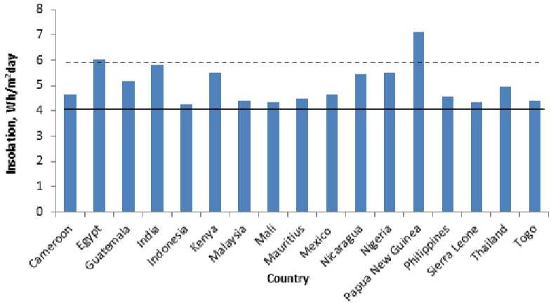
Figure2.1.Totalhorizontalsolarinsolationforsomedevelopingcountries

Classificationof SolarDryers
Solar dryers are typically classified based on their design configuration and mode of air circulation. The two major classifications are passive solar dryers, which rely entirely on natural convection and solar radiation without auxiliary energy, and active solar dryers, which utilize mechanical or electrical components such as fans and heaters to enhance airflow and control conditions withinthe drying chamber. This classification plays a vital role in determining the dryer’s efficiency, cost-effectiveness, and suitability for various agricultural or industrial applications.

PassiveSolarDryers

Passive solar dryers are systems that utilize the natural movement of heated air generated by solar radiation for the drying process. These dryers do not require external power sources or mechanical aids, which makes them ideal for smallholder farmers and rural settings where electricityis scarce or unavailable. Passive solar dryers are further divided into two main types: direct and indirect solar dryers.
      - Direct Passive Solar Dryer: The direct solar dryer operates on the principle of directly exposing the product to solar radiation within an enclosed transparent chamber. The transparent cover (usually made of glass or clear plastic) allows sunlight to pass through and heat the product directly, while also trapping thermal radiation inside the chamber, increasing the internal temperature and facilitating moisture evaporation (Hossain &Bala, 2007). This system typically consists of a drying chamber, mesh trays, and a transparent roof or top surface. Although effective in raising the drying temperature, this method exposes the product to ultraviolet radiation, which may degrade certain nutrients or pigments. It also requires frequent monitoring to prevent overheating and ensure uniform drying.

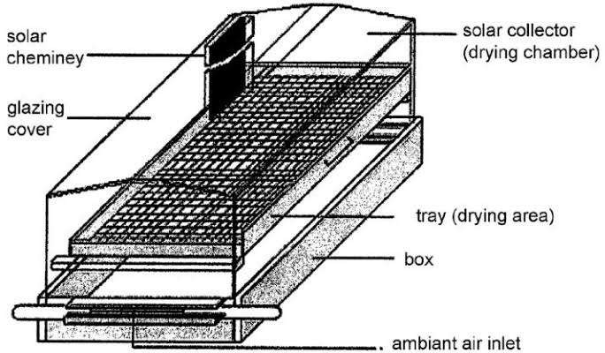

Figure2.2.1.1:Layout of aDirect PassiveSolarDryer

The major advantage of this system is its simplicity and low construction cost. However, itislimitedbyfactorssuchasunevendryingandvulnerabilitytoweatherchanges.Studies by Fudholi et al. (2014) confirm that direct passive dryers are best suited for crops like tomatoes and pepper when applied in areas with high solar intensity and stable weather.
      - IndirectPassiveSolarDryer:Intheindirectpassivesolardryer,solarenergyisfirst used to heat air in a solar collector before channeling it into the drying chamber where the product is kept. This configuration prevents direct exposure of the product to sunlight, thus preserving its color, flavor, and nutrients. The natural convection current created as the hot air rises draws cooler air from the inlet, facilitating continuous airflow through the system (Esper&Mühlbauer, 1998).

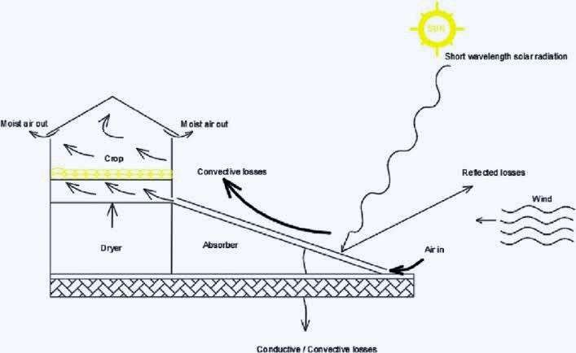

Figure2.2.1.2 :Layout ofan Indirect PassiveSolar Dryer

This type of dryer enhances hygiene and reduces contamination risk, which makes it suitable for delicate crops such as herbs, spices, and leafy vegetables. Research by Bala andWoods(2001)notedthatwhileindirectpassivedryersmaytakeslightlylongerdrying timescomparedtodirectdryers,theproductqualitytendstobesuperiorduetotheabsence of direct sunlight.

ActiveSolsrDryers

Active solar dryers incorporate mechanical components to boost the movement of heated airandregulatedryingconditions,therebyensuringfasterandmoreuniformdrying.These systems usually include fans, blowers, or photovoltaic-powered ventilation systems and are more technologically advanced than passive systems. They are further classified into indirect active, hybrid, and other integrated solar dryer designs.

      - IndirectActiveSolarDryer:Inthissystem,solarenergyheatsairinacollector,and then a fan or blower pushes the heated air into the drying chamber. The airflow is controlledtomaintainaconsistentdryingrate,reducingtheriskofmoldgrowthor spoilage. Unlike passive systems, indirect active dryers can operate under cloudy conditions or at night when coupled with thermal storage units (Madhlopa&Ngwalo, 2007).
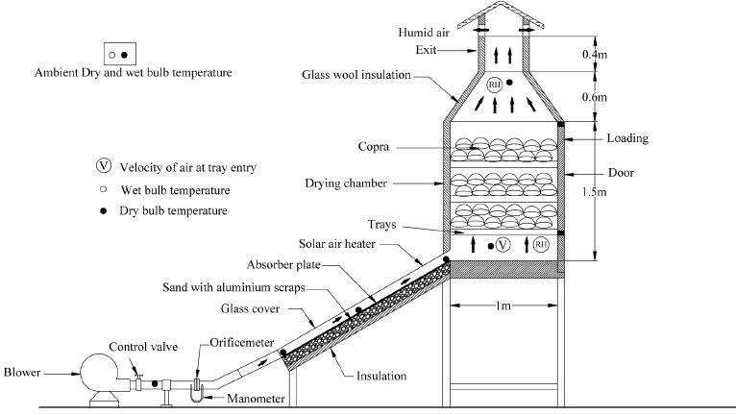

Figure2.2.2.1:LayoutofanIndirectActiveSolarDryersystem

AccordingtoJanjaiandBala(2012),themajoradvantageofindirectactivedryersistheir ability to maintain higher temperatures and better control humidity levels, resulting in shorterdryingdurationsandhigherefficiency.Theyareidealforhigh-valuecropssuchas tomatoes, okra, and medicinal plants.
      - Hybrid Solar Dryer: Hybrid solar dryers combine solar energy with auxiliary heatingsources such as electric heaters, LPG burners, or biomass stoves to ensure

uninterrupted drying regardless of weather conditions. These dryers often include photovoltaic cells to power fans or heaters, thereby integrating renewable energy withmechanicalaidsforoptimizedperformance(Husseinetal.,2017).Thehybrid model is particularly useful in areas with variable weather patterns or high humidity.
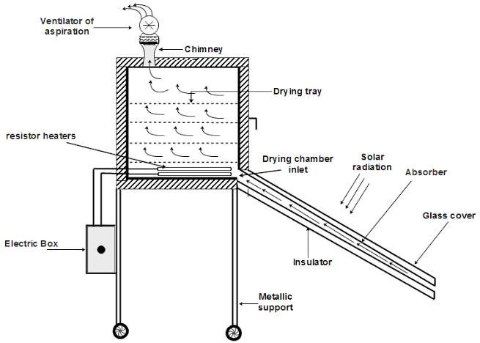

Figure2.2.2.2:Layout of Hybrid Solar Dryer

Studies by Elwakeel et al. (2024) demonstrated that hybrid dryers achieved moisture reductions of up to 80% within 6–8 hours, significantly outperforming passive systems. The incorporation of backup systems ensures that product quality is preserved, and operational efficiency is not weather-dependent.

WorkingPrincipleand physicsof IndirectSolar Dryer

The indirect solar dryer is a drying technology that utilizes solar radiation to generate heated air in a separate collector unit, which is then channeled into an insulated drying chamber.Unlikedirectdryingsystemswhereproductsareexposedtosunlight,theindirect method protects agricultural produce such as pepper from harmful ultraviolet rays, dust, and contaminants,therebyimprovingdryingqualityand hygiene.Thethermal performance of this system hinges on the interplay between solar radiation, air convection, insulation, and moisture diffusion from the product surface. In this study, the indirect solar dryer employedanaturalconvectionapproach,relyingonthenaturalbuoyancyofhotairrather than mechanical air movement.
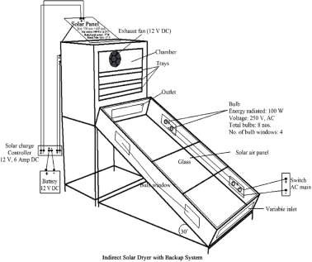

Figure2.3.1:IndirectSolar DryerwithBackup System

Figure2.3.1illustratesa moreadvancedconfigurationofanindirectsolardryer,featuring a backup system composed of a solar panel, battery, and DC exhaust fan. The solar collectorinthisdesignisasloped,glazedenclosurethatcapturessolarenergy,whichis

then converted into thermal energy by internal black-painted absorbing surfaces. The hot air generated inside the collector flows upward due to density differences and enters the drying chamber through a channel.
The drying chamber contains multiple trays arranged vertically, where sliced agricultural produceisspreadinthinlayers.A12VDCexhaustfaninstalledatthetopofthechamber assists in drawing the hot air uniformly over the trays and expelling the moist air through an outlet. The fan is powered by a solar panel that charges a 12 V DC battery via a solar charge controller. For night-time or low-radiation support, the system includes 100 W bulbs installed within “bulb windows” to provide thermal backup and ensure continuous drying, particularly in humid or cloudy weather.
This design ensures enhanced airflow, temperature stability, and reduced drying time. However, it is important to note that the system constructed in this present study did not incorporate electrical backup or forced convection elements. Instead, the fabricated dryer was designed to operate under natural convection, with airflow driven solely by thermal gradients between the collector and the outlet vent.
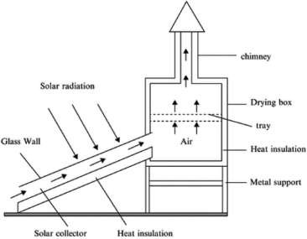

Figure2.3.2:BasicIndirectSolarDryer(WithoutBackupSystem)

Figure 2.3.2 presents a more conventional or passive indirect solar dryer, resembling the oneconstructedinthisstudy.Theprimarycomponentsofthisdryerincludeaslantedsolar collector,adryingchamber,achimneyforairexit,andsupportingframes. Solarradiation passesthroughthetransparentglazing(glasswall)ofthecollectorandstrikestheabsorber plate beneath it. The absorber typically black-coated metal or aluminum converts solar radiation into heat, warming the air inside the collector channel.
As the air is heated, its density decreases, causing it to rise naturally into the drying chamber.Thiscontinuousmovementofhotaircreatesanaturaldrafteffect,promotingthe flow of air through the trays where the product is laid. Moist air rises further and escapes through a chimney placed at the top of the drying box. This chimney effect improves air circulation and maintains the drying gradient necessaryfor continuous moisture removal.
In thesystem used forthis research, theindirect solardryerwas constructed usingan iron skeleton structure, covered with HDF plywood board and transparent glass (10mm inner and 5mm outer layer) on the collector side. The absorber was painted black for enhanced heatabsorption,andtheinnertrayswereplastic(non-metallic),placedonafixedironrack inside the chamber. The construction excluded fans, bulbs, solar panel, or any electrical components.
To better appreciate the operation of the indirect solar dryer, it is important to understand the role of each component and the physical principles they embody:
- SolarCollector:Thecollectoristheheartofthesystem. Itconvertssolarradiation intothermalenergythroughaprocessofradiationabsorption.Solarrayspenetrate the transparent glass layer and are absorbed by a dark-colored metal sheet. This sheet, with high absorptivity and low reflectivity, transfers heat to the air trapped

withintheenclosedcollector.Thetransparentglassalsoactsasacoverthatreduces convectiveheatlossandenhancesthegreenhouseeffect,allowingsunlightinwhile reducingre-radiationofheatout.Theslantangleofthecollector(30°inthebackup systemdiagram)isdesignedtomaximizesolarexposuredependingonthelatitude of the location (in this case, southwestern Nigeria). As the temperature rises, the less dense air becomes buoyant and begins to flow into the adjacent drying chamber.
- DryingChamberandTrays:Thedryingchamberisathermallyinsulatedenclosure where pepper slices are spread on trays. These trays are perforated (if metal) or open (if plastic) to permit even distribution of hot air across the sample. The primarymechanismofmoistureremovalhereisconvection:theheatedairtransfers energytothepepper,raisingitssurfacetemperatureandfacilitatingevaporationof moisture.Heat conduction from the tray into the pepper, and evaporation of water fromtheinternalcellstowardthesurface,areenhancedbyconsistentairmovement. Thechamberistypicallycoatedorlinedtoretainheatandminimizelossesthrough conduction.
- Chimney or Outlet Vent: In passive systems, the chimney serves a crucial role in facilitatingnaturalconvection.Ashotmoistairaccumulatesinthedryingchamber, itbecomeslighterandescapesthroughthechimney,drawingfreshhotairfromthe collector. This creates a continuous airflow cycle that maintains the drying environment. The height and width of the chimney can significantly influence airflow velocity and drying rate.
- Insulation and Structural Materials: Thermal insulation (e.g., fiberglass, foam, or wood board) is used to reduce heat loss to the surroundings, especially from the sidewalls and base of the drying chamber. The materials selected for construction mustbedurable,non-toxic,andstableunderhigh temperatures. Inthe constructed unit,woodwasusedforpaneling,andjointsweresealedtopreventleakage.All

internal parts were painted black to enhance absorption, and aluminum angle iron was used to prevent water ingress between glass and frame joints during rain.
- Air Movement Mechanism: In the backup-supported version, airflow is mechanically enhanced by an electric fan that operates on solar power or battery charge. This increases airflow rate and drying efficiency, especially in high- humidityconditions or during low solar radiation. In contrast, the passive version depends solely on thermal buoyancy, warm air rising and cool air being drawn in to maintain airflow. Though less aggressive, it is effective and more energy- efficient.
- Backup Heating (Bulbs): In the advanced system (Figure 2.1), the inclusion of bulbs as a thermal backup ensures the drying process can continue during cloudy days or at night. These bulbs emit heat, not light, and are typically arranged at strategic locations within the collector to maintain air temperature.However, this addstotheoperationalcostandenergydependency,whichiswhyitwasexcluded from the built version used in this study.
Both configurations of the indirect solar dryer operate on the same underlying physical principles: captureofsolarradiation, conversion into heat, transfer ofheat to airflow, and removalofmoisture through evaporationandventilation.However, thepresenceofa fan, battery, and electrical heating backup in the advanced model allows for enhanced efficiency, shorter drying times, and controlled conditions.
Theconstructedsystemusedinthisstudyadheredtothepassivemodel(Figure2.2),which thoughisslower, ismore sustainable and cost-effectiveforruralor low-resource settings. It was successfully used to dry pepper, with hourly temperature and moisture readings taken to evaluate performance across multiple days.
The effectiveness of an indirect solar dryer is governed by three primary modes of heat transfer:convection,conduction,andradiation,allofwhichworksynergisticallytodrythe agricultural produce.

- Convection is the dominant mechanism in the indirect drying process. As solar radiationheatstheairinthecollector,theairbecomeslighter(lessdense)andrises naturally into the drying chamber. This upward flow of warm air is what drives moisture removal from the pepper slices placed on the trays. As the warm air contacts the moist pepper surfaces, it absorbs moisture, creating a vapor-rich environment that continues to move upward and is eventually vented through the outlet or chimney. In systems with fans (as seen in Figure 2.1), this airflow is mechanicallyaccelerated,leadingtofasterdrying.Inthenaturallyventilatedmodel used in this study (Figure 2.2), convection occurs passively, relying on the buoyancy effect created by temperature gradients.
- Conduction, while less dominant, plays a critical role in the initial transfer of thermal energy from the hot air or heated tray surfaces into the pepper slices. As the hot air bathes the trays, heat is conducted through the traymaterial (especially if metallic) and into the lower layers of the pepper. The internal moisture within each slice also migrates toward the surface through molecular conduction, after whichitevaporatesintotheair.Althoughconductionisaslowerprocesscompared to convection, it is essential for drying the inner tissues of the pepper.
- Insulation acts as a thermal barrier that prevents heat loss from the system to the external environment. In the constructed dryer, insulation was achieved by using fiber material between the chamber walls and by minimizing heat bridges at the joints. This ensured that the majority of the heat energy captured remained within the system to support evaporation, rather than dissipating through structural leakage. Proper insulation improves the thermal efficiency of the system and reduces temperature fluctuations that may slow down drying.
Collectively, these heat transfer modes ensure a continuous cycle: radiation heats the air, convection carries the heat to the drying chamber, conduction transfers it to the pepper, and insulation retains the thermal energy in which all contributes to efficient moisture removal.

WorkingPrincipleand Physicsof GreenhouseSolarDryer

Thegreenhousesolardryerisamodifiedgreenhousestructureusedfordryingagricultural products by trapping solar radiation and creating a warm, enclosed environment that enhances moisture removal. It is particularly effective in reducing post-harvest losses, improvingproducthygiene,andprovidingaconsistentdryingenvironmentirrespectiveof fluctuating external weather conditions.
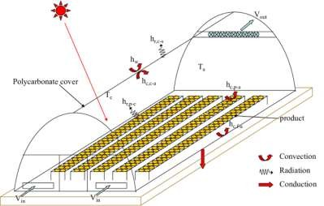

Figure2.4.1:Working Principleofa Greenhouse Solar Dryer

Figure2.4.1illustratesthebasicconfigurationand thermalbehaviorofatypical greenhouse solar dryer. The structure consists of a transparent polycarbonate cover that allows incoming solar radiation to penetrate the drying chamber. This cover is responsible for creating the greenhouse effect, whereby shortwave solar radiation enters the dryer, heats up internal surfaces, and is then re-radiated as longwave infrared energy that becomes trapped, increasing the internal temperature of the chamber.

The diagram features thermodynamic elements labeled as convection, radiation, and conduction to represent the different modes of heat transfer active within the dryer:
Radiationistheinitialenergyinput,wheresunlightdirectlyentersthroughthetransparent cover and heats the air, floor, and any black-painted surfaces inside the dryer. These surfaces then emit longwave infrared radiation, which is partially trapped inside the chamber, contributing to the internal heat buildup.
Convection occurs as the heated air inside the chamber becomes less dense and begins to rise. Cooler air from the bottom is drawn in to replace the rising hot air, creating a continuous flow cycle. This natural air circulation enhances the transfer of moisture from the surface of the product into the air stream.
Conductionisresponsibleforthetransferofheatthroughsolidmaterialssuchasthefloor, tray holders, and metallic parts of the frame. As these materials heat up from radiation, they pass thermal energy into the produce that is in direct contact with them. This aids in drying from the underside of the product, complementing the convective drying above.
The airflow in the system is represented by V-in and V-out, indicating the air inlet and outlet, respectively. Cool air enters through V-in near the base of the structure, is heated by solar radiation, and then rises due to convection. The warm, moisture-laden air exits through V-out, usually located near the top ends or ridge of the dryer. This passive ventilation system ensures that humidity does not accumulate excessively within the chamber, thus preventing microbial growth and condensation.
AlsovisibleinthediagramaresymbolslabeledTandH,whichrepresenttemperatureand humidity, respectively. These parameters are monitored at different points within the chamber to evaluate the thermal performance of the dryer and ensure that the conditions remain within optimal drying ranges for the specific crop. For pepper, efficient drying occurs between 40°C and 55°C with moderate humidity.

The greenhouse solar dryer used in this study closely followed the structure illustrated in the diagram, with several practical adjustments. The frame was constructed using aluminumforstructuralrigidityandwasenclosedentirelywithtransparentglassinsteadof polycarbonate. This provided excellent solartransmission and contributed to asignificant internal heat gain under sunny conditions.
Priortothe commencementofdryingexperiments,the greenhouse dryerrequired repairs. The glass door and parts of the aluminum frame had been damaged and needed to be refixed.Brokenglasspanelswerereplaced,andtheframejointswerereinforcedtoprevent heatleakage.Theentireunitwasmountedonametalironsheet,paintedblacktoimprove solar absorption and minimize heat losses through the floor. This metallic base also contributed to heating through conduction.Unlike mechanically assisted dryers, the greenhouse dryer in this project did not use any fans, heaters, or solar panels. It operated entirely on natural convection and solar energy.
Theperformanceofagreenhousesolardryerdependsonaneffectivecombinationofsolar radiation trapping, controlled airflow, and moisture removal. The following thermodynamic principles govern its operation:
- SolarRadiationandGreenhouseEffect:Solarenergyentersthroughthetransparent glazing and heats up surfaces and air within the chamber. The transparent glass transmits shortwaveradiationbut trapslongwave re-radiation, elevatingtheinternal temperature which is the greenhouse effect. The trapped heat leads to rapid moisture evaporation from the product.
- Convection:Astheinternalairheatsup,itbecomeslessdenseandrises,generating an upward flow. This creates a suction effect that draws fresh, cooler air in from below (V-in) and pushes moist, warm air out through the outlet (V-out). The continuous circulation promotes consistent drying across trays.

- Conduction: Heat absorbed by metallic or solid surfaces (like tray supports or the metal base) is conducted to the produce in direct contact. This helps warm up the product evenly and supports the internal movement of moisture from the core of the pepper to the surface.
- Insulation: Although the glass provides transparency, its thickness and sealed construction also function as insulation. It reduces heat loss to the external environment, especially during wind disturbances or temperature drops. The aluminumframewhichisaconductor,wasminimizedincontactexposuretoretain internal heat.
These mechanisms collectively create a stable micro-environment that accelerates drying whilemaintainingthequalityoftheproduce.Inpracticaluse,dailytemperatureinsidethe chamber was recorded as being consistently 6–12°C higher than ambient conditions, demonstrating strong thermal performance.

WorkingPrinciple ofaHybridSolar Dryer

A hybrid solar dryer combines two or more energy sources to ensure consistent and efficient drying of agricultural produce, regardless of climatic variability. This system primarily uses solar energy, supplemented by auxiliary sources such as electric heaters, biomass burners, or photovoltaic systems which is to guarantee continuous drying even duringcloudyweatheroratnight.Innormaloperation,solarradiationiscollectedbyasolar thermal collector, typicallymade of a black-painted metallic plate enclosed in transparent glazing material likepolycarbonateor glass. The solarenergyheats up the absorber plate, whichthentransferstheheattoairwithinthecollectorviaconduction.Thehotairiseither moved passively (natural convection) or actively (with a solar-powered fan) through a drying chamber where the agricultural products are arranged on trays.
Asheatedairpassesthroughthedryingchamber,itabsorbsmoisturefromthewetproduce throughconvectiveheattransfer.Simultaneously,thelatentheatofvaporizationenables

moisture within the product to transition from liquid to vapor. This vapor is then carried away by the moving air stream, ensuring continuous drying. Exhaust vents are typically placed at the top of the chamber to allow moist air to escape, while drier air circulates in, keeping the drying cycle effective.
One of the key features of the hybrid solar dryer is the backup heating mechanism. When sunlight is insufficient, the system automatically activates an electric or biomass-based heater, or may continue operating with energystored in batteries charged byphotovoltaic panels. This ensures that drying conditions remain optimal throughout the day. The integrationoftemperatureandhumiditysensorshelpsregulatetheenvironmentwithinthe chamber, reducing the risk of over-drying and preserving the quality of the product.
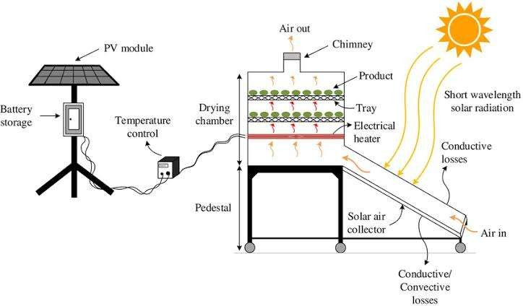

Figure2.5.1: WorkingPrincipleofa HybridSolar Dryer

Hybriddryersareespeciallybeneficialforcropsliketomatoes,peppers,and cassava,which requireconsistentdryingconditionstopreventmicrobialspoilageandpreservenutritional value.StudiesbyElwakeeletal.(2024)andHossainetal.(2023)demonstratedthathybrid

dryerssignificantlyreduceddryingtimeandimprovedoverallefficiencycomparedtoopen sun or conventional solar drying.

Design Considerations forthe SolarDryers

The design of solar drying systems requires a careful balance between thermal performance, structural durability, material availability, and the nature of the agricultural product being dried. In this study, the design of both the indirect solar dryer and the adaptation of an existing greenhouse solar dryer were centered on practical efficiency, energy independence, and preservation quality especially for a perishable, high-moisture crop like pepper. Several technical and environmental factors were taken into account to ensure the constructed systems met these performance targets within the limitations of available resources.
A fundamental consideration was the type of dryingmethod. The indirect solar dryer was selected for its ability to isolate the product from direct solar radiation, thereby reducing the risk of nutrient degradation, color bleaching, or contamination by dust and insects. Unlikedirectsundrying,theindirectmethodensuresthatheatistransferredthroughwarm airgeneratedinaseparatecollectorunitandchanneledintoadryingchamber.Thisreduces exposureto ultraviolet radiation whilestill taking advantage ofsolar energy. Onthe other hand, the greenhouse solar dryer although naturally allowing direct sunlight into the chamber was retained for its passive heating advantage and enclosure benefits. Its large transparent surface and closed design promote heat buildup, providing favorable thermal conditions for drying.
The nature of the product in this case, sliced pepper played a central role in determining dryingchambervolume,traysurfacearea,andairflowrate.Peppercontainsahighlevelof moisture and has soft, thin-walled tissue that deteriorates quickly under poor drying conditions. As such, the chamber needed to allow adequate airflow to ensure uniform dryingandpreventmicrobialgrowth.Thedesignincludedspacefordifferentlayersof

pepper on each tray to optimize surface area exposure and minimize drying time. Trays were selected to be lightweight and non-reactive; plastic trays were used in this case, supported bya welded iron within the chamber. Their spacing was planned to allow even vertical airflow through the product layers.
Theinclinationofthesolarcollectorintheindirectdryerwasanotherthermaloptimization factor. A tilt angle of approximately 30° was adopted based on the latitude of the study location in southwestern Nigeria. This angle maximizes solar irradiance throughout the day, allowing optimal sunlight penetration and energy absorption. The collector surface was covered with transparent glass (10mm inner, 5mm outer) to enable greenhouse trapping while also offering durability against weather elements. The absorber plate beneath the glass was coated in black automobile paint to maximize thermal absorption and raise the internal air temperature effectively.
Materialselectionwasdrivenbyaneedforthermalefficiency,cost-effectiveness,andlocal availability. The frame of the indirect dryer was constructed using welded metal sheet to provide strength and support for both the collector and the chamber. The chamber walls andcollectorbodywerelinedwithfiberinsulationtoreduceheatlosses.Theouterstructure wasenclosedwithHDFplywoodboardandsealedtopreventairleakage.Aluminumangle were used in vulnerable junctions especially between glass and frame to prevent water seepage during rainfall. For the greenhouse dryer, existing aluminum frames were refurbished, broken glass were replaced, and the base was restructured with a painted metalsheet to enhance absorption and structural integrity.
Airflowdynamicsalsoinformedkeydecisions.Theindirectdryeroperatedwithoutforced convection;thus,theinternaldesignwasadjusted tomaximizenaturalairmovement.The collectorwaspositionedataheightslightlylowerthanthechambertoencouragewarmair to rise and enter the drying space by buoyancy. The outlet above the chamber helped to maintainthepressuregradient,expellingmoistairanddrawinginfreshhotairfromthe

collector. This continuous flow created the draft needed for uninterrupted moisture removal, even in the absence of a fan.
Heat retention and energy efficiency were further considered through insulation design. Fiberinsulationwasusedintheindirectdryertominimizeconductiveandconvectiveheat loss through the chamber walls. The greenhouse dryer naturally retained heat through its enclosed glass walls, but gaps from wear and tear were sealed during repairs to improve performance. These retention measures were essential for maintaining high internal temperatures without external energy input.
The ease of assembly and repair was another practical design factor. The project was executed in a low-resource setting, and as such, the design had to accommodate local fabricationtechniquesandmaterials.Theindirectdryerwasconstructedoverthecourseof several days, including time spent welding the frame, cutting wooden boards, and assembling the collector. The greenhouse dryer, already available, required structural modifications and realignment to restore its functionality. By prioritizing modular components, both dryers could be dismantled or upgraded with minimal technical intervention in the future.

MaterialSelectionandDurabilityinSolarDryer Fabrication

The choice of materials for the construction of solar dryers is critical for ensuring durability,thermalefficiency,andcost-effectiveness.Materialsshouldbeselectedbased on their ability to withstand high temperatures, resist corrosion, and maintain thermal efficiency over time (Esper, and Muhlbauer, 1996).

    - AbsorbingSurfaces:Theabsorbingsurfacesofthesolarcollectoraretypically coated with black paint or a selective coating that maximizes absorption and minimizes reflection of solar radiation. Studies byKy et al. (2021) have shown

thatselectivecoatingscanenhancethethermalefficiencyofcollectorsbyupto 15%.

    - Glazing:Glazingmaterials,suchasglassortransparentplasticsheets,areusedto cover the solar collector and drying chamber. Glass is preferred for its high transmissivityanddurability,thoughitismoreexpensiveandheavierthanplastic alternatives like polycarbonate or acrylic (Ismail, and Ibrahim, 2021).

    - Insulation: The insulation of the drying chamber and collector is vital for retainingheatwithinthesystem.Materialssuchasfiberglass,foam,andsawdust are commonly used to reduce heat losses (Bala et al 2001). Proper insulation ensures the dryer operates efficiently even during periods of lower solar radiation.

MaterialsAndMethod
Materials

CHAPTERTHREE

Thefollowingarethematerialsthatwereusedfortheconsstructionofthesolar
dryer.

DirectSunDryingSystem
Cassavasliceswerespreadthinlyontraysexposeddirectlytosunlight.Thesetupwas simple, with no structural protection from weather or contaminants.

IndirectSolarDryer

HighDensityFibreboard(HDF)
The material used for the indirect solar dryer chamber is high density fibreboard(HDF). High density fibreboard (HDF) was selected for constuction part of indirect solar dryer due to its structural and thermal advantages. It it more cost-effective thanhardwoodormetalsheets,andiswidelyavailableinmostregions,makingitidealfor small-to medium-scale dryer project and provides a clean, uniform surface ideal for paintingtoabsorbheateffetively.Itcaneasilybecut,drilled,andshapedwithoutsplitting whichmakesituserfriendlyduringconstruction.Ithasalowthermalcomductivity,which minimizes heat loss from the collector and drying chamber . This improves energy efficiency and maintains a more stable internal temperature. The smooth finish of HDF makes it ideal for painting, especially black coating inside the collector that absorb solar radiation efficiently. HDF has high density and rigidity, providing structural integrityfor frames,trays,andpanelswithinthesolardryer.Whilenotwater,HDFresistswellingwhen properlypaintedorsealed.Thisallowsittobesafelyusedinenclosedindirectsystems,

where is not directly exposed to high humidity.
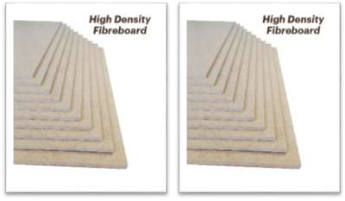
Fig.3.1.2.1:HighDensityFibreboard

TransparentCover
The requirements for the transparent cover are that it should have a low reflectance, low absorptance, and high transmittance. The material that fit this requirement is glass; it transmits a high amount of solar raditation incident on the collector and suppresses the convective and relative losses from the top of the solar collectorplate.Temperedglasswithlowironcontentwasusedduetoitstrength,safety, and higher collector efficiency. It is highly efficient amd also has a high mechanical strength compared to common glass. Tempered glass of 0.001m was used outside and tempered glass of 0.005m was used inside.

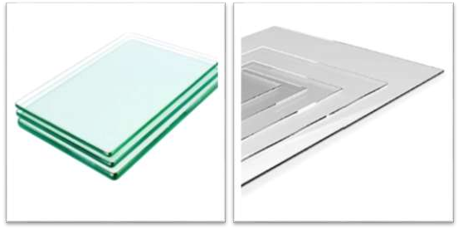

Collector Casing
Highdensityfibreboard(HDF)wasusedforthecollectorcasing;thisisbecauseit is cheap. The collector frame holds the absorber plate, and transparent cover. HDF also lasts long and helps to prevent much heat loss from the collector.
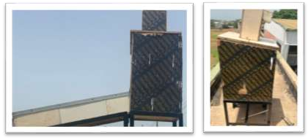

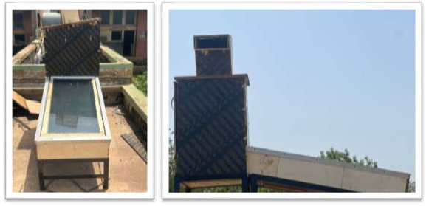
Fig.3.1.2.3:CollectorCasing

CollatorCasing Insulation (Fibre)
Fibre of 0.030m thickness was used to insulate the bottom and sides of the collector.Thefibrewascutinttherequiredsizesandfittedintothecollectorcasing.Itis cheap, readily available and has a good insulation properties.
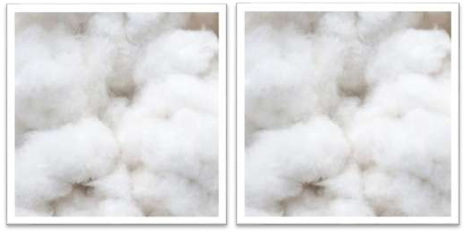
Fig.3.1.2.4:CollectorCasingInsulation(Fibre )

DryingTrays
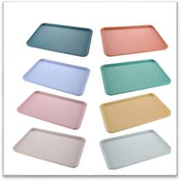
Plastictrayswereselectedfordryingbecauseofitthermalbehaviour,hygiene, durability and food safety. It does not absorb or transfer heat quickly, which prevent overheating ofthe drying product(e.g cassava). This is essential for in indirect dryer where uniform drying is required without heat spot. It ensures that the taste, color, and safety of the dried cassava are maintained. Plastic trays are lighter than metal or wood alternatives, making them easier to load, unload, and clean, especially important for small –scale or rural setups. Unlike metal trays, plastics traysare not prones to rust or corrosion, particularly in high humidity drying environments
Fig.3.1.2.5:DryingTrays

SupportingFrames
Thesupportingframewasconstructedusingangleironof0.04mand0.02m thickness with a one and hafl inch wideness. The entire dryer was mounted on the supporting frame to sustain and maintain a better airflow.

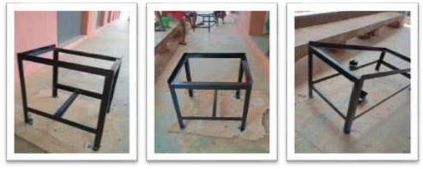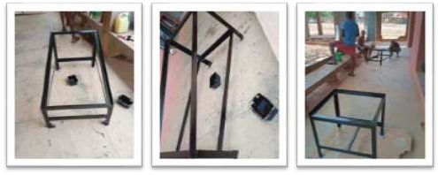
Fig.3.1.2.6: Supporting Frames

TheAbsorberPlate
Theabsorberplate’smainfunctionistoabsorbthesolarradiationincidentonthe collector. Copper, mild steel and aluminium all have high thermal conductivity and absortivity, but iron metal sheet is selected due to it beingh lighter than mild steel and its cost being relativelylower than that of copper. It is also corrosion resistant, ductile and a goodreflectorofvisiblelightandheat.Duetothelackofavailabilityofselectivecoating like black chrome, plain black paint was used to coat the absorber plate to increase the amount of the incident solar radiation absorb by the plate.

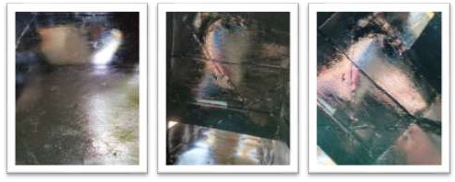

Fig.3.1.2.7: The Absorber Plates

AluminiumAngle Iron
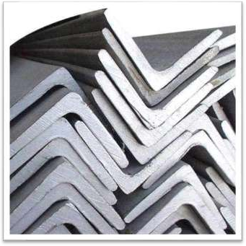
Thealuminiumangleironwastrategicallyplacedatglass-metaljointstosealgaps and prevent rainwater ingress, improving weather resistance.
Fig.3.1.2.7: The Absorber Plates

3.1.2.9.AutomobileBlackPaint
Was applied to the absorber surface within the solar collector and to some internal components of the indirect solar dryer to enhance heat absorption. The color black was specificallychosenbecauseofitshighabsorptivity,allowingittocaptureandretainmore solar radiation compared to lighter colors. By increasing the efficiency of thermal energy collection, theblack-painted surfaces helped raise theairtemperatureinside thecollector, thus improving the overall drying performance of the system.
Metalhinges,nails,screws,andhandleswereusedasfasteningandfunctionalcomponents throughouttheconstructionofbothdryers.Hingeswereattachedtochamberdoorstoallow smoothopeningandclosingduringloadingandunloadingofpeppersamples.Screwsand nails secured the plywood panels, metal frames, and glass supports, ensuring structural firmness.Handlesprovidedeaseofaccessandsafeoperation.Thesematerialswerechosen for their mechanical strength, reusability, and resistance to wear under frequent use, all contributing to the overall durability and usability of the dryers.

Greenhouse
Thegreenhousedryerutilized in this studywas previouslyconstructedand locatedwithin the experimental site. The materials used in the manufacture of the greenhouse dryer has some special characteristics. First, choose materials affordable to expectations in its applicationwereabletosavecostfromtheprice.Second,lightweightmaterialstofacilitate theoperationofthedeviceitself,forexampleifyouwanttobemovedortakentoanother place. Third, the selected material has the properties of heat collectors. With these properties then the heat will accumulate inside the tool so that it can speed up the drying process. This tool is alsomadeofamaterial that is not easilybroken, broken orporous so as to reduce the risk of damage and loss. The aluminum framework formed the structural skeletonofthegreenhousesolardryer,supportingtheglasswalls.Aluminumwasselected duetoitslightweightnature,corrosionresistance,andstructuralstabilityunderprolonged exposuretosunlightandhumidity.Itsstrengthallowedittoholdtheglasswallsecurelyin place,whileitsresistancetorustensuredlong-termdurability.Theuseofaluminumalso

madeiteasiertoassembleand repairthestructurewhendamaged, aswasdoneduringthe rehabilitation phase of the project.

DataCollection Instruments
Tomonitortheenvironmentalanddryingparametersduringtheexperiment,thefollowing instruments were employed:
- Digital Multimeter with Sensor Probe: This multifunctional device was used to measure air temperature inside each drying chamber as well as the ambient environment (see figure 3.2.1).

Figure3.2.1DigitalMultimeterwithsensoryprobe
- DigitalHygrometers:UsedalongsidethemultimeteristheHygrometerusedtotake humidityreadings,ensuringaccurateenvironmentalmonitoring.Itcanalsobeused to take readings of both temperature and time (see figure 3.2.2).

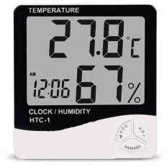

Figure3.2.2 Digital Hygrometer
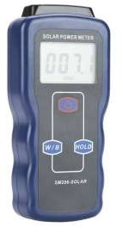
- Solar Radiation Meter (Pyranometer) Model SM206: Used to measured incident solar radiation in W/m². Accurate solar input data was essential for calculating thermal efficiency (see Figure 3.2.3).
Figure3.2.3 SolarRadiation Meter(Pyranometer)

- DigitalWeighingScale:Usedtomeasureweightlossofpeppersamplesatregular intervals to evaluate moisture reduction (see figure 3.2.4).

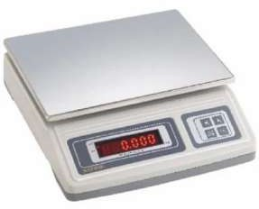

Figure3.2.4DigitalWeighingScale

ConstructionProcess
The construction process began with proper planning and preparation. We first made a clear design of how we wanted both the indirect and greenhouse solar dryers to look and work. We took accurate measurements to guide us on the size of each part and how they would be fixed together.
The metallic flat plate used for the solar collector of the indirect dryer was measured to ensuremaximumabsorptionofsolarenergy.The solarcollectorwasdesignedusingaflat metallic plate with a length of 1.23m, breadth of 0.57m and height of 0.21m. This plate serveasthemainabsorberofsolarradiationtoheattheincomingair.Thedryingchamber (cabinet), wheretheslicedproduceistobeplaced, hadalengthof0.85m andabreadthof 0.525m. At the top section, the chimney was tilted in case of rainfall: the chimney back measured0.38mby0.285m,thechimneysidemeasured0.205mby0.38mandthechimney headhadalength0.28m,breadthof0.33mandheightof0.125m.Thedoorofthedrying

cabinet was also measured at 0.72m in length and 0.67m in breadth for easyaccess to the trays.
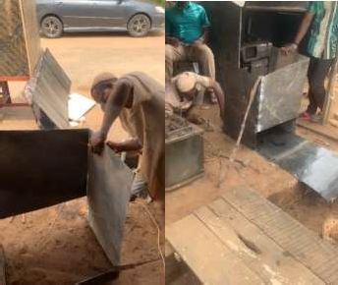
Figure3.3.1 during welding process
Wethenmovedtheflatmetalironsheetsmeantforbuildingtheframeoftheindirectsolar dryer to a welding workshop. The welding was done at a location in GRA, Ilorin, behind the Governor’s Office.
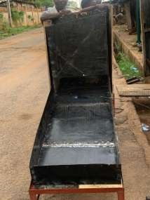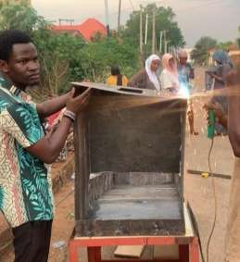

Figure3.3.2frameworkoftheindirectsolar dryer
We were directly involved in the welding process. We helped in handling the materials, checking that the correct measurements were followed, and made sure the structure was built according to our plan. After it was completed, we brought the welded frame back to theschool.Beforeassemblingit,wepaintedthewholemetalframewithAutomobileblack paint. This helps it to absorb more heat from the sun. After the paint dried, we moved the frame to the top of the decking behind Physics Lab A. This high platform was chosen so thatshadowswouldnotdisturbthedryersduringtheexperiment.Weusedaladdertoclimb up and set everything in place.
The next step was to cover the metal frame using High-Density Fibreboard (HDF) plywood. This part of the work took another few days. The wood was used to close the sides of the dryer, while glass was fixed on the top of the solar collector to allow sunlight in.Weusedtwotypesoftransparentglass:theinsideglasswas10mmthick,andtheouter onewas5mmthick.Wesealedtheedgesusingaluminumangle,andrubberwasaddedto prevent water from entering when it rains.
also installed hinges, handles, and locks on the door of the dryer to make it easy to open andclose.Nailsandscrewswereusedtofixallpartsproperly,andhammerswereusedfor nailing. After the full structure was completed, we cleaned the dryer both inside and outside.
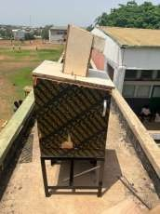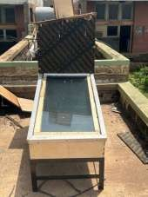

Figure3.3.3 Completeconstruction oftheindirectsolar dryer
We also worked on the greenhouse solar dryer, which had previously been used but required significant repairs. The overall structure of the greenhouse dryer has a measurementof1.545minlength,1.045minbreadthand0.10minheight.Thegreenhouse hasaraisedportionontopdesignedtoenhanceconvectionwhichalsohasa measurement of 0.495m in height, 0.55m in breadth and 1.04m in length. The collector plate newly welded for the greenhouse has a measurement of 1.49m in length and 1.02m in breadth.
Repairs include replacing broken glass panels and fixing the door. The entire dryer was cleaned and reassembled making it ready for the experiment.

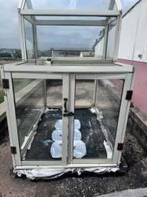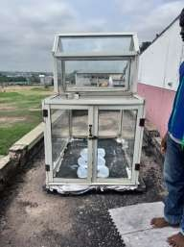
Figure3.3.4 Completeconstruction ofthegreenhousesolar dryer
Just like the indirect dryer, it was also mounted on the decking beside it, facing the same direction for equal sun exposure. Both dryers, the newly constructed indirect solar dryer and the repaired greenhouse dryer were now ready to be used for the drying experiment. They were placed close to each other to ensure that both received similar sunlight throughout the test period.

Experimental Setup

The experimental setup began with the preparation of our sample fresh cassava (Manihot esculenta Crantz.) used for the drying process. The cassavas was gotten from a farmer at theneighborhoodinIlorinandthenbroughttothelaboratoryforpreparation.Theharvested cassavas were washed with clean water to remove any surface contaminants. After washing, it was peeled, and each cassava was sliced into two halves to enhance moisture release during the drying process.
Next, plastic trays were wrapped with aluminum foil, and the weight of each empty tray (includingthefoil)wasmeasuredusingadigitalweighingscale.Thisinitialmeasurement wasnecessarytodeterminethenetweightofthecassavaafterloading.Theslicedcassavas werethenevenlyarrangedintothreetraysinwhichonewasassignedtoeachofthedrying systems: the indirect solar dryer, the greenhouse solar dryer, and the open sun drying method.

Each tray was weighed again after loading with the cassavas sliced. The actual weight of the cassava was obtained by subtracting the tray-and-foil weight from the total weight. Thesetrayswerethenplacedinside,allofwhichhadbeenpreviouslyinstalledonadecking locatedbehindPhysicsLaboratoryA,KwaraStatePolytechnic,Ilorin.Theopensundrying tray was placed on a layer of nylon sheet directly on the decking to protect it from contamination.

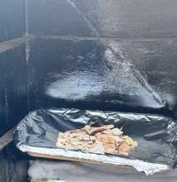
Figure3.4.1:Cassavain the trayplaced insideIndirect Solar Dryer

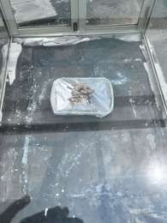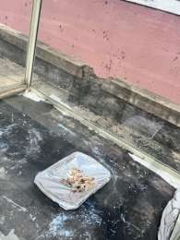
Figure 3.4.2:Trayplaced insideGreenhouseSolar Dryer


Figure3.4.3:Trayplaced underOpen Sun Dryer
Measurementsandobservationswerecarriedouthourlyfrom9:200amto4:20pm,8:10am to4:10pm.830amto3:30pm,8:00amto4:00pm,8:15amto4:15pm,and8:25amto4:25pm dailyrespectivelyacross afive-days dryingperiod.Thedata collected included: Chamber temperatureand humidityinsideeachdryer,usingadigitalmultimeterwithprobesensors anddigitalhygrometer.Weightofcassavasamples,usingadigitalweighingscale,recorded to track moisture loss over time.
Eachmeasuringinstrumentwascalibrateddailybeforeusetoensureaccuracy.Duringthe experiment, a sensor fault was detected in the digital multimeter, which led to unusual temperature readings. This was corrected by replacing the faulty probe and changing the batteries of both the multimeter and weighing balance to maintain consistent performance.Although data collection was interrupted for a few hours due to rainfall, observations resumed immediately when conditions stabilized. The same trays remained in their original positions throughout the experiment, and no agitation or turning of the cassavas sliced was performed, ensuring uniform exposure across all setups.

The entire setup allowed a systematic comparison between the indirect solar dryer, greenhousesolardryer,andopensundryingmethod,focusingontheirrespectivethermal efficiency for both indirect and green house drying systems, moisture removal capacity, and drying performance under real environmental conditions.

PerformanceEvaluation
This is the performance evaluation for evaluating the thermal performance and drying behavior of three solar drying systems: open sun drying, greenhouse solar dryer, and indirectsolardryerwasdesignedtoallowsystematicdatacollectionandaccurateanalysis. Hourly readings were collected for each method over multiple days. The study was conducted using cassava sample, and performance was evaluated using the following parameters:

Determinationof MoistureContentReductionof thesample(cassava)
AsadorptedbyEsperetal(1996).Theamountofmoistureremovedfromtheproducts was obtained using the expression;

MoistureContent=𝑀𝑖−𝑀𝑓
𝑀𝑓
---Eq.(1)

Where
𝑀𝐶= Moisture contentofthesample(cassava);
𝑀_{𝑖}=Initialmass ofsample(cassava)(g);
𝑀_{𝑓}=Finalmassofsample(cassava) (g).

Determinationof DryingRateof thesample(cassava)
As used by Chaudhari et al 2022. The drying rate indicates how quickly moisture is removedfromthecassavasampleovertime.Itismeasuredingramsperhour(g/h)orkg/h. It is calculated using the expression below;

DryingRate=𝑀𝑖−𝑀𝑓
𝑇
---Eq.(4)

Where
𝑀_{𝑖}=Initialmass ofsample(cassava)(g);

𝑀_{𝑓}=Finalmassofsample(cassava) (g).
𝑡=timeinterval(1hour)
Ahigherdryingrate indicatesmoreefficientmoistureremoval.

DeterminationofThermalEfficiency
AsadorptedbyDeepak etal(2025).Thedryingefficiencyofthedryerwasobtained using the expression

η𝑐𝑑𝑔
=𝑀𝐶𝑝𝑎(𝑇𝑖−𝑇𝑂)
𝐴𝑐𝐼𝑔
---Eq.(6)

Where;
𝐶_{𝑝𝑎}:𝑆𝑝𝑒𝑐𝑖𝑓𝑖𝑐𝐻𝑒𝑎𝑡𝐶𝑎𝑝𝑎𝑐𝑖𝑡𝑦𝑜𝑓𝐴𝑖𝑟(𝐶_{𝑝𝑎}∶1.005𝐽/𝑔/ᵒC)
𝑀∶𝑀𝑎𝑠𝑠𝑜𝑓𝑆𝑎𝑚𝑝𝑙𝑒
𝑇_{𝑖}∶𝐶𝑜𝑙𝑙𝑒𝑐𝑡𝑜𝑟𝑇𝑒𝑚𝑝𝑒𝑟𝑎𝑡𝑢𝑟𝑒
𝑇_{𝑂}∶𝐴𝑚𝑏𝑖𝑒𝑛𝑡 𝑇𝑒𝑚𝑝𝑒𝑟𝑎𝑡𝑢𝑟𝑒
𝐼_{𝑔}∶𝑆𝑜𝑙𝑎𝑟𝑅𝑎𝑑𝑖𝑎𝑡𝑖𝑜𝑛
𝐴_{𝑐}∶𝐴𝑟𝑒𝑎𝑜𝑓𝑡ℎ𝑒𝑐𝑜𝑙𝑙𝑒𝑐𝑡𝑜𝑟𝑜𝑓𝑖𝑛𝑑𝑖𝑟𝑒𝑐𝑡𝑑𝑟𝑦𝑖𝑛𝑔𝑠𝑦𝑠𝑡𝑒𝑚(𝐴𝑟𝑒𝑎𝑜𝑓𝐶𝑢𝑏𝑒)
𝑤ℎ𝑒𝑟𝑒𝐴_{𝑐}∶2(1.23×0.57 + 0.57 ×0.21+1.23×0.21)
=2(0.7011 +0.1197 + 0.2583)=2(1.0791)=2.1582≈2.16𝑚²

𝐴_{𝑐}∶𝐴𝑟𝑒𝑎𝑜𝑓𝑡ℎ𝑒𝑐𝑜𝑙𝑙𝑒𝑐𝑡𝑜𝑟𝑜𝑓𝑔𝑟𝑒𝑒𝑛ℎ𝑜𝑢𝑠𝑒𝑑𝑟𝑦𝑖𝑛𝑔𝑠𝑦𝑠𝑡𝑒𝑚(𝐴𝑟𝑒𝑎𝑜𝑓𝑟𝑒𝑐𝑡𝑎𝑛𝑔𝑙𝑒)
𝑤ℎ𝑒𝑟𝑒𝐴_{𝑐}∶(𝑙×𝑏)=(1.49 ×1.02)=1.52𝑚²

SampleCalculationsUsingExperimentalData(Day1-Day6) Calculation of Moisture Content
Tray2–OpenSunDrying(DAY1)

MoistureContent=
𝑀_{𝑖}−𝑀_{𝑓}

𝑀_{𝑓}

InitialWeight𝑀_{𝑖}:524g FinalWeight𝑀_{𝑓}:256g

    - Time: 11:30

MoistureContent=

    - Time: 12:30

MoistureContent=

524− 256

256

485− 256

256

=1.046𝑔

=0.894𝑔

Tray2–IndirectSunDrying(DAY1)

MoistureContent=
𝑀𝑖−𝑀𝑓

𝑀_{𝑓}

InitialWeight𝑀_{𝑖}:660g FinalWeight𝑀_{𝑓}:365g

    - Time: 11:30

MoistureContent=

    - Time: 12:30

MoistureContent=

660− 365

365

641− 365

365

=0.808𝑔

=0.756𝑔

Tray2–GreenhouseDrying(DAY1)

MoistureContent=
𝑀_{𝑖}−𝑀_{𝑓}

𝑀_{𝑓}

InitialWeight𝑀_{𝑖}:641g FinalWeight𝑀_{𝑓}:359g

    - Time: 11:30

MoistureContent=

    - Time: 12:30

MoistureContent=

641− 359

359

578− 359

359

=0.785𝑔

=0.610𝑔

Calculationof DryingRate

Tray2–OpenSunDrying(DAY1)

DryingRate=
𝑀_{𝑖}−𝑀_{𝑓}

𝑇

InitialWeight𝑀_{𝑖}:524g FinalWeight𝑀_{𝑓}:256g

    - Time: 11:00

DryingRate=

    - Time: 12:00

DryingRate=

524 −256

60

485 −256

60

=4.46𝑔 DryingRate=

=3.81𝑔 DryingRate=

524 − 256

3600

485 − 256

3600

=0.07𝑔

=0.063𝑔

Tray2–IndirectSolarDrying(DAY1)

DryingRate=
𝑀_{𝑖}−𝑀_{𝑓}

𝑇

InitialWeight𝑀_{𝑖}:660g FinalWeight𝑀_{𝑓}:365g

    - Time: 11:00

DryingRate=

    - Time: 12:00

660 −365

60

=4.916𝑔 DryingRate=

660 − 365

3600

=0.0819𝑔

DryingRate=
641 −365

60

=4.6𝑔 DryingRate=
641 − 365

3600

=0.076𝑔

Tray2–GreenhouseDrying(DAY1)

DryingRate=
𝑀_{𝑖}−𝑀_{𝑓}

𝑇

InitialWeight𝑀_{𝑖}:641g FinalWeight𝑀_{𝑓}:359g

    - Time: 11:00

DryingRate=

    - Time: 12:00

641 −359

60

=4.7𝑔 DryingRate=

641 − 359

3600

=0.078𝑔

DryingRate=
578 −359

60
=3.65𝑔 DryingRate=
578 − 359

3600
=0.060𝑔

CalculationofEfficiency

Tray2–IndirectSolarDryer (DAY1)

𝑀𝐶_{𝑝𝑎}(𝑇_{𝑖}−𝑇_{𝑂})

η𝑐𝑑𝑔=
𝐴𝐼

𝑐𝑔

𝐶_{𝑝𝑎}:𝑆𝑝𝑒𝑐𝑖𝑓𝑖𝑐𝐻𝑒𝑎𝑡𝐶𝑎𝑝𝑎𝑐𝑖𝑡𝑦𝑜𝑓𝐴𝑖𝑟

𝑤ℎ𝑒𝑟𝑒𝐶_{𝑝𝑎}∶1.005𝐽/𝑔/ᵒC

𝑀∶𝑀𝑎𝑠𝑠𝑜𝑓𝑆𝑎𝑚𝑝𝑙𝑒

𝑇_{𝑖}∶𝐶𝑜𝑙𝑙𝑒𝑐𝑡𝑜𝑟𝑇𝑒𝑚𝑝𝑒𝑟𝑎𝑡𝑢𝑟𝑒

𝑇_{𝑂}∶𝐴𝑚𝑏𝑖𝑒𝑛𝑡 𝑇𝑒𝑚𝑝𝑒𝑟𝑎𝑡𝑢𝑟𝑒

𝐼_{𝑔}∶𝑆𝑜𝑙𝑎𝑟𝑅𝑎𝑑𝑖𝑎𝑡𝑖𝑜𝑛

𝐴_{𝑐}∶𝐴𝑟𝑒𝑎𝑜𝑓𝑡ℎ𝑒𝑐𝑜𝑙𝑙𝑒𝑐𝑡𝑜𝑟(𝐴𝑟𝑒𝑎𝑜𝑓𝐶𝑢𝑏𝑒)

𝑤ℎ𝑒𝑟𝑒𝐴_{𝑐}∶2(1.23×0.57+ 0.57×0.21+1.23×0.21)=2(0.7011+ 0.1197+
0.2583)=2(1.0791)=2.1582≈2.16𝑚²

    - Time: 11:00
𝑀𝐶_{𝑝𝑎}(𝑇_{𝑖}−𝑇_{𝑂})

660×1.005(34.0− 25.2)

5837.04

η𝑐𝑑𝑔=
=
𝐴𝐼
=
2.16×448
=6.032
967.68

𝑐𝑔

    - Time: 12:00
𝑀𝐶_{𝑝𝑎}(𝑇_{𝑖}−𝑇_{𝑂})

641×1.005(46.5− 32.3)

9147.711

η𝑐𝑑𝑔=
=
𝐴𝐼
=
2.16×634
=6.680
1369.44

𝑐𝑔

Tray2–GreenhouseDryer(DAY1)

𝑀𝐶_{𝑝𝑎}(𝑇_{𝑖}−𝑇_{𝑂})

η𝑐𝑑𝑔=
𝐴𝐼

𝑐𝑔

𝐶_{𝑝𝑎}:𝑆𝑝𝑒𝑐𝑖𝑓𝑖𝑐𝐻𝑒𝑎𝑡𝐶𝑎𝑝𝑎𝑐𝑖𝑡𝑦𝑜𝑓𝐴𝑖𝑟

𝑤ℎ𝑒𝑟𝑒𝐶_{𝑝𝑎}∶1.005𝐽/𝑔/ᵒC

𝑀∶𝑀𝑎𝑠𝑠𝑜𝑓𝑆𝑎𝑚𝑝𝑙𝑒

𝑇𝑖∶𝐶𝑜𝑙𝑙𝑒𝑐𝑡𝑜𝑟𝑇𝑒𝑚𝑝𝑒𝑟𝑎𝑡𝑢𝑟𝑒
𝑇𝑂∶𝐴𝑚𝑏𝑖𝑒𝑛𝑡𝑇𝑒𝑚𝑝𝑒𝑟𝑎𝑡𝑢𝑟𝑒
𝐼𝑔∶𝑆𝑜𝑙𝑎𝑟𝑅𝑎𝑑𝑖𝑎𝑡𝑖𝑜𝑛

𝐴𝑐∶𝐴𝑟𝑒𝑎𝑜𝑓𝑡ℎ𝑒𝑐𝑜𝑙𝑙𝑒𝑐𝑡𝑜𝑟(𝐴𝑟𝑒𝑎𝑜𝑓𝐶𝑢𝑏𝑒)
𝑤ℎ𝑒𝑟𝑒𝐴𝑐∶(𝑙×𝑏)=(1.49× 1.02)=1.52𝑚²
    - Time:9:30am

𝑀𝐶𝑝𝑎(𝑇𝑖−𝑇𝑂)
641×1.005(26.0−25.2)
515.364

η𝑐𝑑𝑔=
=
𝐴𝐼
=
1.52× 448
=0.76
680.96

𝑐𝑔

    - Time:10:30am
η =𝑀𝐶𝑝𝑎(𝑇𝑖−𝑇𝑂)=578×1.005(39.4−32.3)=4124.319=4.28

𝑐𝑑𝑔
𝐴𝑐𝐼𝑔
1.52×634

963.68

CHAPTERFOUR
- RESULTAND DISCUSSION
The effectiveness of various solar drying systems in dehydrating sliced cassava was evaluated through a series of experimental tests. This study specifically aimed to identify the most efficient drying method while also highlighting the unique advantages of each drying system employed. Over the course of four days, 660g of cassavas were reduced to 374g using an indirect solar dryer. In comparison, a greenhouse solar dryer effectively reduced671gofcassavato361g,whileopen-airdryingdecreased524gofcassavato284g. The measured parameters included (a) solar radiation incident on the solar collector, (b) ambient temperature, (c) chamber temperatures of both the indirect and greenhouse solar dryers,(d)collectortemperatureintheindirectsolardryer,(e)humiditylevels,(f)moisture content of dried mass, and the overall drying rate. The performance testing adhered to international standards set forth by ASABE/ASAE (2007) for solar air collectors. Temperature measurements at various points within the collector and chambers of the dryers were conducted using a K-type thermocouple multimeter. The drying regimen commenced daily at 8:00 AM and concluded by 4:00 PM.

CHAPTERFIVE

Conclusion
A comparative thermal performance analysis of three distinct drying systems greenhousedrying,indirectsolardrying,andtraditionalopensundryingwassuccessfully conducted.Theresultsdemonstratethatthegreenhousedryerachievedthehighestaverage drying temperature and the most rapid drying rate. The indirect solar dryer followed closely, while open sun drying, despite being the most accessible and cost-effective, exhibited the slowest drying rate and was notably vulnerable to environmental contamination and fluctuations in weather conditions
Thegreenhousesolardryerprovedtobethemosteffectiveamongthethree,offeringfaster drying, better temperature regulation, and greater protection against environmental elements.Theindirectsolardryeralsoperformedwell,particularlyinthermalcontroland hygiene.However,thedirectsundryingmethod,whilecost-free,remainstheleastreliable due to exposure to weather changes, pests, and inconsistent drying rates
The findings confirm that both the greenhouse and indirect solar dryers offer superior thermal efficiency, enhanced product quality, and significantlyreduced dryingtime when compared to conventional open sun drying methods.

Recommendation
It is recommended that small- and medium-scale farmers adopt greenhouse or indirect solar drying systems, as these technologies offer improved drying efficiency and better hygiene standards for agricultural products.
Furthermore, governmentalbodiesandagricultural development agenciesareencouraged to promote the adoption of solar drying technologies by offering subsidies, capacity- building programs, and awareness campaigns. These initiatives can play a vital role in reducing post-harvest losses and strengthening food security

Finally, future researchondryingsystemsshouldprioritize thedevelopmentandevaluation of hybrid drying technologies that integrate solar energy with auxiliary heating sources. Suchinnovationswouldensureconsistentdryingperformanceduringperiodsoflowsolar intensity or nighttime operation

REFERENCE
Abdullahi,M.Y.,Musa,K.,&Ibrahim,T.(2021).Mathematicalmodelingandvalidation of tomato dryingin indirect solar dryers. Nigerian Journal of Solar Energy, 32(1), 45–54.
Adeyanju,A.A.,&Fapetu,O.P.(2019).Performanceevaluationofanindirectsolardryer for tomato drying. Journal of Renewable Energy Applications,8(2), 85–93.
Affognon, H., Mutungi, C., Sanginga, P., &Borgemeister, C. (2015). Unpacking postharvestlosses in sub-Saharan Africa: A meta-analysis. World Development, 66, 49–68.
Agrawal,A.,&Sarkar,A.(2020).Comparativeanalysisofgreenhouseandopensundrying of tomato. International Journal of Energy andEnvironmental Engineering, 11(3), 219– 227.
Ahmed,M.,Usman,H.,&Sani,R.(2022).Designandevaluationofacompactsolardryer for household tomato drying. Solar Energy in Agriculture, 9(1), 102–109.
Ajibola,O.O.,Fapetu,O.P.,&Afolayan,M.O.(2017).Designandperformance evaluation of a solar dryer for agricultural products. Agricultural Engineering International: CIGR Journal, 19(2), 152–160.
Akinola,A.O.,Akinyele,T.A.,&Odedairo,B.O.(2015).Evaluationoftraditionalsun drying and solar drying on the quality of pepper. Journal of Agricultural Technology, 11(4), 785–794.
Bala, B. K., &Mondol, M. R. A. (2018). Thermal performance and economic analysis of PV-powered greenhouse dryers. Renewable Energy Technologies, 13(4), 211–220.
Bala, B. K., & Woods, J. L. (2001). Simulation of the indirect natural convection sola drying of rough rice. Solar Energy, 69(1), 89–98. https://doi.org/10.1016/S0038-092X(00)00128-8

Bala, B. K., &Mondol, M. R. A. (2001). Experimental investigation on solar drying of fish using solar tunnel dryer. Drying Technology, 19(2), 427–436.
Chaudhari, V. S., Patil, P. S., & Bhale, P. V. (2022). Hybrid solar dryer design for consistenttomatodryinginsemi-cloudyclimates.InternationalJournalof Thermal Sciences and Technology, 14(1), 91–98.
Daramola, A. M., & Adesina, K. O. (2022). Effect of pre-treatment on tomatodrying kinetics in direct solar dryers. African Journal of Food Science and Technology, 13(2), 121–130.
Dash, R., Castillo, C., &Amparo, J. (2025). Comparative analysis of greenhouse solar drying and open sun drying of corn in Bukidnon. International Journal of Sustainable Agriculture, 29(1), 56–70.
Deepak,B.,&Behura,A.K.(2025).Thermodynamicandenvironmentalanalysis ofa solar dryer with thermal storage. Scientific Reports, 15,91971. https://www.nature.com/articles/s41598-025-91971-4
Egunjobi, O. A., Akande, A. M., & Alabi, J. A. (2020). Influence of weather variation on solardryer performance in Lagos. West African Journal ofEngineering and Applied Sciences, 9(1), 54–62.
Ekechukwu, O.V., & Norton, B. (1999). Review of solar-energy drying systems. Renewable and Sustainable Energy Reviews, 3(3), 225–253.
El-Sebaii,A.A.,&Shalaby,S.M.(2012).Solardryingofagriculturalproducts: Areview. Renewable and Sustainable Energy Reviews, 16(1), 37–43.
Elwakeel, E. E., Mohamed, S. H., &Soliman, A. (2024). Performance assessment of a tracking hybrid solar dryer powered by photovoltaic cells. Renewable Energy Systems, 45(3), 210–223.

Solomon,Y.,&Tesfaye,A.(2019).Roleofthermalmassintomatodryinginpassivesolar dryers. Ethiopian Journal of Agricultural Sciences, 14(2), 94–102.
Tagoe,M.,&Opoku,A.(2023).Energyefficiencyandeconomicanalysisofsolardrying systemsfortomatocooperatives.JournalofAgribusinessandPostharvest
Technology, 8(2), 72–80.

Tiwari,G.N.,Kumar,S.,&Prakash,O.(2016).Solardryingtechnology:Concept,design, testing, modeling, economics, and environment. Springer International Publishing.
Yusuf, M. O., & Okonkwo, I. C. (2020). Influence of absorber plate materials on solar dryerefficiencyfortomatoes. International Journal ofRenewableEnergyDevelopment, 9(1), 56–63.

