A PROJECT REPORT

ON

PROPOSED FIRE STATION

FOR

SADIKU COMMUNITY ,ABULE EGBA, LAGOS STATE.

BY

SHITTU IDRIS OLAREWAJU
HND/23/ARC/FT/0045

SUBMITTED TO THE DEPARTMENT OF ARCHITECTURAL TECHNOLOGY INSTITUTE OF ENVIRONMENTAL STUDIES (IES) KWARA STATE POLYTECHNIC ILORIN.

IN PARTIAL FULFILMENT FOR THE REQUIREMENT OF THE AWARD OF HIGHER NATIONAL DIPLOMA (HND) IN ARCHITECTURAL TECHNOLOGY,KWARA STATE .

JULY 202
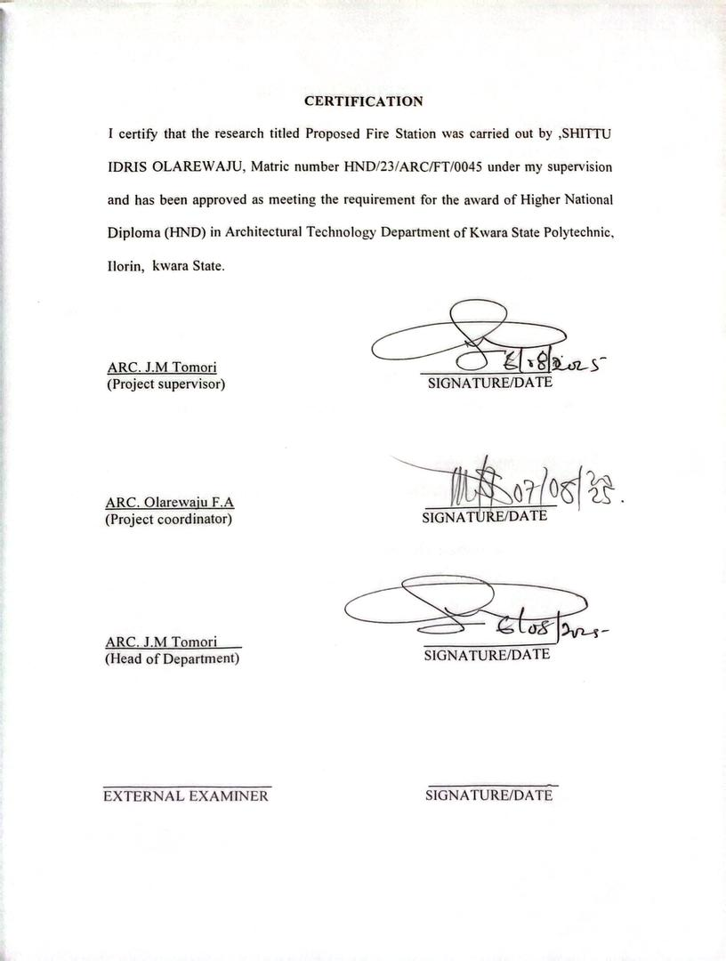
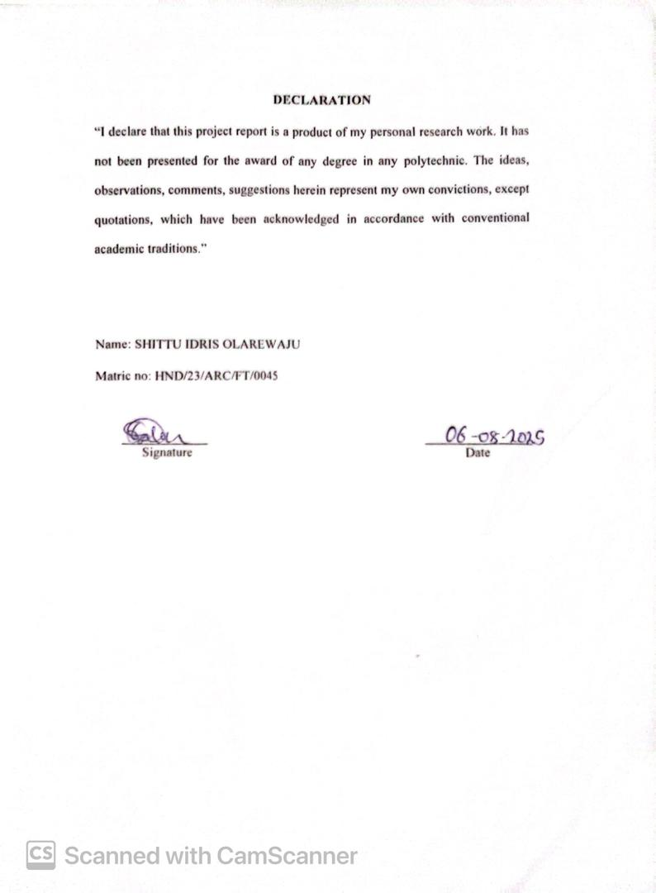
DEDICATION
I dedicated to Almighty Allah who made the this project research a success ,all I could say is alhamdulilaih! I also dedicate the project to my parent Mr. & Mrs. Shittu and my uncle for their prayer and financial support

ACKNOWLEDGEMENT
My profound gratitude goes to Almighty Allah who as always be in existence for taking control of this project for is infinite mercy and for giving me the privilege to write the report.My special gratitude goes to the Department of Architectural Technology the entire staff and my supervisor ARC.MRS J.M. TOMORI, and also to the HOD of the Department in person of ARC.MRS MULIKAT JUMOKE TOMORI who has been supportive throughout this project, may Allah continue to reward you and your family. My sincere appreciation goes to my dearest, lovely and caring parents MR. SHITTU JIMOH and MRS. SHITTU AMUDALAT for the parental, financial and moral support for making my dream a reality. Finally, I see this privilege as a milestone in my career development and I will definitely strive to utilize the gained skills and knowledge in the best way to achieve desired future objective. I wish everyone who contributed to this achievement success in all their endeavors and I pray the blessings of Allah will keep reigning in our lives (Aameen).

ABSTRACT
The fire station serves as a critical infrastructure for ensuring public safety by providing rapid response to fire outbreaks, emergencies, and rescue operations. This project proposes the design of a modern fire station that meets the operational, spatial, and functional requirements of fire service activities. The design incorporates essential facilities such as appliance bays, control rooms, crew quarters, administrative offices, training areas, and maintenance workshops. Special attention is given to site accessibility, traffic flow, and proximity to major roads to enhance response times. The architectural concept focuses on functionality, durability, and adaptability, ensuring compliance with relevant building codes and safety standards. The proposed design integrates sustainable building materials, energy-efficient systems, and adequate ventilation to improve operational efficiency and occupant comfort. The ultimate aim is to create a facility that supports effective fire-fighting operations, enhances community safety, and meets the future expansion needs of the fire service.In many urban and rural communities, the lack of well-equipped and strategically located fire stations contributes significantly to delayed emergency response, increased loss of lives, and destruction of property during fire outbreaks. Existing facilities often suffer from poor maintenance, outdated equipment, and insufficient manpower, limiting their effectiveness in managing emergencies. This project seeks to address these challenges by proposing a modern fire station that meets current safety standards and operational efficiency requirements.

TABLE OF CONTENTS
TITLE PAGE
DECLARATION……………………………………………………………… ii
CERTIFICATION……………………………………………………………… iii
ACKNOWLEDGEMENT……………………………………………………… iv
DEDICATION………………………………………………………………….. v
TABLE OF CONTENTS……………………………………………………… vi
LIST OF TABLES……………………………………………………………… vii
LIST OF FIGURES…………………………………………………………….. viii
LIST OF PLATES………………………………………………………………. ix
ABSTRACT……………………………………………………………………… x
CHAPTER ONE
1.0 INTRODUCTION…………………….……………………………. 1
1.1 DEFINITION……………………………………………………………. 2
1.2 HISTORICAL BACKGROUND………………………………………… 3
1.3 STATEMENT OF DESIGN PROBLEM………………………………. 4
1.4 AIM AND OBJECTIVES………………………………………………. 5
1.5 JUSTIFICATION………………………………………………………. 5
1.6 CLIENT’S BACKGROUND…………………………………………… 6
1.7 SCOPE OF THE PROJECT……………………………………………. 6
1.8 LIMITATION OF STUDY……………………………………………. 7
1.9 RESEARCH METHODOLOGY………………………………………… 7
CHAPTER TWO
2.0 LITERATURE REVIEW ...…………………………………………….. 8
2.1 REVIEW OF RELEVANT LITERATURE ON BUILDING TYPES….. 8
2.2 REVIEW OF LITERATURE ON HOUSING AFFORDABILITY…... 9
CHAPTER THREE
3.1 CASE STUDY………………………………………………………. 12
3.2 CASE STUDY 1: …………………………………………………… 12
3.3 CASE STUDY 2: ………………………………………………….. 19
3.4 CASE STUDY 3: ……………………………………………………. 25
3.5 CASE STUDY 4: ……………………………………………………. 33
CHAPTER FOUR
4.0 STUDYAREA/PROJECT SITE……………………………………… 40
4.1 HISTORY OF LAGOS STATE……………………………………… 40
4.2 LOCATION OF SITE………………………………………………… 41
4.3 SITE INVENTORY AND ANALYSIS ……………………………… 43
4.4 GEOGRAPHIC/CLIMATIC DATA…………………………………. 45
4.5 ANALYSIS OF THE IMMEDIATE ENVIRONMENTAL CONDITIONS OF
THE SITE…………………………………………………………… 48
4.6 PROJECT ANALYSIS/DESIGN CRITERIA……………………… 49
4.6.1 DESIGN CRITERIA………………………………………………… 49
4.7 BRIEF ANALYSIS OF PROJECT………………………………….. 50
4.8 FUNCTIONAL ANALYSIS/SPACIAL CRITERIA………………… 51
4.9 APPRAISAL OF SCHEMES………………………………………… 54
4.10 EQUIPMENT AND OPERATIONAL AND PERFORMANCE REQUIREMENT……………………………………………………………………54
4.12 SPATIAL ALLOCATION/S SCHEDULE OF ACCOMODATION… 54
4.13 CONCEPTUAL DEVELOPMENT…………………………………… 55
CHAPTER FIVE
5.0 APPROACH TO THE DESIGN/DESIGN REALIZATION……………. 56
5.1 TECHNOLOGICAL AND ENVIRONMENTAL CRITERIA……..…. 56
5.1.1 CONSTRUCTION METHOD………………………………………… 56
5.2 SERVICES REQUIRED……………………………………………… 58
5.2.1 ENVIRONMENTAL CONDITION TO BE ACHIEVED…………… 60
5.2.2 PERFORMANCE STANDARDS…………………………………… 60
5.2.3 LEGAL ISSUES AND PLANNING REGULATION..……60
5.2.4 BEHAVIOURAL PATTERNS AND CONSIDERATIONS ………… 61
5.3 CONCLUSION AND RECOMMENDATIONS……………………… 61
REFERENCES………………………………………………………………. .. 63
APPENDICES………………………………………………………………….. 65
LIST OF FIGURES
Figure 1.0: Showing Location Plan………………………………….……………14
Figure 1.1: Showing Floor Plan of Case Study One…………………………….…14
Figure 2.0: Showing Location Plan of Casestudy Two……………………………17
Figure 2.1: Showing Floor Plan of Case Study Two…………………………….…17
Figure 3.1: Showing Floor Plan Of Case Study Three………….……………….…19
Figure 3.2: Showing Floor Plan Of Case Study Three……………………………..19
Figure 4.1: Showing Floor Plan Of Case Study Four………….………..………….21
Figure 4.2: Showing Floor Plan Of Case Study Four…………………………..…...20

LIST OF PLATES
Plate 2.1: Approach And Side View Of Case Study One………………….…….….15
Plate 2.2: Approach View Of Case Study Two…………………………….…….…17
Plate 2.3:Case Two…………………………………………………….…….……..18
Plate 2.4: Approach View Of Case Study Three……………………………………20
Plate 2.5: Approach And Side View If Case Study Three…………………………..21
Plate 2.6: Location Plan Of Case Study Four ( Online )…………………………….23
Plate 2.7: Aerial And Approach View Of Case Study Four ( Online)……..………..24
Plate 2.8: Location Plan Of Case Study Five ( Online )…………………..………...26
Plate 2.9: Aerial And Approach View Of Case Study Five ( Online)……….……....27

CHAPTER ONE
1.1 INTRODUCTION
A fire station, also known as a firehouse or fire hall, is a facility that houses firefighting equipment and personnel. It serves as the operational base for fire services, including firefighters, fire engines, rescue units, and other emergency response vehicles. Fire stations are strategically located within communities to provide quick response to fires, accidents, and other emergencies.
The primary purpose of a fire station is to ensure the safety of people, property, and the environment. It functions not only as a dispatch center during emergencies but also as a training and maintenance hub for fire service operations. Inside a typical fire station, there are garages for fire trucks, living quarters for firefighters, communication rooms, and storage for equipment.
Fire stations play a crucial role in public safety and emergency preparedness. Beyond fire response, many also provide services such as medical aid, rescue operations, disaster management, and public education on fire prevention and safety practices.
1.2 HISTORICAL BACKGROUND
The fire station has a rich historical background that dates back to ancient times, one of the earliest organized fire brigades was establishes in 24 BCE by emperor Augustus in Rome known as the vigils,who served as both firefighting and watchman.
During the medieval period,firefighting efforts were informal and community driven,often involving bucket brigades due to the lack of organized services.
The need for structured fire response became more evident after the great fire of London in 1666, prompting insurance companies to form private fire brigades to protect insured properties.
By the 18th century, fire station began to emerge as centralized locations for storing equipment and coordinating fire response. The 19th century saw a significant advancements with the rise of municipal fire departments during the industrial revolution,particularly in urban areas.
Notably,ciccinatti, ohio established the first official fire station.In the 20th century and beyond, fire stations evolved into complex facilities equipped with fire engines,medical units,communication centers, and living quarter for firefighter.
Today,they serve as vital component of emergency response systems,reflecting centuries of development and adaptation to societal needs.
1.3 STATEMENT OF DESIGN PROBLEM
In many growing communities, the lack of a well equipped and strategically located fire station fire station has resulted in delayed emergency response times, increased property loss, and avoidable facilities, if any, are often outdated, poorly maintained, or insufficient to meet the needs of the population
Abule Egba is currently undeserved in terms of fire safety infrastructure which puts lives and critical infrastructure at risk.
The absence of trained personnel, adequate equipment and a dedicated emergency response center significantly hampers effective fire management and rescue operations.

    - AIM AND OBJECTIVES
1.4.1 AIM
The aim of this project is to design a modern and functional fire station that ensures rapid emergency response,promotes operational efficiency and provides a safe,comfortable working environment for the fire service personnel.
1.14.2 OBJECTIVES
- To create a functional spatial layout that allows for efficient movement of personnel and vehicles,ensuring rapid response to emergencies.
- To incorporate durable and fire resistant materials suited to the demand of a high rank emergency facilities.
- To integrate sustainable and energy efficient design strategies, such as natural lightning,ventilation,and water conservation system.
- To ensure accessibility and compliance with safety codes,fire regulations, and universal design standards.
1.5 SCOPE OF THE PROJECT
The scope of the project is to design and construct a fully functional fire station that will serve the firefighting needs of Lagos sate.the fire station will be equipped to handle emergency response,fire suppression and rescue operation
The project will include the following
- THE MAIN BUILDING STRUCTURE
- Truck bay for housing fire trucks and emergency vehicle
- Control room and dispatch centers
- Dormitories and rest area for fire personnel
- Locker rooms and bathrooms
- Administrative block
- Reception area
- SUPPORT FACILITIES
- Training and drill yard
- Gym / fitness facilities area
- Kitchen/dinning area
- Storage rooms for fire equipment and supplies
- Generator house and utility room
3. SITE INFRASTRUCTURE
- Drive ways and access road for quick deployment
- Parking areas for staff and visitors
- Landscapping and draingage system
- Boundary wall/fencing end the fire station will be designed in compliance with applicable safety standards and fire service guidelines to ensure optimal functionality and durability
1.5 STATEMENT OF PROBLEM
In many growing communities,lack of a well equipped and strategically located fire station has resulted in delayed emergency response times,increased property loss, avoidable fatalities during fire outbreaks and the other emergencies. The existing facilities if any is outdated, poorly maintained .
Abule egba is currently under-served in terms of fire safety infrastructure which puts life and property at risk.
The absence of trained personnel,adequate equipment and dedicated emergency response centre significantly hampers effective fire management and rescue operation
Research methodoloogy
This research adopts a qualitative and case-study based approach to gather relevant information for the design of a modern fire station.the methodology involves the following:
- LITERATURE REVIEWS:
Relevant literature,including journals,design standards,fire safety codes and previous fire station designs, were reviewed to understand the functional and spatial requirements of fire service facilities
- CASE STUDIES
A comprehensive analysis of selected existing fire station was conducted.they provide insight into functional layout , spatial zoning,circulation patterns and equipment accommodation
- INTERVIEWS AND QUESTIONAIRES
Informal interviews were held with local fire service personnel to gain practical knowledge about operational needs,equipment storage,staff accommodation and common challenges faced in existing stations.
1.7 LIMITATION OF THE PROJECT
The limitation experienced during this course of study include:
- FINANCE:funding of the project has been insurmountable task which God has intervened in the management
- RESEARCH MATERIALS: there have not been enough local sources of information and getting the proper architectural plans required for assessment during case studies was not very easy

1.8 JUSTIFICATION OF STUDY
The need for a well planned functional fire station in Lagos state is urgent due to rising population of fire stations are either inadequate, poorly located or lacks modern facilities which results in delayed response times and increased damage
The study is justified as its aims to design a modern fire station that meets contemporary safety standards and operational efficiency.Its contributes to public safety by improving emergency response infrastructure and ensures that fire service personnel are provided with functional,comfortable and well equipped environment to operate effectively.
CHAPTER TWO
2.0 LITERARTURE REVIEW
A fire station, also known as a firehouse or fire hall, is a facility that houses firefighting apparatus, equipment, and personnel. It serves as the operational base for fire and rescue services, offering rapid response capabilities in case of fire outbreaks, rescue operations, and other emergency situations. In recent years, scholarly and professional studies have addressed the design, planning, functionality, and socio-environmental impact of fire stations. This literature review highlights key themes and findings from existing research on fire stations.
Function and Importance of Fire Stations
Fire stations are critical components of urban safety infrastructure. According to Smith (2015), fire stations play a crucial role in reducing fire-related casualties and property loss. Their strategic location and effective design can significantly improve emergency response times. NFPA (National Fire Protection Association) standards emphasize the need for timely deployment of services, ideally reaching emergency sites within 4 to 6 minutes.
Design Considerations
Several studies focus on the architectural and functional design of fire stations. According to Jones and Baker (2018), fire station design should balance operational efficiency with the health and well-being of firefighters. Key design elements include:
- Apparatus bays: for housing fire trucks and equipment.
- Living quarters: dormitories, kitchens, and recreational areas for personnel.
- Training facilities: including simulated rescue zones or drill towers.
- Administrative spaces: offices and communication centers.
Rosenbaum (2020) emphasized that modern fire stations must support both response and recovery, promoting physical fitness, mental wellness, and quick mobilization.
Location and Accessibility
Accessibility is crucial in fire station planning. Ogunlade (2016) states that the effectiveness of a fire service is largely dependent on its spatial distribution and road network connectivity. GIS (Geographic Information Systems) and spatial analysis are often used to determine optimal siting. Musa et al. (2020) found that poor siting of fire stations in Lagos, Nigeria, contributed to delayed emergency response and increased damage in fire incidents.
Sustainability and Modern Trends
Recent literature also focuses on green design and energy-efficient systems in fire stations. Leung and Wong (2021) discussed the incorporation of sustainable materials, solar panels, and water recycling systems in modern fire station architecture. The trend toward Net-Zero Energy Buildings (NZEB) is gradually influencing public infrastructure, including emergency services.
Challenges in Developing Countries
Fire services in many developing countries, particularly in Africa and Asia, face challenges such as inadequate funding, outdated equipment, and poor infrastructure. Adebayo (2017) examined fire services in Nigeria and revealed that many fire stations are understaffed and ill-equipped, with slow response times due to road congestion and lack of planning. Community-based fire safety programs are recommended as a temporary support mechanism.
Technological Integration
Technological advancements are increasingly shaping fire station operations. Li et al. (2019) discussed how smart dispatch systems, real-time data monitoring, and fire prediction software are revolutionizing firefighting. Integration with urban emergency networks and GPS tracking of fire trucks ensures more efficient coordination during disasters.
The literature emphasizes the multidimensional role of fire stations in urban safety, highlighting the need for strategic planning, sustainable design, and technological integration. In both developed and developing countries, the functionality of fire stations hinges on location, design, equipment, and personnel readiness. Future research should focus on integrating climate resilience, community engagement, and smart technology in fire station development, especially in rapidly urbanizing environments.
The development of fire stations has evolved alongside urban growth and technological advancement. Early fire stations, especially in Europe and America during the 18th and 19th centuries, were simple garage-style shelters for horse-drawn engines. According to MacDonald (2012), modern fire stations evolved as urban fires became more frequent and destructive due to population density and industrialization. With the invention of motorized fire engines in the early 20th century, station design adapted to accommodate larger equipment, faster deployment, and centralized communications.

Fire Station Typologies
- Literature distinguishes between several types of fire stations based on size, function, and scope of services:
- Neighborhood or Satellite Fire Stations: Smaller, localized stations primarily serving residential zones.
- Central or Regional Headquarters: Larger facilities with administrative offices, specialized rescue units, and training centers.
- Airport or Industrial Fire Stations: Designed for specific high-risk environments with specialized equipment for chemical or fuel fires.
- Nguyen & Chike (2019) emphasized the need for topological flexibility in station design, particularly in expanding urban areas with changing risk profiles.

Fire Risk Management and Spatial Distribution
A recurring theme in the literature is the relationship between fire risk and the spatial distribution of fire stations. Eliot (2016) argues that urban sprawl without proportional expansion of fire services leads to increased response times and greater loss in fire emergencies. Tools such as GIS modeling, fire hazard mapping, and urban vulnerability assessments are widely used to identify underserved areas. In cities like Johannesburg and Lagos, spatial inequities in fire service coverage continue to be a major public safety concern (Mphahlele, 2021).

10. Firefighter Health, Safety, and Wellness
Fire station design increasingly incorporates wellness facilities for firefighters, recognizing the physical and psychological toll of their profession. Thompson & Keller (2020) noted that sleep deprivation, exposure to carcinogens, and post-traumatic stress are common health challenges faced by firefighters. As a result, modern stations now include decontamination zones, fitness rooms, mental health support areas, and separate HVAC systems to limit toxin exposure.
Moreover, gender-inclusive facilities such as separate dormitories and restrooms are being added to support a more diverse firefighting workforce.

11. Community Integration and Outreach
Modern literature advocates for fire stations to serve not just as emergency response hubs but as community safety centers. Adeyemo (2019) suggests that stations can function as educational outreach centers, offering fire drills, first aid training, and risk awareness programs to local residents. This approach strengthens public trust and enhances early fire reporting and prevention.
Examples include open-house days, school tours, and co-located community halls within fire station compounds.

12. Fire Stations in Informal and Underserved Settlements
In developing nations, fire services often neglect informal settlements due to inaccessibility, lack of infrastructure, or unrecognized land use. Obi & Yusuff (2022) discussed the vulnerability of slums in Lagos and Port Harcourt, where fire stations are absent or too distant to respond effectively. The review calls for the integration of mobile fire units, fire hydrants in slums, and community volunteer brigades as interim solutions.

CHAPTER THREE
Literature reviewed highlights the importance of balancing operational functionality with comfort and safety. These insights form the foundation for the design approach in this project ensuring the proposed fire station meets both international standard and local needs.
Thus,three case studies where carried out during the process
3.1 CASE STUDY
3.2.1 CASE STUDY 1
- NAME : UNILAG FIRE SERVICE
- LOCATION : UNIVERSITY ROAD,AKOKA, LAGOS STATE
MERITS
- The building layout efficiently accommodate fire trucks
- Its strategically located for quick response to emergency
- The building clearly communicate its functions
DEMERITS
- There’s presence of small window that restricts natural light
- Potential limitation for future expansion

  - ds
FIG 1.2: FLOOR PLAN CASE STUDY 1
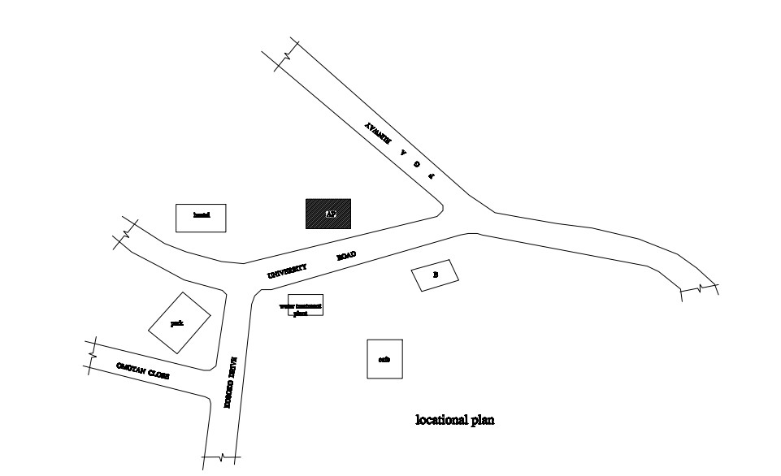
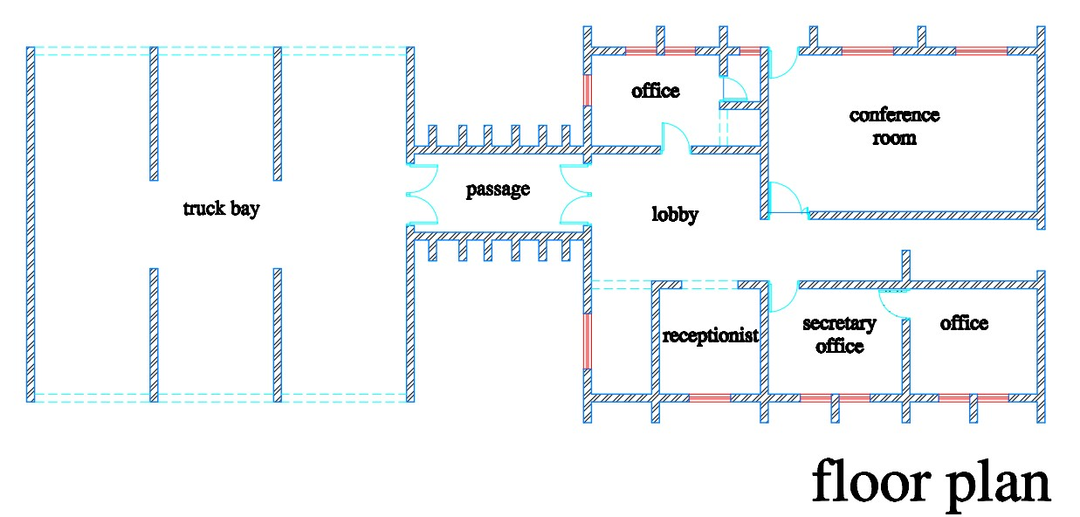
FIG 1.1: LOCATION PLAN CASE STUDY 1

PLATE 3.2:APPROACH VIEW CASE STUDY 1

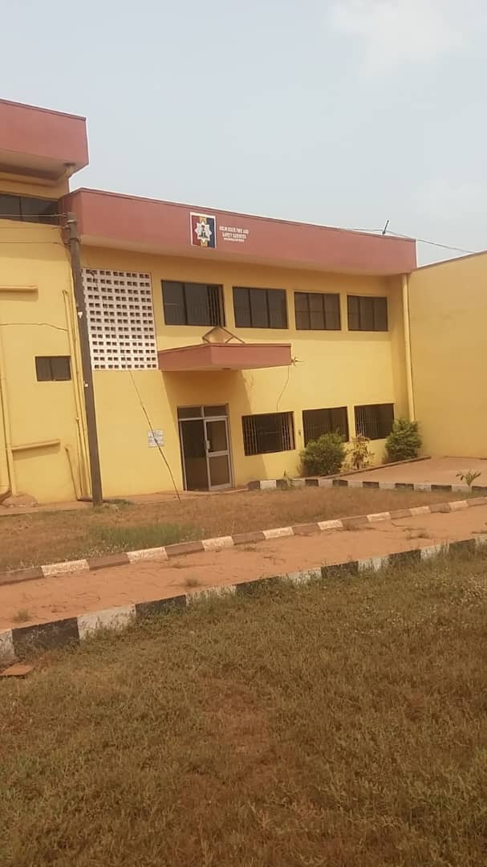
PLATE 3.1: APPROACH VIEW CASE STUDY 1

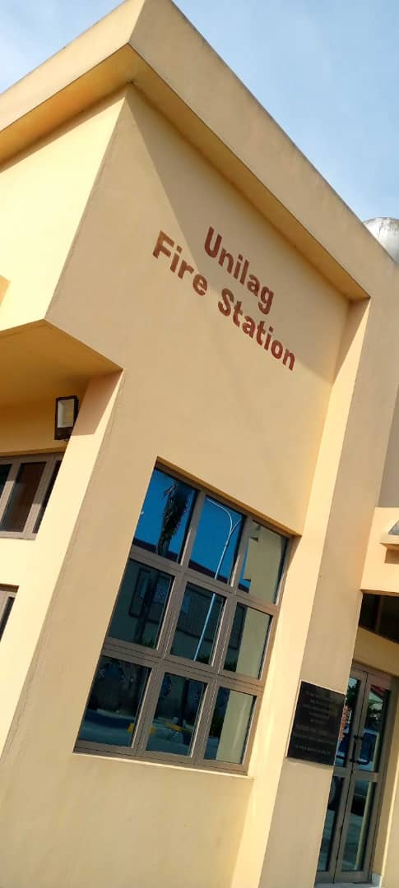

3.2 CASE STUDY 2
PLATE3.3:APPROACH VIEW CASE STUDY 1

PLATE 3.4: SIDE VIEW CASE STUDY 1

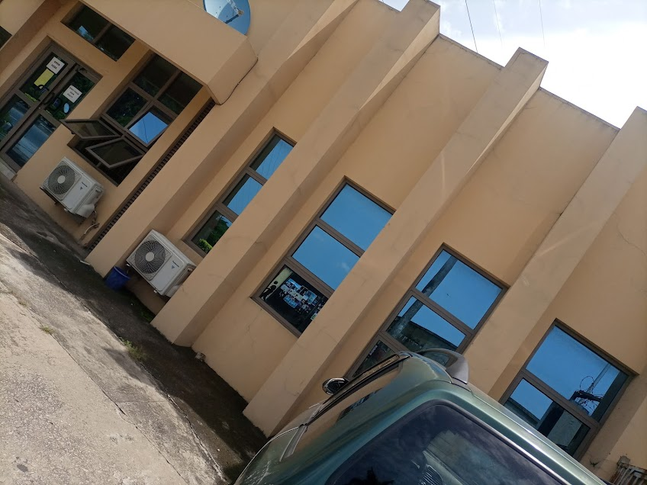
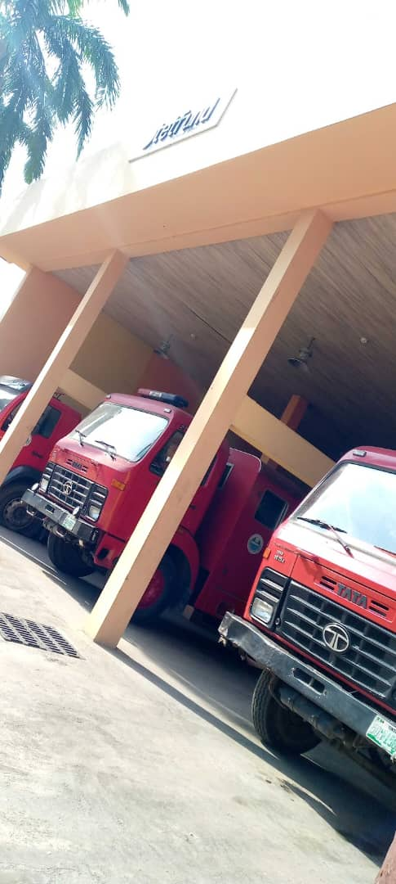
- NAME : OGUN STATE FIRE SERVICE HEADQUARTERS
- LOCATION : ONIKOKO , ABEOKUTA, OGUN SATE
MERITS
- There is easy access for fire fighters and equipment
- There is spacious area on site for training
- There is prominent location which enhanced visibility and accessibility
- The building clearly communicate its functions
DEMERITS
- Limited expansion
- Limited natural lightning to the building(fire station).
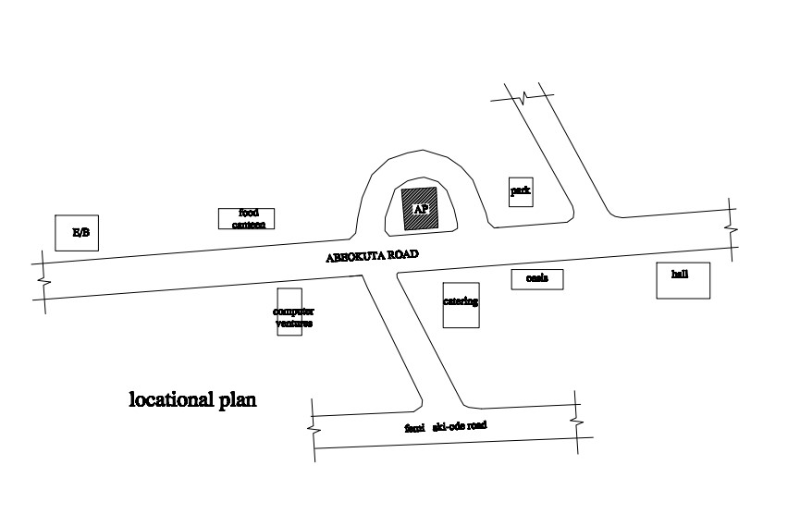

FIG 2.1: LOCATION PLAN CASE STUDY 1

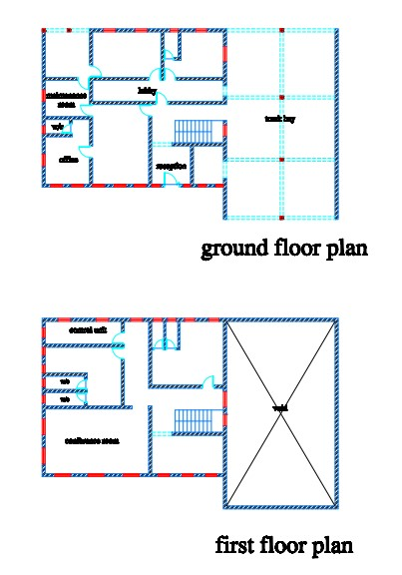
FIG 2.3: LOCATION PLAN CASE STUDY 1

FIG 2.2: LOCATION PLAN CASE STUDY 1

PLATE 3.5:APPROACH VIEW CASE STUDY 2

PLATE 3.6:REAR VIEW CASE STUDY 2

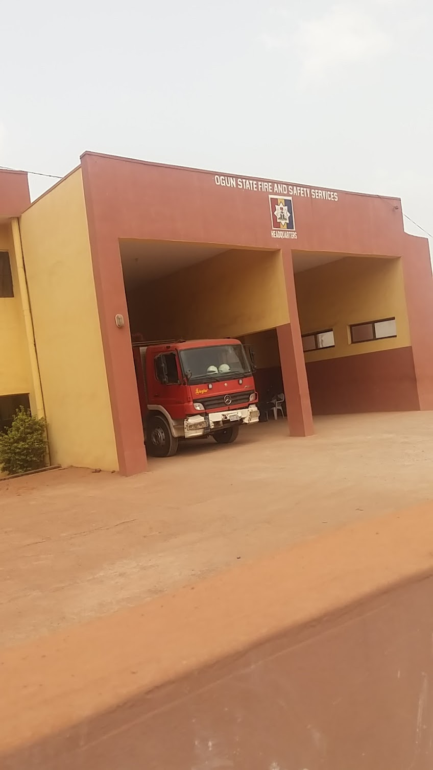
3.3 CASE STUDY 3
- NAME : FIRE SERVICE STATION,ABUJA
- LOCATION : GWARIPA ESTATE,ABUJA.
MERITS
- Its located in the mid city for rapid response
- There spacious area for practice of use of apparatus
- There is tower in t he structure
DEMERITS
- Insufficient parking space for staff
- Some areas receive insufficient ventilation on site.
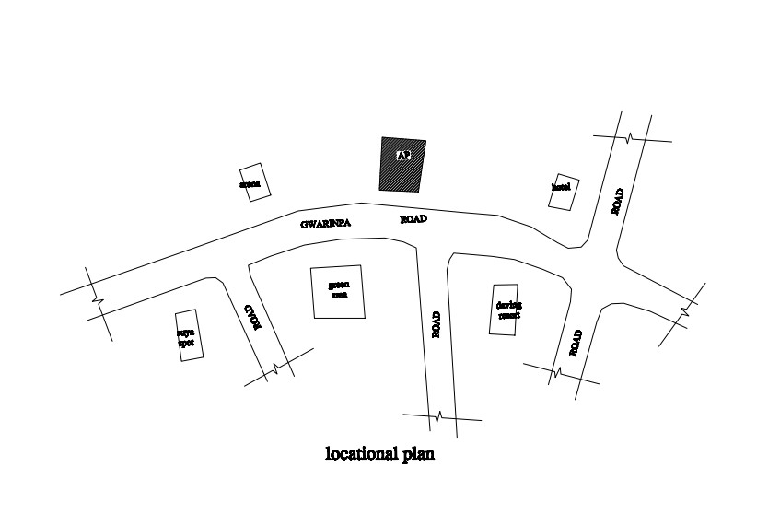

FIG 3.3.1: LOCATION PLAN CASE STUDY 1

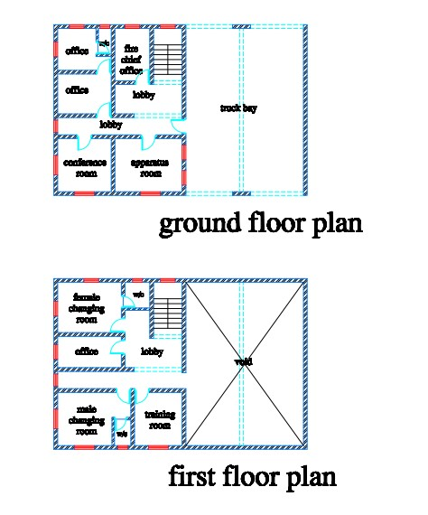

3.4 CASE STUDY 4
FIG 3.3.3: FLOOR PLAN CASE STUDY 1

FIG 3.3.2: FLOOR PLAN CASE STUDY 1

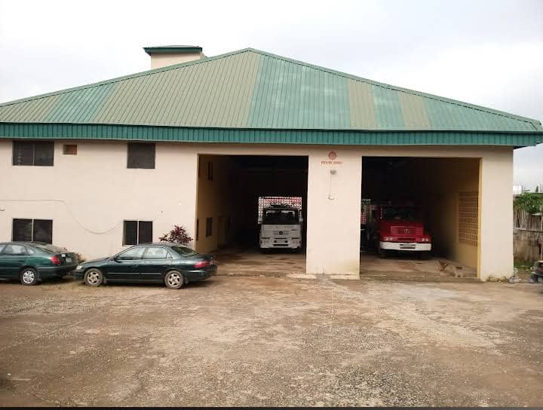
PLATE 3.3.8 : APPROACH VIEW CASE STUDY 3

PLATE 3.3.7 :APPROACH VIEW CASE STUDY 3

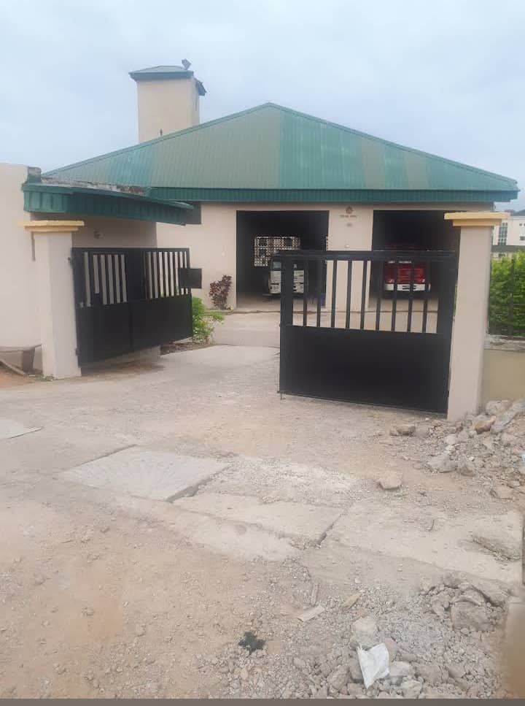
- NAME : OGUN STATE FIRE & SAFETY SERVICE OTTA
- LOCATION : ILO AWELE ROAD OTTA ,OGUN STATE.
MERITS
- Materials used for construction is locally sourced
- There spacious area for practice of use of apparatus
- There is tower in the structure
DEMERITS
- Insufficient parking space for staff
- Some areas receive insufficient ventilation on site.
FIG 3.4.0: LOCATION PLAN CASE STUDY 4

PLATE 3.4. : APPROACH VIEW CASE STUDY 5
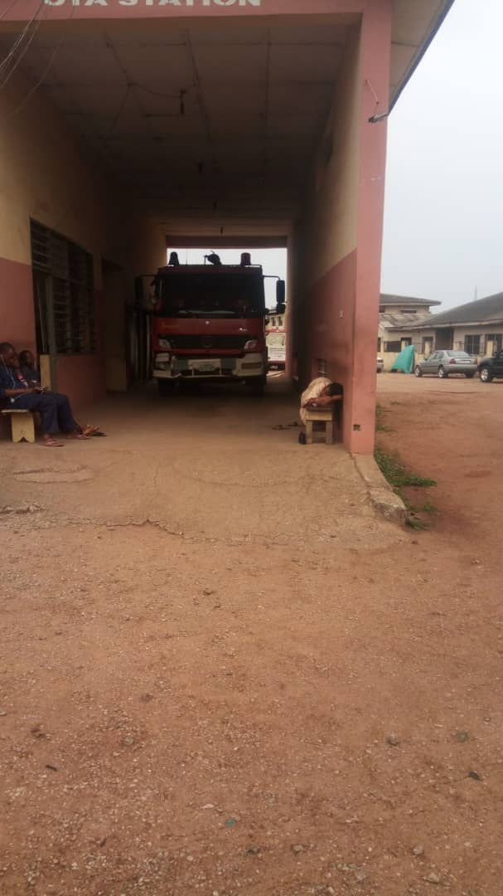
PLATE 3.9 : APPROACH VIEW CASE STUDY 5
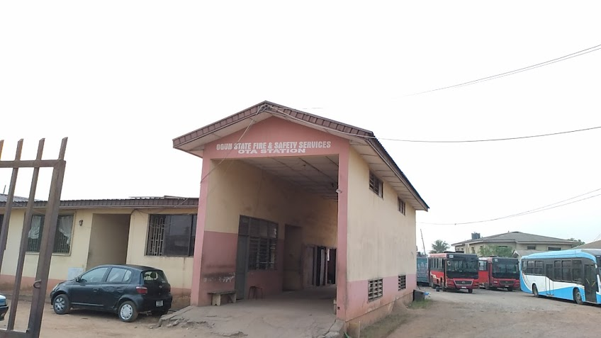
3.5 ONLINE CASE STUDY ONE
- NAME; CLEMET FIRE STATION
- LOCATION: COMMON WEALTH AVE SINGAPORE,ASIA.
BRIEF DESCRIPTION
Clement fire station is one of the civil defense fire stations operated by the Singapore civil defense force(S.C.D.F).located at commonwealth avenue, in the clement area of
Singapore, the station serves a s a critical emergency responses facility for the western region of the city
It was commissioned in 2005, the station is designed to support rapid-response to fire, rescue and medical emergencies. It houses a variety of emergency vehicles, including fire engines, ambulances, and ed rhinos(light fire attack vehicles unique to Singapore.

3.6 ONLINE CASE STUDY TWO
- NAME: KONG WAN FIRE STATION
- LOCATION: HABOUR ROAD, WAN CHAI,HONG KONG
- BRIEF DESCRIPTION
Kong wan Fire station is a key emergency response facility located at 14 Harbour road, wan chai, Hong Kong. Operated by the Hong Kong fire services department.it serves the densely populated wan chai district and its surrounding areas.
Long wan fire station plays a vital role in ensuring fire safety and emergency preparedness in one of the Hong Kong’s busiest commercial and residential area . the station is equipped with multiple appliance bays to house various emergency vehicle including fire engines and ambulances. It also contains administrative offices and accomodation facilities for fire personnel

CHAPTER FOUR
4.0 STUDY AREA/PROJECT SITE
Alimosho Local Government Area (LGA) is one of the 20 local government areas in Lagos State, Nigeria, and is notably the largest in terms of population. Located in the northwestern part of Lagos, Alimosho was created in 1976 and has grown into a densely populated urban center, playing a significant role in the socio-economic development of the state.
Alimosho shares boundaries with Agege and Ifako-Ijaiye LGAs to the west, Ikeja to the south, and Egbeda, Ipaja, and Ayobo areas within its own structure. Due to its vast land area and growing population, Alimosho was administratively divided into several Local Council Development Areas (LCDAs), including:
- Agbado/Oke-Odo LCDA
- Ayobo/Ipaja LCDA
- Egbe/Idimu LCDA
- Mosan-Okunola LCDA
- Alimosho LCDA proper
The headquarters of Alimosho LGA is located in Akowonjo.
Alimosho is a mix of residential, commercial, and semi-rural areas, with a rapidly urbanizing landscape. It hosts a wide range of people from different ethnic backgrounds, although it is predominantly inhabited by the Yoruba ethnic group. The area is characterized by bustling markets, educational institutions, religious centers, and numerous housing estates.
With an increasing number of infrastructural developments, road expansions, schools, and healthcare centers, Alimosho continues to grow as a strategic part of Lagos State’s megacity vision. Despite facing urban challenges such as traffic congestion, housing pressure, and sanitation issues, the local government remains a key contributor to the economic and social fabric of the state.
4.1 HISTORICAL BACKGROUND OF LAGOS STATE
Lagos State, located in the southwestern geopolitical zone of Nigeria, is the nation's commercial capital and one of the most economically vibrant states in West Africa. Created on May 27, 1967, as part of Nigeria's restructuring into twelve states, Lagos has grown to become the most populous state in the country, despite being the smallest in land area. The state shares borders with Ogun State to the north and east, the Atlantic Ocean to the south, and the Republic of Benin to the west.Originally a fishing settlement of the Awori subgroup of the Yoruba people, Lagos developed significantly under British colonial rule and served as the capital of Nigeria until 1991, when the capital was officially moved to Abuja. Nevertheless, Lagos remains the economic nerve center of Nigeria, housing the nation’s largest seaport, busiest airport, and a significant portion of its industrial and commercial infrastructure.Lagos State is divided into five administrative divisions—Lagos Island, Ikeja, Badagry, Ikorodu, and Epe—comprising 20 local government areas (LGAs). Ikeja serves as the state capital and hosts numerous government institutions, commercial businesses, and the Murtala Muhammed International Airport.
The state boasts a diverse and rapidly growing population, attracting people from all parts of Nigeria and beyond due to its vast economic opportunities. It is known for its dynamic urban landscape, cultural richness, entertainment industry (Nollywood and Afrobeat music), and ambitious infrastructure projects, such as the Lekki Deep Sea Port and the Lagos Blue Line Rail.
Lagos plays a critical role in Nigeria's socio-economic development and remains a symbol of progress, innovation, and resilience in the face of urban challenges such as traffic congestion, housing shortages, and environmental concerns.
Lagos State is known for its vibrant economy, driven by trade, manufacturing, entertainment, finance, and transportation. It houses Nigeria’s busiest seaports and international airport, as well as major industrial estates and business districts such as Victoria Island, Lekki, and Ikeja. The state also plays a key role in the country’s cultural and creative industries, being home to Nollywood, Afrobeat music, and numerous art and fashion scenes.
With a diverse population drawn from various ethnic and cultural backgrounds, Lagos State is a melting pot of Nigerian cultures. Its strategic coastal location and continuous urban expansion have positioned it as a leading African mega city and a gateway to West Africa.
4.2 SITE DESCRIPTION
Alimosho Local Government Area (LGA) is one of the 20 local government areas in Lagos State, Nigeria, and is notably the largest in terms of population. Located in the northwestern part of Lagos,
4.3 SITE ANALYSIS
Site Analysis is a thorugh examination and evaluation of site’s conditions, characteristics and context. It involves gathering and analyzing data to understand the site. The goals of the site analysis are to identify site constraints and opportunities, inform design and development decisions, ensure environmental sustainability, respect cultural and historical heritage and enhance the site’s potential.
4.4 SITE INVENTORY
Site inventory is a comprehensive documentation of the physical characteristics, features and conditions of a site. It typically includes: location and boundaries, topography, and drainage, vegetation, soil and geology, water resources and hydrology, climate and weather patterns, existing infrastructure, land use and zoning, environmental conditions ( if applicable ), photographs and maps.

4.4 GEOGRAPHICAL / CLIMATIC DATA
4.4.1 CLIMATIC DATA
In Lagos, the wet season is oppressive and overcast, the dry season is humid and partly cloudy and it is hot year round. Over the course of the year, the temperature typically varies from 64⁰F to 95⁰F and is rarely below 57⁰F or above 100⁰F .

4.2 RAINFALL
Lagos typically receives about 101.45millimeters (3.99 inches) of precipitation and has 148.38 rainy days (40.65% of the time) annually.
Lagos experiences two climatic season i.e rainy and dry season. The rainy season is between march and November with a brief break in august and the annual rainfall varies from 1200mm

4.4.3 WIND
Both tropical continental and tropical maritime air masses affect Lagos.The city experiences thunderstorm, during the beginning and ending of the raining season. The prevailing wind direction is southwest trade wind, which is rain bearing since it takes origin from the sea in the raining season period and from north.

4.4.4 TEMPERATURE
Lagos is within the climatic zone known as the equatorial zone which has a climatic type of low wet equatorial. The two major influences on Lagos climate are the two major wind currents. The south west trade wind is warm and moisture laden and the north east trade wind is cold and dry. The two winds current bring about the two different seasons called the rainy and dry season. The raining season is between April and October while the dry season is between November and March. It is accompanied by cold dust and harmattan.

4.4.5 HUMIDITY
Lagos under certain factors experiences high relative humidity with high rainfall during the month June, July, august, and September.
4.5 BRIEF ANALYSIS
The proposed fire station is designed to meet the urgent demands of emergency response services while incorporating modern architectural principles. Key considerations include functionality, accessibility, safety, and spatial efficiency. The layout is carefully zoned to separate public areas, administrative offices, crew quarters, and the appliance bay for fire trucks, ensuring quick response time and smooth circulation.Emphasis is placed on durability and fire-resistant materials, as well as sustainable features such as natural ventilation, solar power, and water recycling systems. The design also supports future expansion, advanced communication systems, and on-site training facilities, making it a fully functional, adaptable hub for emergency operations within the community.
4.6 CONCEPT DERIVATION
The letter “F” inspires a bold, angular form—symbolic of strength, urgency, and alertness.The building can take on a dynamic layout resembling the shape of “F” in its floor plan, creating functional arms for key zones

CHAPTER FIVE
5.0 APPROACH TO THE DESIGN/DESIGN REALIZATION
In approaching this design, many factors, strategies and research work were taken into consideration. Some of the factors include functionality, durability, and cost of materials. Their search work that were carried out are the study of the area, the neighborhood value. Statistics and population of the community, the household value, the occupations and social lives of the occupant of the area. These factors and deductions were highly considered in the development of this project to achieve a functional and aesthetically balanced design.
5.1 CONSTRUCTION TECHNOLOGY AND ENVIRONMENTAL CRITERIA
5.1.1 CONSTRUCTION METHOD
The method of construction involved in the erection of the building structure is in accordance with the architectural detail required in executing the buildings and the process of construction that is critical to structural component as affected by the site conditions and types of materials to be used.
After the preparation of the overall site plan, many designs are developed to show the specific methods of construction. These details as an integral part of the design process and serve two important purposes. Firstly, they stipulate the aesthetic as structural element of the plan and they provide the basis for costing project.
This section offers a side of representative details of' the various aspect of site development and summed that the details will act as guild to assist site designer in solving their particular problems. The section is not intended to present aesthetic or design solution alone but also indicate how similar technological difficulties are handled, it is clear that the method of construction of any structure such mass housing is determined from the functional requirement of the facilities provided and its exposure to weather and climatic condition for any use, the following factors are considered; Climatic conditions of the site, Condition of the sub-soil present on the site, Fire protection requirement, Appearance of materials, Durability and easy maintenance, Economy, Availability of materials, Aesthetic, Construction technique and Cost of materials.The various building components taken into consideration are:
- SUB-STRUCTURE: This is the part of the building below the natural ground level. The foundation footing is reinforced for stability of the building to enable it to withstand the load (live, superimposed and wind load). The foundation of the building shall be determined by the structural engineer according to the bearing capacity of the soil.
- SUPER-STRUCTURE: This is the building part that is above the natural ground level. The entire structure is designed with reinforced concert columns, beans and hollow sand screed block.
5.1.2 MATERIALS AND STANDARD FORMS
The following materials are applied in the construction of the structure such as:
- FLOORS: The ground floor will be of solid concrete slab of 150mm with asphalt coating as damp proof course laid on well compacted hardware. The upper floors are reinforced concrete suspended floors of 150mm thick. Floor finishes are to be specified for each unit depending on the function it is meant to serve. Floor finishes are to be specified for each tiles and terrazzo floor tiles because they are durable, easy to maintain and do not wear easily.
- DOORS: The size and types of doors used depend on its location but generally the size ranges from 1200mm, 900mm and 750mm and the type of materials specified for the construction is in the door schedule which should be strictly followed.
- WINDOWS: A window in a building is designed primarily to allow natural light, natural air, the building issued to allow free flow of carbon dioxide out of the building as well as to allow for outside view.
- ROOFS: Roof members of all building will be made up of timber and long span of aluminum roofing sheet. This is for the easy maintenance of self-support and longer life span.
- CEILING: The kind of ceiling system specified for the building in the housing estate is the asbestos ceiling sheet. The functional requirement of this ceiling is considered under the following: Durability, Easy to maintain, Heat resistance and Cost
5.2 SERVICES REQUIRED
Services are essential for comfort ability security and safety to create a conducive atmosphere for the user of the housing estate to achieve this, the following services must be provided:
1. ELECTRICITY: The main source of electricity is from the national electric power authority and this should be connected to the site from the power in front of the site way.
2. VENTILATION: Ventilation needed in the intention part of building varies from place to place. Natural ventilation is considered best in building construction and is attained with the use pf natural air. Natural air reaches interior part of the building through windows and some other openings. Artificial ventilation is attained with the use of fans and some other atmospheric cooling machines.
3. LIGHTNING: Natural lightning is the best and most effective source of light for the building though artificial sources will be used where necessary.
4. PLUMBING SERVICES: All water supplies and other distribution to all the required areas would be through 50mmdiameter galvanized steel pipe while sewage will be PVP service pipe, which ranges from 50mm, 100mm and 150mm diameter. All the baths and shower will be provided with shower tray, towel trays, washing hand basin and tissue roll holders. The entire toilet WHB will be with a mirror over it. Septic tanks and soak away pit shall be placed and in suitable location for easy maintenance.
5. ACOUSTICS: The major noise comes from the major road and this could be reduced considerably by maintaining a reasonable setback from the major road and the proper landscaping which include planting of trees and grass to serve as noise and sound absorbent.
6. WASTE DISPOSAL: Waste disposal should be provided where unwanted material such as dirty should be dump in order to make the environment clean.
7. FIRE PROTECTION: Structural protection is achieved by using fire resistance elements and limiting the use of combustible materials and finishes. Fire detectors and firefighting equipment should be provided.
8. SECURITY SERVICES: The entry and exit to the site have been restricted to one entrance. This is to monitor the movement of vehicles in and out of the site. The entrance will be maintained with the security men checking incoming and outgoing vehicles. The entire site will be light up with security light and street light within the site. It is necessary to fence the mass housing to ensure adequate security, a strong fence is provided in addition to police post in order to keep off intruders of all types.
9. EXTERNAL WORK: These are work carried out outside and around the building. It is otherwise known as Landscaping. These are elements used to provide aesthetics and general human comfort in and around the building.
There are two types of landscaping: Soft Landscaping and Hard Landscaping
i. SOFT LANDSCAPING: This is done by planting trees, shrubs and lowers around the building to serve as barrier to the thermal discomfort and beautify the structures.
ii. HARD LANDSCAPING: This is done by paving the whole of the open ground and such paving area include the parking lots, the walk ways, roadster.
5.2.1 ENVIRONMENTAL CONDITIONS TO BE ACHIEVED
There is plantation of trees to regulate the temperature. The orientation of the building structure to achieve maximum comfort thereby controlling the radiation.
5.2.2 PERFORMANCE STANDARDS
The performance standard of the building construction is to be highly luxurious because of the targeted users and the occupants of the town which have a high taste of social lives.
5.2.3 LEGAL ISSUES AND PLANNING REGULATIONS
The proposed building must pass through various process in order to be approved of the planning regulations of the local government authorities and the board of chiefs because of its being public building. The process for approval in the local planning authority is to provide the following which are: The C of O of the Land, The Survey Plan, The original land purchase documents, The Structural Drawings, The Architectural Drawings and The Mechanical and Electrical Drawings.

5.2.4 BEHAVIOURAL PATTERNS AND CONSIDERATIONS
The condition in designing the mass housing is for comfort ability and affordability of the proposed tenant and user of the estate, providing adequate recreational facilities and securities.
5.3 CONCLUSION AND RECOMMENDATIONS
5.3.1 CONCLUSION
This project has examined the contextual and organizational challenges in public housing provision in Ilorin east local government, kwara state.
Research shows that since independence in 1960, government in Nigeria have demonstrated commitment to addressing the housing problems in several ways but due to funding, political and organizational challenges, public housing agencies have provided insufficient number of poor quality and unaffordable housing agencies have provided insufficient number of' poor quality and unaffordable housing units in the country.
5.3.2 RECOMMENDATIONS
- Adopt User-Centered Design Principles
Fire station design should prioritize the daily routines, health, and safety of firefighters. This includes:
- Ergonomic layouts for faster response times.
- Comfortable dormitories and rest areas for shift recovery.
- Gender-inclusive facilities for diverse staff.
- Incorporate Sustainable and Green Building Strategies
Modern fire stations should adopt energy-efficient and eco-friendly designs, such as:
- Solar panels and LED lighting.
- Rainwater harvesting systems.
- Use of local, low-carbon, and fire-resistant materials
- Integrate Smart and Responsive Technologies:The use of Intelligent Building Systems (IBS) enhances functionality and safety:
- Automated dispatch systems and real-time communication.
- Smart HVAC systems with contaminant control
- GIS-based monitoring of fire coverage zones.
- Flexible and Modular Spaces
Designs should allow for future expansions and changes in operational needs:
- Modular bays for different vehicle sizes
- Multi-use training and community rooms.
- Open-plan administrative sections for adaptability.
- Improve Site Selection and Accessibility
Effective siting of fire stations should be based on:
- GIS analysis for optimal response coverage.
- Proximity to main roads and emergency routes.
- Buffer zones to minimize disruption in residential areas.
- Include Wellness and Decontamination Zones
Firefighters face hazardous exposures; thus, designs must feature:
- Proper decontamination rooms at station entries.
- Clean-to-dirty circulation routes.
- Fitness and mental health support areas.

REFERENCES
Adebayo, K. (2017). Challenges facing fire services in Nigeria. Journal of African Safety and Risk Management, 4(2), 88–97.
Burgess, J. (2010). Designing fire stations for modern operations. Architectural Press.
Eliot, J. (2016). Fire risk in expanding cities: A spatial approach. International Journal of Risk and Crisis Response, 8(1), 27–42.
Grimwood, P. (2005). Operational fire-fighting: Command, control and risk management. Fire Protection Publications.
National Fire Protection Association. (2018). NFPA 1710: Standard for the organization and deployment of fire suppression operations, emergency medical operations, and special operations to the public by career fire departments. NFPA.
Nguyen, P., & Chike, I. (2019). Typological studies of fire stations in urban Nigeria. African Journal of Built Environment, 5(2), 55–69.
McConnell, T. (2018). Fire stations as community hubs: Architectural trends in public safety facilities. Journal of Public Architecture, 14(2), 45–59.
Musa, I., Yusuf, A., & Olayemi, T. (2020). Evaluating fire response time in Lagos State. Urban Risk Management Journal, 6(1), 45–59.
Smith, R., & Jones, M. (2016). Sustainable design strategies for fire stations. International Journal of Sustainable Architecture, 22(4), 88–102.
United States Fire Administration. (2019). Fire station design considerations. Federal Emergency Management Agency.

APPENDICES
APENDIX 1: SITE ANALYSIS
APENDIX 2:SITE INVENTORY
APENDIX 3:SITE SELSCTION CRITERIA
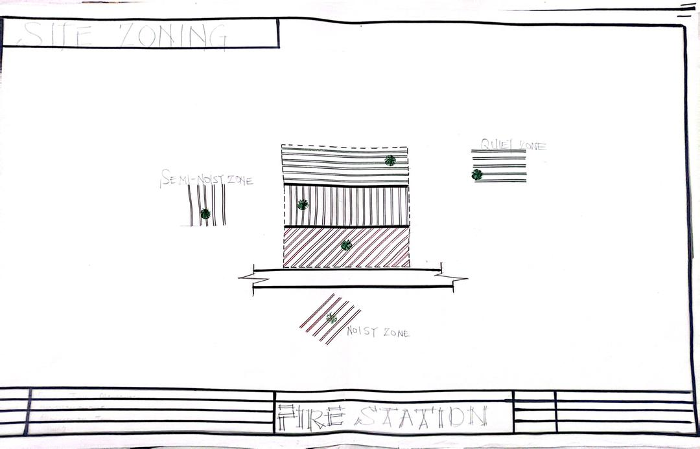
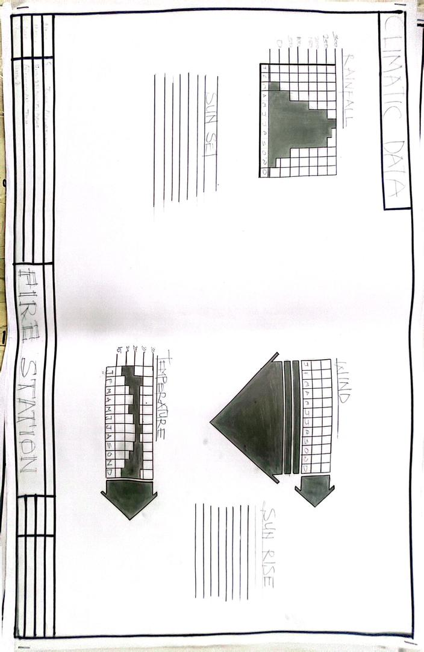
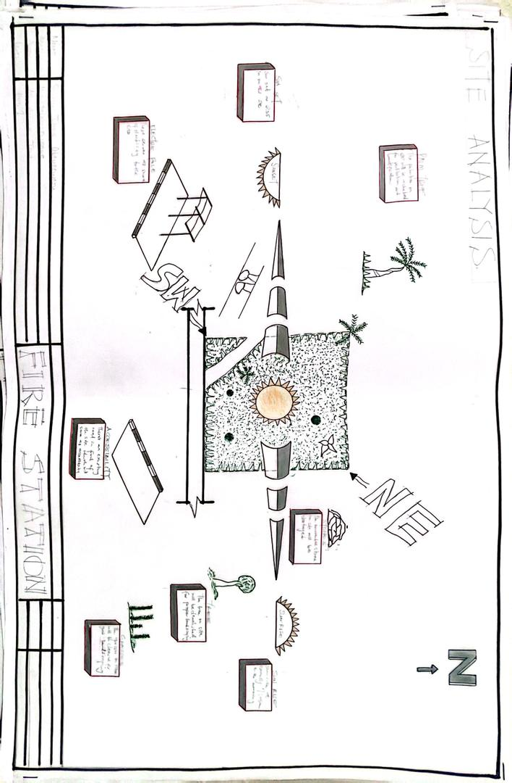

APENDIX 4:PROJECT SCOPE AND DESIGN SCOPE
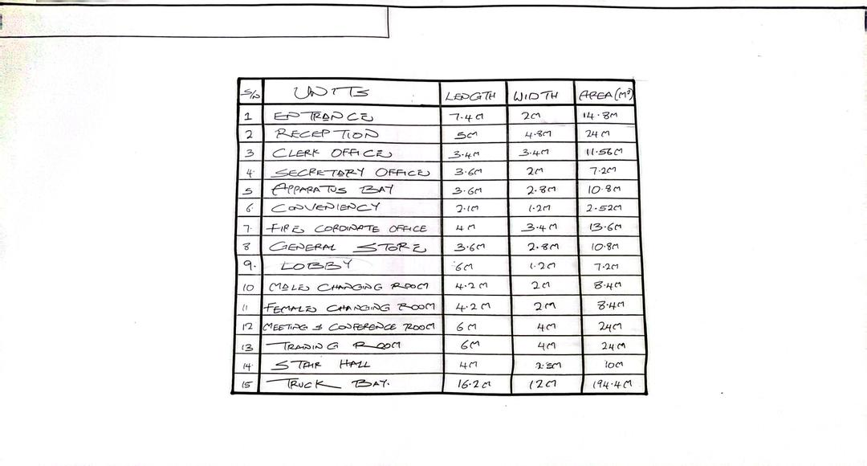
APENDIX 5 :SPACE CALCULATION
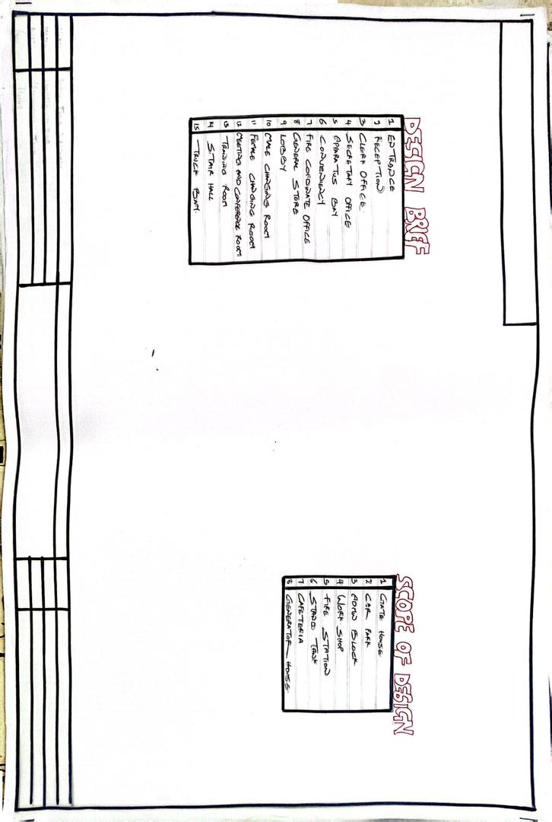
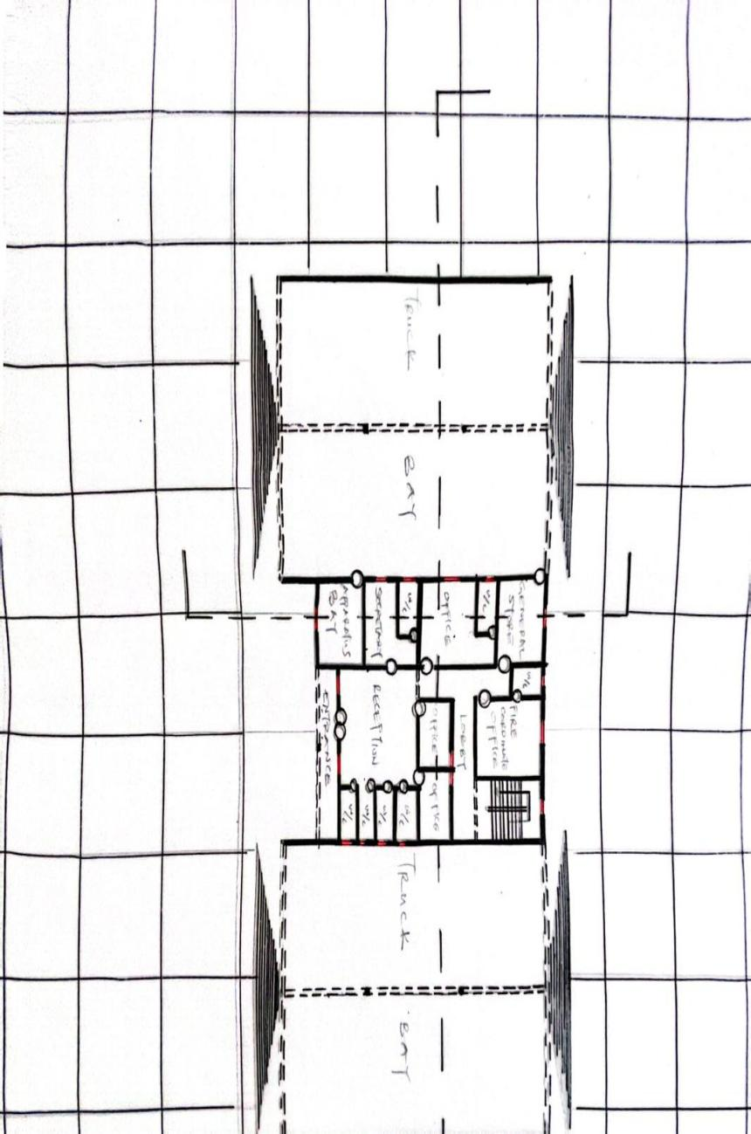
APENDIX 6 :FIRST FLOOR PLAN
APENDIX 7:GROUND FLOOR PLAN

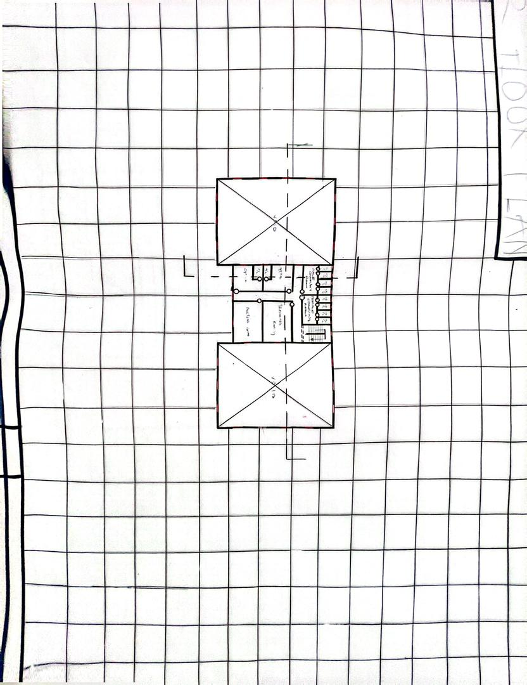
APENDIX 9:CONCEPT DIAGRAM
APENDIX 8:BUBBLE DIAGRAM
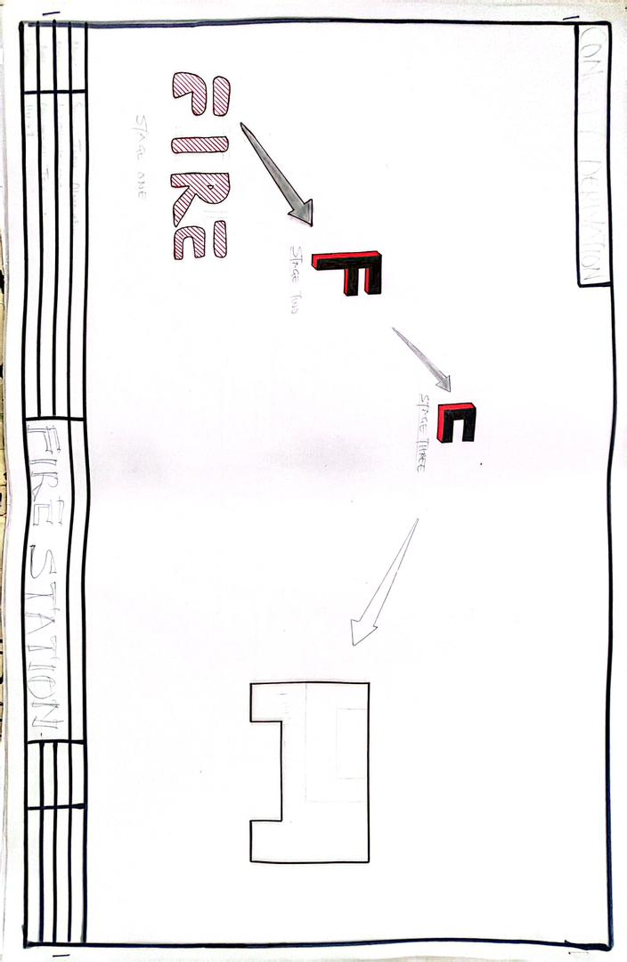
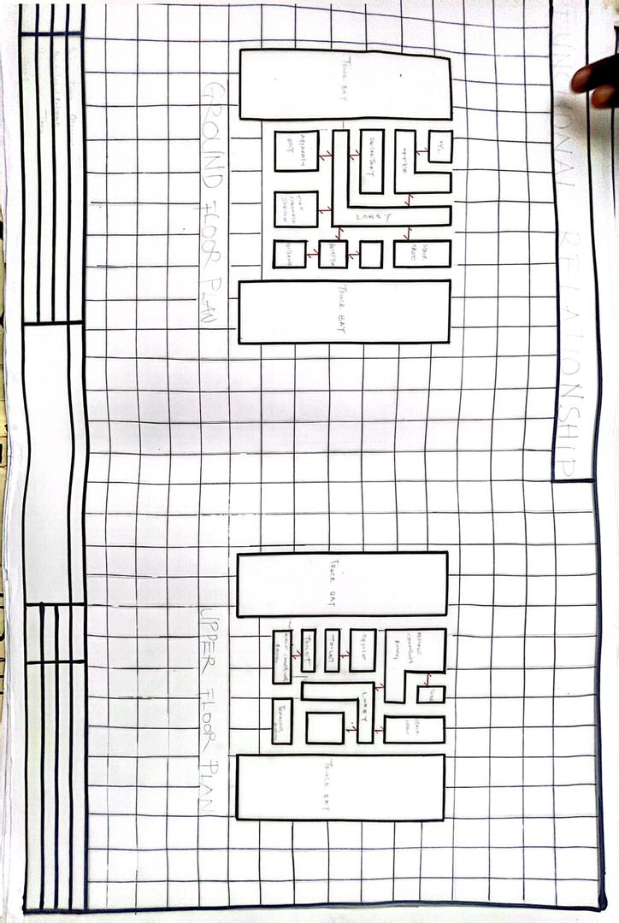
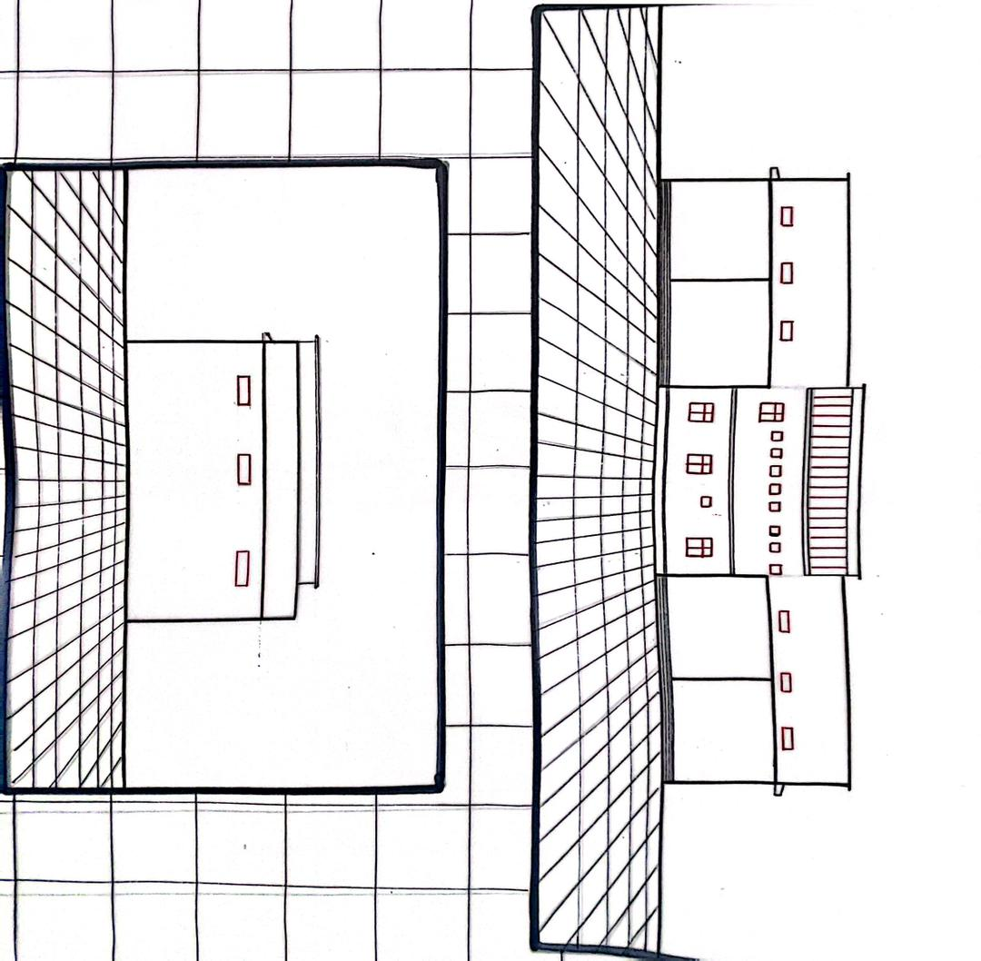

APPENDIX 11:ELEVATIONS

APENDIX 10 :ELEVATIONS
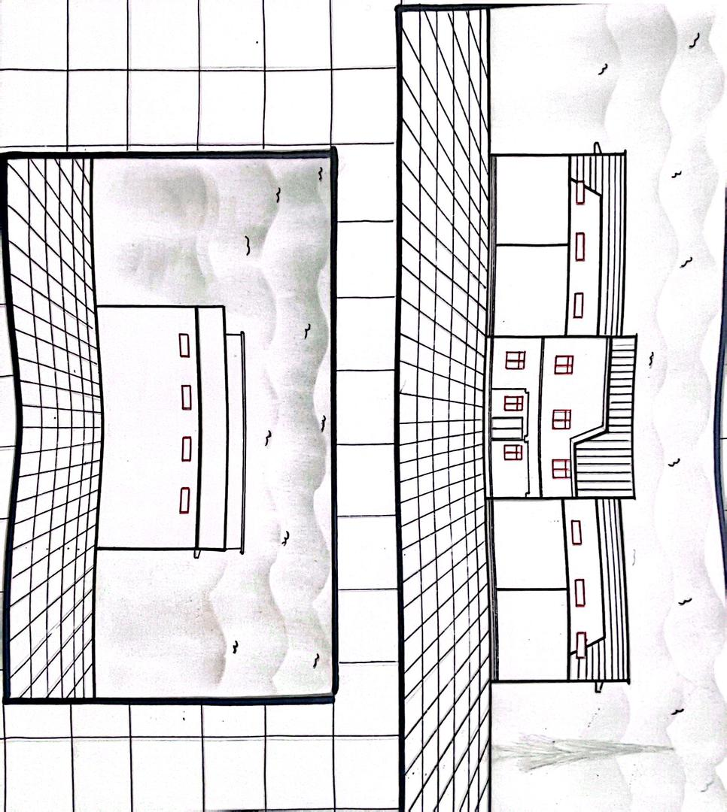
APPENDIX 12 :ROOF PLAN
APPENDIX 13 :SITE PLAN
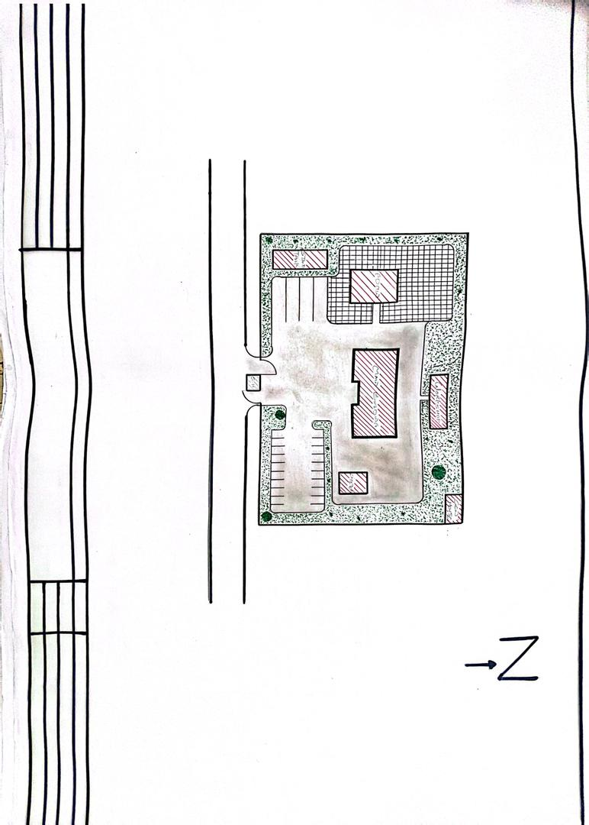
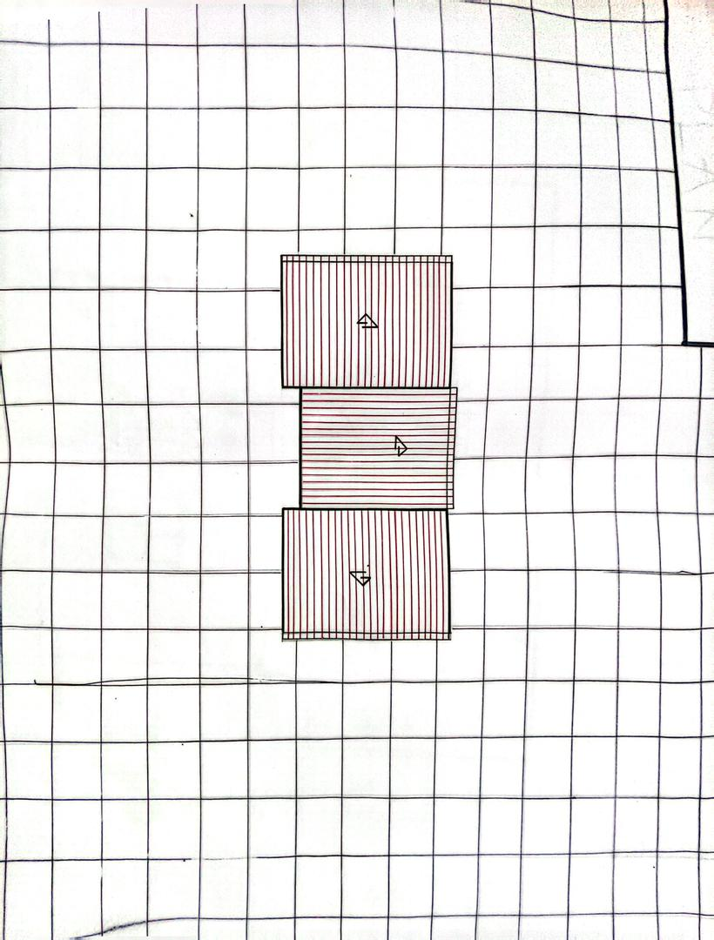

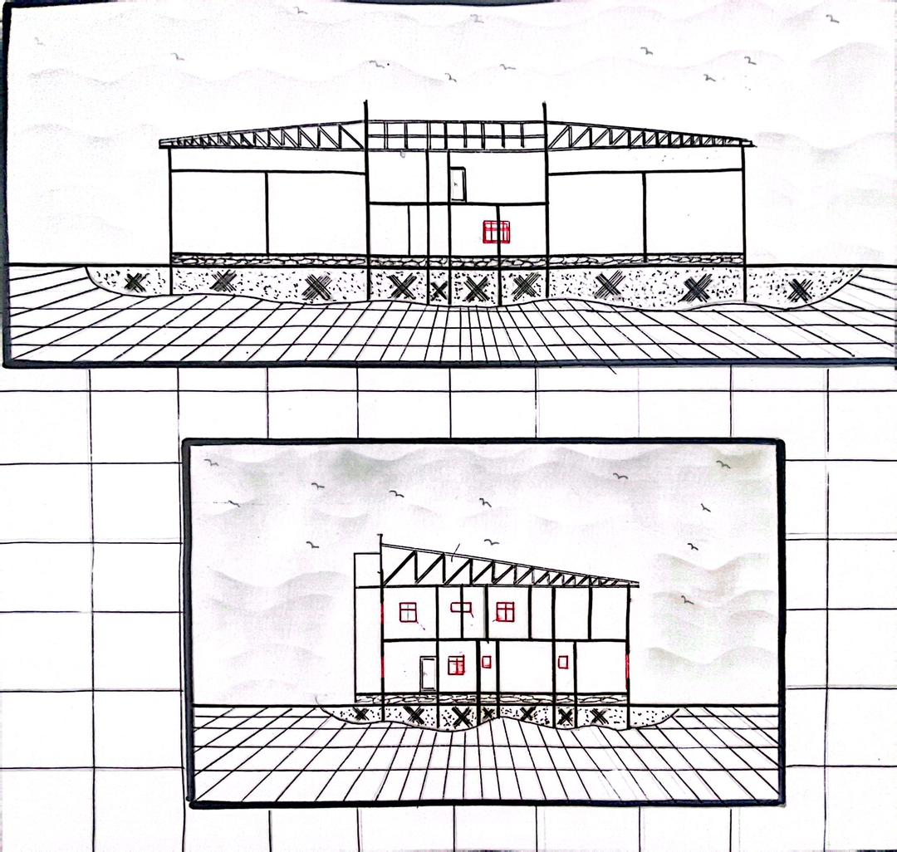
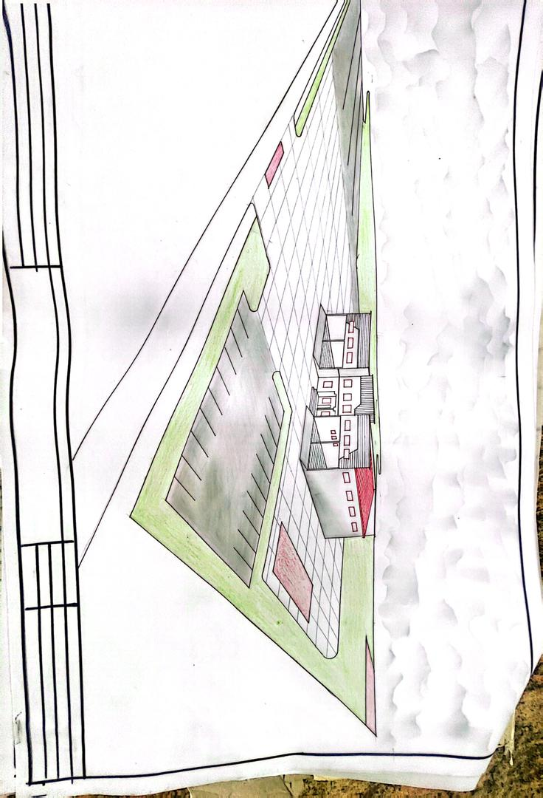
APENDIX 14 :SECTION FOR 1 BEDROM SEMI DETACHED BUNGALOW
APENDIX 15 :PERSPECTIVE

