EVALUATION OF THE IMPACT OF GOLD MINING ON THE WATERS OF ALAGBEDE DABA COMMUNITY MORO LOCAL GOVERNMENT AREA, OF KWARA STATE

BY

Isaac Oseme MOMOH HND/23/MNE/FT/0004

DEPARTMENT OF MINERAL AND PETROLEUM RESOURCES ENGINEERING TECHNOLOGY, INSTITUTE OF TECHNOLOGY KWARA STATE POLYTECHNIC, ILORIN

IN PARTIAL FULFILLMENT OF THE REQUIREMENT FOR THE AWARD OF HIGHER NATIONAL DIPLOMA (HND) IN MINING ENGINEERING TECHNOLOGY

JULY, 2025.

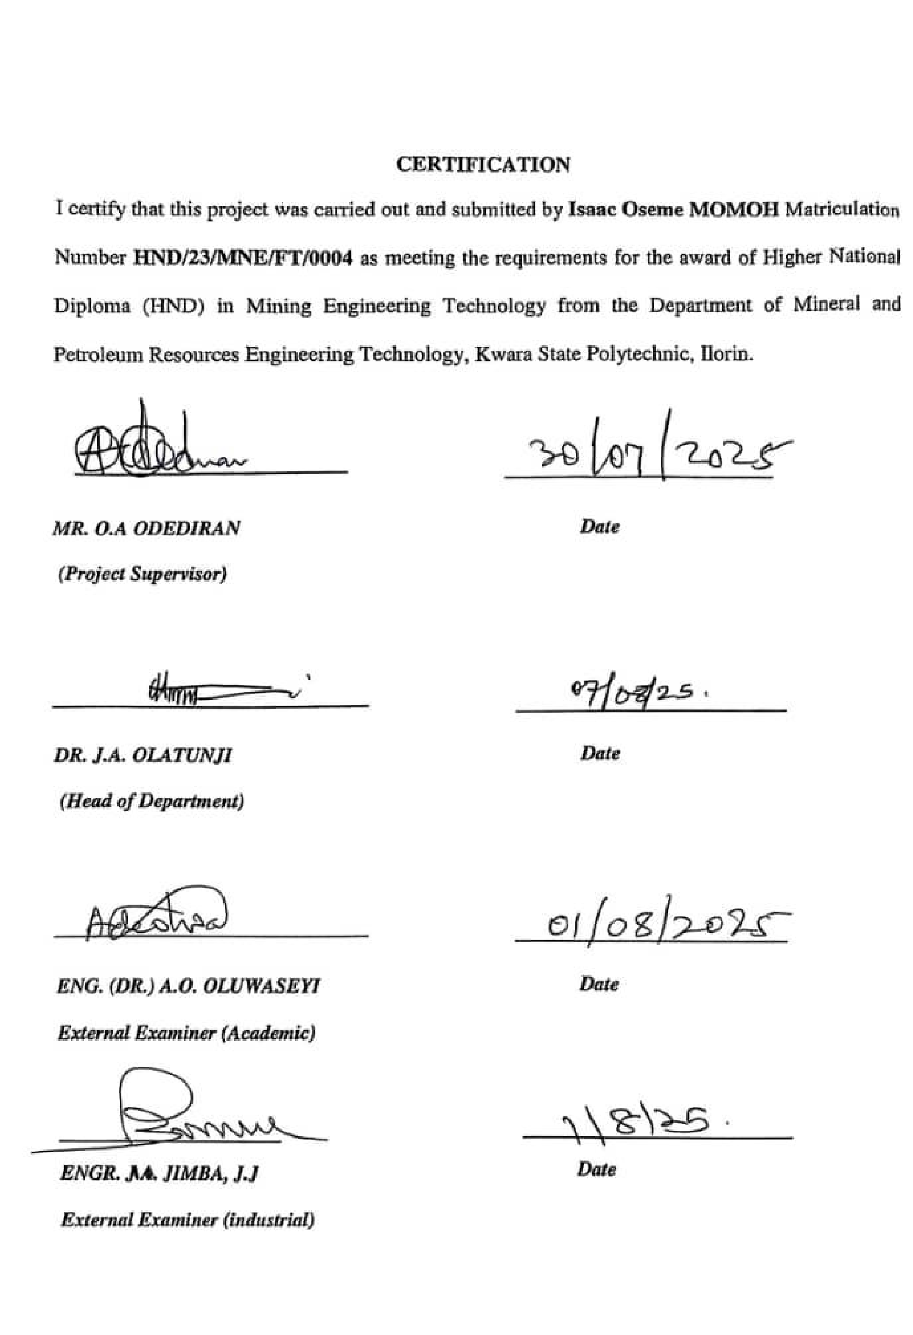
CERTIFICATION

I certify that this project was carried out by
MOMOH
ISAAC

OSEME

with matriculation
number
HND/23/MNE/FT/000
4

as part of
the requirement
s

for the award of Higher
National Diploma in
Mining Engineering from
the Department of Minerals and
Petroleum Resources Engineering Technology, Kwara state polytechnic, Ilorin.

____________________

____________________

MR. ODEDIRAN O.A.

Date

(
Pr
oject Supervisor)

___________________

_______________________

DR. OLATUNJI J.A.

Date

(
Head
of

De
partment
)

___________________

_______________________

ENGR. DR. OLUWASEYI, A.O.

Date

External Examiner

(
Academic
)

___________________

_______________________

ENGR. JIMBA, J.J.

Date

External Examiner

(
Industrial
)

DEDICATION
I dedicated to Almighty God; The creator of heaven and earth, who in his infinite mercy has sustained me from the beginning of this Higher National Diploma Program to the very end and also for the success of this work. I also dedicate this work to my loving parents MR. & MRS. MOMOH for their gracious support in my life. I really appreciate all and sundry.

ACKNOWLEDGMENT
My profound gratitude goes to Almighty God for sparing my life up to this moment.
My appreciation goes to my supervisor MR. ODEDIRAN, O.A. and all the lecturers in Minerals And Petroleum Resources Engineering Department for their great assistance towards the success of the project,
I want to acknowledge the Head of Derpartment DR. OLATUNJI J.A., ENGR. AGBALAJOBI S.A, ENGR. DR. OLATUNJI K.J. ENGR. USMAN, DR. OBARO.
I am greatly indebted to my parents MR. & MRS. MOMOH for their financial, moral and prayer support throughout the duration of the programme
I also give thanks to all my friends and family Members for their direct and indirect support, most especially my lovely brothers ISAIAH,SEGUN and my uncle Mr GABRIEL, BROTHER FRANK and to all my amazing friends, BAWAL for their courage and support throughout this programme.
Finally, to all my friends that contribute directly or indirectly thank you guys so much for everything am really grateful.

ABSTRACT
This study assessed the impact of gold mining activities on water quality in Alagbede Daba community, kwara state. Ten samples were collected randomly from selected water bodies and Physico-chemical parameters, such as TDS, EC, pH and temperature were measured on the field. Selected heavy metals that is Ni, cadmium we're also determined by AAS method of analysis. The results showed elevated levels of heavy metals including cadmium, nickel and lead in water sources, exceeding recommended standard Physico-chemical parameters, such as pH and temperature were also affected. The findings suggest that gold mining activities have potentially contaminated water sources, posing health risks to the community. The study results can inform policy decisions and intervention to mitigate the environmental and health impacts of gold mining in the area.

TABLE OF CONTENTS
Title Page i
Certification ii
Dedication iii
Acknowledgement iv
Abstract v
Table of Content vi
List of tables vii
List of figures ix
CHAPTER ONE
1.0 Introduction 1
1.1 Location and Accessibility 1
1.2 Climate and Vegetation 2
1.3 Relief and Drainage 3
1.4 Aim and Objectives 3
1.5 Problem Statement 4
1.6 Justification 4
1.7 Scope and Limitation of the Study 4 CHAPTER TWO
2.0 Literature Review 6
2.1 Review of Gold Mine and it Environmental Impacts 6
2.2 Review of Existing Studies of Gold Mining and Water Quality 6
2.3 Water Pollution ad Effects on Humans Health and The Environment 7
CHAPTER THREE
3.0 Research And Methodology 8
3.1 Sample Collection ad Preparation 8
3.2.1 Field Techniques 9
3.3.2 Atomic Absorption Spectroscopy (AAS) 9
3.4.3 Potential of Hydrogen (pH) 10
3.5.4 Turbidity 11
3.6.5 Temperature 12
3.7.6 Measurement of Physicochemical parameter 13
3.8.7 Electrical Conductivity (EC) 13
3.9.8 Total Dissolved Solid (TDS) 14
3.10.9 Digestion of Water Samples using Aqua-Regina Method 15
CHAPTER FOUR
4.0 Result And Discussion 16
4.1 Result of Heavy Metals Analysis 16
4.2 Results of Physio-Chemical parameters 17
CHAPTER FIVE:
5.0 Recommendation And Conclusion 18
5.1 Conclusion 18
5.2 Recommendation 18
REFERENCE 19

LIST OF TABLES
Table 1: Coordinate of the Study Area 11
Table 2: Measured Physico-Chemical Parameters 18
Table 3: Heavy Metals of Water 19
Table 4: Standard Values of Water Samples 20

LIST OF FIGURES
Figure 1: Geological Map Showing Alagbede-daba Area (bayode et al., 2023) 2
Figure 2: Geological Map of Nigeria Showing Study Area (ajadi et al., 2018) 2

CHAPTER ONE 1.0 INTRODUCTION 1.1 Location and Accessibility
The Alagbede-Daba communities are located in Moro local government area of Kwara State, Nigeria. Alagbede-Daba communities are situated in a rural area with surrounding communities like Lanwa, Ejidongari and Olooru. The area is characterized by natural resources such as yam, corn, cassava: minerals resources like gold, granite, talc, and silica. Sand also present. The road network in Alagbede-Daba appears to be connected to major towns like Bode-Saadu, the local government headquarters which is about 85km from Ilorin. Buses and motorcycles are common modes of transportation in the areas, during the rainy season, some of the roads may become impassable due to flooding. Due to poor road maintenance.
The roads are prone to damage from flooding accompany by lack of drainage infrastructure. Alagbede-Daba communities are situated in a relatively flat terrace. Ilorin East is well drained i.e the major rivers in Ilorin are river Asa (most popular) and river Oyun (the longest). Inadequate drainage systems can exacerbate flooding, making it more likely for road to becomes impassable.

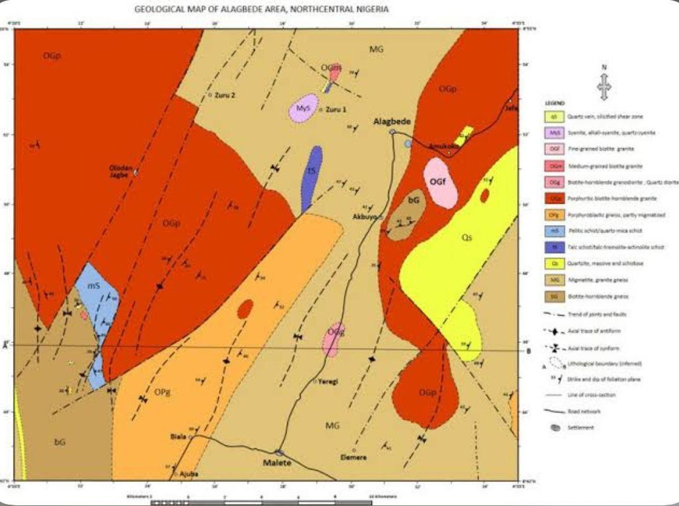

Figure 1: Geological Map showing Alagbede- Daba Area (Bayode et al., 2023)

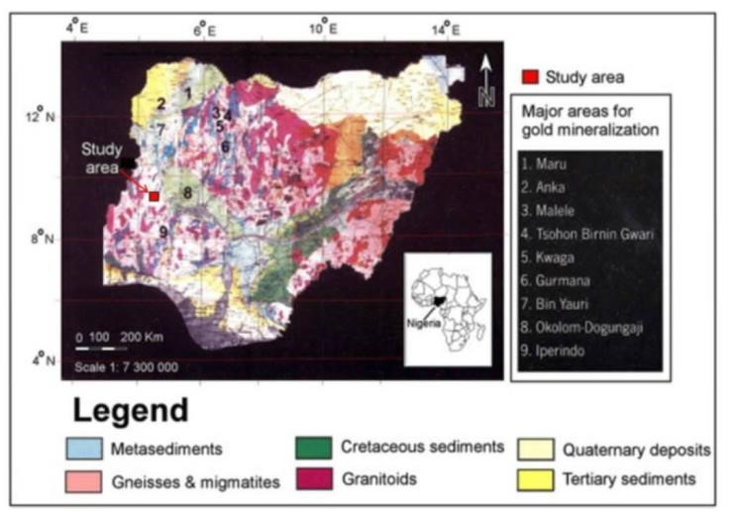

Figure 2: Geological Map of Nigeria showing Study Area (Ajadi et al., 2018) 1.2 Climate and Vegetation
Ilorin has a tropical savannah climate (KOPPen Aw), Characterized By a pronounced wet season and a cry season with haematin wind. Wet season runs from late march /April October /November, Dry season stretches from November to march/ April dominated by dusty, dry hamster winds. Rainfall ranges from 990 mm to 1,318 mm, with a typical figure around 1,200mm, Peak rainfall occurs between June and September featuring a “double peak” Pattern. Mean annual temperature is about
26°C• Daily high range from 33°c -35°c during the dry season (Nov-Jam),rising to 34°c - 37°c during the hottest Period (feb- Apr), mean monthly max : January ~ 33.7°c, march ~ 36. 1°c, monthly min: January ~19°c, March ~23. 7°c-Humidity is high during wet months (75-88%) ,dropping to 35-80% in the dry season. Sunshine hours range from ~ 4 hours /day in Wettest months (July- Aug) up to ~ 7h/day in dry month
Ilorin is located in derived southern Guinea savannah zone, a transitional belt between tropical forests in the south and Sudanian savannah in the North. Savannah woodland with a mix of tall grasses and Scattered medium- sized trees, common tree species include parka biglobosa (locust bean) vitellaris pore doxa (Shea), Adansonia digitata(baobab ), Azadirachta Indicia ( neum), among others . Riparian forest are found along waterways like Asa, Agba, Alalubosa, okun, osere, and aluko Riders, the areas forms part of the Guinean forest – savanna mosaic, a patch work of savanna and forest ecosystem . Soil dervied from (Pre cam brian basement complex, generally loamy to lateritic, moderately fertile, Topography elevation ranges around 273- 36mm, with sobi hills reaching ~ 394m.

1.3 Relief And Drainage
The relief and drainage characteristic of Alagede daba community play a significant role in shaping the environmental impact of gold in mining activities , Ilorin area including Alagade Daba – rest on the basement complex terrain With elevations typically between,275m and ~ 364m above sea Level, and isolated hills like sobi hill reaching ~ 394m . The broader study area Shows elevation from 71m up to 566m, categorised as very low: 71-203m, low 203 – 270m, moderate 270 321m , High: 321 – 371m,very high:→ 566m alagade, daba most likely lies within moderate elevations zones (270-32/m ), making it prone to water movement from Higher to lower surroundings areas. The slope characteristics across Ilorin, slopes range from 0° to 36 °with very law: 0-2°,low 2-3°, moderate :3-6°, High: 6-12°, very high 12-36°.
Approximately 85% of the land scape, Including the Alagade Dada area, feature gentle
Slopes (0-6°) Ideal for infiltration; but capable of runoff towards area during heavy rain.
River basins & Tributaries Ilorin is located within the lower Nigeria River basin and is drained by several rivers inducing Asa, Agba, osere, alalubosa,okun, and aluko through alagade daba isn’t name explicitly , it lies within proximity to the Ada river network . Drainage density (DD). The regions exhibit a drainage density ranging from
0 to 0.74km/km2, with 26% representing high to very higher drainage densities. High DD means more frequent channels runoff – and pollutant – into the streams quickly. proximity to streams approximately 46% of the Ilorin area lies within zoom of major stream , significantly increasing risk of direct runoff into water ways alagede daba , within urban fringe ; is therefore likely to experience strong hydrological connectivity to these drainage channels

1.4 Aim And Objectives
The aim of the project is to evaluate the environmental impact of gold mining activities on surface and groundwater quality in the alagede daba community Moro local government area of Ilorin state Objective:
- Determine selected Heavy metal contamination of the waters of the study area
- Determine the physiochemical form metals of the water of the study area.

1.5 Problem Statement
Gold mining has become a rapidly expanding activity in the alagede daba community, predominantly through small scale and artisanal operation . While mining offer potentials economics benefits, its environmental consequences. Particularly on water resources and increasing alarming. Resident rely heaving on surface water (steams, River ) and shallow wells for daily domestic and agricultural use . However, these water sources are under threat from pollution due to unregulated mining activities.
Mining processes such as digging, washing ore, and the use of hazardous chemicals (e.g., mercury and cyanide) often lead to heavy metal contamination, siltation, and turbidity in local water bodies.
This study there, seeks to fill a critical knowledge gap by evaluating the impact of gold mining on water quality in alagede daba through water sampling , geospatial mapping , and environmental risk assessment the finding will be essential for informing local environmental policies , improving community health , and promoting sustainable mining practices

1.6 Justification
The increasing rate of gold mining in rural Nigerian communities has raised critical environmental and public health concerns. Water is a basic necessity for survival, and its contamination through unregulated mining poses direct risks to human health, food security, and local biodiversity. Generate baseline data on water pollution in Alagade Daba linked to gold mining. Support local advocacy efforts for clean water and responsible mining. Guide policymakers and stakeholders in developing sustainable water and mining management strategies.
Ultimately, the study will serve as a tool for both academic advancement and practical change, ensuring that economic gains from mining do not come at the cost of community health and environmental sustainability.

1.7 Scope And Limitations Of The Study
This study focuses specifically on evaluating the impact of gold mining activities on water resources within the Alagade Daba community in Moro Local Government Area, Kwara State, Nigeria. The research will Cover artisanal and small-scale gold mining operations occurring in or near the community. Investigate both surface water (streams, rivers) and groundwater (wells, boreholes) used by the residents. Access to mining sites some mining operation may be in private or sensitive land, and researchers might not have full access due to security or ownership issues . The absence of previous water quality record in the community makes it difficult to establish long term trends or changes overtime.

CHAPTER TWO
2.0 LITERATURE REVIEW

2.1 Review of Gold Mining And It Environmental Impacts
Gold mining is a globally significant economic activity that provides employment and revenue but is one of the most environmentally disruptive industries. There are two main type of gold mining Lager scale ( industry) and artisanal ( small scale mining ) (ASW) Gold mining has four reaching environmental impacts , particularly on lands , water and air resources key environmental issues are water pollution is one of the most immediate and visible effect of gold mining Akcil and Koldas ( 2006) report that the discharge of mining waste, tailings, and chemicals such as mercury, cyanide, and arsenic into nearby rivers and groundwater sources can lead to severe contamination. Soil and Land Degradation
Mining often involves the removal of topsoil and vegetation, leaving the land exposed and prone to erosion. According to Adekoya (2003), gold mining contributes to land degradation through gully erosion, deforestation, and loss of arable land, which undermines local agriculture and food security. While gold mining offers some economic benefits, especially income for local miners, the environmental costs often outweigh the short-term gains. In Nigeria, Ogundele et al. (2016) found that in mining communities, the rate of waterborne diseases, heavy metal poisoning, and skin infections was significantly higher compared to non-mining areas. Children and women are particularly vulnerable to these effects due to exposure through contaminated water and food chains.
Aquatic Ecosystems Loss of biodiversity Toxic metals reduce fish populations, affecting local food supply. Eutrophication Nitrate-rich runoff cause algal blooms, reducing oxygen and killing aquatic life. Sediment smothering: Fine particles cover streambeds, destroying spawning grounds for fish.
Soil and Vegetation Accumulation of heavy metals in soils reduces agricultural productivity. Uptake of arsenic, lead, and mercury by crops contaminates food, extending exposure pathways.
Long-term Ecological Damage Contamination can persist for decades as heavy metals remain in sediments and groundwater Acid mine drainage (if present) further lowers pH, mobilizing toxic metals into surrounding soils and water.

2.2 Review of Existing Studies of Gold Mining And Water Quality
This study has shown a strong correlation between gold mining activities and the degradation of both surface and ground water mine. Globally research has consistently shown that gold mining contributes to water condemnation.
Akcil and Koldas (2006) examined the environmental effects of mining and noted that chemicals such as mercury and cyanide used in gold extraction often seep into rivers and groundwater, reducing water quality and posing risks to aquatic life and human health. In Nigeria, studies have reported similar trends.
Ogundele et al. (2016) conducted research in Iperindo, Osun State, and discovered that mining activities had led to elevated concentrations of heavy metals like lead and mercury in nearby streams.
Olaleye et al. (2029)- Zamfara State: Documented the lead poisoning crisis, in which over 400 children died due to groundwater and soil contamination from ariisnal gold ore processing.
Sheu et al. (2021)-Niger State: Reporterd significant changes in water quality parameters, including high iron and nitrate levels, and increased turbidity in groundwater around kataeregi minning sites
Haruna et al.(2023)-Niger State: Revealed the presence of mercury, cadmium, and lead in water source near artisanal minning communities in Kuchiko-Hausa, with some concentration exceeding WHO drinking water standards.
Adelakun (2023)-Niger State: investigated mercury contamination in the Manyara River and confirmed significant mercury depositys in sediments and fish tissues, directly linked to artisanal mining activities.

2.3 Water Pollution And Effects On Humans Health And The Environment
Gold mining, especially artisanal and small-scale mining, is a leading cause of water pollution in rural communities. In Alagade Daba, where informal mining activities often involves the use of harmful chemical such as mercury cyanide, and lead, which are either directly discharged into nearby streams or seep into groundwater systems. Heavy Metal Poisoning: Exposure to metals like mercury, lead, and arsenic can cause neurological damage, kidney failure, developmental disorders in children, and reproductive issues. Waterborne Diseases: Mining-related pollution often introduces pathogens and faecal contamination, leading to cholera, dysentery, typhoid fever, and other gastrointestinal diseases. Aquatic Ecosystems Destruction: Mining runoff and sedimentation smother fish habitats, reduce oxygen levels, and harm aquatic organisms. High turbidity also limits sunlight penetration. High turbidity also limits sunlight.
Artisanal and small-scale gold mining (ASGM) is the major activity impacting water quality. The main pollution sources include. Heavy metals like Mercury, lead, arsenic, cadmium, and chromium from ore processing and tailings. Sedimentation, Soil erosion from mining pits leads to high turbidity and siltation of streams and wells. Chemical pollutants, Cyanide (sometimes used in gold extraction) and hydrocarbons from machinery. Microbial contamination: Open pits and disturbed soils foster runoff carrying fecal matter in to water.
Direct Health Risks Heavy Metal Poisoning Mercury causes neurological damage, memory loss, kidney failure, and birth defects. Lead impairs brain development in children, causes anemia, dysfunction, and hypertension. Arsenic: linked with skin lesions, cancers (skin, bladder, and lung), and chronic cardiovascular diseases. Microbial Diseases Mining-induced siltation and stagnant water sources create breeding grounds for bacteria and parasites, leading to cholera, typhoid fever, and diarrhea. Nitrate and Iron Overload. High nitrate levels (like those recorded in Niger
State mining areas) can cause methemolobinemia (blue baby syndrome) in infants. Excess iron contributes to gastrointestinal distress and liver complications.
Indirect Health Effects Reduced access to safe drinking water pushes communities to rely on untreated contaminated sources. Chronic exposure can reduce life expectancy and increase the burden of public health costs.

CHAPTER THREE 3.0 RESEARCH METHODOLOGY 3.1 Sample Collection and Preparation
Water samples were collected from ten different location in Alagbede-Daba communities. The sampling points were selected based on the criteria of accessibility of the site. The geographical coordinate of the selected sampling points were obtained.
Sample location are presented in table below:
Table 3.1.1 Details of Coordinate of the Study Area
S/N | Location | Longitude | Latitude | Remark
1 | L1 | 8⁰ 28’ 23.0” | 4⁰ 40’ 507” | Stream
2 | L2 | 8⁰ 52’ 28.7” | 4⁰ 29’ 33.8” | Borehole
3 | L3 | 8⁰ 52’ 23.8” | 4⁰ 29’ 33.8” | Stream
4 | L4 | 8⁰ 52’ 22.1” | 4⁰ 29’ 29.2” | Stream
5 | L5 | 8⁰ 52’ 20.4” | 4⁰ 29’ 26.0” | Stream
6 | L6 | 8⁰ 51’ 18.9” | 4⁰ 29’ 20.1” | Stream
7 | L7 | 8⁰ 17’ 0” | 4⁰ 29’ 16.3” | Stream
8 | L8 | 8⁰ 15’ 6” | 4⁰ 29’ 9.1” | Stream
9 | L9 | 8⁰ 15’ 4” | 4⁰ 29’ 9.0” | Stream
10 | L10 | 8⁰ 51’ 15.6” | 4⁰ 29’ 9.2” | Stream

Using Global Positioning System GPs receiver. All the samples were taken from the Alagbede-Daba sampling was done manually, and water samples were obtained in sterile containers. Before the sampling, the containers were washed with water at the sampling site during field sampling. The samples were placed in sterilized polyethylene bags and then stored and transported to the laboratory for further analyses.

3.2.1 Field Techniques
In the course of field visits, ten samples of waters were collected from different locations and subjected to detailed analysis. This include laboratory analysis for Total Dissolved solids (TDs), Heavy metals, PH, Temperature, and major elemental composition of the study.
The water samples were analyzed for physical and chemical parameters including PH, Temperature, Turbidity, Total Dissolved Solids, Heavy metal concentrations and major elemental composition, these analytical techniques help assess to the impact of gold mining on water quality and aquatic life in Alagbede-daba communities

3.3.2 Atomic Absorption Spectroscopy (AAS)
Atomic Absorption Spectroscopy (AAS), was used to analyze the waters sample for heavy metals concentrations and elemental composition. According to PerkinElmer (2020). The principles of AAS is based on the absorption of light by atoms in the samples. The procedures involve the following steps: preparation of the sample, setting up the AAS instrument, measuring the absorbance of the sample, calculating the concentration of the heavy metal.
Atomic Absorption Spectroscopy (AAS), measure heavy metals concentration. AAS is based on the principles that atoms absorb light at specific wavelengths, when a samples is atomized, the atoms absorb light at a specific wavelength corresponding to the element being analyzed.
AAS works on the principle that atoms absorb light at specific wavelengths. When a sample is atomized, the atoms absorb light from a light source, and the amount of light absorbed is directly proportional to the concentration of the element in the sample. AAS can detect elements at very low concentrations, it is highly specific, allowing for the analysis of individual elements. AAS provides accurate results when properly calibrated and operated.
According to Bernhard Welz and Michael Sperling. Chemical and physical
interferences can affect the accuracy of AAS analysis.
According to J.A.C Broekaert. Sample preparation is critical to ensure accurate results. AAS is a powerful analytical techniques that provides accurate and reliable results when used correctly. According to Journal of Analytic Atomic spectrometry (JAAS) (2008). AAS requires a specific light source for each element being analyzed standard for AAS include American Public Health Association APHA (1872): standard method for the examination of water and wastewater, international organization for standardization: ISO 3619 Determination of metals in water by Atomic Absorption
Spectroscopy.

3.4.3 Potential of Hydrogen (pH)
PH measures the acidity or alkalinity of water ranging from 0-14, with 7 being neutral. pH levels significantly impact water quality, influencing the solubility and toxicity of metals and pollutants.
According to Soren Soresen a (Danish Scientiststs, 1909). He defines pH as the negatives. Logarithms of the hydrogen ion concentration in a solution.
Gold mining can later pH levels through: Acidic mine drainage, chemical use. pH is determined by measuring the concentration of Hydrogen ions (H+) in a solution.
Procedures for measuring pH include using pH paper, prepare the pH paper using indicator, dip the paper and compare the color using a pH meters can be used depending on the required level of precision.
According to International Union of Pure and Applied Chemistry (IUPAC). pH is a fundamental parameter that plays a crucial role in various fields.
Determination of pH. The pH of water is a measure of hydrogen ion concentration in water. It ranges from 0 to 14, with neutral water at 7. While lower of it is acidic and pH greater than 7 is known as basic. Drinking water with a pH ranging from 6.5 to 8.5 is generally considered satisfactory. It is noticed that water with low pH tends to be toxic and with high degree of pH tastes bitter. The pH of the studied water samples were measured by dipping the electrode of the PH meter into the bowl of the water samples.

3.5.4 Turbidity
Turbidity measures the cloudiness or haziness of water, caused by suspended particles such as sediment algae or their impurities.
According to WHO (2022), turbidity is an important water quality parameter because it can affect the aesthetic value of water, as well as its safety for human consumption. It is an important parameter in water quality assessment, as high turbidity can indicate the presence of pollutants, sediments or microorganisms.
Turbidity can indicate the presence of pollutant, high turbidity can affect the effectiveness of water treatment processes. Also turbidity measurement is essential for monitoring water quality and treatment effectiveness.
ASTM D7726-11 (2016) el standard guide for the use of various turbid meter technologies for measurement of turbidy in water. This standard provides guidelines for calibrating turbid meters using primary standard reference material.
A review of the principles of turbidity measurement according to Ben Kitchener et. al (2017). This article discusses the principles and inconsistencies in turbidity measurement.
According to Anna Rymsozewicz et, al. (2017), published in journal of environmental management. This study highlights the important of harmonizing sensor monitoring techniques.

3.6.5 Temperature
Temperature measures the thermal energy of water, affecting chemical reactions, and the solubility of substances. Temperature is a crucial water quality parameter as it impacts the health and survival of aquatic life.
According to International temperature scale (1990). (ITS-90) is the current international standard for temperature measurement. It provides a practical way to realize the kelvin unit over a wide range of temperatures.
Temperature is a fundamental concept in physics that measures the degree of hotness or coldness of a water.
Temperature has a significant impact on the mining activities in ground water. Chemical reactions and the bio sorption of dissolved heavy metals are all influenced by it. An increase in groundwater temperature is caused by the urban heat island effect, hot water outflow from site, and abrupt climate changes.
The values ranges from 24.0 to 35.0⁰c. During the month of June (35.0mg/L), a definite temperature peak was noted. Additionally, a spike in temperature could not lead to an algae bloom which would lower water’s oxygen content and kill aquatic life. It is claimed that warm water has lower quantities of dissolved oxygen than chilly water. Furthermore, when exposed to temperature increases, some chemicals become more to aquatic life. It appears that seasons have more of an impact on groundwater temperature than anthropogenic activity. Higher chloride concentrations recorded are similar to those reported according to Raimi et., al. and Olalekan et., al. All chloride concentrations were below permissible limits (200mg/L) for drinking water.
One of the main contributors to arsenic toxicity is more than 30 nations throughout the world is drink in water. Human health may be at risk if the quality of arsenic in ground water is 10-100 times higher than what is recommended by (WHO 2011) for drinking water (0.01mg/L). Natural mineral deposit or poorly disposed of arsenical chemicals or pesticides may contaminate groundwater.
The temperature of the water is one of the most important characteristics which determines, to a considerable extent and tendencies of changes in the quality of water. It is taken with the aid of multifunction water kit, and measured in degree Celsius. The water temperature was taken before the other water measurements, because the temperature tends to change very rapidly after a sample is collected.

3.7.6 Measurement of Physicochemical Parameter
Prior to the samples being delivered to the laboratory for analysis, the samples underwent some quick probing during sampling, sometimes known as physical examination, using a portable water kit. pH, temperature, electrical conductivity, and total dissolved solids (TDS) are among the physio-chemical characteristics that were measured.

3.8.7 Electrical Conductivity (EC)
Electrical conductivity is a good measure of salinity hazard to crops as it reflects the TDS in water and soil. Electrical conductivity of natural waters is determined by the presence of substances, which dissociate into cations and anions. Measurement of
EC can be used to monitor and determine the degree of water pollution. The value of EC may serve as an appropriate index of the total content of the dissolved substances for the bodies of waters, which have been subjected to considerable influence run-off waters, to establish the origin and distribution of various waters in the body of water and delineation pollution zones.
The measurement of electrical conductivity in microsiemen per centimeter (us/cm) was determined using portable field conductivity meter for each of the water samples. Conductivity is a measure of the ability of water to conduct an electric current. It increases as the amount of the dissolved minerals (ions) increases.

3.9.8 Total Dissolved Solid (TDS)
The concentration of impurities is often termed Total Dissolved Solid (TDS). It is often measured in ppm or mg/l and can be determined using conductivity method or TDS meter. Water has the ability to dissolve a wide range of inorganic and some organic minerals or salts such as potassium, calcium, sodium, bicarbonates, chlorides, magnesium, sulfates etc. these minerals produced unwanted taste and diluted color in appearance of water which may be injurious to animals and plants.
3.10.9 Digestion of Water Samples Using Aqua-Regina Method
100mls of each water sample was measured into clean 250mls digestion flask. 15mls of conc HNO₃ and 5mls of con Hcl [ 3:1] were added. The digestion flask was heated on a hot plate for 15mins and the sample continuously evaporated to less than 50mls, it was ensured that the sample did not dry and no areas of the bottom of the digestion flask allowed to get dried. The digestion flask was removed from the hot plate and allow to cool at room temperature. Then, the digested sample was filtered through Whatman filter paper into 50mls standard flask and it was transferred into plastic reagent bottle for atomic absorption spectrometry (A.A.S) at Central Research
Laboratory, University of Ilorin for determination of heavy metals such as Cd, Cr, Ni,
Pb, and Mn.

CHAPTER FOUR 4.0 RESULT AND DISCUSSION 4.1 Results of Heavy Metal Analyses
The result of heavy metals of the analyzed water samples are presented in table below:
Table 4.1 Results of heavy metals of the analyzed water samples.
S/N | Sample code | Cd  (mg/l) | Cr  (mg/l) | Ni  (mg/l) |  | Pb²⁺  (mg/l) |  | Mn²⁺  (mg/l)
1 | LW1 | 0.038 | 0.041 | 0.063 |  | 0.019 |  | 0.013
2 | LW2 | 0.001 | 0.013 | 0.011 |  | 0.001 |  | 0.004
3 | LW3 | 0.044 | 0.025 | 0.043 |  | 0.003 |  | 0.007
4 | LW4 | 0.002 | 0.040 | 0.013 |  | 0.006 |  | 0.031
5 | LW5 | 0.037 | 0.021 | 0.015 |  | 0.018 |  | 0.043
6 | LW6 | 0.063 | 0.019 | 0.018 |  | 0.002 |  | 0.051
7 | LW7 | 0.035 | 0.021 | 0.043 |  | 0.004 |  | 0.002
8 | LW8 | 0.052 | 0.018 | 0.036 |  | 0.017 |  | 0.006
9 | LW9 | 0.071 | 0.022 | 0.019 |  | 0.019 |  | 0.013
10 | LW10 | 0.043 | 0.027 | 0.015 |  | 0.003 |  | 0.015
Mean value |  | Cd  (mg/l) | Cr  (mg/l) |  | Ni  (mg/l) |  | Pb2+  (mg/l) |  | Mn2+  (mg/l)
8’NSDWQ 2007 |  | 0.0386 | 0.0247 |  | 0.0276 |  | 0.092 |  | 0.0185
WHO 2012 |  | 0.00386 | 0.0247 |  | 0.0276 |  | 0.092 |  | 0.0185

4.1.2 Standard Value for Interpretation of Waters
Standard value | Cd  (mg/l) | Cr  (mg/l) | Ni  (mg/l) | Pb²⁺  (mg/l) | Mn²⁺  (mg/l)
NSDWQ(2007) | 0.003 | 0.05 | 0.02 | 0.01 | 0.20
WHO (2012) | 0.003 | 0.05 | 0.02 | 0.01 | 0.20

Cadium (Cd)
Cadium is a chemical elements with the atomic number 48. It’s a soft, bluish-white metal that’s highly toxic and can cause environmental and health problem. Cadium can also occur through contaminated food, water, air which can lead to serious health problems. It accumulate in the environment contaminating water and soil. The concentration of Cadium (Cd) ranges from 0.001 to 0.071 mg/L with a mean of 0.0386 which is above the permissible limit of Nigerian Standard for Drinking Water Quality NSDWQ (2007). Therefore, the water samples are considered unsafe for consumption, and it can also cause kidney damage and bone disease.

Chromium (Cr)
Chromium (Cr) is a chemical element with the atomic number 24. It’s a hard, silverwhite metal. Chromium in water can exist in two man forms: Travalent Chromium and Hexavalent Chromium. The concentration of Chromium (Cr) range from 0.013 to 0.041mg/L with a mean of 0.0247mg/L which is remain the limit of Nigeria Standard for Drinking Water Quality NSDWQ (2007) and WHO (2013) that’s 0.05mg/L. therefore the water samples are considered safe for consumption, and the risk of Chromium related issues is minimal.

Nickel (Ni)
Nickel (Ni) is an important metal with a wide range of uses but it can also pose health and environmental risks if not handled properly.
The concentration of Nickel (Ni) ranges from 0.011 to 0.063 with a mean of 0.0276 which is above the permissible limit of Nigeria Standard for Drinking Water Quality
NSDWQ (2007) and World Health Organization WHO (2019), that’s 0.02mg/L. The Nickel concentration are considered unsafe for consumption and the water sample may cause respiratory problems and skin irritation.

Lead (Pb²⁺)
Lead is a toxic metal that can cause significant health problem, particularly in children.
The concentration of Lead (Pb²⁺) range from 0.001 to 0.019mg/L with a mean of
0.0092mg/L which is above the permissible limit of Nigeria Standard for Drinking Water Quality NSDWQ (2007) and World Health Organization WHO (2012) that’s 0.01mg/L. The concentration of water samples are considered unsafe for consumption, lead can leach into water from pipes and filters.

Manganese (Mn²⁺)
Manganese is a metal that’s widely distributed in nature, Manganese (Mn²⁺) can be present in drinking water particularly in the area where the water source is contaminated. Manganese can cause cestessent taste, and odor. The concentration of Manganese (Mn²⁺) range from 0.002 to 0.051mg/L with a mean of 0.0185mg/L which is within Standard of Nigeria Drinking Water Quality (2007) and World Health Organization WHO (2012) that’s 0.020mg/L. therefore the water are considered safe for consumption.

4.2 Result of Physio-Chemical Parameters
The results of the physio-chemical parameter carries out in the area are presented in table below:
Table 4.2 Measured physio-chemical parameters
S/N | Location  Code | pH | EC  (𝜇𝑠⁄𝑐𝑚) | TDS  (ppm) | Temp  (c⁰) | Remark
1 | Lw1 | 0.1 | 777 | 432 | 403.0 | Stream
2 | Lw2 | 6.81 | 486 | 274 | 89.2 | Borehole
3 | Lw3 | 7.58 | 349 | 175 | 89.6 | River
4 | Lw4 | 7.15 | 359 | 180 | 85.1 | River
5 | Lw5 | 7.09 | 345 | 171 | 42.2 | River
6 | Lw6 | 7.30 | 399 | 196 | 87.4 | River
7 | Lw7 | 7.55 | 389 | 191 | 83.1 | River
8 | Lw8 | 7.68 | 414 | 205 | 83.6 | River
9 | Lw9 | 7.81 | 391 | 199 | 89.7 | River
10 | Lw10 | 6.95 | 303 | 150 | 99.3 | River
 | Mean value | 6.602 | 421.2 | 217.3 | 106.27

pH
pH indicates the acidity or alkalinity of the water. The concentration range from 0.1 to 7.81, with a mean of 6.602. The mean value falls within the acceptable limit suggested by WHO (2012).This indicate mostly neutral to slightly alkaline water, which is suitable for most aquatic life and human use. Sample Lw1 with a pH of 0.0 is unusually acidic, which may have resulted from localized contaminated.

Electrical Conductivity (Ec)
Electrical conductivity (Ec) ranges from 303 to 777 𝜇𝑠⁄𝑐𝑚 with a mean of
421.2𝜇𝑠⁄𝑐𝑚 which is within limit. According to Nigeria standard for Drinking Water Quality NSDWQ (2007) that’s 1000𝜇𝑠⁄𝑐𝑚. Sample Lw1 has an Ec which suggesting high dissolved salts possibly from pollution or mineral-rich water.
Electrical conductivity (Ec) below 500𝜇𝑠⁄𝑐𝑚 are suggested the water are likely potable and safe for consumption, with a moderate level of dissolved substances that may not pose significant health risks according to NSDWQ (2012).

Total Dissolved Solids (TDs)
Total Dissolved Solids representing the combined content of all inorganic and organic substances in the water. TDs range from 150 to 432 ppm within a mean of 217.3ppm which is within the limit TDs values below 500ppm are generally acceptable for drinking water according to WHO (1983) guidelines. The value in this dataset suggest the water is within safe limits for TDs.

Temperature
Temperature which influences chemical and biological process in water. It range from 42.2⁰c to 403.1⁰c with the mean of 106.27⁰c. The mean value is above the standard according to WHO (2017) which fall between 10⁰c to 30⁰c for generally suitable for aquatic life and human use. Sample Lw1 with a temperature of 403.1⁰c are excessively high, which means all values appear excessively high which is above boiling point at river level.

CHAPTER FIVE CONCLUSION AND RECOMMENDATIONS 5.1 Conclusion
This project investigated the level of heavy contamination and physio-chemical analyses of the Alagbede-Daba community. It was dissolved that the sampled heavy metal that is: Cd, Cr, Ph, Mn and Ni in various parameters.
Cd, Ni, and Pb in the study exceeded or were close to the recommended standard set by NSDWQ and WHO (2012). Cd and Ni were above the standard while Lead (Pb) was slightly below the WHO limit. The extensive analysis of water resources in the community reveal high metal concentrations and associated health hazards, and carcinogenic potential, while Cr and MN remain within acceptable limit, which is suitable for aquatic life and human use.
Ph, Ec and TDs also fall within acceptable limit while temperature mean of 106.27⁰c significally exceeds the standard limit recommended by WHO (2017) which typically falls between 10⁰c and 30⁰c for safe and suitable drinking water.
This elevated temperature suggests potential issues with the water source or measurement errors, as water at this temperature would like to vaporize.
The water sampled from Lw1 shows unusual readings, due to measurement errors.

5.2 Recommendations
Based on the findings the following recommendation are made:
- Regular Water Quality Monitoring: conduct frequent tests to assess water quality parameters, including PH, Temperature, TDs, and heavy metal concentrations.
- Water Treatment: implement effective water treatment measures to reduce heavy metal concentrations and adjust PH levels to acceptable ranges.
- Source Identification: identify and address potential sources of contamination such as industrial effluent or agricultural run-off.
- Data Verification: verify the accuracy of water quality data to ensure reliable results.
- Public Health Protection: inform the public about potential health risks associated with consuming contaminated water and provide alternative safe drinking water sources if necessary.

Reference
Akcil, A., & Koldas, S. (2006). Acid Mine Drainage (AMD): Causes, treatment and case studies. Journal of Cleaner Production, 14(12–13), 1139–1145.
Akcil, A., & Koldas, S. (2006). Acid Mine Drainage (AMD): Causes, treatment and case studies. Journal of Cleaner Production, 14(12–13), 1139–1145.
Anna Rymszewicz., (2017) Published In Journal of Environmental Management: This Study Highlights the Importance of Harmonizing Sensor Monitoring Techniques.
Adekoya, J. A. (2003). Environmental effect of solid mineral mining. Journal of Physical Sciences, Nigeria Mining and Geosciences Society (NMGS), 4, 625–640.
Bernhard Welz and Micheal Sperling (2017). Chemical and Physical Interferences Can Affect the Accuracy of AAS Analysis.
Dooyema, C. A., Lo, Y.-C., Neri, A., Durant, J., Jefferies, T., Medina‑Marino, A., … & Brown, M. J. (2012). Childhood lead poisoning associated with gold ore processing: A village-level investigation — Zamfara State, Nigeria, October–November 2010. Environmental Health Perspectives, 120(10), 1471–1477
Ogundele, J. A., Oladipo, M. O., & Akinlabi, O. R. (2016). Impact of mining activities on human health in selected mining communities in Nigeria. Journal of Environmental Science, Toxicology and Food Technology (IOSR-JESTFT), 10(6), 61–67.
Ogundele, F. O., Oladipo, M. O., & Akinlabi, O. O. (2016). Assessment of heavy metal contamination in water and sediments of gold mining sites in Iperindo, Osun State, Nigeria.
Journal of Environmental Science, Toxicology and Food Technology, 10(1), 15–22.
PerkinElmer. (2020). Analytical Methods for Atomic Absorption Spectroscopy.
PerkinElmer's official AAS guides (pinAAcle systems fibre-opticsAA)
rensen, S. P. L. (1909). Definition of pH and Hydrogen ion Concentration. [Original Publication in BiochemischeZeitschrift]. 21,131-200.

