DESIGN AND IMPLEMENTATION OF CREDIT CARD FRAUD DETECTION SYSTEM
(A CASE STUDY OF SHOPRITE SUPERMARKET )

BY

AKANDE ALIMAT DAMILOLA
ND/23/COM/PT/0199

SUBMITTED TO THE DEPARTMENT OF COMPUTER SCIENCE,
INSTITUTE OF INFORMATION AND COMMUNICATION TECHNOLOGY
KWARA STATE POLYTECHNIC, ILORIN.

IN PARTIAL FULFILLMENT OF THE REQUIREMENTS FOR THE AWARD OF NATIONAL DIPLOMA (ND) IN
COMPUTER SCIENCE

JULY, 2025.

CERTIFICATION
This is to certify that this project work is carried out by AKANDE ALIMAT DAMILOLA with Matriculation Number ND/23/COM/PT/0199 and it has been read and approved as meeting the requirements for the award of National Diploma in the Department of Compute Science, Institute of Information and Communication Technology (IICT), Kwara State Polytechnic Ilorin, Kwara State.

------------------------------------- ----------------------
MR ABIODUN E.T Date
(Project Supervisor)

--------------------------------- ----------------------
MR OYEDEPO F.S Date
(Head of Department)

----------------------------------- ---------------------
External Supervisor Date

DEDICATION
I dedicate this project to Almighty God who's protect me, guide me through this work a big thanks to Almighty God.

ACKNOWLEDGMENT
With a grateful hearth, I return all glory to the most Merciful and Mighty Lord for the success of this Project.
My profound appreciation goes to my supervisor in person of MR ABIODUN E.T for his enormous contribution, support and guidance from the beginning to the end of this research work, I pray for her growth in all her aspirations in life.
Special thanks to HOD of Computer Science department, (MR OYEDEPO F.S.), and the member of staffs in the department of computer science for their academic support.

LIST OF FIGURES
Figure 4.1: splash screen : this is the first screen of the program 20
Figure 4.2: Encryption screen: this is showing the page to sent text to be encrypted 21
Figure 4.3: Decryption screen: this is showing the result of the encryption 21

TABLE OF CONTENT
TITLE PAGE I
CERTIFICATION II
DEDICATION III
ACKNOWLEDGMENTS IV
LIST OF FIGURES V
TABLE OF CONTENT VII
ABSTRACT VIII
CHAPTER ONE: GENERAL INTRODUCTION
1.1 Background to the Study 1
1.2 Statement of the Problem 2
1.3 Aim and Objectives 3
1.4 Significance of Study 4
1.5 Scope of Study 4
1.6 Organization of the Report 5
CHAPTER TWO: LITERATURE REVIEW
2.1 Review of Related Past work 6
2.2 Review of General Study 10
CHAPTER THREE: RESEARCH METHODOLOGY AND ANALYSIS OF THE EXISTING SYSTEM
  - Research Methodology 16
  - Analysis of the Existing System 17
  - Problem of the Existing System 18
  - Analysis of the Proposed System 19
  - Advantages of the Propose System 19
CHAPTER FOUR: DESIGN, IMPLEMENTATION AND
DOCUMENTATION OF THE SYSTEM
    - Output Design 21
    - Input Design 21
    - Database Design 22
    - Procedure Design 22
  - Implementation of the System 22
    - Choice Of Programming Language 23
    - Hardware support 23
    - Software Support 23
  - System Documentation 24
    - Operating the System 24
    - Maintaining the System 24
CHAPTER FIVE: SUMMARY CONCLUSION AND
RECOMMENDATION
5.1 Summary 25
5.2 Conclusion 25
5.3 Recommendation 25
References 26
APPENDIXES
Appendix 1: System Flowchart 27
Appendix 2: Decryption Flowchart 28
Appendix 3: Encryption flowchart 29

ABSTRACT
Encryption is of prime importance when confidential data is transmitted over the network. Varied encryption algorithms like AES, DES, RC4 and others are available for the same. The most widely accepted algorithm is AES algorithm. We have developed an application on android platform which allows the user to encrypt the messages before it is transmitted over the network. We have used the advanced encryption standards algorithm for encryption and decryption of the data. This application can run on any device which works on android platform. This application provides a secure, fast, and strong encryption of the data. There is a huge amount of confusion and diffusion of the data during encryption which makes it very difficult for an attacker to interpret the encryption pattern and the plain text form of the encrypted data. The application developed for end to end secure transmission of the SMS using advanced encryption standards algorithm. This application is developed on android platform and is one of a kind. Maintaining privacy in our personal communication is something everyone desires. Encryption is a means to achieve that privacy. It was invented for the very same purpose. As short message service (SMS) is now widely used as a business tool; its security has become a major concern for business organization and customers. This work shall be run online with the help of WAMP server using PHP, JavaScript, Ajax as programming language and Mysql as the database engine.

CHAPTER ONE
GENERAL INTRODUCTION
  - BACKGROUND TO THE STUDY
The concept of using a card to purchase was described in 1987 by Edward Bellamy and used in his Utopian novel Looking Backward. Bellamy used the term credit eleven times in his novel. The modern credit card was the successor of a variety of merchant credit schemes. It was first used in 1925 in the United States, specifically to sell fuel to a growing number of automobile owners, and in 1938, several companies started to accept each other’s cards (Apapan& Liu, 2019). The concept of paying merchants using a card was invented in 1950 by Ralph Schneider and Frank X. McNamara to consolidate multiple cards. The dinner clubs were created partially through a merger with Dine and Sign. Produced the first ‘’general purpose’’ charge cards, which are similar but required the entire bill to be paid with each statement; it was followed shortly thereafter by American Express and Carte Blanche Western Union has begun issuing charge cards to its frequent customers in 2021. credit card is a system named after a small card issued to users of the system. A credit card is different in that it does not remove money from the user’s account after every transaction. In the case of credit cards, the issues tend to the (or the user) to be paid to the merchant. It is also different from a charge card (this name is sometimes used by the public to describe credit cards) which requires the balance to be paid in full each month.
In contrast, a credit card allows the customers to ‘revolve’ their balance at the cost of having interest charged, most credit cards sleeve the shape and size as specified by the 180 7810 standard. A user is issued credit after an account has been approved by the credit provider and he is given a credit card, with which the user will be able to make purchases from the merchants accepting the credit card up to a pre-established credit limit. The most common card size, known as 10-1 is 85.60 X 53.98mm (Sivakumar&Balasubramanian, 2019).
The fraud begins with earlier theft of the physical card or the compromise of data associated with the account including the card account number or other information that routinely or necessarily be available to a merchant during a legitimate transaction. The compromise can occur by many common routes and can usually be conducted without typing off the cardholder’s merchant or the bank, at least until the account is ultimately used for fraud. A simple example is that of a store clerk copying receipts for later use. The rapid growth of credit card use on the internet has made database security lapses particularly costly; in some cases, millions of accounts have been compromised(Krishna, 2023).
Fraud is increasing dramatically with an expansion of modern technology and the globalsuper highways of communication, resulting in loss of billions of dollars worldwide each year. Although prevention technologies are the best way to reduce fraud yet fraudsters are adaptors at every given time, and they will usually find ways to circumvent such measures. Methodology for the detention of fraud is essential if we are to catch fraudsters, once fraud prevention has failed. Statistics and machine learning provide effective technologies for fraud detection and have been applied successfully to detect activities such as money laundering, e-commerce credit and fraud, telecommunication fraud, and computer intrusion to name but a few. We describe the tools available for statistical fraud detection and the areas in which detection technologies are most used(Regino, et al., 2023).
Fraud is a big problem today, looking at credit card transactions alone, with millions of purchases every month; it is simply not human.The rapid growth of credit card use on the internet has made database security lapses particularly costly in some cases, millions of accounts have been compromised.
Stolen cards can be reported quickly by cardholders but a compromised account can be boarded by a thief for weeks or months before any fraudulent use, making it difficult to identify the source of the compromise.
1.2 STATEMENT OF THE PROBLEM
Card fraud is either done with the theft of the physical card or with the compromise of data associated with the account including the card account number or other information that would routinely and necessarily be available for a merchant during a legitimate transaction. Some unauthorized users use credit cards to do some sort of fraud activity, I am proposing to develop a web application that will detect the actions of those unauthorized users.

1.3 AIM AND OBJECTIVES
This project aims to design and implement a credit card fraud detection system that can detect and prevent fraudulent transactions in real-time. The objectives are to:
- develop a machine learning model that can detect and prevent fraudulent transactions in real-time;
- devaluate the effectiveness of the developed model in detecting and preventing credit card fraud;
- review the existing literature on credit card fraud detection systems and identify their strengths and weaknesses; and
- provide recommendations on how the credit card fraud detection system can be improved.
1.4 SIGNIFICANCE OF THE STUDY
The main significance of this study is that it gives no room for unauthorized users to have vital information available to authorized users. As the number of unauthorized users that some are calling hackers is increasing, this study is digging down to get their new techniques that may get the cardholder in trouble.
1.5 SCOPE OF THE STUDY
The scope of this project will focus mainly on the design of a computer-based application that will cater to the detection of fraudulent activities on credit card transactions. This project does not go beyond credit card fraud detection.
1.6 ORGANISATION OF THE REPORT
This is the overall organizational structure of the work as presented in this project write-up.
Chapter one of this project deals with the general introduction to the work ofthe project. It also entails statement of the problem, aim and objectives of the project, significance of the study, scope and limitation of the study, andorganization of the report.
Chapter two deals with the review of related journals and books, the historical background of the study, as well as computerization's current state of the art.
Chapter three covers the methods used for data collection, a description of the current procedure, problems of the existing system, a description of the proposed system, and the basic advantages of the proposed web-based application.
Chapter four entails the design, implementation, and documentation of the system. The design involves the system design, output design form, input design form, database structure, and the procedure of the system. The implementation involves the implementation techniques used in detail, the choice of the programming language used, and the hardware and software support. The documentation of the system involves the operation of the system and the maintenance of the system.
Chapter five deals with the summary, conclusion, and recommendations.

CHAPTER TWO
LITERATURE REVIEW
2.1 REVIEW OF RELATED PAST WORK
Apapan and Liu (2018) Presented a journal article on the project titled “Credit Card Fraud Detection using Deep Learning based on Auto-Encoderand Restricted BoltzmannMachine”.Fraudshave no constant patterns.Theyalways change their behavior;so,we need to use unsupervised learning. Fraudsterslearn about new technology that allows them to execute frauds throughonline transactions.Fraudsters assume the regular behavior of consumers,and fraud patternschange fast. So, fraud detection systemsneed to detect online transactionsby using unsupervised learning,because some fraudsterscommit fraudonce through online mediums and then switch to other techniques. This research aimsto 1) focus on fraud cases that cannot be detected based on previous history or supervised learning, and 2)create a model of deep Auto-encoder and restricted Boltzmannmachine(RBM) that can reconstruct normal transactions to find anomalies from normal patterns. The proposed deep learning based on auto-encoder (AE) is an unsupervised learning algorithm that applies backpropagationby setting the inputs equal to the outputs.The RBM has two layers,the input layer (visible) and the hidden layer. In this research, we usethe Tensorflow library from Google to implement AE,RBM,and H2Oby using deep learning.The results show the mean squared error, root mean squared error, and area under the curve(Apapan& Liu, 2018).
Sivakumar and Balasubramanian (2022),wrote a journal article on the project titled “Fraud Detection in Credit Card Transactions” Technological developments have changed the way we view money. ‘Buy now and pay later, enjoy today and pay when able’ with this in mind the Banks introduced the concept of credit cards. It provides cashless shopping at every shop in all countries. With the advancement in electronic commerce technology, the use of credit cards has increased and it becomes the popular mode of payment for both online and offline purchases. Despite this enormous popularity, the cards are not free of risk. Many FDS exist but the efficiency of these system are in question only because they detect fraudulent activity after the suspicious transaction is done. The role of banks and commercial organizations is important todevelop an efficient FDS. This paper principally focuses on the classification, of numerous forms of fraud in credit cards by fraudsters and therefore the direction used to find the fraud economically,(Sivakumar&Balasubramanian, 2022).
Krishna (2021),presented a paper on the project titled “Fraud Detection Technique in Credit Card Transactions using Convolutional Neural Network” Cashless transactions such as online transactions, credit card transactions, and mobile wallets are becoming more and more popular in financial transactions nowadays. With the increased number of such cashless transactions, fraudulent transactions are also increasing. Fraud can be detected by analyzing the spending behavior of customers (users) from previous transaction data. If any deviation is noticed in spending behavior from available patterns, there may be a chance of fraudulent transactions. To detect fraud behavior, bank, and credit card companies are using various methods of data mining such as decision trees, rule-based mining, neural network, fuzzy clustering approach, hidden Markov model, or hybrid approaches of these methods. In the paper, we have used a Convolutional neural network with SMOTE. We have transformed original features into new features(Krishna, 2019).
Ali, Reza, and Reza (2021),wrote a journal article on the project titled “Credit Card Fraud Detection Based on Ontology Graph” Using graphs to extract and present data has a wide range of applications. Such applications may appear in detecting semantic and structural patters and exploiting graphs toward such applications has steadily been growing. In this paper, we are going to display one of the most perilous abnormalities in the credit card industry on such a concept basis. With advancing technology in the field of banking, the rate of use of credit cards has remarkably escalated. Correspondingly fraud frequency has increased in this area which to surmount such anomalies we model them using graphs. The prominent advantage of the proposed approach is a drop in system overload rate during running computations to detect frauds and consequently accelerate detection speed,(Ali, Reza & Reza,2022).
Massimiliano, Miguel, Santiago, and Regino (2019),worked on a project titled “Credit card fraud detection through par enclitic network analysis” The detection of frauds in credit card transactions is a major topic in financial research, of profound economic implications. While this has hitherto been tackled through data analysis techniques, the resemblances between this and other problems, like the design of recommendation systems and diagnostic/prognostic medical tools, suggest that a complex network approach may yield important benefits. In this contribution, we present a first hybrid data mining / complex network classification algorithm, able to detect illegal instances in a real card transaction data set. It is based on a recently proposed network reconstruction algorithm that allows the creationof representations of the deviation of one instance from a reference group. We show how the inclusion of features extracted from the network data representation improves the score obtained by a standard, neural network-based classification algorithm; and additionally how this combined approach can outperform a commercial fraud detection system in specific operation niches. Beyond these specific results, this contribution represents a new example of how complex networks and data mining can be integrated as complementary tools, with the former providing a view of data beyond the capabilities of the latter(Massimiliano, Miguel, Santiago&Regino,2019).
A study by Wang et al. (2022) proposed a novel hybrid deep learning framework for credit card fraud detection. The framework combines autoencoders, stacked denoisingautoencoders, and a convolutional neural network to detect fraud patterns in credit card transactions. The authors showed that their proposed framework outperformed several traditional machine learning models in terms of accuracy, precision, recall, and F1score.
Another study by Chen et al. (2022) proposed a novel method called extreme learning machine (ELM) for credit card fraud detection. ELM is a machine learning algorithm that trains a single hidden layer feedforward neural network using random weights. The authors showed that their proposed ELM-based approach achieved high accuracy in detecting credit card fraud compared to several traditional machine learning models.
In a study by Liu et al. (2022), a new hybrid credit card fraud detection model was proposed that combines two machine learning algorithms: a random forest classifier and an extreme gradient boosting (XGBoost) classifier. The authors showed that the proposed hybrid model achieved high accuracy, precision, and recall in detecting fraudulent transactions.

2.2 REVIEW OF GENERAL TEXT
Credit Card Fraud is one of the biggest threats to business institutions these days. However, to combat fraud effectively, it is vital to initially perceive the mechanisms of executing a fraud. credit card fraudsters use a large variety of modus operandi to commit fraud. In simple terms, credit card Fraud is outlined as: When a private uses another individual’s credit card for personal reasons whereas the owner of the card and also the card issuer are not aware of the fact that the card is getting used. Further, the individual mistreatment of the card has no relation to the cardholder or establishment and has no intention of either contacting the owner of the card or making repayments for the purchases created. So we are intended to look out for a way of getting things that needed to be done on this threat of credit card fraud.

2.3 OVERVIEW OF FRAUD DETECTION IN CREDIT CARD TRANSACTION
A credit card is a plasticcard issued by a bank or non-banking financial company (NBFC) ready to lend money (give credit) to its customers. It is a suitable alternative to cash payment. It is used to execute transactions that are compiled through electronic devices like a card swapping machine, computer with internet facility, etc. It is a syntheticcard made from a laminated plastic sheet and other materials like paints, magnetic stripes, microchips (IC), gelatin, hologram, etc. It entitles (authorizes) the customers to buy goods and services, based on credit sanctioned to them. It shall be used among a prescribed credit limit. This limit relies on earning capability. It gives a customer a suitable choice to plan payments for goods and services that may be most necessary to him on a day-to-day basis. By using it, the customer promises the repayment of credit transactions executed by him. Such a repayment along with interest shall be paid to the bank or NBFC at a later agreed date. Generally, repayments along with an applicable interest are made either after 30-45 days or are done on a monthly billing basis.
Fraud detection in online shopping systems is the hottest topic nowadays. Fraud investigators, banking systems, and electronic payment systems such as PayPal must have an efficient and complex fraud detection system to prevent fraud activities that change rapidly. According to a Cyber Source report from2017, the present fraud loss by order channel, that is, the percentage of fraud loss in their web store was 74percentand 49 percent in their mobile channels. Based on this information, the lesson is to determine anomalies across patterns of fraud behavior that have changed relative to the past. A good fraud detection system should be able to identify the fraud transaction accurately and should make the detection possible in real-time transactions. Fraud detection can be divided into two groups: anomaly detection and misuse detection. Anomaly detection systems bring normal transactions to be trained and use techniques to determine novel frauds. Conversely, a misuse fraud detection system uses the labeled transaction as normal or fraud transaction to be trained in the database history. So, this misuse detection system entails a system of supervised learning and an anomaly detection system a system of unsupervised learning. What is the difference between supervised learning and unsupervised learning? The answer is that supervised learning studies labeled datasets. They use labeled datasets to train and render them accurately by changing the parameters of the learning rate. After that, they apply parameters of learning rate to the dataset, the techniques that implement supervised learning such as multilayer-perceptron (MLP) to build the model based on the history of the database. This supervised learning has a disadvantage, since if new fraud transactions happen that do not match the records of the database, then this transaction will be considered genuine. While unsupervised learning acquires information from new transactions and finds anomalous patterns from new transactions.

CHAPTER THREE
METHODOLOGY AND ANALYSIS OF THE EXISTING SYSTEM
3.1 RESEARCHMETHODOLOGY
This system will be developed with Macromedia Dreamweaver as the text editor while MYSQL will be used as the back end with PHP as the server-side scripting language and JAVASCRIPT as the client-side scripting language for form validation and user input method.The system will be designed with Macromedia Dreamweaver as the text editor using HTML and CSS for interface design, PHP and JavaScript as scripting language, SQL for database provision for querying the database,` b and PHPMyAdmin as the database management system.
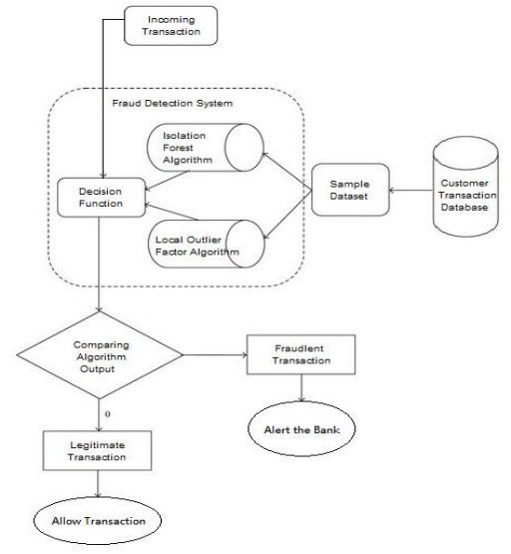Figure 3.1: Workflow of the System
3.2 ANALYSIS OF THE EXISTING SYSTEM
Fraud can be defined as “Illegal or criminal deception intended to result in financial or personal gain.” Source Credit Card fraud can be defined as “The unauthorized use of an individual’s confidential information to make purchases, or to remove funds from the user’s account.” Source the use of Online Shopping, digital payments, net banking, and transactions through payment cards is increasing day by day. The fraud detection system is done in a manual way, where credit card owners have to monitor the way he is using their credit card. The user need not disclose his card details to anyone to prevent fraud on his credit card.

3.3 PROBLEMS OF THE EXISTING SYSTEM
The problem with the existing system is as follows:
- Financial fraud is an issue that has wide-reaching consequences in both the finance industry and daily life.
- Fraud can reduce confidence in industry destabilize the economy, and affect people’s cost of living.
- Social factors such as the increased distribution of credit cards have increased spending but also increased fraud.
- All activities are done manually.
3.4 DESCRIPTION OF THE PROPOSED SYSTEM
Credit card fraud is increasing day by day regardless of the various techniques developed for its detection. Fraudsters are so expert that they engender new ways for committing fraudulent transactions each day which demands constant innovation for its detection techniques based on artificial intelligence, Data mining,fuzzy logic,machine learning, sequence alignment, decision tree, neural network, logistic regression, naïve bayesian, bayesian network, meta-learning, genetic programming, etc., has evolved in detecting various credit card fraudulent transactions. A steady indulgence of all these approaches will positively lead to an efficient credit card fraud detection system. This project presents a survey of different techniques used in credit card fraud detection mechanisms and the Hidden Markov Model (HMM) in detail. HMM categorizes card holder’s profiles as low, medium, and high spending based on their spending behavior in terms of amount. A set of probabilities for the amount of transaction is assigned to each cardholder. The amount of each incoming transaction is then matched with the card owner’s category, if it justifies a predefined threshold value then the transaction is decided to be legitimately declared as fraudulent. Existing fraud detection systems may not be so much capable to reduce fraud transaction rates. Improvement in fraud detection practices has become essential to maintain the existence of the payment system. In this project, Hidden Markov Model (HMM) is used to model the sequence of operations in credit card transaction processing. If an incoming card transaction is not accepted by the trained HMM with sufficiently high probability, it is considered to be fraudulent.
3.5 ADVANTAGES OF THE NEW SYSTEM OVER THE EXISTING SYSTEM
The design and implementation of a credit card fraud detection system using advanced machine learning techniques provide several advantages over traditional methods. Some of the advantages of the new system are:
- Accurate Fraud Detection: The new system uses advanced machine learning algorithms to detect fraudulent activities accurately and efficiently. The system can identify patterns and anomalies in real-time, preventing fraudulent transactions and protecting customers from financial losses.
- Real-time Alerts: The new system provides real-time alerts to relevant parties, such as banks, merchants, and law enforcement agencies, when suspicious activities or transactions are detected. This enables prompt action and prevents further damage from occurring.
- Adaptive Learning: The machine learning algorithms used in the system are designed to learn from historical data and identify new patterns and trends in real-time. This allows the system to adapt to new fraud schemes and prevent them from causing further damage.
- Cost-effective: The new system is a cost-effective solution to credit card fraud detection. It requires minimal human intervention and can detect fraudulent activities accurately and efficiently, reducing the need for expensive manual reviews.
- Customer Satisfaction: The new system provides enhanced security for customers' financial transactions, which increases their confidence in the financial institution and promotes customer satisfaction.
- Regulatory Compliance: Financial institutions are required to comply with various regulations and standards related to fraud detection and prevention. The new system helps institutions to comply with these regulations and standards by providing accurate and efficient fraud detection.
- Reduced False Positives: The new system reduces false positives by accurately identifying fraudulent activities and minimizing the number of false alarms, reducing the number of transactions that require further review.

CHAPTER FOUR
DESIGN, IMPLEMENTATION AND DOCUMENTATION OF THE SYSTEM
4.1 DESIGN OF THE SYSTEM
This project is designed to capture, manipulate and detect fraud in credit card information or credit card transactions through the use of a standard web platform application. System design deals with the description of the four basic components that makeup the application. These units are the expected output description – the output design, description of data capture media and interface – input design, description of the modules of the program – procedure design, and detailed description of the relational data structure used in detecting fraud activities on credit card transaction information – database/file design.
4.1.1 OUTPUT DESIGN
The output design is the results obtained from the computer during the input stage. The output design of this project is defined as this-
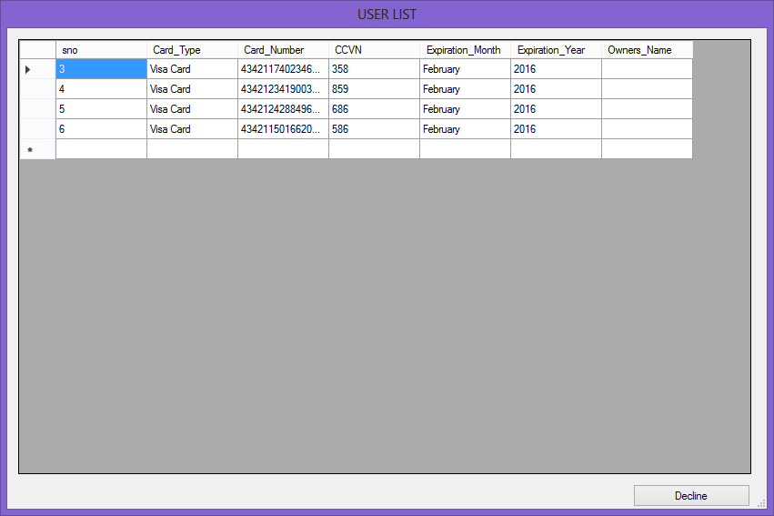

Figure 4.1:Users List Report: This page consists of the card generated.
4.1.2 Input Design
Input is the raw data or figures that are entered into the computer for processing. The input data entered are kept in files that will be used for processing and output. The format used for the input design in this project is given below:
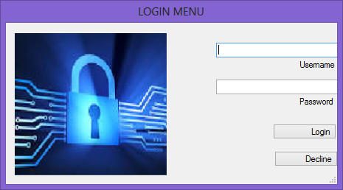

Figure 4.2: Log-In Form
This form is used for login into the system, where the users will have to present his/her username and password for authentication


Figure 4.3: Card Validation Form
This form is used for validation.
4.1.3 Database Design
The file specification for the record is on each file required for processing are specified below:
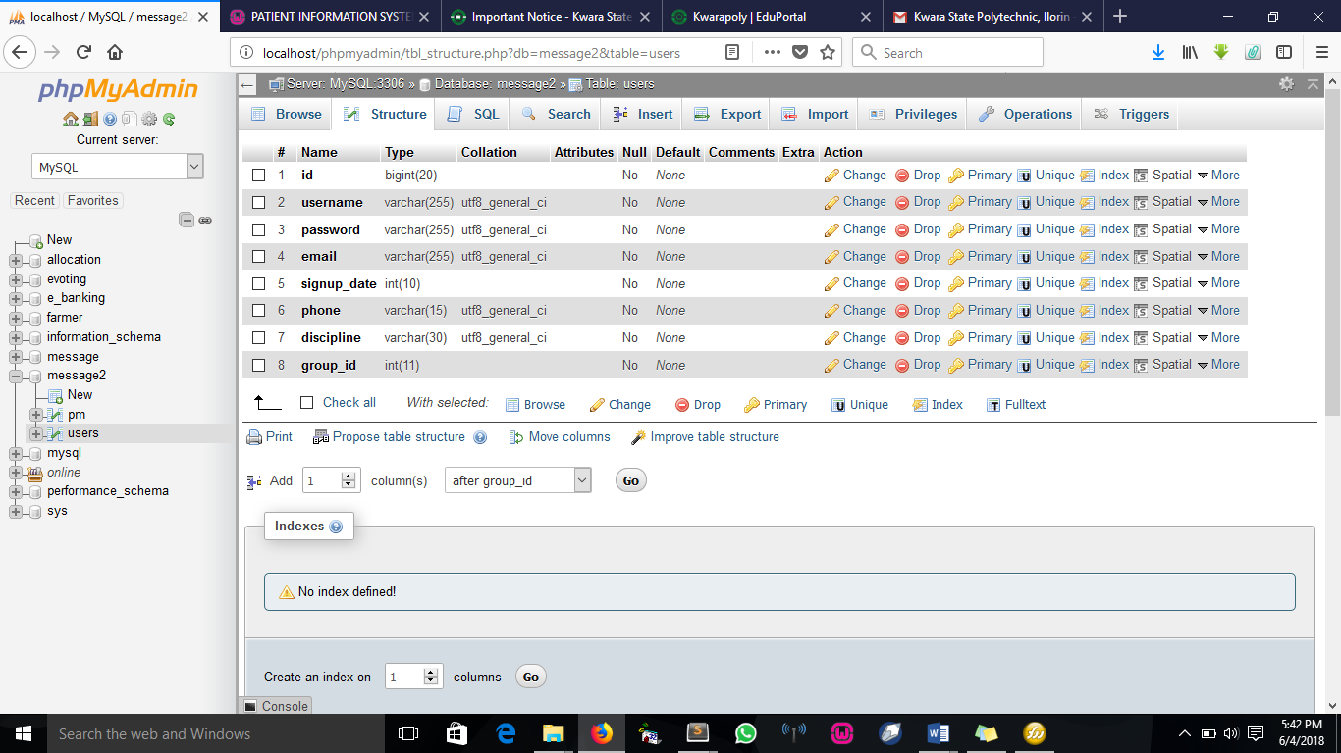
Figure 4.4: Users Table
This table takes in the user's record.
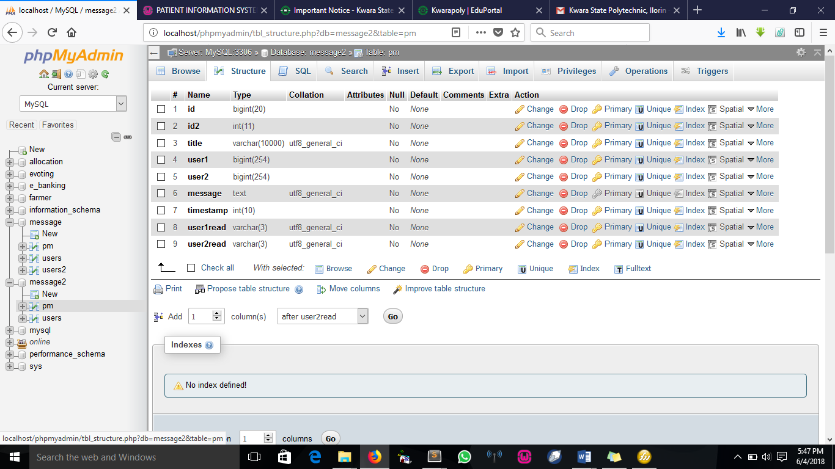
Figure 4.5: Card History Table
This table takes care of the conversation between two users

4.1.4 Procedure Design
The design is very important as it defines the various interfaces supported by the application. This facilitates ease of the system and gives the user a good sense of security. The procedure displays functions from where the user selects his/her desired operation to be performed. To aid this, will lead us to.
The first step towards making this system secure is to identify the person wanting to use the system at any point in time before an individual is granted or denied access to the system any time; he or she must enter his/her correct password and username as the system would demand.
Entering an invalid password and username will prompt a security warning message and automatically deny entry access by ending the application thereby shutting the door against unauthorized users.
4.2 System Implementation
This aspect of the project shows the details of how the package can be fully implemented. It can also be referred to as the user's manual.

4.2.1 Choice of Programming Language
The language used for the implementation of the web application(which uses HTML 5 and CSS for the structural design, JavaScript for validating) and MYSQL database as the back end.

4.2.2 Hardware Support
The hardware requirements for this program are:
- PC: The computer should be a minimum of Pentium IV with 1.5GHz processor speed but preferably Dua Core Processor for greater efficiency
- Memory: This system requires a Higher RAM not less than 1.0GB, 1GB RAM is recommended.
- Storage: the storage capacity must be 200GB and above.
- VDU: Visual Display Unit required should be a very high resolution not less than 1024 x 768 with 256 colorcapability.
- Printer: This system also requires a printer
- Input: The input device required is a mouse, Optical Mouse should be provided for easy use.
- Android-based device
4.2.3 Software Support
The software requirements for the operation of this program are as follows:
- Window Operating System
- XAMPP or WampServer (for Apache server on localhost)
- Web Browser e.g. Mozilla Firefox
- Macromedia Dreamweaver
- Apache Cordova

4.2.4 Changeover Techniques
There are several methods for handling the implementation and the consequent conversion from the old to the new computerized system.
The most secure method for conversion from the old system to the new system to run the old and new system is parallel. In this approach, a person may operate the manual order processing system as well as start to operate the new computerized system. This method offers high security because even if there is a problem in the computerized system we can depend upon the manual system. How often, the cost of maintaining two systems in parallel is very high. This outweighs its benefits. Another common method is direct cutover from the existing manual system to the computerized system. The change may be within a week or a day. There are no parallel activities and there is no remedy in case of a problem. This strategy requires careful planning.
4.3 System Documentation
Here, details of all forms used in the program are well described. There are two main categories of forms used in this program, examples are INPUT AND OUTPUT FORM.
The input forms are used to supply data, records and all needed information into the system.
The output forms are used to display or give processed results from the input value entered into the system.
Relevant input and output and information are respectively kept in a database for easy accessibility and enhances security measures to the stored data and information.

4.3.1 Program Documentation
In order for the proposed system to be used on any Android based system it takes the following ways
- Boot the system
- Open any browser on the system (Microsoft internet Explorer, Mozilla Firefox, Netscape Navigator, Opera, Flock, Safari e.t.c)
- Type http://localhost/frauddetection/ on the address bar and press the return key or enter key.

4.3.2 System Maintenance
- Data cable should be plugged properly
- Repair or replacement of all damaged accessories, system cards, peripheral e.t.c.
- prevention from dust
- Prevention of system from heat and moisture
- Prevention from static charges
- Examination of the new system from time to time to ensure it is performing as specified.

CHAPTER FIVE

SUMMARY, CONCLUSION, AND RECOMMENDATIONS
5.1 Summary
Without the use of computerized systems for fraud detection on credit card transactions, I wonder what will be the stand of our economy today. The implementation of this system does more good than harm in our country, especially in the transaction sector. Hence not only does it provide good business transactions with the help of the following factors, accuracy, flexibility, and speedy treatment, security. But, also it will be a big relief for credit card users. This project is well designed with reliability and efficiency as our mainstay, and has come just in time to correct those weaknesses and anomalies, which exist in the existing credit card transaction method.

5.2 Conclusion
It is a fact that a manual system of operation cannot be compared with a computerized system therefore there is no doubt that an overview of the whole work has achieved its objectives. In conclusion, for proper and effective implementation of the new system, there is a need to have a good internet network in place. However, the level of accuracy, speed, security, and efficiency will be the most useless machine without any human intervention. Therefore there is a need for skilled personnel to operate and facilitate the processing manuals.
Therefore believe that through this project work, tasks can be accomplished with the ability of the system to process and store vast amounts of card generated and transactions, and this will produce high-quality management efficiency at very high speed and low cost.

5.3 RECOMMENDATIONS.
Having computerized a system inthe economy, it is very essential to improve efficiency and security against fraud in credit card transactions, it is therefore recommended that Nigeria should consider and implement the proposed system by properly following all the guidelines stipulated in this project.

REFERENCES
CyberSource. (2017, Nov. 29). 2017 North AMERCA edition, online fraud benchmark report persistence is critical [Online].
L. Seyedhossein and M. R. Hashemi, (2017) “Mining information from credit card time series for timelier fraud detection,” in 5th International Symposium on Telecommunications
UCI Machine Learning Repository. (2017, Nov. 29). Stalog (Australian credit approval) dataset [Online].
UCI Machine Learning Repository. (2017, Nov. 29). Stalog (German credit data) dataset [Online].
N. Malini and Dr. M. Pushpa, “Analysis on credit card fraud identification techniques based on KNN and outlier detection” in 3rd International Conference on Advances in Electrical, Electronics, Information, Communication and Bio-Informatics (AEEEICB17).
A. Charleonnan, “Credit card fraud detection using RUS and MRN algorithm,” in The 2016 Management and Innovation Technology International Conference (MITiCON-2016), 2016
M. K. Mishra and R. Dash, “A comparative study of chebyshev functional link artificial neural network, multi-layer perceptron and decision tree for credit card fraud detection” in 2014 13th International Conference on Information Technology, 2014
Y. Pandey, “Credit card fraud detection using deep learning” Int. J. Adv. Res. Comput. Sci., vol. 8, no. 5, May–Jun. 2017.
A. Niimi, “Deep learning for credit card data analysis,” in World Congrss on Internet Security (WorldCIS-2015).

