DESIGN AND IMPLEMENTATION OF WEB BASED EXAMINATION TIME TABLE
(A CASE STUDY OF COMPUTER SCIENCE DEPARTMENT )

BY

AMZAT AZEEZ ALAO
ND/23/COM/FT/0024

SUBMITTED TO THE DEPARTMENT OF COMPUTER SCIENCE,
INSTITUTE OF INFORMATION AND COMMUNICATION TECHNOLOGY
KWARA STATE POLYTECHNIC, ILORIN.

IN PARTIAL FULFILLMENT OF THE REQUIREMENTS FOR THE AWARD OF NATIONAL DIPLOMA (ND) IN
COMPUTER SCIENCE

JULY, 2025.

CERTIFICATION
This is to certify that this project work is carried out by AMZAT AZEEZ ALAO with Matriculation Number ND/23/COM/FT/0024 and it has been read and approved as meeting the requirements for the award of National Diploma in the Department of Compute Science, Institute of Information and Communication Technology (IICT), Kwara State Polytechnic Ilorin, Kwara State.

------------------------------------- ----------------------
MR ABIODUN E.T Date
(Project Supervisor)

--------------------------------- ----------------------
MR OYEDEPO F.S Date
(Head of Department)

----------------------------------- ---------------------
External Supervisor Date

DEDICATION
I dedicate this project to Almighty God who's protect me, guide me through this work a big thanks to Almighty God.

ACKNOWLEDGMENT
With a grateful hearth, I return all glory to the most Merciful and Mighty Lord for the success of this Project.
My profound appreciation goes to my supervisor in person of MR ABIODUN E.T for his enormous contribution, support and guidance from the beginning to the end of this research work, I pray for her growth in all her aspirations in life.
Special thanks to HOD of Computer Science department, (MR OYEDEPO F.S.), and the member of staffs in the department of computer science for their academic support.

LIST OF FIGURES
Figure 4.1: splash screen : this is the first screen of the program 20
Figure 4.2: Encryption screen: this is showing the page to sent text to be encrypted 21
Figure 4.3: Decryption screen: this is showing the result of the encryption 21

TABLE OF CONTENT
TITLE PAGE I
CERTIFICATION II
DEDICATION III
ACKNOWLEDGMENTS IV
LIST OF FIGURES V
TABLE OF CONTENT VII
ABSTRACT VIII
CHAPTER ONE: GENERAL INTRODUCTION
1.1 Background to the Study 1
1.2 Statement of the Problem 2
1.3 Aim and Objectives 3
1.4 Significance of Study 4
1.5 Scope of Study 4
1.6 Organization of the Report 5
CHAPTER TWO: LITERATURE REVIEW
2.1 Review of Related Past work 6
2.2 Review of General Study 10
CHAPTER THREE: RESEARCH METHODOLOGY AND ANALYSIS OF THE EXISTING SYSTEM
  - Research Methodology 16
  - Analysis of the Existing System 17
  - Problem of the Existing System 18
  - Analysis of the Proposed System 19
  - Advantages of the Propose System 19
CHAPTER FOUR: DESIGN, IMPLEMENTATION AND
DOCUMENTATION OF THE SYSTEM
    - Output Design 21
    - Input Design 21
    - Database Design 22
    - Procedure Design 22
  - Implementation of the System 22
    - Choice Of Programming Language 23
    - Hardware support 23
    - Software Support 23
  - System Documentation 24
    - Operating the System 24
    - Maintaining the System 24
CHAPTER FIVE: SUMMARY CONCLUSION AND
RECOMMENDATION
5.1 Summary 25
5.2 Conclusion 25
5.3 Recommendation 25
References 26
APPENDIXES
Appendix 1: System Flowchart 27
Appendix 2: Decryption Flowchart 28
Appendix 3: Encryption flowchart 29

ABSTRACT
Encryption is of prime importance when confidential data is transmitted over the network. Varied encryption algorithms like AES, DES, RC4 and others are available for the same. The most widely accepted algorithm is AES algorithm. We have developed an application on android platform which allows the user to encrypt the messages before it is transmitted over the network. We have used the advanced encryption standards algorithm for encryption and decryption of the data. This application can run on any device which works on android platform. This application provides a secure, fast, and strong encryption of the data. There is a huge amount of confusion and diffusion of the data during encryption which makes it very difficult for an attacker to interpret the encryption pattern and the plain text form of the encrypted data. The application developed for end to end secure transmission of the SMS using advanced encryption standards algorithm. This application is developed on android platform and is one of a kind. Maintaining privacy in our personal communication is something everyone desires. Encryption is a means to achieve that privacy. It was invented for the very same purpose. As short message service (SMS) is now widely used as a business tool; its security has become a major concern for business organization and customers. This work shall be run online with the help of WAMP server using PHP, JavaScript, Ajax as programming language and Mysql as the database engine.

CHAPTER ONE
GENERAL INTRODUCTION

1.1. BACKGROUND TO THE STUDY
Every school year, institutions of education face the rigorous task of drawing up timetables that satisfies the various courses and their respective examinations being offered by the different department. The difficulty is due to the great complexity of the construction of timetables for exams, due to the scheduling size of the lectures and examinations periods and the high number of constraints and criteria of allocation, usually circumvented with the use of little strict heuristics, based on solutions from previous years (Jose, 2019).
Nowadays, this process has been simplified by semi-automatic solutions based on timetable generation. A timetable management system is designed and created to handle as much course data as fed while ensuring the avoidance of redundancy. An educational timetable must meet a number of requirements and should satisfy the desires of all entities involved simultaneously as well as possible. The timing of events must be such that nobody has more than one event at the same time (Robertus, 2020).
Timetabling concerns all activities with regard to making a timetable that must be subjective to different constraints. According to Collins Concise Dictionary (4th Edition) “a timetable is a table of events arranged according to the time when they take place.”A critical factor in running a university or essentially an academic environment is the need for a well-planned and clash-free timetable. Back in the times when technology was not in wide use, academic timetables were manually created by the educational center staff. Even though most college administrative work has been computerized, the Exam timetable scheduling is still mostly done manually due to its inherent difficulties. The manual exam timetable scheduling demands considerable time and efforts. The exam-timetable scheduling is a Constraint satisfaction problem in which we find a solution that satisfies the given set of constraints. Automatic Timetable Generator is used to generate timetable automatically. Currently timetable is managed manually. It will help to manage all the periods automatically. It Maximum and minimum work load for a Faculty for a day and week will be specified for the efficient generation of timetable. Timetable Scheduler targets to develop software for college in order to handle the „Timetable Formation‟ for the student (Merlot 2019)

1.2. STATEMENT OF THE PROBLEM
The traditional manual generations of timetables encounters a lot of problems which may Repeated time allocations may be made for a particular course thereby leading to data redundancy. A lot of administrative error may occur as a result of confusing time requirements. Timetable generation by center staff may have a slow turnaround. Final generated timetable may not be near optimal as a result of clashing course requirements and allocations. It generates a lot of paperwork and is very tasking. The new state an automated examination time tables using selection and cross over techniques is introduce to eradicate the setback of the existing system.

1.3. AIM AND OBJECTIVES OF STUDY
The aim of this project work is to develop application that will cater for examination timetabling generation system and the objectives are as follows:
- To create system application that will generate system examination time table
- To adapt selection and cross over techniques using c# programming language
- To optimize the algorithm and techniques to generate the best timetabling with no clashes.

1.4 SIGNIFICANCE OF THE STUDY
The significance of this project on “automation examination time table ” is to improve on how Examination Time Table is being generated by school for the usage by the students. In this project, the impact of computer system usage is being greatly analyzed.The study is considered to be the great importance in that it examines the impact of computer introduction in developing an automated time table. This one may confidently state that the introduction of computer system to computer science for development of the generator timetable would bring about improvement in the management in terms of time and resources involved.

1.5 SCOPE OF THE STUDY
The boundaries of this project work take into consideration all department in IICT kwara state polytechnic Ilorin. It will only involve the technical skills of one academic personnel and a few data collaborators to handle the data input and constraint specifications. The proposed system will be able to handle as much data input as possible i.e. the course data, halls data, lecturers data etc.
1.6 ORGANIZATION OF THE PROJECT
This project write-up contains five chapters. Chapter one of this project deals with the introduction to the general work in the project. It also entails the aims and objectives of this project, methods used for data collection the scope and limitation of the study and report organization or the project work.
Chapter two contains literature review and discussion on related issues. Chapter three deals with analysis of the existing system, descriptions of the current procedure, problems of existing system (procedure) itemized and explained as well as description of the proposed system and the basic advantages of the proposed system.
Chapter four contains design, implementation and documentation of the system. The design involves the system design, output design, input design, database design and the procedure design. The implementation involves the implementation techniques used in details, choice of programming language used and the hardware and software support. The documentation of the system involves the operation of the system and the maintenance of the system.
Chapter five contains summary of the research, conclusion, recommendations and references.

CHAPTER TWO

LITERATURE REVIEW
2.1 REVIEW OF RELATED PAST WORK
Sujit (2021) exam timetabling problem using genetic algorithm. Timetabling is an extremely difficult problem which is an element of the wider-field of scheduling. Scheduling is generally defined as the problem of the allocation of resources over time to perform a set of tasks and is NP-hard problems. Scheduling exam timetables in departments of college/university is a complex problem. This is usually done by hand taking several days or weeks of iterative repair after feedback from staff and students. This paper proposed an algorithm to solve the problem of exam timetabling, which is a good candidate to generate a timetable using genetic algorithm (GA). This paper details the implementation of a computer program which employs GA for an optimal solution of solving a timetable problem and generate exam timetable by using real student data from engineering department courses at ICT.
Nnamdi,et al. (2020) An Automatic Examination Timetable System Using Selection and Crossover Technique. With the increase in the number of student population, new programs being attached, an automated time-tabling system is required to cater for this increase. Most of the time-tabling problems belong to the class of (Non Polynomial) NP-hard problems, as no deterministic polynomial algorithm exists. Timetable definition is the total schedule of specific lectures attended by a group of students in an institution and the lecturers at a specific time. When solving the timetabling problem, we are usually looking for some solution, which will be the best among others. The space of all feasible solutions which is the series of desired solutions with some more desirable than the others is called search space (also state space). Each point in the search space represents one feasible solution which can be "marked" by its value or fitness for the problem. The solution is usually one point in the search space. This research centers on the utilization of computerized system concerning electronic planning and exam booking control arrangement in tertiary Institutions. The work conquers the manual arrangement of activities with respects to the issues timing and planning. The work was effectively evolved utilizing python structure, SQLite Database. Client experience was utilized, an easy to use programming language, and the bundle was tried and enhanced to yield a mechanized Time table plan booking control framework
Azilawati,et al., (2022) A Framework for University’s Final Exam Timetable Allocation Using Genetic Algorithm. Nowadays mostly all of the human tasks were replaced or at least assisted by the use of computer system to ensure the task in completed in timely manner. This includes the University’s Final Exam Timetable Allocation. However in UniSZA remote campus, the allocation for Final’s Exam Timetable is still being done manually and it took much time and manpower to generate it. The aim of this study is to present a University’s Final Exam Timetable Allocation using Genetic Algorithm (GA) method. This method is used to find an optimal solution of solving timetable by using a real data from UniSZA’s academic department. The result for these solution is minimizing the time taken in timetable allocation because it been done automatically and more efficient.
José (2023) A System of Automatic Construction of Exam Timetable Using Genetic Algorithms. The complexity of the problem of exam timetables is justified by the scheduling size of the examinations and the high number of constraints and criteria for allocation. This paper presents a method of solution to the problem of automatic construction timetables for the exams. Among several mathematical models of representation, the final option was for a model matrix, which is justified by the benefits that this model presents when used in the algorithm of solution. The method of solution is a meta-heuristics that includes a genetic algorithm. The model is directed to the construction of exam timetables in institutions of higher education. The results achieved in real and complex scenarios are satisfactory; the exam timetabling meets the regulations imposed. We conclude that when the algorithm does not determine a solution with no penalty, is because that solution does not exist.
Azman (2022) Secondary School Examination Timetabling using Genetic Algorithm. Scheduling problems is a difficult task in the artificial intelligence. It deals with the allocation of limited resources to tasks over time. The process is to optimize one or more objectives. Currently, examination timetable scheduling at Sekolah Menengah Kebangsaan Bandar Baru Sintok is done manually, where the time task has been created one month earlier before the exam. Hence, the major aim of this research is to investigate the internal mechanism of genetic algorithm in solving and improving school examination timetabling problem in term of improving the fitness function. The research have targeted on secondary school examination timetabling problem. Hence, Genetic Algorithm (GA) is used as one of the most popular optimization solutions within one of the 5 steps in the design research methodology, at the suggestion phase which includes the development of the model (GA) that setup the suitable penalties of hard and soft constraints based on the fitness function. It has been implemented in various applications, which is suitable for discrete problems and gives a population of good solutions, also the algorithm's flexibility as one of the best robust schemes. This research reports the powerful techniques using GA in scheduling, and the experiments comes out with that the default settings and parameters are the most suitable for generating the school examination timetable and the experiments conclude a high fitness score (2770) and the bigger population size produces the optimal solution.
Achini (2019) Genetic Algorithm For University Course Timetabling Problem. Creating timetables for institutes which deal with transport, sport, workforce, courses, examination schedules, and healthcare scheduling is a complex problem. It is difficult and time consuming to solve due to many constraints. Depending on whether the constraints are essential or desirable they are categorized as ‘hard’ and ‘soft’, respectively. Two types of timetables, namely, course and examination are designed for academic institutes. A feasible course timetable could be described as a plan for the movement of students and staff from one classroom to another, without conflicts. Being an NP-complete problem, many attempts have been made using varying computational methods to obtain optimal solutions to the timetabling problem. Genetic algorithms, based on Darwin's theory of evolution is one such method. The aim of this study is to optimize a general university course scheduling process based on genetic algorithms using some defined constraints.
Asif and Sachin (2019) A Timetable Prediction for Technical Educational System Using Genetic Algorithm. In this paper we glance through the various approaches used by the researchers to develop an automatic timetable using Genetic algorithms. The optimized genetic algorithm can be used with the heuristic approach to design and develop the timetable of an institute. At stake during the process of development, the stakeholders are the professors and the students. The efficient utilization of the infrastructure is the main aim of the authors. The crossover, mutation and the fitness function is to be calculated for the implementation. In genetic algorithm every individual are characterized by a fitness function. After analysis if there is higher fitness then it means better solution and then after based on their fitness, parents are selected to reproduce offspring for a new generation where fitter individuals have more chance to reproduce. The objective of the work is to create a model used to generate the acceptable schedule using probabilistic operators.
Saritha et al., (2022) Automatic Time Table Generator. The manual system of preparing time table in colleges with large number of students is very time consuming and usually ends up with various classes clashing either at same room or with same teachers having more than one class at a time. To overcome all these problems, propose to make an automated system. The system will take various inputs like details of students, subjects and class rooms and teachers available, depending upon these inputs it will generate a possible time table, making optimal utilization of all resources in a way that will best suit any of constraints or college rules. List of subjects may include electives as well as core subjects.
Walusungu (2019) Genetic algorithms for timetable generation. Timetabling presents an NP-hard combinatorial optimization problem which requires an eﬃcient search algorithm. This research aims at designing a genetic algorithm for timetabling real-world school resources to fulﬁl a given set of constraints and preferences. It further aim sat proposing a parallel algorithm hatis envisaged to speed up convergence to an optimal solution, given its existence. The timetable problem is modeled as a constraint satisfaction problem (CSP) and a theoretical framework is proposed, which guides the approach used to formulate the algorithm. The constraints are expressed mathematically and a conventional algorithm is designed that evaluates solution ﬁtness based on these constraints. Test results based on a subset of real-world, working data indicate that convergence on aNfeasible (andoptimal/Pareto)solution is possible within the search space presented by the given resources and constraints. The algorithm also degrades gracefully to a workable timetable if an optimal one is not located. Further, a SIMD-based parallel algorithm is proposed that has the potential to speed up convergence on multi-processor or distributed platforms.
Robertus (2016). A Timetable or schedule is an organized list, usually set out in tabular form, providing information about a series of arranged events: in particular, the time at which it is planned these events will take place. They are applicable to any institution where activities have to be carried out by various individuals in a specified time frame. From the time schools became organized environments, timetables have been the framework for all schools activities. As a result, schools have devoted time, energy and human capital to the implementation of nearly optimal timetables which must be able to satisfy all requirements constraints as specified by participating entities

2.2 REVIEW OF GENERAL TEXT
Timetabling concerns all exercises as to delivering a calendar that must be abstract to various limitations. Schedule can be characterized as the improvement of given exercises, activities or occasions to a lot of items in space time lattice to fulfill a lot of alluring limitations. A key factor in running an instructive focus or fundamentally a scholastic situation is the requirement for an all-around arranged, well all through and conflict free plan. Once upon a time when innovation was not in wide use, (address) schedules were physically made by the scholastic foundation. Each school year, tertiary organizations are confronted with the dull undertaking of drawing up scholarly schedules that fulfills the different courses and the particular assessment being offered by the various offices. Plan advancement process begins when each Head of Department give the accompanying data to be utilized for schedule booking. The data gives the modules dates, time and settings reasonable in a specific semester examinable courses in a specific semester. Dates for talks to be held (Lectures can be booked among Monday and Friday).Specified time for addresses (for example somewhere in the range of 8am and 4pm) the setting of the booked talks. A timetabling issue comprises of four (4) boundaries and they are: T (set of time), R (set of accessible assets), M (set of planned contacts) and C (set of requirements). This issue allocates time and assets to the contacts on such a way, that the limitations will be fulfilled. In different timetabling issues, instructive timetabling has been by and large analyzed from functional viewpoint. Scholastic schedule is exceptionally urgent yet it expends time because of its successive events and utilization among higher establishment of learning. Another purpose behind the trouble is a direct result of the extraordinary intricacy of the development of size of talks and assessments, because of the planning size of the talks and assessments periods and high number of imperatives and rules of designation which is typically bypassed with the utilization of minimal severe heuristics, in view of arrangements from earlier year (Jose, 2018).
The nature of the schedule decides the nature of time committed by speakers, understudies and chairmen to scholarly exercises. Different scholarly timetabling incorporates:
- School plan
- Talk plan
- Assessment plan and
- Task schedule
This scholarly plan must meet various prerequisites and ought to fulfill the wants of all elements included at the same time as could be expected under the circumstances. The timings of occasions must be with the end goal that no one has more than one occasion simultaneously (Roberts, 2002).
Talk time-postponing framework is an arrangement of planning address time and accessible assets in order to augment such assets. It is one the most significant yet tedious errand done occasionally in any scholastic organization of learning. Along these lines address time table ought to be deliberately doled out into proper timeslot for understudies, speakers and auditoriums dependent on imperatives. The talk time-postponing is done halfway and not on school (personnel) premise or departmental premise. Information are gathered from different divisions in each school for the readiness. The plan procedure is in three stages in particular: Data assortment from divisions, where every office will gracefully the different courses which will incorporate the course title, course code, contact hour (addresses and down to earth), course unit and the speaker to take them. The subsequent stage is the analysis of the delivered data and the supplied information by the departments are analyzed with the available space [hall sizes]. The last stage is the Lecture time booking. In view of the examination, the talk time-table is created with three yields versus: Hall time-table, Departmental Input and examination time-table. In booking the talk time table, the accompanying limitations must be mulled over; No understudy can go to more than each talk in turn, No teacher can show more than one course for every time and auditorium can't be allocate to more than each specific course in turn.
Every school year, each season of exams, the various departments of an institution of education facing the difficult task of drawing up timetables for examinations. The difficulty due to be great complexity of the construction of timetables for exams, due the scheduling size of the examinations and the high number of constraints and criteria of allocation, usually circumvented with the use of heuristics little strict, based on solutions from previous years. The objective of this work is the schedules of examinations. The main purpose is to demonstrate the possibility of building them, automatically, using computers. The term scheduling applies to a kind of problems that distribute objects, subject to certain constraints, in a pattern of time or space, so that the costs of these are minimum. Objects may be people, vehicles, machines, exams, etc.., constraints are the rules that govern the process of scheduling, and some are inviolable while others take the form of principles that must be obeyed. The problem of production of a factory, the problem of traveling salesman approached and the problem of school timetabling, with a solution proposed by Queirós , for example, can be seen in perspective problems of sequential scheduling. This subject has received special attention of the scientific community in the last five decades. In this work, the selection and cross over techniques is the method of solution. Designed by John Holland at the end of the fifties years, uses a structure similar to that set out by Charles Darwin in "The Origin of Species'. It is based on two main operators: selection and reproduction, activated in the presence of a number of solutions, called population. The formal model express using matrix representations. The application of genetic algorithm to matrix model, create exam timetables that meet the regulations imposed (Uzo 2020).

2.3 OVERVIEW OF AUTOMATED TIME TABLE
The problem of timetabling entails allotting times and available resources in order to satisfy time scheduling constraints. There are wide range areas where timetabling is required, educational timetabling is one of the most widely studied (Momodu and Omogbhemhe, 2014). Education timetabling (lectures and examinations timetabling) is one of the most crucial and time consuming task which occurs intermittently in all educational institutions. Salwani and Hamdan, 2018 made it clear that the quality and efficiency of the timetabling greatly impacts on a wide range of different stakeholders in the institutions such as including administrators, lecturers, and students. Timetabling scheduled courses or examinations is a fundamental activity in educational institutions, these must be assigned into appropriate timeslots for students, lecturers, and classrooms subject to constraints (Burke et al., 2019). Developing feasible timetables is even more difficult when varieties of constraints are imposed. It clear that resolving lectures or examination timetabling issues using the manual means is exceptionally problematic and may require a group of academic staff to work for several days without a reasonable outcome.
Allocating huge numbers of students and courses in educational institutions is a serious challenge. When manually done, clashes and unfairness are unavoidable. Clashes occur when concurrent exams are scheduled for the same student, and unfairness to a student or invigilators refers to uninterrupted exams or more than two exams on the same day. Mansour and Timany, 2007 stated that a good examination or lecture timetable should aim to minimize clashes between four main constraints which are students, lecturers, venues and time.

2.3.1 AUTOMATED TIME-TABLING GENERATION
Automation is the use of electronics and computer-controlled devices to assume control of processes. The aim of automation is to boost efficiency and reliability. In most cases, however, automation replaces labor. In fact, economists today fear that new technology will eventually push up unemployment rates significantly. With the increase in the number of student population, new programs being mounted and additional lecture halls, an automated time-tabling system is required to cater for this increase. Timetable definition is the total schedule of specific lectures attended by a group of students in an institution and the lecturer at a specific time. It also requires specific resources such as lecture halls and so on. There are a number of papers within that deal specifically with selection and cross over techniques methods of automated time-tabling. Professional software currently available for Automated Timetabling lacks the generality required by different institutions. This can mean that code needs adjustment or lengthy training and installation programs before it can be implemented at an institution which it was not intentionally written for(Gregory 2020).

2.3.2 SCHEDULING
A schedule or a timetable, as a basic time-management tool, consists of a list of times at which possible tasks, events, or actions are intended to take place, or of a sequence of events in the chronological order in which such things are intended to take place. The process of creating a schedule deciding how to order these tasks and how to commit resources between the variety of possible tasks (Burke 2019).

CHAPTER THREE
METHODOLOGY AND ANALYSIS OF THE EXISTING SYSTEM
3.1 RESEARCH METHODOLOGY
Selection
Selection Reproduction (or selection) is an operator that makes more copies of better strings in a new population. Reproduction is usually the first operator applied on a population. During each successive generation, a proportion of existing population is selected to breed a new generation. Individual solutions are selected through fitness-based process, where fitter solutions are typically more likely to be selected presented by(Goldberg and Corne et al. 2017).
Student
Invigilator

Subject

Room
Time Slot

Method of selection
Elitist selection: The fittest members of each generation are guaranteed to be selected. (Most GAs don’t use pure elitism, but instead use a modified form where the single best or a few of the best individuals from each generation are copied into the next generation just in case nothing better turns up.)
Fitness-proportionate selection: More fit individuals are more likely, but not certain, to be selected.
Roulette-wheel selection: A form of fitness-proportionate selection in which the chance of an individual's being selected is proportional to the amount by which its fitness is greater or less than its competitors' fitness. (Conceptually, this can be represented as a game of roulette - each individual gets a slice of the wheel, but more fit ones get larger slices than less fit ones. The wheel is then spun, and whichever individual "owns" the section on which it lands each time is chosen.)
Generational selection: The offspring of the individuals selected from each generation become the entire next generation. No individuals are retained between generations.
Steady-state selection: The offspring of the individuals selected from each generation go back into the pre-existing gene pool, replacing some of the less fit members of the previous generation. Some individuals are retained between generations.
Hierarchical selection: Individuals go through multiple rounds of selection each generation. Lower-level evaluations are faster and less discriminating, while those that survive to higher levels are evaluated more rigorously. The advantage of this method is that it reduces overall computation time by using faster, less selective evaluation to weed out the majority of individuals that show little or no promise, and only subjecting those who survive this initial test to more rigorous and more computationally expensive fitness evaluation.
Cross over
A crossover operator is used to recombine two strings to get a better string. Once parents have been chosen, breeding itself can then take place. A new creature is produced by selecting, for each gene in the chromosome, an allele from either the mother or the father. The process of combining the genes can be performed in a number of ways. The simplest method of combination is called single point cross-over stated by Davis. A child chromosome can be produced using single point crossover, as shown in. A crossover point is randomly chosen to occur somewhere in the string of genes. All genetic material from before the crossover point is taken from one parent, and all material after the crossover point is taken from the other.
In this research, one site crossover has been used de to its advantages over the conventional method, where it can easily exchanged the information in the timetable and makes it optimal and effective as per the requirements. By selecting two parent timetables f and g, and considered them mother and father respectively and further build offspring in such a way that each invigilator, time-slot and room assignment comes from one of the parents. This is done by generating
Crossover Module: has a functionality of simulating the crossover of course population whose constraints are violated. Crossing over individual courses in the population attempts to reduce and or eliminate constraints violations. See Appendix A for source code.

3.2 ANALYSIS OF THE EXISTING SYSTEM
The existing system for examination timetable are done manually with series of problem that occur during the allocation of examination timetable. In many universities, Student are generally required to take more than one courses or more in a session. departmental lecturer can work together as a group. To reduce the chance of examination timetable from clashing on the same date, they are required to provide a finite number of students that are taking each course. This list of ordering with priority is known as the preference list. It is important to realize that a centralized matching scheme is preferred than that of decentralized because of the property of optimality. A decentralized approach cannot guarantee the such property in general.
Normally timetable generation done manually. As we know all Institutions have its own timetable, managing and maintaining these will not be difficult. Considering workload with this scheduling will make it more complex. As mentioned, when Timetable generation is being done, it should consider the maximum and minimum workload that is in institution. In those cases, timetable generation will become more complex. Also, it is a time consuming process. Automatic Timetable manger is used to generate timetable automatically. Will help you to manage all the periods automatically. Proposed system will help to generate it automatically also helps to save time. There is no need for Faculty to worry about their period details and maximum workload. It is a comprehensive timetable management solution for Institution which helps to overcome the challenges in current system.

3.3 PROBLEMS OF THE EXISTING SYSTEM
At present, the monitoring and management of exam timetable has been done manually. This is a daunting task for any coordinators and this method is found to be difficult and less effective and prone to a lot of errors. Based on the review of the past researcher and developer of examination timetable, it was deduced that the use of manual method in generating examination timetable required processing time is longer which makes the method less efficient. The method also result to lossyi.e some student information may be lost in the process of manual generation. The proposed system will be enhanced with the fast techniques to automatically generate examination timetable efficient and lossless.

3.4 ANALYSIS OF THE PROPOSED SYSTEM
The proposed systems was developed to solve the timetabling problem being faced by universities every academic year and reduce high cost and slow turnaround involved in the generation of near-optimal timetables. The system has capabilities for input of the various halls for the examination, departments, programs, buildings, lecturers and the specification of a few constraints from which the timetable is constructed. The proposed timetabling system for this project seeks to generate near optimal examination timetables using the principles of (selection and crossover techniques).
3.5 ADVANTAGES OF THE NEW SYSTEM OVER THE EXISTING SYSTEM
The main advantage of this system is that the time and cost in collecting user’s preferences is greatly reduced. It is easy to use with a user-friendly.
The proposed system has the following advantages
- Unlike the manual timetabling system, the system offers flexibility.
- It greatly reduces the time needed to generate near optimal timetables.
- It provides an easy means for data entry and revision through an intuitive interface.
- It simplifies the timetabling process.
- To eliminates paperwork.

CHAPTER FOUR
DESIGN, IMPLEMENTATION AND DOCUMENTATION OF THE SYSTEM
4.1 DESIGN OF THE SYSTEM
Generally, all efforts are geared toward designing a system program that eliminates all the setbacks of the existing manual method. This new approach is simple, efficient and guaranteed.
The proposed is designed in order to meet the goal and objective of the institution. The design of the system is intended to solve the various problems contributed in the manual method of work leave request and approval method.

4.1.1 OUTPUT DESIGN
In the below figure, it is Admin dashboard page screen which contain the all module of the project like add course, view course, and show generate time table.

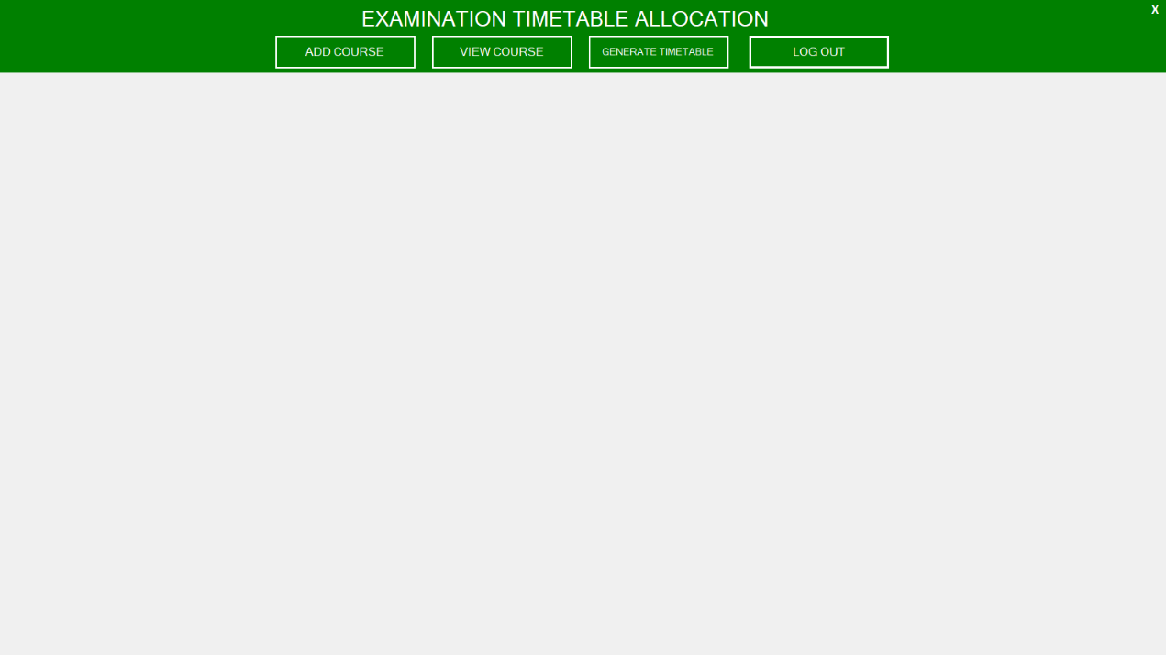

Figure 4.1: Admin Home Page Screenshot
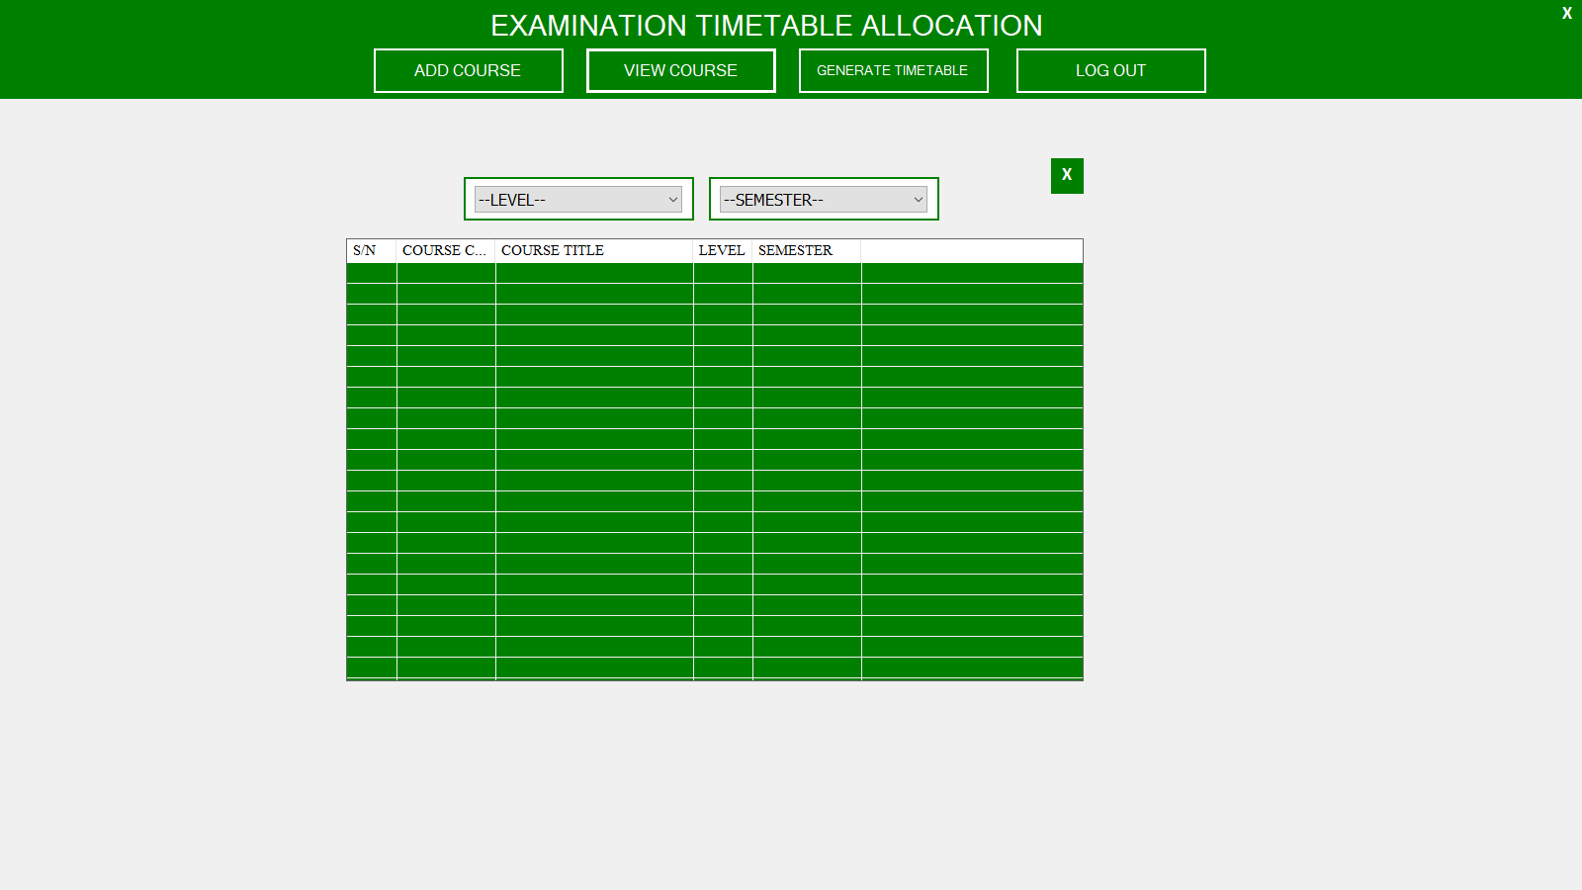
Figure 4.2: Dash Board Page Screenshot

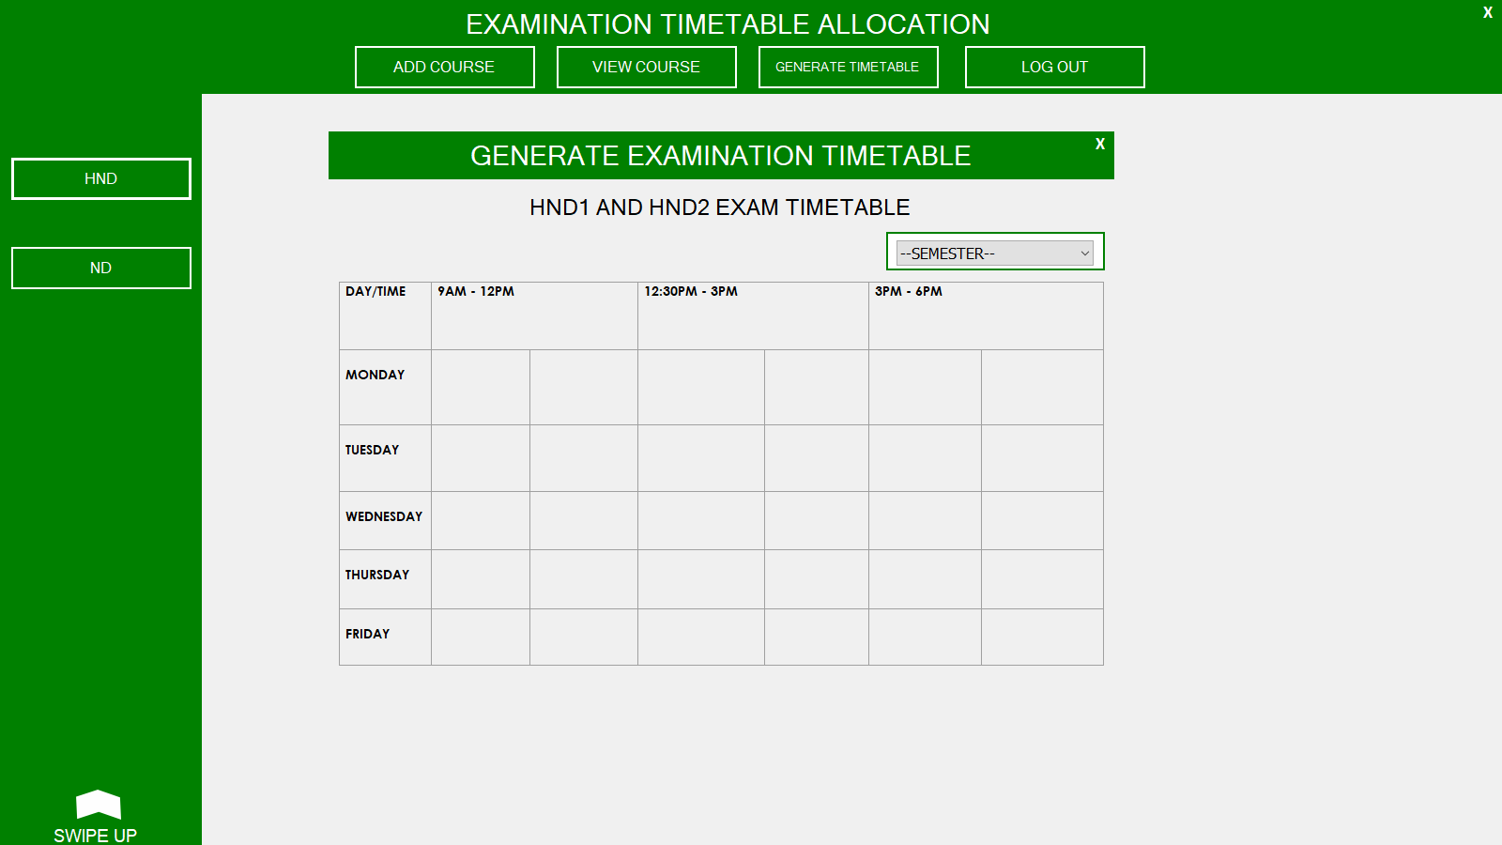
Figure 4.3: Time Table Generation Page Screenshot

4.1.2 INPUT DESIGN
In the below figure management can log-in with their unique Id and password and redirect to the Admin Home Page.
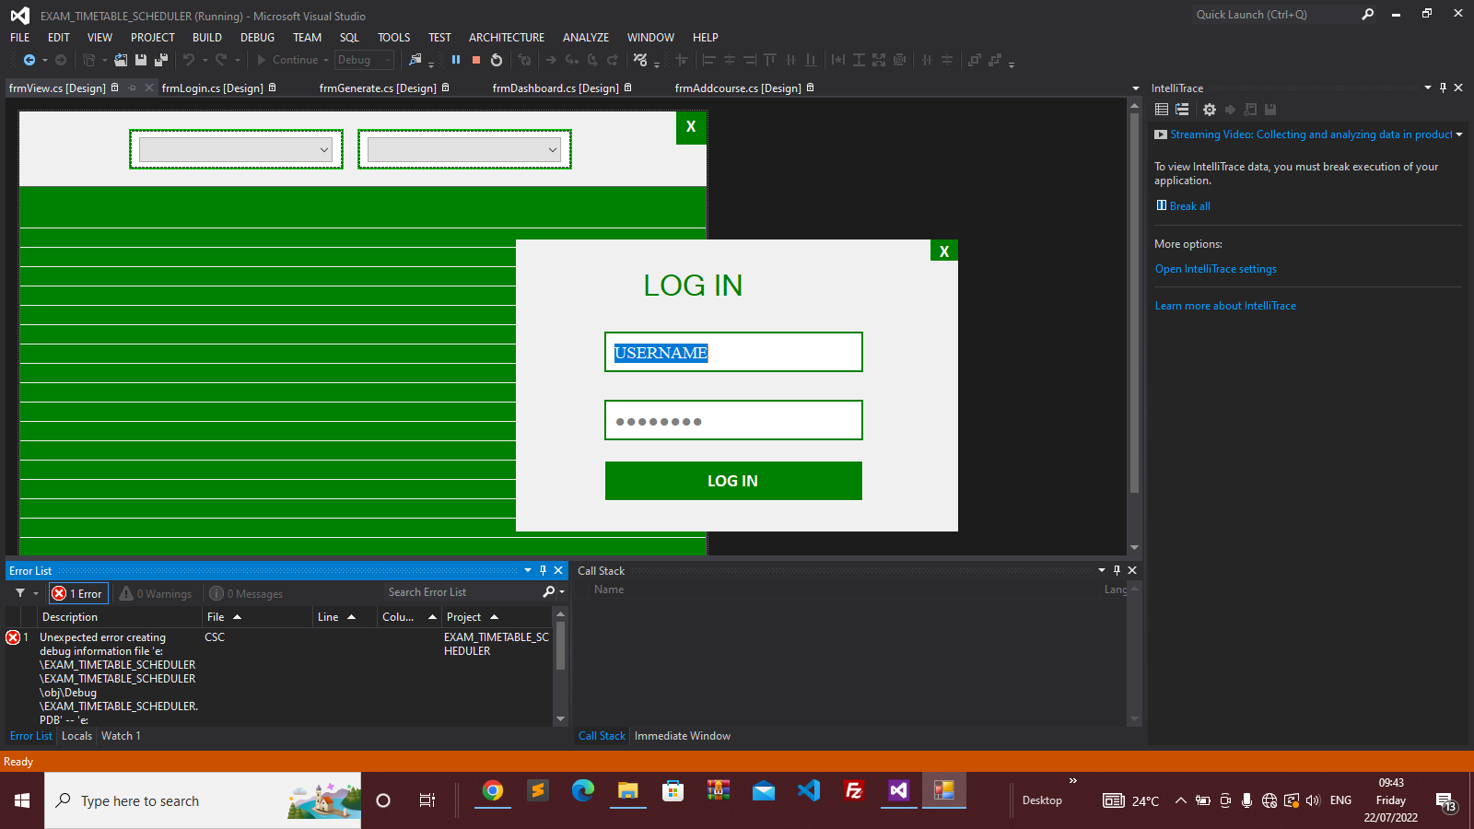

Figure 4.4: Adminlogin Page Screenshot
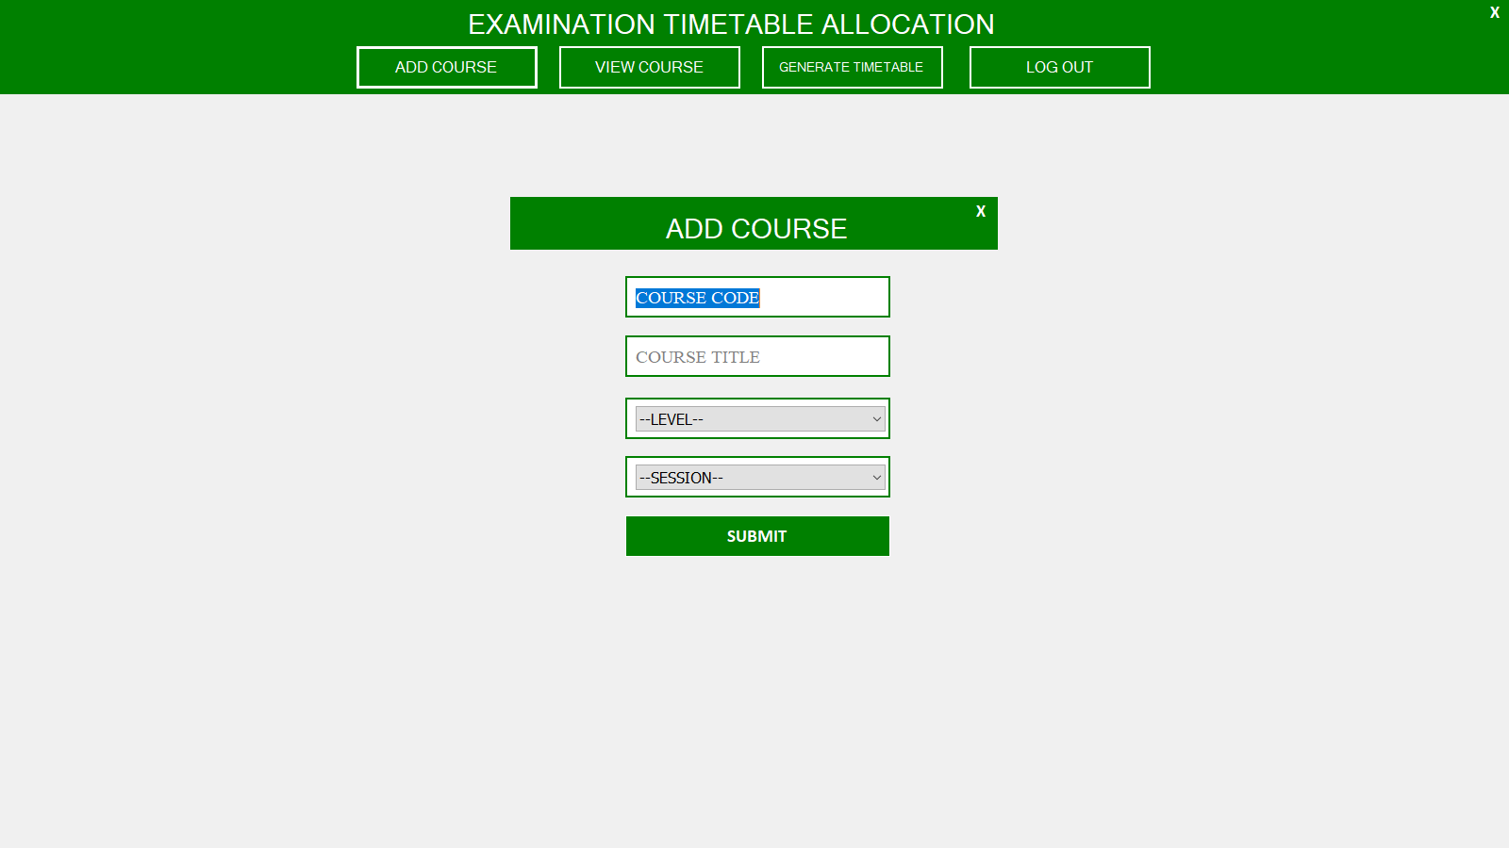

Figure 4.5: Add Course Page Screenshot
4.1.3 DATABASE DESIGN
File Design involve the organization and structure of each file used in the system. It refers to the methods of creating, arranging, storing, retrieving and updating of records on the file.

Table 4.1Time table design view
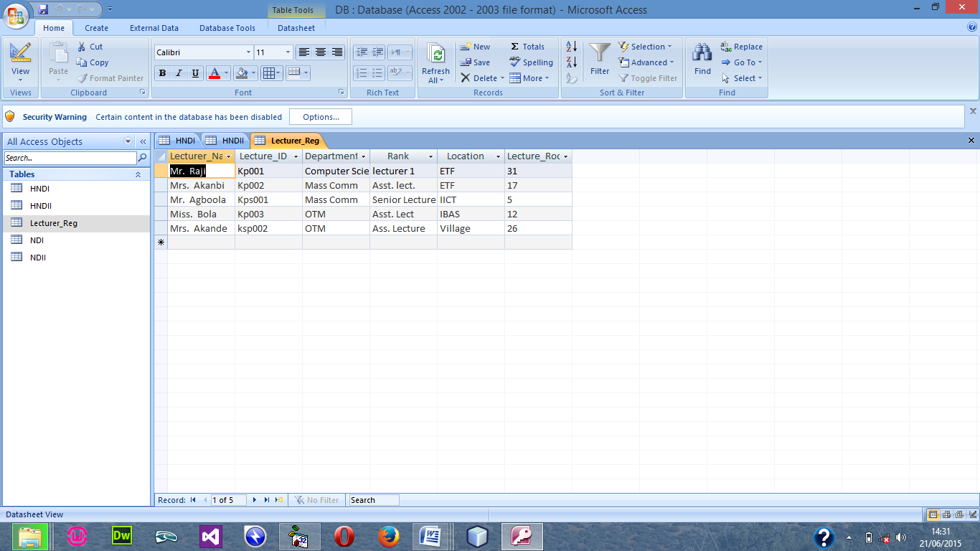

Table 4.2 Course Registration table design view
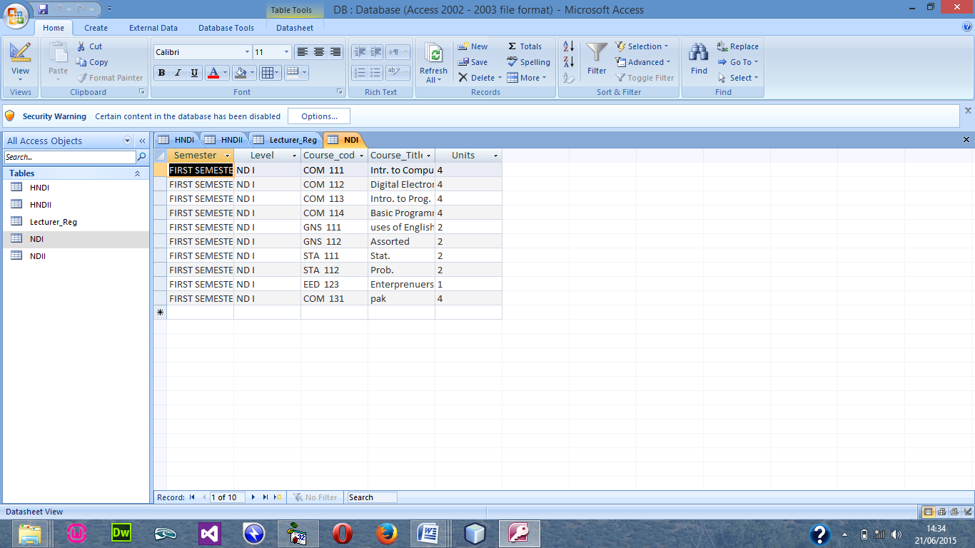

4.1.4 PROCEDURE DESIGN
The procedural design describes the system generally. It describes the various main programs in the system as well as the relationship that exist between all subprograms included. The procedural designs in this new system are of 5 menus of which each menu has it sub menu.
The application also contains several modules of which each module has its own specific function. The purpose of dividing the program into modules is because it enhances maintainability, readability and easy debugging.

  - IMPLEMENTATION OF THE SYSTEM
The implementation of this system is majorly entails the coding aspects of the system. That is the means through which program are written before the system can be run and tested or debugged for correction. Tools that would be used in this aspect of implementation involve various application medias that are meant to serve the purpose or program requirement.

4.2.1 CHOICE OF PROGRAMMING LANGUAGE
Visual basic 6.0 is the chosen programming language for the implementation of the proposed system because of its pedagogy and open source help when needed. As well it has a support for variety of database application like sql server, sqllite, mysql, and Microsoft access but Microsoft Access is selected.

4.2.2 HARDWARE SUPPORT
Hardware is the physical components of the computer system. The hardware needed is
- CPU with at least Pentium III processor, 600 MHZ Processor speed
- 14” monitor with resolution of 1024X768, VGA Card/SVGA
- CD ROM Drive/CD writer
- 10 GB free space hard disk
- UPS to prevent abrupt power supply
4.2.3 SOFTWARE SUPPORT
The software support for the design of the proposed system involves operating system, Microsoft visual basic 6.0, Microsoft Access as well as an anti-virus software which prevents the system from being infected by virus.

4.3 DOCUMENTATION OF THE SYSTEM
Program documentation is a written description of what each program modules does and the interrelationship within them. It guides the user how to go about using the system. Below are the three (3) main discussions under documentation of this research work
4.3.1 OPERATING THE SYSTEM
The program is design with the facilities of a website lunch on the web through a host account, the host provide space for the
STARTING/RUNNING THE PROGRAM
Before the system can be lunch, the user has to com
4.3.2MAINTENANCE OF THE SYSTEM
The last stage in the system life cycle is the maintenance, which can be described as the periodically evaluation and modification of the system. This is done from time-to-time to see whether a system is meeting the goals and providing the services which it’s designed for.
This software can easily be maintained by adding more modules to it or removing existing module that is found to be irrelevant to the user’s need. Also the database allows for data resilience and portability. Maintenance at program refers to the correction, addition, or deletion of part of the program with ease program that has structure and features of maintainability which is referred to as a good ‘structured program’.
Generally to be able to do any modification to each module in the program, one needs to open the program inenvironment. In the design environment of visual BASIC, double click on each module of visual BASIC, double click on each module to take you to its respective coding environment where necessary amendments could be made and the changes will be implemented immediately. This allows the maintenance of the program to be very easy.

CHAPTER FIVE
SUMMARY, CONCLUSION AND RECOMMENDATION
5.1 SUMMARY
The idea of the automated time table generation package is to eliminate the problem of manual examination time table generation which delays the commencement of exam in every new academic session. All said and done in this project, we have seen the inevitability of automation the exam time tables it gives the management and a more wide range of information at once, it saves time and effort user would have wasted in the existing system. Finally, the software development, an automated examination time tabling system was generated to overcome the shortcoming of manual time tabling system. This automated system will simplify the manual process, ensure optimum allocation of resources and reduce the risk of omission of exam and clashes of halls. The application software developed can be adapted and customized in other institutions of learning to ease the burden of the manual process.

5.2 CONCLUSION

The importance of this package to computer science department cannot be over emphasized. The new system has carefully worked on a more advantageous way in which information will be processed quickly, by eliminating the problems encountered in the existing (manual timetable). It is very clear evidence that the automated tie table generation package system can be very timely, accurate, consistent, and efficient it can therefore be concluded that this package will greatly reduce the setback encounter in the manual system of operation. Also based on the statistical analysis of this research study, automated time tabling system will be the best method to be adopted in tackling the lapses of its manual counterpart as evidenced by the opinion of the respondents and the hypothesis tested. This study therefore recommends the full deployment of this prototype and its implementation which will ease the burden of the manual process of time-tabling system and improve the academic activities of the institution at large.

5.3 RECOMMENDATION
Our future work will mainly focus on overcoming these drawbacks by working on an approach that would modify the standard selection cross techniques and in turn allow the segmentation of large number of students with minimal error and a better time efficiency. The future will also focus on considering priorities of different variables when performing.

REFERENCES
Babaei H, Karimpour J, Hadidi A., (2014) A survey of approaches for university course timetabling problem, Comput. Ind. Eng. 86 (1) 43–59.
Bayo M.I. and Izah O. M. (2014) Towards the Implementation Electronic Lecture Timetable System at Ambrose Alli University [J] Applied Science Research Journal. 2014, 1(2): 27-37
Chen R.M, & Shih H.F, “Solving University Course Timetabling Problems Using Constriction Particle Swarm Optimization With Local Search,” Algorithms, 6(2), pp. 227-244, 2013.
Chowdhary A. Kakde P. Dhoke S. Ingle S. Rushiya R. and Gawande D. Timetable generation system. International Journal of Computer Science and Mobile Computing, 2014 3(2).
Elhag, E. & Ozcan, A. (2015) grouping hyper-heuristic framework: application on graph colouring, Expert Syst. Appl. 42 (13) 5491–5507.
Feizi-Derakhshi M.R, Babaei H, Heidarzadeh J, (2012) A survey of approaches for university course timetabling problem, in: Proceedings of 8th International Symposium on Intelligent and Manufacturing Systems (IMS 2012), Sakarya University Department of Industrial Engineering, Adrasan, Antalya, Turkey, 2012, pp. 307–321.
Hambali A. M., et al., (2020) Automated University Lecture Timetable Using Heuristic Approach. Nigerian Journal of Technology (NIJOTECH) Vol. 39, No. 1, January 2020, pp. 1 – 1
Loganathan R, & Smitha K., (2019) Automated Allocation of Resources for Examination System using Genetic Algorithm. International Journal of Engineering and Advanced Technology (IJEAT).
Mohammad M. T., et al., (2019) Proposing a novel heuristic algorithm for university course timetabling problem with the quality of courses rendered approach; a case study. Published by Elsevier B.V. Faculty of Engineering, Alexandria University.
Nnamdi Johnson Ezeora., et al., (2020) An Automatic Examination Timetable System Using Selection and Crossover Technique. International Journal of Research and Innovation in Applied Science (IJRIAS) | Volume V, VIII, 2454-6194
Samuel L, Arnold A, & Milyandreana M. (2012) “Solving Timetable Problem by Genetic Algorithm and Heuristic Search Case Study,” Universitas Pelita Harapan Timetable. Universitas Pelita Harapan Computer Science Journal, pp. 87-93.
Shraddha T., et al. (2020) Automated Timetable Generation using Genetic Algorithm. International Journal of Engineering Research & Technology (IJERT) Vol. 9 Issue 07.
Yamazaki H. V, & Pertoft J. (2014) Scalability of a Genetic Algorithm that Solves a University Course Scheduling Problem Inspired by KTH,.

