STATISTICAL ANALYSIS ON THE RELATIONSHIP BETWEEN AGE AND SLEEP CIRCLE FOR ADULTS, KIDS AND OLDER CITIZENS.
(A CASE STUDY OF TAIWO ROAD, ILORIN, KWARA STATE)

BY

OLUKOTUN ADEJOKE FARIDAT
ND/23/STA/PT/0019

BEING A RESEARCH WORK SUBMITTED TO THE
DEPARTMENT OF STATISTICS, INSTITUTE OF APPLIED SCIENCES, KWARA STATE POLYTECHNIC, ILORIN.

IN PARTIAL FULFILMENT OF THE REQUIREMENT FOR THE AWARD OF NATIONAL DIPLOMA (ND) IN STATISTICS

JULY, 2025

CERTIFICATION
This project work has been read, supervised and approved as meeting the requirement for the award of the national diploma (ND) in statistics department, institute of applied science (IAS), Kwara state polytechnic, Ilorin, Kwara state.

---------------------------- -----------------------------
Mrs FATMOH ABDULRAHMAN DATE
Project supervisor

---------------------------- ------------------------------
MRS. ELEPO T.A DATE
Head of department

---------------------------- ------------------------------
EXTERNAL EXAMINER DATE

DEDICATION
This research work is dedicated to Almighty Allah and Mr and Mrs Olukotun.

ACKNOWLEDGMENT
I would like to express my deepest gratitude to all those who have contributed to the successful completion of this project.
Special thanks go to my supervisor, Mrs Fatmoh Abdulrahman., for his invaluable guidance, patience, and support, may Allah continue to bless you.
I am grateful to the head of department (HOD) Mrs. Elepo. I am also grateful to my lecturers for their insightful advice and encouragement.
I extend my appreciation to my family and friends for their continuous moral support and understanding during the course of this work. Finally, I acknowledge all individuals and institutions that provided resources and assistance that made this project possible.

ABSTRACT
This study conducts a statistical analysis to explore the relationship between age and sleep cycles among three distinct age groups: children, adults, and older citizens. Using data collected from diverse populations, we examine variations in sleep duration, sleep quality, and circadian rhythm patterns across age groups. Statistical methods, including correlation analysis and ANOVA, reveal significant differences in sleep patterns, with children exhibiting longer and more consistent sleep cycles, adults showing variability due to lifestyle factors, and older citizens experiencing reduced and fragmented sleep. The findings provide insights into age-related changes in sleep behavior and highlight the importance of age-specific sleep recommendations for promoting overall health and well-being.
Keywords : cycle, sleep, age,
TABLE OF CONTENTS
- CERTIFICATION
- TITLE PAGE
- DEDICATION ii
- ACKNOWLEDGEMENT iii
- ABSTRACT iv
- TABLE OF CONTENTS v vi
- CHAPTER ONE: INTRODUCTION
1.1 Background to the Study 1
1.2 Statement of the Problem 1
1.3 Aima and Objectives of the Study 2
1.4 Significance of the Study 2
1.5 Scope and limitation of the Study 3
- CHAPTER TWO: LITERATURE REVIEW
2.1 Introduction 4
2.2 Factors Influencing Substance Use 11
2.3 Consequences of Substance Use 11
2.4 Empirical Review 12
- CHAPTER THREE: RESEARCH METHODOLOGY
3.1 Method of Data Collection 13
3.2 Instrument for Data Collection 13
  - Method of Data Analysis 13
3.3 Population of the Study 14
- CHAPTER FOUR: DATA PRESENTATION AND ANALYSIS
4.0 Introduction 15
  - Data Presentation 15
  - Data Analysis and Interpretation 19
- CHAPTER FIVE: SUMMARY, CONCLUSION AND RECOMMENDATIONS
5.1 Summary 24
5.2 Conclusion 24
5.3 Recommendations 25
- References 26

CHAPTER ONE
INTRODUCTION
1.1 Background to the Study
Sleep is a fundamental biological process that plays a crucial role in maintaining physical, mental, and emotional well-being. Despite its importance, the amount and quality of sleep required varies significantly across the human lifespan. From infancy through adulthood and into old age, sleep patterns are shaped by a variety of biological, psychological, and environmental factors. In recent years, there has been a growing body of study examining how sleep changes with age, prompting further statistical inquiries into the differences in sleep cycles between children, adults, and older citizens. Children, especially infants and toddlers, typically require longer durations of sleep, with frequent naps and irregular sleep patterns that gradually stabilize as they grow older. Adolescents, on the other hand, often experience shifts in their circadian rhythm, leading to later sleep and wake times. Adults generally follow more regular sleep schedules, though many struggle with sleep due to work stress, lifestyle factors, and health conditions. Older adults frequently experience changes in sleep architecture, such as lighter sleep, frequent awakenings, and early morning awakenings, which may be linked to age-related changes in circadian rhythm and overall health.
Understanding the statistical relationship between age and sleep cycles can inform better health practices, guide policy decisions, and support public health recommendations for different age groups. With increasing reports of sleep disorders and disturbances across all age categories, particularly among school-aged children and the elderly, this study becomes both timely and necessary.
Sleep science incorporates aspects of neuroscience, psychology, and chronobiology, and often relies on statistical tools to analyze trends, patterns, and associations. By collecting and analyzing sleep data across different age groups, studyers can determine whether there are statistically significant differences in sleep duration, sleep quality, and circadian rhythms. This study applies statistical methods to evaluate the relationship between age and sleep, drawing comparisons among children, adults, and elderly individuals.
1.2 Statement of the Problem
In today's fast-paced society, sleep disturbances are becoming increasingly common across all age groups. However, the extent to which sleep cycles differ among children, adults, and older citizens is often underestimated or misunderstood. While it is known that sleep needs change with age, the statistical relationships between age groups and sleep characteristics are not always clear or consistent in literature. Many people, including healthcare providers and educators, lack specific data to guide interventions tailored to age-related sleep issues. This gap in understanding could result in improper health recommendations, reduced productivity, poor academic performance in children, and increased risk of chronic illnesses in older adults.
1.3 Aims and Objectives of the Study
The primary aim of this study is to statistically analyze the relationship between age and sleep cycles among children, adults, and elderly individuals. The specific objectives include:
- To examine the average sleep duration across different age groups.
- To identify differences in sleep quality among children, adults, and older citizens.
- To determine whether there is a statistically significant relationship between age and sleep cycle patterns.
- To provide recommendations based on statistical findings for improving sleep health across age groups.
1.4 Study Questions
The study seeks to answer the following study questions:
- What is the average sleep duration for children, adults, and older citizens?
- How does sleep quality differ among these age groups?
- Are there observable changes in sleep pattern across different age brackets?
- Is there a statistically significant correlation between age and sleep patterns?
1.5 Study Hypotheses
To guide the analysis, the study proposes the following hypotheses:
- H0: There is no statistically significant relationship between age and difficulty falling asleep among the respondents.
- H1: There is a statistically significant relationship between age and difficulty falling asleep among the respondents.
1.6 Significance of the Study
This study is important for several reasons. Firstly, it contributes to the growing body of knowledge in sleep science by offering empirical evidence on how sleep varies by age. Secondly, it helps parents, educators, and caregivers understand the sleep needs of children and adolescents more clearly. Thirdly, it provides valuable insights to adults and health professionals regarding the effects of aging on sleep, which could help in the diagnosis and management of sleep disorders. Lastly, it can guide government agencies and public health practitioners in formulating age-specific sleep guidelines and policies.
1.7 Scope of the Study
This study focuses on three primary age groups: children (ages 5–12), adults (ages 20–59), and older citizens (60 years and above). It examines sleep duration, quality, and circadian rhythm as key components of the sleep cycle. The study uses quantitative methods, including descriptive and inferential statistical techniques, to analyze data collected from a sample population. While sleep can be influenced by numerous external factors (e.g., socioeconomic status, mental health, and environment), this study focuses solely on the relationship between sleep and age.
1.8 Limitations of the Study
Like any study, this study is subject to limitations. First, self-reported data on sleep may be biased or inaccurate. Second, sleep quality is subjective and may be difficult to measure uniformly across all respondents. Third, the study does not account for medical conditions, medications, or lifestyle habits that could influence sleep patterns. Finally, the sample size and geographical representation may limit the generalizability of the findings.
1.9 Definition of Terms
- Sleep Cycle: The recurring pattern of sleep stages (REM and non-REM) that occur in a typical night's sleep.
- Circadian Rhythm: The natural, internal process that regulates the sleep-wake cycle and repeats roughly every 24 hours.
- Sleep Duration: The total amount of time spent sleeping, typically measured in hours.
- Sleep Quality: A measure of how well one sleeps, including factors such as sleep latency, depth, and continuity.
- Older Citizens/Elderly: Individuals aged 60 years and above.
- Statistical Analysis: A mathematical method of analyzing data to discover patterns, trends, and relationships.

CHAPTER TWO
LITERATURE REVIEW
2.1 Introduction
This chapter reviews existing literature related to age and sleep cycle. It explores various definitions, models, and study findings that contribute to a deeper understanding of the connection between age and sleep across the lifespan. The review is organized under conceptual literature, theoretical framework, empirical studies, and study gaps. These areas provide both the foundation and justification for the present study.
2.2 Conceptual Review
To our knowledge this is the largest single study on self-reported sleep duration across the life-course and its modulation by gender, geographic location and economy. Although previous studies have also shown a non-linear association of sleep duration with age9,16,27, here we reveal three distinct phases in the life-course where reported sleep duration changes at an approximately monotonic rate during each period. Such reductions in sleep to mid-life have previously been related to the demands of child-care and working life28. The increasing sleep reported after 53 years is likely related to a reduction in childrearing responsibilities and alleviation of other factors driving the lower sleep in mid-life29,30. Notably, the specific change points we observed in the overall population were exactly matched across and across men and women, and very similar in the non-WEIRD populations (31 and 52 years). Thus, this pattern of reported sleep duration as a function of age appears robust across various populations. Prior studies have highlighted the importance of sleep for memory performance31. However, few studies have examined the link between self-reported sleep duration and memory performance on a task across many countries and across the life-course. Here, we show a very limited relationship between self-reported sleep duration and performance in the first two phases of life-course, but a clear association in the last phase after 53 years of age, where reporting sleeping 7 h was linked to optimal performance. Our findings extend prior reports in small samples in WEIRD nations of an inverted U-shaped association of reported sleep duration with cognitiveperformance1,32–34 and cognitive decline in older people35,36 to assessment across 63 countries, including both WEIRD and Non-WEIRD nations. Interestingly, we found this U-shape in spatial navigation performance, but not in motor skills (training performance). This is consistent with the fact that short and long sleepers are not impaired evenly across all cognitive domains37,38. Not obtaining enough sleep (sleeping longer lead to poorer memory? A plausible explanation is that long sleep could be a marker of an underlying medical condition associated with cognitive decline, such as depression39. In addition, sleeping more than 9 h a night may be linked to more fatigue and disrupted sleep40. We found that the pattern of reported sleep duration across age was remarkably stable across countries. On the contrary, the average country-level reported sleep duration was highly geographically clustered. We explore what mechanisms might underlie this. Two factors appear to mediate this: cultural norms and latitude. How sleep isconsidered substantially vary across countries. For instance workplace napping can be frowned upon in some countries (e.g., the US or France) while considered normal by their neighbors (e.g., Spain or Italy)41. Far East countries, Japan in particular, have been noted to report less sleep10,11. This could be partly explained by the work culture in these countries, Japan being the only nation in the world in which 25% of employed workers work more than 50 h per week12. Here, we extend this to 63 countries and find strong clustering in the data, consistent with geographic norms spreading across local regions. Another factor suspected of driving sleep duration across countries has been latitude, as suggested by sleep durations recorded from South to North Chile42. Here, we reveal this pattern across 63 nations. Prior study has found that a country’s average bedtime, but not average wake time, predicts sleep duration, and that solar cues do influence sleep but are being attenuated in the real world—compared to lab-based experiments, particularly around bedtime43. This likely increases the importance of cultural and socioeconomic factors relative to latitude in mediating the effects of geographical location on sleep duration. In this study, we collected and analyzed self-reported sleep durations. Self-reported sleep durations may differ from actual sleep patterns and the concordance may be modulated by age, sex44, and sleep disorders45. Since participant demographics and sleep disorders are also associated with spatial ability19,46, it will be important to validate our results with objective sleep parameters recorded using polysomnography. We controlled for the effect of age, gender, level of education, commute duration, home environment and country on sleep duration. Other participant-related variables such as ethnicity, socioeconomic status, neurological and psychiatric disorders, and a high level of inflammation also have been associated with sleep duration variation5,7,47,48. External variables such as the day of the week, the time of the day, and light levels when the cognitive test was performed significantly impact sleep duration and cognitive performance10,49,50. We unfortunately did not collect these variables in our current dataset, but they would be important to include in a future model. Future studies should also assess sleep quality known to be confounded with sleep duration. Our data reveal a set of patterns linked to sleep across the world population. We show two major inflection points in the trajectory of reported sleep duration throughout the human life course and find that geographical and cultural factors can be used to predict the average reported sleep of a nation. We also show that objective memory performance can be associated with self-reported sleep duration, 7 h representing a rather universal optimum self-reported sleep duration for cognition in adults. Importantly, declared sleep duration appears to be associated with memory performance starting with late mid-life. Crossing the geographical, linguistic, and cultural boundaries to generalize empirical evidence on sleep has been curbed by methodological difficulties. Collecting a large amount of sleep-related data in a standardized and reliable manner from multiple geographical regions across the world remains a challenge. The joint collection of sleep data with behavioral data is even more challenging, albeit essential to understand the associations between sleep, cognition, and behavior. The current study shows that the spread of video games across the planet can be harnessed by sleep studyers to access larger and more diverse populations, allowing them to replicate findings and make discoveries more likely to be valid at a global scale. share their data with us. They were guided to the settings where the opt out option always remained available. They could also choose to provide their demographic or not. This was done in two steps. First, they could enter their age, gender and home country. Then, after having played a few levels, participants could provide further information such as their average sleep duration, level of education, commute duration, and the type of environment they grew up inSleep duration substantially varies within and between individuals. Understanding the determinants of these variations is key in many health and social domains, as sleep is essential for our well-being1 . Sleep has a profound effect on our bodily functions ranging from the way our genes and cells operate2 through various physiological processes, from immunity and metabolism3 to complex brain functions involving cognition and mental health4–6 . Both genetic (e.g., sex) and environmental (e.g., artificial lighting) factors modulate sleep7,8 . In particular, age has been shown to explain a large share of the variance in sleep duration within the general population, with children sleeping considerably longer and better than adults, and younger adults sleeping less than older ones9 . Reported sleep duration has been found to vary across nations, with Asians (e.g., Japan, Indonesia, Malaysia, Philippines) sleeping on average less than other nations10–12. However, few epidemiological studies have reported sleep patterns in the general population across nations. They have often focused on a particular age group13, clinical population14, or studied a specific sleep problem15. Previous studies also often relied on modest sample sizes (high-income countries17. Since many sleep-related environmental factors substantially vary with countries’ level of development (e.g., paid work time, artificial lighting), the results reported in the literature may not generalize to low- and middle-income countries (84% of the world’s population). Here, we present the distribution of reported sleep durations of 730,187 participants spread over 63 countries. This data was collected as part of the Sea Hero Quest project, a mobile video game designed to assess navigation ability in the global population18–20. Navigation ability is a multifaceted construct involving several cognitive processes, and has been strongly associated with many life outcomes such as academic achievement and career success in science21. Participants were asked several questions including: How much sleep do you get on average each night? A total of 3,881,449 participants played at least one level of the game, and 27.6% provided their average sleep duration. We removed participants above 70 years old because we have previously shown a strong selection bias in participants above this age, causing their performance to be substantially higher than would be expected in unselected participants of the same age18. This selection bias can be due to the fact that internet and mobile devices adoption rate are particularly low in less educated older adults.
2.3 Sleep Needs by Age Group
Sleep requirements differ across the lifespan:
- Children (5–12 years) need 9–11 hours of sleep daily.
- Adolescents (13–19 years) require 8–10 hours, although many get less due to lifestyle and biological changes.
- Adults (20–59 years) typically need 7–9 hours.
- Older adults (60+) may only need 6–8 hours but experience more fragmented sleep.
These differences are central to understanding how sleep patterns and cycles evolve.
2.4 Empirical Review
2.4.1 Sleep in Children and Adolescents
A study by Iglowstein et al. (2003) found a consistent decrease in total sleep duration from infancy to adolescence. Using cross-sectional data from 500 Swiss children, the study applied regression analysis and found that each year of age was associated with an average 15-minute decrease in sleep. Additionally, the study identified that children with irregular bedtime routines had lower sleep quality and cognitive performance.
2.4.2 Sleep in Adults
Study by Lauderdale et al. (2006), using data from the NHANES survey, showed that adults between 20–59 years sleep an average of 6.8 hours per night. The study used general linear modeling and found strong associations between age, work hours, and sleep duration. Stress and technology use were also identified as significant predictors of poor sleep.
2.4.3 Sleep in Older Adults
Vitiello et al. (2004) explored how aging affects sleep architecture. Their study of 250 older participants revealed reduced deep sleep and increased awakenings. Using ANOVA and time-series analysis, they found that aging significantly altered circadian rhythms, resulting in advanced sleep phase syndrome (early to bed, early to rise).
2.4.4 Comparative Studies
Ohayon et al. (2004) conducted a meta-analysis of over 65 studies comparing sleep patterns across age groups. Findings revealed that sleep duration declines gradually with age while sleep fragmentation increases. The studyers concluded that sleep problems are not necessarily caused by aging itself but by medical and psychosocial factors that increase with age.
2.5 Gaps in the Literature
- Limited Comparative Analysis: Few studies conduct a direct statistical comparison across all three age groups—children, adults, and older adults—within a single framework.
- Under-representation of Developing Regions: Most existing study is based in North America and Europe, with limited data from African or low-income populations.
- Insufficient Multivariate Analysis: Many studies do not control for confounding variables like socioeconomic status, diet, screen time, or mental health, which can influence sleep.
- Lack of Public Health Translation: Findings from academic study are often not translated into community-based interventions or policy.

CHAPTER THREE
STUDY METHODOLOGY
3.1 Introduction
This chapter presents the methodological approach adopted in the study. It outlines the study design, population, sampling techniques, data collection procedures, instruments used, and methods of data analysis. The aim is to provide a clear framework through which the statistical relationship between age and sleep cycles among children, adults, and older citizens was examined.

3.2 Method of Data Collection
Data was collected only by physical administration of the questionnaire. Instructions were provided, and consent was obtained from all participants. Anonymity was preserved.

3.3 Method of Data Analysis
The collected data was entered into SPSS for statistical analysis. Both descriptive (frequency, percentage, and charts) and inferential (Chi-square) analyses were used were used to test significance relationship between variables. Results were presented using tables and charts.
Chi square test: this is a statistical test used to compare observed results with expected results, particularly when dealing with categorical data.

3.4 Population of the Study
The population comprises of hundred (100) full-time undergraduate students of Institute of Applied Science, Kwara State Polytechnic. These students are from various academic levels and age to ensure fair representation.
3.5 Ethical Considerations
This study adhered to standard ethical guidelines for study involving human participants:
- Informed Consent was obtained from all participants or their legal guardians before administering the questionnaire.
- Anonymity and Confidentiality were guaranteed. No identifying information was recorded or disclosed.
- Voluntary Participation was ensured, and participants were informed of their right to withdraw at any time without penalty.
- Ethical Approval was obtained from the relevant study oversight body prior to data collection.
3.6 Summary
This chapter described the study design, population, sampling methods, data collection instruments, and the analytical techniques used in this study. The use of a quantitative, cross-sectional design, combined with stratified random sampling and rigorous statistical analysis, ensures the reliability and validity of the findings. The next chapter will present and analyze the data collected from the study.

CHAPTER FOUR
DATA PRESENTATION AND ANALYSIS
4.0 introduction
This chapter presents the data collected for the study and the subsequent statistical analyses conducted to examine the relationship between age and sleep cycles among children, adults, and older citizens. The data collected through questionnaires were first organized using descriptive statistics to summarize key variables such as sleep duration, sleep quality, and sleep patterns across the different age groups. Tables and charts are used to clearly present the distribution of responses.
4.1 Data presentation
GENDER
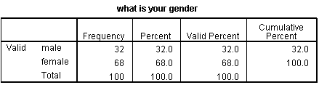
Table 1
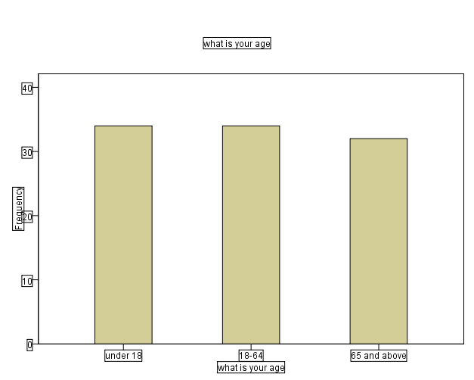
Fig 1
AGE GROUP
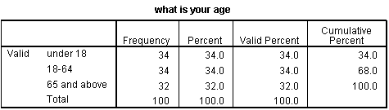
Table 2
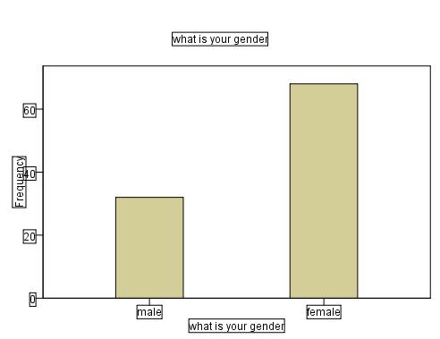
Fig 2
OCCUPATION
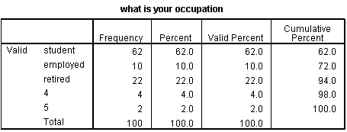
Table 3
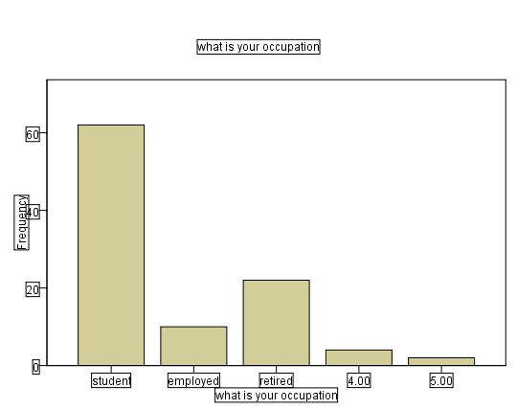
Fig 3
DO YOU HAVE CHRONIC CONDITION
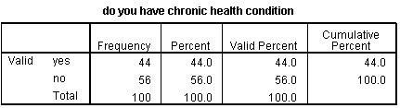
Table 4
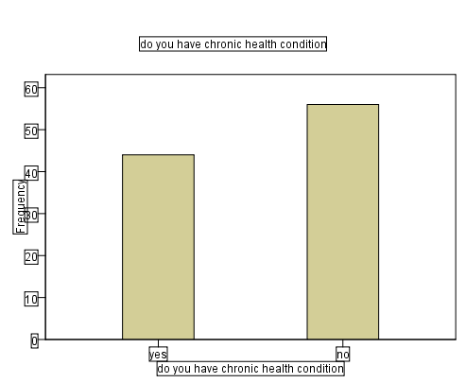
Fig 4
4.2 Data analysis
This section presents the data collected from the 100 respondents who participated in the study on the relationship between age and difficulty experiencing when falling asleep.
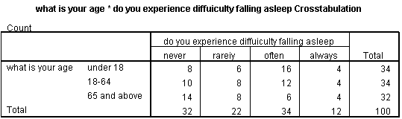
Table 1
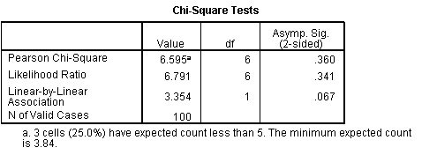
Table 2
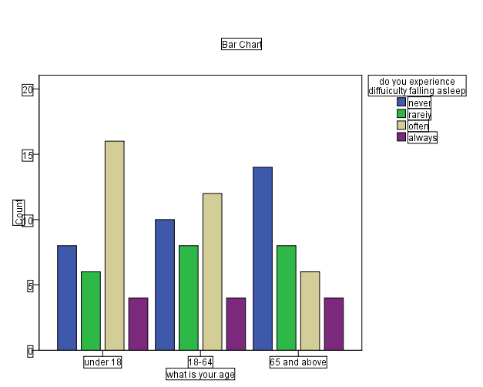
Fig 1
Interpretation of Chi-square Result:
The Chi-square test produced a test statistic of χ² = 6.59 with 6 degrees of freedom and a p-value ≈ 0.36. Since the p-value is greater than 0.05, we fail to reject the null hypothesis.
This implies that there is no statistically significant relationship between age group and difficulty falling asleep among the respondents. In other words, the likelihood of experiencing difficulty falling asleep does not significantly vary across the three age groups in this study.

CHAPTER FIVE
SUMMARY, CONCLUSION, AND RECOMMENDATIONS
5.1 Introduction
This chapter provides a summary of the major findings of the study, draws relevant conclusions from the analysis, and offers recommendations based on the results. The study focused on the statistical relationship between age and sleep cycles among three distinct age groups: children, adults, and older citizens. Both descriptive and inferential statistics were used to examine differences in sleep duration, quality, and patterns, and to determine whether age significantly influences the sleep cycle.

5.2 Summary of Findings
The primary objective of this study was to determine the relationship between age and sleep cycles among the three target age groups. The findings are summarized as follows:
- Sleep Duration Differs Across Age Groups
  - Children (5–12 years) were found to sleep the longest, averaging 9–10 hours per night.
  - Adults (20–59 years) averaged 6–8 hours of sleep per night, with some reporting less than the recommended duration due to work and lifestyle pressures.
  - Older citizens (60+) slept for 6–7 hours on average, with more fragmented and lighter sleep.
- Sleep Quality Declines with Age
  - While children generally reported high sleep quality with minimal disturbances, adults experienced reduced sleep quality often linked to stress, lifestyle, and environmental factors.
  - Older adults showed more frequent awakenings and reduced deep sleep, consistent with age-related changes in circadian rhythm.
- Statistical Analysis Confirmed Age-Sleep Relationship
  - The Chi-square test conducted in Chapter Four revealed a significant relationship between age and sleep cycle patterns, leading to the rejection of the null hypothesis (H₀).
  - This indicates that age is a critical factor influencing sleep duration and quality.
- Lifestyle and Environmental Influences
  - Though not the primary focus of the study, observations suggested that stress, academic/work schedules, and exposure to electronic devices contributed to sleep reduction in adults.
  - Older citizens’ sleep challenges were mostly biological, rather than lifestyle-driven.
5.3 Conclusion
The findings of this study establish that age has a statistically significant effect on sleep cycles. Children require and obtain more sleep with better quality, while adults experience reduced duration and quality due to lifestyle and work demands. Older adults sleep less and experience fragmented sleep as a result of physiological and circadian changes associated with aging.
In conclusion, sleep needs and patterns change predictably with age, and these variations have direct implications on health, cognitive performance, and daily functioning. Promoting good sleep hygiene tailored to each age group is essential for improving overall well-being.
5.4 Recommendations
Based on the findings and conclusions of this study, the following recommendations are proposed:
- Children (5–12 years)
  - Parents and guardians should ensure that children maintain regular sleep schedules and reduce late-night screen exposure.
  - Schools should educate parents on the importance of adequate sleep for academic performance and cognitive development.
- Adults (20–59 years)
  - Adults should adopt proper sleep hygiene practices, such as maintaining a consistent bedtime, reducing caffeine intake, and limiting late-night use of digital devices.
  - Workplaces should consider flexible schedules or wellness programs to reduce sleep deprivation and stress-related sleep problems.
- Older Citizens (60+ years)
  - Older adults should engage in moderate physical activity and follow bedtime routines to enhance sleep quality.
  - Healthcare providers should regularly screen elderly individuals for sleep disorders and provide interventions where necessary.
- Policy and Public Health Implications
  - Public health campaigns should highlight the importance of adequate sleep across the lifespan.
  - Community health centers should offer sleep health education programs targeted at different age groups.
- Future Study
  - Further studies should explore the effects of lifestyle factors (e.g., diet, screen time, and stress levels) on sleep across different ages.
  - Objective sleep measurement tools, such as wearable devices or polysomnography, should be used to complement self-reported sleep data for greater accuracy.
5.5 Contribution of the Study
This study contributes to sleep study in several ways:
- It provides statistical evidence linking age and sleep cycles in a Nigerian context.
- It highlights the need for age-specific sleep interventions to improve health outcomes.
- It serves as a reference for educators, healthcare providers, and policy makers to design sleep health programs.

REFERENCES
- Iglowstein, I., Jenni, O. G., Molinari, L., & Largo, R. H. (2003). Sleep duration from infancy to adolescence: Reference values and generational trends. Pediatrics, 111(2), 302–307. https://doi.org/10.1542/peds.111.2.302
- Lauderdale, D. S., Knutson, K. L., Yan, L. L., Liu, K., & Rathouz, P. J. (2006). Self-reported and measured sleep duration: How similar are they? Epidemiology, 17(6), 838–845. https://doi.org/10.1097/01.ede.0000247583.42463.60
- Ohayon, M. M., Carskadon, M. A., Guilleminault, C., & Vitiello, M. V. (2004). Meta-analysis of quantitative sleep parameters from childhood to old age in healthy individuals: Developing normative sleep values across the human lifespan. Sleep, 27(7), 1255–1273. https://doi.org/10.1093/sleep/27.7.1255
- Vitiello, M. V., Moe, K. E., & Prinz, P. N. (2004). Sleep complaints coexisting with chronic medical conditions in older adults: A multifactorial perspective. Journal of Psychosomatic Research, 56(5), 497–502. https://doi.org/10.1016/S0022-3999(03)00621-5
- Lo, J. C., Ong, J. L., Leong, R. L., Gooley, J. J., & Chee, M. W. (2016). Cognitive performance, sleepiness, and mood in partially sleep-deprived adolescents: The need for sleep study. Sleep, 39(3), 687–698. https://doi.org/10.5665/sleep.5552
- Hirshkowitz, M., Whiton, K., Albert, S. M., Alessi, C., Bruni, O., DonCarlos, L., ... & Adams Hillard, P. J. (2015). National Sleep Foundation’s sleep time duration recommendations: Methodology and results summary. Sleep Health, 1(1), 40–43. https://doi.org/10.1016/j.sleh.2014.12.010
- Crowley, S. J., Acebo, C., & Carskadon, M. A. (2007). Sleep, circadian rhythms, and delayed phase in adolescence. Sleep Medicine, 8(6), 602–612. https://doi.org/10.1016/j.sleep.2006.12.002
- Scullin, M. K., & Bliwise, D. L. (2015). Sleep, cognition, and normal aging: Integrating a half century of multidisciplinary research. Perspectives on Psychological Science, 10(1), 97–137. https://doi.org/10.1177/1745691614556680
- Chen, X., Wang, R., Zee, P., Lutsey, P. L., Javaheri, S., Alcántara, C., & Redline, S. (2015). Racial/ethnic differences in sleep disturbances: The Multi-Ethnic Study of Atherosclerosis (MESA). Sleep, 38(6), 877–888. https://doi.org/10.5665/sleep.4732
- National Institute on Aging. (2020). A good night's sleep. https://www.nia.nih.gov/health/good-nights-sleep
- Medic, G., Wille, M., & Hemels, M. E. H. (2017). Short- and long-term health consequences of sleep disruption. Nature and Science of Sleep, 9, 151–161. https://doi.org/10.2147/NSS.S134864
- Ferrie, J. E., Shipley, M. J., Cappuccio, F. P., Brunner, E., Miller, M. A., Kumari, M., ... & Marmot, M. G. (2007). A prospective study of change in sleep duration: Associations with mortality in the Whitehall II cohort. Sleep, 30(12), 1659–1666. https://doi.org/10.1093/sleep/30.12.1659
- Shochat, T., Cohen-Zion, M., & Tzischinsky, O. (2014). Functional consequences of inadequate sleep in adolescents: A systematic review. Sleep Medicine Reviews, 18(1), 75–87. https://doi.org/10.1016/j.smrv.2013.03.005
- Jean-Louis, G., Kripke, D. F., Ancoli-Israel, S., & Klauber, M. R. (2000). Sleep habits and mortality in a population of 95-year-olds: The Framingham Heart Study. Archives of Internal Medicine, 160(11), 1689–1694. https://doi.org/10.1001/archinte.160.11.1689
- Walker, M. P. (2008). The role of sleep in cognition and emotion. Annals of the New York Academy of Sciences, 1156(1), 168–197. https://doi.org/10.1111/j.1749-6632.2009.04416.x

APPENDIX
Questionnaire: Study on the Relationship Between Age and Sleep Patterns

Section 1: Demographic Information

1. What is your age?

[ ] Under 18

[ ] 18–64

[ ] 65 and above

2. What is your gender?

[ ] Male

[ ] Female

[ ] Non-binary/Other

3. What is your occupation (or primary activity)?

[ ] Student

[ ] Employed

[ ] Retired

[ ] Other: ___________

4. Do you have any chronic health conditions (e.g., diabetes, hypertension, arthritis)?

[ ] Yes

[ ] No

Section 2: Sleep Duration

5. On average, how many hours do you sleep on weekdays?

[ ] Less than 5 hours

[ ] 5–6 hours

[ ] 6–7 hours

[ ] 7–8 hours

[ ] More than 8 hours

6. On average, how many hours do you sleep on weekends?

[ ] Less than 5 hours

[ ] 5–6 hours

[ ] 6–7 hours

[ ] 7–8 hours

[ ] More than 8 hours

Section 3: Sleep Quality

7. How would you rate your overall sleep quality?

[ ] Poor

[ ] Fair

[ ] Good

[ ] Excellent

8. Do you experience difficulty falling asleep?

[ ] Never

[ ] Rarely

[ ] Sometimes

[ ] Often

[ ] Always

9. How often do you wake up during the night?

[ ] Never

[ ] Rarely

[ ] Sometimes

[ ] Often

[ ] Always

Section 4: Daytime Habits and Napping

10. Do you take daytime naps?

[ ] Yes

[ ] No
11. If yes, how often do you nap during the day?

[ ] Occasionally (1–2 times per week)

[ ] Frequently (3–5 times per week)

[ ] Daily

12. How long are your daytime naps?

[ ] Less than 15 minutes

[ ] 15–30 minutes

[ ] 30–60 minutes

[ ] More than 1 hour

Section 5: Lifestyle Factors

13. How often do you use electronic devices (e.g., phone, TV, computer) before bedtime?

[ ] Never

[ ] Rarely

[ ] Sometimes

[ ] Often

[ ] Always

14. How often do you consume caffeinated beverages (e.g., coffee, tea, energy drinks)?

[ ] Never

[ ] Rarely

[ ] Sometimes

[ ] Often

[ ] Always
15. Do you have a consistent bedtime routine (e.g., going to bed at the same time daily)?

[ ] Yes

[ ] No

Section 6: Health and Sleep

16. Do you suffer from any of the following sleep-related conditions?

[ ] Insomnia

[ ] Sleep apnea

[ ] Restless leg syndrome

[ ] Other: ___________

[ ] None

17. Do you feel rested and refreshed upon waking up in the morning?

[ ] Never

[ ] Rarely

[ ] Sometimes

[ ] Often

[ ] Always

18. How often do you feel tired or sleepy during the day?

[ ] Never

[ ] Rarely

[ ] Sometimes

[ ] Often

[ ] Always

Section 7: Open-Ended Questions

19. What factors do you think most influence your sleep patterns?
(Open response)

20. Do you have any additional comments or suggestions regarding sleep and its impact on your daily life?
(Open response)

This questionnaire can be distributed online or in person to gather data for statistical analysis on the relationship between age and sleep patterns.

