EFFECT OF WELDING CONSUMABLES ON THE MICROSTRUCTURE AND MECHANICAL PROPERTIES OF A WELDED SA 530 GR 70 STEEL

BY

SANYAOLU SODIQ OLUWATOSIN
HND/23/MET/FT/0002

SUBMITTED TO:
DEPARTMENT OF METALLURGICAL ENGINEERING TECHNOLOGY, INSTITUTION OF TECHNOLOGY, KWARA STATE POLYTECHIC, ILORIN, KWARA STATE

IN PARTIAL FULFILMENT FOR THE AWARD OF HIGHER NATIONAL DIPLOMA (HND)
IN THE DEPARTMENT OF METALLURGICAL ENGINEERING TECHNOLOGY

SUPERVISED BY:
ENGR. BABALOLA S.A.

AUGUST, 2025

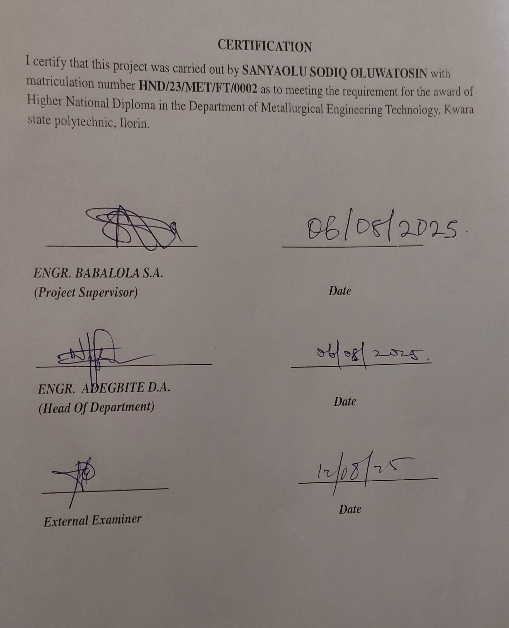

DEDICATION
I dedicated to Almighty Allah; The creator of heaven and earth, who in his infinite mercy has sustained me from the beginning of this Higher National Diploma Program to the very end and also for the success of this work. I also dedicate this work to my loving parents MR. & MRS. SANYAOLU and my beloved brother SANYAOLU AZEEZ for their gracious support in my life. I really appreciate all and sundry.

ACKNOWLEDGMENT
My profound gratitude goes to Almighty Allah for sparing my life up to this moment.
My appreciation goes to my supervisor ENGR. BABALOLA S.A. and all the lecturers in Metallurgical and Material Engineering Department for their great assistance towards the success of the project in person of our honorable H.O.D ENGR. ADEGBITE D.A., ENGR. ALAGBE M., ENGR. ADESHINA A.S. , ENGR. OLAMIDE S., ENGR. (MRS.) IHOGBETIN F.F.
I’m greatly indebted with my parent MR. & MRS. SANYAOLU and my amazing brother MR. SANYAOLU AZEEZ for their financial, moral and prayer support throughout the succession of the programme
I also give thanks to all my friends and family for their direct and indirect support most especially my junior sister NOFISAT, and to someone very special to me OLADOSU SHUKROH, and my friends HAMEED, TOHEEB, AKINOLA ANUOLUWAPO (A.K.A. BIG OOSHA), YUSUF, MR. & MRS. YAKUB, KABIR ROHEEMAT, ABDULYEKEEN ZANIAB for their courage and support throughout this programme.

ABSTRACT
This study investigates the effect of welding consumables on the microstructure and mechanical properties of welded SA 530 Gr 70 steel. The welding consumables evaluated include E6013 and E7018 electrodes, as well as Flux-Cored Arc Welding (FCAW) wire. Standardized welding procedures were employed to produce weld joints on SA 530 Gr 70 steel plates, after which samples were extracted for mechanical testing and microstructural examination.
Mechanical tests such as tensile strength, yield strength, and hardness were conducted across the weld zone, heat-affected zone (HAZ), and base metal. The results revealed significant variations in mechanical performance and hardness distribution depending on the electrode used. Notably, FCAW produced the highest tensile and yield strengths, as well as the greatest hardness values, especially in the HAZ. Microstructural analysis using optical microscopy further showed differences in grain size and phase distribution across the weldments, with low-hydrogen electrodes like E7018 offering more refined microstructures compared to rutile-based E6013.
The findings highlight the critical role of electrode selection in determining the structural integrity and performance of welded components. Ultimately, this study provides insights for optimizing welding parameters and consumable choices in industrial fabrication involving SA 530 Gr 70 steel.

TABLE OF CONTENTS

Title Page

Certification i

Dedication ii

Acknowledgement iii

Abstract iv

Table of Contents v

CHAPTER ONE: INTRODUCTION

1.1 Background of the Study 1

1.2 Problem Statement 2

1.3 Aim of Study 3
1.4 Objectives 3

1.5 Significance 3

1.6 Scope of the Study 3

CHAPTER TWO: LITERATURE REVIEW

2.1 Welding of Steel 6

2.2 Welding Processes 8

2.3 Welding Consumables 8

2.4 Welded Steel Metal Composition 11

2.5 Effect of Welding On the Mechanical Properties of a Mild Steel 13

2.6 Influence of Welding Consumables on Properties of SA 530 Gr 70 Steel 14

CHAPTER THREE: MATERIALS AND EQUIPMENT USED

3.1 Welding of the Metal 16

3.2 Preparation of Test Samples 18

3.3 Non Destructive Test 18

3.4 Machining of Samples 21

3.5 Mechanical Properties 21

3.6 Metallography 26

CHAPTER FOUR: RESULT AND DISCUSSION

4.1 Hardness Test Result 29

4.2 Discussion on Hardness Test Result 29

4.3 Tensile Strength Test Result 31

4.4 Discussion on Tensile Test Result 32

4.5 Microstructural Examination 35

4.6 Discussion on Microstructure Examination 36

CHAPTER FIVE: CONCLUSIONS AND RECOMMENDATION

5.1 Conclusions 38

5.2 Recommendation 38

Reference 39

LIST OF FIGURES
Fig 3.1: Image of the Fit-up process 17
Fig 3.2: Different Electrodes Used 17
Fig 3.3: Images after Magnetic Particle Inspection 19
Fig 3.4: Ultrasonic Test Using 45⁰ Probes 20
Fig 3.5: Ultrasonic Test Using 0⁰ Probes 21
Fig 3.6: Ultrasonic Test Using 30⁰ Probes 21
Fig 3.7: Image after Fracture Occurred 22
Fig 3.8: The Test Piece Inserted In the Jaw of a Tensile Test Machine 22
Fig 3.9: Images after During Tensile Test for SAW and FCAW Specimen 23
Fig 3.10: Images of Hardness Test Carried Out for SMAW 25
Fig 3.11 Images of Hardness Test and Specimen 25
Fig 4.1: A Bar Chart Showing the Hardness Values for Each Consumable Used 30
Fig 4.2: A Bar Chart with Hardness Values for the Different Types of Electrodes 31
Fig 4.3: A Chart Showing the Ultimate Tensile Strength of Each Consumables Used32
Fig 4.4: The Stress Strain Curve for E6013 33
Fig 4.5: The Stress Strain Curve for E7018 34
Fig 4.6: The Stress Strain Curve for FCAW 34
Fig 4.7: Microstructure for HAZ E6013 35
Fig 4.8: Microstructure for Weld Metal E6013 35
Fig 4.9: Microstructure for HAZ E7018 35
Fig 4.10: Microstructure for Weld Metal E7018 36
Fig 4.11: Microstructure for Mild Steel Base Metal 36

LIST OF TABLES
Table 3.1: Chemical Composition of a Mild Steel Plate 18
Table 3.2: Chemical Composition of Various Electrodes 18
Table 4.1: The Hardness Value 29
Table 4.2: Tensile Test Result 32

CHAPTER ONE
INTRODUCTION
1.1 Background Of The Study
Steel is arguably the world’s most ‘advanced” material. It is a very versatile material with a wide range of attractive properties which can be produced at a very competitive cost. It has a diverse range of applications, and is second only to concrete in its annual production tonnage. Steel is not a new invention which leads to a common misperception that “everything is known about steel” amongst those outside its field. Steel is generally defined as a ferrous alloy containing less than 2.0wt%C. The complexity of steel arises with the introduction of further alloying elements into the iron-carbon alloy system. The optimization of alloying content in the iron-carbon system, combined with different mechanical and heat treatment leads to immense opportunities for parameter variations and these are continuously been developed.
Mild steel is a type of steel containing a small percentage of carbon, strong and tough but not readily tempered. It is also known as plain carbon steel and low carbon steel. It is the most common type of steel because its price is relatively low while the material properties are acceptable for many applications. Mild steel contains approximately 0.05-0.25% carbon, making it malleable and ductile. It has a relatively low tensile strength but it is cheap and easy to form, its surface hardness can be increased through carburizing.
It’s often used when large quantities of steel are needed for example structural steel. The density of mild steel is approximately 7.85g/cm and the Young modulus is 200GPa. Low carbon steel contains less carbon than other steel and are easier to cold form, making them easier to handle. This has given them an advantage compared to other nation since it was used in making weapons (Sacks and Bonhart, 2005). Low carbon steel is a type of steel that contains fine grains and it started being designed since the 19th century. Low carbon steel can be classified when the carbon content is lower than 0.2 percent (American Society for Testing and Materials 2001). Low carbon steel is widely used in fabrication industry due to excellent to weight ratio and one of the applications are in automobile industry (Khodabakhshi et al, 2011). This material is suitable to use in automotive industry because it can absorb high impact force without cracking. This happen because it has low carbon which makes it a ductile material compared to high carbon steel that is more brittle and easy to crack although it has more strength.
Steel is an important engineering material. It has found applications in many areas such as vehicle parts, truck bed floors, automobile doors, domestic appliances etc. It is capable of presenting economically a very wide range of mechanical and other properties. Traditionally, mechanical components has been joined through fasteners, rivet joint etc. In other to reduce time for manufacturing, weight reduction and improvement in mechanical properties, welding processes is usually adopted.
Welding is a critical manufacturing process widely utilized in various industries, including construction, shipbuilding, automotive, and aerospace. The integrity and performance of welded structures heavily depend on the quality of the welding process and the materials involved, particularly the welding consumables. The consumables, which include:
- welding electrodes
- filler metals
- shielding gases
Play a pivotal role in determining the microstructure and mechanical properties of welded joints.
SA 530 Grade 70 steel is a high-strength low-alloy steel known for its excellent mechanical properties and good weldability. It is commonly used in applications requiring robustness and resilience, such as pressure vessels and structural components. Understanding how different welding consumables affect the properties of SA 530 Gr 70 steel is essential for optimizing welding processes and ensuring the reliability of welded structures.
1.2 Problem Statement
Despite the extensive use of welding in industrial applications, there is limited understanding of how various welding consumables influence the microstructural evolution and mechanical properties of SA 530 Gr 70 steel. Variations in the chemical composition, deposition rate, and thermal input associated with different welding consumables can lead to significant differences in microstructure, which in turn impact the mechanical performance of the welded joints. Hence, there is a critical need to investigate these effects systematically to guide the selection of appropriate welding consumables for specific applications.

1.3 Aim Of Study
The aim of this work is to study the effect of welding consumables on the microstructural and mechanical properties of a welded SA 530 GR 70 steel.
1.4 Objectives
1. To examine the effect of the different welding types on the microstructure and mechanical properties on the weld.
2. To examine the different types of microstructure obtained using different welding variables.
3. To use non-destructive test to study the effect of each consumables on a welded mild steel.
1.5 Significance
This research holds significant implications for industries reliant on welded structures, particularly those using SA 530 Gr 70 steel. By elucidating the relationship between welding consumables, microstructure, and mechanical properties, the findings of this study can:
- Enhance the understanding of welding processes and their effects on material properties.
- Inform the design and selection of welding consumables for improved weld quality and performance.
- Contribute to the development of better welding guidelines and standards for high-strength steel applications.
1.6 Scope Of The Study
The study will focus on various types of welding consumables, including solid wires, flux-cored wires, and other relevant fillers, assessing their effects on both microstructural characteristics such as grain size and phase distribution, and mechanical properties through standardized testing methods. The experimental work will involve preparing welded specimens, subjecting them to metallographic analysis, and conducting mechanical tests.

CHAPTER TWO
LITERATURE REVIEW
This chapter discusses the literature review carried out in order to identify the research gaps in the broader area of the effect of welding consumables on the microstructural and mechanical properties of a welded mild steel.
Many researchers have analyzed the effect of vibrations on the microstructure and mechanical properties of welded joints and have reached a generic conclusion that vibrations are able to alter/enhance the microstructure thus improving the mechanical properties of welds and cast elements due to the fundamental reason that mechanical properties of welds are influenced by the microstructure and grain size of welds.
Welding is a process of joining materials into one piece. Generally, welding is the preferred joining method and most common steels are weldable. Madhusudhan R. et al. (2013) conducted a study on effect of weld parameters on mechanical and microstructural properties of dissimilar aluminum alloy. Friction stir welding (FSW), a solid state joining technique was widely used for joining aluminum alloys in marine, aerospace, automotive and many other applications of commercial importance. In the past study, dissimilar aluminum alloy plates were welded by varying the weld parameters such as tool rotational speed, weld speed and axial force with square tool pin profile. The mechanical properties (hardness and tensile strength) of the dissimilar friction stir weld specimens were tested and compared with the base materials. The observations have been elaborated in detail along with microstructures of parent and welded specimens through optical microscopy and it is observed that the weld parameters have a significant effect on mechanical and microstructural properties of the welds.
Burzic Meri, et al. (2012) studied the effect of vibrational of residual stresses in butt welded steel plates and on the impact energy in characteristics zones of a welded joint was analyzed in their work. An important segment occurring as a result of the welding was the phenomena of residual stresses in the welded joint zone. Residual stress measurements was conducted both on butt welded plates that were not vibrated during welding on plates simultaneously welded and vibrated.
S.P. Tewari (1993) studied the effects of specimen thickness on tensile properties of medium carbon steel welds prepared under longitudinal oscillation were investigated. Medium carbon steel were welded at different frequencies and amplitudes of longitudinal oscillation. Frequencies and amplitudes of oscillations were varied in the range of 0 to 400 Hz and 0 to 40m, respectively. Specimens were made for tension tests and microstructure examinations from stationary and oscillatory welded work pieces. Test specimens 8mm, 10mm, and 12mm thick were tested and yield strength, ultimate tensile strength, percentage of elongation, breaking strength, impact strength, and hardness were determined. Metallographic examination of the test specimens was carried out. Yield strength, ultimate tensile strength, improves significantly but percentage of elongation (+5.5) reduces in oscillatory (longitudinal) prepared welds in comparison to stationary welded test specimens. The increase in values of tensile properties under longitudinal oscillation is attributed to grain refinement, dendrite fragmentation and grain detachment mechanisms.
Verma, Akanksh et al. (2011) studied that welding processes induce a state of residual stress into materials and jobs. This poses a series of problems, in terms of dimensional stability, corrosion cracking, reduced fatigue life and structural integrity. Thermal cycle produced near weld line generates residual stress and inhomogeneous plastic deformation in weldments. Understanding of grain nucleation and grain growth becomes necessary that are influenced under welding conditions. After completion of nucleation, the solidification process will continue with nucleus growth. With vibratory weld conditioning, the enhancement of weld metal microstructure can be achieved. The mechanical properties, level of residual stresses and deformation can also be affected. Structural changes of the welds prepared under vibratory conditions affects the mechanical properties of the welds. The vibration during welding benefits energy absorbed in impact toughness test of weld metal and improves fracture behavior. The work presents the microstructure, solidification behavior and residual stress relaxation under vibratory welding condition.
Zakaria et al (2010) have studied the change in grain structure as well as mechanical properties. The welding of mild steel pipes can easily be carried out by Tungsten Inert Gas welding (TIG) because of the easy selection of the input parameters. TIG welding is a process that produces an electric arc maintained between a non-consumable tungsten electrode and the part to be welded (Sathish et al, 2012). The heat affected zone (HAZ), the molten metal and the tungsten electrode are all shielded from atmospheric contamination by the blanket of inert gas fed through the TIG torch.
Metallurgical characteristics of the weld metal as well as the heat affected zone (HAZ) are very important because these direct the weld mechanical properties and joint performances. It is well known that the microstructure of base metal as well as HAZ (Wang et al 2002, Kolhe and Datta 2005). The weld microstructures however are somewhat different with respect to distributions of pearlite and ferrite, their amounts, grain sizes, etc. depending upon the welding conditions adopted. In a pass of the welding torch, material is rapidly heated to the maximum temperature and allowed to cool more slowly by conduction of heat into the bulk of the parent metal and phase changes can occur depending on the temperature reached. Sufficiently far from the weld pool, the material remains unaffected. The region next to the fusion zone where microstructural changes have occurred but no melting of base metal has effect is known as heat affected zone. Such micro-structural changes may affect the mechanical properties of the weld and need to be controlled.
The weld metal microstructure is controlled mainly by the cooling cycle (Choi et al 2011). The ultimate tensile strength of the welded joint increases with an increase in the heat input. The average micro hardness of the heat affected zone and fusion zone decreased sharply with an increase of the heat input and then decreases slowly at a relatively high heat input. At lower energy input (i.e. with low level of current), the time for solidification is less this makes the cooling rate to slow down and give way to coarse grains. It was also noticed that depending on the number, size and distribution of inclusions, the weld metal microstructure varies.
2.1 Welding of Steel
Welding is a method of joining metals by coalescences of surface in contact. This is achieved by either melting the two parts a process known as fusion welding or by solid phase joining the two parts that are brought together under pressure and heat is applied. This forms a metallic bond across the interface.

2.1.1 Metallurgical Phenomena Involved
Since the advent of welding technology it has been extensively used as fabrication process. It involves many metallurgical phenomena. Weld metallurgy is considerably affected by the following phenomena:
(a) The base metal and the filler metal if used solidify as an integrated mass under the equivalence of chill casting conditions. This cause redistribution of the micro constituents and the alloying elements in the weld metal zone.
(b) The base metal is subjected to complex heat treatment in the form of temperature gradient extending from high temperature to room temperature and followed by a cooling cycle induced by the neighboring cold metal and atmosphere.
(c)The temperature and the phase change that takes place in and around the weld introduces volume change which result in the plastic flow, residual stresses and sometimes cracking too.
Parent Metal (Unaffected)
It is adjacent to heat affected zone in the parent metal that is not heat up sufficiently to change its microstructures.
Heat Affected Zone (HAZ)
Between parent metal and weld metal is the heat affected zone which is composed of parent metal that does not melt but it is heated to a high temperature for sufficient time. This results in grain growth which changes mechanical properties and microstructure. Heat affected zone consists series of graded structures and contains variety of microstructures. In plain carbon steels their structures range from hard martensite to coarse pearlite. This cause HAZ to be weak in the weakest area in the weldments. Most of the weld failure occurs in this region.
Weld Metal Zone
Weld metal zone is formed as the weld metal solidifies from molten state. This mixture of parent metal and the filler metal, the ratio depending upon the welding process used, the type of joint, the plate thickness etc. welding zone microstructure changes with cooling rate. Depending upon the composition, a martensite structure in the weld indicates a very fast cooling, fine pearlite and coarse pearlite shows comparatively cooling rates. Properties of weld metals are greatly influenced by type of microstructure and grain size. Fine grained materials normally have higher strength and are more ductile than similar coarse grained materials.
It is often intended to achieve fine grain structure in the weld bead because fine grain help improve mechanical properties like ductility and toughness of weld metal.
Welds are small castings except that weld metal often cools much more rapidly. Microstructure variation due to input and thermal stress may lead to cracking. The possibility of entrapment of gases or imperfections, depend upon the welding process, welding conditions, welding consumables etc.
2.2 Welding Processes
Welding is a complex process that can be classified into several types based on the energy source and the technique employed. Common welding methods include:
(a) Gas Metal Arc Welding (GMAW)
(b) Gas Tungsten Arc Welding (GTAW)
(c) Shielded Metal Arc Welding (SMAW)
(d) Flux Cored Arc Welding (FCAW)
(e) Submerged Arc Welding
Hardenability: for a steel to become harder, steel must undergo a phase change. The starting point is austenite, so the steel must first be heated into the austenitic temperature range (see iron-carbon diagram on previous page). Austenite, quench rapidly will be transformed to martensite, but a hard but brittle phase. A slower cooling rate will promote formation of bainite and/or other softer phases cooled even more slowly, a structure of ferrite plus cementite, called pearlite.
2.3 Welding Consumables
However, during the heating and cooling cycles of a welding process, the base material as well as weld material undergoes changes in mechanical properties and microstructure. The extent of these changes in the properties that occurred due to welding depends on the selection of different welding parameters. The proper selection of welding parameters is required for obtaining good results related with the physical, chemical and mechanical behavior of the materials. Hence it is essential to study the effect of different welding parameters on the mechanical properties and microstructure of the material after welding.
2.3.1 Types of Welding Consumables
Welding consumables significantly affect the properties of the weld and can be classified as:
- Filler Materials: These include welding rods, wires, and fluxes that contribute additional material to the weld joint.
- Shielding Gases: Used in processes like GMAW and GTAW, these gases protect the weld area from contamination by atmospheric gases.
- Fluxes: Employed in processes such as FCAW, fluxes can enhance weld quality by preventing oxidation and aiding in the removal of impurities.
2.3.2 Composition of Welding Consumables
The chemical composition of welding consumables directly affects the microstructural evolution of the welds. Different alloying elements (e.g., nickel, chromium, molybdenum) can improve properties such as strength, toughness, and corrosion resistance. For SA 530 Gr 70 steel, the selection of consumables with compatible compositions is vital to ensure sound metallurgical properties.
2.3.3 Electrode
Electrode selection is critical to ease of clean up, weld strength, bead quality and for minimizing any spatter. Electrodes need to be stored in a moisture free environment and carefully removed from any package (following the directions to avoid damage).
Covered Welding Electrodes (Consumables)
When molten metal is exposed to air, it absorbs oxygen and nitrogen, and becomes brittle or is otherwise adversely affected. A slag cover is needed to protect molten or solidifying weld metal from the atmosphere. This cover can be obtained from the electrode coatings.
The composition of the welding electrode coatings determines its usability, as well as the composition of the deposited weld metal and the electrode specification. The formulation of welding electrode coatings is based on well-established principles of metallurgy, chemistry and physics. The coating protects the metal from damage, stabilizes the arc, and improves the weld in other ways, which include:
(a) Smooth weld metal surface with even edges
(b) Minimum spatter adjacent to the weld.
(c) A stable welding arc
(d) Penetration control
(e) A strong, tough coating
(f) Easier slag removal
(g) Improved deposition rate.
The metal arc electrodes may be grouped and classified as bare or thinly coated electrodes and shielded arc or heavy coated electrodes. The covered electrode is the most popular type of filler metal used in arc welding. The composition of the electrode covering determines the usability of the electrodes, the composition of the deposited weld metal, and the specification of the electrode. The type of electrodes used depends on the specific properties required in the weld deposited. These include corrosion resistance, ductility, high tensile strength, the type of base metal to be welded, the position of the weld (flat, horizontal, vertical or overhead) and the type of current and polarity required.
2.3.4 Classification Of Electrode
The American welding society’s classification number series for welding electrodes has been adopted by the welding industry. The electrode identification system for steel arc welding is set up as follows:
(a) E indicates electrode for arc welding.
(b) The first two (or three) digit indicate tensile strength (the resistance of the material to forces trying to pull it apart) in thousands of pounds per square inch of the deposited metal.
(c) The third (or fourth) digit indicates the position of the weld. 0 indicates the classification not used: 1 is for all positions: 2 is for flat and horizontal positions only: 3 is for flat position only.
(d) The fourth (or fifth) digit indicates the type of electrode coatings and the type of power supply used; alternating or direct current, straight or reverse polarity.
(e) The types of coatings, welding current, and polarity position designated by the fourth (or fifth) identifying digit of the electrode classification.
(f) The number E6010 indicates an arc welding electrode with a minimum stress relieved tensile strength of 60,000 psi; is used in all positions and reverse polarity direct current required.
2.3.5 Types of Electrodes
There are two types of electrodes and they are bare electrodes and light coated electrodes.
(a) Bare Electrodes
(b) Light Coated Electrodes
(c) Shielded Arc or Heavy Coated Electrodes
2.4 Welded Steel Metal Composition
Solid solutions are formed when alloying elements such as carbon, manganese or nickel are dissolved atom by atom either by interstitially or substitutionally. When the matrix is saturated with a particular element, a separate phase can form. As a weld metal is either cooled or heated certain elements may inhibits phase transformation in the steel. For example, austenite stabilizers are nickel, cobalt, carbon, manganese and nitrogen while ferrite stabilizers are silicon, chromium, tungsten, molybdenum, vanadium and niobium. Alloying also play a role in the mechanical behavior of the weld metal. Grain refinement is the most favored strengthening mechanism in high strength steel metals and it also contributes to toughness. Precipitation strengthening is also a favored strengthening mechanism. In order to provide some resistance to brittle cleavage fracture, alloying with some substitutional solutes helps to improve toughness. Leslie reported the following list of elements in decreasing effectiveness improves the toughness of iron: Pt, Ni, Ru, Rh, Ir, and Re of these the only one feasible is Ni. This section examines the effect of the different elements on each welding consumables on both microstructural phases and mechanical properties.

2.4.1 Carbon
Carbon content is important to the overall strength and hardness of the weld metal. The location of the carbon atoms whether they remain in solution or if they are precipitated determines whether the steel is martensitic or ferritic. The level of carbon is critical for optimizing microstructure and mechanical properties.
Greater additions of carbon lowers the martensitic transformation temperature. Increasing the amount of martensite with higher carbon in the HAZ raises the risk of hydrogen cracking and also decreases toughness. At too low carbon contents ferrite may be formed and carbon is made up by increasing the alloying content
The carbon content is also directly related to the risk of solidification cracking. At high carbon levels greater amounts of manganese and lower levels of Sulphur are required in order to avoid this type of cracking. The carbon and sulphur content is generally kept low in welding consumables and solidification cracking is not a major problem.
2.4.2 Manganese and Nickel
The alloying content of manganese and nickel are very important in the solidification process in weld metals. Large additions of these elements can prevents the formation of ferrite entirely and instead the weld metal solidifies directly to austenite.
Additional effects of manganese is that it gives strength through solid solution hardening and grain refinement by lowering the austenite to ferrite transformation temperature. Grain refinement also leads to increased toughness, unfortunately manganese tends to segregate which promotes variations in hardness and microstructure. It also forms inclusions that may be detrimental to the toughness, manganese is generally limited to minimize solidification segregation and when combines with Sulphur it reduces the risk of solidification cracking.
Nickel improves toughness adds a solid solution hardening effect and increases quench hardenability. It is also believed to influence the stacking fault energy of ferrite in such a manner that plastic deformation is accommodated at low temperatures.
2.4.3 Chromium and Molybdenum
These elements are well known in the alloying of steel. Chromium stabilizes ferrite but slows down transformation rate. It also increases hardness and strength and has a greater influence when manganese is at low concentrations. With chromium additions, toughness falls as reported in studies of mechanical properties of high strength steel weld metals. It provides solid solution strengthening and promotes carbide formation. Both chromium also increases hardenability and gives both oxidation and corrosion resistance. Chromium and molybdenum increase resistance to high temperature corrosion and are well known for giving resistance against creep in heat resistant steels.
2.4.4 Silicon
Silicon contributes a large solid solution hardening factor. The addition of silicon (in high concentrations, 1.5 wt. %) is reported to eliminate poor toughness in bainitic steels. Silicon has poor solubility in cementite and retards its precipitation.
2.4.5 Titanium, Niobium and Vanadium
Titanium, Niobium and Vanadium are micro alloying elements. These elements can form precipitate in the form of carbon nitrides but are in very low quantities in high strength steel weld metals. If precipitation takes place, it contributes to strength through precipitation hardening. Titanium and niobium increases toughness at low temperatures. Titanium is also known to form oxides.
2.4.6 Oxygen, Nitrogen and Hydrogen
These are the three main absorbed gases within weld metals. Oxygen reduces both the weld and toughness. It is difficult to determine how much quantity is in solid solution since it tends to be present in finely dispersed oxygen rich microscopic inclusions. These microscopic inclusions are an inevitable part of welding and in SMAW their size is determined by the electrode coating type and energy input. Oxides can be in the form of iron-manganese oxide in neutral and acidic weld metal with the latter containing some iron-manganese-silicates oxides while the basic type weld metals.
2.5 Effect of Welding on the Mechanical Properties of a mild steel
When welding is done on a mild steel plate, a reduction in strength is seen as well as an increase in ductility within an area adjacent to the weld. It is observed that from the base metal toward fusion boundary coarsening of grains takes place.
The grains in the weld metal are finer than that of the base metal, HAZ and fusion boundary. Second phase particles and other metallic compounds dissolve in the matrix in a region close to the fusion boundary. This dissolution is also called reversion and is dependent on the heat input. Less heat input result in partial dissolution of second phase particles, this leaves behind some amount of these phases in form of network along the grain boundary and a few partially dissolved nearly spherical particles in the matrix. Increase in input cause almost complete dissolution of the phases along the grain boundary and a large number of particles that are round shaped.
These particles may be the result of re-precipitation of dissolved phases during the cooling after welding. A region very close to the fusion boundary is subjected to full reversion and GP zones can be formed during the post weld natural ageing.
There is not a practical way to re-introduce the stiffness into the base material of a fabricated part after it has been lowered by heating. In theory this can be done by strain-hardening or heat treatment. However due to the procedures required to perform these operations, it is not usually an appropriate method.
These alloys are cold worked to increase mechanical strength, the heat produced during welding will cause the material to return to its original condition before cold work. Control of the heat affected zone (HAZ) is therefore advised to keep the material as cool as possible. If excessive heat is used or very wide beads and the material is not allowed to cool down, HAZ will become wide and weaken the joint. Some of the properties which will affect the material due to welding are:
(a) Tensile property
(b) Hardness
(c) Microstructure
2.6 Influence of Welding Consumables on Properties of SA 530 Gr 70 Steel
Research has shown that specific welding consumables can enhance or degrade the properties of SA 530 Gr 70 steel. Notable findings include:
- The use of high-nickel filler metals has been found to improve toughness in welded joints.
- Flux-cored wires can lead to increased heat input, affecting grain growth and potentially leading to altered mechanical properties.
- Different shielding gases can significantly influence the oxidation levels in the weld pool, resulting in variations in microstructure and performance.

CHAPTER THREE
MATERIALS AND EQUIPMENT USED
The following materials and equipment’s are used to carry out this experimental work:
(a) Mild steel plate (SA 530 Gr 70).
(b) Welding machine
(c) E6013 electrodes (mild steel)
(d) E7018 electrodes (low hydrogen)
(e) Grinding disc
(f) Grinding machine
(g) Cutting disc
(h) Propane gas
(i) TIG Electrodes
(j) Filler wire for FCAW
(k) Lathe machine
(l) Polishing machine
(m) Grinding machine with abrasives
(n) Metallurgical microscope
(o) Vickers hardness machine
(p) Digital weighing machine
(q) Universal Tensile test machine

3.1 Welding of the Metal
The cutting of this metal was done using oxy acetylene cutting to cut out the required dimensions which is 300mmx100mm , the thickness of the plate is 20mm and it was beveled and prepared as butt joint and the fit up was done with the run off plate and braces to hold the plate firmly and the root gap was 3mm. The welding of this metal was done using shielded metal arc welding (SMAW) fluxed core arc welding (FCAW). The process of SMAW was carried out using three welding consumables which are E6013, E7018 and they are cellulosic, rutile and low hydrogen electrode, for the filler wire used for FCAW are carbon steel because there stainless steel filler wire and carbon steel filler wire and carbon steel was used. The selection of welding consumables has to do with the composition, and it must be the same with the composition of the base material that will be used i.e. mild steel plate. The mild steel plate was rooted, hot passes and filled with a current of 80amps and voltage of 19 volts and each of the weld was welded vertical, flat and horizontal.
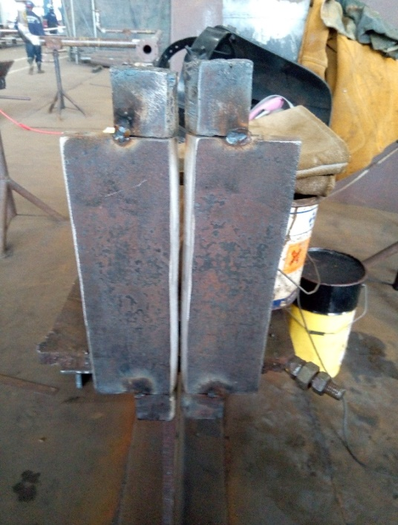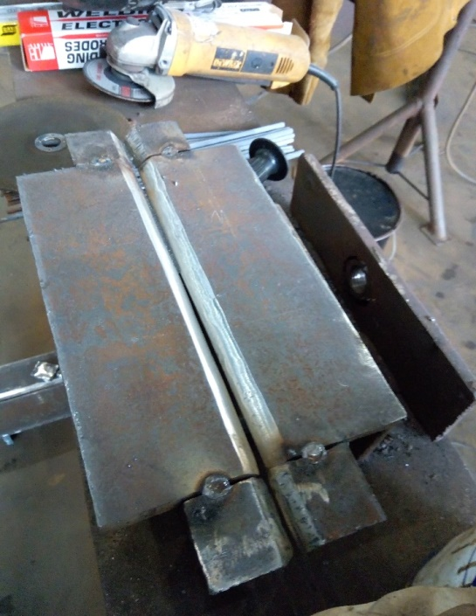
Fig 3.1 Images of the fit-up process

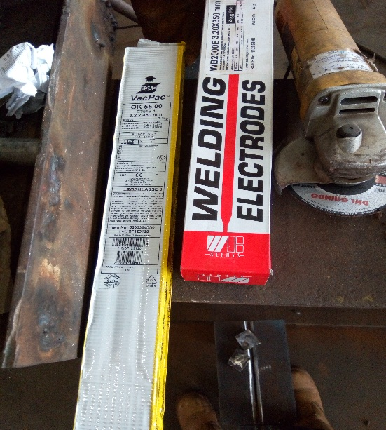

Fig. 3.2 Different Electrodes used

Table 3.1 Chemical composition of a mild steel plate

C% | Si% | Mn% | Nb% | Al% | Mo% | P% | Ti% | S%
0.19 | 0.25 | 0.4 | 0.05 | 0.09 | 0.009 | 0.025 | 0.03 | 0.015

Table 3.2 Chemical composition of various electrode

 | C% | Mn% | Si% | S% | P% | Cr% | Ni% | Mo% | Nb% | Cu% | V%
E6013 | 0.028 | 0.560 | 0.330 | 0.010 | 0.016 | 0.047 | 0.022 | 0.01 |  |  | 0.014
E7018 | 0.085 | 1.138 | 0.294 | 0.015 | 0.025 | 0.033 | 0.041 | 0.093 | 0.008 | 0.032 | 0.016
filler wire | 0.13 | 1.8 | 0.34 | 0.006 | 0.013 | 0.05 | 0.02 | 0.01 |  | 0.04

3.2 Preparation Of Test Samples
This process has to do with cutting off the braces and run off plate and it was grinded and power brush for it to be clean before carrying out the various tests which are non-destructive test (NDT) and mechanical or destructive test (DT). The first test carried out was the non-destructive test.
3.3 Non Destructive Test
This is a non-invasive type of test which is carried out on the weld metal without destroying it. The following non-destructive test carried out are:
(i) Visual test
(ii) Magnetic particle inspection
(iii) Ultrasonic test
3.3.1 Visual Test
Visual inspection is considered to be a relatively simple evaluation method, it has been mentioned that the only way in which visual inspection can be considered to be effective is to evaluate the quality of welds applied and it is done prior to, during and after the welding process. In this aspect the following are put into consideration the types of materials being welded, the technique, filler metal type, position used.
3.3.2 Magnetic Particle Inspection
This particular non-destructive test method is used primarily to discover surface discontinuities in Ferro-magnetic materials. While indications can be observed from subsurface discontinuities very near the surface, they are very difficult to interpret, and often require testing by other methods. Other non-destructive examination (NDE) techniques are usually required for subsurface discontinuity detection and interpretation. However, surface discontinuities present in a magnetized part will cause the applied magnetic field to create “poles” of opposite sign on either side of the discontinuity, creating a very attractive force for iron particles. This process makes used of a yoke, and electricity. If iron particles, which are “magnetic particles” since they can become magnetized, are sprinkled on this surface, they will be held in place by this attractive field to produce an accumulation of iron particles and a visual indication of the discontinuity. This test was carried out on the welded mild steel plate and no defects was shown or indicated.
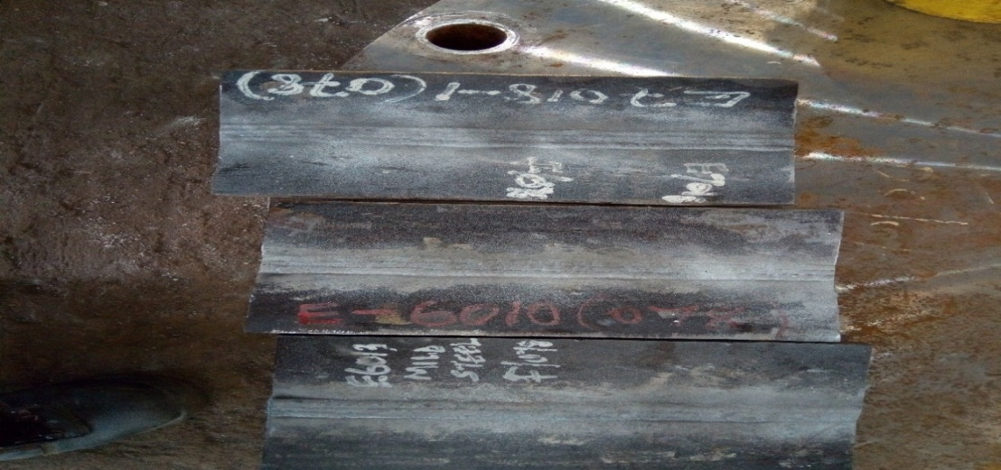
Fig 3.3 Images after magnetic particle inspection
3.3.3 Ultrasonic Test
Ultrasonic testing (UT) is another non-destructive examination method which uses high frequency sound waves, well above the range of human hearing, to measure geometric and physical properties in materials. Sound waves travel at different speeds in different materials. However, the speed of sound propagation in a given material is a constant value for that material. The applications of ultrasonic testing include both surface and subsurface flaw detection. This method is most sensitive to Laminations, cracks, incomplete fusion, inclusions, and voids or porosity in most materials can all be detected by this method
The equipment required for ultrasonic testing includes an electronic instrument with either an oscilloscope or digital display. Using an instrument with an oscilloscope, an ultrasonic operator can determine the location, size, and type of many discontinuities. This process makes used of a probe, a copulant (starch) and also a machine to detect some defects in welding and it was carried out in this process.
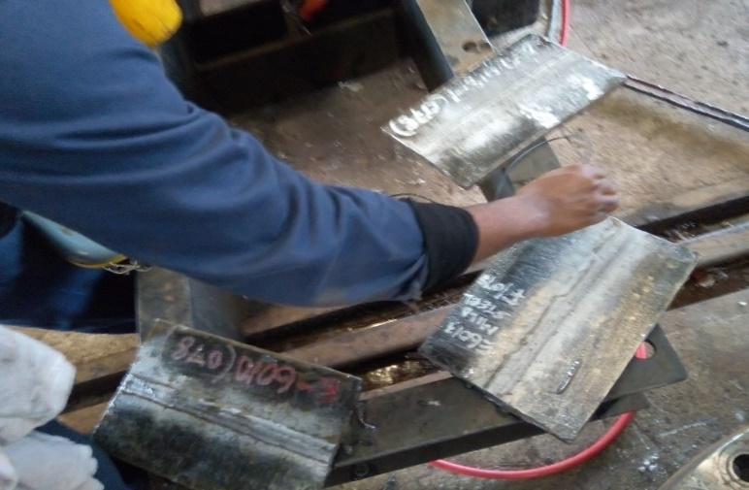
Fig 3.4 ultrasonic test using 45⁰ probe
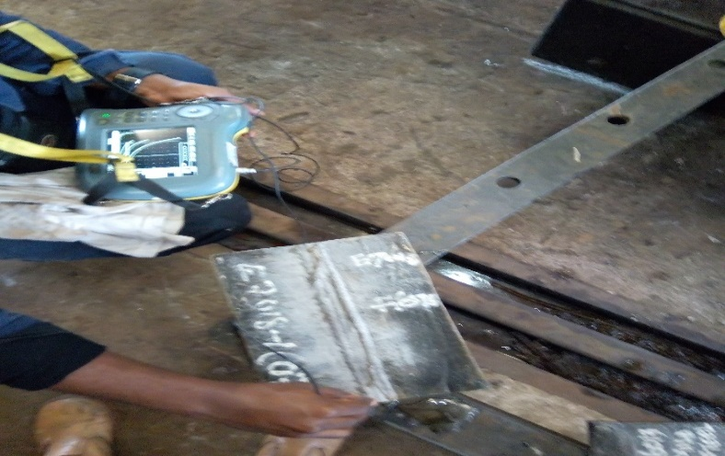
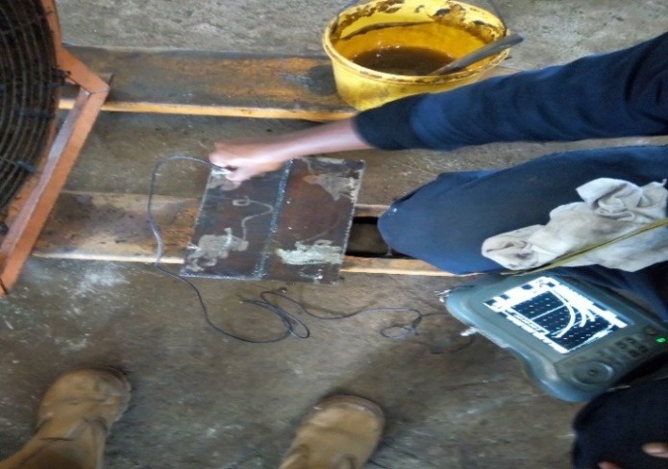
fig.3.5 ultrasonic test using 0⁰ probe fig 3.6 ultrasonic test using 30⁰probe
3.4 Machining Of Samples
The samples were cut into various shapes and sizes and were taken to the machine shop where their surfaces were smoothened using the lathe machine. The specimens for tensile test were machined to the standard dimensions of 10mm by 28mm required for accurate result using lathe machine. The gauge marks were scribed at the two ends surface of the specimens. The specimen for the hardness test was machined using the lathe machine, hack saw and grinding machine to obtain smooth surface.
3.5 Mechanical Properties
Mechanical test were conducted to determine the quality of the materials with respect to strength, hardness and access the likely performance of the materials in a particular service condition.

(a) Tensile tests
This is probably the most fundamental type of mechanical tests. It is fully standardized, simple and expensive. It is used to determine how a material will react under the influence of tensile force. It also helps to determine the strength along with how much a material will elongate. The specimen was held in the jaws of the universal tensile test machine and the load was applied gradually by a hydraulic press which was measured from the pressure developed inside the cylinder. The load reading was noted directly from the load scale. The tensile load was gradually increased at the corresponding extrusion were recorded until the specimen fracture. The maximum tensile strength (MTS), ultimate tensile strength (UTS) and the % elongation were calculated using the formulas.
Maximum Force (N) Pmax
Ultimate tensile test (UTS) =
=
Original C.S.A (mm²) A

Final gauge length – Original gauge length
X 100
% elongation =
Original gauge length
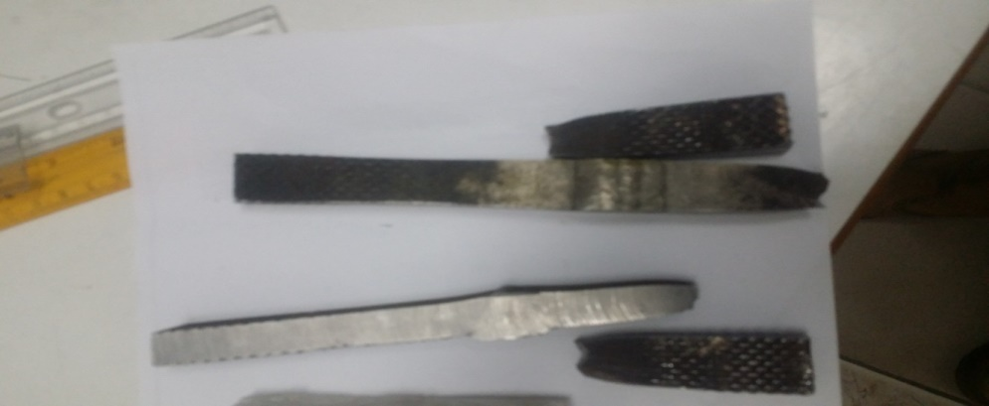
Fig 3.7 Images after fracture occurred
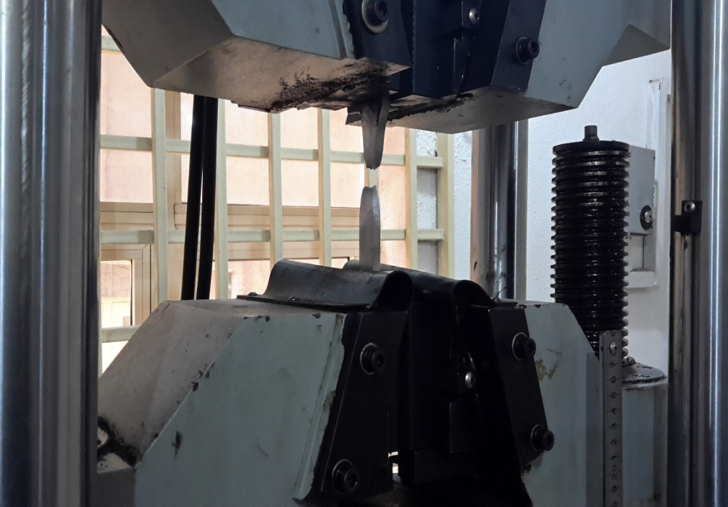
Fig 3.8 The test piece inserted in the jaw of a tensile test machine

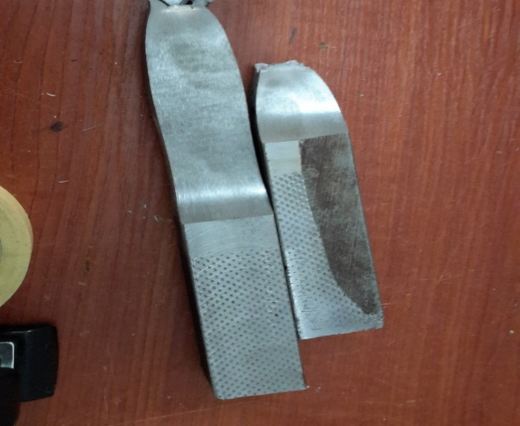
Fig 3.9 Images after during tensile test for SAW and FCAW specimen
(b) Hardness Test
The hardness test of a metal is generally performed to know its resistance against indentation (i.e. penetration) and abrasion. In a popular hardness testing techniques a small indenter is forced into the surface of the materials and an index number is determined on the basis of the size or depth of the resulting indentation. Though there are many types of test used to determine the hardness of different materials.
Vickers Hardness Test
The Vickers hardness test was developed in 1921 by Robert L. Smith and George E. Sandland at Vickers Ltd as an alternative to the Brinell method to measure the hardness of materials. The Vickers test is often easier to use than other hardness tests since the required calculations are independent of the size of the indenter, and the indenter can be used for all materials irrespective of hardness. The basic principle, as with all common measures of hardness, is to observe the questioned material's ability to resist plastic deformation from a standard source. The Vickers test can be used for all metals and has one of the widest scales among hardness tests. The unit of hardness given by the test is known as the Vickers Pyramid Number (HV) or Diamond Pyramid Hardness (DPH). The hardness number can be converted into units of Pascals, but should not be confused with pressure, which uses the same units. The hardness number is determined by the load over the surface area of the indentation and not the area normal to the force, and is therefore not pressure. It was decided that the indenter shape should be capable of producing geometrically similar impressions, irrespective of size, the impression should have well-defined points of measurement; and the indenter should have high resistance to self-deformation. A diamond in the form of a square-based pyramid satisfied these conditions.
It was decided to use this as the included angle of the indenter, giving an angle to the horizontal plane of 22° on each side. The angle was varied experimentally and it was found that the hardness value obtained on a homogeneous piece of material remained constant, irrespective of load. Accordingly, loads of various magnitudes are applied to a flat surface, depending on the hardness of the material to be measured. The HV number is then determined by the ratio F/A, where F is the force applied to the diamond in kilograms-force and A is the surface area of the resulting indentation in square millimeters. A can be determined by the formula.
d²
2 sin (136⁰ / 2)
A =
which can be approximated by evaluating the sine term to give
d²
A =

1.8544
where d is the average length of the diagonal left by the indenter in millimeters. Hence,
F = 1.8544F (kgf/mm²)
HV =
A d²
where F is in kgf and d is in millimeters.
The corresponding units of HV are then kilograms-force per square millimeter (kgf/mm²). To calculate Vickers hardness number using SI units one needs to convert the force applied from newton’s to kilogram-force by dividing by 9.806 65 (standard gravity). This leads to the following equation:
F
HV = 0.1891
(kgf/mm²)
d²
where F is in N and d is in millimeters. A common error is that the above formula to calculate the HV number does not result in a number with the unit Newton per square millimeter (N/mm²), but results directly in the Vickers hardness number (usually given without units), which is in fact kilograms-force per square millimeter (kgf/mm²).To convert the Vickers hardness number to SI units the hardness number in kilograms-force per square millimeter (kgf/mm²) has to be multiplied with the standard gravity (9.806 65) to get the hardness in MPa (N/mm²) and furthermore divided by 1000 to get the hardness in GPa.

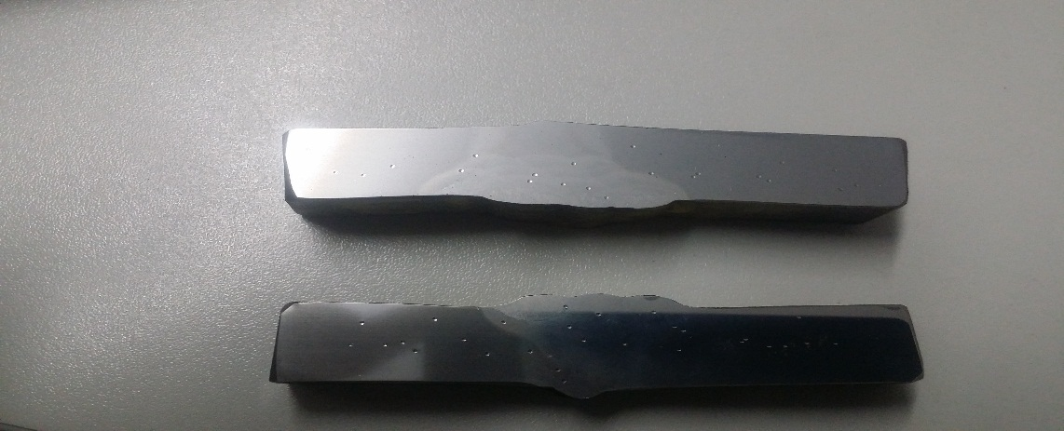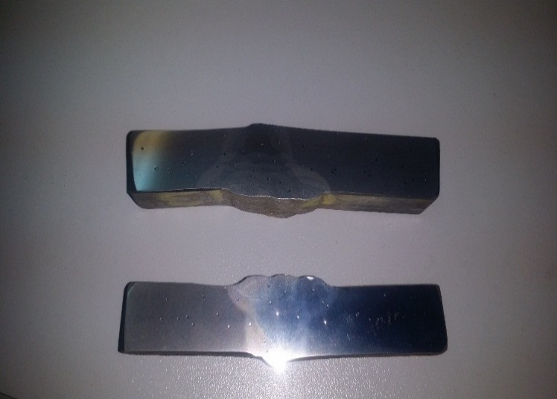
Fig 3.10 Images of hardness test carried out for SMAW
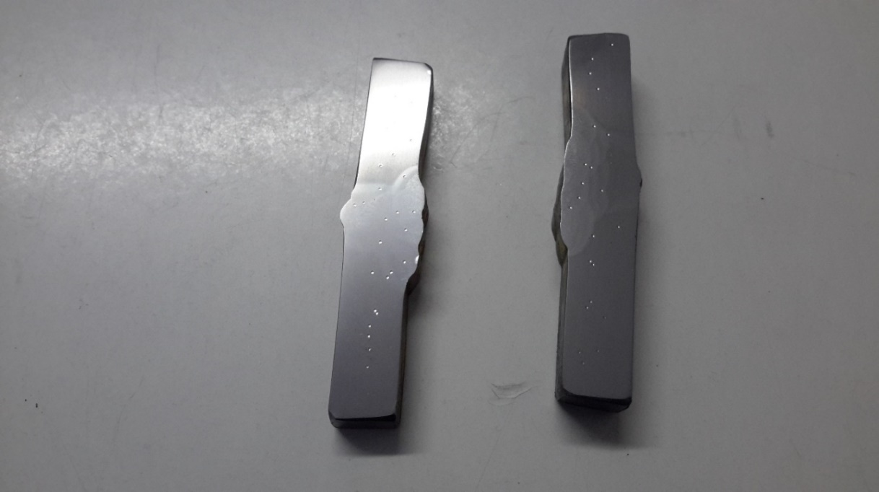
Fig 3.11 Images of hardness test and specimen
3.6 Metallography
Metallography is the study of the internal structure of metals and alloys under microscopic and different magnification. Useful information or grain size, shape distribution and with the percentage of various constituents in the structure can be obtained by metallographic technique.
Preparation of a sample is necessary for revealing the microstructure of a given specimen. These preparation processes involves the following: cutting grinding, polishing and etching.
3.6.1 Sample Cutting
There are several cutting techniques available in metallography but the most used sectioning device in metallography is the abrasive cut off machines. They range from small, thin sectioning machines employing abrasive or diamond rimmed wheels approximately four inches in diameter and a few mills thick to large floor model machines employing abrasive or diamond rimmed wheel up to 12inches in diameter and 1/16 inches thick. An advanced design to automatic cut off machine for laboratory use employs abrasive wheels 6-12 inches in diameter.

3.6.2 Sample Grinding
Grinding is the most important operation in specimen preparation. During grinding, one has the opportunity of minimizing mechanical surface damage that must be removed by such subsequent polishing operations. Even if sectioning is done in a careless manner resulting in severe damage, the damage can be eliminated by prolonged grinding.
Grinding is accomplished by abrading the specimen surface through a sequence of operations using progressively finer abrasive grit. Grit sizes ranges from 40 mesh to 150 mesh and are usually regarded as coarse abrasive and grit sizes from 180 mesh through 600 mesh are fine abrasive. Grinding should commence with coarse grit that will establish an initial flat surface and remove the effect of sectioning within a few minutes.
The purpose of grinding is to lessen the depth of deformed metal to the point where last vestiges of damages can be removed by series of polishing steps. Grinding may be either carried out manually or on a grinding wheel.
3.6.3 Sample Polishing
It is the final stage which is carried out on a rotating disk covered with sylvet or a silicon cloth, which is soaked in water, sprinkled with slurry of aluminum or calcined magnesia. The disc rotate at the speed of 100-400 rpm. When the polished surface of the samples becomes scratch free and mirror like, it is then taken for etching.
3.6.4 Sample Etching
The internal structure of the metal or alloy becomes apparent under microscope only after etching. This is due to the fact that chemical attack varies from phase to phase. These phases are distinguished separately under microscope. Grain boundaries are attacked more easily and at a faster rate by etchant. Therefore they look as thin dark lines under microscope.
A wide variety of etchant are available including acid, base, neutral solution, mixture of solutions and gases. The stability of many etching solution is limited; redox potentials change with time. Changes may also occur while the etchants is in use such that it must be discarded after a limited time.
Variety of etchant include:

Name Formular
Acetic acid CH₃COOH
Aluminum Chloride AlCl₃
Ammonia NH₃
Ammonium Chloride NH₃CL
Ammonium Hydroxide NH₃OH
Hydrofluoric acid HF
Nitric acid HNO₃
Caustic soda NaOH
The etchant used in this sample preparation is nitric acid and the etching times range from several seconds to some hours, when no instructions are given, progress is judged by the appearance of the surface during etching. Usually, the surface will become less reflective as etching proceeds. Etching time and temperature are closely related by increasing temperature.

CHAPTER FOUR
RESULT AND DISCUSSION
The hardness test, microstructural examination and tensile strength test were carried out on the test specimens representing different compositions of mild steel plate and the various consumables used.
4.1 Hardness Test Result
The readings obtained from all the specimens using Vickers hardness testing machine are presented below in the table 4.1.
Table 4.1: The hardness value
Average of electrodes | WELD ZONE | HAZ | BASE METAL
E6013 | 111 | 109 | 91
E7018 | 121 | 130 | 104
FCAW | 191 | 195 | 164

4.2 Discussion On Hardness Test Result
The different tables above indicate the hardness test values of each specimen being carried out with different consumables which are E6013, E7018 and the filler wire for FCAW. And this hardness values were gotten from both the base metal, heat affected zone and the weld metal.

Figure 4.1 A bar chart showing the hardness values for each consumable used

4.2.1 The Hardness Test Result For E6013 And E7018 Welding Consumables For SMAW
The hardness values for the welding consumables E6013 which is a rutile electrode and E7018 which is a low hydrogen electrode or basic electrodes. The hardness values for the E7018 electrode shows the highest hardness values at the heat affected zone and that of E6013 shows the highest hardness value was at the weld metal.
The one which gives its values at the heat affected zone is considered to be the best compared to others because the HAZ did not go into fusion which is melting, during the welding process the HAZ was heated and it cools faster than the normal base metal and the weld itself.

Figure 4.2 A bar chart with hardness values for the different types of Electrodes
4.2.2 The Hardness Test Result For FCAW
The hardness result values for FCAW is higher to that of SMAW because of the current and voltage used. The result shows that for FCAW the hardness test values was higher for that of the HAZ as compared to the weld and base metal.
In conclusion, the hardness test values for E7018, SMAW and FCAW would be considered because it cooled faster at the heat affected zone (HAZ) than that of the weld metal and base metal and it is because of the type of grain structure.
4.3 Tensile Strength Test Result
The experimental results of tensile strength and stress strain are presented in the table 4.2

Table 4.2: Tensile test result.
Processes | Area | Thickness | Width | Maximum Load (KN) | Tensile strength | Yield strength
T@6013  T@7018  T@FCAW | 295.65  152.01  364.99 | 14.60  14.64  17.98 | 20.25  19.87  20.30 | 149.7  82.97  204.10 | 506  546  578 | 348  520  420

Figure 4.3:A chart showing the ultimate tensile strength of each consumables used.

4.4 Discussion On Tensile Test Result
Table 4.3 shows the tensile test values of each specimen being carried out with different consumables which are E6013, E7018 and the filler wire for FCAW. The tensile test values were gotten from the specimen placed in the tensile machine. The type of failure that occurred was a ductile fracture because it gives a shear lips and it indicates warning like the yield strength given, the ultimate tensile test before fracture occurs. The fracture that occurred was at the base metal and not at the weld metal which indicate that the weld metal is strong when compared to the base metal and it can withstand the maximum load placed on it until fracture occur. The yield strength is always lower than that of the tensile strength and the tensile strength for FCAW is higher than the remaining.
Generally, it can be deduced that the effect of the addiction of these welding consumables will affect the desired structure either positively or negatively and as for this experiment it was deduced that the material has a strong weld. The stress- strain curve is given as follows:
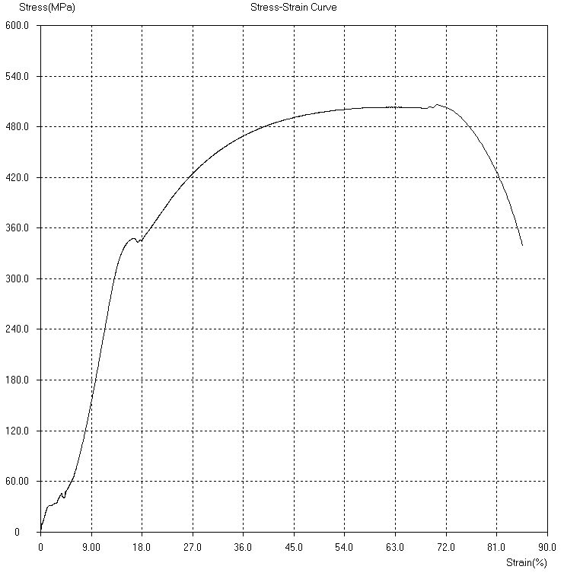

Fig 4.4 The stress strain curve for E6013

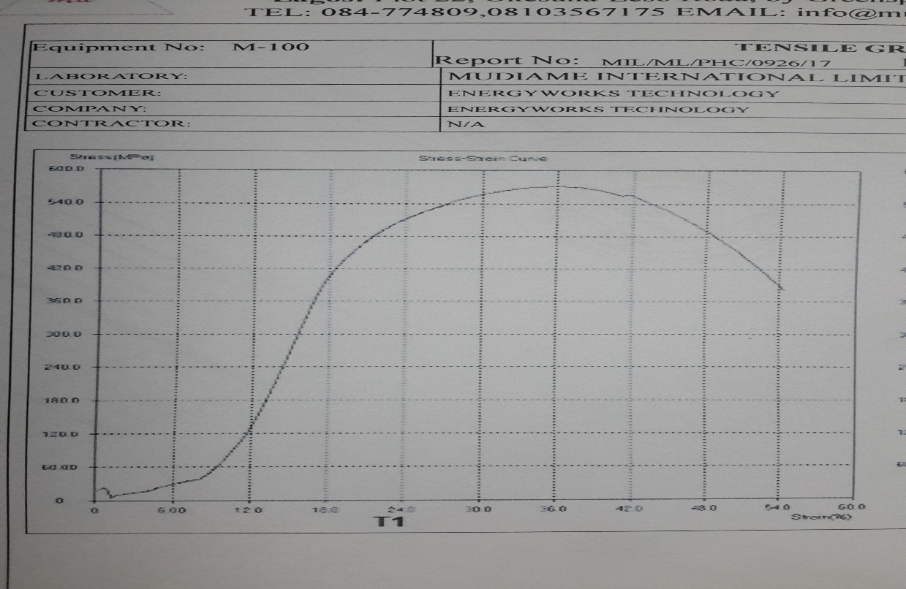
Fig. 4.5 The stress strain curve for E7018
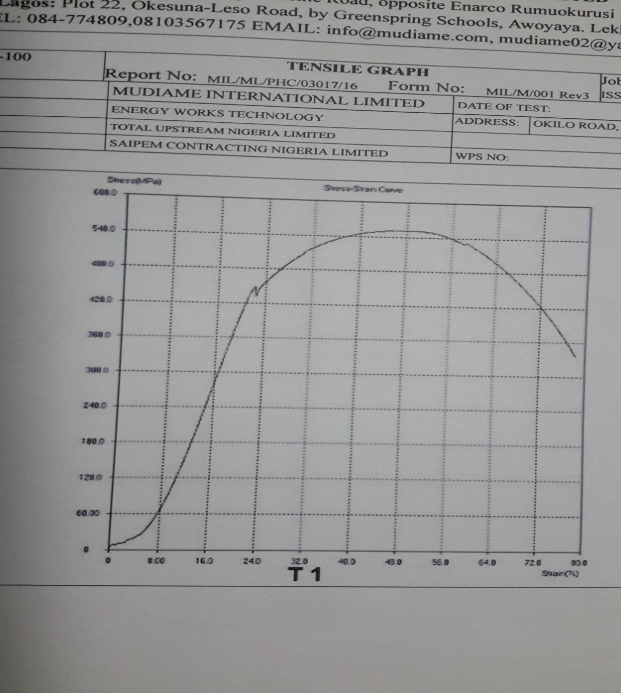
Fig 4.6 The stress strain curve for FCAW

4.5 Microstructural Examination
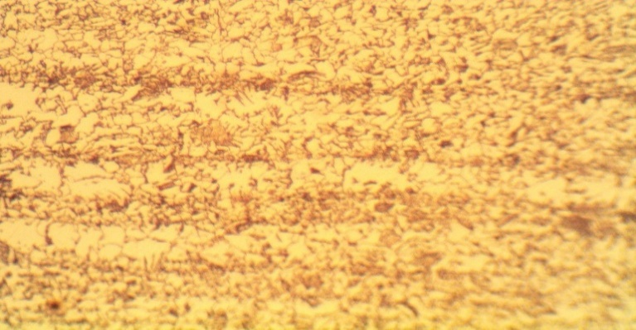
Coarse grains of Martensitic and pearlite
Fig 4.7 Microstructure for HAZ E6013
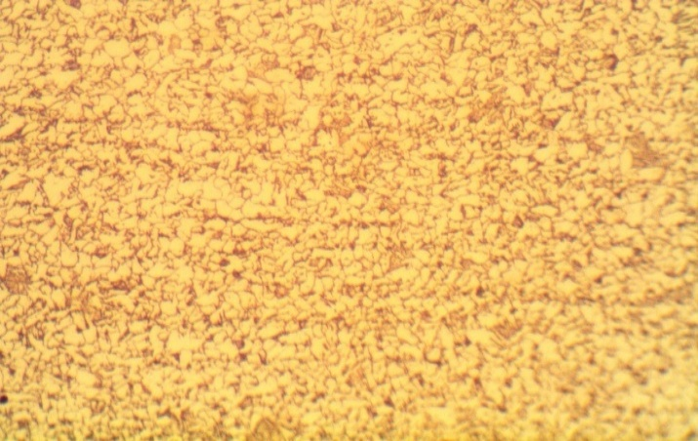
Coarse grains of pearlite and ferrite
Fig 4.8 Microstructure for weld metal E6013
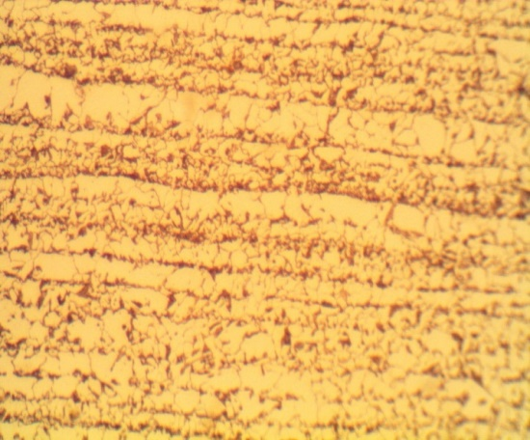
Martensitic pearlite
Fig 4.9 Microstructure for HAZ E7018
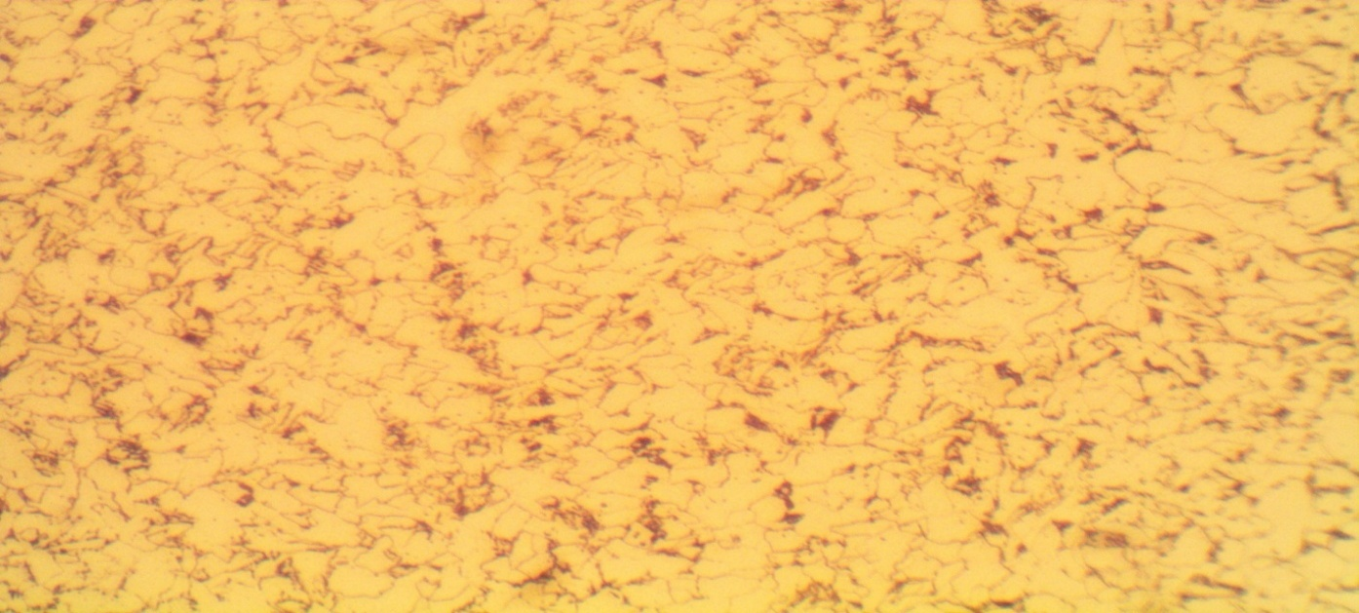
Pearlite Ferrite
Fig. 4.10 Microstructure of the weld metal for E7018
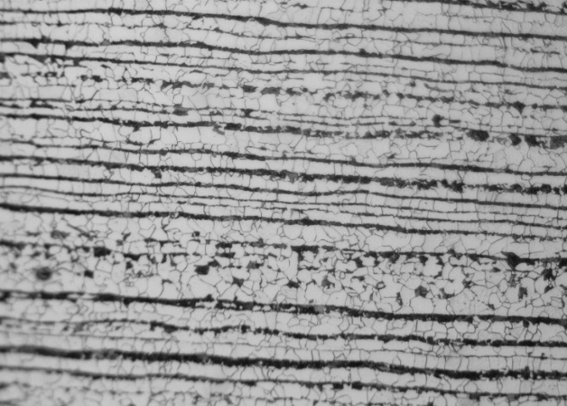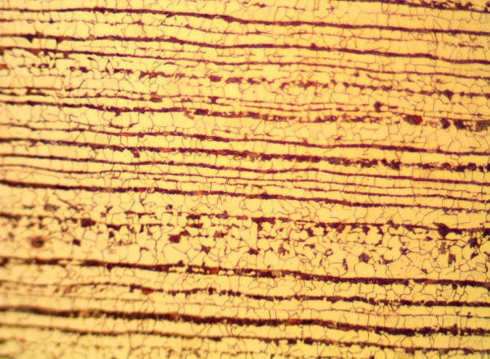
Pearlite Ferrite Pearlite Ferrite
Fig 4.11 Microstructure for mild steel base metal
4.6 Discussion on Microstructure Examination
The weld metal microstructure of fusion welded joints is greatly influenced by the chemical composition of filler metal and the heat input of the process. In general, higher heat input leads to slower cooling rate which results in the fine grains in weld metal. However, lower heat input leads to fast cooling rate which results in coarse microstructure. Though the lower heat input can produce coarse grains compared to higher heat input, the intrinsic nature of the process of the higher heat input also plays major role in refining the weld metal microstructure.
The microstructure of the base metal consists of ferrite and pearlite. For E6013 we also have ferrite, martensite and pearlite, the grains are coarse and not fine and it depends on the type of cooling which takes place. For E7018 also consist of grains of ferrite and martensite at the heat affected zone due to lower heat input which resulted in maximum hardness values while at the weld metal we have pearlite and ferrite which indicates which was as a result of high heat input.
These are the microstructure for the welding consumables for shielded metal arc welding (SMAW) because they were varied.
Owing to higher heat input, phase transformation occurred in the SMAW weld metals. Due to this high heat input and intensity of SMAW process, the coarse grains in weld metal and HAZ were formed. Moreover, filler metal addition also play vital role in weld metal microstructure.

CHAPTER FIVE
CONCLUSIONS AND RECOMMENDATION
5.1 Conclusions
After examining the hardness ,tensile test it shows that
- FCAW (Flux-Cored Arc Welding) is the best choice if maximum hardness and strength are required, but care must be taken with post-weld heat treatment to avoid brittleness.
- E7018 (Low Hydrogen Electrode) provides a good balance of hardness and toughness, making it ideal for structural welds.
- E6013 (Rutile Electrode) is appropriate for general-purpose welding where mechanical performance is not critical.
- Overall shows that the FCAW is best in terms of the hardness and tensile testing on the welding on SA530 GR 70 steel
5.2 Recommendation
- Emphasize the use of high-quality welding consumables specifically formulated for SA 530 GR 70 steel to enhance weld properties.
- Test a variety of welding consumables with different compositions and characteristics to comprehensively assess their effects on microstructure and mechanical properties.
- Implement detailed microstructural analysis (optical microscopy, SEM) and mechanical testing (tensile, hardness) to correlate consumable effects with performance outcomes.
- Maintain detailed records of all experimental conditions, results, and observations to support robust conclusions and facilitate future research.
- Suggest exploring novel welding techniques and alternative consumables in future studies to further optimize the performance of SA 530 GR 70 steel welds.
By following these recommendations, the project can provide valuable insights and contribute to improved practices in the welding industry.

REFERENCES
Anawa E. M. and Olabi .A. G. (2008) “Using Taguchi Method to Optimize Welding Pool of Dissimilar Laser-welded Components, Optics & Laser Technology”, Vol. 40, No. 2, pp. 379-388.
ASTM E384: “Standard Test Method for Knoop and Vickers Hardness of Materials”.
ASTM E92: “Standard method for Vickers hardness of metallic materials” (Withdrawn and replaced by E384-10e2)
Callister W.D. (2003). “Materials Science and Engineering: Introduction,” John Wiley& Sons, USA, pp.779.
Chapman J. (1994). “Steel makers face up to the challenges ahead”. Materials World, 2(3): 139-140.
Clark, D. and Varney, W. (1962). “Physical metallurgy for Engineers”. 2nd edition New York: D Van Nostrand Company.
Davies, A.C. (1993) “The science and practice of welding,” Vol 2, “The practice of welding”. 10th edition Cambridge: Cambridge University Press.
Dieter E.D. (1988). “Mechanical Metallurgy, McGraw-Hill”. ISBN 0-07-0168938.
Elmer J.W, Wong .J, Ressler.T and Palmer.T.A,(April 2002). “6th International Conference on Trends in Welding Research,” Pine Mountain, 6A, pp. 15-19.
Eroglu and Aksoy. M, (2000). “Effect of Initial Grain Size on Microstructure and Toughness,” Materials Science and Engineering A, Vol. 286, No. 2, pp. 289-297.
Galvao .I, Leal R.M, Loureiro .A.(2013) “Influence of tool shoulder geometry on properties of friction stir welds thin copper sheets”. J Mater Process Technology 213(2):129e35.
Ghosh A, Das S, Chatterjee S, Ramchandra Rao P.(2006). “Effect of cooling rate on structure and properties of an ultra-low carbon HSLA-100 grade steel. Mater Charact 56:59e65.
Grong.O and Akselsen. O. M, (1986).“HAZ Grain Growth Mechanism in Welding of Low Carbon Micro-alloyed Steels,” Acta Metallurgical, Vol. 34, No. 9, pp. 1807-1815.
Güral. A, Bostan. B and Ozdemir A.T, (2007). “Heat Treatment in Two Phase Region and its Effect on Welding of a Low Carbon Steel,” Materials and Design, Vol.28, No. 3, pp. 897-903.
John V.B.(1983), “Introduction to Engineering Materials: London Macmillan Publishers”.
Kang J, Wang C, Wang GD (2012). “Microstructural characteristics and impact fracture behavior of a high-strength low-alloy steel treated by inter-critical heat treatment”. Material Science Engineering A; 527:96e104.
Lakshminarayanan A.K, Balasubramanian V. (2010). “An assessment of microstructure, hardness, tensile and impact strength of friction stir welded ferritic stainless steel joints”. Mater Des 2010; 31:4592e600.
Lambert A, Drillet J, Gourgues A.F, Stuel. T, Pineau A.(2000). “Microstructure of martensite-austenite constituents in heat affected zones of high strength low alloy steel welds in relation to toughness properties”. Science Technology Weld Joint 2000; 5(3):168e73.
Magudeeswaran .G, Balasubramanian .V, Madhusudhan Reddy G, Balasubramaian T.S (2008). “Effect of welding processes and consumables on tensile and impact properties of high strength quenched and tempered steel joints”. J Iron Steel Res Inter 2008; 15(6):87e94.
Meyers and Chawla (1999). “Mechanical Behavior of Materials.” Prentice Hall, Inc. "Section 3.8".
Ohaya. K, Kim. J, Yokoyama. K. and Nagumo.M,(1996). “Microstructures Relevant to Brittle Fracture initiation at the Heat-affected Zone of Weldment of Low Carbon Steel,” Metallurgical and Materials Transactions A, Vol. 27, No. 9, pp. 2574-2582.
Olabi. A.G and Hashmi.M .J .S, (1996). “The Microstructure and Mechanical Properties of Low Carbon Steel welded Components after the Application of PWHT,” Journal of Material Processing Technology, Vol. 56, No. 1-4, pp. 88-97.
Sathish .R, Naveen.B, Nijanthan.P, Geethan.K and Rao.V, (2012). “Weldability and process parameter optimization of dissimilar pipe joints using GTAW”, International Journal of Engineering Research and Applications, Vol. 2 No. 3, pp. 252-530.
Thaulow. C, Paauw.A. J, Gunleiksrud. A and Naess.O .J, (1985).“Heat Affected Zone Toughness of Low Carbon Micro- alloyed Steel,” Metal Construct, Vol. 17, No. 2, pp. 94-99.
Thompson .B, Babu SS. (2010). “Tool degradation characterization in the friction stir welding of hard metals”. Weld Res 2010; 89:256e61.
Zakaria Boumerzoug, Chemseddine Derfouf, Thierry Baudin, (2010). “Effect of welding on the mechanical properties”. Engineering, 2010, 2, 502-506. Published Online July 2010.

