A PROJECT REPORT
ON
PROPOSED COMPREHENSIVE HEALTH CENTRE
FOR
ORINSUN IBARE AND IYARO COMMUNITY, OYUN, ILORIN KWARA STATE

BY

ABIODUN OLUWATOBILOBA
HND/23/ARC/FT/075

BEING A PROJECT REPORT SUBMITTED TO
THE DEPARTMENT OF ARCHITECTURAL TECHNOLOGY, INSTITUTE OF ENVIRONMENTAL STUDIES.

IN PARTIAL FUFILMENT OF THE REQUIREMENTS FOR THE AWARD OF THE HIGHER NATIONAL DIPLOMA (HND) IN ARCHITECTURAL TECHNOLOGY KWARA STATE POLYTECHNIC, ILORIN, KWARA STATE.

JULY, 2025

DECLARATION
“I declare that this project project/dissertation is a product of my personal research work. It has not been presented for the award of any degree in any polytechnic. The ideas, observations, comments, suggestions herein represent my own convictions, except quotations, which have been acknowledged in accordance with conventional academic traditions.”

Name: ABIODUN OLUWATOBILOBA
Matric no: HND/23/ARC/FT/075

________________ ________________
Signature Date

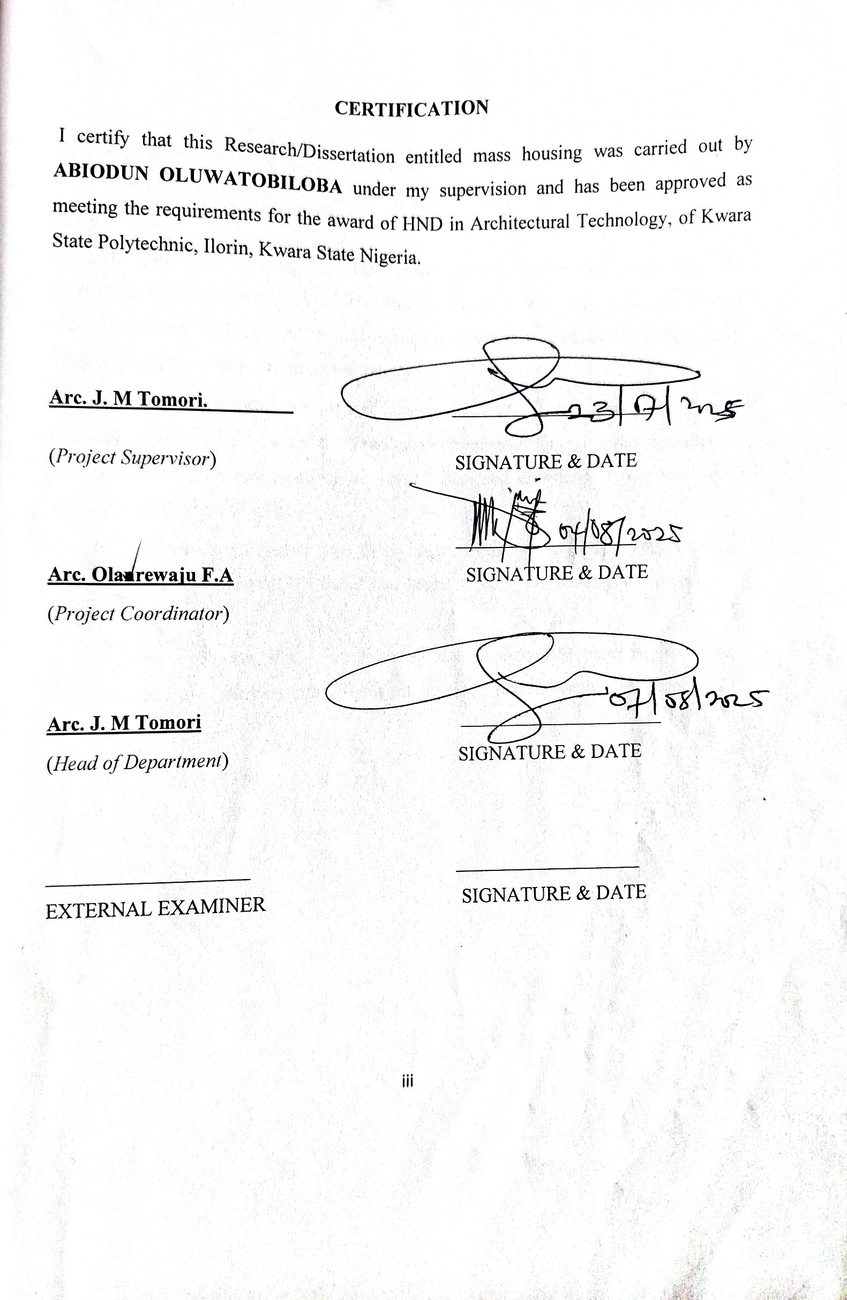
DEDICATION
This report is dedicated to Almighty Allah the universe, the creator of all creators and the source of mankind who has always been my strength throughout this project and also for his unconditional and infinite mercy showered upon me through my studies.

ACKNOWLEDGEMENT
My profound gratitude goes to Almighty God who as always be in existence for taking control of this project for is infinite mercy and for giving me the privilege to write the report.
My special gratitude goes to the Department of Architectural Technology the entire staff and my supervisor Arc J.M. Tomori, and also to the HOD of the Department in person of Arc. TOMORI J.M who has been supportive throughout this project, may Allah continue to reward you and your family.
I extend my appreciation to Arc. Olarenwaju FA, Arc Solomon, Arc Chuks, Arc. Abdulazeez. Finally, I see this privilege as a milestone in my career development and I will definitely strive to utilize the gained skills and knowledge in the best way to achieve desired future objective.
My sincere appreciation goes to my dearest, lovely and caring parents Mr. ABIODUN for his parental, financial and moral support for making my dream a reality.
I wish everyone who contributed to this achievement success in all their endeavors and I pray the blessings of God will keep reigning in our lives (Aameen).

TABLE OF CONTENTS
TITLE PAG………………………………………………………………… i
DECLARATION……………………………………………………………… ii
CERTIFICATION……………………………………………………………… iii
ACKNOWLEDGEMENT……………………………………………………… iv
DEDICATION…………………………………………………………………… v
LIST OF TABLES…………………………………………………………… vii
LIST OF FIGURES………………………………………………………... viii
LIST OF PLATES…………………………………………………………….... ix
ABSTRACT………………………………………………………………………. x
CHAPTER ONE
1.0 INTRODUCTION…………………………………………………………. 1
1.1 DEFINITION……………………………………..………………………. 2
1.2 HISTORICAL BACKGROUND………………………………………… 3
1.3 STATEMENT OF DESIGN PROBLEM…………………………………. 4
1.4 AIM AND OBJECTIVES…………………………………………………. 5
1.5 JUSTIFICATION…………………………………………………………. 6
1.6 CLIENT’S BACKGROUND……………………………………………… 7
1.7 SCOPE OF THE PROJECT………………………………………………. 8
1.8 LIMITATION OF STUDY………………………………………………. 9
1.9 RESEARCH METHODOLOGY………………………………………… 10
CHAPTER TWO
2.0 LITERATURE REVIEW ...……………………………………….…… 11
2.1 REVIEW OF RELEVANT LITERATURE ON BUILDING TYPES…… 12
2.2 REVIEW OF LITERATURE ON HEALTHCARE AFFORDABILIT…… 12
CHAPTER THREE
3.1 CASE STUDY…………………………………………………………. 13
3.2 CASE STUDY 1: COMPREHENSIVE HEALTH CENTRE, GARIKI, FCT ABUJA.……………………………………………………………………………..13
3.3 CASE STUDY 2: COMPREHENSIVE HEALTH CENTRE, OKELELE, ILORIN ….…..………………………………………………………………… 21
3.4 CASE STUDY 3: COMPREHENSIVE HEALTH CENTRE, OKEMESI IPOLE, OSUN STATE ……………………………………………………………………. 28
3.5 CASE STUDY 4: ONLINE CASE STUDY 1 ……….…………………. 28
3.6. CASE STUDY 5: ONLINE CASE STUDY 2…………………………… 30
CHAPTER FOUR
4.0 STUDY AREA/PROJECT SITE……………………………………… 36
4.1 HISTORY OF LAGOS STATE …………………………………………. 36
4.2 LOCATION OF SITE…………………………………………………. 36
4.3 SITE INVENTORY AND ANALYSIS ………………………………….. 37
4.4 GEOGRAPHIC/CLIMATIC DATA………………………………………. 38
4.5 ANALYSIS OF THE IMMEDIATE ENVIRONMENTAL CONDITIONS OF
THE SITE…………………………………………………………………. 40
4.6 PROJECT ANALYSIS/DESIGN CRITERIA…………………………… 41
4.7 DESIGN CRITERIA……………………………………………………. 41
4.8 BRIEF ANALYSIS OF PROJECT…………………………………….. 41
4.9 FUNCTIONAL ANALYSIS/SPACIAL CRITERIA…………………… 44
4.10 APPRAISAL OF SCHEMES…………………………………………… 47
4.11 EQUIPMENT AND OPERATIONAL AND PERFORMANCE 47
REQUIREMENT……………………………………………………….. 47
4.12 SPATIAL ALLOCATION/S SCHEDULE OF ACCOMODATIO……. 47
4.13 CONCEPTUAL DEVELOPMENT……………………………………….. 47
CHAPTER FIVE
5.0 APPROACH TO THE DESIGN/DESIGN REALIZATION……………. 48
5.1 TECHNOLOGICAL AND ENVIRONMENTAL CRITERIA……………. 48
5.1.1 CONSTRUCTION METHOD………………………………………… 48
5.2 SERVICES REQUIRED…………………………………………… 52
5.3 CONCLUSION AND RECOMMENDATIONS……………………….. 55
REFERENCES……………………………………….………………………….. 57
APPENDICES……………………………………………………………………..

LIST OF FIGURES
FIG 3.1: Locational Map of Case Study One………………………………………..…..22
FIG 3.2: Site Plan of Case Study One …………………………………………………...23
FIG 3.3: Floor Plan of Case Study One…………………………………………………23
FIG 3.4: Floor Plan of Case Study One…………………………………………………25
FIG 3.5: Locational Plan of Case Study Two……………………………………………28
FIG 3.6: Site Plan of Case Study Two……………………………………………..........28
FIG 3.7: Floor Plan of Case Study Two…………………………………………………29
FIG 3.8: Locational Plan of Case Study Three……………………………………….…33
FIG 3.9: Site Plan of Case Study Three…………………………………………………34
FIG 4.0: Floor Plan of Case Study Three……………………………………………….34
FIG 4.1: Locational Map of Kwara……………………………………………………..39
FIG 4.2: The proposed site in Orisumibare……………………………………………..41
FIG 4.3: Site Analysis of the project……………………………………………………42
FIG 4.4: Graph of Climate in Orisumibare……………………………………………...43

LIST OF PLATES
Plate 3.1: Location Map of case study one…………………………………………….22
Plate 3.2: Perspective View of case study one………………………………………..24
Plate 3.3: Left View of case study one……………………………………………….24
Plate 3.24: Right View of case study one…………………………………………….25
Plate 3.5: Site Location of case study two…………………………………………...27
Plate 3.6: Left View of case study two………………………………………………30
Plate 3.7: Perspective view of case study two……………………………………….30
Plate 3.8: Site Location of case study three…………………………………………32
Plate 3.9: Perspective view of case study three……………………………………..35
Plate 3.10: internal view of case study three ………………………………………..35

LIST OF APPENDICES
Appendices 1: Cross Section…………………………………………………………….50
Appendices 2: Roof Plan………………...……..………………………………………..51
Appendices 3: Medical Equipment……………………………...……………………….52
Appendices 4: Bubble Diagram………………………………………………………….53
Appendices 5: Elevation…………………………………………....................................54
Appendices 6: Location Plan…………………………………………………………….55
Appendices 7: Conceptual Design………………………………………………………56
Appendices 8: Site Plan………………………………………………………………….57
Appendices 9: Space Analysis…………………………………………………………..58

ABSTRACT
In a comprehensive health centre, circulation is akin to the lifeblood that sustains the entire facility. Just as nerves and arteries facilitate the flow of blood throughout the body, a well-designed circulation system ensures the smooth movement of patients, staff, and services throughout the centre. Any disruption or obstruction in this flow can lead to inefficiencies and compromise the quality of care. Therefore, a well-planned circulation system is crucial in the design of a comprehensive health centre, prioritizing safety, convenience, and functionality. This research aims to conduct an in-depth examination of circulation patterns in health centres, identifying best practices, reviewing existing literature, and gathering relevant data to inform design decisions. The outcome will be a valuable resource for researchers and designers seeking to create optimal circulation systems in healthcare facilities.

CHAPTER ONE
1.0 INTRODUCTION
A comprehensive health center is a vibrant and inclusive healthcare hub that serves as the epicenter of community wellness, providing a vast array of integrated services to address the complex and multifaceted needs of diverse populations. These centers embody a patient-centered approach, fostering a culture of care that is accessible, equitable, empowering, and compassionate. By offering a broad spectrum of preventive, curative, and rehabilitative services under one roof, comprehensive health centers bridge the gap between fragmented healthcare systems, ensuring seamless coordination, continuity of care, and a holistic understanding of individual and community health.
With a strong emphasis on community engagement, cultural sensitivity, and social support, these centers have become beacons of hope for marginalized and underserved populations, tackling health disparities, promoting health equity, and addressing the social determinants of health. By leveraging innovative technologies, evidence-based practices, collaborative partnerships, and a deep understanding of community needs, comprehensive health centers are redefining the healthcare landscape, delivering high-quality, people-centered care that:
- Transforms lives
- Fosters resilience
- Builds thriving communities
- Addresses health inequities
- Promotes health literacy
- Supports community development
- Enhances overall well-being
In essence, comprehensive health centers are dynamic, adaptive, and responsive healthcare environments that put individuals, families, and communities at the forefront of care, ensuring that everyone has access to the resources, support, and services needed to thrive.
Health is an essential tool in life, for the fact that nothing can be done without health, in such case we ruined to build health care centers. Comprehensive healthcare center refers to a step above an ordinary health care Center and made the provision of primary health a fully packages. Ideally, such center should have the full complement of health professionals including doctors, pharmacist, nurses and technicians. In fact, comprehensive health center should undertake some surgical procedures and also have some level of expert staffing. Comprehensive healthcare center comprises of; Administrative block, Out -Patient- Departments (OPD), In-Patient Department (IPD) and Accident & Emergency (A&E). Olusegun (2013)
  - DEFINITION
A Comprehensive Health Centre (CHC) is a healthcare facility that provides a wide range of services to address the physical, emotional, and social needs of individuals and communities. CHCs offer primary healthcare services, including preventive care, diagnosis, treatment, and management of acute and chronic conditions. They also provide specialty services, such as mental health, dental, and pharmaceutical care.
Additionally, CHCs offer health promotion and disease prevention programs, including education, outreach, and community engagement. CHCs coordinate care, integrating services from various healthcare providers and community organizations. They take a patient-centered approach, focusing on individual needs, preferences, and values. CHCs strive to make care accessible and affordable, reducing barriers to healthcare services. Furthermore, CHCs adopt a holistic approach, addressing biological, psychological, social, and environmental factors influencing health. Finally, CHCs are community-focused, responding to local health needs and priorities.

  - HISTORICAL BACKGROUND
The genesis of Comprehensive Health Centres (CHCs) dates back to the 1920s in the United States, where pioneering community health centers were established to address the healthcare needs of underserved populations. These early CHCs laid the foundation for a holistic approach to healthcare, integrating medical, social, and environmental factors to promote overall well-being.
In the post-World War II era, CHCs gained momentum in the United Kingdom and other European countries, driven by the need for reconstruction and social reform. This period saw the establishment of comprehensive healthcare services, including preventive care, health education, and community outreach programs.
The 1960s and 1970s witnessed a significant expansion of CHCs globally, as countries recognized the importance of primary healthcare in achieving health equity. The 1978 Alma-Ata Declaration, a landmark World Health Organization (WHO) conference, reaffirmed the role of CHCs in providing accessible, affordable, and culturally acceptable healthcare services. This declaration galvanized international efforts to strengthen primary healthcare and CHCs.
During the 1980s and 1990s, CHCs continued to evolve, incorporating new technologies, services, and approaches to address emerging healthcare challenges. This period saw the introduction of health promotion, disease prevention, and community-based initiatives, further solidifying the comprehensive nature of CHCs.
In the 21st century, CHCs have adapted to address complex healthcare issues, such as chronic disease management, mental health, and health disparities. The integration of digital health technologies, interdisciplinary care teams, and patient-centered approaches has enhanced the quality and effectiveness of CHC services.
Today, Comprehensive Health Centres remain a cornerstone of healthcare systems worldwide, providing essential services to diverse populations and communities. Their enduring legacy is a testament to the power of comprehensive, coordinated, and community-focused healthcare in promoting health, well-being, and social justice.
  - STATEMENT OF DESIGN PROBLEM
The efficient flow of people and services within a comprehensive health centre is crucial, as it directly impacts the quality of care and overall experience for patients, staff, and visitors. A well-designed circulation system is essential in these facilities, which comprise interconnected services requiring continuous movement and interaction. Inadequate circulation can lead to issues such as congestion, staff fatigue, and compromised patient care. This study aims to address the architectural challenge of designing a comprehensive health centre in Ikorodu, Lagos State, with a focus on optimal circulation, functional space allocation, and harmonious relationships between different areas. By prioritizing the well-being of patients, relatives, and healthcare staff, the design should incorporate specialized features and a thoughtful circulation pattern, ultimately creating a seamless and supportive environment for all users, as envisioned by Henning Lensch's concept of the "Hospital of Tomorrow".
  - AIM AND OBJECTIVES
1.4.1 AIM
This research main goal is to design a comprehensive health centre with efficient circulation planning, which will improve flow and ensure the safety of both patients and employers.
1.4.2 OBJECTIVES
To achieve the aim, the following objectives are set out;
1. To examine the current layout and circulation patterns of the Comprehensive Health Centre (CHC) to identify inefficiencies and potential safety hazards.
2. To analyze the flow of patients, staff, and materials within the CHC to determine areas of congestion and bottlenecks.
3. To assess the impact of current circulation planning on patient safety, staff productivity, and overall operational efficiency.
4. To identify best practices in healthcare facility design and circulation planning to inform recommendations for improvement.
5. To develop a comprehensive plan to optimize circulation planning within the CHC, addressing patient flow, staff workflow, and material management.
1.5 JUSTIFICATION
This research is justified because it aims to identify areas for improvement in the Comprehensive Health Centre's circulation planning, optimize workflows, and enhance patient and staff safety, ultimately leading to improved patient satisfaction, increased staff productivity and morale, enhanced operational efficiency and capacity, and compliance with regulatory requirements and industry standards.
1.6 CLIENT BACKGROUND
The Orisunmibare and iyaro community, Oyun, in partnership with the Comprehensive Health Centre, has identified a critical need for affordable housing in the community. The Chairman of Oyun Local Government has recognized the challenge of providing decent accommodation for residents, particularly those in high, low, and middle-income brackets. To address this issue, the government has initiated a project to provide affordable housing options for all income earners in Ikorodu, ensuring that everyone has access to their dream homes. This initiative aligns with the Comprehensive Health Centre's goal of promoting holistic well-being, including safe and secure living environments, and demonstrates the government's commitment to improving the quality of life for its citizens.
1.7 SCOPE OF THE PROJECT
This study's scope will be restricted to a thorough analysis of the successful circulation planning within the aforementioned medical facility, which will incorporate all preventative, public health, and curative services. The research will be completed by designing a specialized health care facility for moms and their children that incorporates the following features:
1. Administrative unit- medical records, staff facilities, nursing units, training unit.
2. Out-patient department and ancillary facilities.
3. In-patient department and ancillary facilities.
4. Medical technological department; operating theatres, diagnostic radiology (X-rays), pathology (laboratories), pharmacy, accident and emergency unit, physiotherapy,intensive therapy care and new born units.
5. Ancillary services; this include the laundry, catering unit,central sterile and
supply unit, workshop, general stores, supply and disposalunit.
1.8 LIMITATION OF STUDY
The scope of research on optimizing circulation patterns in comprehensive health centres is restricted by various artificial and natural constraints. Some comprehensive health centres declined requests to participate in case studies, limiting access to their facilities and hindering the examination of existing circulation patterns. Consequently, this study was only able to conduct in-depth analyses of three comprehensive health centres, which may not be representative of the broader spectrum of facilities. Despite these limitations, the findings of this research aim to contribute valuable insights to the design and optimization of circulation patterns in comprehensive health centres.

  - RESEARCH METHODOLOGY
This research employs a multi-faceted approach to gather comprehensive insights into the topic. The methodology consists of three primary components:
1. Case Study: In-depth examination of a limited number of comprehensive healthcare centers, selected for their relevance and diversity. This involves analyzing existing circulation patterns, patient flow, staff interactions, and architectural design.
2. Personal Observation: Direct observation of the selected healthcare centers, allowing for firsthand experience and insight into the daily operations, challenges, and successes. This includes observing patient and staff movements, interactions, and workflows.
3. Research on Previous Projects: A thorough review of existing literature, research papers, and projects related to healthcare facility design, circulation patterns, and patient flow. This component aims to identify best practices, lessons learned, and areas for improvement, providing a solid foundation for the research.

CHAPTER TWO
2.0 LITERATURE REVIEW
2.1 DEFINITION OF TERMS
(a) HEALTH CARE: The diagnosis, treatment, and prevention of diseases, illnesses, injuries, and other physical and mental disabilities in humans is known as health care, or healthcare. Allied health professionals, including dentists, midwives, obstetricians, physicians, nurses, optometrists, pharmacists, psychologists, and other healthcare professionals, provide healthcare. It include work in public health as well as primary, secondary, and tertiary care delivery.
(b) PRIMARY CARE: This is a reference to the work done by medical experts who serve as every patient's initial point of contact inside the healthcare system. A primary care physician, such as a family physician or general practitioner, or a non-physician primary care provider, like a physician assistant or nurse practitioner, would often be considered such a professional. Patients may choose to see another health care provider first, such as a pharmacist, nurse (as in the UK), clinical officer (as in some parts of Africa), or specialist in Ayurvedic or other traditional medicine (as in some parts of Asia), depending on the area, the structure of the health system, and occasionally at their own discretion. Patients may then be referred, depending on the specifics of their health condition for secondary or tertiary medical care.
(c) SECONDARY CARE: This refers to the medical services rendered by specialists and other health care providers who typically do not establish initial contact with patients, such as dermatologists, cardiologists, and urologists. Acute care is one of its components; this is the short-term medical attention required for a transient but serious disease, accident, or other health issue, such as in an emergency room of a hospital. It also covers medical imaging services, acute care, and expert attendance during labor. There are instances when "hospital care" and "secondary care" are used interchangeably.
(d) TERTIARY CARE: This is a type of specialist consultative healthcare that is typically provided to inpatients upon referral from a primary or secondary healthcare provider. It takes place in a facility, such a tertiary referral hospital, that has the staff and resources necessary for advanced medical investigation and treatment.
2.1. HEALTHCARE DELIVERY IN NIGERIA
The state of healthcare in Nigeria is a critical aspect of the discussion on healthcare delivery, and it's essential to acknowledge the significant challenges facing the country. With only about 38% of the population having access to modern healthcare services, the country's healthcare system is grappling with immense pressure.
This is reflected in the alarmingly low life expectancy of 46 years, which is significantly lower than the global average. Furthermore, the infant mortality rate is unacceptably high, with 70-150 out of every 1000 births resulting in infant deaths in urban and rural areas respectively.
The child mortality rate is equally concerning, and the maternal mortality rate stands at 2.4 per 1000 births, indicating a high risk for pregnant women. To address these challenges, healthcare delivery in Nigeria is provided by a mix of government agencies, including federal, state, and local governments, as well as voluntary organizations such as religious bodies, community groups, and private individuals.
However, much more needs to be done to strengthen the healthcare system and ensure equitable access to quality healthcare services for all Nigerians.
Comprehensive healthcare delivery in Nigeria aims to provide accessible, affordable, and quality healthcare services to all citizens. The key components of this approach include primary healthcare, secondary healthcare, tertiary healthcare, community health services, referral systems, health promotion and education, disease prevention and control, maternal and child health, and mental health services.
Primary healthcare focuses on preventive, curative, and rehabilitative services at the grassroots level, while secondary healthcare provides specialized care through general hospitals and specialist clinics. Tertiary healthcare offers advanced medical services through teaching hospitals and specialist centers. Community health services deliver healthcare services to rural and underserved areas, and referral systems ensure seamless transfer of patients between levels of care.
Despite these efforts, comprehensive healthcare delivery in Nigeria faces significant challenges. Inadequate funding, limited infrastructure, brain drain and shortage of healthcare professionals, inequitable distribution of resources, and cultural and socio-economic barriers hinder the effectiveness of the healthcare system.
To address these challenges, Nigeria needs to increase healthcare funding, invest in infrastructure development, develop effective health policies, strengthen health workforce capacity, promote public-private partnerships, and enhance community engagement and participation. By addressing these challenges and strengthening the healthcare system, Nigeria can achieve comprehensive healthcare delivery and improve health outcomes for its citizens.
2.2 HISTORY OF COMPREHENSIVE HEALTH CENTRE IN NIGERIA
Nigeria's journey towards comprehensive healthcare began in the pre-colonial era, where traditional healthcare systems thrived, with herbalists and traditional birth attendants providing essential care to communities. However, the country's healthcare landscape underwent significant transformations during the colonial era (1914-1960), when the British established hospitals and healthcare services primarily catering to expatriates and urban elites.
Following independence in 1960, Nigeria embarked on an ambitious expansion of healthcare services, establishing general hospitals and health centers across the country. The Alma-Ata Declaration in 1978 marked a significant turning point, as Nigeria adopted the primary healthcare approach, emphasizing community-based care and decentralization.
The 1980s saw the establishment of comprehensive health centers, integrating primary, secondary, and tertiary care services. This was followed by the National Health Policy in 1988, which reinforced the importance of comprehensive healthcare, community participation, and decentralization.

In the 1990s and 2000s, Nigeria faced significant health challenges, including the HIV/AIDS epidemic, malaria, and tuberculosis. In response, the country received increased international support and implemented various control programs.
National Health Act in 2014 provided a legal framework for comprehensive healthcare, emphasizing universal coverage and access. Key milestones in Nigeria's healthcare journey include:
- Establishment of the National Primary Healthcare Development Agency (NPHCDA) in 1992
- Launch of the National Health Insurance Scheme (NHIS) in 2005
- Development of the National Strategic Health Development Plan (2010-2015) and its successor plan (2018-2022)
Despite progress, Nigeria's healthcare system still grapples with funding, infrastructure, and human resource challenges. Nevertheless, comprehensive health centers remain crucial in delivering integrated services and promoting universal health coverage.
2.3 TYPES OF COMPREHENSIVE HEALTH CENTRE
1. Primary Comprehensive Health Center (PCHC): Provides essential healthcare services, including preventive, curative, and rehabilitative care, at the primary level. Services include:
- Health promotion and education
- Immunization and vaccination
- Maternal and child health services
- Basic diagnostic and treatment services
2. Secondary Comprehensive Health Center (SCHC): Offers specialized care, including diagnostic and treatment services, at the secondary level. Services include:
- Specialist consultations (e.g., cardiology, pediatrics)
- Advanced diagnostic tests (e.g., lab, imaging)
- Surgical services (e.g., general surgery, orthopedics)
- Rehabilitation services (e.g., physiotherapy, occupational therapy)
3. Tertiary Comprehensive Health Center (TCHC): Provides advanced medical services, including specialized diagnostics, treatment, and surgery, at the tertiary level. Services include:
- Advanced specialist consultations (e.g., neurology, oncology)
- High-end diagnostic tests (e.g., MRI, CT scans)
- Complex surgical services (e.g., cardiothoracic surgery, neurosurgery)
- Advanced rehabilitation services (e.g., prosthetics, orthotics)
4. Community Comprehensive Health Center (CCHC): Focuses on community-based care, health promotion, and disease prevention. Services include:
- Community outreach and engagement
- Health education and promotion
- Disease prevention and screening programs
- Support groups and counseling services
2.4 REVIEW OF RELEVANT LITERATURE ON BUILDING TYPES
Comprehensive Health Centres have been shown to significantly enhance health outcomes, patient satisfaction, and care coordination by providing a comprehensive range of integrated services under one roof, thereby streamlining patient care and improving overall well-being. Effective team-based care, facilitated by open communication and collaboration among healthcare professionals, is crucial in achieving these benefits and ensuring seamless care delivery. The design of Comprehensive Health Centres should prioritize patient-centered principles, incorporating elements such as natural light, soothing color schemes, and uplifting artwork to create a supportive and healing environment that mitigates patient stress, anxiety, and discomfort. Meaningful community engagement and participation are vital in the planning, development, and operation of Comprehensive Health Centres, ensuring that services are responsive to local needs and priorities, and community-led initiatives can significantly improve health outcomes, increase access to care, and enhance community capacity and resilience. Addressing health equity and reducing health disparities is a critical imperative in the design and delivery of Comprehensive Health Centres, requiring targeted strategies such as culturally responsive care, language access, and community-based initiatives to address the unique needs of diverse patient populations and promote equitable health outcomes and patient satisfaction.
2.5 REVIEW OF LITRATURE ON HEALTH CARE AFFORDABILITY
The escalating costs of healthcare services, prescription drugs, and administrative fees have rendered healthcare unaffordable for a substantial segment of the population, leading to a plethora of adverse consequences. Research has unequivocally demonstrated that high healthcare costs can precipitate financial burden, reduced access to care, and poor health outcomes, ultimately exacerbating health disparities and diminishing overall well-being.
The financial burden of healthcare costs can have far-reaching consequences, including bankruptcy, debt, and reduced spending on essential needs like food and housing. Moreover, high healthcare costs can lead to delayed or foregone care, resulting in poorer health outcomes and reduced quality of life.
The literature has extensively explored the pivotal role of health insurance in mitigating affordability challenges. Health insurance can provide financial protection against high healthcare costs, improving access to care and reducing financial burden. However, even insured individuals are not immune to affordability challenges, as high out-of-pocket costs, deductibles, and copays can still pose significant barriers to care.
Furthermore, research has highlighted the importance of addressing affordability challenges in vulnerable populations, including low-income individuals, racial and ethnic minorities, and those with chronic conditions. These populations often face unique barriers to care, including limited access to healthcare providers, language barriers, and cultural competency issues.
To address these affordability challenges, researchers have investigated a range of strategies, including cost containment measures, price transparency initiatives, and value-based care models. Cost containment measures, such as price controls and utilization review, can help reduce healthcare costs, while price transparency initiatives can empower consumers to make informed decisions about their care. Value-based care models, which incentivize high-quality, cost-effective care, can also improve affordability and outcomes.
Additionally, studies have examined the impact of policy interventions, such as Medicaid expansion, subsidies, and price controls, on healthcare affordability. These interventions have been shown to improve access to care, reduce financial burden, and promote health equity.

CHAPTER THREE
3.0 CASE STUDY
Methodology of the Study this chapter introduce and describe the research design and methodology which was used to carry out the study.it outlines the sampling design technique that was used to select the sample of study. It also describe the data collection procedures and the tools that was used to select in obtaining data, the process of data analysis. The design and the target population of the community.
A Case study is a process of researching into a project and document through writings sketches. Diagram, and photos, to understand the various aspects of designing and construction a building one must consider learning from other people mistakes, as albert Einstein quoted, learn from from yesterday, live for today, and hope for tomorrow. The important thing is not to stop questioning.
3.1 CASE STUDY ONE
GOVERNENT HEALTHCARE CENTER (FCT GARKI ABUJA)
Comprehensive primary health care (CPHC) is an approach to healthcare that focuses on providing accessible, preventive, curative, and rehabilitative service to individuals and communities. The concept of CPHC was was first introduce at the alma-ata conference.it provide a wide range of healthcare service including preventive, curatives, and rehabilitative care.it focusing on preventing illness and promoting healthy behaviors.
3.1.1 MERITS
- Adequate ventilation
- Well place in a good environment
- Adequate water supply
3.1.2 DEMERITS
- Lack of buffa area
- Hardlandcaping
- Poor access road

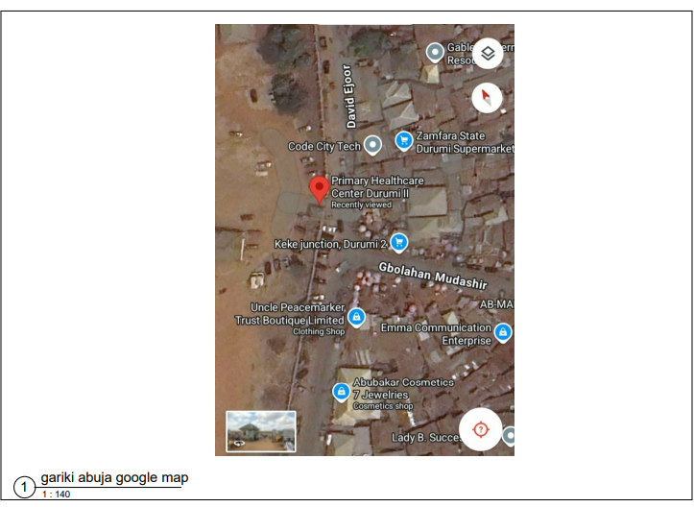
PLATE 3.1.1 GOOGLE MAP
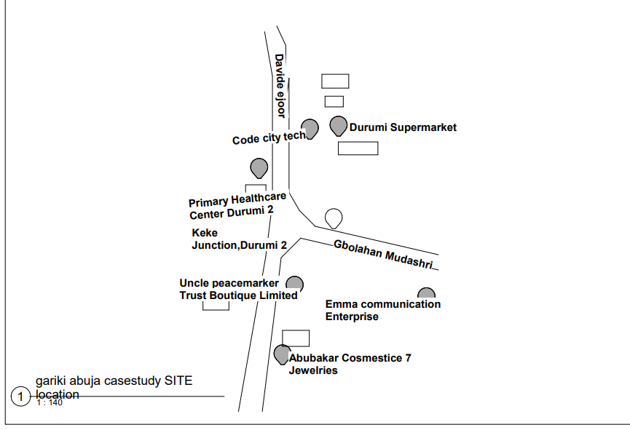
FIGURE 3.1.1 SITE LOCATION PLAN, GARKI ABUJA
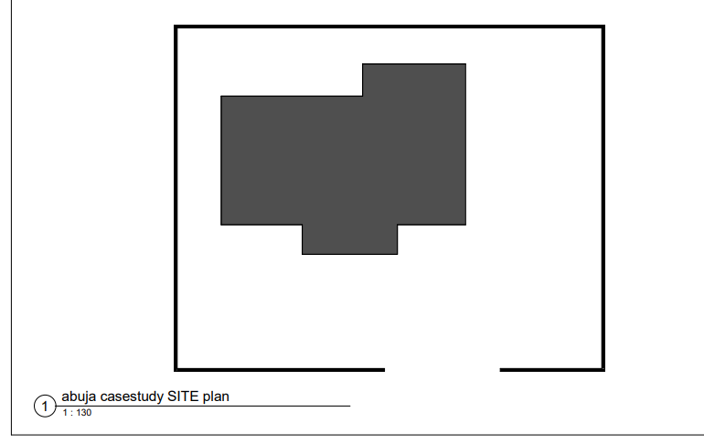
FIGURE 3.1.2 SITE PLAN OF CASE STUDY ONE

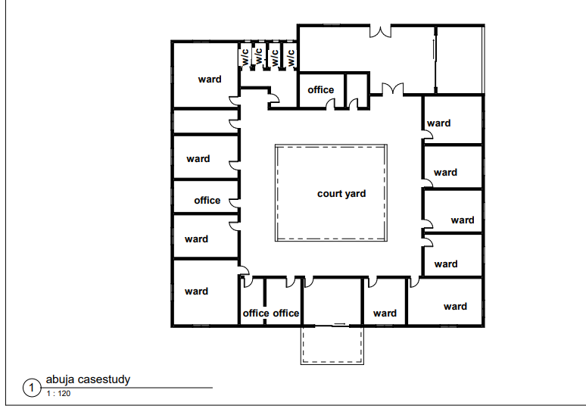
FIGURE 3.1.4 FLOOR PLAN OF CASE STUDY ONE
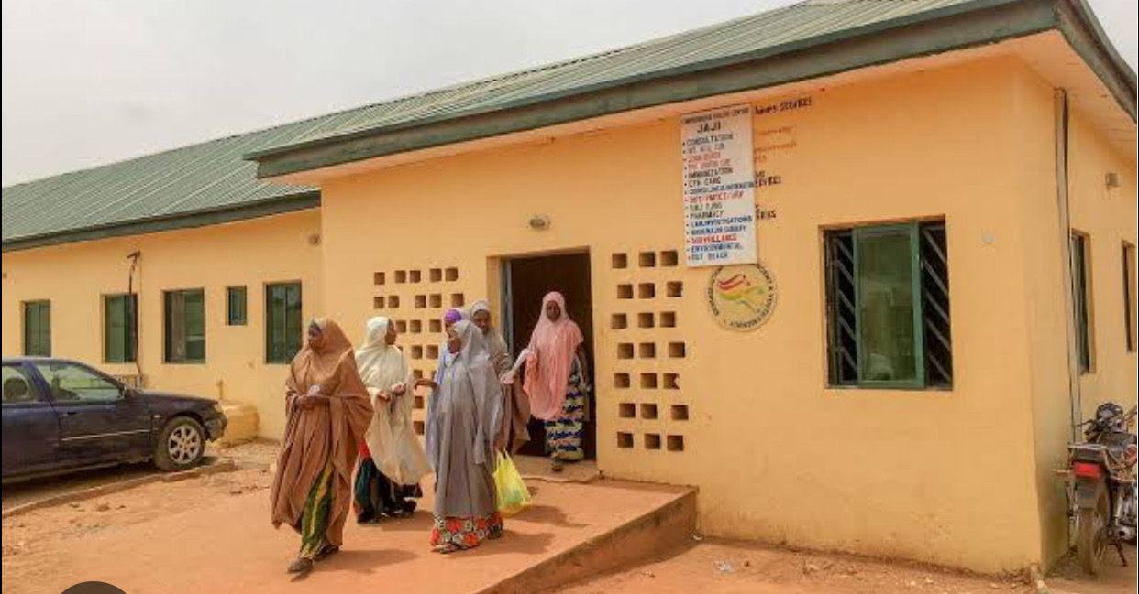
PLATE 3.1.2 BACK VIEW OF CASE STUDY ONE

  - CASE STUDY TWO
COMPREHENSIVE HEALTHCARE (OKELELE ILORIN)
Comprehensive healthcare in okelele, Ilorin has a significant presence in the community, particularly through the okelele.its located at abayawo road, this health center provides a wide range medical service at affordable prices. It offers excellent medical care for various ailments, including general illnesses and chronic disease. It prioritize patient care and respect, striving to provide top-notch healthcare services. Striving staff. The center is conveniently located, within walking distance from nearby parking distance. From nearby parking lots and public.
    - MERITS
- Well placed in good and conducive environment
- Adequate water supply
- Adequate ventilation
    - DEMERITS
- Inadequate of soft landscaping
- Poor access road

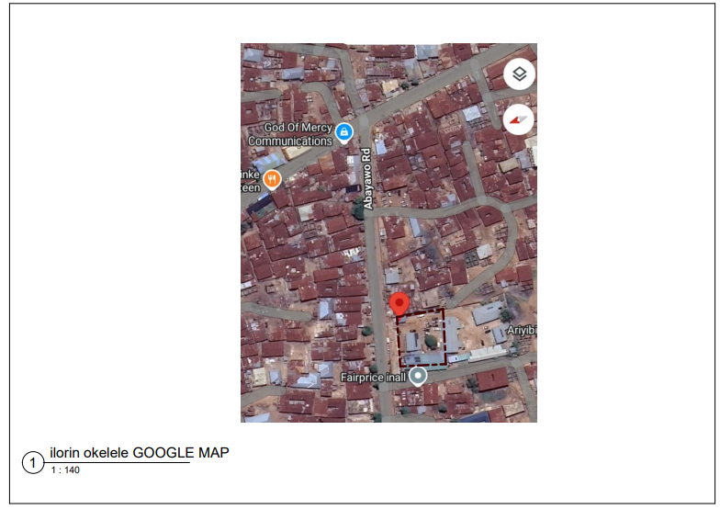
PLATE 3.2.1 GOOGLE MAP
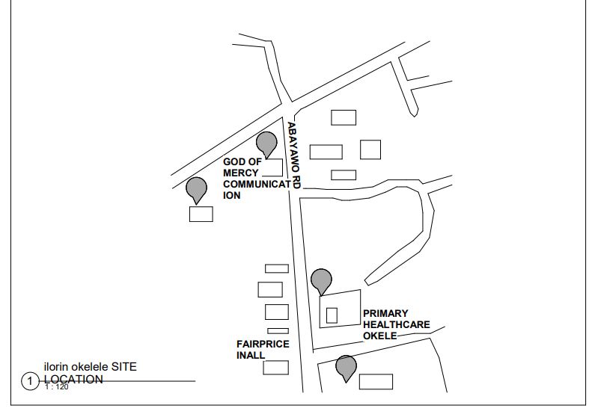 FIGURE 3.2.1 SITE LOCATION PLAN OF CASE STUDY TWO
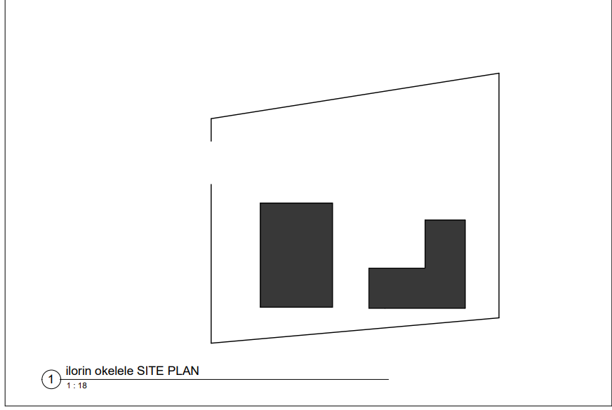 FIGURE 3.2.2 SITE PLAN OF CASE STUDY TWO

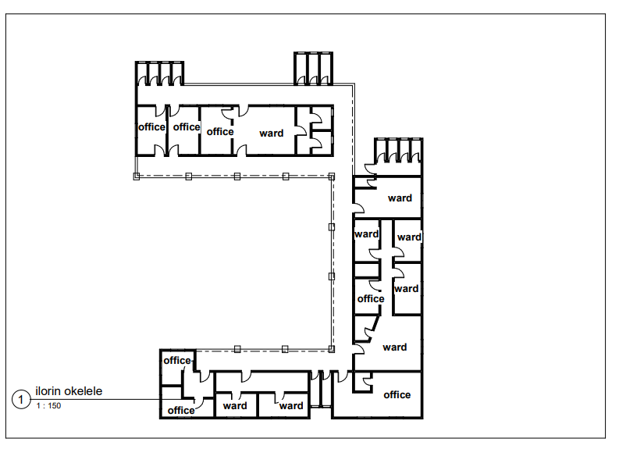 FIGURE 3.2.3 FLOOR PLAN OF CASE STUDY TWO

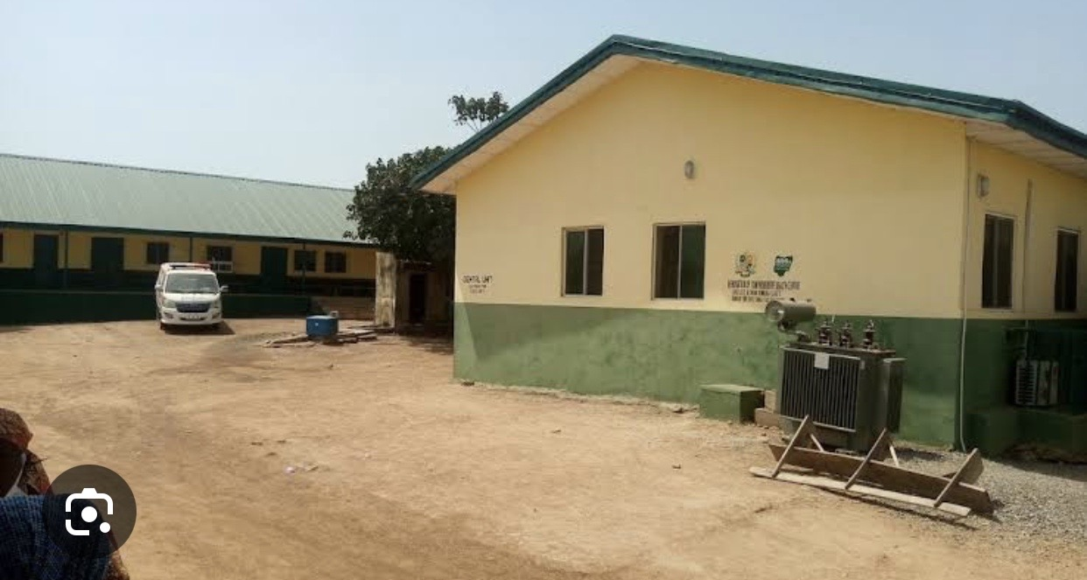
PLATE 3.2.2 APPROACH VIEW OF CASE STUDY TWO
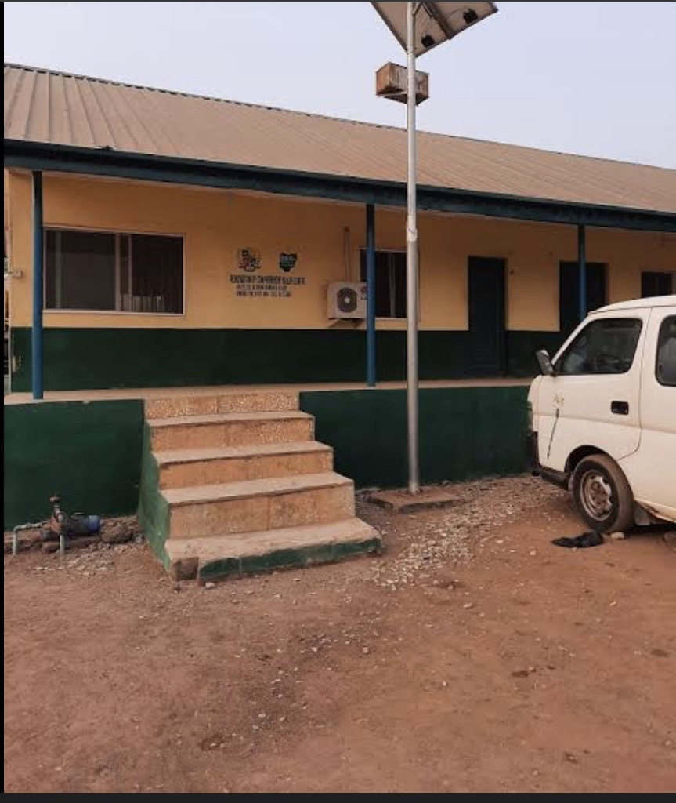
PLATE 3.2.3 FRONT VIEW OF CASE STUDY TWO

3.3 CASE STUDY THREE
COMPREHENSIVE HEALTHCARE OKEMESI IPOLE (OSUN STATE) Comprehensive healthcare okemesi , have a rich history and cultural heritage, okemesi is belive to have originated from ile-ife, the ancient seat of the Yoruba race. Yhe name is derived from its hilly terrain, with some attribute it to ‘’Oke imessin ‘’ meaning a mount that disgraces while others believe its okemesi. According to history account, okemesi and imesi-ile(near ipole) were once a single town before migrating to their current location
    - MERITS
- It will located In a suitable environment
- Adequate water supply
- Adequate ventilation
    - DEMERITS
- Poor landscaping
- Electricity failure
- Poor road networking
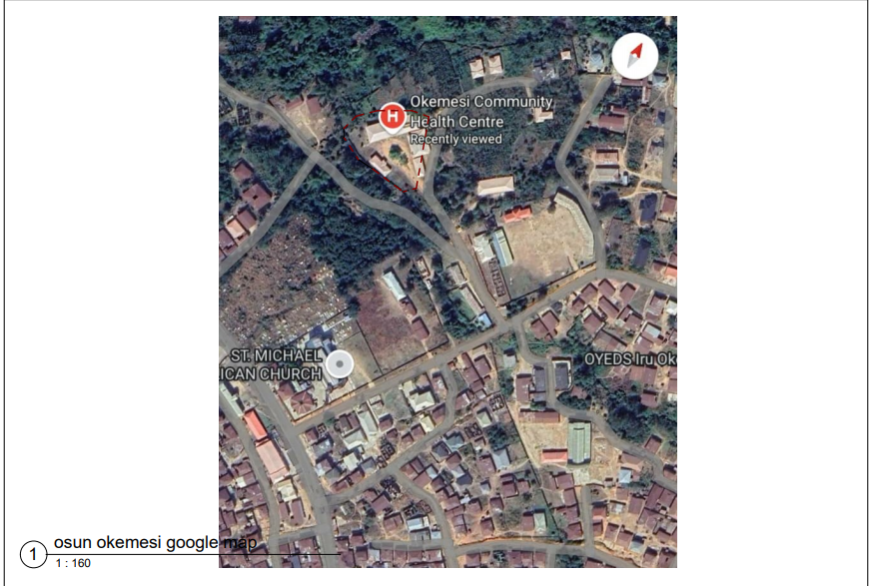
PLATE 3.3.1 GOOGLE MAP CASE STUDY 3
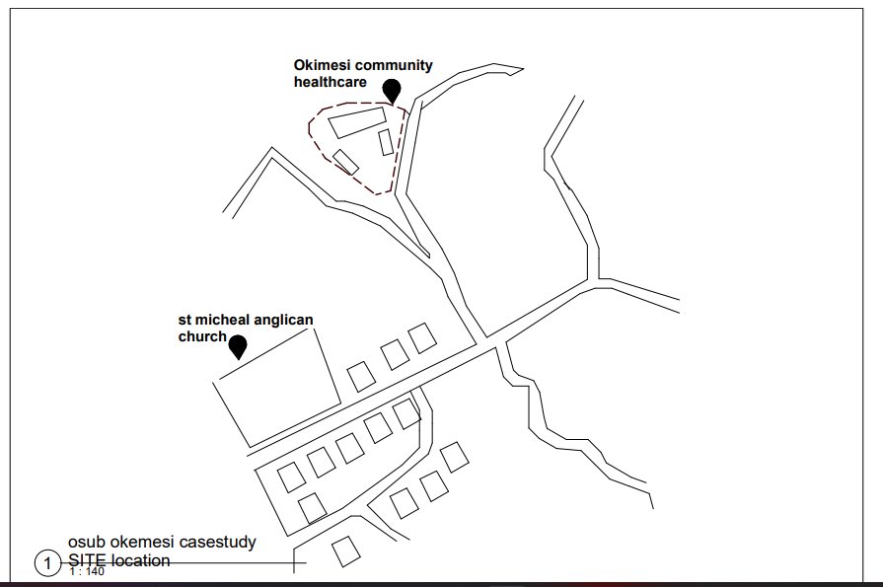
FIGURE 3.3.1 SITE LOCATION CASE STUDY 3
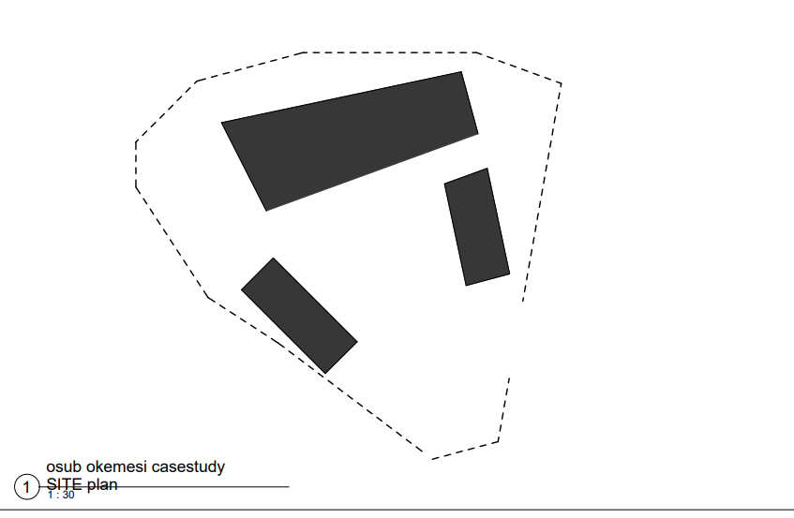
FIGURE 3.3 2 SITE PLAN CASE STUDY 3

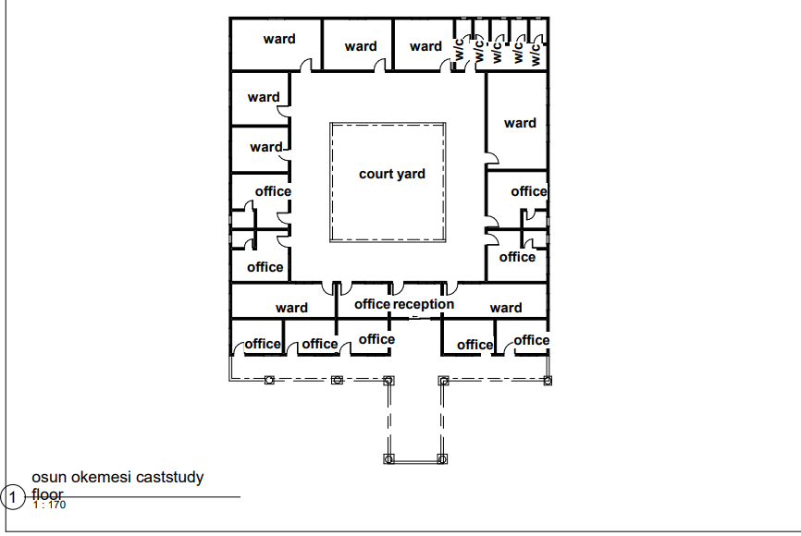
FIGURE 3.3.3 FLOOR PLAN CASE STUDY 3

PLATE 3.3.2 APPROAH CASE STUDY 3

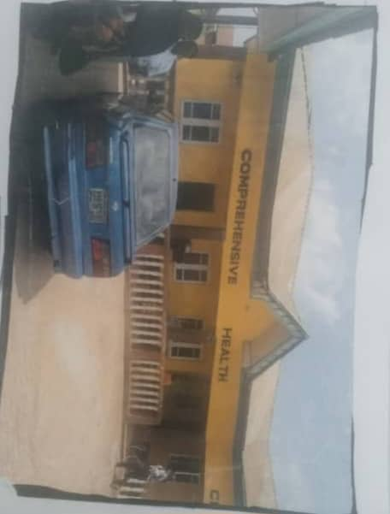
PLATE 3.3.3 FRONT VIEW CASE STUDY 3

ONLINE CASE STUDY
3.4 CASE STUDY 4 (ONLINE CASE STUDY)
COMPREHENSIVE HEALTH CENTRE OF ORLANDO
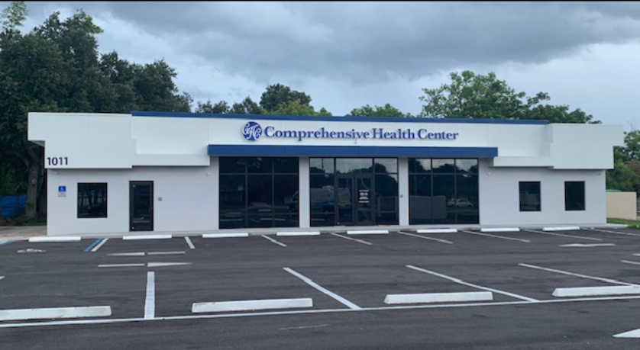
Plate 3.41: External view of online case study one
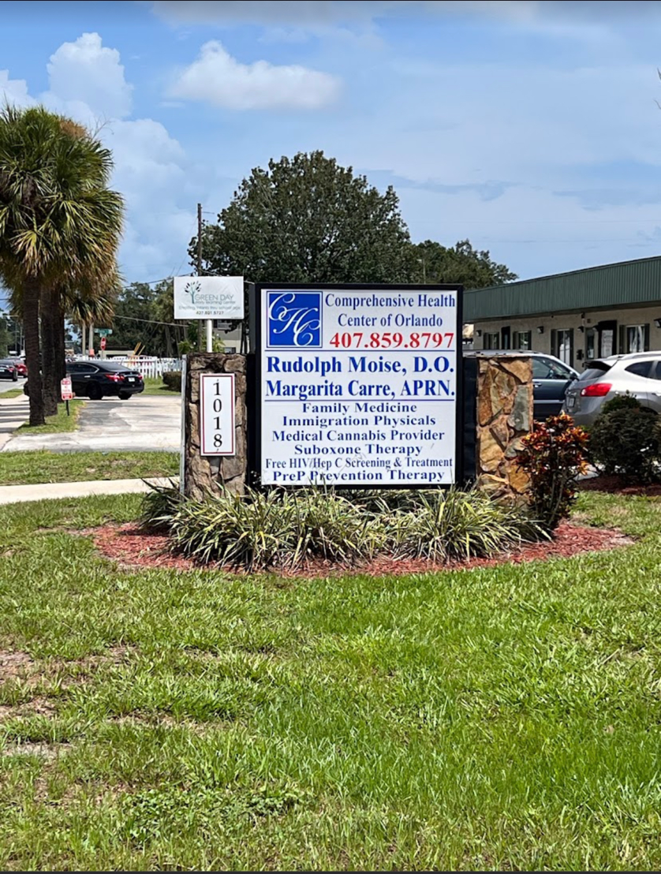
Plate 3.4.2: External view of online case study one

CHAPTER FOUR
4.0 INTRODUCTION
Propose comprehensive healthcare in oyun, Ilorin, kwara state provide essential medical service to the local community. While specific details about comprehensive healthcare center in oyun limited.to provide primary healthcare service materials and child vaccinations, also introduce laboratory and diagnostic service
4.1.1 SITE SELECTION Analyze spatial relationship between potential sites and existing infrastructure, population density. Assess the sites physical characteristic, accessibility, and proximity to
exist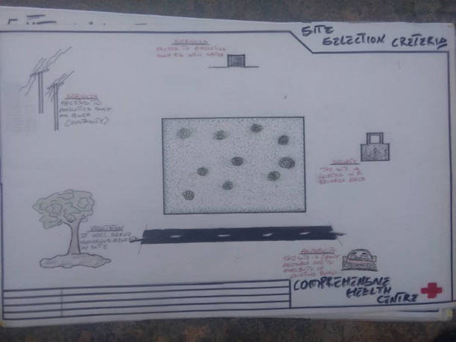
FIGURE 4.1 SITE SELECTION

4.1.2 SITE LOCATION
Propose site location for oyun orisunmibari and iyaro community, healthcare center requires considering several factors such as accessibility, population density and demographics, infrastructure, and proximity to existing healthcare facilities. Its located in the heart of oyun, Ilorin kwara state, would be ideal. Ensuring easy access for the local population. It’s located in close to major road, such as old jebba road would facilitate transportation and accessibility. Site with existing infrastructure, such as electricity water, and sanitation, would reduce construction cost. The area with high population density such as oyun town or nearby villages.
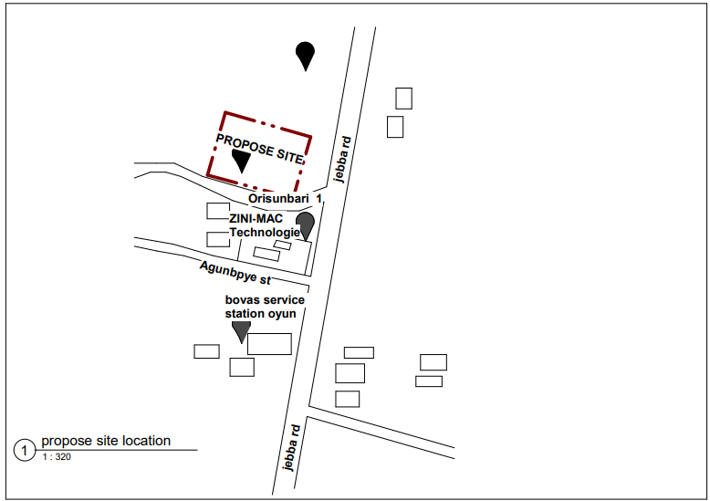
Figure 4.2 proposed site location
4.1.3 SITE ANALYSIS
On site; trees.it cover the area and some will be retained and some will be removed. The retained we served as a shed and and wind breaker. Also the trees and shrubs will be rained to supplement younger ones to be planted to reduce the effect of sun and as noise.
Topography; the site as stable land with a gentle slope toward the north region Orientation; the effect of the four cardinal point are active. Wind floor; the site experience the effect of two trade wind. Solar radiation; the site experience solar radiation which comes from the easy and set at the west.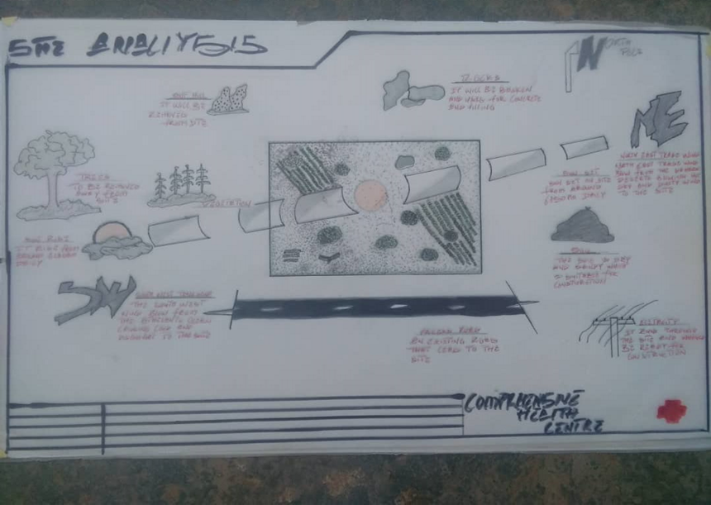
FIGURE 4.2 SITE ANALYSIS

4.1.4 GEOGRAPHICAL DATA
The site is located at oyun Orisumbare with latitude 8.2333 N, longitudinal 4.633.the climate has a tropical savanna climate, with two distinct season dry and wet, and the dry season typically runs from April to October, The Density in oyun is relatively high, with many communities and settlement in the area, The area has a network of roads, including the Ilorin jebba high, with many
communities and settles in the area.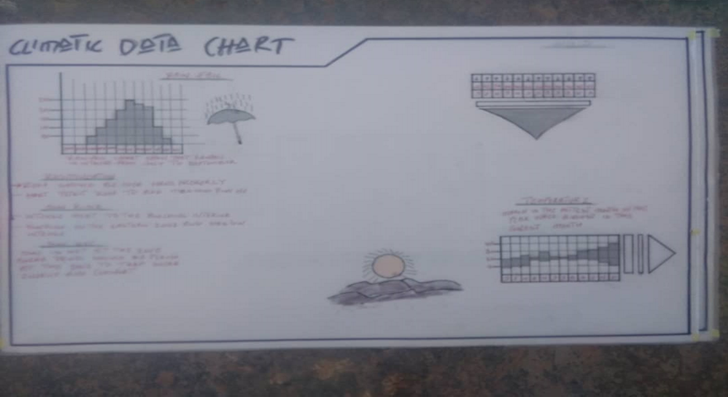
FIGURE 4.3 SITE CLIMATIC DATA CHART
4.1.5 ANALYSIS OF THE IMMEDIATE ENVIRONMENT CONDITIONS OF THE SITE.
The site has initiated clean-up operation in oyun area. The site terrain, slopes and elevation, there is nearby rivers streams, or water. It as average temperature ranges and extremes. Average humidity level and seasonal variations the types of plants, tress and crops in the area. Condition of nearby roads and access to the site the availability of electricity, water, and sanitation. Nearby communities, population density, and potential impact
Table 4.1 Space Allocation
S/N | UNITS | (L)M | (B)M | AREA( SQ M) | NO
1 | ENTRANCE | 3.0M | 6.0M | 18 SQM | 1
2 | RECEPTION | 6.0M | 6M | 36 SQM | 1
3 | CARD ROOM | 3M | 3.6M | 32.4 SQM | 1
4 | RECORD ROOM | 3M | 3.6M | 32.4 SQM | 1
5 | PHARMACY | 8M | 8M | 64 SQM | 1
6 | DOCTOR OFFICE | 3.6M | 5M | 18 SQM | 4
7 | COUNSELING UNITS | 6M | 6M | 36 SQM | 1
8 | DAIGONIST | 6M | 7M | 42 SQM | 1
9 | MARTENITY | 7M | 7M | 49 SQM | 1
10 | LABORATORY | 7M | 7M | 49 SQM | 1
11 | FEMALE WARD | 7M | 7M | 49 SQM | 2
12 | MALE WARD | 7M | 7M | 49 SQM | 2
13 | EMERGENCY WARD | 6M | 8M | 48 SQM | 3
14 | SURGERY | 6M | 6M | 36 SQM | 1
15 | NURSE UNITS | 5M | 5M | 25 SQM | 2
16 | VOID | 10M | 10M | 100 SQM | 1
17 | PRIVATE WARD | 6M | 5M | 30 SQM | 1
18 | INJECTION UNITS | 6M | 4M | 24 SQM | 1
19 | GENERAL UNITS | 6M | 10M | 60 SQM | 1
20 | CONSULATION UNITS | 6M | 6M | 36 SQM | 1
21 | STORE | 3.6M | 7M | 23.2 SQM | 2
22 | W/C | 1.5M | 1.0M | 1.5 SQM | 25
23 | THEATER | 6M | 6M | 36 SQM | 1
24 | THERAPIST | 6M | 6M | 36 SQM | 1

4.2.2 FUNCTIONAL/SPATIAL CRITERIAL A well-designed comprehensive healthcare center in oyun Ilorin should prioritize functionality, incorporating functionality incorporating feature that enhance the quality of medical of incorporate of treatment. Experienced and qualified healthcare professionals, including doctors, nurses, and support staff, adequate staffing ratios to ensure patient receive timely and effective care. Design features to minimize the spread of infection and easy-to-clean surface and materials with adequate ventilation and air filtration system. Designed for efficient patient care, with adequate storage and equipment, also with a comfortable, accessible, and well- ventilated, with amenities for patients and families.
4.2.3 APPRAISAL OF PROPOSED SCHEMES IN THE SPACES,SIZE AND REALSTIONSHIP
In term of clear separation of public, staff, and service circulation paths, it intuitive way finding system to minimize confusion and stress with adequate signage and visual cues to guide patient and visitors. With efficient relationship between clinical and support department. Consideration of future expansion and flexibility, infrastructure for digital systems and medical equipment in integration of technology into patient care area and staff workspace with opportunities for telemedicine and remove monitoring, to design element that promote energy efficiency and sustainability and flexible space that can adapt to changing healthcare needs and technologies with opportunity
It for future expansion and renovation.
Staff workspaces and support areas (e.g. nursing stations, medication rooms) designed for efficiency, with adequate storage and supply chain logistics with opportunity for staff to take breaks and recharge. With design element that promote energy efficiency and sustainability, flexible spaces that can adapt to changing healthcare needs and renovation, with opportunity for future expansion
4.2.4 EQUIPMENT AND OPERATION AND PERFORMANCE REQUIRMENT
EQUIPMENT
- Medical equipment (e.g., diagnostic, imaging, patient monitoring)
- Information technology health record
- Facility equipment (e.g. HVAC, Lighting.)
OPERATION
- patient flow and throughputs)
- scheduling and appointment management
- supply chain management and inventory control
- infection control and sanitation
PERFORMANCE
- Quality ethic (e.g patient)
- Operation matrices (e.g wait times length of stay, throughout
- Staffing and workforce managements matric ( e.g, turnover rate, training and development)
    - SPATIAL ALLOCATION/ SCHEDULE OF ACCOMODATION
- DOOR
The main purpose of door is to provide access into or out of a building and between the various compartment within the building in specifying types of doors, the numbers of people expecting to pass through are considered along with the control desirable. Glazed doors in aluminum frame are provided in the reception hall.
- WINDOWS
The purpose of a window is to admit day and-light, provide natural ventilation exclude rain water and give a view outside.
The selection of size, shape, location, and numbers of windows openings in a room depend upon the size of the ward or room. Direction of the wall, direction of the wind, climate condition and the requirement of the exterior of the building.
    - FUNCTIONAL RELATIONSHIP
- Emergency department; proximity to ambulance entrance, imaging, and operation rooms
- Imaging department; proximity to emergency department, operating rooms, and patient care area
- Operation room; proximity to emergency department, imaging, and recovery area
- Laboratory ; Proximity to patient care area, emergency department and operating rooms
- Nursing station; Proximity to patient care area and support service.
- Staff Area; Proximity to patient care areas, support service, and administrative.
- Infrastructure for digital systems and medical equipment
- Integration of technology into patient care area, staff workspaces, and support

CHAPTER FIVE
5.1 TECHNOLOGICAL AND ENVIRONMRNT CRITERIAL
Integrated renewable energy sources, like solar or wind power, to reduce dependence on Traditional energy sources and minimize carbon footprint. Provide high-speed internet connectivity to support resident’s digital needs and enable remote works, education, and entertainment. Implement intelligent building system that can monitor and control energy usage, water consumption, and waste management, optimizing resource efficiency .incorporate smart home technologies, such as energy-efficient system, smart lighting and home automation, to enhance resident comfort and convenience. Use of sustainable building materials, such as locally sourced materials, recycled materials, and low-VOC (volatile organic compound) paints, to minimize environmental impact.
5.1.1 CONSTRUCTION METHODOLOGY AND MATERIALS/FINISHES DESIRED BY CLIENTS.
- WALLS
This generally defines the outside and inside space of a building structure. Its primary function is to enclose or divide space, offer privacy and specially to provide support to different kinds of loads (live, dead, wind).
Walls can be categorized into load-bearing and non-load bearing walls. Load bearing walls are walls which carry vertical imposed load from roofs and floors while non-load bearing walls are walls which carry only their self-weight and are mainly used as dividing walls, partition and dwarf walls.
For the construction of the walls, block of 450mm*225mm*225mm would be suitable, curtain walls are also used. These are fixed to the face of the structure so as to perform the function of windows and walls.
- ROOF
A roof is usually the uppermost part of the building which protects them from weather i.e rain and wind etc .for the uppermost part of the project, it consists of steel structural element aluminum roofing sheet.
- FLOORS
Floors are the structural part of a horizontal supporting elements as distinct firm the wearing surface. The solid ground floor which is otherwise called German floor in Nigeria. Its consist of concrete not less than 150mm thick laid on a hardcore of a least 250mm thick compacted in layer of 59-75mm.the damp proof membrane should be placed below. The over site concrete which compacted before cement and sand (1:3) screed is finally laid on it to a thickness of not less than 19mm.
- CEILING
Suspended ceiling of aluminum railing with paper pulp sheet are use in the project. This product has an advantage of smooth, flame resistance and good acoustic value.
5.1.3 SERVICE REQUIRED
- VENTILATION
In housing estate, mechanical equipment is required to carry out the thermal loads still remain after techniques of heat rejection, conservation and passive cooling and heating have been applied. However, with proper design and orientation of the housing estate as described earlier on this thesis, the size and energy demands of heating the cooling equipment can be very small.
In the proposed housing estate, air condition is use to heat, cool, clean and circulate air although, windows are also provided for adequate ventilation.
- LIGHTING
Lighting in an estate is a very fundamental for wing of objects and artifact. There are two methods of lighting the museum namely; natural and artificial lighting. Both of these could be damaging to the artifact depending on their intensity. Hence, the use of indirect light is encourage to reduce the risk of fading of colors of the artifact.
Natural lighting is more viable than artificial lighting. There are basically two method of natural lighting namely top and lateral lighting. The choice of lighting system depend on the design program of the housing estate.
Side (lateral) lighting has the advantage of accessibility, low cost of maintenance, low radiation dirt and dust accumulation.it also gives good ventilations, allows for outside viewing and multi-level exhibition.
Lateral lighting is more ideal in place like northern Nigeria because it reduces intensive solar radiation, maintenance cost, natural ventilations and accessibility.
Top lighting is a second method of natural lighting in housing estate.it has advantage of maximum use of wall surface for exhibition, amount of light coming in is regulated.
- PLUMBING AND ELETRICAL INSTILLATION.
The need for water is very important in the public center, however there will be digging of boreholes water, there will be a point where the borehole water will be channel to each apartment.
Paved area are laid to gradient or falls towards gullies or channels that collect surface water and discharge through drains to servers or soak away.
- ELETRICAL INSTILLATION
Electricity is supplied by ikeja electricity power Distributor Company, however in case of power failure, it would be augmented to have stand-by generator set as specified by the service engineer. The power transmission and wiring system shall be conduit step down a/c power transmitter shall be service and maintained by the maintenance section. The housing estate will receive five phase of electricity supply from the electricity grid at the rating of 600 volts and frequency of 200 hertz each. The size of the cable will depend on the service entrance equipment in the housing estate and the amp age supplied by the electricity power authority.
- ACOUSTIC
Sound is absorbed by a mechanism which converts the sound into other forms of energy and ultimately into heat. Most manufactured materials depend largely on their porosity for their absorptivity. Many materials such as mineral wool pads and blankets have multitude of small deeply penetrating inter-communicating pores, the sound waves can readily propagate into these interstices where a portion of sound energy is converted into heat by fractional and viscous resistance within the pores and by vibration of small fibers of the materials.
If the materials is sufficiently porous, and of appropriate thickness, as much as percent of the energy of an incident sound wave may be absorbed in this manner. When sound wave strikes a panel, the alternative pressure of these wave against the panel ay force it into vibration. The resulting flexural vibration use a certain amount of the incident sound energy by converting it into heat.

- FIRE PROTECTION
Fire in building are nearly man-made that is, resulting from errors or negligence. The principal aim of fire precaution are simply to safeguard life and property and are achieved by
- Reducing fire incidence
- Controlling fire propagation and spread
- Providing adequate means of escape occupant of building.
The architect role is in the prevention, detection and combat of fire through appropriate designs. Specification and choice of materials.
5.3.3 ENVIRONMENTAL CONDITION TO BE ACHIEVED
- Air Quality
To design the estate to minimize air pollution from vehicle emissions, industrials activates, and others source.to incorporate green spaces and parks to help purify the air improve air quality
- Water Quality
To design effective storm water management systems to prevent flooding and minimize water pollution.to incorporate water conservation measures, such as rainwater harvesting and greywater reuse, to reduce water consumption.
- Waste management
To design effective waste management systems, including recycling and composting facilities, to minimize waste sent to landfills.to encourage reduction and recycling practices among residents.
- Noise Pollution
To design the estate to reduce noise pollution from traffic, industrial activates, and others sources.to incorporate noise barriers, such as soundproofing materials and green walls, to minimize noise pollution
- Energy efficiency
To incorporate energy-efficient design principles, such as passive solar design and insulation, to reduce energy consumption.to consider incorporating renewable energy source, such as solar or wind power, to reduce dependence on traditional energy source.
5.3.4 PERFORMANCE STANDARDS.
- Sustainability
To design building and systems to minimize energy consumption and reduce greenhouse gas emissions. To implement water-saving measures, such as low-flow fixtures and rainwater harvesting, to reduce water consumption.to design waste management system that promote recycling, composting, and minimizing waste sent to landfills
- Safety and Security
To design the estate to prevent crime, including features like secure access point, CCTV surveillance, and adequate lighting.to ensure that emergency service, such as fire stations, hospitals, and police stations, are easily accessible
- Accessibility and inclusivity
To design building and public spaces to be accessible to people with disabilities, including features like ramps, elevators, and accessible walkways.to foster an inclusive community by providing amenities and services that cater to diverse needs and demographics.
- Community Engagement
To provide community facilities, such as community centers and parks, to foster social interaction and community engagement among resients.to encourage resident participate in decision-making processes and community development initiatives.
- Transportation and Mobility
To encourage sustainable transportation options, such as walking, cycling, and public transportation, by designing pedestrian-friendly and bike-friendly infrastructure.to design effective traffic managements system to minimize congestion and ensure safe traffic flow.

5.4 LEGAL ISSUES AND PLANNING REGULATION
- Land Ownership;
To ensure clear land ownership and title to avoid disputes and litigation.
- Zoning Regulations
Comply with zoning regulations, which dictate land use, density and building height.
- Density and Height Restrictions
Comply with density and height restriction to ensure that the development is in line with the surroundings
- Building Code and Standards
To comply with local building codes and standards to ensure structural integrity and safety.

5.5: CONCLUSION
In conclusion, the Comprehensive Health Center (CHC) project is a vital initiative that addresses the healthcare needs of the community by providing accessible, affordable, and quality healthcare services. Through its comprehensive approach, the CHC offers a wide range of services, from outpatient and inpatient care to diagnostic facilities, pharmacy, and community health programs. By investing in staff training, facilities, and equipment, the CHC ensures that patients receive holistic care, empowering them to take control of their health and well-being.

APPENDICES
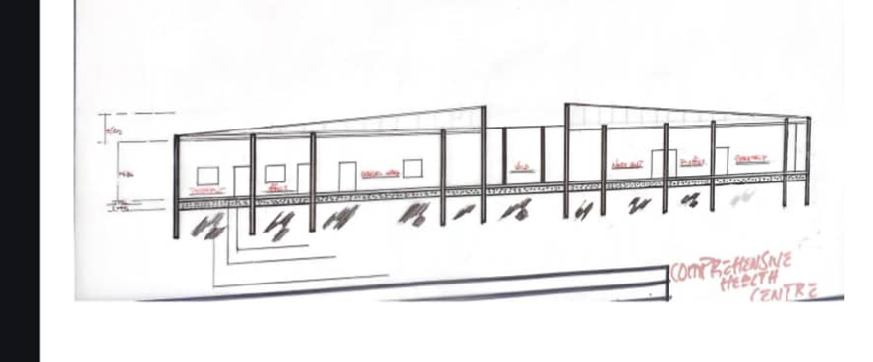
CROSS SECTION A-A

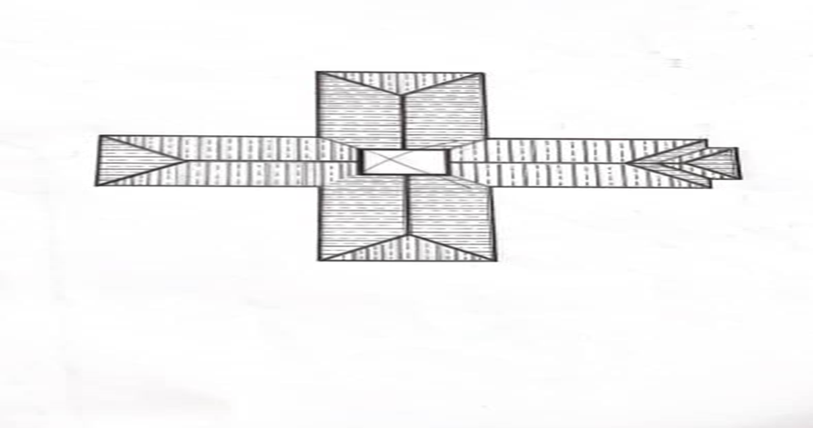 ROOF PLAN
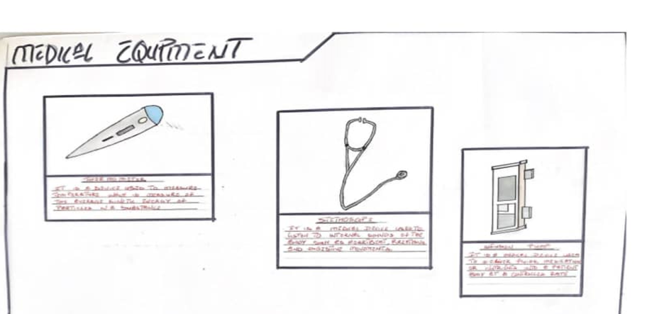
MEDICAL EQUIPMNET DRAWINGS
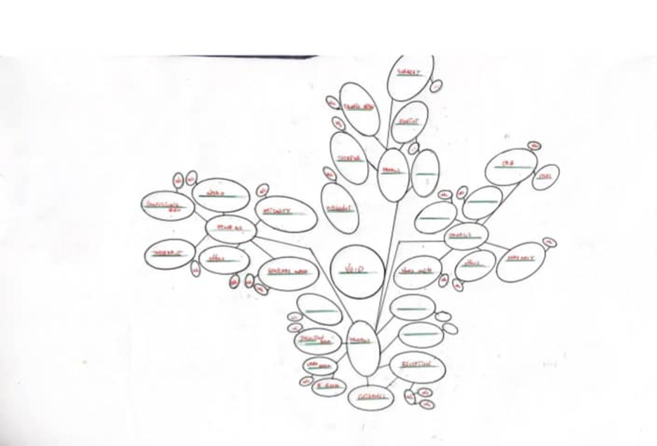 BUBBLE DIAGRAM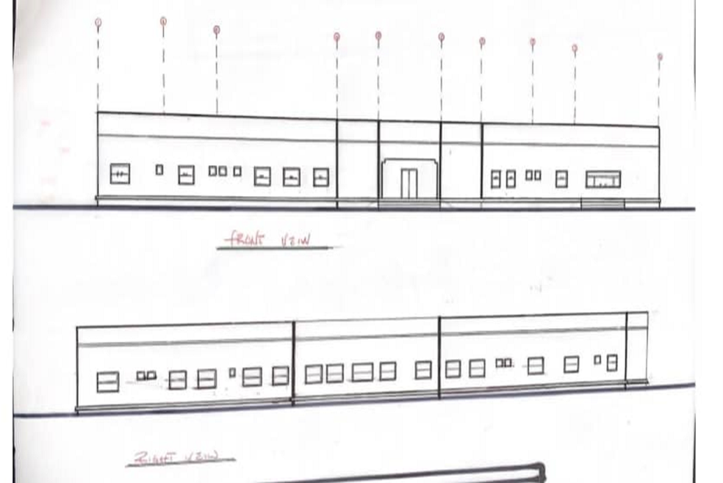
ELEVATION
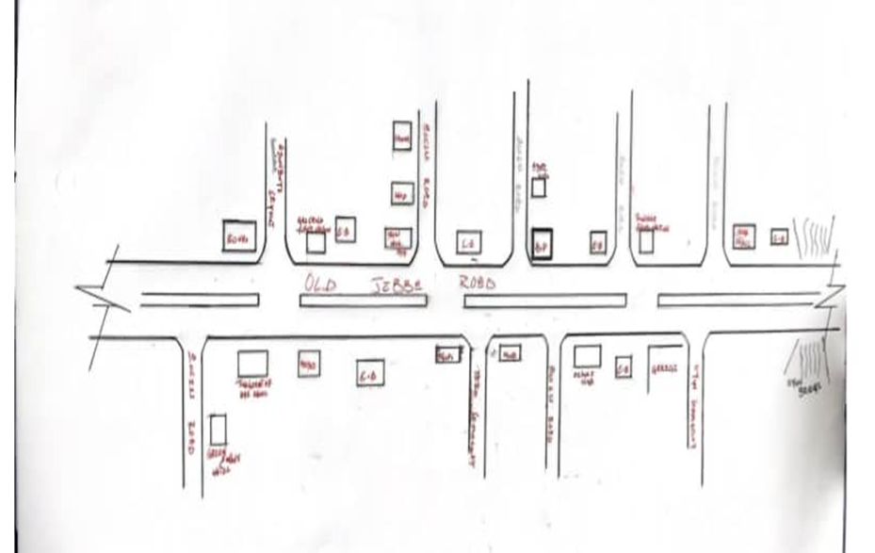LOCATION PLAN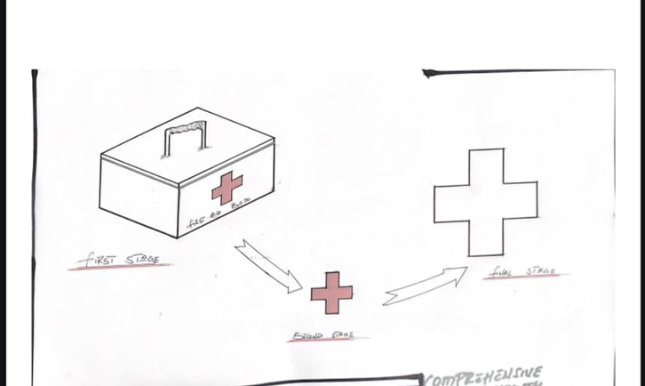CONCEPTUAL DESIGH
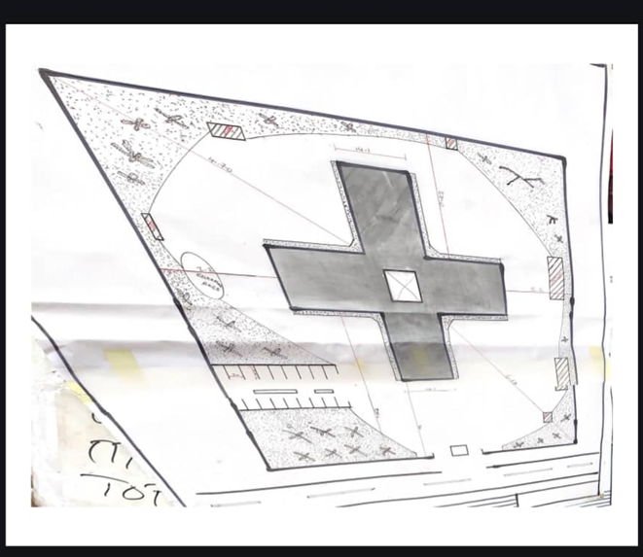
SITE PLAN
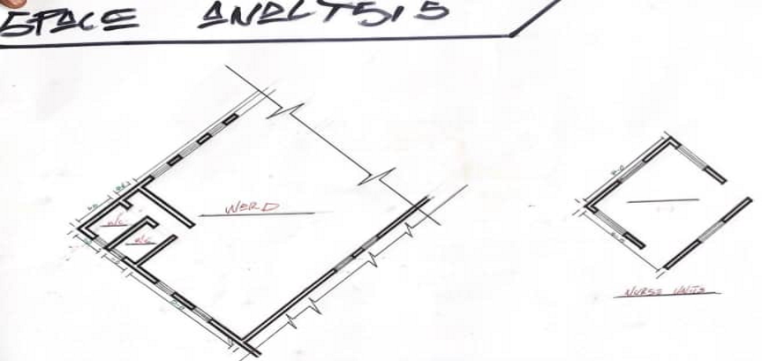
SPACE ANALYSIS

