

KWARA STATE POLYTECHNIC, ILORIN

FABRICATION OF RAIL FENCE

BY

UMAR ADAM GOBIR
ND/23/MEC/PT/0117

DEPARTMENT OF MECHANICAL ENGINEERING, INSTITUTE OF TECHNOLOGY (I.O.T), KWARA STATE POLYTECHNIC, ILORIN.
IN PARTIAL FULFILLMENT OF THE REQUIREMENT FOR THE AWARD OF NATIONAL DIPLOMA (ND) IN MECHANICAL ENGINEERING.

JULY, 2025.
CERTIFICATION
This is to certify that this project was carried out by UMAR ADAM GOBIR of matriculation number ND/23/MEC/PT/0117 in the department of Mechanical Engineering, Kwara State Polytechnic in partial fulfillment of the requirements for the award of National Diploma (ND) certificate in Mechanical Engineering.

_______________________ ________________
ENGR. DR. L.B. ABDULQADIR DATE
(PROJECT SUPERVISOR)

______________________ _________________
ENGR GANIYU ISSA DATE
(PROJECT COORDINATOR)

_____________________________ __________________
DATE
(External Examiner)

DEDICATION
This project is dedicated to Almighty God that kept me. We also honor our beloved parents who give hands in support to the fulfillment of our National Diploma (ND) both morally and financially. May God allow them to reap the fruits of their labour (Amen).

ACKNOWLEDGEMENT
Foremost, I give all praises, honour, glory with thank to the God Almighty who made the writing of this project possible with His total mercy on me from the beginning till the end.
My appreciation goes to my project supervisor ENGR. DR. L.B. ABDULQADIR for his exceptional mentorship and technical expertise. His guidance and insightful suggestions have been instrumental in shaping the direction of this project.
I also express my gratitude to the Head of Department, project coordinator ENGR GANIYU ISSA and other amiable lecturers for their expertise and assistance in various aspects of the project.
Am extending my greetings to my parents MR AND MRS OKENIYI for their unseasoned support and encouragement being it financially, spiritually in this journey of education.

ABSTRACT
A rail fence is a rustic, traditional fencing style made from horizontal logs or split rails, typically arranged in a zigzag or crisscross pattern, supported by vertical post. Fences serve as effective barriers for animal and humans and are often used for decoration boundary or functional purposes. This project involves the fabrication of the Rail Fence. The historical perspectives of fence and rail fence were narrated with pictorial view of different types of rail fence used from times immemorial. The procedure involved in fabrication process were thoroughly followed and captured in this report. These include: material selection, cutting, forming, bending, welding, grinding, painting etc.

TABLE OF CONTENTS
TITLE PAGE i
CERTIFICATION ii
DEDICATION iii
ACKNOWLEDGEMENT iv
ABSTRACT v
TABLE OF CONTENTS vi
CHAPTER ONE 1
1.0 INTRODUCTION 1
1.1 Background of the Rail Fence 1
1.2 Aim and objectives of the project 2
1.3 Scope of the Study 2
1.4 Literature Review-History of Rail Fence 3
CHAPTER TWO 8
2.0 ANALYSIS OF RAIL FENCE 8
2.1 Types of rail fences 8
2.2 Advantages and Disadvantages of Rail Fence 12
2.3 Types of Metal Fencing 13
2.4 Factors to Consider Before Choosing a Metal Fence 22
2.5 What types of metal fences 24
CHAPTER THREE 26
3.0 SELECTION OF MATERIALS 26
3.1 The Material that is Required for this Project 26
3.2 Properties of materials 26
3.3 Fabrication of the Project 27
3.4 Fabrication procedures 28
3.5 Procedures in Summary 34
3.6 Welding Operation 34
3.7 Electrical Joint: 36
3.8 Precautions against other Risks 37
3.9 Problem Encountered 39
3.10 Bill of Engineering Measurement and Evaluation (BEME): 39
CHAPTER FOUR 40
4.0 DESCRIPTION OF THE FENCE RAIL COMPONENT 40
4.1 General Description of the Component 40
CHAPTER FIVE 42
5.0 CONCLUSION AND RCOMMENDATION 42
5.1 Conclusion 42
5.2 Recommendation 42
REFERENCES 43

CHAPTER ONE

1.0 INTRODUCTION

1.1 Background of the Rail Fence
Rail fence is usually being designed and constructed in different forms, but serving the same purpose and aimed for protection at different places depending on the type of security needed. In several places, wood has been consistently used since the first century (Waterman, 1981). Fence rail which either served as a means of providing more security by preventing intruders from getting into the house through the fence.
Naturally, wooden materials were the first to be utilized as fence rail to wade-off intruders (human or animal). However, due to the peculiar attribute of the wooden fence rail which can easily get damage when in contact with water or affected by insect, it could not satisfy man’s desire.
As a result of improvement in science and technology, many diverse method have been discovered for making rail fence, the introduction of rail fence as means of security, as given a man a preferred hope and also due to the advantage over wood, meter rail fence cannot be attack by termite it has a high degree of strain and a high resistance for water, especially when coated with anti-corrosive compare to wood, with metal in making rail fence cannot be over emphasized. Metal rail fence could be various designs. They can be made of rods throughout or with contribution of pipe and many other shapes for the purpose of beautifying it.

1.2 Aim and objectives of the project
The aim of this project is to fabricate secured rain fence from locally available mild-steel material. The following are therefore the objectives of the project:
- To prevent human and animal intruders into buildings
- To prevent more children or domestic animals from getting too close to the busy road while are playing in the yard.
- To beautify the building, thus improving its aesthetic value by making it more attractive.
- To minimize the risk of danger to human live and properties.
- To put into practice, the theoretical aspect of the work taught in the class.

1.3 Scope of the Study
The project incorporates all the processes involved in the fabrication of a durable and presentable rail fence.

1.4 Literature Review-History of Rail Fence
A fence is a building encloses areas such as the building, gardens, cornfields, parks, woods, or groups of trees. The features could be formed by a hedge, wall, ditch, or bank.
There are different fence types across various countries in the world. Some of these include: blind, board, close, cradle, cross, double, foss, hurdle, invisible, live, open board, pale/paling, palisade, picket, post-and-plank, post-and -rail, snake, sunk, trellis, Virginia, wattle, wire, warm, and zigzag.
The choice of fence type was dictated by the materials available, local custom, and the need at hand. For instance, worm fences (also called zigzag, snake, split rail, or Virginia fences) did not require posts or post holes and therefore were easily moved to accommodate changing field use and avoided the problem of posts routing in soil. They were also useful in area where rocky soil made it difficult to dig post holes or in wooded areas where trees made straight fence lines impractical. Paled fences offered a more solid line of defense against deer and rabbits, but had less flexibility and required more labor and finished lumber. Such high fences were effective barriers for animals as well as humans.
Paling fences created visual barriers and were sometimes erected to screen unpleasant views or to provide privacy, particularly in urban settings. For instance, in 19th Century, in the usual selfish style of Philadelphia, the whole ground was surrounded and hid from the public gaze by a high fence. Fences were also used to direct the gaze, whether toward a house or other focal point. In other cases, fences such as sunken types (later replaced by wire fences) were desired for their inconspicuous presence in the landscape. Numerous descriptions and horticultural advice columns praised the effect of unobstructed views created by enclosures that kept animals or human traffic at bay with minimal visibility.
The fences and pales were originally generally made of wooden planks and posts. But a few good economists, having already thought of sparing the woods for future times, have begun to plant quick hedge round their fields.
The fences built in Pennsylvania and New Jersey, but especially in New York, are those which on account of their serpentine form resembling worms are called ‘worm fences’ (Rick, 2007) The rails which compose this fence are taken from different trees, but they are not all of equal duration. Thus, the worm fence is one of the most useful sorts of in closures, especially as they cannot get any posts made of the wood of this country to last above six or eight years in the ground without routing. Considering how much more wood the worm-fences require (since they zigzag) than other fences which go in straight lines, and that they are so soon useless, one may imagine how the forests will be consumed, and what sort of an appearance the country will have forty or fifty years hence
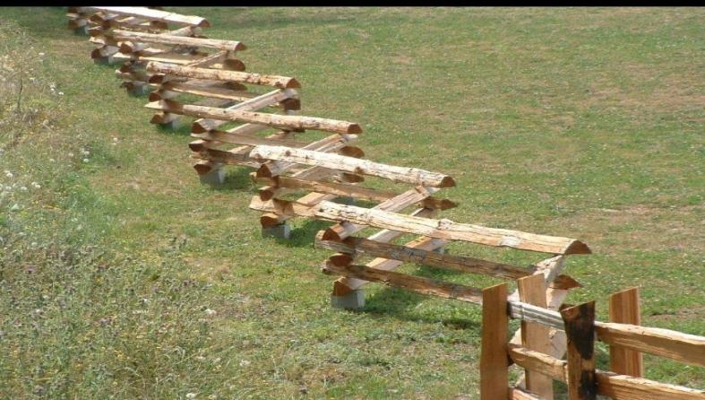
The well-known zigzag fence of rails crossing at the ends. It is also called ‘snake fence’ or ‘Virginia rail fence.’ An example of zigzag fence is shown in Figure 1.1

Figure 1.1: A Pictorial image of zigzag fence
Fences were constructed from variety of material. In the tidewater’s sedimentary soils where stone was scarce, wood was the most common material and was used mainly in paled, post-and-rail or board and worm fences (Dreicer, 1996) Although types of wood that could be used were varied, a typical paling fences utilized different types of wood. For example, hard wood, such as locust, cedar, or oak, was often used for posts; wood with tensile strength, such as oak, poplar, or pine, was used for rails; and lightweight wood, such as pine, could be employed for the pales.
In the 18th century, iron gates and iron fences were employed for the fronts of elite dwellings and notable institutions (Southworth 1992). It was not, however, until the second quarter of the 19th century when the expansion of America’s domestic iron industry and advances in cast iron made iron fences affordable for those of more modest means. This availability is reflected in the more than one hundred fence patents that were registered between 1801 and 1857. Elaborate iron work fences were particularly popular as enclosures for urban parks, educational “every degree of gradation” in between. Figure 1.2 shows a pictorial view of rudest barriers.
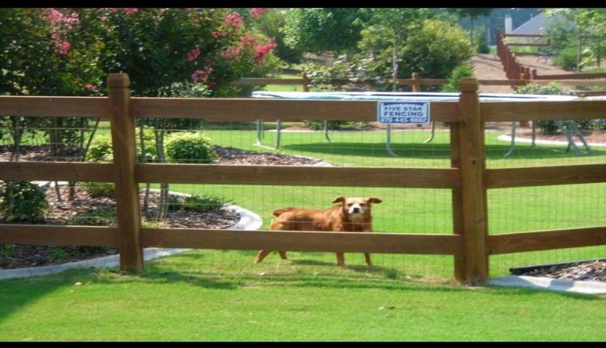

Figure 1.2: A pictorial view of Rudest Barriers
External fences: fences of all kinds are rather necessary and useful, as instruments of shelter and security, than to be chosen as materials of ornament. Whether the view terminates on the fence, or is directed beyond it, the effect on the scene at best is negative: thus, a fence is sometimes made higher than its proper use requires, merely to shut out something most sightline; and, in judiciously purely negative-some prospect worth retaining at considerable cost is not obstructed
Internal fences: these must be lighter and more elegant: but the materials will equally vary with the local position and purpose. What has been said of shrubs for internal fences under flower garden, is applicable to the most extensive ornamented grounds; except that regularity is less requisite, if not out of place; and primness ought to be avoided. Posts, with a single chain, or a rope well pitched, are sometimes enough to keep cattle from a walk. When a stronger barrier is wanted against animals grazing the pasture near the house, so as to intercept a distant view, one of the best devices is what is termed the invisible fence; which is composed of lines of elastic wire passed through upright iron stanchions, the whole painted green (Pollard 1974).

CHAPTER TWO

2.0 ANALYSIS OF RAIL FENCE
Rail fences are made of two, three, or four horizontal rails connected to evenly spaced vertical posts. You can construct in various types of wood, vinyl, composite, or metal to provide your property line with rustic charm or an horizontal bar extending between support and used for support or barrier rail located on a human-constructed barrier which separate two pieces of land or a house perimeter.
Decorative split rail fences in front yards are typically 4 feet tall, while ones used for containing livestock are 6 feet (and are sometimes called ranch rail fences).

2.1 Types of rail fences
2.1.1 Wood Split Rail Fence
Also called a ranch rail fence or post and rail fence, this type of fencing is often used on farms to contain livestock and pasture. Many rural homeowners with large properties build ranch fences to mark their land boundaries because they’re beautiful and cost-effective. So if you’ve ever been to the country side chances are you’ve already seen a split rail fence.
All split rail fences are constructed using evenly spaced vertical post with two, three, or four horizontal rails connecting them.
Pressure-treated pine and high-quality cedar split rail fences are typically insect-resistant and impervious to rot. So, if you choose them for your property, you won’t have to worry about painting them during their lifetime, which spans 15 to 20 years. Figure 2.1 shows a pictorial view of wood split rail fence.
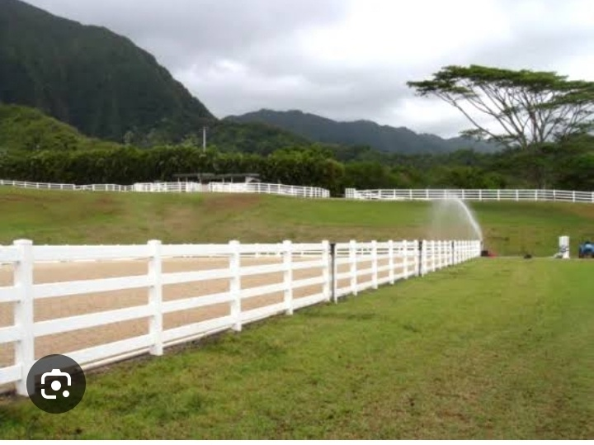

Figure 2.1: Pictorial View of Wood Split Rail Fence
2.1.2 Wood Zig-Zag Fence
Sometimes known as a snake fence, the zigzag fence does what its name says: zigsand zags along a property boundary. Unlike split rail fences, zigzag fences don’t need supporting posts since the timber rails lie on top of one another. Because the fence line isn’t entirely straight, this fence type can be useful for navigating a fence line around trees in a wooded area.
2.1.3 Round Rail Fence
Sometimes called western rail fences or post and dowel fences, round rail fences are built from two to three smooth, round posts and rails. They usually have tapered ends which are used for attaching the rails to the posts.
You also can build round rail fences with pressure-treated wood that resists rot and decay- making them last at least 15years. Or, you can use vinyl to make your fence last even longer. if you’d like to add more security, you can attach a chain link fence to it, allowing you to keep your pets and children safe inside the fence’s perimeter. Figure 2.2 shows a pictorial view of round rail fence.
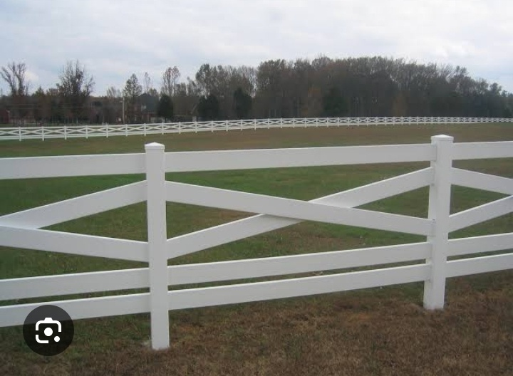
Figure 2.2: Pictorial View of Round Rail Fence
2.1.4 Composite Split Rail Fence
Composite split rail fences are an eco-friendly alternative for adding a rustic fence to your home. Made from plastic and recycled wood, they can withstand the elements and resists mold, rot, and insect better than other popular types of fences like western red cedar; like vinyl, they last around 30years and require minimal maintenance.

2.1.5 Metal Split Rail Fence
Aluminum and metal fences last longer than composite fencing. Steel, in particular, can last up to 50years. You don’t ever have to worry about staining or painting then either- just cleaning with soap and water will suffice.
Steel and aluminum are more expensive yet stronger than their wooden, vinyl, and composite alternatives, so they are often use as decorative fencing or as a ranch rail for horses. Figure 2.3 shows a pictorial view of split rail fence.
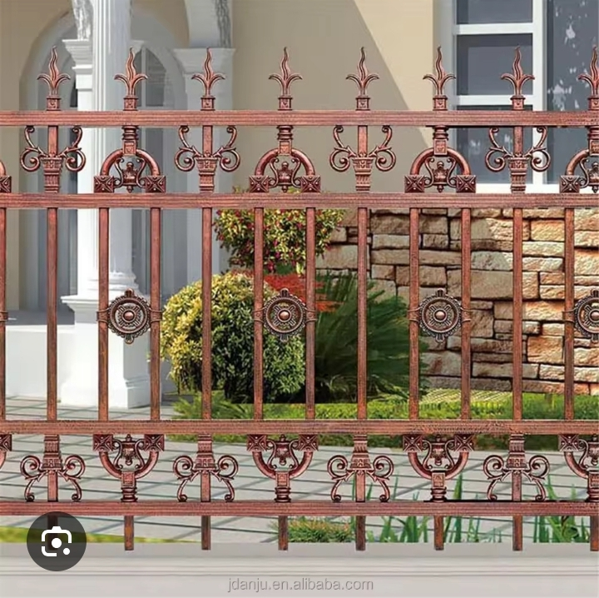

Figure 2.3: Pictorial View Split Rail Fence

2.2 Advantages and Disadvantages of Rail Fence
While different rail fence designs have specific benefits, they all share the following advantages and disadvantages as presented in Table 2.1 below.
Table 2.1: Advantages and disadvantages of Rail Fence
Advantages | Disadvantages
- Reliable containment  - Affordable  - Easy to install.  - Low maintenance  - Rustic aesthetic  - Increases curb appeal | Less privacy can’t contain small pets  Minimal security limited style options  Trickier lawn care

When building a new fence, you must pick high-quality, durable materials to ensure it lasts for years to come. Choosing poor materials can lead to an ugly, sagging fence that’ll be expensive to repair. Here are some of the most durable fencing materials in the market.
- Wrought Iron: ornamental iron fences can last hundreds of years if regularly maintained. In fact, some of the wrought iron latticework found in the French Quarter of New Orleans dates back to the 1700s. However, iron is prone to rust and must be regularly repainted.
- Brick or masonry: fences built from brick or concrete can withstand the test of time. However, these materials are pricey and must be installed by professional masons
- Aluminum: lightweight, rust-resistant, and easy to install, aluminum fences are a sure bet for any climate .aluminum requires little to no maintenance and can be painted to match your home’s exterior.
- Vinyl: A relative newcomer in fencing materials, vinyl can be designed to resemble wood and metal. It doesn’t rot or rust and is resistant to pests. All you need to do is wash it down once a year to keep dirt and debris at bay.
- Pressure-treated wood: wood fences are timeless. Fortunately, pressure-treated wood can last many decades with annual upkeep, such as painting and staining.
Consult a fence professional to discuss what type of fencing material is best for your property.

2.3 Types of Metal Fencing
a. Wrought Iron fences: Wrought iron is a classic fencing design made by heating iron and forming it into various shapes. This labor-heavy process drives up the price but allows for endless customization options. These elegant fences have graced yards for centuries, and there are several styles to suit your tastes, such as:
- Flat top
- Arched top
- Fleur-de-lis
- Spearhead
- Ball top finish
- Closed iron
- Straight top
- Ornamental
Wrought iron is suitable for functional or decorative purposes because of its durability and design. It can keep dogs in as long as your pet can’t squeeze through the pickets. Choose from various powder-coated colors to suit your outdoor décor. Powder –coating also improves resistance to scratches and rust.
You may not know that many wrought iron fences aren’t technically wrought iron. Cast iron fences are popular alternative since they’re cheaper. Cast iron is poured into a mold rather than wrought into shape using tools. Cast iron is more brittle than wrought iron, meaning it’s more likely to break under pressure.
Other materials like steel are sometimes advertised as wrought iron because of the similar style. However, many willingly choose these alternatives because they’re cheaper and provide enough strength and visual appeal for the average homeowner.
Advantages:
- Durable
- Visually appealing
- Custom design option
- Secure
Disadvantages:
- Expensive
- Hard to install
- Provide no privacy
- Susceptible to rust and corrosion if not powder-coated, painted, or sealed regularly (especially in coastal climates)
b. Aluminum Picket Fences: Is rust your biggest concern? Aluminum fences are naturally rust-resistant, making them great pool fences. These lightweight fences are generally less expensive than wrought iron fences. While most aluminum fences are simply designed with a top rail, bottom rail, and pickets, some are modeled after the more stylistic wrought iron designs. You also can select from various powder-coated colors.
Aluminum fences are lower maintenance than wrought iron, they’re not as strong. Aluminum fences can bend if hit by objects like storm debris. Ask your local fences expert for a higher-grade aluminum for a stronger fence, but understand it will cost more.
Advantages:
- Low maintenance
- Cost-effective
- Many styles and color options
- Recyclable
Disadvantages:
- Compromised security and durability
- Provide no privacy
- Steel Picket Fences: Remember how companies often use steel for wrought “iron” fences? That’s because steel fencing is more affordable than wrought iron and comes in many of the same styles. It can either be welded together or joined with rivets.
However, steel is heavy and difficult to install. This feature makes it a less-than-ideal choice for DIYers, though a pro can handle it just fine. Steel fences aren’t rust-proof, but galvanized steel can resist corrosion.

Advantages:
- Comes in many styles
- Adds value to homes
- Galvanized steel can resist corrosion
Disadvantages:
- Heavy and hard to install
- Not resistant to rust unless it’s galvanized
- Provide no privacy
- Chain-Link Fences: Not so worried about appearance? Chain-link fences are practical and affordable, making them a popular fence choice among homeowners and business owners. They’re also popular for dog owners since this fencing has no gaps and can be tall enough to stop high-jumping dogs. Choose from galvanized steel, stainless steel, aluminum, or vinyl-coated varieties in various colors.
Because of its lackluster appearance, chain-link fencing is one of the few metal fence types that does not increase property value. However, there are some ways to customize your chain-link fence or make it private.
The security of chain-link is often overstated; while it keeps most children and pets contained, a human intruder could easily climb or cut through it. You may be able to install barbed wire on top, but many residential areas forbid it for safety reasons.
Advantages:
- Budget-friendly
- Low maintenance
- Easy to install and repair
- Great for dog runs

Disadvantages:
- Provide no privacy unless you install slats
- Not secure
- Not visually appealing
- Doesn’t increase property value
- Wire Fence: Want security on a budget? Wire fences are one of the cheapest fence types and effectively keep animals in or out, making them perfect for gardens. They’re also easy to install and repair. Wire fences range in complexity from simple wires strung between posts to wire mesh in frames.
Here are the most common styles:
- Chicken wire
- Hog wire
- Welded wire
- Barbed wire
- Razor wire
Wire fencing isn’t the most aesthetically pleasing style, though a wooden frame may boost its visual appeal. barbed and razor wire are forbidden in many residential areas, so check your local regulations before installing.
Advantages:
- Budget-friendly
- Easy to install and repair
- Secure for gardens and animal enclosures
Disadvantages:
- Not visually appealing
- Some types are not allowed in residential areas
- Aluminum slat Fences: Do you like the appearance of wooden slat fences but want more durability? Install aluminum slat fencing instead. It has the same private or semi-private appearance but won’t be vulnerable to termites. Choose from several colors to match you decor.
Like aluminum pickets, aluminum slat fences are resistant to rust but prone to denting when hit by objects. They also can get quite pricey compared to other styles because of the amount of material needed. Metal slat fences are available as DIYkits at many home improvement stores.
Advantages:
- Provides privacy
- Comes in many colors
- DIY-friendly
- Rust-proof
Disadvantages:
- Expensive
- Prone to denting
- Corrugated Metal Fences: Want even more privacy? A corrugated metal fence provide complete privacy and is DIY-friendly. For a fun model design, combined corrugated metal panels with wood panels. Most corrugated metal fences are made with galvanized steel to resist rust. They also are eco-friendly since they’re recyclable.
This fence style can add a modern or rustic look to your yard, but not everyone finds it visually appealing. Though you could always paint or cut them, they don’t come in many shapes or styles. They could also have sharp edges, making them dangerous for children. Corrugated metal can make sound echo in a yard, they’re not a good acoustic fencing option.
Advantages:
- Provide privacy
- DIY-friendly
- Can be combined with wooden fencing
- Rust-resistant if they’re made of galvanized steel
- Eco-friendly

Disadvantages:
- Debatable aesthetic appeal
- Sharp edges
- Limited color and shape option
- Metal Privacy Screen Fences: If you decorative fences but aren’t a fan of pickets, metal privacy screens may suit your needs. These fences have intricate shapes cut out to boost the aesthetics of your outdoor space. They provide privacy while still letting some light through. You can purchase metal privacy screens from home improvement stores.
However, many metal privacy screen fences are only aesthetic purposes. They come with stand poles rather than fence posts that you can set in the ground. This feature makes them less than ideal for security purposes. You may need a professional to install a metal privacy screen that’s firmly rooted in the ground. They are also expensive because of the materials and designs, they’re best for small areas.
Advantages:
- Aesthetically appealing
- Provide privacy
- Let light through
Disadvantages:
- Expensive
- Not always secure

2.4 Factors to Consider Before Choosing a Metal Fence
Maybe you can’t decide on a metal fence style or aren’t sure if you want metal at all. Here are some factors to consider before you choose.
- Cost: while ornamental metal is the most expensive fence type, some of the most budget-friendly options, like wire and chain-link, are also made of metal.
- Security: metal fences are secure enough to keep pets and children contained. However, you’ll need to be mindful of their height and gaps between pickets. Select a metal fence that isn’t easy to climb or has spikes on top to prevent trespassing.
- Durability: while masonry is the strongest fence type, metal follows close behind. Iron is the strongest metals for fences, while aluminum is the weakest. However, even the weakest metal fence is stronger and lasts longer than a wooden or vinyl fence (when well taken care of ).
- Visibility and privacy: most metal fences have excellent visibility, which is ideal for situations where you don’t want to block your view. However, there are only a few privacy options for metal fences. You may be able to make some metal fences private with slats, screens, or other items, but metal fences with built-in privacy tend to be expensive.
- Aesthetic appeal: metal fences range from plain to gorgeous. However, the work it takes to make metal beautiful comes with a high price tag.
- Landscaping: sometimes, nature interferes with your fencing plans. If your lawn has bodies of water, you’ll need to ensure your fencing material won’t rust from the extra moisture. Aluminum and chain-link fences are good choices if you have a sloped yard since you can adjust them to follow the land’s design.
- Maintenance needs: no fencing is 100% maintenance-free, but metal fencing requires less maintenance than other fencing materials. If the specific metal you use is prone to rust, you’ll need to paint or seal it regularly. Any metal fencing will need occasional washing to remove dirt. Keep metal fences dry to decrease the chance of rust.
- Ease of installation: You can build wire, chain-link, corrugated metal, aluminum slat, and aluminum picket fencing yourself from scratch or with kits from home improvement stores. However, other metal fencing types can be heavy or require welding, making them best handled by a professional.
- Ease of Repair: Chain-link and wire fences are simple to repair-all you need to do is to cut off the damage portion and attach new wire or chain-link mesh. Other metal fencing types will need whole panels replaced if they’re damaged. You may need a fencing contractor’s help to repair them.

2.5Types of metal fences
Aluminum, galvanized steel, or powder-coated won’t rust. Vinyl-coated chain-link fences are also protected from rust. To minimize the chance of corrosion:
- Paint or coat your existing metal fence
- Remember that coated metals can rust if the protective layer is scratched
- Look for damage regularly so you can reapply the protective coating
2.6 Type of metal fencing lasts the longest
The strength of iron fences makes them long-lasting if they’re correctly maintained. Some wrought iron fences are still standing after hundreds of years. Aluminum fences are the next best choice if you want something lower maintenance. They can last for decades because of their rust resistance.

CHAPTER THREE

3.0 SELECTION OF MATERIALS
An engineer must make a wise and correct selection of material will determine the quality of the project. If the selection is wrong, the project quality will be below the required standard and it would not withstand its particular surrounding and condition (Abdulqadir, 2012)

3.1 The Material that is required for this Project
The materials required for this project is majorly Mild Steel of various shapes and dimensions. Some of these are listed below:
- Rectangular Pipe
- Square Pipe
- Flat bar
The project is based on two dimension 50x5 rectangle pipe, 25x5 square pipe, 25x5 square pipe, 17.5x7.5, and a shaped three-quarter flat bar.

3.2 Properties of materials
The importance of metal to man cannot be over emphasized. The most important metal is the famous group i.e. those that contain iron. It is essential to understand the properties of metal; because the selection and use of metal depend on such characteristics (Richard, 1995)

The properties which metal most possess are as follow:
- Colour: This helps in beautifying metals and enlaces their appearance when polished.
- Conductivity: This is the ease with which a metal allows heat and electricity to flow through it. Because of this the consumer should observe the leakage of the electricity in the burglary proof.
- Toughness: this enables the materials to be bent or twisted and to resist sudden without breaking.
- Tenacity: This is the ultimate tensile stress of the materials
- Malleability: material used can be hammered, rolled without breaking.

3.3 Fabrication of the Project
This chapter is based on the fabrication of the project; it analyzes the procedures of the steps that are considered in the construction. In the act of an engineering design, accuracy and precision are the major factor that determines the level of perfection of the component that is being procedure.
The rail fence was constructed in a well-equipped fabrication workshop; the following machine tools were available for the competence of the operators:
- Welding set
- Metal Guillotine machine
The following hand tools are also required in the construction of the project work:
- Work bench and vie
- Hack saw
- Hammer
- Electrode
- Marking-out tools or equipment, etc.
The following operations are carried out during the construction:

3.4 Fabrication procedures
Measurement: Measurement includes taking down the dimension of various component used during the construction of the burglary proof.
This involves measurement of length, width, and thickness etc.
Tools Use: Tape rule
Marking out: After the dimension has been carried out the next operation was to locate the locate the point where the operation is been performed by marking out with chalk.
Tool used: protractor, caliper, divider, pencil, measuring tape, chalk e.t.c
Figure 3.1 shows a pictorial view of the measuring process
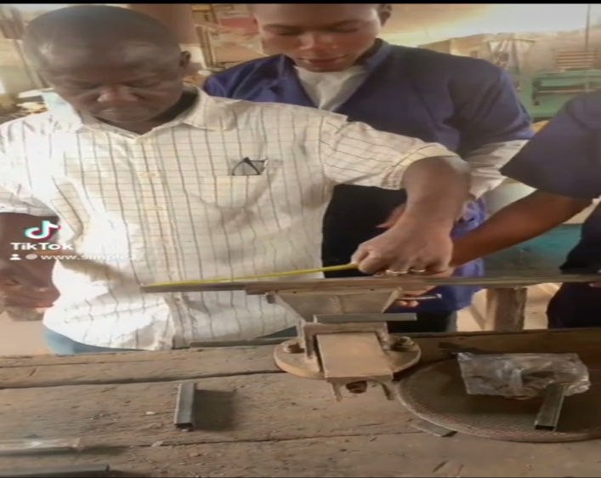
Figure 3.1: Pictorial View of the Measuring Process
Marking out: After the dimension has been carried out the next operation was to locate the point where the operation is been performed by marking out with chalk.
Tool use: protractor, caliper, divider, pencil, measuring tape, chalk e.t.c
Figure 3.2 shows pictorial view of marking out

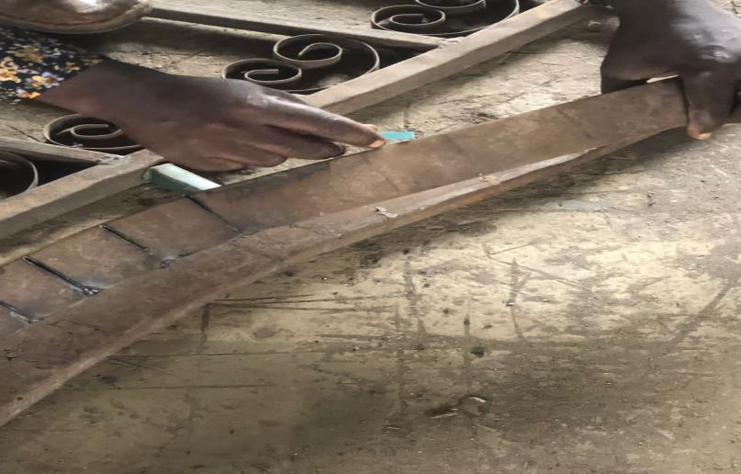

Figure: 3.2: Pictorial View of Marking Out
Cutting procedure: In this aspect, we were able to cut out the require length that need to be welded. The pipe was mounted on holding device called vice of the cutting operation.
Tool use: Hack saw, blade and bench vice electric arc.
Figure 3.3 shows a pictorial view of cutting process
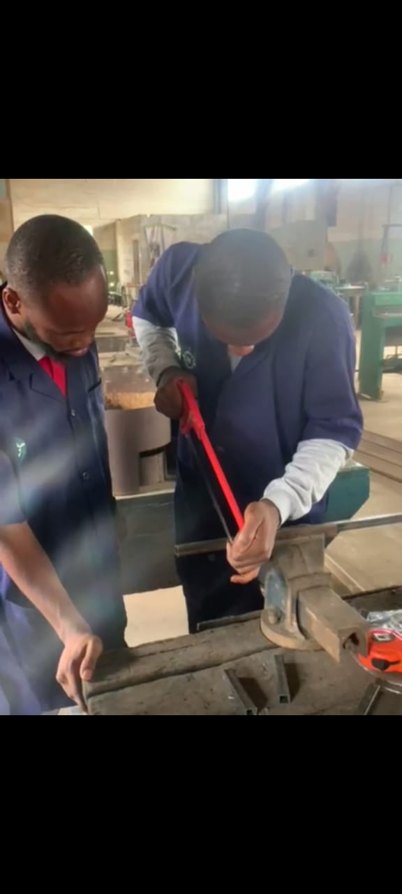

Figure 3.3: Pictorial View of Cutting Process
Forming Process: This refers to the processes used to shape and bend the material into the desired shape and form. Common forming operation used in rail fence construction:
Bending: Rails are bent to create the curved or zigzag pattern characteristics of worm fences.
Shaping: Rails are shaped to fit together perfectly, creating a snug and secure joint.
Notching: Rails are notched to create a secure connection between the horizontal rails and the vertical posts.
Tools used: Drawknife, Spokeshave, chisel, Mallet e.t.c

Figure 3.4 shows a pictorial view of forming process
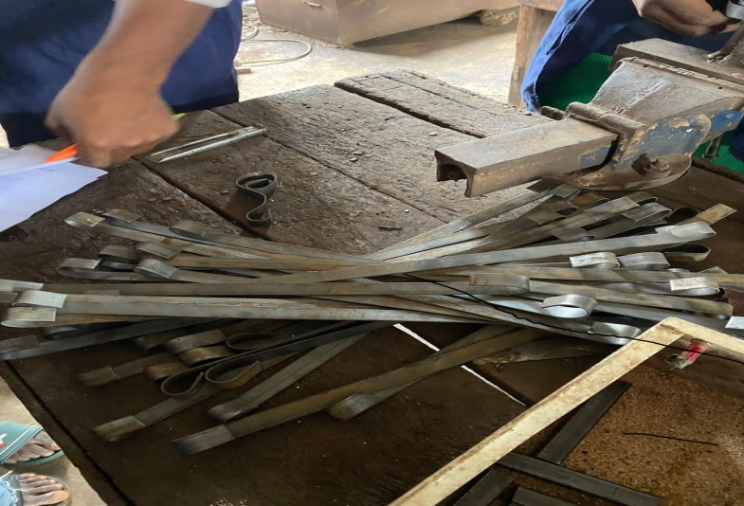
Figure 3.4: Pictorial View of Forming Process
Welding and Joining: This is the most vital aspect of the operation, that need to be very careful about which involved the joining of two or more metals together by-passing electrode current through the electrode metals.
Tool use: Welding, hammer electrode with a thong.
Figure 3.5 shows a pictorial view of welding and joining process
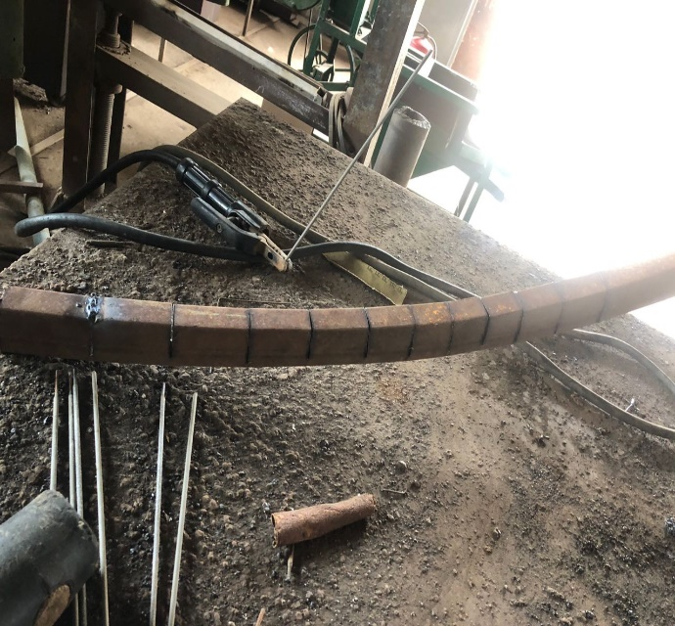

Figure 3.5: Pictorial View of the Welding Process
Finishing Process: This refers to the final steps taking to complete and protect the Fence. So here some common finishing processes:
Trim work: Adding decorative trim to cover any gaps or edges.
Inspecting: final inspection to ensure the fence is sturdy, level, and plumb.
Waterproofing: applying a waterproofing agent to prevent rot and decay.
A well-finished rail fence can enhance the beauty of the surrounding landscape and provide long-lasting durability.
Tools used: tape measure, level, safety glasses, work gloves, hammer, paint tray e.t.c
Grinding Process: Grinding come after welding operation, which involves the operation, and the smoothing of the welded parts.
Tool use: Hand grinding machine and disk plate.
Figure 3.6 shows a pictorial view of grinding process
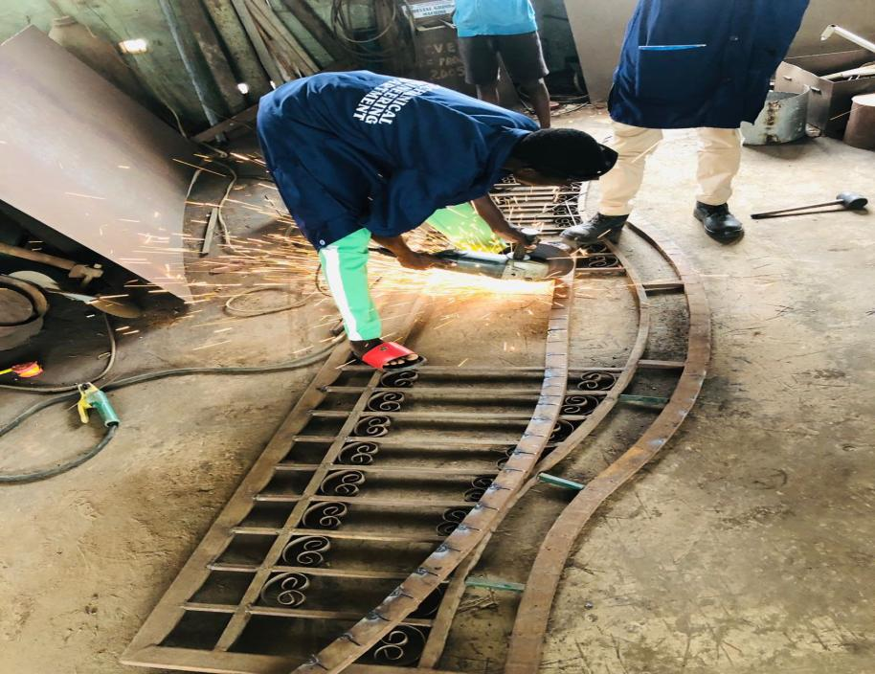

Figure 3.6: Pictorial view of Grinding
Figure 3.7 shows the pictorial view of the completed Rail Fence.
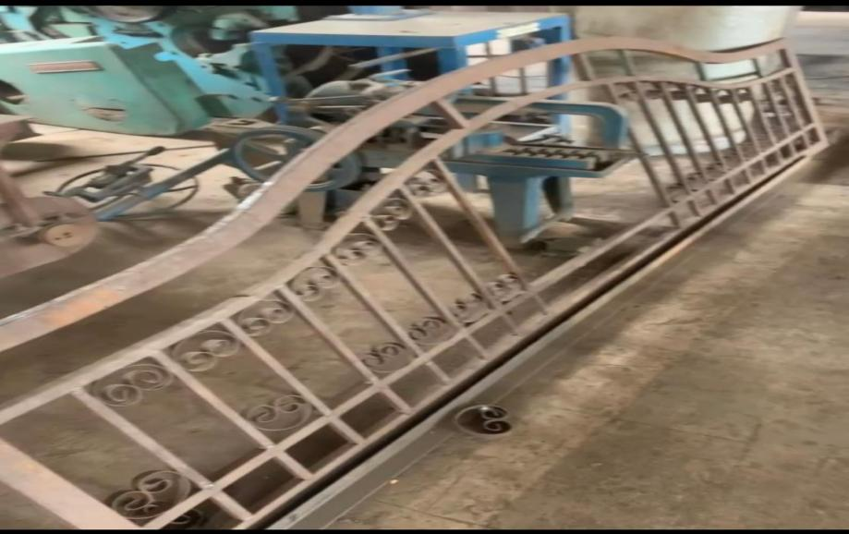
Figure 3.7: Pictorial View of the Completed Rail Fence
Painting: This is the last stage and it’s requiring a good creative mind. This is also to give a beautiful out look to the project work.
Tool use: Brush and Paint.

3.5 Procedures in Summary
After the dimension has been carried out we were able to mark out the point where the dimension stopped, with the use of sabre and chalk.
When the marking out has been done, we mounted the pipe on the vice and cut the pipe with the use of hacksaw blade as marked respectively through the construction based on this dimension as follow:
- Farming of the fence rail wall to wall length 10fat (11inches) = 2950mm
- Cutting of the height 27inches = 685mm
- Cutting of flat bar design using bench shearing machine
- Forging of flat bar design
- Welding of wall to wall rail (i.e. length of 116 inches and height of 27inches)
- Framing of the fence rail
- Forming of the fence rail

3.6 Welding Operation
Welding can be defined as a process of joining metals through the use of welding equipment like, welding machine, welding tong, electrode, etc. (ref: google: “definition of welding”).
3.6.1 Safety Precaution
During welding operation, the electrode and the parts of holder or tong arc are electrically alternative hot. The arc gives a visible of high intensity, ultra-violet radiation and ultra-reed radiation being given off.
Some flame emits OH, but these are not normally detrimental to health. However, arc welding equipment and processes can be used with complete safety provided they are used correctly, and with proper care taking precaution within general simple matter of common sense.
3.6.2 Welding Equipment
Electric arc welding is normally carried out by transformer or motor generator set which take their supply from electrical distribution system in the workshop or alternatively by engine driver general welding transformers which may or may not in corporate rectifier arc either oil-cooled by fan. Care should be taken to ensure sufficient ventilation for the transformer to avoid exceeding rated temperature rise and thereby causing dangerous overheat of the equipment.
In the majority of case the electrical circuit is relatively simple, but it is important to understand the three-essential connection for every circuit.

There are:
- Welding lead: As it is normally committed to the electrode wide, this cable has to be capable of the fill welding current without overheating and must be sufficiently flexible and bust to withstand everyday use.
- Welding return: It is often the most neglected part of the whole welding system. It is not the earth lead. It is the enable by which all the current returns to the welding set. Once this fact is realized the importance of the welding cable, but it need not to be as flexible.
- Welding earth: This is essential to ensure that the welding circuit is adequately earthen. The cross selection of the welding earth should be capable of carrying the full welding current.

3.7 Electrical Joint:
It must be emphasized that the welding circuits is frequently carrying current of served hundred amperes. In addition to ensuring adequate capability-cable for the weld lead return and earth cable must be sufficient at the equipment, the electrode holder and the work. If a cable is joined throughout it length, coupling should be affected by plug and socket cable connections or efficient cable joint and not by nuts and bolts which after work loose, become eroded and result in an efficient circuit danger to personal and equipment.
3.7.1 Electrode Holder
Electrode holder should be of sufficient capacity to hold the largest to be used and carry the maximum welding current without overheating. The holder i.e. the tong must be provided with an insulated handle, as reliance must be placed on the welder’s glove for insulating the operation hand form live part care is necessary in leaving an electrode holder when welding is temporarily suspended. Then stated is to make the holder dead either by means of a plug and socket near the holder or at the transformer regulator alternatively by disconnecting the completer equipment.

3.8 Precautions against other Risks
The arc welding is a source of great heat and these all together can easily cause fire. Inflammable material such as oils, paints, etc. must be removed from the vicinity of welding operation. It is necessary to clean both side of the work to be welded and cover all opening to ensure that spatter does not fall through.
Personnel must be protected during welding against the heat and the possibility of burns, leather apron or other suitable turn ups at cuffs of trouser are wide precaution. Leather or asbestos glove must be used; rubber glove are not suitable. A shoe about six inches high should be worn.
3.8.1 Helmet and Goggle
For all welding work, either the helmet or goggle is essential to protect the welder’s head and eye from radiation, spatter and hot slogs. All helmet and goggle are filtered with filler glass and protective cover glass.
3.8.2 Screens
All electric arc welding operation area should be screened to forestall the ray of the arc from affecting other person working in the vicinity.
3.8.3 Ventilation
Whenever welding is performed adequately, ventilation is necessary when welding, heavy concentration over a long period of time can cause discomfort. Particular care should be taken when welding mild steel material as inhaling the fume is hazardous. The exhaust fans should be suitably position to clear fume from the vicinity of welding.
3.8.4 Painting
This is the last stage of the construction and it application require a good creative mind in the selection of paint to apply.

3.9 Problem Encountered
The project is a fabrication work, which involves welding mostly. The large percentage of the work depended on electricity. This welding operation occupied about 80% of the total period of work.
Power supply was irregular during the construction of the project bringing about a waste of time.

3.10 Bill of Engineering Measurement and Evaluation (BEME):
Due to the depreciation of the value of our naira, the cost of all the materials used cannot stable; however, at the time of fabrication, the costs of materials used for the project are listed in Table 3.1 below
Table 3.1: Bill of Engineering Measurement and Evaluation (BEME)
S/N | MATERIAL | QUALITY | RATE | COST
1. | 2x1x1.2mm Pipe | 4 Lengths | 8,500 | 34,000.00
2. | 1x1mm Pipe | 2 Lengths | 4,000 | 8,000.00
3. | Flat Bars | 6 Lengths | 3,200 | 19,200.00
4. | ¾ Square Black Pipe | 5 Lengths | 3,000 | 15,000
5. | Cutting and Grinding Discs | 5 | 1000 | 5000
6. | Electrode | 1 Packet | 11,800 | 11,800.00
7. | Paint | 2 Litres | 7,500 | 15,000.00
8. | Petrol | 3 Litres | 850 | 2,550.00
9. | Sand Paper | 1pcs | 2,000 | 2,000.00
10. | Transport |  | 5,000 | 5,000.00
11. | Sprayer/ Painter | 1pcs | 3,500 | 3,500.00
 |  |  |  | 121,050.00

CHAPTER FOUR

4.0 DESCRIPTION OF THE FENCE RAIL COMPONENT
Fence rail is rectangular constructed proof, put on top of a brick fence surrounding a building.
This is also a means of providing more security for a building, it is not just a means of beautifying a house but as means of securing people life and properties against any external attack.

4.1 General Description of the Component
The fence rail is made up of 50x5 rectangular pipe, 25x25 square pipe, 17.5x17.5 square pipe and a float bar (flat metal). The fence rail has been deluded into the following component parts.
- The main frame of the fence rail: This is the main body of the fence rail which consist of the outermost pipe of 50x25 rectangular pipe as the main frame.
- Huge unit: This is the unit that allows the fence rail to be fixed on the wall by casting concrete that give maximum rigidity to the whole unit.
4.1.1 External Vertical Frame Pipe
It is made of two part
- The upper most
- The bottom
- The upper most part: This part of the external vertical frame consists of 50x25 pipe to form an arc.
- The bottom: This part of the external vertical frame consists of 50x25 pipe of length 2950mm.
4.1.2 External Horizontal Frame Pipe
This fence rail fabricated consists of horizontal and vertical.
The uppermost vertical is been designed like the external pipe in arc and the bottom pipe using 25x25 square pipe. The horizontal internal frame consist of 17.5x17.5 square pipe and a spiracle flat bar.

CHAPTER FIVE

5.0 CONCLUSION AND RCOMMENDATION

5.1 Conclusion
The fabrication of the fence rail from locally available material which is the aim of the project has been accomplished. This project had really exposed us to practical experience and enable us to put some of the theoretical knowledge gained in the class to practice.
This project has though student how to be independent creative thinking and brain terming. Also, it has prepared student for the challenges ahead, team work and technological advancement.

5.2 Recommendation
As a result of different innovation in the world of technology, improvement is being done on the past and present works. Technology discovers new ways of improving what has been done. It is therefore recommended that this fence rail design be improved on by the incoming student, in term of aesthetic and choice of materials.

REFERENCES

Abdulqadir B.L. (2012): “Strength of Materials”, SMS Publishers & Printing Enterprises, Ilorin, Nigeria, ISBN: 97834393-9-3.

Dreicer, G. (1996): “Between fences” New York: Princeton Architecture Press, ISBN: 1568980809.

Southworth, S. and M. (1992). Ornamental Ironwork. New York: McGraw-Hill ISBN: 0070598045.

Pollard, E., Hooper, M.D. & Moore, N.M. Hedges. London: Collins, 1974. ISBN-10: 0002190819.

Rick Kubic (2007): “How to Build and Repair Fences and Gates”, Voyageur Press, Beverly, USA. ISBN: 978-0760327746

Waterman, Todd (1981): “Rail Fences. Their History and Construction”, Bittersweet inc., Vol. IX, No. 1.

