A PROJECT REPORT
ON
A PROPOSED POULTRY FARM
FOR
MR OLUSEYI ABIODUN MAKINDE
AKINYELE, IBADAN, OYO STATE.

BY.
ADELEKE DAMILOLA DORCAS
ND/23/ARC/PT/OOO8

BEING A PROJECT REPORT SUBMITTED TO
THE DEPARTMENT OF ARCHITECTURAL TECHNOLOGY, INSTITUTE OF ENVIRONMENTAL STUDIES (IES),
KWARA STATE POLYTECHIN, ILORIN.

IN PARTIAL FULFILLMENT OF THE REQUIREMENT FOR
THE AWARD OF NATIONAL DIPLOMA(ND)
IN ARCHITECTURAL TECHNOLOGY.

JULY,2025

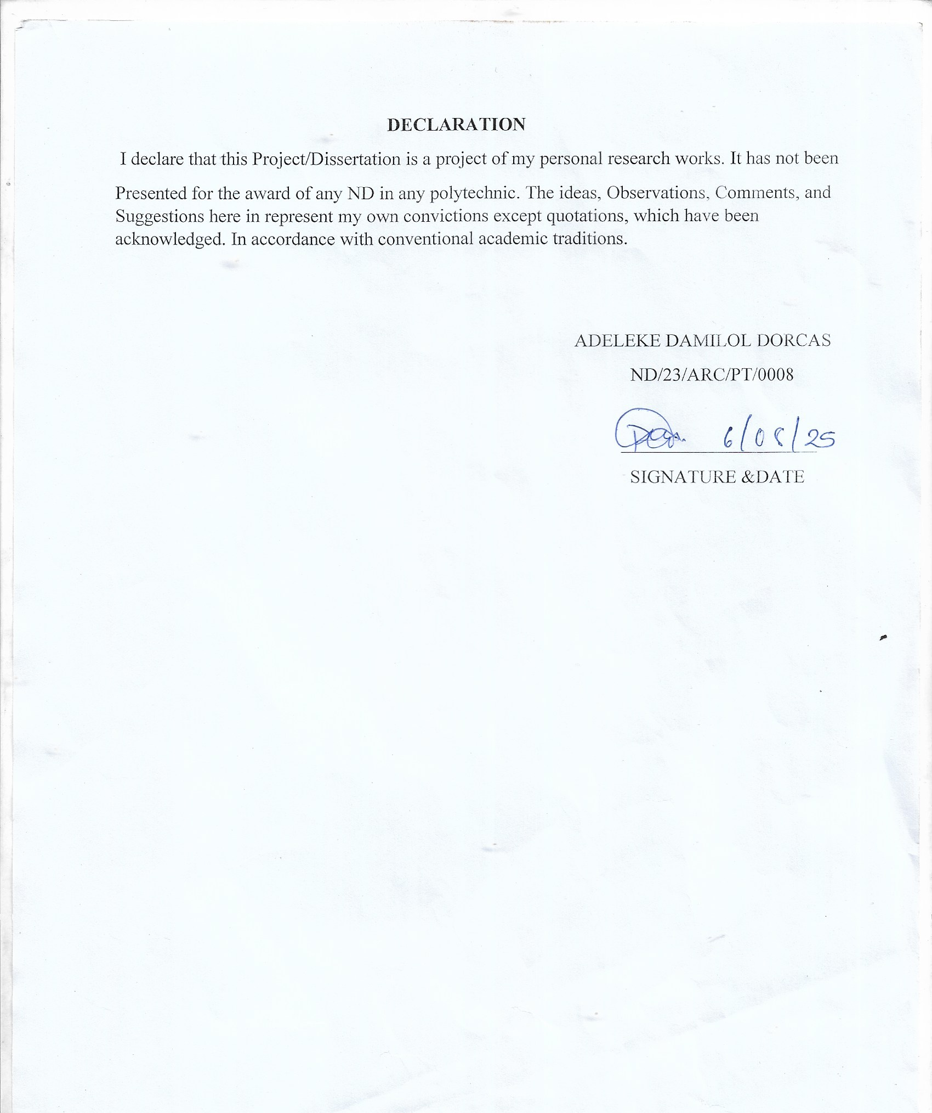

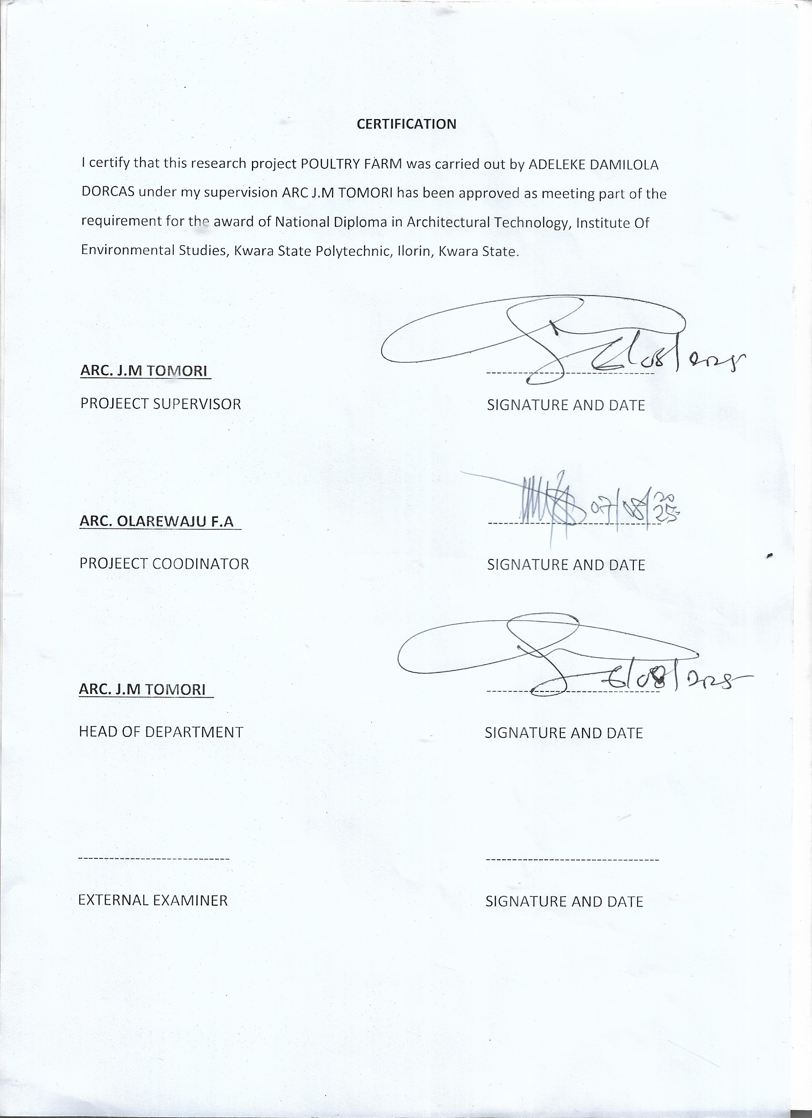

ACKNOWLEDGEMENT
My profound gratitude goes to Almighty God, the creator of universe and fountain of all wisdom whose umbrella of guard and guide. I seek refuge through thick and thin of years of study.
I will also like to appreciate my project supervisor in person of Arc J.M TOMORI whose contribution Prepares me for the challenges in the field and for her immense contribution is all ramification towards the completion of this research work. She encourage me and open the door of interaction with her. I pray Almighty God will shower his blessing and mercy over her, your family and may you live to reap the fruit of your Labor.
I also want to thank and appreciate the effort of all the Lectures in Architectural Technology Department my project coordinator ARC. OLAREWAJU and the host of lectures ARC. FAMILUA O.S, ARC. CHUCKWUMA NMOM, ARC. MOH. SHERO, who taught and give lasting advice’s that led to the success of my program, Almighty God will meet everyone at the point of needs.
I would also show my profound gratitude to my parents MR and MRS ADELEKE for their Immeasurable motivation, advices, efforts, and prayers on me for the completion of this program.
My Lovely Brother: Mr Adeleke Ademola and my lovely sister miss Adeola. Almighty God shower his endless blessing, mercy, unlimited grace, joy, happiness without sorrow, sound health overall and may Almighty God meet everyone at the point of your needs.
Precious friends: My lovely friends Adijat, Adeleke Toyin, Ayomiposi, Abidoun, Idowu, Faith, Emma. Almighty God shower his blessing, grace, and happiness with sound health over you all and our prayer (AMEEN)
I would also show my appreciation for the effort of an unforgettable of MR ADELEKE OLUSHOLAMI , who advise me to carry on my journey.May Almighty God bless you and grant your heart desires, good health over you.
Lastly ,I would like to appreciate the effort of my colleagues in department, school, and hostel, I whole heartedly say a VERY BIG THANK YOU, I appreciate you all, May Almighty God bless you all.
Above all, My utmost thanks go to the all sufficient God, the fountain of my wisdom, for his great and protection over my life, for his undying love, support and guidance throughout my period of learning and also for in sighting writing this project without him am nothing.

DEDICATION This project work is dedicated to Almighty God who has been providing all my need for his blessing and mercy over me all through the program.
And to my parent, my sisters, my brothers, friends, love one’s and supervisor who assist me financially, spiritually, mentally and guide me through my academic pursuit. May Almighty God shower his blessing and mercy over you all.

TABLEOFCONTENT
TITLE PAGE………………………………………………………………………….....i
DECLARATION……………………………………………………………………..…..ii
CERTIFICATION…………………………………………………………………….….iii
ACKNOWLEDGEMENT……………………………………………………………......iv
DEDICATION…………………………………………………………………………....v
TABLE OF CONTENT………………………………………………………………......vi
LIST OF TABLE… ..x
LIST OF FIGURES…………………………………………………………………..…...xi
LIST OF PLATES………………………………………………………………………...xii
LIST OF APPENDICES………………………………………………………………....xiii
ABSTRACT………………………………………………………………………….…..xiv
CHAPTERONE
1.1 INTRODUCTION…………………………………………………………………...1
1.2 DEFINITION…………………………………………………………………………2
1.3 HISTORICALBACKGROUND……………………………………………………..3
1.4 AIMAND OBJECTIVES ……………………………………………………………4
1.5 PROJECT JUSTIFICATION ………………………………………………………...4
1.6 CLIENT BACKGROUND…………………………………………………………....5
1.7 SCOPE OFTHEPROJECT…………………………………………………………..5
1.8 RESEARCHMETHODOLOGY……………………………………………………..5
CHAPTERTWO
2.1 LITERATURE REVIEW……………………………………………………………6
2.2 HISTORICALBACKGROUND……………………………………………………6

CHAPTERTHREE
3.1 CASESTUDIES………………………………………………………………...........6
3.2 SELECTEDCASE STUDIES 6
3.3 CASESTUDYONE………………………………………………………………….7
3.4 CASESTUDYTWO………………………………………………………………..11
3.5 CASE STUDY THREE……………………………………………………………...12
3.5 ONLINECASESTUDY…………………………………………………………….15
3.6 DEDUCTION………………………………………………………………………..16
CHAPTERFOUR
4.1 BRIEF HISTORICAL BACKGROUND………………………………………18
4.2 LOCATION AND SETTING OUT………………………………………….....19
4.3 POPULATION………………………………………………………………….19
4.4 SITE INVENTORY……………………………………………..………………21
4.5 SITE ANALYSIS………………………………………………………………..21
4.5.1SITE SELECTION AND JUSTIFICATION… ……………………… ..……22
4.5.2LOCATION …………………………………………………………………..22
4.5.3ACCESSIBILITY………….………………………………………………….22
4.5.4INFRASTRUCTURE FACILITES….………………………………………..23
4.5.5 TOPOGRAPHY………………………………………………………….........23
4.5.6 SOIL STRUCTURE…………………………………………………………...23
4.6 GENERAL CLIMATE CONDITION.…………………………………………..23
4.6.1RELATIVE HUMIDITY……………………………………………………………...23
4.6.2 WIND…........................................................................................................................23
4.6.3 TEMPERATURE……………………………………………………………………..24
4.6.4 VEGETATION………………………………………………………………………..24
4.7 SOCIAL SERVICES…………………………………………………………………….25
4.7.1 ROAD………………………………………………………………………………….24
4.7.2 WATER AND ELECTRICITY………………………………………………………..24
4.8 DESIGN CRITERIA……………………………………………………………………..25
4.9 DESIGN BRIEF ………………………………………………………………….………25
4.10 DESIGN ANALYSIS… …………………………………………………………...25
4.11 SPACIAL ALLOCATION …………………………………………………………...26
4.12 PLANNING PRINCIPLE……………………………………………………………….28
CHAPTERFIVE
5.1 APPRAISAL OF PROPOSED SCHEME………………………………………………..29
5.2 CONSTRUCTION METHODOLOGY…………………………………………………..29
5.3 SERVICES………………………………………………………………………………..29
5.3.1 VENTILATION…………………………………………………………………………29
5.3.2 LIGHTING………………………………………………………………………………30
5.3.3 PLUMBING……………………………………………………………………………..30
5.3.4 ELECTRICAL INSTALLATION………………………………………………………30
5.3.5 WASTE DISPOSAL…………………………………………………………………….31
5.3.6 FIRE PROTECTION…………………………………………………………………….31
5.3.7 RAIN PROTECTION……………………………………………………………………31
5.3.8 EXTERNALWORK……………………………………………………………………..31
5.4 SUMMARY………………………………………………………………………………..31
5.5 CONCLUSION…………………………………………………………………………….32
5.6 RECOMMENDATION……………………………………………………………………32
5.7 REFERENCES……………………………………………………………………………..33
5.8 APPENDICES……………………………………………………………………………...34

LISTOFTABLES
TABLE4.1;SHOWING THE POPULATION OF THE GENDER……………………….25
TABLE4.2;SHOWING SPACIAL ALLOCATION OF FLOOR PLAN…………………30

LIST OF FIGURES
FIG3.1 SHOWING LOCATION PLAN OF CASE STUDY ONE……………………….10
FIG3.2;SHOWING FLOOR PLAN OF CASE STUDY ONE……………………………10
FIG3.3;SHOWING LOCATION PLAN OF CASE STUDY TWO………………………13
FIG3.4;SHOWING FLOOR PLAN OF CASE STUDY TWO…………………………...14
FIG3.5;SHOWING LOCATION PLAN OF CASE STUDY THRE……………………..16
FIG3.6;SHOWING FLOOR PLAN OF CASE STUDY THREE………………………...17
FIG4.1;SHOWING LOCATIONAL PLAN OF THE PROPOSED SITE………………..24
FIG4.2;SHOWING SITE INVENTORY OF THE PROPOSED SITE…………………..26
FIG4.3;SHOWING SITE ANALYSIS OF THE PROPOSED SITE……………………..27

LIST OF PLATES
PLATE3.1;SHOWING FRONT VIEW OF CASE STUDY ONE…………………………..11
PLATE3.2;SHOWING RIGHT VIEW OF CASE STUDY ONE …………………………..12
PLATE3.3;SHOWING FRONT VIEW OF CASE STUDY TWO………………………….14
PLATE3.4;SHOWING WAITING AREA OF CASE STUDY TWO………………………15
PLATE3.5;SHOWING FRONT VIEW OF CASE STUDY THREE……………………….16
PLATE3.6;SHOWING RIGHT VIEW OF CASE STUDY THREE………………………..17

LISTOFAPPENDICES
APP1;SHOWING SITE PLAN OF THE PROPOSED PROJECT ………………………38
APP2;SHOWING GROUND FLOOR PLAN OF THE PROPOSED PROJECT………..39
APP3;SHOWING ROOF PLAN OF THE PROPOSED PROJECT……………………...40
APP4;SHOWING CROSS SECTION OF THE PROPOSED PROJECT………………..41
APP5;SHOWING FRONT VIEW OF THE PROPOSED PROJECT……………………42
APP6;SHOWING SIDE VIEW OF THE PROPOSED PROJECT………………………43

ABSTRACT
This researcher work was carried out on the project topic "poultry farm for Ibadan, Oyo state ". I felt caring out this project in Akinyele local government will bring out meaningful result. For easy analysis and understanding, the study is being put into five chapters. Chapter one throws light on general introduction, definition of the project, historical background information of the project title, project justification, aim and objectives of the study, scope of the study, Chapter two, a detailed literature review of some books. The third chapter three also mention about thecase studies and deduction from case studies. The fourth chapter deals with historical background of the study area, site location and description, site analysis, and geographical location, climatic data, population of the area, social services, and health services design criteria, design analysis, space allocation and planning principle. Chapter five deals with design appraisal, construction methodology, services, summary, conclusion and references.

CHAPTER ONE
  - INTRODUCTION
Poultry farm involves the domestication and raising of birds, primarily chickens, ducks, turkeys, and geese for the production of meat, eggs and feathers. It plays a vital role in providing animal protein in many parts of the world. Poultry can be categorized into layers (for egg production) and boilers (for meat production).
The poultry industry has grown significantly due to its relatively quick returns, growing demand for poultry products and the adaptability of poultry to various environments. However, success in poultry farming requires understanding a proper management practices, diseases control, feeding and housing to ensure high productivity and sustainability.
Poultry refers to domesticated birds raised for their meat, eggs, and feathers. The term "poultry" encompasses various species, but the most common ones are chickens, turkeys, ducks, geese, and guinea fowl. These birds are an integral part of human agriculture due to their high reproductive rates, low maintenance costs, and the versatility of the products they provide.
Poultry farming has a long history, dating back thousands of years, and has evolved significantly to meet the growing demand for affordable protein sources. The industry plays a vital role in global food security, as poultry products, particularly chicken and eggs, are among the most widely consumed animal proteins worldwide.
The production of poultry is typically divided into two main sectors:
- Layer Farming – Focused on the production of eggs.
- Broiler Farming – Focused on the production of meat.
Poultry farming can be done on a small scale (such as in backyard settings) or on a large commercial scale. Advances in breeding, nutrition, and disease control have enabled the poultry industry to thrive, contributing to economic growth in many regions. Additionally, poultry farming has become more industrialized, with automated systems for feeding, egg collection, and meat processing, ensuring a steady and efficient supply of products to consumers.
In addition to its economic importance, poultry farming is also a significant source of employment for millions of people globally. However, the industry also faces challenges such as disease outbreaks (e.g., avian influenza), concerns over animal welfare, and the environmental impact of large-scale operations. Despite these challenges, the poultry sector remains a cornerstone of modern agriculture.

1.2 DEFINITION
A poultry farm refers to a purposefully designed facility for the breeding, raising, and housing of domestic birds such as chickens, ducks, turkeys, and geese, primarily for meat or egg production. The architectural design of a poultry farm focuses on optimizing bird welfare, productivity, biosecurity, and operational efficiency while ensuring sustainable environmental management.
1.3 HISTORICAL BACKGROUND
Poultry are domesticated birds kept by humans for the purpose of harvesting animal products such as meat, eggs or feathers. The practice of raising poultry is known as poultry farming. These birds are most typically members of the superorder Galloanserae (fowl), especially the order Galliformes (which includes chickens, quails, and turkeys). The term also includes waterfowls of the family Anatidae (ducks and geese) but does not include wild birds hunted for food known as game or quarry.
Recent genomic studies involving the four extant junglefowl species reveals that the domestication of chicken, the most populous poultry species, occurred around 8,000 years ago in Southeast Asia. This was previously believed to have occurred around 5,400 years ago, also in Southeast Asia.The process may have originally occurred as a result of people hatching and rearing young birds from eggs collected from the wild, but later involved keeping the birds permanently in captivity. Domesticated chickens may have been used for cockfighting at first and quail kept for their songs, but people soon realised the advantages of having a captive-bred source of food. Selective breeding for fast growth, egg-laying ability, conformation, plumage and docility took place over the centuries, and modern breeds often look very different from their wild ancestors. Although some birds are still kept in small flocks in extensive systems, most birds available in the market today are reared in intensive commercial enterprises.
Together with pork, poultry is one of the two most widely-eaten types of meat globally, with over 70% of the meat supply in 2012 between them; poultry provides nutritionally beneficial food containing high-quality protein accompanied by a low proportion of fat. All poultry meat should be properly handled and sufficiently cooked in order to reduce the risk of food poisoning. Semi-vegetarians who consume poultry as the only source of meat are said to adhere to pollotarianism.
Worldwide, more chickens are kept than any other type of poultry, with over 50 billion birds being raised each year as a source of meat and eggs. Traditionally, such birds would have been kept extensively in small flocks, foraging during the day and housed at night. This is still the case in developing countries, where the women often make important contributions to family livelihoods through keeping poultry. However, rising world populations and urbanization have led to the bulk of production being in larger, more intensive specialist units. These are often situated close to where the feed is grown or near to where the meat is needed, and result in cheap, safe food being made available for urban communities. Profitability of production depends very much on the price of feed, which has been rising. High feed costs could limit further development of poultry production.
In free-range husbandry, the birds can roam freely outdoors for at least part of the day. Often, this is in large enclosures, but the birds have access to natural conditions and can exhibit their normal behaviours. A more intensive system is yarding, in which the birds have access to a fenced yard and poultry house at a higher stocking rate. Poultry can also be kept in a barn system, with no access to the open air, but with the ability to move around freely inside the building. The most intensive system for egg-laying chickens is battery cages, often set in multiple tiers. In these, several birds share a small cage which restricts their ability to move around and behave in a normal manner. The eggs are laid on the floor of the cage and roll into troughs outside for ease of collection. Battery cages for hens have been illegal in the EU since January 1, 2012.
1.4 AIM AND OBJECTIVES OF THE PROJECT
AIM
To design and develop a modern, efficient, and climate-responsive poultry farm in Ibadan, Oyo State, that enhances poultry production while ensuring biosecurity, sustainability, and economic viability in line with local environmental and agricultural conditions.
OBJECTIVES
- Design compact and well-organized layouts to maximize space, considering future expansion possibilities.
- Adapt structures to Ibadan’s tropical climate by incorporating proper ventilation, heat control, and shading techniques.
- Ensure compliance with Oyo State agricultural regulations and environmental laws
- Design pathways and access roads for smooth transportation of feed, eggs, and poultry products.
- Plan for manure composting or biogas production to enhance sustainability and reduce environmental impact.
1.5 PROJECT JUSTIFICITION
The proposed poultry farm in Ibadan, Oyo State, is justified based on key architectural and operational considerations. The design will incorporate climate-responsive features, such as natural ventilation, insulated roofing, and rainwater harvesting, to mitigate the effects of the region’s tropical climate. Efficient land utilization will be prioritized to maximize productivity while allowing for future expansion.

  - CLIENTBACKGROUND
The name of my client is OLUSEYI ABIODUN MAKINDE
CURRENT GOVERNOR OF OYO STATE
Oluseyi Abiodun Makinde (born 25 December 1967) is a Nigerian engineer, businessman and politician who has served as the governor of Oyo State since 2019.
He is an engineer and a subject matter expert on fluid and gas metering.He is the group managing director of Makon Group Limited; an indigenous oil and gas company in Nigeria. He established his first oil and gas private business called Makon Engineering and Technical Services, (METS) at the age of 29 in the year 1997, after earning years of work experience with international oil and gas companies.
1.7 SCOPE OF THE PROJECT
- Entrance
• Reception area
• Manger office
• Chemical room
•Feed production room
• Pen cage
• IT room
• Changing room
• General storage
• Toilet
• Exit
ADMIN BLOCK SCOPE
- Entrance
- Reception
- Labouratory
- Record Room
- Staff Lounge
- Store
- First Aid
- Account Office
- Marketing Department
- Sec
- Manager Office
- Active office
- Conference Room
- Exist
- w/c
1.8 RESEARCH METHODOLOGY
Various avenues were expressed as regards the method of research on order to arrive at a functional and appealing design concepts. The following research methods were employed.
LITERATURE REVIEW: Reference to tolerate for ideas of various writer were consulted in order to attain useful and important past work on similar project.
INTERNET: This is are search that was done and gained from the internet in other to get further information.
PERSONAL OBSERVATION: personal initiative coupled within quisitive measure, interview and visualize the daily activities that take place within vicinity and necessary pictures were taken in order to attain there quired motive
CASE STUDIES: This involves the thorough synthesis and analysis of similar existing structure (building) Based on the data collected and better deduction was made for realization of the best.

CHAPTER TWO
2.0 LITERATURE REVIEW
2.1 HISTORCIAL BACKGROUND OF A POULTY FARM
Early animal welfare was based on the Five Freedoms, developed in the United Kingdom by the Brambell committee in 1965 as a framework on which to base regulations regarding husbandry of production animals (Fernandes et al. 2021; Webster 2016). Although the Five Freedoms provide a basis for animal welfare, there have since been significant developments in the methods to assess and measure animal welfare, and to what standards we consider welfare to be ‘good’. Definitions of animal welfare must incorporate the physical and mental health of the animal, as well as the interaction of the animal and its environment (Carenzi and Verga 2009). Animal welfare has progressed from being focused on the absence of negative states, to including positive states too (Rayner et al. 2020). Welfare is a continuum, and the state of an animals’ welfare depends on the individual’s experience and perception (Carenzi and Verga 2009). Many definitions of animal welfare exist, including (Fraser and Broom’s 1997) definition ‘The state of an animal as it attempts to cope with its environment’, and more recently, (Fernandes et al. 2021) ‘A transient state within an animal that relates to what the animal experiences’. The importance of considering animal welfare is formalised in the (Treaty of Amsterdam 1997), which acknowledges animal sentience and the need for animal welfare legislation regarding production animals. This is supported by the Cambridge Declaration on Consciousness (Philip Low Foundation 2012), which states that all mammals, birds, and many other creatures are conscious beings and have the capacity for consciousness, and therefore suffering. The European Union (EU) sets out minimum standards for animal management in member states (Falaise 2019), however, many countries outside of the EU have limited or no animal welfare legislation.
Culture, religion, economics, and climate are all factors which influence a country’s perspective of animal welfare, and people from European countries are generally more concerned with animal welfare than those from Asia (Phillips et al. 2012). In Asia in general, animal welfare legislation and regulation are still under development (Murray et al. 2014) and fall behind countries regulated by the EU (Sinclair et al. 2017). There have been multiple incidents where welfare concerns between countries have affected international trade of animal products. For example, Australia implemented a temporary ban on live cattle exports to Indonesia due to recorded animal cruelty at slaughter (BBC 2011), resulting in major economic and animal losses (Phillips 2005). There are also consumer concerns within Europe that imported meat is grown to a lower standard compared to European regulations (Eurogroup for Animals n.d.Sinclair et al. 2017) suggest that to improve animal welfare in Asian countries, an approach tailored to local audiences and climate will be most effective.
Efforts to improve animal welfare in Asia include the Regional Animal Welfare Strategy – Asia, the Far East and Oceania (RAWS), a programme developed by the Australian government and supported by the World Health Organisation (OIE). There is a current (2023) shift in the animal welfare environment to focus on improving standards of animal welfare in Asia and improve biosecurity, including a range of grants available specifically focused on farm animal welfare in Asia, from Compassion in World Farming, World Animal Protection, Animals for Asia Coalition, Universities Federation for Animal Welfare and others. These initiatives demonstrate a focus on and provide opportunities to research, campaign and improve animal welfare in Asian countries. Indonesia is a member of the RAWS programme. Relevant legislation in Indonesia include Law No. 18 of 2009 Concerning Livestock Husbandry and Animal Health, and Regulation No. 95 of 2012 Concerning Veterinary Public Health and Animal Welfare. These mainly focus on animal health and welfare to ensure human health, food safety, and to prevent torture and misuse of animals. Animal welfare is referred to in the legislation where the Five Freedoms are stated in Regulation no. 95 of 2012, regarding all vertebrate animals and invertebrates that can feel pain.
The World Animal Protection (WAP) Index rates countries regarding their recognition and legislation of animal sentience and prevention of cruelty to animals in a score of several factors from A (best) to G (poor). Indonesia in the WAP Index was given an overall score of E (World Animal Protection 2020), because Indonesia does not have an animal welfare strategy, and awareness of animal welfare among animal production farmers is lacking.
In 2018, the Indonesian government prohibited the use of antibiotic growth promotors as supplements in animal feed in an amendment under Law no. 18 of 2009, which also included other restrictions on the use of antimicrobials. Antimicrobials are used to reduce disease, when antimicrobial usage is restricted, an alternative is to improve animal welfare and management to prevent disease instead (Dawkins 2017). Assessment of livestock facilities, and routine inspections are necessary to ensure that legislation are adhered to.
In many areas of Asia, pork is the leading product in the meat industry, e.g. in China (Statista 2023) and Vietnam (Hanh et al. 2019), however, Indonesia is a predominantly Muslim country which restricts the consumption of pork, and chicken is the most consumed meat product there (excluding fish) (Statistics Indonesia 2023). The chicken farming system in Indonesia has similarities to the system in Malaysia, where many farmers are contracted to grow chickens by vertical integrator companies (Baluch et al. 2017), and birds are usually harvested when they reach around 2 kg at 30–33 days. Baluch et al. 2017) suggest that the industry in Malaysia has overly prioritised business interests of growth and profit, and the focus on consumer concerns, health, animal welfare and environmental safety is compromised. Similar concerns may also apply to the industry in Indonesia.
Worldwide, more chickens are kept than any other type of poultry, with over 50 billion birds being raised each year as a source of meat and eggs.traditionally, such birds would have been kept extensively in small flocks, foraging during the day and housed at night. This is still the case in developing countries, where the women often make important contributions to family livelihoods through keeping poultry. However, rising world populations and urbanization have led to the bulk of production being in larger, more intensive specialist units. These are often situated close to where the feed is grown or near to where the meat is needed, and result in cheap, safe food being made available for urban communities. Profitability of production depends very much on the price of feed, which has been rising. High feed costs could limit further development of poultry production.
In free-range husbandry, the birds can roam freely outdoors for at least part of the day. Often, this is in large enclosures, but the birds have access to natural conditions and can exhibit their normal behaviours. A more intensive system is yarding, in which the birds have access to a fenced yard and poultry house at a higher stocking rate. Poultry can also be kept in a barn system, with no access to the open air, but with the ability to move around freely inside the building. The most intensive system for egg-laying chickens is battery cages, often set in multiple tiers. In these, several birds share a small cage which restricts their ability to move around and behave in a normal manner. The eggs are laid on the floor of the cage and roll into troughs outside for ease of collection. Battery cages for hens have been illegal in the EU since January 1, 2012.

CHAPTER THREE
3.1 CASE STUDIES
This is are search or an exercise that is carried out on existing building which is similar to the one researcher is writing on. The objective of a case study is to take a critical appraisal of existing related project with a view to identify the positive and negative aspect of such projects. It is only with time that a project can be adjusted so that it can be successful. The information obtained from the appraisal will guide the designer of new and similar project, the positive aspect of it shall be incorporated in the view proposal while attempts will be made to solve the problem of negative aspects. It is only through this that a designer can better enhance the quality and efficiency of building in the society. For a comprehensive analysis their case studies have been conducted.
3.2 SELETED CASE STUDIES
Case studies are of paramount important. It is an experimental research or analysis carried out on existing building or group of building functionally similar to the one which there search is working.
For any technical design to be meaningful there is always the need for preliminary research effort to be made on this proposal as a very necessary ground work.
The following case study of some poultry farm.
3.3 CASE STUDY ONE
- KENTIMAL FRAM
Location: FRM5, FPX, ERUWA ROAD,SHARPCONER,OLOGUNERU IBADAN, OYO STATE
OBSEVERATION
MERITS
- Availability of land for proper site zoining
- Natural Ventilation and Lighting Potential
- Environmental Learning Opportunity
DEMERITS
- Accessibility Challenges
- Environmental Impact Concerns
- Climatic Challenges (Heat & Rainfall)
- Infrastructure Deficiency.
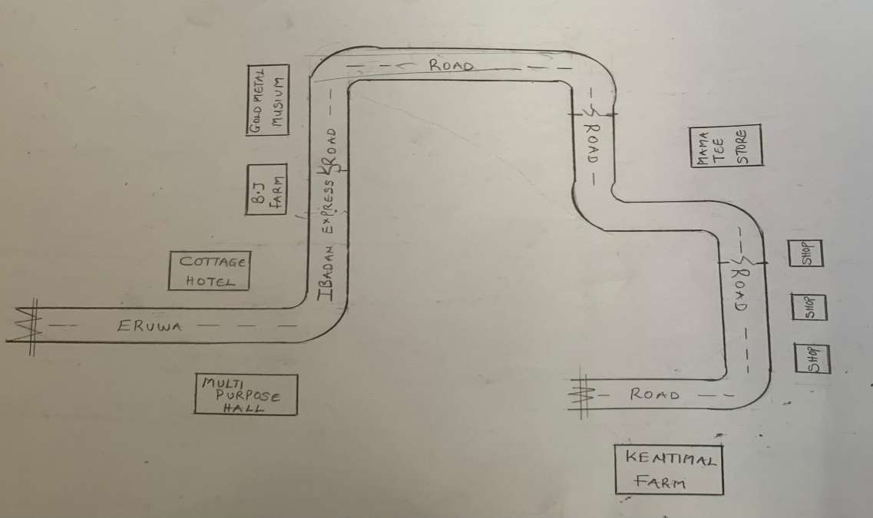
FIG3.1;SHOWING LOCATION PLAN OFCASE STUDY ONE
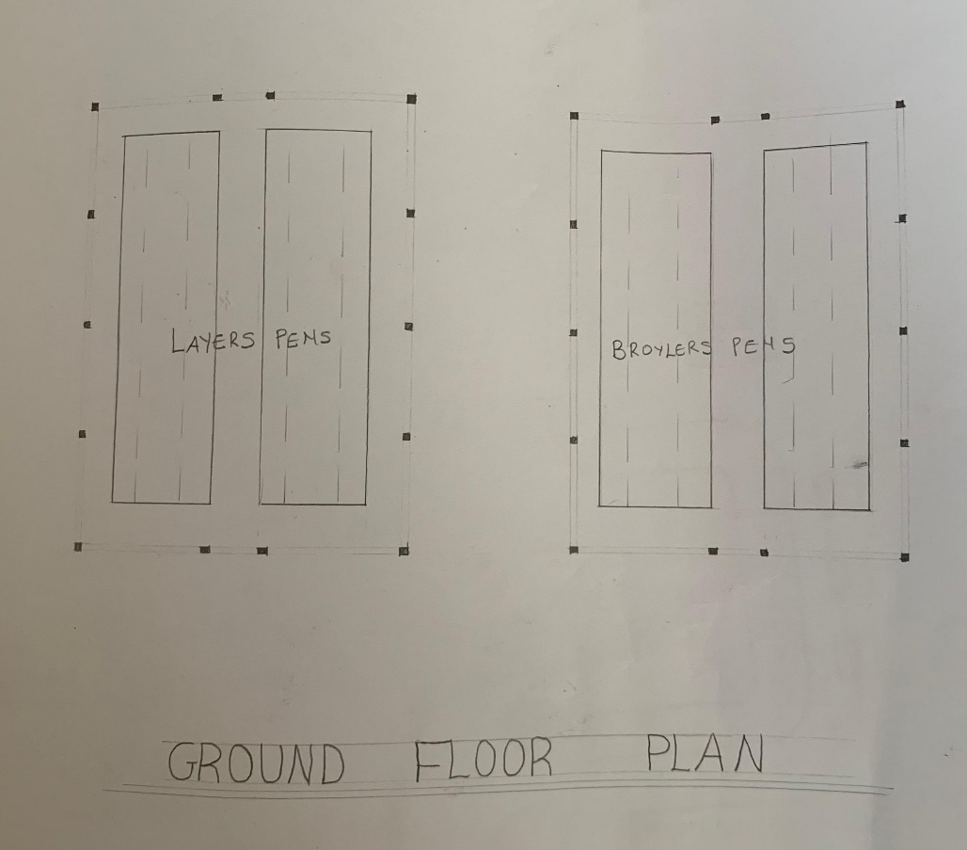
FIG3.2; SHOWING FLOOR PLAN OF CASE STUDY ONE
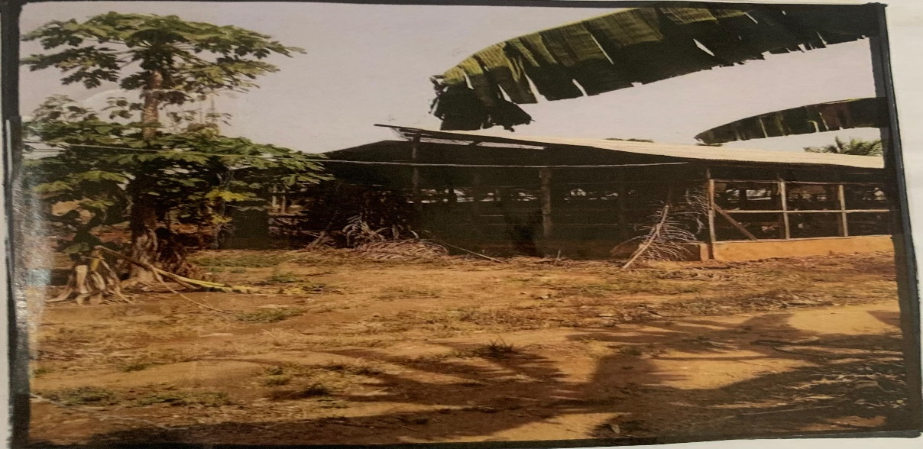

Plate3.1: SHOWING LEFT VIEW OF CASE STUDY ONE

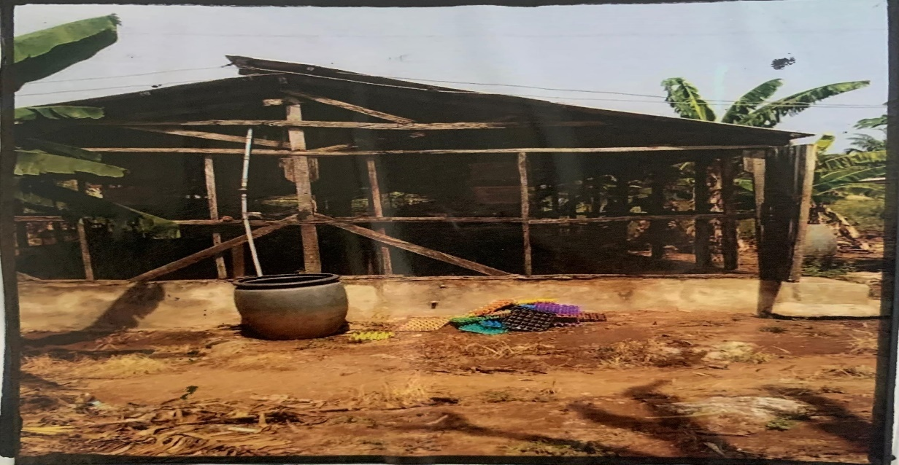
Plate3.2: SHOWING FRONT VIEW OF CASE STUDY ONE
3.3 CASE STUDY TWO
- HERITAGE POULTRY FARM
Location: ODEDA ABEOKUTA OGUN STATE
OBSERVATION
MERITS
- Spacious and Well-Organized Layout
- Good Road Network (Varies by Specific Location in Ogun)
- Moderate Topography
- Environmental Study Opportunity
DEMERIT
- Inconsistent Infrastructure (Depending on Location)
- Environmental Pollution Risks
- Climatic Factors (Rainfall & Heat)

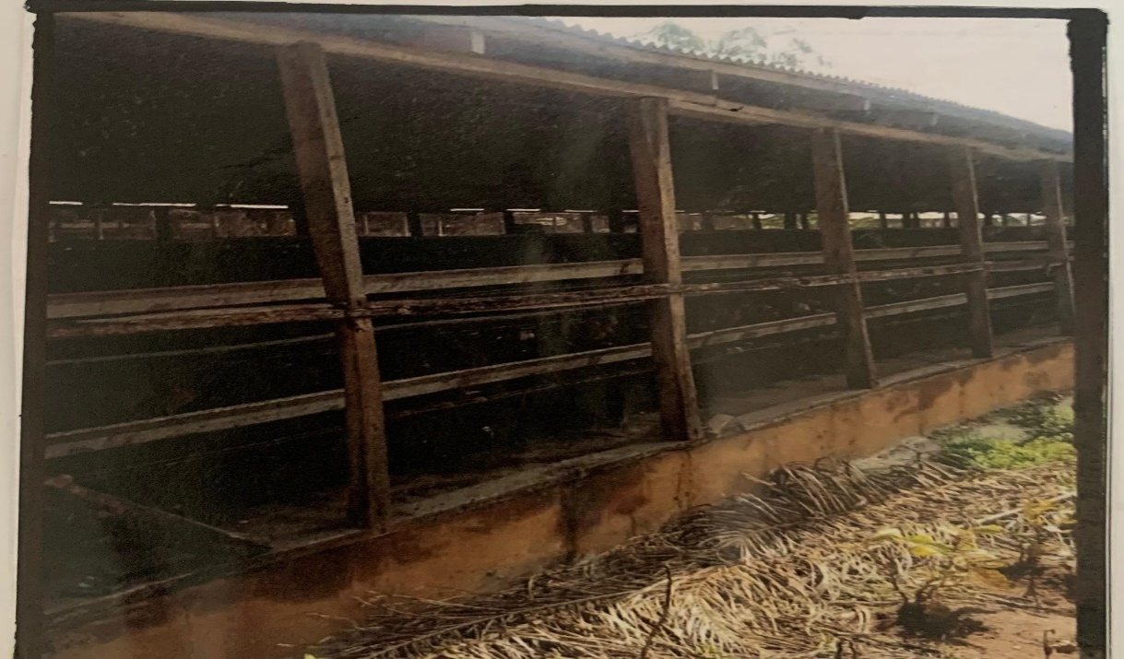
Plate3.3 SHOWING SIDE VIEW OF CASE STUDY TWO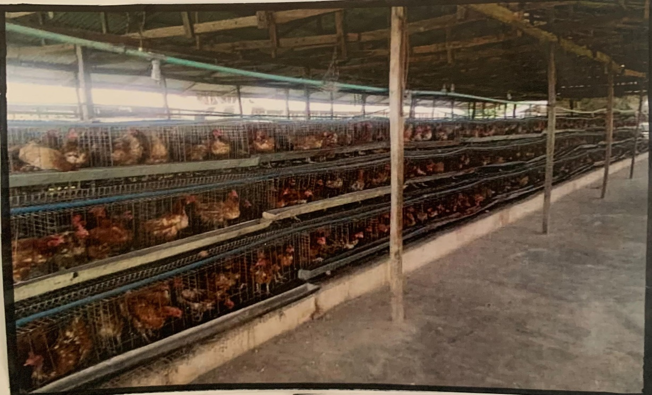
Plate3.4: SHOWING THE INSIDE OF CASE STUDY TWO
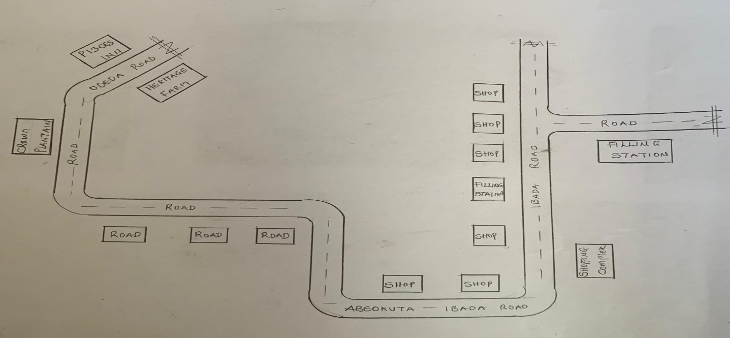
FIG3.3; SHOWING LOCATION PLAN OF CASE STUDY TWO
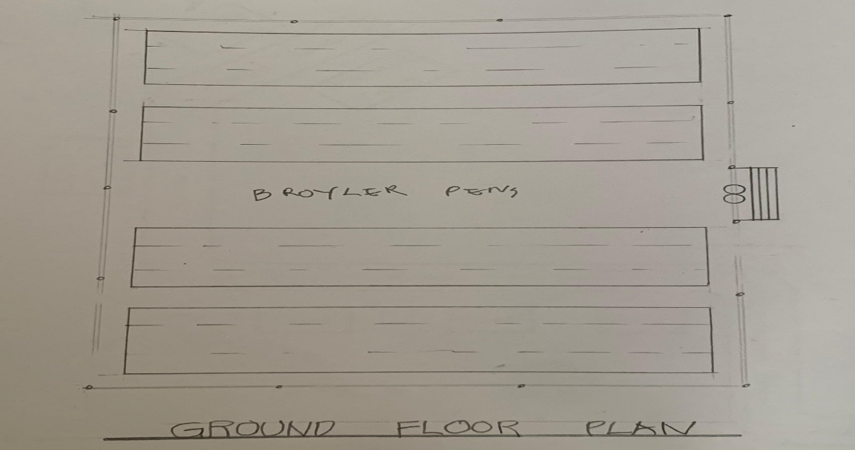
FIG3.4; SHOWING THE FLOOR PLAN OF CASE STUDY TWO

ONLINE CASE STUDY
- RAMGARH AGRO POULTRY FARM
Location: MURAM JHARKHAND KALAN 829122 INDIA
- WINCHESTER POULTRY AND LIVE STOCK

Location: WINCHESTAR ROAD,FAIR OAK EAST LEIGH SOSO UNITED KINGDOM
DEDUCTION FROM CASE STUDIES
During my visit to the poultry farm. I was opportunities to see what was obtain in the poultry farm, I made a proper studies of their related function and analysis were made to their present situation with the aim of incorporation with their merit in my own final proposal.
The following were deduce from my case study
- Critical Role of Ventilation and Orientation.
- Need for Sustainable Building Materials.
- Drainage is a Major Design Consideration.
- Importance of Proper Site Layout.
- Waste Management Requires Architectural Attention.
CHAPTER FOUR
4.0 PROJECT LOCATION
4.1 BRIEF HISTORICAL BACKGROUND OF OYO STATE
Oyo is a state in southwestern Nigeria. Its capital is Ibadan, the third most populous city in the country and formerly the second most populous city in Africa. Oyo State is bordered to the north by Kwara State for 337 km, to the southeast by Osun State for 187 km, partly across the River Osun, and to the south by Ogun State, and to the west by the Republic of Benin for 98 km. With a projected population of 7,976,100 in 2022, Oyo State is the sixth most populous in the Nigeria.
The vast majority of Oyo State residents are Yoruba. Nicknamed the "Pace Setter State", present-day Oyo State sits on territory formerly ruled by the Oyo Empire. The Oyo Empire was a Powerful Yoruba empire that ruled much of Oyo state and by extension major parts of Yoruba lands from c. 1300 to 1896. Built in the 1830s, the modern city of Oyo "New Ọyọ" (Ọ̀yọ́ Àtìbà) is considered a remnant of the imperial Oyo era to distinguish itself from the former capital to the north, 'Old Oyo' (Ọ̀yọ́-Ilé). Although the medieval great Oyo Empire collapsed in 1835, The Alaafin (owner and custodian of the palace) continues to serve a ceremonial role in the new city of Oyo in present Oyo state.
4.1.2 ECONOMY OF OYO STATE
The capital city of Ibadan, is the 3rd most populated city in Nigeria according to the 2006 official census. The state has the highest number of towns and cities mentioned in the top 50 most populous towns in Nigeria with Ibadan, Ogbomoso, Oyo, Saki and Iseyin all featuring in the list. The state economy remains largely agrarian, with the western city of Shaki being described as the state's breadbasket. Cassava, cocoa, and tobacco are among the most important crops to Oyo State's economy.
4.1.3 ORGANIZATION STRUCTRE
An organizational structure is a system that outline shows certain activities that are direct in order to achieve the goals of an organization. These activities can includes rules, roles and responsibilities. The organizational structure also determine show information flows between levels within the poultry farm.
4.2 LOCATION AND SETTING OF OYO STATE
Oyo State covers approximately an area of 28,454 square kilometers and is ranked 14th by size. The landscape consists of old hard rocks and dome shaped hills, which rise gently from about 500 meters in the southern part and reaching a height of about 1,200 metres above sea level in the northern part. Some principal rivers such as Ogun, Oba, Oyan, Otin, Ofiki, Sasa, Oni, Erinle and Osun River originate in this highland. The southern and southeastern parts of the state form a continuous plain.
Oyo State contains a number of natural features including the Old Oyo National Park, Agodi parks and gardens. In this location there was earlier habitat for the endangered African wild dog, Lycaon pictus; however, this canid is thought to have been locally extirpated at the present.
It was formed in 1976 from Western State, and included Ọsun State, which was split off in 1991. Oyo State is homogenous, mainly inhabited by the Yoruba ethnic group who are primarily agrarian but have a predilection for living in high-density urban centres. The indigenes mainly comprise the Oyos, the Oke-Oguns, the Ibadans and the Ibarapas, all belonging to the Yoruba family. Ibadan had been the centre of administration of the old Western Region since the days of British colonial rule.
Apart from Ibadan, other notable cities and towns in Ọyọ State include Ọyọ, Ogbomọsọ, Isẹyín-Okeogun, Ipapo-Okeogun, Kíṣì-Okeogun, Okeho-Okeogun, Saki-Okeogun, Igbeti-Okeogun, Igboho-okeogun [Igboho], Eruwa-Ibarapa, Iroko, Lanlate, OjeOwode-Okeogun, Sepeteri-Okeogun, Ilora-Oyo, Jobele-Oyo, Awe-Oyo, Ilérò-Okeogun, Okaka-Okeogun, Igbo Ora-Ibarapa, Idere
In 2024, Yoruba separatists unsuccessfully attempted to overthrow the state government in Ibadan.
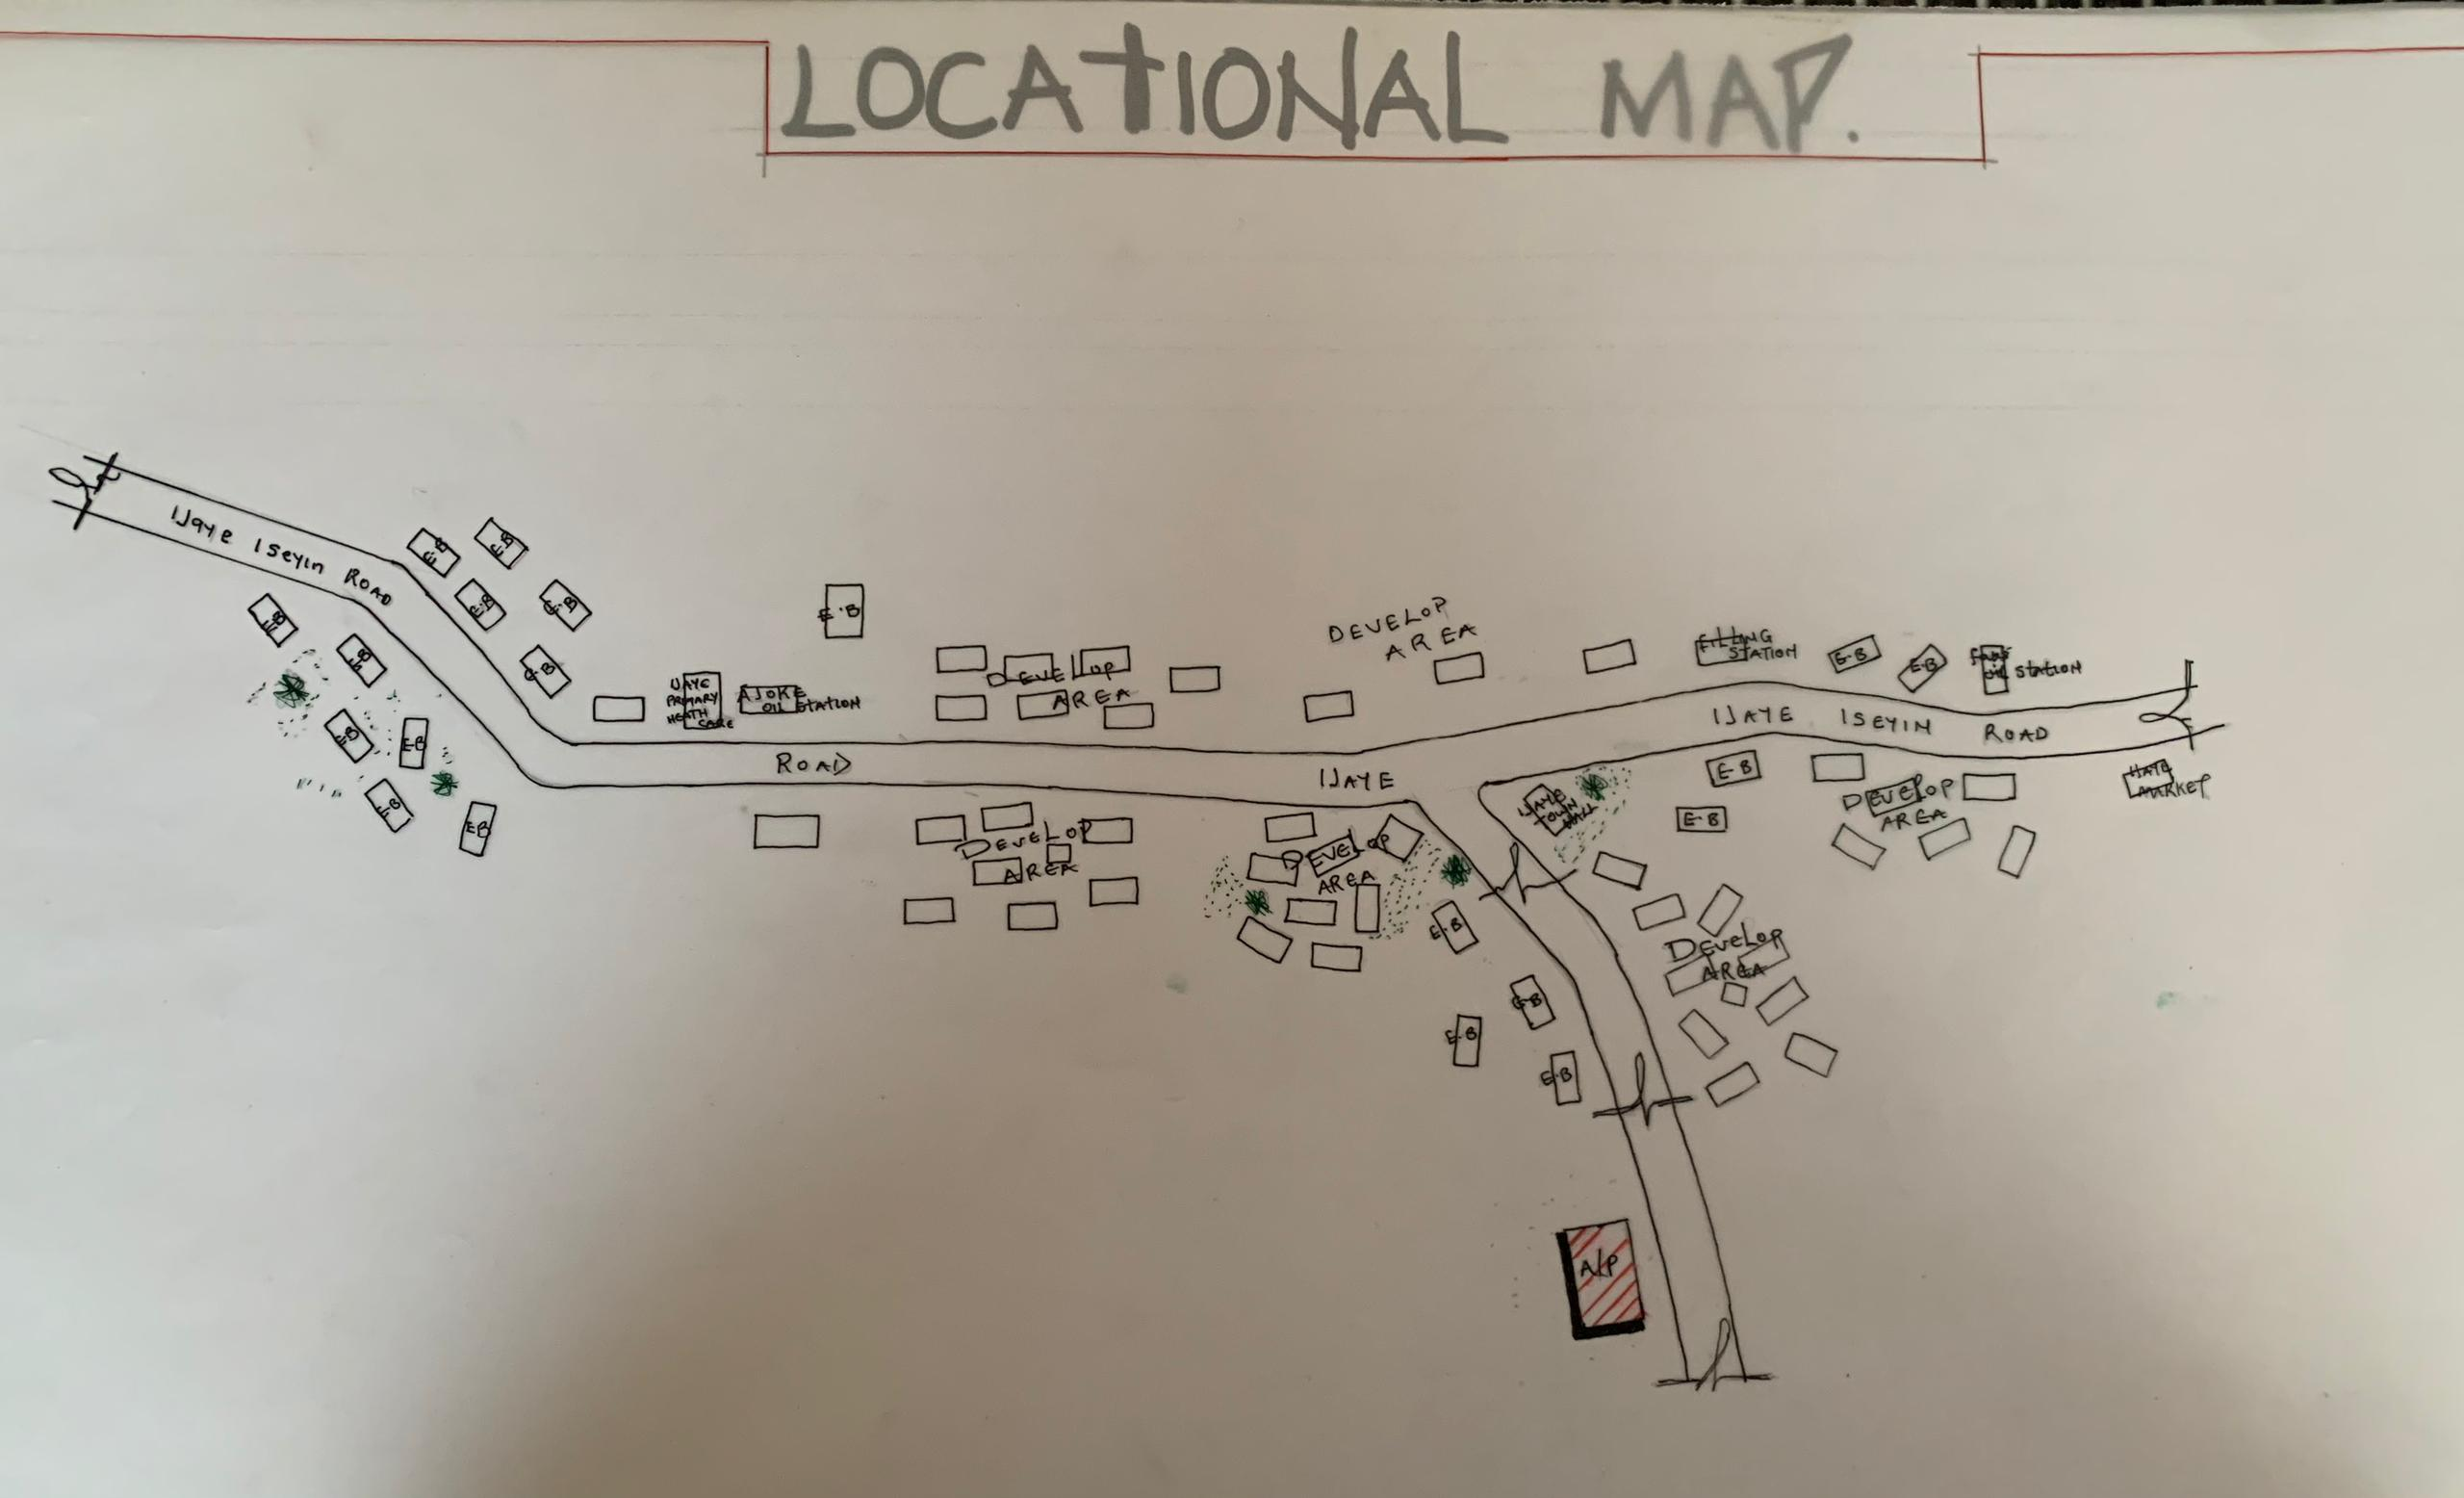

FIG 4.1; SHOWING SITE INVENTORY OF THE PROPOSED SITE
4.3 POPULATION
The population development of Oyo state as well as related information and services.
The current metro area population of Oyo in 2025 is 506,000, a 3.69% increase from 2024.
The metro area population of Oyo in 2024 was 488,000, a 3.61% increase from 2023.
The metro area population of Oyo in 2023 was 471,000, a 3.29% increase from 2022.
The metro area population of Oyo in 2022 was 456,000, a 3.4% increase from 2021.
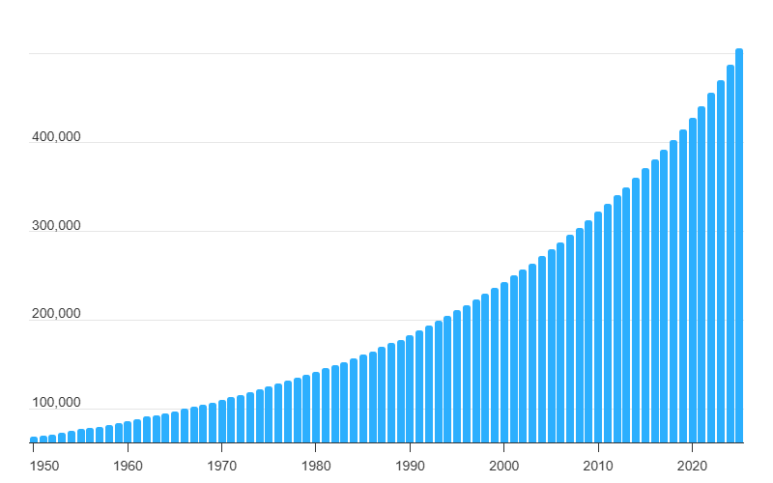
TABLE 4.1; SHOWING GENDER GROUP
4.4 SITE INVENTORY
In the proposed site, some shrubs will be retained on site. It used to reduce sky glare and also serve as soft landscape and wind breaker.
Presence of road network which would serve as a means of accessibility to the site. Presence of electricity pole which serve as source of electricity to the site. Some trees would be retained while some will be removed if they disrupt the construction of building.
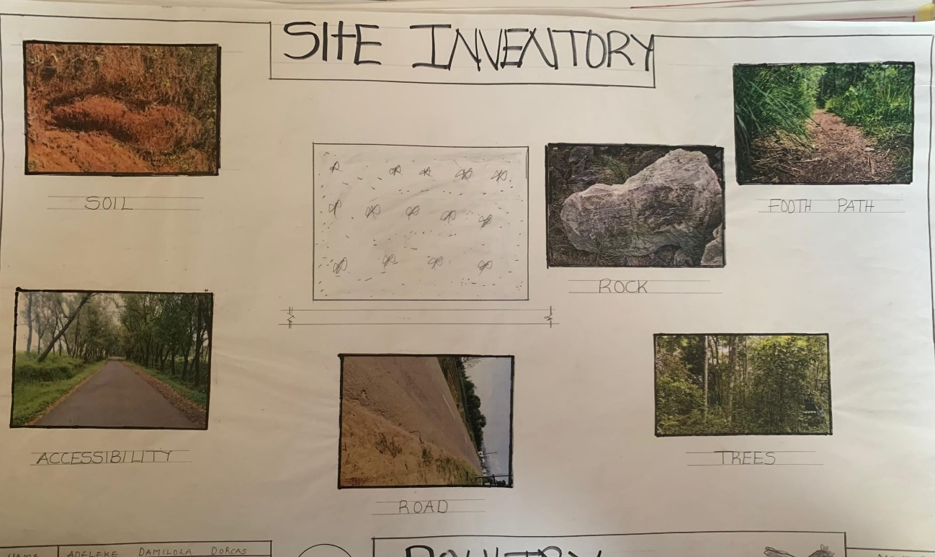
FIG 4.2; SHOWING SITE INVENTORY OF THE PROPOSED SITE
4.5 SITE ANALYSIS
The site is benefitted with loamy soil which is a very good soil for grass and shrubs. It has a gentle slope towards the south east. Some of the grasses, shrubs and trees on the site are to be retained to enhance landscape patter of the site while some are to be removed and replanted where necessary. The two noticeable winds are to be directed into the building using landscape pattern to improve ventilation. Noise generated from vehicle traffic is controlled through proper planning, good landscaping and proper orientation of building. Generally, all the feature on the site are best put into different uses to aid control through proper planning, landscape and orientation.

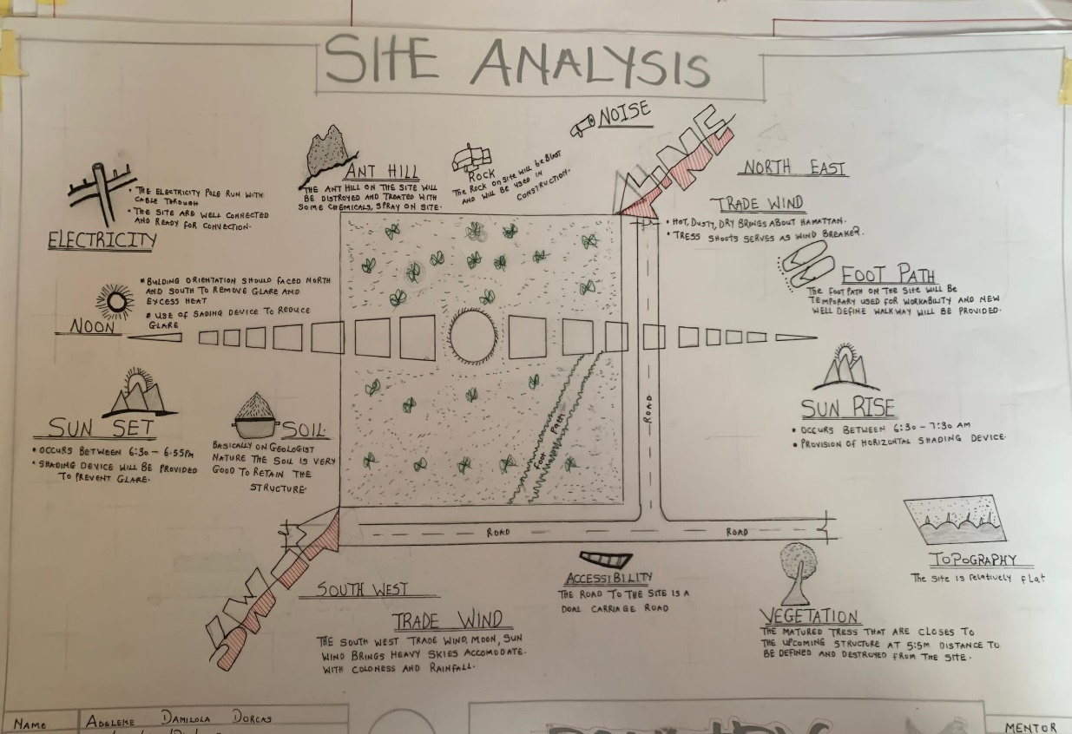
FIG 4.3; SHOWING SITE ANALYSIS OF THE PROPOSED SITE
4.5.1 SITE SELECTION/JUSTIFICATION
In the site selection provision is made for interesting facilities that worth emulating since the overall success and efficiency of any project depend not on the functionality of the design but also on a careful choice of site. The site of this project has been carefully selected which is located in the premises of Akinyele Local government in Ibadan, Oyo state. The proposed site is located at Ijaye Ibadan, Oyo state.
4.5.2 LOCATION
The site is located at along ijaye secondary school
4.5.3 ACCESSIBILITY
The site is easily accessible from the access road off from the main road that goes to ijaye/iseyin road. The site can also be reached through the access road that lead to ijaye.
4.5.4 INFRASTRUCTURAL FACILITIES
Facilities such as water electricity, telephone network and road network are all in oyo, hence it can easily be tapped to the proposed site.
4.5.5 TOPOGRAPHY
The topography of the land is gentle slope which can be filled and levelled up to balance round all the site levels.
4.5.6 SOIL STRUCTURE
It is made up of clayish laterite soil, which is good for building construction.
4.6 GENERAL CLIMATIC CONDITION
Oyo State generally experiences a tropical climate characterized by distinct wet and dry seasons. Temperatures typically range from 25°C (77°F) to 35°C (95°F) throughout the year. The wet season, with higher humidity, lasts from April to October, while the dry season occurs from November to March. Oyo State enjoys abundant sunshine, especially during the dry season.
4.6.1 RELATIVE HUMIDITY
Oyo State experiences relatively high humidity, particularly during the wet season.
4.6.2 WIND
There are two prevailing winds namely: The rain bearing south-west monsoon wind which blows across the Atlantic Ocean between the month of May and October. This is called wet season. The dusty north-east trade wind which laden with dust blows through the Sahara desert during the month of November to April with very title rainfall toward April. This is called the dry season and it brings along Harmattan during its driest period
4.6.3 TEMPERATURE
Average daily temperatures range from 25°C (77°F) to 35°C (95°F).
4.6.4 VEGETATION
The proposed site is covered with grasses few trees and shrubs. Some will be removed before the construction while some will be retain for ornamentation.
4.7 SOCIAL SERVICES
4.7.1 ROAD
There are only two access to the site
The southern access which serve as the main entrance and also main access road
4.7.2 WATER AND ELECTRICITY
There are pipe born water networks and borehole water which serves the habitant of Ibadan. There is electricity supply from NEPA that serve the Oyo state in general
4.8 DESIGN CRITERIA
There are three (3) methods of designing of any project which are: Function before form method
Form before function method Combination of Shapes
Designing projects, the function, before form method used in line with this method, the following are the design criteria for this project:
Functional: in term of functional requirement, the following design criteria must be considered.
Sustainability, Site and Location, Flexibility, Circulation, Accessibility, Organization, Maintenance, Environment and Services
4.9 DESIGN BRIEF
After research and planning, the next step in the series of the project programed is design itself. To achieve functional and well established design there must be a brief to work on. This brief depends generally on the scope of individual design. The brief of this project is therefore based on the various activities that take place in the Farm. To have enough brief for the proposed Poultry Farm, case studies were carried out on the existing Poultry Farm. The studies also give me the opportunity to know the nature of the various unit in the building and how they are related to each other.
4.10 DESIGN ANALYSIS
This is the process of itemizing units within the component of the entire design with a view to establishing a solid understanding and appreciation of the space relationships.
GROUND FLOOR PLAN; Entrance, Reception, Laboratory, Record room, Staff lounge, Store, First aid, Account office, Marketing department, sec, Manger office, Active office, Conference room, exist, w/c
NAME | S/N |  | LENGTH[m] | BREATH[m] | AREA[m]
ENTRANCE | 1 |  | 7.5m | 5.6m | 8.4m2
RECEPTION | 1 |  | 3.0m | 5.6m | 16.8m2
LABORATORY | 1 |  | 5.4m | 4.8m | 25.92m2
RECORD ROOM | 1 |  | 4.5m | 1.8m | 8.1m2
STAFF LOUNGE | 1 |  | 6.8m | 5.7m | 35.76m2
STORE | 3 |  | 1.8m | 3.6m | 19.44m2
FIRST AID | 1 |  | 3.6m | 5.1m | 18.36m2
ACCOUNT OFFICE | 1 |  | 3.3m | 3.6m | 22.88m2
MARKETING DEPT | 1 |  | 4.8m | 5.4m | 25.92m2
SEC-OFFICE | 1 |  | 2.4m | 5.4m | 12.96m2
MANAGER OFFICE | 1 |  | 4.5m | 5.4m | 24.3m2
ACITVE OFFICE | 1 |  | 3.3m | 3.3m | 10.89m2
CONFRERENCE ROOM | 1 |  | 6.0m | 4.8m | 28.8m2
GENERAL OFFICE | 1 |  | 6.0m | 10.0m | 60.0m2
EXIST | 2 |  | 1.2m | 1.8m | 4.32m2
W/C | 9 |  | 0.9m | 1.8m | 14.58m2
TOTAL |  | 329.43m2
TABLE 4.2; SHOWING SPACIAL ALLOCATION OF FLOOR PLAN
Necessary units in the building. A borehole system of water supply is to be adopted alongside the government supplied services and a storage facility is to be provided for effective management of water supply.
4.12 PLANNING PRINCIPLE
The planning principle is one of the most important aspects of any design. The planning of various units taking into consideration the activities performed in each unit, how they are related to one another and the users of the various units in the design. In respect to the above factors.

CHAPTER FIVE
5.0 GENERAL REQUIREMENTS
5.1 APPRAISAL OF PROPOSED SCHEME
The proposed scheme is to satisfy the appropriate building regulation. The project design is to confirm with the intended use of building taking into consideration with both natural factors and human that can pose a throat on the validity and stability of the project design.
5.2 CONSTRUCTION METHODOLOGY AND MATERIAL
The construction is to be carried out following the due process of construction ranging from.
Preliminary: this involves the clearing of the site, setting out and excavation of foundation trench, foundation works down to the basement level.
Sub-Structure: this process also entails the positioning and erection of column and beams, mansonry work etc.
Gypsumboard: is to be used for the Acoustic purpose of the building. This material is often called dry wall, wall board or plaster board. It creates a continuous surface suitable for most types of interior decoration. It comes in different size ranging length of 2.4m, 3.0m, also in thickness of 1/ inch, 3/8 inch.
5.3 SERVICE
A building can be said to be good when it performs the serves required by it. In other to have a well-function building design, there calls for an installation of underground water. This is a means of providing brightness naturally by sun or moon or artificially by lamps. Good natural and artificial lighting is important in lecture rooms, and workshop. It is always easy to make mistake and time the eye in a situation of poor lighting floor. For the purpose of this project, effort is made as much as possible to light up the entire building naturally before the use of artificial lighting. In this project, to obtain maximum lighting more openings are provided for the lecture rooms, workshop and admin. Artificial source of light will still be provided for in case where there is call for the use of it at night or in a situation where the weather condition warrants it.
5.4.1 VENTILATION
As it's relates to architectural, is the intentional introduction of outside AIT into a space through openings (like window/doors and mechanical means (ACs) to provide maximum thermal comfort for human satisfaction. In this design, both means of ventilation ate introduce but majority concentration on the mechanical means of ventilation for all units in the design for the purpose of extracting the used air and introducing fresh air within all spaces for humans consumption and satisfaction.
This is done through installation of mechanical (artificial) ventilation ducts horizontally and vertically all within the units of the design to allow easy floe of free movement of air passage through the ventilation channels and providing well, proper and adequate ventilation for each and every units in the design project.
5.4.2 LIGHTING
This is a means of providing brightness naturally by sun or moon or artificial by lamps. Good natural and artificial lighting is important in all units. It is always easy to make mistake and time the eye in a situation of poor lighting floor. For the purpose of this project, effort is made as much as possible to light up the entire building naturally before the use of artificial lighting.
5.4.3 PLUMBING
The plumbing system in this project design is made easy for waste extraction and brain water extraction through the means of service duct channel and roof gutter drainage.
All waste water and soil waste from the toilet/convenience are extracted through means of drainage pipe running through the walls down to the inspection chamber situated in the service duct, flowing down to the septic tank and soak away for final waste extractions.
5.4.4 ELECTRICAL INSTALLATION
The type of wiring system chosen should be conduct system of wiring, technical are should be wired with strong durable and light current resistance cables because of the power requirements and consumption of the equipment to be used and installed in them. Connection and distributing cable signal. Also electrical installation is to be done to allow for the use quality electrical fittings and fixtures in the whole of the hospital.
5.4.5 WASTE DISPOSAL
Waste disposal are to be put in the building and also some specific areas necessary, this waste bins should be disposed in the incinerator which will be provided within the proposed site premises. The waste should therefore, be burn in the incinerator or taken away from the site.
5.4.6 FIRE PROTECTION
Electrically, fire alarms and sensor are to be installed in the building in generally. This should be done in case of the fire occurrence. Fire extinguishers are to be placed at a certain distance in the lobbies and some other necessary areas. It is also serving as protection in case of fire outbreak.

5.4.7 RAIN PROTECTION DEVICES
The rainfall of a place generally determines the living condition and all comfort associated with that environment hence provision should be made for fast dispersal of the rain water as well as the associated condition with rainfall. This calls for the need to study the nature of rainfall of the area. To control the heavy rainfall during the wet season (April - October) the use of simple sloppy system roofing has been adopted. This is provided with roof gutter system which is linked to the ground drainage network by the use of P.V.C.
5.4.8 EXTERNAL WORKS
The external works are to be earned out generate, kerbs land and shrubs, flowers, grasses and trees planted. Concrete interlocking pavement tiles to be adopted before hard landscape for walk ways and parking spaces and car access roads must be tarred with asphalt finishes.
5.5 SUMMARY
This project, generally, has seriously widen my view and knowledge affecting my observation beyond my expectation. I have been able to deduct what it takes or entails and how to go about designing and achieving a good design of any form of this related project with total seriousness as this project has given out the facts and precise information it comprises.
5.6 CONCLUSION
The architectural design of a poultry farm goes beyond mere shelter for birds; it directly contributes to the health, productivity, and economic viability of the farm. From the case studies and research conducted, it is evident that successful poultry farm operations rely heavily on functional, climate-responsive, and hygienic architectural solutions.
This project has demonstrated that thoughtful design—incorporating proper building orientation, effective ventilation, durable materials, and biosecurity measures—plays a critical role in ensuring bird welfare, reducing mortality rates, and enhancing operational efficiency. Additionally, sustainable design interventions such as rainwater harvesting, passive cooling, and waste management systems align the project with global best practices for environmentally conscious agricultural facilities.
Furthermore, the integration of worker comfort, circulation flow, and flexibility for future expansion reflects the need for user-centered and adaptable architectural solutions within the agricultural sector.
However, challenges such as high construction costs for sustainable materials, potential biosecurity risks, and the need for regular maintenance were identified. These challenges highlight the importance of strategic design decisions to balance functionality, cost, and long-term sustainability.
5.7 RECOMMENDATION
This project reflects the critical role of architecture in enhancing agricultural productivity, environmental sustainability, and animal welfare. The proposed poultry farm design, if implemented effectively, will not only meet functional and operational needs but also contribute positively to food production, economic development, and the well-being of both birds and farm workers.

REFERENCE
Adeyemo, S. B., & Onikoyi, M. P. (2012). Prospects and challenges of large-scale commercial poultry production in Nigeria. World Journal of Agricultural Sciences, 8(3), 256–261.
Akinola, L. A. F. (2015). Environmental management practices in poultry production in Nigeria. Journal of Environmental Issues and Agriculture in Developing Countries, 1(2), 101–106
Albright, L. D. (2020). Environmental Control for Animals and Plants. ASAE.
ASABE Standards (2020). Design of Ventilation Systems for Poultry and Livestock Buildings. American Society of Agricultural and Biological Engineers.
Daghir, N. J. (2020). Poultry Production in Hot Climates (2nd ed.). CABI Publishing.
Federal Ministry of Agriculture and Rural Development. (2018). National Animal Production Guidelines: Poultry. Abuja, Nigeria.
Heritage Poultry Farm, Ogun State, Nigeria – Medium-scale poultry farm with cross-ventilation and biosecurity measures.
Kentimal Farm, Ibadan, Oyo State – Known for commercial broiler and layer production. Used for student case studies.
Mberekpe, J. E., & Okonkwo, J. C. (2017). Site planning for sustainable poultry housing in the humid tropics. Nigerian Journal of Agriculture, Food and Environment, 13(2), 112–117.
National Building Code of Nigeria. (2023). Agricultural and Industrial Buildings Standards. Federal Ministry of Works and Housing.
Neufert, E. (2019). Architects' Data (4th ed.). Wiley-Blackwell.
Obasanjo Farms, Ota, Ogun State – Large-scale integrated poultry operation; useful for large-farm planning and layout.
Olomu, J. M. (2020). Poultry housing and environment in Nigeria: A review. Nigerian Journal of Animal Science, 13(1), 45–53.
Owen, J. E., & D. A. Dykes. (2016). Livestock Housing. Tropical Agriculturalist Series. Macmillan.
Veldkamp, T., & van Harn, J. (2019). Poultry Housing Design and Management. Wageningen UR Livestock Research.


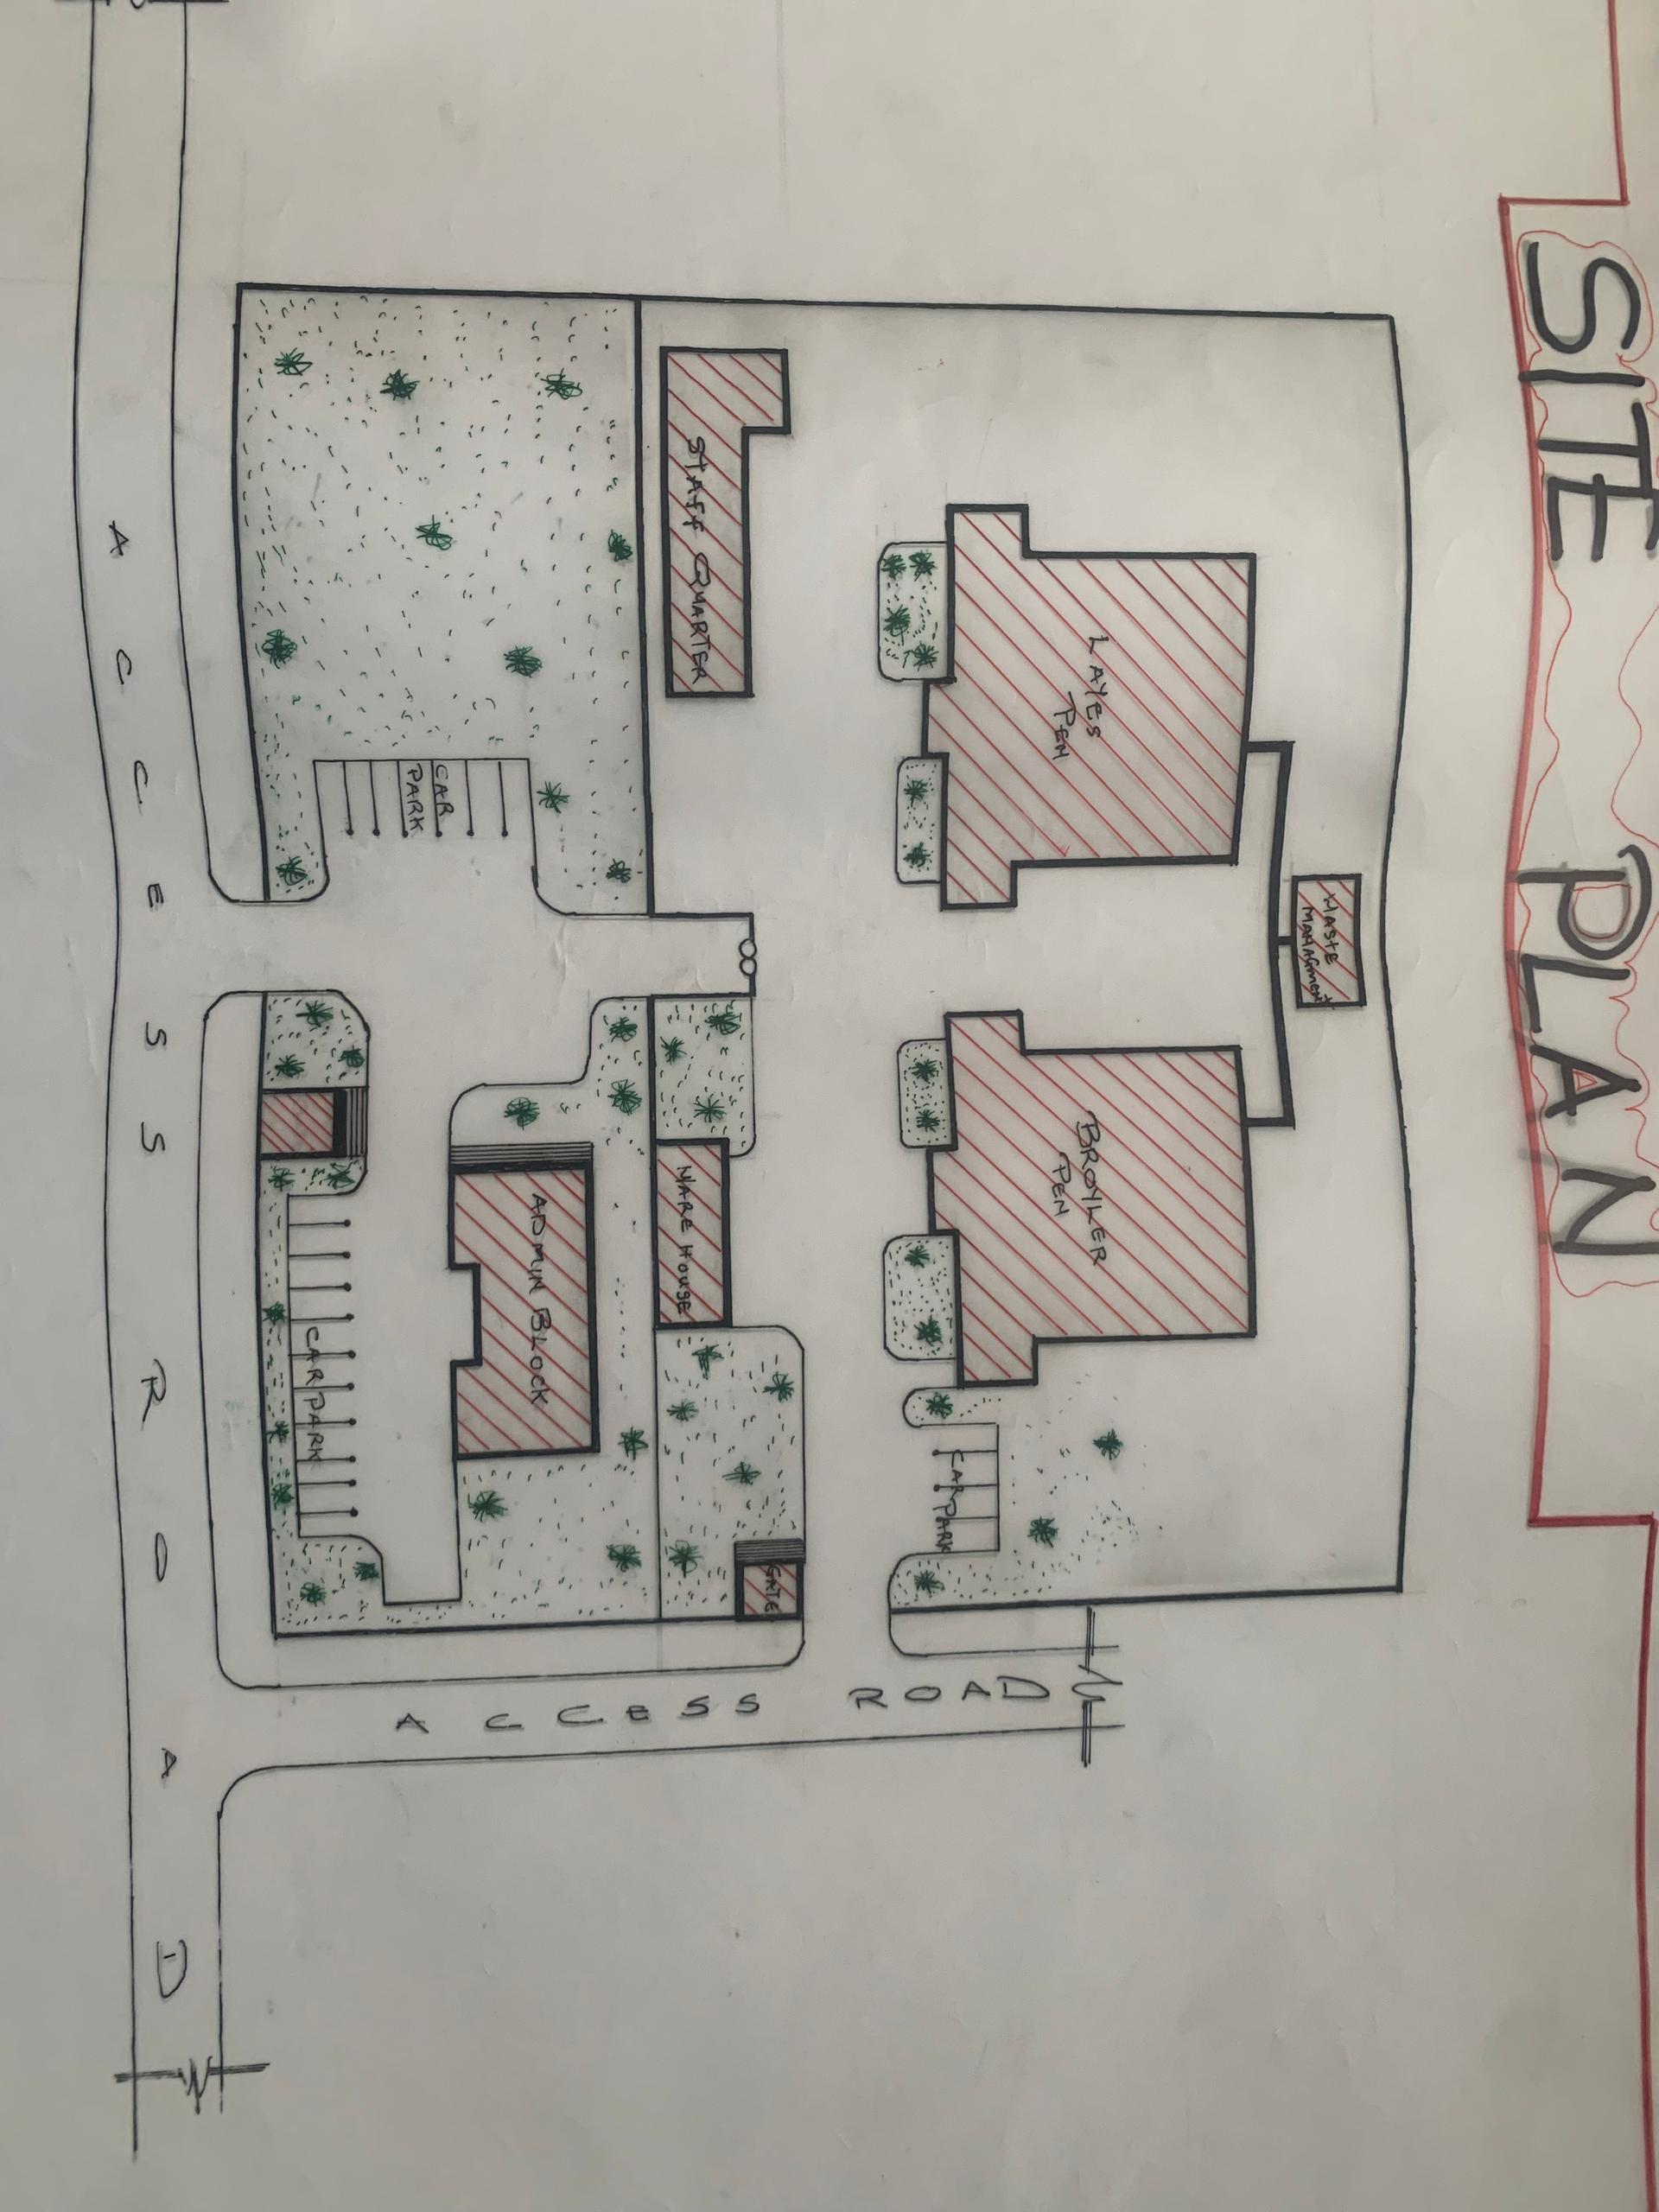
APP1; SHOWING THE SITE PLAN OF PROPOSED PROJECT
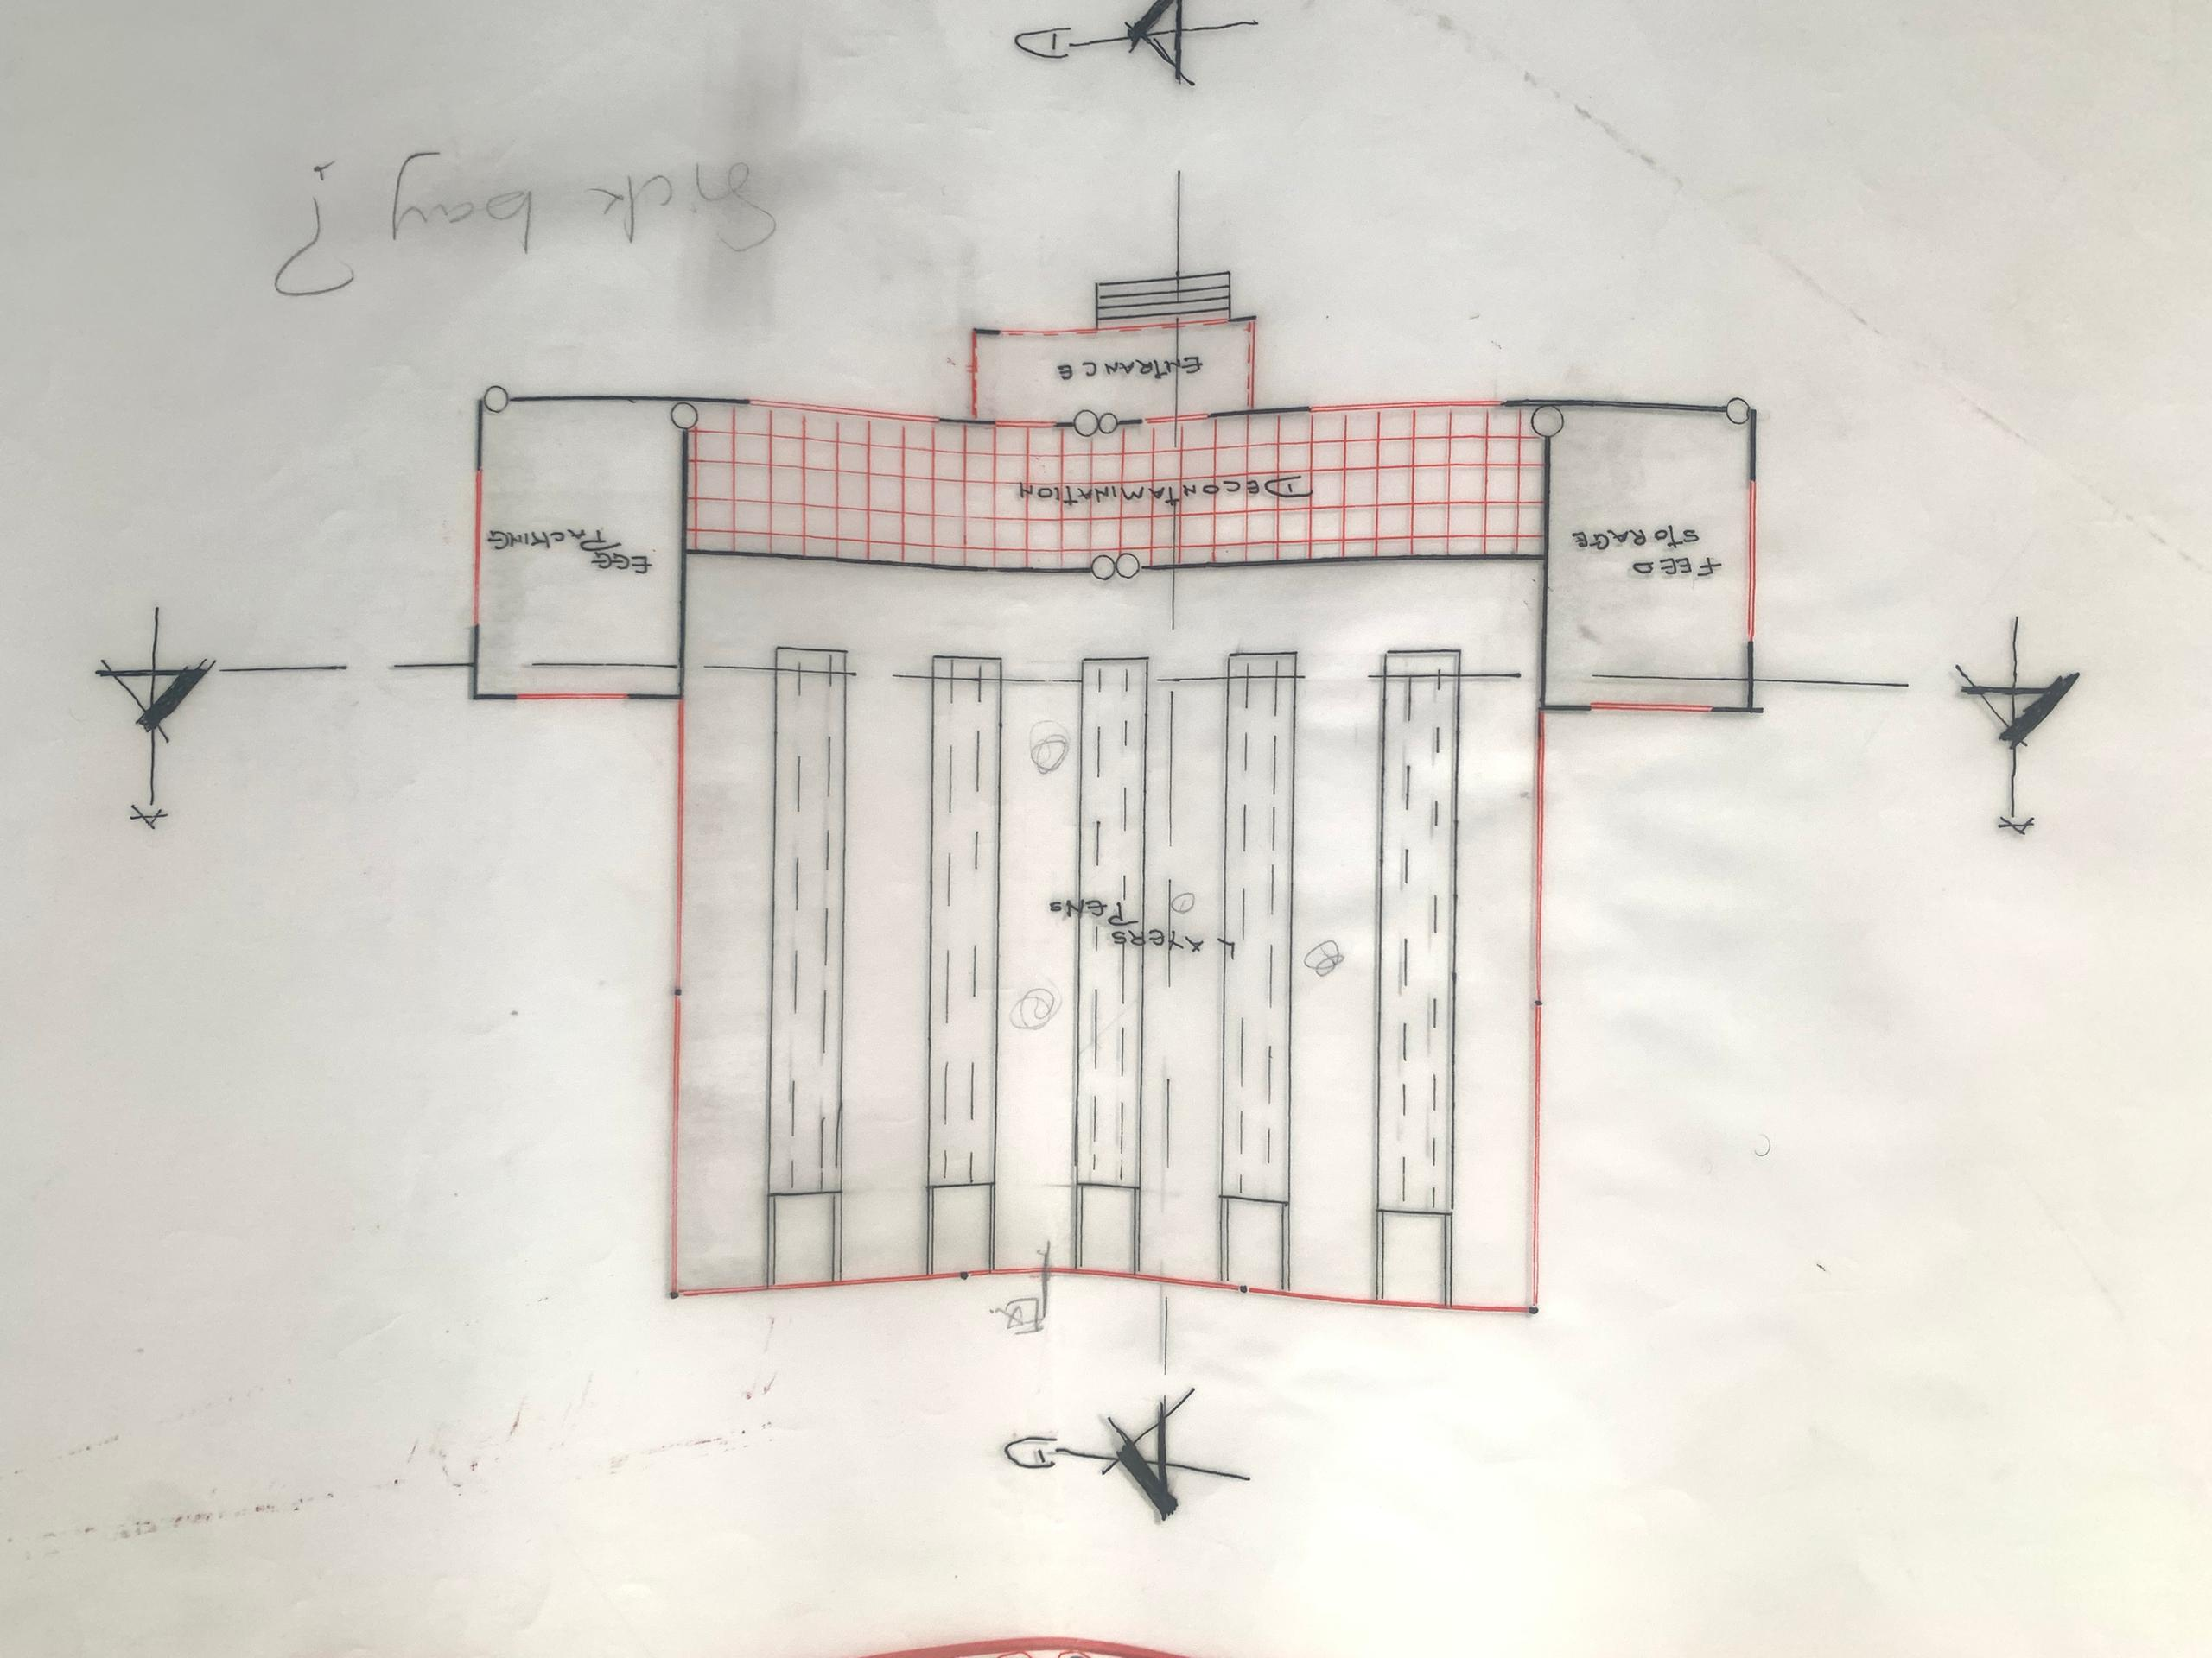
APP2; SHOWING THE FLOOR PLAN OF PROPOSED PROJECT

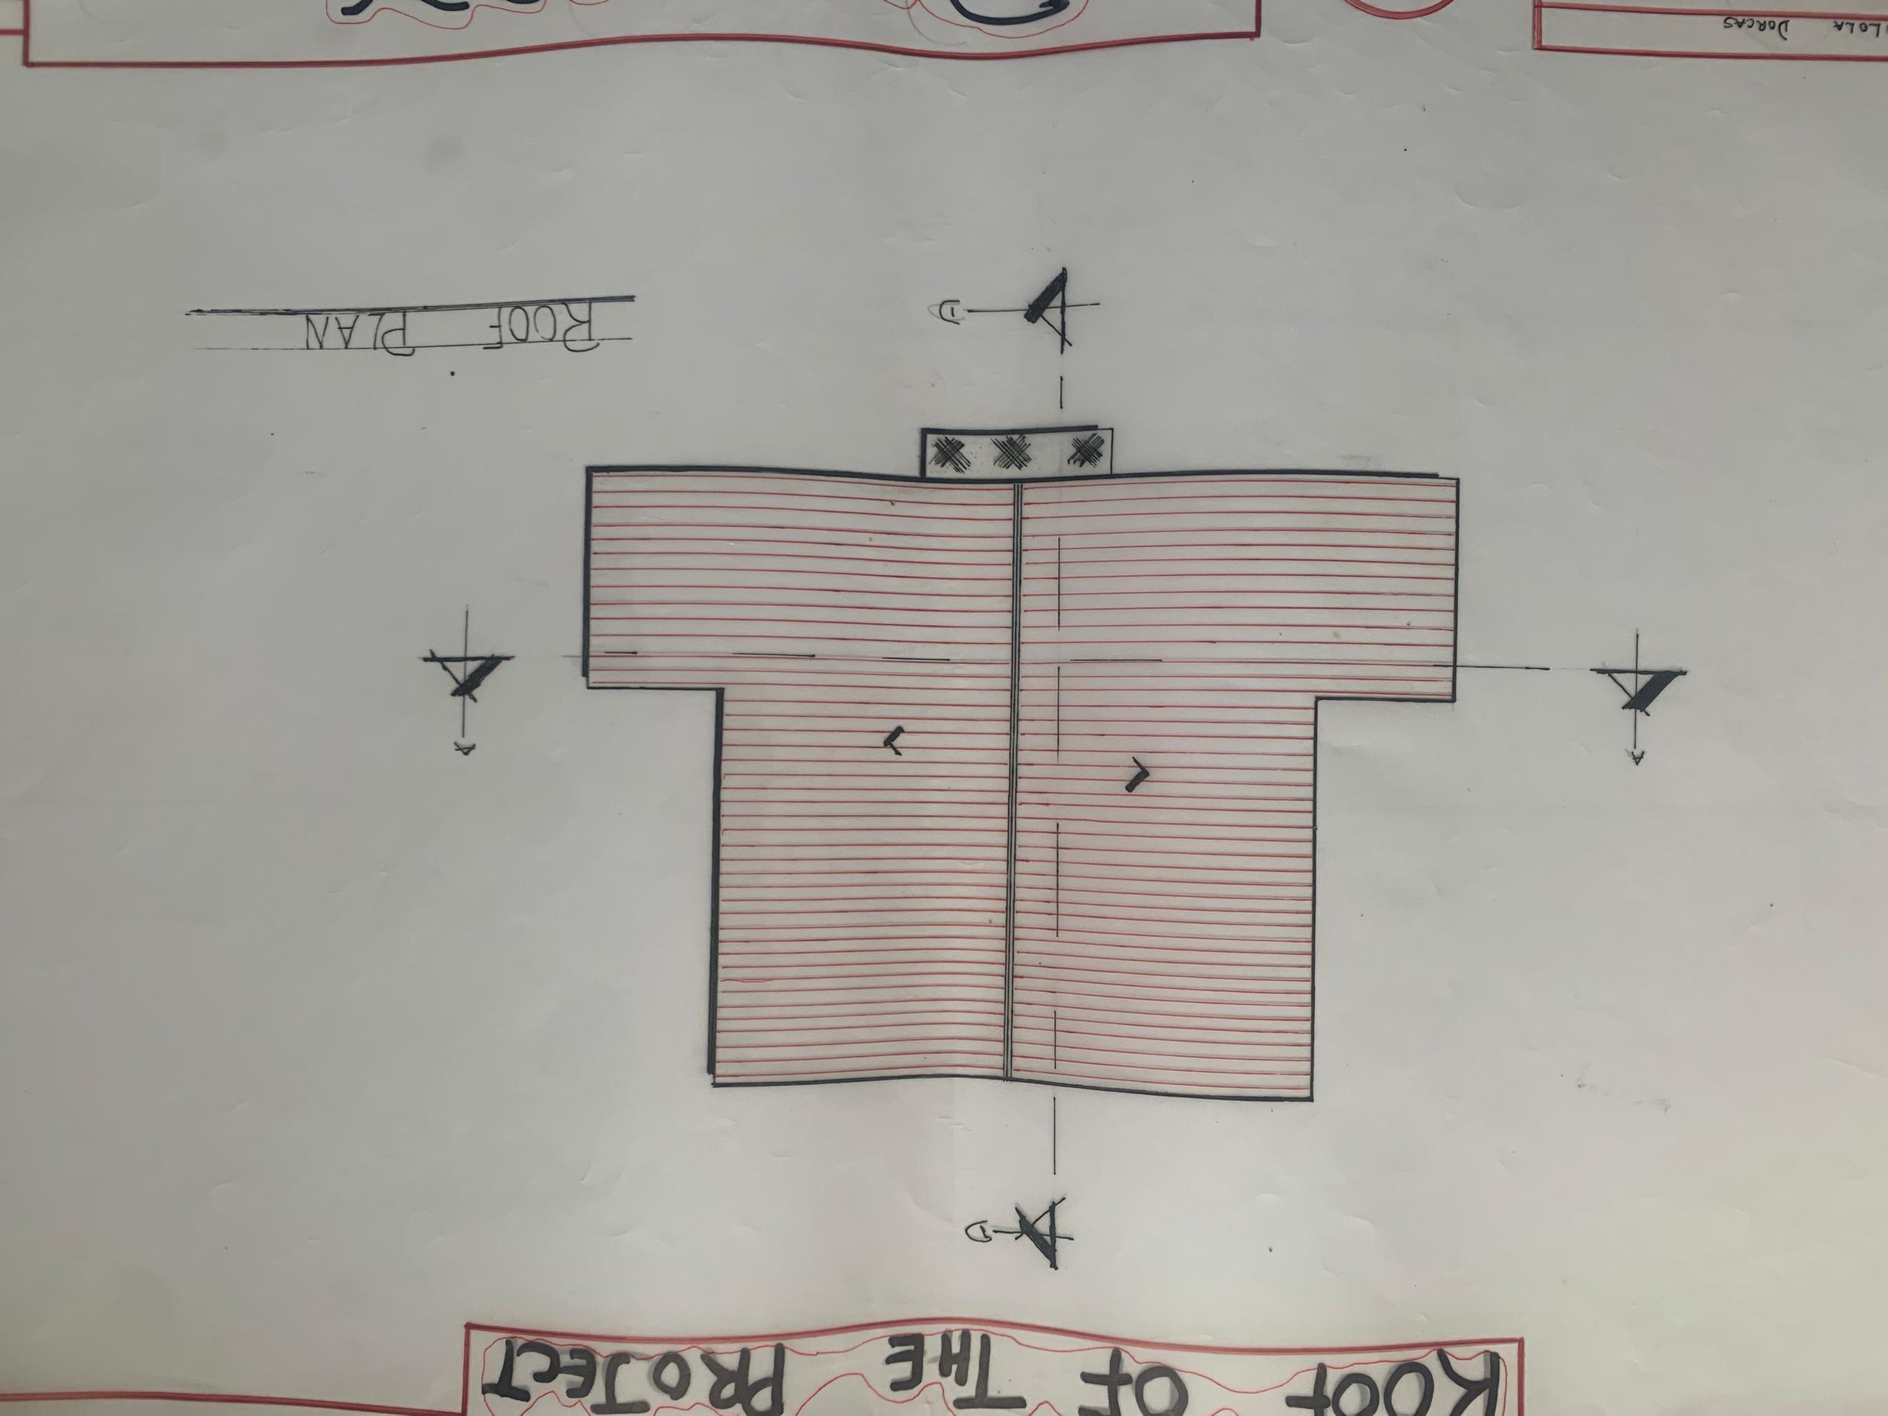
APP3; SHOWING THE ROOF PLAN OF PROPOSED PROJECT
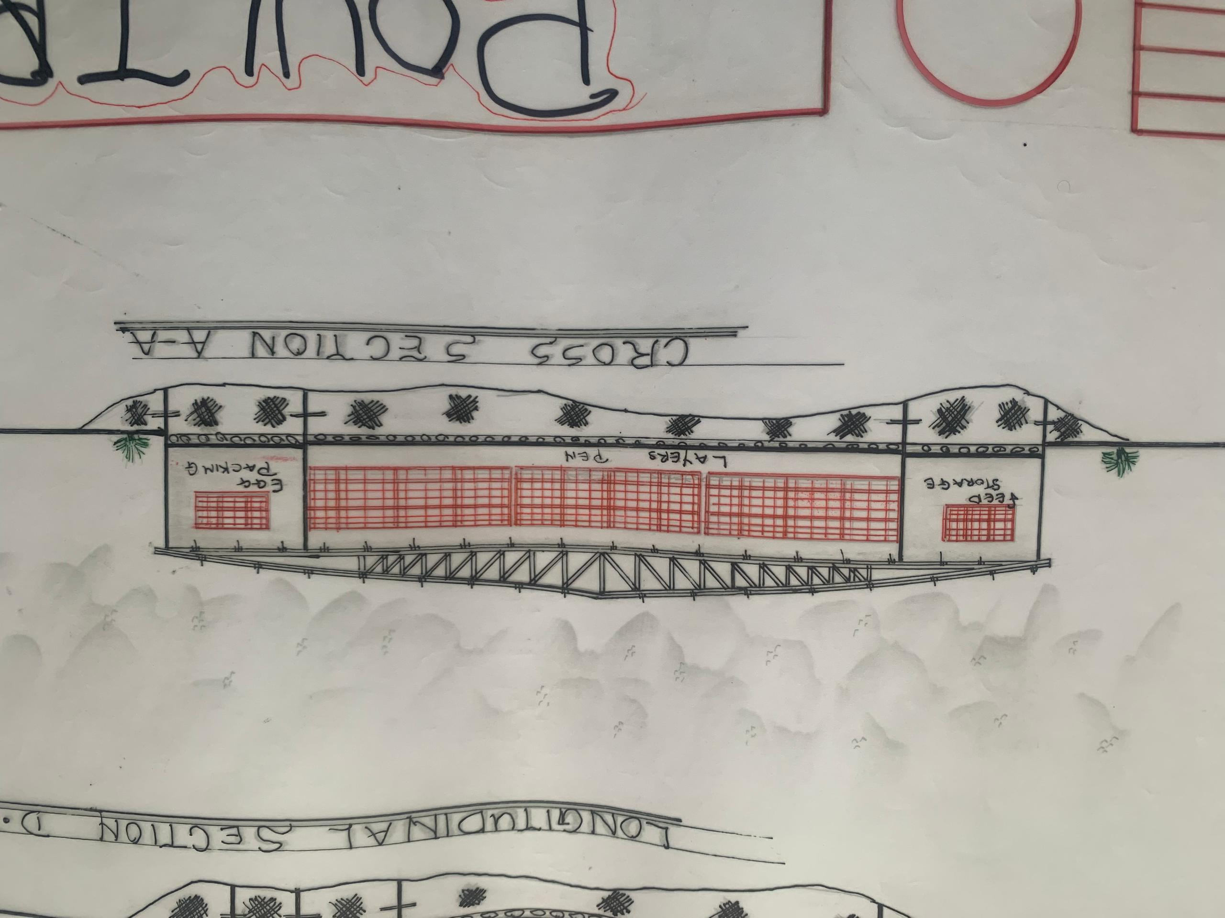
APP4; SHOWING THE CROSS SECTION OF PROPOSED PROJECT
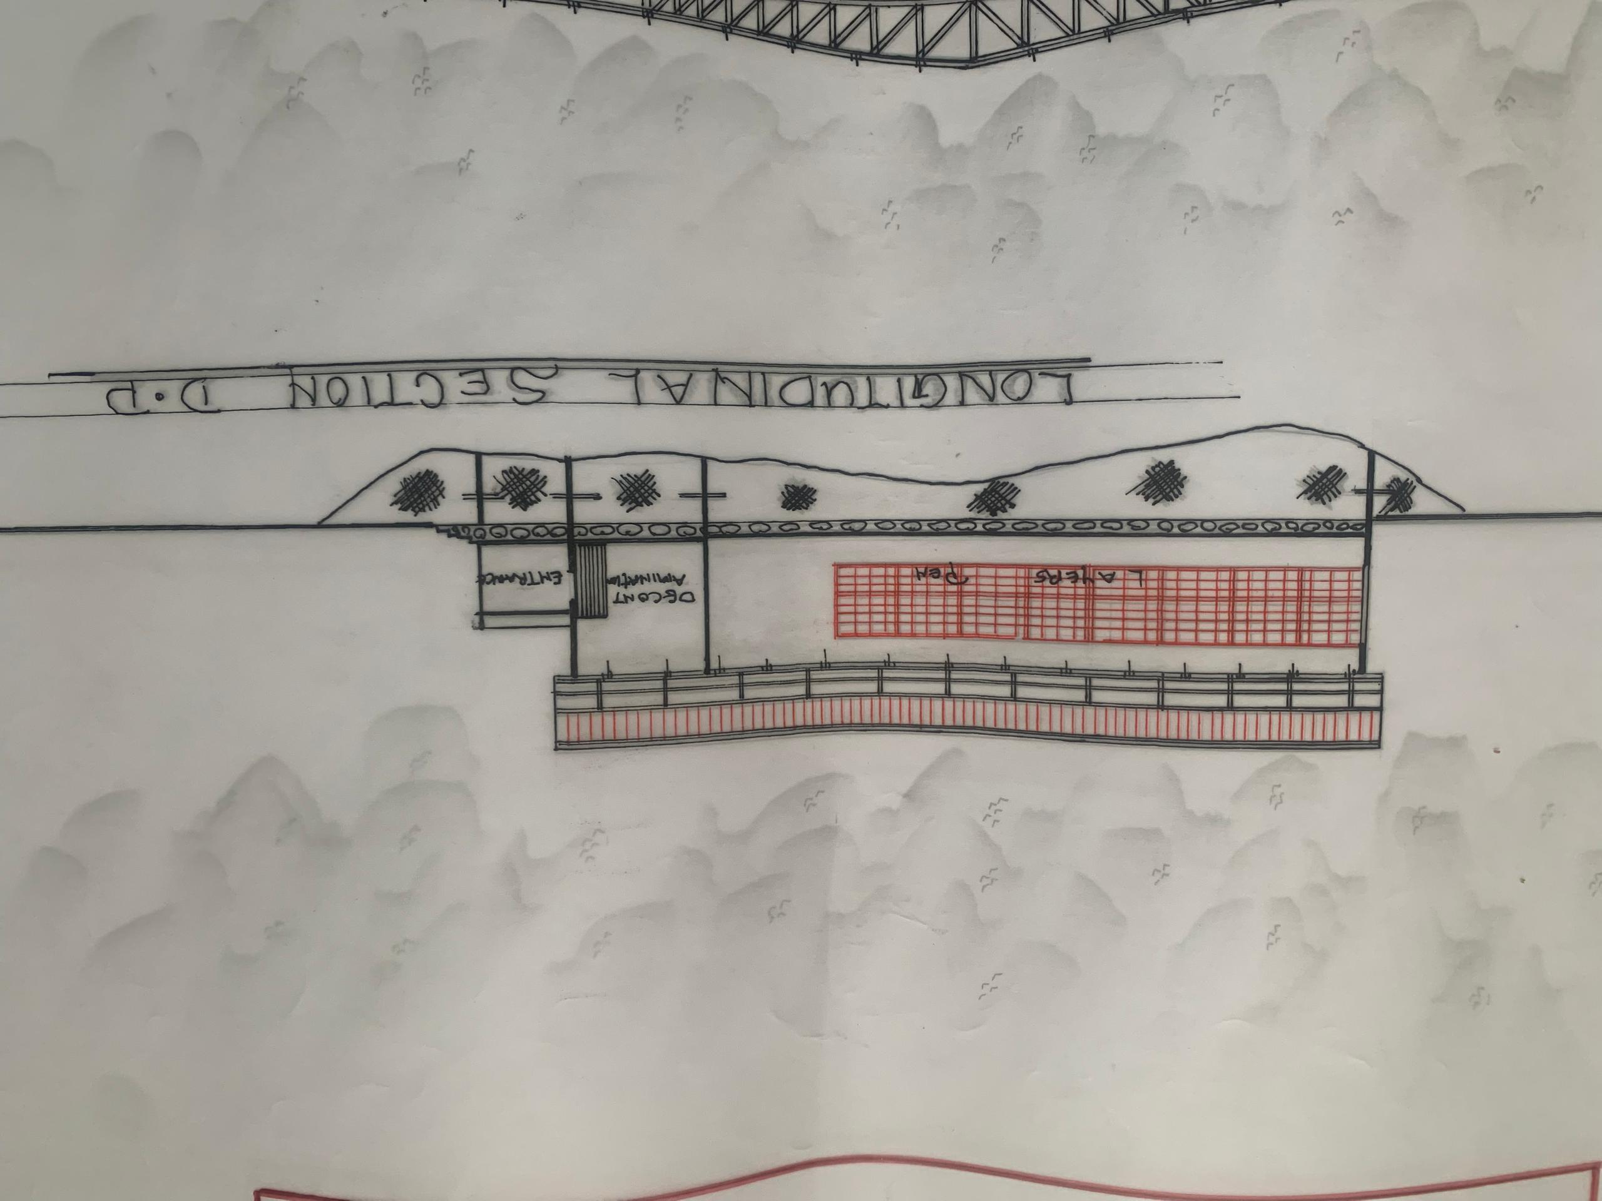
APP5; SHOWING THE LONGITUDINAL SECTION OF PROPOSED PROJECT
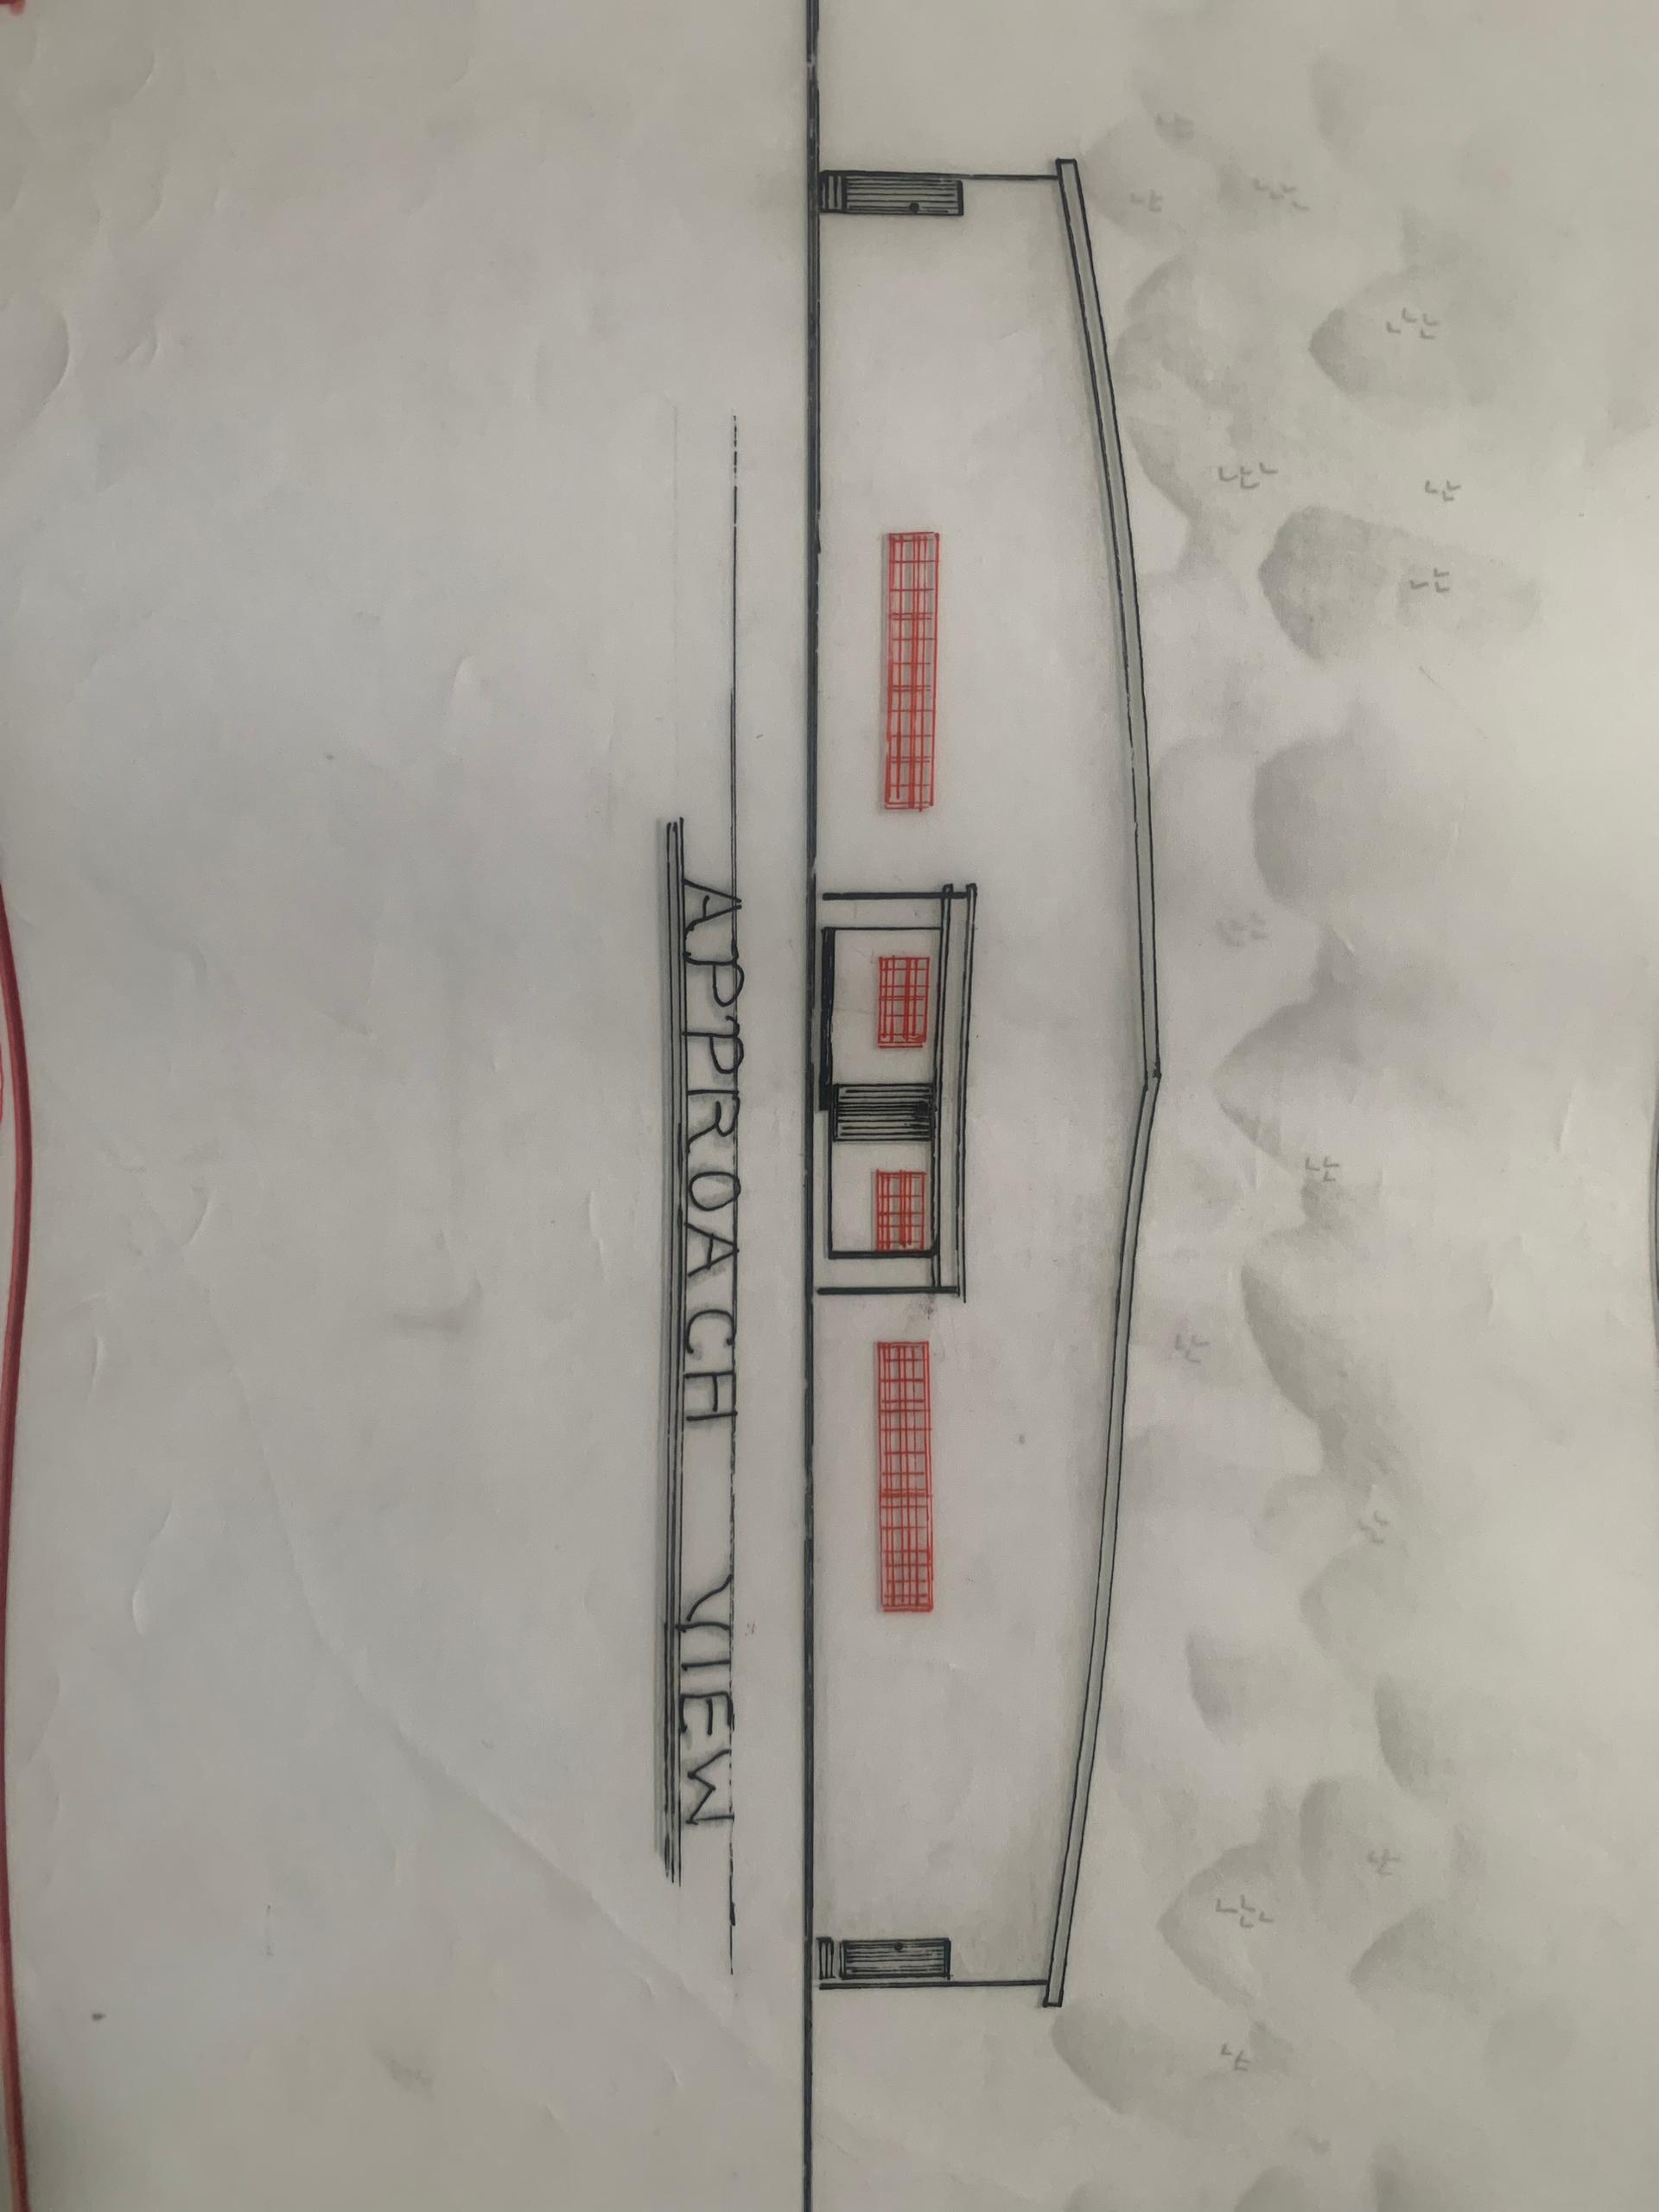
APP6; SHOWING THE APPROACH VIEW OF PROPOSED PROJECT
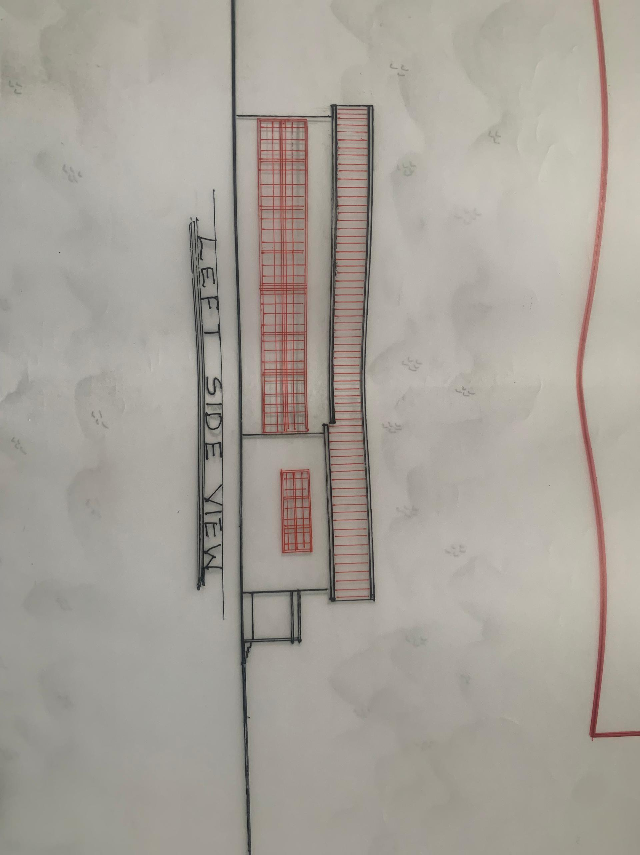
APP6; SHOWING THE LEFT SIDE OF PROPOSED PROJECT
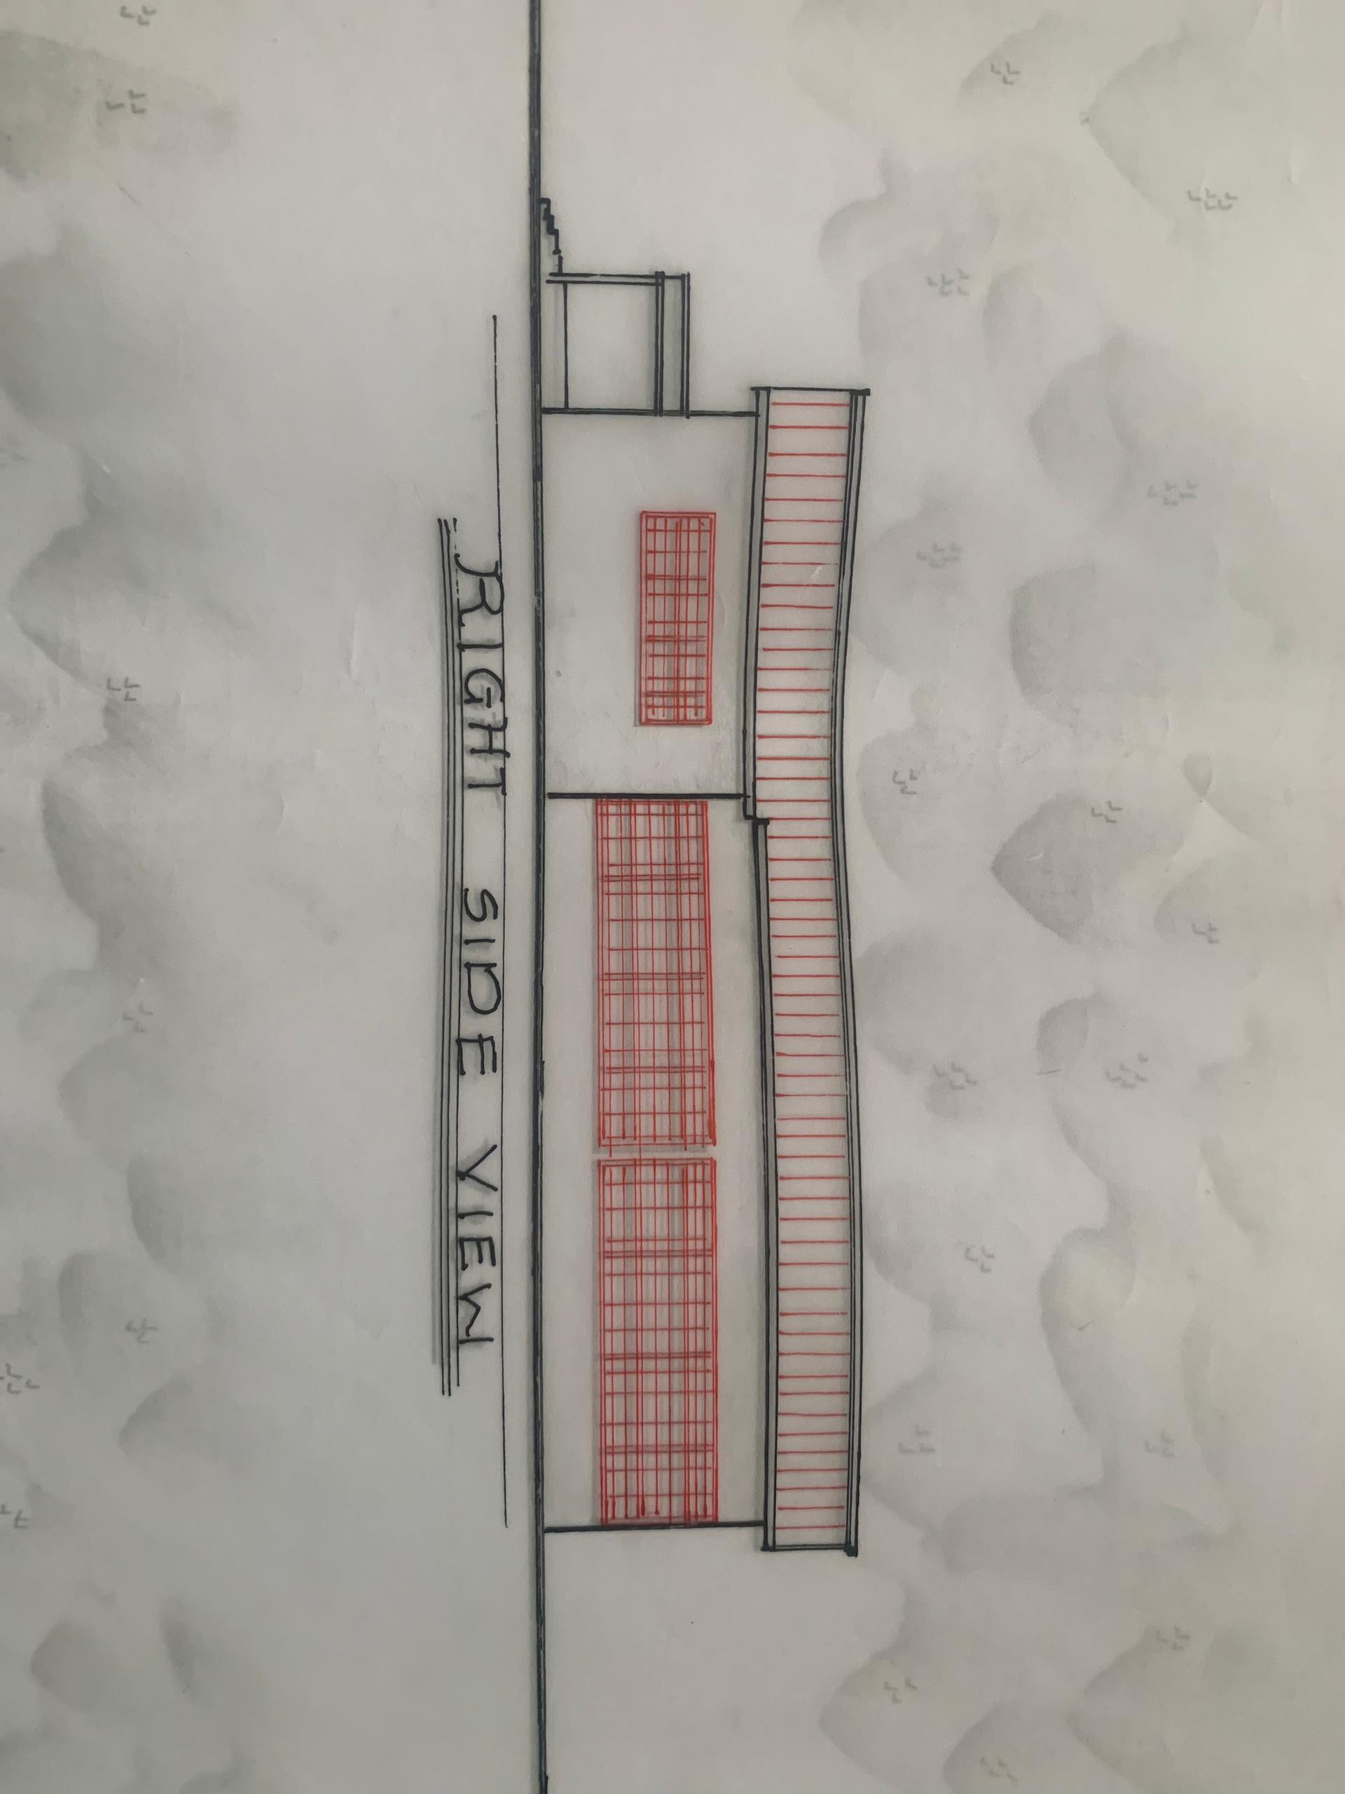
APP7; SHOWING THE RIGHT SIDE OF PROPOSED PROJECT

