THE PHYTOCHEMICAL AND ANTIOXIDANT SCREENING OF AQUEOUS OKRA (ABELMOSCUS ESULENTUS)

BY:
ALAO RIHANAT OYINKANSOLA ND/22/SLT/PT/0316
DADA JOY JUSTINAH ND/22/SLT/PT/1743
AKINBADE BLESSING TOYIN ND/22/SLT/PT/1661
ADEBAYO OLANIYI STEPHEN ND/22/SLT/PT/1211
AJIBADE ESTHER TITILOPE ND/22/SLT/PT/1626
OLUWATAYO ABIGEAL TOYOSI ND/23/SLT/PT/0186
ABDULFATAI ABDULLATEEF A. ND/23/SLT/PT/0164

DEPARTMENT OF SCIENCE LABORATORY TECHNOLOGY
INSTITUTE OF APPLIED SCIENCE
KWARA STATE POLYTECHNIC, ILORIN
(BIOCHEMISTRY UNIT SCIENCE LABORATORY TECHNOLOGY

SUPERVISED BY
MR. LUKMAN I.A

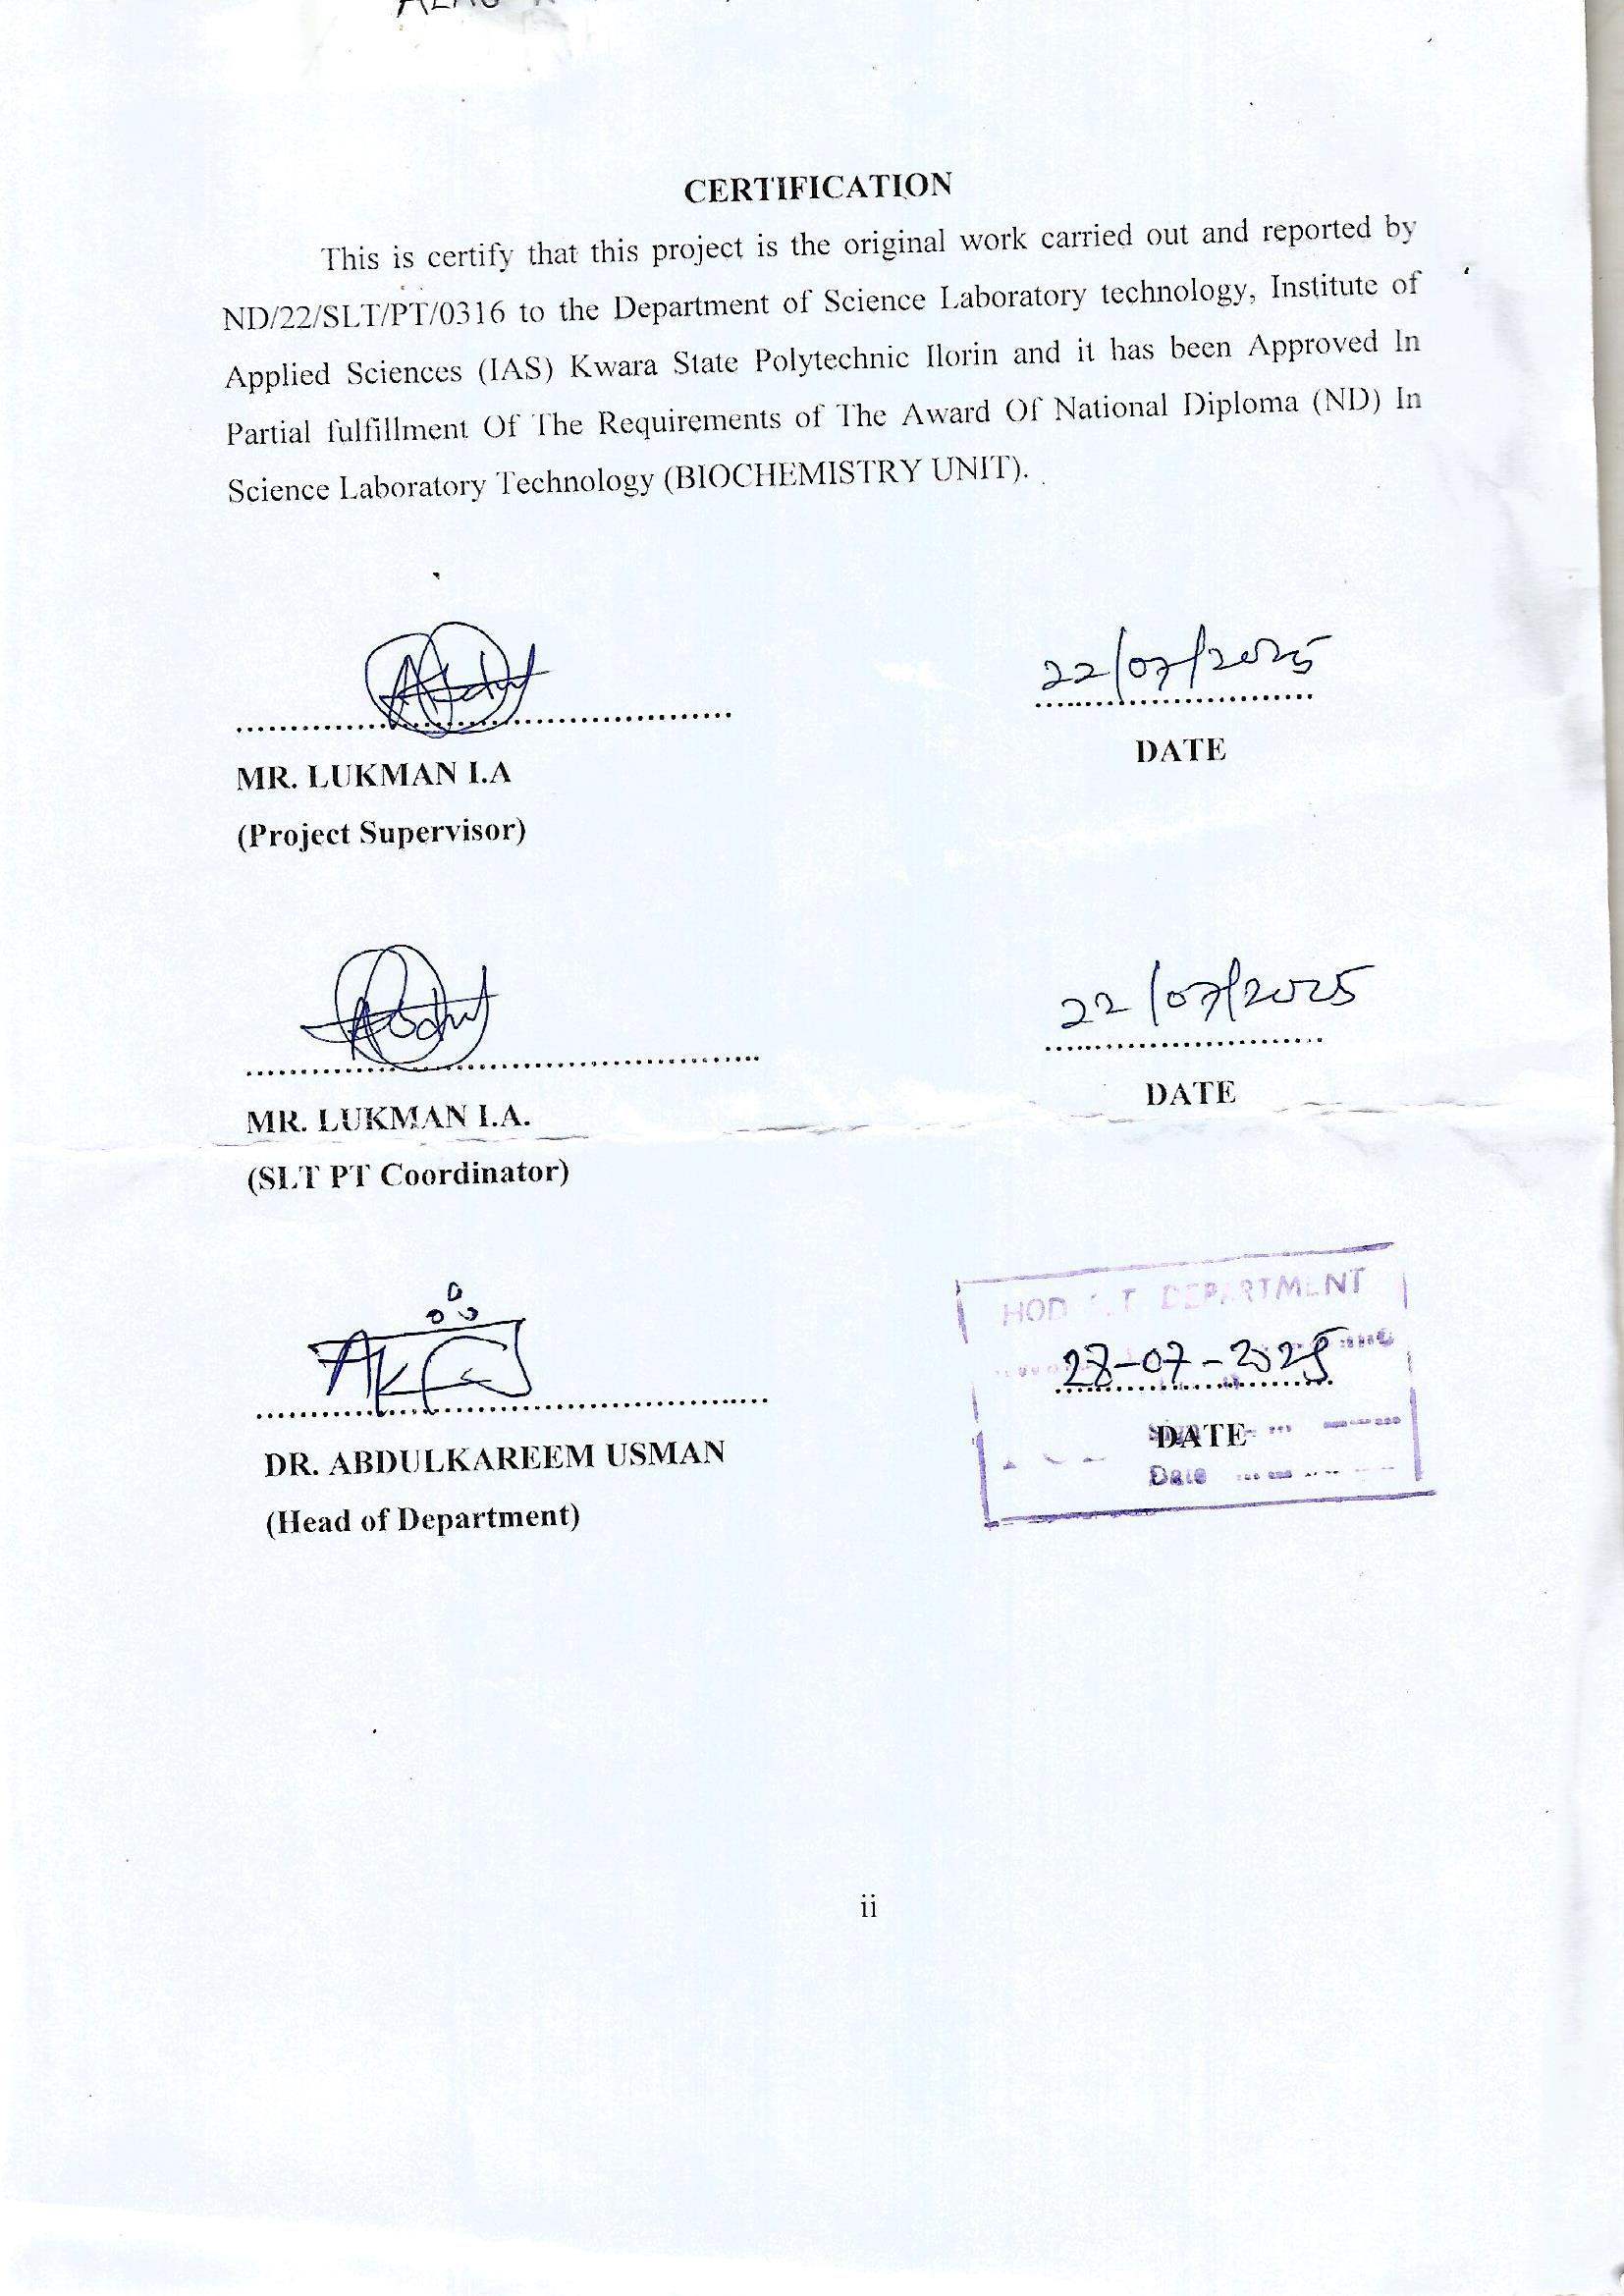

DEDICATION
This project is dedicated to the Almighty Allah the omnipresence and the omnipotent, for his mercy, kindness, faithfulness and love for me. Also my gratitude to my parent whose experience and contribution to make my education and project to a complete success, may God bless you (amen)

ACKNOLEDGEMENT
I express my profound gratitude to God Almighty for seeing me through this academic journey. I am grateful to God for his mercy, divine guidance, understanding and knowledge for completion of this project.
Then I would like to appreciate my supervisor Mr. Lukman I. A., who has a great level of knowledge and who has an art of encouragement correcting, and directing me which has enabled me to complete this project.
Also my appreciation goes to the head of department Dr. Abdulkareem Usman and my coordinator of the project Mr. Lukman I.A, and all the lecturers in department who has helped me towards the completion of this seminar.
Our deepest gratitude goes to our wonderful parents and our siblings, for their unwavering encouragement, support, inspiration and their sacrifice throughout my academic journey, May God in his infinite mercy, continue to bless you and make you live long to eat the fruit of your labour.
Our sincere gratitude to my friends who have helped me in their best understanding for this project.
Thanks so much. God bless you all.

Table of Contents
Title page
Certification
Dedication
acknowledgement
Table of content
Abstract
CHAPTER ONE
1.1 Introduction
1.2 Crops
1.3 Okra(Abelmoschus esculentus)
1.4 Medicinal important of okra
1.5 Scope of study
1.6 Aim
1.7 Objectives
CHAPTER TWO
2.1 Related review on phytochemical and antioxidants study of okra ethanolic extract.
CHAPTERTHREE(MATERIALS AND METHOD)
3.1 Materials
3.2 Method of okra collection
3.3 Method of okra extraction
3.4 Method of phytochemical screening
3.5 Method of antioxidant screening
CHAPTER FOUR
4.1 Result
CHAPTER FIVE
5.1 Discussion
5.2 Summary
5.3 Conclusion
References

Abstract
Okra (Abelmoschus esculentus) is a widely utilized vegetable valued for its nutritional and medicinal attributes. This study evaluates the phytochemical composition and antioxidant potential of aqueous okra extracts, with a focus on identifying dominant bioactive compounds. Phytochemical screening was performed to detect secondary metabolites, including steroids, flavonoids, tannins, saponins, and phenolic compounds. Antioxidant activity was measured using in vitro assays, specifically the 2,2-diphenyl-1-picrylhydrazyl (DPPH) radical scavenging assay and the ferric reducing antioxidant power (FRAP) assay. Results revealed that steroids were present in the highest amount in the aqueous okra extract, alongside significant levels of flavonoids, phenolics, and tannins, and moderate quantities of alkaloids and saponins. The extract demonstrated robust antioxidant activity, exhibiting strong DPPH radical scavenging capacity and considerable reducing power in the FRAP assay. These findings highlight aqueous okra extract as a rich source of steroids and other phytochemicals with potent antioxidant properties, underscoring its potential for use in functional foods and therapeutic applications targeting oxidative stress-related conditions.

CHAPTER ONE
  - INTRODUCTION
Okra is one of the most important a food crop, and its elongated, edible pods are mostly harvested during the immature stages and eaten primarily as a vegetable dish. (Adelakun et al. 2008).
Okra (Abelmoschus esculentus (L.) is one of further important vegetable which is widely distributed from Africa and Asia having better dietary value with medicinal and industrial importance, is flowering plant in the mallow family. Even though, the plant is cultivated in tropical and warm temperate region. It is one of the most widely known and utilized species of the family Malvaceae and an economically important vegetable crop grown in tropical and sub-tropical parts of the world. Okra plays an important role in the human diet by supplying carbohydrates, minerals and vitamins. At last time, okra has been used not only for its nutritional values but, also, for its nutraceutical and therapeutic properties, owing to the presence of various important bioactive compounds and their associated bioactivities. This review presents a summary of the nutritional significance of okra, as well as the possible pharmacological applications of okra bioactive components, and to explore the possible characteristics for the development and formulation of nutraceuticals and functional food.(Muhammad et al .2013)
Many researchers indicate that vegetables may serve as an excellent dietary source of natural antioxidants for disease prevention and health promotion. This potential is linked to their richness in secondary metabolites, among which are the phenolic compounds. Polyphenols are present in high amounts in most of foods plant and beverages which cannot be synthesized by humans. In the 1990s, several epidemiological studies demonstrated that dietary polyphenol consumption is associated with a reduced risk of cardiovascular disease. As the basic and clinical research progressed, multiple functions ofpolyphenols contributing to human health were identified. To help the indigenous population to fight against many diseases, it is necessary to identify and propose to them the plants food rich in phenolic compounds and accessible at a lower cost. The plant has many benefits, it is used as fresh leaves, buds, flowers, pods, stems and seeds. On the other hand, eating too much okra can have adverse effects on some people as gastrointestinal problems because it is rich in fructans, a type of carbohydrates that can cause diarrhea, gas, cramping and bloating in people with bowel problems. It also can cause oxalates and kidney stones as it contains high oxalate contents. Okra, Abelmoschus esculentus (L.), is an important vegetable crop grown mainly in the tropical or subtropical regions during summer and rainy season. It is composed primarily of water, carbohydrates, and proteins with very little fat and a fairnamount of dietary fiber. It is considered as a powerhouse of valuable nutrients, nearly half of which are soluble fibers in the form of gums and pectins which help to lower serum cholesterol and reducing the risk of heart diseases. The other fraction of okra is insoluble fiber,which helps to keep the intestinal tract healthy.(Aremu et al .2014)
  - CROPS
A crop is a plant or plant product that can be grown and harvested for profit or subsistence.
By use, crops fall into six categories: food crops, feed crops, fiber crops, oil crops, ornamental
crops, and industrial crops. Food crops, such as fruit and vegetables, are harvested for human
consumption.
  - OKRA (Abelmoschus esculentus)
Abelmoschus esculentus , particularly known as okra, is popular in all countries around the.world due to its high nutritional value and use of its various parts including the fresh leaves, buds, flowers, pods, stems, and seed particularly in one way or another. Okra usually has a mild taste and a unique structure. Along with nutritional value okra is known for its variety of nutraceutical applications. The different parts of okra contain certain bioactive components which are beneficial for health. Phytochemical components that are present in okra help in treatment of chronic disease such as type 2 diabetics, cardiovascular and digestive diseases. It has antibacterial as well chemo-preventive activities. The pharmacological and bioavailability of okra had made it an even more commercially important food commodity, and various studies are now focused on this particularly as well. Okra waste (unutilized fruits) contains polysaccharides and other components which are very much health beneficial. This review mainly focuses on a revisit to the various nutritional and nutraceutical applications of Abelmoschus esculentus (okra). It summarizes the available literature on okra along with its nutritional composition.
  - MEDICINAL IMPORTANT OF OKRA
Okra crop's Medicinal importance lies in its potential for fiber extraction from the plant's bast and bark, offering an alternative to conventional fibers like jute and flax, and in the use of Okra mucilage for various industrial applications.Natural fibers obtained from plants or animals. Okra fibre is on of the source of natural fibres which comes from okra plant. Natural fibres are good for us and good for the environment. Increasing concerns of environment pollution, natural fiber are widely used instead of synthetic materials. Natural fibers has biode gradable,nontoxic, renewable, high specific strength, high moisture absorption, excellent thermal properties, and economical. Okra fibre is natural bast fibre which is known botanically named as (Abelmoschus esculentus) belongs to the Malvaceae family. After harvesting of vegetable i.e ladies finger, the huge amount of okra fibre are wasted every year lack of collection fibre.The okra plants mainly cultivated for vegetable and pharmaceutical application.The okra plants grow rapidly and its height up to 2-3 metre. After harvesting of vegetable (ladies finger), fibre are extracted from okra plant by way of stagnant water retting. The chemical constitute of okra fibre are 67.5 % -cellulose, 15.4 % hemicellulose, 7.1 %lignin, 3.4 %pectic matter, 3.9 % fatty and waxy matter and 2.7 % aquous extract which are related to jute fiber. Yellowing and photochemical decomposition is responsible which causes of lignin. Medicinal properties are good because of high molecular weight compounds intrinsic of okra fibres.At present, many researchers have characterized of okra fibre for application of diversified products. De Rosa and coworkers have reported that thermal and mechanical properties of okra fibers which are potential as reinforcement of polymer matrix composite. S.Yamuna Devi and Dr. S. Grace Annapoorani have investigated high cellulose content and better mechanical strength of okra fibre. M.N Duman and coworkers have observed that agriculture waste fibres (okra fibre) are good mechanical properties and thermal conductivity.S. I. Hossain and coauthors have founded that, chemically treated of fibres are increased tensile properties and no significant effect of thermal stability Natural Fiber [11]. A. Guleria and coworkers have aloso studied of okra fibres on their fourier-transform infrared spectroscopy (FTIR), thermo-gravimetric analysis (TGA), and scanning electron microscope (SEM) analysis.
  - SCOPE OF STUDY
Scope of Study: Phytochemical screening and Antioxidant Studies of Aqueous Okra Extract The scope of studying the phytochemical screening and antioxidant properties of aqueous okra (Abelmoschus esculentus) extracts.This study focuses on the screening of phytochemicals and antioxidant properties present in the aqueous extract of okra (Abelmoschus esculentus). The primary objective is to identify, evaluate, and quantify the bioactive compounds such as flavonoids, tannins, phenolics, saponins, and alkaloids using standard phytochemical screening methods. In addition, the study assesses the antioxidant potential of the aqueous extract using in-vitro assays such as DPPH (2,2-diphenyl-1-picrylhydrazyl) radical scavenging activity, ABTS assay, and FRAP (Ferric Reducing Antioxidant Power) assay.
  - AIM
Okra (Abelmoschus esculentus L.) is often used as a vegetable and has many benefits, as it contains bioactive compounds beneficial to health and acts as a source of nutrition. This research aimed to determine the phytochemical content, total phenolic content, and antioxidant activity in the ethanolic extract of green okra (Abelmoschus esculentus) fruit obtained from a traditional market in Ilorin Kwara state. The research included four stages: sampling; sample preparation (the making of simplicia); extraction using the macerationnmethod with 96% ethanol solvent; concentration of the extract using a rotary evaporator, followed by qualitative tests on the content of phenolics, alkaloids, flavonoids, saponins,terpenoids, and steroids using reagents as per the test parameters.
  - OBJECTIVE
The objective of phytochemical screening and antioxidant studies on aqueous okra extracts is to identify the plant's bioactive compounds and assess their potential antioxidant andnhealth-promoting properties for use in traditional medicine, food, or pharmaceutical applications.

CHAPTER TWO
2.1 Related review on phytochemical and antioxidants study of okra ethanolic extract.
2.1.1 "ADAM IBRAHIM AHMED OSMAN ET AL '2022"
The aim of the present work is to investigate the phytochemical profiles screening and antioxidant activity of phenolic compounds from okra, Abelmoschus esculentus L., (ladies finger). Which known as tropical vegetable, widely planted in North Darfur State Sudan. Maceration method was used to prepare the crude extracts with methanol and chloroform (1:1) to determine the contents of Abelmoschus esculentusparts by GC-MS, The phytochemical screening made upon the crude extracts of A. esculentus revealed the presence of tannins, flavonoids, reducing compounds, sterols and terpens. The antioxidant capacities in theforms of DPPH(2,2-diphenyl-1-picrylhydrazyl) wasevaluated by spectrophotometric method. The results showed also presence of some bioactive principles such as total phenolic compounds content, flavonoids and tannins. Hence, the total phenolic compounds representa potential source of antioxidants. Okra is a nutritional source of power used throughout history for both medicinal and culinary purposesis good source of natural antioxidants that ate responsible for the health benefit.
2.1.2 "ARD ELSHIFA MOHAMMED ELHASSAN MOHAMMED ET AL '2021"
Plants Materials
Okra (Abelmoschus esculentus L.) samples were collected from a local market in El Fashir city(Umdafaso) in October 2020. The Okra washed properly with distilled water several times, to remove dust and other foreign particles and left on a clean surface to dry in the shade for 10-15 days. The dried material was grinded to fine powder using blender grinder and stored in sealed plastic bags at – 25 0C.
The Powdered material was used further preparation of extracts for phytochemical screening and antioxidant studies.
Extraction method
150 g of fruit powder sample of Abelmoschus esculentus Okra were extracted by macerated with methanol, chloroform (1:1) and allowed to stand at room temperature for a period of 7 days with frequent agitation until the soluble matter has dissolved, the extract was filtered and evaporated by using rotary flask evaporator (IKA®RV10) (rotate 20 rpm heat 25 Co) after 3hours remove the solvent and let it to dry, the residue extracts obtained was stored in container in the dark and kept at 200C until further tests to determine the total phenolic contents, antioxidant activityand GC-MS analysis.
Phytochemical Screening
Screening is a qualitative chemical analysis based on differential staining or precipitation reactions of the major chemical compounds groups contained in plants.
In the phytochemical tests; were screened find for presence of the active chemical constituents present in Abelmoschus esculentus Okra powder; such as flavonoid, phenolic compounds and tannins by the following procedures.
Test for Flavonoid
A few drops of diluted sodium hydroxide solution added to the stock solution ofOkra (0.5 mL). An intense yellow colour appeared in the plant crude extract, which became colorless upon the addition of a few drops of diluted H2SO4 acid,the test done according to.
Test for Phenolic Compounds (Ferric chloride test)
0.5 g crude plant extract of of Abelmoschus esculentus Okra was diluted in 5 ml of distilled water and filtered. To the filtrate, 5% Ferric chloride was added,the test done according.
Test for Tannins
To 0.5 mL of extract solution of Abelmoschus esculentus Okra, 1 ml of water and 1- 2 drops of ferric chloride solution wad added,the test done according to.
Analysis
Gas Chromatography/Mass Spectrometry analyses were performed on an Agilent Technologies 7890A GC System, 5975C with Triple-Axis Detector mass spectrometer witha built-in- Auto sampler formed with the usage of HP-5 capillary column (30 m x 0.32 mm x 0.25 mm). GC/MS detection, electron ionization system and ionization energy was used. Helium carrier gas at a flow rate of 1 mL min-1, the column temperature program was the same as described above.
2.1.3 "ASNIA ZAINUDDIN ET AL '2022 "
Research Method
Materials
Okra fruit (Abelmoschus esculentus) test samples, ethanol, methanol, Wagner’s reagent, Mayer’s reagent, magnesium (Mg) powder, concentrated hydrochloric acid (HCl), Dragendorff's reagent, chloroform (CHCl3),acetic acid anhydride (C4H6O3), concentrated sulfuric acid (H2SO4), iron chloride (FeCl3) 3%, distilled water (H2O), sodium hydroxide 1 N (NaOH), natrium carbonate (Na2CO3) 7.5%, iron (III) chloride (FeCl3), spiritus, aluminum foil, DPPH, ethanol 96%, methanol, vitamin C, quercetin, gallic acid, FolinCiocalteu reagent, and aluminium chloride (AlCl3).
Tools
A set of glassware and extraction tools, UV-Vis spectrophotometer, Erlenmeyer, cuvette, test tube, beaker, measuring cup, spatula, analytical balance, tube rack, tongs, cool box, blender, 60-mesh sieve, aluminum tray, rotary vacuum evaporator, incubator, vacuum filter, flask, dropper, funnel, Petri dish, spoon substance, volume pipette, and reagent bottle.
Preparation and Extraction of the Raw Ingredients
The sampling of the okra (Abelmoschus esculentus) was conducted in the morning at the Kendari City traditional market. The okra fruit was labeled and stored in a closed container during the journey to the laboratory. The preparation of the okra (Abelmoschus esculentus) began with the washing process. Fresh okra fruit was washed using running water. The sample was then drained. Then, the sample was cut, or chopped, into pieces, placed in a container, and dried. After drying, the sample was put into an oven at a temperature of 40–500C until it was completely dry. It was then blended and sieved through a 60-mesh sieve to become powder. The refined sample was then weighed with an analytical balance for further extraction . Maceration was carried out for 24 hours using 96% ethanol as a solvent. The ratio of simplicia powder and solvent used was 1:10. During maceration, the sample was stirred every hour for the first six hours. After 24 hours, filtration was carried out to obtain the maserate, and the maceration process was repeated twice. The result of maceration in the form of a solution is then filtered with filter paper to obtain the filtrate and residue. The filtrate was evaporated until the solvent separated from the extract using a Rotary Vacuum Evaporator at a temperature of less than 50oC. This extract is formulated by adding diluent or aquadest as a solvent.The extraction results were evaporated to obtain a thick extract of okra fruit. The extract was stored in a tightly closed glass container and protected from exposure to sunlight.
Phytochemical Screening
Flavonoid
Several extracts were added with methanol and heated over a water bath; 0.1 mg of powder and five drops of concentrated HCl were added. A positive reaction of flavonoids will be indicated by the formation of a red, yellow, or orange color .
Alkaloids
A total of 0.5 g of extract was added with 1 ml of HCl 2N and 9 ml of distilled water, heated in a water bath for 2 minutes, cooled, and filtered. The filtrate obtained was used for the alkaloids test. 2 test tubes were taken, and then 0.5 ml of filtrate was added to each test tube; 2 drops of Mayer's reagent and Dragendorff's reagent were added to each test tube. If there is a precipitate or turbidity, positive results for alkaloids will be shown.
Terpenoids and Steroids
Examination of triterpenoids and steroids was carried out by the Liebermann-Burchard reaction. 2 mL of the test solution was evaporated in a porcelain cup. The residue was dissolved with 0.5 mL of chloroform, and then 0.5 mL of anhydrous acetic acid was added. 2 mL of concentrated sulfuric acid was added through the tube wall. The formation of a brownish or violet ring on the boundary of the solution indicates the presence of triterpenoids, whereas a greenish blue ring indicates the presence of steroids.
Saponins
A 2.5 mL sample was added with a few drops of distilled water and then shaken vigorously (a positive test result was indicated by the appearance of foam that lasted more than 30 seconds and did not disappear when one drop of HCl 2N was added .
Phenolics
Phenolic compounds were screened by dissolving 0.1 gram of okra fruit ethanol extract with 10 mL of distilled and filtrated water. Take 1 ml of the filtrate and add two drops of 5% FeCl3 solution. A positive reaction of phenol indicates the formation of a green or blue-green color.
Total Phenolic Test
The total phenolic content test was carried out with a solution of the Folin-Ciocalteu method using UV-Vis spectrophotometry, referring to gallic acid as a comparison standard [17]. Ten milligrams of the extract were added with 0.4 mL of Folin-Ciocalteau reagent and incubated for 4-8 minutes. Next, the solution was added with 4.0 mL of 7% Na2CO3 and distilled water. After 2 hours of incubation, the absorbance of the solution was measured at a wavelength of 765 nm. The total phenol content was expressed as gallic acid equivalent (GAE) in mgGAE/g extract.
Antioxidant Activity Test (IC50) Using the DPPH Method
The antioxidant activity test using the 1,1-diphenyl-2-picrylhydrazyl (DPPH) method refers to [15]. The absorbance of each sample was determined using a UV-visible spectrophotometer at a wavelength of 515 nm. Test solutions with concentrations of 20, 40, 80, 160, and 320 mg/L were used to determine the antioxidant activity in the present research. Each test solution (0.5 mL) was added to 1 mL of DPPH solution in ethanol. The resulting solution was incubated for 30 min, and the absorbance was measured as described above. According to Fitriana et al. free radical scavenging activity can be calculated using the following formula:% Inhibition = (Acontrol − Asample)/Acontrol×100 The inhibition of free radical activity was evaluated from the absorbance value of the sample. The regression equation was obtained from the relationship between the sample concentration and the percentage of free radical activity inhibition. The concentration of the test solution that inhibited free radical activity by 50% (IC50) was calculated using a linear regression equation.
Data Analysis
Statistical analysis was carried out on the data relating to the content of phytochemical compounds,the total content of phenolic compounds, and the antioxidant activity of each sample. The data are presented as tables and graphs, which were created using Microsoft Excel.
2.1.4 "MONIKA PATEL et al '2019' "
MATERIALS AND METHODS
Survey and collection of plant parts
Leaves and root of Abelmoschus esculentus family Malvaceae were collected from Jabalpur region (Madhya Pradesh). The plant parts material was washed in running tap water, dried in shade, cut, crushed and kept in airtight bottle for experimental purpose.
Preparation of Aqueous extract
The shade dried 100 gm powdered material of Abelmoschus esculentus leaves and root were placed in a porous bag or “thimble” (filter paper) which is placed in a beaker containing 250ml water solvent. It was well-closed and kept at 4ºC for 24 hour. After that “thimble” was kept in chamber and solvent in the flask of the Soxhlet apparatus.The flask was heated a25ºC. Its vapour passed through condensation. After condensing it dript into the thimble containing the dry Abelmoschus esculentus leaves and root powder. When the level of solvent in chamber reached to the top of siphon tube, the liquid contents of chamber sink into the flask. This process continued until a drop of solvent from the siphon tube dose not leave and root residue when evaporated.
After 4 hour extract were collected from flask of the Soxhlet. Liquid plants parts extract were dried to evaporate solvent at 20ºC.
After that it was kept in water bath at 20ºC, where semi solid extract became solid. The solid was stored in well- closed dark bottle at 1 for further experimental work.
Phytochemical Screening
Phytochemical Screening Chemical tests were carried out on the aqueous extracts to identify the constituents using standard procedures as described by Harborne [15] and Tiwari [16]. The aqueous extracts of Abelmoschus esculentus leaves and root were tested to determine the presence of secondary metabolites like alkaloids, carbohydrate, glycosides, saponins, phenol, flavonoids, protein, terpenoides, and tannins.
Test for alkaloids:
Dragendroff’s Test: Filtrates were treated with Dragendroff’s reagent (solution of Potassium Bismuth Iodide). Formation of red precipitate indicates the presence of alkaloids.
Hager’s test: Extracts were dissolved individually in dilute hydrochloric acid and filtered. Filtrates were treated with Hager’s reagent. Formation of yellow coloured precipitates indicated the presence of alkaloids.
Tests for carbohydrates:
Fehling’s test: Filtrates were mixed with equal volume of Fehling’s A and Fehling’s B solutions and heated. Formation of brick red precipitate of cuprous oxide indicated the presence of reducing sugars.
Test for cardiac glycosides:
Legal’s Test: Extracts were treated with sodium nitropruside in pyridine and sodium hydroxide. Formation of pink to blood red colour indicated the presence of cardiac glycosides.
Keller Killiani test: To the test solution, 2ml of glacial acetic acid containing a few drops of FeCl3 solution was added. 1ml of conc. H2SO4 was added along the side of the test tube carefully. A brown ring at the interface indicated the presence of deoxysugar of cardenoloides. A violet ring may appear beneath the brown ring, while in the acetic acid layer, a greenish ring may also form just gradually throughout the layer.
Test for saponins:
Froth test: Extract was added to 2-3 ml of distilled water. The mixture was shaken vigorously. Formation of foam indicated the presence of saponins.
Test of phenols:
Ferric Chloride Test: Extracts were treated with 3-4 drops of ferric chloride solution. Formation of bluish black colour indicates the presence of phenols.
Test for flavonoids:
Alkaline reagent test: To the test solution, a few drops of sodium hydroxide solution were added. Formation of intense yellow colour which turns to colourless by addition of few drops of dilute acetic acid indicated the presence of flavonoids.
Lead acetate Test: Extracts were treated with few drops of lead acetate solution. Formation of yellow colour precipitate indicated the presence of flavonoids.
Test for proteins:
Xanthoproteic test: The extracts were treated with a few drops of conc. nitric acid. Formation of yellow colour indicated the presence of proteins.
Test for terpenoides
Crude extract was dissolved in 2ml of chloroform and evaporated to dryness. To this, 2ml of concentrated H2SO4 was added and heated for about 2 minutes. A greyish colour indicated the presence of terpenoids.
Test for tannins:
Ferric chloride test: To the test solution, a few drops of ferric chloride solution were added. An intense green, purple, blue or black colour indicated the presence of tannin.

CHAPTER THREE
MATERIALS AND METHOD
3.1 MATERIALS
Key materials used: Okra pods, a solvent system (likely water), and various reagents of analytical standard and techniques for analysis.
3.2 METHOD OF OKRA COLLECTION
Okra (Abelmoschus Esculentus L.) samples were collected from a local market in ilorin city in February 2025. The okra washed properly with distilled water several times, to remove dust and other foreign particles and left on a clean surface to dry in the shade for 10-15 days. The dried material was grinded to fine powder using blender grinder and stored in sealed plastics bags at 25 degree Celsius. The powdered material was used further preparation of extracts for phytochemical screening and antioxidant studies.
3.3 METHOD OF OKRA EXTRACTION
195.38g of fruit powder sample of Abelmoschus esculentus Okra were extracted by macerated with 4 litres of ethanol, and allowed to stand at room temperature for a period of 7 days with frequent agitation until the soluble matter has dissolved, the extract was filtered and evaporated by putting it in a low heat water for 5 hours, the residue extracts obtained was stored in a beaker cover with foil aluminum foil until further tests to determine the total phytochemical contents and antioxidant activity.
3.4 METHOD OF PHYTOCHEMICALS SCREENING
3.4.1 Qualitative analysis
saponins:
A foam test was carried out on the sample, distilled water was added to the sample it was shake thoroughly, if it was foaming it indicated saponins was present.
Tannins:
1ml of freshly prepared 10% potassium hydroxide was added to the sample,if it gives a dirty white precipitate it indicated that tannins was present.
Phenol :
Two drops of 5% ferric chloride was added to the sample, a green color indicated the present of phenol.
Flavonoid:
1ml of 10% sodium hydroxide was added to the sample, a yellow coloration indicated flavonoid is present.
Triterpenoid:
The sample was mixed with chloroform and conc H2SO4, a yellow under layer indicated Triterpenoid ithe present.
Glycocide
The sample was dissolved in distilled water
A few drop of 10% lead acipitate was added. A white precipitate indicated the present of Glycocide.
Steroid:
5 drops of conc H2SO4 was added to the extract, a red coloration indicated the present of steroid.
Alkaloid
1ml of 1% HCL a few drops of Drangedoff was added to the 1ml of okra extract.If indicated orange red precipitate for observation it is present.
Reducing Sugar
5ml of fehlin solution A and B was added to the sample and it was heated in a water bath for 2-3 min. A positive result,that indicated the present of reducing sugars, was a reddish-brown precipitate.
Protein:
Sodium hydroxide and copper sulphate was added to the sample, a violet or purple colour indicated the present of protein.
3.4.2 Quantitative analysis
Quantification of Total Phenolic Content (TPC)
Folin- Ciocalteu Assay:
Procedure: 0.5mL of the extract was mixed with 0.3mL of Folin-Ciocalteu reagents and 10mL of 10% of sodium carbonate solution. The volume of 25mLwas adjusted with distilled water and incubate at 50 degrees Celsius for 1 hour.
Measurements: Absorbance was measured at 765nm using UV-Vis spectrophotometer.Result are expressed as mg of gallic acid equivalent (GAE) per 100 mg of the dried okra seeds.
Quantifications of Total Flavonoid Content (TFC)
Aluminum Chloride Colorimetric Method:
Procedure: The extract reacted with aluminum chloride solution and the resulting complex absorbance was measured at 510nm.
Outcome: Flavonoid content was calculated using a standard curve of rutin and expressed as mg of rutin equivalent per gram of dry weight.
Saponins
1. Vanillin–Sulfuric Acid Colorimetric Assay
1. A standard saponin solution was prepared (e.g., 0.5 mg/mL) using a known saponin compound.
2.1 mL of the sample was mixed with 8% vanillin solution.
3. 5 mL of 72% sulfuric acidwas added to the mixture.
4. The mixture was incubated at 60°C for 10 minutes.
5. The solution was cool to room temperature.
6. The absorbance was measured at 544 nm using a UV-Vis spectrophotometer.
7. The saponin concentration was calculated using a calibration curve derived from the standard solutions.
Notes: This method is suitable for total saponin content but does not differentiate between individual saponin types.
It's important to handle sulfuric acid with care due to its corrosive nature.
Steroids
Gas Chromatography-Mass Spectrometry (GC-MS)
Principle: GC-MS separates volatile steroid derivatives and identifies them based on their mass-to-charge ratios.
1. The steroid compounds was derivative in the extract to make them volatile (e.g., silylation).
2. The derivatized sample was injected into the GC-MS system.
3. A suitable GC column and temperature program was used for separation.
4. The steroids was identified and quantified by comparing mass spectra and retention times with those of known standards.
Notes:GC-MS offers high sensitivity and specificity.It is suitable for detailed profiling of steroid compounds.
Triterpenoid
- HPLC (High-Performance Liquid Chromatography): This method is commonly used for separating, identifying, and quantifying triterpenoids in various samples, including medicinal plants and food products6.
Sample Preparation
Before quantitative analysis, samples typically undergo:
- Drying and Grinding: the plant samples was dried and grounded into a fine powder to facilitate extraction.
- Extraction: Triterpenoids was extracted using suitable solvents, such as methanol or ethanol.
- Filtration: Extracts was filtered to remove impurities.
CHAPTER FOUR
RESULTS
4.1 PHYTOCHEMICAL SCREENING
4.1.1 Table 1 shows the result qualitative analysis of extracts from okra (Abelmoschus esculentus) extract.
Phytochemicals | Present/Absent
Tannins | -
Saponnis | +
Phenol | +
Flavonoid | +
Triter penoid | +
Glycocide | -
Steroid | +
Alkaloids | +
Reducing sugar | -
Protein | -
Keys; + = present
- = absent
From the above results, alkaloid, steroid, triter penoid, flavonoid, saponnis, and phenol are present, while tannins, glycocide, reducing sugar and protein are absent in okra (abelmoschus esculentus) extract.

4.1.2 Quantitative analysis 0f extracts from okra (Abelmoschus esculentus).
This result shows the quantitative analysis of okra (abelmoschus esculentus) extract.
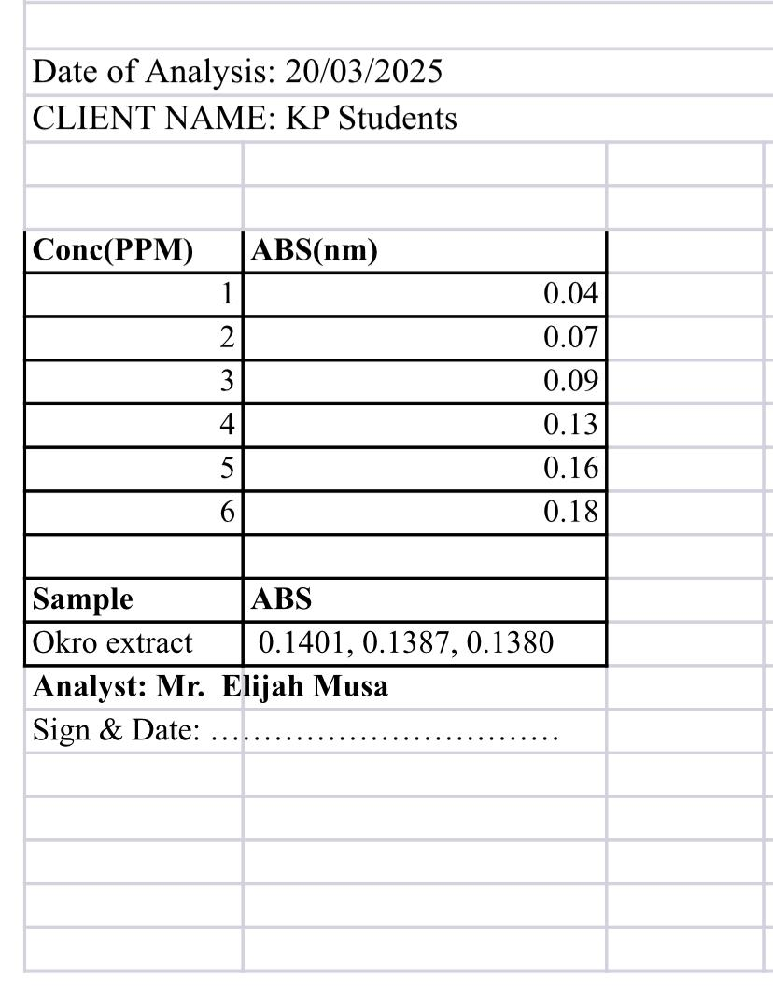
Table 2; SAPONIN RESULT USING UV SPECTROPHOTOMETER

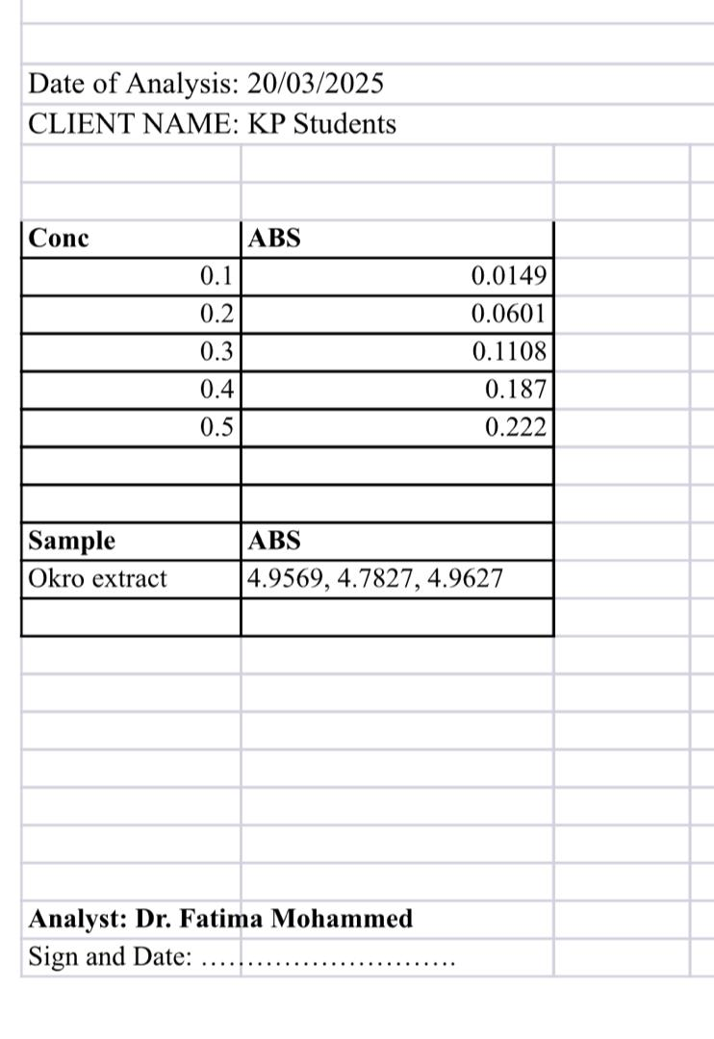
Table 3; TOTAL PHENOLIC RESULT USING UV SPECTROPHOTOMETER

Table 4; FLAVONOID RESULT USING UV SPECTROPHOTOMETER
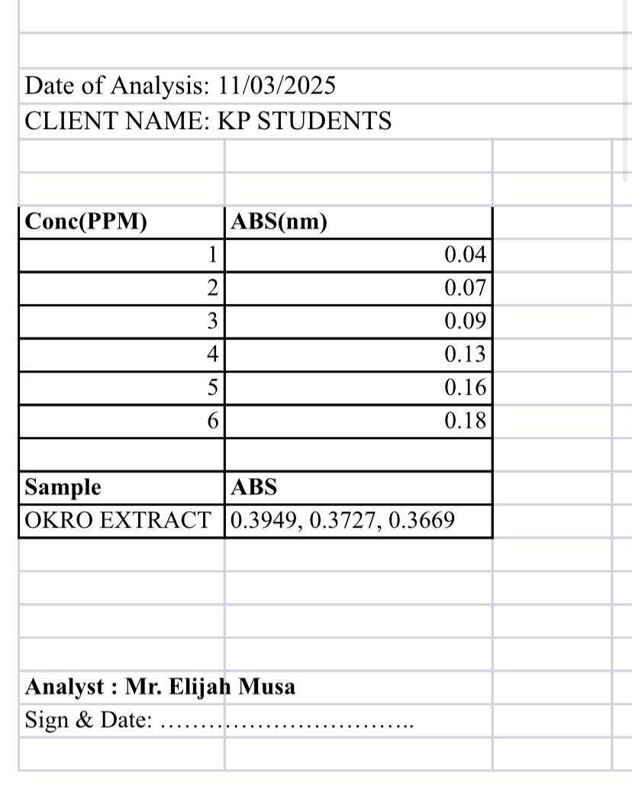

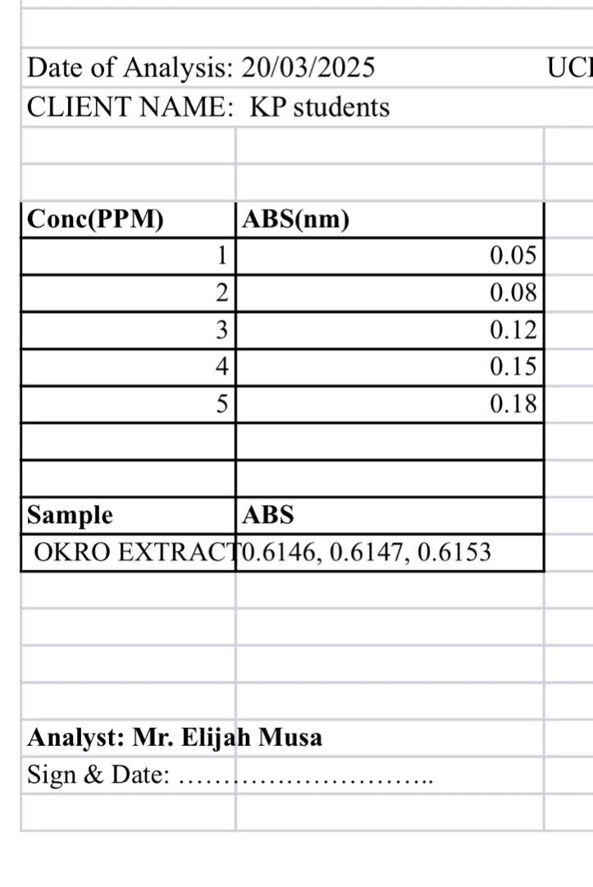
Table 5; TRITEPENOIDS RESULT USING UV SPECTROPHOTOMETER

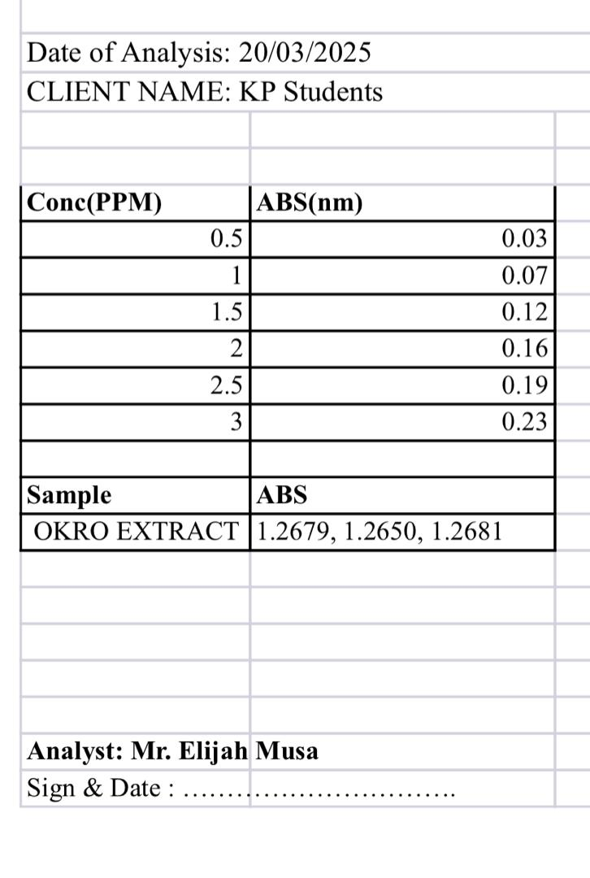
Table 6; STEROIDS RESULT USING UV SPECTROPHOTOMETER

Table 7; this results show the amount of each phytochemical in okra (abelmoschus esculentus)
Phytochemical | Mean + Sum
Steriods | 0.13 + 0.05 = 0.18
Flavonoids | 0.11 + 0.05 = 0.16
Phenol | 0.11896 + 0.05 = 0.17
Saponin | 0.11 + 0.05 = 0.16
Tritepenoids | 0.1 + 0.05 = 0.15
From the above result it shows that steriods as the high quantity in okra extract, while tritepenoids as the lowest quantity in okra extract.

CHAPTER FIVE
5.1 Discussion
The phytochemical analysis of the aqueous extract of Abelmoschus esculentus (okra) revealed the presence of several important bioactive compounds. Qualitative screening indicated the presence of flavonoids, phenolic compounds, saponins, tannins, and alkaloids, while steroids, terpenoids, and glycosides were either absent or present in low concentrations. The richness in flavonoids and phenolics is particularly significant, given their established roles in free radical scavenging and oxidative stress reduction.
The antioxidant activity assessment, typically evaluated using assays like DPPH radical scavenging, ABTS, and FRAP (Ferric Reducing Antioxidant Power), showed that aqueous okra extract possesses considerable antioxidant potential. The extract demonstrated dose-dependent scavenging activities, suggesting that its bioactive components actively neutralize free radicals. This antioxidant effect is most likely attributed to the synergistic action of phenolic compounds and flavonoids, which are known to donate hydrogen atoms or electrons to stabilize free radicals.
Comparative analysis with standard antioxidants (e.g., ascorbic acid) indicates that while the antioxidant potential of aqueous okra extract is significant, it may be slightly lower than that of pure standards. However, its natural origin, combined with its nutritional benefits and safety profile, makes it a promising candidate for functional food applications and natural antioxidant therapies.
Moreover, the presence of saponins and tannins adds to the medicinal value of okra, as these compounds also exhibit anti-inflammatory, antimicrobial, and antidiabetic properties. Alkaloids, though present in smaller quantities, could contribute to additional pharmacological effects, such as analgesic or antispasmodic activities.
The findings support the traditional use of okra in herbal medicine and suggest that its aqueous extract could serve as a natural source of antioxidants, with potential benefits in preventing oxidative stress-related diseases such as cardiovascular disorders, diabetes, and cancer.
5.2 Summary
Phytochemical Constituents
Phytochemicals analyses of aqueous okra extracts have consistently revealed the presence of various bioactive compounds, including :
Phenolic compounds: These are are known for antioxidants activities.
Flavonoids: Such as quercitin derivatives, which contribute to anti-inflammatory and antioxidants effect.
Tannins: Compounds with astringent properties and antioxidants potential.
Saponins: known for their cholesterol lowering and immune boosting properties.
Alkaloids: Nitrogen containing Compounds with diverse pharmacological activities.
Terpenoids and Steroids: Compounds that may contribute to anti-inflammatory and antimicrobial effects.
Antioxidant Screening:
Antioxidant activity of aqueous okra extract is often assessed using assays like:
DPPH radical scavenging assay
Ferric reducing antioxidant power (FRAP) assay
ABTS radical scavenging activity
Results usually show that aqueous okra extract has moderate to strong antioxidant activity, mainly due to its high phenolic and flavonoid content.
The antioxidants in okra help neutralize free radicals, which can prevent oxidative stress-related diseases like diabetes, cardiovascular diseases, and cancer.
5.3 Conclusion
The main features of the okra, Abelmoschus esculentus L., (ladies finger) is a well-known tropical vegetable.Okra is a nutritional source of power used throughout history for both medicinal and culinary purposes. Okra is good source of minerals, vitamins and nutrients that are responsible for the health benefits. This effort is towards providing the evidence in support to encourage more scientific research to find out more pharmacological and nutritional potential of Abelmoschus esculentus that may be suggestive of new drug discovery.Okra, as well as its specific mechanisms of action on different diseases, need more investigation.To focus how to complex etiology of diseases, along with different related factors aiding the diseases.The results of this study clearly showed significantly different bioactive contents and antioxidant activities, source of bioactive compounds and potential antioxidants that could be recommended in pharmaceutical and food preparations.

REFERENCE
Adelakun. O.E., Oyelade. O.J., Ade-Omowaye. B.I.O., Adeyemi. .A., Venter. M. Chemical composition and the antioxidative properties of Nigerian Okra Seed (Abelmoschus esculentus Moench) Flour. Food Chemistry and Toxicology, 47, 1123-1126,2008.
Ansari, N. M., Houlihan, L., Hussain, B., & Pieroni, A. (2005). Antioxidant activity of five vegetables traditionally consumed by south‐ Asian migrants in Bradford, Yorkshire, UK. Phytotherapy Research: An International Journal Devoted to Pharmacological and Toxicological Evaluation of Natural Product Derivatives, 19(10), 907-911.
Asha, V., Sudhanshudhar, D., & Namrata, S. (2013). Spectral analysis of steroidal saponin isolated and purified from leaves extractf Asparagus racemosus (Family—Asparagaceae), American Journal of Advanced Drug Delivery, 1(5), 770–776.
Aremu, M.O., Opaluwa, D. O., Bamidele, T. O., Nweze, C.C., Ohale, I. M., & Ochege, M. O. (2014). Comparative evaluation of nutritive value of okra (Abelmoschus esculentus) and Bush mango (Irvingia gabonensis) fruits grown in Nasarawa State, Nigeria. J. Food Sci. and Quality Manag. 27, 3-8.
Bisht, I.S. & K.V. Bhat 2006. Okra (Abelmoschus spp.). In: Ram J (Ed.) Genetic Resources, Chromosome Engineering and Crop Improvement, Vegetable Crops, CRC Press, Vol. 3: 149–185.
Cheesbrough, M. (2002). Medical laboratory manual for tropical countries. ELBS edition. Tropical health technology publications, UK. 2:2-392.
Cutter, C. N. (2000). Antimicrobial effect of herb extracts against E. coli 0157.H.7. Listeria monocytogensis and Salmonella typhimurium associated with beef. J Food Protect, 63, 601–607.
Crozier A., Jaganath. I.B., Clifford M.N. Dietary phenolics: Chemistry, bioavailability and effects on health. Natural Production Reports, 26, 1001-1043, 2009.
Devi, S. Y., & Annapoorani, S. G. (2017). International Journal of Advance Engineering and Research Characterization of New Natural Fiber Extracted from Abelmoschus esculentus stem, 572–579.2.
Hertog M.G., Kromhout D., Aravanis C., Blackburn H., Buzina. R., Fidanza F., Giampaoli S., Jansen A., Menotti A., Nedeljkovic S.. Flavonoid intake and long-term risk of coronary heart disease and cancer in the seven countries study. Archives of Internal Medicine, 155, 381-386, 1995.
Hertog M.G., Feskens E.J., Kromhout. D. Antioxidant flavonols and coronary heart disease risk. Lancet; 349, 699, 1997.
Landete. J.M. Dietary intake of natural antioxidants: Vitamins and polyphenols. Crit. Rev. Food Science Nutrition, 53, 706-721, 2013.
Manach C., Scalbert A., Morand C., Remesy C., Jimene L. Polyphenols: Food sources and bioavailability. American Journal of Clinical Nutrition, 79, 727-747, 2004.
Messing J, Thole C, Niehues M, Shevtsova A, Glocker E and Hensel A. Antiadhesive properties of Abelmoschus esculentus (Okra) immature fruit extract against Helicobacter pylori adhesion. PLoS One, 2014, 9(1): e84836.
Muhammad RS, Muhammad A, Khurram Z, et al. 2013.Growth, yield and seed production of okra as influenced by different growth regulators. Pakistan Journal of Agricultural Science. 2013;50(3):387– 392.
Kisher DS, Arya K, Yogeesh KJ, et al. Genotypic variation among okra (Abelmoschus esculentus (L.) Moench) germplasms in South India. Plant Breeding and Biotechnology. 2016;4(2):234–241.
Santos BM, Dittmar PJ, Olson SM, et al. Okra production in Florida. University of Florida IFAS extension; 2012:163–171.
Xu B.J., Chang S.K.C.A., Comparative study on phenolic profiles and antioxidant activities of legumes as affected by extraction solvents. Journal of Food Science, 72, 160-161, 2007.

