A PROJECT REPORT
ON
A PROPOSED RESTAURANT
FOR
MR KAYODE ALABI
AT TAIWO, ILORIN, KWARA STATE

BY.
ADEDEJI AMOS OLUWATOBI
ND/23/ARC/PT/OO17

BEING A PROJECT REPORT SUBMITTED TO
THE DEPARTMENT OF ARCHITECTURAL TECHNOLOGY, INSTITUTE OF ENVIRONMENT STUDIES (IES),
KWARA STATE POLYTECHIN, ILORIN.

IN PARTIAL FULFILLMENT OF THE REQUIREMENT FOR
THE AWARD OF NATIONAL DIPLOMA(ND)
IN ARCHITECTURAL TECHNOLOGY.

JULY, 2025
DECLARATION
I declare that this Project/Dissertation is a project of my personal research works. It has not been presented for the award of any ND in any polytechnic. The ideas, Observations, Comments, and Suggestions here in represent my own convictions except quotations, which have been acknowledgedIn accordance with conventional academic traditions. Under the supervision of ARC OLAREWAJU F.A

ADEDEJI AMOS OLUWATOBI ND/23/ARC/PT/0017
_________________ SIGNATURE & DATE

CERTIFICATION
I certify that this research project/Dissertation entitled RESTURANT was carried out byADEDEJI AMOS OLUWATOBI under my supervision ARC OLAREWAJU F.A has been approved.As meeting the requirement for the award of National Diploma (ND) in Architectural Technology, Kwara State Polytechnic Ilorin, Kwara State.

ARC OLAREWAJU F.A__________________
(Project Supervisor)SIGNATURE & DATE

ARC OLAREWAJU F.A_________________
(Project Coordinator)SIGNATURE & DATE

ARC MRS J.M TOMORI _________________
(Head of Department)SIGNATURE & DATE

________________EXTERNAL EXAMINER SIGNATURE & DATE

ACKNOWLEDGEMENT
My profound gratitude goes to Almighty God, the creator of universe and fountain of all wisdom whose umbrella of guard and guide. I seek refuge through thick and thin of years of study.
I will also like to appreciate my project supervisor in person of ARC OLAREWAJU F.A whose contribution prepares me for the challenges in the field and for his immense contribution is all ramification towards the completion of this research work. He encourage me and open the door of interaction with him. I pray Almighty God will shower his blessing and mercy over him, your family and may you live to reap the fruit of your Labor.
I also want to thank and appreciate the effort of all the Lectures in Architectural Technology Department my H.O.D ARC MRS TOMORI and the host of lectures ARC FAMILUA O.S, ARC CHUCKWUMA NMOM, ARC. MOH SHERO, who taught and give lasting advice’s that led to the success of my program, Almighty God will meet everyone at the point of needs.
I would also show my profound gratitude to my parents MR ADEDEJI AYEGBE OLOLADE for their Immeasurable motivation, advices, efforts, and prayers on me for the completion of this program.
My lovely sister, Miss ADEDEJI HELEN Almighty God shower his endless blessing, mercy, unlimited grace, joy, happiness without sorrow, sound health overall and may Almighty God meet everyone at the point of your needs.
Precious friends: My lovely friends AJIBOLA FUMBI, IBRAHIM ADEZIA, MUHAMMED ADIJAT. Almighty God shower his blessing, grace, and happiness with sound health over you all and our prayer (AMEEN)
Lastly ,I would like to appreciate the effort of my colleagues in department, school, and hostel, I whole heartedly say a VERY BIG THANK YOU, I appreciate you all, May Almighty Allah bless you all.
Above all, My utmost thanks go to the all sufficient God, the fountain of my wisdom, for his great and protection over my life, for his undying love, support and guidance throughout my period of learning and also for in sighting writing this project without him am nothing.
DEDICATION This project work is dedicated to Almighty God who has been providing all my need for his blessing and mercy over me all through the program.
And to my parent, my sisters, my brothers, friends, love one’s and supervisor who assist me financially, spiritually, mentally and guide me through my academic pursuit. May Almighty God shower his blessing and mercy over you All.

TABLEOFCONTENT
Titlepage………………………………………………………………………………....i
Declaration………………………………………………………………………………..ii
Certification………………………………………………………………………………iii
Acknowledgement………………………………………………………………………..iv
Dedication…………………………………………………………………………….......v
Tableofcontents………………………………………………………………………....vi
List of tables… .x
List of figures…………………………………………………………………………….xi
List of plates…………………………………………………………………………….xii
List of Appendices……………………………………………………………………..xiii
Abstract………………………………………………………………………………...xiv
CHAPTERONE
1.1 INTRODUCTION…………………………………………………………………...1
1.2 DEFINITION…………………………………………………………………………1
1.3 HISTORICALBACKGROUND……………………………………………………..2
1.4 AIMAND OBJECTIVES ……………………………………………………………4
1.5 PROJECT JUSTIFICATION ………………………………………………………...4
1.6 CLIENT BACKGROUND…………………………………………………………....4
1.7 SCOPE OFTHEPROJECT…………………………………………………………..5
1.8 RESEARCHMETHODOLOGY……………………………………………………..5
CHAPTERTWO
2.1 LITERATURE REVIEW……………………………………………………………6
2.2 HISTORICALBACKGROUND……………………………………………………6
CHAPTERTHREE
3.1 CASESTUDIES………………………………………………………………...........9
3.2 SELECTEDCASE STUDIES 9
3.3 CASESTUDYONE………………………………………………………………….9
3.4 CASESTUDYTWO………………………………………………………………..11
3.5 CASE STUDY THREE……………………………………………………………...13
3.5 ONLINECASESTUDY……………………………………...…………………….16
3.6 DEDUCTION……………………………………..………………………………..16
CHAPTERFOUR
4.1 BRIEF HISTORICAL BACKGROUND……………………………………20
4.2 LOCATION AND SETTING OUT……………………………………….....20
4.3 POPULATION……………………………………………………………….21
4.4 SITE INVENTORY……………………………………………..……………21
4.5 SITE ANALYSIS……………………………………………………………..22
4.5.1 SITE SELECTION AND JUSTIFICATION… …………………… ..……22
4.5.2LOCATION ………………………………………………………………..22
4.5.3 ACCESSIBILITY………….……………………………………………….23
4.5.4 INFRASTRUCTURE FACILITES….……………………………………..23
4.5.5 TOPOGRAPHY……………………………………………………….........23
4.5.6 SOILSTRUCTURE………………………………………………………...23
4.6 GENERAL CLIMATE CONDITION.………………………………………..23
4.6.1RELATIVE HUMIDITY…………………………………………………………...23
4.6.2 WIND…....................................................................................................................23
4.6.3 TEMPERATURE………………………………………..………………………..23
4.6.4 VEGETATION…………………………………………………………………..24
4.7 SOCIAL SERVICES……………………………………………………………….24
4.7.1 ROAD…………………………………………………………………………….24
4.7.2 WATER AND ELECTRICITY…………………………………………………..24
4.8 DESIGN CRITERIA………………………………………………………………..24
4.9 DESIGN BRIEF …………………………………………………………….………24
4.10 DESIGN ANALYSIS… ……………………………………………………...24
4.11 SPACIAL ALLOCATION ……………………………………………………...25
4.12 PLANNING PRINCIPLE………………………………………………………….26
CHAPTERFIVE
5.1 APPRAISAL OF PROPOSED SCHEME…………………………………………..27
5.2 CONSTRUCTION METHODOLOGY……………………………………………..27
5.3 SERVICES…………………………………………………………………………..27
5.3.1 VENTILATION……………………………………………………………………27
5.3.2 LIGHTING…………………………………...……………………………………28
5.3.3 PLUMBING………………………………………………………………………..28
5.3.4 ELECTRICAL INSTALLATION…………………………………………………28
5.3.5 WASTE DISPOSAL……………………………………………………………….28
5.3.6 FIRE PROTECTION……………………………………..……………………….28
5.3.7 RAIN PROTECTION……………………………………………………………28
5.3.8 EXTERNALWORK……………………………………………………………..29
5.4 SUMMARY………………………………………………………………………..29
5.5 CONCLUSION…………………………………………………………………….29
5.6 RECOMMENDATION……………………………………………………………29
5.7 REFERENCES……………………………………………………………………..30
5.8 APPENDICES……………………………………………………………………...31

LISTOFTABLES
TABLE4.1;SHOWING THE POPULATION OF THE GENDER…………………….19
TABLE4.2;SHOWING SPACIAL ALLOCATION OF FLOOR PLAN………………23

LIST OF FIGURES
FIG3.1;SHOWING LOCATION PLAN OF CASE STUDY ONE…………………….10
FIG3.2;SHOWING FLOOR PLAN OF CASE STUDY ONE…………………………10
FIG3.3; SHOWING SITE PLAN OF CASE STUDY ONE…………………………….11
FIG3.4;SHOWING LOCATION PLAN OF CASE STUDY TWO……………………12
FIG3.5;SHOWING FLOOR PLAN OF CASE STUDY TWO………………………...12
FIG3.6;SHOWING LOCATION PLAN OF CASE STUDY THREE………………....14
FIG3.7; SHOWING SITE PLAN OF CASE STUDY TWO……………………………15
FIG3.8;SHOWING FLOOR PLAN OF CASE STUDY THREE……………………...15
FIG3.9; SHOWING SITE PLAN OF CASE STUDY THREE…………………………16
FIG4.1;SHOWING LOCATIONAL PLAN OF THE PROPOSED SITE……………..18
FIG4.2;SHOWING SITE INVENTORY OF THE PROPOSED SITE………………..19
FIG4.3;SHOWING SITE ANALYSIS OF THE PROPOSED SITE…………………..20

LIST OF PLATES
PLATE3.1;SHOWING FRONT VIEW OF CASE STUDY ONE……………………..11
PLATE3.2;SHOWING RIGHT VIEW OF CASE STUDY ONE ……………………..12
PLATE3.3;SHOWING FRONT VIEW OF CASE STUDY TWO…………………….14
PLATE3.4;SHOWING WAITING AREA OF CASE STUDY TWO…………………15
PLATE3.5;SHOWING FRONT VIEW OF CASE STUDY THREE………………….17
PLATE3.6;SHOWING RIGHT VIEW OF CASE STUDY THREE…………………..18

LISTOFAPPENDICES
APP1;SHOWING SITE PLAN OF THE PROPOSED PROJECT ……………………32
APP2;SHOWING GROUND FLOOR PLAN OF THE PROPOSED PROJECT……..32
APP3;SHOWING ROOF PLAN OF THE PROPOSED PROJECT…………………...33
APP4;SHOWING CROSS SECTION OF THE PROPOSED PROJECT……………..33
APP5;SHOWING FRONT VIEW OF THE PROPOSED PROJECT…………………34
APP7;SHOWING SIDE VIEW OF THE PROPOSED PROJECT……………………34

ABSTRACT
This researcher work was carried out on the project topic "Restaurant for Ilorin, Kwara state ". I felt caring out this project in Taiwo local government will bring out meaningful result. For easy analysis and understanding, the study is being put into five chapters. Chapter one throws light on general introduction, definition of the project, historical background information of the project title, project justification, aim and objectives of the study, scope of the study, Chapter two, a detailed literature review of some books. The third chapter three also mention about thecase studies and deduction from case studies. The fourth chapter deals withhistorical background of the study area, site location and description, site analysis, and geographical location, climatic data, population of the area, social services, and health services design criteria, design analysis, space allocation and planning principle. Chapter five deals with design appraisal, construction methodology, services, summary, conclusion and references.

CHAPTER ONE
1.1 INTRODUCTION
A restaurant is an establishment that prepares and serves food and drinks to customers. Meals are generally served and eaten on the premises, but many restaurants also offer take-out and food delivery services. Restaurants vary greatly in appearance and offerings, including a wide variety of cuisines and service models ranging from inexpensive fast-food restaurants and cafeterias to mid-priced family restaurants, to high-priced luxury establishments.
Restaurant guides review restaurants, often ranking them or providing information to guide consumers (type of food, handicap accessibility, facilities, etc.). One of the most famous contemporary guides is the Michelin series of guides which accord one to three stars to restaurants they perceive to be of high culinary merit. Restaurants with stars in the Michelin guide are formal, expensive establishments; in general the more stars awarded, the higher the prices.
The main competitor to the Michelin guide in Europe is the guidebook series published by Gault Millau. Its ratings are on a scale of 1 to 20, with 20 being the highest.
In the United States, the Forbes Travel Guide (previously the Mobil travel guides) and the AAA rate restaurants on a similar 1 to 5 star (Forbes) or diamond (AAA) scale. Three, four, and five star/diamond ratings are roughly equivalent to the Michelin one, two, and three star ratings while one and two star ratings typically indicate more casual places to eat. In 2005, Michelin released a New York City guide, its first for the United States. The popular Zagat Survey compiles individuals' comments about restaurants but does not pass an "official" critical assessment.
Nearly all major American newspapers employ food critics and publish online dining guides for the cities they serve. Some news sources provide customary reviews of restaurants, while others may provide more of a general listings service.
More recently Internet sites have started up that publish both food critic reviews and popular reviews by the general public.
1.2 DEFINITION
A restaurant is a designed space specifically planned for food preparation, dining, and customer service, integrating functional, aesthetic, and operational aspects to enhance the dining experience. It includes key architectural elements such as layout efficiency, spatial organization, ambiance, ventilation, lighting, acoustics, and accessibility.
1.3 HISTORICAL BACKGROUND
A public eating establishment similar to a restaurant is mentioned in a 512 BC record from Ancient Egypt. It served only one dish, a plate of cereal, wildfowl, and onions.
A forerunner for the modern restaurant is the thermopolium, an establishment in Ancient Greece and Ancient Rome that sold and served ready-to-eat food and beverages. These establishments were somewhat similar in function to modern fast food restaurants. They were most often frequented by people who lacked private kitchens. In the Roman Empire, they were popular among residents of insulae.
In Pompeii, 158 thermopolia with service counters have been identified throughout the town. They were concentrated along the main axis of the town and the public spaces where they were frequented by the locals.
The Romans also had the popina, a wine bar which in addition to a variety of wines offered a limited selection of simple foods such as olives, bread, cheese, stews, sausage, and porridge. The popinae were known as places for the plebeians of the lower classes of Roman society to socialize. While some were confined to one standing room only, others had tables and stools and a few even had couches.
Another early forerunner of the restaurant was the inn. Throughout the ancient world, inns were set up alongside roads to cater to people travelling between cities, offering lodging and food. Meals were typically served at a common table to guests. However, there were no menus or options to choose from.
Early eating establishments recognizable as restaurants in the modern sense emerged in Song dynasty China during the 11th and 12th centuries. In large cities, such as Kaifeng and Hangzhou, food catering establishments catered to merchants who travelled between cities. Probably growing out of tea houses and taverns which catered to travellers, Kaifeng's restaurants blossomed into an industry that catered to locals as well as people from other regions of China. As travelling merchants were not used to the local cuisine of other cities, these establishments were set up to serve dishes familiar to merchants from other parts of China. Such establishments were located in the entertainment districts of major cities, alongside hotels, bars, and brothels. The larger and more opulent of these establishments offered a dining experience similar to modern restaurant culture. According to a Chinese manuscript from 1126, patrons of one such establishment were greeted with a selection of pre-plated demonstration dishes which represented food options. Customers had their orders taken by a team of waiters who would then sing their orders to the kitchen and distribute the dishes in the exact order in which they had been ordered.
There is a direct correlation between the growth of the restaurant businesses and institutions of theatrical stage drama, gambling and prostitution which served the burgeoning merchant middle class during the Song dynasty. Restaurants catered to different styles of cuisine, price brackets, and religious requirements. Even within a single restaurant choices were available, and people ordered the entrée from written menus. An account from 1275 writes of Hangzhou, the capital city for the last half of the dynasty.
The people of Hangzhou are very difficult to please. Hundreds of orders are given on all sides: this person wants something hot, another something cold, a third something tepid, a fourth something chilled.one wants cooked food, another raw, another chooses roast, another grill.
The restaurants in Hangzhou also catered to many northern Chinese who had fled south from Kaifeng during the Jurchen invasion of the 1120s, while it is also known that many restaurants were run by families formerly from Kaifeng.
In Japan, a restaurant culture emerged in the 16th century out of local tea houses. Tea house owner Sen no Rikyū created the kaiseki multi-course meal tradition, and his grandsons expanded the tradition to include speciality dishes and cutlery which matched the aesthetic of the food.
In Europe, inns which offered food and lodgings and taverns where food was served alongside alcoholic beverages were common into the Middle Ages and Renaissance. They typically served common fare of the type normally available to peasants. In Spain, such establishments were called bodegas and served tapas. In England, they typically served foods such as sausage and shepherd's pie. Cookshops were also common in European cities during the Middle Ages. These were establishments which served dishes such as pies, puddings, sauces, fish, and baked meats. Customers could either buy a ready-made meal or bring their own meat to be cooked. As only large private homes had the means for cooking, the inhabitants of European cities were significantly reliant on them.
France in particular has a rich history with the development of various forms of inns and eateries, eventually to form many of the now-ubiquitous elements of the modern restaurant. As far back as the thirteenth century, French inns served a variety of food — bread, cheese, bacon, roasts, soups, and stews - usually eaten at a common table. Parisians could buy what was essentially take-out food from rôtisseurs, who prepared roasted meat dishes, and pastry-cooks, who could prepare meat pies and often more elaborate dishes. Municipal statutes stated that the official prices per item were to be posted at the entrance; this was the first official mention of menus.
Taverns also served food, as did cabarets. A cabaret, however, unlike a tavern, served food at tables with tablecloths, provided drinks with the meal, and charged by the customers' choice of dish, rather than by the pot. Cabarets were reputed to serve better food than taverns and a few, such as the Petit Maure, became well known. A few cabarets had musicians or singing, but most, until the late 19th century, were simply convivial eating places. The first café opened in Paris in 1672 at the Saint-Germain fair. By 1723 there were nearly four hundred cafés in Paris, but their menu was limited to simpler dishes or confectionaries, such as coffee, tea, chocolate (the drink; chocolate in solid state was invented only in the 19th century), ice creams, pastries, and liqueurs.
At the end of the 16th century, the guild of cook-caterers (later known as "traiteurs") was given its own legal status. The traiteurs dominated sophisticated food service, delivering or preparing meals for the wealthy at their residences. Taverns and cabarets were limited to serving little more than roast or grilled meats. Towards the end of the seventeenth century, both inns and then traiteurs began to offer "host's tables" (tables d'hôte), where one paid a set price to sit at a large table with other guests and eat a fixed menu meal.
1.4 AIM AND OBJECTIVES OF THE PROJECT
AIM
To design and develop a functional, aesthetically pleasing, and culturally relevant restaurant in Ilorin, Kwara State, that enhances the dining experience while ensuring efficiency, comfort, and sustainability.
OBJECTIVES
- To create a well-organized layout with designated areas for dining, kitchen, storage, and restrooms.
- To incorporate traditional and modern architectural elements that reflect the local culture of Ilorin.
- To design with natural ventilation systems to minimize energy consumption.
- To use durable, non-slip flooring to prevent accidents.
- To design seating areas that cater to different group sizes and preferences.
1.5 PROJECT JUSTIFICATION
The proposed restaurant in Ilorin will be a modern, culturally relevant, and environmentally sustainable space, designed to enhance customer comfort, optimize efficiency, and comply with safety and hygiene standards. Its architectural design will support a vibrant and welcoming dining experience, contributing to the city's growing hospitality industry.

1.6 CLIENT BACKGROUND
The name of my client is KAYODE ALABI
THE CURENT DEPTUY GOVERNOR OF KWARA STATE
Kayode Alabi (born 1 August 1963) is a Nigerian politician, who is deputy governor of Kwara State. He was born in Oro-Ago, Kwara State, Nigeria into the family of late Yahaya Samuel Alabi (1925–2007) Oro-Ago in Kwara State, he is the third child of his parents. He has two elder brothers and a younger sister. Alabi's mother, who was 93 years old, passed away in the early hours of Friday, 5th April 2024.He ran on the same ticket with Governor AbdulRahman AbdulRazaq on the platform of All Progressives Congress (APC) in the 2019 General elections.Few months after he swore into office, he was appointed by Governor AbdulRahman AbdulRazaq of Kwara State as the head of COVID-19 Technical Committee in Kwara State.
1.7 SCOPE OF THE PROJECT
- Proposed Building
- Waiting Area
- Gate House
- Generator House
- Packing Lot
- Recycling Area
- Access Road
1.8 RESEARCH METHODOLOGY
Various avenues were expressed as regards the method of research on order to arrive at a functional and appealing design concepts. The following research methods were employed.
LITERATURE REVIEW: Reference to tolerate for ideas of various writer were consulted in order to attain useful and important past work on similar project.
INTERNET: This is are search that was done and gained from the internet in other to get further information.
PERSONAL OBSERVATION: personal initiative coupled within quisitive measure, interview and visualize the daily activities that take place within vicinity and necessary pictures were taken in order to attain there quired motive
CASE STUDIES: This involves the thorough synthesis and analysis of similar existing structure (building) Based on the data collected and better deduction was made for realization of the best.

CHAPTER TWO
2.0 LITERATURE REVIEW
2.1 HISTORICAL BACKGROUND
Menu maintains its dominant position in restaurant firms, since it is the core of food and beverage operations. Specifically, menu is an instructor that clearly dictates. what will be produced, what type of equipment and ingredients are needed, and which qualifications employees should have. Menu also functions as a communicating and selling tool (Kincaid and Corsun, 2003). More specifically, it communicates not only the food and beverage offerings, but also the image of the firm. Furthermore, menu is a base on which the customers make their food choices and a well designed menu can direct customers' attention to the items the firm wants to sell more (Antun and Gustafson, 2005).
The critical qualifications attributed to menu describe its importance to restaurant operations and customer experiences. In fact, in contemporary understandings of menu, it has material and immaterial meanings. Materially, menu is a list or a card which documents the food and beverage options being offered by a restaurant. Immaterial meanings of menu highlight that it is a medium that affects customers' perceptions of restaurant experience (Wansink et al., 2005), and it is also an element of restaurant management that requires conducting critical managerial activities such as planning, pricing, designing and analyzing (Jones and Mifli, 2001). It also differs from the main product of a restaurant. Prior research (Johns and Kivela, 2001, Gustafsson, 2004, Hansen et al., 2005) claim that the primary product of restaurants is meal experience and it is constituted by many components such as food and beverages, atmosphere, social factors and management. What customers receive from consumption in restaurants is their memories and overall perceptions of meal experience, and menu is part of that experience and has associations with customers' perceptions. Consequently, menu cannot be considered as the overall product of a restaurant but it is an important component complementing atmosphere, interactions with servers and other customers, and managerial systems which are jointly available in a restaurant where a good, memorable meal experience is the main product.
Since it is a key factor in attracting and satisfying customers and effecting performance of restaurant firms, menu has been gaining a considerable academic attention from researchers. The previous studies on menu constitute a substantial body of literature and they primarily examined the issues including menu planning, menu pricing, menu designing, and menu analysis. For instance, Kivela (2003) investigated menu planning through employing an experimental research design and proposed a menu item selection framework. Menu pricing was examined by several authors from a range of perspectives including the price perceptions of customers (Shoemaker, 1994, Iglesias and Guillen, 2002), price sensitivity, pricing methods (Kelly et al., 1994, Raab et al., 2009, Kelly et al., 2009), and psychological pricing (Carmin and Norkus, 1990, Naipaul and Parsa, 2001, Parsa and Hu, 2004). Menu designing has also gained a particular attention from menu researchers who have particularly focused on positioning the menu item on the menu card (Bowen and Morris, 1995, Kincaid and Corsun, 2003, Reynolds et al., 2005), labeling (Lockyer, 2006, Wansink et al., 2001) and describing menu items (McCall and Lynn, 2008, Hwang and Lorenzon, 2008). In the field of menu analysis, researchers have offered several models such as menu engineering (Kasavana and Smith, 1982), analysis of menu items' profitability (Hayes and Huffman, 1985), and more recently multi-dimensional analysis of menu items (Taylor and Brown, 2007). From a practical perspective, menu is directly related to many functions of food and beverage operations and also absorbs a wide range of interrelated managerial decisions in the areas of planning, pricing, designing, operating, and developing menu.
The system adopts that consumers will be utilizing smartphones to place their orders. Once the consumer lands at the outlet, they can prove their preserved order completely by affecting their smartphone screen. The list of pre-picked articles will open or fan out on the room for cooking food screen, and upon ratification, an order slip will be impressed for further deal with. This answer facilitates the pre- order process for clients, making it a more nearby alternative.
The most illustrious of all 19th-century Paris restaurants was the Café Anglais, on the Boulevard des Italiens at the corner of the rue Marivaux, where the chef, Adolphe Dugléré, created classic dishes such as sole Dugléré (filets poached with tomatoes and served with a cream sauce having a fish stock base) and the famous sorrel soup potage Germiny. On June 7, 1867, the Café Anglais served the now-famous “Three Emperors Dinner” for three royal guests visiting Paris to attend the Universal Exposition. The diners included Tsar Alexander II of Russia; his son the tsarevich (later the tsar Alexander III); and King William I of Prussia, later the first emperor of Germany. The meal included soufflés with creamed chicken (à la reine), fillets of sole, escalloped turbot, chicken à la portugaise (cooked with tomatoes, onions, and garlic), lobster à la parisienne (round, flat medallions glazed with a gelatin-mayonnaise mixture and elaborately decorated), ducklings à la rouennaise (the carcasses stuffed with liver and pressed, presented on a platter with boned slices of the breast and the grilled legs, and served with a red wine sauce containing pureed liver), ortolans (small game birds) on toast, and eight different wines, although the Café Anglais closed in 1913, when the building was demolished, the table setting for this dinner is now displayed at La Tour d’Argent, the oldest surviving restaurant in Paris.
Toward the end of the 19th century, in the gaudy and extravagant era known as la belle époque, the luxurious Maxim’s, on the rue Royale, became the social and culinary centre of Paris. The restaurant temporarily declined after World War I but recovered under new management, to become an outstanding gastronomic shrine.
France produced many of the world’s finest chefs, including Georges-Auguste Escoffier, who organized the kitchens for the luxury hotels owned by César Ritz, developing the so-called brigade de cuisine, or kitchen team, consisting of highly trained experts each with clearly defined duties. These teams included a chef, or gros bonnet, in charge of the kitchen; a sauce chef, or deputy; an entremettier, in charge of preparation of soups, vegetables, and sweet courses; a rôtisseur to prepare roasts and fried or grilled meats; and the garde manger, in charge of all supplies and cold dishes. In Escoffier’s time, the duties and responsibilities of each functionary were sharply defined, but in modern times, rising labour costs and the need for faster service have broken down such rigidly defined duties. In the kitchens of even the leading modern restaurants, duties at the peak of the dinner-hour preparations are likely to overlap widely, with efficiency maintained amid seeming chaos and confusion.
French Restaurants in the 20th century.
In the 20th century, with the development of the automobile, country dining became popular in France, and a number of fine provincial restaurants were established. The Restaurant de la Pyramide, in Vienne, regarded by many as the world’s finest restaurant, was founded by Fernand Point and after his death, in 1955, retained its high standing under the direction of his widow, Madame (“Mado”) Point. Other leading French provincial restaurants have included the Troisgros in Roanne; the Paul Bocuse Restaurant near Lyon; the Auberge de l’Ill in Illhaeusern, Alsace; and the hotel Côte d’Or, at Saulieu.
Selected restaurants throughout France are evaluated annually by the Guide Michelin, a publication devoted to surveying eating establishments and hotels in more than 3,400 towns and cities and awarding one, two, or three stars, based upon quality.

CHAPTER THREE
3.1 CASE STUDY
This is are search or an exercise that is carried out on existing building which is similar to the one researcher is writing on. The objective of a case study is to take a critical appraisal of existing related project with a view to identify the positive and negative aspect of such projects. It is only with time that a project can be adjusted so that it can be successful. The information obtained from the appraisal will guide the designer of new and similar project, the positive aspect of it shall be incorporated in the view proposal while attempts will be made to solve the problem of negative aspects. It is only through this that a designer can better enhance the quality and efficiency of building in the society. For a comprehensive analysis their case studies have been conducted.
3.2 SELETED CASE STUDIES
Case studies are of paramount important. It is an experimental research or analysis carried out on existing building or group of building functionally similar to the one which there search is working.
For any technical design to be meaningful there is always the need for preliminary research effort to be made on this proposal as a very necessary ground work.
The following are case studies of some restaurant.
- KILIMANJARO RESTAURANT
Location: 8 ASA DAM ROAD,ILORIN KWARA STATE
- LATITUDE CAFÉ AND LOUNGE
Location: V2/V3 VENTURA MALL,SANGO-OJOO ROAD IBADAN OYO STATE
- YAKOYO AFRIKANA
Location: SHOP 001, OJAJA MORE, IBADAN-IFE ROAD 220101,OSUN STATE
3.3 CASE SYUDY ONE
KILIMANJARO RESTAURANT
LOCATION:8 ASA DAM ROAD, ILORIN KWARA STATE.
OBSEVERATION
MERITS
- Adequate of staff
- There is enough toilet
- There is enough space for eating area.
DEMERITS
- Inadequate space for packing
- No enough spaces in the building
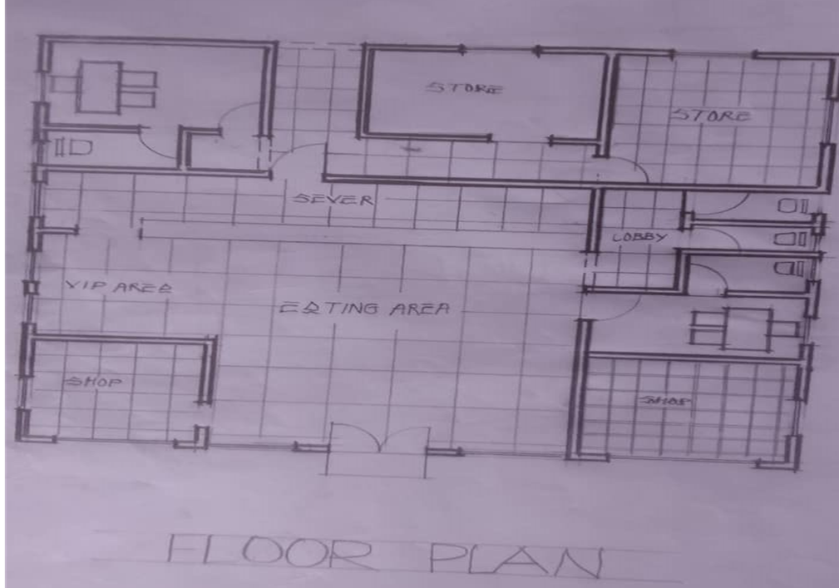
- It not well oriented.
FIG3.1; SHOWINGFLOOR PLAN OF CASE STUDY ONE
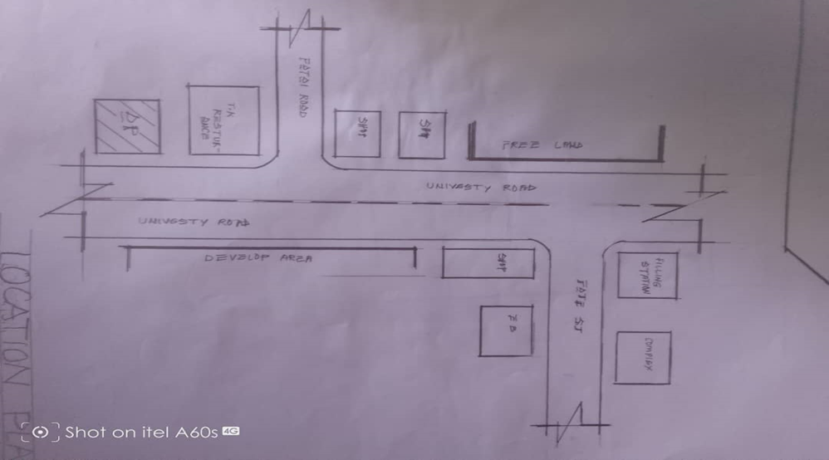
FIG3.2; SHOWING LOCATIONAL PLAN OF CASE STUDY ONE
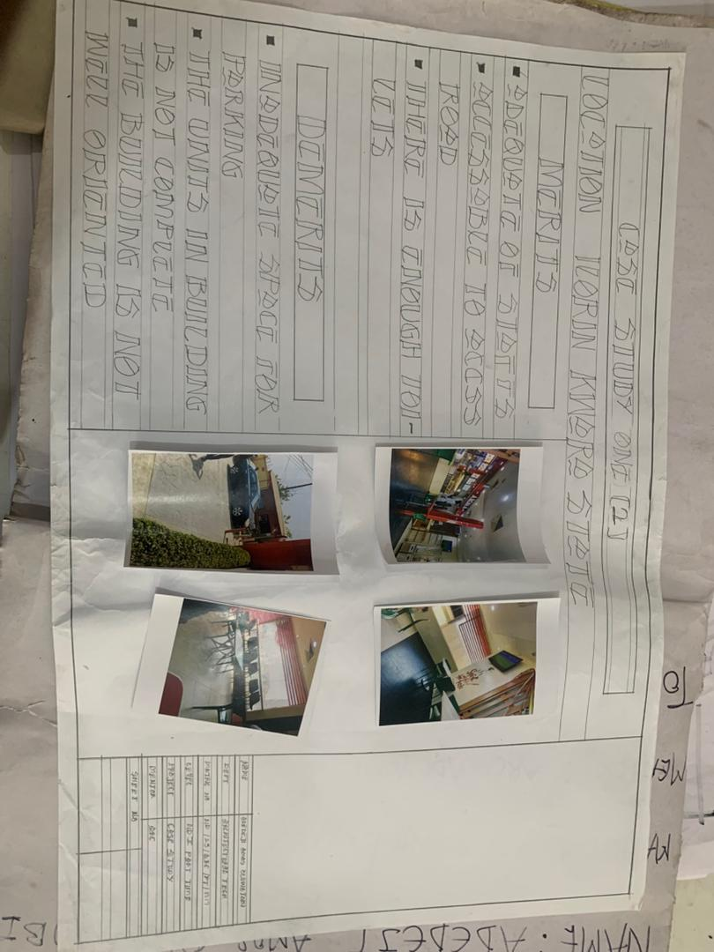
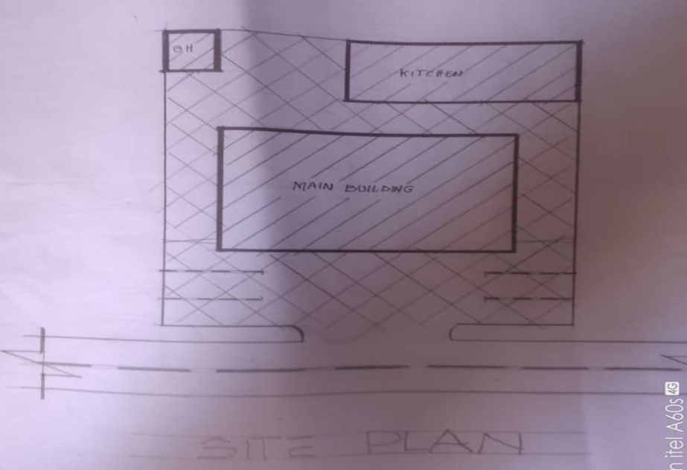
FIG3.3; SHOWING SITE PLAN OF CASE STUDY ONE

PLATE3.1; SHOWING THE FRONT VIEW OF CASE STUDY ONE
PLATE3.2; SHOWING THE EATING AREA OF CASE STUDY ONE

3.4 CASE STUDY TWO
LATITUDE CAFÉ AND LOUNGE
Location: V2/V3 VENTURA MALL,SANGO-OJOO ROAD IBADAN OYO STATE
OBSEVERATION
MERIT
- The eating area is spacious.
- Adequate of parking space.
- Very accessible to the access road.
- The building is well oriented.
DEMERIT
- No access from main office to the kitchen.
- Changing room is not enough for the staff.
- Inadequate space for the delivery bay.

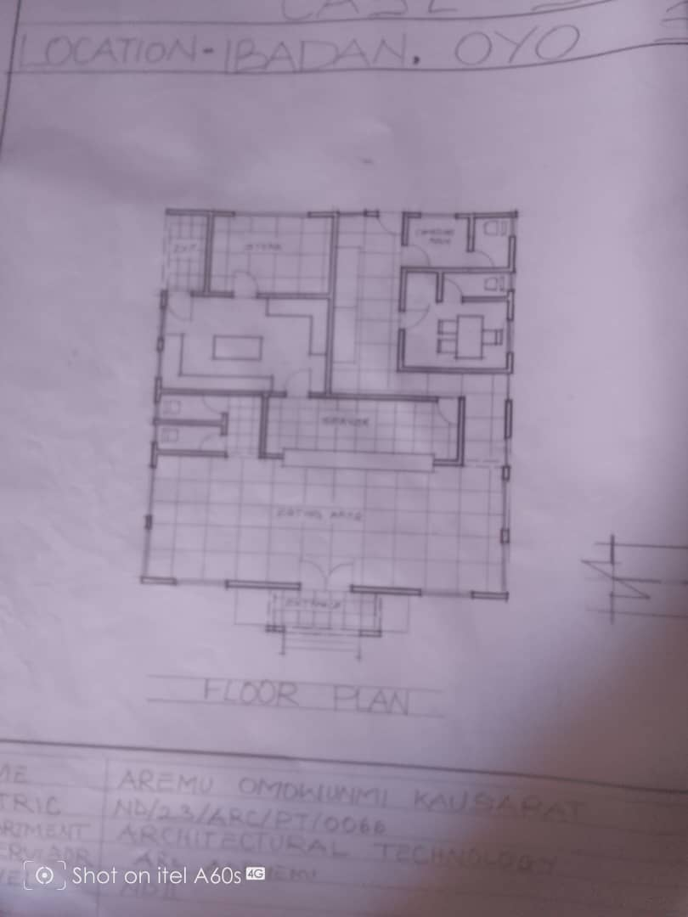
FIG3.4; SHOWINGFLOOR PLAN OF CASE STUDY TWO
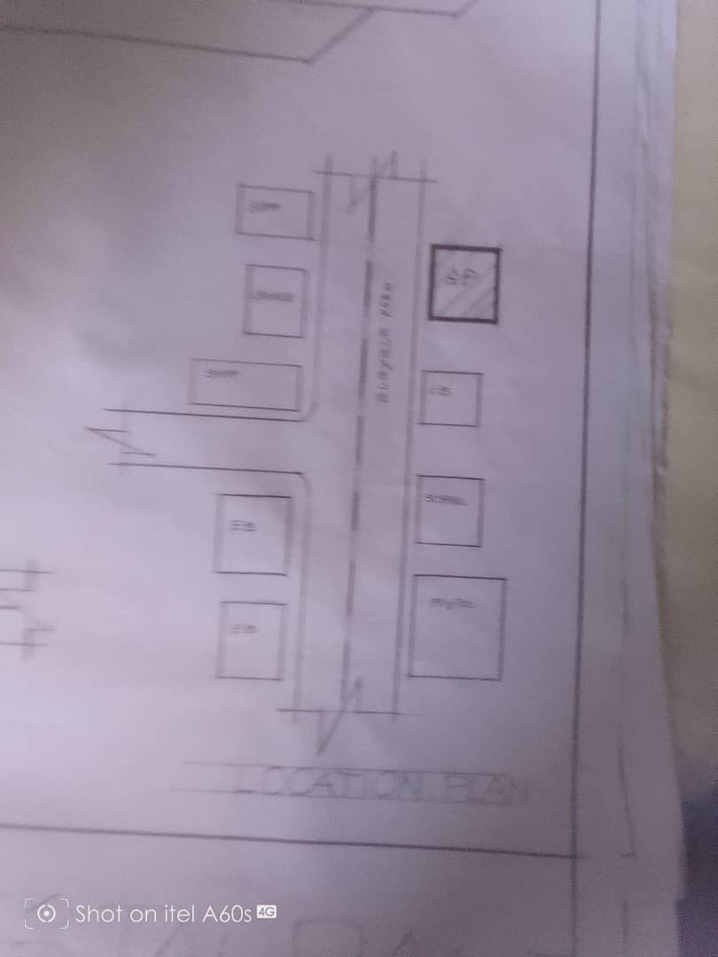
FIG3.5; SHOWING LOCATIONAL PLAN OF CASE STUDY TWO
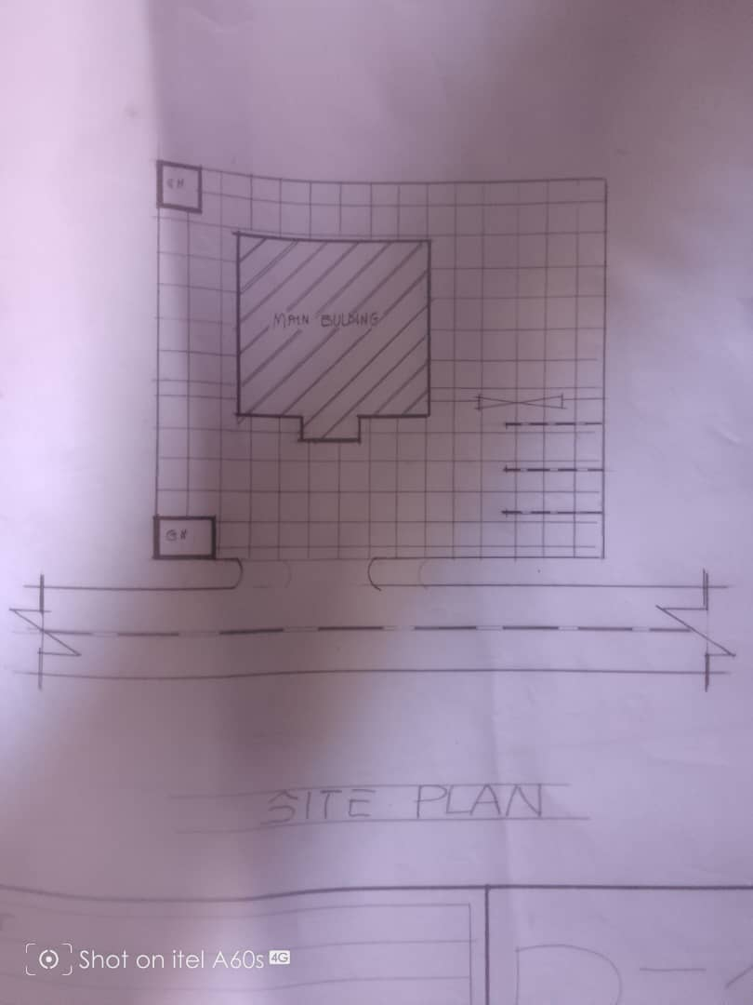
FIG3.6; SHOWING SITE PLAN OF CASE STUDY TWO
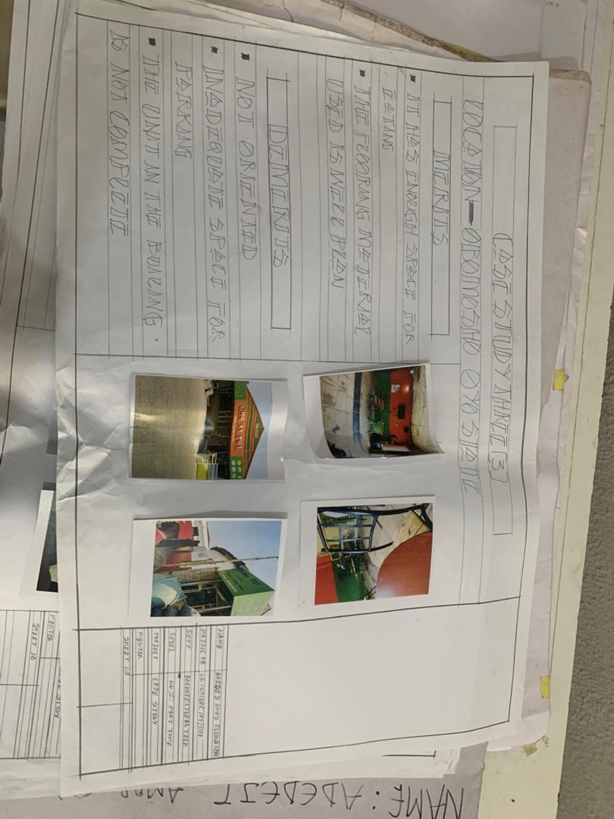
PLATE3.3; SHOWING THE FRONT VIEW OF CASE STUDY TWO
PLATE3.4; SHOWING THE EATING AREA OF CASE STUDY TWO

3.5 CASE STUDY THREE
YAKOYO AFRIKANA
LOCATION: SHOP 001, OJAJAMORE, IBANDAN-IFE ROAD 220101, OSUN STATE.
OBSEVERATION
MERIT
- It has enough space for eating
- The flooring material used is well friendly
DEMERIT
- Inadequate space for packing
- The unit in the building is not complete
- Not well oriented
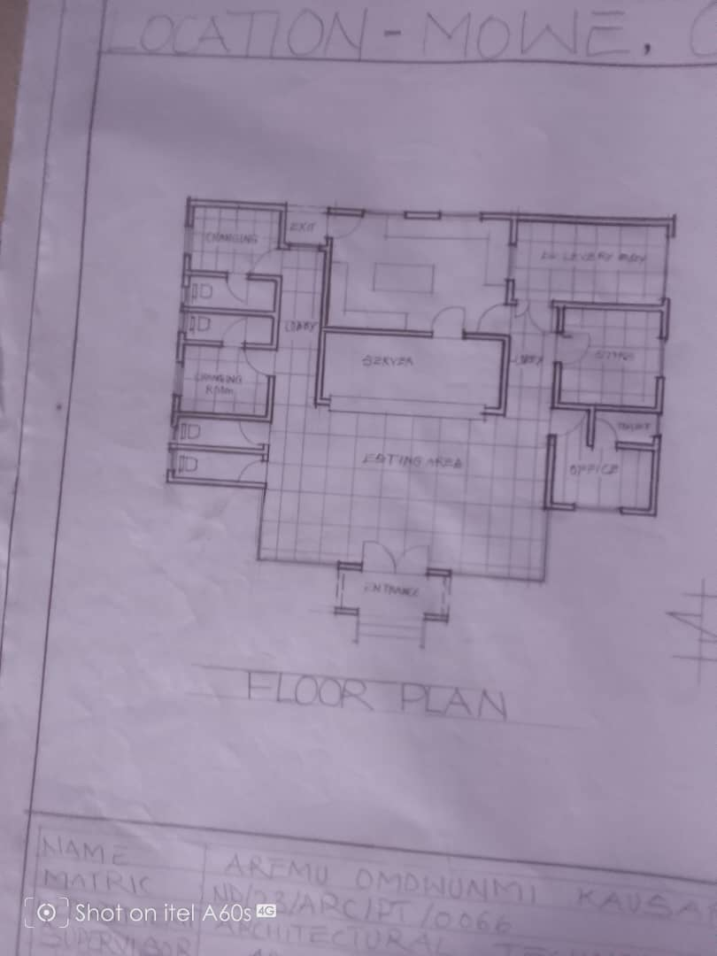
FIG3.7; SHOWING FLOOR PLAN OF CASE STUDY THREE
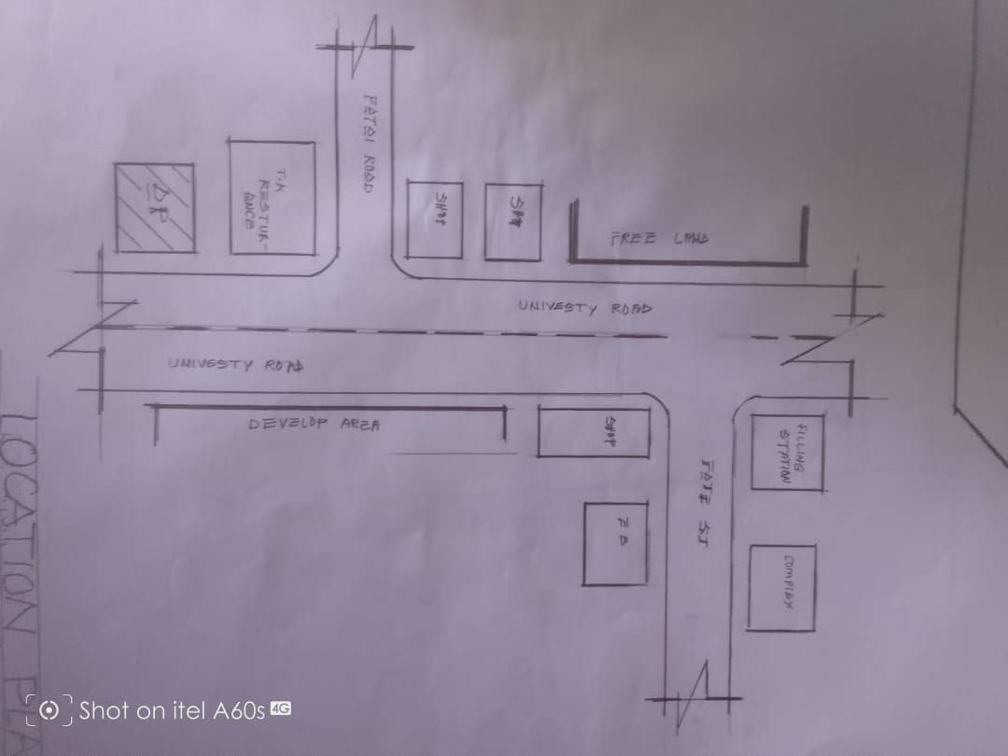
FIG3.8;SHOWING LOCATIONAL PLAN OF CASE STUDY THREE
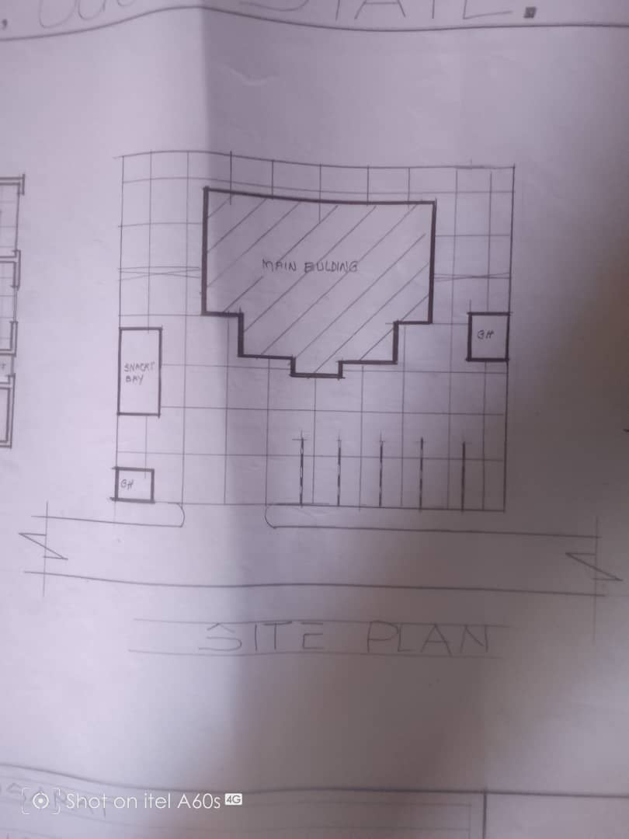
FIG3.9; SHOWING SITE PLAN OF CASE STUDY THREE
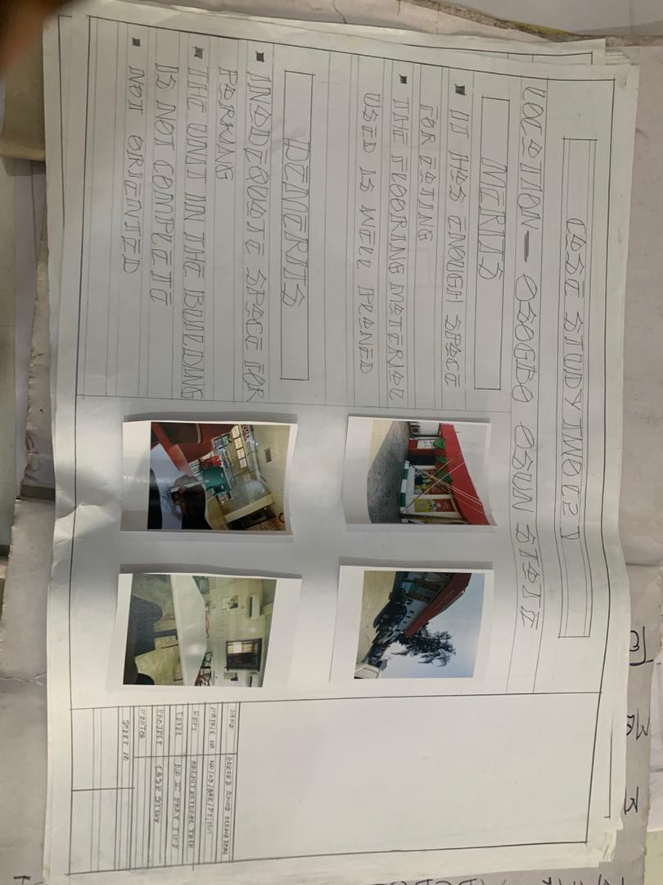
PLATE3.5;SHOWING THE FRONT VIEW OF CASE STUDY THREE
PLATE3.6; SHOWING THE EATING AREA OF CASE STUDY THREE

3.6 ONLINE CASE STUDY
ONLINE CASE STUDY ONE
PROJECT NAME: RESTAURANTS & BARS
LOCATION: KECAMATAN TINGKIR, INDONESIA
ARCHITECT: SAHABAT SELOJENE
LEAD ARCHITECT: ARY INDRA
YEAR: 2024
AREA: 1100m2

ONLINE CASE STUDY TWO
PROJECT NAME: CAPICHE RESTAURANT
LOCATION: SURAT INDIA
ARCHITECT: NEOGENESIS+STUDIO261
YEAR: 2024
AREA: 185m2
DEDUCTION FROM CASE STUDIES
During my visit to the restaurant. I was opportunities to see what was obtain in the restaurant, I made a proper studies of their related function and analysis were made to their present situation with the aim of incorporation with their merit in my own final proposal.
The following were deduce from my case study
- Proper zoning of dining, kitchen, storage, and service areas improves functionality and customer experience.
- Well-planned entrances, seating arrangements, and pathways enhance movement for both customers and staff.
- Natural ventilation, shading, and energy-efficient materials help adapt to the local climate and reduce costs.
- Architectural elements reflecting local traditions and culture create a unique identity for the restaurant.
- Smart lighting, automated ventilation, and digital ordering systems enhance efficiency and modernize operations.

CHAPTER FOUR
4.0 PROJECT LOCATION
4.1 BRIEF HISTORICAL BACKGROUND OF KWARA STATE
Kwara (Yoruba: Ìpínlẹ̀ Kwárà) is a state in Western Nigeria, bordered to the east by Kogi State, to the north by Niger State, and to the south by Ekiti, Osun, and Oyo states, while its western border makes up part of the international border with Benin. Its capital is the city of Ilorin and the state has 16 local government areas.
Of the 36 states of Nigeria, Kwara is the ninth largest in area but the sixth least populous with an estimated population of about 3.2 million as of 2016.Geographically, Kwara is split between the West Sudanian savanna in the east and the Guinean forest–savanna mosaic ecoregion in the rest of the state. Important geographic features include rivers with the Niger flowing along the northern border into Lake Jeba before continuing as the border while the Awun, Asa, Aluko, and Oyun rivers flow through the interior. In the far northwest of the state is the Borgu section of the Kainji National Park, a large national park that contains populations of grey heron, kob, hippopotamus, African bush elephant, olive baboon, and roan antelope, along with some of the last remaining West African lions on earth. In the far southwest, a small part of the Old Oyo National Park contains crowned eagle, martial eagle, African buffalo, oribi, and patas monkey populations.
4.1.2 ECONOMY OF KWARA STATE
Agriculture is the main source of the state's economy and the principal cash crops are: cotton, cocoa, coffee, kola nut, tobacco, sesame and palm produce. Kwara state is home to Shonga Farms, a product of the Back-to-Farm project of one of the past administrators of the state, Dr. Abubakar Bukola Saraki. Shonga Farms is made up of 13 commercial farmers. Mineral resources in the state are Petroleum, Gold, limestone, marble, feldspar, clay, kaolin, quartz and granite rocks, and laterite found majorly in omuaran.
4.1.3 ORGANIZATION STRUCTRE
An organizational structure is a system that outline shows certain activities that are direct in order to achieve the goals of an organization. These activities can includes rules, roles and responsibilities. The organizational structure also determine show information flows between levels within the Resturant.
4.2 LOCATION AND SETTING OF KWARA STATE
Kwara State was created on 27 May 1967, when the Federal Military Government of General Yakubu Gowon broke the four regions that then constituted the Federation of Nigeria into 12 states. At its creation, the state was made up of the former Ilorin and Kabba provinces of the then Northern Region and was initially named the West Central State but later changed to "Kwara", a local name for the River Niger, in the Hausa language.
Kwara state has since 1976 reduced considerably in size due to further state creation exercises in Nigeria. On 13 February 1976, the Idah/Dekina part of the state was carved out and merged with a part of the then Benue/Plateau state, to form Benue state.
On 27 August 1991, five Local Government areas, namely Oyi, Yagba, Okene, Okehi and Kogi were also excised to form part of the new Kogi state, while a sixth, Borgu Local Government Area, was merged with Niger state. The major populated local governments are Ilorin and Offa.
Kwara state has numerous mineral resources such as tourmaline, tantalite, and many mineral deposits in the northern part. Cocoa and Kolanut in the Southern parts Oke - Ero, Ekiti and Isin LGA.
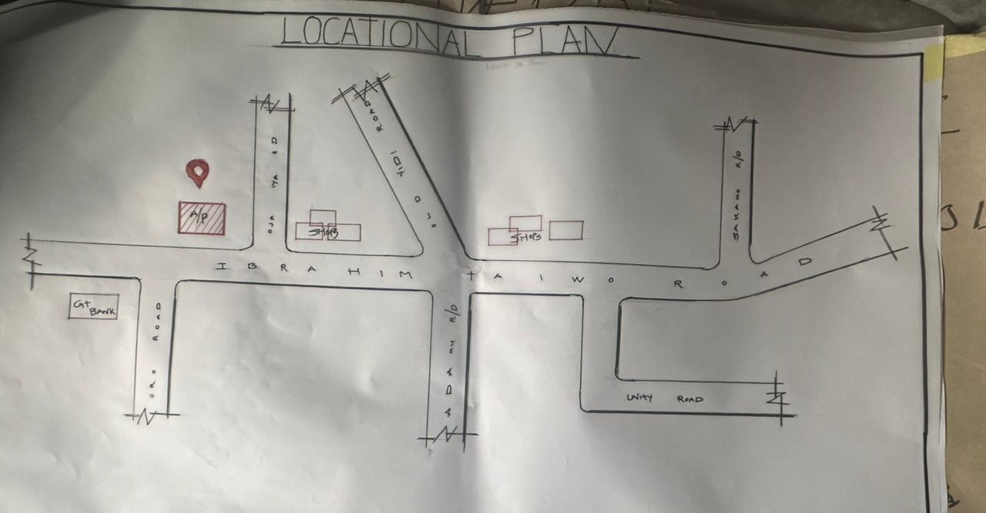
FIG 4.1; SHOWING LOCATION OF THE PROPOSE SITE
4.3 POPULATION
The population development of kwara state as well as related information and services.
The current metro area population of Ilorin in 2025 is 1,100,000, a 3.38% increase from 2024.
The metro area population of Ilorin in 2024 was 1,064,000, a 3.3% increase from 2023.
The metro area population of Ilorin in 2023 was 1,030,000, a 3% increase from 2022.
The metro area population of Ilorin in 2022 was 1,000,000, a 2.67% increase from 2021.
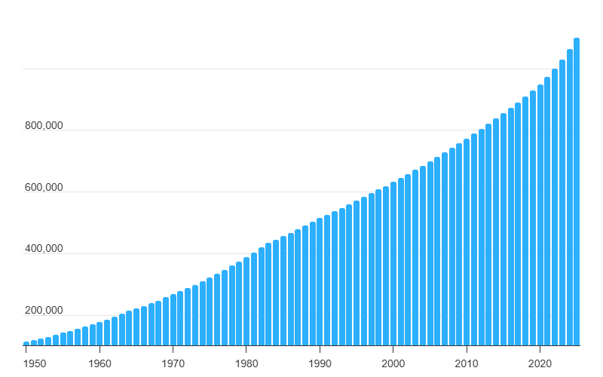
TABLE4.1; SHOWING GENDER GROUP
4.4 SITE INVENTORY
In the proposed site, some shrubs will be retained on site. It used to reduce sky glare and also serve as soft landscape and wind breaker.
Presence of road network which would serve as a means of accessibility to the site. Presence of electricity pole which serve as source of electricity to the site. Some trees would be retained while some will be removed if they disrupt the construction of building.
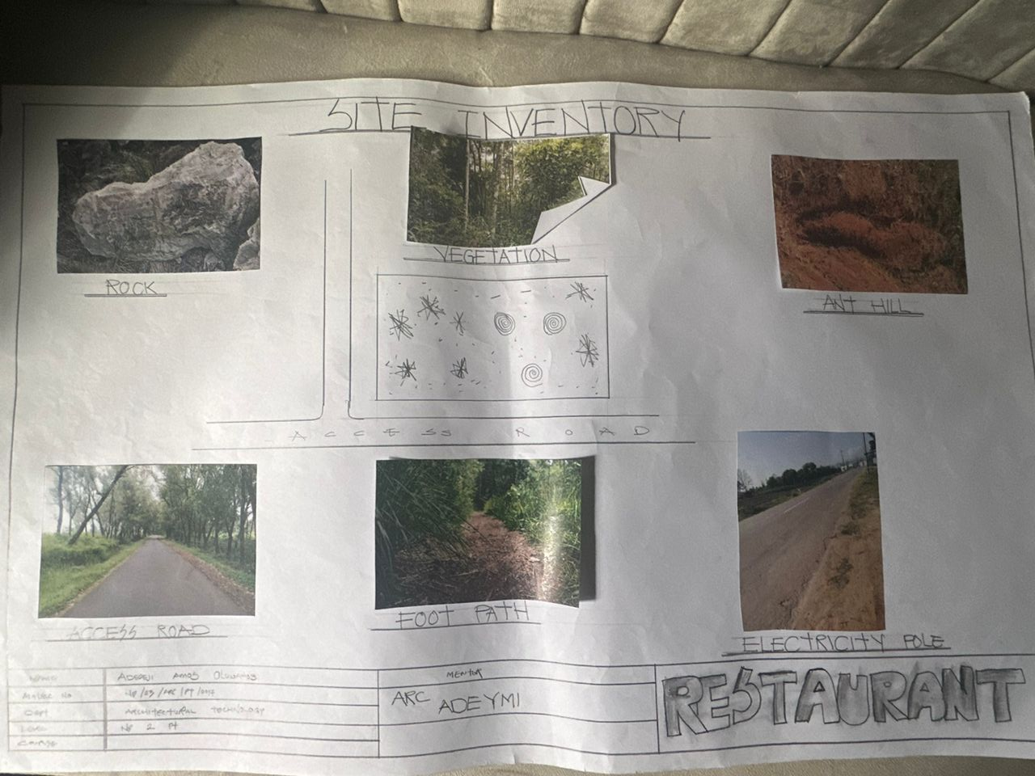
FIG4.2; SHOWING SITE INVENTORY OF THE PROPOSED SITE

4.5 SITE ANALYSIS
The site is benefitted with loamy soil which is a very good soil for grass and shrubs. It has a gentle slope towards the south east. Some of the grasses, shrubs and trees on the site are to be retained to enhance landscape patter of the site while some are to be removed and replanted where necessary. The two noticeable winds are to be directed into the building using landscape pattern to improve ventilation. Noise generated from vehicle traffic is controlled through proper planning, good landscaping and proper orientation of building. Generally, all the feature on the site are best put into different uses to aid control through proper planning, landscape and orientation.
Certainly, steps are considered to obtain vital information of the site, this information is the analysed in details. For design purpose, the information include soil condition, geology, topography, vegetation etc. It also involves carrying out a preliminary survey.
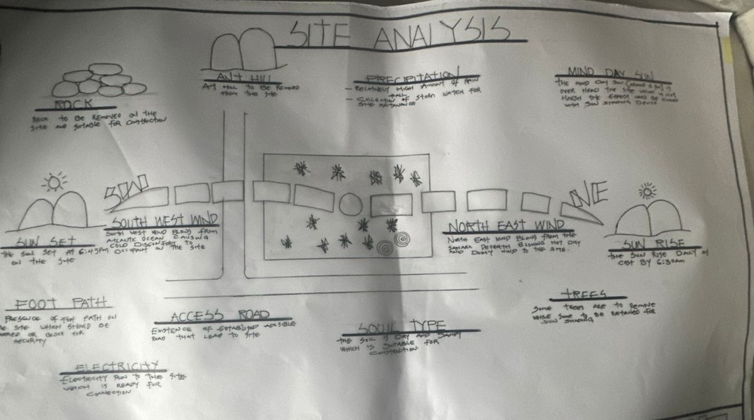
FIG4.3; SHOWING SITE ANALYSIS OF THE PROPOSED SITE
4.5.1 SITE SELECTION/JUSTIFICATION
In the site selection provision is made for interesting facilities that worth emulating since the overall success and efficiency of any project depend not on the functionality of the design but also on a careful choice of site. The site of this project has been carefully selected which is located in the premises of Taiwo Road, Ilorin local government kwara state. The proposed site is located at Ilorin, Kwara state.

4.5.2 LOCATION
The site is located
Taiwo Road 240241 Ilorin, Kwara state Nigeria.
Taiwo Road is one of the most prominent commercial corridors in Ilorin. The road is characterized by High vehicular and pedestrian traffic, a mix of commercial establishments such as eateries, banks, retail stores, and offices.
4.5.3 ACCESSIBILITY
Easy accessibility from different parts of the city, making it a strategic location for commercial developments such as eateries, restaurants, and retail outlets.
4.5.4 INFRASTRUCTURAL FACILITIES
Facilities such as water electricity, telephone network and road network are all in Ilorin, hence it can easily be tapped to the proposed site.
4.5.5 TOPOGRAPHY
The topography of the land is gentle slope which can be filled and levelled up to balance round all the site levels.
4.5.6 SOIL STRUCTURE
It is made up of clayish laterite soil, which is good for building construction.
4.6 GENERAL CLIMATIC CONDITION
Kwara State generally experiences a tropical savanna climate (Aw) with distinct wet and dry seasons. The temperature is warm throughout the year, with an average around 29.54°C (85.17°F). Rainfall varies, with an annual average of about 101.45 millimeters (3.99 inches), and the state has around 148.38 rainy days annually.
4.6.1 RELATIVE HUMIDITY
Relative humidity is higher during the rainy season, ranging from 75% to 88%, and lower during the dry season, ranging from 35% to 80%.
4.6.2 WIND
The prevailing winds are the south-west monsoon wind and the north-east continental wind.
4.6.3 TEMPERATURE
Kwara State is characterized by warm temperatures year-round, with January being the coolest month and April being the hottest. Temperatures can range from a minimum of 14°C (58°F) in January to an average of 27°C (81°F) throughout the year, with April experiencing intense heat that can reach 43°C (109°F).
4.6.4 VEGETATION
The proposed site is covered with grasses few trees and shrubs. Some will be removed before the construction while some will be retain for ornamentation.
4.7 SOCIAL SERVICES
4.7.1 ROAD
There are only two access to the site
The southern access which serve as the main entrance and also main access road
4.7.2 WATER AND ELECTRICITY
There are pipe born water networks and borehole water which serves the habitant of Ibadan. There is electricity supply from NEPA that serve the Kwara state in general
4.8 DESIGN CRITERIA
There are three (3) methods of designing of any project which are: Function before form method
Form before function method Combination of Shapes
Designing projects, the function, before form method used in line with this method, the following are the design criteria for this project:
Functional: in term of functional requirement, the following design criteria must be considered.
Sustainability, Site and Location, Flexibility, Circulation, Accessibility, Organization, Maintenance, Environment and Services
4.9 DESIGN BRIEF
After research and planning, the next step in the series of the project programed is design itself. To achieve functional and well established design there must be a brief to work on. This brief depends generally on the scope of individual design. The brief of this project is therefore based on the various activities that take place in the hospital. To have enough brief for the proposed Restaurant, case studies were carried out on the existing restaurant. The studies also give me the opportunity to know the nature of the various unit in building and how they are related to each other.
4.10 DESIGN ANALYSIS
This is the process of itemizing units within the component of the entire design with a view to establishing a solid understanding and appreciation of the space relationships.
GROUND FLOOR PLAN; Entrance, Eating area, VIP eating area, Snacks, Servers, Chef office, Kitchen, Changing room, Delivery bay, Dry store, Cold store, MD office, Rest room, Account office, W/C, Exist.
S/N | NAME | AREA[m2]
1 | ENTRANCE | 27.8m2
2 | EATING HALL | 47.5m2
3 | VIP EATING HALL | 32.2m2
4 | SNACKS | 19.0m2
5 | SERVERS | 17.5m2
6 | CHEF OFFICE | 17.9m2
7 | KITCHEN | 28.6m2
8 | CHANGING ROOM | 19.5m2
9 | DELIVERY BAY | 42.9m2
10 | DRY STORE | 8.9m2
11 | MD OFFICE | 21.8m2
12 | REST ROOM | 18.5m2
13 | COLD STORE | 16.2m2
14 | ACCOUNT OFFICE | 28.0m2
15 | EXIST | 18.9m2
16 | W/C | 11.2m2
TABLE4.2; SHOWING SPACIAL ALLOCATION OF FLOOR PLAN
Necessary units in the building. A borehole system of water supply is to be adopted alongside the government supplied services and a storage facility is to be provided for effective management of water supply.
4.12 PLANNING PRINCIPLE
The planning principle is one of the most important aspects of any design. The planning of various units taking into consideration the activities performed in each unit, how they are related to one another and the users of the various units in the design. In respect to the above factors.

CHAPTER FIVE
5.0 GENERAL REQUIREMENTS
5.1 APPRAISAL OF PROPOSED SCHEME
The proposed scheme is to satisfy the appropriate building regulation. The project design is to confirm with the intended use of building taking into consideration with both natural factors and human that can pose a throat on the validity and stability of the project design.
5.2 CONSTRUCTION METHODOLOGY AND MATERIAL
The construction is to be carried out following the due process of construction ranging from.
Preliminary: this involves the clearing of the site, setting out and excavation of foundation trench, foundation works down to the basement level.
Sub-Structure: this process also entails the positioning and erection of column and beams, mansonry work etc.
Gypsumboard: is to be used for the Acoustic purpose of the building. This material is often called dry wall, wall board or plaster board. It creates a continuous surface suitable for most types of interior decoration. It comes in different size ranging length of 2.4m, 3.0m, also in thickness of 1/ inch, 3/8 inch.
5.3 SERVICE
A building can be said to be good when it performs the serves required by it. In other to have a well-function building design, there calls for an installation of underground water. This is a means of providing brightness naturally by sun or moon or artificially by lamps. Good natural and artificial lighting is important in lecture rooms, and workshop. It is always easy to make mistake and time the eye in a situation of poor lighting floor. For the purpose of this project, effort is made as much as possible to light up the entire building naturally before the use of artificial lighting. In this project, to obtain maximum lighting more openings are provided for the lecture rooms, workshop and admin. Artificial source of light will still be provided for in case where there is call for the use of it at night or in a situation where the weather condition warrants it.
5.3.1 VENTILATION
As it's relates to architectural, is the intentional introduction of outside AIT into a space through openings (like window/doors and mechanical means (ACs) to provide maximum thermal comfort for human satisfaction. In this design, both means of ventilation ate introduce but majority concentration on the mechanical means of ventilation for all units in the design for the purpose of extracting the used air and introducing fresh air within all spaces for humans consumption and satisfaction.
This is done through installation of mechanical (artificial) ventilation ducts horizontally and vertically all within the units of the design to allow easy floe of free movement of air passage through the ventilation channels and providing well, proper and adequate ventilation for each and every units in the design project.
5.3.2 LIGHTING
This is a means of providing brightness naturally by sun or moon or artificial by lamps. Good natural and artificial lighting is important in all units. It is always easy to make mistake and time the eye in a situation of poor lighting floor. For the purpose of this project, effort is made as much as possible to light up the entire building naturally before the use of artificial lighting.
5.3.3 PLUMBING
The plumbing system in this project design is made easy for waste extraction and brain water extraction through the means of service duct channel and roof gutter drainage.
All waste water and soil waste from the toilet/convenience are extracted through means of drainage pipe running through the walls down to the inspection chamber situated in the service duct, flowing down to the septic tank and soak away for final waste extractions.
5.3.4 ELECTRICAL INSTALLATION
The type of wiring system chosen should be conduct system of wiring, technical are should be wired with strong durable and light current resistance cables because of the power requirements and consumption of the equipment to be used and installed in them. Connection and distributing cable signal. Also electrical installation is to be done to allow for the use quality electrical fittings and fixtures in the whole of the hospital.
5.3.5 WASTE DISPOSAL
Waste disposal are to be put in the building and also some specific areas necessary, this waste bins should be disposed in the incinerator which will be provided within the proposed site premises. The waste should therefore, be burn in the incinerator or taken away from the site.
5.3.6 FIRE PROTECTION
Electrically, fire alarms and sensor are to be installed in the building in generally. This should be done in case of the fire occurrence. Fire extinguishers are to be placed at a certain distance in the lobbies and some other necessary areas. It is also serving as protection in case of fire outbreak.
5.3.7 RAIN PROTECTION DEVICES
The rainfall of a place generally determines the living condition and all comfort associated with that environment hence provision should be made for fast dispersal of the rain water as well as the associated condition with rainfall. This calls for the need to study the nature of rainfall of the area. To control the heavy rainfall during the wet season (April - October) the use of simple sloppy system roofing has been adopted. This is provided with roof gutter system which is linked to the ground drainage network by the use of P.V.C.
5.3.8 EXTERNAL WORKS
The external works are to be earned out generate, kerbs land and shrubs, flowers, grasses and trees planted. Concrete interlocking pavement tiles to be adopted before hard landscape for walk ways and parking spaces and car access roads must be tarred with asphalt finishes.
5.4 SUMMARY
This project, generally, has seriously widen my view and knowledge affecting my observation beyond my expectation. I have been able to deduct what it takes or entails and how to go about designing and achieving a good design of any form of this related project with total seriousness as this project has given out the facts and precise information it comprises.
5.5 CONCLUSION
The design of a restaurant extends beyond the creation of a functional space; it shapes the dining experience, reflects brand identity, and significantly impacts operational efficiency. Through this project, it is evident that the architectural planning of a restaurant directly influences customer satisfaction, staff productivity, and overall business success.The case study and design process revealed that a successful restaurant requires careful attention to space zoning, circulation, ventilation, lighting, acoustics, and aesthetics. A well-planned layout ensures seamless movement for both customers and staff, creating a comfortable, efficient, and visually appealing environment.
Moreover, the incorporation of sustainability principles such as energy-efficient lighting, passive cooling, and the use of eco-friendly materials aligns the project with modern architectural practices and environmental responsibility.
The research also highlighted challenges such as limited urban spaces, high construction costs, and the need to balance aesthetic appeal with functionality. Addressing these challenges requires strategic planning, creative design solutions, and efficient space management.
5.6 RECOMMENDATION
This project underscores the role of architecture in creating functional, aesthetically pleasing, and customer-centered restaurant spaces. A well-designed restaurant not only enhances the dining experience but also contributes to operational efficiency, staff well-being, and the overall success of the business. By combining functionality, sustainability, and brand identity, the proposed restaurant design reflects modern architectural values and meets the expectations of both the client and the end-users.
REFERENCES
1 Neufert, E. (2012). Architects' Data. Wiley-Blackwell.
2 Ball, R. (2002). The fundamentals of interior architecture. AVA Publishing
3 Piotrowski, C. M. (2010). Professional practice for interior designers (5th ed.). Wiley.
4 Karlen, M., & Fleming, J. (2003). Space planning basics (2nd ed.). Wiley.
5 Ching, F. D. K. (2007). Architecture: Form, space, and order (3rd ed.). Wiley.
6 Kivrak, S., & Arslan, H. (2018). Design criteria in food and beverage spaces: A review of literature. Journal of Environmental Science and Technology, 11(2), 22–28.
7 National Building Code of Nigeria. (2006). Building standards and regulations for public buildings. Federal Ministry of Works and Housing.
8 American Society of Heating, Refrigerating and Air-Conditioning Engineers. (2019). ANSI/ASHRAE Standard 62.1-2019: Ventilation for acceptable indoor air quality. ASHRAE.
9 Lawson, B. (2001). The Language of Space. Architectural Press.
10Rengel, R. (2003). Shaping Interior Space. Fairchild Books.
11 Pile, J. F. (2005). Interior Design. 4th ed., Prentice Hall.
12 Tschumi, B. (1996). Architecture and Disjunction. MIT Press.
13 Broadbent, G. (1990). Emerging Concepts in Urban Space Design. Routledge.
14 Karlen, Mark, and James Fleming. Space Planning Basics. 2nd ed., Wiley, 2003.
15 Ching, Francis D. K. Architecture: Form, Space, and Order. 3rd ed., Wiley, 2007.
16 Kivrak, S., and H. Arslan. "Design Criteria in Food and Beverage Spaces: A Review of Literature." Journal of Environmental Science and Technology, vol. 11, no. 2, 2018, pp. 22–28.



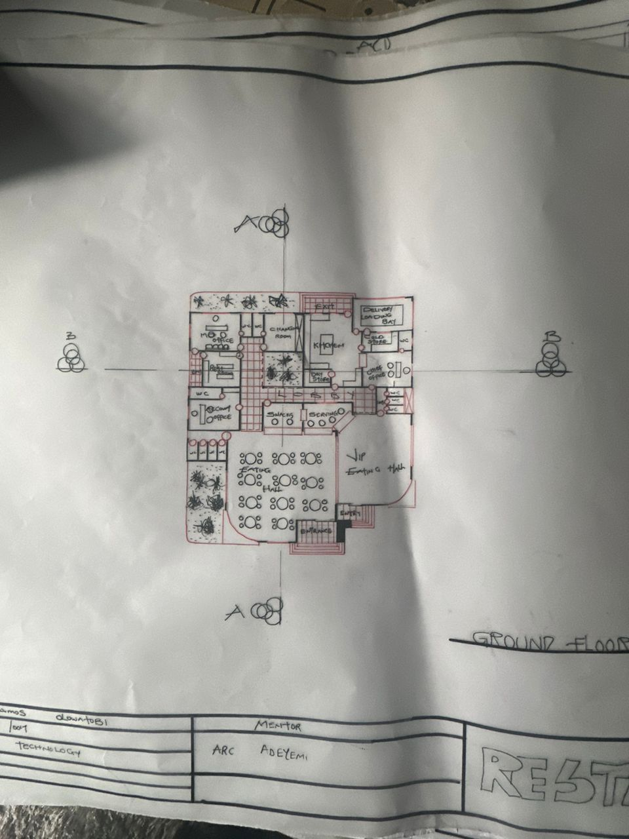
APP1: FLOOR PLAN OF PROPOSED PROJECT
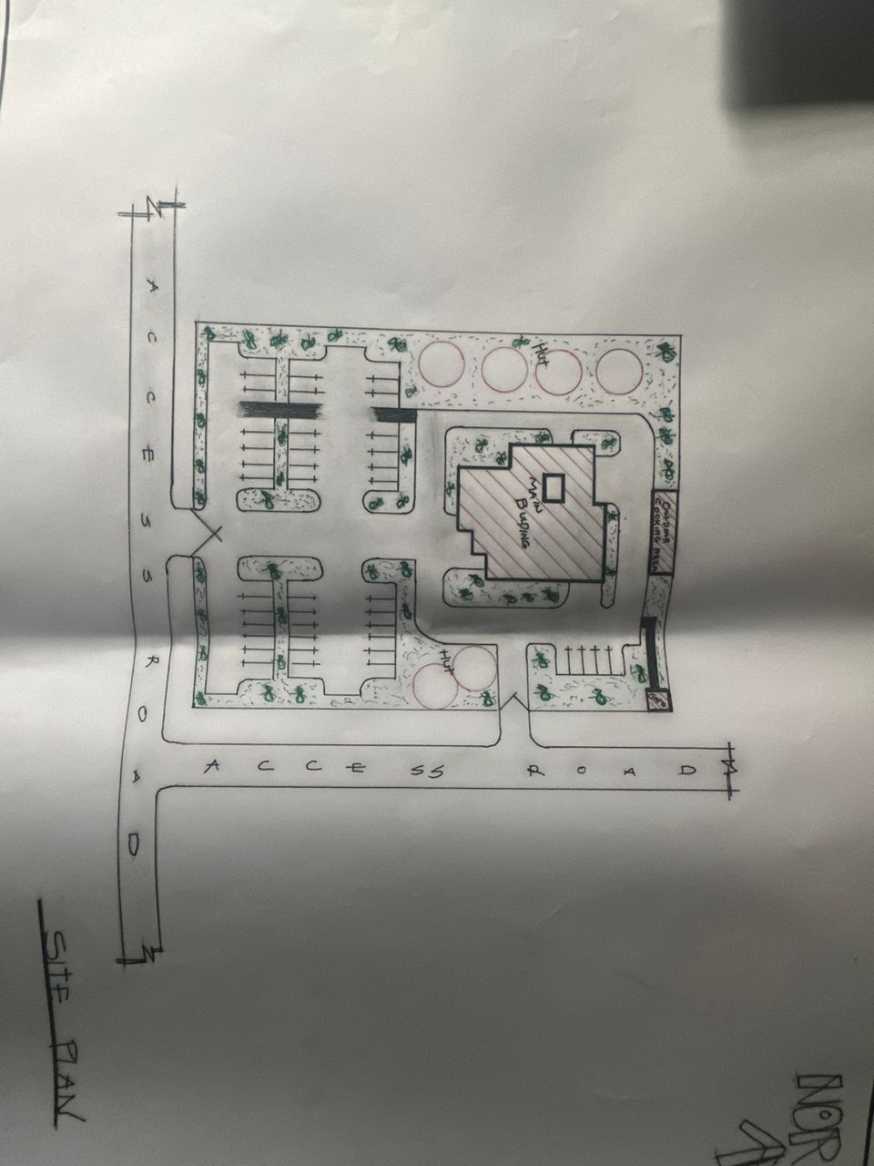
APP2: SITE PLAN OF PROPOSED PROJECT
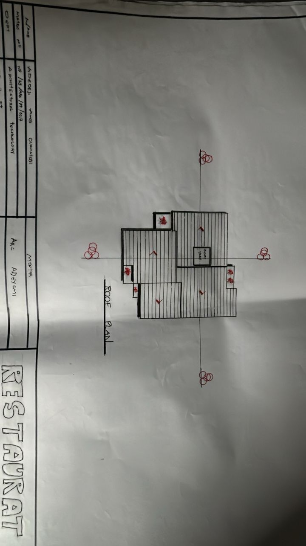
APP3: ROOF PLAN OF PROPOSED PROJECT
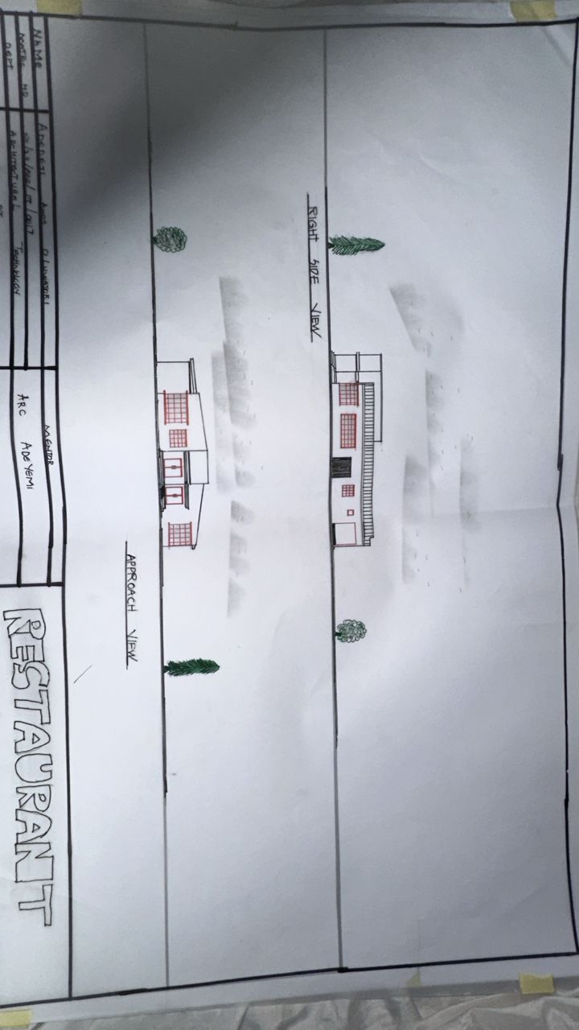
APP4: ELEVATION OF PROPOSED PROJECT
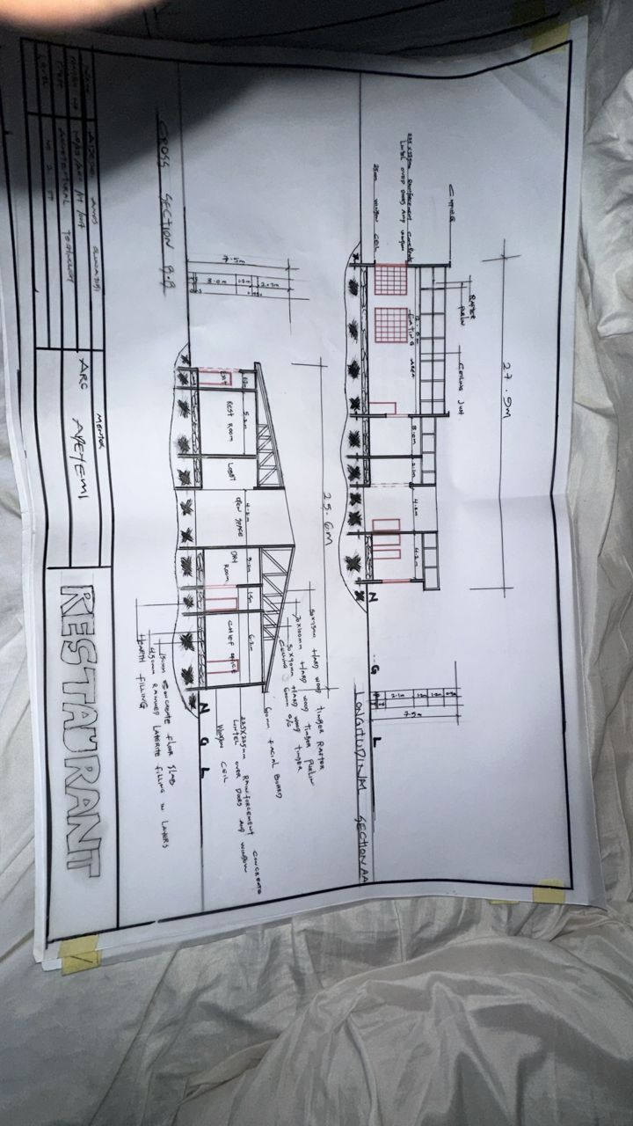
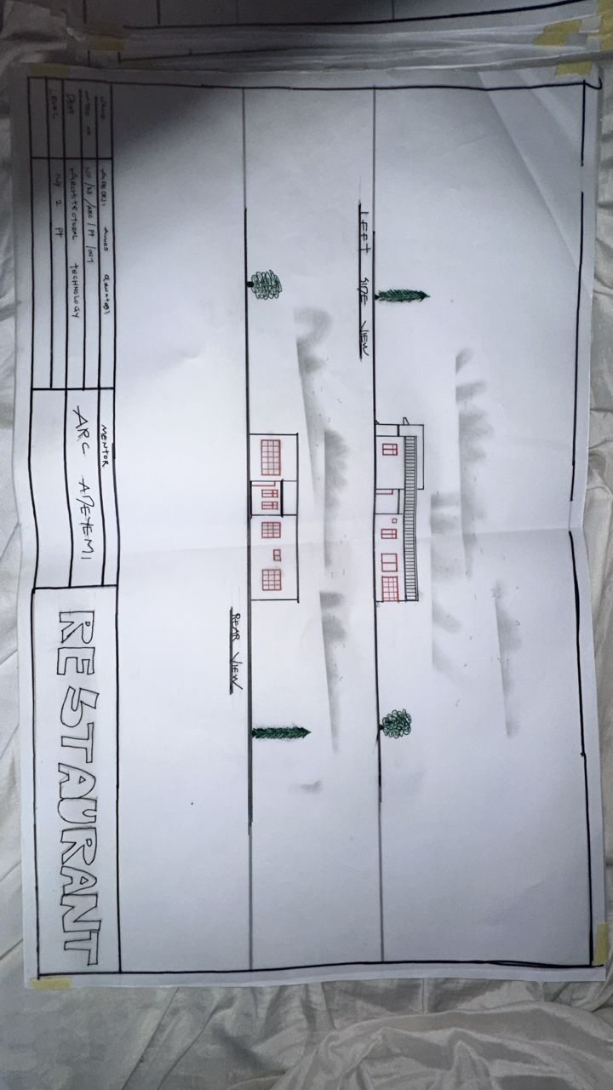
APP5: ELEVATION OF PROPOSED PROJECT

APP6: SELECTION OF PROPOSED PROJECT

