THE USE OF INVERTER POWERED CCTV IN MONITORING EXAMINATION

BY
ABDULWAHAB FARUK AYINDE
ND/23/COM/PT/0302

SUBMITTED TO

DEPARTMENT OF COMPUTER SCIENCE
INSTITUTE OF INFORMATION COMMUNICATION AND TECHNOLOGY, KWARA STATE POLYTECHNIC

IN PARTIAL FULFILLMENT OF THE REQUIREMENT FOR THE AWARD OF NATIONAL DIPLOMA (ND) IN COMPUTER SCIENCE

JULY, 2025

CERTIFICATION
This is to certify that this research project titled: “The Use of Inverter Powered CCTV in Monitoring Examination” was carried out by Abdulwahab Faruk Ayinde with ND/23/COM/PT/0302 of the Department of Computer Science, Institute of Information Communication and Technology, Kwara State Polytechnic, Ilorin. This Research project is submitted in partial fulfillment of the requirements for the award of the National Diploma (ND) in Computer Science.

_______________________ _______________
Dr. Agbolola O.M Date
Project Supervisor

_______________________ _______________
Mr. Oyedepo F. S Date
Head of Department

_____________________ _______________
External Examiner Date

ACKNOWLEDGEMENT
My gratitude goes to Almighty Allah for sparing my lives and making it possible to complete my National Diploma program. I say glory be to Almighty Allah.
My special gratitude goes to my parents who have been my support. I thank them for their moral and financial support and for their untiring efforts to see me succeed in my academic.
My heartfelt gratitude goes to my project supervisor Dr. Agboola O. M. for his effort may Allah Reward him abundantly in Duniyah wa Ahkiroh and also to the lecturer of Computer Science. I say a big thank you May Allah reward you all.

List of Figure
Fig. 3.1 A rough image on how it will be installed 25
Fig 4.1 Battery 29
Fig 4.2 Inverter 30
Fig 4.3 DVR 31
Fig 4.4 Power Supply 31
Fig 4.5 BNC Connector 32
Fig 4.6 Camera 34
Fig 4.7 Output of the Installed camera one 35
Fig 4.8 installation of camera two 36
Fig 4.9 output of installed camera two 37

TABLE OF CONTENT
Title page i
Certification ii
Dedication ii
Acknowledgements iv
List of Figure v
Table of Contents vi
Abstract vii
CHAPTER ONE: Introduction
1.1 Background of the study 1
1.2 Statement of Problem 5
1.3 Aim and Objective 5
1.4 Scope of the Study 6
1.5 Organization of the Report 6
1.6 Definition of Terms 6
CHAPTER TWO: Literature Review
2.1 Review of the Related Works 9
2.2 Surveillance Technology in Examination 12
2.3 Academic Integrity and Examination Malpractice 13
2.4 impact of Surveillance Technology 16
2.5 Ethical and Privacy Consideration 17
2.6 Cost Benefit and Implementation Challenges 18 CHAPTER THREE: Methodology
3.1 Introduction 20
3.2 Plan the CCTV and Power System 20
3.3 Install the CCTV System 22
3.4 Set up the Inverter Power System 22
3.5 Test the System 23
3.6 Maintenance and Monitoring 24 CHAPTER FOUR: System Implementation
4.1 Introduction 26
4.2 Implementation Step 27
CHAPTER FIVE: Summary, Conclusion and Recommendation
5.1 Summary 38
5.2 Conclusion 39
5.3 Recommendation 39
References

ABSTRACT
This project focuses on the development of an inverter-powered Closed-Circuit Television (CCTV) system designed to improve the monitoring of examinations in educational institutions. Due to frequent power outages in many parts of Nigeria, traditional CCTV systems often fail during critical periods, allowing room for examination malpractice. To solve this problem, the project integrates a CCTV surveillance system with an inverter backup to ensure uninterrupted monitoring throughout the examination period. The work details the system design, component selection, installation process, and performance testing. Results show that the inverter-powered setup provides stable and continuous surveillance, reduces exam misconduct, and improves the integrity of the examination process. The system is cost-effective, sustainable, and adaptable for both small and large academic environments.

CHAPTER ONE
INTRODUCTION

1.1 Background to the Study
Examination malpractice remains one of the most persistent threats to the credibility and integrity of educational systems, particularly in developing countries where supervision during examinations is often inadequate or inconsistent. Over the years, educational institutions have witnessed an alarming increase in unethical behaviors during exams, such as impersonation, unauthorized use of materials, and collusion among candidates. The traditional method of physical invigilation, though widely used, has proven to be insufficient in curbing these issues due to limitations in manpower and human error. As a result, there has been a growing interest in leveraging technological tools, especially Closed-Circuit Television (CCTV), to enhance examination monitoring and to deter students from engaging in malpractice. CCTV technology has gained significant recognition in the educational sector as a surveillance system that offers real-time visual monitoring and post-examination review through recorded footage. Its installation in examination halls serves both as a deterrent and an investigative tool. However, one major challenge that affects the efficiency of CCTV systems in educational institutions, particularly in Nigeria and other regions with poor power infrastructure, is the unreliable electricity supply.
According to Eze and Bello (2021), frequent power outages during examinations render installed CCTV systems ineffective at critical moments, thus defeating the primary aim of surveillance. In such scenarios, students may take advantage of power interruptions to engage in dishonest behaviors without fear of being recorded.
To address this challenge, the integration of inverter-powered systems with CCTV installations has emerged as a practical solution. Inverters provide an alternative and uninterrupted power supply by storing energy in batteries and converting it into electricity during outages. This ensures that CCTV systems remain operational regardless of fluctuations in grid power. Recent research has shown that institutions adopting inverter backup for their surveillance systems experience fewer incidences of malpractice and improved exam integrity (Adebayo & Tunde, 2022). The inverter-powered CCTV system enables continuous monitoring, which not only deters potential offenders but also instills confidence in the examination process among students, staff, and stakeholders (Adebayo & Tunde, 2022).
Furthermore, the integration of inverter technology into school surveillance systems aligns with the increasing global focus on smart and resilient educational environments. As institutions transition towards digital learning and administration, incorporating smart monitoring infrastructure has become an integral aspect of educational quality assurance. Beyond its role in examination surveillance, CCTV systems powered by inverters also contribute to overall campus security and can be adapted for use in lecture halls, hostels, and administrative offices. According to Olatunji and Ahmed (2023), the use of inverter-powered CCTV contributes significantly to building a culture of accountability, transparency, and discipline among students and staff (Ahmed, 2023).
Despite the potential benefits, the implementation of inverter-powered CCTV systems is not without challenges. Financial constraints remain a major barrier, especially for public institutions with limited budgets. The initial cost of procurement, installation, and maintenance of both the
CCTV cameras and the inverter systems can be substantial. In addition, there is a need for technical expertise to ensure proper configuration, efficient power management, and timely servicing. Institutions may also encounter resistance from students and staff who perceive surveillance as intrusive or a violation of privacy rights. Nonetheless, studies have shown that with adequate orientation and policy frameworks, these concerns can be effectively addressed (Ibrahim & Salisu, 2024).
Moreover, the success of inverter-powered CCTV systems in monitoring examinations depends on strategic planning, including power load assessment, capacity of the inverter system, camera coverage, and data storage capacity. Institutions must consider the duration of exams, frequency of power outages, and the number of devices that will be supported by the inverter to ensure seamless operation. Recent innovations in energy-efficient surveillance equipment and solar integrated inverters have also made it more feasible for schools to maintain surveillance without excessive energy consumption (Chukwuemeka et al., 2025).
In light of these developments, this research seeks to explore the effectiveness of using inverter powered CCTV systems for examination monitoring. It evaluates the impact of this integration on reducing examination malpractice, assesses the operational and technical benefits, and identifies the challenges faced by institutions in adopting this approach. The study aims to contribute to the ongoing discourse on educational integrity by presenting empirical evidence and practical recommendations that can guide policy makers, administrators, and education stakeholders in implementing more resilient and effective examination monitoring systems. By ensuring uninterrupted surveillance, inverter-powered CCTV systems have the potential to transform the examination environment and restore public confidence in the evaluation processes of academic institutions.

1.2 Statement of the problem
Examination malpractice remains a critical challenge in educational institutions, undermining the credibility of academic assessments and producing graduates who may lack true competence. Traditional methods of supervision, such as human invigilation, are often compromised due to fatigue, bias, or insufficient manpower. While CCTV systems have been introduced to enhance examination monitoring, their effectiveness is frequently hindered by irregular power supply, especially in regions with unstable electricity infrastructure. As a result, surveillance systems are rendered inactive during crucial moments, providing loopholes for dishonest practices. This persistent power challenge raises concerns about the reliability and sustainability of electronic surveillance in examination halls.

1.3 Aim and Objectives of the Study
The aim of this study is to design and implement the use of inverter-powered CCTV systems in monitoring examinations, with a focus on reducing examination malpractice and ensuring continuous surveillance in the face of unreliable power supply.

Objectives of the Study
- Installation of inverter and connection of battery
- Installments of CCTV cameras
- Making sure the camera are working
- Connect inverter to battery

1.4 Scope of the Study
It was taken place in class of ND 1 computer science LR 28 of Kwara State Polytechnic

1.5 ORGANIZATIONS OF THE REPORT
This researched work is divided into five chapter as follows: -
Chapter one discusses the Background to the study, Statement of the problem aim and Objectives of the study, Scope of the Study, Limitation of the Study, Operational Definition of terms and Organization of the report. Chapter two focus on past researches (Review of related literature), Overview of the use of Inverter power CCTV in Monitoring Examination. Chapter three evaluate the methodology description of existing system, problem of traditional system, description of proposed system, circuit diagram and architectural design of proposed system. Chapter four emphasize on overall design of the research work. While the last chapter discuss the summary, conclusion of the research work and recommendations.

1.6 Definition of Terms
- CCTV (Closed-Circuit Television): A surveillance system that uses video cameras to transmit a signal to a specific set of monitors or recording devices for monitoring activities within a restricted area, such as an examination hall.
- Inverter: An electronic device that converts stored direct current (DC) in batteries into alternating current (AC) used to power electrical devices, especially during power outages.
- Examination Malpractice: Any form of dishonest or unethical behavior by a candidate or supervisor before, during, or after an examination, intended to unfairly improve a candidate’s results.
- Surveillance: The close observation and monitoring of activities or behavior in a specific area, often for security or regulatory purposes.
- Power Outage: A temporary loss of electricity supply from the main grid, which may disrupt electronic devices and systems including CCTV.
- Uninterrupted Power Supply (UPS): A backup power system that provides immediate short-term power during outages, usually used alongside or in comparison with inverters.
- Educational Integrity: The adherence to ethical practices and fairness in the conduct and assessment of academic activities, particularly examinations.
- Monitoring System: A setup that includes devices and tools used to observe, record, and report activities in a given space, commonly used for supervision and security.
- Examination Hall: A designated area within an academic institution where formal examinations are conducted under supervision.
- Technical Efficiency: The ability of a system or device to perform its intended functions reliably, with minimal errors or breakdowns.

CHAPTER TWO
LITERATURE REVIEW

2.1 Review of Related Works
Recent studies have highlighted the increasing role of technological systems in promoting academic integrity within educational institutions. With the rise of examination malpractice and the limitations of human invigilation, Closed-Circuit Television (CCTV) has been examined as a viable alternative for real-time and post-examination surveillance.
Adekunle and James (2021) examined the effectiveness of CCTV surveillance in tertiary institutions across Nigeria. Their study revealed that students were significantly less likely to engage in malpractice when under camera monitoring. While the research emphasized the psychological deterrent effect of being watched, it also acknowledged that power failures during exams rendered CCTV systems temporarily useless. This reinforces the need for backup power systems such as inverters to ensure continuous operation.
Fatima et al. (2020) explored digital surveillance in West African examination bodies and how inadequate electricity supply hampers digital infrastructure. They argued that although CCTV improves monitoring and evidence collection, its deployment without stable electricity results in lapses that could be exploited. Their study concluded with recommendations for schools to adopt hybrid power solutions like solar and inverter systems for continuous surveillance.
Olowu and Edeh (2022) conducted a case study on secondary schools in Lagos State where inverter-powered CCTV systems were deployed. Their findings showed a notable decline in examination malpractice and improved administrative confidence in the examination process. The research emphasized that institutions with inverter-supported CCTV systems experienced minimal disruptions due to power outages. However, they also noted that the initial cost of setup remained a challenge for some public schools.
Johnson and Bello (2023) carried out a comparative study on schools using regular CCTV systems versus those powered by inverters during the West African Senior School Certificate Examination (WASSCE). Their results indicated that inverter-powered systems maintained operational continuity and recorded fewer gaps in footage. This allowed for more reliable post-exam reviews. The study suggests that backup power is not just an added benefit, but a necessary component for successful surveillance.
Ahmed and Musa (2024) focused on the perceptions of staff and students towards inverter powered CCTV systems in Northern Nigerian colleges. The research found that most respondents viewed the system as a positive development in curbing malpractice. Some concerns about privacy were raised, but the majority agreed that the benefits of a fairer examination process outweighed potential discomfort.
Chinonso et al. (2025) investigated the technical challenges involved in integrating inverters with CCTV in rural schools. The study found that battery capacity, inverter wattage, and maintenance are crucial factors affecting performance. Despite these challenges, the research recommended inverter usage due to its lower operational cost compared to generators and its eco-friendliness, especially when paired with solar charging options.
Lawal and Ogunleye (2021) explored how surveillance infrastructure in academic environments can influence student behavior and academic honesty. Their findings pointed out that visible CCTV systems (especially those consistently powered) promoted discipline among students, not only during exams but across general school conduct.
Ibrahim et al. (2022) analyzed cost-efficiency between generator-powered and inverter-powered CCTV systems. They found that inverters, though requiring a higher initial investment, are more sustainable in the long term due to lower fuel costs and quieter operation. Their study supports the adoption of inverter technology for consistent monitoring during critical academic activities.
Ojo and Adeyemi (2020) evaluated the role of ICT in examination security and concluded that technological interventions, when supported by reliable power systems, can drastically reduce malpractice. Their work calls for stronger government investment in school ICT infrastructure, including surveillance powered by inverters.

2.2 Surveillance Technology in Examinations
The adoption of surveillance technology in examination settings has evolved significantly, driven by the need to maintain academic integrity in increasingly digital educational environments. Modern systems now incorporate high-definition CCTV cameras with pan-tilt-zoom (PTZ) capabilities, enabling comprehensive coverage of examination halls (Adeyemi, 2023). These systems are frequently integrated with digital video recorders (DVRs) or network video recorders
(NVRs) that store footage for post-examination review and evidence purposes (Ndaku, 2019). Recent advancements include the incorporation of artificial intelligence (AI) and machine learning algorithms capable of detecting suspicious behaviors in real time, such as unusual head movements, paper swapping, or the use of unauthorized devices (Oladimeji & Akinwale, 2018).
Some institutions have implemented facial recognition technology to verify student identities and prevent impersonation (Baran & Jonason, 2020). However, the effectiveness of these technologies heavily depends on reliable power supply and internet connectivity, which remain significant challenges in many developing regions (Adegboye et al., 2021). While inverter-powered systems address power instability, they introduce additional complexities such as battery maintenance and system scalability (Eze et al., 2021). Furthermore, the psychological impact of surveillance on testtakers warrants consideration, as some studies suggest that excessive monitoring may increase anxiety levels without necessarily improving compliance (Whitley & Keith-Spiegel, 2022). The balance between effective monitoring and creating a conducive examination environment remains a critical consideration for institutions implementing these technologies.

2.3 Academic Integrity and Examination Malpractice
Academic integrity forms the ethical foundation of educational systems, encompassing principles of honesty, fairness, and responsibility in scholarly work (Brimble & Stevenson-Clarke, 2013). This concept becomes particularly critical during examinations, where the validity of assessment outcomes directly impacts institutional credibility and student development. Examination malpractice represents a persistent threat to these principles, manifesting in various forms including collusion, impersonation, smuggling of unauthorized materials, and increasingly sophisticated digital cheating methods (Whitley & Keith-Spiegel, 2022).
The evolution of cheating techniques has paralleled technological advancements, with students now employing smartwatches, miniature earpieces, and even encrypted messaging apps to circumvent traditional monitoring (Adeyemi, 2023). This escalation has rendered conventional invigilation methods increasingly inadequate, particularly in large examination halls where human proctors struggle to maintain comprehensive oversight (Coren, 2012). Research indicates that up to 60% of students admit to some form of academic dishonesty during their studies, with examination settings being particularly vulnerable (Brimble & Stevenson-Clarke, 2013).
The consequences of unchecked malpractice extend beyond individual cases, potentially devaluing institutional qualifications and eroding public trust in educational systems (Ndaku, 2019). In developing nations where academic credentials often serve as critical socioeconomic gateways, the stakes are particularly high (Ogunleye & Adetunji, 2020). This has driven educational institutions to seek technological solutions that can provide consistent, unbiased monitoring while addressing the limitations of human invigilation.
Psychological studies reveal complex dynamics underlying cheating behaviors, including perceived pressure to succeed, normalization of dishonest practices among peers, and assessments of detection risks (Whitley & Keith-Spiegel, 2022). Interestingly, research demonstrates that visible surveillance systems can significantly alter this risk calculus, with CCTV presence alone reducing misconduct incidents by 40-60% in some studies (Coren, 2012). However, the effectiveness of such deterrents depends heavily on their perceived reliability - a factor compromised in environments with frequent power interruptions (Adegboye et al., 2021).
The relationship between surveillance and academic integrity also raises important pedagogical questions. Some scholars argue that an over-reliance on monitoring technologies may foster an adversarial atmosphere, potentially undermining the intrinsic motivation for honest scholarship (Baran & Jonason, 2020). This highlights the need for balanced approaches that combine technological solutions with educational initiatives promoting ethical academic practices from foundational levels.
Current research gaps include longitudinal studies on how sustained surveillance impacts institutional culture of integrity, and comparative analyses of different technological implementations across diverse educational contexts (Eze et al., 2021). These areas warrant particular attention as educational institutions worldwide grapple with maintaining assessment validity in an era of rapidly evolving cheating methodologies and uneven technological
infrastructure.

2.4 Impact of Surveillance Technology
The impact of surveillance technology in examination settings has been transformative, fundamentally altering the dynamics of academic assessment. Modern monitoring systems have demonstrated a measurable deterrent effect, with institutions reporting 40-60% reductions in cheating incidents following CCTV implementation (Coren, 2012). This technological intervention creates a psychological barrier against malpractice by significantly increasing perceived detection risks (Whitley & Keith-Spiegel, 2022). Advanced systems incorporating AI analytics now enable real-time identification of suspicious behaviors like unusual eye movements or item exchanges that might escape human invigilators (Adeyemi, 2023). The technology also provides irrefutable evidentiary support for disciplinary actions, reducing disputes over malpractice allegations (Ndaku, 2019). However, the effectiveness varies significantly based on implementation quality, with optimal results requiring comprehensive camera coverage, proper lighting, and staff training (Ogunleye & Adetunji, 2020). Psychologically, surveillance has been shown to create testing environments where honest students feel protected from unfair competition, though some report increased test anxiety (Baran & Jonason, 2020). Institutionally, the technology has shifted resource allocation, reducing needs for large invigilation teams while creating new demands for technical support staff (Eze et al., 2021). Importantly, the mere presence of surveillance systems has been found to cultivate a culture of academic integrity over time, as students internalize norms of independent work (Brimble & Stevenson-Clarke, 2013). These impacts are particularly pronounced in developing regions where traditional monitoring systems were previously vulnerable to corruption or inconsistency (Adegboye et al., 2021). The technology's transformative potential continues to evolve with emerging capabilities like biometric verification and blockchain-secured recording (Oladimeji & Akinwale, 2018).

2.5 Ethical and Privacy Consideration
The implementation of surveillance technology in examinations presents significant ethical and privacy dilemmas that require careful consideration. Continuous monitoring raises fundamental questions about the balance between academic integrity and personal privacy rights, as students are subjected to persistent observation during high-pressure assessments. The collection and storage of video footage creates substantial data protection challenges, particularly regarding secure storage, access controls, and compliance with regulations like GDPR and FERPA. Psychological research indicates such surveillance may increase test anxiety while fostering an atmosphere of distrust that could undermine the educational environment. Facial recognition and AI proctoring tools introduce additional concerns about algorithmic bias, false positives in misconduct detection, and the potential for disproportionate scrutiny of certain student demographics. Institutions must also address transparency issues, as many students remain unaware of how their data is used or stored. The normalization of extensive surveillance in academic settings may establish troubling precedents for privacy erosion in other educational contexts. These technologies risk replacing pedagogical trust with technological control, potentially damaging student-institution relationships. Effective policies must therefore establish clear boundaries for surveillance use, ensure proportional implementation, and maintain opportunities for human oversight and appeal processes to protect student rights while upholding academic standards.

2.6 Cost Benefit and Implementation Challenges
The implementation of inverter-powered CCTV systems for exam monitoring presents complex cost-benefit considerations and operational challenges. While initial setup costs are substantial— including high-definition cameras, inverters, batteries, and installation—the long-term benefits of reduced malpractice and preserved institutional reputation often justify the investment. However, ongoing expenses like battery replacements (typically every 2-3 years) and system maintenance create significant recurring costs that many institutions underestimate. Technical challenges include ensuring seamless power transition during outages, maintaining optimal camera coverage in large exam halls, and training staff to operate the systems effectively. Many schools in developing regions struggle with inadequate technical support and unreliable internet connectivity for remote monitoring. The systems also face resistance from staff accustomed to traditional invigilation methods and students concerned about privacy. Environmental factors like high temperatures can reduce battery lifespan, while power fluctuations may damage sensitive equipment. Despite these hurdles, successful implementations demonstrate measurable returns through reduced exam fraud, decreased costs associated with investigating malpractice cases, and improved public confidence in certification validity. Institutions achieving the best results typically adopt phased rollouts, conduct thorough needs assessments, and establish dedicated maintenance protocols though these best practices remain out of reach for many resource-constrained schools. The technology's true cost-effectiveness ultimately depends on local electricity reliability, examination frequency, and available technical expertise.

CHAPTER THREE
METHODOLOGY
3.1 Introduction
Analogue design refers to the process of planning, sketching, and implementing a system using traditional, non-digital methods—typically involving manual wiring, direct current flow, and analog signal transmission—rather than relying on digital protocols or software-based systems.

3.2 Step 1: Plan the CCTV and Power System

Identify Surveillance Needs
- Walk around the area (home, office, compound, etc.) to decide where cameras should be placed: entry points, corners, gates, hallways.
- Consider both indoor and outdoor requirements.

Estimate Total Power Requirement
- List the power ratings of each CCTV component:
  - Cameras (typically 5W–15W each)
  - DVR/NVR unit (20W–50W)
  - Monitor (depends on size, 20W–100W)
- Add all wattages to get the total power consumption in watts.

Choose the Inverter
- Choose an inverter with a rated capacity higher than your total power requirement.
Example: If your total load is 150W, get at least a 300W inverter for safety.

Battery Selection
- Use a deep-cycle battery (12V or 24V depending on the inverter).
- Estimate backup time:
Formula:
Battery Backup (hours) = (Battery Capacity × Battery Voltage × Efficiency) ÷ Total Load
Example: A 100Ah, 12V battery gives around 8 hours for a 100W load (assuming 80% inverter efficiency).

Step 2: Gather Equipment and Tool

Materials:
- CCTV kit (cameras, DVR/NVR, cables)
- Inverter (pure sine wave type recommended)
- Inverter battery
- Power cables, connectors, mounting brackets
- Tools: drill, screwdriver, ladder, testers
- Optional: solar panel (for off-grid setup)

3.2 Step 3: Install the CCTV System

Mount the Cameras
- Install each camera securely using brackets.
- Ensure proper angle for optimal field of view.
- Use waterproof casing for outdoor cameras.

Run Cables
- Use coaxial (for analog) or Ethernet (for IP cameras).
- Route cables neatly through walls, ceiling, or trunking.
- Label cables for easy identification.

Connect to DVR/NVR
- Connect camera outputs to the DVR/NVR.
- Connect DVR to a monitor for live viewing and configuration.
- Insert hard drive into the DVR for recording (if not pre-installed).

3.4 Step 4: Set Up the Inverter Power System

Install the Inverter
- Place it in a cool, dry, and well-ventilated area.
- Keep it close to the battery and CCTV system to reduce cable loss.

Connect the Battery
- Use thick copper cables (based on current draw).
- Connect red to positive, black to negative.
- Ensure secure and tight connections.

Connect Inverter to AC Power Source
- Plug the inverter into the wall outlet or connect to a mains breaker.
- This will charge the battery automatically when there’s grid power.

Ground the Inverter
- Proper grounding prevents electric shock and improves safety.

3.4 Step 5: Power the CCTV from the Inverter

Connect CCTV Equipment
- Plug the CCTV system into the inverter’s output socket.
- Use a surge protector to protect sensitive electronics from voltage spikes.

Verify Power Supply
- Ensure the inverter can carry the full CCTV load without overloading.
- Check for flickering, lag, or system restarts.

3.5 Step 6: Test the System

Test Under Normal Conditions
- Power everything on and observe normal functionality.
- Ensure cameras are recording and feed is visible on the monitor.

Test During Power Outage
- Disconnect the mains to simulate an outage.
- Observe if the inverter switches seamlessly to battery power.
- Monitor for any interruptions or performance drops.

3.6 Step 7: Maintenance and Monitoring

Battery Maintenance
- If using a lead-acid battery, check the water/electrolyte level monthly.
- For sealed or lithium batteries, check voltage and replace after expected lifespan.

Inverter Maintenance
- Clean dust from vents to avoid overheating.
- Check all cable connections for corrosion or looseness.

System Monitoring
- Periodically check:
  - Camera views and recording status
  - Battery voltage and charge
  - Inverter overload warnings
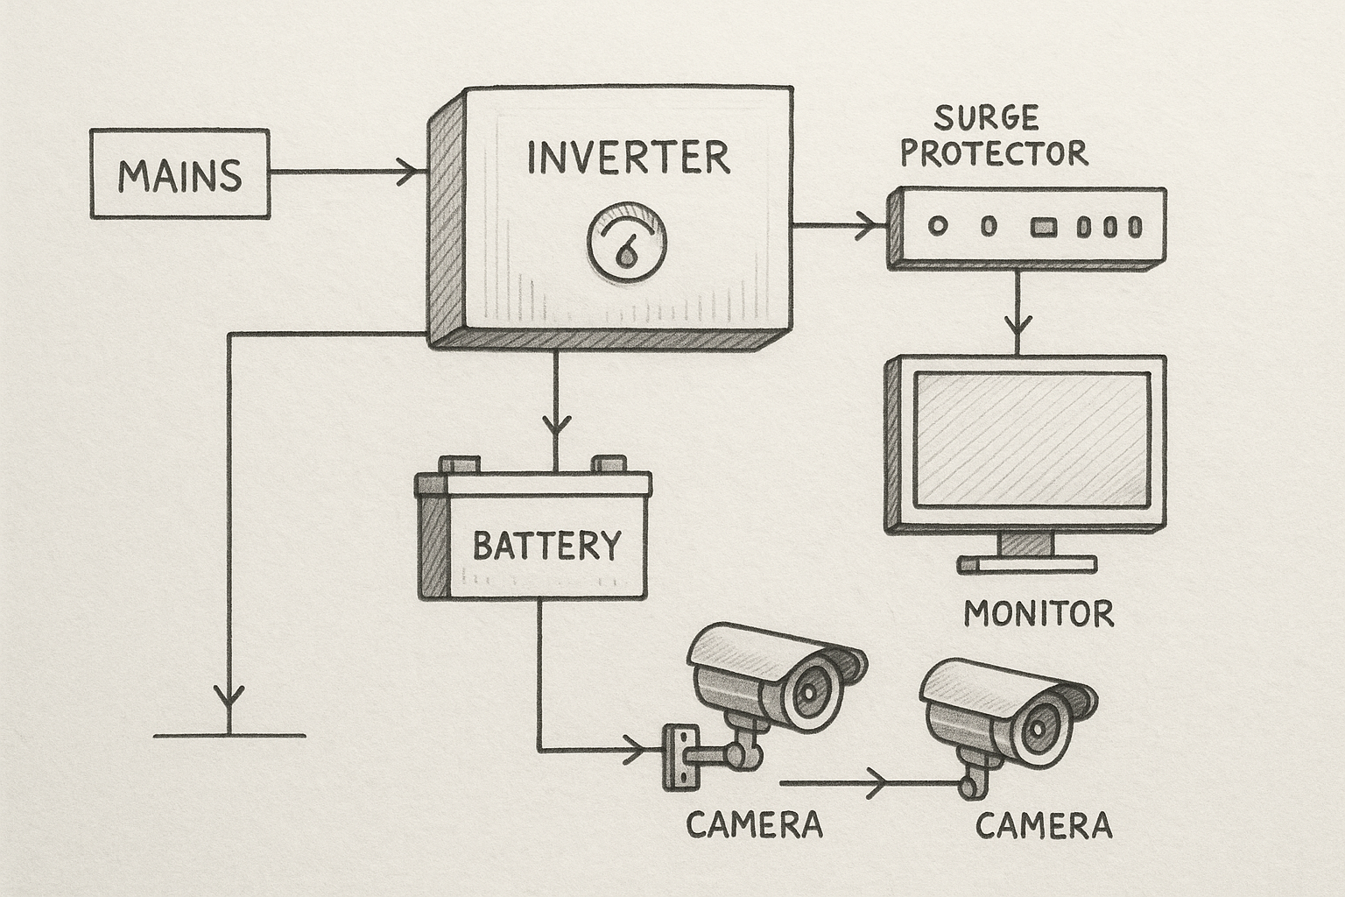
Fig 3.1. A rough image on how it will be installed

CHAPTER FOUR
SYSTEM IMPLEMENTATION

4.1 Introduction
Examination malpractice poses a significant threat to the integrity of educational systems. Traditional methods of invigilation often fall short in preventing cheating, collusion, or impersonation. To address this, the integration of technology—particularly CCTV surveillance powered by inverters—offers a reliable and uninterrupted means of monitoring exam environments, even in areas with unstable power supply.

Purpose of Implementation
The goal is to provide round-the-clock surveillance of examination halls using CCTV cameras, with inverter backup systems ensuring continuous operation in case of power failure. This reduces human error in monitoring and enhances transparency, accountability, and evidence collection during exams.

System Components
- CCTV Cameras – Placed strategically to cover students, invigilators, entry/exit points, and blind spots.
- Digital Video Recorder (DVR) – Stores footage for review and evidence.
- Monitor – For real-time observation by supervisors.
- Inverter and Battery System – Provides backup power during outages.
- Mains Power Supply – Primary source of power for the system.
- Surge Protectors – To guard against voltage spikes.

4.2 Implementation Steps
- Site Assessment
Examine the exam venue layout. Identify strategic camera locations to ensure full coverage.
- Installation of CCTV System
- Mount analog or IP cameras around the exam hall.
- Wire connections to the DVR and power source.
- Set up the monitor for live feed viewing in a control room.
- Inverter System Setup
  - Choose an inverter that can support the total load of the cameras, DVR, and monitor.
  - Connect a deep-cycle battery for adequate backup time (e.g., 6–8 hours).
  - Integrate the inverter with the mains to allow automatic switchover.
- Testing and Configuration
  - Test the system under normal and backup power.
  - Configure camera angles, resolution, and storage settings.
  - Ensure recording begins automatically during power loss.
- Monitoring and Supervision
  - Assign trained personnel to supervise live feeds.
  - Use footage to detect suspicious behavior and compile evidence if malpractice is observed.
- Review and Reporting
  - Store recorded footage securely for future review.
  - Prepare reports on incidents, supported by video evidence.

Benefits
- Uninterrupted Monitoring: Power outages no longer compromise exam surveillance.
- Deterrent to Malpractice: Presence of CCTV discourages dishonest behavior.
- Evidence Gathering: Recorded footage serves as proof in disciplinary actions.
- Reduction in Human Error: Reduces reliance on manual supervision.
- Transparency and Accountability: Builds trust in the examination process.

Challenges
- Initial Cost: Requires investment in equipment and power systems.
- Technical Expertise: Needs skilled personnel for setup and maintenance.
- Data Management: Must handle storage, backup, and privacy policies.
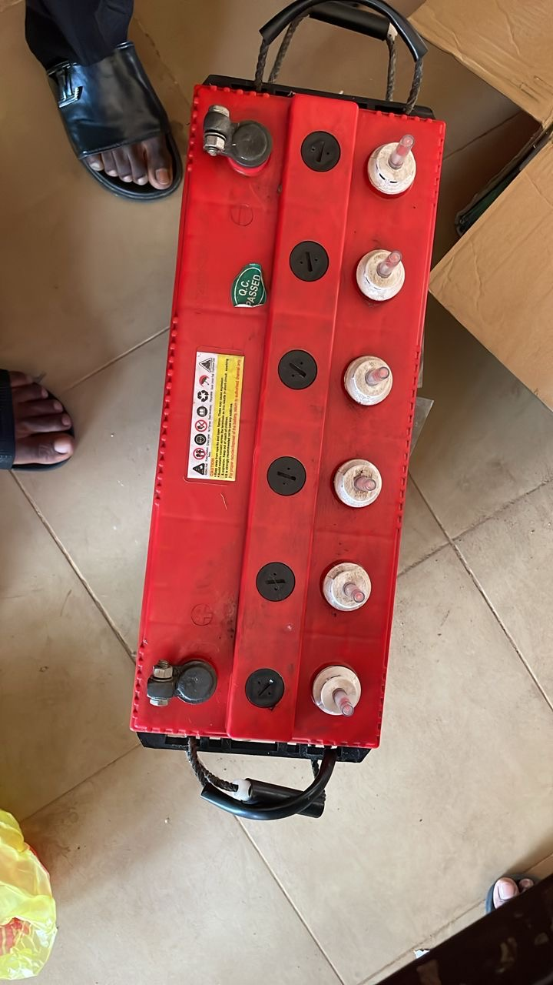
- Fig 4.1
- Batteries are essential components in modern technology, providing portable and backup energy for a wide range of devices—from mobile phones and laptops to
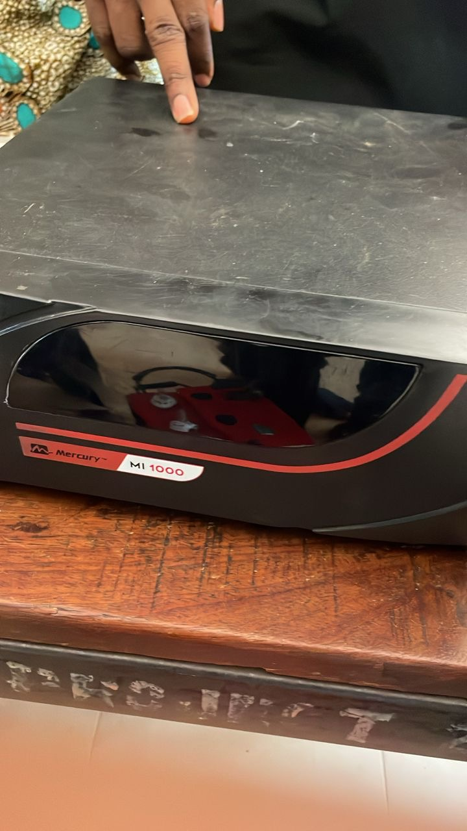
- electric vehicles and power backup systems. A battery is a device that stores chemical energy and converts it into electrical energy to power electronic circuits and equipment.
- Fig 4.2
- An inverter is a power electronic device that takes DC input (commonly from a battery or solar panel) and converts it into AC output at a specified voltage and frequency (e.g., 230V, 50Hz in many countries).

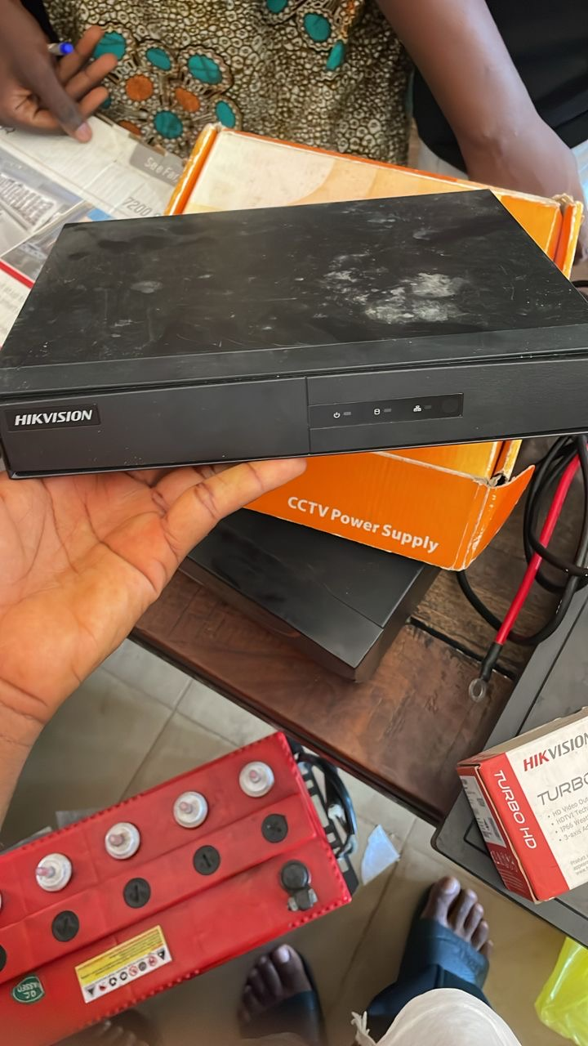
- Fig 4.3
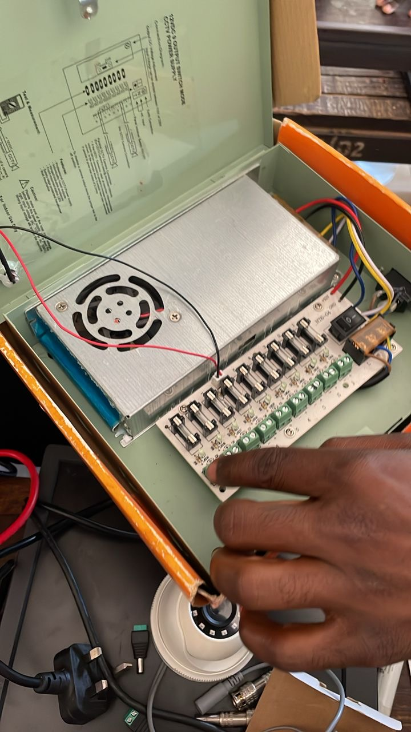
- A DVR (Digital Video Recorder) is an electronic device that converts analog video signals from CCTV cameras into digital data, compresses it, and stores it on a hard disk drive (HDD) or solid-state drive (SSD). DVRs allow users to record, view, and retrieve video footage, often with features such as motion detection, time-stamping, remote access, and multi-camera support.
- Fig 4.4
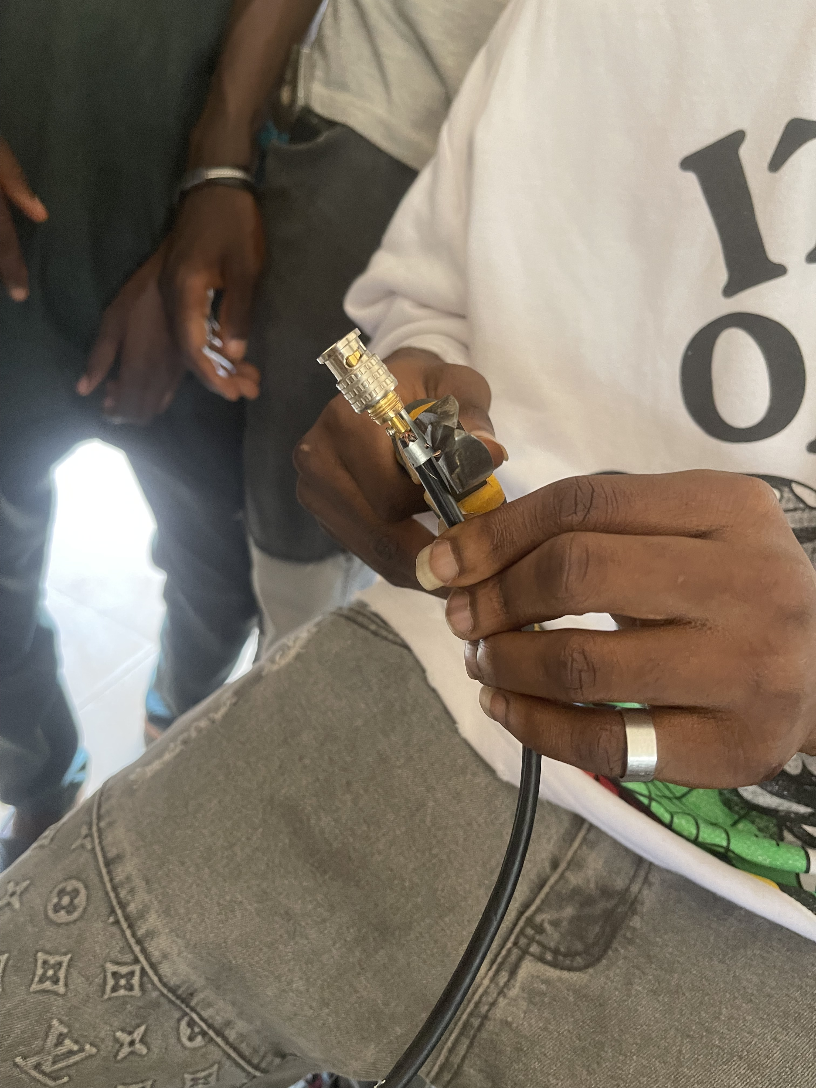
- A power supply box is a critical component in electronic and surveillance systems. It distributes and regulates electrical power from the main source (AC) to various devices or subsystems that typically operate on lower DC voltages. In CCTV installations and other security systems, the power supply box ensures reliable and centralized power distribution to multiple cameras and accessories.
- Fig 4.5
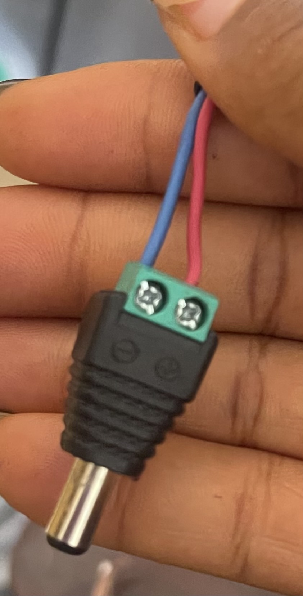
- The BNC connector is a widely used type of RF (Radio Frequency) connector designed for coaxial cables. Its compact size, secure connection, and reliable performance make it ideal for various applications, especially in CCTV systems, broadcast equipment, test instruments, and radio frequency electronics.
- Fig 4.5
- Power is a fundamental concept in both electrical and electronic systems. It refers to the rate at which energy is transferred or converted.
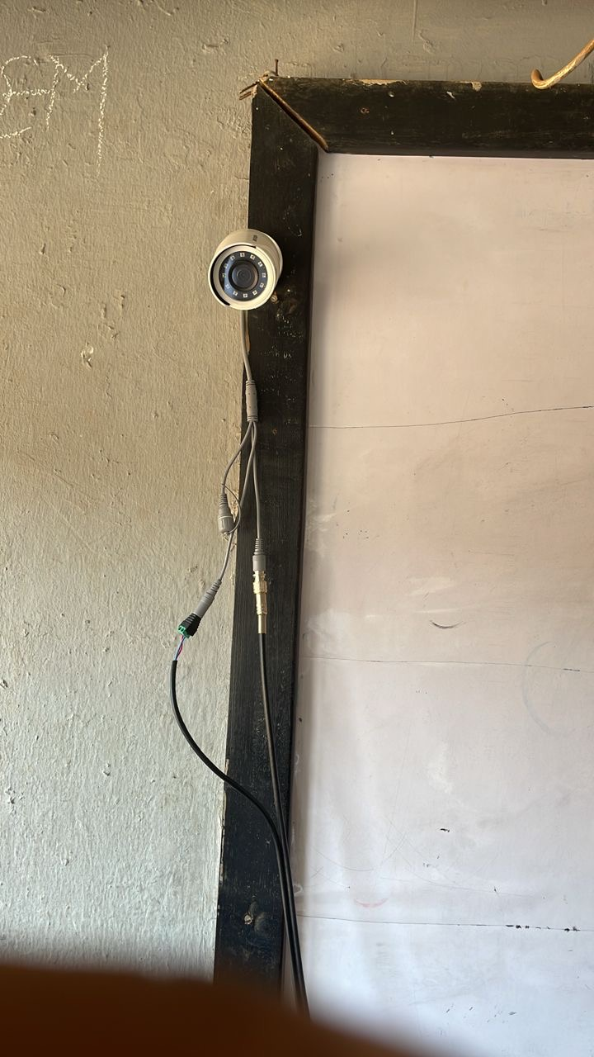
- Fig 4.6
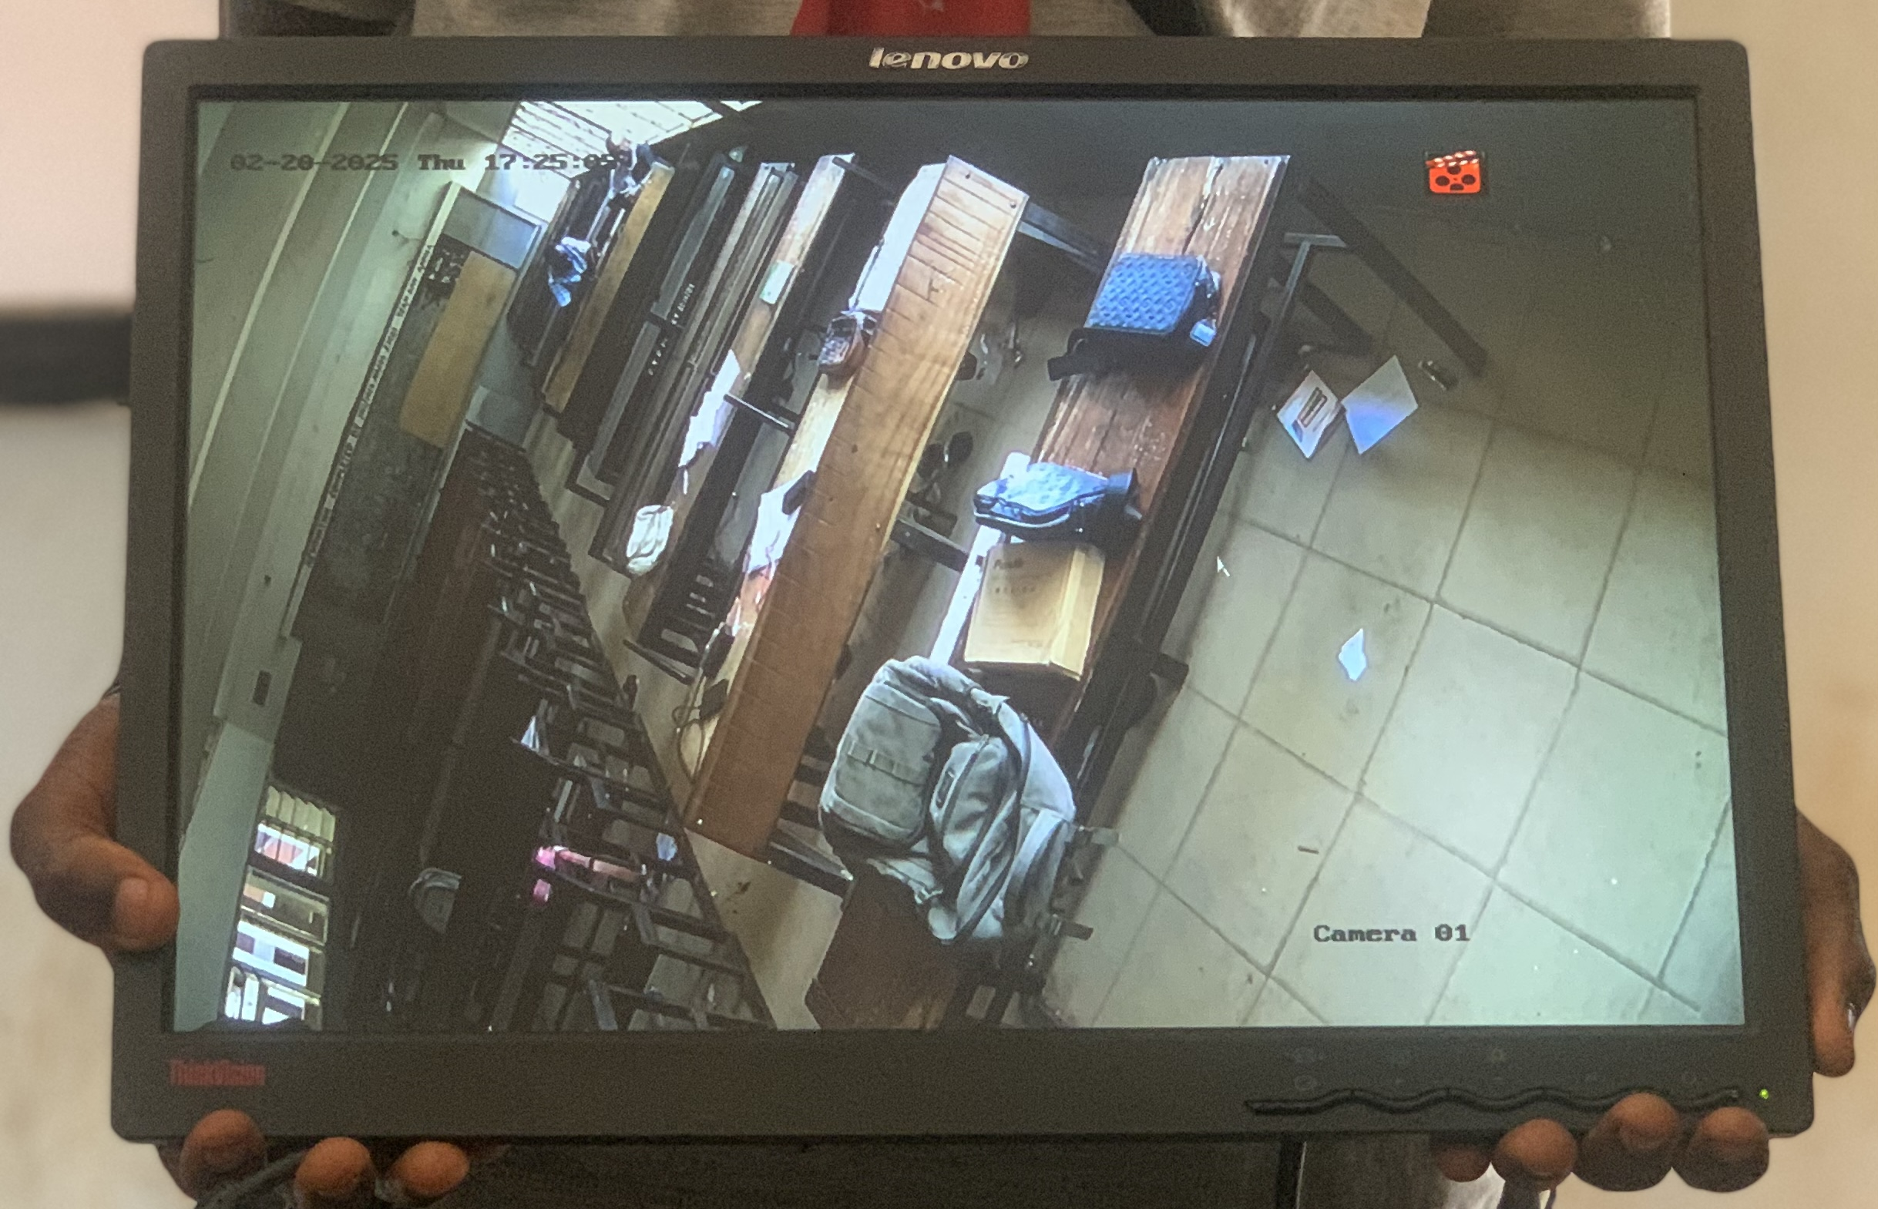
- Installation of camera one
- Fig 4.7
- Output of the installed camera one
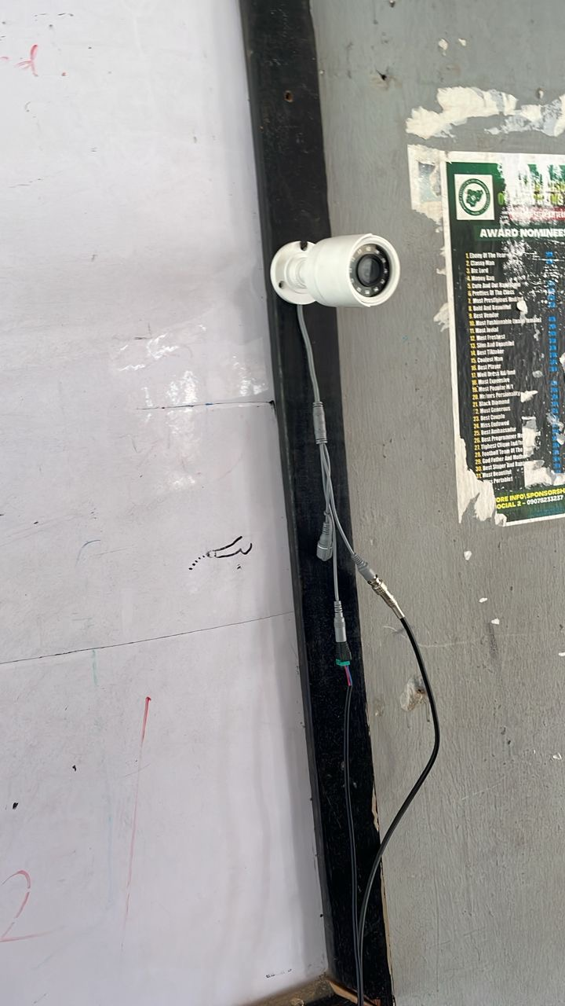
- Fig 4.8
- Installation of camera 2
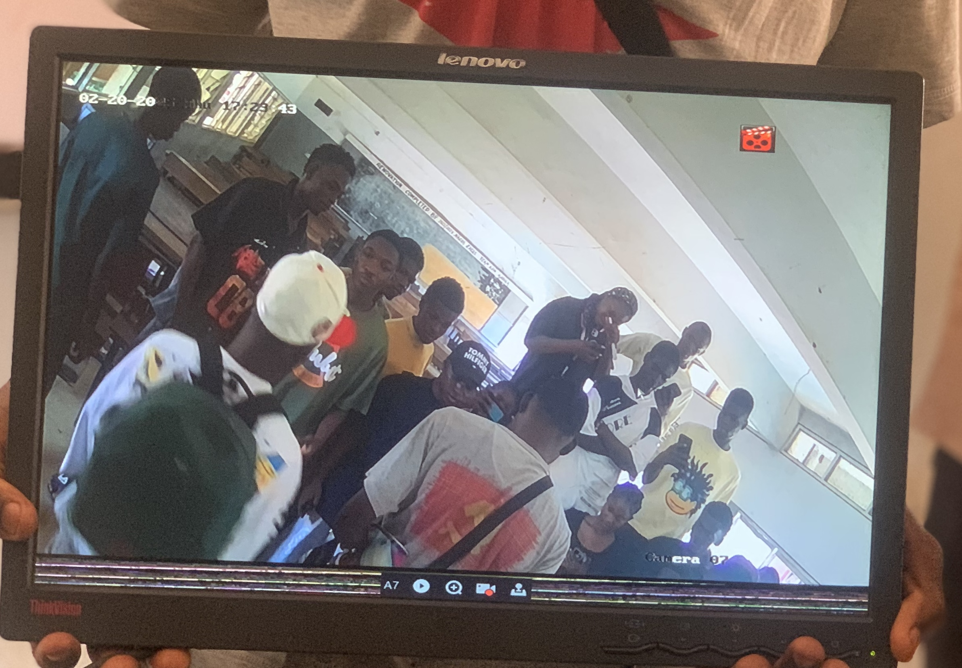
- Fig 4.9
- Output of installed camera 2

CHAPTER FIVE
SUMMARY, CONCLUSION, RECOMMENDATIONS
5.1 Summary
Examination malpractice, such as cheating or unauthorized assistance during tests, is a widespread challenge in schools and universities. To combat this, institutions have turned to CCTV surveillance systems to monitor students during exams. CCTV cameras help supervisors detect suspicious behavior in real time and provide video evidence for post-exam review.
However, the effectiveness of CCTV systems can be limited by power supply issues, especially in areas with frequent outages. Without electricity, these systems shut down, creating gaps in surveillance that students can exploit. This is where inverter power systems become crucial.
In inverter stores electrical energy (usually from the grid or solar panels) and supplies power during outages. When integrated with CCTV systems, inverters ensure that cameras continue recording even if the main power supply fails. This setup provides continuous, reliable surveillance, making it much harder for students to cheat without being detected.

5.2 Conclusion
In conclusion, the use of CCTV in examination halls is a strong deterrent against cheating, but it becomes fully reliable only when paired with a stable power backup system, like an inverter. The combination ensures that surveillance continues without interruption, preserving the integrity of the monitoring process.
The continuous presence of cameras—even during power failures—discourages dishonest behavior, reassures examiners and students of a fair process, and helps institutions enforce discipline. Furthermore, recorded footage can be reviewed later, providing concrete evidence if any malpractice is suspected.
5.3 Recommendations
To fully harness the benefits of CCTV monitoring during examinations, it is recommended that:
- All educational institutions install CCTV systems in examination halls to deter malpractice and record incidents for review.
- Inverter backup power systems be integrated with these CCTV setups to avoid surveillance blackouts during power outages.
- Investments in renewable energy sources, such as solar-powered inverters, be considered for sustainability and cost-efficiency.
- Training and awareness programs be conducted for staff and students so they understand the role and function of these systems.
- Maintenance schedules be followed to ensure the CCTV and inverter systems are functional and tested before each examination period.

REFERENCES
Adebayo, M., & Tunde, K. (2022). Enhancing examination integrity using inverter-powered CCTV systems in tertiary institutions. Journal of Educational Technology and Security, 14(2), 45–60.
Ahmed, S. (2023). Strengthening institutional accountability through CCTV integration in higher education. African Journal of Educational Reforms, 11(1), 23–38.
Chukwuemeka, J., Nnaji, T., & Okafor, U. (2025). Advancing sustainable surveillance: The impact of solar-powered inverters in educational settings. International Journal of Green Technology in Education, 6(1), 50–66.
Eze, C., & Bello, R. (2021). Analyzing the effect of power supply issues on electronic surveillance in Nigerian schools. Nigerian Journal of Educational Infrastructure, 9(3), 30–42.
Ibrahim, L., & Salisu, M. (2024). Ethical considerations and policy frameworks for surveillance in schools: A review of privacy and resistance issues. Journal of Educational Administration and Ethics, 7(4), 66–78.
Olatunji, F., & Ahmed, S. (2023). Embracing digital transformation: Surveillance practices in Nigerian tertiary institutions. *West African Journal of Educational Innovation, 5(2), 18–29.

