A TECHNICAL PROJECT REPORT
ON
A PROPOSED DAYCARE
FOR
(OKC NURSERY AND PRIMARY SCHOOL)
BY
ADEGBOYE GABRIEL TOFUMI
ND/23/ARC/PT/0026

SUBMITED TO:
DEPARTMENT OF ARCHITECTURAL TECNOLOGY,
INSTITUTE OF ENVIRONMENTAL STUDIES,
KWARA STATE POLYTECHNIC ILORIN.

IN PARTIAL FULFILMENTS OF THE REQUIREMENTS,
FOR AWARD OF NATIONAL DIPLOMA
(ND) IN ARCHITECTURAL TECHNOLOGY

SUPERVISOR: ARC. FAMILUA O.S

JULY, 2025

DECLARATION
I ADEGBOYE GABRIEL TOFUMI of matric number ND/23/ARC/PT/0026 I hearby declare that this project research DAYCARE is my own unaided technical report works. It has not been presented for the award of any ND in any Polytechnic. The ideas, observations, comments, suggestions of this report represent my own convictions, except quotations, which have been acknowledged in accordance with conventional academic traditions

ADEGBOYE GABRIEL TOFUMI ………………………….

ND/23/ARC/PT/0026 SIGNATURE

CERTIFICATION
I certify that this Research Project/Dissertation entitle DAYCARE as carried out by ADEGBOYE GABRIEL TOFUMI, under my supervision and has been approved as meeting the requirements for the award of ND in Architectural Technology, Kwara State Polytechnic, Ilorin Kwara State.

ARC. FAMILUA O.S

(Project Supervisor SIGNATURE/DATR


ARC. OLAREWAJU F.A
(Project coordinator ) SIGNATURE/DATE


ARC. J.M TOMORI.
(Head of Department) SIGNATURE/DATE

EXTERNAL SUPERVISOR SIGNATURE/DATE

ACKNOWLEDGEMENT

I utmost gratitude goes to almighty God for his grace, guidance protection and infinite mercy that gave me courage, wisdom and endurance needed to start and finish the research in spite of all difficulties. I cannot but appreciate the effort to my supervisor in person of ARC.FAMILUA for her support and assistant. I also grateful to my head of department (H O D) ARC. J. M , and my course mate for their readiness to help, to all my guidance and suggestions. Finally, my gratitude and adoration goes to almighty GOD for his protection, enduring mercy over me throughout the period of my study. I also wish to express our profound gratitude to my parents (Mr and Mrs ADEGBOYE ), for their love, care, assistance, financial moral support and most importantly for always been there for us, and to my love ones.
DEDICATION
This research is dedicated to almighty GOD whose guidance and protection has been more than enough for me since the beginning of this research to the end.I also to my parents MR AND MRS ADEGBOYE for been there for me at all time.

TABLE OF CONTENTS
TITTLE PAGE………………………………………………………………………... i
DECLARATION……………………………………………………………………...ii
CERTIFICATION………………………………………………………………….….iv
ACKNOWLEDGEMENT……………………………………………………………..v
TABLE OF CONTENT…………………………………………………………….... vi
LIST OF FIGURE………………………………………………………………….....vii
LIST OF PLATES……………………………………………………………………viii
LIST OF APPENDIX……………………………………………………………….... ix
ABSTRACT…………………………………………………………………………...x
CHAPTER ONE
1.0 INTRODUCTION…………………………………………………………………1
1.1 PROJECT DEFINITION……………………………………………………….….1
1.2 HISTORICAL BACK GROUND………………………………………………….2
1.3 JUSTIFICATION ………………………………………………………………….2
1.4 AIM…………………………………………………………………………………3
1.5 OBJECTIVES………………………………………………………………………3
1.6 CLIENT BACKGROUND, PHILOSOPHY………………………………………..3
1.7 SCOPE OF STUDY………………………………………………………………...3
1.8 LIMITATION OF DESIGN………………………………………………………..4
1.9 RESEARCH METHODOLOGY…………………………………………………..5
CHAPTER TWO
2.1 LITERATURE REVIEW…………………………………………………………...6
2.2 REVIEW OF ALL LITERATURE ON THE SUB-TOPIC………………………..8

CHAPTER THREE

3.1 CASE STUDY ONE…………………………………………………………………9
3.2 CASE STUDY TWO…………..……………………………………………………12
3.3 CASE STUDY THREE………………………………………………………….….15
CHAPTER FOUR
4.1 INTRODUCTION OF STUDY AREA………………………………………….…18
4.2 SITE LOCATION/DESCRIPTION………………………………………………...19
4.3 SITE ANALYSIS/INVENTORY…………………………………………………...19
4.4 GEOGRAPHICAL/CLIMATIC CONDITIONS……………………………….…..20
4.5 DESIGN CRITERIA…………………………………………………………….….20
4.6 BRIEF ANALYSIS………………………………………………….……………....20
4.7 SPATIAL PROGRAMMING (REAQUIREMENT AND ANALYSIS)……..……21
4.8 CONCEPTUAL DEVELOPMENT…………………………………………...……21
4.9 SITE CONCEPT………………………………………………………………...….22
4.10 BUILDING CONCEPT……………………………………………………...……23

CHAPTER FIVE
5.1 PROJECT APPRAISAL…………………………………………………………..24
5.2 CONSTRUCTION METHODOLOGY AND MATERIALS…………………….26
5.3 BUILDING SERVICE…………………………………………………………….28
5.4 CONCLUSION AND RECOMMENDATION…………………………………...30
5.5 REFERENCES…………………………………………………………………….31

LIST OF FIGURES
FIGURE 2.1: LOCATIONAL PLAN CASE STUDY ONE………………….9
FIGURE 2.2: FLOOR PLAN OF CASE STUDY ONE ……………………..9
FIGURE2. 3: LOCATIONAL PLAN OF CASE STUDY TWO……...……..12
FIGURE2. 4: FLOOR PLAN OKELERIN CASE STUDY TWO …………..13
FIGURE2. 5: LOCATIONAL PLAN OF CASE STUDY THREE.…..……..15
FIGURE2. 6: FLOOR PLAN OF CASE STUDYTHREE… …………….....15
FIGURE3.1. GEOGRAPHICAL/ CLIMATIC DATA ……………………...18
FIGURE3.2. AVERAGE MONTHLY TEMPERATURE …………………..23

FIGURE3.3. AVERAGE MONTHLY RAINFALL IN ILORIN ……………24
FIGURE 4.1 BUILDING CONCEPT ………………………………………..27
LIST OF PLATE

PLATE 2.1 .FRONT VIEW OF CASE STUDY ONE…………………….….10

PLATE 2.2 .INTERNAL VIEWS OF CASE STUDY ONE …….……….…..10

PLATE 2.2 .INTERNAL VIEWS OF CASE STUDY TWO …….……….…..11

PLATE 2.3 .FRONT VIEW OF CASE STUDY TWO ……………………….13

PLATE 2.4 .PICTURES OF CASE STUDY THREE…….…………..…........16

PLATE 2.4 .PICTURES OF CASE STUDY THREE…….…….......................16

LIST OF APPENDIX

APPENDIX 5 .1; SHOWING LOCATIONAL MAP………..…………..……….32

APP ENDIX 5 .2; SHOWING LOCATIONAL PLAN………….……………......32

APPENDIX.5;3 SHOWINGINTERNAL PERSPECTIVE…………….………..33
APPENDIX 5. 4; SHOWING SITE ANALYSIS…………..…………….….…....33

APPENDIX 5. 5; SHOWING ROOF……...…………………………….….….….34

APPENDIX 5 .6; SHOWING FLOOR PLAN…….………………………….…...34

ABSTRACT
This project explores the significance of day care in supporting working parents and promoting the development of young children. Day care, also known as child care, refers to the care and supervision of children when their parents or guardians are not present. The primary goal of day care is to provide a safe, nurturing, and stimulating environment that promotes the physical, emotional, and cognitive development of children. The importance of day care cannot be overstated. High-quality day care programs provide children with a foundation for future academic success and social development, while also enabling parents to balance work and family responsibilities. However, the availability and accessibility of day care services vary widely, and many families face significant challenges in accessing affordable and high-quality care. This project examines the benefits and challenges of day care, including its impact on child development, parent-child relationships, and family well-being. It also explores the different types of day care, including center-based care, home-based care, and family child care, and discusses the importance of quality care, staff training, and parent-provider partnerships. The findings of this project highlight the need for increased investment in day care services, including funding, infrastructure, and workforce development. They also emphasize the importance of promoting parent-provider partnerships, supporting diverse needs, and ensuring that day care services are accessible and affordable for all families. Overall, this project contributes to a deeper understanding of the significance of day care in supporting working parents and promoting the development of young children. Its findings have implications for policymakers, practitioners, and families, and highlight the need for continued investment and innovation in day care services.

CHAPTER ONE
1.0 INTRODUCTION
A daycare, also known as a childcare center, is a facility that provides care and supervision for children, typically from infancy to age 12, while their parents or guardians are away at work or school, offering a safe, nurturing, and educational environment that promotes cognitive, social, and emotional development through various activities, including early childhood education, socialization, and play-based learning, while also providing convenience for parents, economic benefits, and a positive impact on the community, but it's essential to ensure that the daycare center maintains high-quality standards, including qualified staff, a safe and healthy environment, engaging activities, and open communication with parents, which can have a profound impact on a child's development, future success, and overall well-being, making it a crucial decision for parents to make, as it can shape their child's early years and lay the foundation for a lifelong love of learning
1.1 HISTORICAL BACKGROUND
The concept of daycare has its roots in ancient civilizations, where childcare was often provided by extended family members, neighbors, or community-based care. In ancient Greece and Rome, for example, childcare was often provided by slaves or servants.
Industrial Revolution and the Emergence of Daycare
The modern concept of daycare, however, emerged during the Industrial Revolution in the 18th and 19th centuries. As women began to enter the workforce, there was a growing need for childcare services. In response, philanthropists and social reformers established the first daycare centers, which were often linked to factories or mills.
Early 20th Century Developments
In the early 20th century, the daycare movement gained momentum, with the establishment of organizations such as the National Association for the Education of Young Children (NAEYC). The NAEYC played a crucial role in promoting high-quality childcare and developing standards for daycare centers.
Post-WWII Expansion
Following World War II, there was a significant expansion of daycare services, driven by the increasing participation of women in the workforce. The 1960s and 1970s saw the establishment of federal programs such as Head Start, which provided funding for childcare services for low-income families.
Contemporary Daycare Landscape
Today, daycare is a ubiquitous part of modern life, with millions of children attending daycare centers worldwide. The daycare landscape has evolved to include a range of options, from center-based care to home-based care, and from traditional daycare models to more innovative approaches such as Montessori and Reggio Emilia.
Challenges and Opportunities
Despite the growth and evolution of the daycare sector, there are still significant challenges to be addressed, including issues of affordability, accessibility, and quality. However, there are also opportunities for innovation and improvement, driven by advances in technology, changes in family structures and workforce participation, and growing recognition of the importance of early childhood education.
1.2 DEFINITION.
Daycare refers to the care and supervision of children, typically from infancy to age 12, by trained professionals or caregivers, in a group or individual setting, while their parents or guardians are away at work, school, or other activities. Daycare provides a safe, nurturing, and educational environment that promotes cognitive, social, and emotional development, and offers a range of activities, including early childhood education, socialization, and play-based learning. Daycare can be center-based, home-based, or a combination of both, and may offer full-time, part-time, or drop-in care options.
1.3 JUSTIFICATION
Designing a day care for OKC Nursery and Primary School is justified for several reasons. Firstly, it will provide a safe and nurturing environment for young children to learn and develop, aligning with the school's mission to support the holistic development of its students. Secondly, a day care will offer working parents a reliable and trustworthy option for their children's care, enhancing the school's reputation and appeal to families. Additionally, a well-designed day care will foster a sense of community and cooperation among parents, staff, and children, promoting socialization and a sense of belonging. Furthermore, a day care will enable the school to provide a seamless transition for children from nursery to primary school, supporting their emotional, social, and cognitive development. By incorporating a day care into its offerings, OKC Nursery and Primary School can differentiate itself from other educational institutions, attract and retain students, and contribute to the well-being of families in the community. Overall, designing a day care for OKC Nursery and Primary School is a strategic decision that will benefit the school, its students, and the wider community.
1.4 AIM AND OBJECTIVES
My aim for this project is to design a day care for OKC Nursery and Primary School is to provide a nurturing and stimulating environment that supports the holistic development of young children, aged 0-6, within the school community and local government area. The day care will foster social, emotional, cognitive, and physical growth, while promoting a sense of community and cooperation among children, parents, and staff, ultimately contributing to the well-being and development of the local community.

1.5 OBJECTIVE
1. To design and Provide a daycare to Provides a safe, nurturing, and stimulating environment for young children to learn and develop
2 To design a daycare that will offer opportunities for children to experiment, explore, and discover in a safe and supportive setting.
3 To design and Offers a high-quality care and education program that meets the diverse needs of children and families.
4 To design a daycare that will Meets the needs of working parents and families in the local community
1.6 CLIENTS BACKGROUNG, PHYLOSHOPHY
OKC (Ola Kayode College), established in 2008 in Ilorin South Local Government Area of Kwara State, Nigeria, is a reputable educational institution known for its high standards and diverse academic activities. The college has a secondary school section with boarding facilities, providing students with a comprehensive learning experience. Located in a region with a rich cultural heritage, OKC benefits from the local government's focus on education. Ilorin South LGA, where the college is situated, has a population of approximately 208,691 people, according to the 2006 census. The area is divided into three districts and 11 wards, with its headquarters in Fufu. The local government area is home to various institutions, including secondary schools like Government Day Secondary School Ilorin and Unity Community Secondary School. Given its location and establishment, OKC Ola Kayode College likely plays a significant role in providing quality education to students in Ilorin South LGA and beyond. Its boarding facilities suggest a commitment to fostering academic excellence and personal growth among its students

1.7 SCOPE AND BRIFE OF PROJECT
* Gate house
*Proposed building (daycare)
*Parking lot
*water storage
*Power house
1.8 LIMITATION
Types of Limitations
1. Methodological Limitations: Limitations related to the research design, sampling strategy, or data collection methods.
2. Sampling Limitations: Limitations related to the sample size, population, or sampling frame.
3. Data Limitations: Limitations related to the quality, accuracy, or completeness of the data.
Examples of Limitations
1. Small sample size: Limited statistical power and reduced generalizability.
2. Biased sampling: Non-representative sample, which may lead to inaccurate conclusions.
3. Limited access to data: Incomplete or inaccurate data, which may impact the validity of the findings.

Importance of Acknowledging Limitations
1. Transparency: Acknowledging limitations demonstrates transparency and honesty in research.
2. Contextualizing findings: Recognizing limitations helps to contextualize the findings and interpret them accurately.
3. Future research directions: Identifying limitations can inform future research directions and improve the quality of subsequent studies.
1.9 RESEARCH METHODOLOGY
Research methodology refers to the systematic and scientific approach used to conduct research, including the methods, techniques, and procedures employed to collect and analyze data. It provides a framework for investigating a research question or hypothesis and ensures the validity, reliability, and accuracy of the findings.
Types of Research Methodologies
1. Quantitative Research: Uses numerical data and statistical methods to investigate research questions or hypotheses.
2. Qualitative Research: Employs non-numerical data, such as text, images, or observations, to gain insights into research phenomena.
3. Mixed-Methods Research: Combines quantitative and qualitative approaches to provide a more comprehensive understanding of the research topic.
Research Methodology Steps
1. Literature Review: Conducting a thorough review of existing research on the topic to identify gaps and inform the research question.
2. Research Design: Selecting an appropriate research design, such as experimental, quasi-experimental, or descriptive, to investigate the research question.
3. Data Collection: Collecting data using various methods, such as surveys, interviews, observations, or experiments.
Importance of Research Methodology
1. Ensures Validity and Reliability: A well-designed research methodology ensures that the findings are valid, reliable, and generalizable.
2. Provides a Framework: Research methodology provides a systematic approach to conducting research, guiding the researcher through the entire process.
3. Enhances Credibility: A rigorous research methodology enhances the credibility of the research findings and contributes to the advancement of knowledge in the field.

CHAPTER TWO

2.1 LITERATURE REVIEW
Day care, also known as child care, is the care and supervision of children when their parents are not present. The goal of day care is to provide a safe, nurturing, and stimulating environment that promotes the physical, emotional, and cognitive development of children.
HISTORY OF DAY CARE
The concept of day care has been around for centuries, with early examples found in Europe and Asia. In the 19th century, day care centers began to emerge in France and Great Britain, primarily serving working-class families. Today, day care is a vital part of many societies, supporting working parents and providing early childhood education.
GOALS AND OBJECTIVES
The primary objectives of day care are
1 Support each child's self-esteem: Foster a sense of self-worth, self-awareness, and self-confidence.
2 Recognize individuality: Encourage independence and meet the developmental needs of each child.
3 Provide a nurturing environment: Offer opportunities for children to experiment, explore, and discover in a safe and supportive setting.
4 Foster wholesome relationships: Help children develop positive relationships with others through understanding and guidance.
REQUIREMENTS AND STANDARDS
Day care centers must adhere to specific requirements and standards, including ¹:
1 Child-to-adult ratios: Vary by age group, with a general guideline of 1:3 for infants and 1:6 for toddlers.
2 Space requirements: Provide adequate space for children to play, learn, and rest, with a minimum of 2-3 square meters per child.
3 Safety and security: Ensure structural safety, fireproofing, and emergency preparedness.
4 Health and hygiene: Maintain a clean and hygienic environment, with adequate ventilation and lighting.
PROGRAMS AND SERVICES
Day care centers offer various programs and services, including ¹:
1 Early childhood education: Provide a structured curriculum that promotes cognitive development and school readiness.
2 Recreational activities: Offer opportunities for physical activity, creative play, and socialization.
3 Nutrition and meals: Provide healthy meals and snacks, or accommodate children with dietary restrictions.
4 Health and wellness: Monitor children's health, provide basic medical care, and promote healthy habits.
BENEFITS AND CHALLENGES
Research highlights the benefits of high-quality day care, including ² ³ ⁴:
1 Improved cognitive development: Day care programs can enhance children's cognitive skills and school readiness.
2 Better socialization: Day care provides opportunities for children to interact with peers and develop social skills.
3 Support for working parents: Day care enables parents to balance work and family responsibilities.
2.2 REVIEW OF ALL LITERATURE ON THE SUB-TOPIC
Day-care, also known as child care, refers to the care and supervision of children when their parents or guardians are not present. Research has consistently shown that high-quality day-care can have a positive impact on children's cognitive, social, and emotional development (Shonkoff & Phillips, 2000). Studies have also highlighted the importance of qualified caregivers, staff-to-child ratios, and stimulating environments in promoting healthy development (NICHD, 2006). The benefits of day-care for children include improved social skills, emotional regulation, and academic readiness (Belsky et al., 2007). Additionally, day-care can provide a safe and nurturing environment for children, allowing parents to balance work and family responsibilities. However, research has also identified potential challenges associated with day-care, such as increased risk of illness and stress (Bradley & Vandell, 2007). To mitigate these risks, it is essential to ensure that day-care centers maintain high standards of quality, including adequate staff training, safe and healthy environments, and effective communication with parents. Overall, the literature suggests that high-quality day-care can be a valuable resource for families, supporting the development of young children and promoting positive outcomes. By prioritizing quality and investing in day-care services, policymakers and practitioners can help ensure that children receive the care and support they need to thrive.

CHAPTER THREE

3.0 CASE STUDY
This can be defined as the gathering of information through various means o: was Case Study 2.2 This is a research or an exercise that is carried out on existing building which 1s Similar to the one researcher is writing on. The objective of a case study is to take a critical appraisal of existing related project with a view to identity the positive and negative aspect of such project. It is only with time that a project can be adjusted so that it can be successful. The information obtained from the appraisal will guide the designer of new and similar project, the project position aspect of it shall be incorporated in the View proposal while attempts will be made to solve the problem of negative aspect. lt is only through this that a design can better enhance the quality and efficiency of building in the society, tor a comprehensive analysis their case studies have been conducted.
3.1 CASE STUDY
CASE STUDY ONE
NAME: FLOURISH DAY CARE
LOCATION: OGBOMOSHO, OYO STATE
MERIT
1 It has a large and mass area of land
2. It is easily accessible through existing road
DEMERIT
1 The roof needs renovation
2. It has no toilets to use

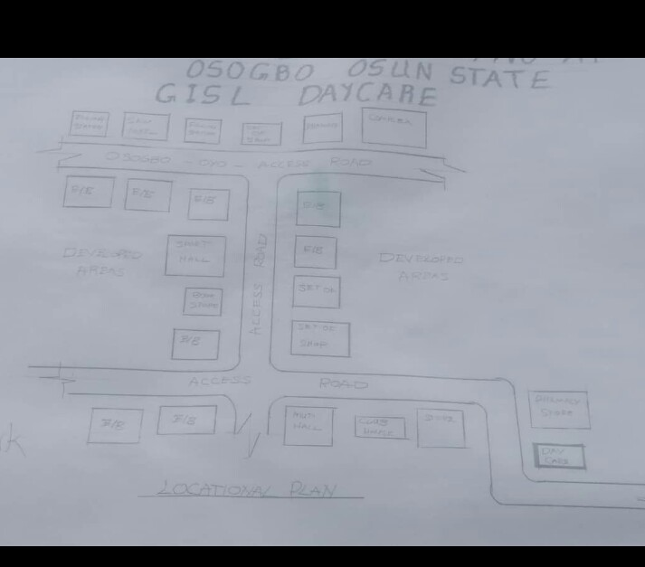

FIGURE3.1: LOCATIONAL PLAN OF CASE STUDY ONE

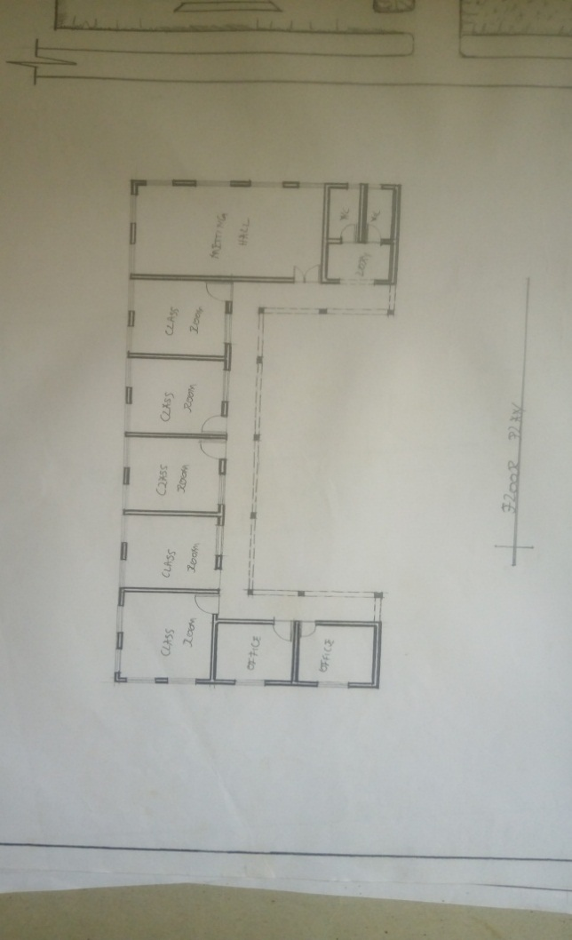
FIGURE3.2: FLOOR PLAN OF CASE STUDY ONE

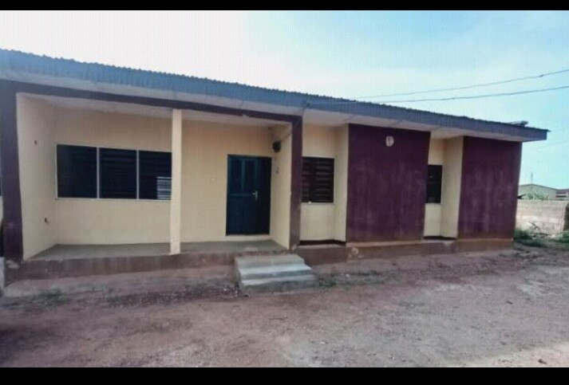

PLATE3.1: FRONT VIEW CASE STUDY ONE
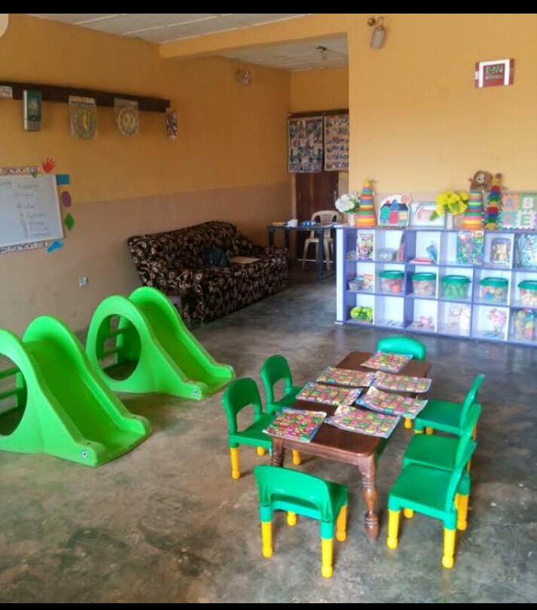

PLATE3.2: INTERNAL VIEW CASE STUDY ONE
CASE STUDY TWO
NAME: DALAT DAY CARE
LOCATION: OGBOMOSHO, OYO STATE.
MERIT
1 It is well ventilated
2 The approach is well aesthetic
DEMERIT
1 It has no landscape
It has no playing ground/ field for students
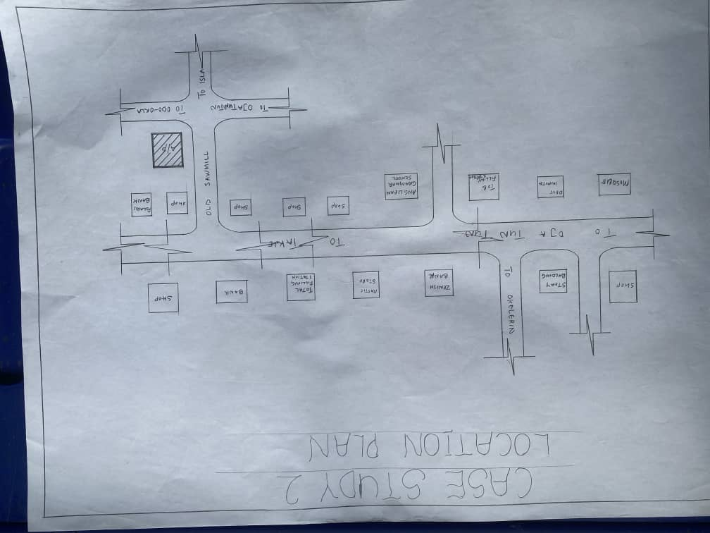

FIGURE3.3: LOCATIONAL PLAN F CASE STUDY THREE

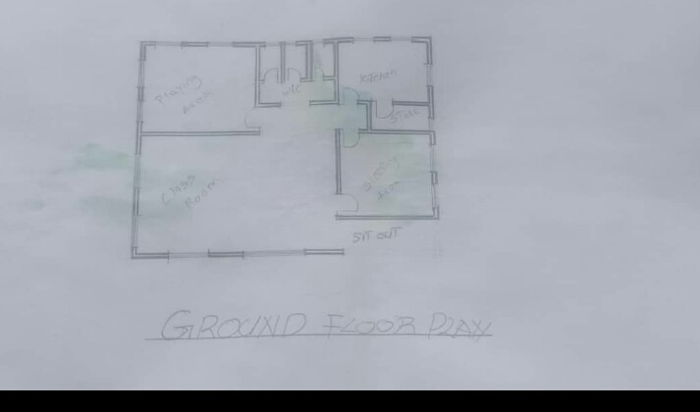
FIGURE3.4: FLOOR PLAN OF CASE STUDY THREE

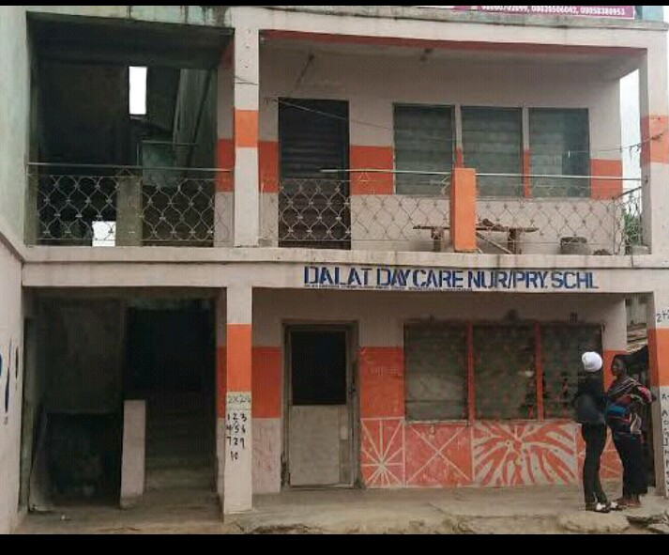

PLATE 3.3 .FRONT VIEW OF CASE STUDY THREE

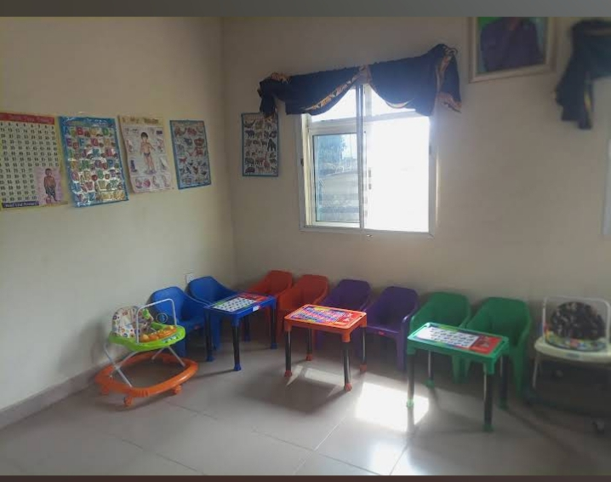

PLATE 3.4 INSIDE VIEW OF CASE STUDY TWO

STUDY THREE
NAME: BRIGHT DAYCARE
LOCATION: FATE TANKE, ILORIN KWARA STATE
MERIT
1. It is easily accessible through existing road
DEMERIT
1. It is not well ventilated
2. The approach is aesthetically poor

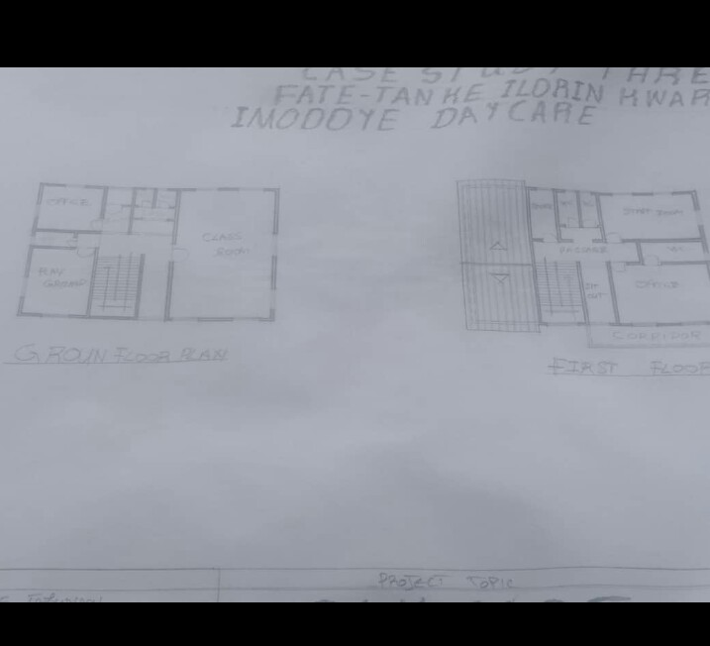

FIGURE3. 5: LOCATIONAL PLAN OF CASE STUDY THREE

FIGURE3. 6: FLOOR PLAN OF CASE STUDY THREE

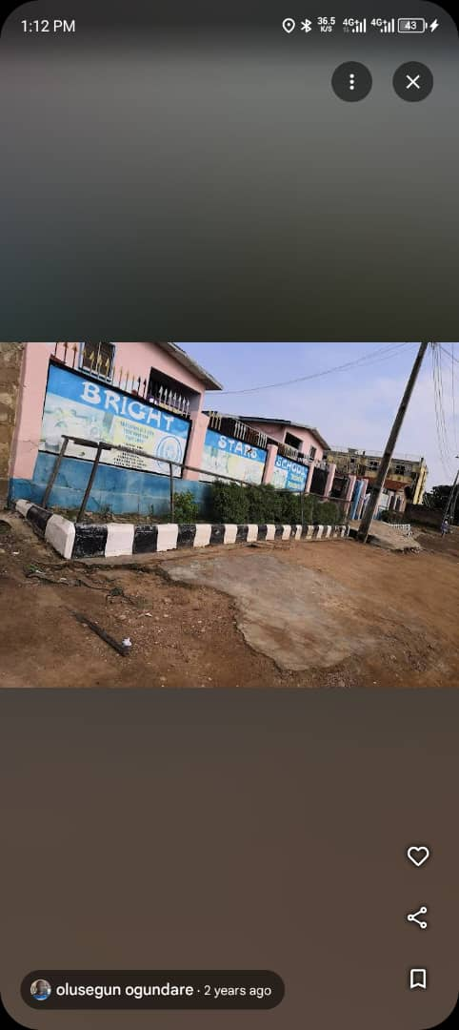
PLATES 3. 5: SHOWING FRONT VIEW OF CASE STUDY THREE
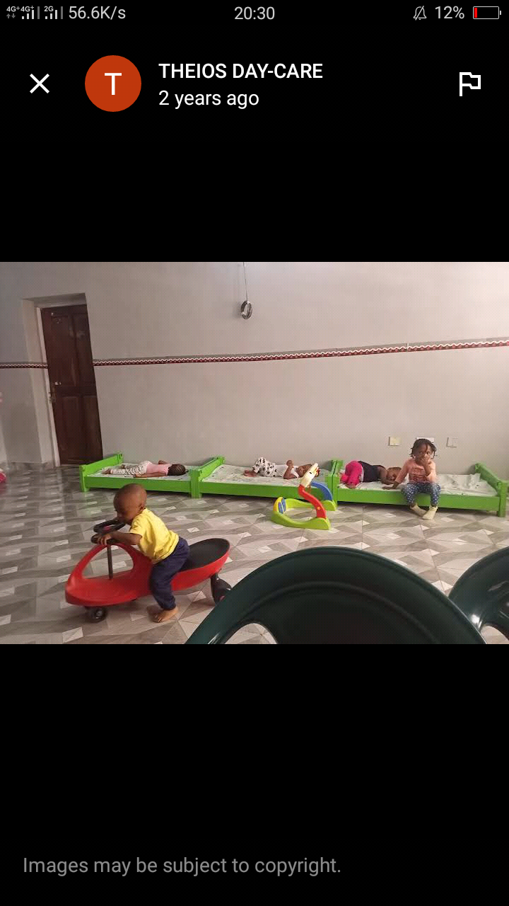
PLATES 3. 6: SHOWING INTERNAL VIEW OF CASE STUDY THREE

CASE STUDY FOUR (ONLINE CASE STUDY)
NAME: MUM WAITIND DAYS
LOCATION: TEXAXZ U.S.A

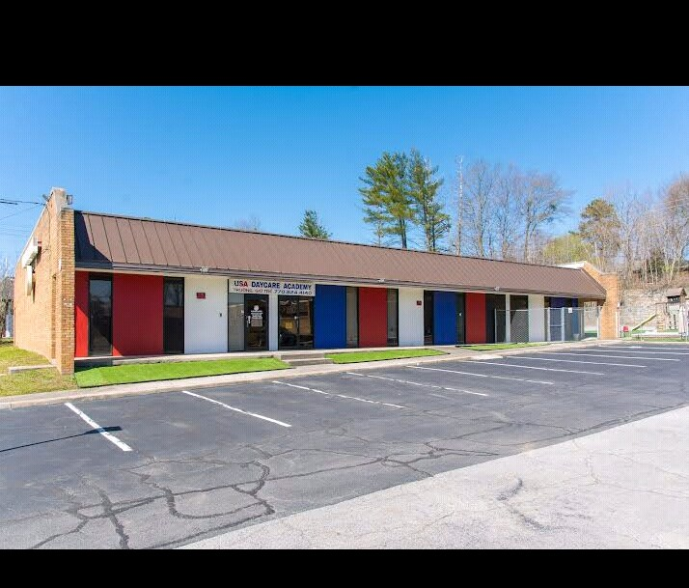
PLATES 3.7: SHOWING VIEW OF ONLINE CASE STUDY
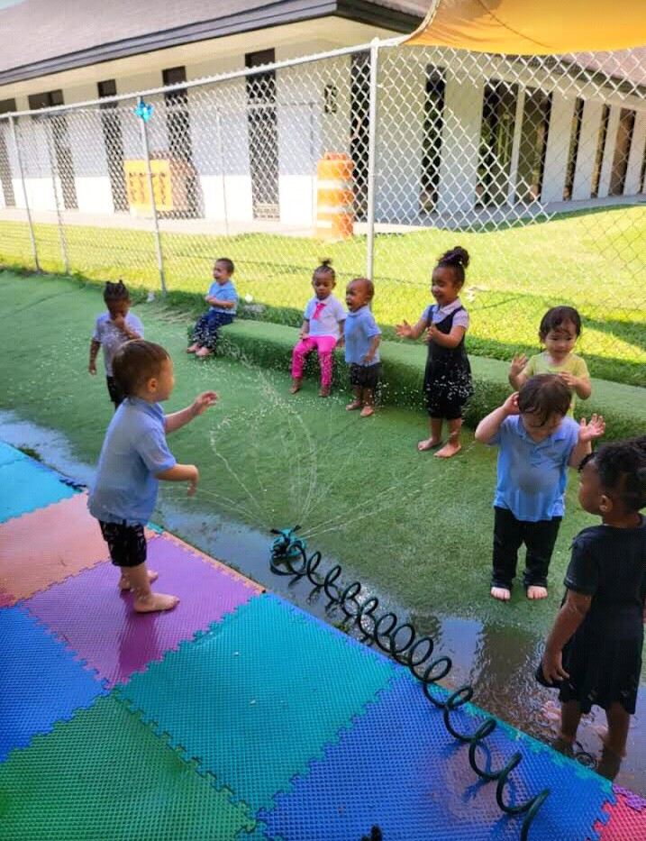
PLATES 3.8: INTERNAL VIEW ONLINE CASE STUDY

CHAPTER FOUR
4.0 PROJECT LOCATIONAL AREA
4.1 BRIEF HISTORY OF KWARA STATE
Kwara state come into existence in 1967 when the country was divided into twelve states by the federal military government of Nigeria (Decree 14), it was then called west central state and later changed to kwara state. It shares common boundaries with niger, oyo, osun, ondo, kogi, and benin republic. Kwara state ranks among five largest with total area about 75,000smm that is eight percent area of Nigeria. The area is generally sparsely populated with population of about 1.7milllion in 1983 but presently to be 2.5million. the state is blessed with some natural features, which serve as tourist attraction in the state and nationwide, which including the owu falls, sobi hills, esie museum etc. The eastern of the state is hill and valley, scenery, vegetation is largely the typical guinea savannah consistency of full-interspersed grasses with trees. The state also comprises of it local government areas with their respective local government headquarters .Avoid pollution by harmful smokes, fumes, and boots. Ease of access: there should be ease of access to and from site to allow for smooth traffic flow. There should be adequate space for future expansion. Sufficient and adequate space for parking Compatible with current and probable future zoning regulations Close to parks museum, museums, and other community services Favorable orientation to wind and natural light Size of site, possibility for expansion, suitability and availability. Commercial potential of surrounding area Land-use compliance Visual and aesthetical potential Proximity to national landmark.
UTILITY SERVICE
Availability of electricity, drainage, sewer feasibility of bringing utilities to site at reasonable cost restrictions on right of way.
4.1.1 HISTORY OF PROJECT TOWN (ILORIN)
Ilorin is the capital city of kwara state and it is believed to be the sixth of the first ten largest cities in Nigeria, Ilorin is located in the southern part of kwara state in latitude 8.26N and longitude 4E and 2E of Nigeria. It is about 300km away from Abuja (the federal capital city by road) it has a north-south rail line linking it to various part of the country apart from the numerous road networks. Ilorin is also provided with airstrip, which has facilities for standard international airport and a standard 5star hotel.
4.2 SITE LOCATION / DESCRIPTION
THE SITE FOR THE PROPOSED DAYCARE FOR OKC INTERNATIONAL NURSERY AND PRIMARY SCHOOL, ALONG AJASE-IPO ROAD, BEHINDE WINNER CHARPEL ILORIN SOUTH L.G.A KWARA STATE.
4.3 SITE SELECTION CRITERIA
Site selection is the consideration of certain factors which influence the development of the state. Before the execution of any project, the following factor are to be considered for selection of site.
Accessibility
Zoning
Availability of infrastructure etc.
The site selection was based on the following, these include;
Location: the choice of location should be in relation to the following.
Zoning: the site should be within an area reserved for institutional facilities and public utilities. It should be free from industrial zones.
4.4 SITE ANALYSIS/ INVENTORY
This is done on the basic of the purpose for which the site is to serve.
Certain steps are considered to obtain vital information of the site; this information is then analyzed after in details for design purpose, the information includes soil condition, geology, topography, vegetation etc.
It also involves carrying out a preliminary survey of the site.
Soil condition: the type of soil on the site is loamy and hence aids good vegetation of trees, shrubs and grasses etc.
Geology: the soil has a very sound load bearing capacity and hence strip foundation will be used for the structure to be erected on the site.
Vegetation cover: the site is covered with shrubs, trees and grass which covers the ground. Which most of it will be retained for landscape.
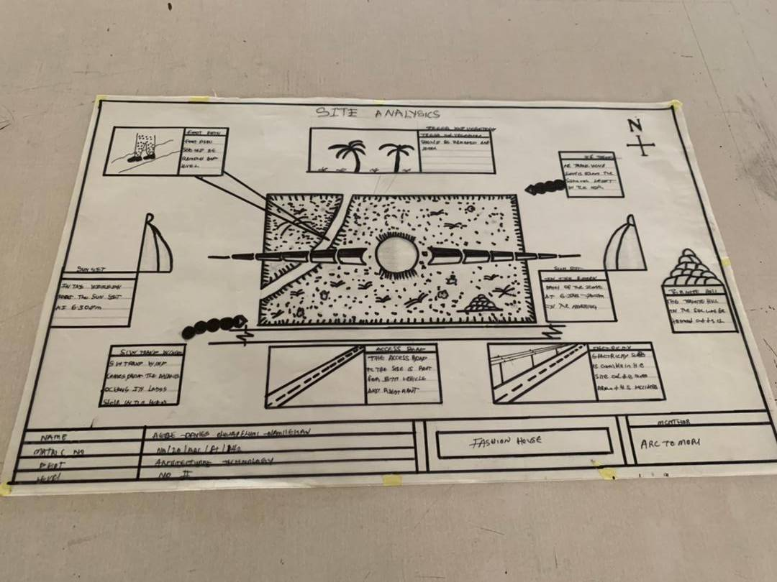
Topography: this is the layout of the site; the site gently slopes toward west

4.5.1 Climatic Data
The environmental and climatic conditions of the project site are analyzed to further understand the factors that will guide the achievement of a functional design.

Such factors are;
Climatic Data of Ilorin
Ilorin falls under the climatic region referred to as guinea savannah and in the middle belt of the country. The monthly average temperature is quite uniform, having February and march as the hottest months, recording a higher average of about 45⁰c (about 85⁰f) July and august are the coolest (lowest monthly average temperature of 76⁰f) the town is under relative humidity figure of about 80% average.
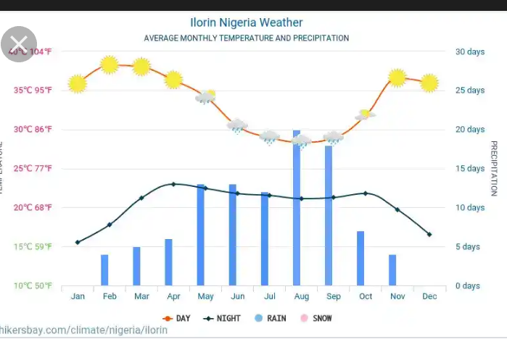

Figure3.2. Average monthly temperature
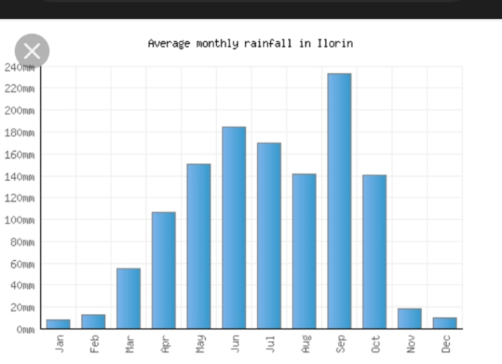
4.5.2 TEMPERATURE
The monthly temperature in Ilorin ranges between 12⁰c to 24⁰c, the annual range of temperature of the city is 18⁰c meanwhile the city experience it’s highest temperature between april and October every year. The southwest trade wind which carries moisture blows within april and October every year while the northeast trade wind which is dry and carries harmatan blows within February and march and April every year. The south west trade wind which carries moisture blows within October, November and January.
4.5.3 DAYLIGHT
The light is adequately and moderate in Ilorin throughout the year. The daylight is between the hours of 7.0 and 18.0GMT.
4.5.4 RELATIVE HUMIDITY
The importance of temperature influences that actual amount of water vapor present in air and this decide the moisture and carrying capacity of the air. It decides the rate
of evaporation and condensation and also affect the nature and type of cloud formation and precipitation as relative humidity is directly related to the temperature of the air, the highest humidity in the state is therefore experienced in the month of April.
WIND DIRECTION: the north-east trade wind blows undesirable cold wind, it is dry, dusty and bring harmattan which is prevalent between the month of march and November.
VEGETATION: Ilorin is in the guinea region of the country. The amount of rainfall that is normally experienced between February and November result into this type of vegetation cover over the area of the site. The thick forest characterized by hard and soft timber with layers of vegetation covers or the low grass covers. The medium highest trees and trees at the highest level of the ground. The vegetation cover is identified with two shapes, the umbrella shapes and conical shape sharing both properties of the vegetation in forest and the region.
SOLAR PATH DIRECTIO: The sunrise from the east and set in the west, the high intensity of the sun normally experienced at this period the shading devices through the conservation and presentations of the existing natural featuring will surely reduce and combat the effect of this heat emission and transmission at the centre.
4.6 DESIGN CRITERIA In this type of design there is need for proper research using both the local (existing similar structure in the same country) and international structure as a case studies to inculcate the new ideas into the design in order to have a well functional conforming and unique structure that suit the international tastes. Some of the criteria are: Accommodation Analysis: I make provision for at least average number of people to be accommodated from two of my cases studies. Source of supply: in this project design the structure is largely make use of artificial source of lightening and ventilations therefore there should be a provision for a standby source of electricity. Landscaping: the environment must be warmth landscaped for both the visitors and the occupant to feel amused within the environment. Shrubs used for landscape include. Functionality of the units; all the units should be well functional so as to make every activities to be ease i.e provision of internet facilities within the structure and a control office within the building also.
4.7 BRIEF ANALYSIS
In this type of project, it can be seen that some building are accompany by sub-units which are required in this project and these units form the design scope of this project which are listed below:
ENTRANCE
RECEPTION HALL
CAD ROOM
Director office
LABORATORY OFFFICE
CONSULTANT
PHAMACY
PHAMACY STORE
SURGRY ROOM
RECOVERY ROOM
CHIFE DENTAL OFFICE
STRERILAZATION ROOM
KITCHEN
DENTAL OFFICE
NURSE STATION
METROL OFFICE
EXIT
ACHIVE/ STORE

4.8 BUBBLE DIAGRAM
This is to show the problem that is on ground to solve by mentioning all the design brief that present in the proposed design are low all these can be related.
4.9 CONCEPTUAL DEVELOPMENT (SITE AND BUILDING)
The design concept of this project is based on the principle of FORM follows FUNCTION where the basic design is gotten through the use of bubble and functional relation diagram.
4.10 SITE CONCEPT
The site design was achieved by taking into considerations some environmental and physical features. They are orientation, circulation and zoning. Orientation: the building is oriented in such a way that as much as possible direct sunlight is prevented from entering the building. Circulation: the site is distinguished in such a way that allows for easy accessibility and circulation of pedestrian and vehicles. zoning: zoning of required functional spaces is done with respect to their various

CHAPTER FIVE
5.0 APPROACH TO THE DESIGN/DESIGN REALIZATION
5.1 PROJECT APPRAISAL
The smooth operation of the proposed DENTAL CLINIC would depend largely on the availability of services such as lightning (mostly artificial), ventilation (mostly natural), electricity services plumbing and water services, fire services and drainage etc.
5.1.1 CONSTRUCTION METHODOLOGY AND MATERIAL
In construction of building, the skill and workmanship dose not only brings out the beauty but until the when specification detail of materials and construction method which had been adopted in this project are skillfully built are as followed.
5.2 SITE CLEARANCE
Trees in all the area where building is to cover would be cut down and carried away from the site in order to get the organic matter, and the top soil is also removed to a depth of 150mmm Both the clearing of the site can either be done manually or with the use of machine i.e bulldozer or grader.
5.3 FOUNDATION
In these project two type of foundation will be use which are strip and pad foundation. the strip which is the continue spread of concrete shall be use for the load bearing wall and the thickness shall be the same size as the block wall, and the spread will be three times side of the wall, the pad will be use and footing for all the base and also retaining wall of 30mm thick are adopted in some case like rakings in the main conference and will be reinforced.
5.4 STRUCTURAL SYSTEM
This is a horizontal surface design and constructed to accommodate and serve the purpose of supporting people furniture and equipment in the building.
5.5 FLOOR
The thickness for the floor slab will be 150mm in the floor, except the generator house which has 300mm thick for generator stand. the following finishing will be use for the project. P.V.C Floor tiles- these are floor tiles made from thermal-plastic binder (vily
CERAMIC FLOOR TILES: patterned glazed ceramic floor tiles of brown color will be use for the entire toilet and bath.
ACOUSTIC CARPET UNDERLAY: sundown acoustic carpet underlay is a composite material using sundown tuff-mass as a barrier in weight of 1 to 2b and acoustic foam decouple. there is an option for a soft or firm acoustic foam layer that provide a comfortable feel. sundown carpet reduces noise radiating from carpet surface. It may be used alone or to supplement installation applied in spaces sundown carpet underlay is manufactured in 54’ with ¼ and ½ thickness.
5.6 WALLS
These are vertical continuous solid structure which is usually made by brick, stone. concretes, metals etc to serve the purpose of which it is desired. the walls would be a load bearing or non-load bearing walls. all the walls in the building are 225mm wall and it has been supported by columns a beams running vertically and horizontally for structural rigidity. The walls of the main conference hall are slanted 10⁰ to the floor slab, they are made up of columns at 5.5m interval with a precast reinforced concrete blind of 5500x450x50mm thick arranged in a louver pattern, overlapped by 50mm to each other. all other meeting hall wall is cladded with marble tiles because of its sound absorbent characteristics and of its aesthetics value, except the toilet which shall be tiled white and patterned grazed ceramic tile to door height. The wall finishes for the building interior is marble honeycomb panels wall material as sound insulator within the various unit in the building.

5.7 ROOF
Roofs in building construction are constructed in order to protect the building from all the weather condition and the materials varies according to the materials available e.g steel roof or timber roof. steel roof used in this project as a result of large span and is been covered with asbestos roofing sheet with a pitched roof and hipped roof are adopted.
5.8 STEEL
This is metal which is made of alloy of carbon and iron having a very strength in both tension and compression but it is a very stiff material. steel possess the capacity undergoing a consideration strain after the elastic limit before it fall. steel has the ability to carry dead/imposed load with its limit. it is used in the building construction industry for reinforcement of concrete, windows, and door frame, floor slab etc. it is a very versatile construction material.
5.9 CEILING
The material use for the project is an acoustic ceiling tile to reduce noise from the roof. the vacuum between the roof and the ceiling should be filled with rock wool material.
5.10 DOOR
These are solid barrier fixed at opening to serve the purpose of gaining and denying access into building and it can be used as security as well as fire barriers which had been adopted for use in the project.
5.11 STANDARD DOUBLE LEAVE SINGLE SWING GLAZED ALUMINIUM DOOR- This are door, which will serve the main entrance into the building this is composed of aluminum frame and glasses glazed.
PURPOSE NADE METAL DOOR -These types of door are provided in three-bed type for proper ventilation and lightening. necessary place that is required.
FIRE CHECKED PURPOSE MADE DOOR – These type of door will be use in all the door ways in the building like the kitchen, conveniences these is necessary because there is the need to control the spreads of fire in the building.
ALUMINIUM
This is another material that is used in building construction industry and it is made up of alloyed mixed with other element to made a suitable structural material. they are usually corrosion resistance and very light compared to the weight of the steel and highly resistance to corrosion and it is used in the building construction for roofing sheet, partitioning frames, windows frames etc.
TIMBER
Timber is one of the earliest forms of concrete and other material and it is light in weight . it is sometimes used for structural aspect of the building having weight one sixteenth that of steel. timber is a very versatile material and can be used in conjunction with other materials such as steel without any issue arising. it can also be use for constructing room carcass, roof trusses, floor finishes, ceiling finishes, skirting and other building materials.
GLASS
These is another material used in the heating of soda line and sand to a temperature of which they melt and fuse to the stage it can be draw cast rolled on bed of molten tin to be flat glass. Glass can either be transparent or translucent and they come in different ways and types.
CLEAR SHEET GLASS: This type of glass is usually transparent and has varying thickness and may cause optical distortion.
Wired Glass: This type of glass wire is usually embedded into it, it is glazing because the wire holds the glass together so as to reduce the danger of its breakage.
DOUBLE GAZING UNITS: This type of glass can either be transparent or translucent but usually very thick and comprises of float glass spaced apart and sealed around a dehydrated method which had been adopted in the project and are skillfully built.
TOUGHENED GLASS: This type of glass can either be transparent or translucent but usually very thick it can be broken into fragments and comparatively harmless pieces, it is usually used for doors and softly screens.
PATTERN GLASS: This type of glass is translucent because of the pattern or the texture of the glass. it could also be timed or plane.
WINDOW
These are openings found on walls and also on roofs so that day light can pass through, some transparent materials can also be used to allow passage of light and ventilation into the building. The following are the types of windows to be used in the projects.
Aluminum pivoted windows(tinted): this type of window will be used in the guest house and restaurant.
Aluminum pivoted window(plane): this type of window will be used in all other units.
5.12 SERVICES
5.13 VENTILATION
The major source of ventilation is a system of natural ventilation, which is centrally controlled. Efforts were made to ensure cross ventilation principle in the design, while the other source of ventilation is the artificial ventilation provided in the form of CENTRAL AIR CONDITIONING SYSTEM (AC) The various components are ventilated by ducts that are linked to the source of the ventilation.
5.14 PLUMBERING SERVICES
All the water is to be supplied and distributed to other areas through 50mm diameter 100mm and 150mm diameter. All the bath and showers tray and towel trays, while all the toilets will be provided with tissue rolls holder, man holes, septic tanks and soak away pits shall be placed in suitable location for easy maintenance.
LIGHTNING
Lightning is very important for accuracy, safety and productivity, for this proposal the use of natural lightning provided for by the use of windows on the surrounding walls, the natural light is complemented with artificial lights provided by means of varieties of light fittings.
FIRE SERVICES
In the electrical panel room, a fire control unit box is provided to serve each building on site and each building has its own electrical panel room which has/smoke detector which alert the people if there is outbreak of fire in any part of the building before damage is done to other part of the building. carbon oxide gas are positioned and strategic locations in the building.
DRAINAGE
The surface water are channeled into 600mm wide and 600mm deep covered drains with inspection chamber at strategic points and emptied into the main municipal city drain. separate drain system has been employed to drain of foul water from the water closets, surface water and pave areas.
5.15 SECURITY SERVICE
The entry and exits into the site have been fitted with cctv cameras, this is to monitor the movement of vehicles in and out of the site. The entrances will also be maintained with security men checking incoming and outgoing vehicles.
ELECTRICAL SERVICES
The power holding company of Nigeria (PHCN) mean which pass across the site shall be the major source of power supply into the building but an alternative source will however be provided which s generator and effective 3 phase line will be used and the connection will be armored cables while the internal distributions/connections would be conduit conduct piping.
5.16 SUMMARY
Day care is a vital service that provides care and supervision for children when their parents or guardians are not available, offering a safe, nurturing, and stimulating environment that promotes physical, emotional, and cognitive development. By providing early childhood education and care, day care centers and providers play a crucial role in supporting the growth and development of young children, helping them develop social, emotional, and cognitive skills that are essential for future success. Day care also enables parents to balance work and family responsibilities, promoting economic stability and reducing stress, while providing opportunities for children to interact with peers and develop important social skills. High-quality day care is characterized by trained and experienced staff, a safe and healthy environment, and engaging and stimulating activities that promote learning and development. Despite the benefits of day care, there are challenges to be addressed, including ensuring accessibility and affordability for all families, maintaining high standards of care, and meeting the diverse needs of children and families. Overall, day care is an essential service that supports the well-being and development of young children and their families, and its importance cannot be overstated. By investing in high-quality day care, we can promote positive outcomes for children, support working families, and contribute to the social and economic development of our communities. Furthermore, day care centers and providers must be equipped to meet the unique needs of children with special needs or from diverse cultural backgrounds, and to provide care that is tailored to the individual needs of each child. By doing so, we can ensure that all children have the opportunity to thrive and reach their full potential. Additionally, policymakers and stakeholders must work together to develop and implement policies that support the development of high-quality day care, including providing funding and resources for day care centers and providers, and promoting public awareness of the importance of early childhood education and care. By prioritizing day care and early childhood education, we can build a stronger, more supportive, and more equitable society for all.
5.17 RECOMMENDATION
To improve the quality and accessibility of day care, it is recommended that policymakers and stakeholders prioritize increasing funding for day care programs, providing subsidies and grants to families who need financial assistance, and expanding eligibility criteria to include more families. Additionally, day care providers should focus on enhancing the quality of care by providing ongoing training and professional development opportunities for staff, maintaining optimal staff-to-child ratios, and developing and implementing high-quality curricula that promote cognitive, social, and emotional development. Furthermore, day care providers should strive to support diverse needs by providing culturally responsive care, offering support and resources for children with special needs, and providing flexible care options to meet the diverse needs of families. By taking these steps, we can promote positive outcomes for children and families, support working parents, and contribute to the social and economic development of our communities. Moreover, regular communication between parents and providers, parent involvement in day care programs, and feedback mechanisms can help ensure that children's needs are met and that parents are satisfied with the care provided. By prioritizing day care and working together to address the challenges and opportunities in this field, we can build a stronger, more supportive, and more equitable society for all.

5.18 CONCLUSIONS
In conclusion, day care plays a vital role in supporting working parents and promoting the development of young children. By providing a safe, nurturing, and stimulating environment, day care centers and providers help children develop social, emotional, and cognitive skills that are essential for future success. To ensure that day care is accessible and effective, it is essential to prioritize quality, affordability, and accessibility. This can be achieved by increasing funding, providing subsidies and grants, and expanding eligibility criteria. Additionally, day care providers should focus on enhancing the quality of care by providing ongoing training and professional development opportunities for staff, maintaining optimal staff-to-child ratios, and developing and implementing high-quality curricula. By working together to address the challenges and opportunities in the field of day care, we can promote positive outcomes for children and families, support working parents, and contribute to the social and economic development of our communities. Ultimately, investing in high-quality day care is crucial for building a stronger, more supportive, and more equitable society for all. By prioritizing day care and early childhood education, we can help children thrive and reach their full potential, and create a brighter future for generations to come.

5.19 REFERENCES
1 Blackmore, J., Bateman, D., Loughlin, J., O'Mara, J., & Snyder, I. (2011). Innovative learning environments: A review of the literature. Melbourne: Australian Institute for Teaching and School Leadership.
2 Gao, F., Zhang, J., & Wang, Y. (2013). Exploring the impact of interactive whiteboards on teaching and learning. Journal of Educational Technology Development and Exchange, 5(1), 1-22.
3 Higgins, S., Hall, E., Wall, K., Woolner, P., & McCaughey, C. (2005). The impact of school environments on student outcomes. London: EPPI-Centre, Social Science Research Unit, Institute of Education, University of London.
4 Kaplan, S. (1995). The restorative benefits of nature: Toward an integrative framework. Journal of Environmental Psychology, 15(3), 169-182.
5 Knezek, G., Christensen, R., & Tyler-Wood, T. (2013). The impact of technology on student learning outcomes. Journal of Educational Computing Research, 48(2), 147-164.
6 Kullmann, S. (2013). Sustainable school design: A review of the literature. Journal of Green Building, 8(2), 137-155.
7 Myerson, J., Bichard, J., & Erlich, A. (2013). The impact of classroom design on student learning. Journal of Educational Research, 106(4), 281-293.

LIST OF APPENDIX

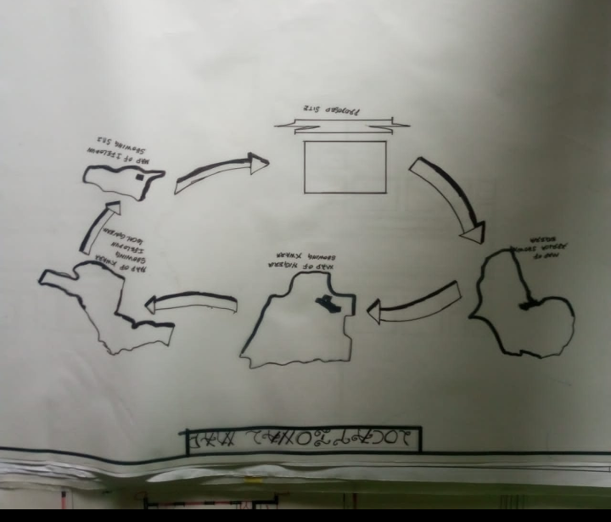
APPENDIX 1. SHOWING LOCATIONAL MAP
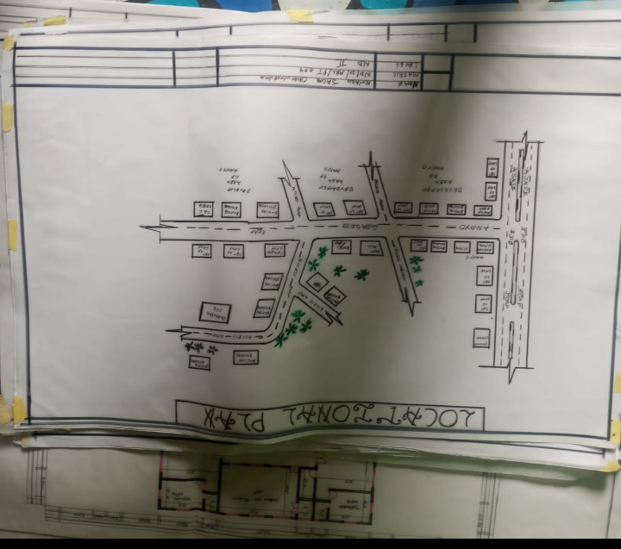
APPENDIX 2. SHOWING LOCATIONAL PLAN

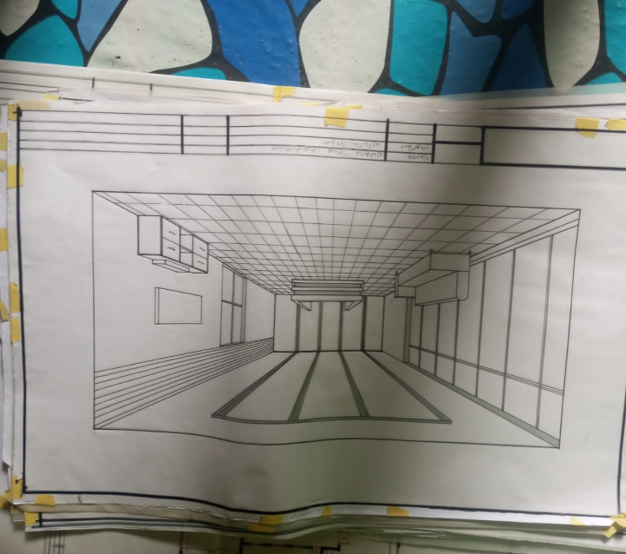
APPENDIX 3. SHOWING INTERNAL PASPECTIVE

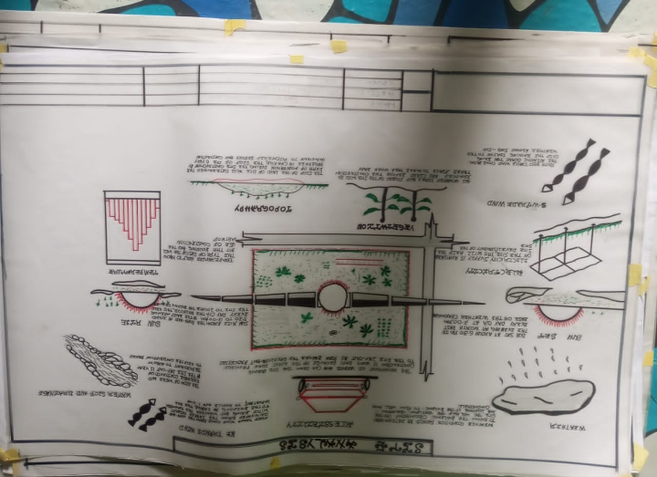
APPENDIX 4. SHOWING SITE ANALYSIS

