PETROGRAPHICAL AND GEOCHEMICAL STUDIES OF LEPIDOLITE
IN KAKAFU, PATIGI LGEA, KWARA STATE, NIGERIA)

BY
OSHO, OLUWADAMILOLA MICHEAL
HND/23/MNE/FT/043

SUBMITTED TO
THE DEPARTMENT OF MINERALS AND PETROLEUM RESOURCES ENGINEERING TECHNOLOGY, INSTITUTE OF TECHNOLOGY, KWARA STATE POLYTECHNIC, ILORIN.

IN PARTIAL FULFILLMENT OF THE REQUIREMENT FOR THE AWARD OF HIGHER NATIONAL DIPLOMA (HND) IN MINING ENGINEERING TECHNOLOGY

AUGUST, 2025

CERTIFICATION
This is to certify that this project was carried out and submitted by OSHO OLUWADAMILOLA MICHEAL of matric number HND/23/MNE/FT/043 to the department of Minerals and Petroleum Resources Engineering Technology, Kwara State Polytechnic, Ilorin in partial fulfillment of the requirement for the award of Higher National Diploma (HND) in Mining Engineering.

……...……………………………………… ………………………………
Mr. Usman, I.S Date
(Supervisor)

……...……………………………………… ………………………………
Dr. Olatunji, J.A Date
(Head of Department)

……...……………………………………… ………………………………
Engr. Dr. Oluwaseyi, A. O Date
(External Examiner)

……...……………………………………… ………………………………
Engr. Jimba, J. J Date
(External Examiner)

DEDICATION
This work is dedicated the Supreme Being and my Dad, Mum and my siblings.

ACKNOWLEDGEMENTS
My heartfelt gratitude goes to the Almighty God for given life and success on the completion of my programme. The most gratitude goes to my family for their unwavering support and encouragement throughout this project write up.
My special thank goes to Mr. and Mrs. Osho, Ademola, Babajide, Agboola and my aunt Aderonke Amechi for their love and guidiance towards this programme. My special thank also to my supervisor Mr Usman, I.S for his close and constructive accessing this project. Also, I appreciate the entire staff of Minerals and Petroleum resources Engineering Technology Department.
I therefore appreciate Ogundele Gabriel and Olatunji Opeyemi for their coordination and understanding during this project write up may the glory of almighty continue to bless you more.

TABLE OF CONTENTS
Cover page i
Certification ii
Dedication iii
Acknowledgements iv
Table of Contents v
List of Tables vi
List of Figures vii
Abstract viii
Chapter one
- Introduction 1
1.1 Scope of the project 2
1.2 Aim and Objectives 2
1.3 Statement Problem 3
1.4 Justification 3
Chapter two
2.0 Literature review 4
2.1 Geology of the study area 4
2.2 Occurrence of Lepidolite 7
2.3 Characteristic of Lepidolite 7
2.4 Lithium Ore 8
2.5 Application of Lithium 11
Chapter three
3.0 Materials and Methods 12
3.1 Materials 12
3.2 Methods 13
3.3 Description of study area 13
3.4 Sample collection 15
3.5 Sample preparation 15
3.5.1 Atomic Absorption Spectrometry (AAS) 16
3.5.2 Petrographical (Thin Section) analysis 17
Chapter four
4.0 Result presentation and discussions 19
4.1 Atomic Absorption Spectrometry (AAS) results 19
4.2 Petrographical (Thin sections) analysis results 19
4.3 Discussions of the result 25
Chapter five
5.0 Conclusion and recommendations 26
5.1 Conclusions 26
5.2 Recommendations 26
References 27
Appendix 28

LIST OF TABLE

Table 1: Selected Lithium ores and their formula 7
Table 2: Selected major oxides and their average percentage composition 19
Table 3:Estimated modal composition of Lepidolite in the study samples photograph 24

LIST OF FIGURE
Figure 1; Geological Map of Nigeria showing the study area 5
Figure 2: Arrangement of SiO₄ tetrahedra as found in common rock-forming silicate, emphasizing the lithium minerals in each group. 6
Figure 3.1: Photograph of a digital GPS machine 13
Figure 3.2: Photograph of a Geological hammer 13
Figure 3.3a: Nigeria map (Kwara State) showing study area 15
Figure 3.3b: Photograph of a sample in the study area 15
Figure 3.5: Photograph of ICE 3000 series AAS machine 17
Figure 3.6a: Photograph of 600 grit carborundum grinding machine 18
Figure 3.6b: Photograph of Petrographical Microscope 18
Figure 4.2: Photograph of hand specimen of lepidolite on site 21
Figure 4.3: Photomicrograph of sample D under plane polarizing light 22
Figure 4.4: Photomicrograph of sample D under cross polarizing light 23
Figure 4.5: Photomicrograph of sample E under plane polarizing light 23
Figure 4.6: Photomicrograph of sampe E under cross polarizing light 23
Figure 4.7: Pie chart representation of modal composition of sample D 24
Figure 4.8: Pie chart representation of modal composition of sample E 24

ABSTRACT
The petrographic, and geochemical investigations of the pegmatites (Lepidolite) of Kacafu community, Patigi, North Central Nigeria was carried out with the aim of understanding its mineralization potential. Five samples were collected from different location and they were subjected to petrographic studies which was carried out at department of Geology and Mineral Science Laboratory, University of Ilorin, Kwara State , while the geochemical analysis was carried out using Atomic Absorption Spectrometry (AAS))techniques in the Nigerian Geological Survey Agency(NGSA) Laboratory Kaduna, Nigeria. Identified in the area consist of major mineral quartz, mica feldspar and lepidolite, with percentages of quartz range from 27-30%, mica with 3-55%, feldspar has range from 15-20% and the accessory mineral consist of lepidolite with 50% revealed from petrographic studies. The atomic absorption spectrometry result shows the major oxides with SiO2 (68.43-76.36%), Al2O3 is high ranges between 15.33-16.45%, Fe2O3 low varies between 0.77-1.73%, MgO is low range from 0.0-1.98%, CaO has value ranges from 0.0-3.10%, Na2O is low ranging from 0.30-1.20%, K2O ranges from 0.01-4.00%, TiO₂ is varies between 0.0-1.73%, MnO varies from 0.06-0.60% and Li₂O has value ranging from 0.15-0.94%, while the LOI ranges from 2.80-5.20% respectively. The sample results show that they contain minimum required percentages of lithium needed for batteries production when compared with production requirement.

CHAPTER ONE
1.0 Introduction
Lithium in the modern day technology is a critical element, and its minerals are playing a key role in the lithium-ion batteries. Lithium deposits are limited on the Earth in a surprising diversity of mineral species, from pyroxenes to amphiboles, phyllosilicates to phosphates (kent, 2021). Lithium is a soft, silvery-white to grey alkaline metal with a metallic lustre when fresh and tarnishes to dull silver grey and then black when in air. Lithium is the third element on the periodic table and has numerous physical and chemical properties. It is the lightest of the alkaline metal with an atomic weight of 6.939 and atomic radius of 1.33 Å. Its density is about half of the water density and can float on water even at the point of reaction (Christie and Brathwaite, 2008). The demand for lithium minerals has increased considerably in recent years due to the application of lithium compounds in lithium-ion battery technology, portable electronic gadgets and power storage systems (Feng et al., 1995; Swain, 2017; Tran and Luong, 2015). Lepidolite is a lilac-grey or rose-colored member of mica group of minerals; it is the most abundant lithium-bearing mineral and a secondary source of this metal. It is the major source of alkali metal rubidium. Lepidolite is rare lithium-rich mica mineral that is usually purple, red or pink in color. Lepidolite is relatively rare mineral found in pegmatites together with another mineral, spodumene, and quartz, albite, microcline, and muscovite (Klein and Anthony 2013). Lepidolite occurs almost exclusively in complex lithium-bearing pegmatites but has also been recorded as a component of a few granites, (John 2012).

1.2 Aim and Objectives
The aim of this project work is to determine the chemical constituent using Atomic Absorption Spectrometry and Petrographical study of lepidolite deposit for its suitability in baterires production industries. The objectives include;
- to determine the chemical compositions of the lepidolite using atomic absorption spectrometry (AAS)
- to carry out petrographical study using thin section by observing the Lepidolite under the plane polarized light (PPL) and Cross polarized light (XPL)
1.3 Scope of the study
The study is limited to three samples from three different location on lepidolite deposit from kacafu, Patigi Local Government, Kwara State to be subjected to Petrographical analysis and Atomic Absorption Spectrometry (AAS) analyses.
1.4 Problem Statement
Lithium deposit is limited and the demand Lithium for lithium ion batteries productions required constant supply of lithium ore as primary raw materials.
1.5 Justification
The demand for lithium ore in the Lithium ion batteries industries cannot be overlook therefore; the project will provide more information on the lepidolite deposit in the study area.

CHAPTER TWO
2.0 Literature review
Lithium containing minerals known is over a hundred, but only a few are currently economically significant (spodumene, lepidolite, petalite, hectorite, zinnwaldite, amblygonite, jadarite, and a few others) (Bradley et al. 2017; Kavanagh et al. 2018). In the Earth’s crust (17-20ppm), magmatic rocks (28-30 ppm) while in sedimentary rocks (53-60 ppm) were estimated on the average of Lithium content (Evans, 2014; Kunasz 2006).Accorging to Gerside, (2022) the sudden rise in lithium production from 28,100 metric tons in 2010 to 100,000 metric tons in 2021 was attributed to the increased in lithium ion battery demand for electric vehicles and suggested that thet global lithium demand will increase to about 2 million metric tons by 2030. The Zimbabwe Lithium deposit of Bikita pegmatite is one of the world’s largest lithium deposits with an estimated reserve of 30,000 tons of 4.2% Li2O and besides lithium has yielded Be, Cs, Sn, Ta, Nb and feldspars (Evans and Pisarevsky, 2008).
2.1 Geology of the study area
The study area is made up of the Pre-Cambrian basement complex rocks partly cretaceous recent sediment of Bida basin. The cretaceous recent sediments of Bida basin occupy the northern half of the studied area and are composed of recent alluvium which cover banks of the tributaries and 8 flood plains of Niger River sedimentary rocks Nupe sandstone. Basement complex rock units occupying the southern half of the area composing of granites, gneisses and metamorphic rocks into which area are in folded upper Proterozoic supra-crust low grade metasedimentary and metavolcanic rock. These are rocks of migatite gneiss complex schist, amphibolite, biotite and granitic- gneisses, granite and pegmatite (Garba et al., 2019).
The pegmatite of Kacafu pegmatite field forms a prominent topographic features (patikiesan hill) and intrudes amphibolite, schists and gneisses as shown in the geologic map of study area. This pegmatite is extensively kaolinized layer that could reach <4m. Field observation suggests the pegmatite are complex type with well-developed zoning. The intermediate zone composed of k-feldspar and occasional mineralization of wolframite were observed. Microlite + tantalite and + beryl, + tourmaline is the more noticeable mineral in the altered outer core zone with the mineralogy containing quartz + muscovite + lepidolite + plagioclase (albite). The core zone of pegmatite body was mineralogy containing mainly quartz + tourmaline + rubellite. It has an approximate strike direction of 60º, detailed observation mapping of the internal zonings of the pegmatite could not be made due to weathering Lithium mica is prominent here and is mostly found as relies on the weathered profile and also associated with the kaolinized layer. Mineralization is sometimes found associated with weathered kaolinized material rich in lepidolite which are occasionally preserved due to their high resistance to weathering.

Figure 1: Geological Map of Nigeria showing the study area (After Okunlola, 2005)

2.3 Lepidolite Mineralization
Lepidolite as a Lithium minerals, can be found in nature combined with other elements in a variety of minerals (Table 1). The common rock-forming minerals, being in the form of polymerized SiO₄₄− groups: rings, chains, bands and sheets (Fig. 2), which are held together by interstitial lithium and aluminium ions. Therefore,, enstatite is a form of pyroxene and has the formula MgSiO₃ (= Mg₂Si₂O₆), while spodumene has Li⁺ + Al³⁺ in place of the 2Mg²⁺ (LiAlSi₂O₆).
Some lithium minerals are phosphates. Lithiophyllite and triphyllite are end-members of a solid solution series, that is, there is a continuous change of composition between them. Several lithium minerals are prized as gemstones: spodumene, amblygonite, petalite and elbaite—a member of the tourmaline group. Amblygonite and petalite only occur rarely in gem quality and they are both relatively soft (5.5–6 and 6–6.5, respectively).

Table 1: Selected Lithium Ores and their formula
Mineral | Formula
Spodumene | LiAl Si₂O₆
Holmquistite | Li₂(Mg,Fe)₃Al₂Si₈O₂₂(OH)₂
Lepidolite | K(Li,Al)₃(Si,Al)₄O₁₀(F,OH)₂
Polylithionite | KLi₂AlSi₄O₁₀(F,OH)₂
Zinnwaldite | –
Hectorite | Na_{0.3}(Mg,Li)₃Si₄O₁₀(OH)₂
Cookeite | (LiAl₂)Al₂(AlSi₃O₁₀)(OH)₈
Petalite | LiAlSi₄O₁₀
Eucryptite | Li(AlSiO₄)
Amblygonite | (LiNa)Al(PO₄)(F,OH)
Lithiophyllite | LiMn(PO₄)
Triphyllite | LiFe(PO₄)
Elbaite | Na(Li_{1.5}Al_{1.5})Al₆Si₆O₁₈(BO₃)₃(OH)₄
Jadarite | NaSiB₃O₇OH

Figure 2: Arrangements of SiO₄ tetrahedra as found in common rock-forming silicates, emphasizing the lithium mineral in each group. These units are held together by other cations: Fe²⁺, Mg²⁺, Al³⁺ or in this case Li⁺.

2.4 Properties of Lepidolite
Lepidolite is characterized as an uncommon form of mica that is found in pegmatite with properties such as coloureless, grey/white, lilac, yellow coloration, vitreous to pearly luster, hardness range from 2.5-3 on Moh scale. It has density of 2.8-3kgm3 with lamella cleavages. In its elemental form, litium other than alkali metals it react easily with water and potentially explosive. It also react with oxygen and be inflammable when exposed to air. Naturally Lithium occurred in compound which is non-flammable. It is most electronegative metal with low resistivity and excellent electrical conductivity which is the ideal properties Lithium is use in batteries production.

2.5 Ores of Lithium
Ore of lithium or Lithium ore are naturally occurring minerals deposited in traces within pegmatite, brine or clay minerals that containing lithium. A common lithium ores includes; spodumene, lepidolite, petalite, amblygonite and etc

2.5.1 Spodumune
Spodumene as Lithium ores is the most abundant lithium-bearing minerals with high lithium percentage and found deposited economically. It occur as prismatic, lath-shappped, crystals in granites and pegmatites sometime intermixed with quartz. It is characterized with density of 3.1-3.2kg/m3 and hardness of 6.5-7 in Mohs scale. It produce longitudinal cleveage and decomposes on weathering to kaolinite and montmorillonite.Spodumene varieties available is kunzite or hiddenites which considered to be a gem quality (Kunasz, 2006, Garrett, 2004). It is a stable aluminum silicate (LiAlSi₂O₆) lithium mineral and has a theoretical lithium content of 3.73% (Dessemond et al., 2019; Meshram et al., 2014; Salakjani et al., 2021). It is currently being explored and processed at an industrial scale due to its high Li content and the occurrence of extensive deposits and commercially feasible to process (Garrett, 2004).

2.5.2 Lepidolite
Lepidolite is most common in lithium-bearing minerals and serve as a minor of lithium metal, with rubidium and cesium sometimes being byproducts. Lepidolite is relatively rare mineral found in pegmatites together with another mineral, spodumene, and quartz, albite, microcline, and muscovite (Klein and Anthony 2013). Lepidolite occurs almost exclusively in complex lithium-bearing pegmatites but has also been recorded as a component of a few granites, (John 2012).

2.5.3 Amblygonite
This is a florophosphate minerals with chemical formula (LiNa)AlPO₄(F,OH) which consist of Lithium, Sodium, Aluminium, Phosphate, Flouride and hydroxide (Warr, 2021). Amblygonite minerals commonly occurred in pegmatite deposit within the pegmatite vein. It contains about 10% lithium. It is uncommon and has little economic importance having been extracted in Zimbabwe. It has hardness of 5.5 to 6.0 on Mohs scale, density of 3kgm3, triclinic crystal with pinacoidal crystal class and white or creamy coloration (Kunasz, 2006, Garrett, 2004)

2.5.4 Petalite
This is monoclinic minerals with two cleavages direction, commonly found in Lepidolite pegmatite.It is an aluminum tectosilicate minerals with chemical formula LiAlSiO₄O₁₀ which occurred as colorless, grey, yellow, yellow-grey to white tabular crystal and columner masses. Petalite shows evidence of alteration into spodumene in some cases. It has hardness of 6.0 on Mohs scale with density of 2.4kgm³ (Kunasz, 2006, Garrett, 2004).

2.5.5 Zinnwaldite
This is a lithium bearing ore of mica group with chemical formula KLiAl(AlSi₃O₁₀(OH,F)₂ which comprises of potassium, lithium, iron, aluminium, silicates, hydroxide and fluoride. It is a monoclinic crystal system minerals with prismatic class, gray-brown, yellow-brown, pale violet dark green coloration (Warr, 2021). Zinnwaldite can be found in greisens, pegmatite and quartz veins, often associated with tin ore deposit (www.wikipedia.org).

2.5.6 Triphylite
This is a lithium iron II phosphate minerals with chemical formula LiFePO₄ (IMA, 2015). It is a member of triphyilite-group minerals which form complete solid solution series with lithium manganeseII phosphate. It form prismatic crystal class from orthorhombic crystal system, It has green-blue grey, brown-black coloration (www.wikipedia.org)

2.5.7 Eucrylite
This is a lithium bearing aluminium silicate minerals commonly found in lithium rich pegmatite in association with albite, spodumene, petalite, lapidolite and quartz (hand book of mineralogy). It has chemical formula LiAlSiO₄. It has brown, colourless or white colour, hardness of 6.5 on Mohs scale, indistinct cleavage with very brittle tenacity, density is 2.67kg/m³ and rhombohedral crystal class from trigonal crystal system (Garrett, 2004)..

2.5.8 Jadarite
Jadarite is the newest Lithium minerals discovered in 2007 in Jadar Basin in Serbia (Szlugj and Radwanak, 2022; Brown et al., 2016). It belong to Zeolite group which occursin massive form, forming a larger deposit of over 7 millions thick, and in the form of nodules in a fine-grained carbonate matrix with lithium content of 1.8% Li₂O (Brown et al., 2016).It has 4-5 hardness on Mohs scale with density of 2.45kgm⁻³ (Stanley et al., 2007). Jadarite is deposited massively in Serbia which currently not extracted for Lithium but has the potential to be significant sources in the nearest future (Mills, 2011)

2.6 Application of Lithium (Lepidolite)
Applications of lithium include the manufacture of batteries. Lithium batteries have widely been used in portable electronic instruments and more importantly, lithium-ion batteries (LIBs) are used to power the next generation of electric vehicles (EVs) with the aim to be environmentally friendly (Dunn et al., 2011). LIB production is the largest consumer of lithium resources today. Lithium batteries are classified as primary and secondary batteries. Primary lithium batteries contain a solid lithium metal with compounds like manganese dioxide and sulphur dioxide as the cathode and are not rechargeable (Lisbona and Snee, 2011; Talens Peiró et al., 2013)

CHAPTER THREE
3.0 Methodology
These are the stages where the field was visited, samples were collected, and the samples prepared for analysis.
3.1 Materials
The materials used during the sample collection include; Global Positioning System (GPS), Geological hammer, Sample bags, Masking tape, Nylon bag, Permanent marker and Field note.
- Global Positioning System (GPS): This is the computer machine used for taking the coordinates of the sample point.
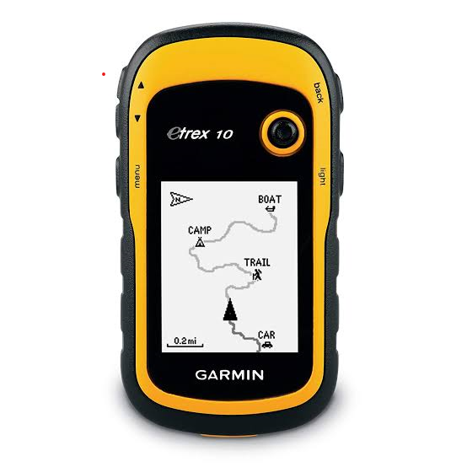
Figure 3.1: A photograph of a GPS

- Geological hammer: Geological hammer is used for reducing the size of lump or boulder samples in the field and to get a fresh surface of the samples.
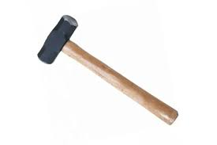
Figure3.2: A photograph of a geological hammer

- Masking Tape:- This is used for rap up the samples on which the labels was done.
- Permanent marker:- This is used to labels each sample accordingly and of different colours.
- Sample Bags:-These materials are made of polythene, leather or any other material and is used for carrying rock samples/specimens during the field work.
3.2 Methods
The methods involves in this work were field visitation for sample collection, samples preparation for laboratory analysis where the thin sections was done at University of Ilorin, Department of Geology and Mineral Sciences laboratory while the Atomic Absorption Spectrometry was carried out at Nigerian Geological Survey Agency laboratory, Kaduna State.
3.3 Description of the study area
Kacafu is a settlement in Patigi local government northern part of kwara state, it is a nupe speaking community with about 1000 residents, it is about 3.8km from Lade, it is popular for its agricultural cultivation and mining activities. The study area is about 1.1km from Kacafu community, it is on the Latitude and Longitude for three sample A, B & C as follow; N8˚38’38.61”, E15˚36’29.27”, N8˚38’38.59”, E15˚36’29.26” and N8˚38’38.13”, E15˚36’29.32” and highly elevated environment with average elevation of 300m, this terrain hosts numerous artisanal miners, the minerals being mined is lepidolite and quartz.
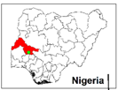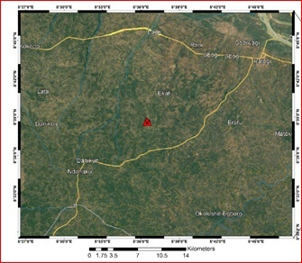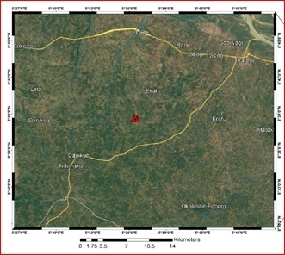
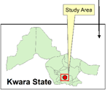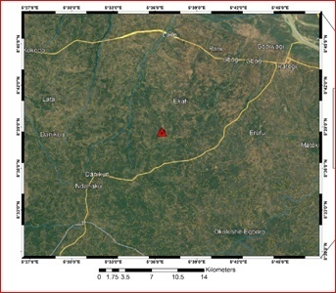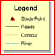
Fig 3.3a: Map of Nigeria (Kwara State) showing the study area

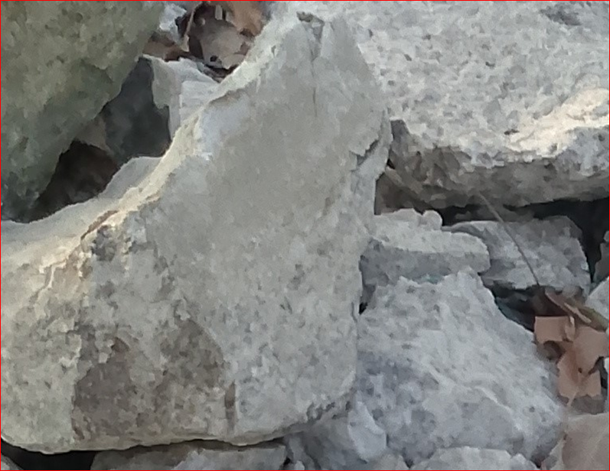
Fig 3.3b: shows the photograph of the sample in the study area

3.4 Sample collection
Fresh representative samples of lepidolite from location1, location 2 and location 3, were collected from three different points on the field using hammer, chisel, sample bags and GPS. The samples were labeled accordingly and were sent for analysis at NGSA Laboratory, Kaduna. for geochemical analysis while the petrographical analysis was carried out at University of Ilorin Department of Geology and Mineral Science laboratory.
3.5 Sample preparation
Dry the sample (ore) at 105⁰C to remove moisture. Grind the sample into a fine powder using an agate mortar or mechanical grinder. Weigh 0.1g of the powdered sample into a platinum crucible. Fusion with sodium carbonate, add3.5g of anhydrous sodium carbonate (Na₂CO₃) as flux to the crucible then mix thoroughly using a clean spatula. Place the crucible in a muffle furnace and heat to 1000⁰C, ensure the temperature is maintain for 20-30 minutes until a clear, molten bead or fused mass is form (Indicates complete fusion).
Remove the crucible and allow it to cool slowly at room temperature, then transfer the fused bead into a beaker and add dilute hydrochloric acid (HCl). Heat gently on a hot plate and stir until the fused mass is completely dissolves. This will convert metal carbonate/oxides into their respective chlorides, if necessary add more HCl to ensure complete disillusions. Filter the solution using whatman No 42 filter paper or similar to remove any insoluble residues and collect the clear filtrate in a clean volumetric flask of 1000ml. Rinse the filter paper with small volume of dilute HCl, add it to the filtrate and make up the mark with deionized water.
Thin section was prepared by cutting an individual grab samples with a diamond saw, where by the slab cut is labeled on one side and the other side is lapped flat and smooth and grinding on a cast iron lap with 400 grit carborundum. The grinding sample is then finished on a glass plate with 600 grit carbonrundum, allow to dry on a hot plate, then glue the sample to a glass slide with epoxy to the lapped face. The thickness is further reduced on thin section grinder to a 30 microns. After this thickness is achieved then the section is placed in a holder for petrographical or microscopic analysis.
3.5.1 Atomic Absorbtion Spectroscopy (AAS)
AAS is technique that detects element in either liquid or solid samples through the application of characteristic wavelengths of electromagnetic radiation from a light source. It is Spectro-analytical procedure for the determination of chemical elements using the absorption of optical radiation by free atoms in the gaseous state .It uses the principle that atoms (and ions) absorb light at a specific, unique wavelength, when this happened the energy is absorbed by the atom (Puja et al, 2017). AAS was calibrated with standard lithium solution e.g 0.25, 0.5, 0.75, 1.0ppm with the wavelength of 670.8nm for lithium set automatically using an air acetylene flame for which the AAS will record the absorbance, compare it with calibration curve and determine the lithium concentration.
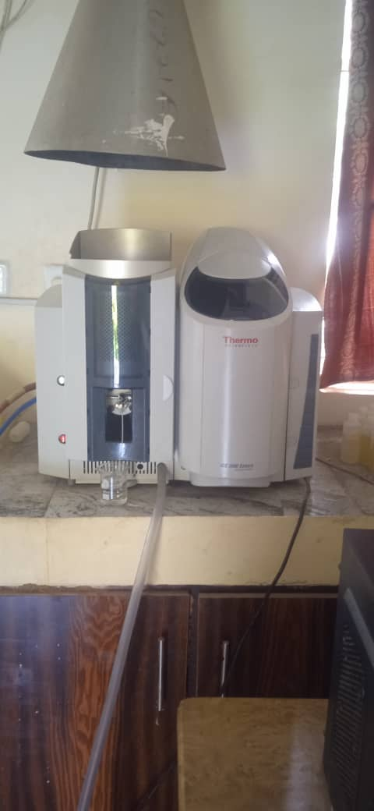
Figure 3.5: Photograph of ICE 3000 Series AAS Machine

3.5.2 Petrographical Analysis (Thin Section)
This analysis examine the microscopic structure of the samples in thin sections of rocks, minerals and other materials by identifying their textures, mineral composition and others critical properties which give information of origin, formation and characteristics of rocks and minerals.

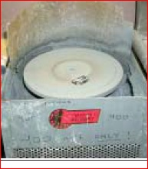
Figure 3.6a: Photograph of 600 grit carborundom grinding machine

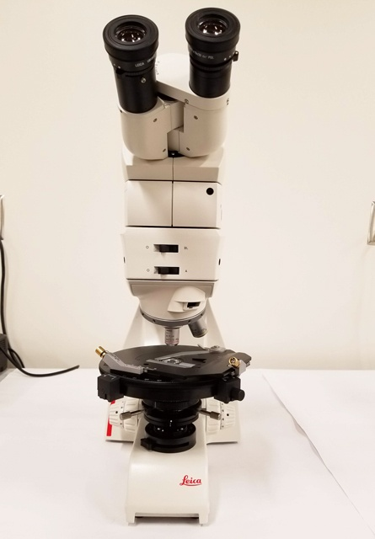
Figure 3.b: Photograph of petrograhical microscope
CHAPTER FOUR
Result Presentation and Discussions
4.1 Result of the Atomic Absorption Spectrometry (AAS)
The Lepidolite sample major and trace element compositions were presented in Table 2
Table 2: Selected major oxides and their percentage average composition
Oxides | Sample A (%) | Sample B (%) | Sample C (%) | Average Composition (%)
SiO2 | 68.43 | 76.36 | 72.92 | 72.57
Al2O3 | 15.33 | 15.82 | 16.45 | 15.86
Fe2O3 | 1.73 | 0.77 | 1.07 | 1.19
MgO | 1.98 | ND | ND | 0.66
CaO | 3.10 | ND | ND | 1.03
Na2O | 0.30 | 1.20 | 1.10 | 0.86
K2O | 0.01 | 3.20 | 4.00 | 2.4
TiO2 | 1.73 | ND | ND | 0.57
MnO | 0.60 | 0.06 | 0.31 | 0.32
Li₂O | 0.94 | 0.15 | 0.93 | 0.67
Mo | 0.45 | 0.16 | 0.22 | 0.27
LOI | 5.20 | 3.10 | 2.80 | 3.70
Au (ppm) | 0.66 | 1.70 | 1.1 | 1.15
Pb (ppm) | 3.78 | 6.06 | 7.94 | 5.92
Zn (ppm) | 3.47 | 1.99 | 4.88 | 3.44
Cu (ppm) | 0.01 | ND | ND | 0.003

4.2 Megascopic description (Hand specimen)
The lepidolite is dominantly composed of aluminosilicates minerals, although light and dark colored minerals were identified, the dark coloured mineral is less than 33%, hence the rock is leucocratic in terms of color index. Purple, white and dark colours were prominent; the bulk essential mineral composition of the lepidolite observable is quartz, muscovite and biotite. The rock is an intrusive igneous rock with Holocrystalline texture, composed of medium grained size and the grain shape is Subhedral (Figure 4.2). The grain sizes are visible to the naked eyes, that is, they are phaneritic. The crystals of the mineral constituent are Equigranular and they are also interlocked

Figure 4.2 Hand specimen of lepidolite in the study area

4.3 Microscopic description (Thin section)
The prepared thin section was examined and studied under plane polarized light (PPL) and cross polarized light (XPL). Photomicrographs of important sections (D&E) were analyzed from the thin section (Table 3). The minerals are recognized in plane polarized light view by lack of alteration and in cross polarized light view by their interference colour (Mackenzie et al., 1982).
4.3.1 Plane Polarized Light (PPL) Description
In the thin section (figure 4.3-4.5), quartz, muscovite mica, and biotite mica and plagioclase feldspar were the major rock forming minerals based on their characteristics. The quartz is colorless under plane polarized light (PPL) with low relief and no cleavage with absent pleochroism and its grain shape is anhedral. Plagioclase is gray in color with no pleochroism and low relief with anhedral grain shape. The biotite in L1 is light brown in color which standout with a moderate relief and strong pleochroism with a platy grain shape and one directional cleavage. The muscovite is brownish-red to red in color with moderate to strong pleochroism and one directional cleavage with low to moderate relief. The opaque mineral appears to be black in color with no cleavage and has subhedral grain shape.
4.3.2 Cross Polarized Light (XPL) Description
The samples was examine under crossed polarized light show properties such as birefringence and extinction (figure 4.4-4.6) The quartz displays low interference color, it is uniaxial, and it has undulose extinction which indicates dislocation walls in mineral grains, the plagioclase is anisotropic and it is identified by albite twinning which gives a series of fine lamellae and low birefringence. The muscovite is anisotropic with low to moderate birefringence

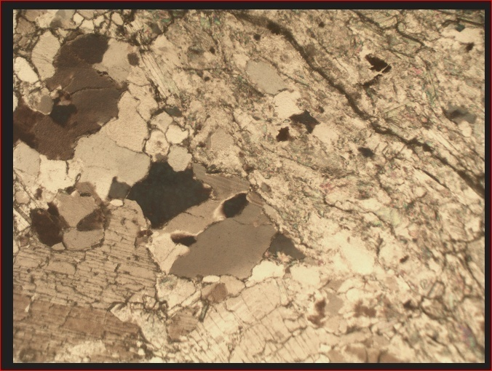
Figure 4.3: Photomicrograph of sample D under plane polarized light

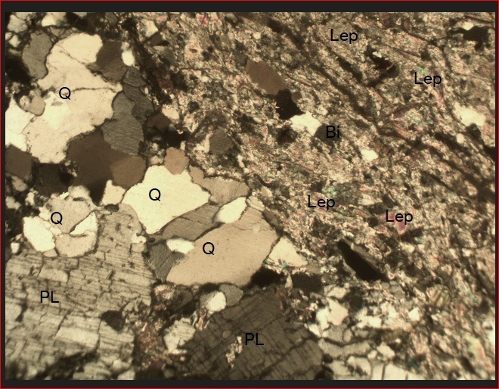
Figure 4.4 photomicrograph of sample D under crossed polarized light
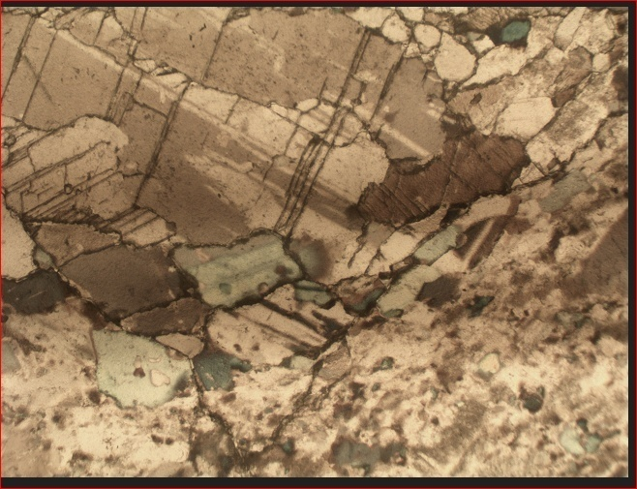
Figure 4.5 Photomicrograph of sample E under plane polarized light

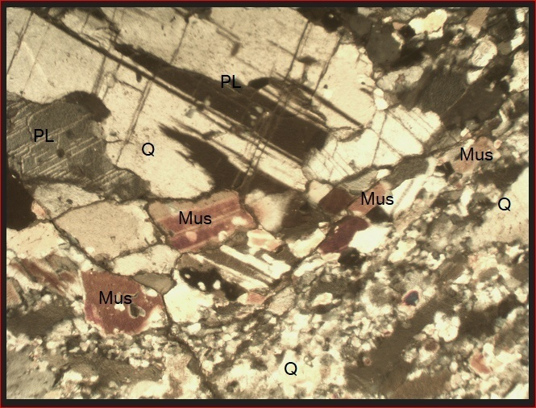
Figure 4.6 photomicrograph of sample E under crossed polarized light

Table3: Estimated modal composition of lepidolite in the study samples photomicrograph
Sample Name | % Composition of the Minerals Present in the Studied Samples |  |  |  | Grand Total (%)
Sample Name | Quartz | Mica | Feldspar | Lepidolite | Grand Total (%)
D | 27 | 3 | 20 | 50 | 100
E | 30 | 55 | 15 | -- | 100

Figure 4.7 Pie chart representation of modal composition of sample D

Figure 4.8 Pie chart representation of modal composition of sample E

4.4 Discussion of the results
The concentrations of major oxides of the samples analyzed as presented in table 2 has SiO2 is high ranges from 68.43-76.36% with an average of 72.57%, while Al2O3 is high ranges between 15.33-16.45% with average value of 15.86%. The Fe2O3 low varies between 0.77-1.73% with average of, while MgO is low 0.0-1.98% with average value of 0.66%. CaO has value ranges from 0.0-3.10% with average of 1.03%, while Na2O is low ranging from 0.30-1.20% with average of 0.86%. K2O ranges from 0.01-4.00% with average of 2.4%, while TiO₂ is varies between 0.0-1.73% with average value of 0.57%. Low value for MnO varies from 0.06-0.60% with average of 0.32%, Li₂O has value ranging from 0.15-0.94% with average of 0.67%, while the LOI ranges from 0.15-0.94% with average value of 0.67%.The results indicate that the samples can be applicable in portable electronics and with more beneficiation the required percentage needed for lithium ore for use in battery production can be attained.

CHAPTER FIVE
5.0 Conclusion and Recommendations
5.1 Conclusions
The five samples are composed of Quartz, plagioclase, muscovite and biotite with average percentages of 72.57% for SiO₂, 15.86% for Al₂O₃, 1.19% for Fe₂O₃, and 0.67% for Li₂O and 5.92% for Pb, 3.44% for Zn and 0.003% for Cu indicate high fractionation and mineralization potential. The geologic relationship of the minerals discovered to be lepidolite suggests that lepidolite may not be the dominant mineral in these samples. Instead, quartz appears to be a major component in all three samples. The presence of plagioclase, muscovite and opaque minerals indicates a diverse mineral assemblage.
5.2 Recommendations
From the result of petrographical and atomic absorption spectrometry analysis, it is therefore recommended that concentration of lithium is closed to requirement for lithium ion battery production except from a sample.

References
Bradley, D.C., Stillings, L.L., Jaskula, B.W., Munk, L.-A. & McCauley, A.D. 2017. Lithium. In: Schulz, K.J., et al. (eds). Critical mineral resources of the United States— economic and environmental geology and prospects for future supply, U.S. Geological Survey Professional Paper, Vol. 1802, pp. K1–K21.

Christie, T., Brathwaite, B. (2008), ‘‘Mineral Commodity Report 19-Beryllium, Gallium, Lithium, Magnesium, Uranium and Zirconium, Institute of Geological and Nuclear Sciences Ltd.

Dessemond, C., Lajoie-Leroux, F., Soucy, G., Laroche, N., Magnan, J.-F. (2019), "Spodumene: The Lithium Market, Resources and Processes", Minerals Vol. 9, 334 pp.

Evans, R.K. (2008). An abundance of lithium. World Lithium. Santiago, Chile

Evans, R.K. (2014). Lithium in Gunn, A.G. (ED.). Critical metal hand book chapter 10. John Wiley and Son Ltd. Chichester, UK. ISBN 978-0-470-67171-9.

Feng, Q., Kanoh, H., Miyai, Y., Ooi, K. (1995), ‘‘Li+ Extraction/Insertion Reactions with Lizn0.5Mn1.5O4 Spinel in the Aqueous Phase’’, Chemistry of Materials Vol. 7, pp. 379-384

Garba, A.A., Adekele, Jacob I.D, Akande, S.O and Ajadi, J. (2019). Geochemistry and rare-metal bearing potentials of pegmatites of Gbugbu, Lema and Bishewa areas of North Central Nigeria. Journal of Environment and Earth Science.Vol.9, No.3, Pp 5-7.

Garrett, D.E. 2004. Handbook of Lithium and Natural Calcium Chloride, their deposits, processing uses and properties. Elsevier Acad. Press. pp. 476.

Garside, M. (2022), "Lithium - Statistics & Facts, in: Statista (Ed.), Mining, Metals & Minerals. Statista, Https://Www.Statista.Com/Topics/3217/Lithium/#Topicheader__Wrapper

John P. R (2012). Minerals. Britannica educational publishing 2012. P 194

Kent, B. (2020). Lithium minerals. Journal of Geology Today vol.36. John Wiley and Son Ltd. Pp192-197.

Klien C & Anthony R.P (2013). Earth Materials: Introduction to mineralogy and petrology, Cambridge university press, p 1026

Krukonski, S.J. (Eds). Industrial mineral and rock, 7th edition Society for Mining, Mteallurgy and Exploration Inc, Littlleton, Colorado, USA.

Kunasz, I. (2006). Lithium Reviews. Pp 599-613. In Kogel, J.E., Trivedi, N.C., Barker, J.M. and
Lisbona, D., Snee, T. (2011), "A review of hazards associated with primary lithium and lithium-ion batteries". Process safety and environmental protection, 89, 434-442.

Mackenzie, W. S., Donaldson, C. H. and Guilford, C. (1982). Atlas of igneous rocks and their textures. Vol: 148. Harlow: Longman.

Mills, R. (2011). From ancientgrounds,most modern minerals. Rio Tinto Review, Pp 15-17.

Moecher, and David, (2004) Characterization and Identification of Mineral Unknowns: A Mineralogy Term Project, Journal of Geoscience Education, vol. 52 #1, p. 5-9.

Okunlola, O. A. (2005) Metallogeny of Tantalum – Niobium mineralization in Precambrian pegmatites of Nigeria.Mineral Wealth. Vol. 137 p 38-50.

Stanley, C.J., Jones, G.C., Rumsey, M.S., Blake, C, Robert, A.C., Sterling, J.A., Carpenter, G.J.C., Whitefield, P.S., Grice, D.J, and Leage, Y. (2007).

Warr, L.N. (2021).IMA-CNMNC approved mineral symbols. Mineralogical magazine 89(3) Pp 291-320.

