A PROJECT REPORT
ON
A PROPOSED COMPREHENSIVE HEALTH CENTER
AT AJELANWA COMMUNITY
ILORIN EAST LOCAL GOVERNMENT, KWARA STATE

BY

ABDULLAHI LAWAL
HND/23/ARC/FT/0012

THE DEPARTMENT OF ARCHITECTURAL TECHNOLOGY, INSTITUTE OF ENVIRONMENTAL STUDIES, KWARA STATE POLYTECHNIC, ILORIN, KWARASTATE.
IN PARTIAL FUFILMENT OF THE REQUIREMENTS FOR THE AWARD OF THE HIGHER NATIONAL DIPLOMA (HND) IN
ARCHITECTURAL TECHNOLOGY

JULY, 2025

DECLARATION

“I declare that this project/dissertation is a product of my personal research work. It has not been presented for the award of any degree in any polytechnic. The ideas, observations, comments, suggestions herein represent my own convictions, except quotations, which have been acknowledged in accordance with conventional academic traditions.”

Name: ABDULLAHI LAWAL

Matric no: HND/23/ARC/FT/0012

Signature Date



ACKNOWLEDGEMENT

My profound gratitude goes to ALLAH (SWA) for the grace and mercy endowed on me throughout my journey in life and for His help over me in achieving this important phase of my academic pursuit. I express my profound gratitude to my project supervisor Arc J.M Tomori, despite her incredible tight schedule coupled with her multifarious commitments, still carved out time to go through my work and guide me diligently all through this project work. My sincere gratitude goes to the Department of Architectural Technology and the entire staff and the project coordinator Arc. Olarewaju F.A. for the part they played in the completion of this project work.
I am highly grateful and indebted to my lovely parents, Mr. and Mrs Amosa, for their overwhelming love, financial support and words of encouragement. Also, my appreciation goes to my siblings, Rosheedah Aduke, Teslim Olarewaju May Almighty ALLAH protect them and shower his infinite mercy on them all. I also wish to appreciate My Boss. Arc Abdul Azeez Adodo My sincere gratitude also extends to my cherished friends, whose support has made this journey memorable and lastly, my course mates and every person who in one way or the other has contributed to the success of this project. I wish everyone of us a very fruitful future.

DEDICATION

This report is dedicated to Almighty Allah the universe, the creator of all creators and the source of mankind who has always been my strength throughout this project and also for his unconditional and infinite mercy showered upon me through my studies.
Also, I dedicated this project to my parent Mr. and Mrs. Amosa for their parental, financial and moral support.
Finally to my sisters and my colleague and other for their contribution to attain great achievement. I pray Almighty Allah reward everyone abundantly.

TABLE OF CONTENTS
TITLE PAGE ……………………………………………………………….………i
DECLARATION…………………………………………………………….…….. ii
CERTIFICATION………………………………………………………….………iii
ACKNOWLEDGEMENT………………………………………………….………iv
DEDICATION……………………………………………………………….………v
TABLE OF CONTENTS………………………………………………….….…….vi
LIST OF FIGURES………………………………………………………..….…...viii
LIST OF PLATES……………………………………………………………..........ix
ABSTRACT………………………………………………………………………….xi
CHAPTER ONE
1.0 INTRODUCTION……… ……………………………………………………1
1.1 DEFINITION………………………………………………………………....1
1.2 HISTORICAL BACKGROUND…………………………………………….2
1.3 STATEMENT OF DESIGN PROBLEM………………………………........3
1.4 AIM AND OBJECTIVES……………………………………………..……...3
1.5 JUSTIFICATION……………………………………………………….........4
1.6 SIGNIFICANCE OF THE STUDY……………………………….…..……..5
1.7 SCOPE OF THE PROJECT………………………………………….……...5
1.8 LIMITATION OF STUDY………………………………………….....……..5
1.9 RESEARCH METHODOLOGY…………………………………….…….. 9

CHAPTER TWO
2.0 LITERATURE REVIEW ...…………………………………………….….. 8
CHAPTER THREE
3.1 CASE STUDY……………………………………………………………….. 12
3.2 CASE STUDY 1: COMPREHENSIVE HEALTH CENTER OKELELE, ABAYAWO ROAD ILORIN, KWARA STATE ….……………………………....12
3.3 CASE STUDY 2: ODINJO COMPREHENSIVE HEALTH CENTER,IBADAN OYO STATE…………………………….…………………....16
3.4 CASE STUDY 3: RURAL COMPREHENSIVE CENTER OKE-MESI, IPOLE OSUN STATE……………………………………………………………… 20
3.5 CASE STUDY 4: AREA TWO COMPREHENSIVE HEALTH CENTER,GARKI, ABUJA FCT……. …………………………………………….24
CHAPTER FOUR
4.0 STUDY AREA/PROJECT SITE……………………………………..……… 33
4.1 HISTORY OF KWARASTATE…………………………………………….... 33
4.2 LOCATION OF SITE………………………..……………………………..... 33
4.3 SITE INVENTORY AND ANALYSIS ……………………………….……… 35
4.4 SITE CHARACTERISTICS…………………………………………………..37
4.4.1 CLIMATE……………………………………………………………….........37
4.4.2 RAINFALL…………………………………………………………………...37
4.4.3 HUMIDITY…………………………………………………………………....38
4.4.4 : SOIL TYPE…………………………………………………………………..39
4.4.5 : TOPOGRAPHY……………………………………………………………...39
4.4.6 : VEGETATION ………………………………………………………………39
4.4.7 : DRAINAGE …………………………………………………………………39
4.4.8 ACCESSIBILITY …………………………………………………………….39
4.4.9: SITE FEATURES AND INFRASTRUCTURE …………………………….39
4.4.10: NOISE SOURCES…………………………………………………………..39
4.5: SITE ANALYSIS (PHYSICAL AND CLIMATIC)…………………………...40
4.5.1: Temperature ………………………………………………………………….40
4.5.2 :Precipitation…………………………………………………………………..40
4.5.3: Sunshine……………………………………………………………………....41
4.5.4: Wind…………………………………………………………………………..41
4.5.5 Man Made Features………………………………………………………….. 42
CHAPTER FIVE
5.0 Appraisal of Proposed Scheme …………………………………………….…..43
5.1 Design Appraisal………………………………………………………….……..43

LIST OF FIGURES
Figure3.1: Locational Plan of Case Study One at Okelele comprehensive health center, Abayawo Ilorin, kwara State……………………………………………………….13
Figure3.2: Floor Plan of Case Study One at Okelele comprehensive health center, Abayawo Ilorin, Kwara state…….…………………………………………………14
Figure3.3: location plan of case study two at Odinjo comprehensive health center, odinjo, Ibadan, oyo state……………………………………………………………15
Figure3.4: Floor plan of case study two at odinjo comprehensive health center, odinjo, Ibadan, oyo state…………………………………………………………………... 16
Figure 3.5: Location plan of case study three at rural comprehensive health center oke-mesi, ipole, osun state …………………………………………………………….. 21
Figure 3.6: Floor plan of case study three at rural comprehensive health center oke-mesi, ipole, osun state ……………………………………………………………...21
Figure 3.7: Location plan of case study four at Area two comprehensive health center, Garki,Abuja FCT…………………………………………………………………...25
Figure 3.8: Floor plan of case study four at Area two comprehensive health center, Garki,Abuja FCT……………………………………………………………………25
Figure 4.1: Map of Nigeria Showing kwara State…………………………..….......34
Figure 4.2: Map of kwara State………………………………………….…………35
Figure 4.3: Site inventory of the proposed site……………………………….…....35
Figure 4.4: Site Analysis of the proposed site……………………………………..36
Figure 4.5: Climate of the Site……………………………………………………..37
Figure 4.6: Graph of Rainfall in Ilorin……………………………………………..38
Figure 4.7: Graph of humidity in kwara state……………………………………...38
Figure 4.8: Graph of temperature in Ilorin………………………………………....40
Figure 4.9: Showing site analysis……………………………………………...…...42

LIST OF PLATES
plate3.1: Site Location of Case Study One at Okelele, Abayawo road Ilorin, kwara State………………………………………………………………………………….13
Plate3.2: patient room at Okelele comprehensive health center, Abayawo ilorin, kwara State…………………………………………………………………………………..14
Plate 3.3: Entrance Gate at Okelele comprehensive health center, Abayawo ilorin, kwara State…………………………………………………………………….….….15
Plate 3.4: Interior view of the surrounding at Okelele comprehensive health c.enter, Abayawo ilorin, kwara State…………………………………………………………15
Plate 3.5: Dental Interior view of the surrounding at Okelele comprehensive health center, Abayawo ilorin, kwara State…………………………………………………16
Plate 3.6: Site location of case study two at odinjo comprehensive health center, odinjo, Ibadan, oyo state …………………………………………………………………… 17
Plate 3.7: Surgery Room of case study two at odinjo comprehensive health center, odinjo, Ibadan, oyo state…………………………………………………………….18
Plate 3.8: Patient unit (baby) at odinjo comprehensive health center, odinjo, Ibadan, oyo state …………………………………………………………………………….. 19
Plate 3.9: Waiting Unit at odinjo comprehensive health center, odinjo, Ibadan, oyo state …………………………………………………………………….…………….19
Plate 3.10: site location of case study three at rural comprehensive health center oke-mesi, ipole, osun state………………………………………………………..………20
Plate 3.11: Lobby at rural comprehensive health center oke-mesi, ipole, osun state………………………………………………………………………..…………22
Plate 3.12: Waiting Area at rural comprehensive health center oke-mesi, ipole, osun state ……………………………………………………………………….…………22
Plate 3.13: Interior view at rural comprehensive health center oke-mesi, ipole, osun state……………………………………………………………………….………….23
Plate 3.14: Labour Room at rural comprehensive health center oke-mesi, ipole, osun state………………………………………………………………………….……….23
Plate 3.15: Site location of case study four at Area two comprehensive health center, Garki,Abuja FCT……………………………………………………………………24
Plate 3.16: Perspective view of case study four at Area two comprehensive health center, Garki,Abuja FCT…………………………………………………………....26
Plate 3.17: Rear view of case study four at Area two comprehensive health center, Garki,Abuja FCT……………………………………………………………………26
Plate 3.18: Waiting Area of case study four at Area two comprehensive health center, Garki,Abuja FCT……………………………………………………………………27
Plate 3.19: Left side view of case study four at Area two comprehensive health center, Garki, Abuja FCT…………………………………………………………………...27
Plate 3.20: perspective view of Valley wise Comprehensive Health centre, Phoenix-Arizonal at U.S.A…………………………………………………………………...28
Plate 3.21: Patient room……………………………………………………………28
Plate 3.22: Waiting Room………………………………………………………….29
Plate 3.23: Exterior View…………………………………………………………..29
Plate 3.24: Showing the signboard………………………………………………...30
Plate 3.25: scan Area………………………………………………………………30
Plate 3.26: lobby…………………………………………………………………...31
Plate 3.28: Approach View………………………………………………………...31
Plate 3.29: Labour Room………………………………………………………….32
Plate 4.1: The proposed site in Ilorin west local government……………………..32

ABSTRACT

Comprehensive health center (CHC) is essential care based on practical, scientifically sound, and socially acceptable methods and technologies, made universally accessible to individuals and families in the community through their full participation and at a cost that the community and country can. Afford to maintain at every step. of their development in a spirit of autonomy and self-determination. It is an integral part of both of the country's health system, of which it is the central function and main axis, and of the general social and economic development of the community. It is the first level of interaction with the national health system of people, families, and communities that takes health care as close as possible to the place of life and work and is the first interaction of care. The health workforce’s awareness of comprehensive health center delivery and procedure is a matter of concern. That is why this IBS research was designed to assess the extent at which comprehensive health center is applied and practiced by health workers. 45 questionnaires on the methods and application of comprehensive health center were analyzed in the report. With the health care workers, a closed questionnaire was exchanged. In the analysis, a descriptive, designed study was used. The findings indicate that 95.56 percent of health staff has knowledge of comprehensive health center. In addition, in comprehensive health center, 89 percent had good experience. Finally, 88.89 percent had a constructive outlook towards the variables hindering comprehensive health center implementation. The findings indicate that the health workers at the CITE DES PALMIER DISTRICT HOSPITAL had a strong understanding of comprehensive health center delivery and practice. Regarding my research, it is concluded that the health workforce has a good knowledge of the practice and implementation of the primary health workforce and that more than five factors prevent adherence to the implementation and the practice of comprehensive health center due to lack of resources.Keywords: comprehensive Health center ,Knowledge of Health Personnel, Agreement
CHAPTER ONE
1.0 INTRODUCTION
Comprehensive health centers are innovative healthcare facilities that offer a wide array of medical services to individuals and communities. These centers focus on providing holistic and integrated care that encompasses physical, mental, and social well-being. By offering a variety of services under one roof, comprehensive health centers aim to improve access to healthcare, enhance patient outcomes, and promote overall wellness.
Comprehensive health centers typically provide primary care services, such as routine check-ups, preventive screenings, and treatment for common illnesses. In addition to primary care, these centers may also offer specialty services, including mental health counseling, dental care, vision care, and chronic disease management. By offering a comprehensive range of healthcare services, these centers can address the diverse needs of patients and provide continuity of care.
One of the key advantages of comprehensive health centers is their focus on preventive care and wellness. These centers often emphasize health promotion and disease prevention through education, counseling, and lifestyle interventions. By encouraging healthy behaviors and early detection of health issues, comprehensive health centers can help individuals maintain optimal health and prevent the onset of chronic diseases.
In conclusion, comprehensive health centers play a crucial role in promoting health and well-being in communities. By offering a wide range of services and emphasizing preventive care, these centers can improve access to healthcare, enhance patient outcomes, and support the overall health of individuals and families

1.1 DEFINITION
A comprehensive health center, also known as a comprehensive healthcare center or comprehensive primary care center, is a healthcare facility that offers a wide range of medical services and programs to address the diverse needs of individuals and communities. These centers focus on providing integrated and holistic care that encompasses physical, mental, and social well-being.
Comprehensive health centers typically provide primary care services, such as routine check-ups, preventive screenings, and treatment for common illnesses. In addition to primary care, these centers may offer specialty services, including mental health counseling, dental care, vision care, chronic disease management, and social services.

1.2 HISTORICAL BACKGROUND
Comprehensive health centers have evolved over time in response to the changing healthcare needs of individuals and communities. The concept of comprehensive healthcare emerged as a response to the limitations of traditional healthcare models, which often focused on treating acute illnesses and injuries rather than addressing the underlying causes of poor health.
The roots of comprehensive health centers can be traced back to the community health center movement in the United States during the 1960s. The establishment of the first community health centers was a result of the Civil Rights Movement and the War on Poverty, which highlighted the disparities in healthcare access and outcomes among underserved populations.
In 1965, the federal government launched the Community Health Center Program as part of the Economic Opportunity Act, which aimed to provide comprehensive healthcare services to low-income individuals and communities. The program funded the establishment of community health centers in medically underserved areas, with an emphasis on primary care, preventive services, and community engagement.
Over the years, community health centers expanded their scope of services to encompass a wide range of healthcare needs, including mental health, dental care, vision care, chronic disease management, and social services. These centers adopted a patient-centered, holistic approach to care that focused on addressing the physical, mental, and social determinants of health.
Today, comprehensive health centers continue to play a vital role in promoting health and well-being in communities by offering integrated and holistic care to individuals of all ages and backgrounds. These centers serve as a cornerstone of the healthcare system, providing accessible, high-quality care to those who need it most and addressing health disparities and inequities in healthcare access and outcomes.

1.3 STATEMENT OF DESIGN PROBLEM

The design problem for a comprehensive health center involves creating a healthcare facility that effectively addresses the diverse needs of individuals and communities while promoting holistic and integrated care. The goal is to design a space that optimizes patient care, enhances the patient experience, and supports the well-being of both patients and healthcare providers.
And also by Creating a welcoming and comfortable environment that prioritizes the needs and preferences of patients. This includes designing waiting areas, exam rooms, and consultation spaces that are accessible, culturally sensitive, and conducive to healing.

1.4 AIM AND OBJECTIVES
1.4.1 AIM
The aim of this project is to design a well compatible functional spaces, conceptualized structure that will ensuit all the required units in the Comprehensive health centre that will enhance free movement with the building.
1.4.2 OBJECTIVE
To achieve the aim, the following objectives are set out;
1. To ensure a well ventilated and well lightening structure in the design
2. Improve the capacity of health care system and infrastructure within the community.
3. Qualitative and effective healthcare services
4. To ensure the site is well landscaped for design consideration
5. To promote and grant recognition to research in field of health
To ensured people receive adequate and comprehensive care ranging from
promotion and prevention, treatment, rehabilitation and pediatric care dose as
feasible to people every day activities.
1.5 JUSTIFICATION
Over a titanic days review and researched there's no actual Standard. Comprehensive health centre for individuals for good Care services in Ajelanwa Community and it environment Hence provision for one is important and justified.
Below are the key factors that justified for
• Improve Access: provide easy access to an wide range of health care centre, reducing Barriers and increasing health care Utilization.
• Coordinate Care: Offers a team-based approach, ensuring that patients receive seamless, Comprehensive care from multiple providers.
• Holistic Approach: Addresses physical, mental and social needs, recognizing the Interconnectedness of health factors.
• Early Intervention: Encourage preventive Care, early detection and treatment, reducing complications and costs.
• Patient-centered: Focuses on individualized care, respecting patients, unique needs, Values, and preferences.
• Cost-effective: Reduce healthcare cost by minimizing Unnecessary tests, procedures and hospitalization.
• Enhanced patient experience: provides a convenient, one stop-shop experience, reducing wait times and administrative burdens.
• Improved health outcomes : leads To better health outcomes, reduced morbidity and mortality
• Community focused: Addresses local health needs, prioritizing equality and reducing health disparities.
• Economic Benefits: creates jobs, Stimulates local economic and reducing health disparities.
By justifying the establishment of a comprehensive health centre, act Ajelanwa Community to prioritize the well-being of the Community and to promote a healthier, more thriving society.

1.6 SIGNIFICANCE OF THE STUDY
The significance of this research is to provide an essential design that will carter/provide the need of health issues to the beneficiaries of the community
people based on both Ajelanwa community and State at large, in relation to achieve a sustainable and infrastructural health amenities within the community.
1.7 SCOPE OF THE PROJECT
The scope of this study is to design comprehensive health centre for the Community people of Ajelanwa area. This is limited to out -patient - department (OPD), In-patient Departmant (IPD) and accident & emergency (A&E), also the proposed comprehensive health centre should be comfortable.
PROJECT SCOPE :Gate house,GenHouse,CarPark,Generalstore,Greenarea,MainBuilding,Access Road PROJECT BRIEF
ADMINISTRATIVE :Entrance,Reception,Waitingarea,Doctorsoffice,Cardroom,ConsultingRoom,NurseStation,Changing room, ambulance bay
OUT-PATIENTDEPT:X-Ray, Treatment room, Injection room, Pharmacy, laboratory, Dental unit, Eye care unit, Waiting Area, Reception, Doctor office
IN - PATIENT DEPT: Male Ward, Female ward, VIP ward, Children ward, Nurse station, Dental Care, Labor room, Operation Room, Anti –Natal ,Post_ natal
1.8 LIMITATION OF STUDY
Limitation to the research is very many and some of them were overcome in the course of study. The scope of the study is limited to the following which are;
- Sample Size: One limitation of a study on comprehensive health centers may be a small sample size, which can limit the generalize ability of the findings to a larger population. A small sample size may also reduce the statistical power of the study, making it difficult to detect significant differences or associations.
2. Selection Bias: There may be inherent selection bias in the study sample, as individuals who choose to use comprehensive health centers may differ from those who do not, leading to potential confounding factors that could impact the study results.
3. Data Collection Methods: The quality and accuracy of the data collected in the study may be limited by the methods used for data collection, such as self-reported surveys or medical records review. Inaccuracies in data collection could affect the validity and reliability of the study results.
4. Time Constraints: Time constraints may limit the duration of the study and the ability to assess long-term outcomes or trends related to comprehensive health centers. Short study periods may not capture the full impact of these facilities on patient outcomes and healthcare delivery.
5. Resource Constraints: Limited resources, such as funding, personnel, and technology, may pose challenges in conducting a comprehensive study on health centers. These constraints could affect the scope of the study, the depth of analysis, and the ability to implement interventions or improvements based on study findings.
6. External Factors: External factors, such as changes in healthcare policies, economic conditions, or societal trends, may influence the results of the study on comprehensive health centers. These external factors may be beyond the control of the researchers and could impact the interpretation of the study findings.
7. Bias and Confounding: There may be potential biases or confounding variables that could impact the study results, such as researcher bias, patient preferences, or unmeasured variables that could influence the outcomes of the study.
Overall, it is important for researchers to acknowledge and address the limitations of their study on comprehensive health centers to ensure the validity and reliability of the findings and to provide a comprehensive understanding of the impact of these facilities on patient care and healthcare delivery.
1.9 RESEARCH METHODOLOGY
This project (Comprehensive health Centre) is well exceptionally and thoroughly searched for through the listed unit: Net browsing, Field survey (Case studies),Literature Review, Photograph, Oral interview

CHAPTER TWO
2.1 LITERATURE REVIEW
Introduction
Comprehensive Health Care Centers (CHCCs) aim to integrate a broad range of health services within a single facility, providing a model for holistic and patient-centered care. The landscape of health care is continually evolving, and CHCCs play a crucial role in addressing the multifaceted needs of patients. This review examines the latest research on CHCCs, exploring their effectiveness, patient and community impact, and international perspectives.
1. Definition and Models of Comprehensive Health Care Centers
CHCCs provide a full spectrum of health services, typically including primary care, specialty care, mental health services, and social support. According to the World Health Organization (2023), these centers are characterized by their focus on integrated care, which aims to enhance patient outcomes and streamline service delivery (WHO, 2023).
Models of CHCCs:
Integrated Models: Operate within larger health systems, benefiting from shared resources and coordinated care. Challenges include managing diverse provider interests and administrative complexity (Smith et al., 2023).
Independent Models: Function autonomously, offering flexibility and innovation but facing difficulties with financial sustainability and limited access to specialized resources (Jones et al., 2023).
2. Effectiveness and Outcomes
CHCCs have been shown to positively impact health outcomes through various mechanisms:
Chronic Disease Management: Studies reveal that CHCCs can significantly improve the management of chronic diseases. Patel et al. (2024) found that patients with chronic conditions such as diabetes and hypertension showed better management and fewer complications when treated in CHCCs compared to traditional settings.
Preventive Care: CHCCs often emphasize preventive care, leading to earlier detection of diseases and reduced healthcare costs. Garcia et al. (2023) reported that CHCCs increased the uptake of preventive services and screenings, contributing to improved long-term health outcomes.
3. Patient Engagement and Experience
Patient engagement is a critical component of CHCCs. Effective engagement strategies are essential for ensuring that patients are actively involved in their care, which can lead to better adherence to treatment plans and improved outcomes.
Patient-Centered Care: CHCCs strive to offer personalized care that aligns with individual patient needs and preferences. Adams et al. (2024) noted that patient-centered approaches in CHCCs often include shared decision-making, which enhances patient satisfaction and engagement.
Challenges in Engagement: Despite these efforts, challenges remain in fully engaging patients. Thompson et al. (2024) identified issues such as limited health literacy and barriers to accessing care within large integrated centers.
4. Community Impact
CHCCs have a substantial impact on the communities they serve. They often focus on addressing health disparities and improving access to care for underserved populations.
Addressing Health Disparities: Brown & Patel (2024) found that CHCCs effectively reduce health disparities by providing services to low-income and marginalized communities, often through sliding fee scales and community outreach programs.
Economic Impact: The presence of CHCCs can also have a positive economic impact on communities by creating jobs and reducing the need for more costly emergency care. Martin et al. (2023) reported that CHCCs contribute to local economies by employing healthcare professionals and supporting local businesses.
5. Comparative Effectiveness
Comparative effectiveness research evaluates how different models of CHCCs perform in terms of patient outcomes and cost-effectiveness.
Integrated vs. Independent Models: A comparative study by Smith et al. (2023) assessed the performance of integrated and independent CHCC models. Integrated models were found to be more effective in managing complex cases due to their extensive resources, while independent models excelled in flexibility and patient satisfaction.
Cost-Effectiveness: Research by Lee & Chang (2023) highlighted that CHCCs can be cost-effective by reducing hospital admissions and emergency room visits. However, the initial setup and maintenance costs can be high, which poses a challenge for long-term sustainability.
6. Innovations and Future Directions
Innovations are continuously shaping the evolution of CHCCs, enhancing their ability to provide high-quality care.
Technology Integration: The integration of Telehealth, EHRs, and mobile health applications is transforming CHCCs. Baker & Morris (2024) reported that these technologies improve care coordination, patient monitoring, and accessibility, particularly for remote and underserved populations.
Artificial Intelligence and Data Analytics: AI and data analytics are playing an increasingly important role in CHCCs. Wright et al. (2024) discussed how AI can predict patient needs and optimize care delivery, while data analytics helps in monitoring performance and identifying areas for improvement.
7. International Perspectives
Examining CHCCs from an international perspective provides insights into how different countries approach comprehensive care.
Global Models: In Europe, for example, the concept of Primary Care Networks (PCNs) is similar to CHCCs and emphasizes the integration of primary and secondary care services. Studies from the UK (Jones et al., 2023) show that PCNs improve patient access and continuity of care.
Developing Countries: In low-resource settings, CHCCs often function as essential health service providers. Research by Patel et al. (2024) highlighted that these centers are crucial in expanding access to basic health services and addressing public health challenges in developing countries.

8. Policy Implications and Recommendations
Effective policies are critical for the success of CHCCs. Policymakers play a key role in supporting the establishment and sustainability of these centers.
Funding and Support: Policies that provide funding and support for CHCCs are essential. Recent initiatives by the U.S. Department of Health and Human Services (HHS, 2023) aim to enhance funding for CHCCs to expand services and improve infrastructure.
Regulatory Framework: Creating a regulatory framework that supports integration and innovation while ensuring quality and accountability is crucial for the continued success of CHCCs (Smith et al., 2023).
Comprehensive Health Care Centers represent a significant advancement in healthcare delivery, offering integrated, patient-centered care. While they demonstrate potential in improving health outcomes and addressing health disparities, challenges related to financial sustainability, service integration, and patient engagement persist. Innovations in technology and evolving policy frameworks are likely to drive the future of CHCCs, enhancing their effectiveness and reach.

CHAPTER THREE
3.1CASE STUDY
Case study is a process of researching into a project and documenting through writing, sketching, diagrams and photos. To Understand the various aspects of designing and constructing a building
One must consider learning from other people's mistakes. As Albert Einsten quoted. ‘’ learn from yesterday, live for today and hope for tomorrow. The important thing is not to stop questioning.
A Case study can be a starting part of any project or it can also serve as a link or reference which Can help in explaining the project with ease. It is not necessary that the building we choose for our case study should be the true representation of our project. the man purpose is to research and Understand the Concepts that an architect has used while designing that project and how it worked and air Own should be to learn from It's perfections as well as from It mistakes two while adding our creativity

3.2 CASE STUDY 1: COMPREHENSIVE HEALTH CENTER OKELELE, ABAYAWO ROAD ILORIN, KWARA STATE

MERITS
.There is spacious clinical treatment Units
.Good accessibility
.Well structure
.Well organized and equipped
DEMERITS
.Absence of landscaping in the area
.No parking Slots (car park)
.

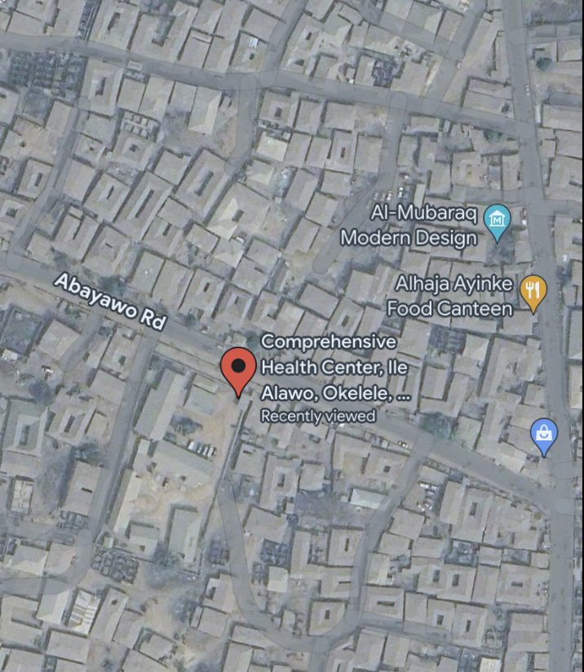

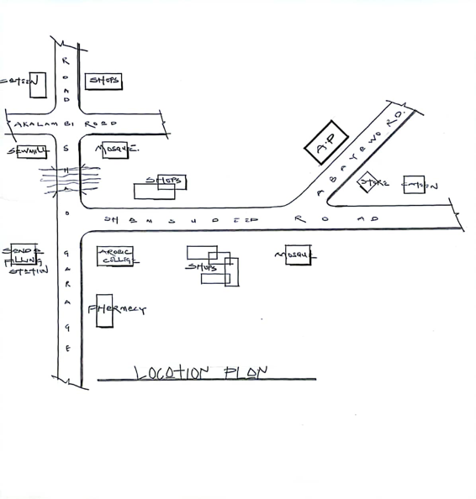
plate3.1: Site Location of Case Study One at Okelele, Abayawo road Ilorin, kwara State

Figure3.1: Locational Plan of Case Study One at Okelele comprehensive health center, Abayawo Ilorin, kwara State
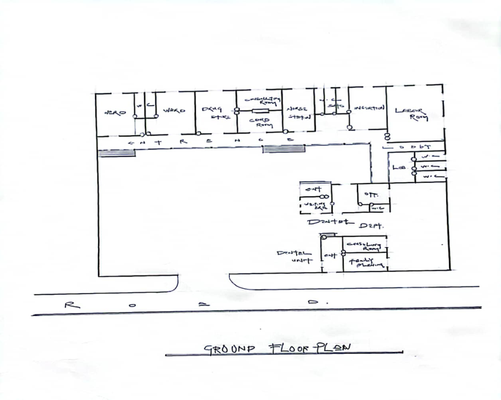

Figure3.2: Floor Plan of Case Study One at Okelele comprehensive health center, Abayawo Ilorin, Kwara state

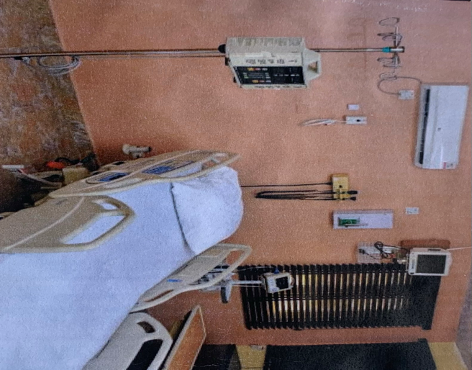
Plate3.2: patient room at Okelele comprehensive health center, Abayawoilorin, kwara State.

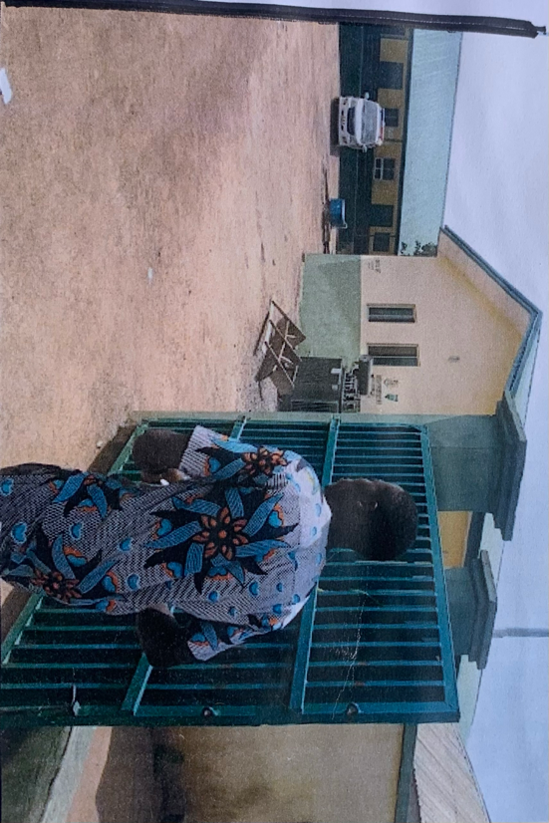
Plate 3.3: Entrance Gate at Okelele comprehensive health center, Abayawoilorin, kwara State.

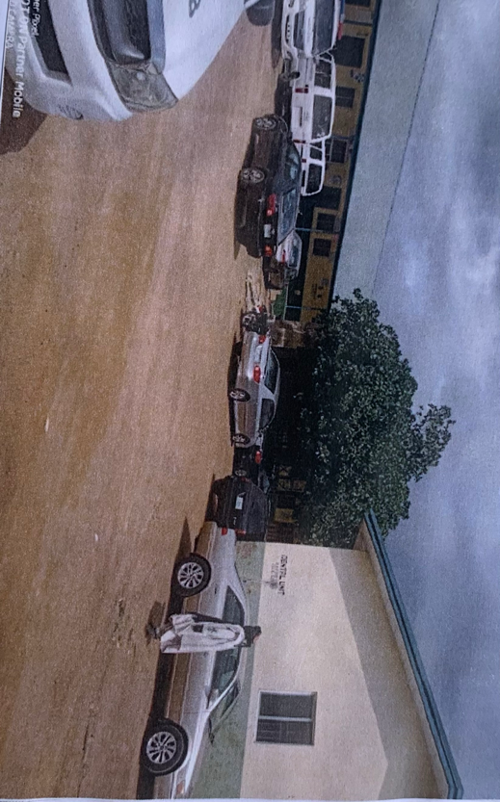
Plate 3.4: Interior view of the surrounding at Okelele comprehensive health center, Abayawoilorin, kwara State.

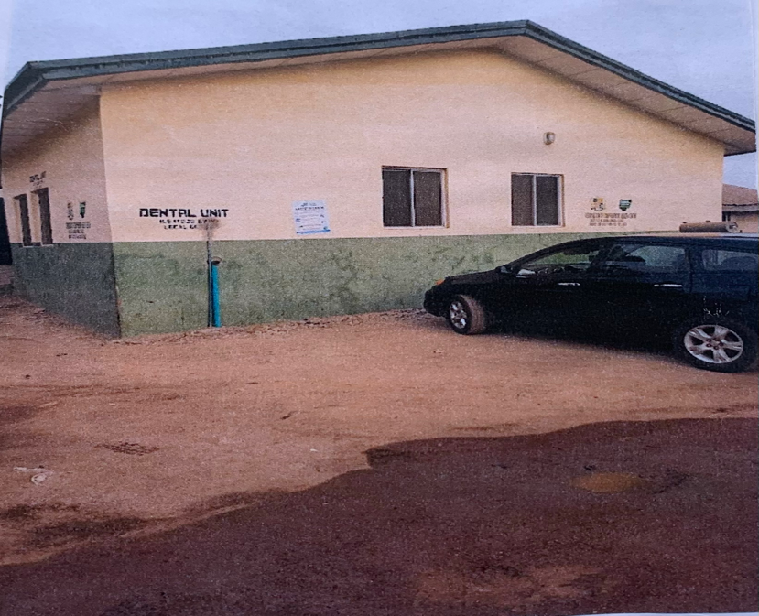
Plate 3.5: Dental unit at Okelele comprehensive health center, Abayawoilorin, kwara State.

3.3 CASE STUDY 2: ODINJO COMPREHENSIVE HEALTH CENTER, ODINJO, IBADAN, OYO STATE

MEEITS
.Good location of the site is considered for care
.Units are well arrange in the building placement

DEMERITS
.There is no space for future extension
.There is less clinical department spaces

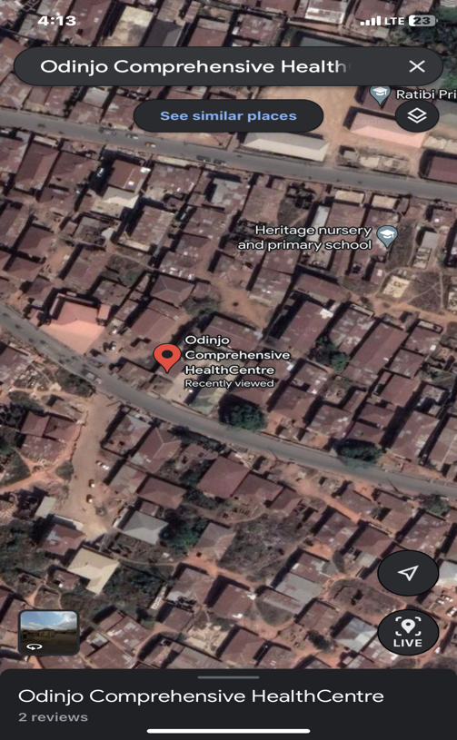
Plate 3.6: Site location of case study two at odinjo comprehensive health center, odinjo, Ibadan, oyo state
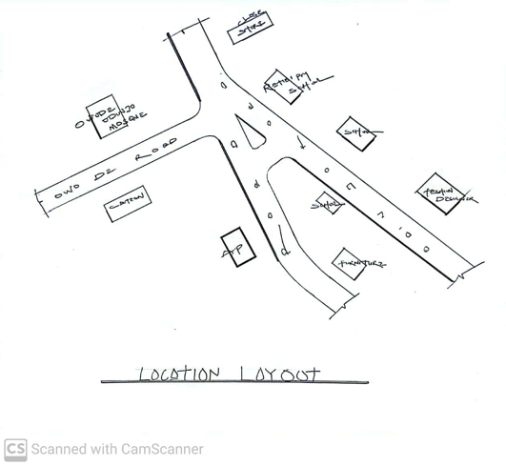

Figure 3.3 location plan of case study two at odinjo comprehensive health center, odinjo, Ibadan, oyo state

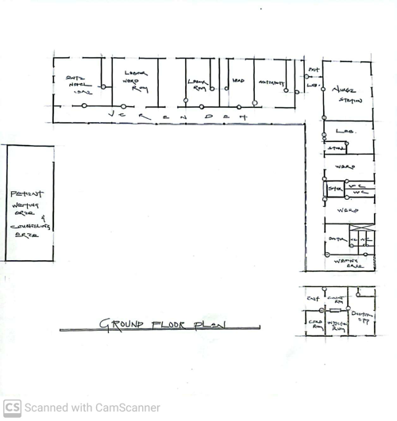
Figure 3.4 Floor plan of case study two at odinjo comprehensive health center, odinjo, Ibadan, oyo state
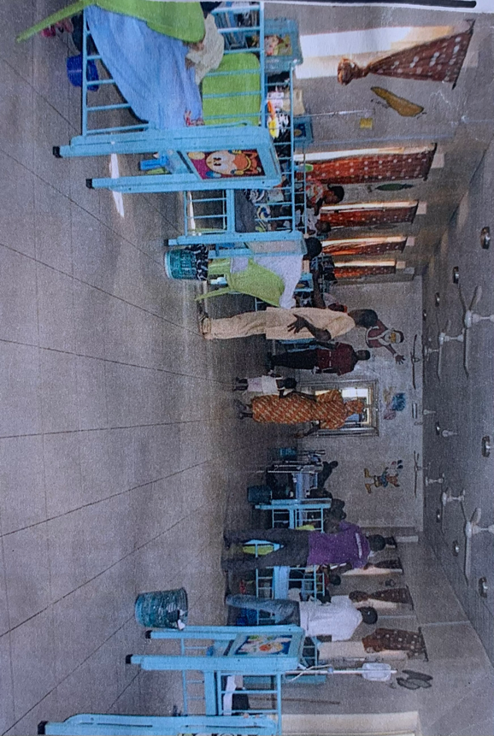
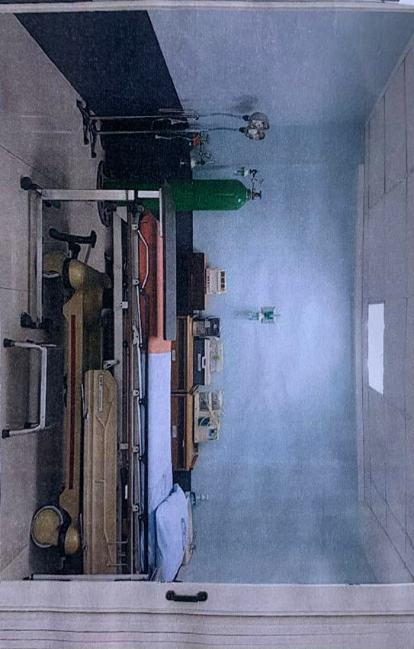
Plate 3.7: Surgery Room of case study two at odinjo comprehensive health center, odinjo, Ibadan, oyo state.Plate 3.8: Patient unit (baby) at odinjo comprehensive health center, odinjo, Ibadan, oyo state

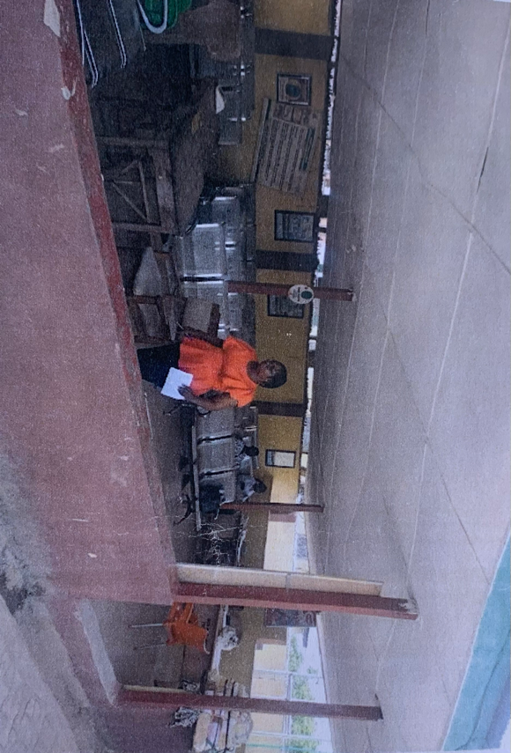

Plate 3.9: Waiting Unit at odinjo comprehensive health center, odinjo, Ibadan, oyo state

3.4 CASE STUDY 3: RURAL COMPREHENSIVE CENTER OKE-MESI,IPOLE, OSUN STATE
MERITS
.Well and adequate ventilation and well design structure
.It’s well spacious
. It is easy to locate
. There is space for future development for clinic
DEMERITS
.No security consideration in the building
.The parking space is not well defined
.Poor landscape
. The building are not well organized
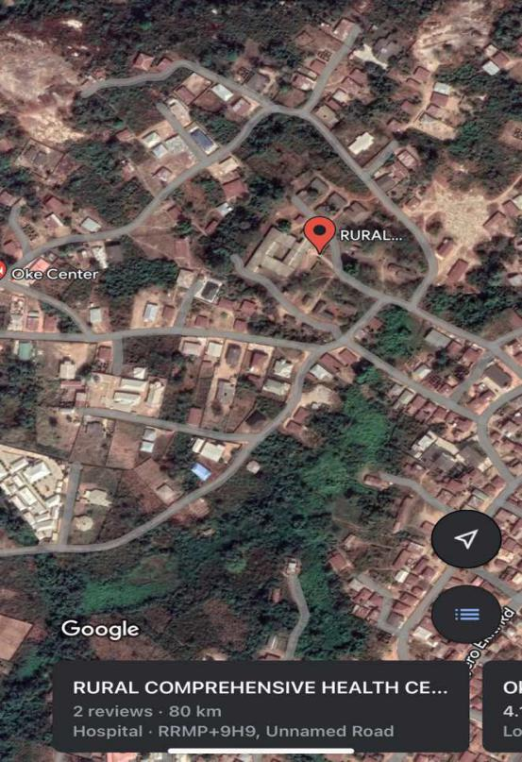
Plate 3.10: site location of case study three at rural comprehensive health center oke-mesi, ipole, osun state.

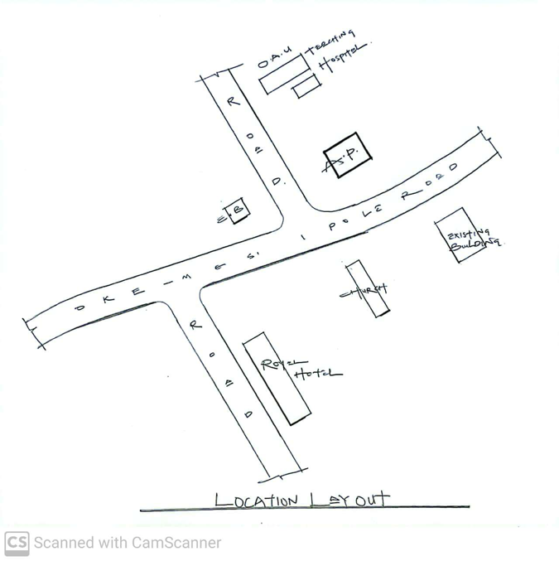
Figure 3.5: Location plan of case study three at rural comprehensive health center oke-mesi, ipole, osun state

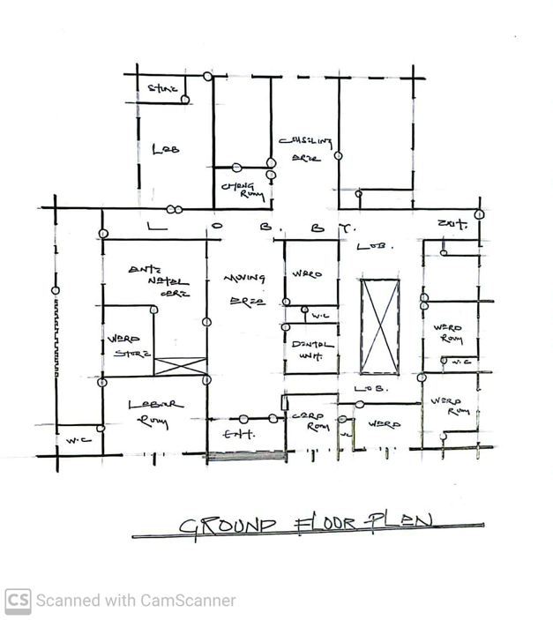
Figure 3.6: Floor plan of case study three at rural comprehensive health center oke-mesi, ipole, osun state

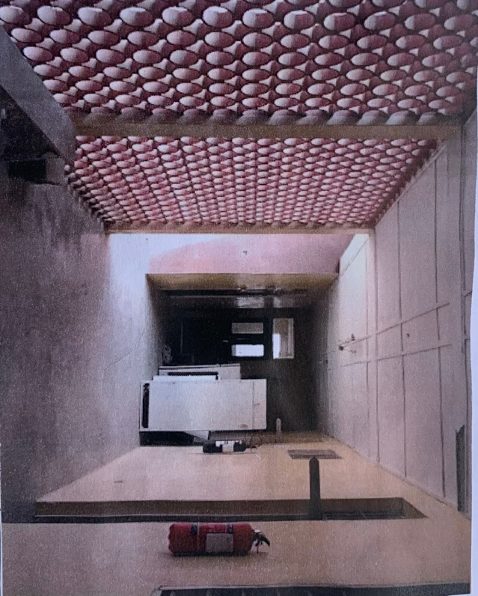
Plate 3.11: Lobby at rural comprehensive health center oke-mesi, ipole, osun state

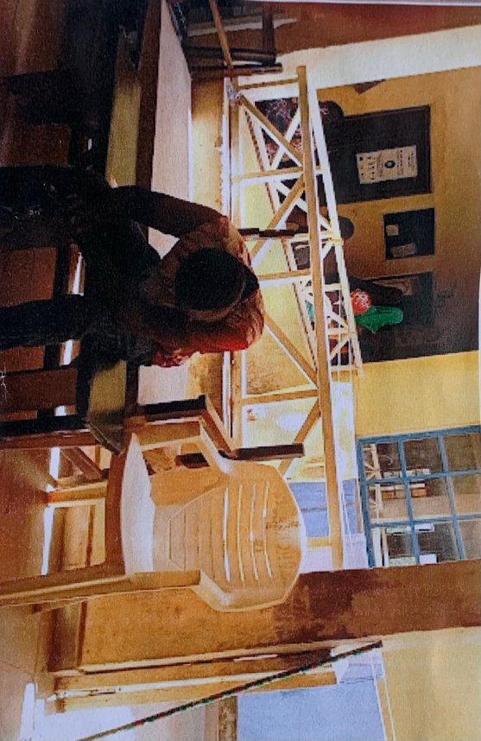
Plate 3.12: Waiting Area at rural comprehensive health center oke-mesi, ipole, osun state

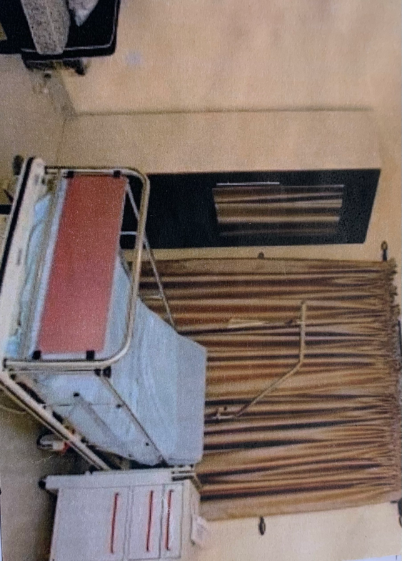
Plate 3.13: Interior view at rural comprehensive health center oke-mesi, ipole, osun state

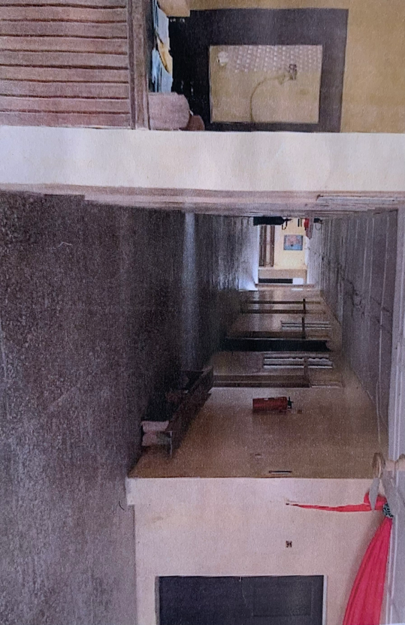
Plate 3.14: Labour Room at rural comprehensive health center oke-mesi, ipole, osun state
3.5 CASE STUDY 4: AREA TWO COMPREHENSIVE HEALTH CENTER, GARKI, ABUJA FCT

MERITS
.Well conducive and adequate ventilation in the building
.Well design structure
DEMERITS
.Building in an open site (no fence)
.The parking space is not well defined
.Location is not easy accessible

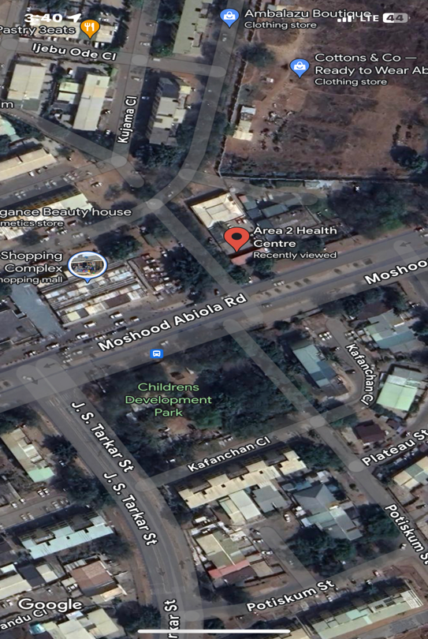
Plate 3.15: Site location of case study four at Area two comprehensive health center, Garki,Abuja FCT

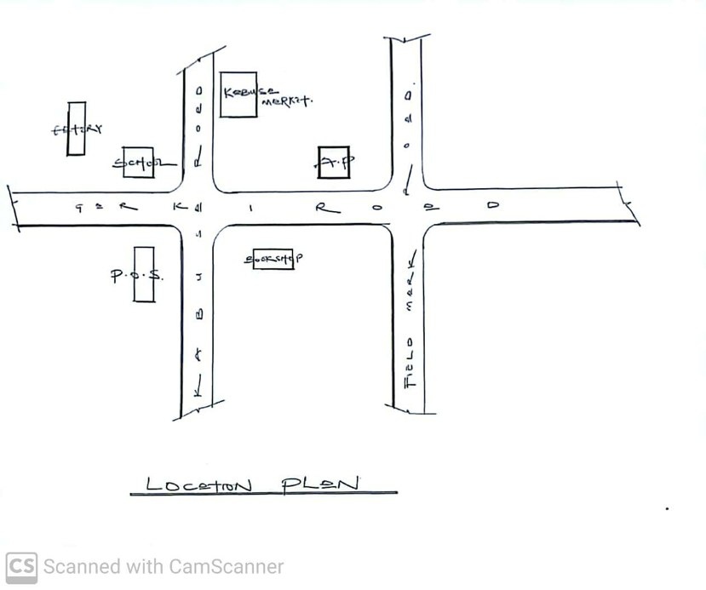

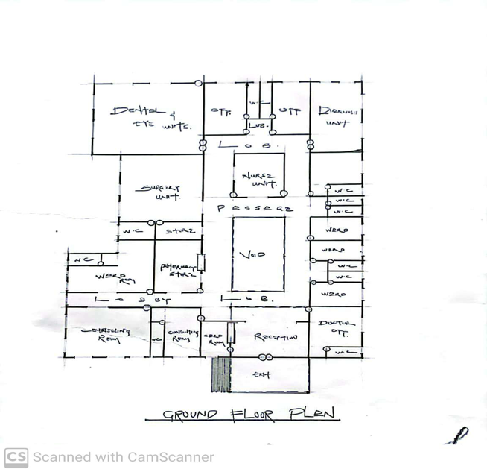
Figure 3.7: Location plan of case study four at Area two comprehensive health center, Garki,Abuja FCT
Figure 3.8: Floor plan of case study four at Area two comprehensive health center, Garki,Abuja FCT

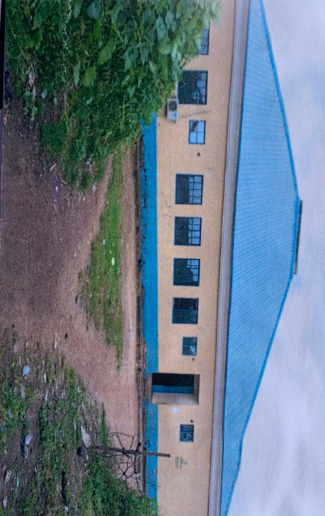
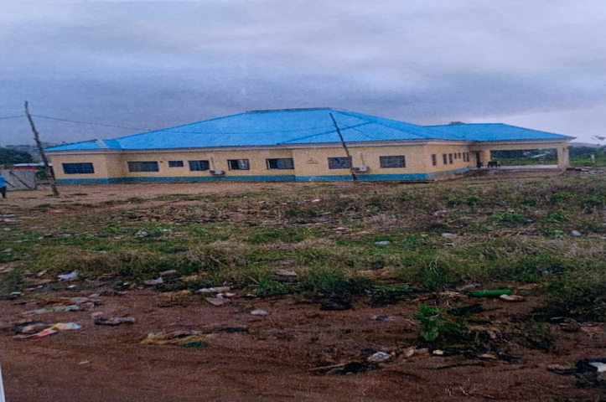
Plate 3.16: Perspective view of case study four at Area two comprehensive health center, Garki,Abuja FCT
Plate 3.17: Rear view of case study four at Area two comprehensive health center, Garki,Abuja FCT

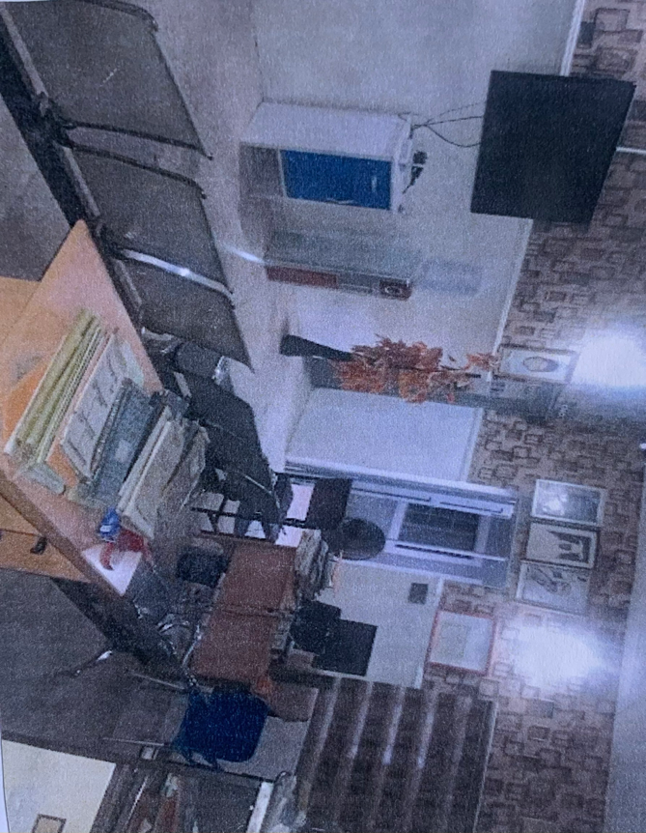
Plate 3.18: Waiting Area of case study four at Area two comprehensive health center, Garki,Abuja FCT
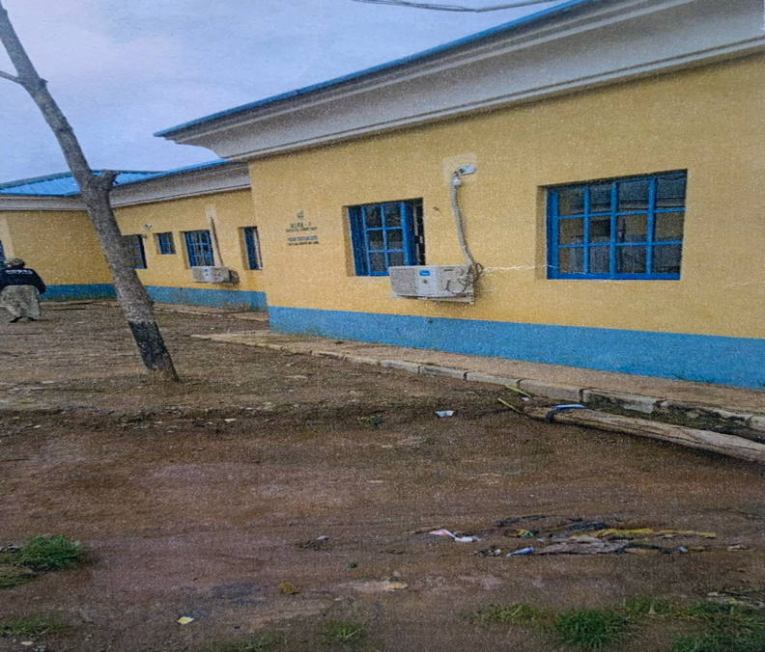
Plate 3.19: Left side view of case study four at Area two comprehensive health center, Garki,Abuja FCT

3.5: CASE STUDY 5: ONLINE CASE STUDY ONE
VALLEY WISE COMPREHENSIVE HEALTH CENTER PHOENIX-ARIZONAL AT U.S.A


Plate 3.20: perspective view

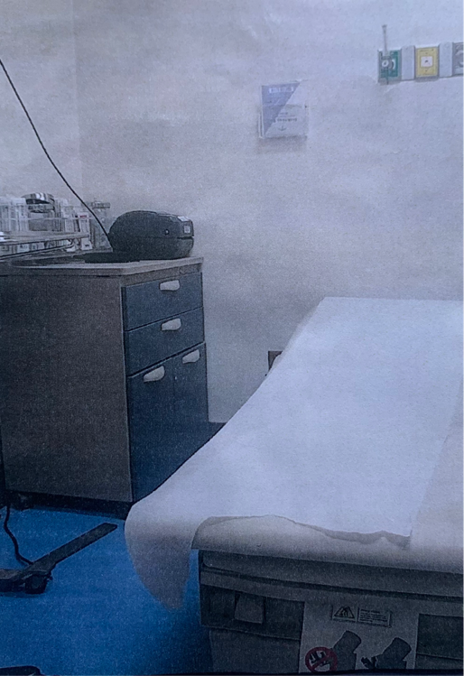

Plate 3.21: Patient room

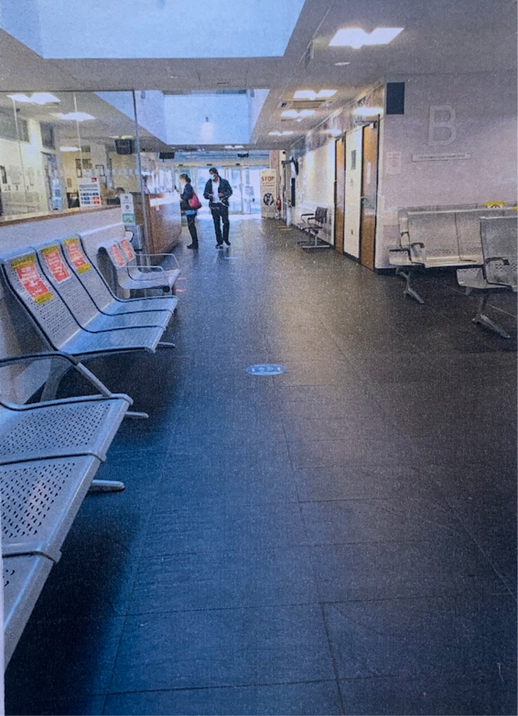

Plate 3.22: Waiting Room

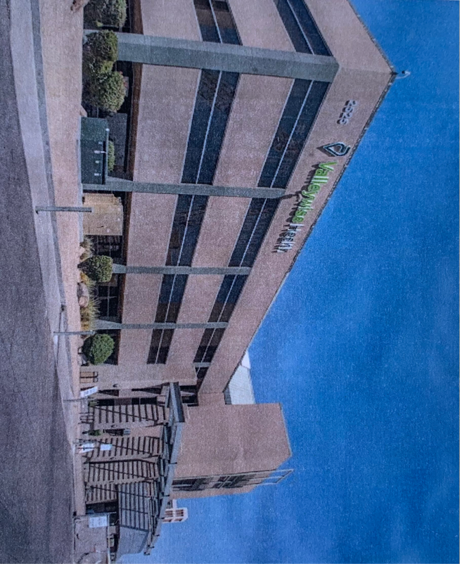
Plate 3.23: Exterior view

3.6: CASE STUDY 6: ONLINE CASE STUDY TWO
H.CLAUDE HUDSON COMPREHENSIVE HEALTH CENTER AT CALIFORNIA
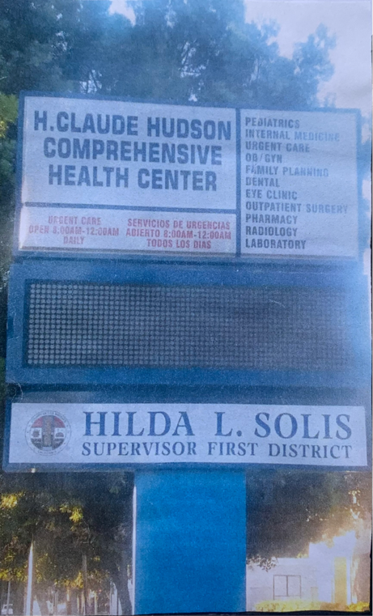
Plate 3.24: Showing the signboard

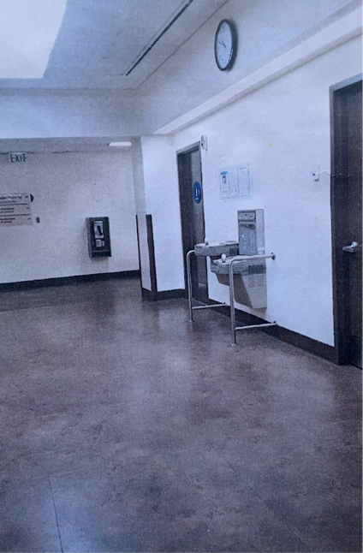
Plate 3.25: scan Area

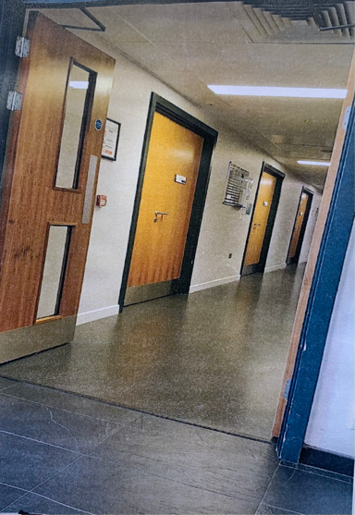
Plate 3.26: lobby

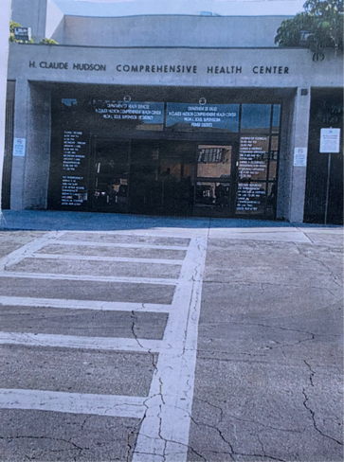
Plate 3.27: Approach View

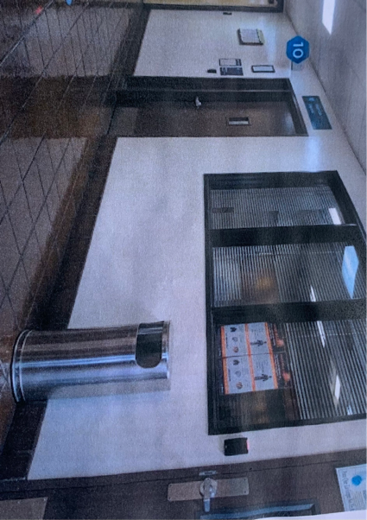
Plate 3.29: passage
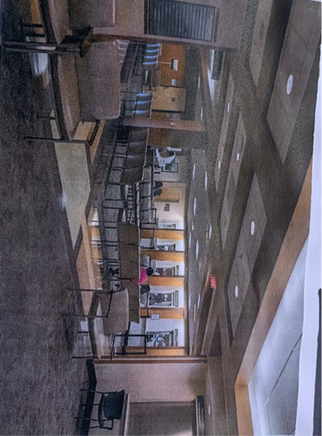
Plate 3.30: Waiting Area

CHAPTER FOUR
4.0 STUDY AREA/PROJECT SITE
4.1 HISTORY OF KWARA STATE
Kwara state is a state located in the North central region of Nigeria and it was created on May 27,1967, by General Yakubu Gowon, along with 11 other state. It was originally named the west central state but was later renamed kwara, which is a local name for River Niger.
The region was conquered by the Fulani in the 19th century and was part of the greater Fulani empire until it was defeated by the forces of sir George Goldie’s Royal Niger company in 1897. It was then incorporated into the protectorate of Nigeria in 1914.
Kwara state is bordered by Benin to the west and by the Nigerian state of Niger to the North, kogi to the east, and Ekiti, Osun and oyo to the South. The state mostly consists of wooded savanna, but there are also forested regions in the south.
As of 2006, the population of kwara state was around 2.3million, making it the 30th most populous state in Nigeria.

4.2 LOCATION OF SITE
The Site proposed for this project is located at Ajelanwa Zango, Ilorin, kwara state.
Kwara State is situated in central Nigeria. It is bordered by Niger State to the north, Kogi State to the east,Benue State to the south, and Osun State to the west. Its capital is Ilorin. Kwara State was created on July 3, 1967, during the military regime of General Yakubu Gowon. The state was carved out of the Western Region, which at that time included the present-day states of Lagos, Ogun, Oyo, Osun, and Kwara. The creation of Kwara State was aimed at providing better administration and development opportunities for the people of the region. The state is named after the Kwara River, which runs through it. Kwara State has an area of approximately 27,500 square kilometers (10,599 square miles). This makes it the 16th largest state in Nigeria in terms of land size. Kwara State has a geographical coordinate of approximately 8.5298° North latitude and 4.7540° East longitude. Its location in central Nigeria places it within the tropical climate zone, characterized by hot temperatures and significant rainfall during the rainy season. The capital city of Kwara State is Ilorin. Ilorin is the largest city in the state and serves as the administrative, economic, and cultural center. The city has a rich history and is known for its diverse population, traditional markets, and educational institutions.

4.2.1 Site Location Map

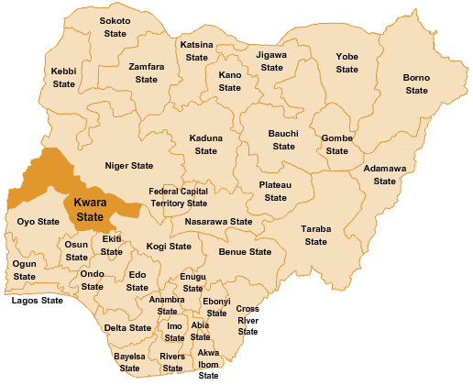

Figure 4.1: Map of Nigeria Showing kwara State
Source: google, 2024

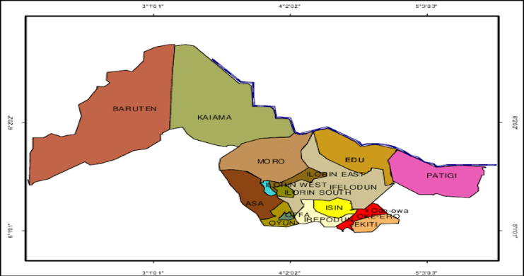

Figure 4.2: Map of kwara State
Source: google, 2024

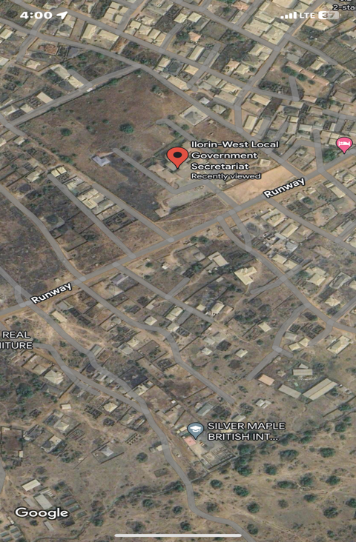

Plate 4.1: The proposed site in Ilorin west local government

4.3 SITE INVENTORY AND SITE ANALYSIS
Site inventory is a comprehensive documentation of the physical characteristics, features and conditions of a site. It typically includes: location and boundaries, topography, and drainage, vegetation, soil and geology, water resources and hydrology, climate and weather patterns, existing infrastructure, land use and zoning, environmental conditions ( if applicable ), photographs and maps.
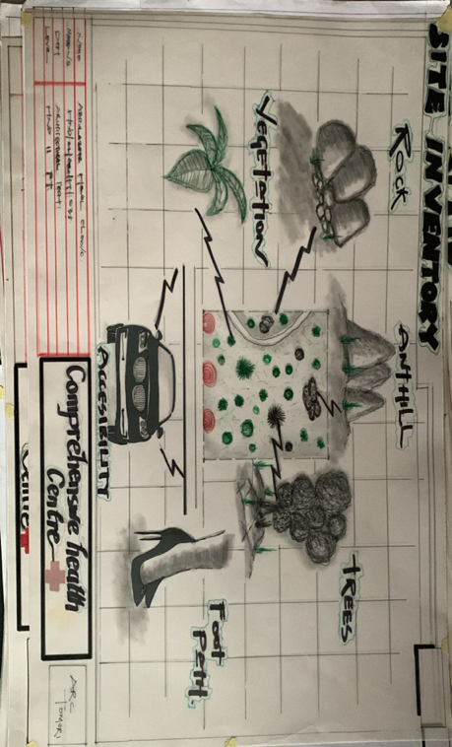
Figure 4.3: Site inventory of the proposed site
Source: Author’s field work 2025

Site Analysis is a thorugh examination and evaluation of site’s conditions, characteristics and context. It involves gathering and analyzing data to understand the site. The goals of the site analysis are to identify site constraints and opportunities, inform design and development decisions, ensure environmental sustainability, respect cultural and historical heritage and enhance the site’s potential.

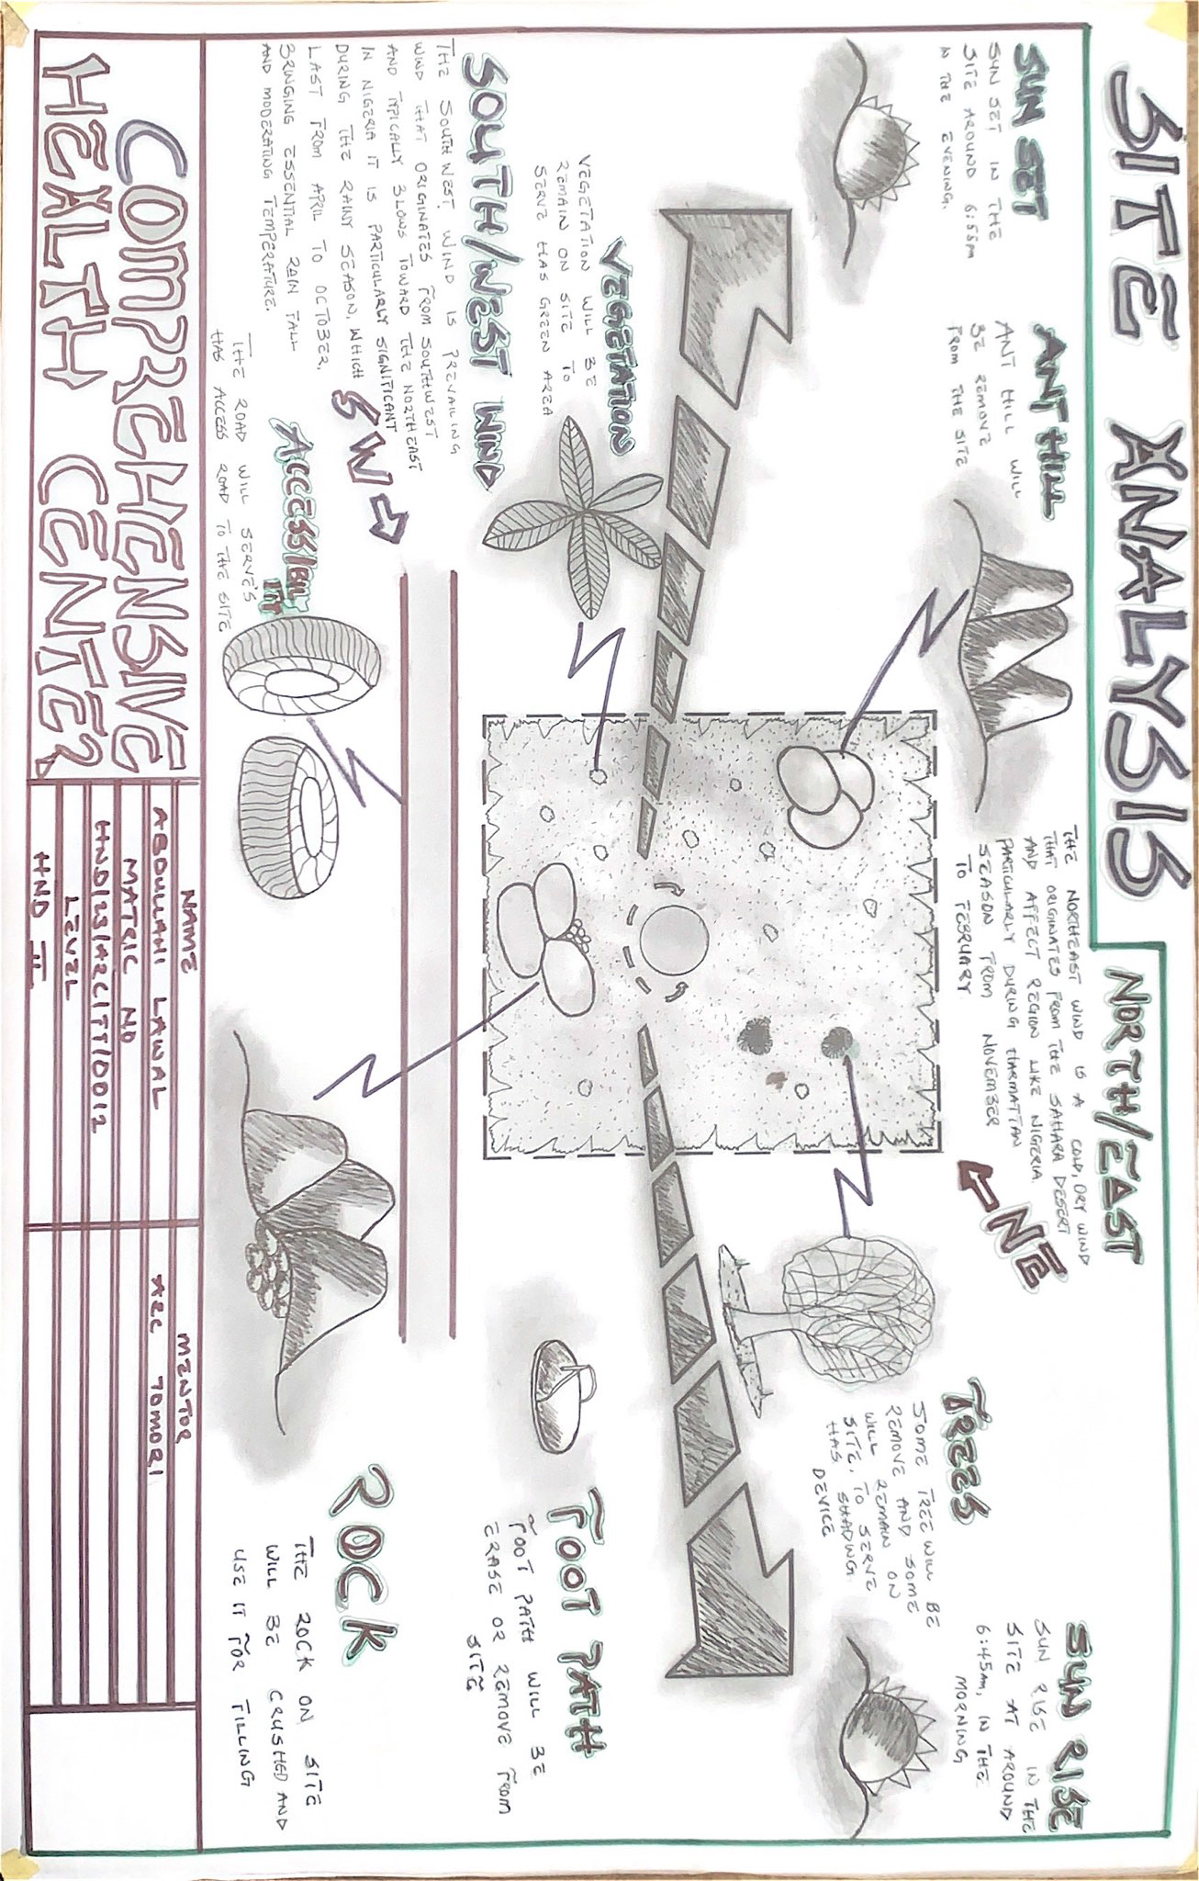
Figure 4.4: Site Analysis of the proposed site
Source: Author’s field work 2024

4.4 SITE CHARACTERISTICS
Site characteristics are the features of the site. They are realized during the inventory of the site for analysis of impact on the proposed project on the chosen site.
4.4.1 CLIMATE
Mild heat can be experienced throughout the major period of the year on the site, the climatic condition is still considered favourable and heat gain is at normal level. Solar energy can be adopted for energy usage on site.
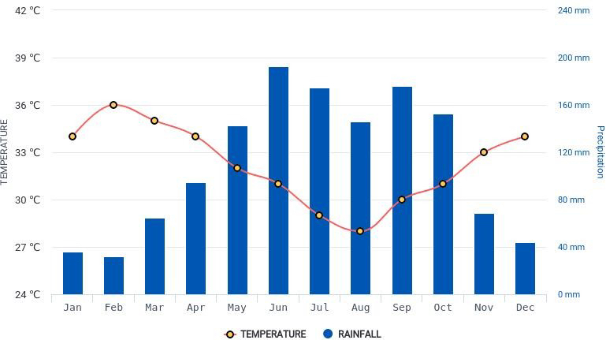

Figure 4.5: Climate of the Site
Source: hikersbay, 2024

4.4.2 RAINFALL
Kwara typically receives about 101.45millimeters (3.99 inches) of precipitation and has 148.38 rainy days (40.65% of the time) annually.
Ilorin experiences two climatic season i.e rainy and dry season. The rainy season is between march and november with a brief break in august and the annual rainfall varies from 1200mm
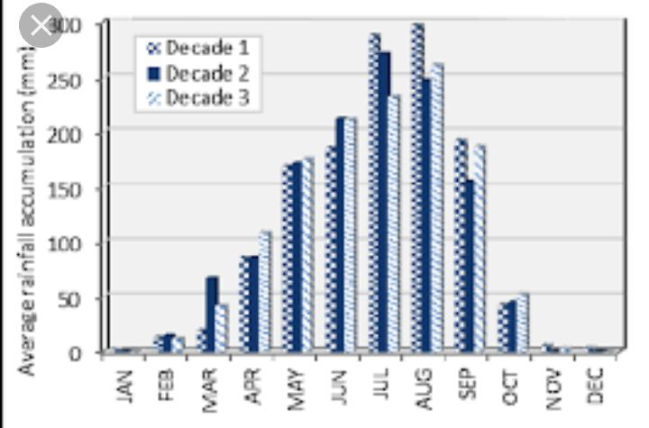
Figure 4.6: Graph of Rainfall in Ilorin

4.4.3 HUMIDITY
Kwara under certain factors experiences high relative humidity with high rainfall during the month june, july, august, and September.
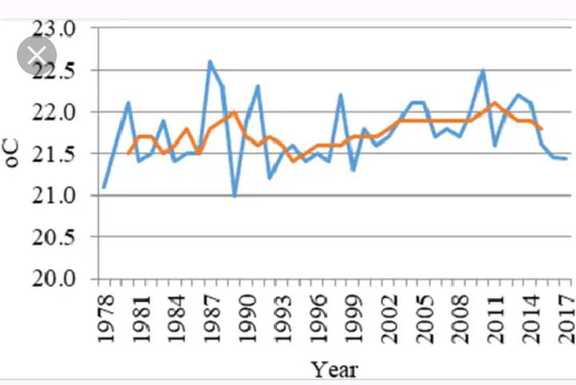

Figure 4.7: Graph of humidity in kwara state

4.4.4 : SOIL TYPE

The nature of the site is confirmed during the inventory to be wet and clumpy. This is known to be a loamy/clayey soil

4.4.5 : TOPOGRAPHY

The site is slightly sloppy towards the south of the site and this can be a good consideration for the drainage system.

4.4.6 : VEGETATION

The site is majorly a Savannah grassland with scattered trees and shrubs. It is specified that the some existing trees will also be retained to beauty of landscape

4.4.7 : DRAINAGE

The drainage available in proximity to the site is along the access road axis. It is through this axis all drainage to be designed on the site would be channels and directed towards following the site topography.
4.4.8 ACCESSIBILITY
There is a major express road along the North axis of the site which allow for efficient and effective vehicular movement. There will be a proposed access road that will lead to the site from the major road.
4.4.9: SITE FEATURES AND INFRASTRUCTURE
There is no existing building on the site. The site is composed mainly of grass and trees which are to be uprooted. Any further excavations can be used in the backfilling of the foundation.
4.4.10: Noise Sources
Minor noise source on the site originates from the major express road to the site. It is regarded as minor because the proposed buildings are quite at a distance from the major road. Major noise will originate from the service centre within the site through use of tools and machinery.
4.5: SITE ANALYSIS (PHYSICAL AND CLIMATIC)
4.5.1: TEMPERATURE
Ilorin, Nigeria, experiences a tropical savanna climate, characterized by high temperatures and distinct wet and dry seasons. The average annual temperature in Ilorin ranges from 23°C to 28°C (73°F to 82°F). The wet season, which lasts from March to October, is typically hot and humid, with average temperatures ranging from 25°C to 32°C (77°F to 90°F). The dry season, lasting from November to February, is cooler with average temperatures ranging from 20°C to 30°C (68°F to 86°F). However, temperatures can sometimes reach up to 38°C (100°F) during the hottest months of the dry season. It is also important to note that Ilorin's elevation and its location in the interior of Nigeria can result in slightly cooler temperatures compared to coastal areas.
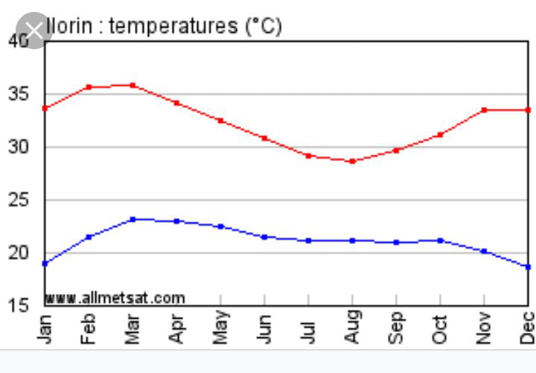

Figure 4.8: Graph of temperature in Ilorin
4.5.2 :Precipitation
The average annual precipitation in Ilorin, Nigeria, is approximately 1400-1600mm (55-63 inches). However, the amounts can vary greatly from year to year and between different parts of the city. The city experiences two distinct seasons: the wet season, which lasts from March to October, and the dry season, which lasts from November to February. The wet season is characterized by heavy rainfall, while the dry season is typically hot and dry with little to no rainfall. It is important to note that these averages are subject to change due to factors such as climate change and local weather patterns.

4.5.3: Sunshine
Ilorin, Nigeria, enjoys a significant amount of sunshine throughout the year due to its tropical savanna climate. The city experiences two distinct seasons: the wet season and the dry season. The wet season lasts from March to October and is characterized by heavy rainfall. During this period, the daily duration of sunshine can be shorter due to the cloud cover, but the city still receives a considerable amount of sunlight. The dry season lasts from November to February and is marked by hot and dry weather. This is the period when Ilorin experiences the most sunshine, with long hours of daylight and relatively clear skies. The average daily duration of sunshine during the dry season can range from 7 to 9 hours. It is important to note that sunshine hours can vary from year to year and may be influenced by factors such as local weather patterns and climate change.

4.5.4: Wind
Ilorin, like many other parts of Nigeria, experiences varying wind conditions throughout the year. However, specific wind patterns and speeds for Ilorin are not widely available. In general, the country experiences two wind seasons: the southwest monsoon and the harmattan. The southwest monsoon occurs during the wet season (March to October), when winds blow from the southwest, bringing in moisture from the Atlantic Ocean. These winds can sometimes be strong and gusty, particularly during the peak of the rainy season. The harmattan is a dry, dusty wind that occurs during the dry season (November to February). It originates from the Sahara Desert and blows from the northern direction. The harmattan can cause significant temperature drops, reduced visibility, and increased air pollution. It's important to note that wind patterns can vary from year to year and can be influenced by local geography and weather conditions.

4.5.5: Man Made Features:
i. Electricity: Electricity is supply to the site through overhead cables along the site boundary.
ii. Drainage system: The drainage flow through the site towards the road where there is provision of covert along the road.
iii. Footpath: Presence of footpath across the site.

Figure 4.9: Showing site analysis.
Source: Author’s field work 2025

CHAPTER FIVE

5.0 Appraisal of Proposed Scheme
5.1 Design Appraisal
In any project design, there are two basics factors that should be taken into consideration. These factors are functionally and aesthetics of the design, although to some designers, aesthetics and functionally of any building are impartibly but in the case of project both aesthetics and functionality of the design were take care of to satisfy the highly demanded functional requirement and to create aesthetically and proportionally balanced design.
The functional efficiency of institute of business and vocational studies depends largely on the closeness of the immediate section that are strongly related in function all these are being taken up as seen on the site and floor respectively.
Construction Methodology
The choice of materials and constructions techniques is influence by a number of factors.
i. The cost of Materials
ii. The climate condition as it affects material
ii. The topography of the site
iii. iv. Economics: the initial cost and maintenance cost should be reasonable.
iv. The availability of construction materials. vi.​The durability and suitability of materials.
Services
Electricity to trap from the nearest pole of the institute building. The main water pipeline is closely located to the site where drinking water can be tapped telephone line is within the polytechnic which makes connection easy. All of the drains ruins to the surrounding gutter which finally drains to the solid and liquid waste are effectively dispose of by the soak away put and septic tanks.
Circulation
Horizontal circulation based on guided principle of separating human activities from reticular activities.

Ventilation
1. Natural Ventilation: these ventilation is experienced in the building through openings. This depends on material wind force and their directions of movement due to the temperature, different between the air and the building.
2. Artificial Ventilation: this method of ventilation is often used to improve the colonies of the interior of the units. Such artificial mechanism include fan and air conditioners where necessary.
Lighting
This is a means of providing brightness naturally by sun or moon or artificially by lamps good natural and artificial lighting is important in lecture room and library. It always easy to make mistake and time the eye is in a situation of poor lightening.
Plumbing
Water services are necessary in an installation and both the scope and design of these systems are subjected to statutory and water authority regulation. There is need to install water system to guide against water supply failure. Adequate installation of pipes are recommend.
Electrical Installation
The light fitting should be designed to avoid glare and should be easy to clean and maintain the main sources of electricity supply shall be from the Power Bolding Company of Nigeria but since it is well known that PHCN cannot guarantee uninterrupted services of electricity supply.
Water Disposal
Site slopes is of major factors to be considered in the location and changeling of drains, the use of reinforced concrete drainage covered with precast lead and drainage pipe will be constructed from where waste water will be carried to the drainage zones on the site using surface drainage system.
Fire Protection
Building regulations and construction with local fire authority backed up by insurance policy survey takes care of fire protection.
Noise Control
The is an unpleasant sound often load harsh excessive noise and liberation can cause fatigue, leading to errors and general dissatisfaction in the classrooms, lecture, library, external noise could be easily be controlled with the aid of landscape materials and enough setbacks.
Orientations
The orientation of a building involves the arrangement of the building toward a way from the surreys across or along the trade winds normally determine the thermal comfort in the building.
Sun and Wind Breaking
In the pre-ventilation design gets rid excessive heat moisture and obvious product such as smoke moisture (generator house) and dust the use of terrace couple with spacious and useful often courtyard to avoid all functional part of the building enough natural ventilation
Materials and Finish
The influencer of building material on construction work in Ibadan and its environment is similar to what prevail in the middle belt of the country.
The materials choice and finishes are influenced by the following:
i.​The durability and suitability of materials
ii.​Geology and topography of the site
iii.​Availability of materials
iv.​The climatic condition
v.​Prospective of materials
vi.​The cost of materials
Roof
Roof should preferably of light weight construction with parapet converging it and the external super should absorb as little solar energy as possible.
Ceilings
Suspended ceiling is used in some lecture room with fang ceiling suitable center to center.
Doors
The door type and size depend on the door location but generally metal door are used for the administrative block, mechanical workshop, aluminum glass door and steel door are used.
Window
The windows uses are glassed pivot aluminum windows.
5.2​Recommendations
In carrying out the research works, there are several problems challenges and shortcomings noticed thereby using this medium to recommend some solutions.
The government should try to build more standard comprehensive health care center.
5.3Conclusion and Summary
There is ongoing debate over the Universal health coverage that it can be achieved through primary health care services. To accomplish the universal health coverage India has taken so many steps starting from primary health care services strengthening by upgrading the infrastructure of primary, secondary health care delivery system in health and wellness centers through which comprehensive
primary health care services are disseminating all over the country. We have come so far from our lacking and bringing up the public health system to another level. But still there are some challenges to nail our vision of health for all. Challenges like funding issues of services, shortage of manpower in health care centers, vague role of private sector towards the goal of achieving universal health coverage are the speed breakers in our path. We have more to go towards our dream to achieve
“Health for all”.

REFERENCES

Adams, R., Smith, J., & Williams, K. (2024). The impact of telehealth on comprehensive health care centers: A systematic review. Journal of Telemedicine and Telecare, 30(2), 115-126.

Baker, T., & Morris, L. (2024). Digital health tools in comprehensive care: Opportunities and challenges. Health Informatics Journal, 30(3), 220-234.

Brown, M., & Patel, R. (2024). Access to care in comprehensive health care centers: Addressing health disparities. Journal of Community Health, 49(4), 567-578.

Garcia, P., Williams, A., & Thompson, J. (2023). Effectiveness of comprehensive health care centers in reducing health disparities. American Journal of Public Health, 113(6), 789-798.

HHS. (2023). Federal funding opportunities for comprehensive health care centers. U.S. Department of Health and Human Services. Retrieved from [HHS website].

Jones, A., Lee, K., & Chang, T. (2023). The sustainability of independent comprehensive health care centers: Financial and operational perspectives. Health Services Research, 58(2), 302-317.

Lee, J., & Chang, T. (2023). Outcomes of diabetes management in comprehensive health care centers. Diabetes Care, 46(7), 1432-1441.

Martin, L., Patel, R., & Adams, H. (2023). Financial challenges in comprehensive health care centers: A review. Healthcare Financial Management, 77(1), 45-53.

Patel, S., Garcia, M., & Williams, R. (2024). Systematic review of patient outcomes in comprehensive health care centers. Journal of Healthcare Quality, 46(2), 120-133.

Smith, J., Morris, R., & Brown, K. (2023). Integrated vs. independent models of comprehensive health care centers: A comparative analysis. Health Policy Review, 12(4), 455-468.

Thompson, J., Lee, K., & Brown, M. (2024). Patient-centered care in large integrated comprehensive health care centers. Patient Experience Journal, 11(1), 22-34.

WHO. (2023). Comprehensive health care center definitions and models. World Health Organization. Retrieved from [WHO website].

Wright, C., Adams, R., & Patel, S. (2024). Artificial intelligence in comprehensive health care centers: Future prospects. Journal of Artificial Intelligence in Healthcare, 10(1), 88-99.

APPENDIX
Appendix I: Location map

Appendix II: Site analysis

Appendix III: Site plan

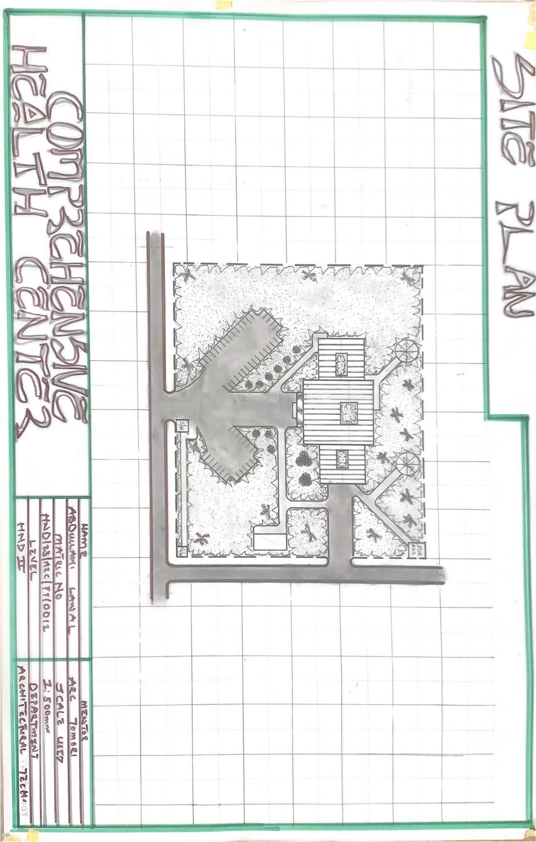

Appendix VI: Ground floor plan
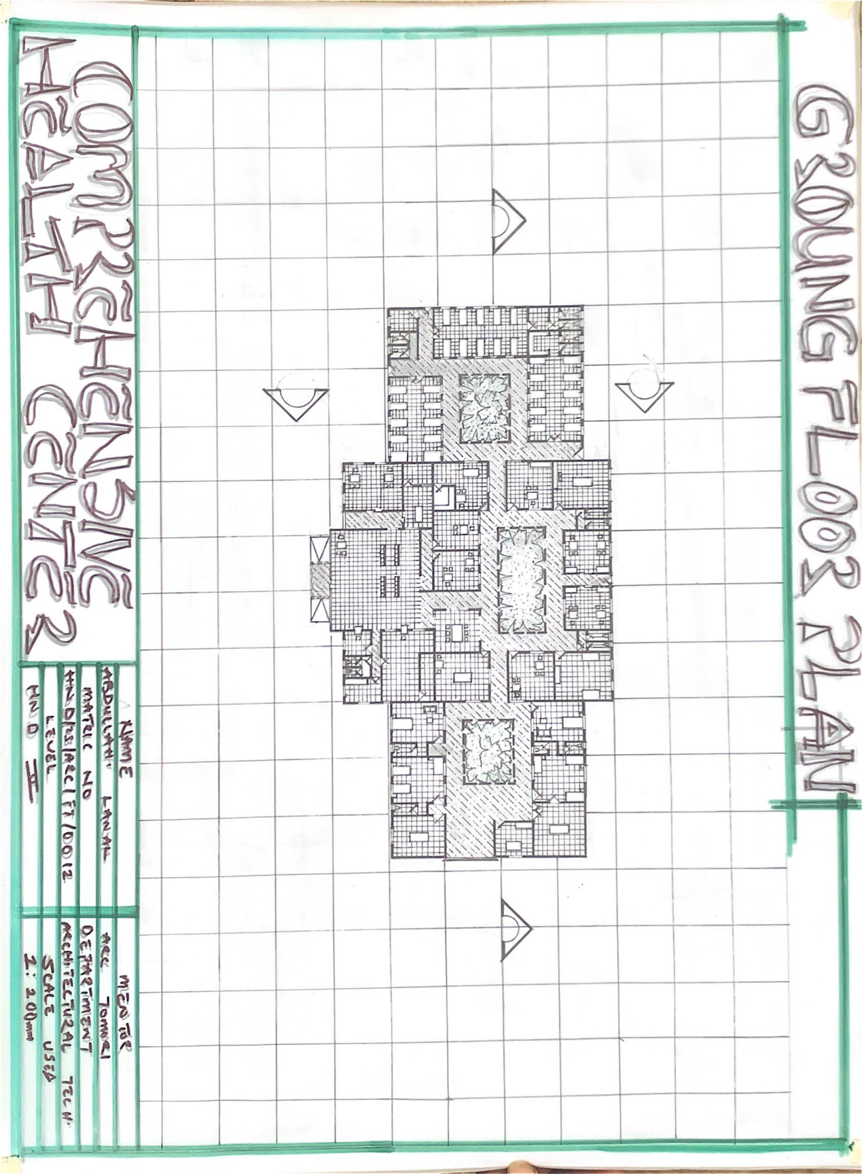

Appendix V: Section plan

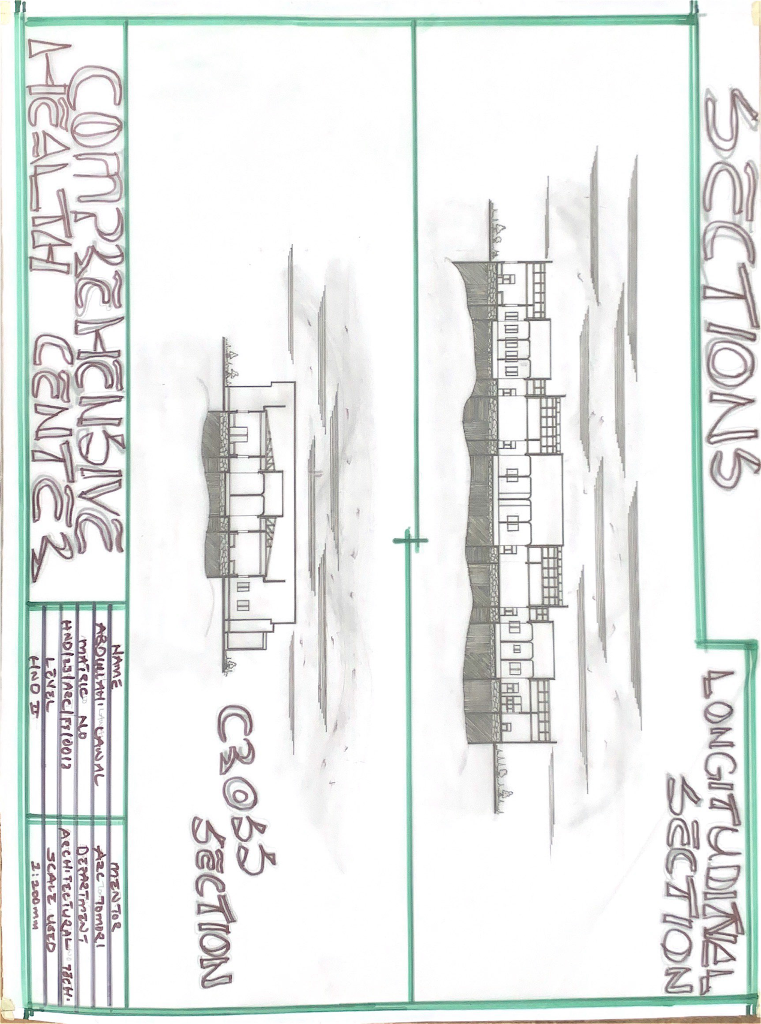

APPENDIX VI: ELEVATION

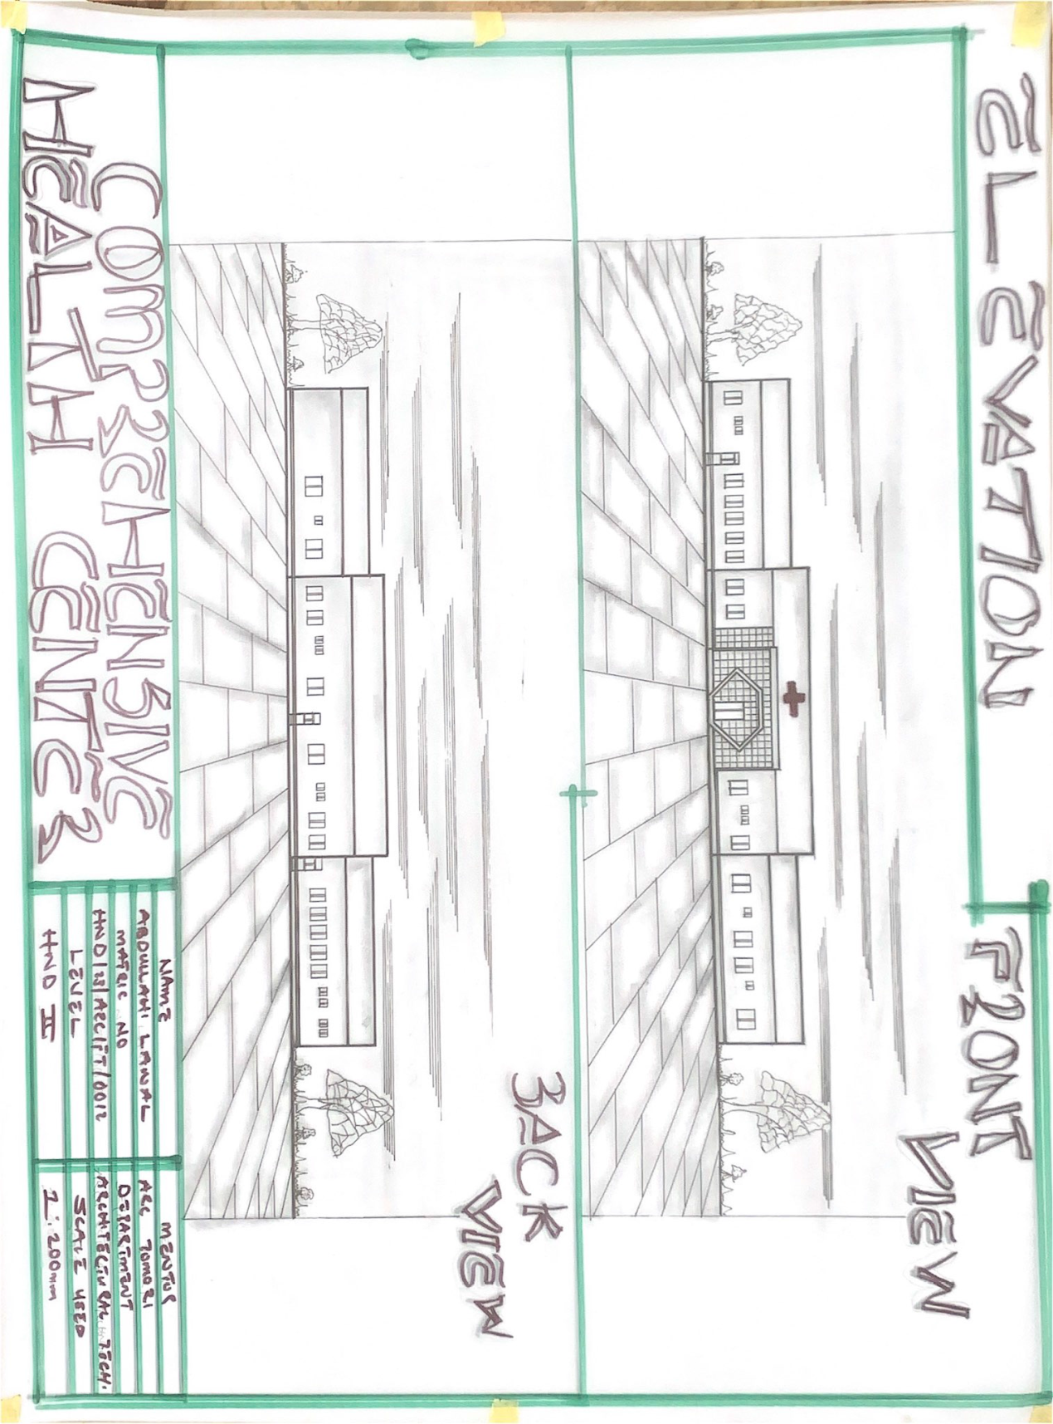

Appendix VII: Perspective

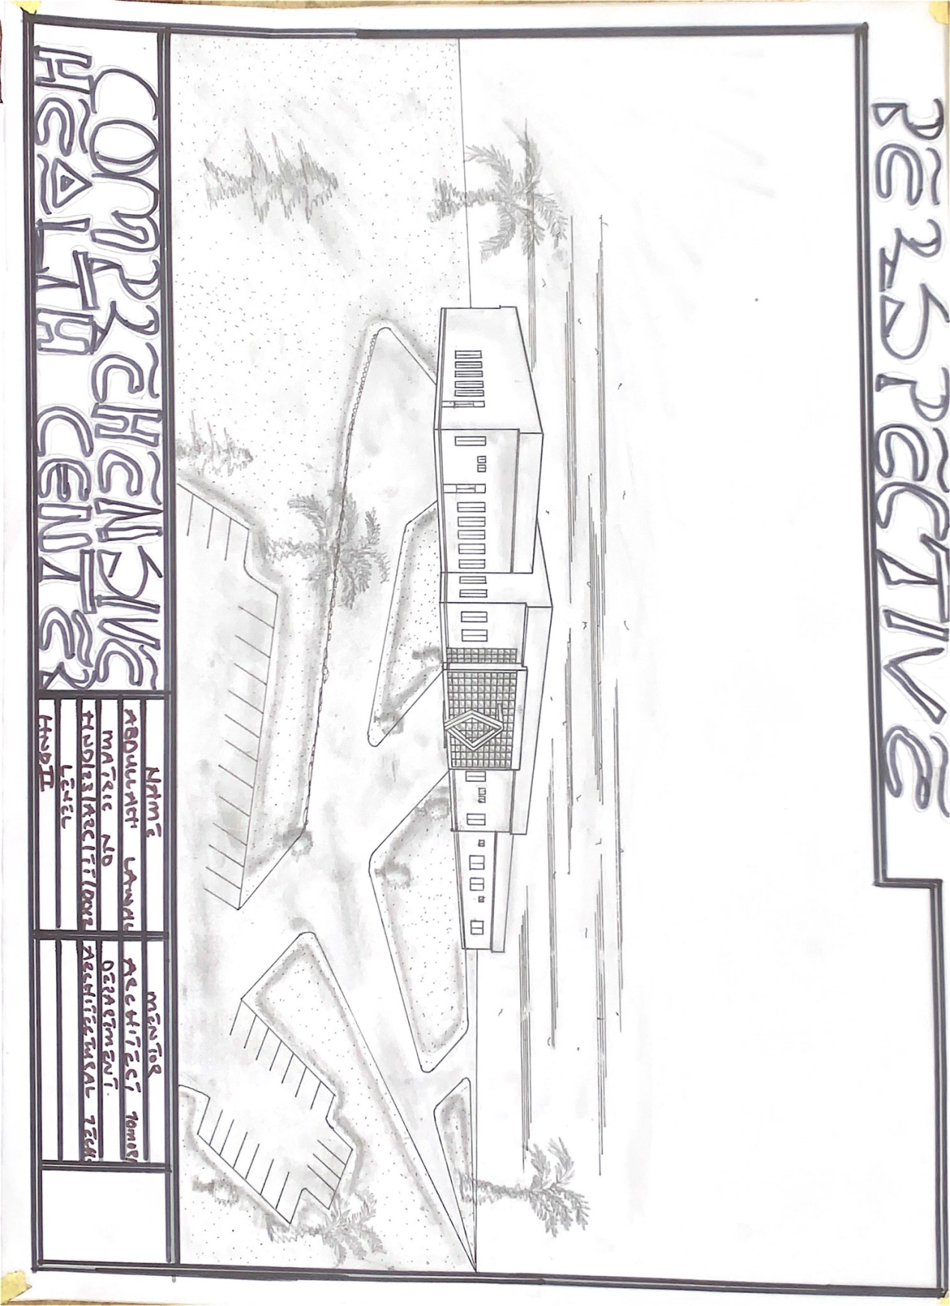

APPENDIX VIII: DETAILING

