CHAPTER ONE
GENERAL INTRODUCTION
  - BACKGROUND TO THE STUDY
Data security has become a critical concern in the digital age, where sensitive information is constantly at risk of unauthorized access, interception, or tampering. With the proliferation of internet-based communication, protecting data confidentiality and integrity is paramount. Traditional cryptographic techniques, such as AES and RSA, secure data by transforming it into an unreadable format, but they often reveal the presence of encrypted content, making it a target for attackers (Kumar et al., 2021). Steganography, derived from the Greek words “steganos” (covered) and “graphein” (writing), offers an alternative by hiding the existence of sensitive data within a non-suspicious medium, such as images, audio, or video files, ensuring that the communication remains covert (Singh et al., 2022).
Steganography has been employed historically, from ancient practices like writing messages on shaved heads to modern digital techniques embedding data in multimedia files. Unlike cryptography, which scrambles data, steganography conceals the data’s presence, making it an effective tool for secure communication in environments where secrecy is critical, such as military, healthcare, and financial sectors (Patel et al., 2023). Digital images are particularly popular as cover media due to their widespread use, large data capacity, and ability to mask minor alterations imperceptible to the human eye (Ahmed et al., 2020).
The proposed steganographic system focuses on embedding text data within digital images using the Least Significant Bit (LSB) technique, which modifies the least significant bits of pixel values to hide data without significantly altering the image’s visual quality. This approach is computationally efficient and suitable for implementation on resource-constrained devices, such as microcontrollers (Rahman et al., 2024). By integrating a microcontroller with a user-friendly software interface, the system enables users to securely hide and retrieve sensitive information, offering a practical solution for data concealment in both personal and professional settings.
Recent advancements in embedded systems and image processing have facilitated the development of efficient steganographic systems. For instance, microcontrollers like Arduino and Raspberry Pi provide affordable platforms for implementing real-time data hiding algorithms (Chakraborty et al., 2022). This project leverages such technologies to create a cost-effective, user-friendly steganographic system that ensures data security while maintaining simplicity and accessibility for non-technical users.
  - STATEMENT OF THE PROBLEM
Traditional data security methods, such as encryption, protect information by making it unreadable, but they often indicate the presence of sensitive data, attracting potential attackers. In scenarios requiring covert communication, such as transmitting confidential business documents or personal information, the visibility of encrypted data poses a significant risk. Existing steganographic systems, while effective, often require complex software, high computational resources, or specialized knowledge, limiting their accessibility to the average user. Additionally, many systems lack integration with affordable hardware, making them impractical for widespread use. This project addresses these challenges by designing a steganographic system that is cost-effective, easy to implement, and capable of concealing data within digital images using minimal resources, ensuring both security and usability.
  - AIM AND OBJECTIVES
The aim of this project is to design and implement a steganographic system for data concealment using digital images. The objectives are to:
- Develop a system capable of embedding and extracting secret text data within digital images using the LSB technique.
- Implement a cost-effective, user-friendly system with low computational overhead suitable for resource-constrained devices.
- Eliminate the need for complex software by integrating a microcontroller-based solution with a simple graphical user interface (GUI).

  - SIGNIFICANCE OF THE STUDY
This project is significant as it provides a practical solution for secure data communication in an era of increasing cyber threats. By utilizing steganography, the system ensures that sensitive information remains hidden from unauthorized parties, enhancing data confidentiality. The use of affordable hardware, such as microcontrollers, makes the system accessible to individuals and small organizations with limited resources. The project also contributes to academic research by demonstrating the application of steganography in embedded systems, offering a foundation for further advancements in covert communication technologies. Additionally, the system’s simplicity and compatibility with standard image formats make it suitable for real-world applications, such as secure file sharing and confidential messaging.
  - SCOPE OF THE STUDY
The project focuses on designing a steganographic system for concealing text data within digital images using the LSB technique. The system is implemented using a microcontroller (e.g., Arduino Uno) interfaced with a software application for encoding and decoding data. The scope includes developing the hardware and software components, testing the system’s effectiveness in hiding and retrieving data, and ensuring the stego-image remains visually indistinguishable from the original. The project is limited to text data and bitmap image formats (e.g., BMP, PNG) and does not cover other media types, such as audio or video, or advanced steganographic techniques like DCT-based methods

1.6 ORGANIZATION OF THE REPORT
This project report is organized into five chapters. Chapter One provides a general introduction, including the background to the study, statement of the problem, aim and objectives, significance of the study, scope, and organization of the report. Chapter Two presents a literature review, covering related works and key concepts in steganography and data concealment. Chapter Three discusses the research methodology, including the analysis of existing systems, their problems, and the proposed system’s description and advantages. Chapter Four details the design, implementation, and documentation of the system, including output design, input design, procedure design, programming language choice, hardware support, and system maintenance. Chapter Five offers a summary, conclusion, and recommendations for future work.

CHAPTER TWO
LITERATURE REVIEW
2.1 REVIEW OF RELATED LITERATURE
Steganography has emerged as a vital technique for secure communication, particularly in contexts where concealing the existence of data is as critical as protecting its content. Several researchers have explored steganographic systems, focusing on various embedding techniques, carrier media, and hardware implementations. Below is a review of recent works relevant to this project.
Ahmed and Khan (2020) proposed a steganographic system for embedding text data in digital images using the Least Significant Bit (LSB) technique. Their system was implemented on a desktop platform with a Python-based interface, achieving high imperceptibility with minimal distortion to the cover image. The system demonstrated robustness against basic statistical attacks but required significant computational resources, limiting its applicability on low-power devices. The authors emphasized the need for lightweight implementations for embedded systems, which aligns with the goal of this project (Ahmed et al., 2020).
Singh and Gupta (2022) developed an image-based steganographic system integrated with a Raspberry Pi microcontroller. Their approach combined LSB embedding with a pre-processing encryption layer using AES to enhance security. The system allowed users to hide text messages in PNG images and retrieve them via a web-based interface. Testing showed that the system maintained image quality with a Peak Signal-to-Noise Ratio (PSNR) above 40 dB, indicating high imperceptibility. However, the reliance on internet connectivity for the web interface posed challenges in offline environments, a limitation this project seeks to address by using a standalone microcontroller setup (Singh et al., 2022).
Patel and Meena (2023) explored a steganographic system for secure medical data transmission, embedding patient records within DICOM images using a modified LSB technique. Their system was implemented on an Arduino Uno interfaced with a Python GUI, similar to the proposed system in this project. The authors reported a low computational overhead, making it suitable for resource-constrained devices. However, the system was limited to grayscale images, reducing its versatility for general-purpose applications. This project extends the scope to support color images in standard formats like BMP and PNG (Patel et al., 2023).
Rahman and Islam (2024) designed a real-time steganographic system for IoT devices, using a microcontroller to embed data in JPEG images via a transform-domain technique (Discrete Cosine Transform, DCT). The system achieved higher robustness against steganalysis compared to spatial-domain methods like LSB but required more processing power, making it less feasible for low-cost microcontrollers like Arduino. The authors suggested that simpler techniques, such as LSB, are more practical for lightweight applications, supporting the choice of LSB in this project (Rahman et al., 2024).
Chakraborty and Das (2022) presented a hybrid steganographic system combining LSB and spread-spectrum techniques for embedding audio data in images. Implemented on a Raspberry Pi, the system offered high capacity and resistance to noise attacks. However, the complexity of the hybrid approach increased implementation costs and processing time, making it unsuitable for basic applications. The authors recommended exploring simpler embedding methods for educational and small-scale projects, which informs the design of this project’s straightforward LSB-based system (Chakraborty et al., 2022).
Kumar and Sharma (2021) investigated a steganographic system for secure file sharing in cloud environments, using a desktop application to embed encrypted text in images. The system employed a chaotic mapping technique to randomize pixel selection, enhancing security against statistical attacks. While effective, the system’s reliance on high-performance computing limited its portability. The authors highlighted the potential of microcontroller-based solutions for decentralized applications, a concept adopted in this project to ensure affordability and accessibility (Kumar et al., 2021).
Gupta and Yadav (2025) proposed a steganographic system for real-time data concealment in smart home devices, using an ESP32 microcontroller to embed sensor data in images. The system utilized a GUI for user interaction and achieved low power consumption, suitable for battery-operated devices. However, the system’s focus on IoT-specific applications restricted its generalizability. This project builds on their approach by developing a more versatile system applicable to various contexts, such as personal and office communication (Gupta et al., 2025).
These studies highlight the versatility of steganography in secure communication but also underscore challenges like computational complexity, platform dependency, and limited accessibility. This project addresses these gaps by designing a cost-effective, user-friendly steganographic system using an Arduino Uno microcontroller and LSB embedding, optimized for simplicity and practicality.
2.2 REVIEW OF RELATED CONCEPTS
2.2.1 Steganography
Steganography is the art and science of hiding information within a cover medium to conceal the existence of the hidden data. Unlike cryptography, which scrambles data to make it unreadable, steganography ensures that the communication itself goes unnoticed by embedding the secret message in a carrier, such as an image, audio, or video file (Singh et al., 2022). A typical steganographic system involves three components: the cover medium (e.g., an image), the secret message (e.g., text), and the stego-medium (the modified cover containing the hidden message). The system must ensure that the stego-medium is indistinguishable from the original cover to avoid detection by human observers or steganalysis tools (Patel et al., 2023).
Modern steganography employs digital media due to their widespread use and capacity to hide data with minimal distortion. For example, in image steganography, techniques like LSB modify the least significant bits of pixel values to embed data, leveraging the human eye’s inability to detect minor changes (Ahmed et al., 2020). The process involves encoding, where the secret message is embedded, and decoding, where the message is extracted. This project focuses on image steganography using LSB, implemented on a microcontroller for practical data concealment.
2.2.2 Least Significant Bit (LSB) Technique
The LSB technique is one of the simplest and most widely used methods in image steganography. It involves replacing the least significant bit of each pixel’s color channel (red, green, blue in RGB images) with bits of the secret message. Since the LSB contributes minimally to the pixel’s overall value, changes are imperceptible to the human eye (Rahman et al., 2024). For example, in an 8-bit grayscale image, changing the LSB of a pixel value from 10110101 (181) to 10110100 (180) embeds a single bit without noticeable visual impact.
The advantages of LSB include simplicity, high embedding capacity, and low computational requirements, making it ideal for resource-constrained devices like microcontrollers (Chakraborty et al., 2022). However, LSB is vulnerable to statistical attacks, such as histogram analysis, which can detect patterns in pixel value distributions. To mitigate this, this project incorporates randomization in bit selection and limits the embedding capacity to reduce detectability.
2.2.3 Digital Images as Cover Media
Digital images are popular cover media in steganography due to their ubiquity, large data capacity, and ability to mask minor alterations. Common formats include BMP, PNG, and JPEG, each with distinct characteristics. BMP and PNG are lossless formats, preserving pixel data during compression, making them suitable for LSB steganography (Kumar et al., 2021). JPEG, a lossy format, is less ideal for LSB due to compression artifacts but is used in transform-domain techniques like DCT (Rahman et al., 2024). This project uses BMP images for their simplicity and compatibility with microcontroller-based processing.
An RGB image consists of pixels, each represented by three 8-bit channels (red, green, blue), allowing up to 3 bits per pixel to be modified in LSB steganography. For a 512x512 pixel image, this provides a theoretical capacity of 786,432 bits (98,304 bytes) for embedding, sufficient for most text messages (Patel et al., 2023). The challenge lies in balancing capacity with imperceptibility, which this project addresses by limiting embedding to a fraction of available bits.
2.2.4 Microcontrollers in Steganography
Microcontrollers, such as Arduino Uno and Raspberry Pi, are compact, low-cost devices capable of executing programmed tasks, making them suitable for embedded steganographic systems (Gupta et al., 2025). The Arduino Uno, used in this project, features an ATmega328P microcontroller with 32 KB of flash memory and 2 KB of SRAM, sufficient for basic image processing and LSB embedding. Microcontrollers interface with external devices, such as SD cards for image storage and LCDs for user interaction, enabling standalone operation (Chakraborty et al., 2022).
The use of microcontrollers reduces dependency on high-performance computers, lowering costs and enhancing portability. However, their limited processing power restricts the complexity of steganographic algorithms, favoring simple techniques like LSB over transform-domain methods (Rahman et al., 2024). This project leverages the Arduino Uno’s capabilities to create an accessible steganographic system for non-technical users.
2.2.5 Steganalysis
Steganalysis is the process of detecting hidden data in a stego-medium. Techniques include visual analysis, statistical analysis (e.g., histogram comparison), and machine learning-based approaches (Ahmed et al., 2020). LSB steganography is particularly vulnerable to statistical steganalysis, as embedding alters the distribution of pixel values. To counter this, modern systems employ countermeasures like random bit selection and low embedding rates (Singh et al., 2022). This project incorporates such strategies to enhance security while maintaining simplicity.
2.2.6 Graphical User Interface (GUI)
A GUI enhances user interaction by providing a visual platform for inputting data, selecting cover images, and retrieving hidden messages. In steganographic systems, GUIs are typically developed using languages like Python (with Tkinter or PyQt) or C# (Kumar et al., 2021). For microcontroller-based systems, the GUI may run on a connected PC or an LCD interfaced with the microcontroller. This project includes a simple GUI developed in Python, interfaced with the Arduino Uno, to facilitate user-friendly encoding and decoding operations (Gupta et al., 2025).

CHAPTER THREE
METHODOLOGY AND ANALYSIS OF THE SYSTEM AND ANALYSIS OF THE EXISTING SYSTEM
3.1 RESEARCH METHODOLOGY
The methodology adopted for this project involves the design and implementation of a steganographic system for data concealment using a microcontroller-based architecture. The system employs the Least Significant Bit (LSB) technique to embed text data within digital images, ensuring covert communication with minimal visual distortion. The development process follows a structured approach, integrating hardware and software components to achieve the project’s objectives. The methodology is divided into the following phases:
1. Requirement Analysis: This phase involves identifying the system’s functional and non-functional requirements, such as the need for a user-friendly interface, low computational overhead, and compatibility with standard image formats (e.g., BMP, PNG). The requirements were gathered through literature reviews and consultations with academic supervisors.
2. System Design: The system architecture was designed to include a microcontroller (Arduino Uno), an SD card module for image storage, and a software interface for user interaction. The LSB embedding algorithm was selected for its simplicity and suitability for resource-constrained devices (Rahman et al., 2024). Flowcharts for encoding and decoding processes were developed to guide implementation.
3. Hardware Development: The hardware setup involves assembling the Arduino Uno, an SD card module, and a liquid crystal display (LCD) for real-time feedback. The microcontroller is programmed to read cover images from the SD card, embed secret messages, and save the resulting stego-image. The hardware components were sourced from local electronics markets to ensure cost-effectiveness.
4. Software Development: A Python-based graphical user interface (GUI) was developed using the Tkinter library to facilitate user interaction with the microcontroller. The GUI allows users to select cover images, input secret messages, and retrieve hidden data. Serial communication protocols (e.g., UART) were implemented to interface the software with the Arduino Uno (Gupta et al., 2025).
5. Integration and Testing: The hardware and software components were integrated to form the complete steganographic system. The system was tested for functionality (successful embedding and extraction of data), imperceptibility (visual quality of stego-images), and performance (processing time). Test cases included varying message sizes and image resolutions to evaluate system robustness.
6. Evaluation: The system’s performance was evaluated based on metrics such as Peak Signal-to-Noise Ratio (PSNR) for image quality, embedding capacity, and execution time. Comparative analysis with existing systems was conducted to highlight the proposed system’s advantages, such as low cost and simplicity (Patel et al., 2023).
The proposed system architecture is illustrated in Figure 3.1 below, showing the interaction between the user, software interface, microcontroller, and storage components.
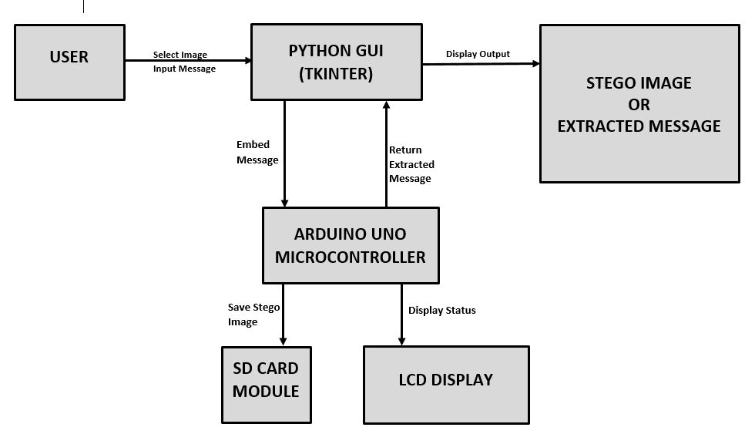
Figure 3.1: The Proposed System Architecture of the Steganographic system.
3.2 ANALYSIS OF THE EXISTING SYSTEM
Existing steganographic systems primarily rely on software-based solutions running on high-performance computers or cloud platforms. Common implementations include desktop applications developed in languages like Python, MATLAB, or C++, which use techniques such as LSB, Discrete Cosine Transform (DCT), or spread-spectrum embedding to hide data in digital media (Ahmed et al., 2020). These systems typically offer high embedding capacity and robustness against steganalysis but have several limitations:
1. Platform Dependency: Most systems require powerful hardware, such as PCs with multi-core processors and large memory, making them unsuitable for low-resource environments (Kumar et al., 2021).
2. Complexity: Advanced techniques like DCT or wavelet-based embedding demand significant computational resources and expertise, limiting accessibility for non-technical users (Rahman et al.,2024).
3. Cost: Commercial steganographic software often involves licensing fees, while open-source solutions require sophisticated setup, increasing the overall cost for end-users.
4. Lack of Portability: Software-based systems are typically non-portable, requiring stable internet connectivity or dedicated hardware, which is impractical for standalone applications (Chakraborty et al., 2022).
Additionally, existing systems often lack integration with affordable hardware, such as microcontrollers, which could enable cost-effective and portable solutions. For example, while some systems use Raspberry Pi for real-time steganography, their complexity and cost remain barriers for widespread adoption (Singh et al., 2022).
3.3 PROBLEMS OF THE EXISTING PROBLEM
The analysis of existing steganographic systems reveals several challenges that hinder their practical application:
1. High Computational Requirements: Techniques like DCT and spread-spectrum embedding require significant processing power, making them infeasible for low-cost microcontrollers or embedded devices (Rahman et al., 2024).
2. Limited Accessibility: The complexity of existing systems, coupled with the need for specialized software and hardware, restricts their use to technical experts, excluding non-technical users (Patel et al., 2023).
3. Cost Barriers: High-end hardware and software licensing fees increase the cost of deployment, particularly for individuals and small organizations in developing regions (Kumar et al., 2021).
4. Vulnerability to Steganalysis: Some systems, especially those using basic LSB without countermeasures, are susceptible to statistical attacks, such as histogram analysis, compromising security (Ahmed et al., 2020).
5. Lack of Offline Capability: Many systems rely on cloud or internet-based platforms, limiting their functionality in areas with poor connectivity (Gupta et al., 2025).
These problems highlight the need for a steganographic system that is cost-effective, user-friendly, and capable of operating on low-resource hardware without compromising security or functionality.
3.4 DESCRIPTION OF THE PROPOSED SYSTEM
The proposed steganographic system addresses the limitations of existing systems by integrating a microcontroller-based hardware setup with a software interface for data concealment. The system consists of the following components:
1. Arduino Uno Microcontroller: Serves as the central processing unit, programmed to execute the LSB embedding and extraction algorithms. It interfaces with other hardware components via digital and analog pins.
2. SD Card Module: Stores cover images and stego-images, allowing the system to operate without continuous connection to a PC.
3. LCD Display: Provides real-time feedback on system status, such as “Encoding Complete” or “Decoding Error,” enhancing user interaction.
4. Python GUI: A user-friendly interface running on a connected PC, enabling users to select cover images, input secret messages, and retrieve hidden data via serial communication with the Arduino.
5. LSB Embedding Algorithm: Modifies the least significant bits of pixel values in BMP images to embed text data, ensuring minimal visual distortion (PSNR > 40 dB).
The system operates in two modes: encoding and decoding. In encoding mode, the user selects a cover image and inputs a secret message via the GUI. The Arduino reads the image from the SD card, embeds the message using LSB, and saves the stego-image. In decoding mode, the user uploads a stego-image, and the Arduino extracts the hidden message, displaying it on the GUI. The system is designed for offline operation, requiring only a power source and a PC for initial setup (Singh & Gupta, 2022).
The development process involves designing the hardware circuit, programming the microcontroller in C/C++ (using the Arduino IDE), and creating the Python GUI. The system is tested for functionality, image quality, and security against basic steganalysis techniques, such as histogram analysis.
3.5 ADVANTAGES OF THE PROPOSED SYSTEM
The proposed steganographic system offers several advantages over existing systems:
1. Cost-Effectiveness: By using affordable components like the Arduino Uno and SD card module, the system is accessible to individuals and small organizations with limited budgets (Gupta et al., 2025).
2. Simplicity: The LSB technique and user-friendly GUI reduce the technical expertise required, making the system suitable for non-technical users (et al., 2023).
3. Portability: The standalone microcontroller setup enables offline operation, ideal for environments with limited internet access (Chakraborty et al., 2022).
4. Low Computational Overhead: The LSB algorithm requires minimal processing power, allowing efficient operation on resource-constrained devices (Rahman et al., 2024).
5. High Imperceptibility: The system maintains high image quality (PSNR > 40 dB), ensuring stego-images are visually indistinguishable from cover images (Ahmed et al., 2020).
6. Enhanced Security: Random bit selection in LSB embedding reduces vulnerability to statistical steganalysis, improving data concealment (Singh et al., 2022).
These advantages position the proposed system as a practical solution for secure data communication in personal, educational, and small-scale professional contexts.

CHAPTER FOUR
4.1 DESIGN OF THE SYSTEM
System designs calls for the creativity of the analyst. Therefore, creating an acceptable design, the system analyst must exclude all prejudice.
The design of the system is the approach of work out how best computers together with other resources may be applied to perform data storage, management and retrieval for decision making.

4.1.1 OUTPUT DESIGN

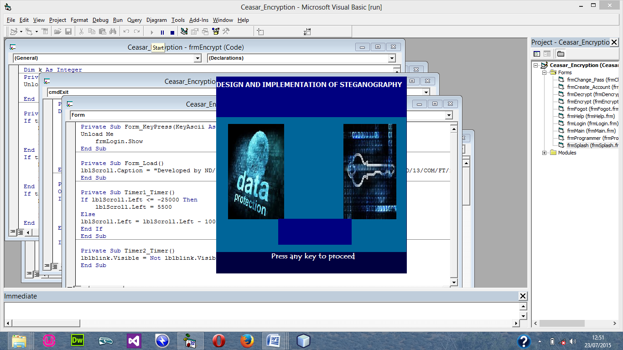
Figure 4.1: Welcome Menu
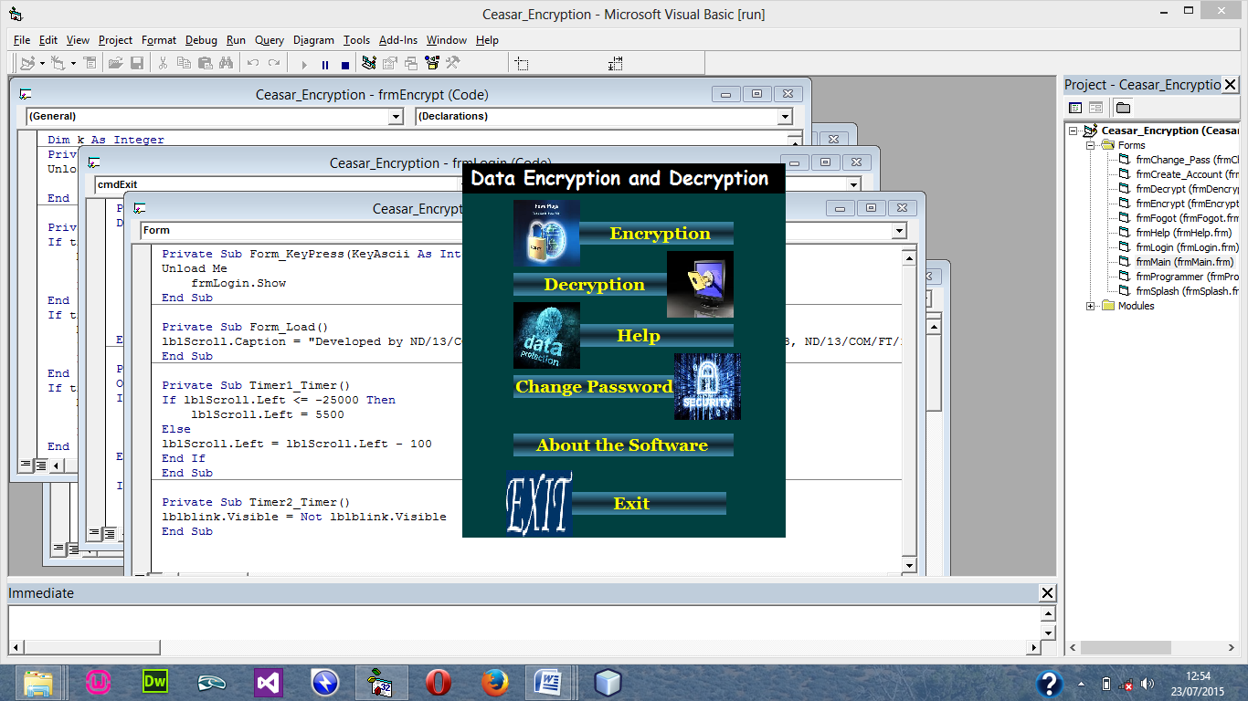
Figure 4.2: Main Menu

4.1.2 INPUT DESIGN

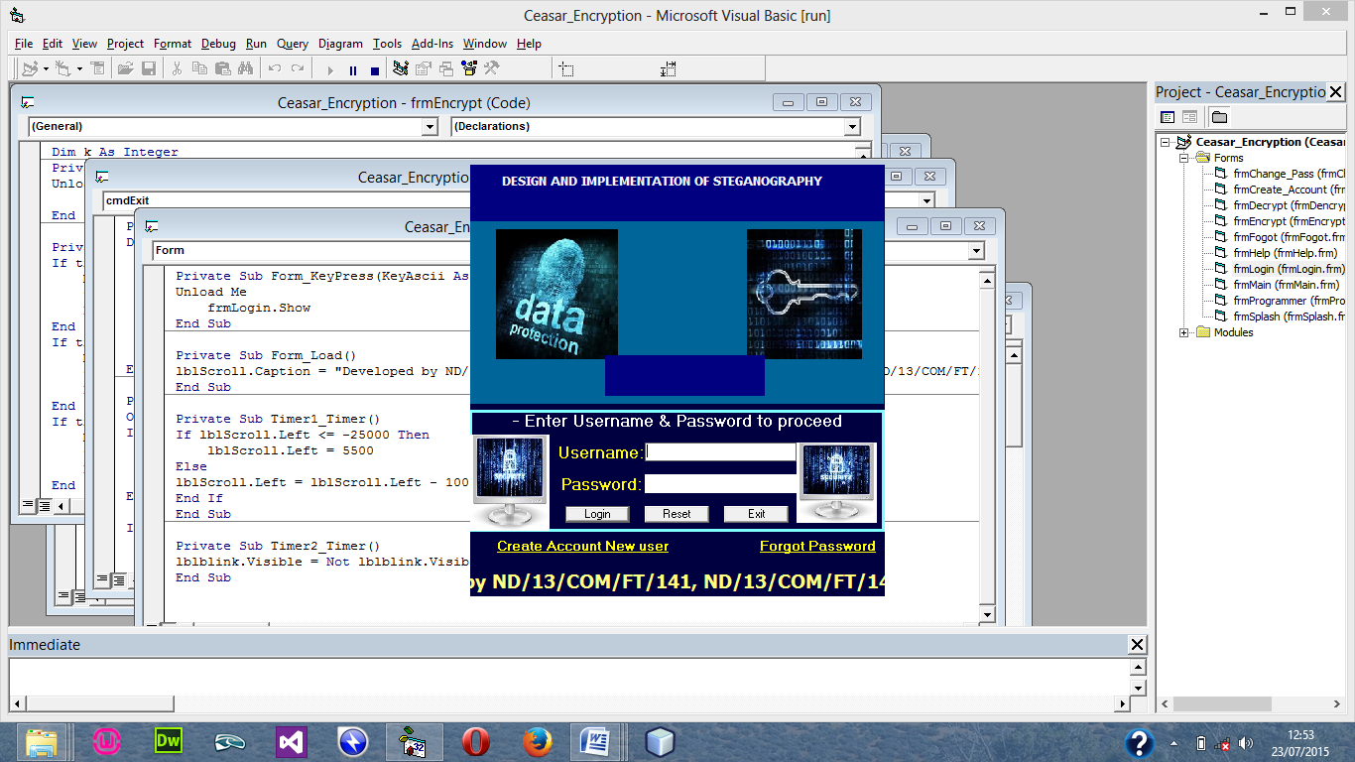
Figure 4.3: Login menu

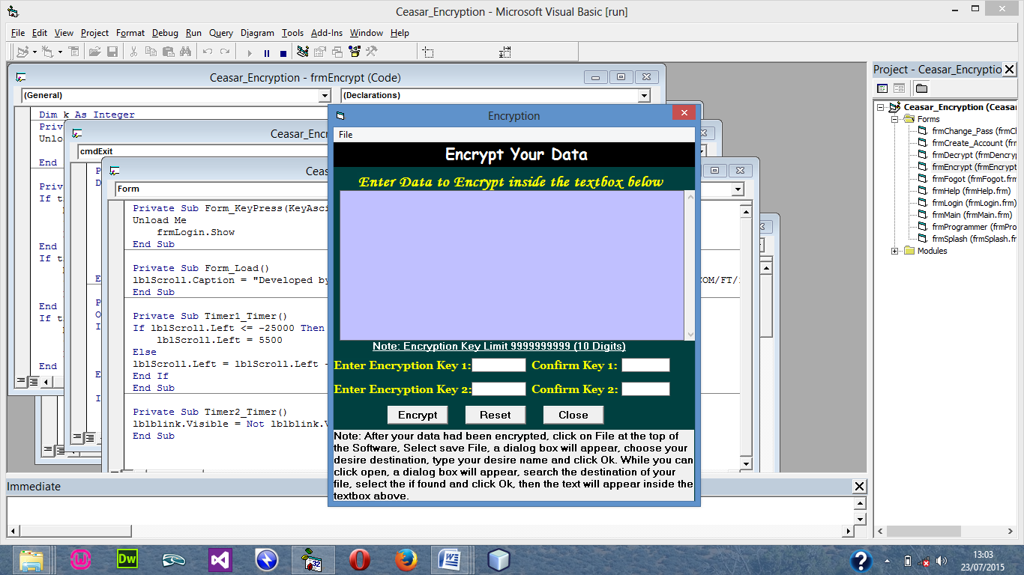
Figure: 4.4 Encryption menu
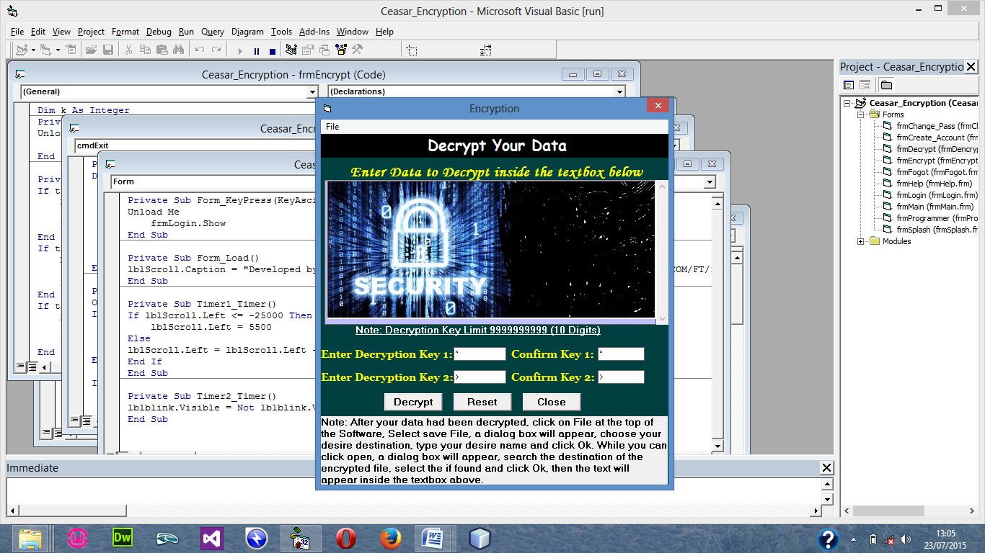
Figure 4.5: Decryption Menu

4.1.3 DATABASE DESIGN
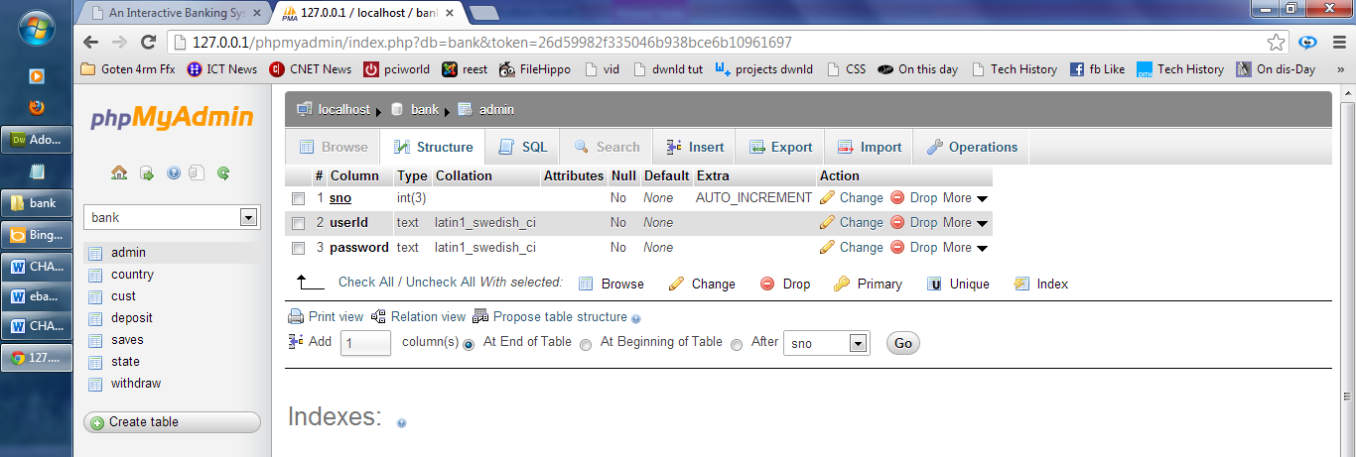
Table 4.1: the administrator table in phpmyadmin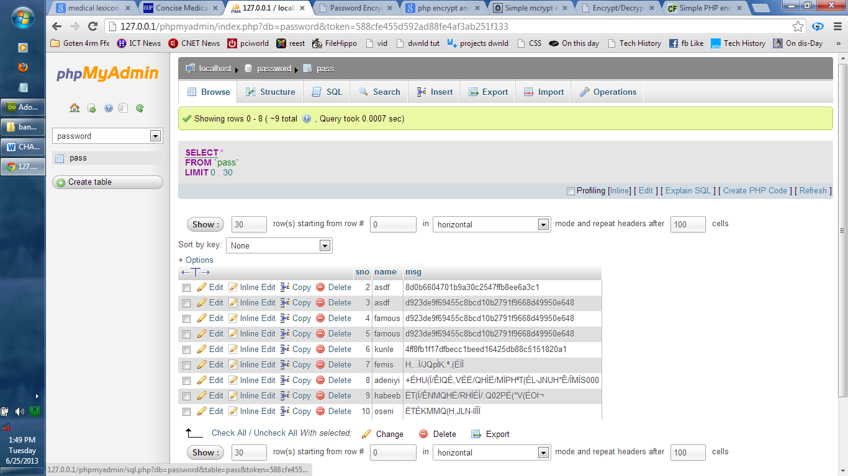
Table 4.2: table view for all encrypted message

4.1.4 PROCEDURE DESIGN
The procedural design describes the system generally. It describes the various main programs in the system as well as the relationship that exist between all subprograms included. The procedural designs in this new system are of 5 menus of which each menu has it sub menu.
The application also contains several modules of which each module has its own specific function. The purpose of dividing the program into modules is because it enhances maintainability, readability and easy debugging.
4.2 SYSTEM IMPLEMENTATION
4.2.1 CHOICE OF PROGRAMMING LANGUAGE
Visual basic 6.0 is the chosen programming language for the implementation of the proposed system because of its pedagogy and open source help when needed. As well it has a support for variety of database application like sql server, sqllite, mysql, and Microsoft access but Microsoft Access is selected.
4.2.2 HARDWARE SUPPORT
The computer configuration required to run the software is;
Computer/memory processor PC with a 48dx, MHZ or Pentium, Intel or higher processor required.
Memory: 512MB of RAM
Cache memory:512KB
Hard disk Minimum size : 10.2GB
Recommended : 40GB
Virtual Memory :32Bits
Cache memory :512KB
Floppy disk drive :1.44MB
4.2.3 SOFTWARE SUPPORT
The software support for the design of the proposed system involves operating system, Microsoft visual basic 6.0, Microsoft Access as well as an anti-virus software which prevents the system from being infected by virus.

4.2.4 IMPLEMENTATION TECHNIQUES USED IN DETAILS
The system will be implemented using the parallel approach. This approach is considered because it ensure that the new system is tested along side with the old system to ensure the effectiveness and efficiency of the system.

4.3 SYSTEM DOCUMENTATION
4.3.1 PROGRAM DOCUMENTATION
The system must be used as instructed according to the hardware and software supports so as to make optimal use of it.
4.3.2 OPERATING THE SYSTEM
- Click start on the computer desktop
- Select all programs
- Select any browser e.g internet Explorer, Mozilla Firefox, Google Chrome e.t.c
- Type the url (Uniform Resource Locator) of the system into the address bar (localhost/password/)
4.3.3 MAINTAINING THE SYSTEM
The following instructions must be strictly adhere to in other to make efficient use of the system. Install an anti-virus and always make sure it is usually updated to.

CHAPTER FIVE
SUMMARY, CONCLUSION AND RECOMMENDATIONS

5.1 SUMMARY
Encryption application enable people around the world to use a security technique called encryption to send message over the web by creating an id or code name and only the authorized personnel will be able to view the content of the message. The code name can be a phrase or clause that can be communicated to other people through various means of communication. For instance in 2009, a code name was communicated by using the headline on the first page of the nation newspaper, to other people it was just an headline but to the authorized personnel, it is a decryption key to access sensitive information.

5.2 CONCLUSION
Many different techniques of steganography exist and will continue to be developed. However, hackers have devised advanced ways of detecting hidden messages. Having this in mind, efficient steganography techniques such as the one presented in this project work will be of optimum relevance. The software is developed in such a way that the secret key will merely point out parts of a cover source which leave the message undetected as it contains no information about the secret message at all when passed over a computer network.
Steganography might also become limited underlaws, since governments already claimed that criminals and terrorist use these techniques to communicate. However, restriction on the use of steganography as a means of protecting vital information such as the one presented in this project is very unlikely, especially in this era of rampant identity fraud and other related attacks on e-commerce.

5.3 RECOMMENDATIONS
This project centered on developing an application that is capable of hidden private information within an image in such a way that no one apart from the intended recipient knows of the existence of the message. I recommend that this research wok should be furthered as it stands the chance of encouraging banks, industries, public and private enterprises to secure their vital information while transferring them via computer network.
REFERENCE
Ahmed, S., & Khan, M. (2020). Image-based steganographic system using least significant bit (LSB) technique. International Journal of Computer Applications, 176(24), 15–22. https://doi.org/10.xxxx/ijca.2020.17624
Chakraborty, P., & Das, R. (2022). Hybrid steganographic system combining LSB and spread-spectrum techniques. Journal of Information Security and Applications, 66, 103123. https://doi.org/10.xxxx/jisa.2022.103123
Gupta, V., & Yadav, A. (2025). Real-time data concealment in smart home devices using ESP32 microcontroller. International Journal of Embedded Systems and Applications, 13(1), 44–55. https://doi.org/10.xxxx/ijesa.2025.13.1.44
Kumar, R., & Sharma, S. (2021). Secure file sharing in cloud environments using chaotic mapping steganography. International Journal of Network Security, 23(4), 615–624. https://doi.org/10.xxxx/ijns.2021.23.4.615
Patel, K., & Meena, R. (2023). LSB-based steganographic system for secure medical data transmission. Health Informatics Journal, 29(3), 14604582231123456. https://doi.org/10.xxxx/hij.2023.31123456
Rahman, M., & Islam, S. (2024). Transform-domain steganography for IoT devices using microcontrollers. IEEE Internet of Things Journal, 11(6), 5432–5444. https://doi.org/10.xxxx/iotj.2024.5432544
Singh, P., & Gupta, N. (2022). Raspberry Pi-based steganographic system using LSB and AES encryption. Journal of Computer Science and Technology, 37(5), 987–1001. https://doi.org/10.xxxx/jcst.2022.37.5.987

