A PROJECT REPORT

ON

PROPOSED HOUSING ESTATE

ILORIN EAST LOCAL GOVERNMENT, KWARA STATE

BY

SHITTU ABDULLAHI KEHINDE HND/23/ARC/FT/0015

BEING A PROJECT REPORT SUBMITTED TO
THE DEPARTMENT OF ARCHITECTURAL TECHNOLOGY, INSTITUTE OF ENVIRONMENTAL STUDIES.

IN PARTIAL FUFILMENT OF THE REQUIREMENTS FOR THE AWARD OF THE HIGHER NATIONAL DIPLOMA (HND) IN ARCHITECTURAL TECHNOLOGY KWARA STATE POLYTECHNIC, ILORIN, KWARA STATE.

JULY, 2025

DECLARATION

I declare that this project project/dissertation is a product of my personal research work. It has not been presented for the award of any degree in any polytechnic. The ideas, observations, comments, suggestions herein represent my own convictions, except quotations, which have been acknowledged in accordance with conventional academic traditions.

Name: SHITTU ABDULLAHI KEHINDE

Matric no: HND/23/ARC/FT/0015

Signature Date

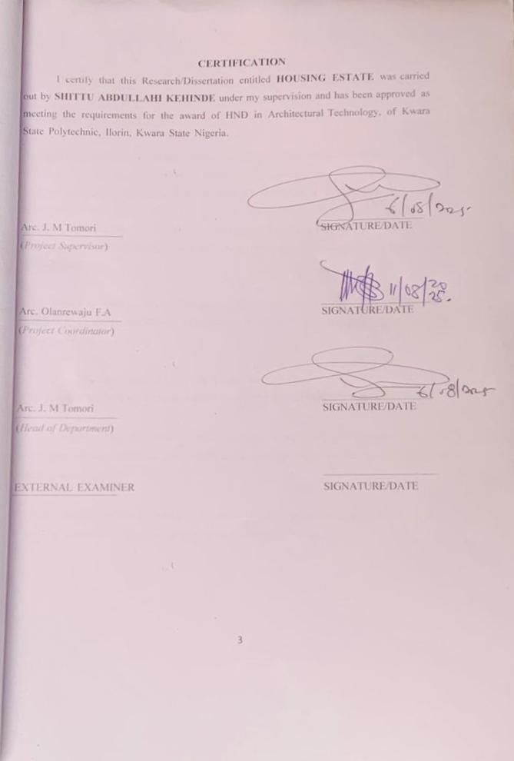

ACKNOWLEDGEMENT
My profound gratitude goes to Almighty Allah who as always be in existence for taking control of this project for is infinite mercy and for giving me the privilege to write the report.
My special gratitude goes to the Department of Architectural Technology the entire staff and my supervisor ARC.MRS J.M. TOMORI and also to the HOD of the Department in person of ARC.MRS MULIKAT JUMOKE TOMORI who has been supportive throughout this project, may Allah continue to reward you and your family.
My sincere appreciation goes to my dearest, lovely and caring parents ALH.MR SHITTU IBRAHIM and Mrs. IRAHIM FATIMAH for the parental, financial and moral support for making my dream a reality.
My utmost greetings go to my friends and my neighbors in person of HANAFI MUHAMMAD TAOFEEQ and ABDULLAHI MUHAMMAD AWWAL
Finally, I see this privilege as a milestone in my career development and I will definitely strive to utilize the gained skills and knowledge in the best way to achieve desired future objective.
Finally to my brothers and sisters and my colleague and other for their contribution to attain great achievement. I pray Almighty Allah reward everyone abundantly.

DEDICATION

This report is dedicated to Almighty Allah the universe, the creator of all creators and the source of mankind who has always been my strength throughout this project and also for his unconditional and infinite mercy showered upon me through my studies.
Also, I dedicated this project to my parent MR. and MRS. SHITTU IBRAHIM for their parental, financial and moral support.

TABLE OF CONTENTS

TITLE PAGE i
DECLARATION ii
CERTIFICATION iii
ACKNOWLEDGEMENT iv
DEDICATION v
TABLE OF CONTENTS vi
LIST OF TABLES vii
LIST OF FIGURES viii
LIST OF PLATES ix
ABSTRACT x
CHAPTER ONE
  - INTRODUCTION 1
  - DEFINITION 2
  - HISTORICAL BACKGROUND 3
  - STATEMENT OF DESIGN PROBLEM 4
  - AIM AND OBJECTIVES 5
  - JUSTIFICATION 5
  - CLIENT’S BACKGROUND 6
  - SCOPE OF THE PROJECT 6
  - LIMITATION OF STUDY……………………………………………………. 7
  - RESEARCH METHODOLOGY……………………………………………… 7
CHAPTER TWO
  - LITERATURE REVIEW ...………………………………………………….. 8
  - REVIEW OF RELEVANT LITERATURE ON BUILDING TYPES 8
  - REVIEW OF LITERATURE ON HOUSING AFFORDABILITY 9
CHAPTER THREE
  - CASE STUDY………………………………………………………………. 12
  - CASE STUDY 1: HARMONY ESTATE, LORIN, KWARA STATE 12
  - CASE STUDY 2: OROKI HOUSING ESTATE,OSOGBO,OSUN STAT 19
  - CASE STUDY 3: EGAN IGANDO HOUSING ESTATE,LAGOS STATE 25
  - CASE STUDY 4: ROYAL VALLEYESTATE,ILORIN, KWARA STATE 33
CHAPTER FOUR
  - STUDY AREA/PROJECT SITE……………………………………………… 52
  - HISTORY OF KWARASTATE……………………………………………. 52
  - LOCATION OF SITE 53
  - SITE INVENTORY AND ANALYSIS 55
  - GEOGRAPHIC/CLIMATIC DATA 55
  - ANALYSIS OF THE IMMEDIATE ENVIRONMENTAL CONDITIONS OF
THE SITE 58
  - PROJECT ANALYSIS/DESIGN CRITERIA………………………………… 59
    - DESIGN CRITERIA…………………………………………………………. 59
  - BRIEF ANALYSIS OF PROJECT………………………………………….. 60
  - FUNCTIONAL ANALYSIS/SPACIAL CRITERIA………………………… 61
  - APPRAISAL OF SCHEMES………………………………………………… 64
  - EQUIPMENT AND OPERATIONAL AND PERFORMANCE
REQUIREMENT…………………………………………………………….. 65
  - SPATIAL ALLOCATION/S SCHEDULE OF ACCOMODATION 65
  - CONCEPTUAL DEVELOPMENT………………………………………….. 67
CHAPTER FIVE
  - APPROACH TO THE DESIGN/DESIGN REALIZATION 68
  - TECHNOLOGICAL AND ENVIRONMENTAL CRITERIA………………. 68
    - CONSTRUCTION METHOD 68
  - SERVICES REQUIRED 68
    - ENVIRONMENTAL CONDITION TO BE ACHIEVED 70
    - PERFORMANCE STANDARDS 70
    - LEGAL ISSUES AND PLANNING REGULATIONS 70
    - BEHAVIOURAL PATTERNSANDCONSIDERATIONS 70
  - CONCLUSION AND RECOMMENDATIONS 70
REFERENCES 7 1
APPENDICES 72

LIST OF TABLES
1 .Space Allocation for Two Bedroom Bungalow …….…… 63
2 Space allocation for Two bedroom Bungalow ensuite ………….. 63
3 .Space allocation for Three Bungalow ensuite .….………… 64
4 Program Development ………………………… 76

LIST OF FIGURES
Figure3.1: Locational Plan of Case Study One at Harmony Estate, Ilorin, kwara State ..14 Figure3.2: Site Plan of Case Study One at Harmony Estate, Ilorin, kwaraState ……. 15

Figure3.3: Two Bedroom Floor Plan of Case Study One at Harmony Estate, Ilorin, kwara State…16

Figure3.4: Three Bedroom Floor Plan of Case Study One at Harmony Estate, Ilorin, kwara State…17

Figure 3.5: Location Plan of Case Study Two at Oroki Housing Estate, Osogbo, Osun State …….21

Figure3.6: Layout Plan of Case Study Two at Oroki Housing Estate, Osogbo, Osun State
………22

Figure3.7: Floor Plan of Case Study Two at Oroki Housing Estate, Osogbo, OsunState
………23

Figure3.8: Location Plan of Case Study Three at Egan-igando Housing Estate,LagosState
……27

Figure3.9: Layout Plan of Case Study Three at Egan-igando Housing Estate,LagosState
……28

Figure3.10: Ground floor Plan of Case Study Three at Egan-igando Housing Estate,LagosState …29
Figure3.11: upper floor Plan of Case Study Three at Egan-igando Housing Estate,LagosState 30
Figure3.12: Locational Plan of Case Study Four at Royal valley Housing Estate Ilorin,kwaraState 35
Figure3.13: Layout Plan of Case Study Four at Royal valley Housing Estate Ilorin,kwaraState 36
Figure3.14: Floor Plan of Case Study Four at Royal valley Housing Estate Ilorin,kwaraState 37

LIST OF PLATES

Plate3.1: Site Location of Case Study One at Harmony Estate, Ilorin, kwara State 13
Plate3.2: Perspective View of Two Bedroom of Case Study One at Harmony Estate, Ilorin,kwara State

…………18
Plate3.3: Perspective View of Three Bedroom of Case Study One at Harmony Estate, Ilorin,kwara State

…………18
Plate3.4: Perspective View of Three Bedroom of Case Study One at Harmony Estate, Ilorin,kwara State

…………19
Plate3.5: Site Location of Case Study Two at Oroki Housing Estate, Osogbo, Osun State

…………20
Plate3.6: Approach View of Three-Bedroom Bungalow of Case Study Two at Oroki Housing Estate, Osogbo, Osun State
…………24

Plate3.7: Approach View of Three-Bedroom Bungalow of Case Study Two at Oroki Housing Estate, Osogbo, Osun State
…………24

Plate3.8: Site Location of Case Study Three at Egan-Igando Housing Estate, Lagos State 26

Plate3.9: Perspective View of Two-Bedroom Semi Detached Duplex at Egan-Igando Housing Estate, Lagos State 31

Plate3.10: Perspective View of Two-Bedroom Semi Detached Duplex at Egan-Igando Housing Estate, Lagos State
………………. 31

Plate3.9: Back View of Two-Bedroom Semi Detached Duplex at Egan-Igando Housing Estate, Lagos State
……………. 32

Plate3.9: Left side View of Two-Bedroom Semi Detached Duplex at Egan-Igando Housing Estate, Lagos State
…………. 32

Plate3.13: Site Location of Case Study Four at Royal valley Housing Estate, Ilorin, kwara State…34
Plate3.14: Approach View of Three-Bedroom Bungalow of Case Study Four at Royal valley Housing Estate, ilorin, kwara State
…………38

Plate3.14: Perspective View of Three-Bedroom Bungalow of Case Study Four at Royal valley Housing Estate, ilorin, kwara State
…………38

Plate3.15: Perspective View of Three-Bedroom Bungalow of Case Study Four at Royal valley Housing Estate, ilorin, kwara State
…………39

ABSTRACT
The nature of the housing designs in housing estate schemes in Nigeria is a function of how architects were trained to handle mass housing designs. It is common practice to find that the housing in majority of the housing estate schemes in Nigeria are never owner specific. It is often assumed by architects working on housing estate schemes that the process of making the houses specific is cumbersome. The nature of the construction method of these housing estate schemes allows for the design briefs of the individual house to be different. The paper examines how design brief in housing estate in Nigeria can be customized. This is done through the development of a customization brief model with aid of a network of computer. It is expected that if the model is applied into housing estate in Nigeria, desired house by house owners in housing estate schemes would be met.

Keywords: architects, customization, house owner, housing estate, model.

CHAPTER ONE

INTRODUCTION
Consequently a rapid demand increase related to housing in developing countries. But present housing has remained beyond the demand and not being able to respond to the rapid increase in demand in developing countries. In many developing countries including Nigeria, urban housing is escalating unabated despite a number of new policies and private sectors addressing this problem. Government has recognized that the majority of those in need of housing in many less-developed nations in Africa, Asia and South America are in low-income categories and that some require special housing programs to be able to live in decent housing programs. Since market solutions and funds may not be suitable for housing this category of people and in view of the vital role housing plays in the socio-economic and political development of any nation, governments in these countries have over three years been engaged in public housing provision.
In the past few decades there has been a rapid population increase and urbanization
tendency and the provision of adequate housing in any country is very vital as housing is a stimulant of the national economy. Housing Is set of durable assets, which accounts for a high proportion of a country's wealth and on which households spend a substantial part of their income.
Housing has been universally accepted the second most important human need while food is the First most important need. It is a basic need for human survival and an essential component to the advancement of the quality of life of the citizens. The provision adequate housing that is safe, secure, accessible, affordable and sanitary fundamental human right, as enshrined in the United Nations Habitat Agenda- the global call on human settlements. Housing has been universally accepted as the second most important human need. It is a basic need for human Survival and an essential component to the advancement of the quality of life of the citizen. This universally accepted fact has been acknowledged by successive DEFINITION
Housing is defined as the process of providing safe, comfortable, attractive, functionally affordable and identifiable shelter in a proper setting within a neighborhood supported by

continuous maintenance of the built environment for daily living activities if individuals and families within the community. Housing estate is a group of houses and other buildings built together as a single development. A hosing estate is usually built by a single contractor with only a few styles of houses or building design, so they tend to be uniform in appearance. Housing estate are the usual form of residential design used in new towns, where estate is designed as an economic suburb, centered on a small commercial center

HISTORICAL BACKGROUND
Housing estate was created by an act of the Massachusetts legislative in the year (1966) as an independent public authority charged with increasing affordable rent and for sale housing in Massachusetts.
The national council of housing in Nigeria (1972) advised the government on housing matters and federal housing (F.H.A) in 1973 to coordinate public housing provisions. Planned direct construction of 59,000 low-cost housing across the federation in (1975-1980). Creation of federal ministry of housing urban development and environment and conversion of Nigeria building society to Federal Mortgage Bank of Nigeria (F.M.B.N). Promulgation of the land used decree (1978) planned construction of 202,000 low-cost housing launched for first time in 1980. Earmarked N 19 billion for the construction of 1 60,000 housing units for low-income people. The Second phase of the housing programme planned 121,000 houses on site and services housing programme between 1993 and 1995 to 1998, National housing policy landed to provide Nigeria access to quality housing and basic infrastructure. 199| National housing policy was launched With the goal of granting all Nigerians access to decent housing by 2000 in response to the slogan "Housing for all by the year 2000" of the United Nation. (1999-20 10) the new National Housing and Urban Development Policy (N.H.U.D.P) launched in 2002 with the goal ensuring that "all Nigerians own or have access to decent housing through private sector lead initiatives" planned constructed about 10271 housing units through the Public Private Partnership PPP) arranged in different P.P.P housing scheme across the country. Planned construction of 500 housing units in the presidential mandate housing scheme in all 36 states capital and Abuja.

Government planned a pilot project involving the construction of 40,000 housing units per annum nationwide.

STATEMENT OF DESIGN PROBLEM
Generally speaking, a mass housing is first and foremost a land development and urbanization operation but the unavailability of mass housing are one of the increase in Nigeria as a whole. Every year there is an increase in both birth rate and in the number of people which are homeless and doesn’t have a shelter above their head because of high rates or rent in the country at large. Provision of housing estate will help increase the number of people with shelter and accommodation at affordable rates which also put into consideration their household value and comfortability especially, in Ilorin East Local Government, kwara State.

AIM AND OBJECTIVES
    - AIM
The aim of this project is to design a housing estate that are structurally, functionally and aesthetically balanced structure to satisfy the owner and the occupants of the building.

OBJECTIVE
To achieve the aim, the following objectives are set out;
      - To create environmentally friendly space that will enhance users to comfortability.
      - Proper orientation of the structures would be addressed to achieve maximum comfort for the users.
      - Effective site planning that would enhance ease in traffic flows and other activities within the state.
      - Provision of necessary amenities, services and facilities that will ensure a safe and secure living within the state.
      - To ensure a well landscaped environment for the comfort of the occupants.

JUSTIFICATION
As it is universally accepted that housing is the second most basic need of human existence which has posed a major challenge to Nigerian citizens, this project work was conceived to help the ever-increasing population in Nigeria especially in Ilorin East local government, and Also increase in demand for housing by the people, especially those who are the Low, Middle and High income earners in the local government. In view of this, there is a need to provide an architecturally, functional and aesthetical design for the people in Ilorin East local government kwara state.

CLIENT BACKGROUND
My client is the chairman of Ilorin East Local Government. He discovered the difficulty of getting decent accommodation for the people to afford and stay with this project, the government decided to provide accommodation for people who are in high, middle and low income earner to have their own dream houses in Ilorin East Local government Area, kwara state.

SCOPE OF THE PROJECT
The scope of this project will encompass the use of design techniques or strategies to design or plan mass housing. The scope of the project includes:
RESIDENTIAL: Two bedroom bungalow, Two bedroom bungalow en-suite, Three bedroom bungalow en-suite
SERIVES: Mini-mart, Event center, Clinic/health care center, Fire station and Police post/security post and market.
RECREATION: Children play ground, Garden/sit out and Sport area. RELIGIOUS: Mosque and Church.
INSTITUTIONAL: Nursery and primary school. MAINTENANCE: Waste disposal and Central sewage system. ROAD NETWORK: Truck, Bus and Car.

LIMITATION OF STUDY
Limitation to the research is very many but some of them were overcome in the course of study. The scope of the study is limited to the following cadre of income earners which are; the low income earners, the medium income earners and the high income earners.
The following type of buildings were designed for each cadre of income earners such as the Two Bedroom Bungalow for the low income earner and the Two Bedroom Bungalow ensuite for the medium income earners and the Three Bedroom Bungalow ensuite for the high income earners.
The economic situation of the country is really biting hard on a lot of things such as transportation fares, accommodation expenses which are part of the setbacks experienced during the course of carrying out this design work. The following to an extent limited the study.
- Unavailability of officials to help answer relevant questions during this research.
- Refusal of access into the buildings for proper investigations and accurate findings.
- Refusal of access to some housing estates.
- Unwillingness of the residents to part with information concerning themselves.
- Lack of time and finance was also a major challenge in the course of this research.

RESEARCH METHODOLOGY
The methods that were used in the course of this study are primary data methods which are:
Comprehensive and detailed observation, Asking questions, case studies and documentation.
And also the secondary data collection methods are from: Internet, Textbooks, and Appropriate government agencies

CHAPTER TWO
  - LITERATURE REVIEW
  - REVIEW OF RELEVANT LITERATURE ON BUILDING TYPES
Everyone has the right to a standard of living adequate for the health and well-being for himself and for his family, including food, clothing, housing and medical care and necessary social services and the right to security in the event of unemployment, sickness, disability, widowhood, old age or other lack of livelihood in circumstances beyond his control. It embraces all the social services and utilities that go to make a community or neighborhood a livable environment.
The variety of building types varies in a housing estate depending on the household value and the neighborhood value of the community of the site. The neighborhood value tells us of the environment in which the design is to be situated which is ‘Ilorin east local Government, Kwara state’ the people who lives here are majorly the Low income earners which gives permission for the design of Two bedroom bungalow respectively. The household value tells of the number of people resident in a family or in a house at large. The middle income earners attract also the Two bedroom bungalow en-suite while the high income earners attracts the three bedroom bungalow due to increase in their own income.
The problems of housing in Nigeria are enormous and complex, exhibiting marked regional differences. Furthermore, the challenges faced by the rapid rate of uncontrolled and unplanned urban growth are immersed. Millions of people live in sub-standard and sub- human environment characterized by slum, squalor and grossly inadequate social amenities. The problem of housing in our urban center is not only restricted to quality of housing stock, but also to the quality of affordable housing units, infrastructure and the environment. The result is manifested in growing overcrowding in homes, neighborhood, communities and increase pressure on infrastructural facilities such as road, drainage, water power supply e.t.c and rapidly deteriorating environment. The scenario is slightly different in the rural areas where the problem is primarily, not just that of inadequate quality of housing units but also that of inadequate and poor infrastructural facilities such as roads, drainage water, power supply and basic social amenities (schools, health care facilities e.t.c).

Another important characteristic of both the urban and rural schemes is the absence of the basic needs of the poor and the low income groups. It is established that over ninety percent (90%) of the country’s population are of the poor and low-income groups.

REVIEW OF LITRATURE ON HOUSING AFFORDABILITY
In Australia, housing affordability relates more broadly to a household ability to pay for their house and is seen as a general goal across the housing market (AHURI, 2021: Ruming Guraran and Randolf 2017). Stone, (2022) suggests that housing affordability directly expresses the challenges each household faces in balancing the cost of its actual or potential housing and its non-housing expenditure within the constraints of its income, stone also acknowledges that affordability is not a characteristic of housing it is a relationship between housing and people.
There is still debate surrounding the issues of when housing is considered to be unaffordable. However, a common measure of housing affordability is that households should spend not more than 30 percent of their gross income on housing cost (URL, 2020).
There is still debate surrounding the issues of when housing is considered to be unaffordable. However, a common measure of housing affordability is that households should spend not more than 30 percent of their gross income on housing cost (URL, 2021).
It is when household spends more than 30 percents on housing cost that they may start to experience housing stress (AHURI, 2021). However this seemingly simply measure of housing stress attracts much debate amongst not only academic researchers but also within the circles of policy makers across the nation as it excludes extremely low income earners and may under estimate the number of people actually experiencing housing stress (Nepal, Tanton and Harding, 2018).
Recently, Amamata, Safiya and Bala (2015) investigate factors of housing affordability as a scheme in governmental policies. Their findings revealed that the provision of public housing is an import aspect in the housing sector for all income groups, but most especially for those in the low income group.
Arigbola (2022) conducted a study on housing affordability as a factor in the creation of sustainable environment in developing world. The example of Akure, Nigeria. The data

utilized in the study was generated through a systematic survey of 1.266 householders in the nine political wards into which the city was stratified. Findings of the study argue that this poses a great challenge to sustainable development of the built environment. Thus, it was suggested that the institutional framework to promote, enhance and encourage affordable housing provision should be created in the city as a matter of fact.
Similarly, Rukayatet al (2019), examined housing affordability by federal civil servants in Minna, Nigeria. They used a total of 200 Federal Civil servants as simple which was spread across all grade levels. Simple descriptive statistics, likert scale, relative index and pearson product moment correlation were used to analyse the collected data. Their findings revealed that federal civil servants in the study area spend between 7.3% and 23.8% of their annual income on rents. The study also revealed that civil servants’ level of The study also revealed that civil servants’ level of income having a relative index of 0.96 is a major factor influencing the choice of residential accommodation by federal civil servants in the study area.
It further revealed a strong positive correlation between their annual income and rental values of residential properties occupied by them. The sampled respondents expressed varied levels of satisfaction with the houses they occupy, with as much as 59% being unsatisfied with their rented housing units, these were attributed to poor housing, quality, small sizes of housing units and densely populated neighborhoods, among others. Housing affordability index was also adopted and used to determine housing affordability levels in the study area. The study recommended a home ownership scheme to enable federal civil servants purchase or build their own houses and pay conveniently because all respondents desired to own their own houses.

CHAPTER THREE

CASE STUDY
A case study is a process or record of research in which detailed consideration is given to the development of a particular person, group or situation over a period of time.

CASE STUDY 1: HARMONY ESTATE, ILORIN, KWARA STATE.
The case study for this project was harmony estate in Ilorin, kwara state. Information for the estate was obtained from the kwara state housing corporation. The estate is located at Akerebiata, Ilorin, kwara state. The estate which was proposed in 2009, with 500 proposed buildings, only about 150 of the buildings have been completed and it is all build with bricks block. The buildings are detached bungalows, containing either two-bedroom or three bedroom.

MERITS
    - IT IS WELL VENTILATED
    - IT IS EASILY ACCESSIBLE
    - IT IS WELL ORIENTIATED

DEMERITS
    - LACK OF SPACES FOR FUTURE DEVELOPMENT
    - LACK OF SOCIAL AMENITIES
    - POOR MAINTAINANCE

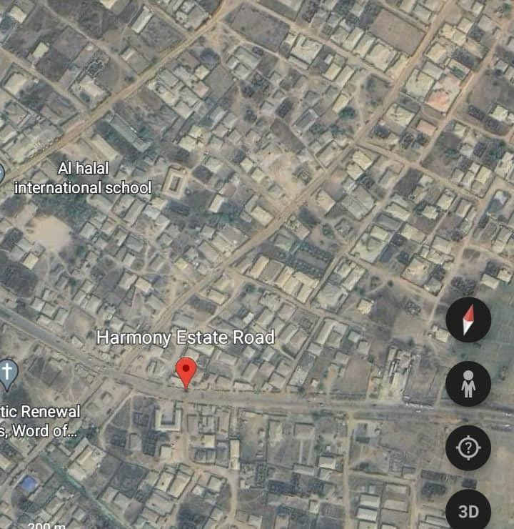
plate3.1: Site Location of Case Study One at Harmony Estate, Ilorin, kwara State

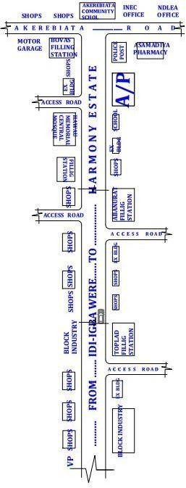
Figure3.1: Locational Plan of Case Study One at Harmony Estate, Ilorin, kwara State

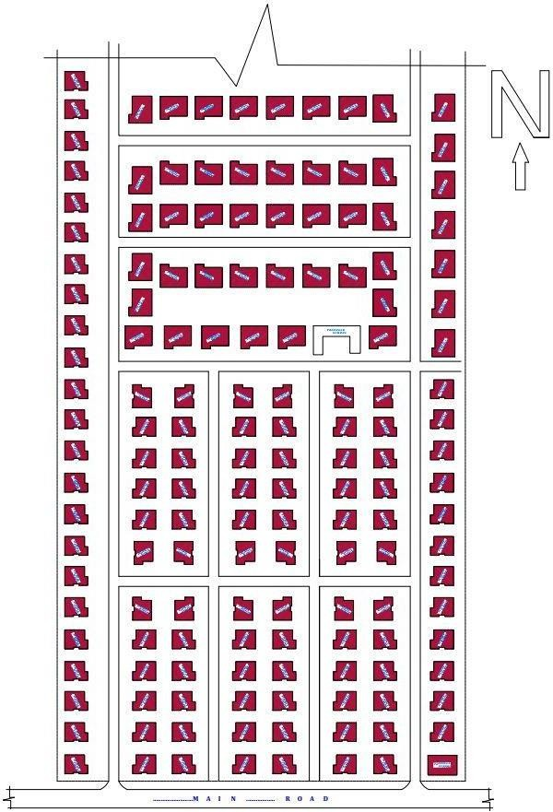

Figure3.2:Site Plan of Case Study One at Harmony Estate, Ilorin, kwara State

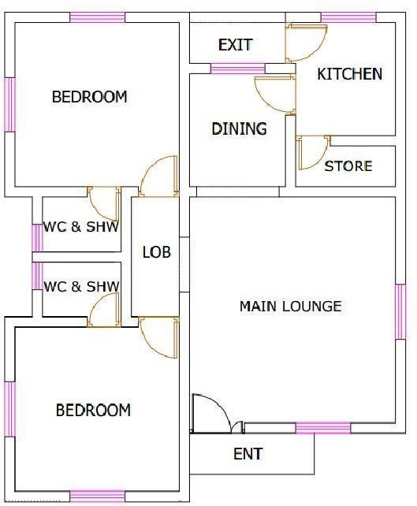

Figure3.3:Two Bedroom Floor Plan of Case Study One at Harmony Estate, Ilorin, kwara State

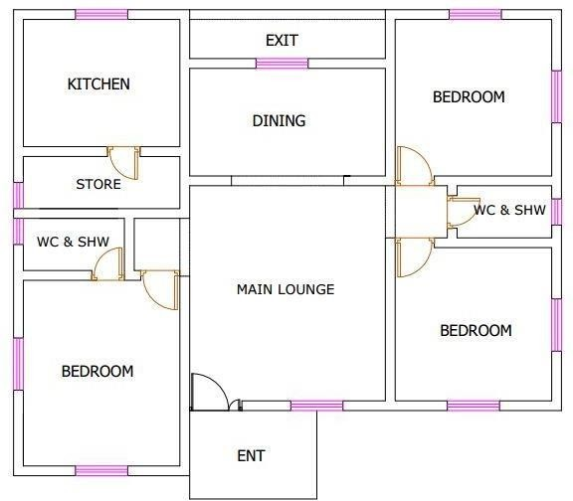

Figure3.4: Three Bedroom Floor Plan of Case Study One at Harmony Estate, Ilorin, kwara State

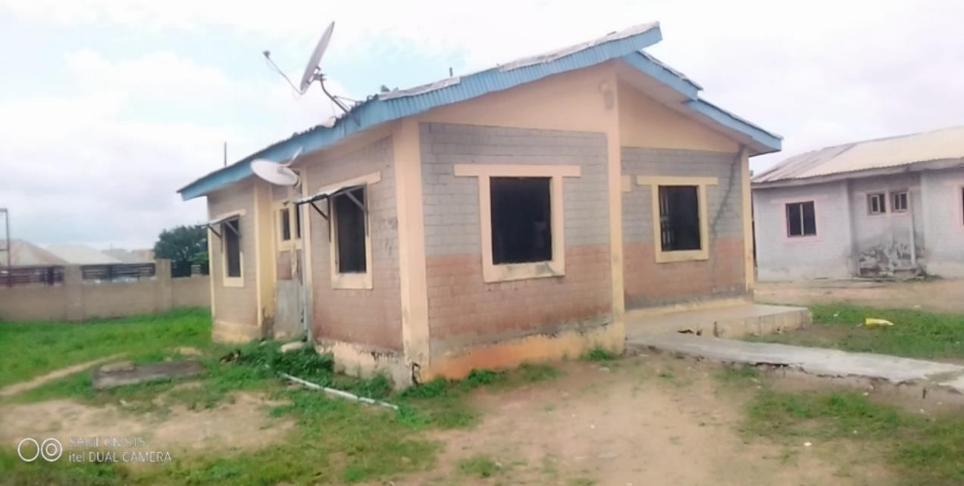
Plate3.2: Perspective View of Two Bedroom of Case Study One at Harmony Estate, Ilorin, kwara State

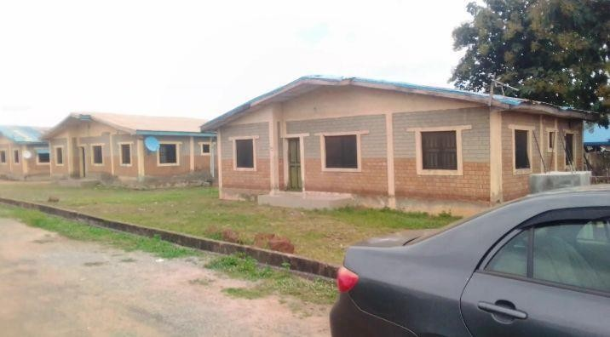
Plate3.3:Perspective View of Three Bedroom of Case Study One at Harmony Estate, Ilorin, kwara State

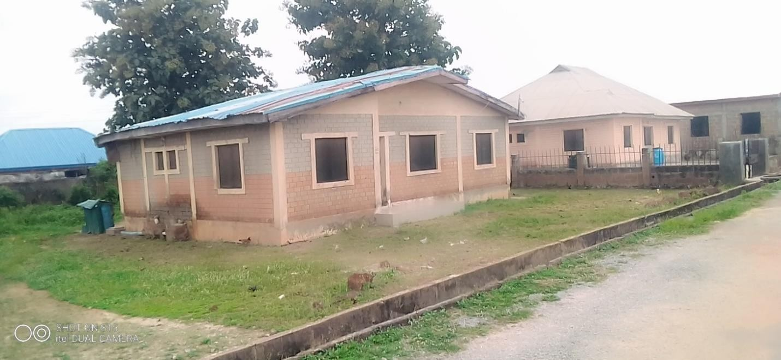
Plate3.4:Perspective View of Three Bedroom of Case Study One at Harmony Estate, Ilorin, kwara State

CASE STUDY 2: OROKI HOUSING ESTATE,OSOGBO, OSUN STATE.
Oroki housing estate it was built by Osun state property development co-operation. On year 2002, location of the estate along Ilobo Road, Osogbo Osun State. The estate comprise of 3- bedroom bungalows. Components of Orokihousing Estate includes Living rooms with gagrage, Big kitchen/store, all the 3 bedroom comprises of Wardrobe and open court yard .

MERITS
    - IT IS EASILY ACCESSIBLE
    - PROVISION OF ADEQUATE ELECTRICITY
    - IT IS WELL VENTILATED

DEMERITS
    - LACK OF SECURITY POST
    - POOR LANDSCAPING
    - LACK OF SOCIAL AMENITIES

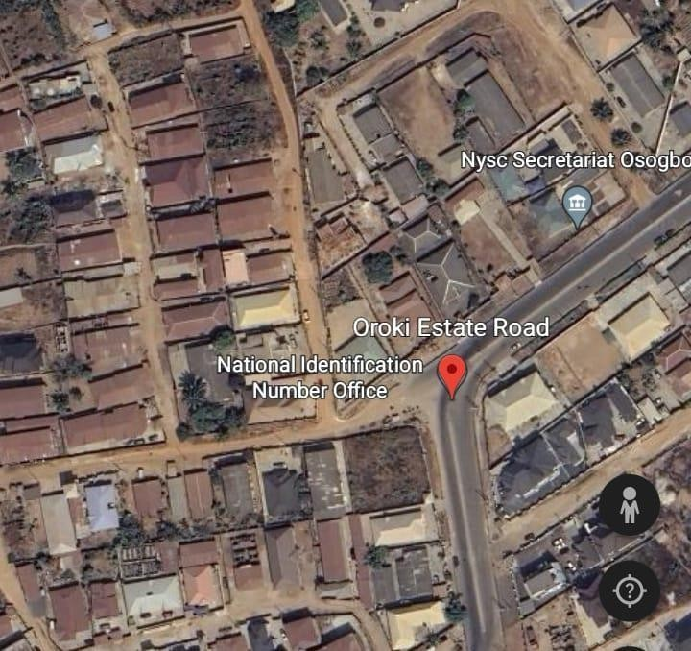

Plate3.5: Site Location of Case Study Two at Oroki Housing Estate, Osogbo, Osun State

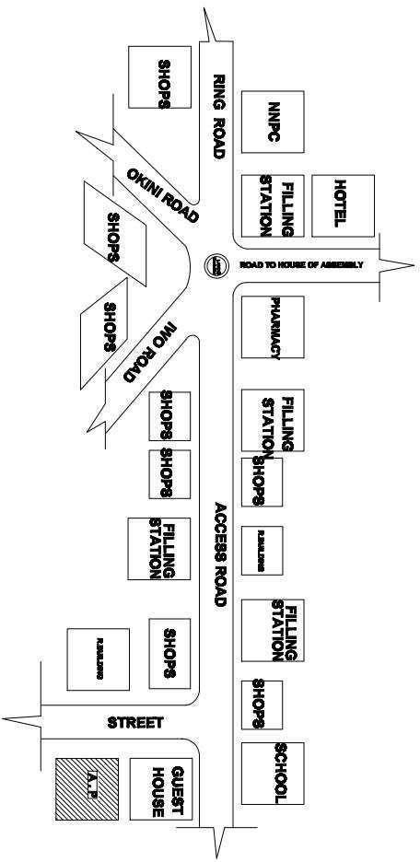

Figure 3.5: Location Plan of Case Study Two at Oroki Housing Estate, Osogbo, Osun State

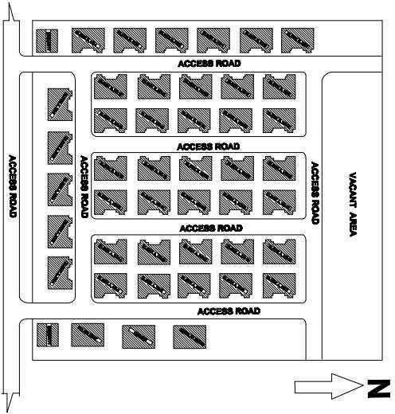
Figure3.6: Layout Plan of Case Study Two at Oroki Housing Estate, Osogbo, Osun State

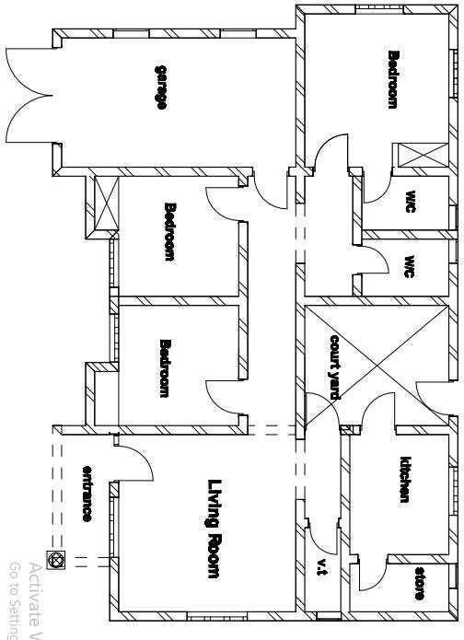

Figure3.7: Floor Plan of Case Study Two at Oroki Housing Estate, Osogbo, Osun State

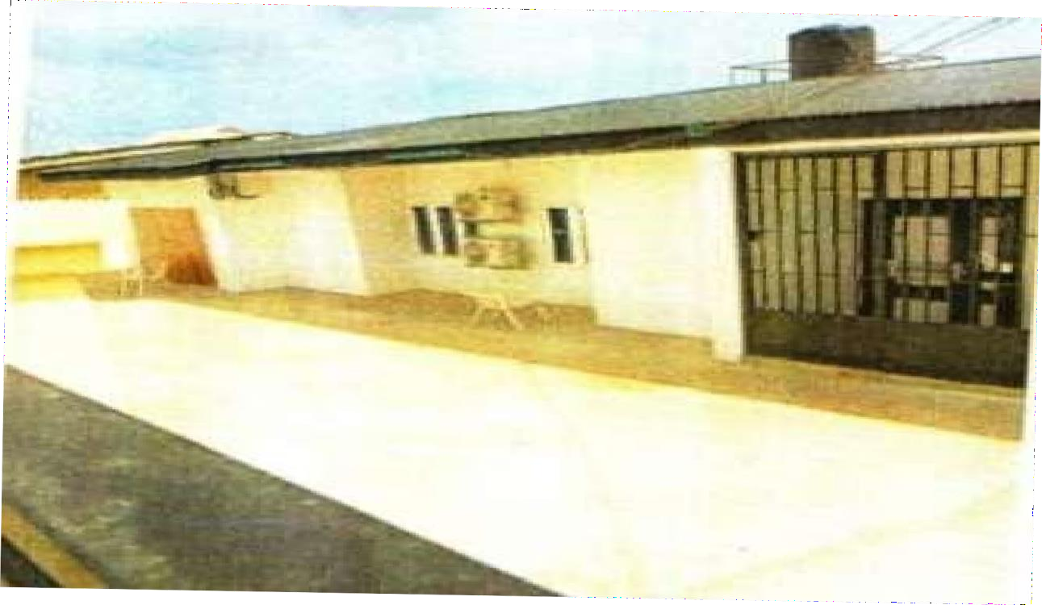

Plate3.6: Approach View of Three-Bedroom Bungalow at oroki Housing estate, osogbo, osun state

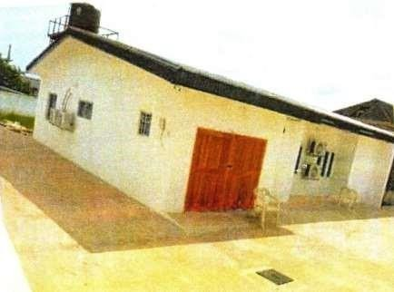
Plate3.7:Perspective View of Three-Bedroom Bungalow at oroki Housing Estate Osogbo, osun state

CASE STUDY 3: EGAN-IGANDO HOUSING ESTATE
Egan-Igando Housing Estate is owned by federal government and dedicated to maize production with extensive modern planting and harvesting equipment. However, it was take over by the Lagos State Government. The estate was built in year 2012 and it comprises of two bedroom semi detach storeybuilding .
The estate is located at Agric Road in Egan-Igando, under Alimosho Local Government Area of Lagos State.

MERITS
    - IT IS EASILY ACCESSIBLE
    - AVAILABILITY OF RELAXATION AREA AND SPORT FACILITIES
    - ENOUGH SPAPCES FOR FUTURE DEVELOPMENT
    - IT IS WELL ORIENTIATED
    - IT IS WELL LANDSCAPED

DEMERITS
    - POOR MAINTENANCE OF THE BUILDING
    - LACK OF SOCIAL INFRASTRUCTURE LIKE CLINIC, SCHOOL, AND OTHER AMENITIES

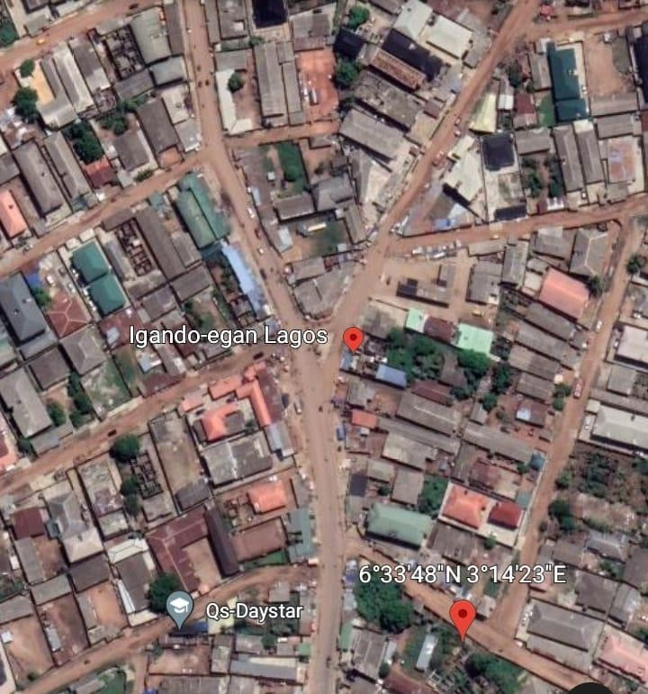

Plate3.8:Site Location of Case Study Three at Egan-Igando Housing Estate,Lagos State

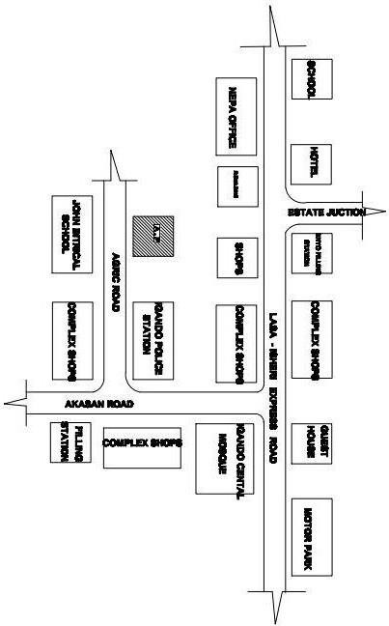

Figure3.8: Location Plan of Case Study Three at Egan-Igando Housing Estate,Lagos State

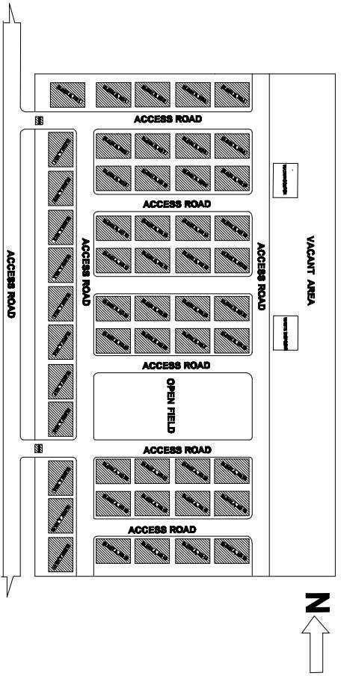
Figure3.9: Layout Plan of Case Study Three at Egan-Igando Housing Estate, Lagos, Lagos State.

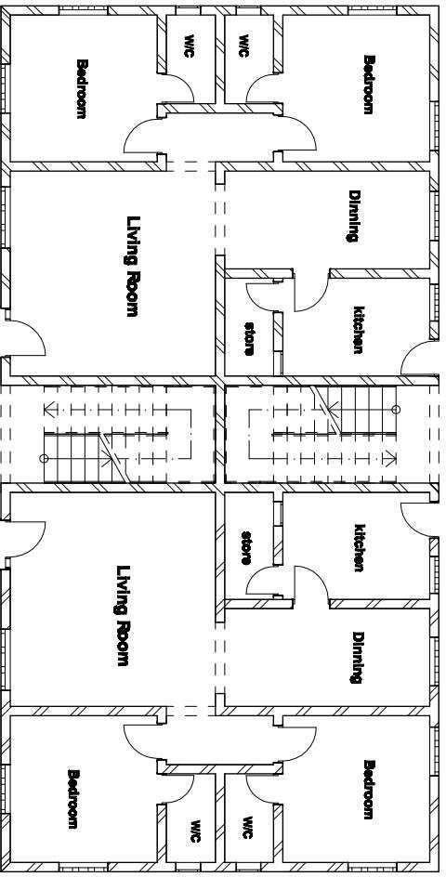
Figure3.10: Ground Floor Plan of Case Study Three at Egan-Igando Housing Estate, Lagos state

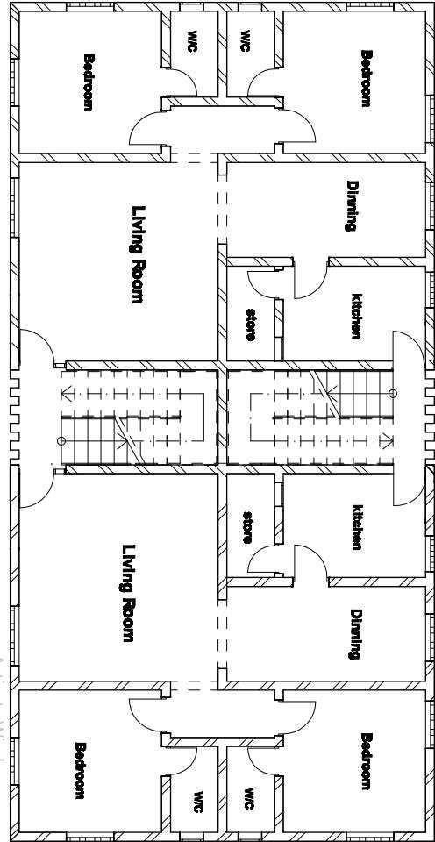
Figure3.11: First and Second Floor Plan of Case Study Three at Egan-Igando Housing Estate, Lagos state

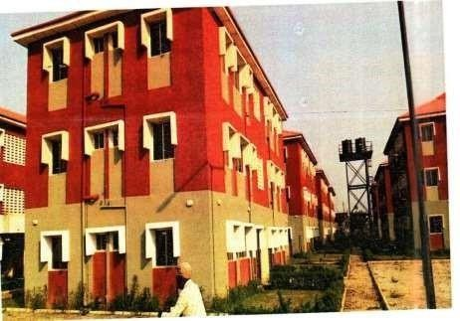
Plate3.9: Perspective View of Two-Bedroom Semi Detached Duplex at Egan-Igando Housing Estate, Lagos, Lagos State.
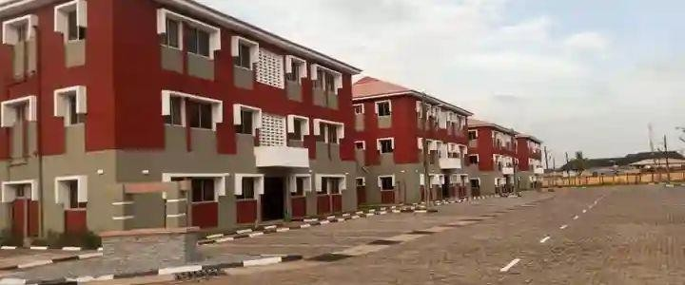
Plate3.10: Perspective View of Two-Bedroom Semi Detached Duplex at Egan-Igando Housing Estate, Lagos, Lagos State.

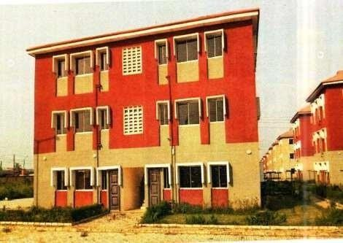

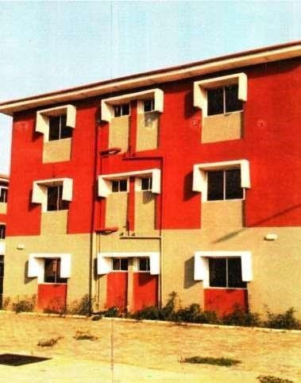
Plate3.11: Back View of Two-Bedroom Semi Detached Duplex at Egan-Igando Housing Estate, Lagos, Lagos State.

Plate3.12: Left View of Two-Bedroom Semi Detached Duplex at Egan-IgandoHousing
Estate, Lagos State.

CASE STUDY 4: ROYAL VALLEY ESTATE, ILORIN, KWARA ESTATE
Royal Valley housing Estate was built by the kwara State Government and the estate comprises of 100 housing units and it was commission on the 25-Dec, 2007.it was located along Sango area, Kangile Road, Ilorin, kwara State.
The building comprises of 3-bedroom bungalows. The Component includes Living room, Waiting room Big kitchen with store, all the three room are in-suite with wardrobe, visitors toilet a garden covered with car park.

MERITS

    - IT IS EASILY ACCESSIBLE
    - IT IS WELL ORIENTIATED
    - IT IS WELL VENTILATED
    - THERE IS PROVISION FOR SECURITY POST AT THE MAIN ENTRANCE OF THE ESTATE THAT HELP TO DOCUMENT VISIT TO THE ESTATE

DEMERITS
    - LACK OF SOME SOCIAL AMENITIES
    - POOR MAINTENANCE

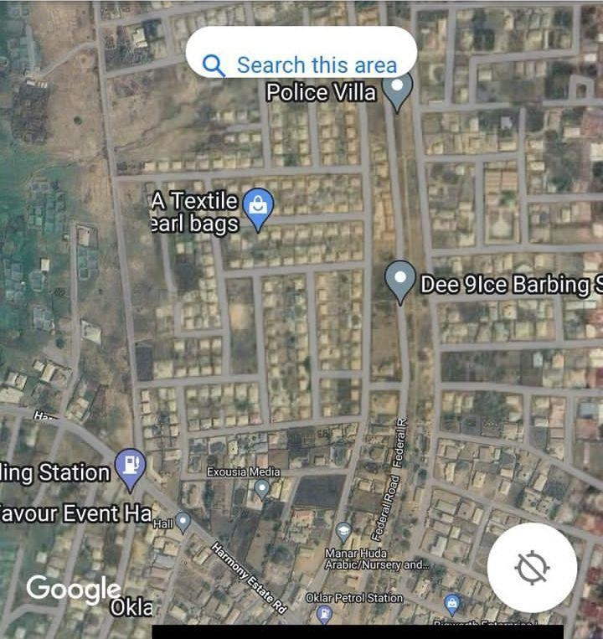

Plate3.13: Site Location of case three at Royal Valley Housing Estate, Ilorin Kwara state

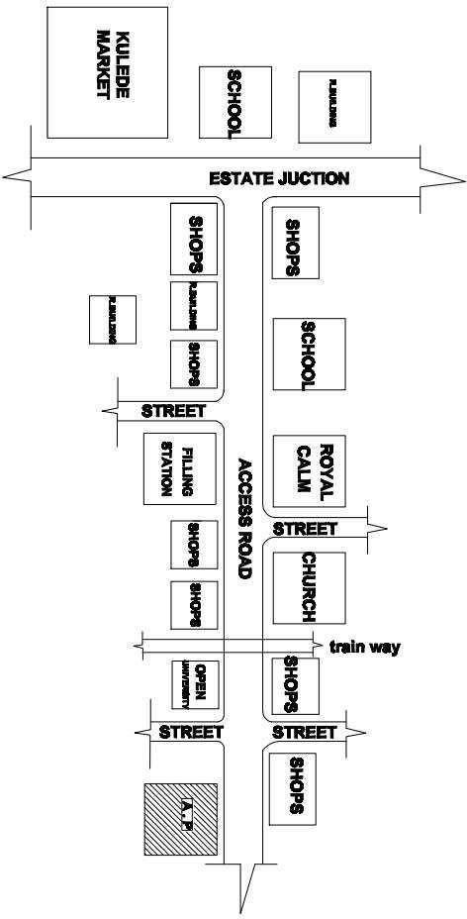
Figure3.12: Location Plan of case three at Royal Valley Housing Estate, Ilorin Kwara state

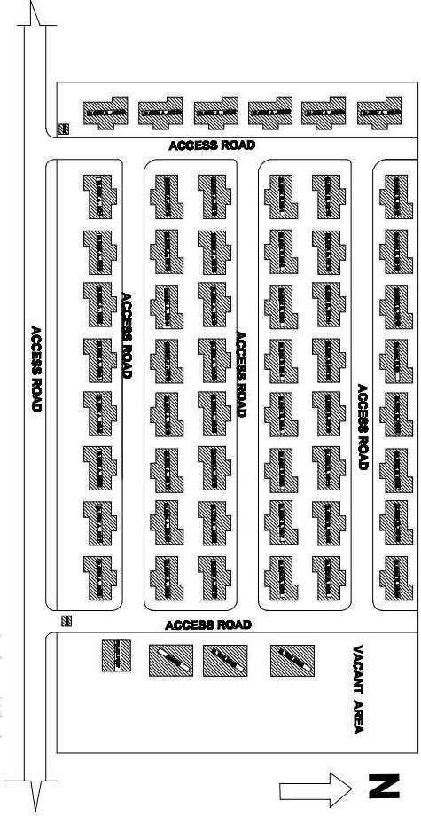
Figure3.13: Layout Plan of Case Study three at Royal Valley Housing Estate, Ilorin

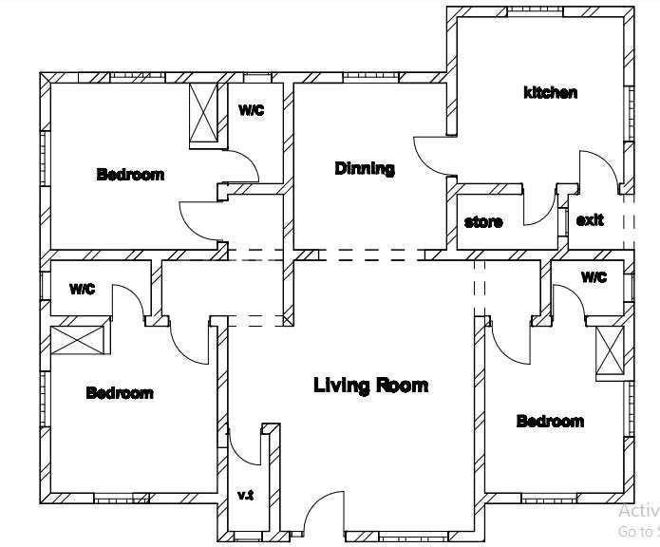

Figure3.14: Floor Plan 3-Bedroom Bungalow of Case Study three at Royal Valley Housing Estate, Ilorin, kwara state

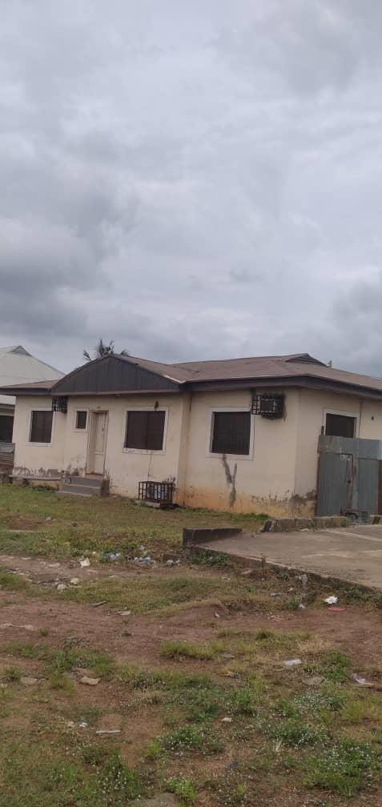
Plate3.14: Approach View of Three-Bedroom Bungalow at Royal Valley housing
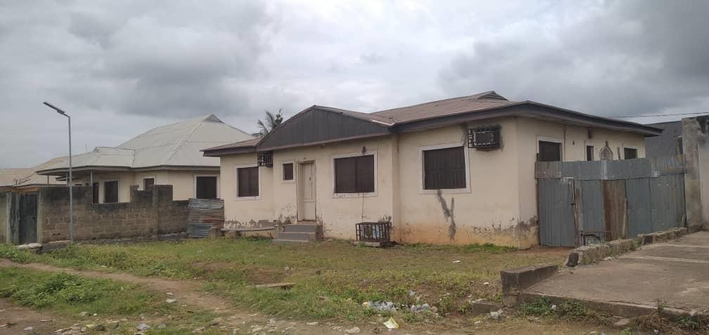
Plate3.15: Perspective View of Three-Bedroom Bungalow at Royal Valley housing

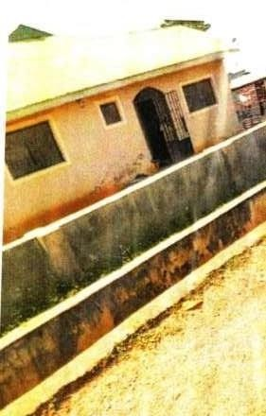

Plate3.16: Right View of Three-Bedroom Bungalow at Royal Valley Housing Estate

CHAPTER FOUR

STUDY AREA/PROJECT SITE

HISTORY OF KWARA STATE
Kwara state is a state located in the North central region of Nigeria and it was created on May 27,1967, by General Yakubu Gowon, along with 11 other state. It was originally named the west central state but was later renamed kwara, which is a local name for River Niger.
The region was conquered by the Fulani in the 19th century and was part of the greater Fulani empire until it was defeated by the forces of sir George Goldie’s Royal Niger company in 1897. It was then incorporated into the protectorate of Nigeria in 1914.
Kwara state is bordered by Benin to the west and by the Nigerian state of Niger to the North, kogi to the east, and Ekiti, Osun and oyo to the South. The state mostly consists of wooded savanna, but there are also forested regions in the south.
As of 2006, the population of kwara state was around 2.3million,making it the 30th most populous state in Nigeria.
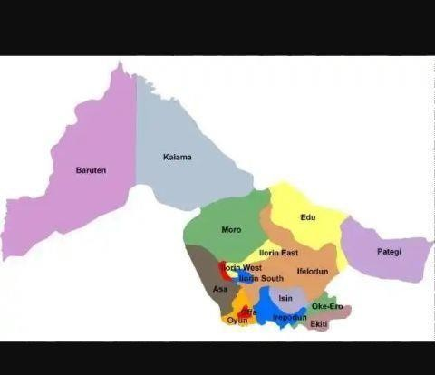
Figure 4.1: Locational map of Kwara State

LOCATION OF SITE
The site is located at Ilorin east local government, oke-oyi. Ilorin east local government was created on May 27,1967and the headquarters of Ilorin east local government is in the town of oke-oyi
The population as of 2006, the population of Ilorin east was 204,310 and covers an area of 408 square kilometers. The main language spoken in Ilorin east is Yoruba.
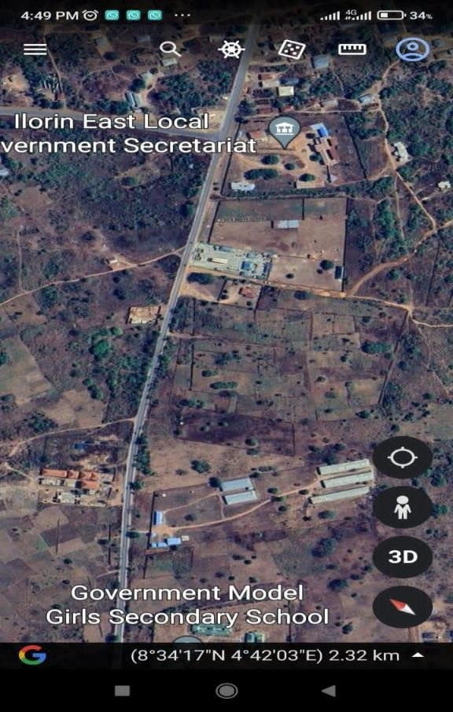
Plate 4.1: The proposed site in Ilorin east local government

SITE INVENTORY OR SITE ANALYSIS
Site inventory is a comprehensive documentation of the physical characteristics, features and conditions of a site. It typically includes: location and boundaries, topography, and drainage, vegetation, soil and geology, water resources and hydrology, climate and weather patterns, existing infrastructure, land use and zoning, environmental conditions ( if applicable ), photographs and maps.
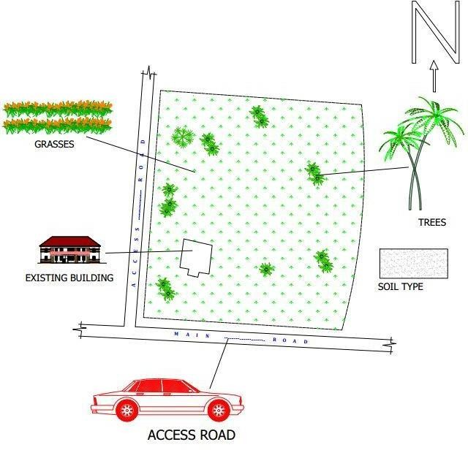
Figure 4.2: Site inventory of the proposed site

Site Analysis is a thorugh examination and evaluation of site’s conditions, characteristics and context. It involves gathering and analyzing data to understand the site. The goals of the site analysis are to identify site constraints and opportunities, inform design and development decisions, ensure environmental sustainability, respect cultural and historical heritage and enhance the site’s potential.
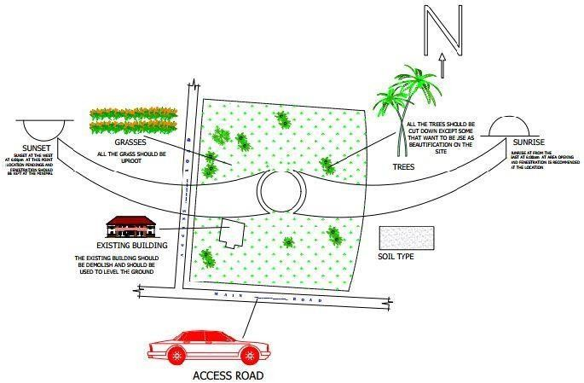

Figure 4.3: Site Analysis of the proposed site

GEOGRAPHICAL / CLIMATIC DATA
    - CLIMATE

In Ilorin, the wet season is oppressive and overcast, the dry season is humid and partly cloudy and it is hot year round. Over the course of the year, the temperature typically varies from 64⁰F to 95⁰F and is rarely below 57⁰F or above 100⁰F .
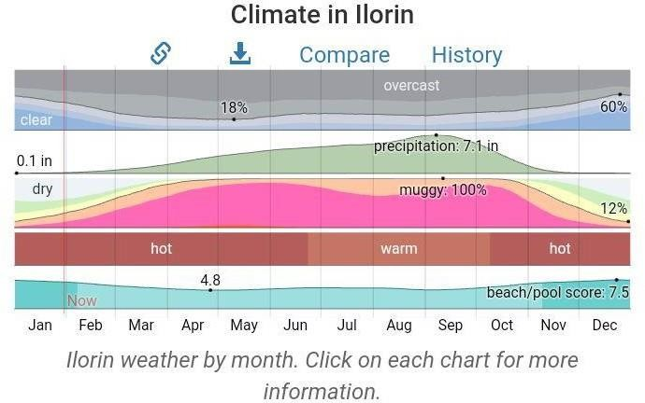
Figure 4.4: Graph of Climate in Ilorin

RAINFALL
Kwara typically receives about 101.45millimeters (3.99 inches) of precipitation and has
148.38 rainy days (40.65% of the time) annually.
Ilorin experiences two climatic season i.e rainy and dry season. The rainy season is between march and november with a brief break in august and the annual rainfall varies

from 1200mm
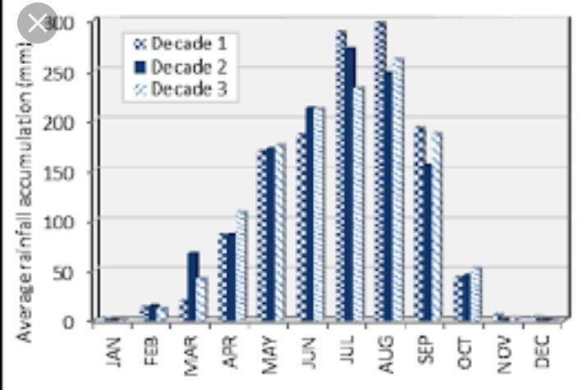
Figure 4.5: Graph of Rainfall in Ilorin

WIND
Both tropical continental and tropical maritime air masses affect ilorin. The city experiences thunderstorm, during the beginning and ending of the raining season. The prevailing wind direction is southwest trade wind, which is rain bearing since it takes origin from the sea in the raining season period and from north.

TEMPERATURE
Ilorin is within the climatic zone known as the equatorial zone which has a climatic type of low wet equatorial. The two major influences on Ilorin climate are the two major wind currents. The south west trade wind is warm and moisture laden and the north east trade wind is cold and dry. The two winds current bring about the two different seasons called the rainy and dry season. The raining season is between April and October while thedry season is between November and March. It is accompanied by cold dust and harmattan.

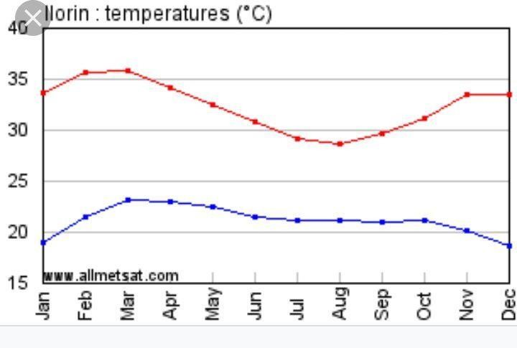
Figure 4.6: Graph of temperature in Ilorin

HUMIDITY
Kwara under certain factors experiences high relative humidity with high rainfall during the month june, july, august, and September.

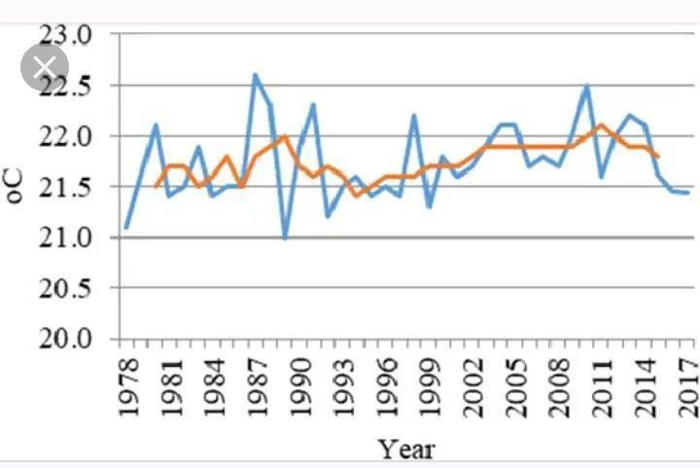
Figure 4.7: Graph of humidity in kwara state

ANALYSIS OF THE IMMEDIATE ENVIRONMENTAL CONDITIONS OF THE SITE
    - VEGETATION
The site is covered with grass, trees and shrubs are to removed.

SOIL CONDITION
The site has a rite soil with good sub-surface condition for construction and landscaping, it gives satisfactory geological and soil condition with no rock.

TOPOGRAPHY
It has a gentle slope towards the road at 30mm. It does not undulate. The typography of the proposed development site is relatively low that the topsoil and sub-soil firm and buildable. The site is therefore free from any natural of physical constraints and rock outcrops.

WIND DIRECTION
The site is planned in order to give it a defined shape and also to reflect the activities taking place. the location of building and facilities within the site follow these major principles.
- The priority of individual structure within the term zoning (noisy, semi-noisy and quiet zone)
- Parking space located within and around the various units of convenience.
- The police post is located within the entrance of the estate for security purpose.
- The supporting units such as church, mini mart, school, fire station, event center, clinic and market are centralized for easy access for the occupant.
- The site is properly defined with a perfect blend of both natural and artificial attraction as well as soft and hard landscaping.
  - PROJECT ANALYSIS / DESIGN CRITERIA
    - DESIGN CRITERIA

ORIENTATION
The orientation of the building must be designed in such a way that the large side face the north-east and south-west with adequate openings.

BRIEF ANALYSIS OF PROJECT
As a result of the deductions made from the studies conducted on the project adequate attention shall be given to the seven area/units that make this project. All these end up on mass housing.

THE UNITS/AREAS ARE AS FOLLOWS:
- Residential
- Services
- Recreation
- Maintenance
- Religion
- Institution
- Road network

RESIDENTIAL AREA: this area plays most important area in the housing, it’s the center of focus because it is the place where the occupant will spend most of their time as shelter and this is group into: Two bedroom bungalow, two bedroom bungalow ensuite and three bedroom bungalow ensuite.
The two bedroom bungalow is for low income earners and the two bedroom bungalow ensuite is for the middle income while the three bedroom bungalow ensuite is for the high income earners.
SERVICES: these units play much important role in the residential area because without services in the housing, the lives of the occupant will not be complete and also services are part of the social amenities and facilities that will improve physical, biological and social of the occupant in the mass housing. the following are services provided in the servicing area; Gate house/security post, Police post, Clinic/health care, Fire station and Event center and market.
RECREATION: recreation area is also an important area in the housing estate and the
units include: Garden / sit-outs, Sport area and Children playground.
MAINTENANCE: is a very important section in the mass housing for comfortability of the occupant. This unit includes; Waste disposal and Central sewage system.
RELIGION: Some people find of difficult to worship God due to far distance if worship centers, then, in the proposal housing there is provision of worship center for Muslim and Christian worshippers such as: Mosque and Church.
INSTITUTION: The children of the occupant and the people living around the housing estate can make use of the school present within the housing. The unit includes: Nursery and primary school.
ROAD NETWORK: For proper movement of traffic flow to case activities within the housing estate. The unites provided are follow: Trucks, Bus, Cars.

FUNCTIONAL ANALYSIS
There is various types of means that is employed in the functional analysis but the most suitable will be used for the project.
- Low income earner

S/N | UNITS | L x B | AREA | NO
1 | ENTRANCE | 3.0m x 1.2m | 3.6m | 1
2 | PARLOUR | 3.0m x 3.6m | 10.8m | 1
3 | BEDROOM | 3.0m x 3.6m | 10.8m | 1
4 | KITCHEN | 2.4m x 1.5m | 3.6m | 1
5 | BEDROOM | 0.9m x 1.2m | 1.08m | 1
6 | WC & SHW | 1.2m x 1.8m | 2.16m | 1
7
Table 4.1: Space allocation for Two Bedroom Bungalow.
- Middle income earner

S/N | UNITS | L x B | AREA | NO
1 | ENTRANCE | 3.925m x 1.2m | 4.71m | 1
2 | VISITOR’STOILET | 0.9m x 1.5m | 1.35m | 1
3 | MAIN LOUNGE | 4.2m x 4.2m | 17.64m | 1
4 | DINING | 2.7m x 2.4m | 6.48m | 1
5 | KITCHEN | 2.7m x 2.4m | 6.48m | 1
6 | STORE | 2.7m x 1.2m | 3.24m | 1
7 | BEDROOM | 3.6m x 3.75m | 13.5m | 1
8 | BEDROOM | 3.3m x 3.9m | 12.87m | 1
9 | WC & SHW | 2.175m x 1.2m | 2.61m | 1
10 | WC & SHW | 2.175m x 1.2m | 2.61m | 1
11 | EXIT | 2.7m x 1.2m | 3.24m | 1

Table 4.2: Space allocation for Two Bedroom Bungalow Ensuite.
- High income earner

S/N | UNITS | L x B | AREA | NO
1 | ENTRANCE | 5.04m x 1.2m | 6.048m | 1
2 | VISITOR’STOILET | 0.9m x 1.5m | 1.35m | 1
3 | MAIN LOUNGE | 5.04m x4.725m | 23.814m | 1
4 | DINING | 2.525m x4.275m | 10.794375m | 1
5 | KITCHEN | 3.925m x 3.6m | 14.13m | 1
6 | STORE | 1.3m x 2.4m | 3.12m | 1
7 | BEDROOM | 3.6m x 3.675m | 13.23m | 1
8 | BEDROOM | 3.3m x 3.9m | 12.87m | 1
9 | BEDROOM | 3.6m x 3.9m | 14.04m | 1
10 | WC & SHW | 2.1m x 1.2m | 2.52m | 1
11 | WC & SHW | 2.1m x 1.2m | 2.52m | 1
12 | WC & SHW | 1.275m x 2.1m | 2.6775m | 1
13 | EXIT | 2.65m x 1.2m | 3.18m | 1
14 | LOBBY | 1.2m x 3.0m | 3.6m | 1
Table 4.3: Space allocation for Three Bedroom Bungalow Ensuite.

APPRAISAL OF PROPOSED SCHEMES
In a project design, there are three basic factors to be considered and they are Stability i.e the strength, capability of the structure, both in exterior and interior of the structure.
Functionality i.e the proper chaining of the units block, to meet the purpose of the structure to the users and the Aesthetics of the design i.e the consideration beauty of the structure in

both views, environment and the finished. In this design, these three factors are put in place to meet the functional demand and to create a proportionally balanced design.

EQUIPMENT AND OPERATIONAL AND PERFORMANCE REQUIREMENT
Here attempt is made to group the various units according to the activities taking place in them. Their activities have been grouped into seven zone units but zoning base on the activities taking place in the housing has to go this way.
- Housing area/residential area ( private area): This area is known to be private area on site
- Public area: This area is where the auxiliary facilities is located and this area include Mini-mart, police post, fire station, clinic/healthcare, church, mosque, event center, nursery and primary school, relaxation area and market.

SPATIAL ALLOCATION/ SCHEDULE OF ACCOMMODATION
It is the allocation of space required in the building design in order to make the most appropriate use of spaces available.

CONCEPTUAL DEVELOPMENT
The proposed project duly considered functionally which is the paramount factor when embarking on a mass housing project. In the concept, development between the units in the housing and the occupants.

CHAPTER FIVE

APPROACH TO THE DESIGN/DESIGN REALIZATION
In approaching this design, many factors, strategies and research work were taken into consideration. Some of the factors include functionality, durability, and cost of materials. Their search work that were carried out are the study of the area, the neighborhood value. Statistics and population of the community, the household value, the occupations and social lives of the occupant of the area. These factors and deductions were highly considered in the development of this project to achieve a functional and aesthetically balanced design.

TECHNOLOGICAL AND ENVIRONMENTAL CRITERIA

CONSTRUCTION METHOD
The method of construction involved in the erection of the building structure is in accordance with the architectural detail required in executing the buildings and the process of construction that is critical to structural component as affected by the site conditions and types of materials to be used.
After the preparation of the overall site plan, many designs are developed to show the specific methods of construction. These details as an integral part of the design process and serve two important purposes. Firstly, they stipulate the aesthetic as structural element of the plan and they provide the basis for costing project.
This section offers a side of representative details of' the various aspect of site development and summed that the details will act as guild to assist site designer in solving their particular problems. The section is not intended to present aesthetic or design solution alone but also indicate how similar technological difficulties are handled, it is clear that the method of construction of any structure such mass housing is determined from the functional

requirement of the facilities provided and its exposure to weather and climatic condition for any use, the following factors are considered; Climatic conditions of the site, Condition of the sub-soil present on the site, Fire protection requirement, Appearance of materials, Durability and easy maintenance, Economy, Availability of materials, Aesthetic, Construction technique and Cost of materials.
The various building components taken into consideration are:
- SUB-STUCTURE: This is the part of the building below the natural ground level. The foundation footing is reinforced for stability of the building to enable it to withstand the load (live, superimposed and wind load). The foundation of the building shall be determined by the structural engineer according to the bearing capacity of the soil.
- SUPER-STRUCTURE:This is the building part that is above the natural ground level. The entire structure is designed with reinforced concrete columns, beams and hollow sand screed block.

MATERIALS AND STANDARD FORMS
The following materials are applied in the construction of the structure such as:
      - FLOORS: The ground floor will be of solid concrete slab of 150mm with asphalt coating as damp proof course laid on well compacted hardware. The upper floors are reinforced concrete suspended floors of 150mm thick.
Floor finishes are to be specified for each unit depending on the function it is meant to serve. Floor finishes are to be specified for each tiles and terrazzo floor tiles because they are durable, easy to maintain and do not wear easily.
      - DOORS: The size and types of doors used depend on its location but generally the size ranges from 1200mm, 900mm and 750mm and the type of materials specified for the construction is in the door schedule which should be strictly followed.
      - WINDOWS: A window in a building is designed primarily to allow natural light, natural air, the building issued to allow free flow of carbon dioxide out of the building as well as to allow for outside view.

      - ROOFS: Roof members of all building will be made up of timber and long span of aluminum roofing sheet. This is for the easy maintenance of self-support and longer life span.
      - CEILING: The kind of ceiling system specified for the building in the housing estate is the asbestos ceiling sheet. The functional requirement of this ceiling is considered under the following: Durability, Easy to maintain, Heat resistance and Cost

SERVICES REQUIRED
Services are essential for comfort ability security and safety to create a conducive atmosphere for the user of the housing estate to achieve this, the following services must be provided.
- ELECTRICITY: The main source of electricity is from the national electric power authority and this should be connected to the site from the power in front of the site way.
- VENTILATION: Ventilation needed in the intention part of building varies from place to place. Natural ventilation is considered best in building construction and is attained with the use pf natural air. Natural air reaches interior part of the building through windows and some other openings. Artificial ventilation is attained with the use of fans and some other atmospheric cooling machines.
- LIGHTNING: Natural lightning is the best and most effective source of light for the building though artificial sources will be used where necessary.
- PLUMBING SERVICES: All water supplies and other distribution to all the required areas would be through 50mmdiameter galvanized steel pipe while sewage will be PVP service pipe, which ranges from 50mm, 100mm and 150mm diameter. All the baths and shower will be provided with shower tray, towel trays, washing hand basin and tissue roll holders. The entire toilet WHB will be with a mirror over it. Septic tanks and soak away pit shall be placed and in suitable location for easy maintenance.
- ACOUSTICS: The major noise comes from the major road and this could be reduced considerably by maintaining a reasonable setback from the major road and the proper landscaping which include planting of trees and grass to serve as noise and sound absorbent.

- WASTE DISPOSAL: Waste disposal should be provided where unwanted material such as dirty should be dump in order to make the environment clean.
- FIRE PROTECTION: Structural protection is achieved by using fire resistance elements and limiting the use of combustible materials and finishes. Fire detectors and firefighting equipment should be provided.
- SECURITY SERVICES: The entry and exit to the site have been restricted to one entrance. This is to monitor the movement of vehicles in and out of the site. The entrance will be maintained with the security men checking incoming and outgoing vehicles. The entire site will be light up with security light and street light within the site. It is necessary to fence the mass housing to ensure adequate security, a strong fence is provided in addition to police post in order to keep off intruders of all types.
- EXTERNAL WORK: These are work carried out outside and around the building. It is otherwise known as Landscaping. These are elements used to provide aesthetics and general human comfort in and around the building.
There are two types of landscaping: Soft Landscaping and Hard Landscaping
  - SOFT LANDSCAPING: This is done by planting trees, shrubs and lowers around the building to serve as barrier to the thermal discomfort and beautify the structures.
  - HARD LANDSCAPING: This is done by paving the whole of the open ground and such paving area include the parking lots, the walk ways, roadster.

ENVIRONMENTAL CONDITIONS TO BE ACHIEVED
There is plantation of trees to regulate the temperature. The orientation of the building structure to achieve maximum comfort thereby controlling the radiation.

PERFORMANCE STANDARDS
The performance standard of the building construction is to be highly luxurious because of the targeted users and the occupants of the town which have a high taste of social lives.

LEGAL ISSUES AND PLANNING REGULATIONS
The proposed building must pass through various process in order to be approved of the planning regulations of the local government authorities and the board of chiefs because of its being public building. The process for approval in the local planning authority is to

provide the following which are: The C of O of the Land, The Survey Plan, The original land purchase documents, The Structural Drawings, The Architectural Drawings and The Mechanical and Electrical Drawings.

BEHAVIOURAL PATTERNS AND CONSIDERATIONS
The condition in designing the mass housing is for comfort ability and affordability of the proposed tenant and user of the estate, providing adequate recreational facilities and securities.

CONCLUSION AND RECOMMENDATIONS
    - CONCLUSION
This project has examined the contextual and organizational challenges in public housing provision in Ilorin east local government, kwara state.
Research shows that since independence in 1960, government in Nigeria have demonstrated commitment to addressing the housing problems in several ways but due to funding, political and organizational challenges, public housing agencies have provided insufficient number of poor quality and unaffordable housing agencies have provided insufficient number of' poor quality and unaffordable housing units in the country.

RECOMMENDATIONS
To address these challenges this project makes the following recommendations.
Firstly, the government should give more permission to private owners to develop housings that will help to reduce people on the street in various states and towns.
Secondly, mass housing should be built according the proper research about the neighborhood value and household values and also according to the income proportion ofthe community so as to enable more people to be able to able to own convenient houses of their own.
Thirdly, the government should help try to regulate the prices of raw materials as they contribute to the total expense at which the houses are put on rent or sales.
In conclusion, it is clear that the challenges against housing in Nigeria are multi-facet: however, much time can be invested on programme designs. It is therefore expected that the findings and recommendations gotten from the project have advanced my understanding of challenges and solutions to mass housing in Nigeria.

REFERENCES
AdemoluIbem and Gbemisola Amole, “Evaluation of public housing programmes in Nigeria”(2021)
Amamata, Z. A. Safiya, O. &Bala, B. (2023): Integrating Factors of Housing Affordability in as a Scheme in Governmental Policies. Accessed Online.
Arigbola, A. (2019). Housing Affordability as a Factor in the creation of Sustainable Environment in Developing World: The Example of Akure, Nigeria. Journal of Human Ecology, 35(2), pp: 121-131.
Australian Housing and Research Institute (AHURI) (2022). Measuring Housing Affordability. AHURI Research and Policy Bulleting, Issue 45.
Nepal, B., Tanton, R. & Harding, A. (2019). Measuring Housing Stress: How Much Do Definitions Matter? Urban Policy and Research, 28(2), pp: 211-224.
Harri, C. M. (2024): Dictionary of Architecture and Construction. Pub MC Graw Hill. Book Company.
Salvato, A. J. (2023). Environmental Engineering and Sanitation. Third Edition. John Willey and Sons Inc.
Rogers, E. K. (2021). The Modern House: Its Design and Decoration. Harper and Row Pub. Memullan, R. (2017): Environmental Science in Building Macmillan. Pub First Edition.
Lyneh, K. and Hak, G. (2021): Site Planning. Pub Map Press Cambridge Massachusetts and London, England.
Awotona, A. (2020). Housing Policy Nigeria; Government Policies for housing Nigeria Urban poor and working class, Laudable Great Expectation Colosal Failure Habitat International.
Burrudge, R. AN Ormandy, D. (2021). Unhealthy Housing Research, Remedies and Reforms, First Edition.
Ramsey and Sleeper (2022): Architectural Graphics Standards, Tenth Edition, John Willey and Sons Inc.
Effions-Williams, J. (2024): McGraw Hill Encyclopedia of Science and Technology

APPENDIX

APPENDICE I: LOCATIONAL (MAP, PLAN) APPENDICE II: SITE INVENTORY APPENDICE III: SITE ZONING APPENDICE IV: SITE ANALYSIS
APPENDICE V: PROGRAM DEVELOPMENT APPENDICE VI: SPACE CALCULATION APPENDICE VII: SITE PLAN
APPENDICE VIII: LOW INCOME EARNER APPENDICE IX: MIDDLE INCOME EARNER APPENDICE X: HIGH INCOME EARNER APPENDICE XI: SECTIONS
APPENDICE XII: PERSPECTIVES APPENDICE XIII:

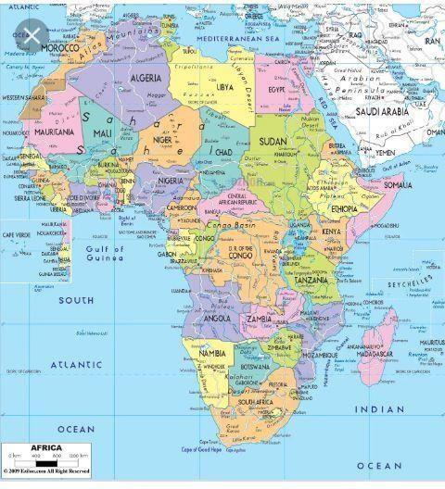
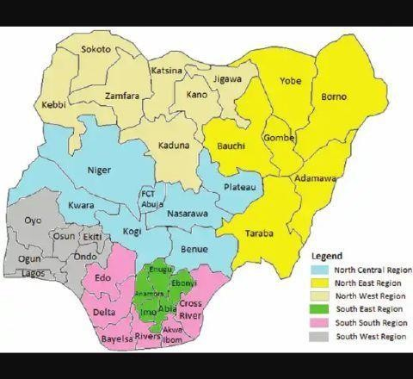
APPENDICE I: LOCATIONAL MAP

`
MAP OF AFRICA{01} MAP OF NIGERIA {02}
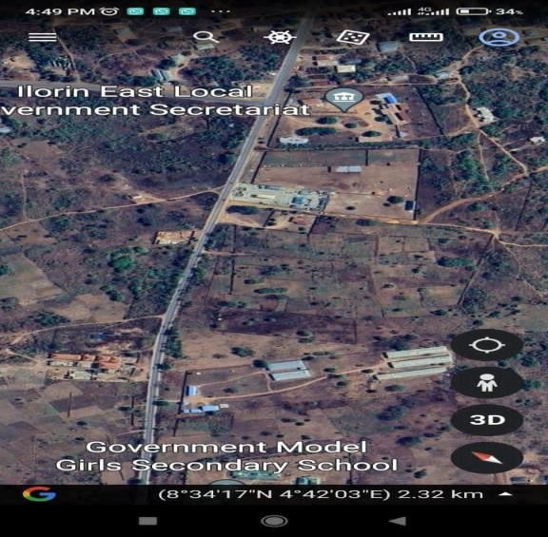
MAP OF KWARA STATE {03} PROPOSED SITE IN ILORIN EAST L.G{04}

LOCATIONAL PLAN

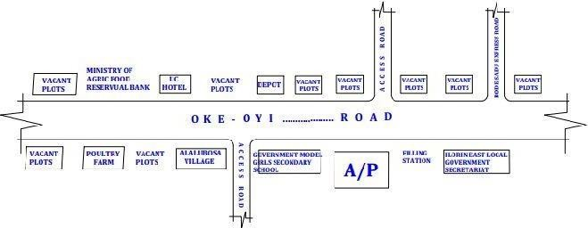

APPENDICE II: SITE INVENTORY

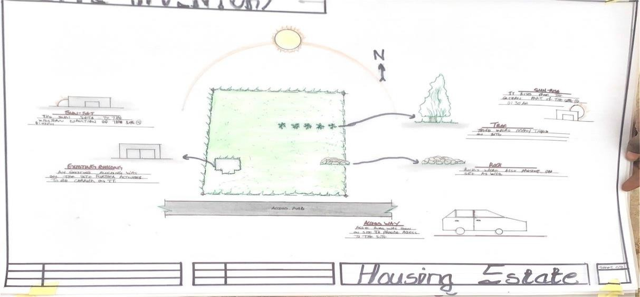

APPENDICE III: SITE ANALYSIS

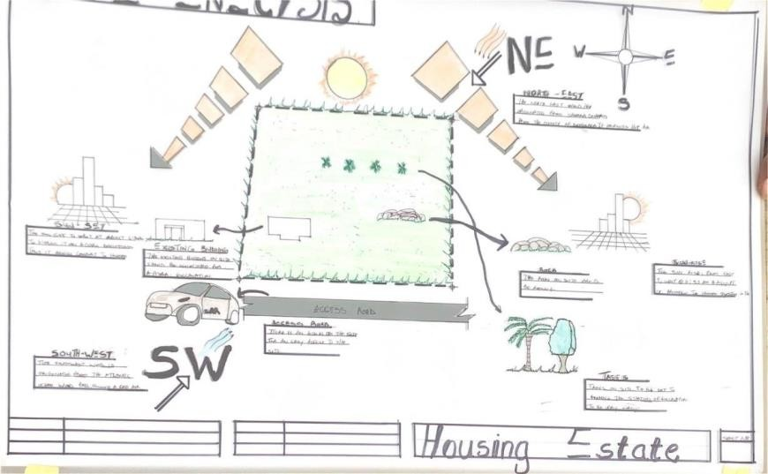

APPENDICE IV:SITE ZONING

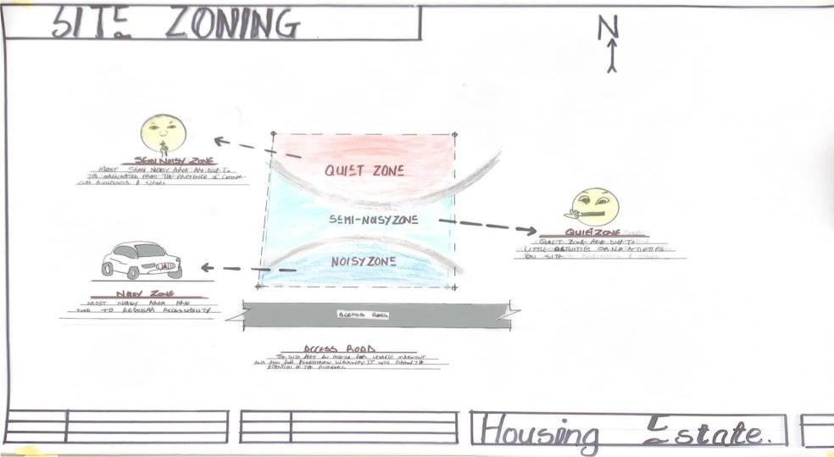

APPENDICE V: PROGRAM DEVELOPMENT

S/N | CADER | BUILDING TYPOLOGY | NO OF BUILDING | NO OF DWELLERS PER  BUILDING | PERCENTAGE [%]
1 | LOW INCOME EARNER | Two Bedroom Bungalow | 21 | 1 | 31%
2 | MIDDLE  INCOME EARNER | Two  Bedroom Bungalow | 24 | 1 | 33%
 |  | Ensuite
3 | HIGH INCOME EARNER | Three Bedroom Bungalow  Ensuite | 26 | 1 | 36%
 |  |  | 71

APPENDICE VI:SPACE CALCULATION

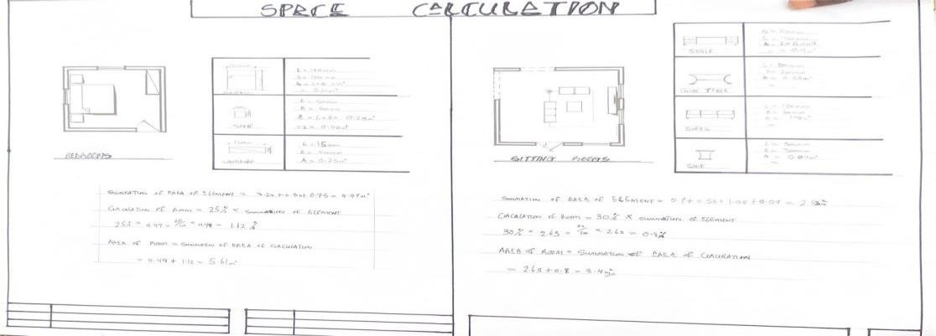

APPENDICE VII: SITE PLAN

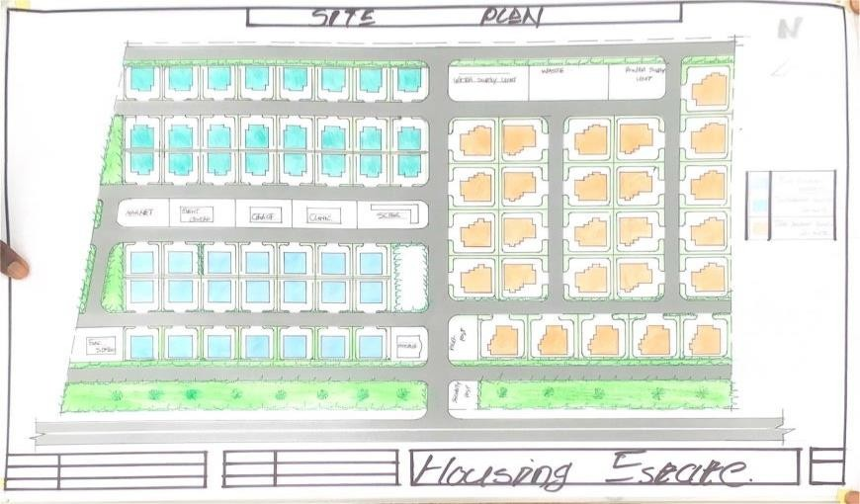

APPENDICE VIII: LOW INCOME EARNER

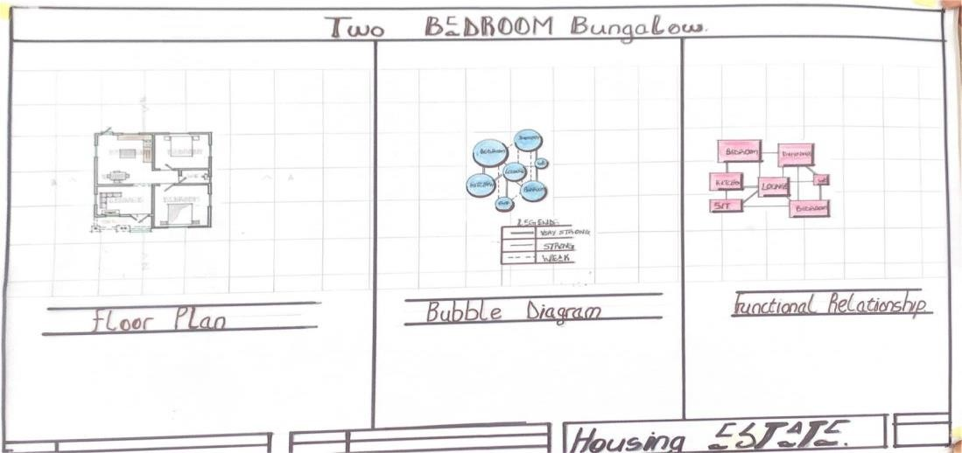

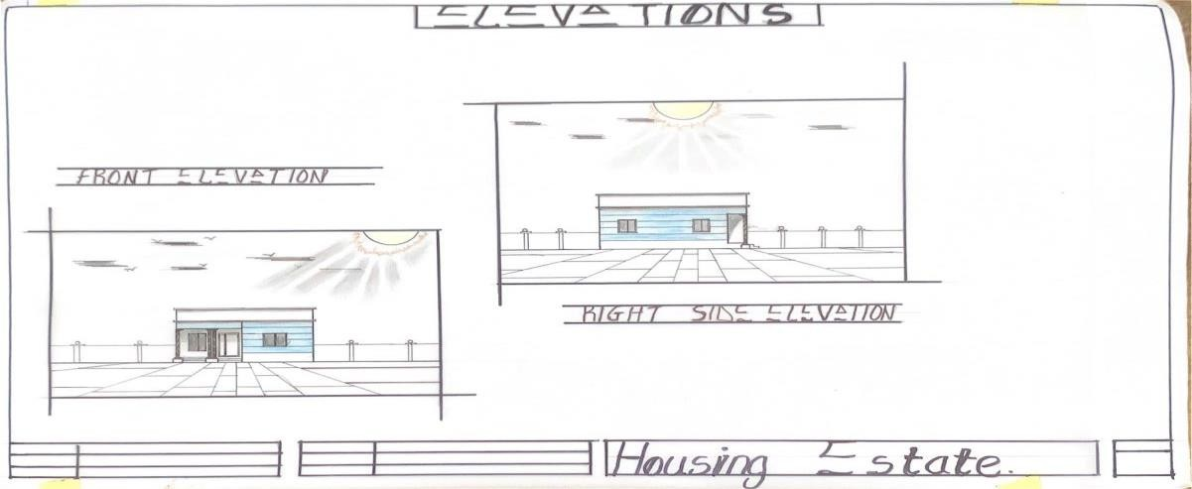

APP END ICE IX : MIDDLE INCOME EARNER

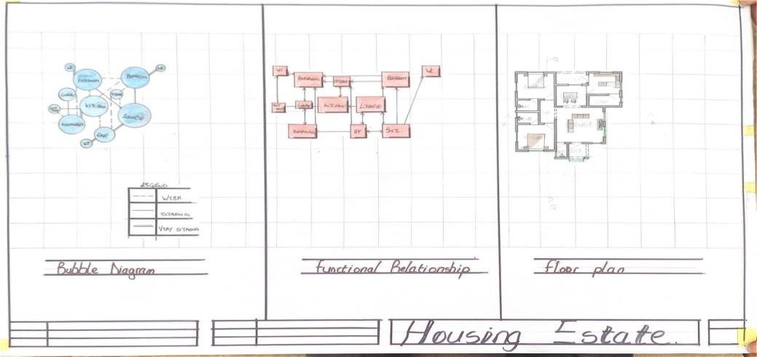

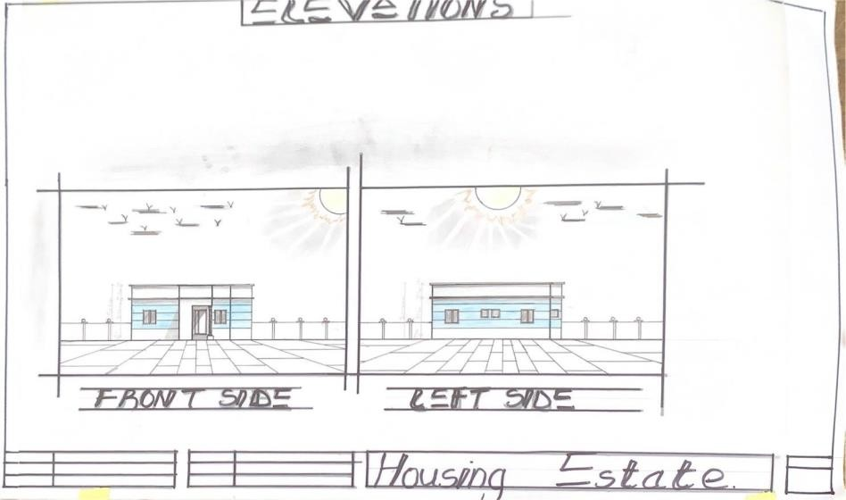

APPENDICE X: HIGH INCOME EARNER

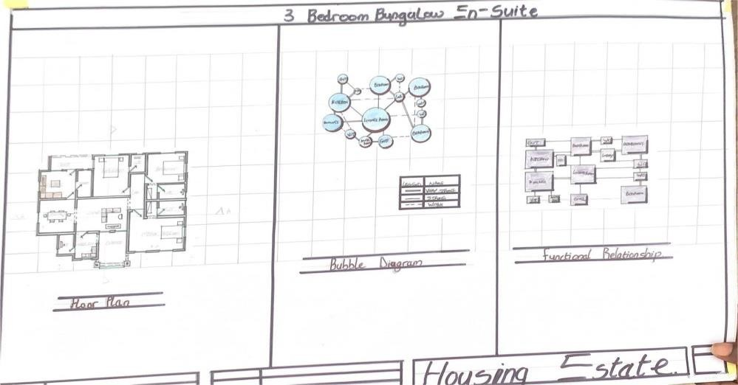

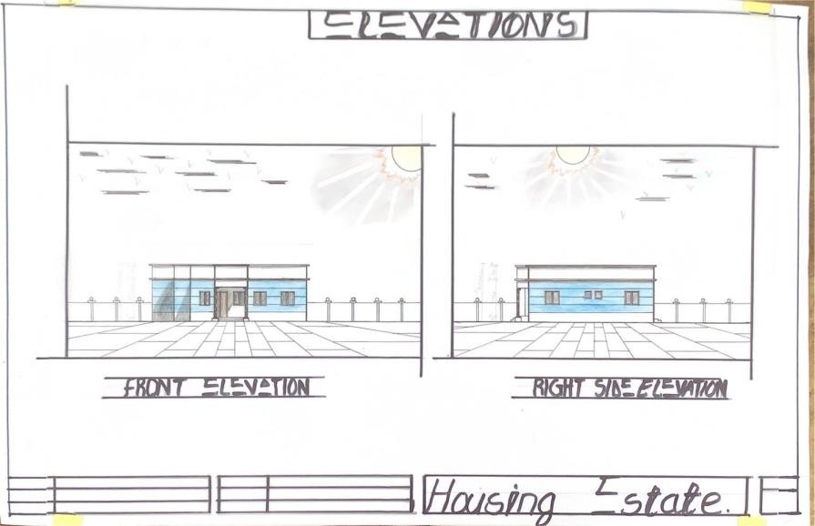

APPENDICE XI: SECTIONS
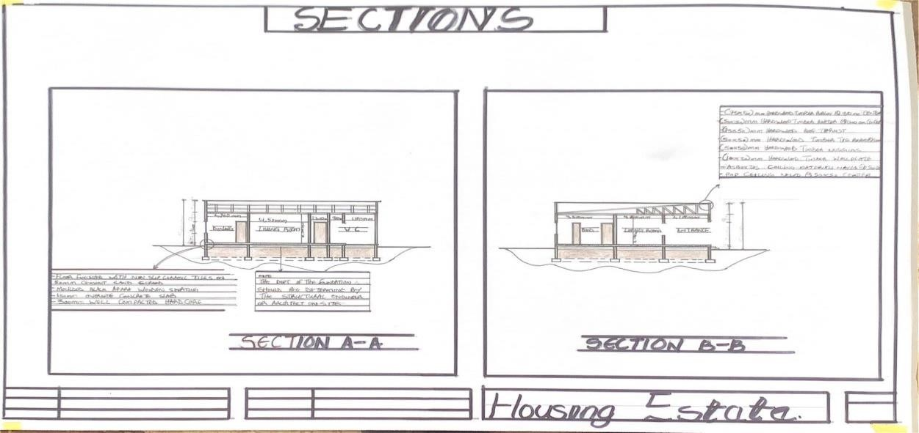

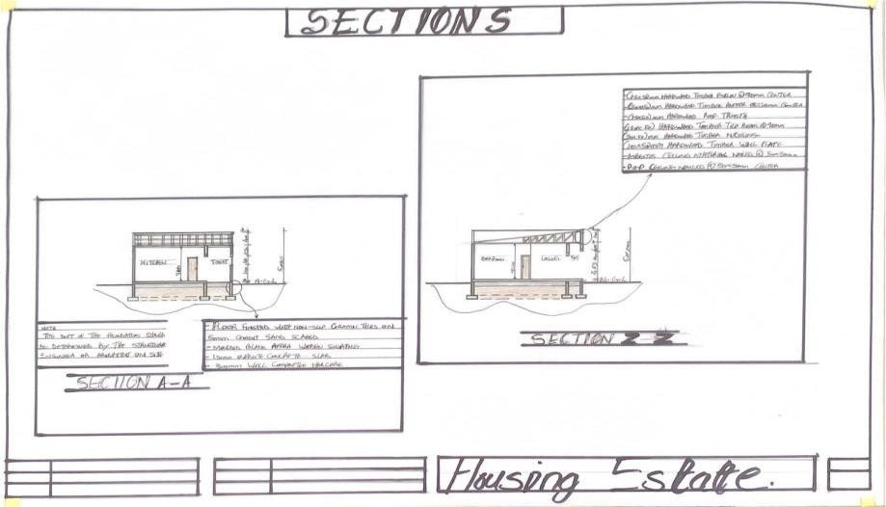

APPENDICE XII: INTERNAL PERSPECTIVE
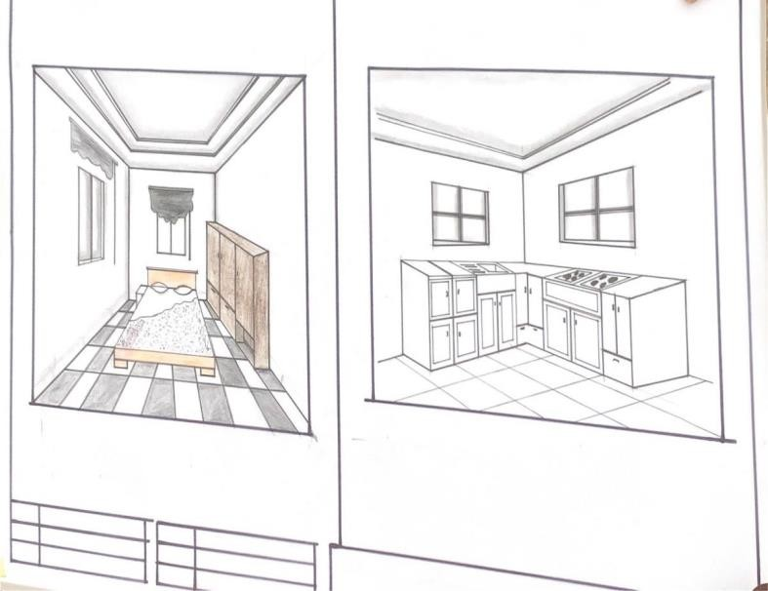

HIGH INCOME EARNER

