A TECHNICAL PROJECT REPORT
ON

PROPOSED BOARDING SECONDARY SCHOOL
FOR
KABBA DONGARI VILLAGE AMOYO, KWARA STATE.
BY:
AKATAKA EMMANUEL PRINCE
HND/23/ARC/FT/0028

SUBMITTED TO
THE DEPARTMENT OF ARCHITECTURALTECHNOLOGY, INSTITUTE OF ENVIRONMENTAL STUDIES, KWARA STATE POLYTECHNIC, ILORIN.

IN PARTIAL FULFILMENT OF THE REQUIREMENTS FOR THE AWARD OF HIGHER NATIONAL DIPLOMA (HND)
IN ARCHITECTURAL TECHNOLOGY.

JULY 2025

DECLARATION
I declare that this Project/Dissertation is a product of my personal research work. It has not been presented for the award of any degree in any Polytechnic/University. The ideas, observations, comments, suggestions herein represent my own convictions, except quotations, which have been acknowledged in accordance with conventional academic traditions.

AKATAKA EMMANUEL PRINCE
HND/23/Arc/Ft/0028 SIGNATURE/DATE

CERTIFICATION
“I certify that this Research Project/Dissertation entitled BOARDING SECONDARY SCHOOL” was carried out by AKATAKA EMMANUEL PRINCE, with Matriculation Number HND/23/arc/ft/0028, under my supervision and has been approved as meeting the requirements for the award Of Higher National Diploma in Architectural Technology, of Kwara State Polytechnic, Ilorin, Kwara state, Nigeria.


ARC. FAMILUA O.S
(Project Supervisor SIGNATURE/DATR


ARC. OLAREWAJU F.A
(Project coordinator ) SIGNATURE/DATE


ARC. J.M TOMORI.
(Head of Department) SIGNATURE/DATE

EXTERNAL SUPERVISOR SIGNATURE/DATE

ACKNOWLEDGEMENT
This ultimate dominion still belong to Almighty GOD. All praises to GOD, no partner has He, there is no deity worthy of worship than Him, He is the final resurrection. Peace and blessing be upon the lord JESUS. and His family, His companion and everyone of us who adhere to his teaching till the day of judgement. I also recognize the support, love, care and guidance of my precious parents in person of MRS AKATAKA, I pray Almighty GOD reward you abundantly ,may you reap the fruit of your labour and shall be blessed more than your imagination (Amen) My sincere gratitude goes to my supervisor ARC. FAMILUA O.S for sparing his time to take me through all the stages and exhaustible efforts and constructive remarks in writing this project. Never must I forget the indefatigable and untiring efforts of my family, my lovely sister AKATAK JOY, MOSE ELIZABETH and my lovely brother JONE AKATAKA . Lastly I want to appreciate my lovely friends who render their service for me when I needed them may Almighty GOD bless you all abundantly. (AMEN)
In appreciation to my HOD ARC J.M Tomori and Director IES ARC BYF Abdulazeez, I appreciate your support for our HND studies. Your guidance and resources have been invaluable. Thank you for creating an enabling environment for us to thrive. Your leadership and vision inspire us to excel. We're grateful for your mentorship and backing."

DEDICATION

This Project is dedicated to God almighty for his protection and provision throughout my Higher National Diploma [HND] Program. And also, my loving family, for their unwavering support, encouragement, and understanding throughout this journey. Your belief in me has been my greatest strength. And In Loving of my MOM AKATAKA ROSE whose spirit and love continue to be a source of inspiration and guiding light in all that I do.

TABLE OF CONTENTS
DECLARATION ii
CERTIFICATION iii
ACKNOWLEDGEMENT iii
DEDICATION v
ABSTRACT x
CHAPTER ONE 2
1.1 INTRODUCTION 2
1.3 HISTORICAL BACKGROUND 2
1.5 AIM AND OBJECTIVES 4
1.5.1 AIM 3
1.5.2 OBJECTIVES 3
1.6 JUSTIFICATION FOR THE PROJECT 5
1.7 CLIENTS BACKGROUND, PHILOSOPHY, OPERATIONAL STRUCTURE 4
1.8 SCOPE OF STUDY 6
1.9 LIMITATION OF STUDY 6
1.10 BRIEF DEVELOPMENT OF THE PROJECT 7
1.11 RESEARCH METHODOLOGY 8
CHAPTER TWO 9
2.1 REVIEW OF RELEVANTLITERATURE 10
2.1.1 REVIEW OF LITERATURE ON THE BUILDING TYPE 11
2.1.1.1 Evolution of Shopping Arcade topology. 12
2.1.1.2 IMPORTANT ISSUES AND PROBLEMS PECULIAR TO SECONDARY SCHOOLTYPOLOGY. 14
2.1.1.3 UNIQUE SOLUTIONS TO SPECIFIC PROBLEMS PECULIAR TO BUILDING? 16
2.1.1.4 FUNCTIONS AND RELATIONSHIPS BETWEEN SPACES COMMON TO BOARDING SECONDARY SCHOOl 18
2.1.1.5 TECHNOLOGICAL AND ENVIRONMENTAL APPROACHES FOR DESIGNING TYPOLOGY. 20
2.1.1.6 MECHANICAL AND SERVICES 22
2.2 REVIEW OF LITERATURE ON THE SUB-TOPIC OF THE THESIS 23
2.2.1 IN THE SPECIFIC CONTEXT OF SCHOOL, SOME OF THE IMPORTANT ISSUES AND PROBLEMS INCLUDE: 23
2.2.2 ARCHITECTURALLY RELATED MERITS AND DEMERITS OF THE PROJECT 16
CHAPTER THREE 24
3.0 CASE STUDIES 24
3.1 SELECTED CASE STUDIES 24
3.2 CASE STUDY ONE 25
3.3 CASE STUDY TWO 289
3.4 CASE STUDY THREE 33
3.5 CASE STUDY FOUR [ONLINE CASE STUDY] 39
CHAPTER FOUR 40
4.1 STUDY AREA/PROJECT SITE 41
4.1.1 Analysis of the topographical and environmental conditions of the site. 43
4.1.1.1 Introduction of study area/site selection 45
4.1.1.2 SITE LOCATION/ DESCRIPTIONS/ CRITERIA 47
4.1.1.3 SITE ANALYSIS/INVENTORY 47
4.1.1.4 GEOGRAPHICAL/CLIMATIC DATA 48
4.1.1.5 ANALYSES OF THE IMMEDIATE ENVIRONMENTAL CONDITIONS OF THE SITE. 49
4.2 PROJECT ANALYSIS/ DESIGN CRITERIA 49
4.2.1 PROJECT GOALS 50
4.2.2 FUNCTIONAL/SPATIAL CRITERIA 50
4.2.3 APPRAISAL OF PROPOSED SCHEMES IN THE SPACES, SIZE AND RELATIONSHIPS 50
4.2.4 EQUIPMENT AND OPERATIONAL AND PERFORMANCE REQUIREMENTS 52
4.2.5 SPATIAL ALLOCATION / SCHEDULE OF ACCOMMODATION 54
4.2.6 FUNCTIONAL RELATIONSHIP 55
CHAPTER FIVE 56
5.1 APPROACH TO THE DESIGN/DESIGN REALIZATION……………………………..56
5.1.1 THE DESIGN IDEAS/CONCEPTS AT DIFFERENT LEVELS OF THE DESIGN PROCESS (SITE /BUILDING)…………………………………………………………...….57
5.1.3 TECHNOLOGICAL AND ENVIRONMENTAL CRITERIA 59
5.1.3.1 CONSTRUCTION METHODOLOGY AND MATERIAL /FINISHES DESIRED BY THE CLIENTS 60
5.1.3.2 SERVICES REQUIRED: CIRCULATION, VENTILATION, LIGHTING, PLUMBING AND ELECTRICAL INSTALLATION, ACOUSTICS, WASTE DISPOSAL, FIRE PROTECTION AND EXTERNAL WORKS. 60
5.1.3.3 ENVIRONMENTAL CONDITIONS TO BE ACHIEVED 61
5.1.3.4 PERFORMANCE STANDARDS 62
5.1.4 LEGAL ISSUES AND PLANNING REGULATIONS 62
5.1.5 BEHAVIORAL PATTERN 62
5.2 SUMMARY, RECOMMENDATION AND CONCLUSION 63
5.2.1 SUMMARY 63
5.2.2 RECOMMENDATION 64
5.2.3 CONCLUSION 64
5.3 REFERENCES 65
5.4 APPENXI……………………………………………………………………………...…66

TABLE OF FIGURES

FIG 3.2.1. LOCATIONAL MAP OF CASE STUDY ONE 25
FIG. 3.2.2 SITE PLAN OF CASE STUDY ONE 26
FIG. 3.2.3 GROUND FLOOR PLAN OF CASE STUDY ONE 26
FIG. 3.2.4 UPPER FLOOR PLAN OF CASE STUDY ONE 26
FIG. 3.3.1 LOCATIONAL PLAN OF CASE STUDY TWO 29
FIG. 3.3.2 SITE PLAN OF CASE STUDY TWO 30
FIG. 3.3.3 TYPICAL FLOOR PLAN OF CASE STUDY TWO 30
FIG. 3.4.1 LOCATIONAL PLAN OF CASE STUDY THREE 33
FIG. 3.4.2 SITE PLAN OF CASE STUDY THREE 33
FIG. 3.4.3 FLOOR PLANS OF CASE STUDY THREE 34
FIG. 3.5.1 FLOOR PLAN OF ONLINE CASE STUDY 34

TABLE OF PLATES
PLATE: 3.2.1 - FRONT ELEVATION OF CASE STUDY ONE 27
PLATE: 3.2.2 - LEFT ELEVATION OF CASE STUDY ONE 27
PLATE: 3.3.1 - FRONT ELEVATION CASE STUDY TWO 31
PLATE: 3.3.2 - BACK ELEVATION OF CASE STUDY TWO 31
PLATE: 3.4.1 - FRONT ELEVATION OF CASE STUDY THREE 35
PLATE: 3.4.1 – INTERIOR VIEW OF UPPER FLOOR OF CASE STUDY THREE 35
PLATE: 3.5.1 – FRONT ELEVATION OF ONLINE CASE STUDY 37
PLATE: 3.5.2 – INETERNAL PERSPECTIVE OF ONLINE CASE STUDY 338
PLATE: 3.5.3 – INETERNAL PERSPECTIVE GROUND FLOOR OF ONLINE CASE STUDY 39

ABSTRACT

This project focuses on optimizing the educational experience in a boarding secondary school setting, emphasizing the integration of academic excellence, personal development, and community engagement. Boarding schools play a pivotal role in shaping students' academic trajectories and personal growth by providing a structured environment that fosters learning, discipline, and social interaction. The proposed project aims to enhance the overall experience of students in a boarding secondary school by implementing strategies that promote academic achievement, emotional well-being, and extracurricular engagement. Key components of the project include developing tailored academic support programs to address individual learning needs, implementing wellness initiatives to support students' mental and physical health, and fostering a vibrant extracurricular program that encourages participation in sports, arts, and leadership activities. By creating a balanced and supportive environment, the project seeks to improve students' academic performance, enhance their social skills, and cultivate a sense of community and responsibility among students and staff. The boarding secondary school setting provides a unique opportunity for holistic development, as students live and learn together in a community-oriented environment. This project recognizes the importance of this setting in shaping well-rounded individuals who are prepared for future challenges. Outcomes of the project are expected to include improved academic metrics, higher levels of student satisfaction with school life, and increased participation in extracurricular activities. Furthermore, the project emphasizes the role of faculty and staff in creating a nurturing yet challenging environment that supports the diverse needs of boarding students.By addressing the academic, emotional, and social needs of students in a boarding secondary school, this project aims to set a model for enhancing educational experiences in similar settings. The findings and strategies developed through this project could inform best practices for boarding schools seeking to optimize student outcomes and create a supportive, engaging community. Ultimately, the project strives to contribute to the development of confident, capable, and compassionate individuals who are well-prepared for success in their future endeavors.
This study focuses on site analysis and conceptual development for a proposed project. Through a thorough examination of the site's physical and environmental characteristics, this research aims to inform design decisions and create a cohesive concept. The analysis will consider factors such as climate, topography, and existing infrastructure to develop a contextually responsive design.

CHAPTER ONE

1.1 INTRODUCTION
A boarding day secondary school is an educational institution that combines academic rigor with residential living, providing students with a structured environment that fosters discipline, responsibility, and independence. These schools offer a unique opportunity for students to develop essential life skills, such as time management, self-reliance, and teamwork, while pursuing their academic goals. By living on campus, students can form lasting bonds with their peers and develop a sense of community and belonging. Boarding day secondary schools provide a holistic education that extends beyond the classroom, offering a range of extracurricular activities, sports, and character-building programs that promote physical, emotional, and social well-being. The schools' experienced staff, including teachers, tutors, and residential advisors, provide guidance, support, and supervision to ensure students' academic and personal success. With state-of-the-art facilities, including classrooms, libraries, and laboratories, boarding day secondary schools create an environment that is conducive to learning and growth. By attending a boarding day secondary school, students can gain a competitive edge in their academic and professional pursuits, while developing the skills, confidence, and character necessary to succeed in an ever-changing world. Overall, boarding day secondary schools offer a transformative educational experience that prepares students for future success.

1.2 DEFINITION
A boarding secondary school is a residential educational institution where students live on campus during the academic term, typically in dormitories or hostels, and attend classes during the day. These schools provide a comprehensive education that combines academic rigor with personal development, fostering independence, self-reliance, and responsibility. Students are immersed in a community that promotes friendship, teamwork, and mutual support, with access to experienced teachers, tutors, and mentors. Boarding secondary schools offer a structured environment that encourages students to develop essential life skills, pursue their passions, and achieve academic excellence, preparing them for success in higher education and beyond.

1.3 HISTORICAL BACKGROUND
The concept of boarding schools dates back centuries, with roots in ancient civilizations such as Greece and Rome. In these cultures, young men would often live and study with their teachers, developing their intellectual and physical abilities. During the Middle Ages, boarding schools were primarily associated with monasteries and convents, where monks and nuns would educate young boys and girls in reading, writing, and theology. The modern concept of boarding schools emerged in the 16th century in Europe, particularly in England, where boarding schools were established to educate the sons of nobility and gentry. These schools emphasized character development, academic rigor, and physical activity, shaping the young men into leaders and gentlemen. Over time, boarding schools have evolved to accommodate students from diverse backgrounds and needs, offering a unique blend of academic excellence, personal growth, and community living. Today, boarding schools can be found worldwide, providing students with a transformative educational experience that prepares them for

1.5 AIM AND OBJECTIVES

1.5.1 AIM
My aim for this project is to design a good and standard boarding secondary school is to create a supportive and inclusive community that fosters academic excellence, personal growth, and social development, providing students with a safe, comfortable, and inspiring environment to thrive and reach their full potential.
.

1.5.2 OBJECTIVES
- To Design educational buildings as a secondary school to enhance access to education and improve learning outcomes.
- To designs consider accessibility for all community members and prioritize safety in facilities like hostels and educational buildings.
- To designs to meet the unique needs of Kabba Dongari, considering local context, culture, and challenges.
- To ensure vehicular parking areas in such a manner as to be functional aesthetically academic building, site plan in terms of landscaping and safe for a good strandard of learning

1.6 JUSTIFICATION FOR THE PROJECT
The lack of adequate secondary educational facilities and buildings in Kabba Dongari, Ifelodun LGA, hinders educational development and future opportunities for residents. Designing and constructing educational buildings addresses this gap, promoting community development, increasing access to education, and supporting future generations. Without a local secondary school, students face barriers due to distance, cost, and safety concerns. Providing facilities fosters growth, improves socioeconomic status, and enhances quality of life. Educational buildings can serve as community hubs, promoting engagement and development. By investing in education infrastructure, Kabba Dongari can improve educational outcomes and contribute to economic development, equipping individuals with skills for the workforce.

1.7 CLIENTS BACKGROUND, PHILOSOPHY, OPERATIONAL STRUCTURE
Kabba Dongari is a rural area in the Gammo community, Ifelodun Local Government Area (LGA), Kwara State. The community faces challenges typical of rural Nigerian areas, including limited access to education, healthcare, and essential services. The operational philosophy in such a context likely emphasizes community development through strategic initiatives in education, healthcare, and economic empowerment. Enhancing access to education is critical given the lack of secondary schools and educational buildings. Fostering community growth, improving socioeconomic status, and promoting financial inclusion are key considerations for development in Kabba Dongari, aiming to improve residents' quality of life and opportunities.

1.8 SCOPE OF STUDY
- GATE HOUSE
- PARKING LOT
- ACADEMIC BUILDING
- SECURITY HOUSE
- GENERATOR HOUSE
- SEPTIC TANKS
- SCHOOL HOSTEL( MALE/ FEMALE)
- STAFF LODGE
- ASSEMBLY GROUND
- SCHOOL SHOP
- PLAYING GROUND

1.9 LIMITATION OF STUDY
- High costs: Tuition fees, accommodation, and other expenses can be prohibitively expensive for many families.
- Homesickness and adjustment issues: Students may experience homesickness, loneliness, or difficulty adjusting to a new environment.
- Limited family time: Students may have limited opportunities to spend time with their families, potentially affecting relationships.
- Safety and supervision concerns: Ensuring student safety and providing adequate supervision can be a challenge.
- Academic pressure: The boarding school environment can sometimes exacerbate academic pressure and stress.
- Limited personal freedom: Students may have to adhere to strict rules and schedules, limiting their personal freedom.

1.10 BRIEF DEVELOPMENT OF THE PROJECT
- ENTRANCE POUCH
- RECEPTION HALL
- JENIOR CLASS ROOM
- PHYSIC LAB
- CHEMISTRY LAB
- DIRECTOR PARKING LOT
- COMPUTER LAB
- STAFF ROOM
- EXAM OFFICE
- TECHNICAL DRAWING CLASS
- MUSIC STUDIO
- ADMIN OFFICE
- ASSEMBLY HALL
- CONTROL UNIT
- SCIENCE, ART, COMMERCIAL CLASS
- SENIOR ACADEMIC UNIT
- CONFERENCE HALL
- DIRECTOR OFFICE

1.11 RESEARCH METHODOLOGY
Various avenues were explored as regard the method of research in order to arrive at a functional and appealing design concept. The following research methods were employed;
- Oral Interview: This is an interview conducted and gathered by professional Body so as to know the efficiency and deficiency of the project.
- Literature Reviews: To provide focus, references to tolerate ideas from various writer were consulted in other to attain usefulness on an important past work on similar project.
- The Internet: This research was done in other to gain more insight and to gain more collective data.
- Case Studies: This was done by synthesis analysis of existing similar structures (Buildings), through writing, sketches, diagrams and photos. To understand the various aspects of the project designing and construction methods.

CHAPTER TWO

2.1 REVIEW OF RELEVANTLITERATURE

2.1.1 REVIEW OF LITERATURE ON THE BUILDING TYPE

2.1.1.1 EVOLUTION OF BOARDING SECONDARY SCHOOL TOPOLOGY.
Boarding secondary schools have been a vital part of the educational landscape for centuries, providing students with a unique opportunity to live and learn in a supportive community. This literature review aims to explore the existing research on boarding secondary schools, focusing on their impact on students' academic performance, personal growth, and emotional well-being.
1 ACADEMIC PERFORMANCE
Numerous studies have investigated the relationship between boarding schools and academic performance. Research suggests that boarding schools can have a positive impact on students' academic achievement, particularly in terms of discipline and motivation (Coleman, 1987). A study by Martin and Dowson (2009) found that boarding school students tend to perform better academically than their non-boarding peers, attributing this to the structured environment and access to resources. However, other studies have noted that the academic benefits of boarding schools may be influenced by factors such as socio-economic status and prior academic achievement (Lubienski & Lubienski, 2014).
2 PERSONAL GROWTH
Boarding schools are often designed to foster personal growth and development in students. Research has shown that living away from home can promote independence, self-reliance, and resilience in students (Shields, 2017). A study by Gazda-Grace (2002) found that boarding school students reported higher levels of self-confidence and self-esteem compared to non-boarding students. However, other studies have noted that the boarding school experience can also present challenges to personal growth, particularly in terms of adapting to a new environment and navigating social relationships (Baldwin, 2017).
3 EMOTIONAL WELL-BEING
The emotional well-being of boarding school students is a critical concern. Research has highlighted the potential risks of homesickness, anxiety, and depression among boarding school students (Fisher, 2011). A study by Wilkins (2017) found that boarding school students reported higher levels of stress and anxiety compared to non-boarding students. However, other studies have noted that boarding schools can also provide a supportive environment that promotes emotional well-being, particularly when effective support systems are in place (Martin, 2017).
4 SUPPORT SYSTEMS
The importance of effective support systems in boarding schools cannot be overstated. Research has shown that counseling, mentorship, and peer support can play a critical role in promoting student well-being and mitigating the challenges associated with boarding school life (Simmons, 2018). A study by Harris (2019) found that boarding schools with strong support systems reported lower rates of student attrition and higher levels of student satisfaction.

2.1.1.2 IMPORTANT ISSUES AND PROBLEMS PECULIAR TO BOARDING SECONDARY SCHOOL
1. INFRASTRUCTURE AND FACILITIES
Dormitories/Hostels: Safe, comfortable, and well-maintained living quarters with adequate space, lighting, and ventilation.
Classrooms: Equipped with modern teaching aids, technology, and sufficient space for effective learning.
Recreational Facilities: Sports fields, playgrounds, libraries, and other amenities that promote physical activity, relaxation, and personal interests.
Dining Hall: Clean, spacious, and well-managed cafeteria providing nutritious meals.
2. ACADEMIC SPECIFICATIONS
Curriculum: Comprehensive and well-structured curriculum aligned with national or international standards.
Teaching Staff: Qualified, experienced, and dedicated educators who provide individual attention and support.
Learning Resources: Access to libraries, digital resources, and other materials that facilitate learning and academic growth.

3. SAFETY AND SECURITY
Campus Security: Measures in place to ensure student safety, including surveillance, secure entry and exit points, and on-site security personnel.
Emergency Procedure: Well-defined protocols for handling emergencies such as fires, natural disasters, and medical crises.
4. HEALTH AND WELLNESS
Medical Care: Access to on-site medical facilities or partnerships with local healthcare providers for routine check-ups and emergencies.
Counseling Services: Trained counselors or psychologists providing support for students' emotional and psychological well-being.
5. ADMINISTRATIVE AND SUPPORT STAFF
House Parents/Residential Advisors: Trained staff who oversee student living areas, provide guidance, and ensure a supportive environment.
Administrative Staff: Efficient and responsive administrative team handling admissions, student records, and other operational tasks.
6. Community and Extracurricular Activities
*Clubs and Societies: Opportunities for students to engage in extracurricular activities that foster interests, talents, and social skills.
*Community Service: Programs or initiatives that encourage students to participate in community service and develop a sense of social responsibility.
7. Technology and Resources
IT Infrastructure: Reliable internet access, computer labs, and other technological resources that support learning and communication.
Sustainability Practices: Initiatives aimed at reducing environmental impact, such as energy-efficient buildings, recycling programs, and sustainable practices.

2.1.1.3 FUNCTIONS AND RELATIONSHIPS BETWEEN SPACES COMMON TO BOARDING SECONDARY SCHOOL.
In a secondary school setting, the function and relationship between space and community are interconnected and crucial for effective learning and student development. Here’s how they relate:
FUNCTION OF SPACE IN SECONDARY SCHOOLS
1. LEARNING ENVIRONMENTS:
*Classrooms: Designed to facilitate teaching and learning, equipped with resources like whiteboards, projectors, and seating arrangements that support various instructional methods.
* Specialized Spaces: Science labs, art rooms, and technology workshops provide hands-on learning experiences tailored to specific subjects.

2. SOCIAL SPACES:
- Common Areas: Courtyards, cafeterias, and outdoor spaces encourage social interaction, relaxation, and community building among students.
- Recreational Facilities: Sports fields, gyms, and playgrounds promote physical activity and teamwork.
3. SUPPORT SPACES:
- Libraries/Media Centers: Serve as hubs for research, reading, and digital learning, supporting both individual and collaborative study.
- Counseling Offices: Provide a safe and confidential space for students to discuss personal, academic, or social issues with trained professionals.
RELATIONSHIP BETWEEN SPACE AND COMMUNITY
1. Inclusive Design:
- Spaces that are accessible and welcoming foster a sense of belonging and inclusion among all students, regardless of their background or abilities.
2. Community Building:
- Shared Spaces: Common areas like cafeterias, courtyards, and sports fields encourage interaction and collaboration, helping to build strong relationships within the school community.
- Flexible Learning Spaces: Open and adaptable classrooms can support collaborative learning and group projects, promoting teamwork and communication skills.
3. WELL-BEING AND SAFETY:
- Safe Environments: Well-designed spaces that prioritize safety and security contribute to a positive school climate, allowing students to focus on learning and personal growth.
- Wellness Spaces: Quiet areas, green spaces, or mindfulness rooms can support students' mental and emotional well-being, enhancing their ability to learn and thrive.
4. Engagement and Motivation
- Inspiring Environments: Aesthetically pleasing and well-maintained spaces can motivate students and staff, creating a positive atmosphere that encourages engagement and productivity.
5 Key Considerations
- Sustainability: Designing spaces that are energy-efficient and environmentally friendly can teach students about sustainability and responsibility.
- Technology Integration: Incorporating technology into learning spaces can enhance engagement and prepare students for the digital world.
- Adaptability: Spaces that can be reconfigured for different activities or needs ensure that the school can adapt to changing educational practices and student requirements.

2.1.1.54TECHNOLOGICAL AND ENVIRONMENTAL APPROACHES FOR DESIGNING TYPOLOGY.
TECHNOLOGICAL APPROACHES:
1. Smart Building Systems: Implement building management systems that control lighting, heating, cooling, and ventilation to optimize energy use and maintain comfort.
2. Interactive Directories and Wayfinding: Use digital kiosks and mobile apps to help visitors navigate the arcade, find stores, and access information about promotions or events.
3. Digital Storefronts: Equip retail spaces with digital displays that can change content, promoting sales and events or providing interactive experiences.
4. Wi-Fi and Connectivity: Provide free, high-speed Wi-Fi throughout the arcade to enhance the visitor experience and enable retailers to engage with customers through mobile apps and online platforms.
5. Energy-Efficient Lighting: Use LED lighting and smart sensors that adjust brightness based on natural light levels and occupancy to reduce energy consumption.
6. Security and Surveillance: Incorporate advanced security systems with high-definition cameras and analytics software for a safe

Environmental Approaches:
1. Green Roofing and Living Walls: Incorporate green spaces within the arcade to improve air quality, provide insulation, and create a pleasant ambiance.
2. Rainwater Harvesting: Collect and reuse rainwater for landscaping and non-potable uses to conserve water resources.
3. Sustainable Materials: Use locally sourced, recycled, and low-emission materials in the construction and fit-out of the arcade.
4. Natural Ventilation and Day lighting: Design the arcade to maximize the use of natural light and air flow to reduce reliance on artificial lighting and HVAC systems.
5. Waste Management: Implement comprehensive recycling and composting programs to minimize the environmental impact of the arcade's operations.
6. Renewable Energy: Install solar panels or integrate other renewable energy sources to power common areas and reduce the carbon footprint.
7. Transportation: Encourage the use of public transport, cycling, and walking by providing easy access, bike racks, and pedestrian-friendly entrances.

2.1.1.6 MECHANICAL AND SERVICES
MECHANICAL SYSTEMS:
1. HVAC (Heating, Ventilation, and Air Conditioning):
- Provides climate control to maintain comfortable temperatures throughout the year.
- Includes air filtration and purification systems to ensure good indoor air quality.
2. Plumbing:
- Supplies water to restrooms, food service areas, and maintenance facilities.
- Includes waste and stormwater management systems.
3. Fire Protection and Suppression:
- Sprinkler systems and fire extinguishers throughout the arcade for fire suppression.
- Fire alarms and smoke detectors for early warning.
4. Elevators, Stairs and Escalators:
- Facilitate vertical circulation for customers, especially in multi-level arcades.
- May include lifts for individuals with disabilities to ensure accessibility.
5. Lighting:
- Energy-efficient lighting systems with automated controls for energy savings.
- Emergency lighting systems for power outages and evacuations.
SERVICES:
1. Security:
- Surveillance cameras and security personnel to monitor activity and ensure safety.
- Access control systems to manage entry to restricted areas.
2. Waste Management:
- Centralized waste collection points for tenants.
- Recycling and composting programs to minimize environmental impact.
3. Information Technology:
- Infrastructure for high-speed internet and Wi-Fi connectivity.
- Digital signage and interactive screens for advertising and information.
4. Maintenance:
- Facilities for the storage of maintenance equipment and materials.
- Staff and systems for the ongoing upkeep of the arcade.
5. Customer Services:
- Information desks, lost and found, and other customer assistance services.
- Amenities such as public restrooms, seating areas, and baby changing facilities.
6. Parking:
- Parking facilities, either on-site or nearby, including spaces for bicycles..

2.2 REVIEW OF LITERATURE ON THE SUB-TOPIC OF THE THESIS
A literature review on the sub-topic of boarding secondary schools reveals mixed findings on the impact of boarding schools on student development. Research suggests that boarding schools can have both positive and negative effects on students' cognitive, behavioral, affective, and physical development.
1 IMPACT ON STUDENT DEVELOPMENT
- Cognitive Development: Boarding schools have a significant positive predictive effect on students' cognitive development.
- Affective and Attitudinal Development: Boarding schools have a significant negative predictive effect on students' affective and attitudinal development.
- Behavioral and Physical Development: No significant predictive effects were found on students' behavioral and physical development.
2 MODERATING FACTORS
- School Stage: The relationship between boarding schools and student development is moderated by school stage, with junior middle school students experiencing more significant negative effects.
- Type of Boarding SchooL: Urban boarding schools have a positive effect on student development compared to rural boarding schools.
3 RESEARCH FINDINGS AND IMPLICATIONS
Studies have shown that boarding schools provide a collectivized learning and living environment, which can improve students' academic achievement. However, the dilution of parent-child relationships in boarding schools may lead to emotional and psychological challenges for students.
2.2.1 IN THE SPECIFIC CONTEXT OF BORDIND SECONDARY SCHOOL, SOME OF THE IMPORTANT ISSUES AND PROBLEMS INCLUDE:
In the context of boarding secondary schools, several important issues and problems require attention to ensure the well-being, safety, and effective education of students. These issues can impact student development, school management, and overall outcomes.
KEY ISSUES AND PROBLEMS
1 Adjustment Challenges: Students often face challenges adjusting to boarding life, including separation from family and adapting to a structured environment.
2 Mental Health and Well-being: Boarding students may experience stress, loneliness, or other mental health issues due to the residential setting.
3 Safety and Security Concerns: Ensuring the safety of students in a residential setting is critical, including protection from bullying, harassment, or other risks.
4 Balancing Independence and Supervision: Finding the right balance between allowing students independence and providing necessary supervision is important.
5 Diversity and Inclusivity: Managing diversity and promoting inclusivity among students from different backgrounds can be a challenge.
6 Academic Pressure and Performance: Boarding schools often have high academic expectations, which can impact student stress levels and performance.
7 Parent-Student-School Communication: Effective communication between parents, students, and school staff is essential but can be challenging in a boarding setting.
ADDRESSING THESE ISSUES
1 Support Systems: Implementing robust support systems like counseling services can help address mental health and adjustment issues.
2 Clear Policies and Procedures: Having clear policies on safety, discipline, and communication helps in managing the boarding environment.
3 Training for Staff: Staff training on managing boarding school dynamics and supporting student needs is crucial.

2.2.2 ARCHITECTURALLY RELATED MERITS AND DEMERITS OF THE PROJECT
1 Cost Control: With a clear plan and defined scope, architectural projects can better manage costs and avoid unexpected expenses. Item rate contracts, for instance, provide transparency in pricing, allowing clients to know exactly what they're paying for.
2 Flexibility : Some project management models, like iterative development, offer flexibility in design and implementation, enabling adjustments as needed.
3 Single Point of Contact: Turnkey contracts, where the contractor handles everything from design to construction, can simplify communication and reduce client risk.
4 Faster Completion: Projects with a clear plan and defined responsibilities can be completed more quickly, reducing delays and downtime.
5 Risk Management: Certain project management models, like the spiral model, focus on risk reduction, helping to identify and mitigate potential issues early on.
DEMERITS:
1 Limited Client Control: In turnkey contracts, clients may have limited influence over the project's design and implementation.
2 Inaccurate Estimates: Item rate contracts can lead to cost overruns or underutilization of resources if estimates are inaccurate.
3 Disputes: Discrepancies between actual and estimated quantities can cause disputes between clients and contractors.
4 Quality Compromise: Contractors might prioritize cost savings over quality, especially if the contract is awarded based on the lowest bid.
5 Higher Costs: Turnkey contracts can be more expensive due to the contractor's increased risk and responsibility

CHAPTER THREE

3.0 CASE STUDIES

3.1 SELECTED CASE STUDIES
Case studies are of paramount important. It is an experimental research or analysis carried out on existing building or group of building functionally similar to the one which the researcher is working.For any technical design to be meaningful there is always need for Preliminary research effort to be made on this proposal as a very necessary groundwork. The following case studies of boarding day secondary school both private and public were visited and been carried out include the following:
PHYSICAL CASE STUDIES
1. Case Study One layola international, M.K.O Agboola Way, Oluyole Ibadan.
2. Case Study Two: FAITH ACADEMIC, ITALAMU AJASE IPO ROAD, ILORIN, KWARA STATE.
3. Case Study Three: HOLARB COLLAGR GAA KANBI ROAD, ILORIN, KWARA STATE.
Online case study
1. CASE STUDY FOUR: THE ULTIMAT ITERNATIONAL, CLEVELAND, OH, UNITED STATES

3.2 CASE STUDY ONE
layola international, M.K.O Agboola Way, Oluyole Ibadan.
BRIEF INTRODUCTION
Loyola International in Ibadan, Oyo State, Loyola Jesuit College is a well-known institution in IBADAN, Nigeria. Loyola Jesuit College offers:
- Quality education: A focus on academic excellence, character development, and spiritual growth.
- Modern facilities: State-of-the-art classrooms, laboratories, sports facilities, and boarding facilities.
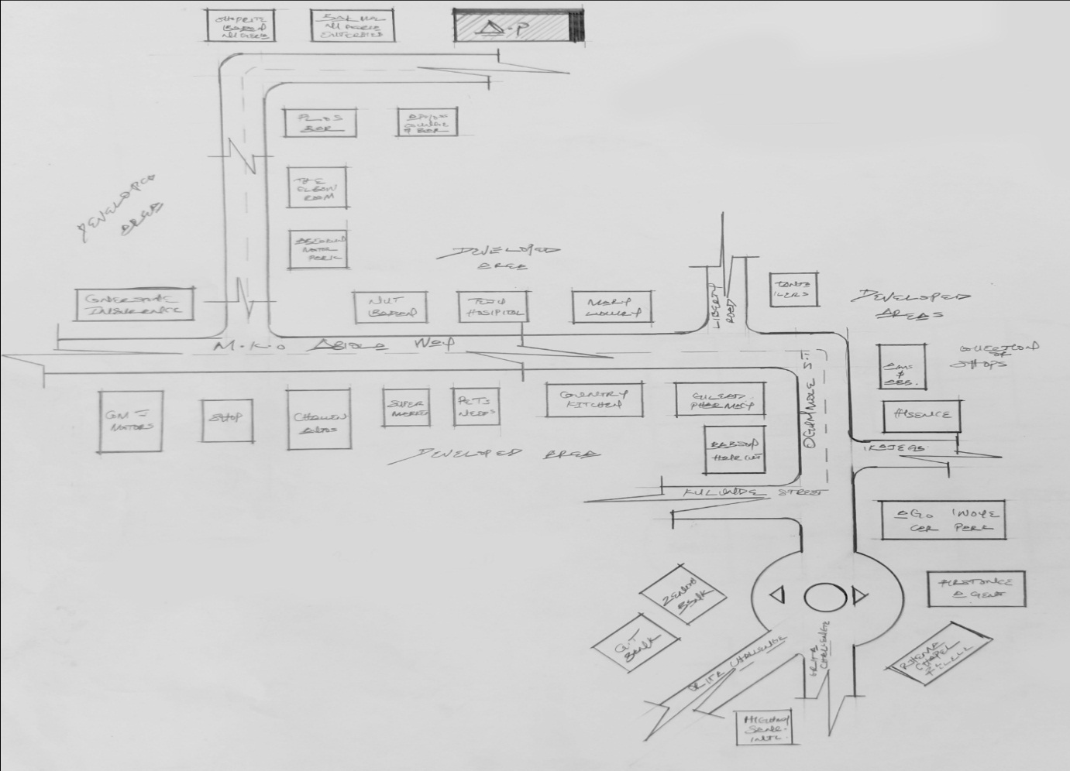

FIG. 3.2.1. LOCATIONAL PLAN OF CASE STUDY ONE
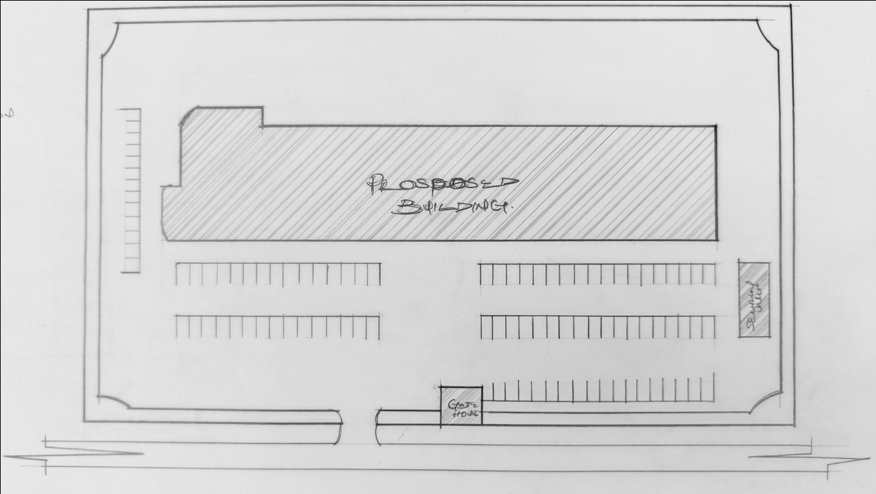
FIG. 3.2.2 SITE PLAN OF CASE STUDY ONE
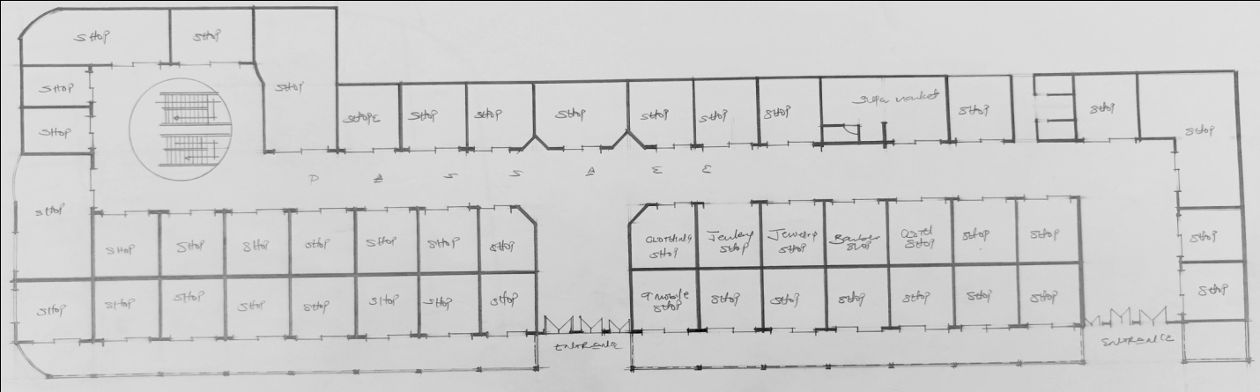
FIG. 3.2.3 GROUND FLOOR PLAN OF CASE STUDY ONE
FIG. 3.2.4 UPPER FLOOR PLAN OF CASE STUDY ONE

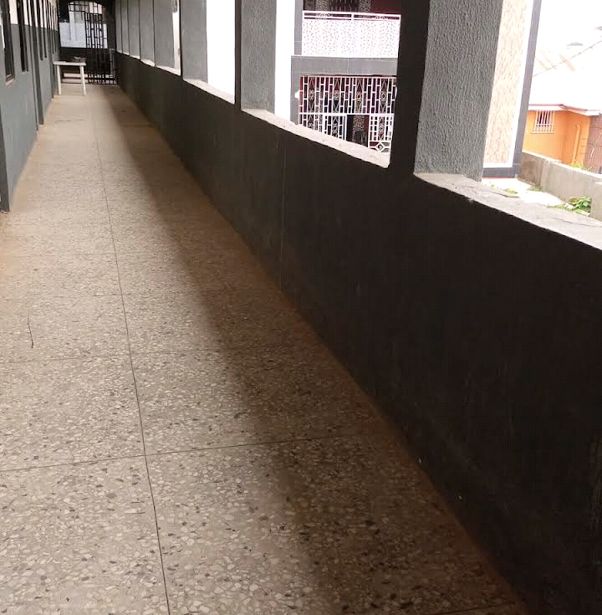
PLATE: 3.2.1 - FRONT ELEVATION OF CASE STUDY ONE

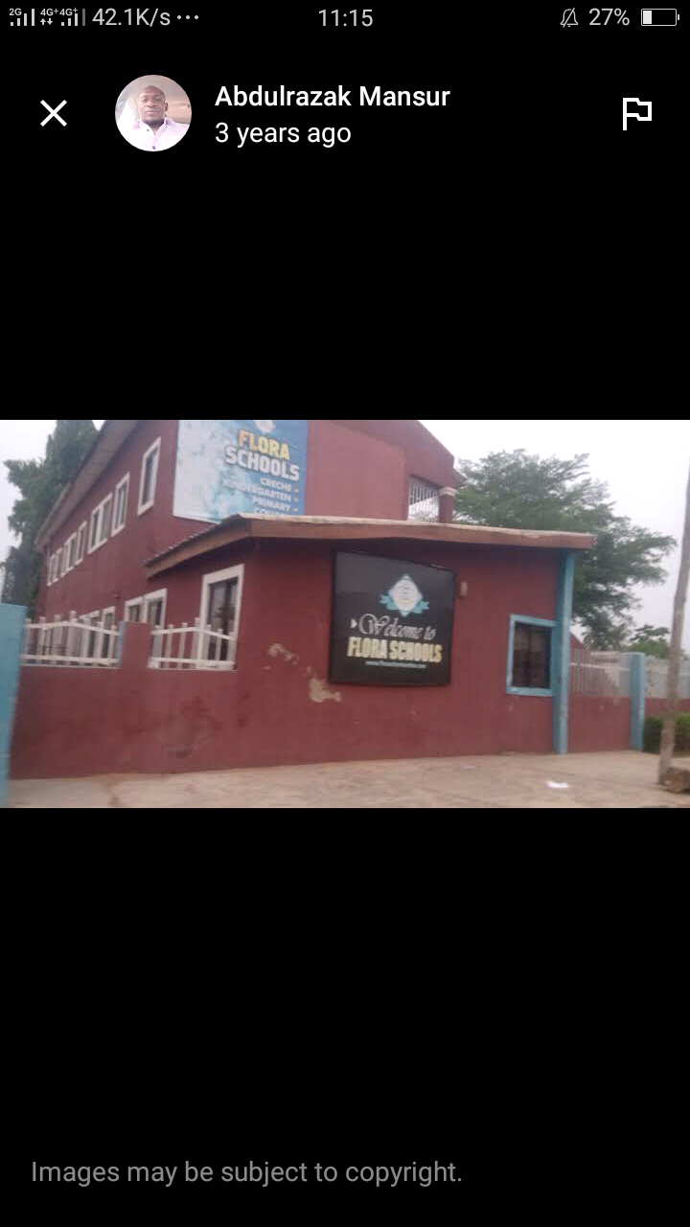

PLATE: 3.2.2 - LEFT ELEVATION OF CASE STUDY ONE

OBSERVATION
MERITS
1. The building is properly Oriented
2. Access to each shop is well taken or observed
3. Movement and Pedestrian Connection was Resolved.
4. It had a good convenience space.
5. A Good Functional settings
6. A Good and Well Functional parking spaces
DEMERITS.
1. Ground Floor did not have convenience space.
2. It has too much hard landscaping

3.3 CASE STUDY TWO
FAITH ACADEMY, ITALAMU AJASE IPO ROAD, ILORIN, KWARA STATE.
BRIEF INTRODUCTION
Faith Academy is a well-known school in Ilorin, Kwara State, with a reputation for academic excellence. While I couldn't find specific information on "Faith Academic," Faith Academy offers:
- Quality education: A focus on academic excellence and character development.
- Modern facilitie: State-of-the-art classrooms, laboratories, and sports facilities.
- Experienced staff: A team of qualified and dedicated teachers who provide individualized attention to students.
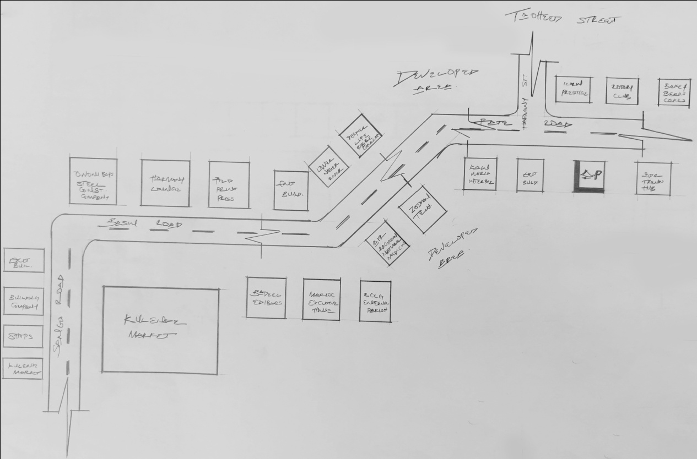
FIG. 3.3.1 LOCATIONAL PLAN OF CASE STUDY TWO

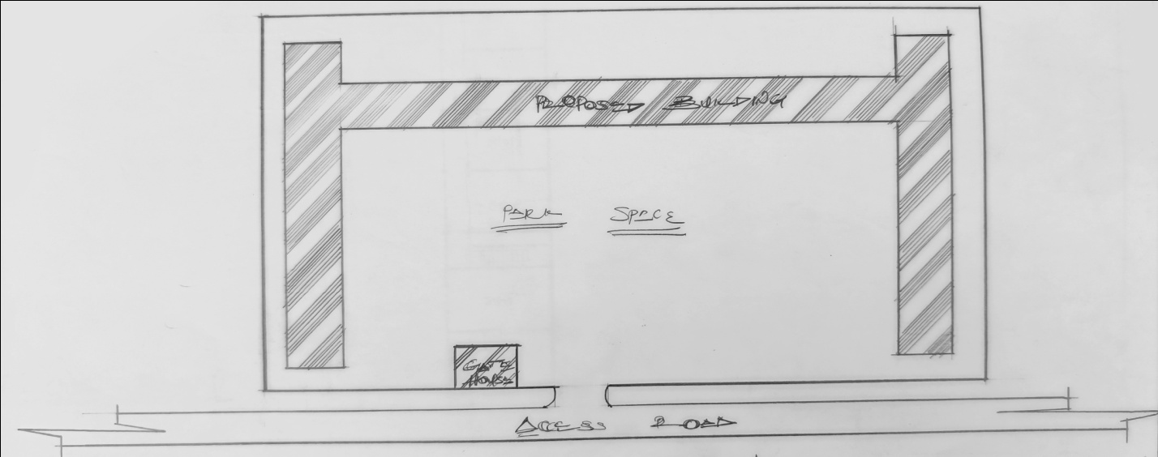
FIG. 3.3.2 SITE PLAN OF CASE STUDY TWO
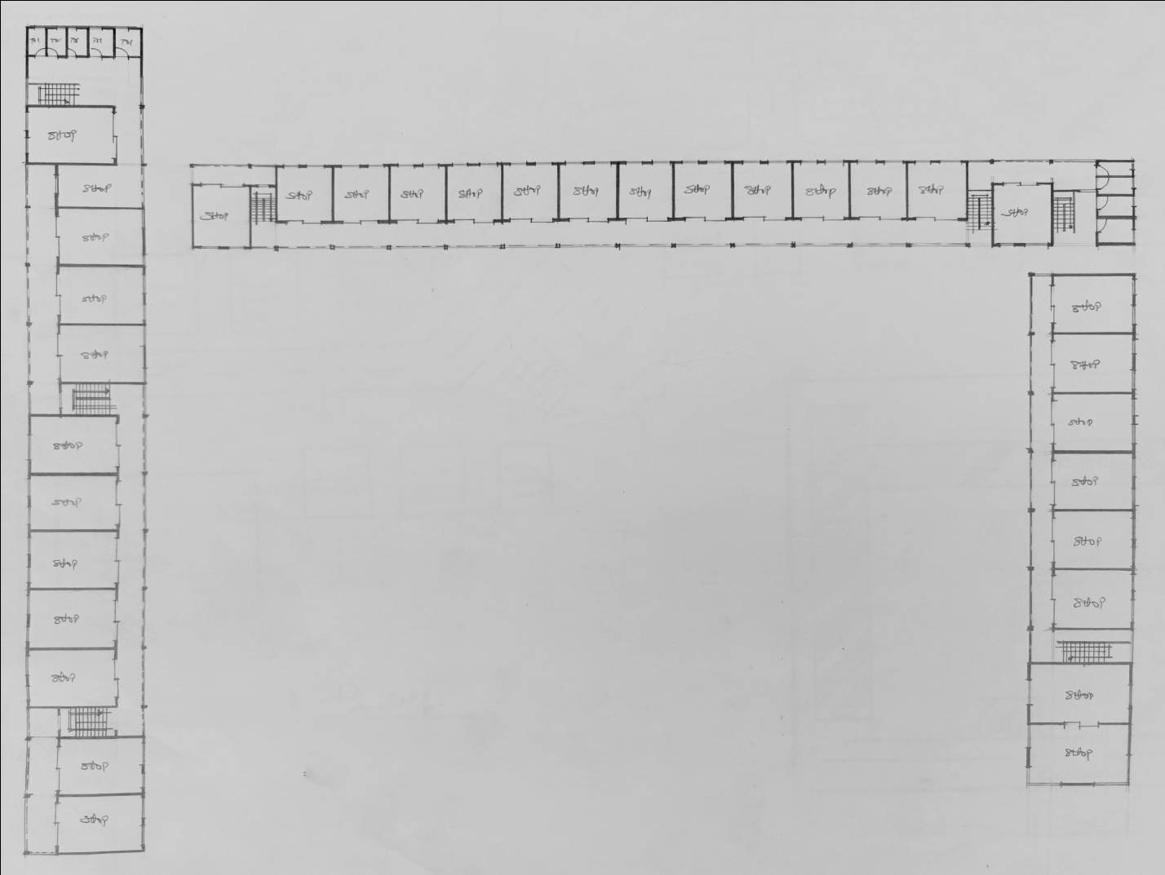
FIG. 3.3.3 TYPICAL FLOOR PLAN OF CASE STUDY TWO

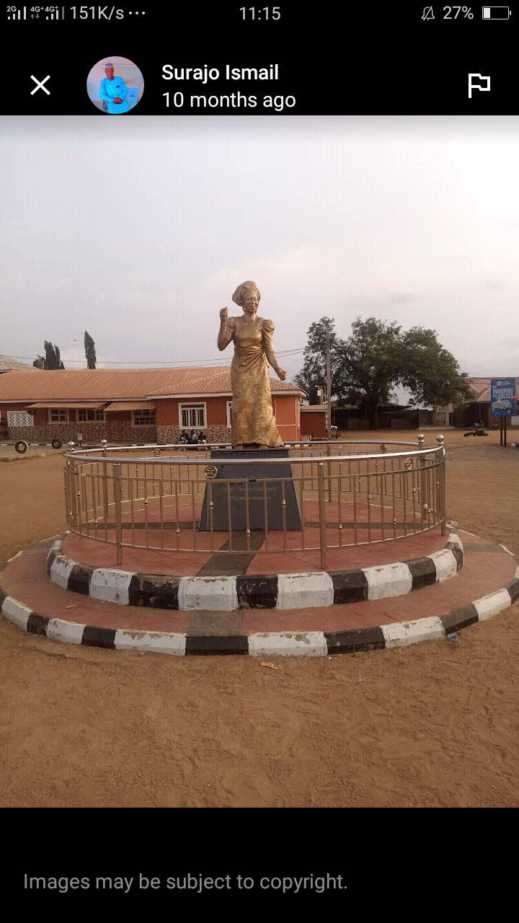
PLATE: 3.3.1 - FRONT ELEVATION OF CASE STUDY TWO
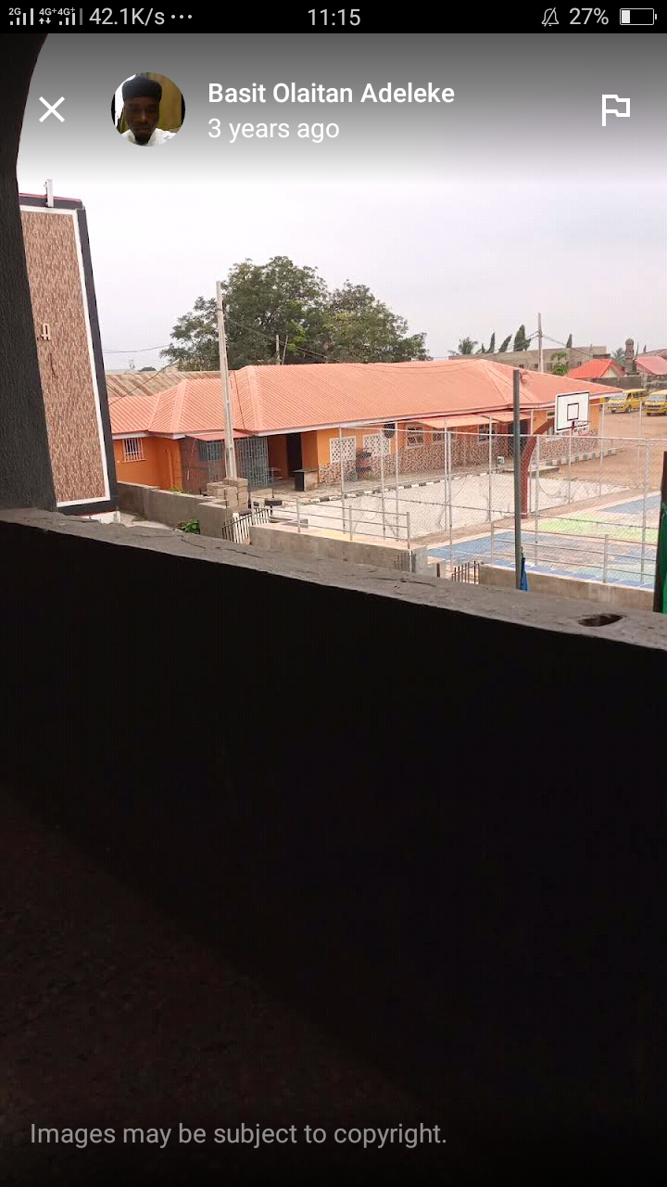
PLATE: 3.3.2 - BACK ELEVATION OF CASE STUDY TWO
OBSERVATION
MERITS
1. Good and Perfect Parking Spaces.
2. Building is well ventilated.
3. Very easily accessible stair case to access the upper floor.
4. Good Functionality
5. Good Convenience Spaces
DEMERITS
1. Accessibility to some shops is not easily to locate
2. Does not meet architectural standards when talking about aesthetic senses
3. Convenience Spaces such as toilet is too far from reach
4. Too much Hard landscaping is affecting the building
5. Parking Spaces is not created or observed at all.

3.4 CASE STUDY THREE
hollabe INTERNALTIONAL COLLAGE , gaa kanbi, Ilorin, Kwara State
BRIEF INTRODUCTION
-Scholars International School: Offers affordable and quality education with a focus on core values, modern facilities, and a conducive learning environment. Other schools in GAA KANBI : There may be other reputable schools in GAA KANBI that offer quality education, but specific details are not readily available.

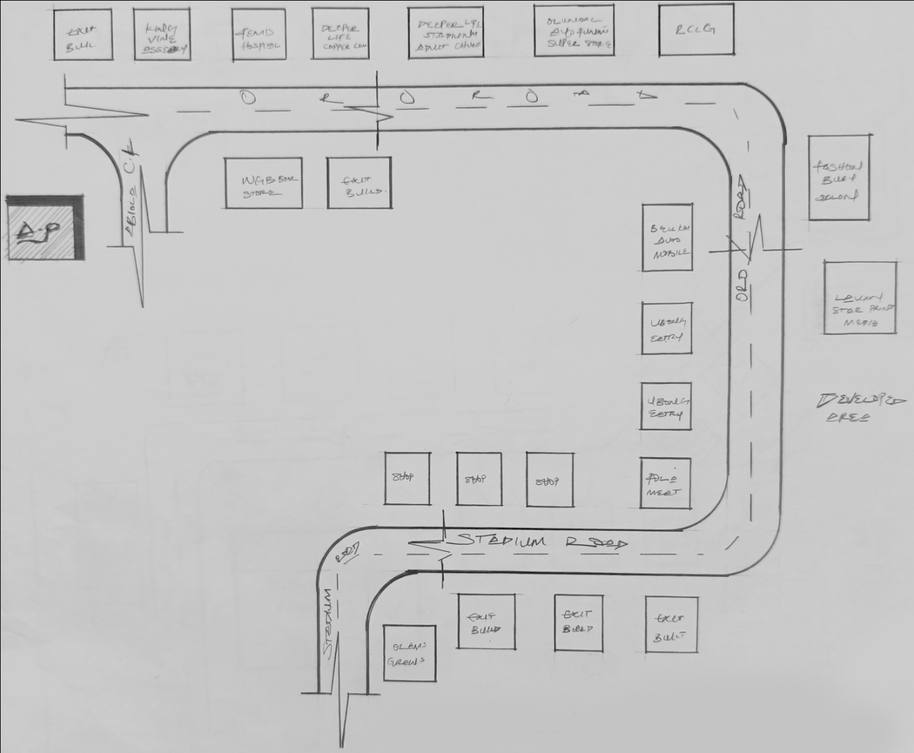
FIG. 3.4.1 LOCATIONAL PLAN OF CASE STUDY THREE

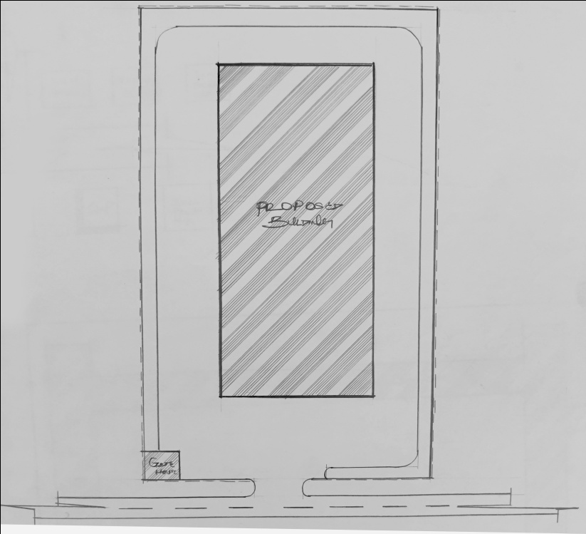
FIG. 3.4.2 SITE PLAN OF CASE STUDY THREE
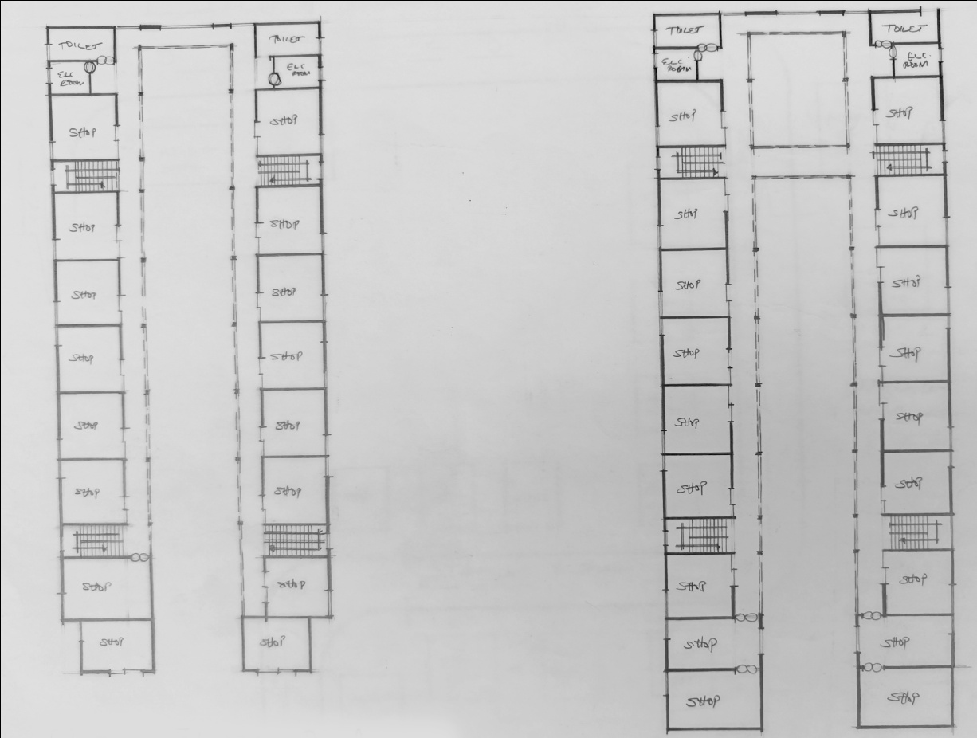
FIG. 3.4.3 FLOOR PLANS OF CASE STUDY THREE
PLATE: 3.4.1 - FRONT ELEVATION OF CASE STUDY THREE
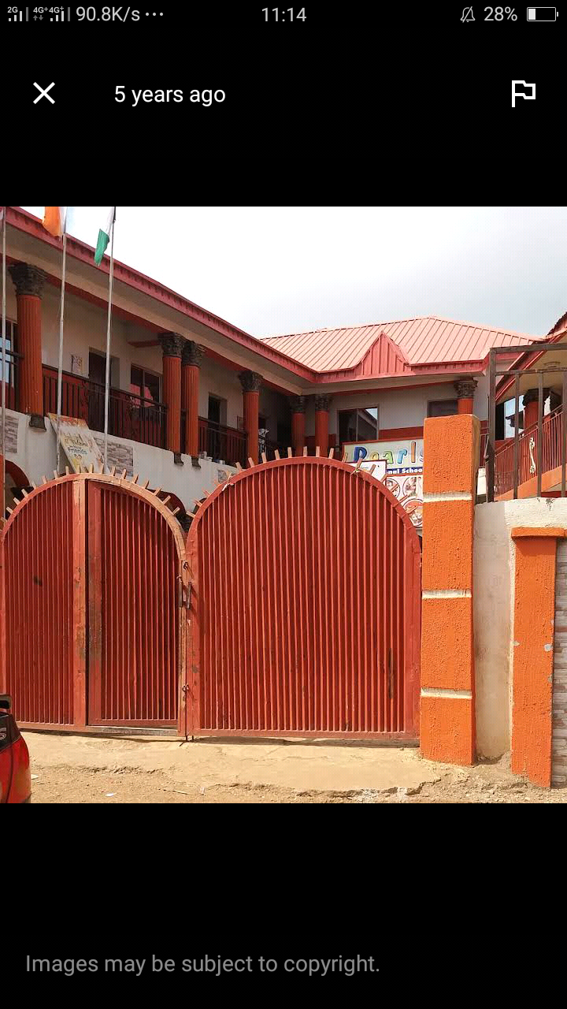PLATE: 3.4.1 – FRONT VIEW OF CASE STUDY THREE

OBSERVATION
MERITS
1. The Functional Relationship of the shop was well arranged.
2. Good Ventilation in the sense of Natural lightening
3. Good Aesthetic sense
4. Was properly oriented
5. Geometric Balance was a success
DEMERITS
1. No space for parking lots
2. The site has too much hard landscaping
3. Convenience rooms is not easy to locate
4. Pedestrian walkway is limited
5. No pedestrian connection planning considered

3.5 CASE STUDY FOUR [ONLINE CASE STUDY]
THE OTIMATE SECONDARY SCHOOL, UNITED STATES
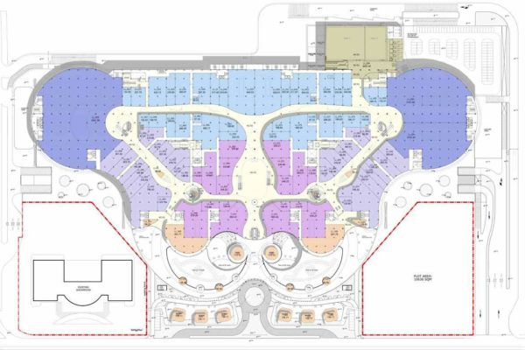
FIG. 3.5.1 FLOOR PLAN OF ONLINE CASE STUDY
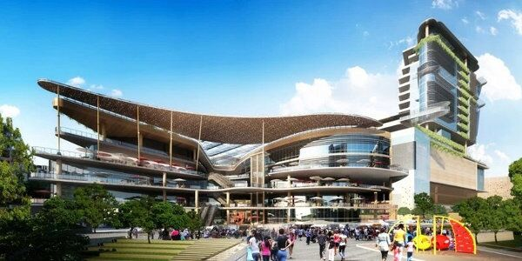
PLATE: 3.5.1 – FRONT ELEVATION OF ONLINE CASE STUDY
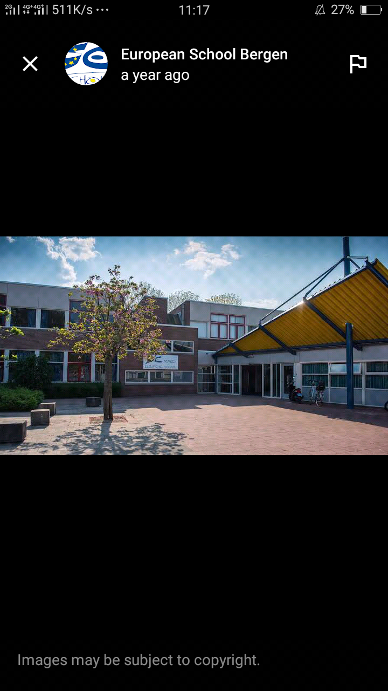
PLATE: 3.5.2 – INETERNAL PERSPECTIVE OF ONLINE CASE STUDY
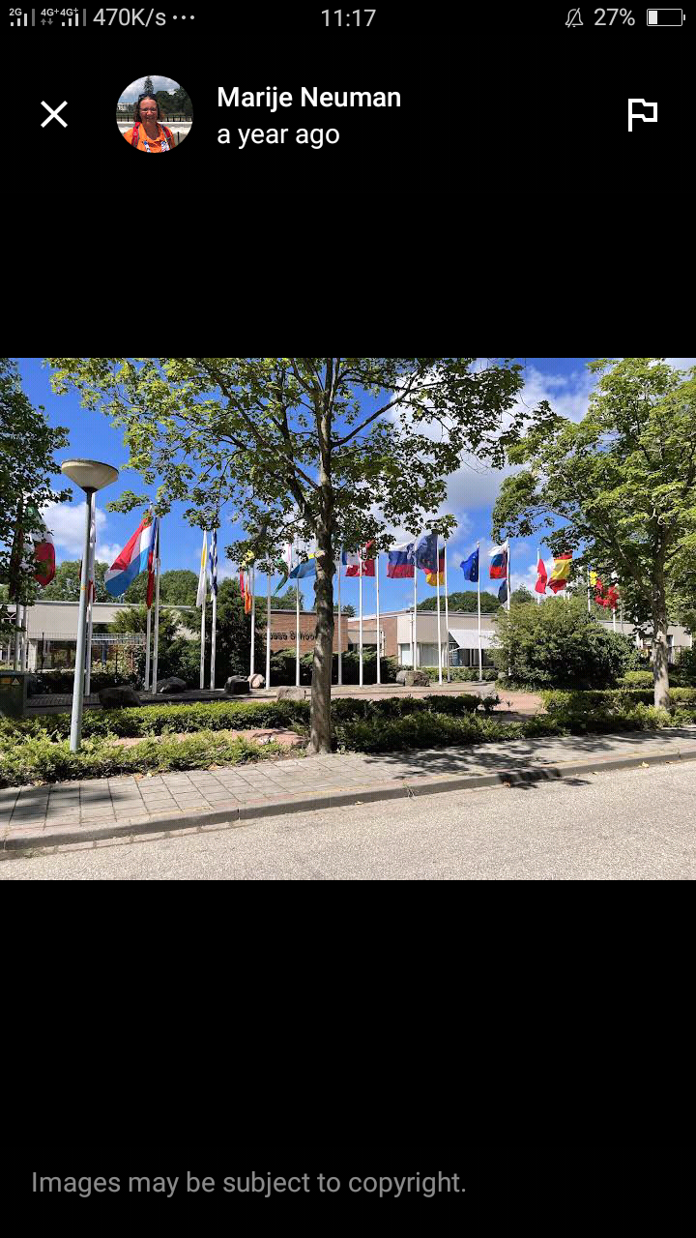
PLATE: 3.5.3 – INETERNAL PERSPECTIVE GROUND FLOOR OF ONLINE CASE STUDY

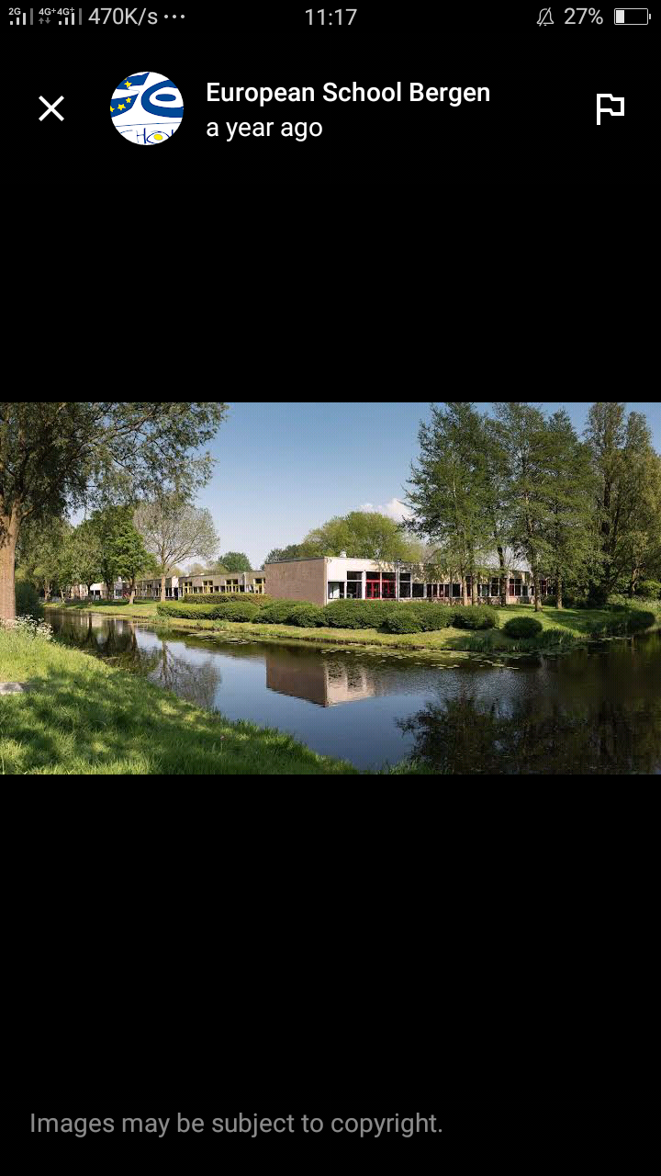
PLATE: 3.5.4 – INETERNAL PERSPECTIVE GROUND FLOOR OF ONLINE CASE STUDY

CHAPTER FOUR

4.1 STUDY AREA/PROJECT SITE

4.1.1ANALYSIS OF THE TOPOGRAPHICAL AND ENVIRONMENTAL CONDITIONS OF THE SITE.

4.1.1.1 INTRODUCTION OF STUDY AREA/SITE SELECTION
THE PROPOSAL FOR A STANDARD BOARDING DAY SECONDARY SCHOOL in Kabba Dongari, Amoyo Community, Ifelodun Local Government Area (LGA) of Kwara State, aims to provide high-quality education and holistic development opportunities for students in a safe, supportive, and stimulating environment. The school will cater to students from diverse backgrounds, fostering academic excellence, social responsibility, and emotional intelligence. By investing in modern facilities, innovative teaching methods, and extracurricular activities, the school will equip students with the skills, knowledge, and values necessary to succeed in an ever-changing world.
SITE SELECTION
After conducting a thorough analysis, the Amoyo Community has been identified as an ideal location for the proposed boarding day secondary school due to its strategic position within the Ifelodun LGA. Specifically, the site selection criteria considered include:
1 Accessibility: Proximity to major roads and public transportation
2 Space: Adequate land area for facilities, including classrooms, dormitories, sports fields, and recreational spaces
3 Safety: A secure environment with minimal risks from environmental hazards
4 Community: Opportunities for community engagement and partnerships with local businesses and organizations
Given the criteria above, Kabba Dongari in Amoyo Community appears suitable due to its relatively quiet and safe environment, which is conducive to learning.
PROPOSED SITE BENEFITS
The proposed site for the boarding day secondary school in Kabba Dongari offers several benefits, including: Community Engagement Opportunities for partnerships with local businesses, organizations, and community groups Accessibility easy access to major roads and public transportation Space Adequate land area for facilities and future expansion By establishing a standard boarding day secondary school in Kabba Dongari, Amoyo Community, the proposal aims to provide students with a supportive and stimulating environment that fosters academic excellence, social responsibility, and emotional intelligence.
ACCESSIBILITY
THE SITE IS EASILY ACCESSIBLE FROM AJASE IPO ROAD, OPPOSITE WINNER CHAPEL CHURCH, AYOMO, KWARA STATE.
LOCATION
THE SITE IS LOCATED AT KABBA DONGARI, AMOYO COMMUNITY, IFELODUN LOCAL GOVERNMENT AREA (LGA) OF KWARA STATE, ILORIN KWARA STATE. IT IS LOCATED OPPOSITE THE FEDERAL ROAD, BEFORE GETTING TO JABSON FILLING STATION CLOSE TO GANMO JUNCTION.
URBANIZATION
Situating the site in amoyo is a method of urban development in the Area. It's a means of adding to the infrastructural facilities in the environment.
INFRASTRUCTURAL FACILITIES
Facilities such as water, electricity, telephone network and road network etc.
Hence, it can be easily tapped to the proposed site.
SOIL STRUCTURE
The soil has a very high load bearing capacity; thus, the structure will lie in hard crust and firm land.
TOPOGRAPHY
The topography of the site is a gentle slope towards west which can assist for the sanitary system on the site e.g drainage.

4.1.1.2 SITE LOCATION/ DESCRIPTIONS/ CRITERIA
1. Accessibility: The site should be easily accessible from major transportation routes, including highways, railways, and airports. Proximity to major roads and public transportation hubs is essential to ensure convenient access for both suppliers and customers.
2. Demographics: Consider the surrounding population and demographics. A location with a high concentration of residents, as well as proximity to commercial and residential areas, can ensure a strong customer base for the secondary school.
3. Visibility and Foot Traffic: A prime location with high visibility and significant foot traffic is desirable. This could include areas near popular landmarks, educational institutions, or commercial centers.
4. Size and Infrastructure: The site should offer ample space for the secondary school, including parking facilities for customers and delivery vehicles. Additionally, the availability of necessary infrastructure such as water, electricity, and waste management services is crucial.
5. Zoning and Regulations: Ensure that the chosen site complies with local zoning regulations and permits for commercial development. It's important to conduct due diligence to avoid potential legal or regulatory issues.
6. Competition and Complementary Businesses: Consider the presence of existing retail establishments and complementary businesses in the vicinity. A location that offers synergy with other businesses can enhance the appeal of the secondary school.
7. Market Potential: Analyze the market potential for the specific products and services that the aims to offer. Understanding the needs and preferences of the local consumer base is vital for the success of the venture.
8. Future Development Plans: Consider any upcoming infrastructure or development projects in the area, as well as potential changes in traffic patterns or urban growth that could impact the long-term viability of the site.

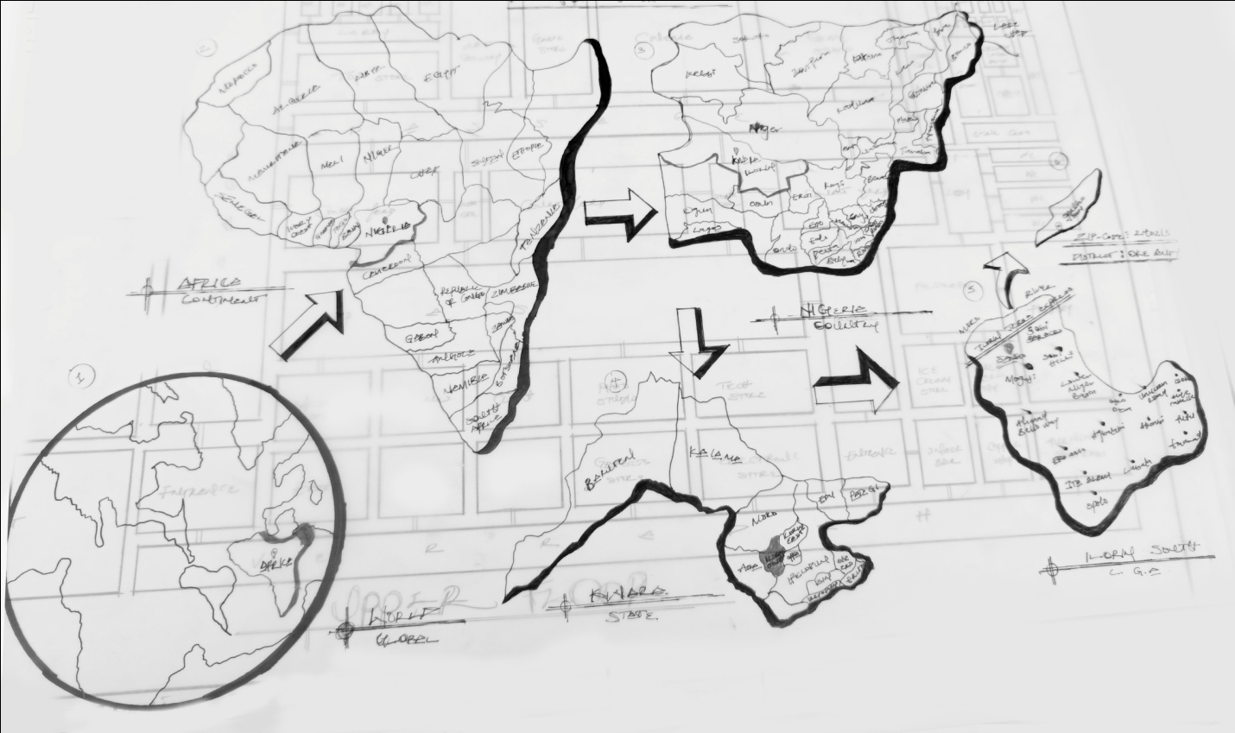
Location maps

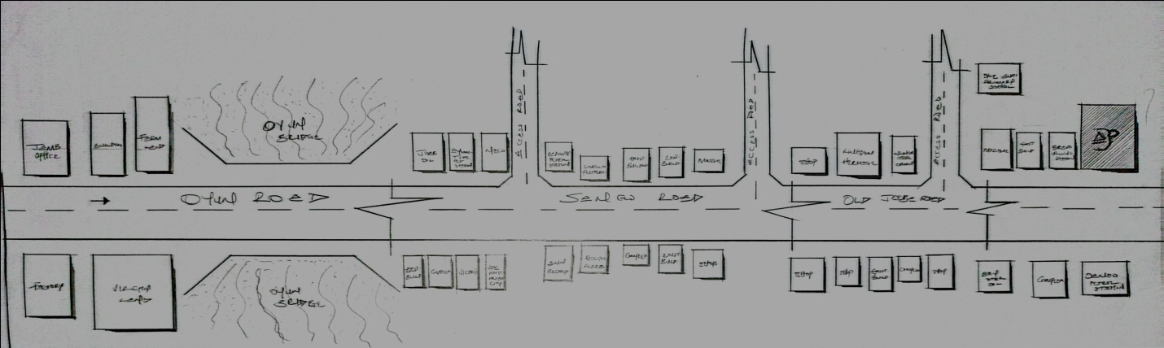
Location Plan

4.1.1.3 SITE INVENTORY/ANALYSIS
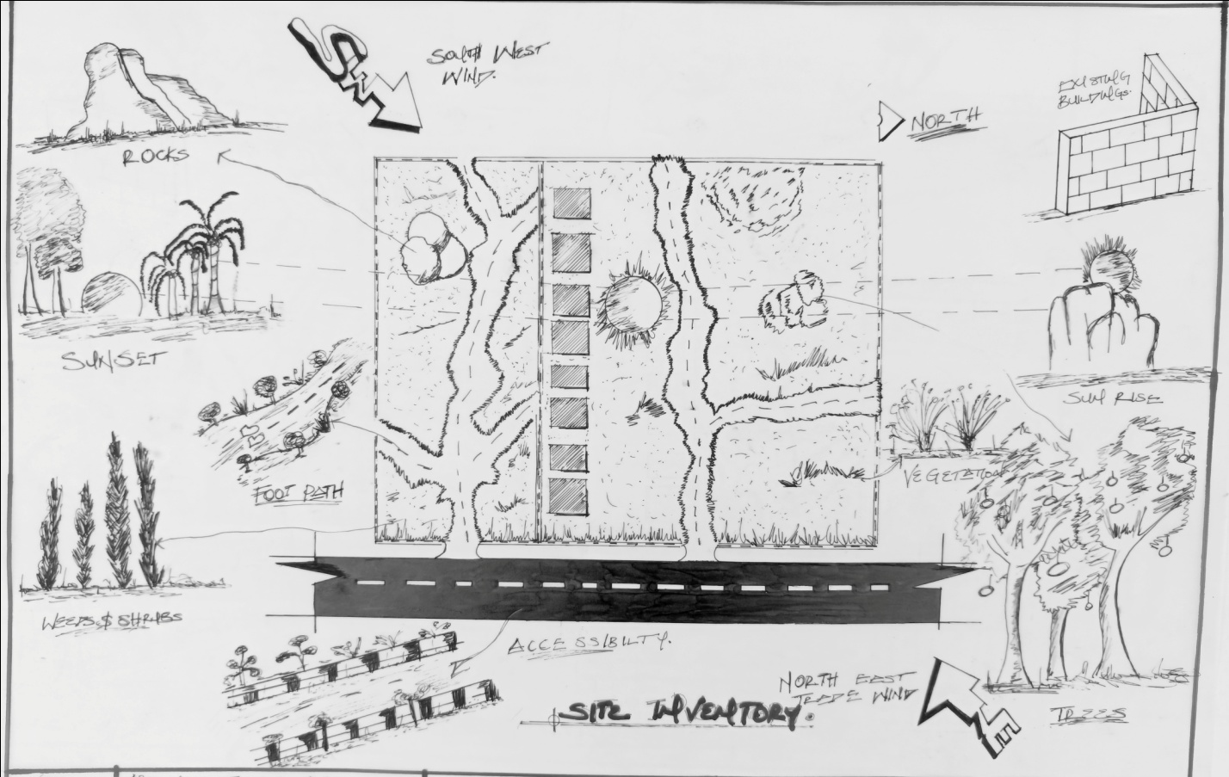
SITE INVENTORY
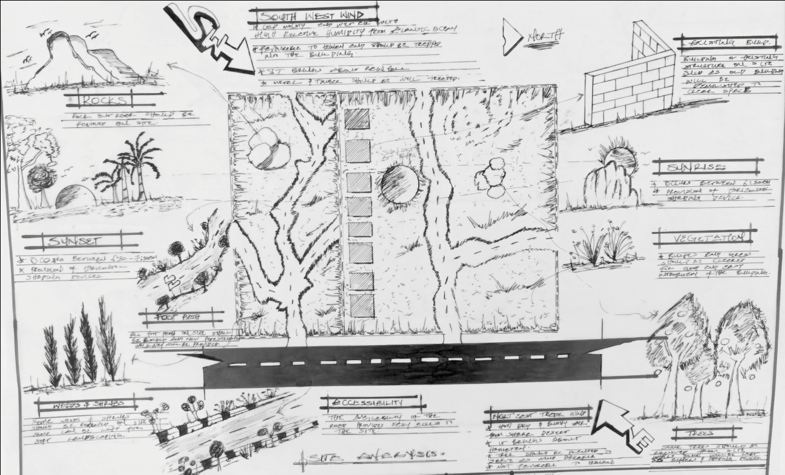
SITE ANALYSIS

4.1.1.4 GEOGRAPHICAL/CLIMATIC DATA
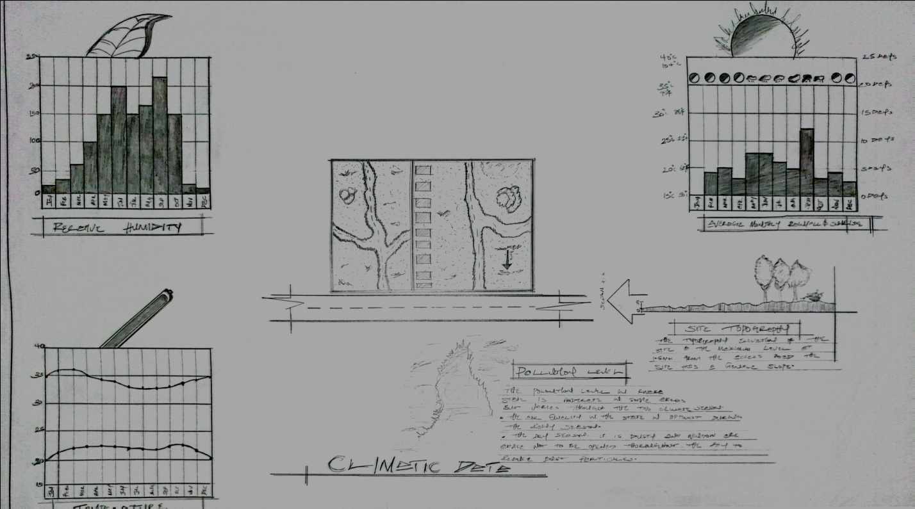
Climatic data of The area

4.1.1.5 ANALYSES OF THE IMMEDIATE ENVIRONMENTAL CONDITIONS OF THE SITE.
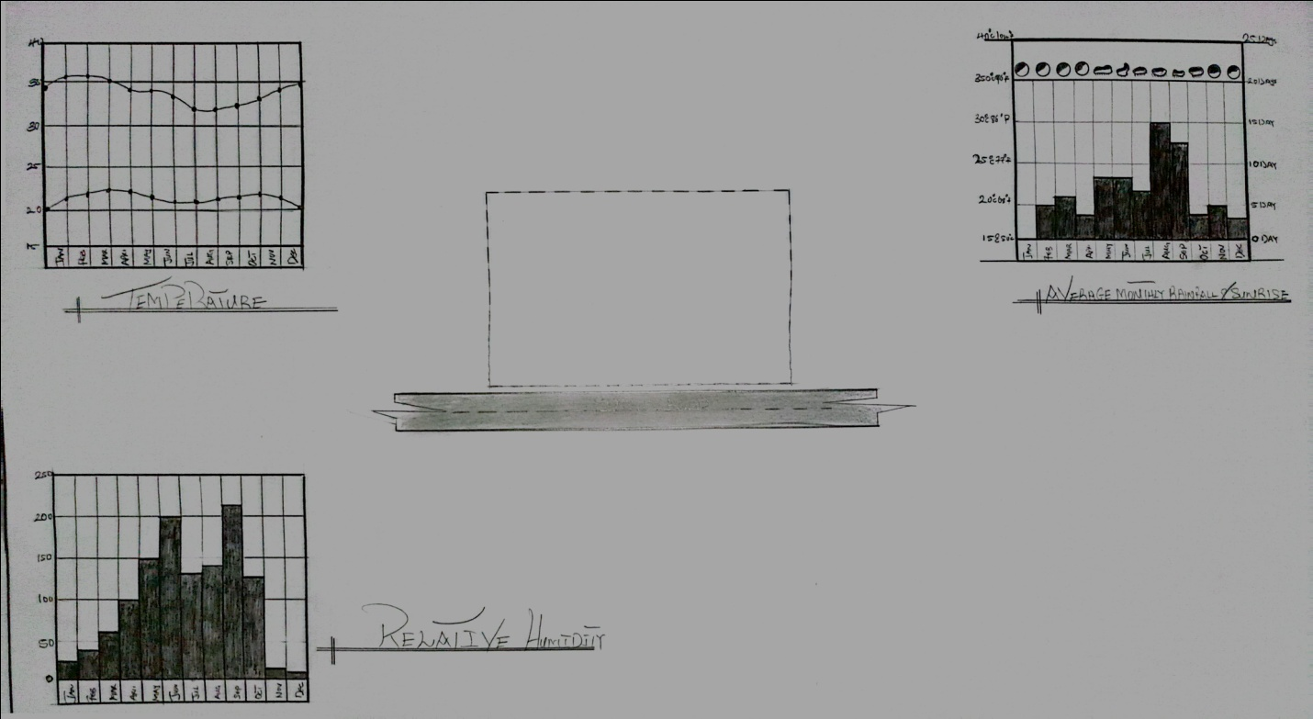

4.2 PROJECT ANALYSIS/ DESIGN CRITERIA

4.2.1 PROJECT GOALS
OVERVIEW
The project goal is to design a boarding secondary school that provides a safe, conducive, and supportive environment for students to learn, grow, and develop academically, socially, emotionally, and physically. The design should balance academic facilities, boarding accommodations, recreational spaces, and support services to foster a holistic educational experience.
OBJECTIVES
1. Academic Excellence: Design academic facilities that promote effective learning and teaching, including classrooms, laboratories, libraries, and technology integration.
2. Boarding and Living Arrangements: Create comfortable, safe, and supervised boarding facilities that cater to students' needs for rest, study, and social interaction.
3. Recreational and Extracurricular Spaces: Include spaces for sports, arts, and other extracurricular activities to promote physical fitness, creativity, and teamwork.
4. Support Services: Incorporate facilities and services for student well-being, including counseling, health services, and dining facilities that promote healthy eating.
5. Sustainability and Safety: Design the school with considerations for environmental sustainability, safety, and security of students and staff.
6. Community and Inclusivity: Foster a sense of community and inclusivity through design elements that encourage interaction among students, teachers, and staff.
DESIGN CONSIDERATIONS
1 Site Planning: Optimize the use of the school site for academic, boarding, and recreational areas considering accessibility and safety.
2 Facilities for Diverse Needs: Cater to the diverse needs of students including those with special needs.
3Technology Integration: Incorporate technology for teaching, learning, and management of school operations.
4 Environmental Considerations: Implement sustainable design practices for energy efficiency, water use, and waste management.\
Expected Outcomes
1 A boarding secondary school design that supports academic achievement and personal growth of students.
2 A safe and supportive environment that promotes student well-being.
3 Efficient use of resources with considerations for sustainability.
IMPLEMENTATION CONSIDERATIONS
1 Collaboration with educators, architects, and stakeholders to ensure the design meets educational goals and operational needs.
2 Compliance with local building codes, safety standards, and educational regulations.
3 Phased implementation if necessary, to ensure continuity of educational activities.

4.2.2 FUNCTIONAL/SPATIAL CRITERIA
Designing a boarding secondary school requires careful consideration of function and spatial criteria to ensure the facility supports the academic, social, emotional, and physical needs of students. Key function/spatial criteria include:
ACADEMIC AREAS
1Classrooms: Adequate number of classrooms with appropriate size, lighting, and technology integration for effective teaching and learning.
2 Laboratories and Specialized Spaces: Science labs, art rooms, music rooms, and other specialized spaces for hands-on learning.
3 Library/Resource Center: A central resource for study, research, and reading with comfortable seating and access to digital resources.
BOARDING AND RESIDENTIAL AREAS
1 Dormitories: Safe, comfortable, and supervised living spaces with adequate storage for personal belongings.
2Common Are as: Spaces for socializing, relaxation, and study within boarding houses.

RECREATIONAL AND EXTRACURRICULAR AREAS
1 Sports Facilities: Fields, courts, or spaces for physical education and sports like football, basketball, athletics.
2 Arts and Cultural Spaces: Areas for music, drama, art, and other creative pursuits.
SUPPORT SERVICES
1 Dining Hall: A central dining area promoting healthy eating and social interaction.
2 Health Services: Access to medical care and counseling services for student well-being.
3 Administrative Spaces: Offices for administration, staff, and support services.
SAFETY AND ACCESSIBILITY
1 Secure Boundaries: Ensuring safety and security of students and staff.
2 Accessibility: Design considering accessibility for students with diverse needs.
SUSTAINABILITY
1 Environmental Considerations: Incorporating sustainable practices like energy efficiency, water conservation, and waste management. Spatial Organization
1 Zoning: Organizing spaces by function (academic, residential, recreational) for efficient use and safety.
2 Circulation: Clear pathways for movement between areas considering safety and supervision.
CONSIDERATIONS FOR IMPLEMENTATION
1 Collaboration with stakeholders including educators, architects, and local authorities.
2 Compliance with local regulations and educational standards.

4.2.3 APPRAISAL OF PROPOSED SCHEMES IN THE SPACES, SIZE AND RELATIONSHIPS BOARDING DAY SECONDARY SCHOOL
An appraisal of a proposed scheme for a boarding/day secondary school involves evaluating the adequacy of spaces, appropriateness of sizes, and effectiveness of relationships between different functional areas to support the educational, residential, and extracurricular needs of students.
SPACES AND SIZES
1 Academic Spaces: Classrooms, laboratories, and other academic areas should be adequately sized for the number of students and type of activities. Sizes should allow for flexibility in teaching methods and accommodate necessary equipment.
2 Boarding Facilities: Dormitories, common rooms, and other residential spaces need to balance comfort, safety, and supervision. Sizes should reflect the number of boarding students and needs for rest, study, and socialization.
3 Recreational and Extracurricular Spaces: Areas for sports, arts, and other activities should be appropriately sized for intended uses and number of participants.
RELATIONSHIPS BETWEEN SPACES
1 Proximity of Academic and Boarding Areas*: Boarding facilities should be reasonably close to academic areas for convenience and supervision.
2 Accessibility of Recreational Spaces: Recreational and extracurricular spaces should be accessible from both academic and boarding areas to encourage participation.
3 Support Services Placement: Services like dining halls, health services, and counseling should be centrally located or easily accessible to support student needs efficiently.

EVALUATION CRITERIA
1 Functionality: Do spaces support intended educational and residential functions effectively?
2 Safety and Security: Are spaces designed with safety and security of students as a priority?
3 Sustainability: Does the design incorporate sustainable practices for resource efficiency and environmental impact reduction?
4 Flexibility: Can spaces adapt to changing needs or educational approaches over time

4.2.4 EQUIPMENT AND OPERATIONAL AND PERFORMANCE REQUIREMENTS
Equipment Requirements BOARDING DAY SECONDARY SCHOOL
Equipment, Operations, and Performance Requirements for a Boarding/Day Secondary School A boarding/day secondary school requires specific equipment, efficient operations, and clear performance requirements to ensure effective functioning and achieve educational goals.
EQUIPMENT
1 Academic Equipment: Classrooms need furniture, teaching aids, and technology like computers and projectors. Laboratories require specialized equipment for science, arts, and other subjects.
2 Boarding Equipment: Dormitories need beds, storage, and basic amenities. Dining halls require kitchen equipment for food preparation and service.
3 Recreational Equipment: Sports equipment for physical education and extracurricular activities.

OPERATIONS
1 Academic Operations: Scheduling classes, managing curriculum delivery, and assessing student performance.
2 Boarding Operations: Managing student living spaces, meals, and supervision.
3 Support Operations: Maintenance, security, and health services ensuring smooth school functioning.
PERFORMANCE REQUIREMENTS
1 Academic Performance: Meeting educational standards and achieving learning outcomes.
2 Operational Efficiency: Efficient use of resources and management of facilities.
3 Safety and Well-being: Ensuring safety, security, and well-being of students and staff.
4 Sustainability: Implementing practices for environmental sustainability.

.4.2.5 SPATIAL ALLOCATION / SCHEDULE OF ACCOMMODATION
TABLE FIG. 4.1
S/N | UnitS | LXB | Area m²
1. | enreance pouch | 6.9 X 3.9 | 26.91
2. | reception | 3.9 X 4.5 | 17.55
3. | walk way | 3.9 x4.5 | 17.55
4. | bursay office | 4.5 x 3.9 | 17.55
5. | directot parking lott | 3.9 x 4.5 | 17.55
6. | utility | 3.9 x4.2 | 16.38
7. | agric lab | 3.9 x 4.5 | 17.55
8. | biology lab | 1.2 x 2.1 | 2.52
9. | computer lab | 4.5 x 6.9 | 31.05
10. | bilogy lab | 6.9 x 4.5 | `31.05
11. | chemistry lab | 3.9 x 4.5 | 31.05
12. | physic lab | 3.9 x 4.5 | 31.05
13. | music class | 4.5 x 3.9 | `31.05
14. | food and nut | 4.5 x 3.9 | 31.05
15. | toilet male | 1.5 x 3.9 | 16.05
16. | toilet female | 1.6 x 4.5 | 16.2
17. | assembly hall | 3.6 x 4.5 | 16.2
18. | court yard | 4.5 x 3.9 | 31.05
19. | admin office | 3.9 x 4.5 | 31.05
20. | jss 1 a/b | 3.9 x 4.5 | 31.05
21. | jss 2 a/b | 3.9 x 4.5 | 31.05
22. | jss 3 a/b | 8.1 x 4.5 | 36.45
23. | jss 3 a/b | 8.1 x 4.5 | 36.45
24. | ss1 art | 7.8 x 4.5 | 35.1
25. | ss2 art | 4.2 X 8.4 | 35.28
26. | ss3 art | 8.4 X 8.4 | 70.56
27. | ss1 commercial | 7.5 X 8.4 | 63.0
28. | ss2 commercial | 3.9 X 8.4 | 32.76
29. | ss3 commercial | 3.9 X 8.4 | 32.76
30. | wc [2] | 1.8 X2.5 | 4.5
31. | office 2 | 3.0 X4.8 | 14.4
32. | Security Cam era room | 3.0 X 6.7 | 20.1
33. | wc [3] | 1.2 X 2.1 | 2.52
34. | ss1 science | 11.2 X 11.0 | 123.2
36 | ss2 science | 4.2 X 8.4 | 35.28
37 | ss3 science | 4.2 X 8.4 | 35.28
38 | examination hall | 3.9 x 4.5 | 31.05
39 | admin office | 3.9 x 4.5 | 31.05
40 | vice principal office | 4.2 X 8.4 | 35.28
41 | principal office | 3.9 X 8.4 | 32.76
42 | secetory office | 3.9 x 4.5 | 31.05
43 | director office | 4.2 X 8.4 | 35.28
44 | director rest room | 4.2 X 8.4 | 35.28
45 | conferrence hall | 3.9 x 4.5 | 31.05
46 | senior lectural office | 3.9 x 4.5 | 31.05
47 | sss tiolet male | 1.2 X 2.1 | 2.52
48 | sss toilet female | 1.2 X 2.1 | 2.52

4.2.6 FUNCTIONAL RELATIONSHIP

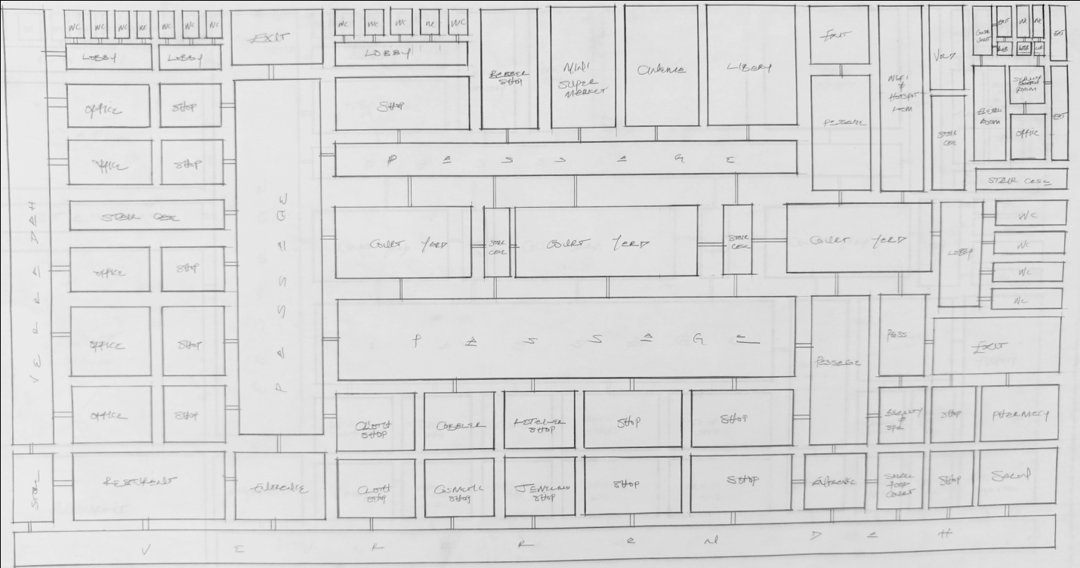
Ground floor
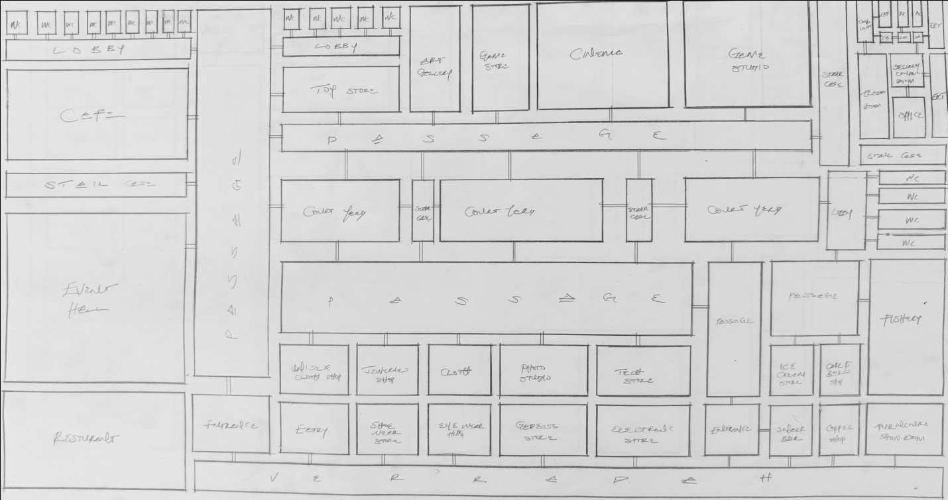

Upper floor

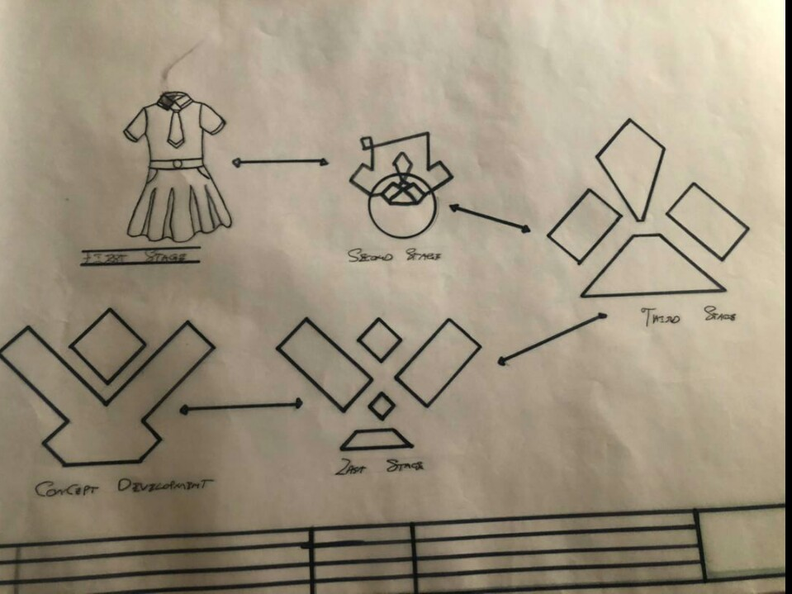

4.2.7 Conceptual development

CHAPTER FIVE

5.1 APPROACH TO THE DESIGN/DESIGN REALIZATION

5.1.1 THE DESIGN IDEAS/CONCEPTS AT DIFFERENT LEVELS OF THE DESIGN PROCESS (SITE /BUILDING)
Site Level
1. Contextual Integration: Incorporating the local culture, history, and urban context into the design to create a unique sense of place that resonates with the community.
2. Pedestrian Accessibility: Designing the site to ensure easy pedestrian access, connectivity to public transportation, and seamless integration with the surrounding urban fabric.
3. Green Spaces: Integrating courtyards into the site to provide areas for relaxation, social interaction, and community engagement.
4. Sustainability: Implementing sustainable site planning strategies such as rainwater harvesting, green infrastructure, and energy-efficient landscaping to minimize environmental impact.
Building Level
1. Flexible Layouts: Designing adaptable floor plans that can accommodate diverse retail concepts, pop-up, and temporary installations to create a dynamic and ever-changing environment.
2. Atriums and Skylights: Incorporate atriums and skylights to introduce natural light into the arcade, creating a visually engaging and inviting interior environment.
3. Mixed-Use Spaces: Integrating complementary uses such as restaurants, entertainment venues, or cultural facilities to create a multifaceted destination that offers more than just retail experiences.
4. Technology Integration: Incorporating digital displays, interactive kiosks, and smart way finding systems to enhance the shopping experience and provide valuable information to visitors.
5. Material Selection: Using a mix of high-quality materials, textures, and finishes to create a visually appealing and tactile environment that reflects the desired brand image and ambiance.
6. Sustainability Features: Implementing sustainable building design strategies such as energy-efficient HVAC systems, natural ventilation, and green building materials to reduce the environmental footprint of the arcade.

5.1.2 TECHNOLOGICAL AND ENVIRONMENTAL CRITERIA
Technologyical Criteria
Include smart building systems, digital signage, Wi-Fi connectivity, security, and e-commerce integration.
Environmental criteria
Involve energy efficiency, sustainable materials, natural ventilation, daylighting, water conservation, green infrastructure, and waste management.

5.1.3.1 CONSTRUCTION METHODOLOGY AND MATERIAL /FINISHES DESIRED BY THE CLIENTS
Construction Methodology
1. Prefabrication and modular construction techniques to minimize on-site construction time and disruption.
2. Use of sustainable construction practices such as minimizing waste, recycling materials, and utilizing renewable energy sources during construction.
3. Incorporation of smart building systems for efficient management of construction processes and resources.
Materials and Finishes
1. Sustainable building materials such as recycled steel, reclaimed wood, and low-impact concrete.
2. Energy-efficient glazing systems for natural daylighting and insulation.
3. Green roofs or living walls to improve insulation, reduce stormwater runoff, and provide a visually appealing environment.
4. High-quality, durable finishes such as low-VOC paints, sustainable flooring materials (e.g., bamboo, cork, or recycled content carpet), and eco-friendly wall coverings.
ROOF
In areas experiencing tropical climate condition such as Ilorin South where there is rainfall, roof should preferably not be of light weight construction. A corrugated iron sheet should absorb as little solar energy as possible.
CEILING
Acoustic Ceiling Tiles are to be used. These are popular for their sound-absorbing properties, which can help reduce noise levels in a busy shopping arcade. They come in a variety of styles, textures, and colors, allowing for design flexibility.
WALL
The structural walls of the building are to be constructed with 225mm engine molded sand/cement hollow blocks.
Brick walls can add character and warmth to to the shopping arcade, especially in a rustic or industrial design theme. Brick walls can also provide a sense of history and authenticity to the space.
Doors
The door type and size depends on the door location, but generally range from Sliding doors, revolving doors, metal and panels doors of sizes from 750mm, 900mm, 1200mm, 1500mm, 2100mm etc..... Some doors are purposely made swinging doors for durability, fire resistance and noise control.
WINDOWS
The windows that are to be used range from Glass, Fixed light, and casement windows etc with metal and aluminum frame.

5.1.2.2 SERVICES REQUIRED: CIRCULATION, VENTILATION, LIGHTING, PLUMBING AND ELECTRICAL INSTALLATION, ACOUSTICS, WASTE DISPOSAL, FIRE PROTECTION AND EXTERNAL WORKS.
Circulation
Efficient circulation spaces are crucial for any shopping arcade. They should be planned in such a way that encourages visitors to explore the entire space without any difficulty. Walkways should be wide enough for the expected crowd, escalators, lifts, and stairs must also be appropriately positioned.

Ventilation
A well-planned HVAC system should be installed to maintain air quality and temperature, ensuring that customers are comfortable.
Lighting
Ambient and accent lighting is critical to create an inviting atmosphere. Natural light should be utilized wherever possible, and synthetic lighting should supplement it, especially in areas that do not receive adequate daylight.
Plumbing and Electrical Installations
Restrooms should be strategically placed and well-maintained. Water drinking points can also provide relief to customers. Electrical installations, such as outlets for shops, lighting, and HVAC, should be planned early in the design process.
Waste Disposal
A centralized waste disposal area should be planned, and shops should be educated about waste segregation. It's important to have recycling bins in well-seen places to promote sustainable habits among shoppers.
Fire Protection
A comprehensive fire protection system should include smoke detectors, fire alarms, extinguishing systems, and clear signage to guide people towards exits during an emergency.
External Works
Adequate parking is a must, with clear signage to guide visitors. Landscaping should be appealing and benches can be placed strategically for people needing a break.

5.1.3.3 ENVIRONMENTAL CONDITIONS TO BE ACHIEVED
1. Natural Light: Maximizing the use of natural light can improve the ambiance, save energy, and increase customer satisfaction. Skylights or large, strategically placed windows can be used to achieve this.
2. Air Quality: Indoor environments should be comfortable, clean, and have good air circulation. This can be achieved with efficient ventilation and air conditioning systems.
3. Temperature Control: Proper insulation and HVAC systems are needed to maintain a comfortable temperature throughout the year. Designs should also consider local climate and weather patterns.
4. Noise Control: With lots of people and activities, shopping arcades can get very noisy. The architectural design should use noise-barrier materials and techniques to maintain a pleasant on-site sound environment.
5. Green Spaces: Including indoor plants and green spaces not only enhances aesthetics but also improves air quality and contributes to a sense of well-being.
6. Sustainable Materials: Use of locally sourced, sustainable construction materials reduces the building's carbon footprint and supports local businesses.
7. Energy Efficiency: Design elements should prioritize energy efficiency – this could involve energy-saving lighting systems, efficient HVAC systems, and possibly renewable energy sources (like solar panels).
8. Water Management: Provision for rainwater harvesting and the use of water-efficient systems can help reduce the arcade's water footprint.
9. Waste Management: Adequate facilities for the segregation and collection of waste, including recyclable waste can promote sustainable practices.

5.1.2.4 PERFORMANCE STANDARDS
1. Natural Light and Temperature Control: The design should ensure good indoor climate, using natural light and efficient heating/cooling systems for comfort.
2. Air Quality, Noise Control, and Safety: The design should include efficient ventilation and noise barrier materials, while adhering to safety standards.
3. Sustainable Use of Resources: Using sustainable, locally-sourced materials, and incorporating energy/water-efficient systems are essential.
4. Green Spaces and Waste Management: Including green spaces can enhance aesthetics and air quality, and a comprehensive waste management strategy is crucial.

5.1.3 LEGAL ISSUES AND PLANNING REGULATIONS
1. Planning Permissions: The Kwara State Town Planning and Development Authority (KTPDA) oversees physical development and planning permissions in the state. You'd have to submit your building plans and receive approval before you could start construction.
2. Zoning Laws: The project site must align with Ilorin's zoning policies. Certain zones may be designated specifically for commercial use and you'll want to make sure your shopping arcade fits into the approved zone.
3. Building Codes: Nigeria has a National Building Code that all buildings must adhere to. These codes ensure safety, health, and welfare in both public and private buildings.
4. Environmental Laws: This includes legislation like the National Environmental Standards Regulatory and Enforcement Agency (NESREA) Act, which addresses environmental impact assessments and potential pollution from construction and operation.
5. Land Use Act: In Nigeria, this act controls land ownership and property rights. You need to ensure that you have the legal right to develop the property.
6. Public Health Laws: You will need to abide by public health laws, especially in the design of food and beverage outlets within the arcade.
7. Physical Planning and Development Regulations: These control aesthetic appearances, space optimization, and functionality of the design.

5.2 SUMMARY, RECOMMENDATION AND CONCLUSION

5.2.1 SUMMARY
A boarding secondary school provides an environment where students live and learn together, fostering academic excellence, personal growth, and social development. Boarding schools offer structured schedules, supervised activities, and access to facilities that support holistic education. Students in boarding schools often develop strong bonds with peers and may experience personal growth through independence and shared living experiences. The impact of boarding schools on student development can vary based on factors like school culture, management practices, and individual student needs. Effective boarding schools balance academic rigor with extracurricular opportunities, support services, and a safe living environment. Research indicates mixed outcomes on the impact of boarding schools compared to day schools, highlighting the importance of school-specific practices and student characteristics. Overall, boarding secondary schools aim to provide a supportive yet challenging environment that prepares students for future endeavors.

5.2.2 RECOMMENDATION
Recommendations for boarding secondary schools emphasize the need for balanced approaches to student development. Schools should prioritize safety, security, and well-being of students in both academic and residential settings. Effective communication between staff, students, and parents is crucial for addressing needs and concerns. Boarding schools should foster a sense of community and inclusivity among students from diverse backgrounds. Providing adequate support services like counseling and health care is essential for student well-being. Schools should also encourage extracurricular participation to promote physical, emotional, and social development. Training for staff on managing boarding school dynamics and supporting student needs is important. Implementing sustainable practices in school operations contributes to environmental awareness and responsibility among students. Regular evaluation of school practices and outcomes helps in making informed decisions for improvement. By focusing on these aspects, boarding secondary schools can enhance student experiences and outcomes.

5.2.3 CONCLUSION
A boarding secondary school provides an environment where students live and learn together, fostering academic excellence, personal growth, and social development. Boarding schools offer structured schedules, supervised activities, and access to facilities that support holistic education. Students in boarding schools often develop strong bonds with peers and may experience personal growth through independence and shared living experiences. The impact of boarding schools on student development can vary based on factors like school culture, management practices, and individual student needs. Effective boarding schools balance academic rigor with extracurricular opportunities, support services, and a safe living environment. Research indicates mixed outcomes on the impact of boarding schools compared to day schools, highlighting the importance of school-specific practices and student characteristics. Overall, boarding secondary schools aim to provide a supportive yet challenging environment that prepares students for future endeavors.

5.3 REFERENCES
TOP BOARDING SCHOOLS IN LAGOS:
1. Grange School, Ikeja: Known for its serene environment and ideal learning setup, offering full-time and flexi-boarding options.
2. Children International School, Lekki: Provides world-class education with a focus on enabling students to become successful learners.
3. Lekki British International School: Offers an international standard of studying with well-equipped laboratories and internet-connected computers.
4. Chrisland International Schools, Idimu: A prominent privately-owned international school providing all-round and quality education.
5. Corona Secondary School, Agbara: Boasts one of the best boarding facilities and a proven reputation for excellence.
TOP BOARDING SCHOOLS IN ABUJA:
6. Loyola Jesuit College: Emphasizes academic rigor and moral education with a nurturing environment.
7. Premiere Academy: Recognized for its rigorous academic standards and commitment to student success.
8. Capital Science Academy: Specializes in science and technology education, encouraging critical thinking.
9. Whiteplains British School: Offers a balanced education with academics and extracurricular activities.
10. Funtaj International School: Focuses on academic success and personal growth with modern facilities.
OTHER NOTABLE SCHOOLS:
11. Rainbow College, Ogun State: Applies a global approach to teaching and nurturing with excellent boarding facilities.
12. Meadow Hall College, Lagos: Offers an integrated scheme of British and Nigerian curricula with world-class facilities.
13. Avi-Cenna International School, Lagos: Provides a strong academic and pastoral culture with innovative approaches.

LIST OF APENDIX
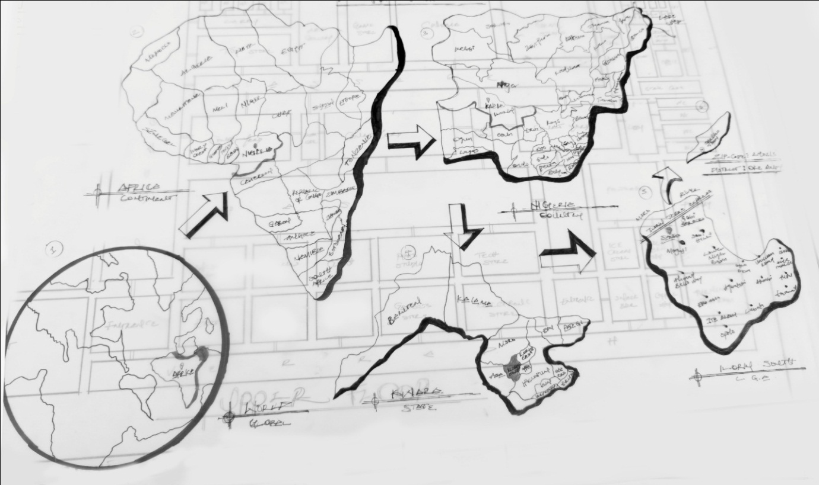
APPENDIX ONE SHOWING LOCATIONAL MAP

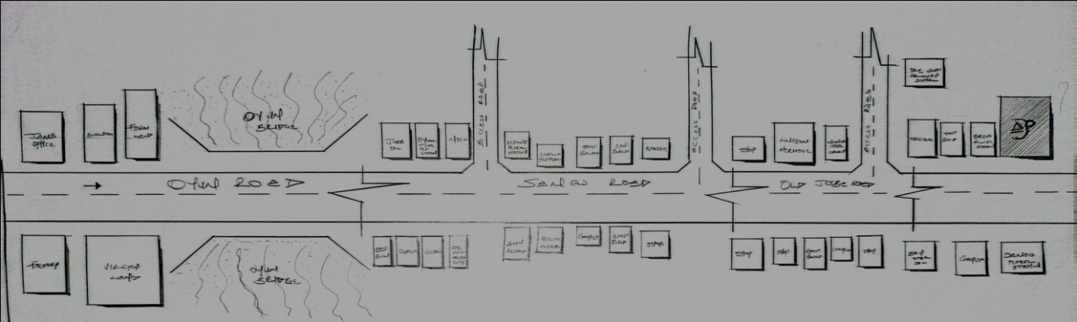
APPENDIX TWO SHOWING LOCATIONAL PLAN

APPENDIX THREE SITE INVENTORY
APPENDIX FOUR SITE ANALYSIS

APPENDIX FIVE SITE ANALYSIS

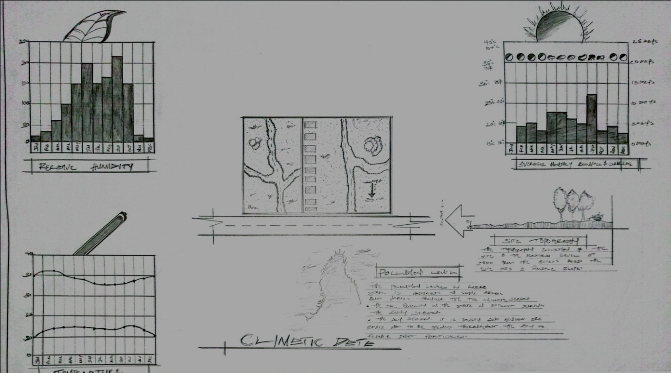
APPENDIX SIX CLIMATIC DATA

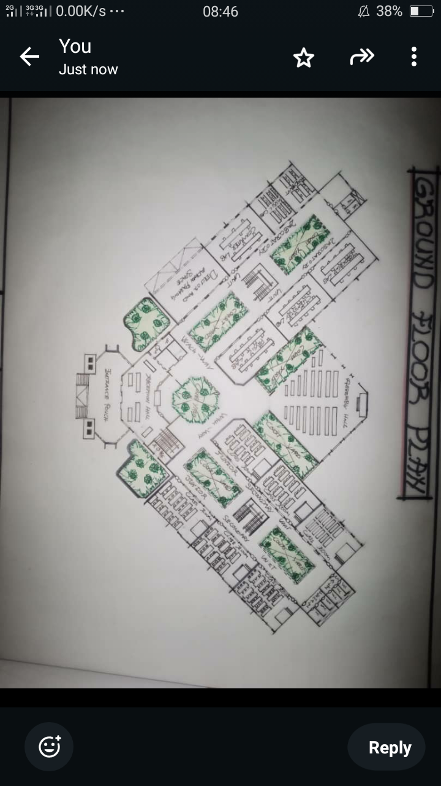
APPENDIX SEVEN SHOWING FLOORL PLAN

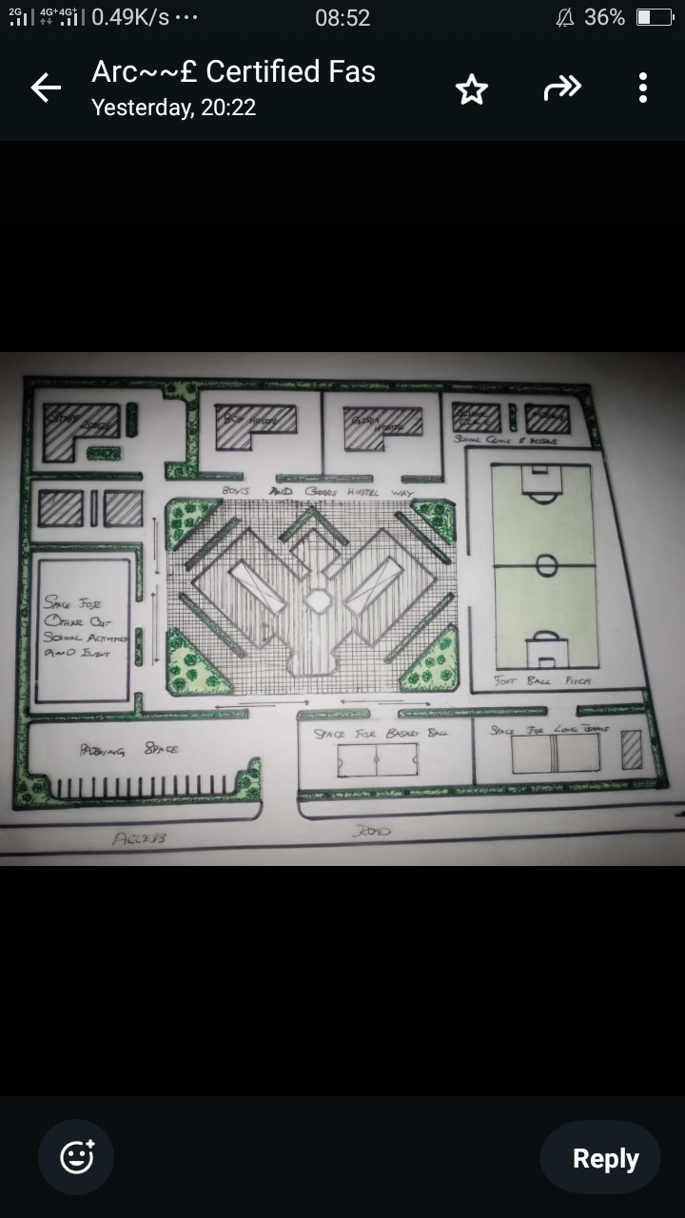
APPENDIX EIGHT SHOWING SITE PLAN

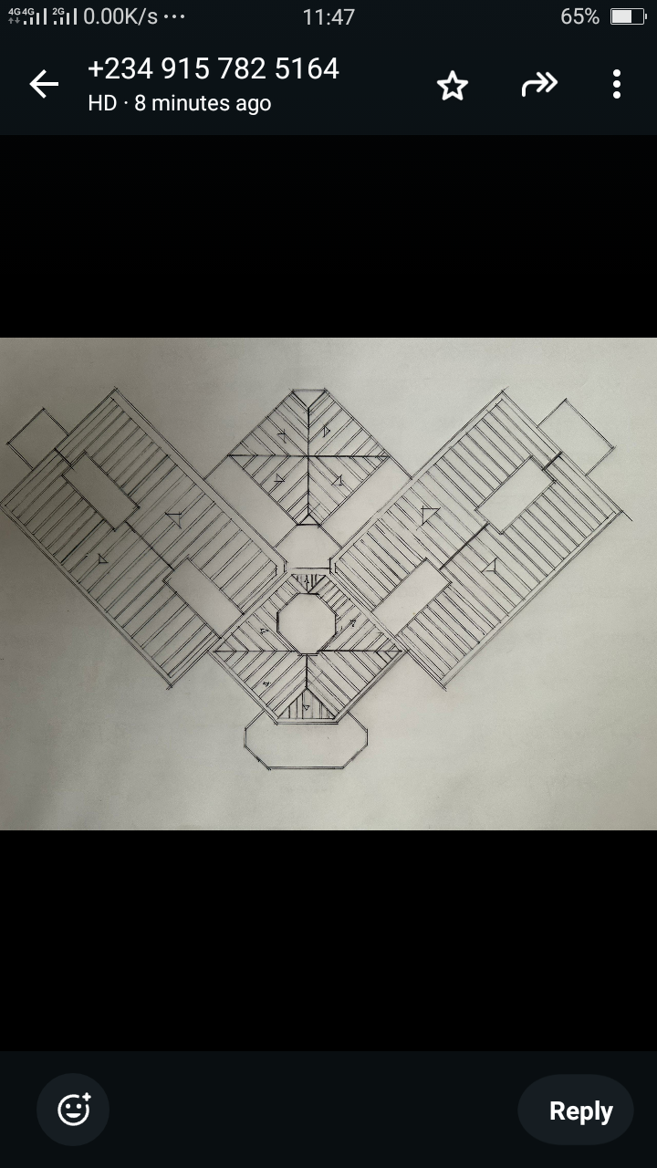

APPENDIX NINE SHOWING ROOF PLAN

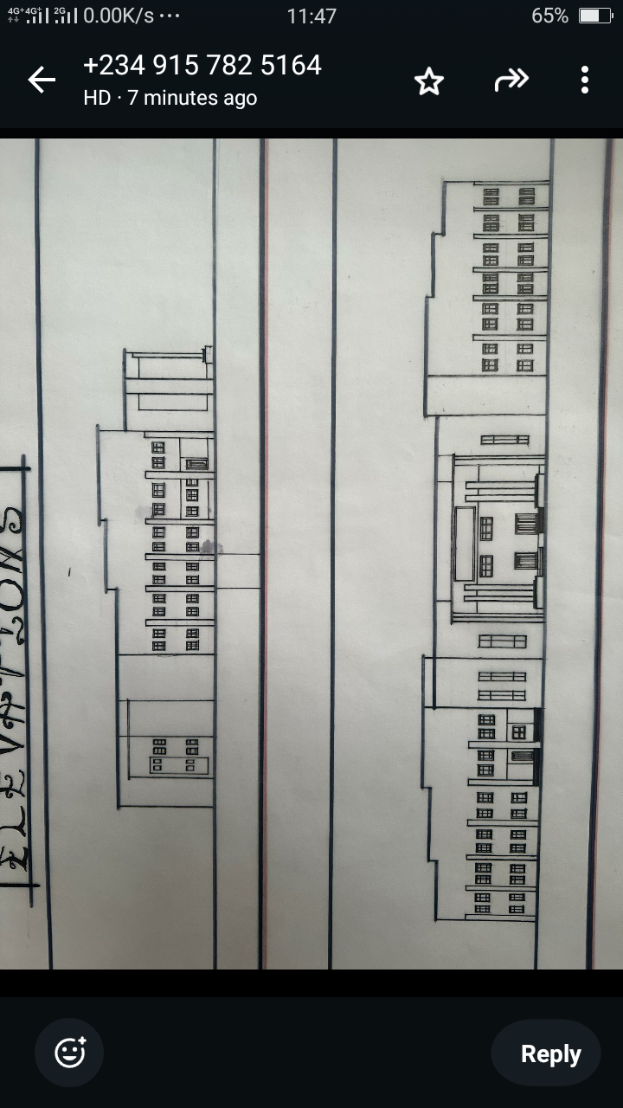

APPENDIX NINE SHOWING FRONT VIEW

