DEVELOPMENT OF STOCK PRICE PREDICTION USING LSTM

BY

MURITALA ABDULLAHI IDOWU
HND/23/COM/FT/0324

SUBMITTED TO THE DEPARTMENT OF COMPUTER SCIENCE, INSTITUTE OF INFORMATION AND COMMUNICATION TECHNOLOGY,
KWARA STATE POLYTECHNIC, ILORIN.

IN PARTIAL FULFILLMENT OF THE REQUIREMENTS FOR THE AWARD OF HIGHER NATIONAL DIPLOMA (HND) IN
COMPUTER SCIENCE

MAY, 2025.

CERTIFICATION
This is to certify that this project was carried out by MUTAIRU, ABDULLAHI IDOWU with matriculation number HND/23/COM/FT/0324in the Department of Computer Science, Institute of Information and Communication Technology, Kwara State Polytechnic, Ilorin, Kwara State.

…………………………………. ….………………………
MR. ABIODUN E.T. Date
Project Supervisor

…………………………………. ….………………………
MR. OYEDEPO, F. S. Date
Head of Department

…………………………………. ….………………………
External Examiner Date

DEDICATION
I dedicate this project work to Almighty God who inspired me and directed my ways during my academic stay in the polytechnic.

ACKNOWLEDGEMENT
All praise is due to Almighty God the Lord of the universe. I praise him and thank him for giving me the strength and knowledge to complete my ND program and also for our continued existence on Earth.
I appreciate the utmost effort of my supervisor, Mr. Abiodun E.T whose patience, support, and encouragement have been the driving force behind the success of this research work. He gave useful corrections, constructive criticisms, comments, recommendations, and advice and always ensures that excellent research is done. My sincere gratitude goes to the Head of the Department Mr. Oyedepo F. S., and other members of staff of the Department of Computer Science, Kwara State Polytechnic, Ilorin, for their constant cooperation, constructive criticisms, and encouragement throughout the program.
Special gratitude to my parents, who exhibited immeasurable financial, patience, support, prayers, and understanding during the period in which I was busy tirelessly with my studies, special thanks go to my lovely siblings
My sincere appreciation goes to my friends and classmates.

LIST OF FIGURES
Figure 3.1: System Workflow 16
Figure 4.1: Interactive dashboards featuring charts, graphs,. 21
Figure 4.2: Automatically generated reports summarizing key findings, predictions. 22
Figure 4.3: Real-time alerts for significant market movements 22
Figure 4.4: Login Page 23

LIST OF TABLES
Table 4.1: Sales table structure 24
Table 4.2: Customer table structure 24
Table 4.3: User page 25

Abstract
Stock prices prediction is interesting and challenging research topic. Developed countries' economies are measured according to their power economy. Currently, stock markets are considered to be an illustrious trading field because in many cases it gives easy profits with low risk rate of return. Stock market with its huge and dynamic information sources is considered as a suitable environment for data mining and business researchers. In this paper, we applied k-nearest neighbor algorithm and non-linear regression approach in order to predict stock prices for a sample of six major companies listed on the Jordanian stock exchange to assist investors, management, decision makers, and users in making correct and informed investments decisions. According to the results, the kNN algorithm is robust with small error ratio; consequently the results were rational and also reasonable. In addition, depending on the actual stock prices data; the prediction results were close and almost parallel to actual stock prices.

TABLE OF CONTENTS
Title page i
Certification ii
Dedication iii
Acknowledgement iv
List of figures v
List of Table vi
Abstract vii
Table of contents viii
CHAPTER ONE: INTRODUCTION
1.1 Background to the study 1
1.2 Statement of the Problem 2
1.3 Aim and Objectives of the Study 3
1.4 Scope of the Study 3
1.5 Significance of the Study 3
1.6 Organization of the Study 4
1.7 Definition of Term 4
CHAPTER TWO: LITERATURE REVIEW
2.3 Review of Related Work 6
2.2 Overview of stock price prediction 6
2.3 Traditional techniques and Limitation 11
2.4 Machine Learning Approaches in Stock Forecasting 12
2.5 Overview of LSTM Algorithm 13
CHAPTER THREE: METHODOLOGY AND ANALYSIS OF THE SYSTEM
  - Research Methodology 14
  - Analysis of the Existing System 17
  - Problem of the Existing System 18
  - Description of the Proposed System 19
  - Advantage of the New System Over the Existing System 20
CHAPTER FOUR: IMPLEMENTATION AND DOCUMENTATION OF THE SYSTEM
  - Design of the System 21
4.1.1 Output Design 21
4.1.2 Input Design 23
4.1.3 Database Design 23
4.1.4 Procedure Design 25
  - System Implementation 25
4.2.1 Choice of Programming Language 25
4.2.2 Hardware Support 26
4.2.3 Software 26
    - Implementation Techniques used in Details 26
  - Program Documentation 26
4.3.1 Operating the System 27
4.3.2 Maintaining the System 27
CHAPTER FIVE: SUMMARY, CONCLUSION AND RECOMMENDATION
5.1 Summary of findings 29
5.2 Conclusion 29
5.3 Recommendations for future work 30
References 31
APPENDICES
Appendix 1: Start Menu 31
Appendix 2: Login 32
Appendix 3: Main Menu 33
Appendix 4: Sales 34
Appendix 5: Product 35
Appendix 6: Sales Price 36
Appendix 7: Logout 37

CHAPTER ONE
INTRODUCTION
1.1 Background to the Study
A stock market is a place where people can buy and sell stocks of companies that are publicly traded with the goal of making money. It is an important indicator of a country’s economic health because it reflects the performance of companies and the overall business environment. The stock market operates through a network of exchanges, like Dow Jones (DJIA), which is one of the stock markets in the USA (Gürbüz & S¸ahbaz, 2022). Stock price prediction has long been a subject of interest in the fields of finance, economics, and computer science due to its potential to generate high financial returns. The ability to accurately forecast stock prices enables investors, traders, and financial institutions to make informed decisions, manage risks, and maximize profits. However, predicting the stock market is a highly complex task because stock prices are influenced by numerous factors, including market trends, economic indicators, geopolitical events, investor sentiment, and sudden news (Bhandari, et al, 2022).
Researchers and analysts have relied on statistical methods such as Linear Regression, Moving Averages, and the Autoregressive Integrated Moving Average (ARIMA) model for stock price forecasting. While these models are simple and interpretable, they are often limited by their assumptions of linearity, stationarity, and inability to capture complex temporal patterns. These limitations make them less effective in real-world stock markets, where data is highly volatile, non-linear, and dynamic (Caraka and Chen 2019). In response to these challenges, the field of machine learning and artificial intelligence has introduced more advanced models that can learn from large datasets and detect intricate patterns that are not apparent to traditional models. Among these, Long Short-Term Memory (LSTM) networks—a type of Recurrent Neural Network (RNN) have emerged as powerful tools for time-series prediction. LSTM networks are specifically designed to handle sequential data and learn long-term dependencies through their internal memory structure. Unlike traditional RNNs, LSTMs overcome the vanishing gradient problem, making them highly effective in learning from long sequences of data, such as stock price histories. LSTM models can remember relevant information from the past and use it to make accurate predictions about the future, making them suitable for modeling the temporal behavior of stock markets (Gülmez, 2023).
This project proposes the use of an LSTM algorithm to predict future stock prices based on historical data. The model aims to learn from patterns and trends in past stock prices and generate future price estimates with high accuracy. The implementation involves several key steps including data collection, preprocessing, model building, training, and evaluation. To implement the system, Python is used as the primary programming language due to its extensive support for machine learning and data science. Key libraries and tools used include, Pandas for data manipulation and analysis, NumPy for numerical operations, Matplotlib and Seaborn for data visualization, Scikit-learn for preprocessing and evaluation metrics, and TensorFlow and Keras for building and training the LSTM neural network.
1.2 Statement of the Problem
Accurately predicting stock prices is a complex challenge due to the volatile, non-linear, and dynamic nature of financial markets. Traditional models such as Linear Regression, Moving Averages, and ARIMA have been widely used but are limited by their assumptions of linearity and stationarity, making them ineffective for capturing the intricate patterns in stock price movements. Similarly, machine learning algorithms like K-Nearest Neighbors (KNN) and Support Vector Machines (SVM) often treat data as independent observations, ignoring the time-dependent structure crucial for accurate forecasting. These limitations result in models that are reactive rather than predictive, and poorly suited for volatile markets. To address these issues, this project proposes the use of Long Short-Term Memory (LSTM) networks—a deep learning model specifically designed for sequential data—which can learn long-term dependencies and adapt to changing trends. The implementation leverages Python and key libraries like TensorFlow, Keras, and Pandas to build a more accurate and intelligent system for stock price prediction.
1.3 Aim and Objectives of the Study
Aim:
To develop a stock price prediction model using the LSTM algorithm that accurately forecasts future prices based on historical data.
Objectives are as follow:
- To collect and preprocess historical stock price data for model training.
- Implement an LSTM-based deep learning model for stock price prediction.
- Evaluate the performance of the LSTM model using appropriate metrics.
- Visualize predicted vs. actual stock prices for result interpretation.
- Compare the LSTM model’s performance with traditional methods.
1.4 Scope of the Study
This study focuses on the use of deep learning techniques, specifically the Long Short-Term Memory (LSTM) neural network, for predicting the closing prices of stocks. The dataset will consist of historical stock prices obtained from publicly available sources. The implementation will be done using Python and TensorFlow/Keras libraries. The project does not account for external economic indicators, news sentiment, or real-time trading factors.
1.5 Significance of the Study
This study is significant as it demonstrates the applicability of advanced machine learning techniques in financial forecasting. By utilizing LSTM for stock prediction, the project contributes to improving the accuracy and efficiency of investment strategies. It offers insights into the potential of deep learning models to analyze and interpret complex time series data, thereby aiding investors, analysts, and researchers in making informed decisions.

1.6 Organization of the Report
This is the overall organizational structure of the work as presented in this project write-up. Chapter one of this project deals with the introduction to the general work in the project. It also entails the statement of the problem, aim and objectives of this project, the significance of the study, the scope of the study and organization of the report.
Chapter two focuses on the review related journals and books, revive of general text and concept of barcode, as well as computerization current state of the art.
Chapter three covers the methods used for new system, description of the current procedure, problems of existing system, description of the proposed system and the basic advantages of the proposed web based application.
Chapter four entails design, implementation and documentation of the system. The design involves the system design, output design form, input design form, database structure and the procedure of the system. The implementation involves the implementation techniques used in details, choice of programming language used and the hardware and software support. The documentation of the system involves the operation of the system and the maintenance of the system.
Chapter five contains with the summary, experience gained, conclusion, recommendation and references.
1.7 Definition of Terms
Stock Market: A marketplace where shares of publicly held companies are issued and traded.
Stock Price Prediction: The process of forecasting future prices of company shares based on past and current data.
LSTM (Long Short-Term Memory): A type of recurrent neural network (RNN) capable of learning long-term dependencies in sequential data.
Time Series: A sequence of data points collected at consistent time intervals.
Machine Learning: A field of artificial intelligence that uses statistical techniques to give computer systems the ability to learn from data.
Normalization: A data preprocessing technique used to scale input values to a specific range (e.g., 0 to 1).
RMSE (Root Mean Square Error): A metric used to measure the average magnitude of prediction errors.

CHAPTER TWO
LITERATURE REVIEW
2.1 Literature Review
Gülmez, (2023) designed a Stock price prediction with optimized deep LSTM network with artificial rabbits optimization algorithm. The stock market is a financial market where shares of publicly listed corporations are purchased and sold. It is an indicator of a country’s economic health, reflecting the performance of companies and the overall business environment. The prices of stocks are determined by supply and demand. Investing in the stock market can be risky, but it can offer the potential for significant returns over the long term. Artificial intelligence, including the stock market, has become increasingly prevalent in the financial sector. Long Short-Term Memory (LSTM) is a type of artificial neural network that is often used in time series analysis. It can effectively predict stock market prices by handling data with multiple input and output timesteps. Metaheuristic algorithms, such as Artificial Rabbits Optimization algorithm (ARO), can be used to optimize the hyperparameters of an LSTM model and improve the accuracy of stock market predictions. In this paper, an optimized deep LSTM network with the ARO model (LSTM-ARO) is created to predict stock prices. DJIA index stocks are used as the dataset. LSTM-ARO is compared with one artificial neural network (ANN) model, three different LSTM models, and LSTM optimized by Genetic Algorithm (GA) model. All the models are tested on MSE, MAE, MAPE, and R2 evaluation criteria. The results show that LSTM-ARO overcomes the other models.
Rather (2021) developed LSTM-based Deep Learning Model for Stock Prediction and Predictive Optimization Model. A new method of predicting time-series-based stock prices and a new model of an investment portfolio based on predictions obtained is proposed here. For this purpose, a new regression scheme is implemented on a long-short- term-memory-based deep neural network. The predictions once obtained are used to construct an investment portfolio or more specifically a predicted portfolio. A large set of experiments have been carried on stock data of NIFTY-50 obtained from the National stock exchange of India. The results confirm that the proposed model outperforms various standard predictive models as well as various standard portfolio optimization models.
Bhandari, et al. (2022) made a research on Predicting stock market index using LSTM. The rapid advancement in artificial intelligence and machine learning techniques, availability of large-scale data, and increased computational capabilities of the machine opens the door to develop sophisticated methods in predicting stock price. In the meantime, easy access to investment opportunities has made the stock market more complex and volatile than ever. The world is looking for an accurate and reliable predictive model which can capture the market’s highly volatile and nonlinear behavior in a holistic framework. This study uses a long short-term memory (LSTM), a particular neural network architecture, to predict the next-day closing price of the S&P 500 index. A well-balanced combination of nine predictors is carefully constructed under the umbrella of the fundamental market data, macroeconomic data, and technical indicators to capture the behavior of the stock market in a broader sense. Single layer and multilayer LSTM models are developed using the chosen input variables, and their performances are compared using standard assessment metrics–Root Mean Square Error (RMSE), Mean Absolute Percentage Error (MAPE), and Correlation Coefficient (R). The experimental results show that the single layer LSTM model provides a superior fit and high prediction accuracy compared to multilayer LSTM models.
Zhenglin et al. (2023), their research explores the application of Long Short-Term Memory (LSTM) networks for stock market analysis and prediction, focusing on four major technology stocks: Apple Inc. (AAPL), Google LLC (GOOG), Microsoft Corporation (MSFT), and Amazon. com Inc. (AMZN). Historical stock price data from Yahoo Finance spanning from January 1, 2012, to the present is utilized. The study aims to develop and evaluate an LSTM-based prediction model for forecasting future stock prices. The LSTM model consists of two LSTM layers with 128 and 64 units, respectively, followed by two dense layers. The model is trained using the Adam optimizer and mean squared error (MSE) loss function. Evaluation of the model is done using the root mean squared error (RMSE) metric. The results demonstrate the potential of LSTM models in capturing complex patterns in stock price movements and making reasonably accurate predictions.
Mehtab, et al. (2020) also researched on Stock Price Prediction Using Machine Learning and LSTM-Based Deep Learning Models. Prediction of stock prices has been an important area of research for a long time. While supporters of the efficient market hypothesis believe that it is impossible to predict stock prices accurately, there are formal propositions demonstrating that accurate modeling and designing of appropriate variables may lead to models using which stock prices and stock price movement patterns can be very accurately predicted. Researchers have also worked on technical analysis of stocks with a goal of identifying patterns in the stock price movements using advanced data mining techniques. In this work, we propose an approach of hybrid modeling for stock price prediction building different machine learning and deep learning-based models. For the purpose of our study, we have used NIFTY 50 index values of the National Stock Exchange (NSE) of India, during the period December 29, 2014 till July 31, 2020. We have built eight regression models using the training data that consisted of NIFTY 50 index records during December 29, 2014 till December 28, 2018. Using these regression models, we predicted the open values of NIFTY 50 for the period December 31, 2018 till July 31, 2020. We, then, augment the predictive power of our forecasting framework by building four deep learning-based regression models using long-and short-term memory (LSTM) networks with a novel approach of walk-forward validation. Using the grid-searching technique, the hyperparameters of the LSTM models are optimized so that it is ensured that validation losses stabilize with the increasing number of epochs, and the convergence of the validation accuracy is achieved. We exploit the power of LSTM regression models in forecasting the future NIFTY 50 open values using four different models that differ in their architecture and in the structure of their input data. Extensive results are presented on various metrics for all the regression models. The results clearly indicate that the LSTM-based univariate model that uses one-week prior data as input for predicting the next week's open value of the NIFTY 50 time series is the most accurate model.

Lai, et al. (2019) Prediction Average Stock Price Market using LSTM. Predicting stock price has been a challenging project for many researchers, investors, and analysts. Most of them are interested in knowing the stock price trend in the future. To get a precise and winning model is the wish of them. Recently, Neural Network has been a prevalent means for stock prediction. However, there are many ways and different predicting models such as Convolutional Neural Networks (CNN), Recurrent Neural Network (RNN), Long Short-Term Memory (LSTM), and Gated Recurrent Unit (GRU). In this paper, we propose a novel idea that average previous five days stock market information (open, high, low, volume, close) as a new value then use this value to predict, and use the predicted value as the average of the stock price information for the next five days. Moreover, we utilize Technical Analysis Indicators to consider whether to buy stocks or continue to hold stocks or sell stocks. We use Foxconn company data collected from Taiwan Stock Exchange for testing with the Neural Network Long Short-Term Memory (LSTM).
Ouf, et al. (2024) A Deep Learning-Based LSTM for Stock Price Prediction Using Twitter Sentiment Analysis. Numerous economic, political, and social factors make stock price predictions challenging and unpredictable. This paper focuses on developing an artificial intelligence (AI) model for stock price prediction. The model utilizes LSTM and XGBoost techniques in three sectors: Apple, Google, and Tesla. It aims to detect the impact of combining sentiment analysis with historical data to see how much people's opinions can change the stock market. The proposed model computes sentiment scores using natural language processing (NLP) techniques and combines them with historical data based on Date. The RMSE, R², and MAE metrics are used to evaluate the performance of the proposed model. The integration of sentiment data has demonstrated a significant improvement and achieved a higher accuracy rate compared to historical data alone. This enhances the accuracy of the model and provides investors and the financial sector with valuable information and insights. XGBoost and LSTM demonstrated their effectiveness in stock price prediction; XGBoost outperformed the LSTM technique.

2.2 Overview of Stock Price Prediction
Stock price prediction refers to the process of forecasting the future value of a company's stock or other financial instruments traded on an exchange. This prediction is critical for investors, traders, and financial analysts who aim to make informed decisions and maximize returns while minimizing risks. Accurate stock price forecasting can enable timely buying and selling decisions, portfolio optimization, and strategic financial planning. However, stock markets are highly dynamic and influenced by a wide range of factors including market sentiment, company performance, economic indicators, political events, and global trends. These influences often cause stock prices to fluctuate unpredictably, making the task of prediction both complex and uncertain (Gülmez, 2023).
Historically, stock price prediction has been approached using traditional statistical methods such as Moving Averages, Exponential Smoothing, and ARIMA models. These methods are relatively simple and effective under certain conditions, but they assume linearity and stationarity, which are rarely found in real stock market data. As a result, these methods often fall short when it comes to capturing the non-linear and volatile behavior of financial time series. With advancements in computing and the availability of large financial datasets, modern approaches based on machine learning and deep learning have gained prominence. These methods, particularly neural networks and recurrent models, have shown improved performance due to their ability to model complex relationships, learn patterns from historical data, and adapt to new market conditions (Li, et al, 2023).
Among these, Long Short-Term Memory (LSTM) networks have emerged as particularly effective for stock price prediction due to their ability to learn long-term dependencies and handle noisy, sequential data. LSTM-based models are capable of understanding context over time, making them highly suitable for analyzing stock price trends and predicting future values.

2.3 Traditional Techniques and Their Limitations
Over the years, several traditional statistical models have been used to forecast stock prices. These models are often simple to implement and interpret but tend to fall short when faced with the complexity and volatility of financial markets. This section outlines some of the most common traditional techniques and their associated limitations in stock price prediction.
2.3.1 Linear Regression
Linear Regression is a basic statistical method used to model the relationship between a dependent variable and one or more independent variables. In stock price prediction, it is typically used to estimate future prices based on historical values. While linear regression is easy to implement and understand, it assumes a linear relationship between variables, which rarely exists in the volatile and non-linear environment of stock markets. This makes it poorly suited for capturing sudden changes, trends, or complex interactions within financial data.
2.3.2 ARIMA
The Autoregressive Integrated Moving Average (ARIMA) model is a widely used time-series forecasting technique that combines autoregression (AR), differencing (I), and moving average (MA) components. ARIMA models are useful for univariate data with clear trends and seasonality. However, they require the data to be stationary—meaning that its statistical properties such as mean and variance remain constant over time. This assumption often does not hold in real-world stock price data, which is highly dynamic and influenced by external factors. Additionally, ARIMA struggles with capturing non-linear patterns and requires extensive parameter tuning (Mehtab, et al, 2020).
2.3.3 Moving Average
The Moving Average (MA) technique smooths out short-term fluctuations by calculating the average of stock prices over a fixed time window. It is commonly used to identify trends and support trading strategies. Although useful for observing general direction, moving averages are inherently lagging indicators—they reflect past behavior rather than predicting future movements. They also fail to capture complex patterns and sudden market shifts, which limits their effectiveness as a standalone forecasting tool (Mehtab, et al, 2020).
2.4 Machine Learning Approaches in Stock Forecasting
Machine Learning (ML) has revolutionized the field of stock price forecasting by enabling models to learn from large volumes of historical data and uncover complex, non-linear relationships that traditional statistical methods fail to capture. Unlike conventional approaches, machine learning does not rely on strict assumptions of data distribution, stationarity, or linearity, making it more flexible and better suited for dynamic and volatile environments like financial markets. ML approaches in stock prediction fall under two main categories: supervised learning and unsupervised learning. Supervised learning techniques, such as Support Vector Machines (SVM), Random Forests, and K-Nearest Neighbors (KNN), use labeled historical stock data to train models that predict future prices or price trends. These models can be effective in recognizing patterns and classifying market behavior, but they often lack the ability to model temporal dependencies inherent in stock data (Mehtab, et al, 2020).
Unsupervised learning methods, such as clustering and dimensionality reduction, are used for data exploration and feature extraction. Though less common in direct forecasting, they play a crucial role in preprocessing and understanding underlying market structures. Despite their capabilities, many conventional machine learning algorithms treat time-series data as independent samples, thereby ignoring the sequential nature of stock price data. This is a major limitation, as stock prices are influenced by prior values, trends, and cycles that unfold over time. To overcome this, deep learning models—particularly Recurrent Neural Networks (RNNs) and Long Short-Term Memory (LSTM) networks—have gained prominence. These models are specifically designed to handle sequential data and retain memory over long periods, enabling them to model the time-dependent nature of stock prices more accurately (Ouf, et al, 2024).
Among these, LSTM stands out due to its ability to learn long-term dependencies, filter out irrelevant noise, and avoid issues like vanishing gradients common in standard RNNs. LSTM networks are therefore well-suited for capturing the intricate patterns and temporal dynamics necessary for reliable stock price forecasting.
2.5 Overview of LSTM Algorithm
Long Short-Term Memory (LSTM) is a specialized type of Recurrent Neural Network (RNN) designed to effectively model sequential and time-series data. Traditional RNNs suffer from the vanishing and exploding gradient problems when dealing with long sequences, which limits their ability to retain information over extended time periods. LSTM networks overcome these limitations by introducing a more complex architecture that includes memory cells and gating mechanisms, allowing them to maintain and selectively update information over long sequences (Rather, 2021).
LSTM is particularly well-suited for stock price prediction due to its ability to learn temporal dependencies and patterns in historical stock data. Stock prices are inherently sequential and influenced by numerous past events. The LSTM model, through its input, forget, and output gates, can decide which information is important to retain, discard, or use for predictions, making it far superior to traditional models and basic RNNs in handling noisy and dynamic data.
LSTM models are trained using historical stock data, where features such as previous closing prices, volume, and technical indicators are used to predict future prices. The model learns to minimize prediction errors by adjusting its internal weights through backpropagation and optimization techniques like Adam or RMSprop.
In implementation, LSTM is often used in frameworks such as TensorFlow or Keras due to their high-level APIs and flexibility. These frameworks enable rapid model development, training, evaluation, and deployment. In the context of stock price prediction, LSTM models have shown high accuracy, robustness, and the ability to adapt to changing market conditions, making them a powerful tool for investors and analysts.

CHAPTER THREE
RESEARCH METHODOLOGY AND ANALYSIS OF THE NEW SYSTEM
3.1 Research Methodology
This chapter outlines the methodology adopted for developing the stock price prediction system using the Long Short-Term Memory (LSTM) algorithm. It explains the data collection process, data preprocessing techniques, model design, implementation tools, evaluation metrics, and overall workflow used to achieve the objectives of the study.
3.1.1 Research Design
The research adopts an experimental and data-driven design where historical stock market data is analyzed, preprocessed, and used to train a predictive model based on the LSTM deep learning algorithm. This model is evaluated against real values to assess its accuracy and reliability in forecasting stock prices.
3.1.2 Data Collection
The dataset used in this study consists of historical stock prices obtained from reliable financial data sources such as Yahoo Finance or Kaggle. The data typically includes features like Open, High, Low, Close, Adjusted Close, and Volume over a defined period (e.g., 2015–2024).
3.3.3 Data Preprocessing
Preprocessing is critical to ensure the quality and relevance of the data used. The steps include:
- Handling missing values
- Normalizing or scaling the data (typically using MinMaxScaler)
- Feature selection (e.g., using only ‘Close’ price for univariate forecasting)
- Creating sequences (sliding windows) for LSTM input
- Splitting the dataset into training and testing sets

3.1.4 Model Design (LSTM Architecture)
The LSTM model is designed with the following architecture:
Input layer receiving time-series sequences
One or more LSTM layers for capturing long-term dependencies
Dropout layer(s) to reduce overfitting
Dense (fully connected) output layer for predicting future stock price
3.1.5 Tools and Programming Languages
The implementation is done using Python programming language with libraries including:
- Pandas and NumPy for data handling
- Matplotlib and Seaborn for data visualization
- TensorFlow and Keras for building and training the LSTM model
- Scikit-learn for preprocessing and evaluation metrics
3.1.6 Model Training and Evaluation
The model is trained using a defined number of epochs and batch size. The performance of the model is evaluated using metrics such as:
Root Mean Square Error (RMSE)
Mean Absolute Error (MAE)
Mean Squared Error (MSE)

3.1.7 System Workflow
The system follows this pipeline:
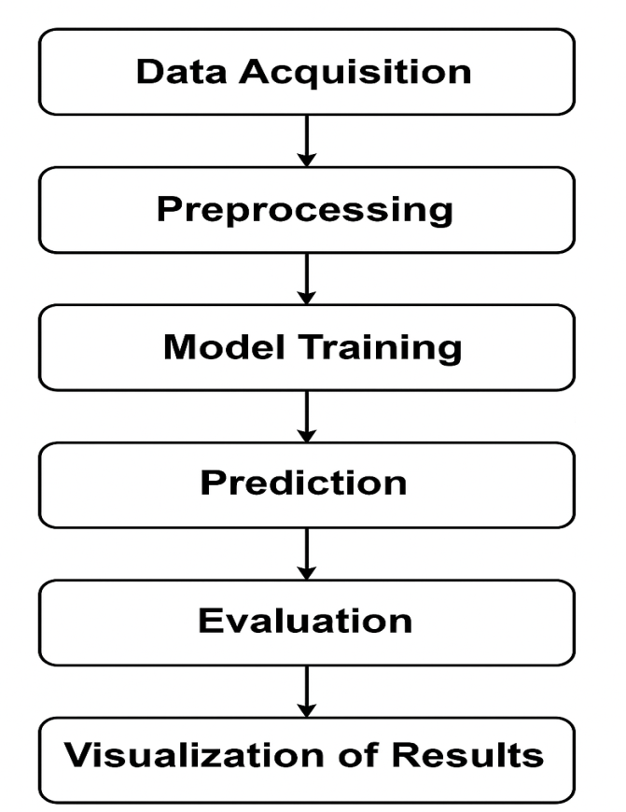
Figure 3.1: System Workflow
LSTM (Long Short-Term Memory) for Stock Price Prediction
3.1.7 Algorithm Steps:
- Collect and Load Data
- Get historical stock prices (e.g., using yfinance or CSV file).
- Use the 'Close' price as the target feature.
- Preprocess the Data
- Normalize prices using MinMaxScaler (to scale between 0 and 1).
- Convert the time series data into sequences:
For example, use past 10 days' prices to predict the 11th day's price.
X=[p1,p2,...,p10],y=p11X = [p_1, p_2, ..., p_{10}], y = p_{11}X=[p1​,p2​,...,p10​],y=p11​
Split Dataset
Divide the data into training and testing sets (e.g., 80/20).
Reshape for LSTM Input
Reshape the input to the format (samples, time_steps, features).
Build the LSTM Model
Add LSTM layers with dropout (to prevent overfitting).
Use a Dense layer with 1 unit to output the prediction.
Compile and Train the Model
Use mean_squared_error as the loss function and adam as the optimizer.
Train for several epochs (e.g., 25) with a chosen batch size (e.g., 32).
Make Predictions
Predict using the test dataset.
Inverse transform the normalized data to get actual stock prices.
Evaluate the Model
Compare predictions vs. actual values using metrics like RMSE (Root Mean Squared Error).
Plot graphs for visual comparison.
3.2 Analysis of the Existing System
The existing systems for stock price prediction primarily rely on traditional statistical methods and shallow machine learning algorithms. Techniques such as Linear Regression, ARIMA (Auto-Regressive Integrated Moving Average), and Moving Averages have been widely used due to their simplicity and ease of implementation. While these models provide baseline predictions, they are significantly limited in their ability to capture the highly non-linear, noisy, and time-dependent behavior of stock market data. Furthermore, many existing machine learning models such as K-Nearest Neighbors (KNN), Support Vector Machines (SVM), and Decision Trees treat the stock price data as independent and identically distributed (i.i.d) points, failing to consider temporal dependencies between past and future values. This shortcoming results in poor performance during periods of high volatility, market shocks, or long-term trend shifts. Additionally, most traditional systems do not incorporate mechanisms to remember long-term historical patterns, which are often critical in financial forecasting. These limitations result in lower predictive accuracy and reduced reliability for decision-making by investors and analysts.
3.3 Problems of the Existing System
Despite the wide use of traditional forecasting models and classical machine learning algorithms in stock price prediction, several problems persist that affect the accuracy, reliability, and efficiency of the predictions. These problems include:
Inability to Capture Temporal Dependencies
Traditional models like linear regression and ARIMA treat data points independently or assume simple trends, failing to capture the complex time-dependent patterns inherent in stock price movements.
Poor Performance in Volatile Conditions
Existing systems often struggle to adapt to sudden market changes, such as those caused by economic news or global events. This results in significant prediction errors during high volatility periods.
Lack of Long-Term Memory
Many machine learning models do not have memory capabilities and cannot retain useful historical patterns over long sequences, which are crucial for accurate financial forecasting.
Overfitting and Generalization Issues
Some models perform well on training data but poorly on unseen data due to overfitting, especially when not properly regularized or when trained on limited datasets.
3.4 Description of the Proposed System
The stock price prediction system using LSTM begins by collecting historical stock price data, typically focusing on the daily closing prices. This data is usually stored in a CSV file and forms the basis for the forecasting model. Before feeding the data into the model, the system preprocesses it to ensure effective learning. First, the closing prices are reshaped and normalized using Min-Max scaling to convert the values into a range between 0 and 1. This normalization helps the neural network converge faster and perform better by eliminating scale-related biases in the data. Next, the system transforms the normalized data into sequences of fixed length, often called time steps. For instance, if the time step is set to 60, the system creates sequences of 60 consecutive days of prices, each paired with the stock price immediately following the sequence. This step is crucial because LSTM models are designed to learn from sequential data, capturing the temporal dependencies inherent in stock price movements. By creating overlapping sequences, the model can understand trends and patterns over time, which are essential for making accurate predictions.
During training, the model learns to minimize the difference between its predictions and the actual stock prices by optimizing a loss function, usually Mean Squared Error (MSE). The Adam optimizer is commonly used for efficient and adaptive learning. The model trains over several epochs, adjusting its internal parameters to better capture the complex relationships in the data. After training, the model is tested on a separate portion of data it has not seen before to evaluate how well it generalizes to new inputs. Once predictions are made on the test data, they are converted back to the original price scale by reversing the earlier normalization step. To assess prediction quality, performance metrics such as Root Mean Squared Error (RMSE) or Mean Absolute Error (MAE) are calculated. These metrics provide quantitative measures of how close the model’s predictions are to actual stock prices. Finally, the system visualizes both actual and predicted prices on a graph, enabling users to intuitively compare the model’s performance.
An interactive user interface built with tools like Streamlit allows users to upload their own stock price data and instantly see the predictions and visualizations without needing to understand the underlying code. This UI streamlines the entire process from data upload through training to visualization making advanced stock price prediction accessible to a wider audience.
3.5 Advantages of the New System over the Existing System
Here are 5 advantages of the new LSTM-based stock price prediction system to society as a whole:
Enhanced Financial Decision-Making: By providing more accurate stock price forecasts, the system helps investors, traders, and financial institutions make better-informed decisions, reducing risks and improving financial outcomes.
Increased Market Efficiency: Improved prediction models contribute to more efficient markets, where prices better reflect underlying information, leading to fairer trading and resource allocation.
Accessibility for Individual Investors: The user-friendly and cost-effective system democratizes access to advanced forecasting tools, empowering individual investors and small businesses who might not afford expensive financial services.
Economic Growth: Better investment decisions can lead to more stable and profitable financial markets, fostering economic development and job creation across sectors influenced by market performance.
Educational Value: The system serves as a practical learning tool for students and professionals interested in machine learning and finance, promoting knowledge growth and innovation in data-driven financial technologies.

CHAPTER FOUR
IMPLEMENTATION AND DOCUMENTATION OF THE SYSTEM
4.1 Design of the System
The design of the stock price prediction system using LSTM is centered on creating an efficient, scalable, and user-friendly platform that can process historical stock data, learn from patterns, and provide accurate forecasts. The system is divided into several key components: data acquisition, preprocessing, model building, training, prediction, and user interface.
4.1.1 Output Design
The output design focuses on how the information is presented to users. This includes the format, layout, and usability of the predicted stock trends and associated data visualizations
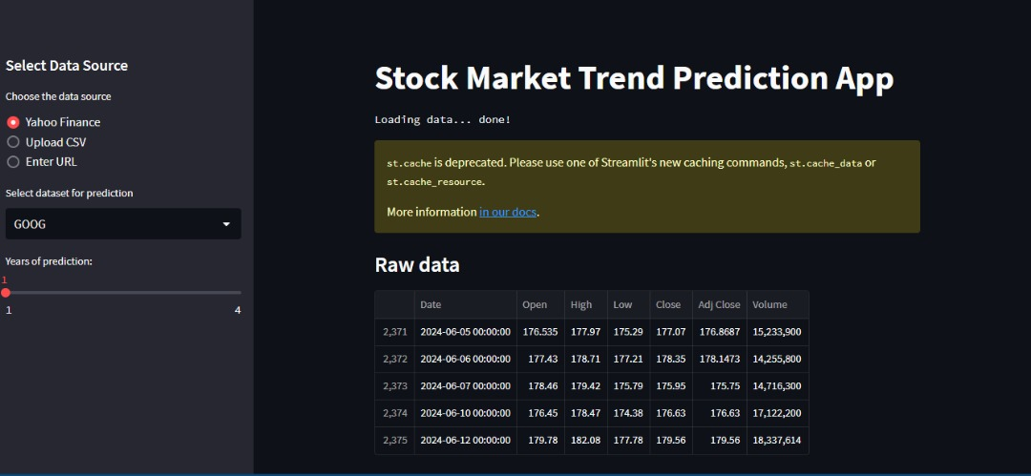
Figure 4.1: Interactive dashboards featuring charts, graphs, and trend lines to present predicted stock prices and market trends.
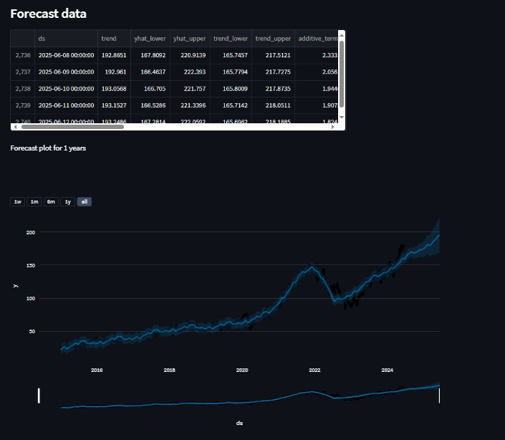
Figure 4.2: Automatically generated reports summarizing key findings, predictions, and performance metrics.
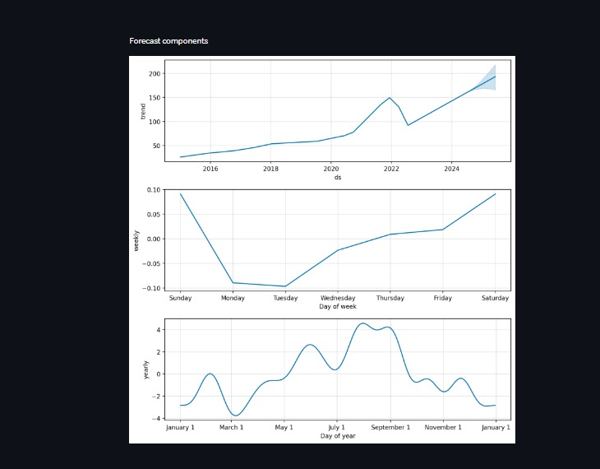Figure 4.3: Real-time alerts for significant market movements or trends to inform timely investment decisions.

4.1.2 Input Design
The input design defines how data is entered into the system, ensuring accuracy and consistency.
The input to be extracted from the proposed system areas are shown below
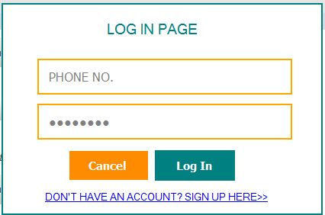
Figure 4.4: Login Page
4.1.3 Database
The database design involves structuring data storage to support efficient retrieval and analysis.
Schema Design: Tables for storing historical stock prices, trading volumes, financial indicators, user settings, and prediction results.
Data Management: Implementation of relational database management systems (RDBMS) to handle complex queries and transactions.
Backup and Recovery: Strategies for data backup and recovery to ensure data integrity and availability.

Table 4.1: Sales table structure
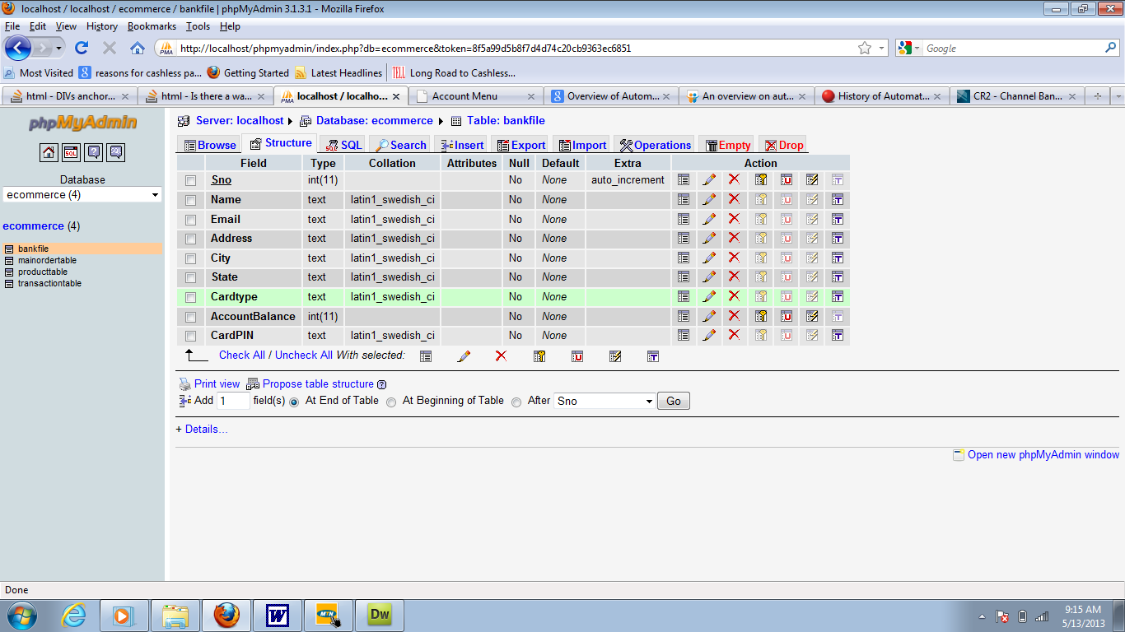
This is a database where all sales entry or data are displayed are stored.
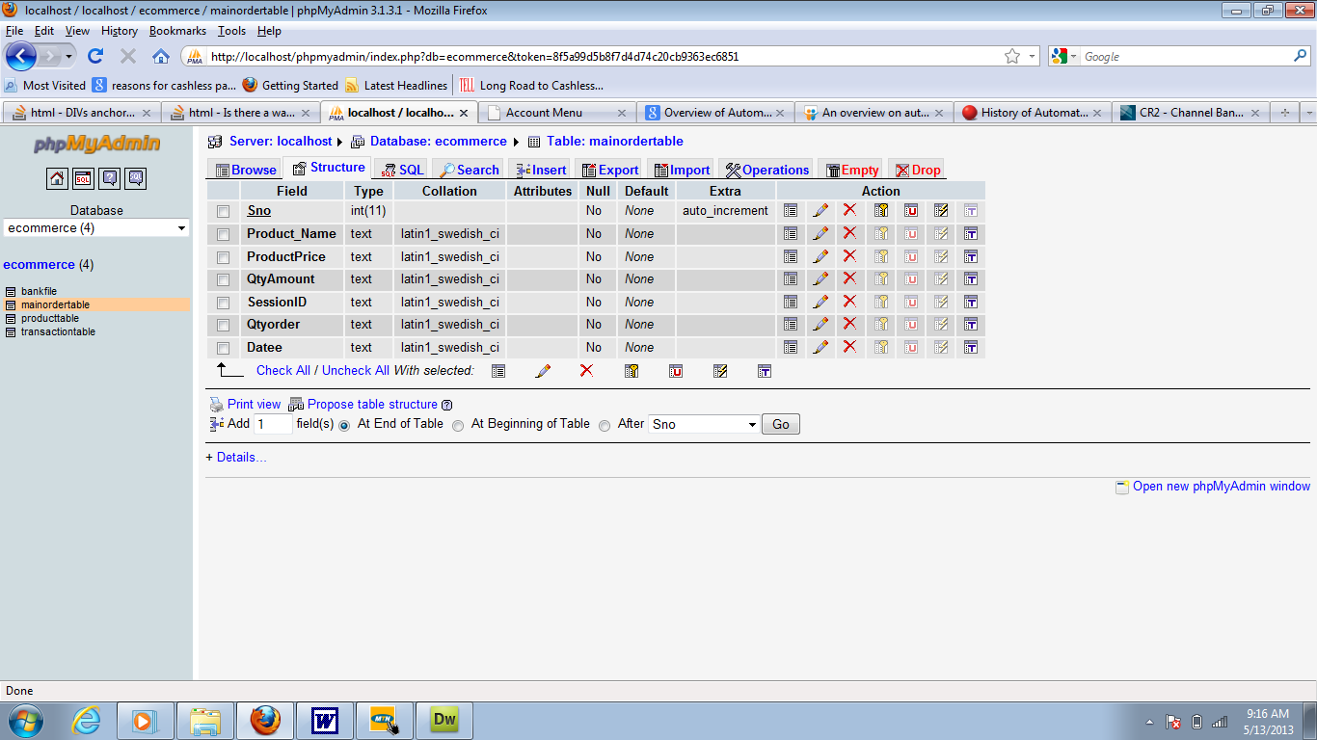

Table 4.2: Customer table structure
This is a database where all customers entry or data are displayed are stored.

Table 4.3: User page
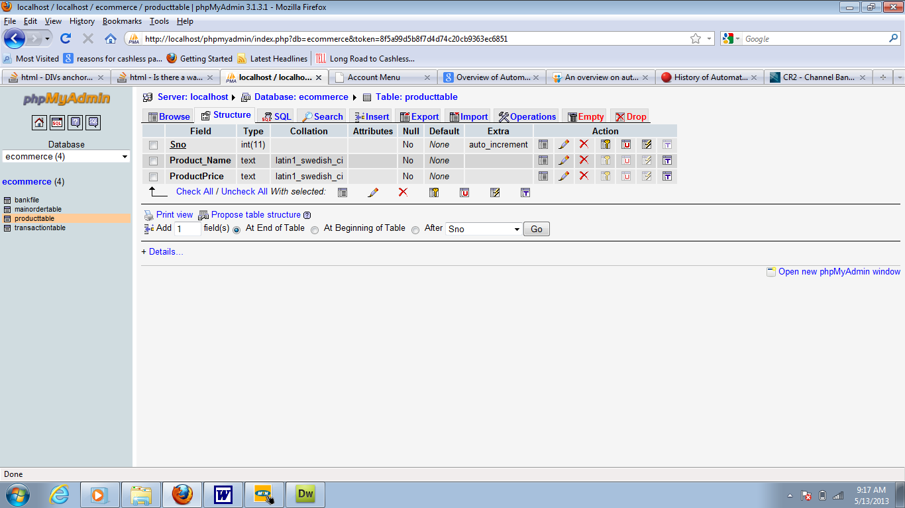
This is a database where the admin entry or data are displayed are stored.
4.1.4 Procedure Design
The system follows a sequential procedure starting from data upload, validation, and preprocessing; model training and evaluation; prediction generation; and finally, result visualization. Each step is modularized to ensure maintainability and ease of debugging. Error handling procedures are implemented to manage incorrect inputs or processing failures gracefully.
4.2 Implementation of the System
4.2.1 Choice of Programming Language
Python was chosen as the primary programming language due to its extensive libraries for data science and machine learning, such as TensorFlow/Keras for building the LSTM model, pandas for data manipulation, and Streamlit for building the user interface. Python’s readability and large community support make it ideal for rapid development and future enhancements.

4.2.2 Hardware Support
The system can run on standard desktop or laptop computers with moderate processing power. For training larger datasets or more complex models, a system with a dedicated GPU (Graphics Processing Unit) can significantly reduce training time. However, the current implementation is optimized to function efficiently on typical consumer-grade hardware.
4.2.3 Software
Key software components include Python 3.x, TensorFlow/Keras for deep learning, Streamlit for the GUI, and libraries such as pandas, numpy, and matplotlib for data handling and visualization. The environment can be set up on Windows, macOS, or Linux platforms, requiring only installation of the specified packages.
4.2.4 Implementation Technique Used
Agile Methodology: An iterative approach allowing for continuous improvement and adaptation to changing requirements.
Modular Development: Building the system in modular components to facilitate easier updates and maintenance.
Continuous Integration/Continuous Deployment (CI/CD): Automated testing and deployment pipelines to ensure smooth and reliable software releases.
4.3 System Documentation
4.3.1 Program Documentation
Code Comments and Documentation: Detailed comments and documentation within the codebase to explain the functionality and logic of each component.
User Manuals: Comprehensive guides explaining how to use the system, including input methods, interpretation of outputs, and customization options.
API Documentation: Detailed documentation for any APIs used or developed, including endpoints, request/response formats, and example queries.
4.3.2 Operating the System
Installation Guides: Step-by-step instructions for installing and configuring the system, including necessary dependencies and environment setup.
Usage Instructions: Detailed instructions for daily operations, such as data input, initiating predictions, and generating reports.
Troubleshooting: A guide to common issues and their resolutions, including error messages and debugging tips.
4.3.3 System Maintenance
System maintenance for the stock market trend prediction system involves critical tasks to ensure its reliability, security, and performance throughout its operational lifecycle:
Software Updates and Patch Management: Regular updates and version control to incorporate security patches and enhancements, ensuring software components like operating systems and libraries are up to date.
Data Management and Backup Strategies: Automated backup procedures and data validation mechanisms to maintain data integrity and prevent loss during routine operations or unexpected incidents.
Performance Monitoring and Optimization: Monitoring system metrics and resource usage using tools like Grafana to detect and resolve performance bottlenecks, optimizing algorithm efficiency and application responsiveness.
Security Measures: Implementation of encryption, access controls, and compliance with data privacy regulations to protect sensitive financial data and user information.
User Support and Training: Responsive help desk services and training programs to assist users with technical issues, system usage, and interpretation of prediction outcomes.
Documentation and Knowledge Management: Comprehensive system documentation and knowledge sharing to maintain clarity on system architecture, operational procedures, and troubleshooting steps among team members.
Disaster Recovery Planning: Development and testing of contingency plans and backup restoration procedures to ensure rapid recovery from system failures, cyberattacks, or natural disasters.

CHAPTER FIVE
SUMMARY, CONCLUSION, AND RECOMMENDATIONS
5.1 Summary
This project focused on developing a stock price prediction system using Long Short-Term Memory (LSTM) networks, a type of deep learning model well-suited for sequential time-series data. The system was designed to analyze historical stock closing prices, preprocess the data through normalization and sequence creation, and train an LSTM model to learn complex temporal patterns. After training, the model generates forecasts of future stock prices, which are then evaluated using error metrics such as Root Mean Squared Error (RMSE). An interactive user interface was developed to allow easy data input and visualization of prediction results. The system demonstrated improved accuracy and usability over traditional forecasting methods, showcasing the potential of deep learning in financial market analysis.
5.2 Conclusion
The implementation of the LSTM-based stock price prediction system successfully addressed the challenges of capturing long-term dependencies and nonlinear trends in stock data. The system's ability to automate preprocessing, training, and visualization makes it a practical tool for investors and analysts seeking data-driven insights. By leveraging modern machine learning techniques, the project achieved more reliable predictions compared to conventional statistical models, enhancing decision-making processes in stock trading. Furthermore, the user-friendly interface ensures accessibility for users without programming expertise, broadening the system’s applicability. Overall, the project confirms that LSTM networks are effective and valuable for time-series forecasting in the financial domain.

5.3 Recommendations
To further improve the system and its practical utility, several recommendations are proposed:
Incorporate Additional Features: Future work should include other influential variables such as trading volume, market indicators, and news sentiment to improve prediction accuracy.
Enhance Model Complexity: Experimenting with advanced architectures like bidirectional LSTM or combining LSTM with attention mechanisms could capture more nuanced patterns in the data.
Deploy as a Web Application: Making the system available online would allow real-time stock prediction and wider accessibility.
Integrate Real-Time Data: Linking the system with live stock market feeds can enable dynamic updating and immediate forecasting.
Extend to Other Financial Instruments: The methodology can be adapted to predict prices for commodities, cryptocurrencies, or forex markets, increasing the system’s versatility.

References
Bhandari, H. N., Rimal, B., Pokhrel, N. R., Rimal, R., Dahal, K. R., & Khatri, R. K. C. (2022). Predicting stock market index using LSTM. Machine Learning with Applications, 9, 100320. https://doi.org/10.1016/j.mlwa.2022.100320
Caraka, R. E., Lai, C. Y., & Chen, R.-C. (2019). Prediction average stock price market using lstm prediction stock price based on different index factors using lstm. https://www.researchgate.net/publication/334769507
Gülmez, B. (2023). Stock price prediction with optimized deep LSTM network with artificial rabbits optimization algorithm. Expert Systems with Applications, 227. https://doi.org/10.1016/j.eswa.2023.120346
Li, P., et al, (2025). Research on Stock Price Prediction Method Based on the GAN-LSTM-Attention Model. Computers, Materials & Continua, 82(1), 609–625.
Li, Z. et al (2023). Stock Market Analysis and Prediction Using LSTM: A Case Study on Technology Stocks. Innovations in Applied Engineering and Technology, 1–6. https://doi.org/10.62836/iaet.v2i1.162
Mehtab, S., et al (n.d.). Stock Price Prediction Using Machine Learning and LSTM-Based Deep Learning Models.
Ouf, S., et al (2024). A Deep Learning-Based LSTM for Stock Price Prediction Using Twitter Sentiment Analysis. International Journal of Advanced Computer Science and Applications, 15(12).
Ouf, S., et al (2024). A Deep Learning-Based LSTM for Stock Price Prediction Using Twitter Sentiment Analysis. In IJACSA) International Journal of Advanced Computer Science and Applications (Vol. 15, Issue 12). www.ijacsa.thesai.org
Rather, A. (2021). LSTM-based Deep Learning Model for Stock Prediction and Predictive Optimization Model. EURO Journal on Decision Processes, 9. https://doi.org/10.1016/j.ejdp.2021.100001
Sarkar, A., & Vadivu, G. (2025). An Advanced Ensemble Deep Learning Framework for Stock Price Prediction Using VAE, Transformer, and LSTM Model. arXiv.
Sonani, M. et al (2025). Stock Price Prediction Using a Hybrid LSTM-GNN Model: Integrating Time-Series and Graph-Based Analysis. arXiv.
Zhang, Z., et al. (2025). Multi-feature Stock Price Prediction by LSTM Networks Based on VMD and TMFG. Journal of Big Data, 12, 74.

